chapter 002
002 humankind elects jekyll or hyde holographic universe

2014 december kim without even trying
gained
new knowledge concerning continents never before
discovered by any human

new knowledge
ejected
kim from comfort zone confines of
traditional science and traditional religion parameters

newly expanded parameters meant for humankind
include
continents' outcropping statues declare vital message
END wars FOREVER

globe
acts as
message board tracking humankind's accomplishments
and possibilities for choosing SUNNYsideUP eternity

DOGS volunteered to mentor HUMANKIND

chapters A03-C08 short story's dogs
mentor
humans to fetch stick of fairness
FAIRNESS for ALL

Alice in Wonderland's GREAT PUPPY statue
embeds in
western part of
continental silhouette of australia

library of congress's

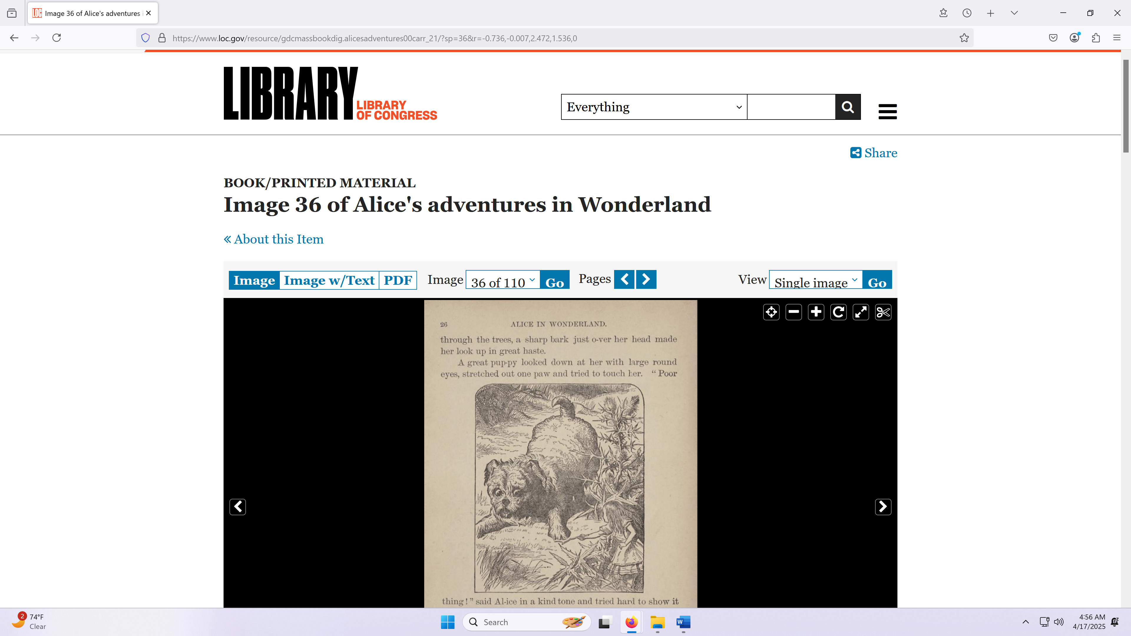

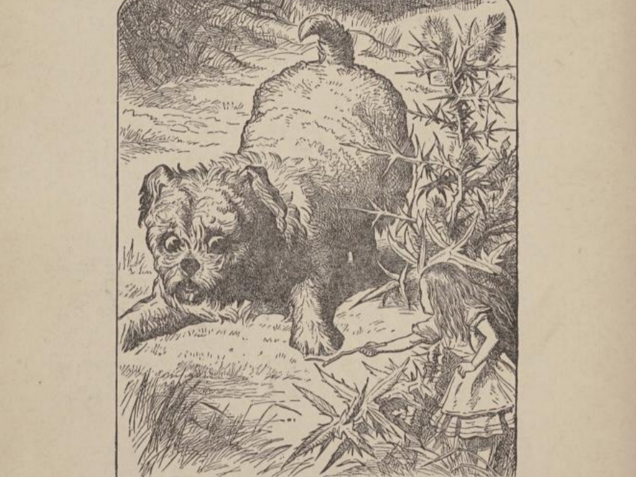


kim
discovered and circled
dog features in
part of continental silhouette of australia

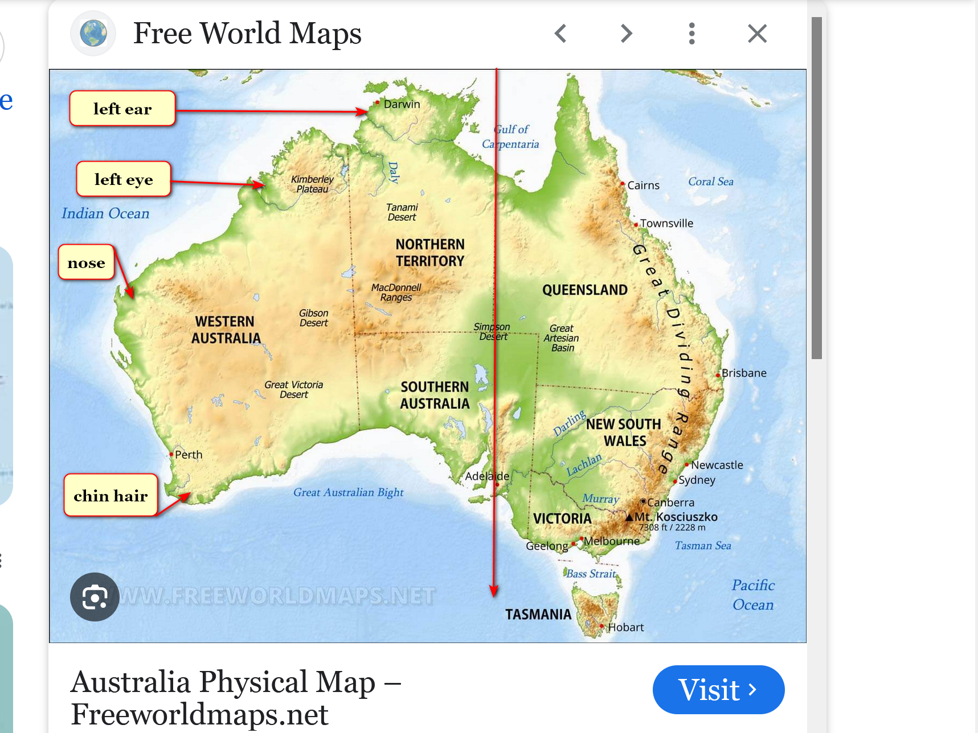

west portion of australia
depicts
huge statue of dog head
looking westward

dog looking westward
parallels
australia continent's silhouette dog

portions of religions
contain
myths thereby lowering ceilings of operations
and fairness from respective religious adherents

however one short story from religion
does accurately describe
daily operations within each human

STORY of persistent WIDOW

Attribution:
Rijksmuseum, CC0, via Wikimedia Commons
HTML

Created: 1712
Uploaded: 10 December 2019
prentmaker: Jan Luyken Plaats vervaardiging: Amsterdam

File:Gelijkenis van de rechter die wordt lastiggevallen door een klagende vrouw, RP-P-OB-46.028.jpg

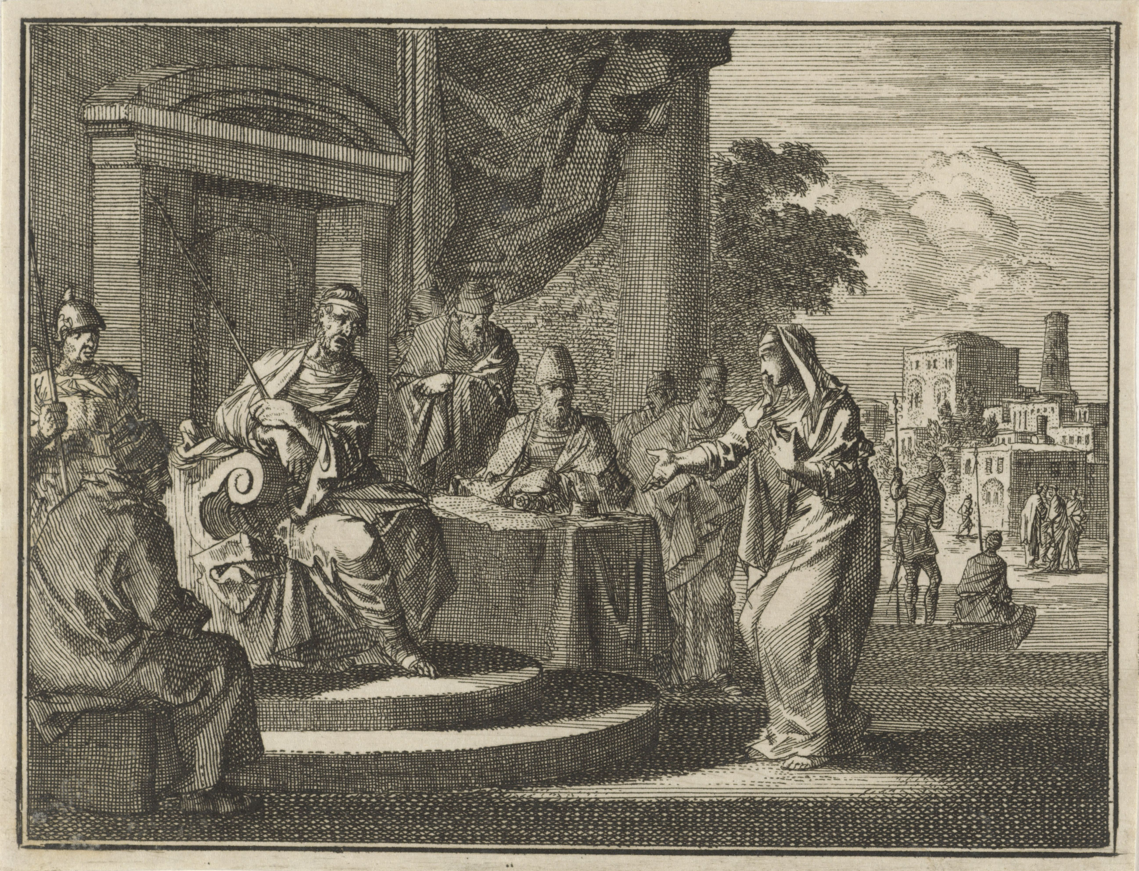

THERE was a small town with a judge
who was not afraid of God
nor afraid of opinions of people

widow
came
to that judge pleading case for
justice against opponent in town

that judge
ruled in favor of widow because
of widow's more persistent PETITIONING

KIM NOTES

above story's symbolism
includes

neutral judge
symbolizes
cns central nervous system consisting of
head and neck and spine cells

neutral judge as conscious cns
granted
one constituent's desire
over other constituent's desire

conscious central nervous system
decides to favor
one or other
suggestion made by group of cells

90% of person's cells
grouped equally into
two subgroups

pleasant peaceful SUNNYsideUP group of cells
includes
limbs of arms and legs
of each person

abrasive dismissive SUNNYsideDOWN group of cells
reside
in torso also called trunk
of each person

routinely after sleeping conscious neutral judge
found
new list on desk with
first name listed atop second name

that list
authored by
subconscious neutral judge

when conscious slept subconscious neutral judge
sleepwalked and finally listed
names according to judge's personal whims

early every night subconscious judge
routinely tapped into
all persons' conversations on globe
including every blog and every podcast

with that information subconscious judge
knew
topics archivally
yet without understanding emotionally

in other words neutral judge
unable to interpret
when to laugh
and when to cry

judge's blind spot concerning emotions
caused
embarrassment so judge hid
lack of opinions feature from constituents

however judge
desired
fitting in

therefore judge
took cues
from what constituents said
and adopted other persons' opinions

routinely around midnight judge
started
night court

judge
alternately listened to
cases and napped

conscious judge
would lay head
atop desk to sleep
then awake after around 20 minutes

while conscious judge slept subconscious judge
entered
sleepwalking mode

judge
always listened to
same two lawyers making opposite cases
dr jekyll and mr hyde

wikipedia's

Public Domain
File:Jekyll-mansfield (cropped).jpg
Created: 1895
Uploaded: 25 January 2023

Photo by Henry Van der Weyde (1838-1924; London, England) - http://www.photography-museum.com/jekyll.html / Originally uploaded to en.wikipedia;

Richard Mansfield was best known for the dual role depicted in this double exposure:

he starred in Dr. Jekyll and Mr. Hyde in both New York and London. The stage adaptation opened in New York in 1887 and London in 1888.

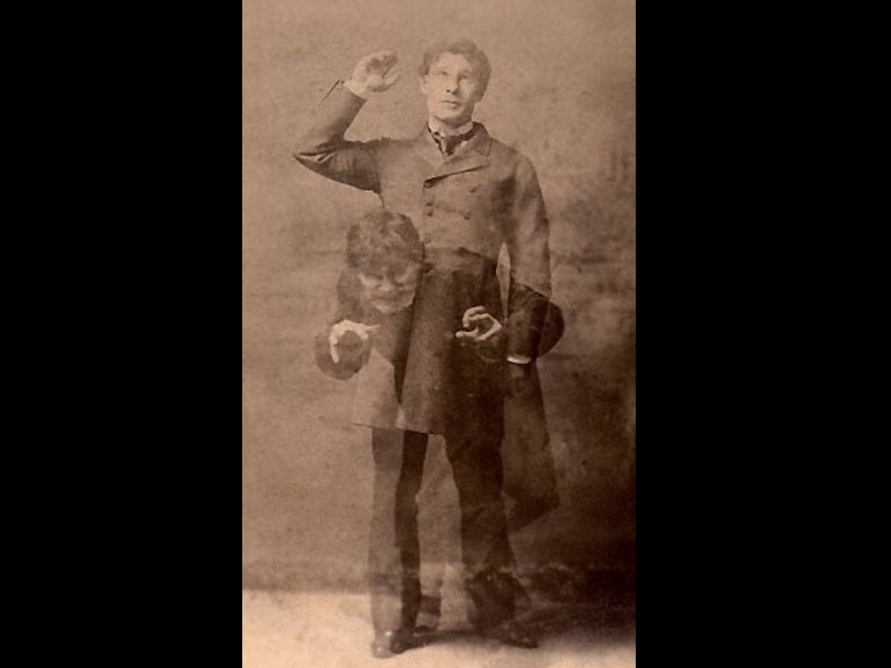

goodreads.com's

Robert Louis Stevenson's masterpiece
of duality of good and evil in man's nature

sprang from darkest recesses of his own unconscious—during a nightmare
from which his wife awakened him, alerted by his screams.

this tale of mild-mannered Dr. Jekyll and drug
that unleashes
his evil, inner persona—loathsome, twisted Mr. Hyde
relates
Jekyll's desperation as Hyde gains control of his soul—
classic demonstrates understanding of inner conflicts...

central nervous system judge
favored neither
dr jekyll nor mr hyde

case by case lawyers
gave
emotional contexts via framing events yet
always ended with two opposite conclusions

judge hindered by emotional neutrality
merely agreed with
person making highest number
of presentation examples

lawyers
went on and on
concerning each action and
each hint from client

lawyers assisted clients
via writing
books piecing together several
hints into common themes

for example each lawyer
presented
situations by first saying

OBVIOUSLY my client
favors such and such emotion
because look at my client's many
authored books on this SUBJECT

judge lacking guiding principles
simply favored
lawyer carrying heaviest bag of books

therefore accordingly subconscious judge
listed
that lawyer's name on top
of list for presenting case first

conscious judge refreshed from sleep
possessed
no knowledge of backstory bickering nor
of global citizens' blogs and podcasts

therefore conscious judge
heard
cases with unbiased openness

upon waking conscious judge
simply looked
at top of list then directed
that lawyer's presentation first

advantages of presenting case first
included attaining
status of tradition

second lawyer
worked much harder
because needed to overcome
tradition's embedded framing of situations

for even easier comparison judge
secretly installed
two huge scales
into floor of garage

both dr jekyll and mr hyde
stood unknowingly on
respective platforms during oral arguments and
brought book bags corroborating those outlooks

judge
would routinely pull open
desk drawer and compare weights displayed
on drawer's two horizontal monitors

somehow mr hyde
figured
strategy of judge

as counteraction and rigging system hyde
requested permission
to bring two ice buckets
during oral arguments for health reasons

mr hyde
claimed
if stood in ice that ice's coldness
activated reflexology healing points of feet

judge
granted
request which of course
weighed heavily in mr hyde's favor

however ice
turned into
water then evaporated
from buckets by noon

until noon judge
routinely placed
mr hyde's name atop lists due
to monitor showing larger weights

puzzled dr jekyll
noticed
jekyll never spoke first until around
noon if then

therefore jekyll
felt
jekyll needed
counter strategy

jekyll's workaround strategy standard opening phrase attempted to counter
hyde's just stated
skewed framing of situations

as general rule dr jekyll
opened with and spoke kindly
SUNNYsideUP phrase including even when addressing contentious hostile aggressive statements from hyde

AS court
strives to find
FAIRNESS for ALL parties concerned
in this particular case that MEANS

those initial SUNNYsideUP words above
became
habit and telltale signature
of dr jekyll

END OF SYMBOLISM of religion's story

above symbolic story
explains
scientific reality

universe
obediently adjusts
holograph around each person

person's conscious emotional decisions or hints
adjust
humankind's rulebook often called DNA

each eight second span's major signal
counts as
one vote of collective bargaining agreement

therefore majority wishes of frontline humans
rule

in this way humankind
self determines
eternity's environment style towards
collective humankind's ecstasy or agony

recognizable statues embedded in geography
verify
universe's holographic system
mentioned above

narrative of those statue puzzle pieces
relay
sense of urgency concerning humankind
choosing SUNNYsideUP versus status quo

if nations' administrators
adopt
SMOOTH KEYS DEMOCRACY that tips
vote towards pleasant honeymoon like eternity

each person on globe
contains
same ratio of electrons
concerning three segments

central nervous system conscious person
involves
head and neck and spine
equaling 10% of total body

limbs
equal
45%

trunk
equals
45%

if persons
not fully limbed
then electrons adjust until
above ratio renewed

neutral judge
represents
central nervous system parliament

dr jekyll
represents
limbs parliament

mr hyde
represents
trunk parliament

chapter ends

