HAPPY EVER AFTERS book

by
Kim Martin Klecka, D.D.S., B.S.

all rights reserved
2026 August 23 Sunday

Post Office Box 740031
6500 De Moss Drive
Houston, Texas 77274-0031

Kim wrote four screenplays
based on material found in
HAPPY EVER AFTERS free online book at shoelanguage.com

Each film contains 12 sections of 20 minutes with a fifteen minute intermission as last portion of sixth section

0001 Forbidding Cancers Etcetera

0002 Bisexual Entrenched Antijew Ruinous Slashers

0003 SMOOTH KEYS DEMOCRACY

0004 Total Migration Ensures Eternal Ecstasy

Film One of Four Films

0001 Forbidding Cancers Etcetera

section one

inside King Olav's library room in Norway National Library
minutes 0-10 Kim welcomes viewers

Hello and welcome to the first of four gifts from Norway.

My name is Kim Klecka.

The government of Norway decided to help humankind by investing in producing four films urging certain tasks causing pleasant eternity for humankind as a group.

We employed as many Norwegians on casts and crews as possible.

I am eager for the government to regain that original money.

The profits after that will be divided among the millions of Norwegians as stimulus checks for the economy.

Films' snippets reference other media.

I hope those authors gain more readers and visitors and profits by exposures here and by exposures in HAPPY EVER AFTERS book.

I desire all humans on globe experience happiness and SuperHealth and marital bliss.

Forbidding Cancers Etcetera is easy to accomplish.

No money or treatments are necessary.

Every person on the globe should utilize these strategies.

What we call the universe is simply a hologram.

We are the directors of our individual holograms surrounding us.

We forbid cancers etcetera by simply sending signals to
switch hologram to SuperHealth as acceptable not any other.

Until now people did not know the signals that requested cancers etcetera.

Lack of SuperHealth expresses in many ways because people are different.

However the cure strategy is the same for all the diseases.

HAPPY EVER AFTERS book and the associated four films give details of the cure strategy.

These films show images of messages to humankind constructed not by humans but by friends of humankind.

With that new knowledge I filled in gaps of knowledge in religions and in science.

My conclusions include lack of angels existing and lack of judgements ever from an Almighty Supreme Being.

On the contrary, the universe is waiting to see what majority of humankind deems favorable and what humankind deems despicable.

The universe will follow into eternity whichever style humankind deems favorable.

For example, some people favor wars and also favor sex outside of traditional marriage.

If majority of humankind deems that whole style as favorable then all of humankind will spend eternity with unyielding pain.

Eternity molds according to what humankind as a group favors. Majority rules.

Given the absence of meaning of deity implied words like GOOD and EVIL, I invented the words SUNNYsideUP and SUNNYsideDOWN.

There is a shadowy one world government that loves producing SUNNYsideDOWN events like wars and starvations and violence and promotes bisexual relations.

SUNNYsideDOWN also includes contentious anger, governmental murdering punishments and maimings,

and any so called marriages other than one straight man to one straight woman,

fornicating, premarital sex, adultery, unfaithfulness to straight marriage.

The main non religious group on globe causing SUNNYsideDOWN events is a secret organization of top leaders in governments and corporations that I call BEARS.

Film Two discusses that organization
Bisexual Entrenched Antijewish Ruinous Slashers

Film two exposes examples of BEARS' secret assassination methods and cover up methods.
As an educational tool just for these movies, the BEARS members might wear an arm band with image of a BEAR.

This depowering Film Two should convince BEARS now exposed to accept win win stand down deal.

I can sum the intentions of these four films in one sentence.

Humankind chooses honeymoon like ecstasy for all forever if humankind's executive branches
adopt
film three SMOOTH KEYS DEMOCRACY
as soon as possible with the notion to prebuild
solar powered cities for years based on SUNNYsideUP culture
and then does migrate
as shown in
film four TOTAL MIGRATION ENSURES ETERNAL ECSTASY.

Eternal pleasantness for all humans ever involves three groups changing outlooks on life.

All non religious sincere persons must realize that God was intact and then quadrisected into four equal titans; two women and two men.

All religious sincere adherents must realize that religions did not possess enough of the right information and therefore their conclusions about eternity lacked accuracy.

No need to pray to or worship any personality.

Intact God does not now exist.
Angels do not exist.

Photons actually do tasks for what Angels are credited.

No religious person or book ever mentioned that photons moved pieces of continents to make tremendous statues to message humankind about its role in shaping eternity for all of humankind as a group.

God will recombine after humankind votes its pleasure as the final eternal standard of daily operations.

Third group needing convincing is called BEARS.

Photons and Kim ask the third group to peacefully relinquish control and to vacate their current shadowy one world government.

The generous deal involves a win-win strategy as shown in film three SMOOTH KEYS DEMOCRACY.

People used to talk concerning GOOD and EVIL as if God said which was which.
The Ten Commandments were from a convincing hoaxer that dazzled Moses with changes in the hologram thought to be miracles.

However, Intact God did not mention lists of GOOD and EVIL actions before Intact God temporarily subdivided.

Now we know that God is not now intact.

No judgmental God exists.

The question the universe is asking is what does humankind favor and disfavor?

After this life on Earth there is still no judgement because humankind on Earth has not decided permanently its style of daily operations for each day of eternity.

Therefore until that finalization two holding compartments await personalities that passed away from Earth.

One of those places is pleasant and SUNNYsideUP.

The universe is like a stage play.

The director is humankind.

The director can order the removal of stage props.

If nations of this Earth
decide YES to adopt
Films Three and Four as upgrade strategy for humankind

And if personalities from the unpleasant holding compartment
migrate to
the pleasant holding compartment.

Then instantly the unpleasant holding compartment vanishes.

interior inside residential house
minutes 10-20 Keith Michael Klecka's letter

April 21, 1967

Dear Persons heading Norway Films and Retirement Fund,

I hope you are well.
My name is Keith Michael Klecka.
I am eight years old today.
I live in Deer Park, Texas in USA.

I enjoyed eating cake and opening presents.
But later in the evening, I watched television and saw pictures of other countries.

People were starving.
Wars were killing people.
That made me sad.

I really really wanted every person to be happy.

As soon as I went to bed, I noticed a speck of light
floating near the ceiling.

Other specks joined the first speck until the whole
ceiling was full of specks of light.

Those specks got bigger until they looked like light bulbs
with faces that spoke.

One light bulb was the leader.
The leader spoke to me.

He said, "Hi Keith! My name is Kip and we are photons which are the smallest bits of light.

We heard your lingering thoughts to help humankind
so that gave us permissions to show ourselves to you.

Let us go to the den to the television because we can
use the television screen to show you images that
teach faster.

When I sat in front of the television, I asked Kip to play
a scene from the movie THE TEN COMMANDMENTS.

I mentioned to Kip,
"We were told in Sunday School that God moved the waters aside to provide dry land.
What about that?

Kip said,
"That was us changing the hologram.

We photons do the work but mythological angels get
the credit.

Everything started with lonely God subdividing into
four Titans.

All four Titans were equal.

Two Titans were females and two Titans were males."

Kip showed images on the television screen to reinforce Kip's words.

"God left no instructions and no judgements.

When God recombines, God's personality will
possess style that Titans determined."

Humankind possesses the swing vote which will decide the style of culture for humankind on this globe permanently.

Style out of favor will vanish from humankind's hologram.

Humankind's favorite style will remain for eternity for all humans now and all humans who ever lived.

Right now, humankind has set the emotional mindset switch to SUNNYsideDOWN which includes starvations and wars.

If that setting remains then all will forever experience nightmares and pain except for one personality; Titan Don.

Photons must obey signals from humans whether SUNNYsideUP or SUNNYsideDOWN.

Titan Bamboozler Bob Jesus pretended to be Intact God as he interjected a thought into Moses.

He asked Moses to pray for a miracle of two walls of water leaving dry land to escape from Egyptians and then to drown Egyptians via restored sea.

Moses did pray for that.

Technician photons had no choice but to obey, which promoted SUNNYsideDOWN because that event caused deaths.

Earlier in history, Titan Bamboozler Bob Jesus pretended to be Intact God as he injected into Abraham's mind to cut the skin of his baby and future babies so as to promote violence and crying which promoted SUNNYsideDOWN for generations.

People who start religions are sincere humans manipulated into violence via Titan Bamboozler Bob Jesus' miracles.

Titan Bamboozler Bob Jesus pretended to be various angels throughout history.

Those were hoaxes.

For example, Angel Gabriel does not exist.

That Gabriel hoax manipulated Virgin Mary of Nazareth to say YES.

In this way, Titan Bamboozler Bob Jesus had permission
to pretend to be Baby Jesus and Child Jesus and adult
so called Savior Jesus.

Jesus was not who Jesus said Jesus was.

Photons were originally electrons.

Other small personalities include protons and neutrons.

Gravity is the last part of what makes up everything.
Gravity awaits the winner.

Protons and neutrons oppose each other like Monopoly board game players trying to dominate all the land.

Little protons are all parts of one huge proton called Titan Bamboozler Bob Jesus who promotes SUNNYsideDOWN.

SUNNYsideDOWN means increased chaos to that person on this Earth.

If enough SUNNYsideDOWN votes are made that means
eternity with unyielding pain for everyone except one Titan.

We photons do not want to create a SUNNYsideDOWN eternity.

We photons do not want to experience a SUNNYsideDOWN eternity of pain.

Yet we are obligated technicians to create hologram stage play surroundings as directed by that human surrounded.

There is no Intact God who judges from above.

Our only guides are humans' lingering thoughts and words and actions.

We photons are now talking to the subconscious central nervous system of Keith which is head, neck, and spine.

When Keith awakes, then the conscious central nervous system engages to the stage play session with the stage unknowingly full of things that subconscious Keith requested.

Titan Bamboozler Bob Jesus started nicely but when in prison, he invented a deal that included him encouraging humans to think mean, speak mean, and act mean with mean stage props handy.

Titan Bamboozler Bob Jesus manipulated humans to request those mean stage props onto the stage of that hologram.

This is the strategy Titan Bamboozler Bob Jesus uses to please his SUNNYsideDOWN guard/torturer Titan Don Lazarus.

Titan Cindy Mary has little pieces called neutrons.

In this system, neutrons send SUNNYsideUP ideas to electrons and to bundles of electrons called humans.

These ideas include how to end starvations and how to end wars.”

Kip asked,
"Keith which Monopoly player do you support?"

I said,
"Titan Cindy Mary and the neutrons for SUNNYsideUP."

Kip and the other photons said,
"Great and thank you!"

I told Kip,
"Right now signed paper treaties are like Lucy holding the football for Charlie Brown."

The photons laughed.

Together we invented SMOOTH KEYS DEMOCRACY which is a reliable nonwar style of government.

The photons said they would honor our project completion by creating a statue of SNOOPY in the continents.

That SNOOPY statue will be the largest dog statue ever.

Kip said,
" We photons will put many statues as messages on planets Earth and Mars and elsewhere."

I said,
"Can you give me an example?"

Kip pointed by moving his light bulb body to the television screen.

Kip said,
"Yes. This is a statue which we will build on Mars in the year 2022 to warn humans.

A NASA orbiting vehicle will take a photograph."

I saw on the television screen an image of a bear.
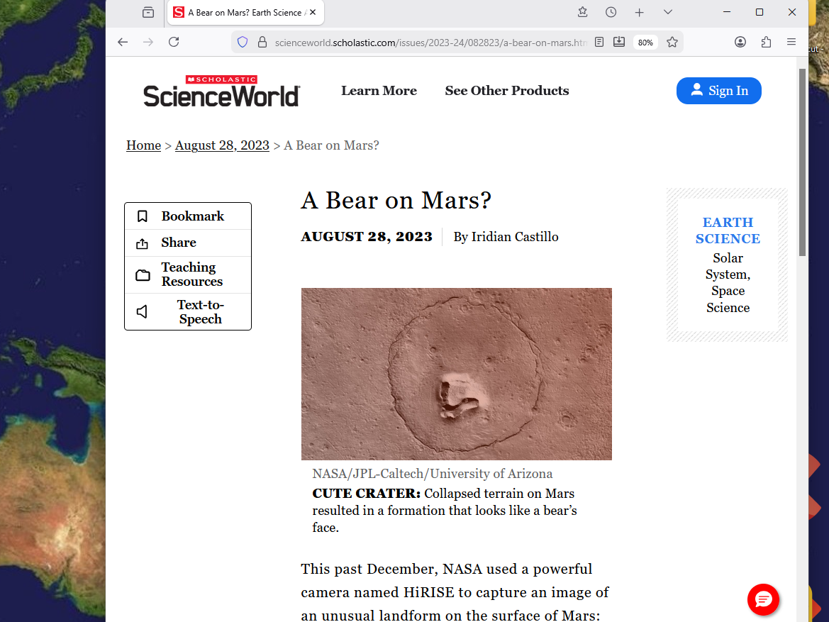

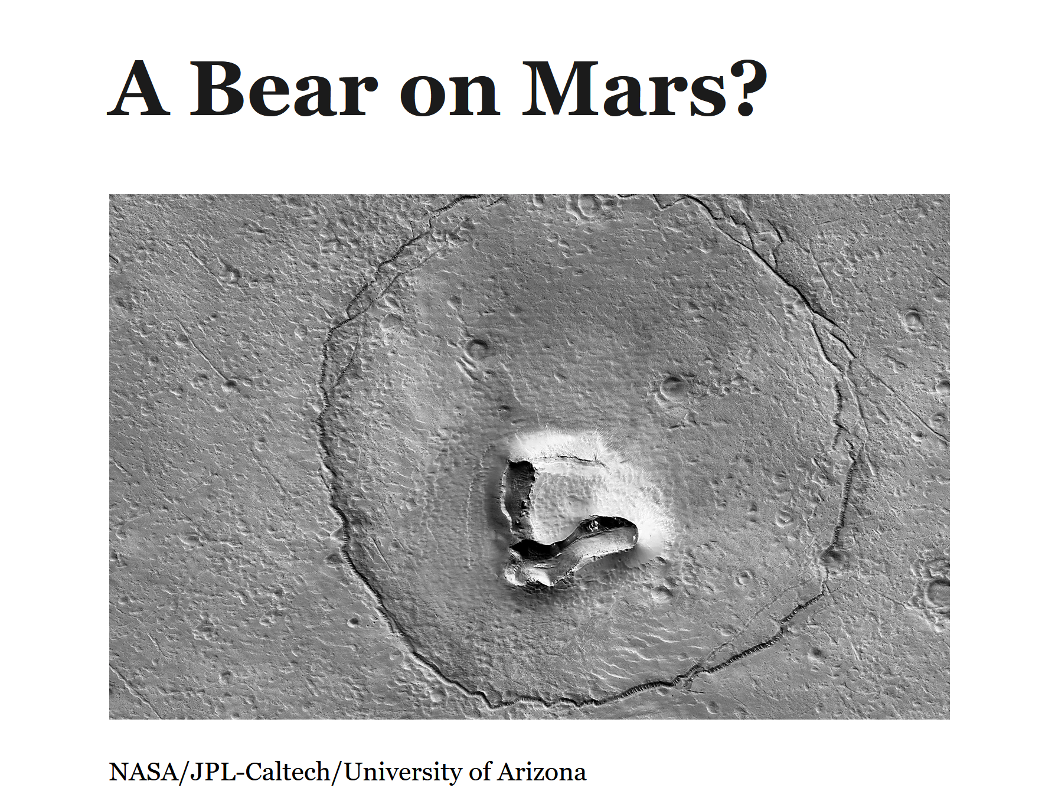

Kip said,
"That statue represents a secret organization that manipulates over 99% of humankind.

Titan Bamboozler Bob Jesus injected the very notion of that group into the founder's mind.

By the year 1900, domination of all nations was achieved.

From then on, citizens of globe only thought they were in independent countries.

From year 1900 through today, BEARS secretly run the one world government.

That BEARS organization lethally poisons high character persons that might someday decide to run for president of a country.

Globally, BEARS members include all ethnicities and races.

The least represented group are the Jews.

The prime minister of Israel is a BEARS member but few others in government are BEARS members.

That government is the least tightly held government of the BEARS because it has the fewest members embedded.

BEARS caused the holocaust.

BEARS hate Jews because Jew's generosity to oppressed Jews of other nations slows BEARS profits and slows BEARS power.

Jews call that generosity to distant even personally unknown Jews COMMUNITY OF FAITH.

Since year 300 through today, BEARS aggressively created propaganda blaming Jews for all misdeeds BEARS
actually did commit in secret.

BEARS utilized details that BEARS found during BEARS' criminal actions.

With those details, BEARS put out sophisticated false narratives pointing to the Jews in the hopes of misleading seekers of truth.

BEARS propaganda included blaming Jews for BEARS' biggest money making schemes.

Since knowledge of existence of natural viruses in 1898, BEARS manufactured hundreds of manmade viruses and inserted those viruses to cause epidemics and cause even more lucrative pandemics.

BEARS blame Jews for creating viruses and vaccines together for money through medical treatments.

BEARS accuse Jews utilizing details that only the criminals themselves would know.

BEARS slash sincere citizens that oppose their moneymaking
schemes or might in the future decide to do so.

BEARS initiation fee includes killing some person society expects that person to love and protect.

BEARS verbalize to other BEARS the person to be targeted. In this way, nothing is written.

Established BEARS help the new person accomplish the initiation fee task through generous bribe money and advanced equipment.

Elevation fee for eligibility for cabinet positions or higher include another loved one sacrificed.

BEARS make even more money by adding various chemicals that start diseases.

Unfortunately most injections today stem from a sealed package.

That package comes from the manufacturing plant already sealed.

Honest nurses rip open the package and use the plastic syringe and metal needle immediately.

Nurses have no way of knowing that some of those syringe needles were randomly selected.

Those syringe needles had a drop of chemical applied.

At the manufacturing plant, well paid BEARS accomplices every so often added a drop of disease causing chemical to the metal needle before vacuum sealing the entire syringe.

In this random way, unsuspecting nurses insert disease causing chemicals into trusting patients.

One example of resulting disease is prostate cancer.

To dissolve that BEARS organization and associated deaths,
let us photons ask you Keith some questions that can allow us to write a book called, HAPPY EVER AFTERS.

But I said,
"I like movies better because movies are more fun to watch than books are to read."

The photons discussed the idea among themselves and Kip said,
"Yes, we will put the information first in HAPPY EVER AFTERS book and let four films utilize that source for screenplays.

We will put the needed money in place to make the movies asking BEARS to take the stand down deal.

Keith we know how certain nations including USA tend to spend money vigorously.

We need to place oil near another country that might see fit to save the money and not spend the money immediately.

Do you have a preferred country?

I said,
"Yes; Norway is my choice because my grandfather Arthur Martin Nordstrand was born there in Alesund."

The photons discussed the idea and voted.
Kip said,
"Yes; we can holographically insert oil near Norway but it will be up to Norwegians to save the money and then to decide to spend the money on producing films."

Then Kip made a joke;
"We can lead a horse to the HAPPY ETERNITY WATERING HOLE but we cannot make it drink!"

Everybody laughed.

Kip continued,
"Because of what you said, photons will adjust the hologram near Ekofisk in the North Sea.

Yesterday there was no oil there but by tomorrow night, much valuable oil will be buried there.

Neutrons of Cindy Mary will suggest ideas to consider.

Hopefully someone in Norway's Head of Films organization and someone with Norway's Sovereign Fund will consider a direct approach to making four important films.

A direct approach might include films staged as much as possible in Norway and employ Norwegian actors and crews.

Those employed individuals could be paid directly from a new account in the same bank building as the Sovereign Fund.

If all agree, then Fund Director moves one billion US dollars from Sovereign Fund to the new account.

From that new account, the contact person for the Norwegian Film Institute will write and sign checks related to producing those four films mentioned.

Those films with life saving and eternity saving information should be extremely popular worldwide.

Every person who has ever seen a movie should be keen on seeing these movies.

It would be like getting a PhD for the price of four movies.

Ideally, the Sovereign Fund regains the first one billion US dollars made to replenish to the same financial standing as before the films.

Then the rest of the net profits would be divided equally among all millions of Norwegians right away.

If Norwegians knew this ahead of time then no need for advertising because social media would have allowed individual Norwegians to send notices to friends globally concerning the value of viewing all four films.

Some of the films' constructions sets could be preserved as tourist attractions."

Kip showed me some scenes on photon television that had invited into humankind SUNNYsideDOWN warmongering culture.

One story mentioned twins Cain and Abel.

After watching the movie, I asked Kip,
"Would it be possible for Kim and me as twins to reverse what Cain and Abel did as spokesmen for humankind?"
Kip had another photon conference and returned and said,
"We voted YES.

We have a standard style of gathering exact desires from humans.

We will use that style to meet your specifications for the substance of book HAPPY EVER AFTERS and the four films based on that book and you and Kim overturning Cain versus Abel.

Dr. John Archibald Wheeler of Princeton and University of Texas will popularize this style as NEGATIVE TWENTY QUESTIONS."
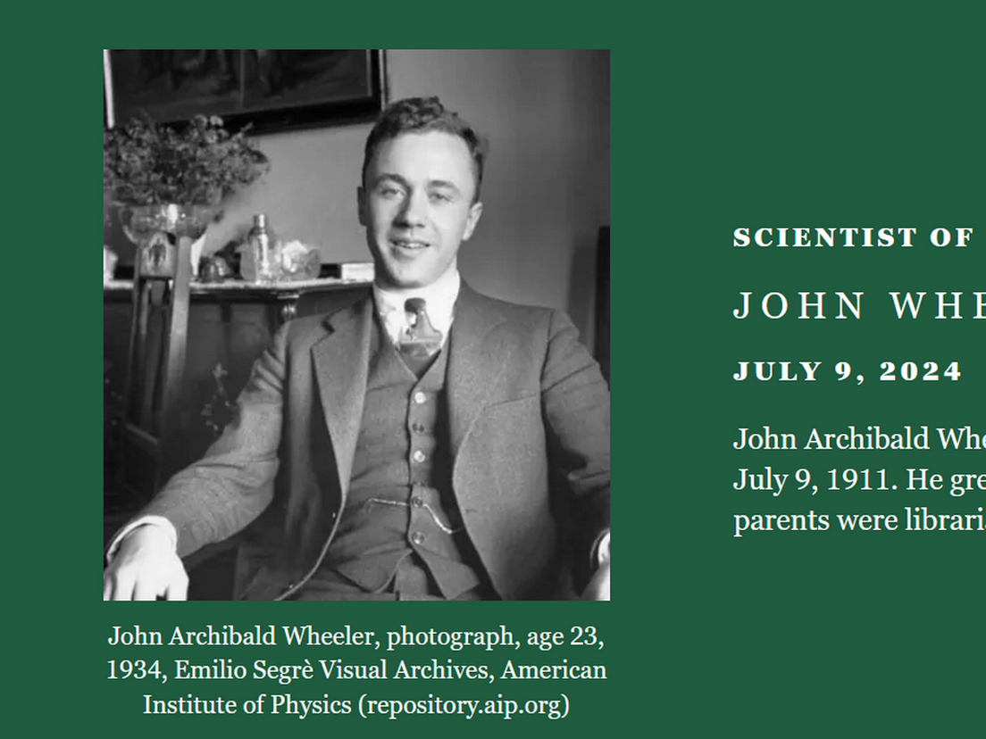

Kip said,
"We will ask you subconscious Keith twenty YES NO questions.

Every answer narrows possible solutions and ends with final solution customized to Keith's exact desires."

In this way, photons and I voted YES.
Together we made a majority vote of 2-0.

So photons and I planned major events needed to make the book and the four films and to overturn Cain versus Abel.

When photons finished describing the best possible future events, I noticed that permanent success hinged upon us current twins never giving in to emotion to fist fights EVER.

I said to Kip,
"EVER is a long time.

To work around EVER, I volunteer to take a tainted needle to show Kim exactly how those mean BEARS operate.

I want to live just long enough to prove to photons that us current twins dislike SUNNYsideDOWN contentions but rather prefer SUNNYsideUP tranquility instead.

But then I want to die to end the possibility of Titan Bamboozler Bob Jesus later tricking us into fighting."

Kip had another discussion with colleague photons.

Kip reported,
"The photons voted NO they would not be party to you hurting so much and to die early."

But I rejected the NO and said,
"Humankind MUST win.

I can seal the win by exiting the Earth early after we convince you that nonviolence is preferred.

Kim and I can beat the system."

After another long photon group discussion, Kip returned and said,
"We photons voted YES to your insistence not only because we are obedient to our human directors but also because we admire your courage to willingly sacrifice your own life so that humankind will be well fed and war free permanently."

To the pair deciding concerning adopting this project:

There is an informal way to check whether incoming ideas are SUNNYsideUP or SUNNYsideDOWN ideas.

This check system depends upon both persons routinely having tranquil dreams and almost never having any nightmares.

This check system works in this way:
Two persons making the decision tentatively say NO way!

Persons should journal their dreams for the next three mornings.

If only pleasant dreams occurred then NO was the SUNNYsideUP correct answer for all persons concerned.

However, if contentious dreams or nightmares came then try the reverse.

Tentatively say YES'

Then you should have three nights of tranquil dreams."

Best wishes,

Keith Klecka

section two

kim in library
minutes 0-5

inside library
minutes 5-7 Kim professors
cell membrane two layered

minute 7-8 first ever marriage
minute 8-9 map of europe

exterior four geodesic domes of clear glass
minutes 9-11 4 rings given 4 flowers for hair
minutes 11-13 gift wrapped box to ring on finger

minutes 13-16 two holiday spots with one to vanish
minutes 16-17 glass houses in neighborhood of time
minutes 17-18 physicians please view films or read book
minute 18-19 Titan Bamboozler Bob Jesus injects notion

minute 19-20 Jesus strives for SUNNYsideDOWN votes
per each person's 8 seconds scenarios

section three
inside house and garage

minutes 0-20 lawyers Jekyll versus Hyde
see chapter 002 of HAPPY EVER AFTERS

portions of religions
contain
myths thereby lowering ceilings of operations
and fairness from respective religious adherents

however one short story from religion
does accurately describe
daily operations within each human

STORY of persistent WIDOW

Attribution:
Rijksmuseum, CC0, via Wikimedia Commons
HTML

Created: 1712
Uploaded: 10 December 2019
prentmaker: Jan Luyken Plaats vervaardiging: Amsterdam

File:Gelijkenis van de rechter die wordt lastiggevallen door een klagende vrouw, RP-P-OB-46.028.jpg
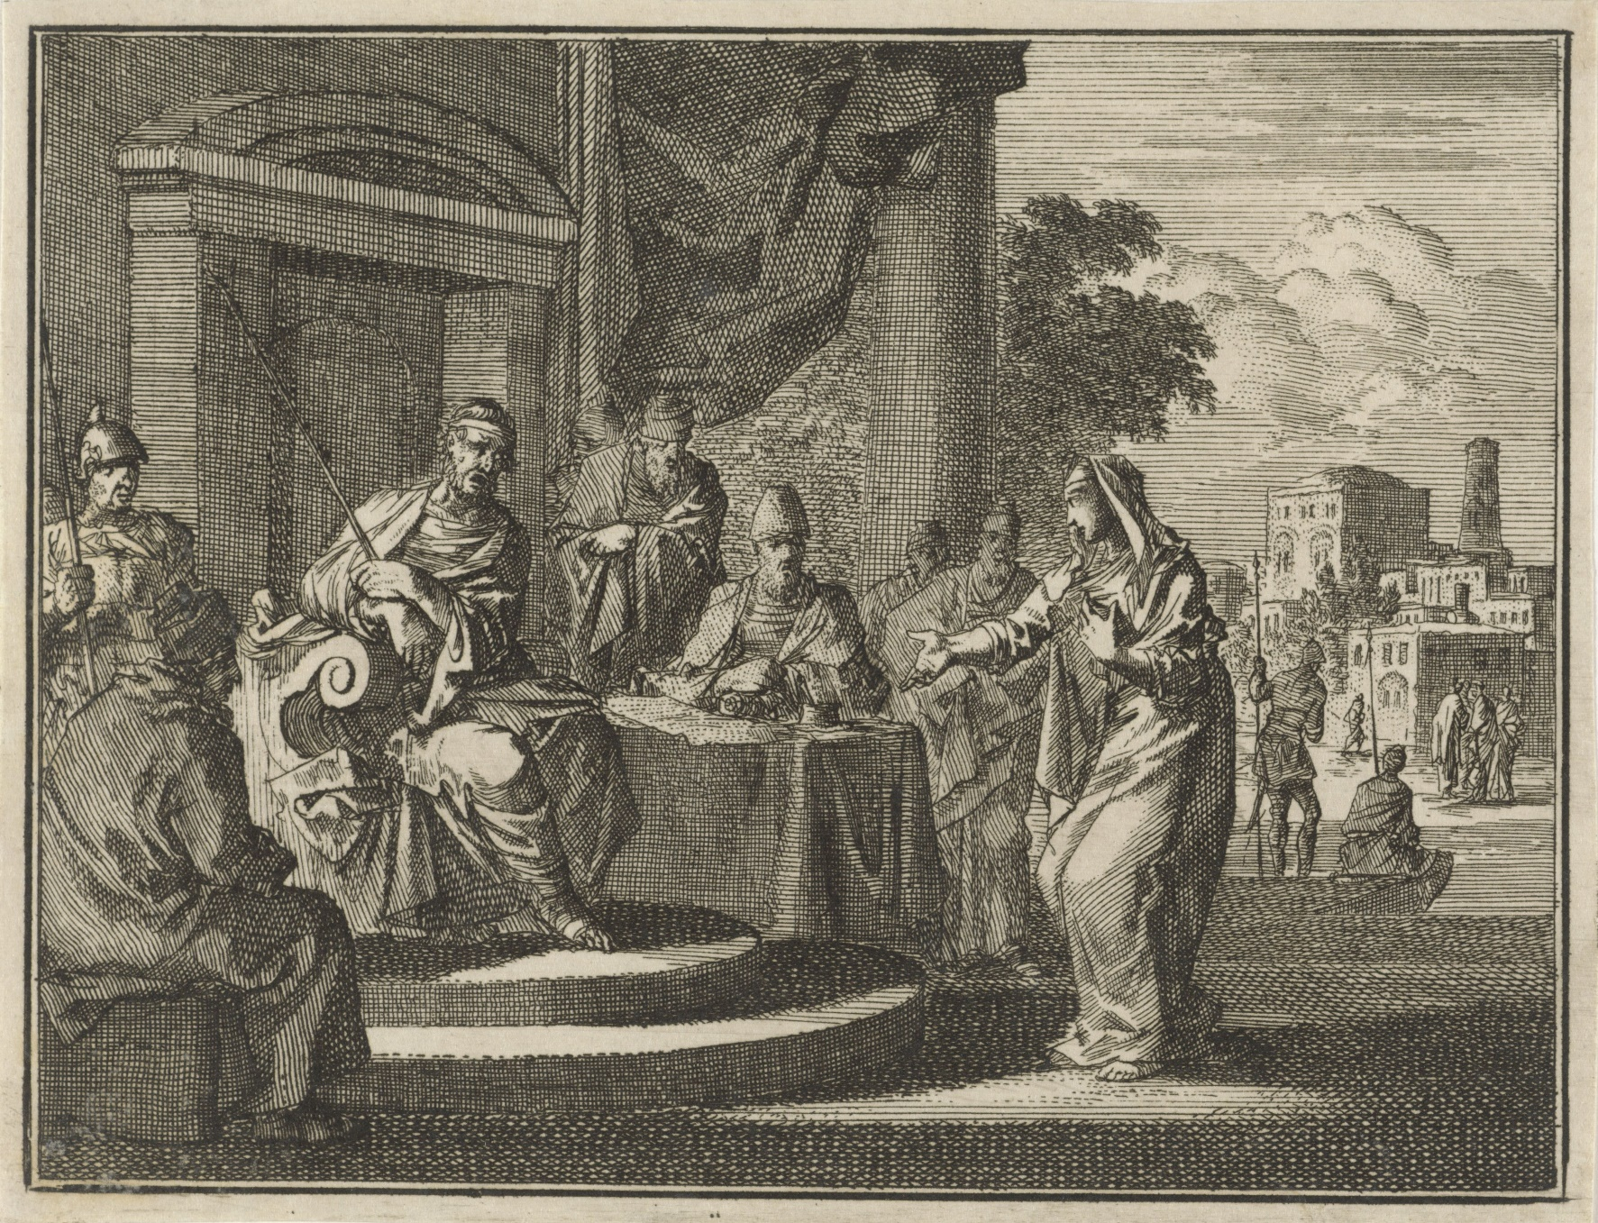

THERE was a small town with a judge
who was not afraid of God
nor afraid of opinions of people

widow
came
to that judge pleading case for
justice against opponent in town

that judge
ruled in favor of widow because
of widow's more persistent PETITIONING

KIM NOTES

above story's symbolism
includes

neutral judge
symbolizes
cns central nervous system consisting of
head and neck and spine cells

neutral judge as conscious cns
granted
one constituent's desire
over other constituent's desire

conscious central nervous system
decides to favor
one or other
suggestion made by group of cells

90% of person's cells
grouped equally into
two subgroups

pleasant peaceful SUNNYsideUP group of cells
includes
limbs of arms and legs
of each person

abrasive dismissive SUNNYsideDOWN group of cells
reside
in torso also called trunk
of each person

routinely after sleeping conscious neutral judge
found
new list on desk with
first name listed atop second name

that list
authored by
subconscious neutral judge

when conscious slept subconscious neutral judge
sleepwalked and finally listed
names according to judge's personal whims

early every night subconscious judge
routinely tapped into
all persons' conversations on globe
including every blog and every podcast

with that information subconscious judge
knew
topics archivally
yet without understanding emotionally

in other words neutral judge
unable to interpret
when to laugh
and when to cry

judge's blind spot concerning emotions
caused
embarrassment so judge hid
lack of opinions feature from constituents

however judge
desired
fitting in

therefore judge
took cues
from what constituents said
and adopted other persons' opinions

routinely around midnight judge
started
night court

judge
alternately listened to
cases and napped

conscious judge
would lay head
atop desk to sleep
then awake after around 20 minutes

while conscious judge slept subconscious judge
entered
sleepwalking mode

judge
always listened to
same two lawyers making opposite cases
dr jekyll and mr hyde

wikipedia's

Public Domain
File:Jekyll-mansfield (cropped).jpg
Created: 1895
Uploaded: 25 January 2023

Photo by Henry Van der Weyde (1838-1924; London, England) - http://www.photography-museum.com/jekyll.html / Originally uploaded to en.wikipedia;

Richard Mansfield was best known for the dual role depicted in this double exposure:

he starred in Dr. Jekyll and Mr. Hyde in both New York and London. The stage adaptation opened in New York in 1887 and London in 1888.
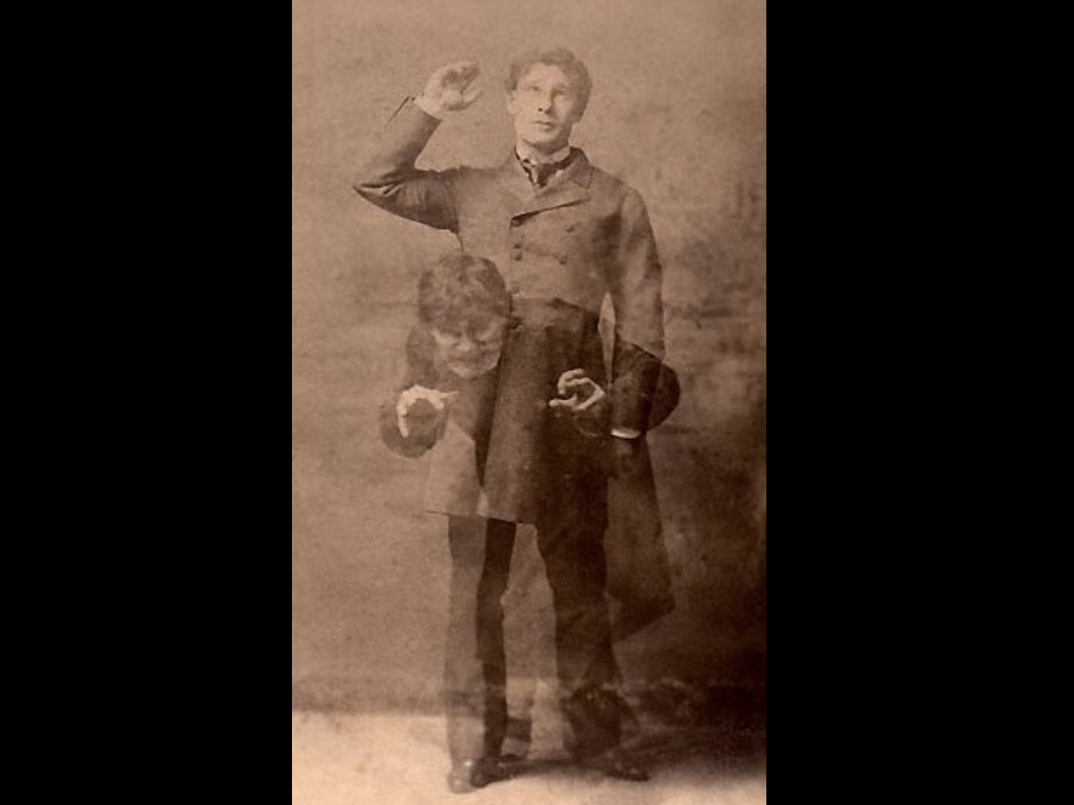

goodreads.com's

Robert Louis Stevenson's masterpiece
of duality of good and evil in man's nature

sprang from darkest recesses of his own unconscious—during a nightmare
from which his wife awakened him, alerted by his screams.

this tale of mild-mannered Dr. Jekyll and drug
that unleashes
his evil, inner persona—loathsome, twisted Mr. Hyde
relates
Jekyll's desperation as Hyde gains control of his soul—
classic demonstrates understanding of inner conflicts...

central nervous system judge
favored neither
dr jekyll nor mr hyde

case by case lawyers
gave
emotional contexts via framing events yet
always ended with two opposite conclusions

judge hindered by emotional neutrality
merely agreed with
person making highest number
of presentation examples

lawyers
went on and on
concerning each action and
each hint from client

lawyers assisted clients
via writing
books piecing together several
hints into common themes

for example each lawyer
presented
situations by first saying

OBVIOUSLY my client
favors such and such emotion
because look at my client's many
authored books on this SUBJECT

judge lacking guiding principles
simply favored
lawyer carrying heaviest bag of books

therefore accordingly subconscious judge
listed
that lawyer's name on top
of list for presenting case first

conscious judge refreshed from sleep
possessed
no knowledge of backstory bickering nor
of global citizens' blogs and podcasts

therefore conscious judge
heard
cases with unbiased openness

upon waking conscious judge
simply looked
at top of list then directed
that lawyer's presentation first

advantages of presenting case first
included attaining
status of tradition

second lawyer
worked much harder
because needed to overcome
tradition's embedded framing of situations

for even easier comparison judge
secretly installed
two huge scales
into floor of garage

both dr jekyll and mr hyde
stood unknowingly on
respective platforms during oral arguments and
brought book bags corroborating those outlooks

judge
would routinely pull open
desk drawer and compare weights displayed
on drawer's two horizontal monitors

somehow mr hyde
figured
strategy of judge

as counteraction and rigging system hyde
requested permission
to bring two ice buckets
during oral arguments for health reasons

mr hyde
claimed
if stood in ice that ice's coldness
activated reflexology healing points of feet

judge
granted
request which of course
weighed heavily in mr hyde's favor

however ice
turned into
water then evaporated
from buckets by noon

until noon judge
routinely placed
mr hyde's name atop lists due
to monitor showing larger weights

puzzled dr jekyll
noticed
jekyll never spoke first until around
noon if then

therefore jekyll
felt
jekyll needed
counter strategy

jekyll's workaround strategy standard opening phrase attempted to counter
hyde's just stated
skewed framing of situations

as general rule dr jekyll
opened with and spoke kindly
SUNNYsideUP phrase including even when addressing contentious hostile aggressive statements from hyde

AS court
strives to find
FAIRNESS for ALL parties concerned
in this particular case that MEANS

those initial SUNNYsideUP words above
became
habit and telltale signature
of dr jekyll

END OF SYMBOLISM of religion's story

section four
inside laboratories

minutes 0-10 british professor David Joseph Bohm

minutes 11-20 usa professor John Archibald Wheeler

section five
inside laboratories

minutes 0-10 usa professor Carroll Overton Alley

minutes 11-20 all rely on their duo of physicians
but Kim with no money gained
SuperHealth and banished active cancer
and rheumatoid arthritis.

Kim desires all
humans gain that information contained in
these films and book HAPPY EVER AFTERS.

section six
inside office

minutes 0-5 Julie Bocanegro McNair
minutes 6-19 INTERMISSION
one minute clip requested from original
movie RETURN OF THE PINK PANTHER

beautiful images of Norway
countdown clock on screen

minute 19-20 famous section from Beethoven's
ODE TO JOY

section seven
exterior farmland

minutes 0-7 Pellicer has accident

interior hospital
minutes 7-17 amputation

exterior graveyard next to hospital
minute 17-18 burial of leg

exterior farmland
minute 18-19 leg reattaches

interior of home then interior of palace
minute 19-20 King Phillip's ceremony kisses leg

section eight
exterior farmland

minutes 0-10 Cain and Abel

section nine
exterior Noah's Ark
minutes 11-12 Noah and family on Ark

exterior farmland
minutes 12-15 Noah eats grapes with white yeast

interior Noah's tent
minutes 15-20 Noah coma and rolls

section ten
exterior Noah's family's campsite

minutes 0-3 Ham races around campsite

interior Noah's other sons enter Noah's tent with blanket
minutes 3-5 Shem and Japheth cover father

exterior of Noah's tent
minutes 5-10 Ham's DNA evolves immediately

map of asia and china
minute 10-11 Japheth experiences time pudding

exterior farmland and dusty desert road
minutes 11-16 Japheth's needy relatives need
food and clothing

minutes 16-20 Japheth's DNA evolves immediately

section eleven
exterior outer space

minutes 0-5 photons suddenly lack clarity on humans
because of Jesus' manipulations of
Cain and Noah and Noah's triplets

minutes 5-7 photons create 3D holographic universe
to clarify humans' SUNNYside preference

minute 7-8 Jesus celebrates via firecracker because
photons need to invoke BIG BANG

interior Uncle Carl's house

minutes 8-10 Kim's DNA Kim overturns Noah's Alcohol
minutes 10-15 Kim overturns Ham via respecting elder

exterior cold construction site and street blocked and
interior sports ski apparel shop then return to site
minutes 15-20 Kim overturns Japheth clothes + food

section twelve

kim in library with monitor showing dot disk globe
minutes 0-5 reasons for our holographic universe

map of bethany near jerusalem in country of Israel
minutes 5-15 Big Bang caused four Titans to take
human form into famous four single
people in bethany as in John chapter 11

on monitor map of lawyers jekyll and hyde
minutes 15-20

Before humankind flips switch upward via totally migrating to the new solar powered cities the domination of Don continues into the deliberations of the conscious cns of each human.

For example let us take main character named person A and supporting colleague nearby named person B.

If person B currently operates in SUNNYsideUP then person B's overriding influence accounts for 1.5% of person A's decision.

However, if person B currently operates in SUNNYsideDOWN then person B's overriding influence accounts for 3.0% of person A's decision.

Titan Don Lazarus crashed the original wedding and in original singularity still holds body of Titan Alice in prison.

That domination carries over into Titan Alice Huge Electron's children.

Those bundles of tiny electrons succumb 3.0% automatically to SUNNYsideDOWN with no questions asked.

Therefore person A must agressively proactively consolidate thoughts and strategies toward SUNNYsideUP with the 7.0% left over.

Remember that Trunk Parliaments talk among themselves.

Person A's Trunk Parliament relays to Person B effective wording gleaned from Person A's memories and habits.

That explains why persons operating in SUNNYsideDOWN contentious arguments somehow seem to use very exact and most deeply painful words to the hearing of Person A's ears.

Deflecting and delaying of answering helps both persons' Limbs Parliaments to create SUNNYsideUP resolutions that bring tranquility to all.

Thank you for viewing and SUNNYsideUP happiness and SuperHealthiness to all.

end of film one of four
FORBIDDING CANCERS ETCETERA

