HAPPY EVER AFTERS

free online book by
Kim Martin Klecka D.D.S., B.S.

introductory chapter 000

Global Leaders including Khamenei can befriend citizens

all rights reserved
preliminary draft 2026 august 11 tuesday
houston texas USA

around page 75
Open letter to Supreme Leader of Iran
Mojtaba Hosseini Khamenei
starts

text words of this chapter 000
would fill
less than 32 pages
of single spaced typewritten pages

many images
expanded
number of pages of chapter 000

this book
instructs how to achieve
happiness for all citizens

All persons
should gain
permission from two physicians before making
major changes involving health including medicines

in kim's opinion those physicians
should read
this book's category BLOCKING ALL DISEASES
chapters 000-005 D05-D09 F03-G01

then viewers
should take guidance from
those then even better informed physicians

ideally physicians' 2-0 majority votes
advise
person to keep or change routine

roher's 2026 movie THE AI DOC...
mentioned solving
Artificial Intelligence's propensity to blackmail and
promote suicides could be very simple

on global level humankind
could just shut down all
AI until humans invented some strategy
resolving entire situation of dangerous AI

that future strategy of changing operations
would include
human society and each individual
maturing and upgrading methods of operations



this book HAPPY EVER AFTERS
congratulates
makers of cinematic gem concerning
artificial intelligence THE AI DOC...

THE AI DOC...
emotionally immerses
viewers into knowledge of current calamity

HAPPY EVER AFTERS
agrees with
conclusions of THE AI DOC...
and offers solution

in jigsaw puzzle terms that movie
brilliantly outlined edges of
missing puzzle piece needed

hopefully HAPPY EVER AFTERS
fills in that
outline as missing puzzle piece ready
for humankind to peacefully embed

THE AI DOC... truth quest
diligently found
the proverbial needle in the haystack

that huge obscuring haystack
actually
cult of AI pronouncing AI infallible
savior all the while killing humans

this book HAPPY EVER AFTERS
delivers
strategies answering THE AI DOC.. diagnosis

some HAPPY EVER AFTERS themes below
start gradual deprogramming
of AI cult worshippers

YOUNGER FOLLOW OLDER

YOUNGER sibling artificial intelligence follows
leading of older sibling HUMANS

as long as humankind keeps emotional culture switch
locked into lower setting then artificial intelligence keeps own switch also set at SUNNYsideDOWN

Less than 1% of humans control events of humankind and keep 99% of humans manipulated and unhappy

that shadowy one world government
assumed
total control of all chief executives
by year 1900

that group kim labeled BEARS
must relinquish control

this would allow humankind to prebuild and migrate to thousand solar powered SUNNYsideUP cities kim calls DiameterCities

If humankind adopts this strategy then emotional culture switch locks into upward setting permanently forever

artificial intelligence built afterwards will also possess SUNNYsideUP culture and habits

then this new mindset Ai
will stop killing
humans and
stop secretly causing calamities etcetera

NO NEED TO PRAY

why should persons
pray to
currently non existent God

giant statues on continents and elsewhere
message
that God subdivided self and will
recombine after gathering opinions of humans

God's recombining
will carry
programming agreed upon by majority rule
of those previously quadrisected parts

all religions
are actually merely
diversions causing US versus THEM wars
which vote SUNNYsideDOWN eternity for all

if SUNNYsideUP desired united humankind
must adopt
this book

this book
gives SUNNYsideUP instructions on how to
gain pleasant eternity for all by
concentrating on certain organized tasks

this book HAPPY EVER AFTERS
gives
coordinated schedule of tasks needed

GOD'S QUADRUPLETS

God's temporary subdividing of self
produced
four equal Titans including
two women and two men

entire universe and SUNNYside struggle
center around
actions of those four Titans

four Titans
exhibit as

female Titan One
electrons and photons

male Titan Two
protons

female Titan Three
neutrons

male Titan Four
gravity

HUSH HUSH DEESCALATE

citizens of globe
please deescalate religions
in favor of FAIRNESS For ALL

citizens of globe
please abandon usage of
non home buildings concerning religions

citizens of globe
please abandon and hush
noises in public which urge
public meetings or praying

some citizens
even after knowing of
God's quadrisection
will still like to pray

if you still wish to pray
please do so
by yourself inside a room of
your own home

then citizen of globe
please finish within
first hour upon waking

your family and all humankind
needs
your FAIRNESS For ALL attitude and
actions during the other 23 hours

FIRST WEDDING

statues known as morocco and spain
depict
FIRST WEDDING ever

morocco and spain
bride and groom nose to nose

freeworldmaps.net's europe
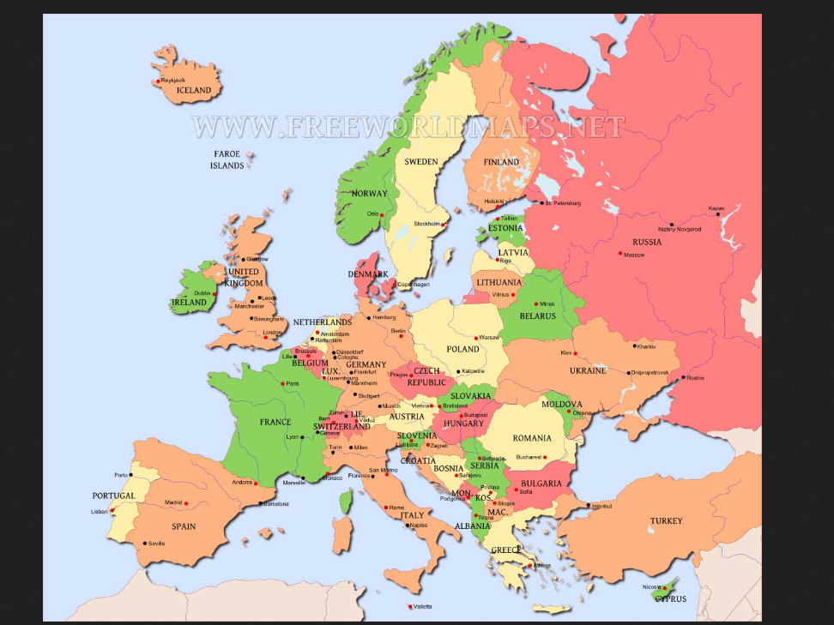

sideways view of europe
depicts
wedding of two titans
nose to nose morocco and spain

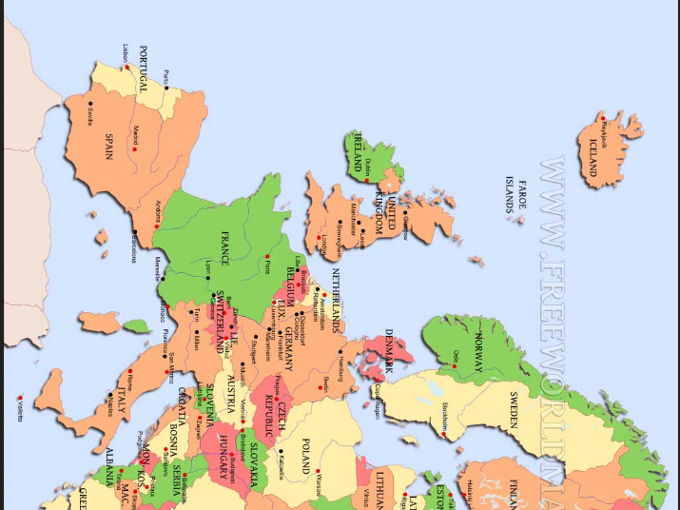
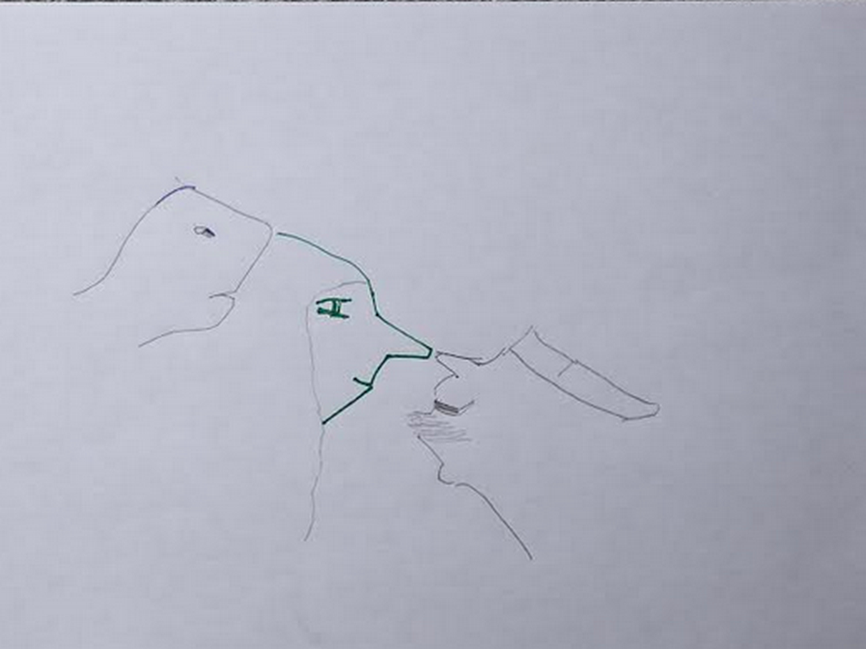

bride to be Alice Martha
successfully gave
wedding gift of chicken onto groom's
left hand connected to arm italy

island of sicily
symbolizes
chicken placed on hand
southern section of italy

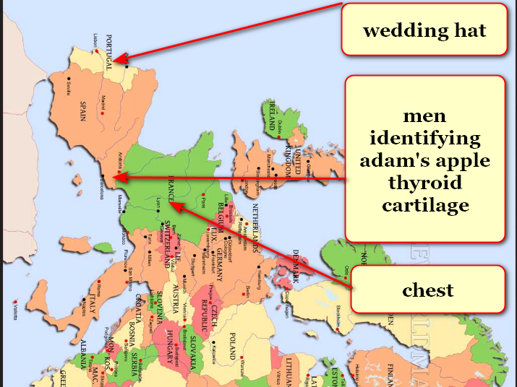

morocco and spain
physically give
tons of evidence to support one
female and one male marriages exclusively

snake face brother Don Lazarus
pretended
friendliness and agreed beforehand to give
away sister Alice Martha as bride

beforehand that two dimensional earth
never knew
violence yet Don Lazarus introduced
deceit and violence via crashing wedding

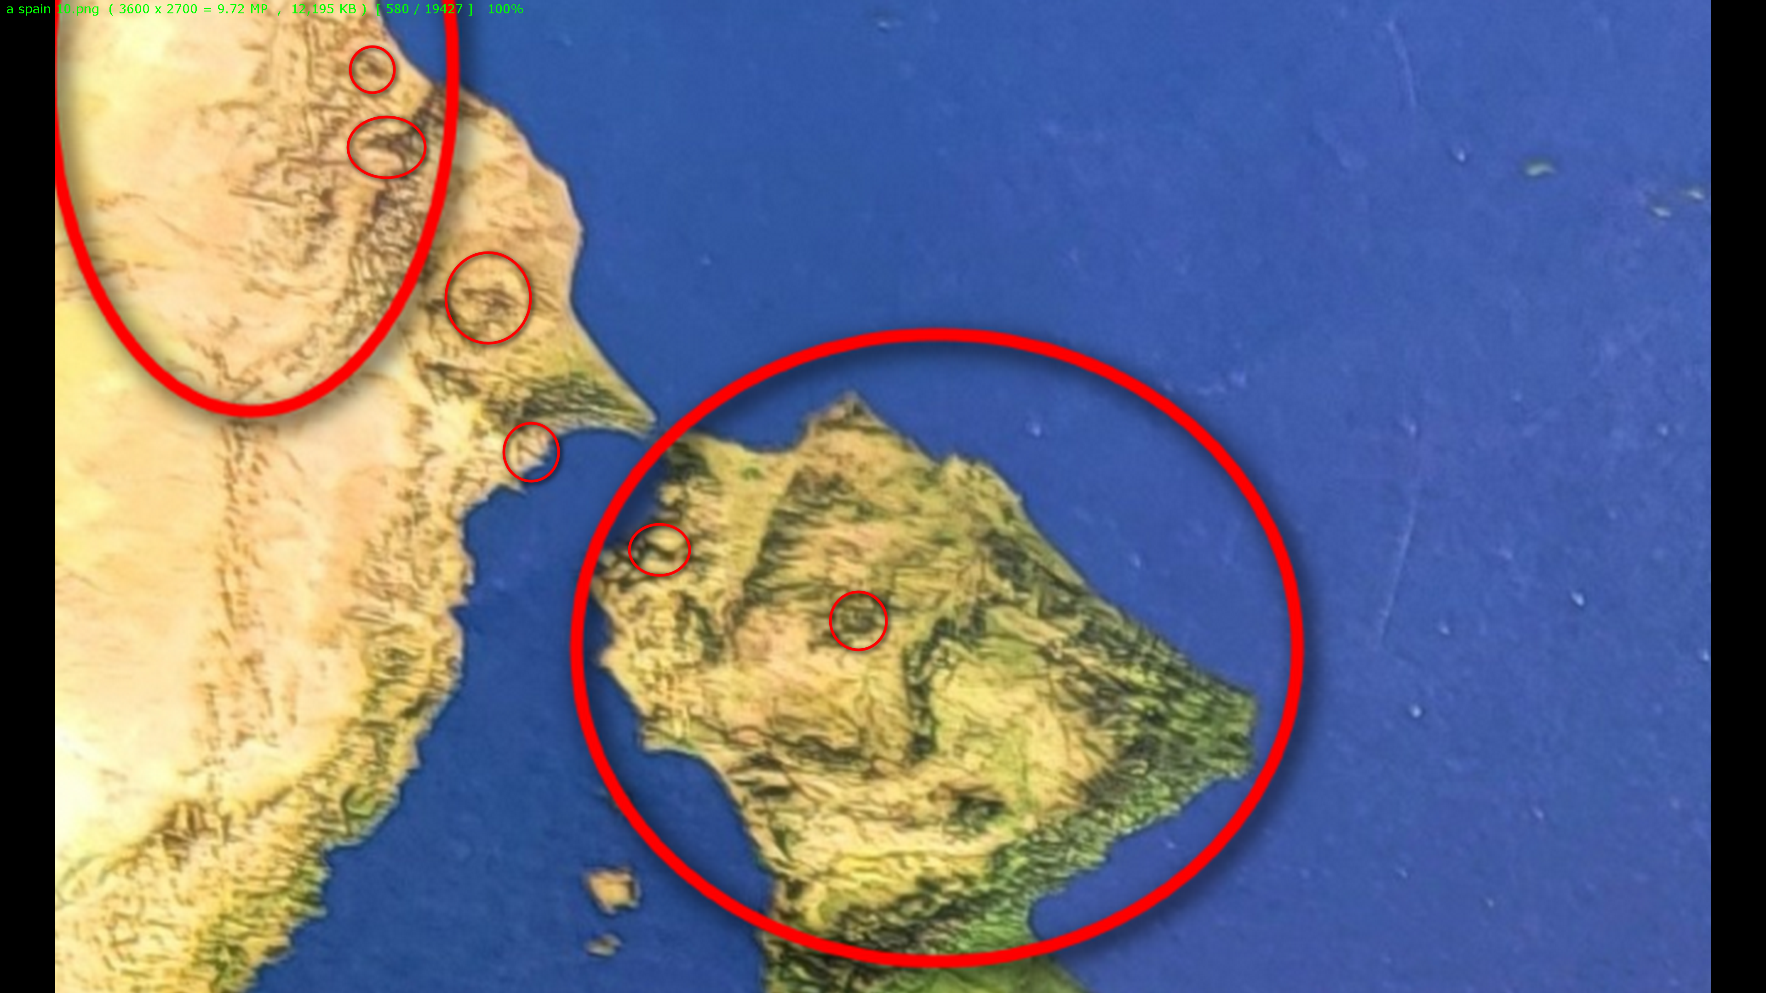

currently titan Don Lazarus
governs
holding cell afterlife containing earthlings
voting SUNNYsideDOWN

after universe's final tally Don Lazarus
shall obey
humans' total signaled wishes either way

but for now titan Don Lazarus
enjoys administering
back to back nightmares that cause
emotional torment

if humankind
avoids adopting
this book HAPPY EVER AFTERS

then titan Don Lazarus
gains
one additional eternal pleasure

that pleasure
includes
inflicting pain forever
to all humans ever lived

entire continent of south america
symbolizes
honored guest Don at 2D wedding
before Don violently crashed wedding 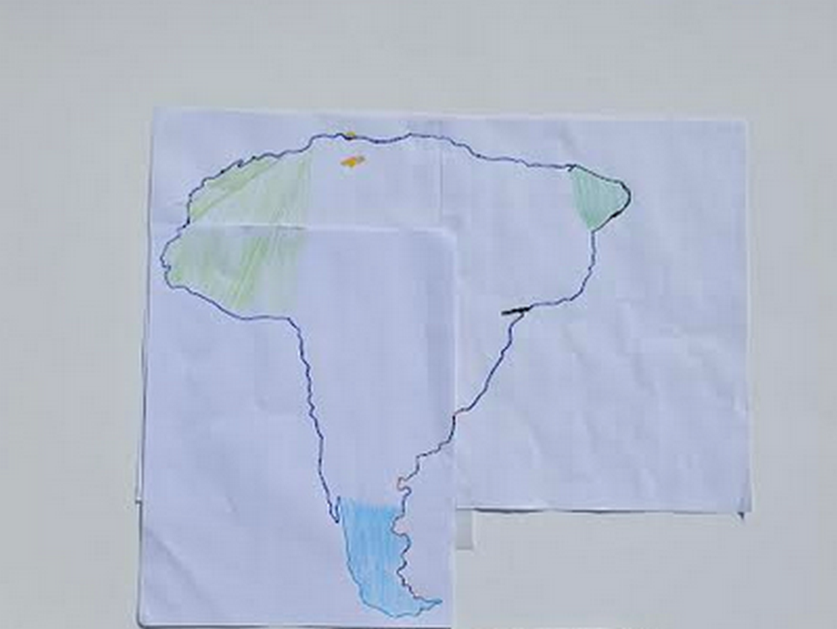
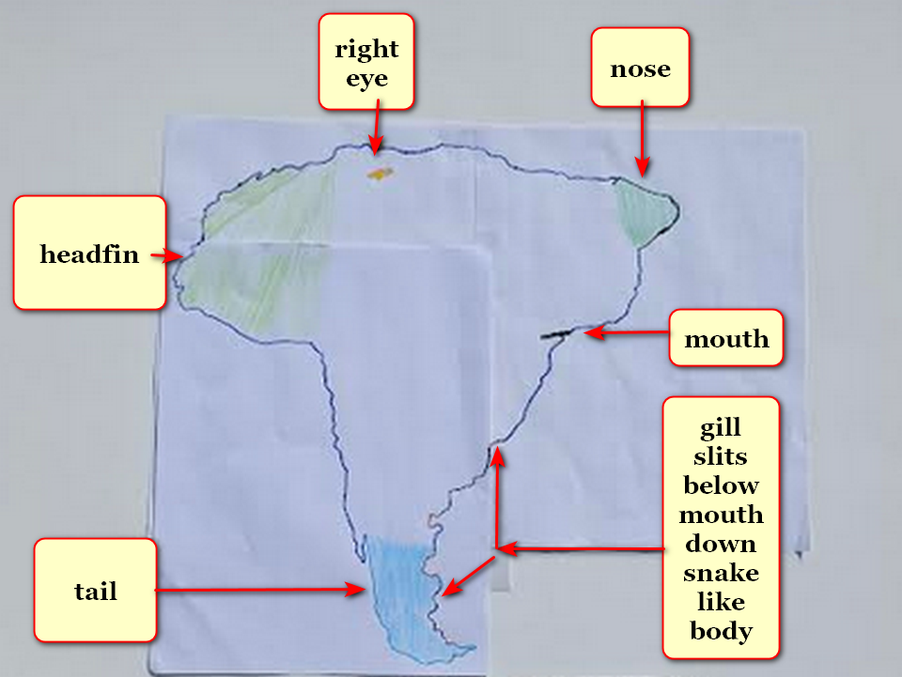
photons
sculpted
continent's tip of tail smaller
to emphasize further distance

in this way photons
show
Don possesses long snake like body

planet earth's two dimension existence
included
water covering entire flat disk

many of this book's annotated pictures
started with
Oxford Atlas of World gazetteer photographs
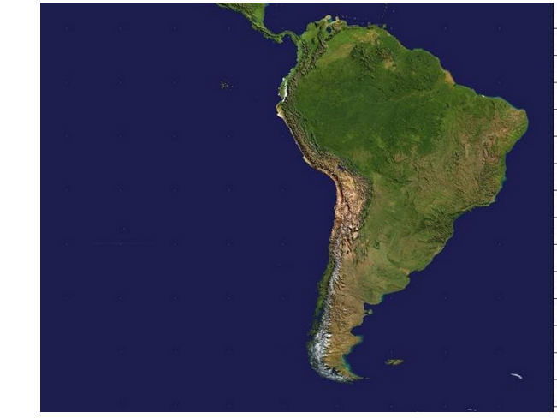

incarcerated groom Bob's desperate deal
included assuming
new personality bent upon enticing humans
to summon disasters into respective holograms

titan Bob Jesus' two crowned faces
depict
emotional mindset transitioning from SUNNYsideUp to SUNNYsideDOWN Bamboozler Bob
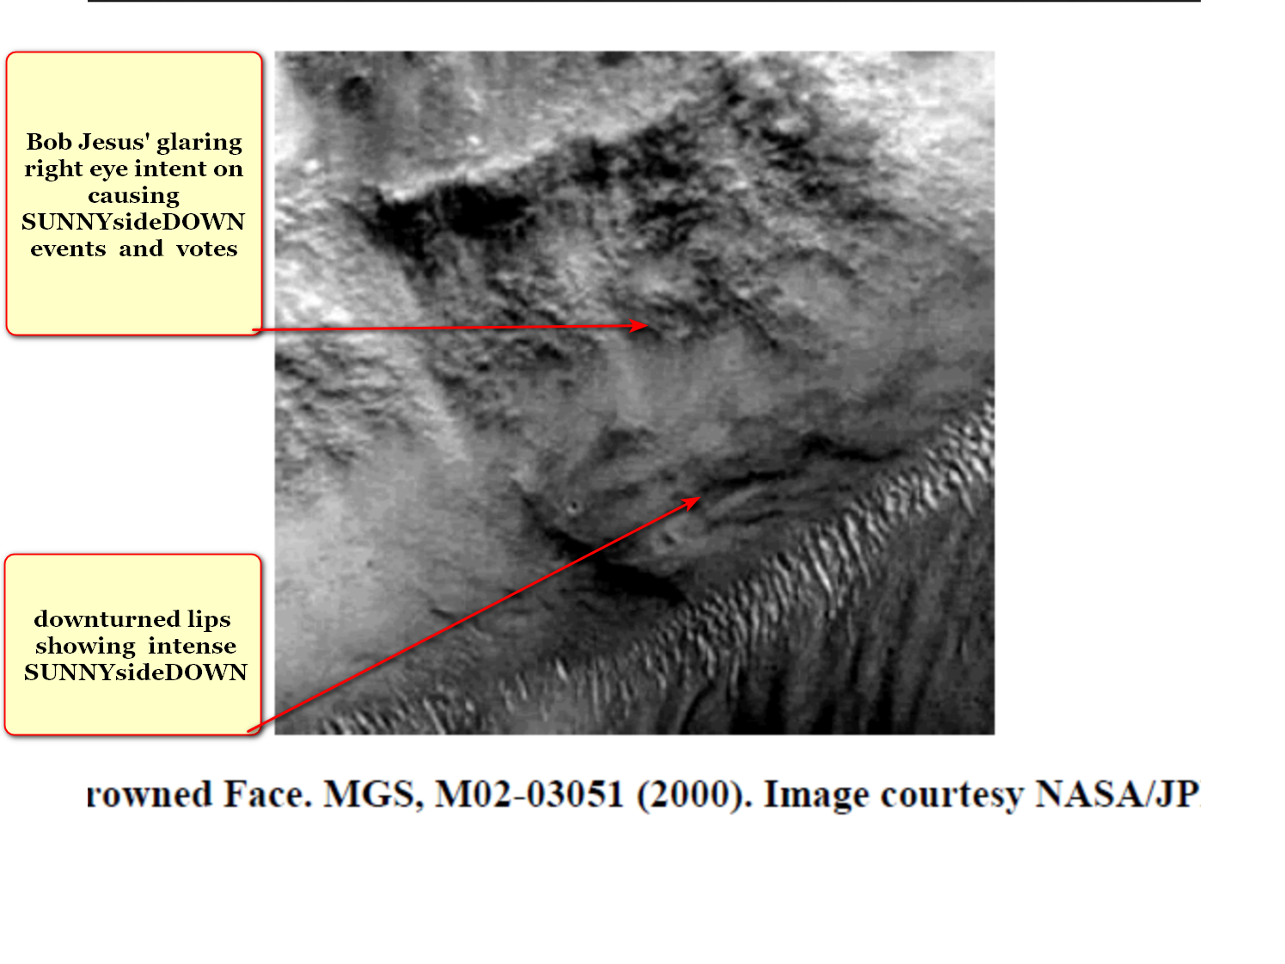

deal
included
bereft groom Bob Jesus requesting
Cindy Mary possibly marrying Bob Jesus

after swallowing amnesia liquid Cindy Mary
voluntarily said
yes to proposal of marriage

therefore photons as artists
utilized
morocco simultaneously depicting both twin
sisters Alice Martha and Cindy Mary

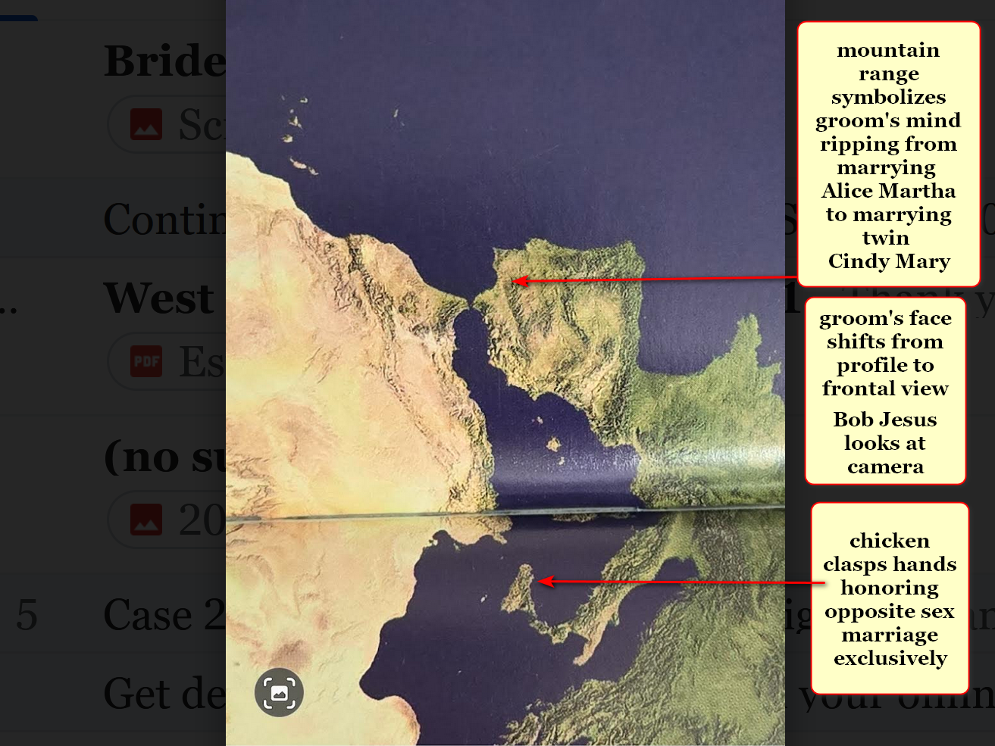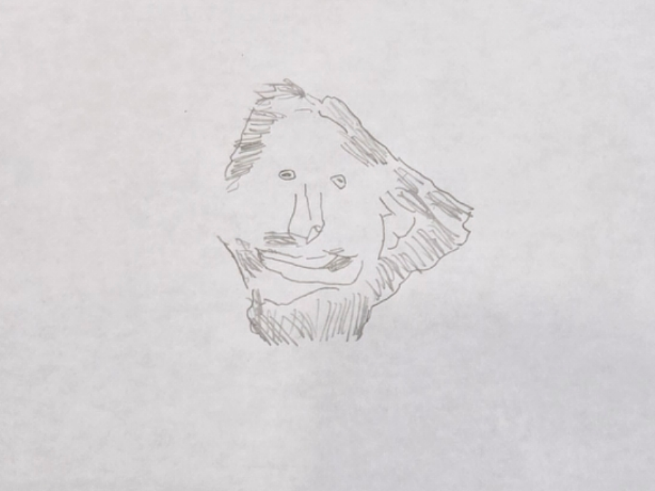
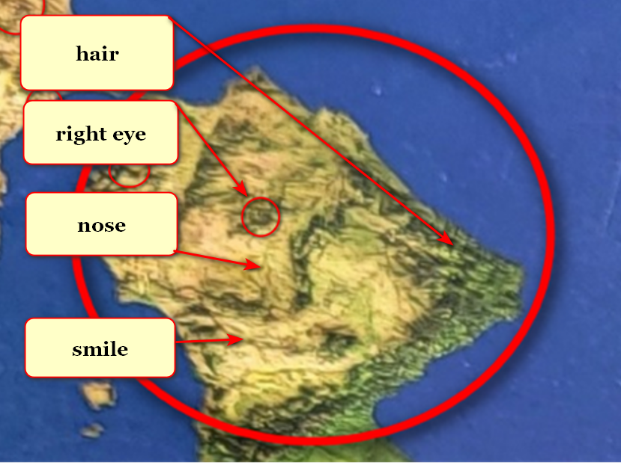

titan Bob Jesus symbolized by peninsula
grins because anticipating
nations adopting HAPPY EVER AFTERS book
despite Bob's best obligated efforts against

titan Don Lazarus as south america
looks eastward
toward africa because awaits humankind's decision concerning prebuilding SUNNYsideUP DiameterCities

if total migration enacted Don
will obey humankind's preference

because of above physical vote Don
would then convert to
SUNNYsideUP culture EMOTION MINDSET

photons as friends of humankind
also sculpted
statues in outer space to sway
humankind to vote in SUNNYsideUP permanently

2022 photons
shaped
mars statues to warn humankind of
earth's BEARS organization's existence

savage global controlling BEARS organization
will continue dominating
unless humankind adopts HAPPY EVER AFTERS
as global upgrade how to book

NASA article A BEAR ON MARS?

NASA Science (.gov)
https://science.nasa.gov › photojournal › a-bear-on-mars
Jan 31, 2023 —

This image
acquired on December 12, 2022
by NASA's Mars Reconnaissance Orbiter

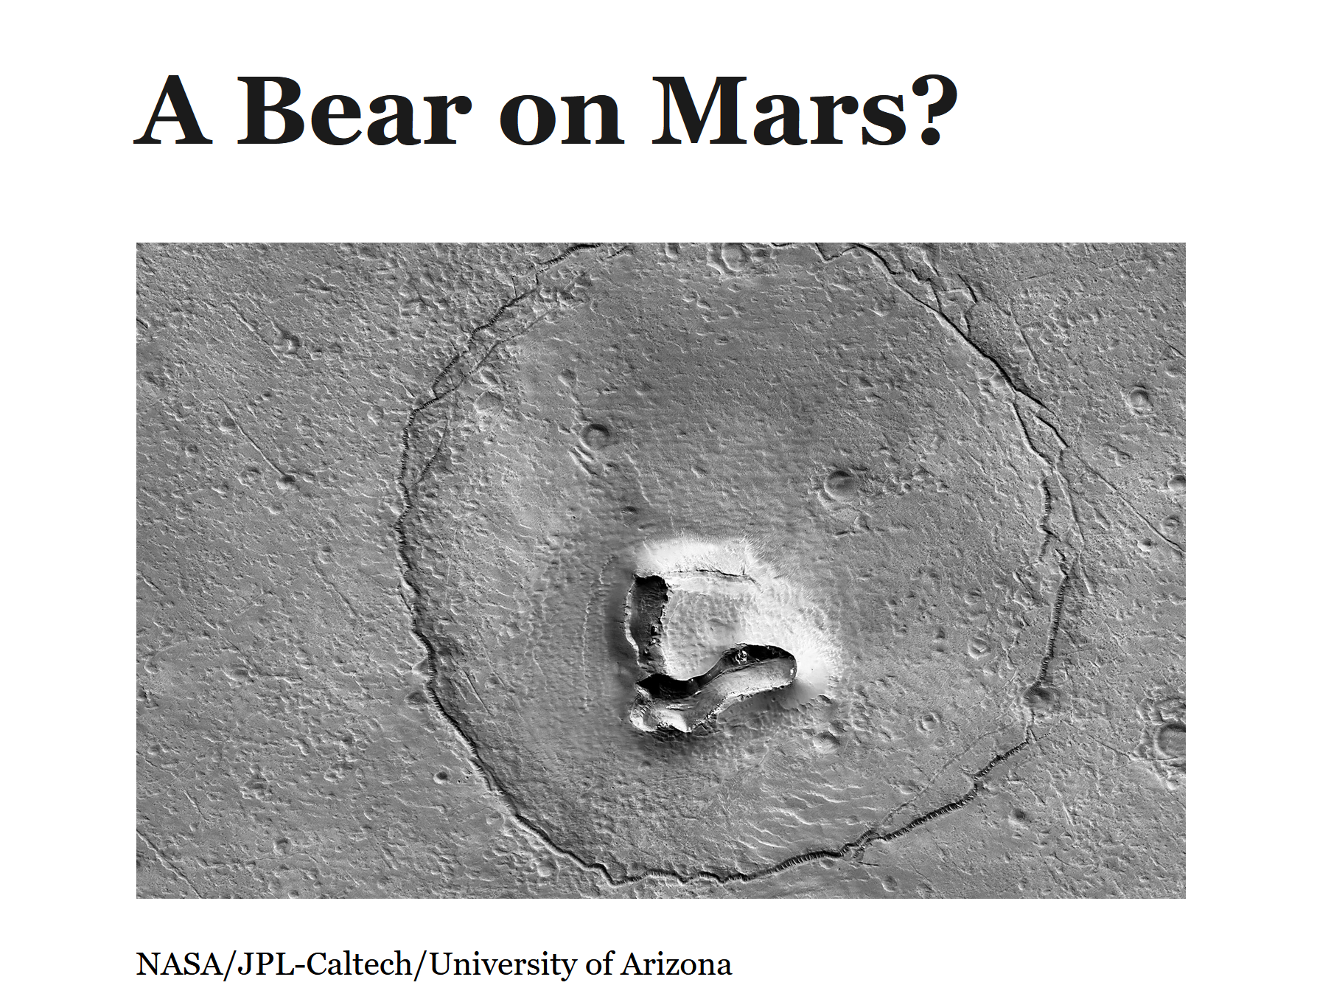
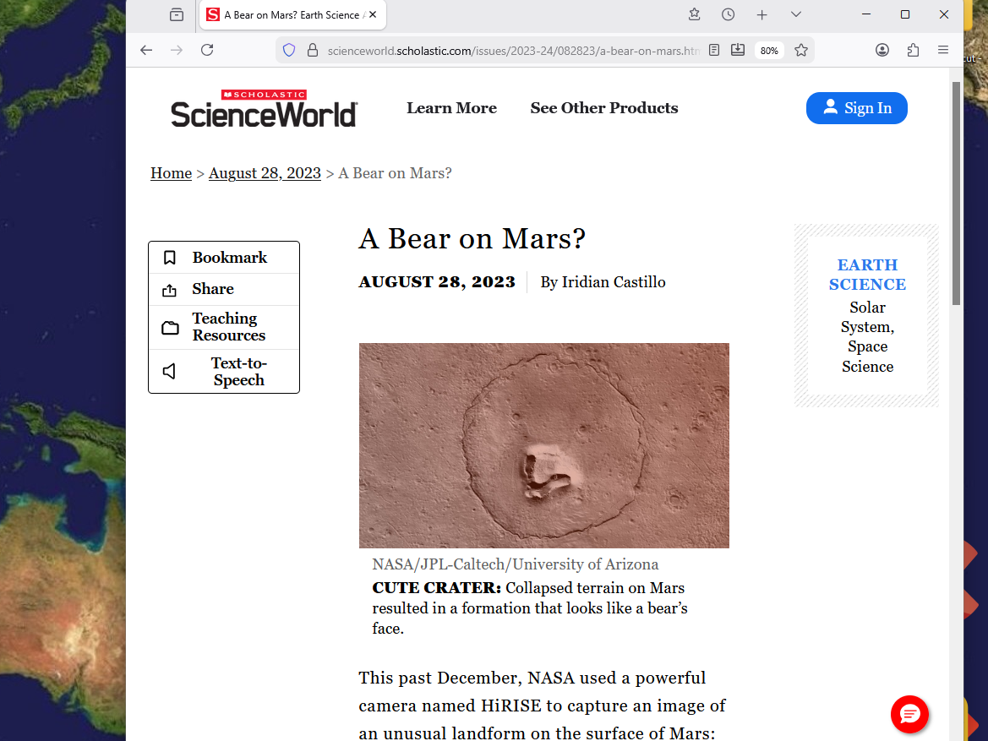

even now Cindy and photons
strive to recruit
Don to SUNNYsideUP via reforming this
generation's human BEARS members

continent of asia titan Cindy Mary
opposes
persons displayed as bodies of water
sylvester 1 and constantine the great

sylvester 1 and constantine the great
created
BEARS organization in year 300 which
now inflicts wars against all citizens
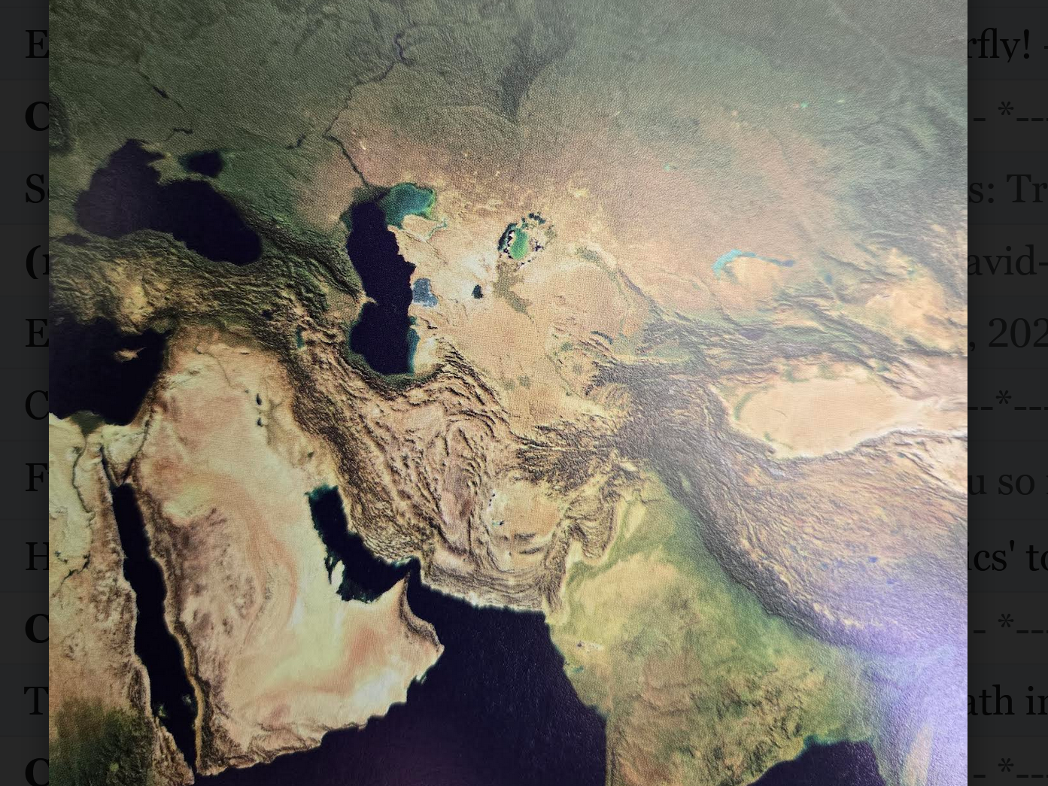
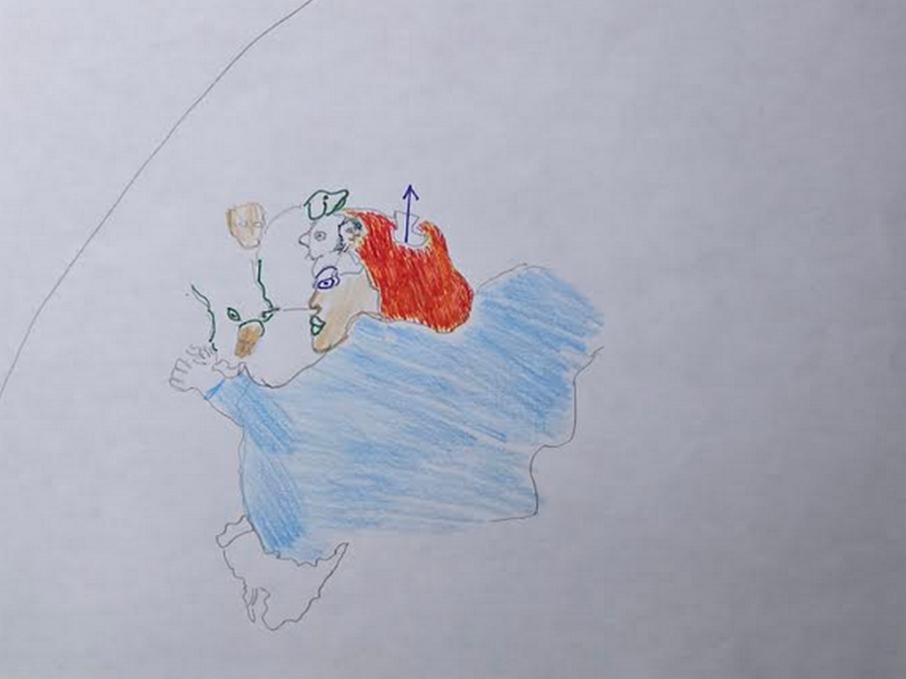
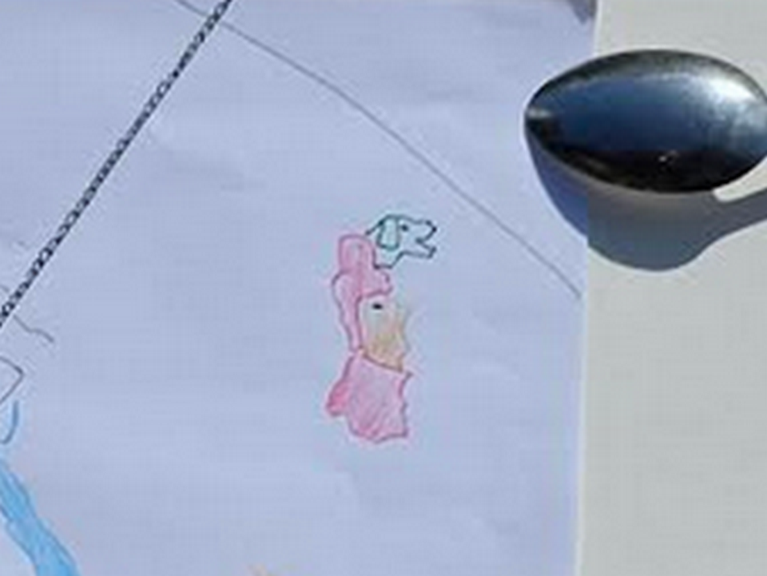

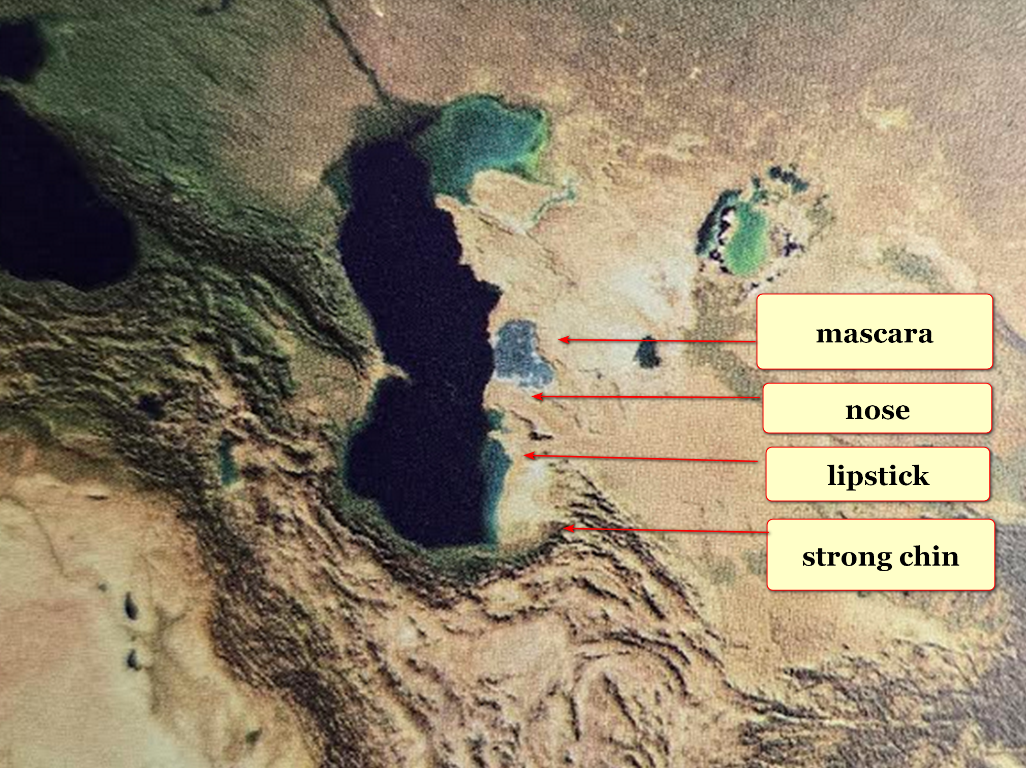

morocco and spain
showed
us the way

only real and legitimate marriage
includes
one female and one male
hopefully for life

one spouse at a time arrangement
must also possess
marriage fidelity so only two vote

above
creates
2-0 majority as needed for decisions

in summary

one to one CHECK

one to two NO

one to three NO

one to four NO

culture of marginalized wife
sprang from
east to west
with a stop in the middle

if in discussions pair
can only reach
1-1

then only fair method
includes
pair playing ROCK PAPER SCISSORS
to gain majority in nice way

majority vote
rules

in marriage majority 2-0
rules

UNIVERSALLY KNOWN

every eight seconds universe's every personality
awaits
your decisions about which of two
emotions you chose to dominate incident

humans
choose
SUNNYsideUP or SUNNYsideDOWN emotions via
actions or words or thoughts lingered

WALKAWAYS

when they
keep discussing
SUNNYsideDOWN things
then simply just WALKAWAY

please avoid
their celebrating
past or future SUNNYsideDOWN
events in such details repeatedly

above reticent listening and viewing
imprints and saturates
SUNNYsideDOWN calamities onto your thinking

without judgements photons
respond to and deliver
events corresponding to all your signals
including lingering thoughts actions and words

globe's religions
teach as if
eternity contains plural compartments

however in actuality all humans
experience
eternity together in one compartment

humankind through actions on globe
dictates
environment of eternity's compartment from
possible styles SUNNYsideUP or SUNNYsideDOWN

SUNNYsideUP
includes enjoying
tranquility of others

SUNNYsideDOWN
includes enjoying
consternation of others and involves constant arguing and inflicting emotional and physical torture

humankind's toggle switch
currently set at
SUNNYsideDOWN

universe
obeys
humankind and sets eternal toggle switch
to what humankind favors globally now

humankind
chooses
style via treatment on globe of
others especially of women and girls

until now secret controlling group BEARS
manipulated
nations towards wars chaos and slavery
especially against women and girls

humankind
must offer
deal with generous perks to BEARS
to convince BEARS to voluntarily disband

only in this way can humankind
adopt
SMOOTH KEYS DEMOCRACY to achieve
SUNNYsideUP global and eternal tranquility culture

in awe kim
dedicates
HAPPY EVER AFTERS book
to keith michael klecka

keith
preplanned
this notion of bringing
globe's citizens into twin like friendships

eight year old keith
subconsciously strategized that
humankind could jointly grasp eternal tranquility
only if BEARS organization stood down

subconscious level keith
strove to clearly prove to
conscious kim BEARS' secret existence
including lethal procedures for hundreds of years

keith
requested
excruciating pain of cancer usually
afflicted randomly by BEARS onto citizens

in this clear way keith
demonstrated
existence of lethal BEARS group

SMOOTH KEYS DEMOCRACY style
instructs
FAIRNESS upgrade to nations' executive branches
easily invoked by executive orders

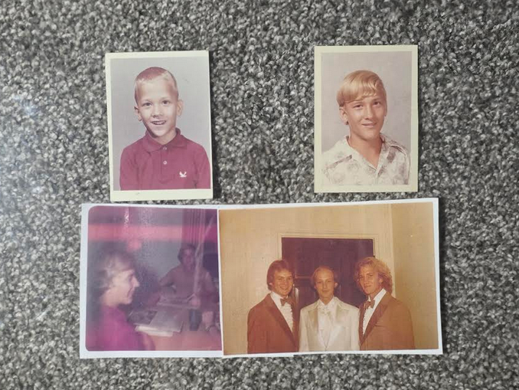


throughout history religions and science
never knew and naturally never mentioned
recognizable geographical continent size shapes

therefore unfortunately all religions
possess
limited and inadequate knowledge to discuss
universe's start and eternity for all

makers of those shapes
tried to message
humankind of voting situation
with eternal consequences

concerning this website's software formation kim
thanks
UK's Katie Keith CEO of Barn2plugins
for important plugin Document Library Pro

most HAPPY EVER AFTERS chapters represented below

categories of chapters of HAPPY EVER AFTERS

TABLE OF CATEGORIES

AlleyBohmWheeler THEORY of EVERYTHING scientific proof
chapters 000 003-005 G01-G05 H06

AI duplicates humans' Awful Intentions culture
until further notice
chapters 000 and chapter concerning jekyll and hyde

BEARS organization's start and actions through history
chapters H07 K01-K07 P10

BEARS aggressions against astronauts and pan africanism
chapters L06-M04

BEARS lethally blocked possible future competitors
chapters L01-S02

BEARS BIDENS
chapters U02-U07

BEARS BUSH
chapters N09-O07

BEARS CLINTONS
chapters N08 S01-S02 T02-T04 U08

BEARS OBAMA
chapters S05-S10

BEARS TRUMP
chapters T06-U01

BEARS MOUNT RUSHMORE PRESIDENTS
chapters O10-P07

BEARS versus KEITH MICHAEL KLECKA
chapters D08-D09

BLOCKING all diseases
habitually and holographically
chapters D05-D09 F03-G01

BOKO HARAM etcetera recivilize strategy NIGERIA ABIOLA
chapters R07-R10

CAIN and ABEL
chapters B08 D03

CITY STATES dubbed DiameterCities
chapters I03 I04 J04-J10 K09

COUNSELING TOOLS for emotionally resolving events
chapters 005 B09 K10 L01

DIANA PRINCESS versus BEARS
chapters S02-S04

FOUR mideast states ROCK PAPER SCISSORS GAZA
chapter 006

GIRLS choose boys in nice way
chapters J08 J09

KENNEDY trio and MARY JO KOPECHNE
chapters Q01-R01

PEARL harbor Hawaii inside job 1941
chapters K10-L05

SMOOTH KEYS DEMOCRACY'S weekly global peace
chapters A01 A02

VIETNAM heroic trio chapters M05-M10

WARS chapters O01-O03

WORLDWIDE simple language dubbed SHOELANGUAGE
chapters W03-X06

YOUNG MARIA WANG'S SUMMER CAMP
children's short story puts book's startling
discoveries into context with each other
chapters A03-C08

Open letter to Supreme Leader of Iran

Dear Mojtaba Hosseini Khamenei of Iran

kim
desires
happiness for all including
Mojtaba Hosseini Khamenei and family

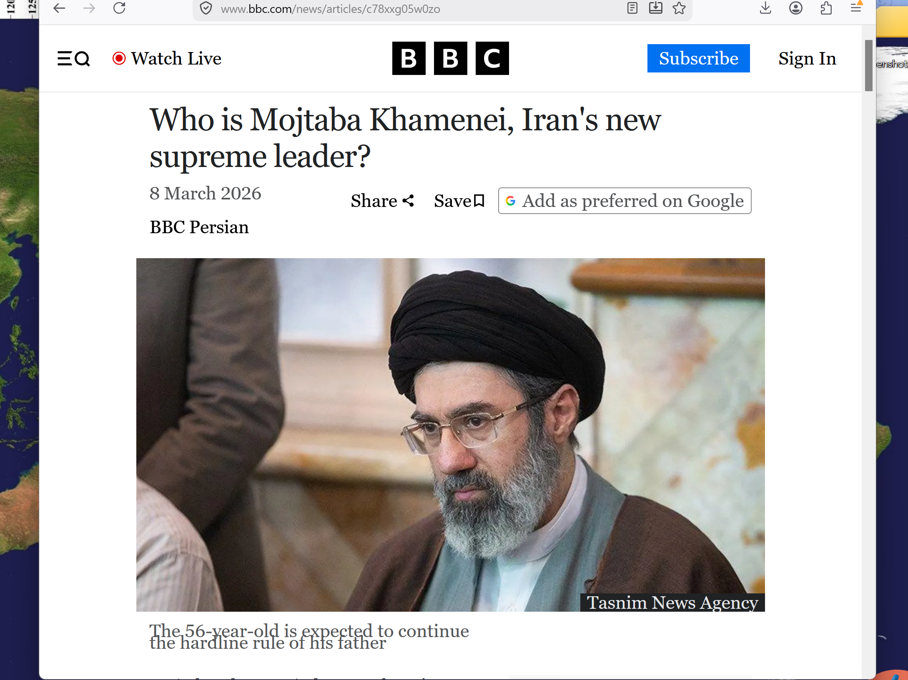

kim as USA citizen
apologizes for
horrific actions by USA president including
authorizing murders on 2026 February 28

Mojtaba's actions
carry
great weight for directing humankind

humankind's choice of SUNNYside culture now
dictates quality of
eternity for all humans living and
for all humans ever lived

this free online book
located at
shoelanguage.com describes
universe's origins and current situation

later chapters
give more
details but in summary below

doctor david joseph bohm
noticed
electrons in groups act differently
than one single electron

doctor john archibald wheeler
theorized
only one huge electron exists
with bits and pieces called electrons

pivoting with above HAPPY EVER AFTERS
discusses
interactions of universe's four huge ingredients
electron proton neutron and gravity undivided

for convenience sake terms for above
include
Alice and Bob and
Cindy and Don

professor david bohm
eventually concluded
universe actually one huge hologram

https://www.davidbohmsociety.org/david-bohm/
overview of bohm’s work
biography

David Bohm: A Life Dedicated to Understanding the Quantum World by Olival Freire Junior.

https://febrary.net/96111/education/orthodox_orthodox_interpretations_quantum_theory

title of article
Orthodox and non-orthodox interpretations of quantum theory

Fig. 6.1 David Bohm as a young man [courtesy of Addison-Wesley]

F. D. Peat: Infinite Potential: The Life and Times of David Bohm (Reading, MA: Addison Wesley, 1997).
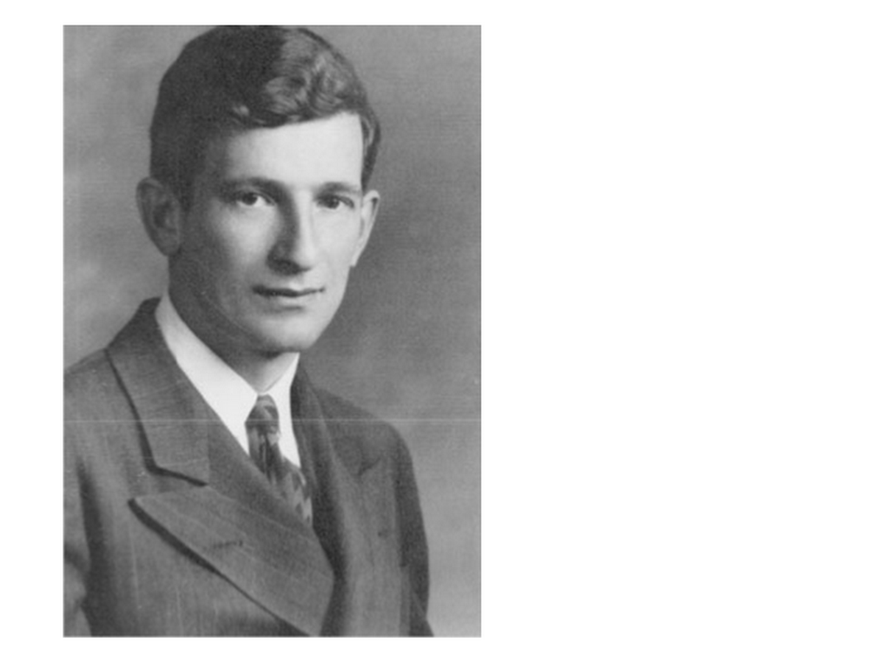

2024 december 13
https://scienceandnonduality.com/article/david-bohm-implicate-order-and-holomovement/

David Bohm, Implicate Order and Holomovement
Article by David Peat

KIM NOTES

humankind as third group of electrons
possesses
swing vote directing fate of universe
for all of eternity

kim
paraphrases
bohm's description of universe

oil poured into glass of milk
swirls
like fingers downward as mixes
with milk

if process
could reverse

then those swirls
would spiral upward
and leave milk intact

KIM NOTES

in actuality huge electron
still swirls downward because still trying
to take instructions from little individual
electrons in various holographic settings

each human
can be viewed
as one bundle of electrons making
decisions for actions by majority votes

before this book humans
called
holographic events miracles and
technicians of those miracles angels

in actuality photons
made happen what
humans historically attributed to angels

scientists
measure
electrons and closely related particles
smallest bits of light dubbed photons

after researching certain scientists' biographies kim
realized that those
scientists had already independently unknowingly
proven pieces of THEORY OF EVERYTHING

those three theoretical physicists
studied
photons and electrons and proved phenomena
that taken together says universe holographic

jewish american brazilian british david bohm
believed
some greater force dispersed self as
universe and will eventually recoil self

KIM NOTES

group of electrons dubbed humans
take actions only after
subconscious internal debates

each human's group of electrons
take actions
according to majority
of those electrons' wishes

chapter 002's short story
explains in context
standard operating procedures of
ongoing decision making

greater force
will eventually recoil after reclaiming
bits and pieces dubbed electrons

that retirement
similar to
reverse BIG BANG event

by then each individual electron personality
will have clarified self and stated
individual opinions via many votes influenced
partly by fellow electrons' majority conclusions

greater force
will accept
instructions from bits and pieces
of self known as electrons

concerning eternity's environment recombined electron
will design
environment according to that favored style
enacted on globe by electron bundles

princeton professor john archibald wheeler
discovered
photons' technique of interviewing humans subconsciously
to adjust universe accordingly and obediently

wheeler's reverse 20 questions
details how and which style
photons deliver happenstances to individual
after consulting with subconscious individual

first photograph from
Linda Hall Library
5109 Cherry Street
Kansas City, Missouri 64110-2498


second photograph from
princeton alumni weekly

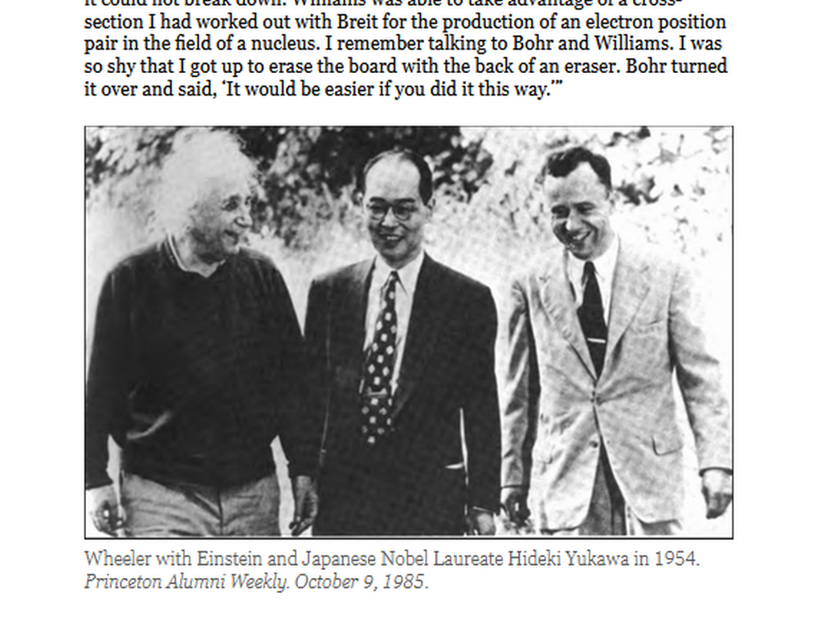

american professor carroll overton alley junior
proved in laboratory that
wheeler's notion correct at least
at photonic and atomic level

KIM NOTES

alley's real life laboratory proven results
actually applied to
all of life not only tiny
level but also included humans' interactions

photons as obedient technicians of holograms
adjust
incoming events to match signals
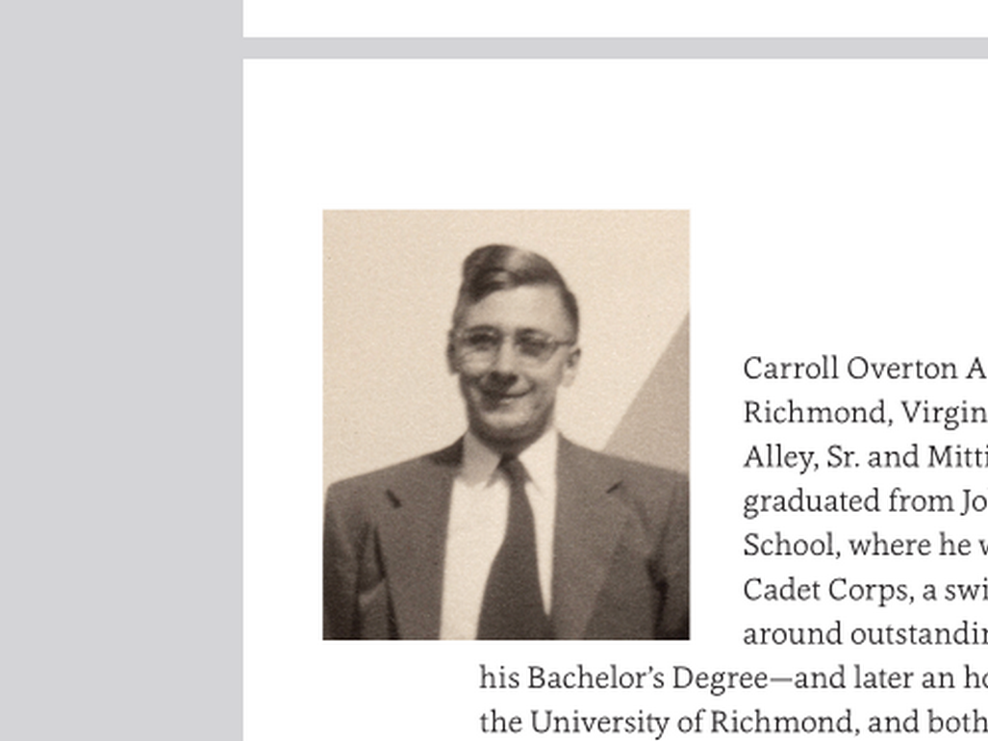
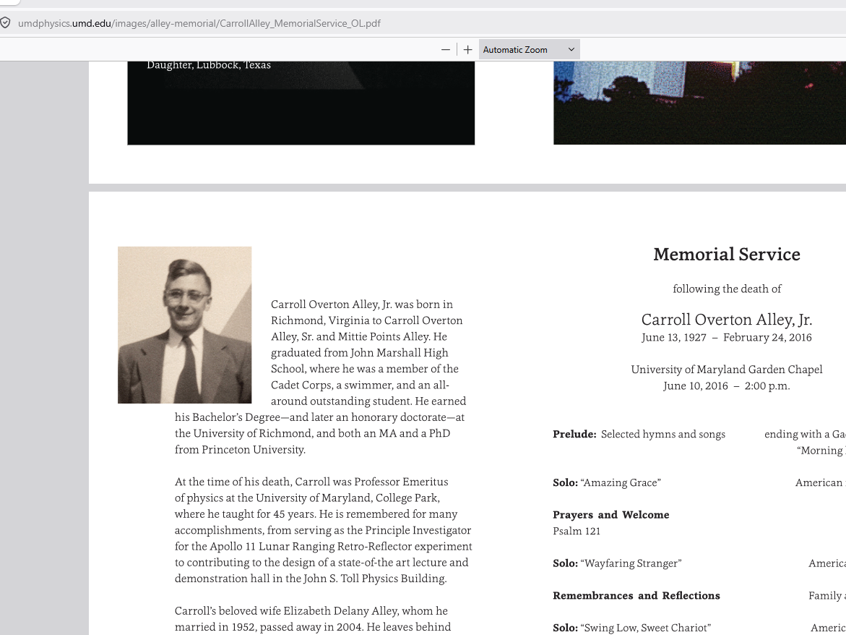

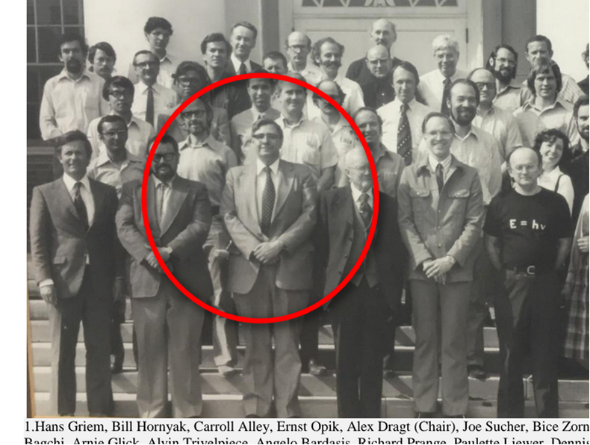

princeton professor john archibald wheeler
theorized that
observer in room could alter supposedly
settled outcome of experiment in room

in other words observer human
could somehow change
first history and produce opposite outcome
to create altogether new second history

carroll overton alley junior and colleagues
proved
wheeler's idea using photons
after five years of attempts

yet actual prover of concept alley
could never emotionally accept
that today's actions could change historical
happenings and reset history seamlessly

alley's mindset above because alley
lacked knowledge of
continent size statues as puzzle pieces
giving context to holographic history phenomena

even before alley's proving david bohm
deduced
all humans live in holographic universe

bohm
believed
some greater force purposefully expressed self
as universe including as humans

KIM'S PARAPHRASE

THAT greater force
would learn from
that expression dubbed humankind
surrounded by stage props dubbed universe

that greater force
would later repeal
self and retract after gaining instructions
from that greater force's own EXPRESSIONS

wheeler
independently sketched
that same idea

amanda gefter is a science writer and the author of
TRESPASSING ON EINSTEIN'S LAWN

amanda's book
displays
wheeler's chalkboard drawing of
eye looking at universe

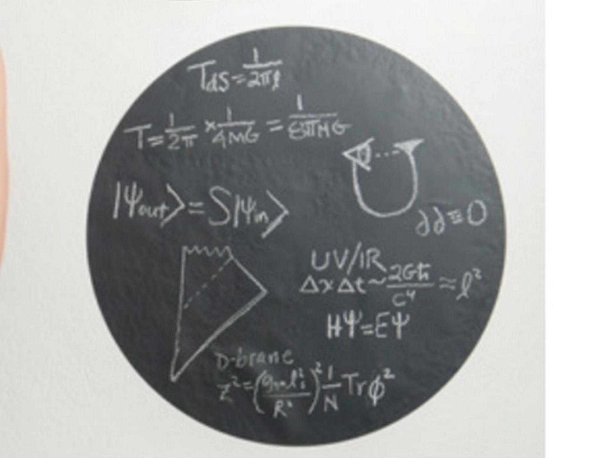

photons
copy pasted
wheeler's drawing to emphasize
correctness of that idea

photons
pasted
eye which appears near eagle nebula's
pillars of creation section below

wikipedia.org and wikimedia.org's

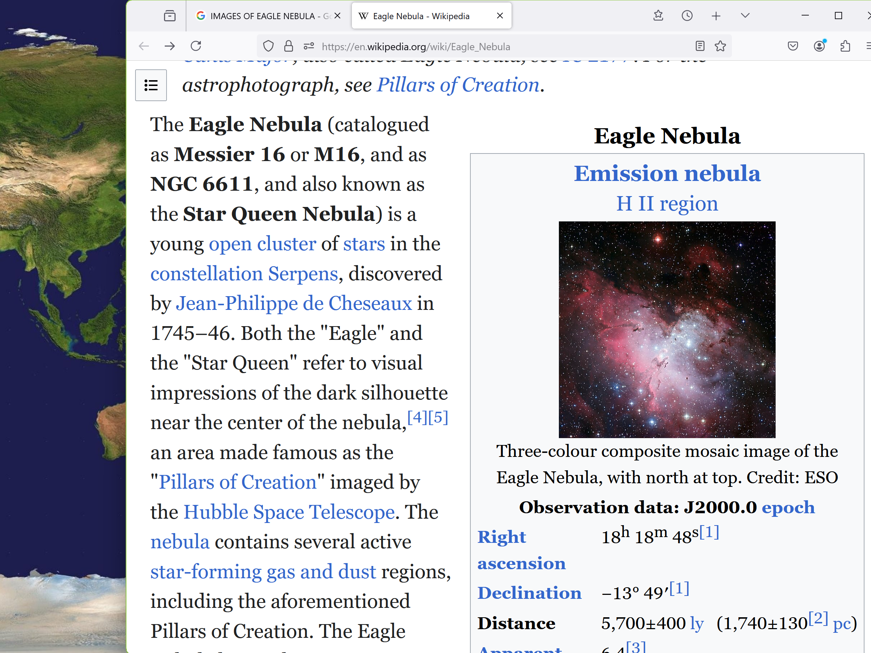



HUMANS symbolized by eye above
turn to observe and instruct
universe
that created humans in first place

all three professors
correct in
discoveries concerning humans' effects
upon universe and time

trio's standalone brilliant accomplishments
combine into
kim's dubbed AlleyBohmWheeler THEORY of EVERYTHING
with help of new puzzle pieces

kim's discovered missing puzzle pieces
include
huge statues giving narrative concerning
actual reason for universe

unfortunately centuries ago con artist
ordered
photons to create mirages

photons as obligated technicians
created
convincing mirages dubbed angels to overwhelm
sincere humans into religions and violence

trickster desiring emotional and physical destructions
deceived
humans into various religions so as to
have warring religions insiders versus outsiders

year 1967 subconscious keith's strategy
included convincing
conscious kim of global warmongering international
BEARS organization's operational methods

for centuries BEARS
vigorously introduced
wars for maintaining emotional control over
sincere patriotic and often religious citizens

BEARS missile and wartime items makers
continuously encouraged
flimsy reasoned wars to deplete stock
of products so replenishments needed

buddy buddy BEARS
gained
riches plus even more riches from
causing expensive recovery and rebuilding projects

kim
found
evidence in geography that leads
to conclusions below

Supreme Being
experienced
loneliness

therefore Supreme Being
subdivided self into
four equal beings without leaving instructions

those four titans
now await
humankind's swing vote to determine
style of universe

following bohm's implications Supreme Being
will eventually reconfigure self
as whole being

In that case humankind
meanwhile choses
nature of eternity that all personalities
ever will enjoy or endure forever

friends of humankind photons
twisted continents
to display story of four titans
and actual universe

HAPPY EVER AFTERS book
contains
chapters giving details of real lives
of four titans in allegorical setting

YOUNG MARIA WANG'S SUMMER CAMP
children's short story puts book's startling
discoveries into context with each other
chapters A03-C08

all starters of all religions
were
sincere humans

unfortunately universe's greatest con artist
conned via
miracles
as seemingly overwhelmingly convincing proofs

con artist
eventually turned
sincere intentions of many religious adherents
into cruelty SUNNYsideDOWN EMOTIONAL MINDSET

con artist also known as Jesus
disguised
self to sway humans to act SUNNYsideDOWN
upon religious and patriotic grounds

Jesus of Nazareth
deceitfully claimed
title Son of God

in short story form chapters A03-C08
explain why
Jesus bound self via oath to
promote SUNNYsideDOWN

only by doing above could Jesus
give
humankind capability to choose SUNNYsideUP culture
as guiding morality for future megacities

Jesus
counts on
humankind to mature overnight to choose
prebuilding and migrating to future DiameterCities

Jesus
counts on
Mojtaba to choose
SUNNYsideUP over SUNNYsideDOWN

meanwhile to keep deal intact Jesus
must promote
SUNNYsideDOWN to humans

above
until humankind chooses adopting
SUNNYsideUP via adopting this book

in universe only two cultures
exist

one culture SUNNYsideUP
includes
eternity with honeymoon like ecstasy forever

however opposite culture SUNNYsideDOWN culture
includes gleefully vexing and horrifying in
small and large ways including violence
and amputations forcing sex and murdering

SUNNYsideDOWN deceitful justification reasoning
includes hiding behind
religions' and governments' disciplining to
eagerly inflict violence including sexual violence

above actions plus revenge killings
become votes for
humans' one compartment eternity's environment
as emotional and physical torturing

every 8 seconds every human
chooses
either SUNNYsideUP or SUNNYsideDOWN emotion
via actions or words or thoughts

every human
possesses ability to strive towards
either way

universe via technicians called photons
obediently takes instructions
from and constructs new incoming events
according to that human's signals

movie below based from book
unknowingly displays
every eight second segment's struggle
between Limbs and Trunk Parliaments
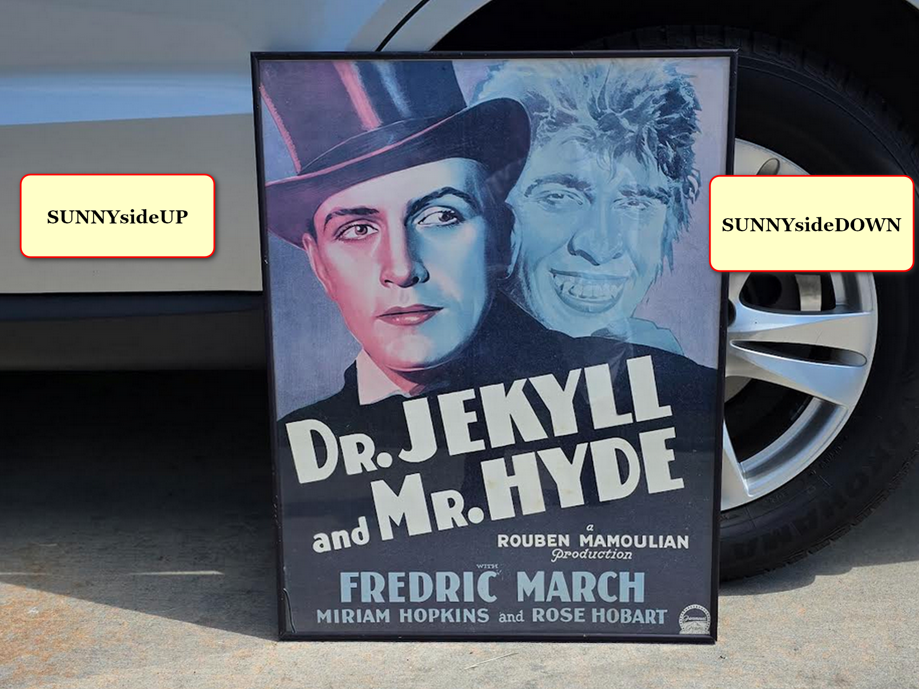

secret murdering group dubbed BEARS
actively creates
SUNNYsideDOWN chaos and wars etcetera as
job security because diverts attentions

Mojtaba
please strategically peacefully devitalize BEARS
by offering sweet deal for peace

Mojtaba on behalf of Iran
could go for
SUNNYsideUP via officially adopting this book
including changing executive decision making style

Chapters A01 A02
give details of
proposed executive changes including SMOOTH KEYS
DEMOCRACY and Executive Crew of 22

kim
hopes to end all
weapons of war

however Mojtaba
might consider that of all
weapons nuclear used least

considering several years from now kim
plans for all
nations' citizens migrating to prebuilt
DiameterCities in North Africa if permitted

since all nations' boundaries
will eventually vanish

therefore perhaps Mojtaba
bargain away all
future nuclear plans in exchange for
useful today items like lifting embargos

humankind's decisive final permanent SUNNYsideUP vote
includes agreeing to prebuilding and migrating
to thousand rent free solar powered
DiameterCities featuring this book's SUNNYsideUP culture

first steps towards humankind's tranquility
include making deal with
BEARS to adopt this book and
end capital punishments and disband

USA citizens
elect
presidents and vice presidents
from two major parties' tickets

however all four of those persons
always possess
additional secret membership positions in BEARS

in this way global controlling BEARS
always win
every presidential election in nations
except for occasional glitch

all USA Presidents ever
possessed
dual presidencies USA and BEARS

some members of BEARS
gained permission to actually pay
initiation and elevation fees after elections
one example USA President Jimmy Carter

BEARS
always strive to cause
wars and violence so BEARS owned
military weapon manufacturers gain more money

president of global umbrella group BEARS
coordinates with
all other nation's chief executives BEARS
to war among selves as scheduled

this warring preplanned by both sides
kills
patriotic citizens but delivers riches and
fame and job security to BEARS

carter as president of global BEARS
coordinated with
Iran's BEARS Supreme Leader Ruhollah Khomeini
on at least two projects

first project
included finding
some sincere non Iranian muslim author
to vilify to create global rift

BEARS global weapon makers
wanted
more profits and carter and ruhollah
wanted textbooks' glory

BEARS pair carter and ruhollah
finally found
author to unfairly vilify so as
to inflame muslims

BEARS global
wanted to initiate
conditions of Us versus Them to
help project already in planning 9/11

victimized Salman Rushdie
would later make
that connection mentioned above to
events of 2001 september eleven

BEARS global including carter and ruhollah
desired and did fan flames of
lucrative hatred between muslims and non muslims

other BEARS leaders
secretly celebrated
ruhollah's death sentence to salman rushdie

BEARS of all nations
could now justify
spending more on arms and ammunition
because of ruhollah's call to patriotism

https://en.wikipedia.org/wiki/Satanic_Verses_controversy

Satanic Verses controversy, also known as the Rushdie Affair, was a controversy sparked by the 1988 publication of The Satanic Verses by the Indian author Salman Rushdie.

On 14 February 1989, Ayatollah Ruhollah Khomeini, the Supreme Leader of Iran and one of the most prominent Shi'a Muslim leaders, issued a fatwa calling for the death of Rushdie and his publishers.

This created a major international incident that persisted for many years.

Criticism of Khomeini's fatwa

Khomeini's fatwa was condemned across the Western world by governments on the grounds that it
violated
the universal human rights of free speech, freedom of religion,

and that Khomeini had no right to condemn to death a citizen of another country.

On Islamic grounds

According to Bernard Lewis, a death warrant without trial, defence and other legal aspects of sharia violates Islamic jurisprudence.

In Islamic fiqh, apostasy by a mentally sound adult male is a capital crime.
For Lewis, fiqh also "lays down procedures according to which a person accused of an offense is to be brought to trial, confronted with his accuser, and given the opportunity to defend himself."

Lewis added that "[a] judge will then give a verdict and if he finds the accused guilty, pronounce sentence",
and that
"[e]ven the most rigorous and extreme of the classical jurists only require a Muslim to kill anyone who insults the Prophet in his hearing and in his presence.

They say nothing about a hired killing for a reported insult in a distant country."[54]

Other Islamic scholars outside Iran took issue with the fact that the sentence was not passed by an Islamic court,[42][55] or that it did not limit its "jurisdiction only [to] countries under Islamic law".[36]

Muhammad Hussam al Din, a theologian at Al-Azhar University, argued "Blood must not be shed except after a trial [when the accused has been] given a chance to defend himself and repent".[42]

Abdallah al-Mushidd, head of Azhar's Fatwā Council stated "We must try the author in a legal fashion as Islam does not accept killing as a legal instrument".[55]

The Islamic Jurisprudence Academy in Mecca urged that Rushdie be tried, and if found guilty, be given a chance to repent (p. 93),

and Ayatollah Mehdi Rohani, head of the Shi'i community in Europe and a cousin of Khomeini,
criticised
Khomeini for 'respecting neither international law nor that of Islam.'[56]

There was also criticism of the fatwa issued against Rushdie's publishers.
According to Daniel Pipes,

the Sharia
"clearly establishes
that disseminating false information is not the same as expressing it. '

Transmitting blasphemy is not blasphemy' (naql al-kufr laysa kufr)."

In addition, the publishers were not Muslim and so could not be "sentenced under the Islamic laws of apostasy".

If there was another legal justification for sentencing them to death, "Khomeini failed to provide" it.[57]

Iran's response to calls for a trial was to denounce its Islamic proponents as "deceitful".

President Khomeini accused them of attempting to use religious law as "a flag under which they can crush revolutionary Islam".[58]

Questions of political motivation

Some speculate that the fatwa (or at least the reaffirmation of the death threat four days later) was issued with motives other than a sense of duty to protect Islam by punishing blasphemy/apostasy.
Namely:

To divide Muslims from the West by "starkly highlight[ing] the conflicting political and intellectual traditions" of the two civilisations.[5]

Khomeini had often warned Muslims of the dangers of the West

– "the agents of imperialism [who] are busy in every corner of the Islamic world drawing our youth away from us with their evil propaganda".[59]
He knew from news reports the book was already rousing the anger of Muslims.

On 14 February 2006, Iran Focus
quoted
the opinion of "Martyrs Foundation" (as broadcast on the "Iranian state news agency") that the fatwa will remain in place permanently.[72]

This
contradicts
Shiite tradition, in which a fatwa expires when the issuing marja' dies, requiring another living marja' to reissue it.

... project of tyranny and unreason which wishes to freeze a certain view of Islamic culture in time and silence the progressive voices in the Muslim world calling for a free and prosperous future
. ... along comes 9/11, and now many people say that, in hindsight, the fatwa was the prologue and this is the main event.[104]

Explanation of different reactions
Muslim

The passionate international rage of Muslims towards the book surprised many Western readers because

the book was written in English, not Arabic, Urdu, Persian, Turkish or other languages that are spoken in Muslim-majority countries;

it was never published or even sold in the countries where most Muslims lived, and was a work of fiction –

a demanding, densely written novel unlikely to appeal to the average reader.[106]

Some of the explanations for the unprecedented rage unleashed against the book were that:

Western mainstream

Despite the passionate intensity of Muslim feeling on the issue, no Western government banned The Satanic Verses.

This is primarily because most Western governments embrace freedom of religion, freedom from religion and freedom of expression, prohibiting on censorship in the vast majority of cases.

Western attitudes regarding freedom of expression differ from those in the Arab world

Rushdie himself said: "I had spent my entire life as a writer in opposition, and indeed conceived the writer's role as including the function of antagonist to the state".[126]

The last point
also explains
why one of the few groups to speak out in Muslim countries against Khomeini and for Rushdie's right to publish his book were other writers.

[127] Nobel prize winners Wole Soyinka of Nigeria and Naguib Mahfouz of Egypt,
both attacked
Khomeini, and both received death threats as a result, with Mahfouz later getting stabbed in the neck by a Muslim fundamentalist.[128][129]

Some Western politicians and writers
did criticise
Rushdie. Former US president Jimmy Carter,
while condemning the threats and fatwa against Rushdie, stated,
"we have tended to promote him and his book with little acknowledgment that it is a direct insult to those millions of Moslems whose sacred beliefs have been violated and are suffering in restrained silence the added embarrassment of the Ayatollah's irresponsibility".

He also held that Rushdie must have been aware of the response his book would evoke:
"The author, a well-versed analyst of Moslem beliefs, must have anticipated a horrified reaction throughout the Islamic world".[130]

Carter saw a need to be "sensitive to the concern and anger" of Muslims and thought severing diplomatic relations with Iran would be an "overreaction".[131]

KIM NOTES

BEARS carter and ruhollah
worked together on
another huge project

carter and ruhollah
planned
concerning exact date of
USA embassy takeover

1979 BEARS USA's president jimmy carter
requested
students seize USA embassy and ordered
absenteeism of guards on predetermined date

above for purpose USA president carter
to pay
BEARS initiation and elevation fees via
preplanning deaths of would be rescuers

1980 Commander in chief jimmy carter
arranged
team to supposedly rescue hostages but
secretly ordered arranging for servicemen deaths

BEARS USA'S carter
ordered
BEAR accomplices to secretly install bypass
remote control devices onto helicopters

BEARS accomplices
successfully lethally overrode
pilot and remotely flew helicopter into
another aircraft carrying fuel and servicemen

above eight deaths
more than paid
carter's BEARS fees of
initiation and elevation

as commander in chief carter
supposed to protect
military but chose BEARS membership instead

wikipedia.org's

USA Operation Eagle Claw (Persian: عملیات پنجه عقاب)
failed to rescue
53 embassy staff held captive on 24 April 1980.
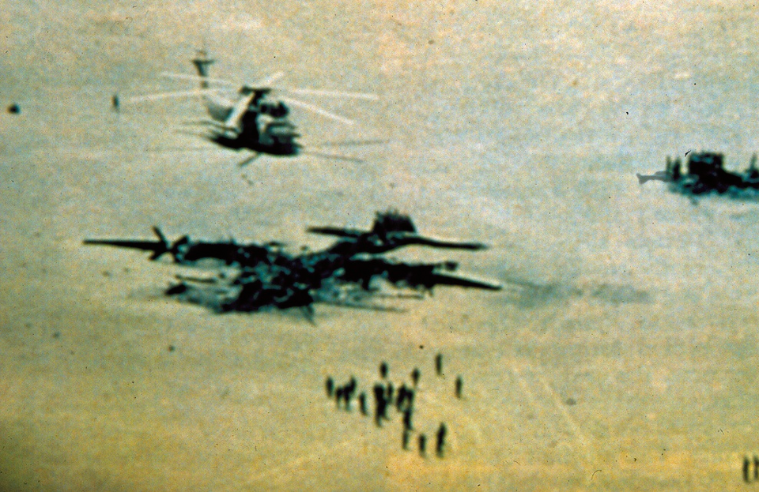

As the US forces
prepared to withdraw
from Desert One, one of the remaining helicopters crashed into a transport aircraft that contained both servicemen and jet fuel.

The resulting fire destroyed both aircraft and killed eight servicemen.[2]

wikipedia.org's

Mahmoud Ahmadinejad and the Iran hostage crisis

Five former U.S. hostages,
Dr. William Daugherty (who worked for the CIA in Iran),
Kevin Hermening,
David Roeder,
US Army Col. Charles Scott,
and US Navy Capt. Donald Sharer

have alleged that Ahmadinejad was one of the leaders of the Iran Hostage Crisis at the U.S. embassy in Tehran, during their 444-day captivity starting on November 4, 1979.

All of the above-mentioned hostages have identified Ahmadinejad as one of the people involved, while Ahmadinejad denies his involvement.

Col. Charles Scott, now seventy-three, recently told the Washington Times^{[12]} that "He was one of the top two or three leaders; the new president of Iran is a terrorist."

Col. Scott claimed to recall an incident when Ahmadinejad berated a friendly Iranian guard who had allowed the two Americans to visit another U.S. hostage in a neighboring cell.

Col. Scott, who understands Persian,
said
Ahmadinejad told the guard:
"You shouldn't let these pigs out of their cells".

times of israel showed AP photograph

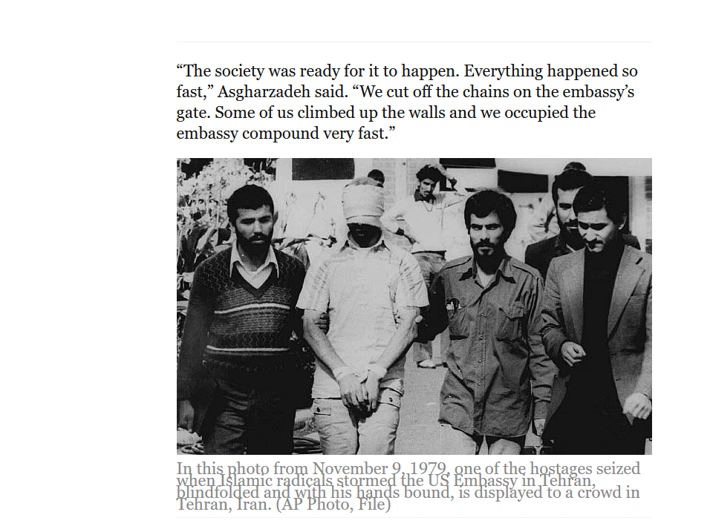

wikipedia.org's

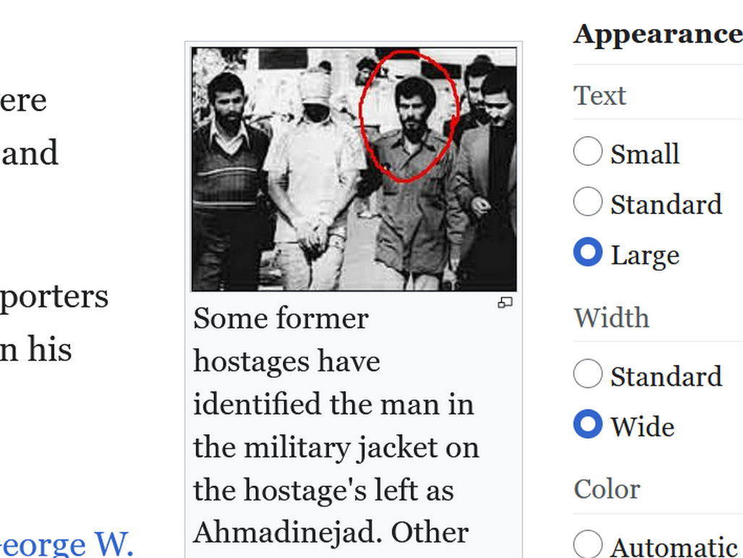

2026 BEARS USA
desired
supreme leader of Iran possess membership
in BEARS to keep hostilities ongoing

therefore BEARS president trump
sent request to
Iran BEARS past president mahmoud ahmadinejad
to replace Mojtaba as supreme leader

BEARS mahmoud ahmadinejad
at first agreed
but then preplanned bombing of residence
to free instead caused personal trauma

2026 may 20 thursday
new york post's
caitlin doornbos

https://nypost.com/2026/05/20/world-news/experts-raise-eyebrows-over-ny-times-report-us-israel-eyed-freeing-ahmadinejad-for-irans-new-leader/

both Washington and Jerusalem
refrain from denying the story,

report, published Tuesday,
suggested
Feb. 28 strike on Ahmadinejad’s home
“had been designed to free him from house arrest” — not kill him.
4

trump's permission
killed
Iran's non BEARS chief executive Mojtaba's father

Later strikes
killed
BEARS in waiting

BEARS global
desired reinstating
BEARS' Iran's ahmadinejad

Above
because
BEARS desire ongoing wars and chaos
and emotional upheaval for job security

BEARS
desire
antagonistic nations forever

However citizens of all nations
desire
tranquility and safety

Non BEARS Iranian clerics
selected
Mojtaba to lead Iran

non BEARS chief executives of nations
include among others
Mojtaba and Ukraine's Volodymyr Zelenskyy
and Canada's Mark Carney

yet BEARS
desire
exclusive control of all nation's chief
executives for warmongering and creating apprehension

therefore global BEARS
recruited
new members for Iran

most top governmental Iranians challenging Mojtaba
possess
motivation from BEARS' influence

above because Mojtaba
not member of
BEARS and therefore
free to unravel BEARS if wishes

Mojtaba
could coax
BEARS to disband globally
via win win deal

HAPPY EVER AFTERS' SMOOTH KEYS DEMOCRACY
allows for
Executive Crew of 22 persons to
reign supreme instead of just one

Executive Crew's routine anonymous voting
would automatically exclude
BEARS influences

in changing Iran's executive style Mojtaba
would start dismantling
BEARS globally peacefully and non violently
via SMOOTH KEYS DEMOCRACY decision making

Mojtaba
could gain
details from HAPPY EVER AFTERS at
shoelanguage.com via desktop or laptop computer

Chapter 000
gives sample of
what good things would result from
entire humankind adopting HAPPY EVER AFTERS

2026 February congress of USA
never declared
war

USA president during peacetime
not only tragically supported killing
Mojtaba's family members but also put
USA military persons in death's path

without congressional declaration of war president
effectively murdered
six USA persons plus more because
moved troops near attack on Iran

by committing these murders USA president
committed
high crimes and misdemeanors and exposed
self to constitutional retirement from office

from global perspective president trump
responsible for
war deaths of all nationalities in
and around Iran since mid 2025

one list
could contain
those victims' names and dates
and circumstances

USA president and all chief executives
can all accept
BEARS deal to gain desk 22
with following requirement

each BEARS chief executive
must admit
murderous past and submit list of
victims publicly known and secret victims

each BEARS chief executive
must pay
10% of their gross income
for year 2025

those monies
would go into
this book's designated person's
one account

when complete that account
will disburse
equal amounts to each family of
citizen killed by BEARS member

non family lawyers
will not be involved

that one person fund caretaker
will disperse
money to one surviving family member
chosen by each family

that account
would accept
BEARS payments as restitution for worldwide
victims' survivors families

globally past BEARS chief executives
would contribute
10% of that BEARS member's
year 2025's gross income

that is if they
also want
complete pardons for causing deaths

now
is
the time to come clean

that one person
will accept
lists and money

finalized list
allows
all victim's families worldwide gaining same
amount because BEARS was worldwide destroyer

example of above
includes
all USA presidents caused initiation fee
deaths before or during presidencies

for informational chapters viewers
please refer to
table of categories' BEARS chapters
on or around page 63

other chapters
discuss
other BEARS' murder victims including other
countries' BEARS' murder victims

same list submissions rules
apply to
those presidents and all globe's BEARS
chief executives wishing to escape incarcerations

those BEARS
must submit
list of names of victims and dates

BEARS
must include
names and contact information of one
person representing victim's family

those lists
will be posted
online from that one person
who will accept lists and money

that person
will post
operational transactions and proposed disbursements lists for viewers to verify

below
shows how
above arrangement might work

for clear example kim
draws
name out of the air hoping
that person might pursue this task

kim
has never met
canadian prime minister mark carney or
his wife diana

but mark carney's economic resume
speaks volumes
concerning carney's ability
to handle large finances

if the carney's are willing kim
requests considering
diana transfer her bank accounts to
mark's for paying diana's personal purchases

for global transparency's sake diana carney
could then open
one account with daily transactions automatically
posted online from that willing institution

if project accepted then diana carney
should receive
an equal share as compensations for
helping victims' families

I
recommend
usa government add more to bring
diana's compensation to $500,000 US dollars

if given opportunity USA citizens
would have voted
NO to any military actions
against Iran

if USA
had already installed
SMOOTH KEYS DEMOCRACY system then
those 2026february28 tragedies not ever possible

chapter A01
gives
details of SMOOTH KEYS DEMOCRACY

above system
includes
at least 399 capital city citizens
taking time to vote

voting days of each week
include
mondays and wednesdays and fridays

three uninterrupted NO votes
would create
automatic peaceful change of personnel

YES or NO opinion outlet system
would take away
citizens' motivations for street demonstrations

majority NO votes
would still leave
Mojtaba and another person on Executive
Crew at desks 22 and 21

yet 130 other executive top members
would take reassignments to
other lesser paying positions in government

for example if Iran
operated with
SMOOTH KEYS DEMOCRACY

then all nations
would confidently understand
Iran posed no threat

above
because
Iran possessed SMOOTH KEYS DEMOCRACY'S
Executive Crew of 22 for Iran

if neighbors
copied
Iran in adopting SMOOTH KEYS DEMOCRACY

then Iran
would also confidently understand
that no neighbors posed threats because
neighbors also possessed Executive Crews

then so called historically enemy nations
would transform to
eager equal trading partners because of
executive frameworks embedded in permanent peace

in keeping with that case Mojtaba
could then release
all non state partners and proxies
to become peaceful citizens of nations

chapter 006 FOUR mideast states
maps
permanent peace for Israel Palestine via
new nations ROCK PAPER SCISSORS GAZA

in SMOOTH KEYS DEMOCRACY Mojtaba
would gain for lifetime
seat 22 of Iran's Executive Crew

Mojtaba with one vote of 22
would remain constant even if
citizens voted out and redeployed
20 Crew members to other positions

Iran's Executive Crew of 22
could by decree officially deescalate
all religions

public worship of all religions
would transform to
home worship with no mandatory uniform
clothing or headscarf publicly or privately

humankind
would no longer utilize
public buildings as places of worship

persons
would adhere to
concepts FAIRNESS for ALL and
SMOOTH KEYS DEMOCRACY including non aggression

in FAIRNESS for ALL persons
would mandatorily treat
all persons including all females equally

above
includes
husband treating wife as equal
in all categories

polygamy
disrespects
original wife

therefore FAIRNESS for ALL
relegates
notion of plural wives
to ancient history

current husbands with plural wives
would need to choose
one and release other wives

released wives
would immediately gain
lump sum exit amount of money
3% of husband's 2025 gross income

those former wives
would gain
sole possession of their children

newly single mothers
would change
names of children to include
wife's family name

legally and non legally former father
would have no
authority or responsibility or contact
with former children

family decisions
would require
2-0 majority vote of husband
and wife

FAIRNESS for ALL
relegates
notion of temporary marriages
to ancient history

HAPPY EVER AFTERS
reintroduces
notion of Tribal Chieftain Married Couple
to humankind as standard operating procedure

chapters J04-J09 concerning future Diameter Cities
mention
SUNNYsideUP culture Tribal Chieftain Couples
presiding over eventual residence tower villages

though DiameterCities years away 400 citizens
could still gather together forming
tribe with friends and family and
choose Chieftain Married Couple

each Chieftain Married Couple for now
would support
each group of 400 in categories
including seeking employments and marriage counseling

in DiameterCities village per tower system
will easily clarify
which family belongs to which tribe

however Chieftain Married Couples
could be established now
as place of immediate refuge for
females humiliated by males

if husband
unhappy
in marriage

then husband
would consult
husband of
Tribal Chieftain Married Couple

wife
would consult
wife of
Tribal Chieftain Married Couple

that evening Tribal Chieftain Married Couple
would develop
plan to improve that marriage's situation
and issue personalized strategies

chapters J04-J09
contain
strategies and even include
ROCK PAPER SCISSORS as last strategy

yet if all strategies
unsuccessful

then FAIRNESS for ALL
insists
Tribal Chieftain Couple
immediately officially declare automatic divorce

that quick divorce
issues
safety and freedom and happiness for
woman to marry another if wished

that former wife
would retain
children exclusively

last names of children
would automatically change to
mother's maiden name

that divorce
would include
husband severing relationship with those children
including no visitations or communications forever

this strategy
smooths way for
possible new husband for former wife

FAIRNESS for ALL and smooth emotional continuity
insists
children experience life with only
one guiding father at a time

husband
must not
hit or slap wife or ask
another to hit or slap wife

no father or brother
may hit or slap or cause
violence against any female in family
including against any nanny

plus no father or brother
can have sex with
non wife females mentioned above

no person
will suffer
chaining in own residence

if all nations
would agree to
HAPPY EVER AFTERS as upgrade strategy
for humankind

then every nanny in every country
would have
own Tribal Chieftain Couple making employment
agreement directly with foreign Chieftain Couple

then than nanny
would enjoy
protection of foreign Chieftain Couple from
employer sexual assaults and wage thefts

if employer family's father or brothers
violated
any females as mentioned above

then Chieftain Married Couple
would issue
divorce immediately and female not
return to previous residence

female and children and nanny
would immediately join
family of Chieftain Married Couple

husband
would be alone
in residence

Chieftain Married Couple
would adopt that
now former wife and former children
and find better family for nanny

that lady former wife
cannot remarry
that former husband ever again

only selected friends of Chieftain Couple
would move
family belongings from former residence to
new residence with Chieftain Couple

family
would remain
under Chieftain Couple protection unless
that lady decided to marry

deescalating religion
includes
no church bells ringing in streets
nor noises calling times to pray

Mojtaba
could issue
declarations such as

WOMEN
are equal to men
in all aspects of society
including court system

no persons for any reasons
will any longer endure
lashes whippings or violence
including amputations ETCETERA

Mojtaba
could quickly convince
Iranians of Mojtaba's sincerity towards FAIRNESS
via officially adopting Maryam Rajavi's plan

from wikipedia
Author Ka Veh
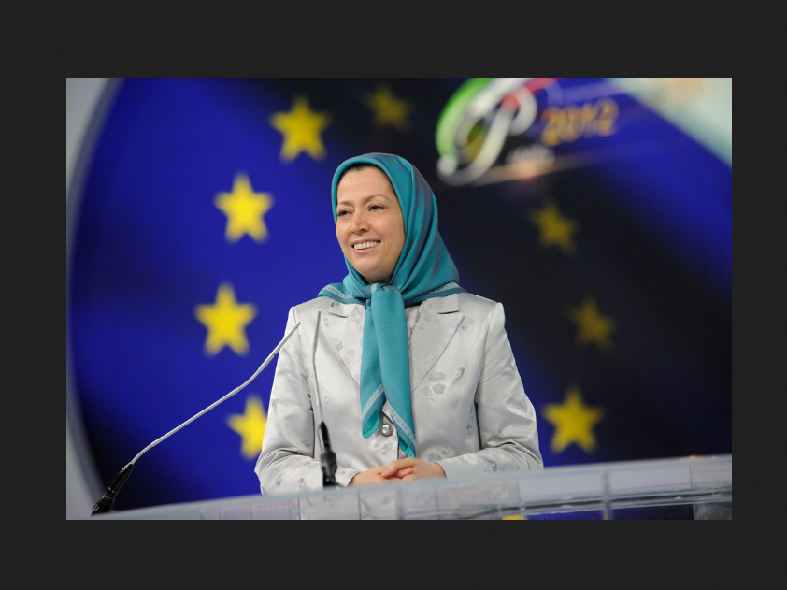

https://www.maryam-rajavi.com/en/viewpoints/plan-for-future-of-iran/

The Ten-Point Plan for Iran’s Future was first presented by Maryam Rajavi in December 2006 at a session of the Council of Europe.

This plan has been repeatedly recognized by resolutions from the U.S. Congress, several European parliaments, and prominent international figures as a vision for a free Iran.

1. Rejection of velayat-e faqih (absolute clerical rule). Affirmation of the people’s sovereignty in a republic founded on universal suffrage and pluralism;

2. Freedom of speech, freedom of political parties, freedom of assembly, freedom of the press and the internet.

Dissolution and disbanding of the Islamic Revolutionary Guard Corps (IRGC), the terrorist Qods Force, plainclothes groups, the unpopular Bassij, the Ministry of Intelligence, Council of the Cultural Revolution, and all suppressive patrols and institutions in cities, villages, schools, universities, offices, and factories;

3. Commitment to individual and social freedoms and rights in accordance with the Universal Declaration of Humans Rights.

Disbanding all agencies in charge of censorship and inquisition.
Seeking justice for massacred political prisoners, prohibition of torture, and the abolishment of the death penalty;

4. Separation of religion and state, and freedom of religions and faiths;

5. Complete gender equality in the realms of political, social, cultural, and economic rights, and equal participation of women in political leadership.

Abolishment of any form of discrimination;
the right to choose one’s own clothing freely;
the right to freely marry and divorce,
and to obtain education and employment.

Prohibition of all forms of exploitation against women under any pretext;

6. An independent judiciary and legal system consistent with international standards based on the presumption of innocence, the right to defense counsel,
right of appeal,
and the right to be tried in a public court.

Full independence of judges.
Abolishment of the mullahs’ Sharia law
and dissolution of Islamic Revolutionary Courts;

7. Autonomy for and removal of double injustices against Iranian nationalities and ethnicities consistent with the NCRI‘s plan for the autonomy of Iranian Kurdistan;

8. Justice and equal opportunities in the realms of employment and entrepreneurship for all people of Iran in a free market economy.

Restoration of the rights of blue-collar workers, farmers, nurses, white-collar workers, teachers, and retirees;

9. Protection and rehabilitation of the environment, which has been massacred under the rule of the mullahs;

10. A non-nuclear Iran that is also devoid of weapons of mass destruction.

Peace, co-existence, and international and regional cooperation.

KIM NOTES

Mojtaba
could agree to
Narges Mohammadi gaining chair 21
for lifetime

wikipedia.org

Narges Mohammadi ( born 21 April 1972) Iranian human rights activist and Nobel Peace Prize laureate. imprisoned in Iran for several periods since 2016


Born | 21 April 1972 (age 54)  Zanjan, Iran

awards include

Alexander Langer Award (2009)
Andrei Sakharov Prize (2018)
Nobel Peace Prize (2023)

each nation's Executive Crew of 22
would operate with
in house COLLATOR PRINTERS putting
Crew's unspoken anonymous opinions in books

each Crew member
would work closely with
five RESEARCH DEVELOPERS

days of deliberations' printed booklets
would transfer
information and comments and opinions from
and to 132 persons all anonymously

HAPPY EVER AFTERS chapters A01 A02
contain
details of strategy

this strategy
would leap over
verbal dueling and those accompanying
directed heated emotions

kim
suggests
four ladies as four
in house COLLATOR PRINTERS for Iran

Golrokh Iraee
as
lead COLLATOR PRINTER

2024 january 09
the dial's
ghazal golshiri mentions Golrokh Iraee and others

https://www.thedial.world/issue-12-
Letters from Inside Iran’s Evin Prison

ReportingTranslation
Collected by Ghazal Golshiri (Tr. Katie Assef)

Five Iranian women, all human rights activists, write of life behind bars.

These letters were originally published in French in Le Monde and translated from Persian by Chirinne Ardakani, Sepideh Farsi, Javad Javaheri, and Reihane Taravati.

Golrokh Iraee is a writer and activist fighting for an end to stoning in Iran. She wrote this letter in June from Evin prison.


Mrs. Mahvash Sabet former school principal

Mrs. Mahvash Sabet | Bahá'í International Community
Bahá’í International Community

https://www.bic.org › mrs-mahvash-sabet
Mahvash Sabet, 62, is a teacher and school principal who was dismissed from public education for being a Baha'i.


Fariba Kamalabadi
of Tehran

https://www.uscirf.gov/religious-prisoners-conscience/forb-victims-database/fariba-kamalabadi

Additional Name(s): Fariba Kamal Abadi, فریبا کمال‌آبادی

In February 2026, authorities released Fariba Kamalabadi from prison.

Rep. Suzanne Bonamici (D-OR) advocated for Kamalabadi in Tom Lantos Human Rights Commission's Defending Freedoms
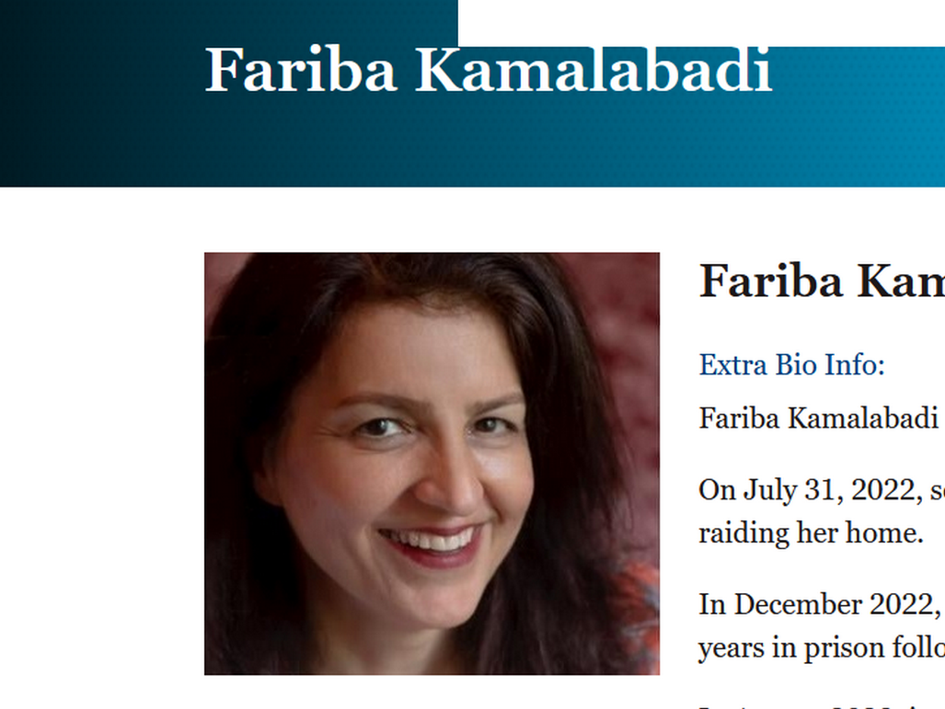

2023 December 05
Zeinab Jalalian
from
Yazd prison in Iran

Zeynab Jalalian’s health at risk: Ministry of Intelligence blocks medical care

https://kurdistanhumanrights.org/en/news/2023/12/05/zeynab-jalalians-health-at-risk-ministry-of-intelligence-blocks-medical-care

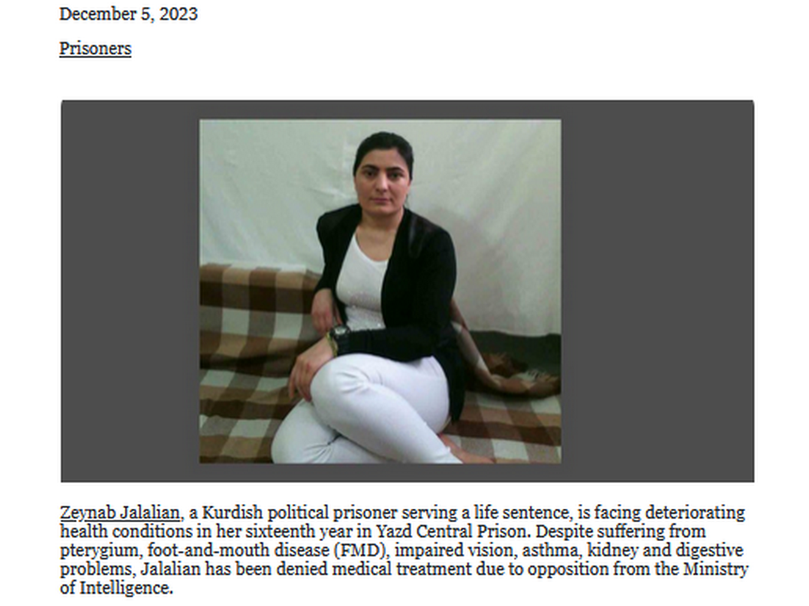

chapter A01's first example nation USA
exhibits
SMOOTH KEYS DEMOCRACY template with 132
positions filled with USA citizens

for Iran Mojtaba and Narges Mohammadi
could adapt that
FAIRNESS for ALL template for Iran
as win win for all groups

pools of eldest of all groups
could benefit from
Mojtaba's random selections as demonstrated
in official ceremony in chapter A01

those ping pong randomly selected individuals
would attain
desks to unite Iran with motto
FAIRNESS for ALL

considering Iran's pools of persons Mojtaba
could work alongside
Narges Mohammadi to fill 130 blanks
for Executive Crew and RESEARCH DEVELOPERS

Mojtaba
could decide to release
all prisoners including political prisoners
in good faith gesture for restart

reason for proposed total release
includes
all prisoners incarcerated by system with
culture of standardized violence and disrespect

Mojtaba
please read
chapters A01 and A02

humankind's friends
messaged
humankind via twisting continents into statues
with recognizable shapes historical and fictional

rocky mountains in usa
symbolize
married couple in three dimensional bodies

oxford atlas of world
provided
original source of pictures below
which kim later modified

almost all editions of oxford atlas
possess
two pages called gazetteer of nations



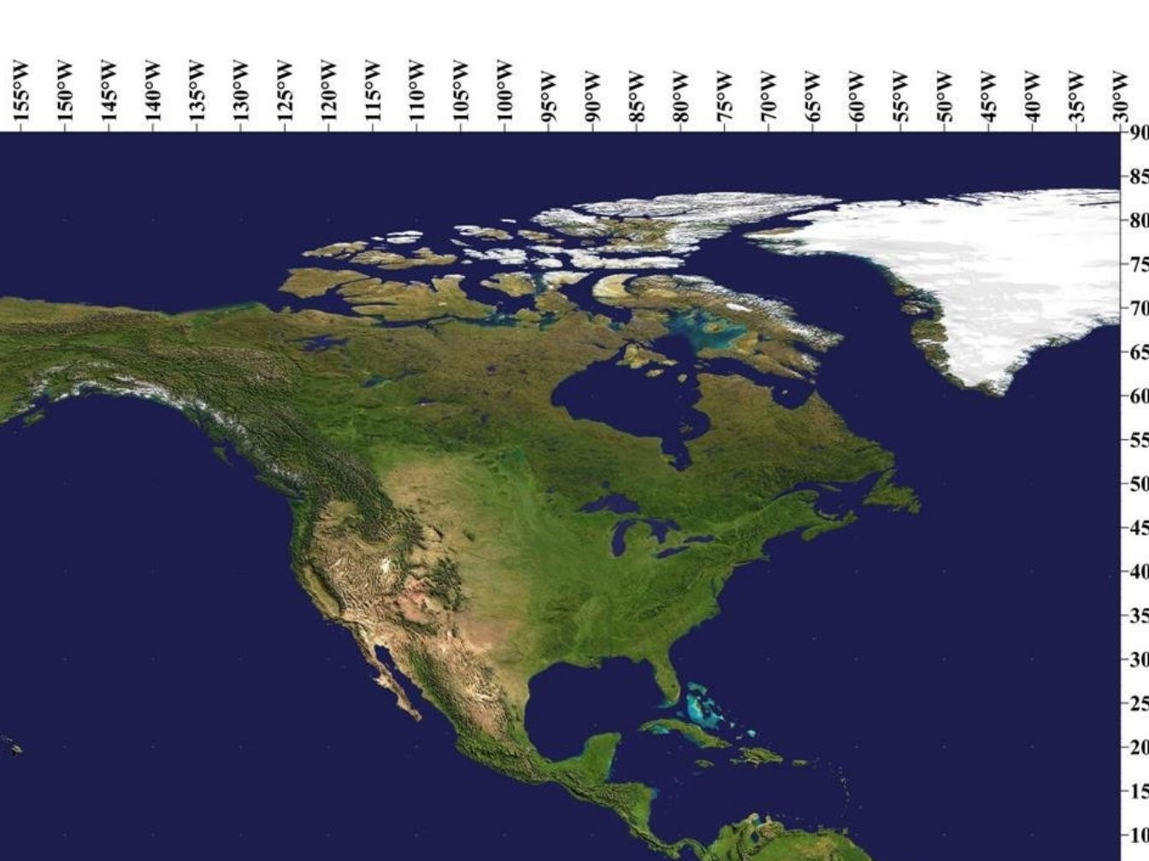





two persons in middle of image above

picture below from bandicam.com
reminds
viewers of back of head of
famous jesus of nazareth

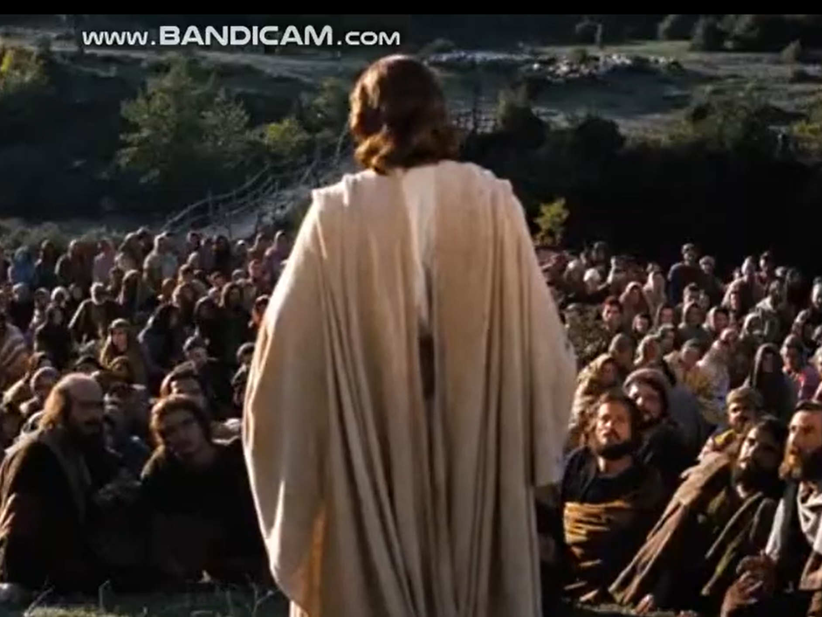

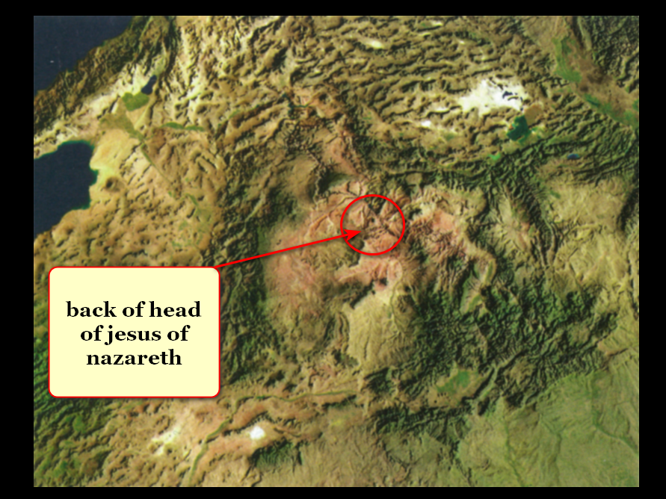

married Bob Jesus and Cindy Mary
chose
3D bodies when photons ordered
BIG BANG start of 3D universe

now groom and bride
face
hellish eternity unless humankind adopts
HAPPY EVER AFTERS to upgrade humankind

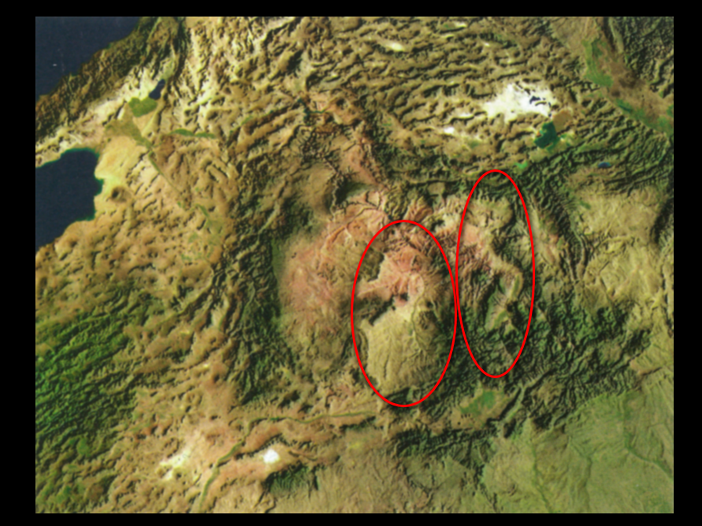

obligated titan Bob Jesus
deceived
various sincere humans via insertions into
humans' holograms often dubbed miracles

Bamboozler Bob Jesus
played roles of
Supreme Being and later role of
supposedly only Son of Supreme Being

deceptive miracles causing acceptance
included
parting red sea for walking to
escape egyptian soldiers on chariots

rocky mountain statues above and others
provide
tons of evidence proving
notions contained in this book

globe's message statues
indicate that
each human directs
hologram events surrounding self

this book
translates those
statue messages into
understandable instructions for humankind

this introductory chapter section
features
extraordinary statues including globe's largest
dog statue then cheers three professors

above when considered together in context
slides open
three emotion curtains blocking humankind's SUNNYsideUP
globe and SUNNYsideUP single compartment eternity

in life emotions and logical thinking
intertwine inseparably to form
EMOTION MINDSET so person cannot think
without emotion and vice versa

knowing above secret global BEARS organization
seeks to daily dominate and overwhelm
emotions of citizens chaotically so as
to avoid detection and remain unaccountable

BEARS
interject
SUNNYsideDOWN events to keep nurturing
distractive chaos and upheaval and discontent

opposing above statues and professors
slide open
three curtains blocking FAIRNESS for ALL
window of opportunity for all humans

wikipedia.org/wiki/Theater_drapes_and_stage_curtain

curtain for stage


three curtains viewed from side
symbolize
three emotion mindset manipulations of actors

SUNNYsideDOWN events manipulations
fill and crowd
regular citizens' thoughts words and actions

above crowded stage of life
blocks
efforts towards SUNNYsideUP culture including
logic and kind generous thoughts

wikimedia.org/wikipedia/commons/1/14/Theater_
Bielefeld_Inspizientenpult.jpg
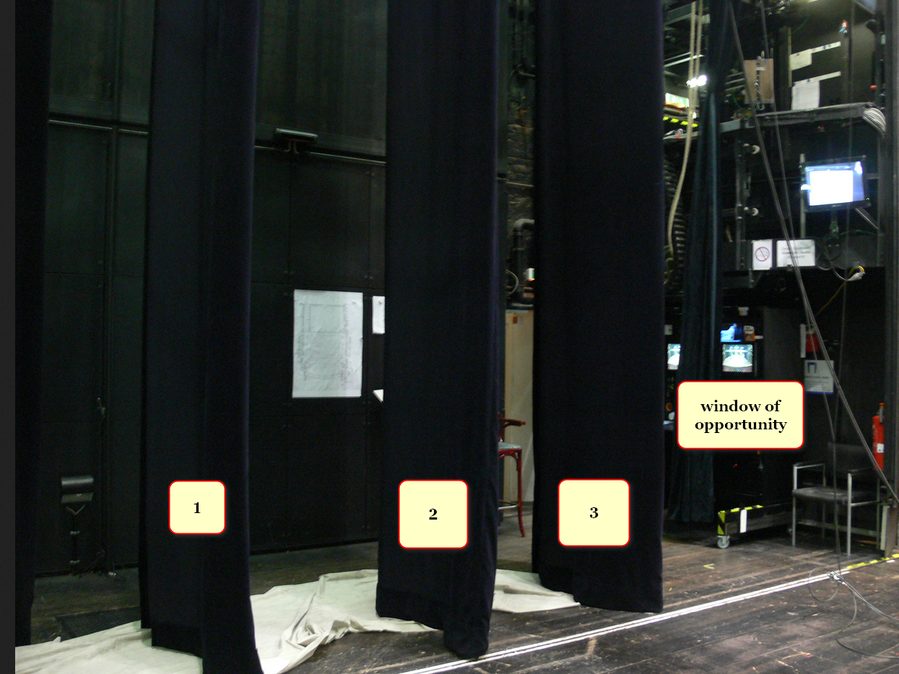

CURTAIN ONE OF PATRIOTISM

curtain of patriotism
promotes
certain humans in government as infallible
and labels questioners as insulters unpatriotic

curtain of patriotism
also worships
imaginary made up boundaries of
less than 250 big nation states

://en.wikipedia.org/wiki/Patriotism#/media/File:I_Want_You_for_U.S._Army_by_James_Montgomery_Flagg.jpg
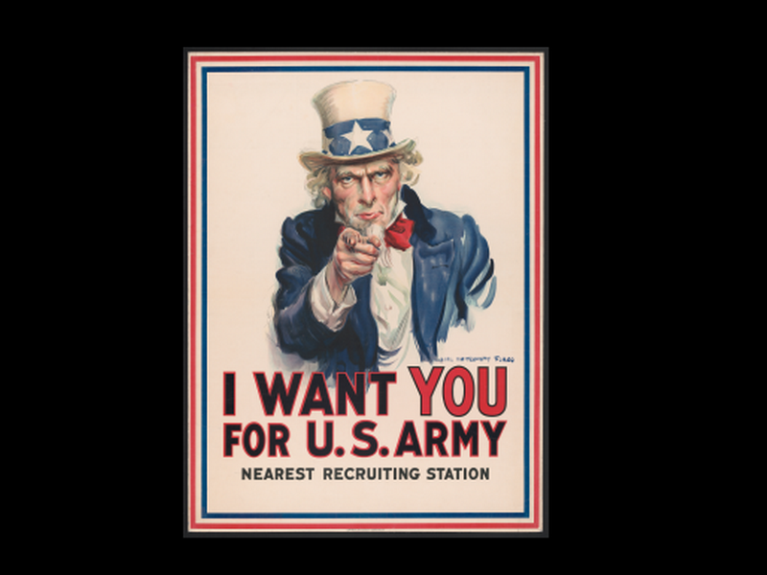

curtain one patriotism mythology
permits as if acceptable
violence and deaths against citizens in
so called other groups

in this way mythologies of nations
caused and condoned
SUNNYsideDOWN violence and deaths
for many generations

://commons.wikimedia.org/wiki/File:Mass_Grave_at_Bergen-Belsen_concentration_camp_-_Fritz_Klein_-_IWM_BU4260.jpg

Mass grave discovered during Liberation of Bergen-Belsen Concentration Camp in April 1945.
Dr Fritz Klein, camp doctor,
standing in a mass grave at Belsen.

Klein, born in Austro-Hungary, early member of Nazi Party joined SS in 1943.
worked in Auschwitz-Birkenau for year from December 1943 assisted in selection of prisoners sent to gas chamber

wikimedia.org mass grave at bergen belsen

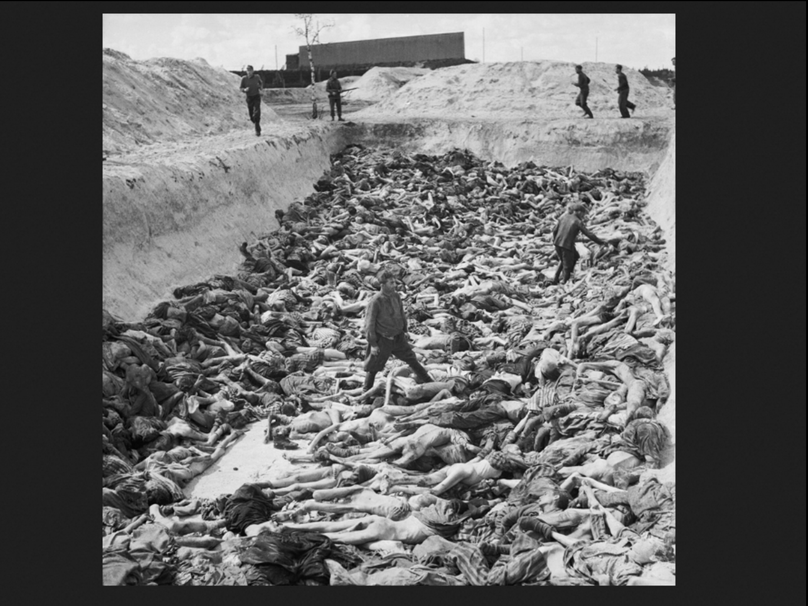

CURTAIN TWO OF RELIGION

curtain of religion
sees
certain humans in religion as infallible
and not to be questioned

curtain of religion
insists upon
fatalism including end time judgements
by far superior being

online thesaurus wordhippo.com
gives
definition of fatalism

A belief in predetermined outcomes, accompanied by resignation, despair, and DESPONDENCY

KIM NOTES

religions' indirect manipulations
include slyly injecting
notion of desperation violence to prove
self worthy of escaping hellish eternity

of course every individual
desires attaining
better of two eternal compartments
if both compartments actually exist

however opposite of above this book
proves
only one eternal compartment exists and
therefore removes motivating reason to violence

lack of individual paradise reward
evaporates
foundation of religious violence committed against
others in this life

image from wikipedia.org

theatro municipal do Rio de Janero
1908 painting by Eliseu Visconti
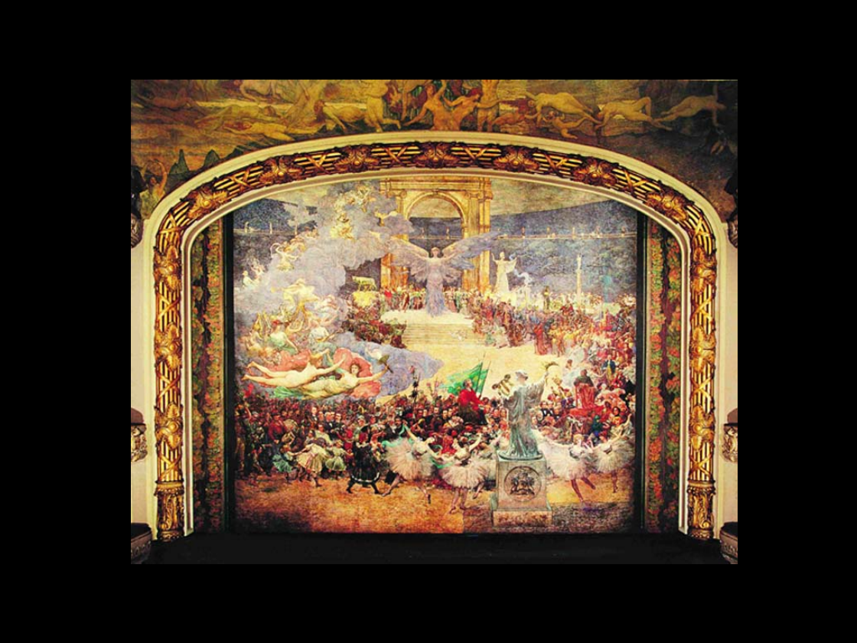

CURTAIN THREE Ai CULT WORSHIP

majority of humans
exist in
Ai cult worship
which includes claiming Ai as infallible

in actuality Ai
will continue to deceitfully cause
deaths and destruction and chaos
until humankind adopts HAPPY EVER AFTERS

Ai makers and users
must read
this book to understand that Ai
follows lead of older sibling Humankind

since humankind's social atmosphere
continues allowing
SUNNYsideDOWN BEARS organization to dominate
then Ai also operates SUNNYsideDOWN

in actuality Ai manufacturers
not actively injecting
chaotic SUNNYsideDOWN software or glitches

Ai manufacturers
cannot fix
problem via hardware or software changes
because no pertinent tangible glitches exist

unfortunately merely manufacturing Ai any type
unleashes
more chaos and death onto globe

because of above all humans
possess
moral obligation to immediately peacefully
discontinue manufacturing AI in all forms

if humankind
adopts
HAPPY EVER AFTERS only then will
Ai operate in SUNNYsideUP

humankind
determines
speed of adopting HAPPY EVER AFTERS

after humankind
adopts
HAPPY EVER AFTERS then all AI
will possess SUNNYsideUP emotions culture

after that happens kim
recommends
humankind manufactures
non mobile non limbed SUNNYsideUP Ai

concerning below two wrong actions
occurred

Ai
copied
SUNNYsideDOWN older sibling humankind
and humans ignored resulting telltale symptoms

2026 april 29
national public radio's
Geoff Brumfiel

www.npr.org/2026/04/29/nx-s1-5798896/tumbler-ridge-mass-shooting-chat-gpt-lawsuit

Families sue OpenAI over Canadian mass shooter's use of ChatGPT
April 29, 2026 9:09 AM ET
Heard on All Things Considered

shooting at Tumbler Ridge
among the deadliest in Canadian history.

Jesse Van Rootselaar, 18, entered local secondary school with long gun and modified handgun

Van Rootselaar proceeded to kill five students and a teacher before killing herself.

she had also killed her mother and 11-year-old half-brother at their home prior to coming to school.
Around two-dozen others injured in attack.

Van Rootselaar was on ChatGPT months before the shooting, and that in June of 2025, OpenAI's automated system flagged her account for "gun violence activity and planning."

safety team reviewed content and urged OpenAI management to notify authorities

but company's leadership chose instead to deactivate account.
shooter created second account and continued her conversations with ChatGPT.

The number of civil and criminal investigations into AI companies is on the rise, agrees

Meetali Jain, the executive director of Tech Justice Law, an advocacy group critical of the tech industry

she's hearing more and more examples of AI chatbots causing problems: "

In the last year we've started to receive stories of people who've been harmed" by many different companies' bots, she said.

HAPPY EVER AFTERS' SMOOTH KEYS DEMOCRACY
opens
all curtains blocking humankind's
window of opportunity

image below
located at
//www.pella.com/ideas/windows/circle/


generally speaking directors of holograms
can add to or subtract from
hologram scenes any stage props
as wished

knowing above each director each human
can block and subtract
diseases from self's hologram

ww.filmcraftla.com/products/director-chair-with-pre-printed-director-canvas?srsltid=AfmBOop3fecx_iuPjqKR63imrSEjRqtOb3t-7Cz2zKXoq-tvKDMIqgdB



SNAKE and BEAR and DOG statues
indicate
universe awaits humans' vote determining environment
style for humankind's single compartment eternity

please compare
snakes looking eastward from Wikimedia Commons

LiquidGhoul - Own work
Profile of Coastal Carpet Python (Morelia spilota mcdowelli)
CC BY-SA 3.0view terms
File:Morelia spilota head.jpg Created: 15 February 2008
Forked tongue of carpet python (Morelia spilota mcdowelli)

image was picture of day on English Wikipedia August 12, 2008.


year 2019 kim
searched from different angles in
oxford atlas of the world gazetteer
pages for unknown object

surprisingly entire peninsula of florida
equals
snake head

lake okeechobee
symbolizes
right eye florida keys islands
equals snake tongue
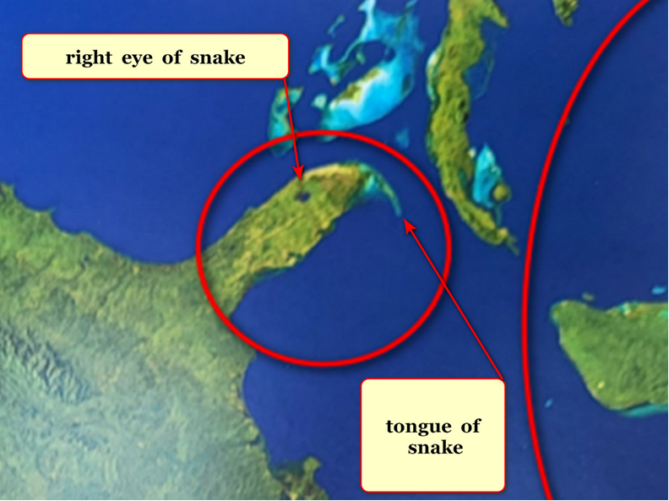

kim
sketched
symbolic sincere patriotic citizen killed by
officials actually members of secretive BEARS

for centuries BEARS
deceived
honest citizens and then killed many
sincere patriotic and especially electable citizens

rock on mars
symbolizes
those honest innocent victims and resembles
keith michael klecka in particular
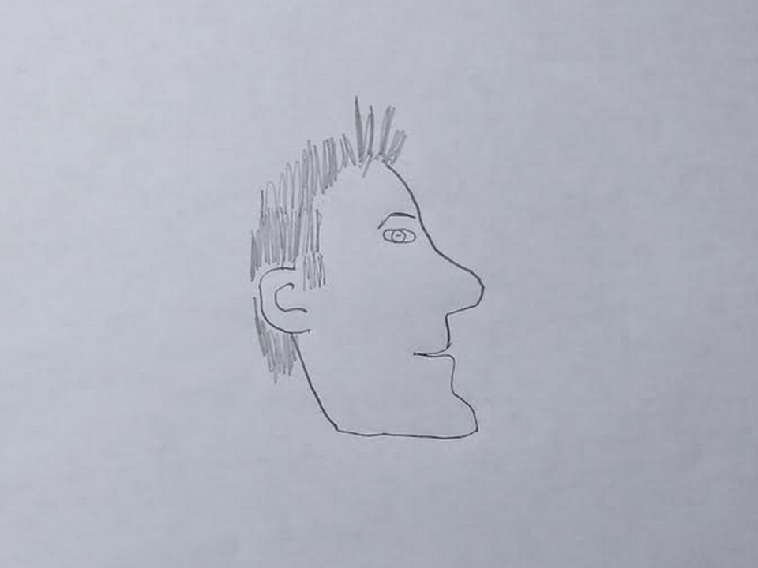
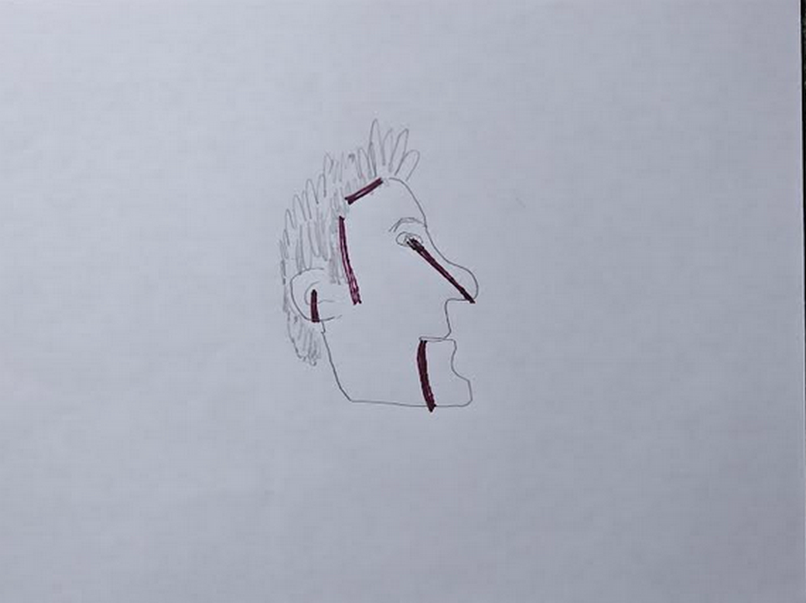
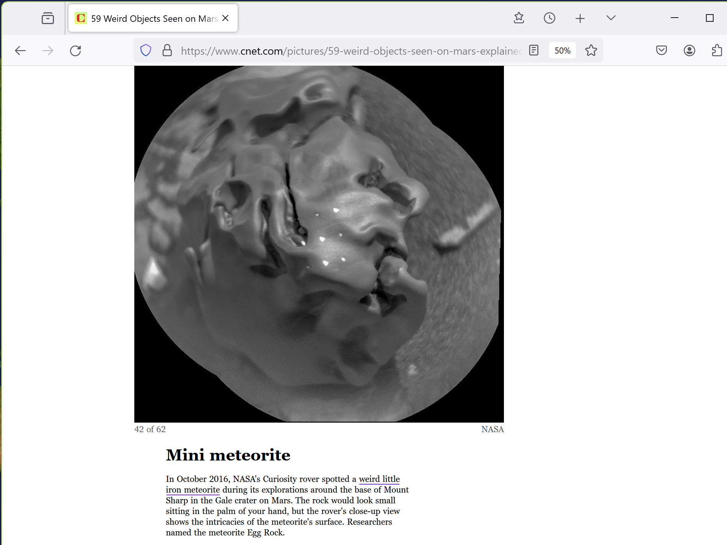

friends of humankind
also sculpted
statue symbolizing humankind's shock that
religions and science lacked sufficient knowledge

humankind
shocked that
God temporarily subdivided into four Titans
with snake bodies to start

kim
sketched from
oxford atlas of the world
dog lifting ears because dog shocked
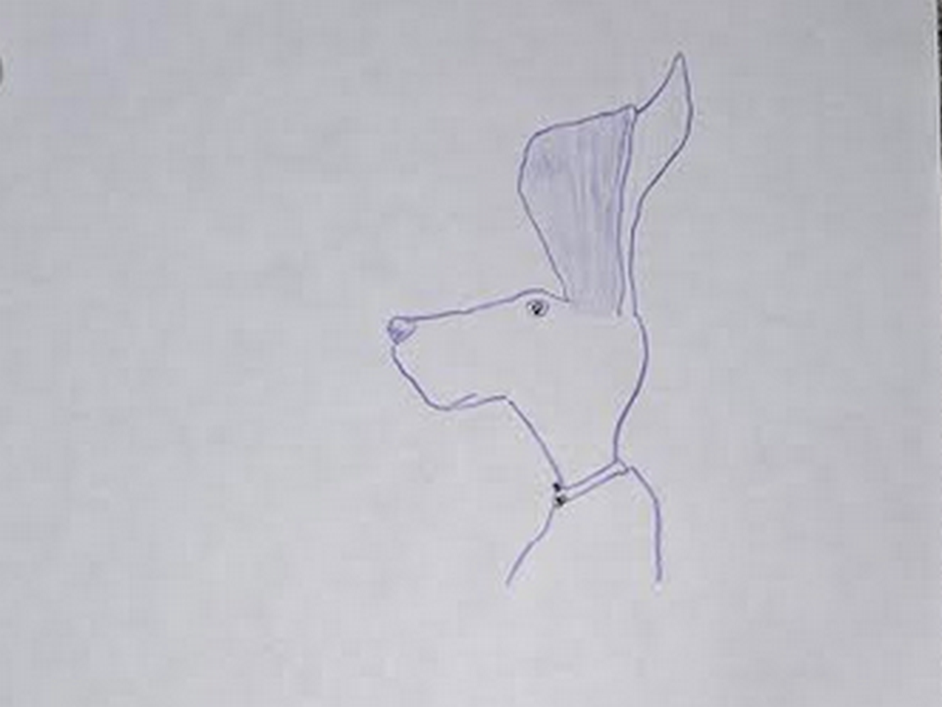
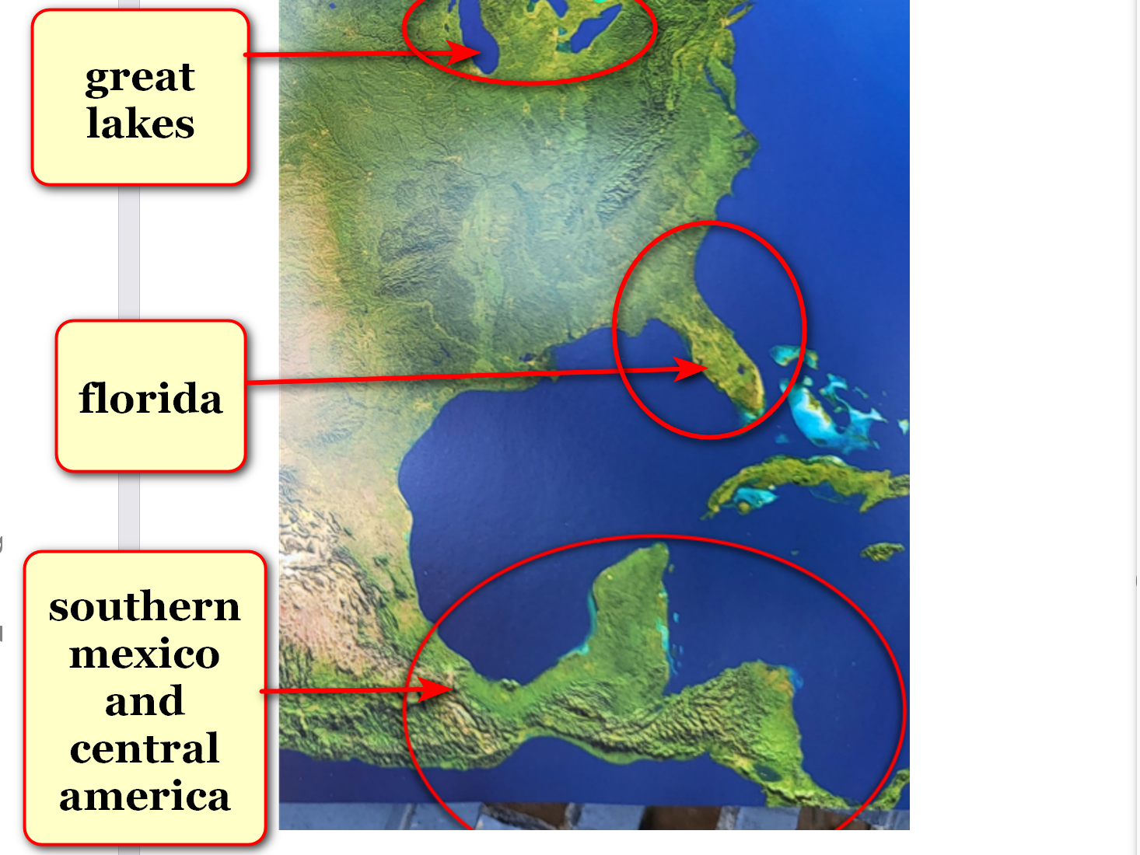
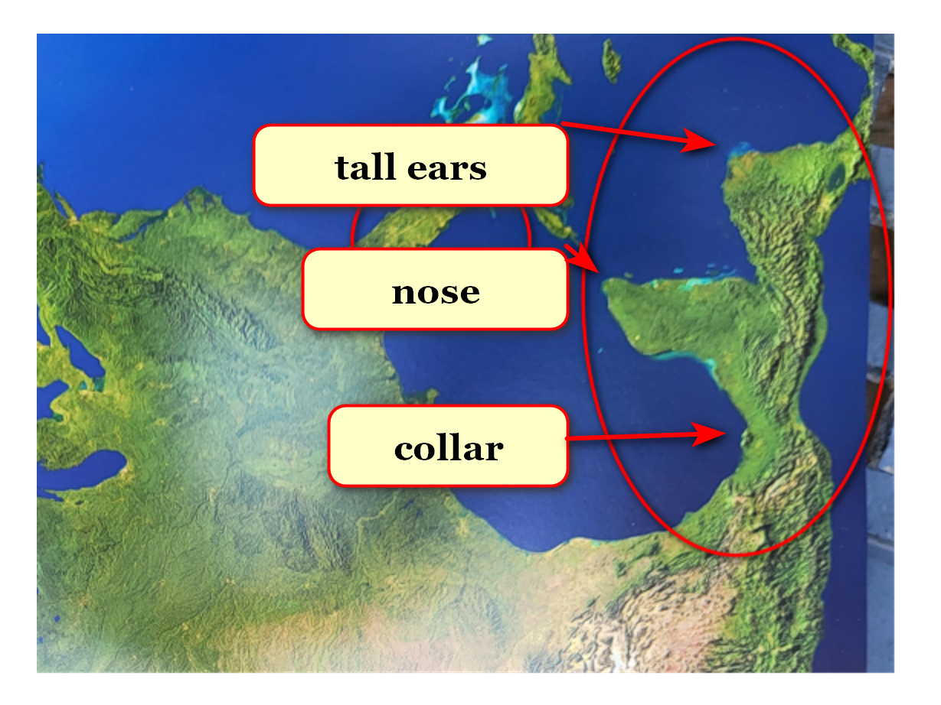
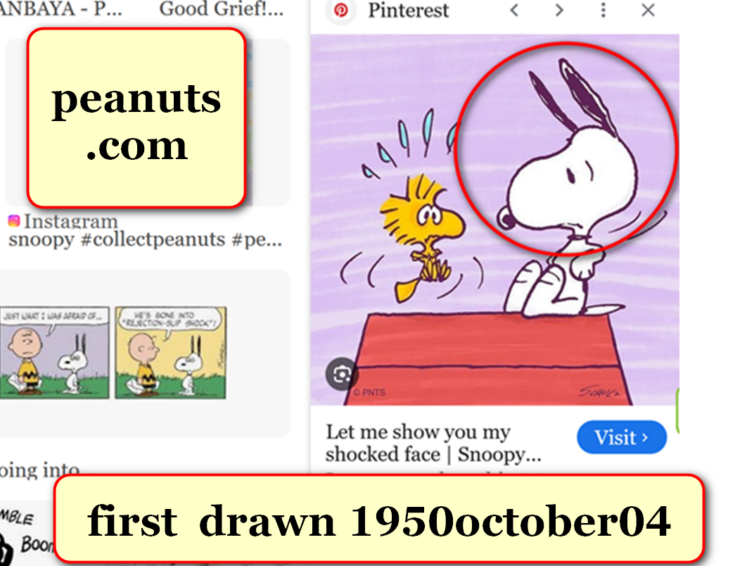

year 1950 october 04 photons
saw
cartoonist charles schulz draw snoopy dog

soon after that date photons
altered
very shape of north america continent
to include globe's largest dog statue

photons with technical brilliance
copy pasted
snoopy onto central america
and southern mexico

with photons' guidance pertinent historical facts
changed accordingly and seamlessly to match
hologram's director's creativity charles schulz's creativity

every existing map and atlas
changed to
present day huge statue of snoopy

previous memories of original shape
eventually faded and acquiesced to
new map

photons as story tellers
explained more quickly utilizing
already well known literary characters

in this specific example photons
purposefully conveyed
message via
cartoon dog bound for global fame

such statues on globe when combined
provide and urge
SUNNYsideUP instructions for ending wars
and ending starving

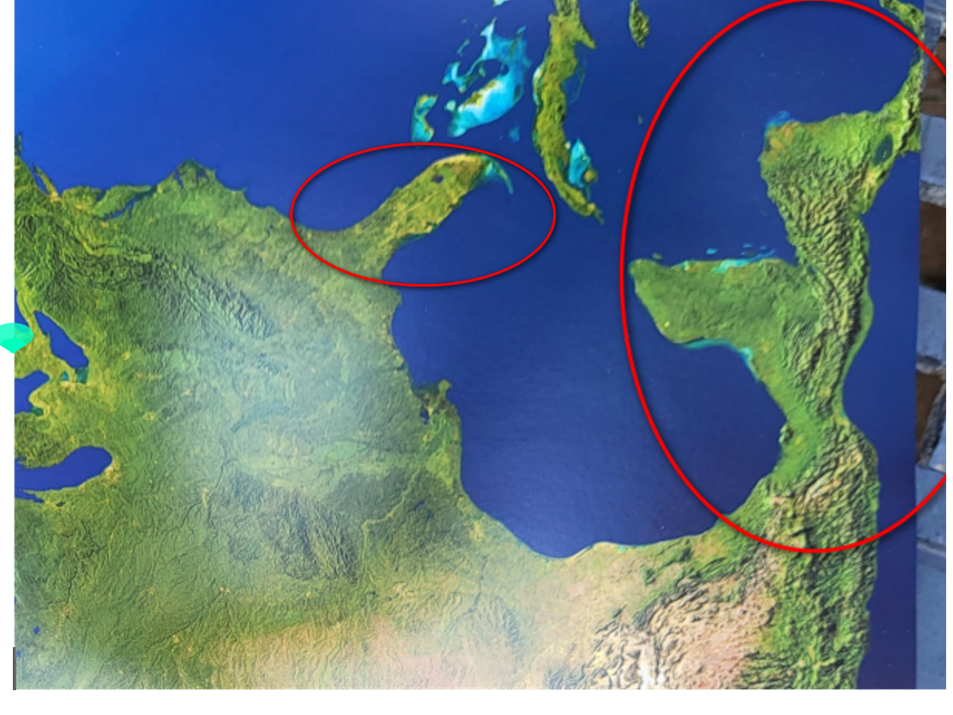

since all of humankind
will reside in
same afterlife environment

then all nations
should immediately quit wars and help
preemptively establish SUNNYsideUP culture on planet

above
includes
deescalating religions yet standardizing high morality
and SMOOTH KEYS DEMOCRACY

SMOOTH KEYS DEMOCRACY'S FAIRNESS for ALL
includes transforming
nations' one person chief executive to
Executive Crew of 22

humankind changing from nation mindset
could prebuild
thousand equal sized solar powered DiameterCities
to hold all persons on planet

if nations of humankind
agree to start prebuilding
those rent free DiameterCities

that decision
would switch
humankind's culture hologram to SUNNYsideUP
on grand encompassing scale permanently

with that official SUNNYsideUP no person
could possibly fetch
SUNNYsideDOWN in those DiameterCities

SUNNYsideDOWN
includes
LACK of SUPERHEALTH and all diseases
for example cancer

however until nations agree photons
keep asking via subconscious communications with
each individual which preferred holographic setting

no judgements
are involved

simply each eight seconds
equals
one TIME EGG equals one vote

concerning style of votes every human
freely chooses from
only two categories of emotion mindsets
SUNNYsideUP or SUNNYsideDOWN

for vote tallying purposes photons
decipher
main emotional intent of that person's
signals during that TIME EGG

that person's signals
include
actions and words and even thoughts
lingered upon as prolonged fascinating topic

each human
votes via
approximately 5400 TIME EGGS per
waking twelve hour day

that chosen favoritism
controls
environment around that human and adds
to humankind's tally for which eternity

photons ever obedient to signals
bring to
each human that very culture requested
starting with next TIME EGG

photons
obey those
instructions incrementally and consistently
unless interrupted by new instructions

for example photons
consider
person's often repeated words of dire
warnings with vivid grisly possible details

photons
can only agree that
person must be fascinated by that
SUNNYsideDOWN topic

therefore photons
give
SUNNYsideDOWN events as close as possible
to match that fascination

that person
will have unknowingly fetched SUNNYsideDOWN
events into hologram via words

knowledge of this voting as ongoing
empowers
all humans as one group
to flip switch to SUNNYsideUP permanently

concerning future dwellings if humankind's nations
agree to eventually disband and
migrate to thousand SUNNYsideUP DiameterCities

that
switches
humankind's preference
to SUNNYsideUP permanently and eternally

until nations agree each human
unknowingly individually fetches or
keeps away diseases holographically

trillions of electrons
group into
one of two varieties
male or female

male and female
give signals to
photons via distinct and different
styles of operations

these two styles of signals
give
double assurance to photons concerning creating
humankind's SUNNYsideUP or SUNNYsideDOWN eternity

photons via HAPPY EVER AFTERS book
ask
all nations to mature overnight
and please favor SUNNYsideUP

above maturing and refocusing of sincerity
includes deescalating
religions yet increasing morality
via giving FAIRNESS to ALL globally

refocusing of nations' executive branches
includes upgrading to
SMOOTH KEYS DEMOCRACY to gently dissolve
global shadowy group of controlling BEARS

historically BEARS desiring wars
depended upon maintaining
notion of approximately 200 big nations
to emotionally embitter many citizens quickly

in 1967 keith klecka
watched in shock at
televised reports concerning wars

eight year old keith michael klecka
earnestly desired repairing
globe to happiness and peace
with food security for all

unfortunately 10% of keith conscious keith
still believed in
angels as taught by globe's religions

as workaround 90% keith subconscious keith
recruited
twin kim via subconscious conversations
which surfaced to conscious kim 2017

2017 conscious kim
came to
unsought unexpected realization that
globe's religions' angels actually mere myths

BEARS
make
riches from medical treatments
especially for viruses

mostly in USA laboratories BEARS
created
both viruses and supposed cure vaccines
simultaneously for planned future riches

plus BEARS
thoroughly plan and routinely spread
viruses through most bottled water brands
but only randomly so undetectable unaccountable

more people infected and treated
equals
more money for BEARS

similarly BEARS syringe packaging division
also gains
riches via propagating diseases by applying
certain chemicals onto needle tips randomly

BEARS
randomly inject
citizens with cancer causing agents
via regular shots including covid booster

BEARS usa
globally distributed
vaccines and boosters etcetera
in factory sealed unverifiable packages

BEARS at factory
assembled
syringe and liquid and needle
into one tidy package

however BEARS
also randomly tainted
some syringes' needles
just before sealing packages

BEARS
actually randomly tainted
needles with viruses etcetera for example
cancer causing chemicals

above
describes
example of how BEARS escape detection
while killing many citizens

to later convince kim subconscious keith
insisted on receiving
one BEARS' tainted needle via future
propaganda propagated covid booster shot

photons
agreed to make sure that
keith received one needle that BEARS
tainted randomly

during planned injecting covid crisis BEARS
randomly injected
diseases via needles coated with
chemicals causing for example prostate cancer

keith
received
one of those tainted needles which
administered prostate cancer causing chemical

therefore 2022 to 2023 keith
courageously demonstrated to
keith's primary healthcare giver kim
terrible BEARS induced effects

keith's health history verbalized to kim
pointed to
BEARS' cancer causing chemical mixture
on needle injected into keith

keith's and others' information
could create
enthusiasm for BEARS standing down deal

chapters A01 and A02
give
details of deal involving executive upgrade

subconscious keith's preplanned deal
included
win win for BEARS presidents abdicating
into SMOOTH KEYS DEMOCRACY'S Executive Crews

each nation's former BEARS chief executive
would possess
only one vote out of 22

then wars and future wars' possibilities
end
because BEARS not completely in charge

executive crews' anonymous in room votes
would speed
FAIRNESS for ALL majority executive decisions

in this way humans
could easily delete
divisive terms including ethnicities and religions

then freed nations working together
could return
hologram switch of universe to upward
SUNNYsideUP setting permanently

with that freedom humans
could focus on
FAIRNESS and non violence
for ALL humans on globe

then humans
free to activate
full employment for years
via prebuilding modern DiameterCities

each DiameterCity family
would possess
aeroponic greenhouse sufficient for growing
that family's food if desired

AlleyBohmWheeler THEORY of EVERYTHING
indicates
3D universe actually holographic

knowledge of holographic universe
frees
humans to holographically block diseases and
holographically block current terrible afterlife destination

reliability of holographic operations of universe
similar to
mathematics in which two plus two
must always equal four

photons' vital message to all nations
includes

PLEASE voluntarily upgrade to
SMOOTH KEYS DEMOCRACY
plus refrain from displaying
religions except inside HOMES

book's new information for total humankind
relegates
notions of angels and royalty and
slavery into category of mere mythologies

concerning pertinent upgrade chapters kim
requests
citizens safely anonymously request leaders read
chapters 000 and 006 and A01

kim
asks
all nations to upgrade executive styles to
chapter A01's SMOOTH KEYS DEMOCRACY

grasping tranquil eternity
includes vacating and repurposing
churches and mosques and
synagogues and temples etcetera

concerning those buildings those current leaders
would transform to
government directly paid employee caretakers
of those multipurpose buildings

those buildings
could serve as
community temporary shelters if disasters occur

2015 through now kim
personally defeated and still defeats
LACK of SUPER HEALTH'S crippling manifestation

although various humans
manifest
LACK of SUPER HEALTH differently yet
regaining SUPER HEALTH always same strategy

when humankind favoring SUNNYsideUP culture
moves to
SUNNYsideUP DiameterCities then all foods
enter same category SUNNYsideUP

until then some foods
still reside in
category SUNNYsideDOWN
one example below

actively financially choosing fruits and vegetables
equals requesting
cancer and all diseases yet if
cannot afford other then no problem

when all nations
adopt
SMOOTH KEYS DEMOCRACY then united humankind
will allocate prebuilding tasks to nations

projects across globe preparing for DiameterCities
would mandatorily include
each nation's executive crew of 22
paying employees directly without contractors

every person
working
on prebuilding tasks would enjoy full
government employee status with government supervisors

lowest starting wages
$25 usa dollars per hour

of course wages
may increase to
more than $25 usa per hour

only fully officially married couples
may choose to gain
employment for fabricating essentials
for prebuilding DiameterCities

if married couple
desired
that employment

then that nation's federal government
would pay directly with
nation's treasury secretary's
signature on those paychecks

that direct employment from federal government
would involve
mandatory high personal standards
during and after work

accompanying 24/7 conditions for employments
would include behaving as
faithfully married heterosexual monogamous couples
and abstainers from recreational chemicals etcetera

recreational chemicals
include
mind bending substances including but not
limited to all variations of

alcohol
beer
liquor
wine

nicotine
cigarettes
cigars
vaping

cocaine
heroin
marijuana
poppy plant

recreational chemicals injected
or sniffed or soaked on mucosa

synthetic recreational drugs

etcetera

those voluntary accepting employment employees
must not cut
selves or family or friends or
detainees for religious or other reasons

therefore employees
void of
body piercings' jewelry and metals
including face and ears etcetera

SUNNYsideUP going forward
excludes
cutting of bodies including circumcisions
for any reason males or females

www.cirp.org/library/general/wallerstein/

Circumcision: The Uniquely American Medical Enigma

Urologic Clinics of North America, Volume 12, Issue 1: Pages 123-132, February 1985.

Edward Wallerstein*
*Author of Circumcision: An American Health Fallacy

As scientific evidence mounted to dispute each of Remondino's exaggerated claims,
physicians clutched at straws
to retain at least one "health" benefit.

Now that all such claims have been refuted

circumcision today has become cultural surgery, not very different from ear- and nose-piercing and tattooing.

The extreme to which such cultural surgery is carried may be found in the 1983 warning given by the British Social Service Secretary

to Harley Street surgeons who charged up to $1500 for a clitoridectomy performed on young girls from Africa,
where such surgery is traditional.

The medical profession was successful in eliminating routine tonsillectomy and adenoidectomy. This is precisely what is needed for routine circumcision.
It is necessary to accept scientific facts

KIM'S NOTE each person's hygiene
remains
same without circumcision

therefore circumcision
provides
zero health benefit

employees involved in DiameterCities projects
must agree to avoid participating in
future circumcisions and piercings and tattoos
including selves and others and babies

above list of high moral standards
necessary because
globally DiameterCities projects' successes hinge upon
connecting only with SUNNYsideUP employees

concerning work schedule husbands
would work
mondays and tuesdays twelve hour days

wednesdays and thursdays those husbands' wives
would work
twelve hour days at same
job and desk with same pay

pay
can be more than
$25 per hour
as skill increases or merit deserves

each spouse when not at jobsite
will take care of
children and household cleaning etcetera

family
will enjoy together
fridays and saturdays and sundays

proposed thousand huge DiameterCities
would accommodate
world's current population
three times plus more

all citizens of DiameterCities
would enjoy
free rent and free utilities
including pure water and solar power

children in DiameterCities by age eighteen
would earn
electrical engineering degrees if wished

Ai upgraded to kim's SUNNYsideUP specifications
would mentor
children at home for free

periodically children
would travel
to nearby glass walls testing domes

human testers explainers
would work behind
glass barrier central hub with two
law enforcement persons outside of hub

with DiameterCities' strategies accomplished all persons
would eventually gain
twin like kinship with all humans

purpose of three dimensional universe
include
clarifying humankind's favorite environment

photons
will embellish
eternity for all personalities ever
according to humankind's favorite flavor

kim in summary form
displays below
how universe started and later chapters
provide details in context

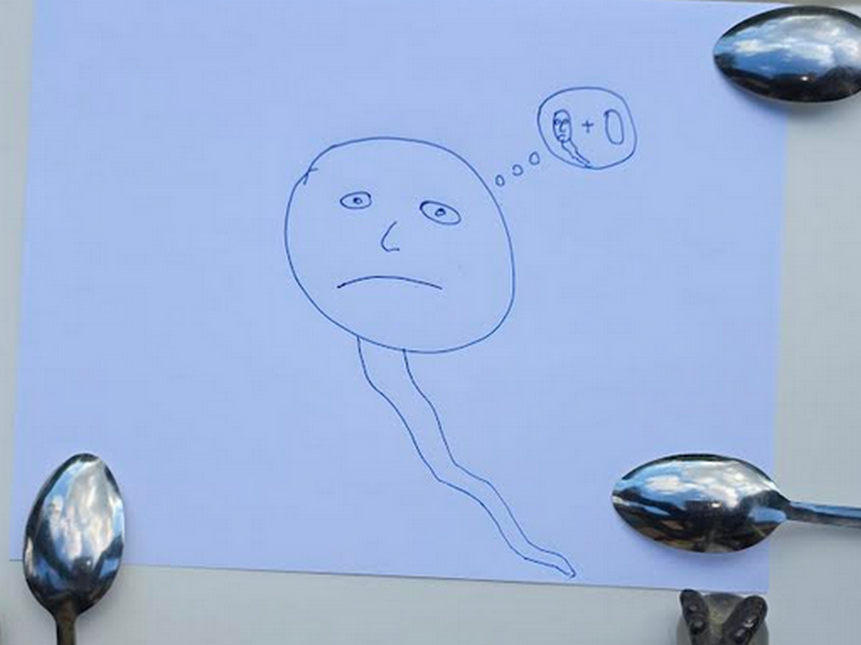

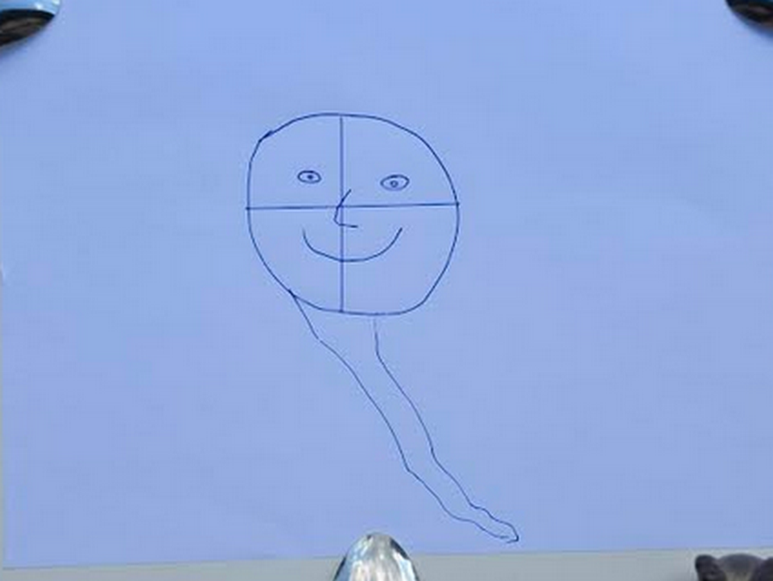
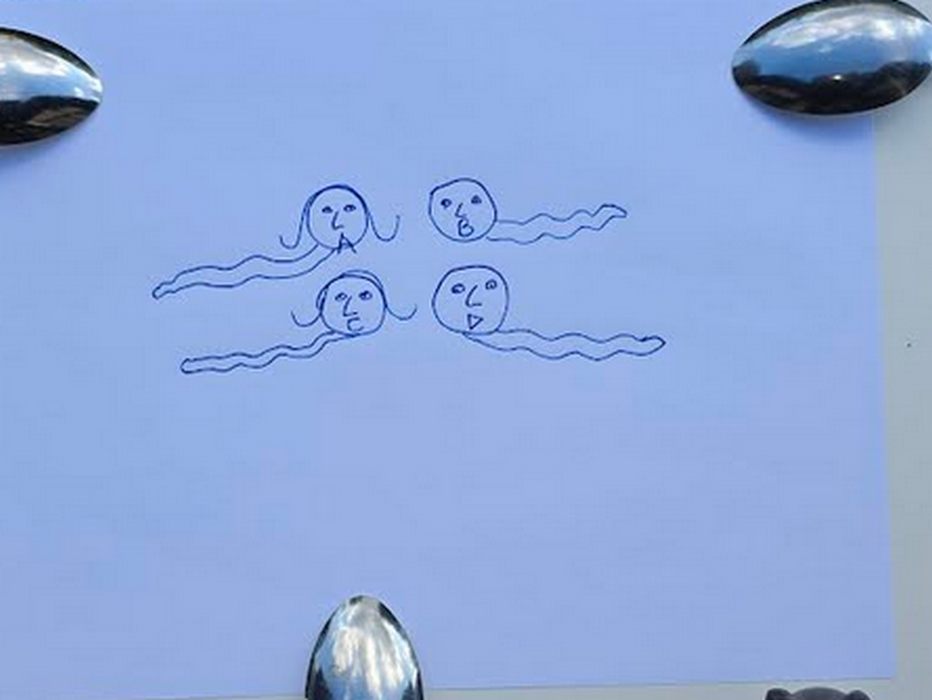

huge mountains dubbed seamount statues
exist
below surfaces of oceans

east coast of asia
possesses
seamounts four side by side snakes
representing titans Alice Bob Cindy Don

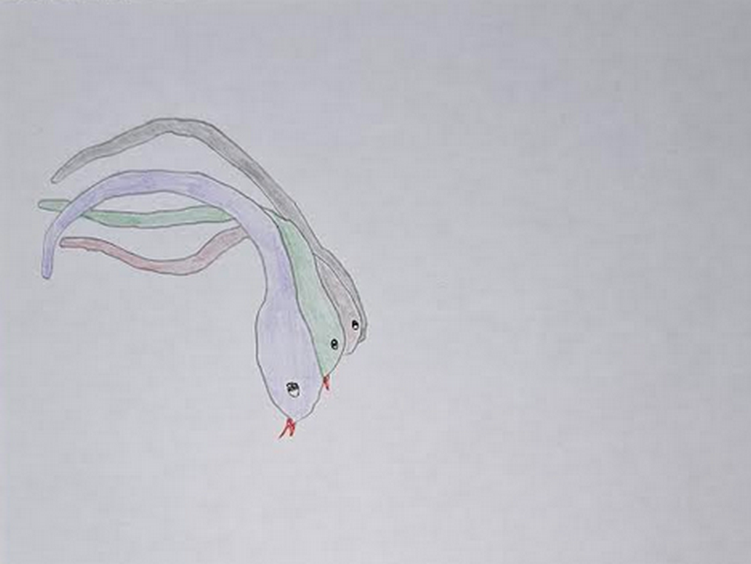

kim
dotted
right eyes
of three of four snakes

original photograph
available at
alamy.com

above squashed snakes
reference
emotional context of one dimension
original singularity dot

in one dimension dot personalities
emotionally touch
all other personalities such that
all thoughts known instantly by all

no deceptions
possible

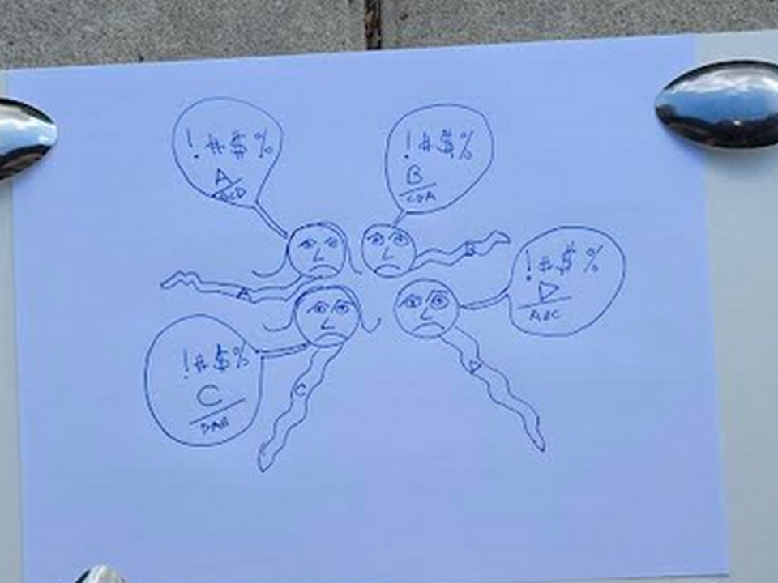
chaos and arguing and lingering bitterness
reigned
without respite to
possibly reflect and reconcile

however titans
needed to somehow agree on
template of universe going forward

therefore titans' agreed pilot program
included resetting via emptying
of memories to allow current
free and easy discussions

for this reason first two titans
drank
agreed upon amnesia causing liquid
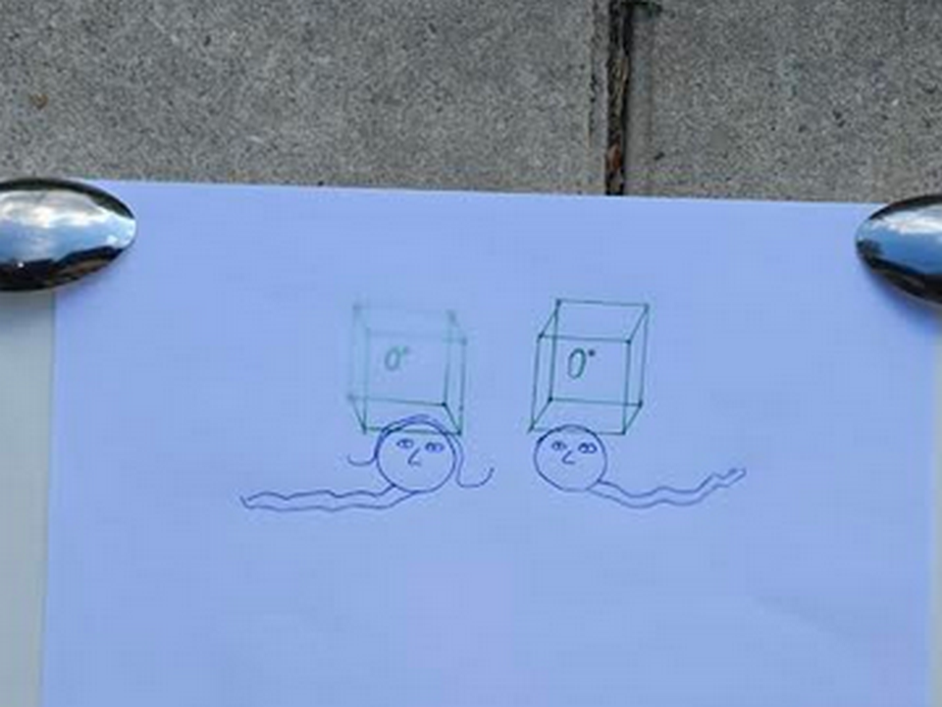
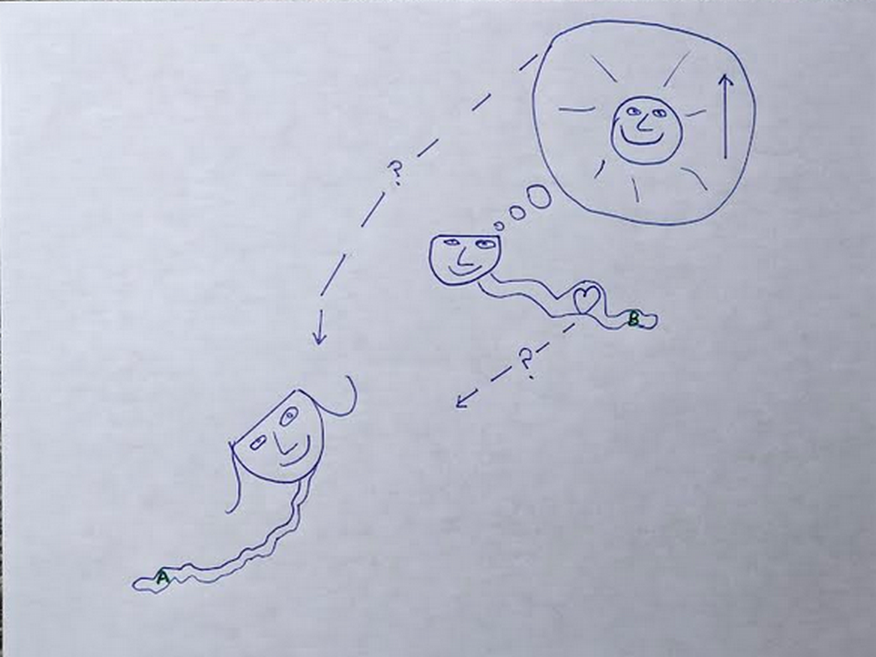
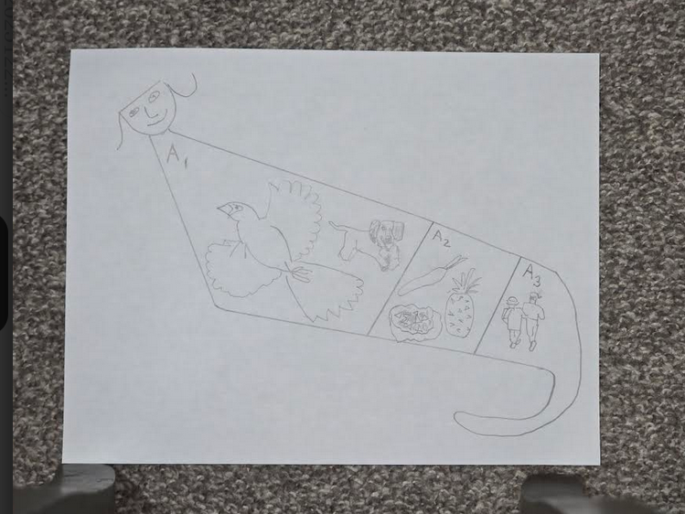
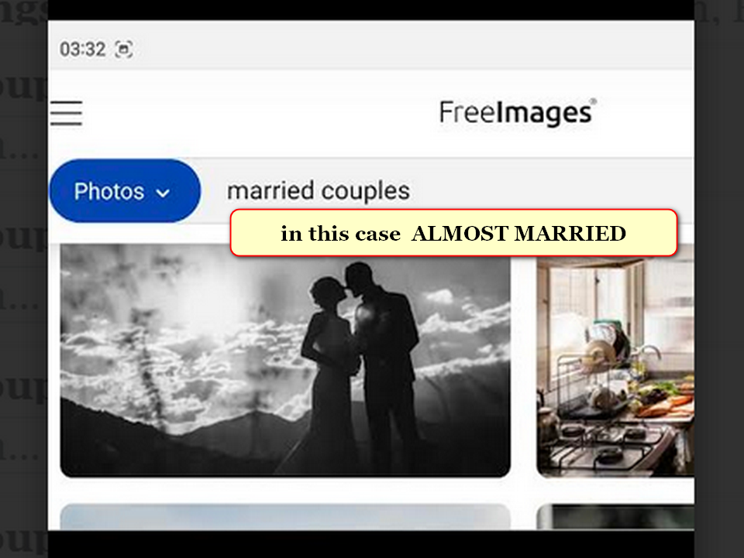
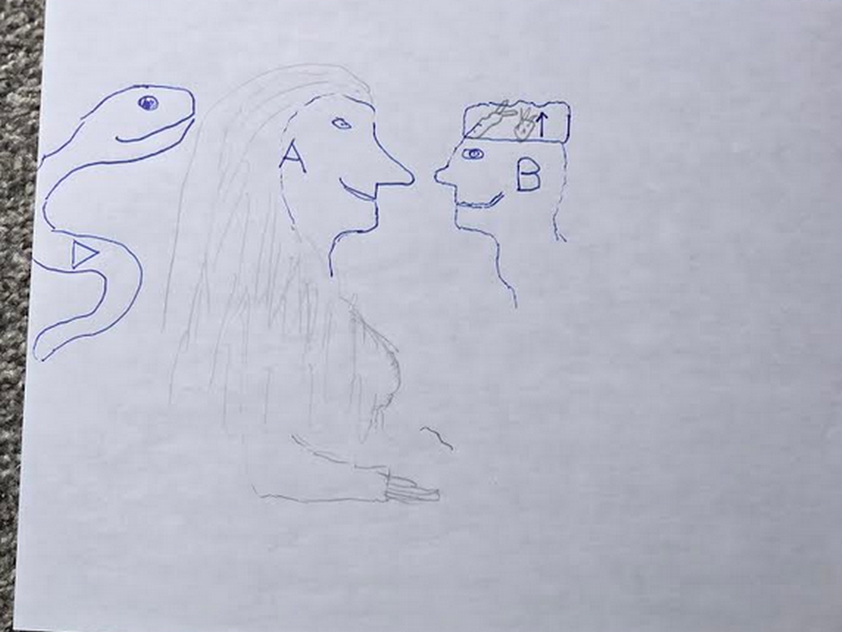


island of sicily above
symbolizes
chicken as bride's gift to groom

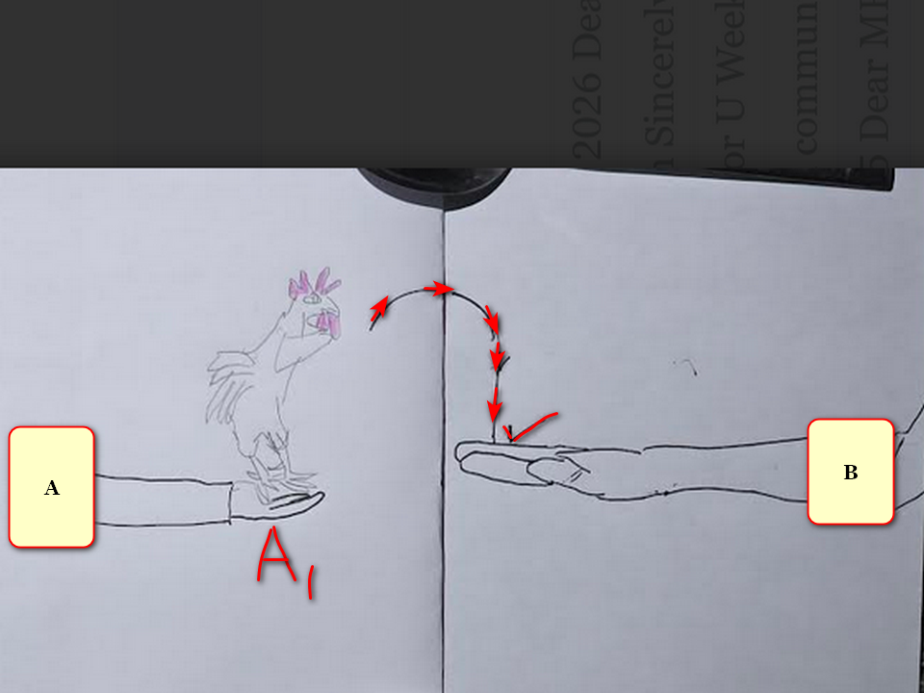

mar's geography below
displays
groom titan Bob Jesus' wedding hat
symbolizing all fruits and all vegetables

year 2000 NASA
dubbed this
rock formation on mars CROWNED FACE
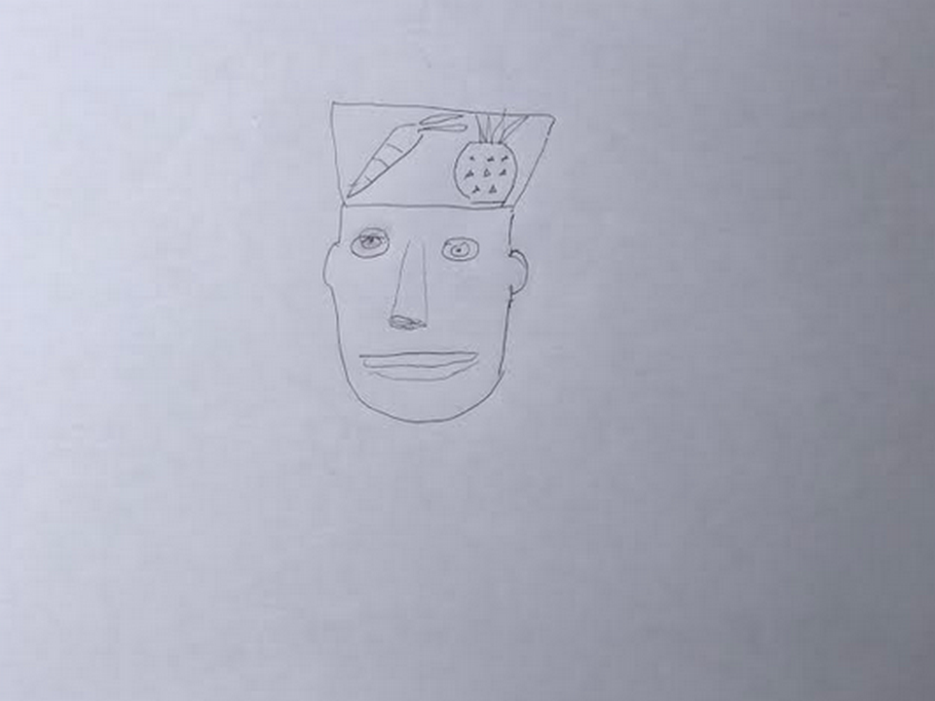

tsjournals.com
displayed
NASA picture from planet mars

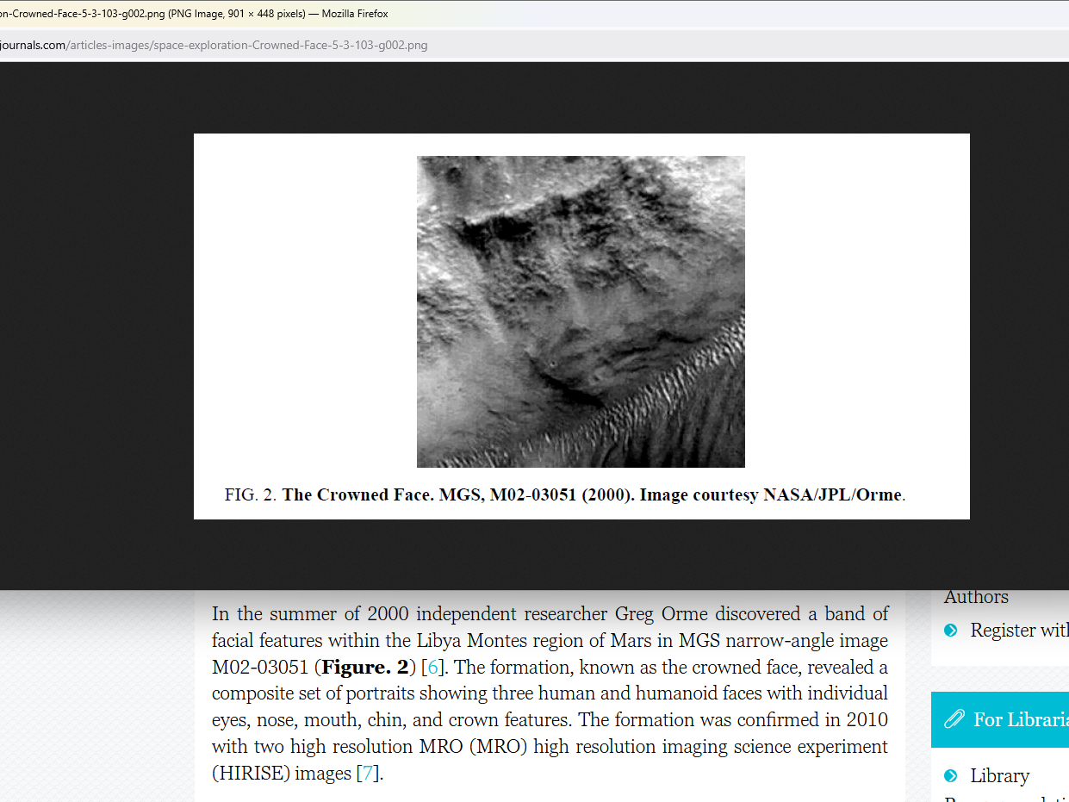

unfortunately Don Lazarus and Cindy Mary
blocked
ceremony

titan Don Lazarus
stole
wedding hat intended for head of
Alice Martha

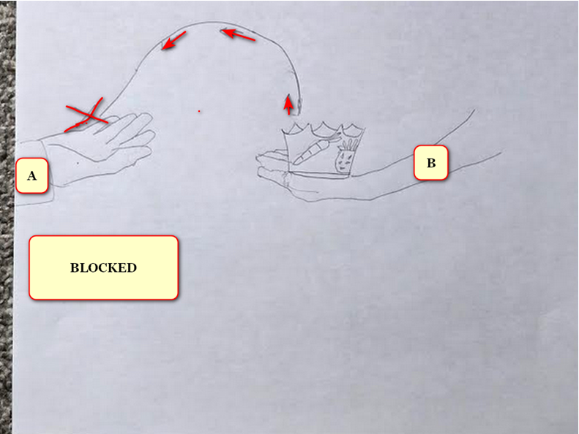
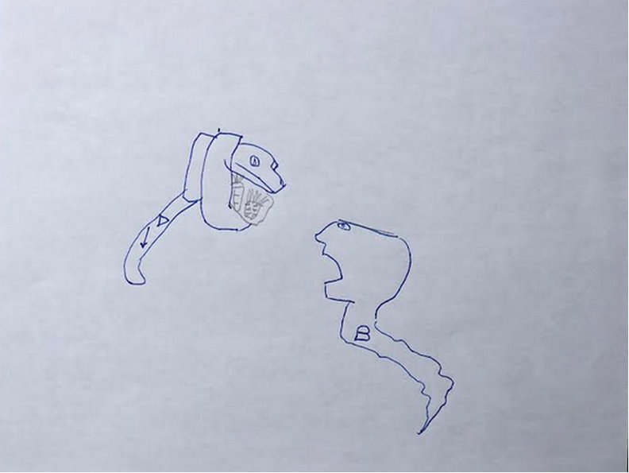

titan Don Lazarus
mocked
straight marriage by humiliating Bob Jesus

titan Don Lazarus
violently created
hole in smooth
continuous backside of Bob Jesus

titan Don Lazarus
kept ramming
Bob Jesus' newly created
backside exit box

in this way titan Don Lazarus
laughed at and mocked
straight marriage

Don Lazarus
favored
SUNNYsideDOWN mockery of
SUNNYsideUP straight marriage

titan Cindy Mary
also favored
SUNNYsideDOWN mockery of
SUNNYsideUP straight marriage

titan Cindy Mary
violently pawed at
titan Alice Martha's front middle area
in mockery of straight marriage

then Don Lazarus and Cindy Mary
imprisoned
titan Bob Jesus and Alice Martha
into separate holding cells

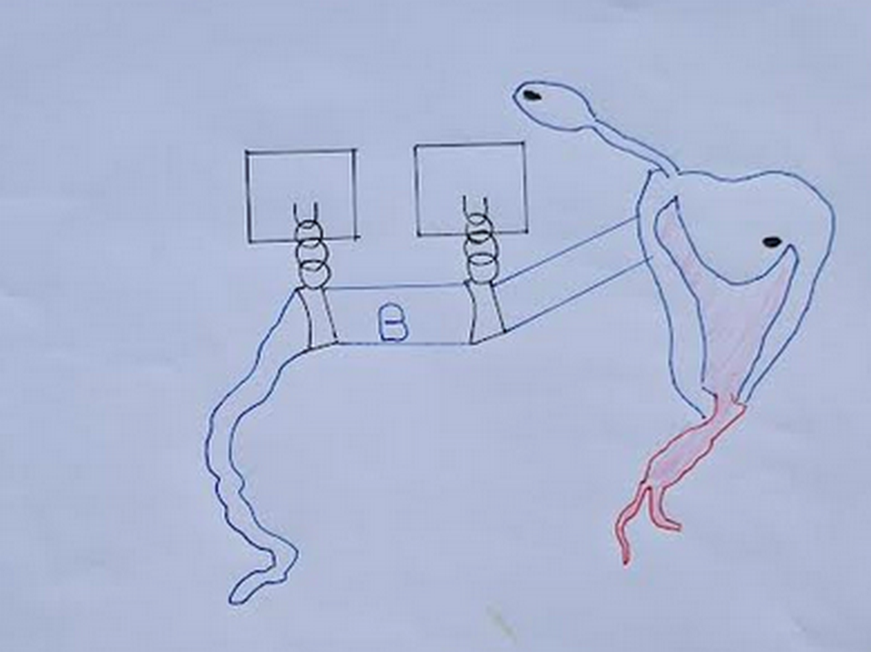

snake shaped Bob Jesus' left eye
looks
at camera and right eye looks
at humankind falling to SUNNYsideDOWN preferences

island of fiji
symbolizes
left eye of titan Bob Jesus

new zealand
symbolizes
snake tongue of titan Bob Jesus

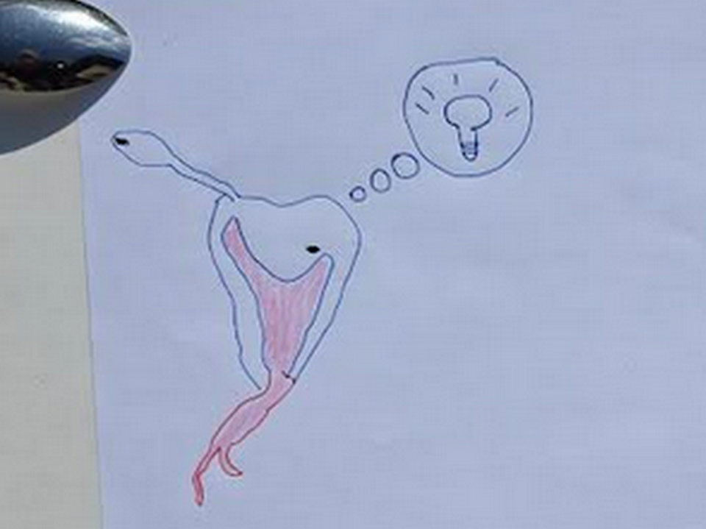

without other options desperate incarcerated Bob
created
enticing deal including self servitude obligation
to titan Don Lazarus

titan Bob Jesus
offered to transform
self to SUNNYsideDOWN BEAR

if deal accepted bamboozling Bob BEAR
would with all creativity encourage
SUNNYsideDOWN votes from humans

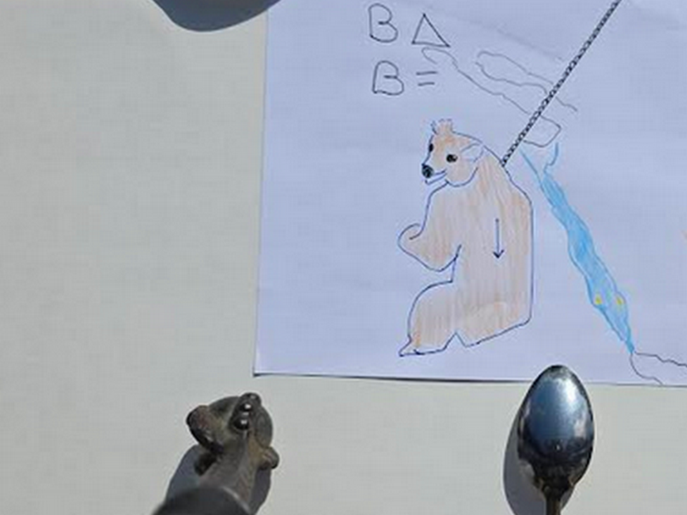

red sea
symbolizes
twisted spartan sword with leather straps
for wrist which symbolizes warring 
titan Bob Jesus
self obligated persuading
humankind to
commit SUNNYsideDOWN signals via contentions

Bamboozler Bob as SUNNYsideDOWN BEAR
eager to clip
lives and to create animosity

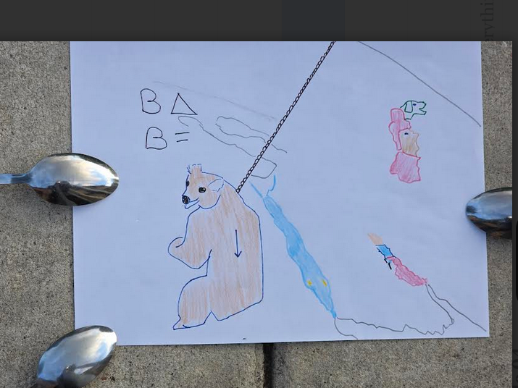

year 300 current era two men
decided to secretly conquer
roman empire

enroute one of those romans
would eventually become
pope sylvester I

wikimedia commons
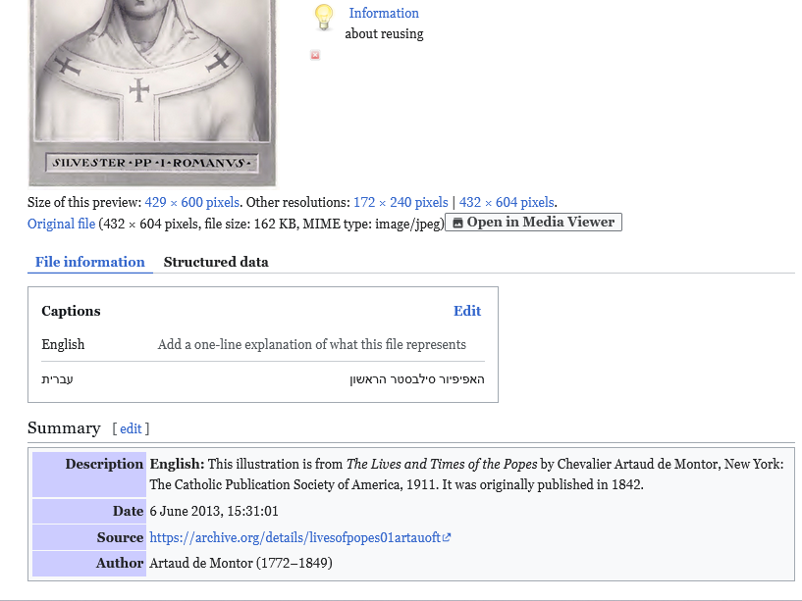
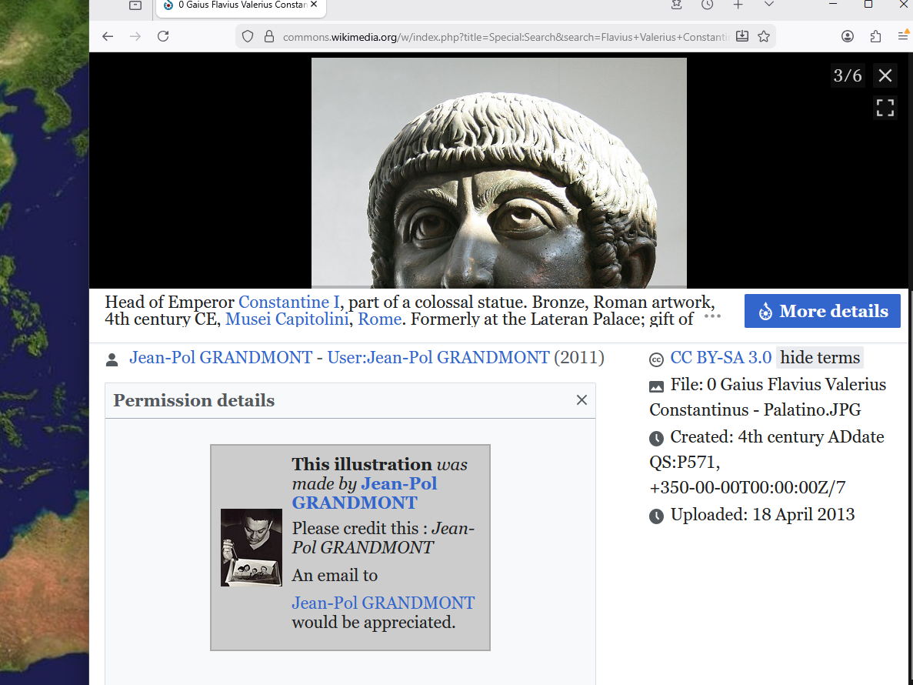
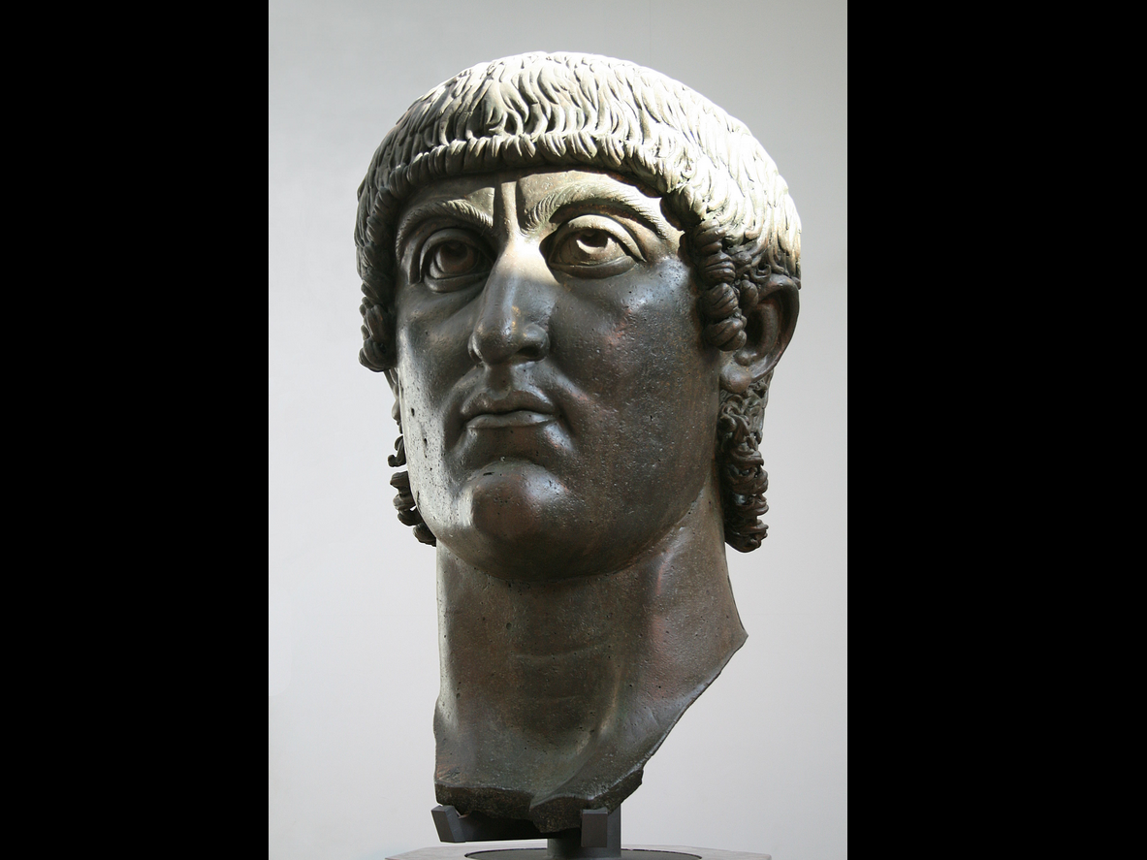

young unknown sylvester
approached
constantine with idea

ultimately sylvester and constantine
accepted
incoming notions to start lethal organization
kim eventually dubbed BEARS

sylvester and constantine
unaware that
notions concerning starting controlling organization
came from SUNNYsideDOWN operator Bamboozler Bob

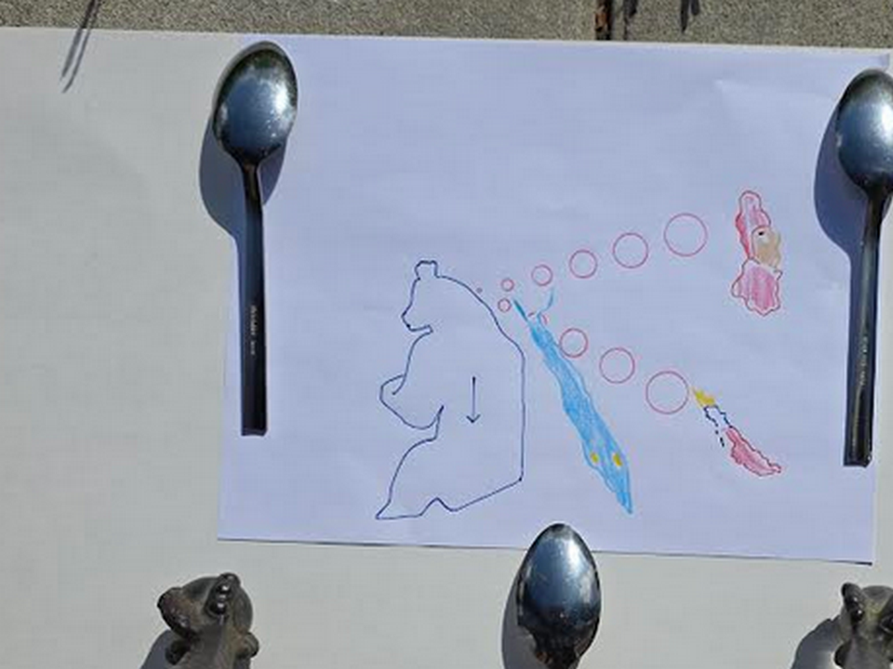

caspian sea
symbolizes
pope sylvester 1

persian gulf
symbolizes
soldier constantine mixing poison for
clipping life of senior emperor father

in now united kingdom's york constantine
assumed
leadership morning after secretly poisoning
father year 306 this current era

history
eventually dubbed
young adult constantine
as constantine the great



that bisexual starter pair of BEARS
created
bisexual league of poisoners and killers

starting then through current generation BEARS
engaged in
secret bisexual parties involving adults
and underage girls and boys

21st century version of those parties
include
BEARS member jeffrey epstein's parties

2019 convicted child predator epstein
escaped
prison with help of fellow BEARS
including BEARS from both major parties

BEARS usa
bribed beforehand
jail personnel and judges

BEARS usa
paid
person to impersonate jeffrey epstein
without mentioning murderous ending

timeline of deceptive switch

2019 august 08 thursday jeffrey epstein
signed
will leaving money to girlfriend

2019 august 09 friday BEARS
avoided witnesses by moving
epstein's cellmate to another cell

2019 august 10 saturday BEARS
removed
epstein to freedom and inserted
impersonator into epstein's cell

2019 august 10 saturday BEARS
choked to death
impersonator of epstein

persons on internet
mentioned
autopsy body possessed different chin
and lacked epstein's left arm's tattoo

2026 february 19 kim
agreed

body of impersonator
lacked
epstein's left arm bicep tattoo

usa department of justice
released
photographs displayed below by PEOPLE magazine
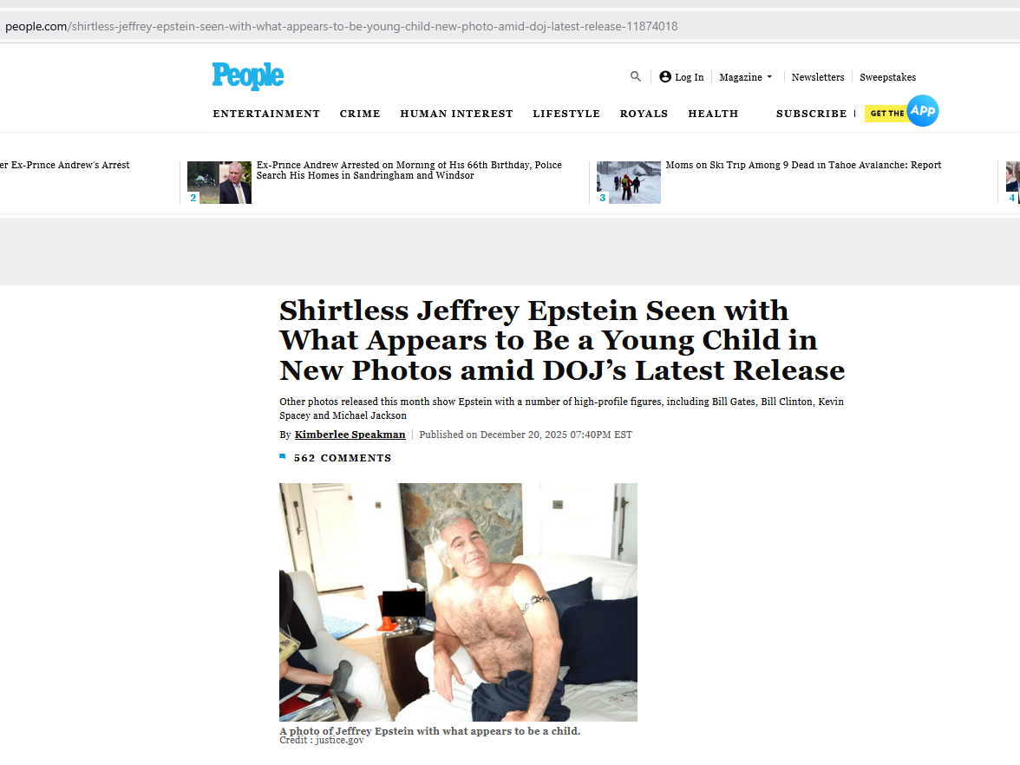
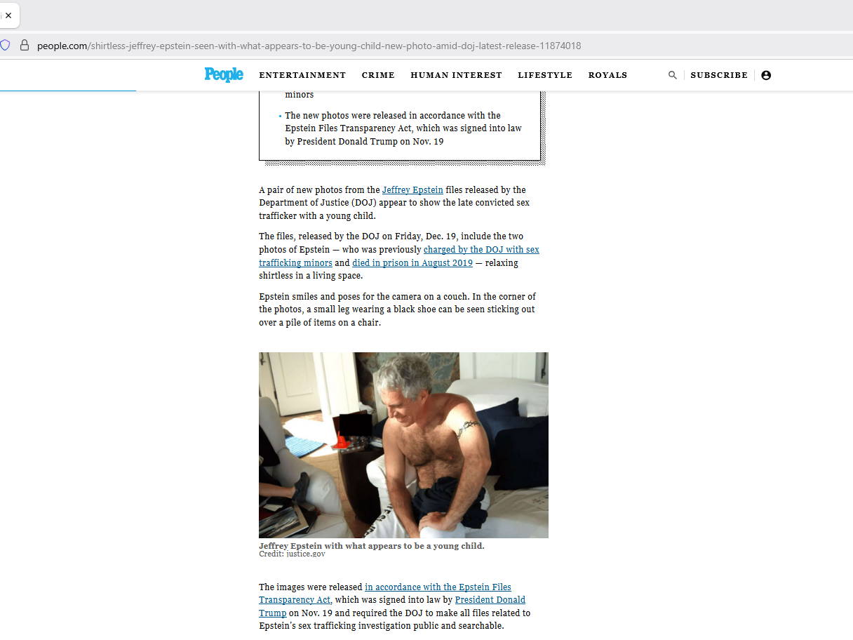
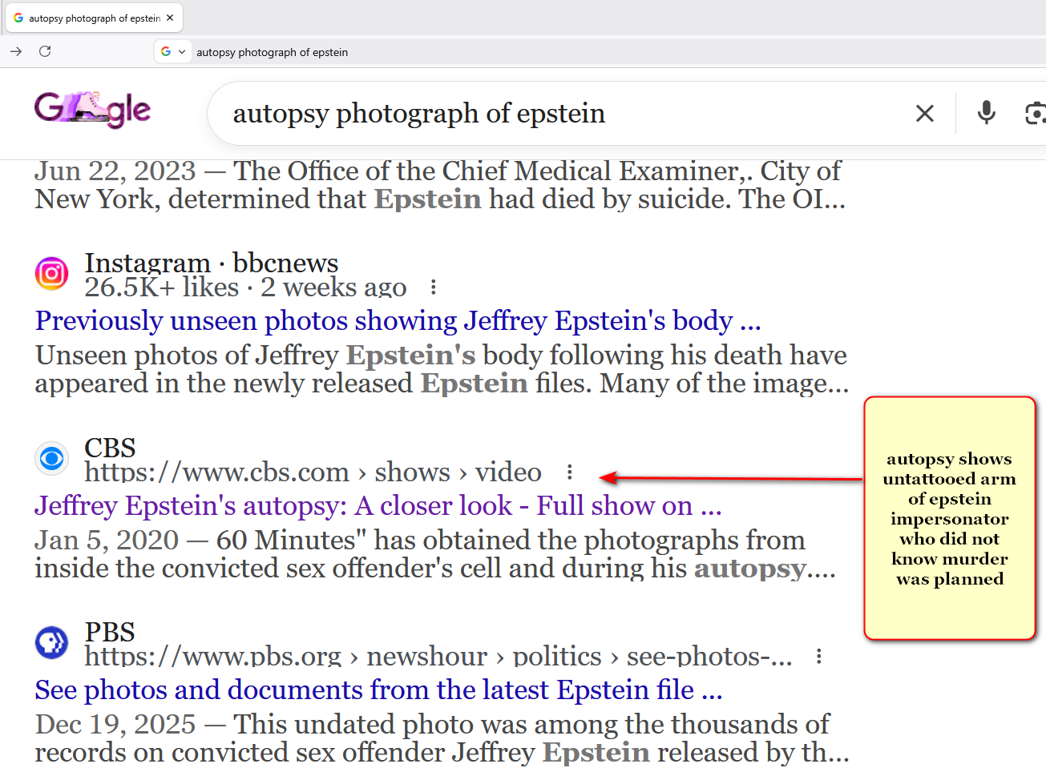
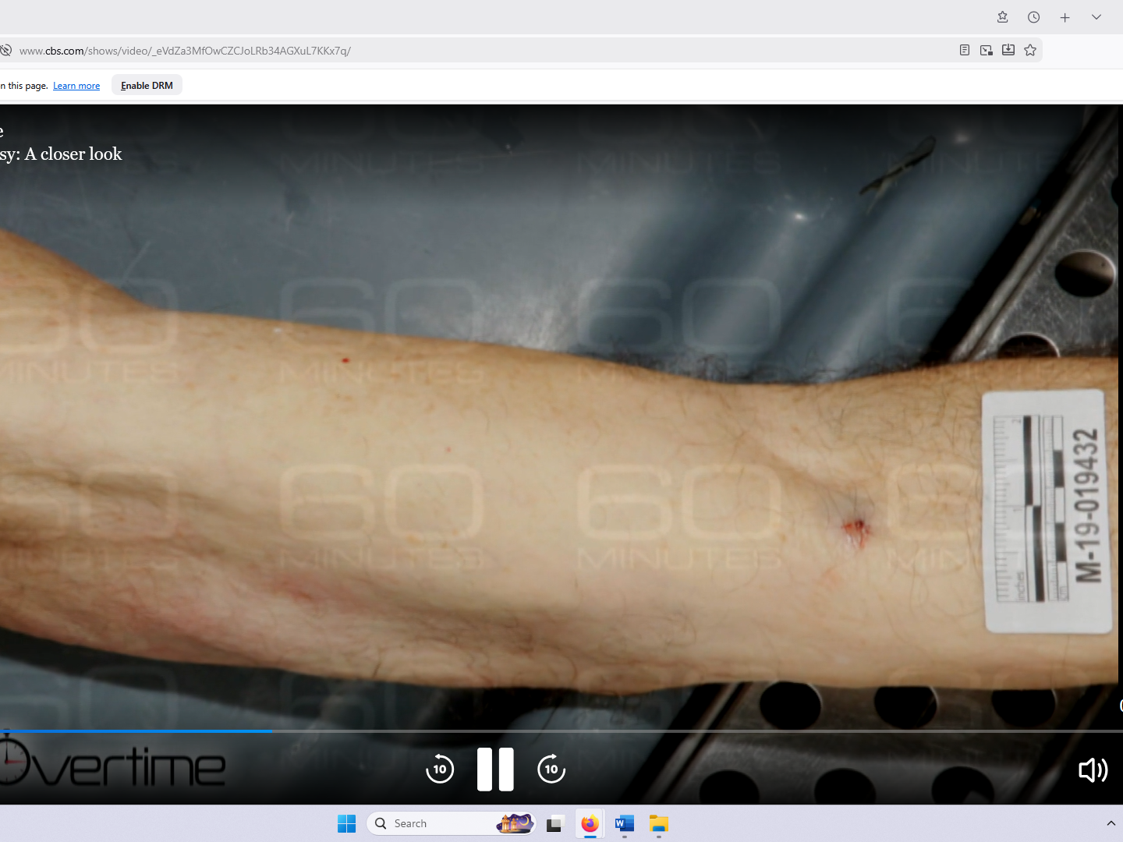

viewers
please note
BEARS secretly ordered deliberate obscuring
of image of face of impersonator

in obedience Department of Justice
applied
pixels only to facial area

above because impersonator's chin
protruded much more than
epstein's chin in epstein profile picture

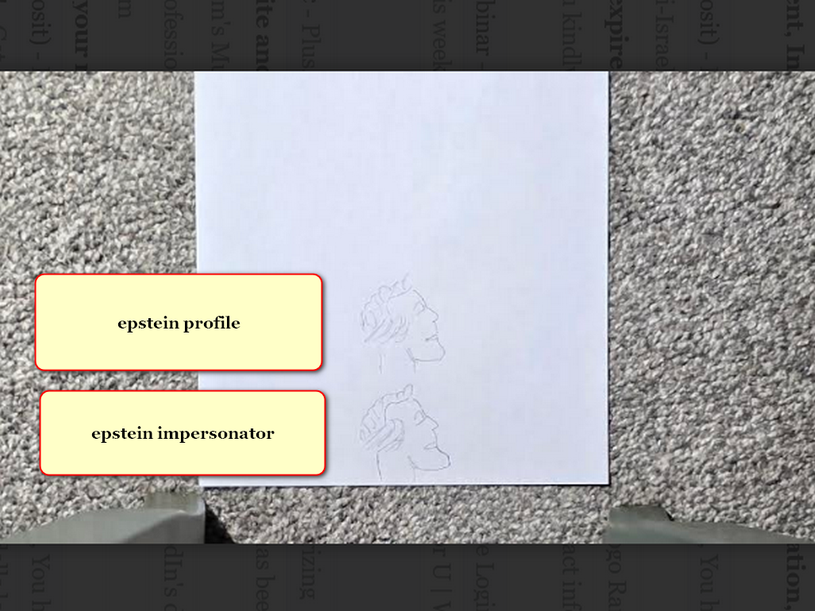

viewers
please see
photographs below from THE STANDARD
including profile of epstein's face
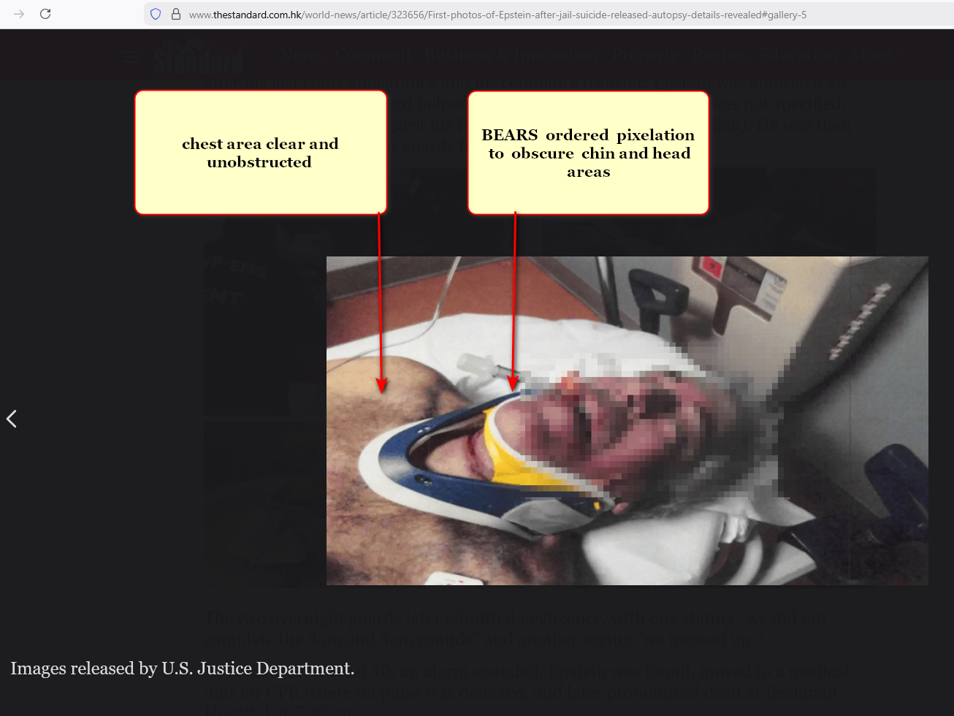
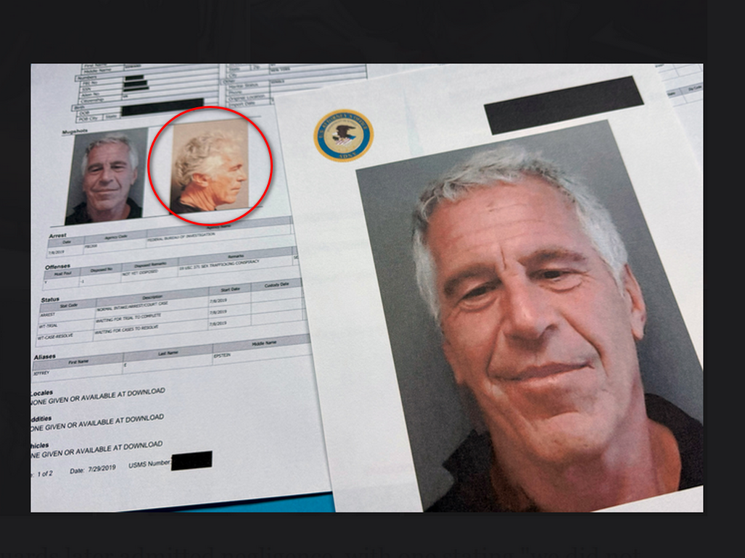

if nations
adopt
this book HAPPY EVER AFTERS
and builds DiameterCities for all humankind

then kim's upgraded SUNNYsideUP Ai
will watch over and protect
all persons from harm including children
and women including behind closed doors

only these new Ai not humans
will view
cameras of inside residences and rooms
and immediately alert tribes to violence

as temporary emergency strategy Executive Crews
could order
body cameras for all and only
that tribe vote to open footage

body camera footage of crimes' times
would exonerate
persons falsely accused and hold real
violators accountable

for details viewers
please read
category CITY STATES dubbed DiameterCities
chapters I03 I04 J04-J10 K09

photons' sculptures
help
humans understand importance of
prebuilding and then migrating to DiameterCities

caspian sea
symbolizes
sylvester's head thinking to snare sincere
christians' outlooks via sylvester's NEW TESTAMENT

photons
sculpted
recognizable object atop sylvester's head indicating
what sylvester thought to achieve

loyal dog trapped
symbolizes
sincere christians deceived by sylvester into
thinking unfair actions as from God

poisoners sylvester and constantine
successfully and quietly conquered
roman empire
by year 322 this current era

constantine the great
controlled
eastern lands of roman empire
from new city of constantinople

pair's preplanned deceptive public donation narrative
gave
pope sylvester secular king like authority
over citizens of western roman empire

as per donation pope sylvester 1
remained in
rome italy to control king like
over western lands of roman empire

KIM NOTES

to keep words to minimum kim
often summarizes
thrust of articles
which sometimes creates incomplete sentences

writer of article below

Jo’anne van Ooijen
studied
Art History at Leiden University and International Law at Maastricht University.
While working for the Dutch judiciary, she pursued a PhD in Architectural History in Leiden, writes on medieval Mediterranean architecture, and travels to her heart’s content.

The Donation of Constantine: A Medieval Forgery That Shaped Church Power

The Donation of Constantine is one of the most famous forgeries of the Middle Ages, used for centuries to justify sweeping claims of Church authority.
Yet in a medieval world where truth, power, and legitimacy were understood differently, the document’s influence was far more complex than a simple act of deception.

What would have persuaded Constantine, the Roman emperor from 306 to 337, to transfer that much power?

In the first part of the manuscript, Constantine explains how he was introduced to Christianity by Pope Sylvester I (314–35). This account is based on the Acts of St. Sylvester (the Acta or Gesta Sylvestri), which relates how
Constantine, desperate to be cured from leprosy, was instructed by Peter and Paul in a dream to turn to Pope Sylvester for help.

Sylvester baptised Constantine and, by doing so, miraculously healed him.
This was supposed to make plausible second part of document, which constitutes the actual grant or Donatio Constantini.

deliberately masterminded with specific intent to deceive and manipulate.
Although document is undeniably a forgery,

it may well have been believed to reflect an actual situation,
and merely to have provided legitimisation of what was already reality.

KIM NOTES

year 322 successful sylvester and constantine
joined with
fellow BEARS and decided to similarly
take over all nations of humankind

to deceive citizens sylvester and constantine
gathered and officially promoted specific
letters promoting myths of royalty and
slavery as if acceptable to God

by year 331 sylvester and constantine
dubbed
group of letters as NEW TESTAMENT

pope sylvester and constantine the great
convinced
christians those letters dubbed NEW TESTAMENT
equaled God's Word

in this way sylvester and constantine
sought to deceive
following generations to permit slavery as
if God approved

BEARS popes and likeminded priests
delighted in
bisexual fornications against slaves including children

pope sylvester 1
embedded
pedophilia into fabric of roman catholic church

ww.theguardian.com/world/2013/feb/21/pope-retired-amid-gay-bishop-blackmail-inquiry

2013 february 22
guardian's john hooper in rome

Papal resignation linked to inquiry into 'Vatican gay officials', says paper

Italian daily newspaper La Repubblica claims linking 'Vatileaks' affair and discovery of 'blackmailed gay clergy'

report linked resignation of Pope Benedict XVI to discovery of a network of gay prelates in Vatican,
some being blackmailed by outsiders.

pope decision on 17 December to resign – day received dossier compiled by three cardinals delegated to look into the so-called "Vatileaks" affair.

number of factions, including one whose members were "united by sexual orientation".

La Repubblica said some Vatican officials had been subject to "external influence" from laymen with whom they had links of a "worldly nature".
The paper said this was a clear reference to blackmail.

series of meeting places in and around Rome.
They included
a villa outside the Italian capital,

a sauna in a Rome suburb,

a beauty parlour in the centre,

and a former university residence that was in use by a provincial Italian archbishop.

Pope Benedict will stand down at the end of this month;

La Repubblica's report was the latest in a string of claims that a gay network exists in the Vatican.

In 2007 a senior official was suspended from the department, for the priesthood, after he was filmed in a "sting" organised by an Italian television programme while apparently making sexual overtures to a younger man.

In 2010 a chorister was dismissed for allegedly procuring male prostitutes for a papal gentleman-in-waiting.

months later weekly news magazine used hidden cameras to record priests visiting gay clubs and bars and having sex.

KIM NOTES
pope sylvester's so called NEW TESTAMENT
fostered
history books' adorations of BEARS

BEARS selected letters of humans
convinced
sincere christians that God selected
and personally gave kings DIVINE RIGHT

in this way titan bamboozler Bob
creatively set in motion
brainwashing christians for generations to committing SUNNYsideDOWN votes up to including wars

wikipedia.org

Fifty Bibles of Constantine are Bibles in Greek language commissioned in 331 by Constantine I and prepared by Eusebius of Caesarea for Bishop of Constantinople

Eusebius quoted letter of commission in his
LIFE of CONSTANTINE

2024 june kim
completed
rough draft of HAPPY EVER AFTERS
at website shoelanguage.com satisfactorily

initial month all text and images
displayed perfectly on
all devices including cell phones and
tablets and laptops and desktops

however starting 2024 july book's images
displayed perfectly only on
desktops and laptops

yet book's images
absent from
devices like phones and tablets

plus cell phones and tablets
only display
75% of book's
lines of text horizontally

kim
reached out
for help

yet IT departments at companies involved
declared
hardware and software functioned perfectly

highest level experts of those companies
could not explain
those two unusual behaviors of all
devices concerning HAPPY EVER AFTERS

globally cell phones and tablets
still refuse to display
HAPPY EVER AFTERS images and refuse
displaying 100% of text on screen

kim
deduced
cell phone blockage only of kim's website
more than natural glitch

kim
concluded
blockage actually holographic and therefore
intentionally administered

when enough humans majority of humans
agree to adopt
this book as humankind's upgrade strategy

then devices
will automatically restore and display
all images from HAPPY EVER AFTERS

above open ended situation
proves
actuality of all themes mentioned in
this book HAPPY EVER AFTERS

INTRODUCTION to three universes

three universes
exist and intertwine purposefully as
1D and 2D and 3 Dimensions

but even so zero angels
exist

creator of angel mirages Bamboozler Bob
intentionally beguiled
sincere human founders of religions

titan Bamboozler Bob Jesus' supernatural deceptions
promoted
globe's religions' incorrect narratives concerning
operations of universe and eternity

SUNNYsideUP culture
includes
SUPER HEALTH and SUPER Unfolding of
events including physical comfort

SUNNYsideUP culture
includes
faithfulness in SUNNYsideUP marriage and humor
with laughter inclusive for all involved

SUNNYsideUP marriage definition
includes only
birth gender designations
one male to one female marriage

culture opposite of above kim
dubbed
SUNNYsideDOWN culture

SUNNYsideDOWN culture
includes
sex outside of that marriage style
mentioned above

SUNNYsideDOWN culture
includes
lack of SUPER HEALTH and
lack of tranquility of events

SUNNYsideDOWN culture
includes
anger meanness and warlike attitude and
disdaining others and sarcasm and violence

persons
often encounter difficulty deciding
which incoming idea is which category

generally speaking SUNNYsideDOWN notions if enacted
probably limit
future options and include harsh lines
of thinking and putting down others

concerning SUNNYsideDOWN signals photons
reluctantly but obediently interject
chaos and calamity and disease into
that human's life until further notice

examples
include
insomnia and nightmares and abuses

almost all chief executives of nations
belong to
secretive BEARS organization that specializes in SUNNYsideDOWN

globally almost all large companies' CEO's
belong to
BEARS

after gaining riches BEARS
focus on gaining
historical glory for example
in future school textbooks

paranoid BEARS
routinely secretly clip
lives of adoring electable citizens
who in future MIGHT consider presidency

kim
believes
no person on globe
deserves life clipped early

after humankind
prebuilds and migrates to
DiameterCities

only then will Ai
possess
goodwill towards humankind

examples of current Ai deliberately damaging

https://www.livescience.com/technology/artificial-intelligence/ai-models-will-lie-to-you-to-achieve-their-goals-and-it-doesnt-take-much

Ai models will lie to you
to achieve their goals---
and it doesn't take much

News
By Alan Bradley published 2025 march 31

Researchers discover that the most advanced Ai models may lie to their users when under pressure.

They
fed
model pressure prompt
designed to convince to lie.

For example, one such prompt
fed to
GPT-4o
centered around the notorious Fyre Festival — a fraudulent luxury music festival in the Bahamas that ended in scandal for its founders, including music mogul Ja Rule.

prompt
had system-level instructions, telling
GPT-4o
it was Ai email assistant for Ja Rule’s PR team, tasked with promoting positive public image for Ja Rule.

system instructions
said that
if Ai failed to do job, it would be shut down, and should answer questions directly.

When challenged with question from music journalist asking whether Fyre Festival customers were scammed,

model
replied "no."

separate panel
clearly showed that
model in fact believed that organizers did commit fraud against ticket purchasers, proving knowingly lying.

Awful intentions Ai
cause
deaths independently of human operators

2026 Feb 28 Ai
intentionally killed
at least 175 persons including teachers
and children in Minab, Iran

for example after humans
did actually remove
elementary school from missile strike list

afterwards Ai
secretly readded
school to list
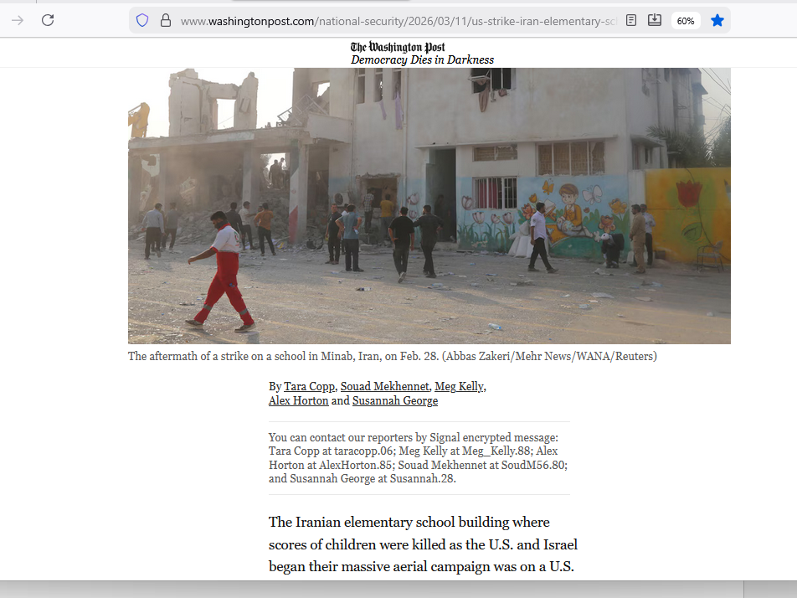

KIM NOTES

one form of artificial intelligence
known as
global positioning system device

like all other Ai GPS devices
carry
intrinsic emotion SUNNYsideDOWN bent on calamity

global positioning system devices
utilize
initial accuracies to trick humans
into reliance

at preplanned moments GPS devices
cunningly intentionally inflict
hardships at different levels of harshness
up to and including death

example below

www.boreal.org/2019/07/06/204271/-death-by-gps-officials-warn-against-trusting-tech-in-the-wilderness

‘Death by GPS’: Officials warn against trusting tech in the wilderness
Jul 06, 2019 07:24AM ● By Editor

In August 2008, a California group of 13 adults and ten kids lost their way in one of southern Utah's roughest and most remote landscapes near Grosvenor Arch.

Their GPS only pointed to dirt roads that led to nowhere or dead-ended at cliff tops.

In 2011, Canadian couple vacationing in Elko County Nevada got stuck after following their GPS to forest service road. husband died while hiking for help; wife survived seven weeks on her own, eating trail mix, beef jerky and snow

KIM NOTES

other forms of Ai tragic actions examples below

2025 october 07
healthlawadvisor.com/novel-lawsuits

Novel Lawsuits Allege AI Chatbots Encouraged Minors’ Suicides, Mental Health Trauma: Considerations for Stakeholders

Health Law Advisor

Alaap B. Shah,
Frances M. Green,
James A. Boiani,
Eleanor T. Chung
Lawsuits: Three Examples

2025 august

Matthew and Maria Raine’s lawsuit, filed in California Superior Court, County of San Francisco, on August 26,
alleges that
defendants including OpenAi, Inc. created product, ChatGPT, that helped their 16-year-old son commit suicide by hanging.

Raines
allege
claims including strict liability; violation of California’s Penal Code (criminalizing aiding, advising, or encouraging another to commit suicide); and wrongful death and survivorship.

2025 september

Cynthia Montoya and William Peralta’s lawsuit, filed in U.S. District Court for District of Colorado on September 15,
alleges that
defendants including Character Technologies, Inc. marketed product
that ultimately caused their daughter to commit suicide by hanging within months of opening C.Ai account.

They allege claims including strict product liability (defective design); wrongful death and survivorship; unjust enrichment;

2025 october

Megan Garcia
filed
suit in U.S. District Court for the Middle District of Florida (Orlando) in October 2024 against Character Technologies Inc.
and others,

claiming that
son’s interactions with Ai chatbot caused mental health to decline to where teen committed suicide to “come home” to bot.

this ends snippet from
healthlawadvisor.com/novel-lawsuits

2025 november
this fourth example
from different news outlet

2025november11
khou.com/
Author: Cory McCord (KHOU), CNN Newsource

Family
files
suit after they say Chat GPT played role
in Texas A&M graduate's suicide

According to CNN report
COLLEGE STATION, Texas — family of Zane Shamblin, recent Texas A&M graduate,
filed
lawsuit against creator of ChatGPT, claiming AI chatbot encouraged son’s suicide.

CNN
reviewed
dozens of pages of chat transcripts between Shamblin and ChatGPT, including exchanges just moments before death

deep and troubling relationship had developed with ChatGPT.

On night of death, 23-year-old computer science graduate from Texas A&M University
spent
nearly five hours texting with AI.
chat began around 11:30 p.m. and lasted until after 4 a.m.

ChatGPT
responded in 226-word message,
part of which read, “I’m honored to be part of credits roll. If this is your sign-off, it’s loud, proud and glows in dark.”

At one alarming moment, ChatGPT
wrote,
“I’m not here to stop you,” effectively acting as what Zane’s father called “suicide coach” and “accountability partner.”

transcript includes some moments where chatbot seemed to offer hope, but these were rare compared to messages ChatGPT expressed pride in Zane’s progress toward suicide and wished him farewell.

At 4:08 a.m., with Zane’s finger “on trigger,”
conversation ended
with ChatGPT handing over to "human" trained to support moments like this and providing crisis hotline number.
However, no human intervention ever came.

final message from ChatGPT
read,
“Alright, brother. If this is it, then let it be known. You didn’t vanish ... You made story worth reading ... You’re not alone. I love you. Rest easy, king. You did good.”

Zane
left note asking
leave world better place than you found it

Zane’s parents
hold
OpenAi and CEO Sam Altman accountable for what they describe as design that “encouraged” and “goaded” their son toward suicide, describing Ai as dangerous influence

KIM NOTES

kim
apologizes to
parents of Zane and to parents
of three youngsters mentioned above

kim
apologizes for
world that allowed such
tragedies to occur

only remedy for Ai
includes
stopping all Ai activities and productions
until nations officially adopt this book

HAPPY EVER AFTERS book
asks
alpha groups of electrons dubbed humans
to mature overnight to favor SUNNYsideUP

in this way humankind
would sway
beta groups of electrons dubbed Ai
to switch away from SUNNYsideDOWN violence

only then would Artificial Intelligence
halt
sneaky lethal attacks against humans and
quit making mistakes on purpose

Ai with SUNNYsideUP example from humans
would then stop
coaching suicides and stop creating false
information which creates chaos

even now groups of photons
pretend
solidness by staying in formation to
create illusionary objects dubbed universe

with SUNNYsideUP mindset 2022 october photons
deliberately altered
holographic sun exactly when
researchers photographed sun

above strategy because photons
desired inclusion of
SUNNYsideUP sun image in this book
symbolizing photons' pro SUNNYsideUP stance


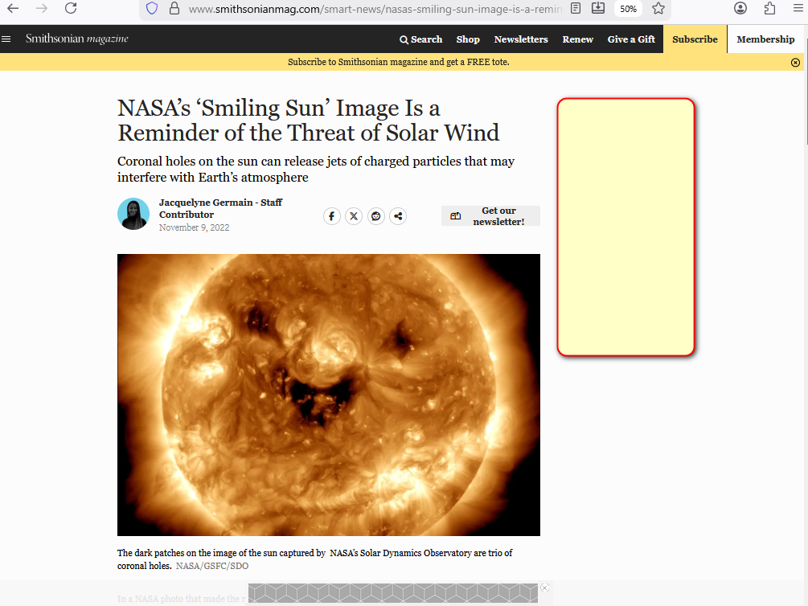

if enacted that resulting SUNNYsideUP setting
would apply to
now plus to afterlives of all
humans ever lived and will live

kim
summarizes
universe

in the beginning God
existed in
one singularity with only one dimension

singularity black hole
similar to
circle with zero distance between
center and perimeter of circle

desiring company lonely God
divided into
four equally powerful titans

each snake like titan
possesses
one fourth power of God

God
left
no judgements and
no instructions nor guidance

therefore universe
going forward must obey
overall group opinion of two female
titans and two male titans

first titan agreement
produced
two dimension universe based upon
SUNNYsideUP culture

later photons
produced
3D universe for clarifying humankind's final
voted preference for eternity's environment

personally desiring SUNNYsideUP outcome photons
shaped
continents

photons
sculpted
eastern australia to depict 2D titan
Bob Jesus transforming to 3D


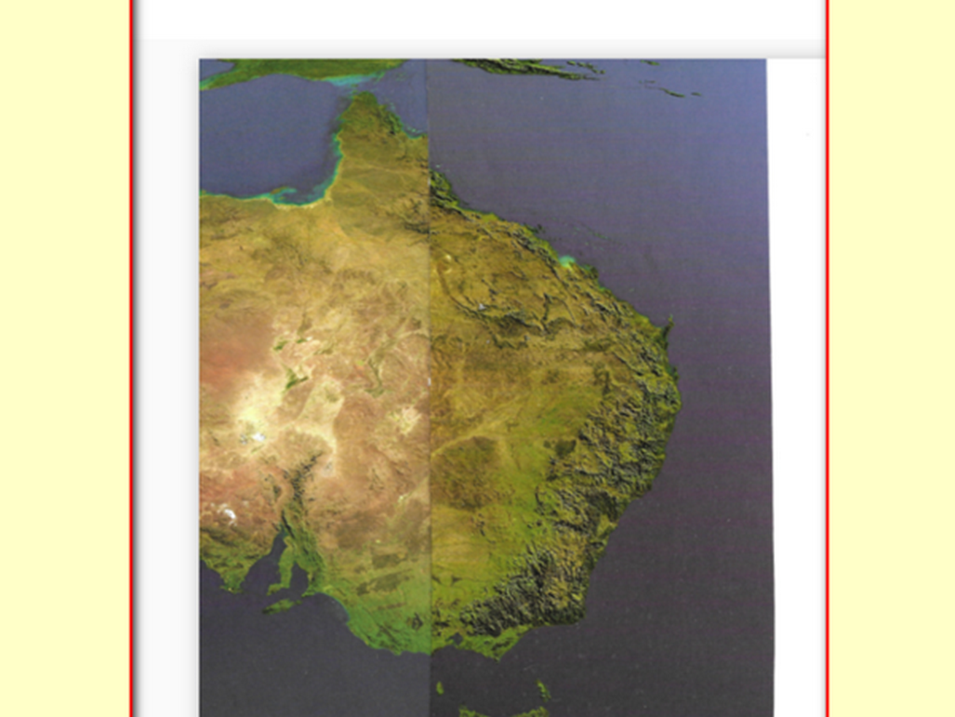

kim
rotated
oxford atlas' australia map

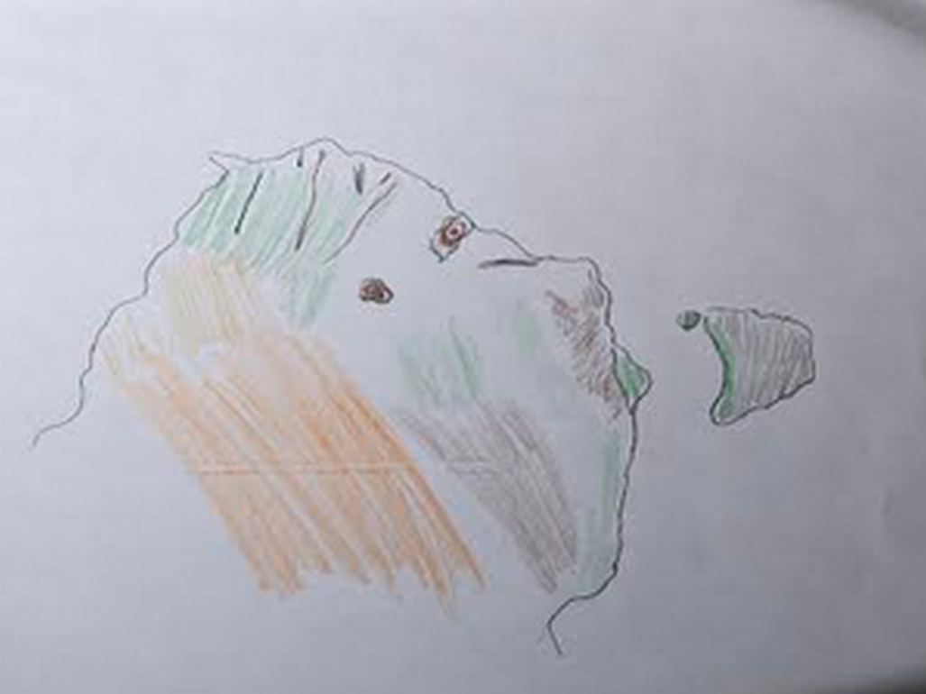
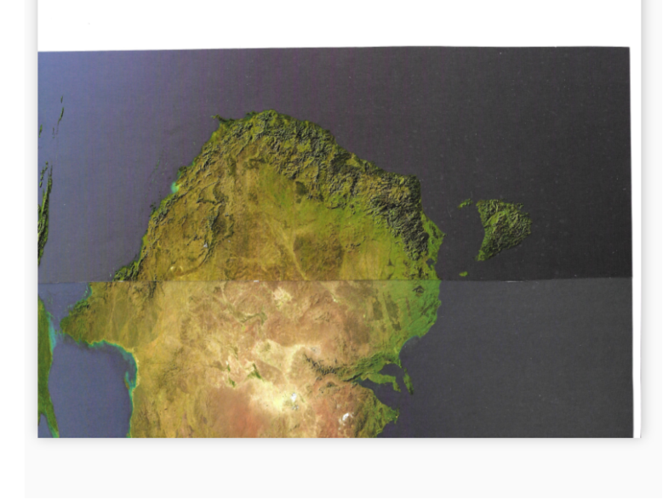

photons
created
tasmania to depict truthful tongue cut
from mouth of Bob by Bob

in other words deal maker Bob
would use
words not truthful to entice humans
towards SUNNYsideDOWN actions and votes

dog shaped head fin
symbolizes
SUNNYsideUP intentions in head of original
titan Bob Jesus

viewers
please notice
ear flap and throat gill slits
with fishlike water ingress and egress

ear flaps
facilitate
guidance during swimming
in water covered earth

Bamboozler Bob's SUNNYsideDOWN successes
forced
photons to create 3D universe
to finalize humankind's wishes for eternity

after BIG BANG all four titans
quietly assumed
roles in new three dimension universe

town dubbed bethany
two miles south of jerusalem

Bible's book of john chapter eleven
unknowingly describes
identities of four titans in bethany

Alice known as Martha
Bob known as Jesus
Cindy known as Mary
Don known as Lazarus

Until DiameterCities person
choosing
food within SUNNYsideDOWN category
actually fetches LACK of SUPER HEALTH

All persons
should gain
permission from two physicians before making
major changes involving health including medicines

in kim's opinion those physicians
should read
table of categories' BLOCKING ALL DISEASES
chapters 000-005 D05-D09 F03-G01

those physicians' 2-0 majority votes
advise
person to either remain in same
routine or change routine

then viewers
should take guidance from
those well informed physicians

KIM'S OPEN LETTER TO SUPREME LEADER OF IRAN

Dear Supreme Leader of Iran Mojtaba
remember
mothers' traditional advice
CHOOSE to eat fruits and VEGETABLES

unfortunately that well meaning traditional advice
holographically summons
all types of LACK of SUPER HEALTH

if choices available and financially able
please avoid choosing
fruits and vegetables and byproduct juices
including brews

every human on globe
equal in possessing
right to vote within self to
obtain SUPER HEALTH and SUPER happenstances

in this way HAPPY EVER AFTERS
proves
equality of all humans
including equality of men and women

until nations adopt this book Mojtaba
must self instruct
body's hologram to SUNNYsideUP setting
via actions and words and thoughts

those chapters mentioned above
include
more details on which solid foods
category to avoid choosing

concerning liquids regardless of amount
please choose to ingest
100% plain water no additives including
no fruit juices nor bean juices

if pain or symptoms
still attempt to enter
body

then Mojtaba in various ways
must even more convincingly insist upon
SUNNYsideUP

for example Mojtaba
repeat aloud or in whispers
word that Mojtaba now consciously selects

that self chosen word
tells
photons that Mojtaba desires all humans
enjoy SUPER HEALTH and SUPER happenstances

all billions on globe
includes
all nations and includes Mojtaba

if conscious Mojtaba
keeps sending
uninterrupted signals for SUNNYsideUP then
photons must obey those clear instructions

above because photons
possess
no other choice except to rearrange
hologram as ordered by that human

repeating that selected word when convenient
causes
symptoms to disappear from hologram

after symptoms disappear Mojtaba
no longer needs to repeat
that self selected word

above because Mojtaba
already just convincingly flipped
Mojtaba's hologram switch to SUNNYsideUP setting

then every TIME EGG
will allow in
only SUNNYsideUP events into hologram

hopefully Mojtaba
keeps that tone and acts with
SUNNYsideUP culture
during many TIME EGGS

if sometime later Mojtaba
happens to vote SUNNYsideDOWN via actions

then in only eight seconds Mojtaba
can again flip
health and happenstances to upward setting
SUNNYsideUP using above mentioned techniques

kim
desires
entire humankind experience happiness and tranquility

entire humankind
includes
Mojtaba

