O01 patriotic ranger kevin tillman on usa

2006 kevin tillman ex ranger
offered
summary current status of usa

2006 kevin tillman
observed
SUNNYsideDOWN theme of country usa

concerned sincere patriotic citizen kevin tillman
issued
remarks during time when no person
knew of secret controlling group BEARS

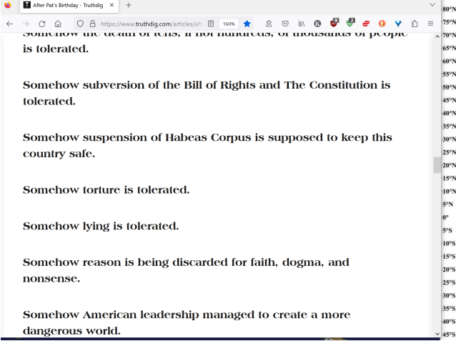

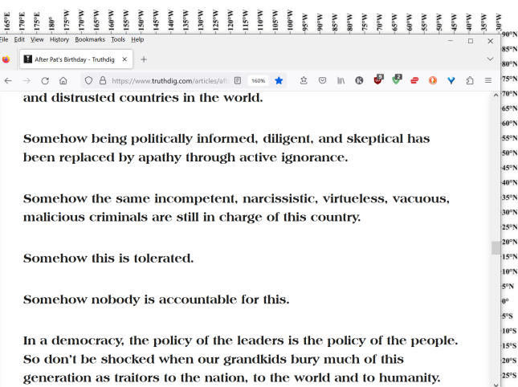

By Grunge StaffUpdated: April 8, 2024 10:59 am EST

Read More: https://www.grunge.com/23227/long-list-stars-died-age-27/Pat Tillman

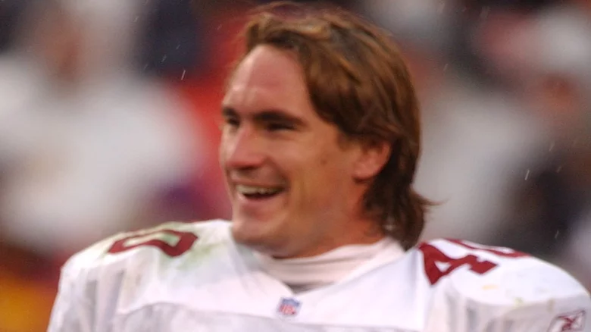

Selected by the Arizona Cardinals in the 1998 NFL Draft, Arizona State defensive back Pat Tillman

Playing three full seasons and almost all of a fourth, he was a tackling and intercepting machine for the Cardinals until he abruptly retired from football after playing 12 games in the 2001 NFL season.

According to AZ Central, he quit in the wake of the 9/11 attacks, and joined the U.S. Army as part of the war on terror, foregoing a $3.6 million contract to become an Army Ranger.

While patrolling in a rural area of eastern Afghanistan in April 2004, according to History, Tillman was struck by gunfire and died from his wounds.

The U.S. Army reported that Tillman's death was the result of an enemy ambush, and he posthumously received a promotion to corporal and was awarded a Purple Heart and Silver Star.

A few weeks later, Tillman's family received word that the athlete-turned-soldier had died in a "friendly fire" accident, inadvertently shot and killed by fellow American troops. Tillman was 27.

BEARS including BEARS operatives
lose
fairness emotion mindset via toggle switching
to lifestyle of deceptions etcetera

above phenomenon
explains
BEARS keep near BEARS sincere patriotic
citizens on team to interpret sincerity

example initial investigator
recommended
criminal charges against tillmans' fellow rangers

emotionally twisted BEARS
utilized
honest captain scott's report
as starting point of reality

BEARS
patched
holes via instructing rangers
to adjust stories

BEARS on purpose
avoided
fulfilling recommendations included in captain scott's
investigation conclusions

BEARS
merely utilized
honest captain's report for ordering key
testimony changes concerning incriminating details

sincere patriotic captain richard scott
possessed
fairness emotion mindset therefore gave assessment
from viewpoint of sincere patriot

usa armed forces officials
illegally faked
signatures of military personnel

usa armed forces officials
deceitfully framed
situation to convince childlike faith citizens

BEARS officials
gained
free pass for forgeries without penalties

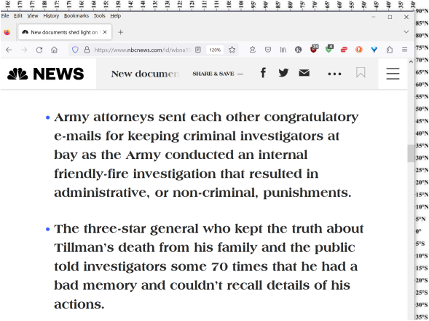

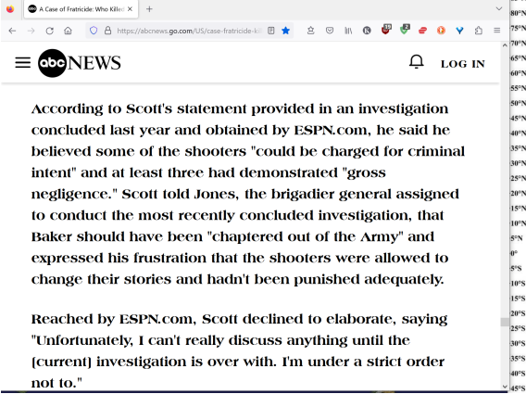

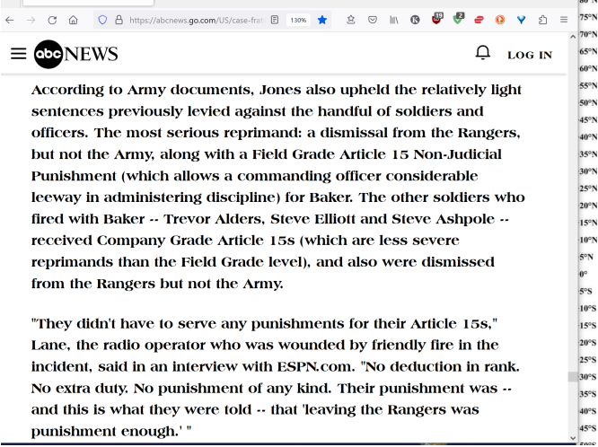

BEARS operative uthlaut
coordinated
entire lethal masquerade on ground
knew investigations to follow possible convictions

out of line of fire uthlauth
self inflicted
wound to leg
thereby averting suspicion of premeditated murder

chapter ends

