F08 malala yousafzai pesticides paradox

heroic young lady malala
chose
SUNNYsideUP habitually therefore
created miraculous recovery for self

Malala Yousafzai

Welcome to the United Nations

https://www.un.org › messengers-peace › malala-yousafzai
malala yousafzai from www.un.org

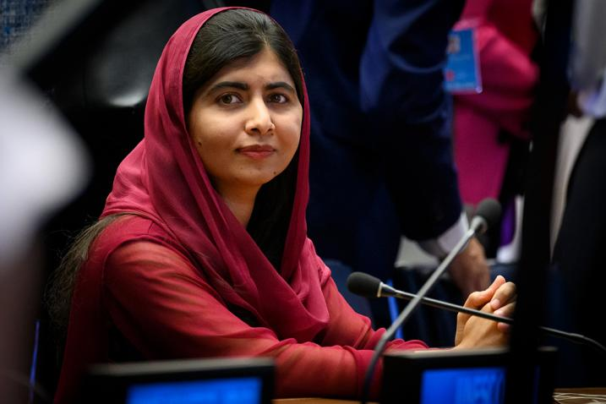

Malala Yousafzai
became
an international symbol of the fight for girls' education

after she
was shot
in 2012 for opposing Taliban restrictions on female
education in her home country of Pakistan.

In 2009, Malala
had begun writing
a blog under a pseudonym

about the increasing military activity in her home town and about fears that her school would be attacked.

After her identity
was revealed,
Malala and her father Ziauddin continued to speak out for the right to education.

2012 october 09 Taliban
attacked
Malala
as she was returning home from school with her friends

received
worldwide condemnation.

In Pakistan, over 2 million people
signed
a right to education petition,

and the National Assembly
ratified
Pakistan's first Right to Free and Compulsory Education Bill.

In December 2014, she
became
the youngest-ever Nobel Peace Prize laureate.

Secretary-General António Guterres
designated Malala
as a United Nations Messenger of Peace in 2017 to help raise awareness of the importance of girl’s education.

before violent event malala
created
SUNNYsideUP habits therefore
self ripple effect helpful

SUNNYsideUP emotion habits
helped
miracles of surviving bullet etcetera

shooter's opposing parliaments limbs and trunk
acted
from feelings of patriotism

shooter against malala
resolved
inner struggle via supervisor's ripple effect

shooter's conscious central nervous system
chose promoting
SUNNYsideDOWN culture creating 2-0 majority

therefore that person
physically acted and shot

but malala's CNS conscious cells
never
actively agreed to violence for example
never wished violence against shooter

unfortunately malala's subconscious trunk cells
utilized
connectivity argument therefore
swayed central nervous system

trunk cells' connectivity argument
insisted
MALALA desires SUNNYsideDOWN culture because
malala ingests vegetation vegetation products

because of SUNNYsideDOWN vegetation connectivity malala
actually desires
SUNNYsideDOWN EVENTS

malala's subconscious limbs cells
countered
connectivity argument with financial non choice argument

limbs cells' non choice argument
insisted
finances disallowed expensive non vegetation food

therefore malala
never directly chose
vegetation as diet therefore never actively
chose SUNNYsideDOWN culture never invited violence

trunk cells' final reply
declared
malala possessed choice of liquids ingested
yet malala bypassed plain water

malala concerning liquid
chose
water mixed with vegetation vegetation products

therefore trunk parliament claimed malala
desired
chaos SUNNYsideDOWN events

in this way trunk parliament of cells
convinced
central nervous system parliament of cells
patriotic duty insert SUNNYsideDOWN circumstances

therefore shooter
shot
malala close range shot into head
almost always fatal

yet malala's eventual advantage comatose state
included
not physically capable choosing diet
including liquids after shooting

in this way malala's limb parliaments
swayed
malala's central nervous system cells
55%-45% SUNNYsideUP

then malala's cells
possessed
inescapable assignment start creating SUNNYsideUP
masterpiece others perhaps call miracle

malala's TIME EGGS
not blocked
by vegetation ingestion choosings because
comatose malala not choosing SUNNYsideDOWN ingestions

worldwide sincere patriotic faithful citizens
ripple effected
malala's hologram

worldwide citizens including all religions' adherents
delivered
emotion to malala via prayers counted as
votes for SUNNYsideUP emotion mindset culture

in other words humankind
declared
HUMANKIND NOT GOING ANYWHERE
WITHOUT MALALA

humankind's obedient DNA
received message
made holographic adjustments globally
therefore miracle malala lived

ripple effects from others
very meaningful
because each human's two huge clever
parliaments create stalemate

both opposing arguments
equally attractive
custom designed via that person's conscious
mind drawing from all memories lessons

above usually
produces
standstill tie

ripple effect
from
person nearby weighs on one side
tips persuasions swaying head neck spine

kim
requests
malala's shooter
start sending SUNNYsideUP signals

another ripple example globally world’s farmers
used
pesticides increasingly

yet pests’ numbers
highest
in history

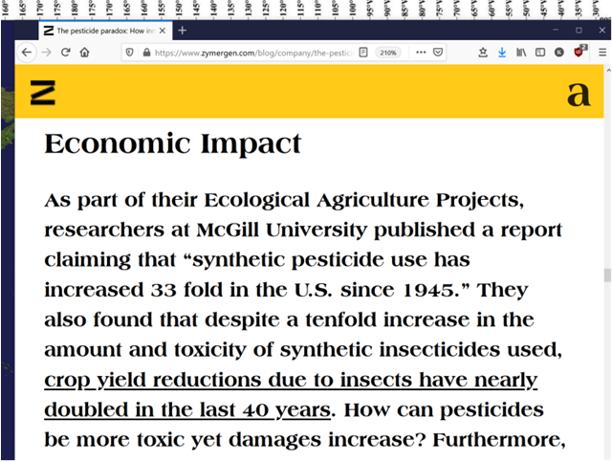

unknowingly farmers
continue
giving SUNNYsideDOWN signals
therefore always gain more pests

if farmers concerning liquids in diet
upgrade
drink only water water

then farmers
find more success
because water water signals SUNNYsideUP

chapter ends

