B04 wedding crashed donkey court jesters

titan pair two strong intact
crashed
wedding ceremony before final crowning
of headband with ring of flowers

Don strategically located
violently grabbed
vegetation headband

Don and Cindy
overcame
pair one spread thin

Don and Cindy
mocked
straight marriage

Don Lazarus
forcibly violently humiliated
Bob Jesus

Don Lazarus
rammed
orifice in backside of Bob Jesus
where none existed before

Cindy Mary
utilized
hand to violently enter
and humiliate Alice Martha

titan pair two
imprisoned
pair one in times tower’s basement
in separate holding cells forever

titan pair two’s strategy
interrupted
proceedings obstructed ceremonies blocked vote
therefore stopped SUNNYsideUP progress forever

now kids' futures
only included
staying trapped in theaters’ dark basements
enduring emotional anguish

above because titan pair two
enjoyed
causing continuous nightmares to kids

titan pair two quite content
to keep
new status quo

meanwhile betrayed defeated desperate Bob
sought
solution

Bob
almost experienced
wedding joy and yet now joy
turned to prison misery

Bob Jesus
devised
plan that included price of changing
to grim SUNNYsideDOWN servitude and actions

mars statue
depicts
Bob's changed emotions

www.tsijournals.com/articles-images/space-exploration-Crowned-Face-5-3-103-g002.png

MGS, M02-03051 year 2000
courtesy NASA/JPL/Orme

FIG. 2. The Crowned Face. MGS, M02-03051 (2000). Image courtesy NASA/JPL/Orme.

/www.semanticscholar.org/paper/Bearded-Profile-with-Avian-Headdress-within-the-the-J.Haas-R.Saunders/1882a712d38e36c76e465c8997eee9d85ef0b195

Corpus ID: 133006915

Bearded Profile with Avian Headdress within the Southeast-Facing Slope of an Impact Crater in the Utopia Planitia Region of Mars

George J.Haas,
W. R.Saunders,
D. Ma
Published 2016
Environmental Science
Journal of Space Exploration

This
is
an analysis of a facial formation

set
within
an impact crater
located in the Utopia Planitia region of Mars.

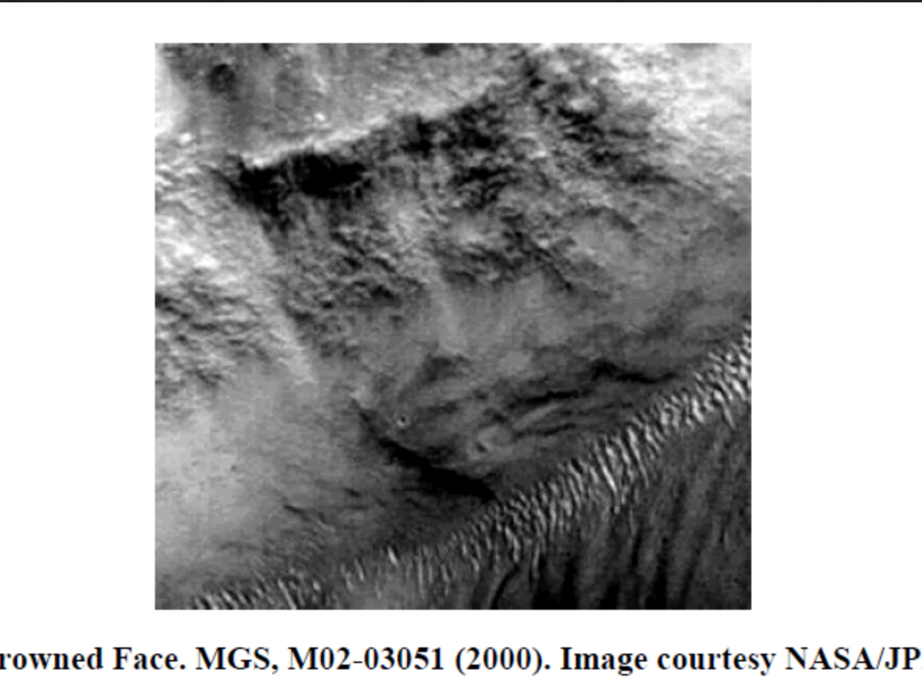

kim
circled
eye

front face
utilizes
left eye with red circle

eastward face
utilizes
same eye as
right eye with red circle

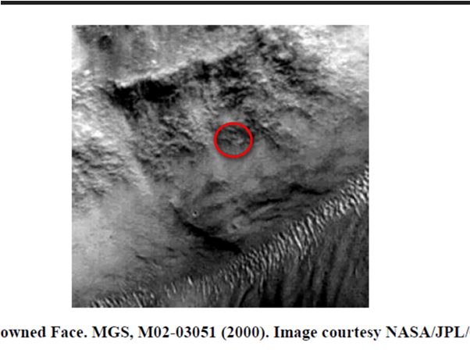

kim
circled
both mouths

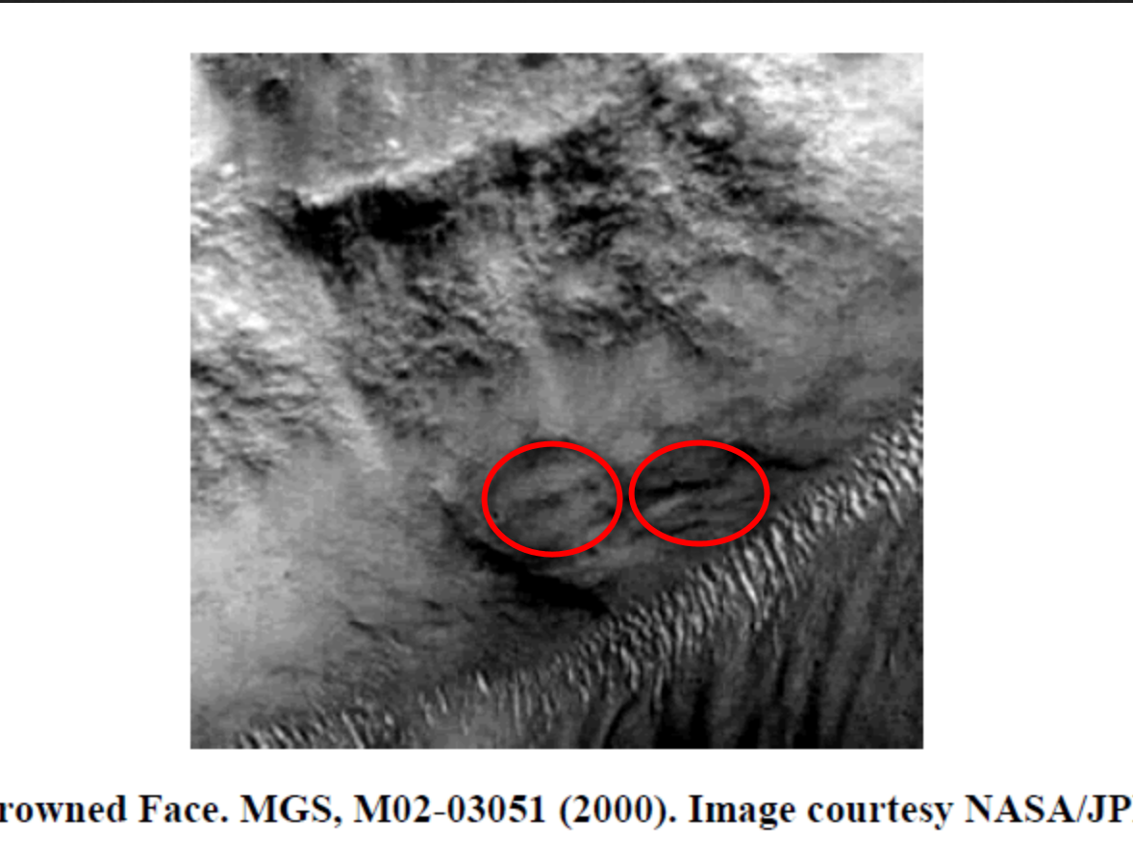

glaring right eye of eastward face
symbolizes
misery of new SUNNYsideDOWN character

viewers
please notice
downward slope of lips
expressing misery and awful mission

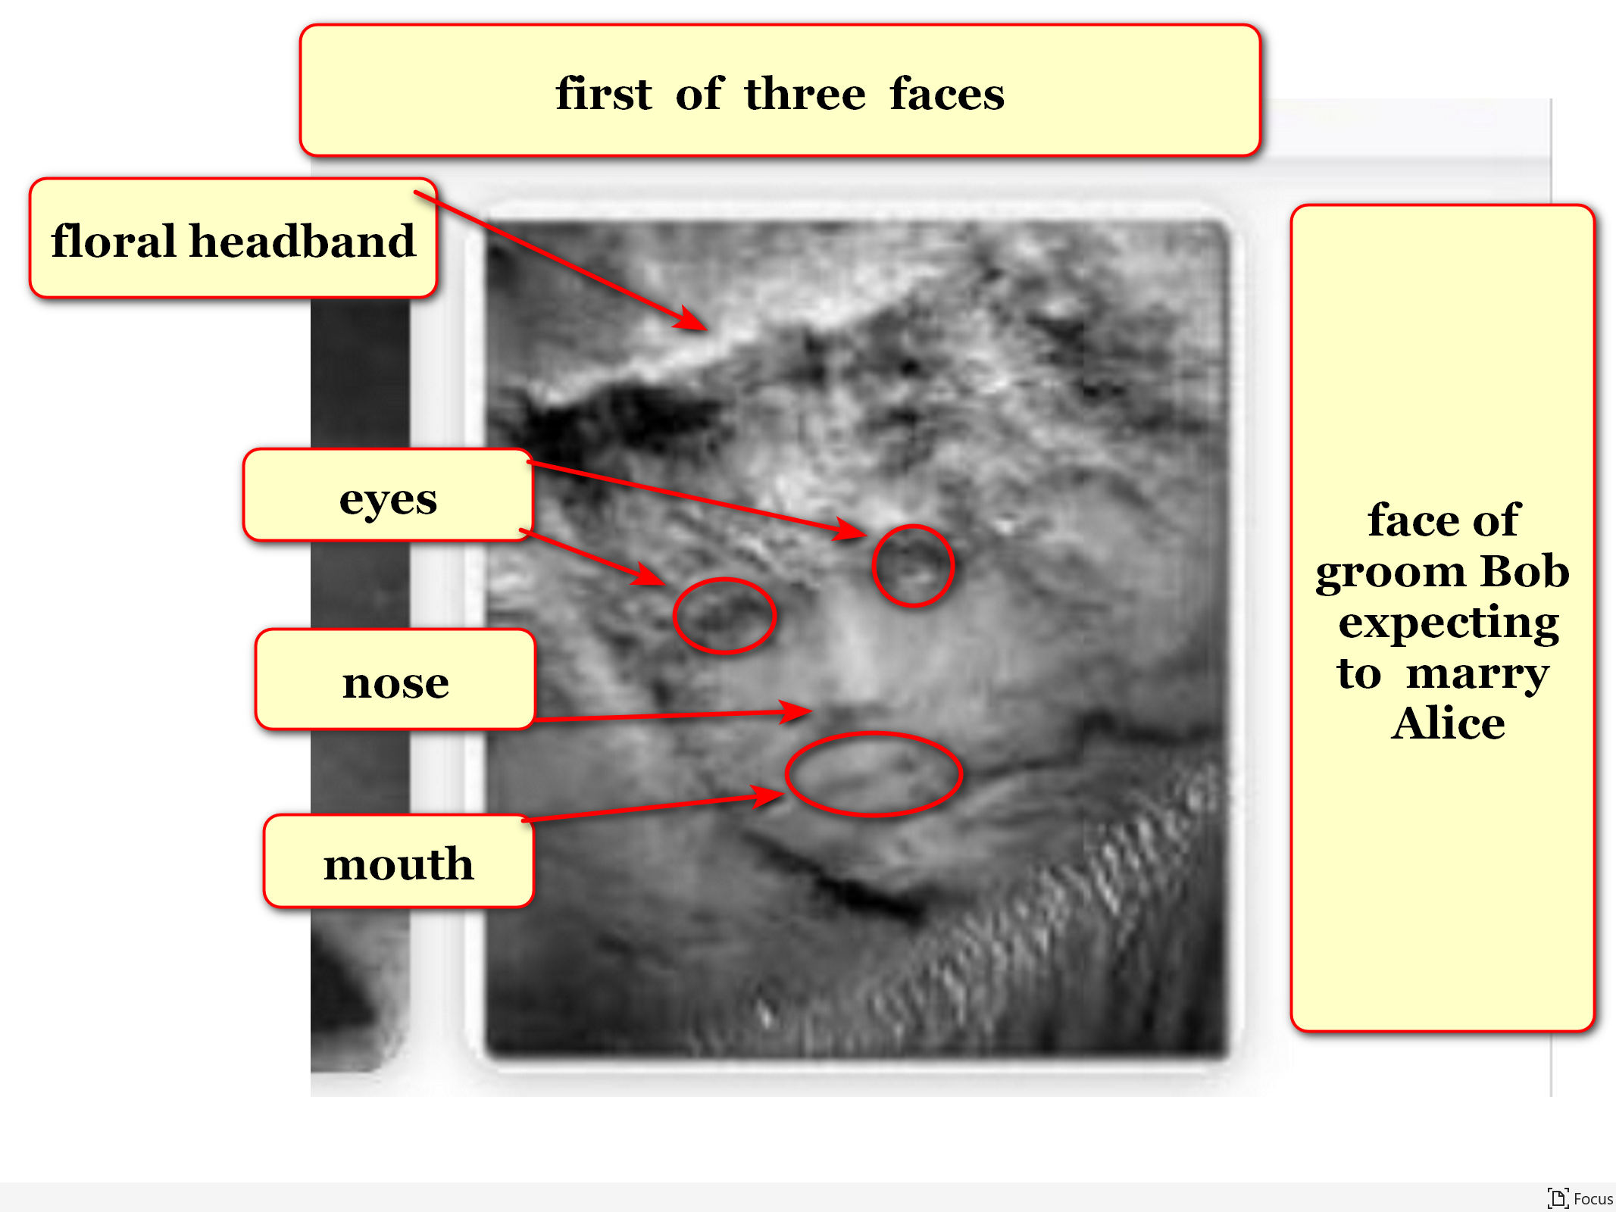

Bob
invented
bargaining item hopefully appealing

Bob
communicated
offer

Bob
offered
juicy alternative to merely shelving proceedings
keeping agreement unfinished forever

Bob
invented
robust SUNNYsideDOWN system horror shows genre
including new development called physical pain

titan pair two
already relished
causing kids' consternations via nightmares

possibility of even more delight
enticed
titan pair two

Bob's offer of full legitimacy
included
pair two accept majority vote concept

vote VEGETATION and ALL OTHER LIFE
already counted
as SUNNYsideDOWN vote
because never crowned onto Alice

Bob
promised
utmost in convincing ANIMALS and MINERALS
revote to vote pro SUNNYsideDOWN

plus Bob
promised
Bob's utmost to convince boys
to vote pro SUNNYsideDOWN

above if titan pair two
accepted
majority decisions concept as new
standard operating procedure for universe

if titan pair two
accepted
concept

then unanimous titan decisions
no longer necessary

majority rules concept
would replace
unanimous decision concept

Cindy and Don
accepted

Bob
further offered
disavowing pancake slice rights if pair
gave Bob engagement bride replacement possibility

titan pair two
discussed
possibilities if Cindy took amnesia serum

titan pair
concluded
Cindy’s likely vote still SUNNYsideDOWN vote
even after ingesting amnesia inducing serum

then titan pair two
would still possess
2-1 majority even if Bob failed

confident titan pair two
agreed
via Cindy Don 2-0 majority vote
for Cindy ingesting amnesia serum

tranquility minded Bob’s risky transaction
allowed at least
official acceptance majority rule concept

Bob's strategically withdrawn vote
upgraded
Alice’s 1/4 importance vote
to now 1/3 importance

tranquility Bob
hoped
memory cleansed Cindy
would somehow champion SUNNYsideUP

Bob's hope
manifested

Cindy
actually converted
after ingesting amnesia causing serum

Cindy’s amnesia cleansed emotional mind set
accepted
Bob's and Alice's SUNNYsideUP design for
universe plus accepted Bob as husband

Don
still favored
SUNNYsideDOWN

yet now Cindy
favored
SUNNYsideUP

therefore titans' one to one tie
needs
Alice's tiebreaker vote resolution

Alice in three portions
possessed
internal one to one tie

ANIMALS and MINERALS pro SUNNYsideUP
versus
SUNNYsideDOWN VEGETABLES and ALL OTHER LIFE

universe
awaited
vote of Alice portion called humankind

now obligated bamboozler Bob
creatively promoted
SUNNYsideDOWN
therefore keeping deal valid

third face in statue on mars
indicated
Bob now obligated
to distasteful task champion SUNNYsideDOWN

ariel view of donkey face
looks
southwestward

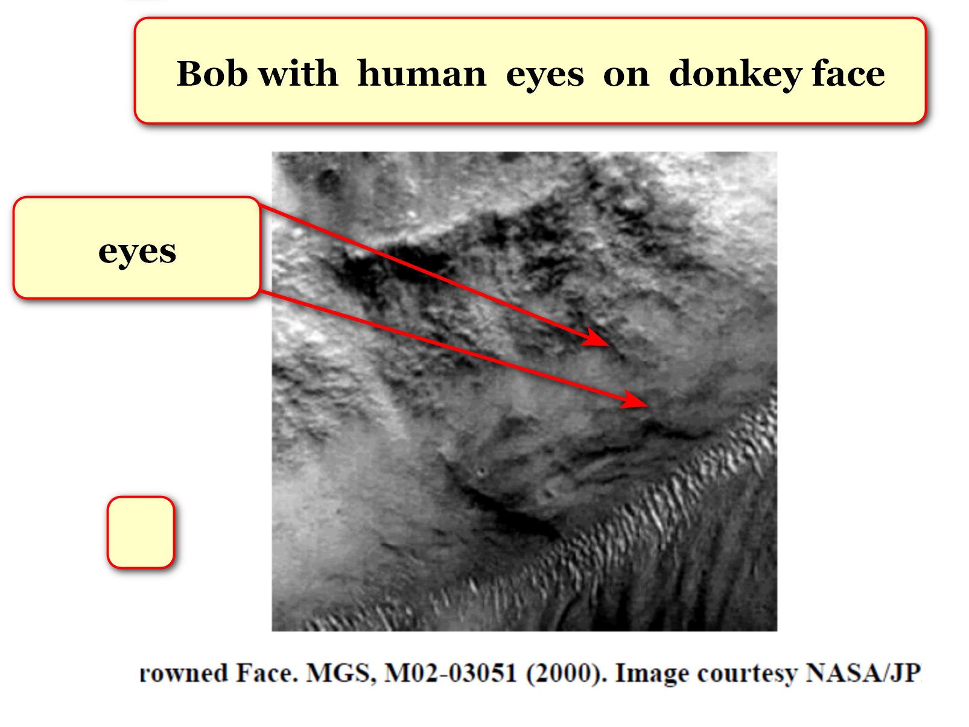
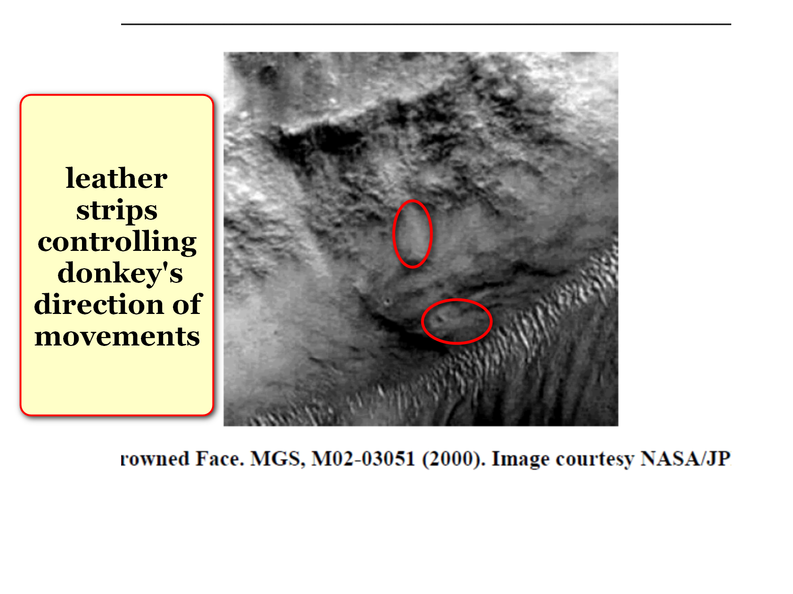
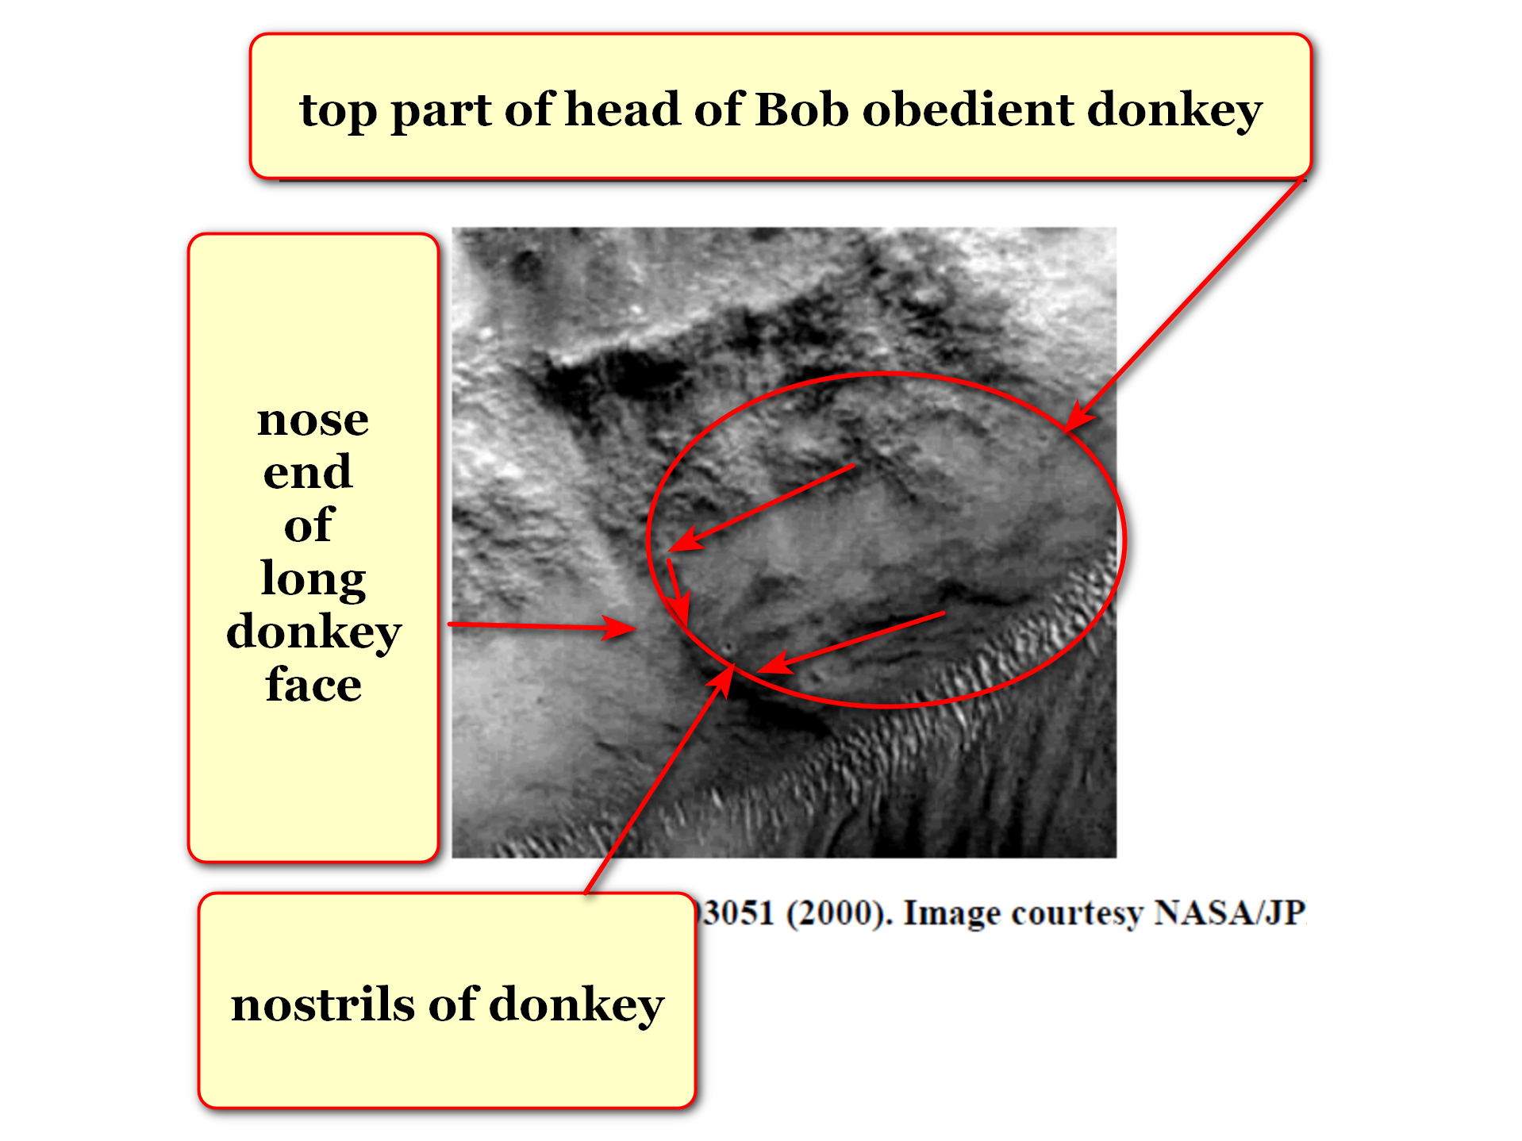

fictional story of pinocchio
includes
donkeys originally bad boys like Bob
transformed into donkeys

in ancient times court jesters
sometimes
wore mask depicting head of donkey

in history royal courts' jesters
mocked sarcastically
without repercussions

current example CLASS CLOWNS
make fun of
teacher or fun of what happens
inside classroom

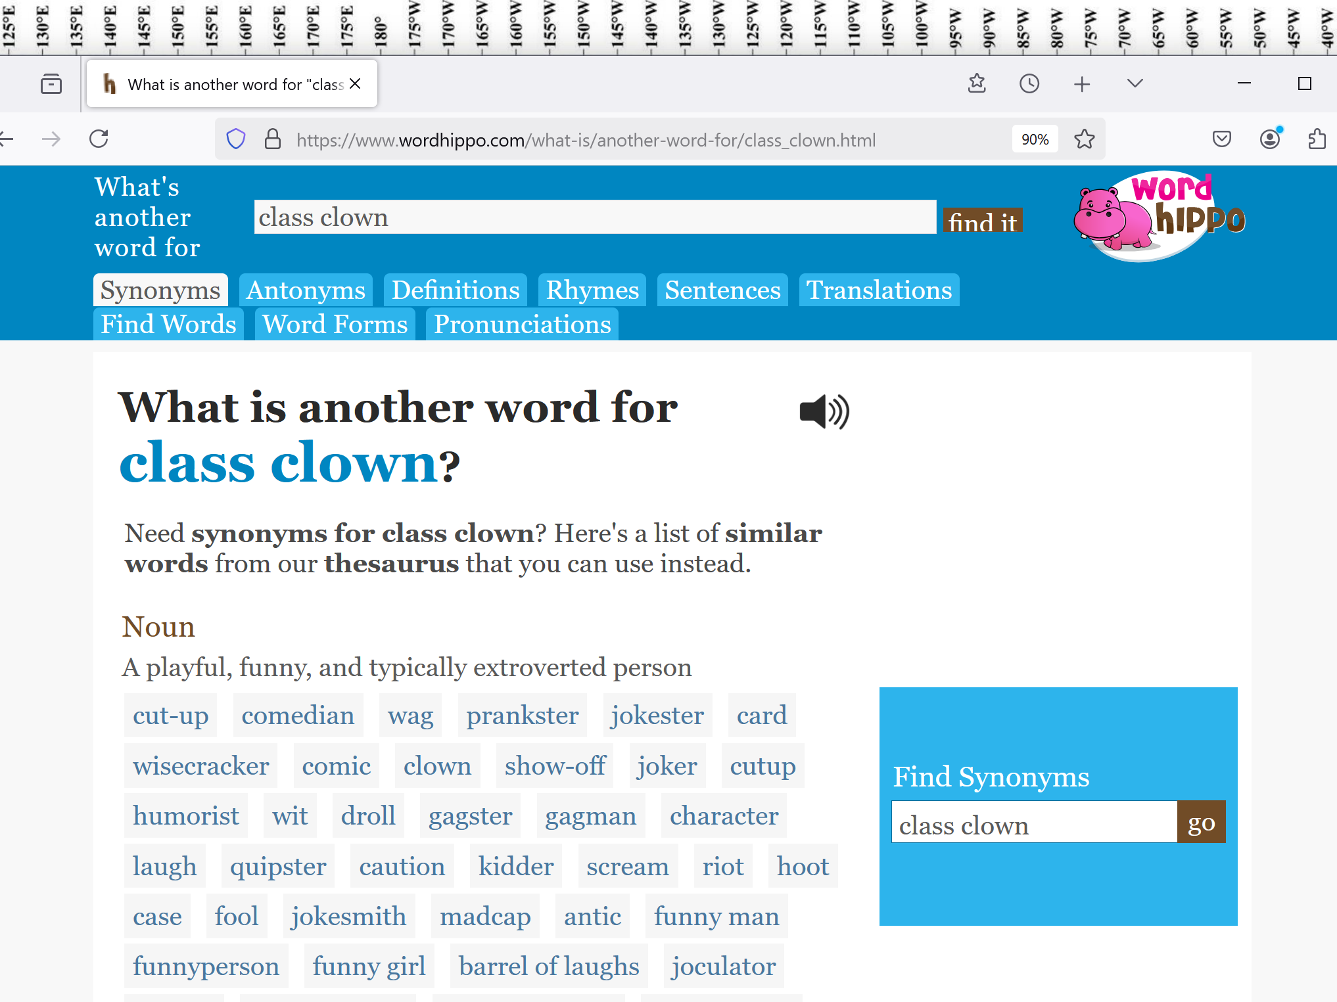

Bob
assumed
role court jester with SUNNYsideDOWN humor
including sarcasm

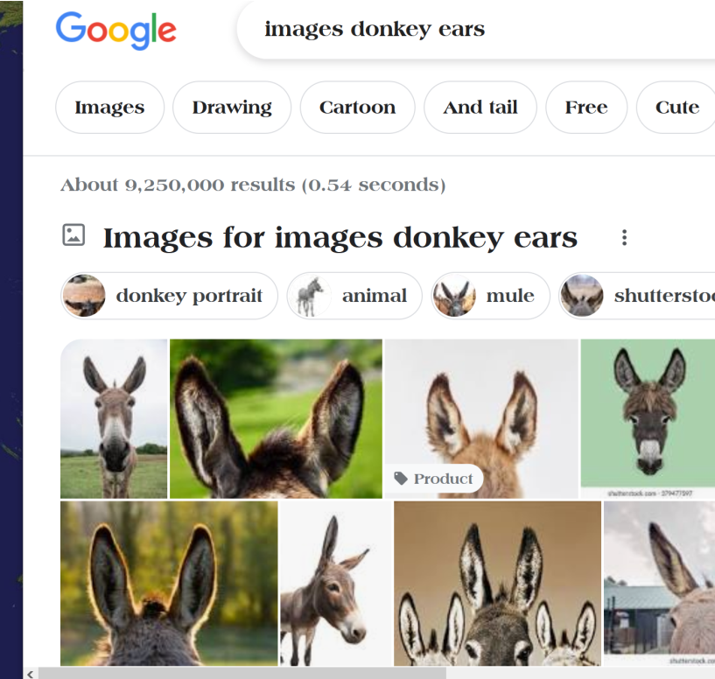

EAGLE NEBULA'S PILLARS OF CREATION
reference
donkey ears

donkey ears
reference
Bob assumed
costume of court jester

chapter ends

