A01 SMOOTH KEYS DEMOCRACY = global peace

all nations on globe
need to invoke
SMOOTH KEYS DEMOCRACY win win strategy
to accomplish peace and security globally

any chief executive of any nation
instituting
SMOOTH KEY DEMOCRACY'S Executive Crew
gains crew desk 22 for lifetime

if by chance person seeing above
causes violence to attain
above automatically bans self from crew

in SMOOTH KEYS DEMOCRACY citizens
vote
Mondays and Wednesdays and Fridays
whether government's actions please or displease

Majority NO votes three uninterrupted times
automatically reassigns among others
crew members 1-20
above
initiates
randomly selecting replacements from
pool of elders

if all nations
upgraded
to this SMOOTH KEYS DEMOCRACY system

better than paper treaties nations
would gain confidence
all other nations would not invade

in this case former defense monies
could then be spent on
prebuilding modern solar megacities
kim dubbed DiameterCities

chapters I03 and J04-J09
discuss
DiameterCities

currently USA federal judges
gain
lifetime appointments

nations' upgrading per adopting this book
give
similar longevities to heads of states
for joining Executive Crews

therefore after abdicating somewhat former heads
would still retain
one anonymous vote out of 22
anonymous votes per task

Executive Crew of 22
would lead
executive branch as nation's highest authority
because all branches contribute leaders

Executive Crew of 22
would declare
final words on executive and
legislative and judicial matters

for example if president trump
voluntarily proceeded with
this new initiative

then trump
would attain
desk 22 for life

kim martin klecka
would attain
desk 21 until 2028
presidential election

normal cycle of presidential terms
equals
that person occupying desk 21 for
four year term regardless

membership of Executive Crew USA
would include
supreme court justices occupying desks 01 - 09

vice president vance
would occupy
desk 10

three senators and six from house
would occupy
desks 11 through 19

recurring style of selection
includes
random selection from pool of eldest
members of governing group

after SMOOTH KEYS DEMOCRACY adoptions humankind
would start planning and eventually prebuilding
materials for DiameterCities

eventually thousand equal sized DiameterCities
would replace
current de facto one world government
of supposedly independent nations of globe

entire humankind
would migrate to
rent free titanium residences each with
self sufficient family greenhouse gardens

concerning this book if president trump
describes
book's trump chapters as truthful and
apologizes for personal deaths of persons

then USA
receptive to upgrading to
SMOOTH KEYS DEMOCRACY with trump at
desk 22

trump chapters
include
S06 and S10 and T05-U01

going forward president trump
could initiate
global tranquility via
establishing Executive Crew USA

SMOOTH KEYS' Executive Crew of 22
would vote
concerning whatever chief executive
decides by self now

some examples
include
bills from congress and executive orders
and military actions and pardons etcetera

in other words crew's 22 persons
vote
FAIRNESS for ALL case by case

SMOOTH KEYS majority rules protocol
insists
at least 12 of crew must
vote YES GO TO WAR

very few if any Executive Crews
would vote yes to war
to amass patriots' deaths

far easier for Executive Crews
to reach
mutual peaceful agreements
even if by extraordinary verbal efforts

if war unjust then citizens' votes
could redeploy
first 20 of crew and 110
RESEARCH ASSISTANTS via three routine votes

in this second way citizens
would nullify
notions of warring

for example if district of columbia
votes NO
three consecutive uninterrupted voting days that
redeploys 130 of 132 top persons

those persons
include
83 house members and 3 senators

130 of 132 top persons
automatically redeploy
elsewhere in government replaced by others

selections of new members
would include utilizing
random ping pong barrel tumbler method

kim's invented stadium voting strategy
includes utilizing
capital city's stadium to attain citizen's
majority opinion via physical movement

concerning USA'S population statistics
say
390 persons' opinions
gives same ratio as nation's population

early voting mornings non masked volunteers
would unfold
A frame signs on steps
at end of each row

each sign
would display
progressive number corresponding to
that filled row of seats

last sign
would display
number 399

non masked volunteers
would place
A frame signs backwards onto
that last row's unneeded seats

in this way all in stadium
would easily verify
exact number 399 persons
about to physically vote

at noon masked voters
would show
identification at entry gates

volunteers
would hand to
each verified capital city resident
one random midsection seat ticket

volunteer master of ceremonies
would direct
seated voters to several midsections
of 399 seats each

in this way all in stadium

would easily count
full sections of 399 each

master of ceremonies
would remove from
numbered rack equal number ping pong
balls as groups of 399 filled

voters with cell phones
would take pictures
to verify ping pong ball rack
vacancies equal number of midsections filled

master of ceremonies
would insert
numbered ping pong balls and crank
tumbler barrel and then select one

master of ceremonies
would direct
non masked volunteers to fill steps
on both sides of selected group

master of ceremonies
would then direct
seated persons to vote by physically
moving to above or lower section

some voters
would travel to 399 seats upper
section if had opinions YES

other voters
would travel to 399 seats lower
section if had opinions NO

in this way all in stadium
would easily count
number of YES votes and
number of NO votes

others in stadium
could easily take pictures
to verify YES votes
and NO votes in same picture

above strategy
provides
reliable secure voting results

three uninterrupted majority NO votes
would initiate
peaceful redeployment of first 20 of
crew plus all 110 RESEARCH DEVELOPERS

yet 21st crew member
would stay until
end of four year presidential cycle

SMOOTH KEYS scientific group decisions style
enhances
collaborations because utilizes communications
anonymously written

plus group
votes anonymously
YES or NO concerning proposed solutions

SMOOTH KEYS' anonymous communiques
would possess
SUNNYsideUP tone comments transcending
emotionally susceptible verbal duels during meetings

routine strategy several days' methodical reevaluations
include exposing
some first glance SUNNYsideUP appearing ideas
as actually SUNNYsideDOWN ideas

when legislature
sends
legislation for president's signature

then that legislation
gains
equivalent of Executive Crew's tuesday's
YES vote

then like other ideas that bill
undergoes
opposite view scrutiny in weekly process
until thursday's vote YES or NO

crew members plus RESEARCH DEVELOPERS
actively comment and seek clarifications
via in house published memorandums
in book form

during projects 132 top decision makers
simultaneously express
various major considerations to each other
via books published in house

in this way SMOOTH KEYS technique
adds
anonymity to both idea presenters and
commentators

therefore SMOOTH KEYS DEMOCRACY
harvests
wisdom without fear of repercussions

USA administration's Executive Crew of 22
would include

all 9 supreme court justices

current vice president in desk 10

3 members from senate

6 members from pool of house of
representatives members plus observers

in 2028 newly elected president
would attain
desk 21

in 2028 newly elected vice president
would attain
desk 10

president trump
would randomly ping pong select
three senators from pool of five
eldest african american senators

those senators
would gain
desks 11 and 12 and 13

president trump
would again hand crank spin to
randomly select ping pong balls
with numbers corresponding to those senators

in same way 6 house members
attain
desks 14 through 19 via
random selection from 16 eldest congresspersons

6 of pool of above
include
6 eldest native americans
in house of representatives

5 of pool of above
include
5 eldest asian americans and
pacific islanders in house of representatives

5 of pool of above
include
5 eldest others
in house of representatives

during random selections each of those
would grab
one of numbered ping pong balls
and list name to that number

after tumbling those president
would remove enough
ping pong balls without directly looking

those ping pong ball associated persons
would then assume
Executive Crew desks 14 through 19

SMOOTH KEYS DEMOCRACY decisions style
includes
secret ballot voting from all 22
Executive Crew members inside same room

each Executive Crew member
facilitated by
five RESEARCH DEVELOPERS for prioritizing foci
for tasks and developing innocuous solutions

selection process for RESEARCH DEVELOPERS
repeats
random ping pong barrel tumbler method

first group
includes
pool of 100 eldest females of
house of representatives

in this way female RESEARCH DEVELOPERS
attain
desks for facilitating
each female Executive Crew member

pool of 100 eldest congressmen
repeat
above for male RESEARCH DEVELOPERS
facilitating each male Executive Crewmember

83 members of house of representatives
will attain
desks of either Executive Crew or
desks of RESEARCH DEVELOPERS

five SMOOTH KEYS DEMOCRACY geodesic domes
located in
ellipse will possess offices
for 135 SMOOTH KEYS DEMOCRACY persons

Public Domain
File: Aerial view of White House and the Ellipse.jpg
Created: Taken on 15 May 2010, 22:48
Uploaded: 15 May 2010

Carol M. Highsmith - This image is available from the United States Library of Congress's Prints and Photographs division under the digital ID highsm.04915.

120 feet diameter central dome
will connect
four similar domes north south east west
for combined 360 feet radial footprint
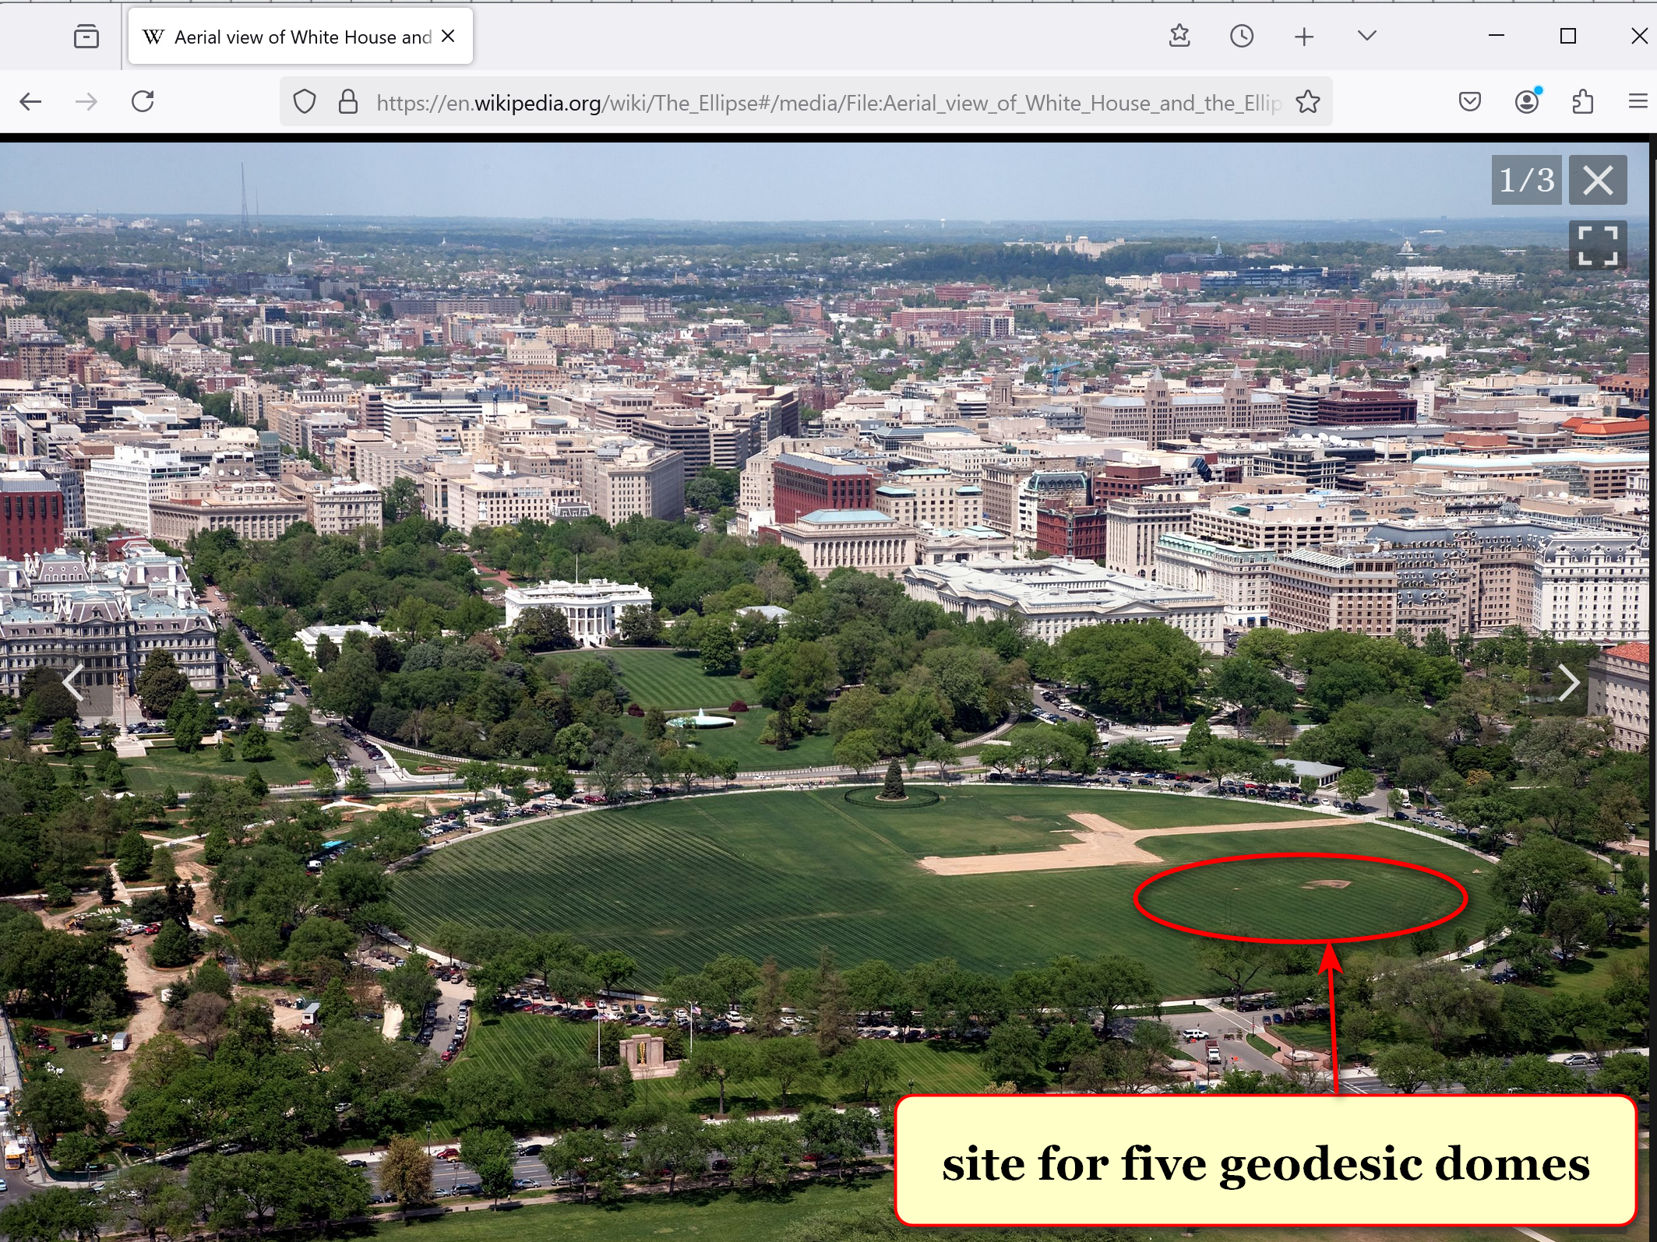

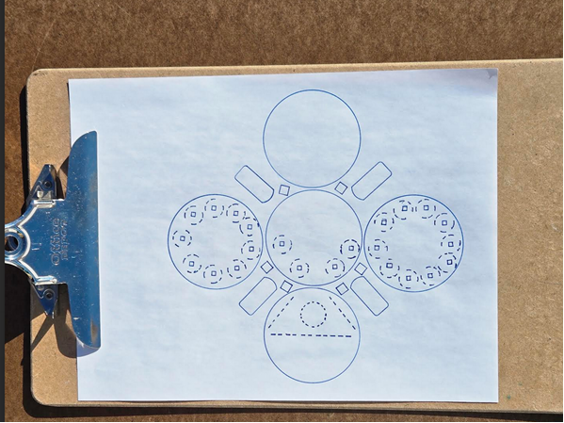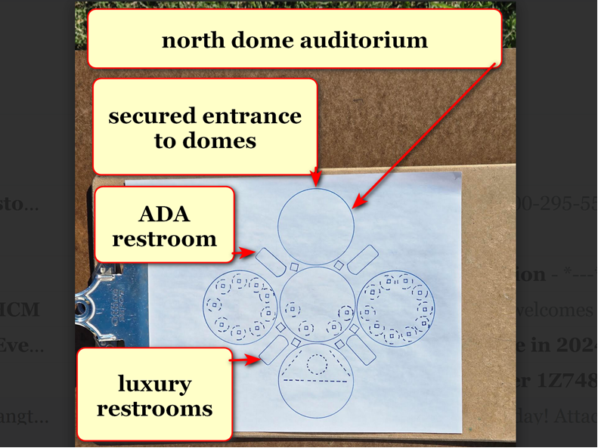

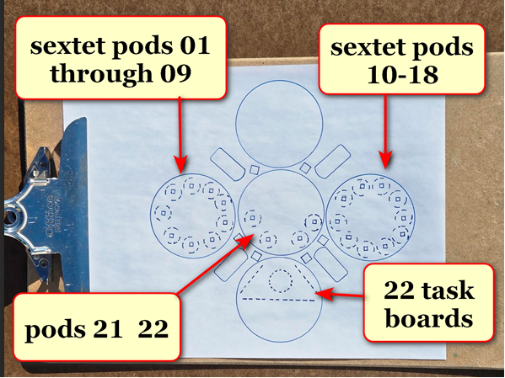

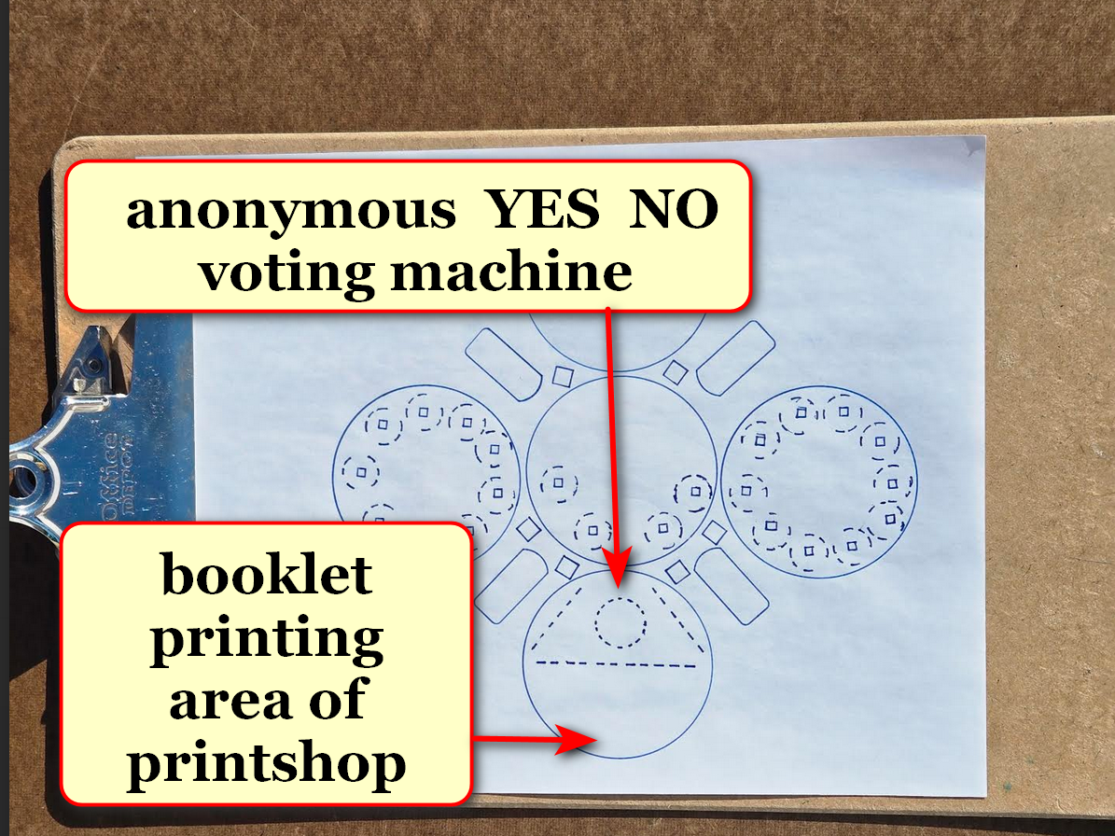

domes
will exclusively host
Executive Crew of 22 plus 110
RESEARCH DEVELOPERS plus 3 COLLATOR PRINTERS

all persons mentioned above
may freely and repeatedly view
all top secret unredacted unsummarized documents
and pictures and other classified media

therefore persons working inside decision domes
will solve
situations as equals

other communications including with news media
will occur
elsewhere far from domes

with above simplification secret service
will more easily protect
all persons equally from outside domes
along perimeter securing safety of group

secret service agents
will operate
north dome for screenings

Executive Crew plus RESEARCH DEVELOPERS
will store
camera devices including cell phones in
north dome lockers during workdays

stadium style voting
keeps
citizens in loop of decision making

above check and balance system
behooves
Executive Crew keeping public informed
as to reasons for actions

supreme court
controls
volume of cases for voluntary review

constitution
allows
supreme court if court desires
to hear zero cases per year

before SHOELANGUAGE book supreme court
ruled on
less than 85 cases per year

federal courts of appeal
could transform to
role of final courts of appeal

weekly quintets of 110 RESEARCH DEVELOPERS
review
events and prioritize for crew
total of 22 tasks for week

110 RESEARCH DEVELOPERS in quintets
evaluate
events decide on three most pressing
matters for that week's crew's votes

then executive crew
chooses
22 most urgent tasks
from 66 suggestions

decision domes' officials' anonymously written arguments
replace
oral arguments

in SMOOTH KEYS system justices' wisdom
helps shape
tasks' resolutions during creations
rather than afterwards

76 other members of house
fill
remaining desks for RESEARCH DEVELOPERS

200 eldest of house including observers
gain membership in
pool from which president will scoop
76 associated numbered ping pong balls

hopefully that Executive Crew
successfully handles
affairs of country very well for
both four year terms

however three uninterrupted citizen NO votes
initiate
changing 20 persons of Executive Crew
plus 110 RESEARCH DEVELOPERS

those persons
redeploy
to original offices duties
or to other USA government roles

for filling vacant desks 1-9 president
randomly ping pong chooses
9 federal judges from pool of
30 eldest federal judges

9 supreme court justices
switch
roles with those 9 federal judges

those 9 federal judges
gain
increased pay to Executive Crew rate

9 supreme court justices' wages
revert to
lower pay of regular
supreme court justices' wages

desk 20's sophia strother lewis
would take assignment as
fourth COLLATOR PRINTER

crew desks 10 and 20
shall be occupied by
selections from six elder congresspersons
not already in domes

ping pong random method
choses
above

initially 110 RESEARCH DEVELOPERS desks
seat
25 cabinet and cabinet level persons
and legislators

members of house of representatives
will fill
numbered desks without names below

official televised ceremony
includes
random selection via
ping pong barrel tumbler selection method

TABLE BELOW

legislators from house
cabinet level persons
secretaries of departments
RESEARCH DEVELOPERS

executive desk numbers RESEARCH DEVELOPER #

01 samuel alito 001 agriculture
brooke leslie rollins

002
003
004
005

02 amy coney barrett 006 attorney general
todd blanche

007
008
009
010

03 ketanji brown jackson 011 commerce
howard william lutnick

012
013 council of economic
advisors chairman
stephen ira miran

014
015 veterans affairs
douglas allen collins

04 neil gorsuch 016 CIA
john lee ratcliffe

017 FBI head
kashyap pramod patel

018 director of national
intelligence
tulsi gabbard

019 homeland security
markwayne mullin

020 nation security advisor

05 elena kagan 021 education
linda marie mcMahon

022 defense
peter brian hegseth

023 border czar
thomas douglas homan

024
025 solicitor general
d john sauer

06 brett kavanaugh 026 energy
christopher allen wright

027
028 environmental
protection agency
lee michael zeldin

029
030 interior
doug james burgum

07 john roberts 031 health and human
services
robert f kennedy jr
032
033 housing and urban
development
eric scott turner

034
035

08 sonia sotomayor 036 labor
lori chavez-deRemer

037
038 small business
administration
kelly lynn loeffler

039
040

09 clarence thomas 041 office of management and budget
russell thurlow vought

042 treasury
scott kenneth h bessent

043

044
045

10 vice prez JD vance 046 office of science and
technology policy
michael k kratsios

047
048
049
050

11 legislator 051 state
052
053 ambassador to UN
054

055 US trade representative
jamieson lee greer

12 legislator 056 transportation
sean patrick duffy

057 drctr of nat econ cncl
kevin allen hassett

058
059
060

13 legislator 061 national institutes health d
062
063
064
065

14 legislator 066 federal comm comm chair

067
068
069
070

15 legislator 071 centers for m.care & cade
Dr. Mehmet Oz
072
073
074
075

16 legislator 076 077
078
079
080

17 legislator 081
082
083
084
085

18 legislator 086
087
088
089
090

19 legislator 091
092 093
094
095

20 kim recommends 096
sophia strother lewis 097
of austin texas 098
099
100

21 kim klecka until new 101 deputy chief of staff
2028 president stephen n miller

102
103
104
105

22 president trump 106 white house chief of staff
susan L wiles

107 assistant to president
sergio gorokhovsky

108 press secretary
karoline claire leavitt

109 communication director
huyen steven cheung

110 white house counsel
david alan warrington

new 2028 president
will complete
four year term at desk 21
even if voters redeploy others

precise weekly paid hourly compensations
more fair than
salary

Executive Crew members
gain
equal compensations to president's compensation

each member of executive crew
compensated
193 dollars per hour
based on 40 hour week

each RESEARCH DEVELOPER and COLLATOR PRINTER
compensated
145 dollars per hour
based on 40 hour week

Executive Crew of 22 voting
occurs
tuesdays at 10:00 in morning
then thursdays at 16:30 in afternoon

both days' majority YES votes
needed
to propel task forward officially

plus Executive Crewmembers
possess
specific times to evaluate comments
attached to physical bulletin boards

chapter A02
details
weekly tasks of SMOOTH KEYS DEMOCRACY
RESEARCH DEVELOPERS and COLLATOR PRINTERS

COLLATOR PRINTERS
collate
anonymous written opinions from Executive Crew
and from RESEARCH DEVELOPERS

same persons
create
books with those opinions
for all 132 persons to read

chapter ends

