chapter 006
4 mixed states ROCK PAPER SCISSORS GAZA
2026 may 08 friday

any and all nations
need to start creating
FAIRNESS for ALL system called SMOOTH
KEYS DEMOCRACY with accompanying executive crews

for mideast chapter 006
contains
map for permanent tranquility in mideast
via establishing executive crews of 22

each member of executive crew
possesses
one vote concerning executive actions

if knesset
adopts
chapter 006

then prime minister benjamin netanyahu
voluntarily abdicates somewhat
into lifelong appointment to desk 22

under same deal sarah netanyahu
attains
lifelong appointment to desk 21

agreement
includes
pardoning both for crimes committed
before understanding concerning chapter 006 deal

if palestinian governing bodies
also adopt
chapter 006 then hamas dissolves

then former hamas members
gain
amnesty for all actions committed before
understanding chapter 006 deal

SHOELANGUAGE book's adoption and then amnesties
include
hamas actually dissolving plus no other
hamas like replacements under new names

if every nation
adopts
SMOOTH KEYS DEMOCRACY style of government

that upgrade
equals
nations' heads leaving BEARS league

chapter 000
details
centuries old secret BEARS league

historically to avoid tranquility BEARS presidents
often secretly asked
other nations' BEARS presidents and
chiefs of states to threaten wars

BEARS
frequently scheduled
staged playfights complete with actual deaths

BEARS
weighed costs of losing
certain number of own patriotic citizens

on one hand BEARS
enjoyed
GUSHING STREAMS of praise coming from
mouths of own patriotic citizens

on other hand BEARS
valued
grander glory forever in history textbooks

plus across globe BEARS network
gain
massive fortunes from selling war equipment
including bullets missiles vessels etcetera

therefore for glory and money BEARS
planned
deaths of own GUSHING STREAMS citizens

individual heads of states BEARS
gain
textbook glory for withstanding other nations'
assaults which actually secretly invited

unknowingly sincere secretary of defense forrestal
attempted blocking
major source of future BEARS income

of irish descent forrestal
became
first victim of BEARS' lucrative
israeli palestinian conflicts

wikipedia.org
US Government - https://archive.org/stream/lbnana148sf#page/n8/mode/1up
work of employee of U.S. Navy, of person's official duties. As work of U.S. federal government, in public domain U.S.

File:James Forrestal - SecOfDef.jpg
Created: 1 January 1948
Uploaded: 26 February 2012
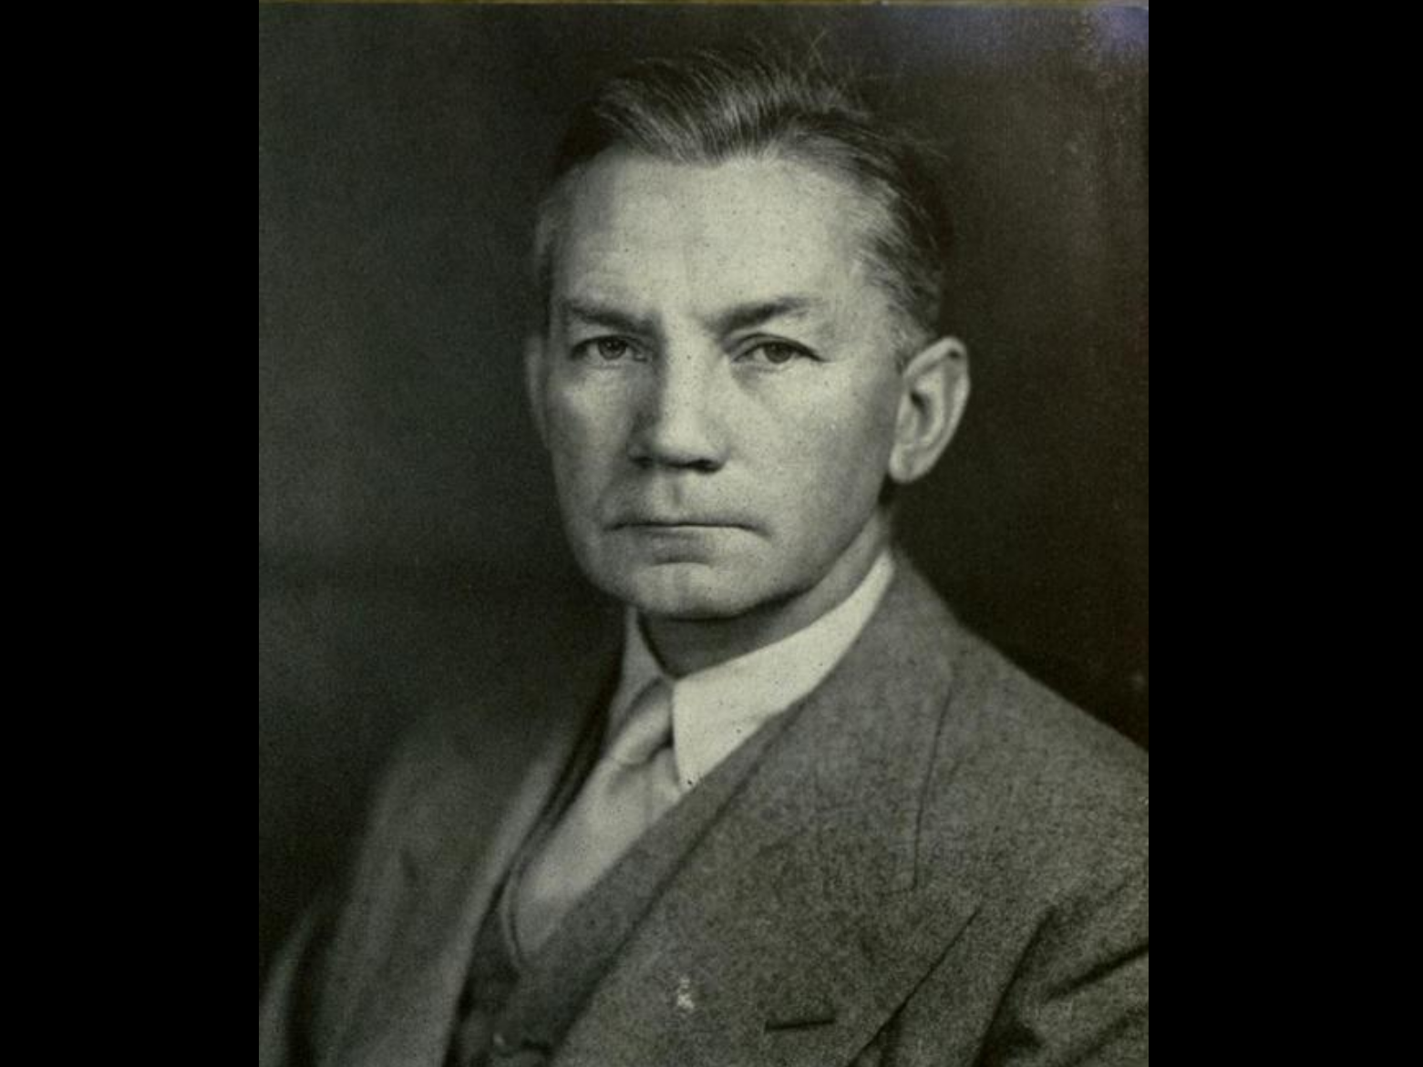

wikipedia.org

A number of works (shown below) have implied or indicated that Forrestal's death was suspicious or nefarious.

In December 1950 William Bradford Huie
published
article titled "Untold Facts about the Death of James Forrestal"
in THE AMERICAN MERCURY

That article, later entered into the Congressional Record and republished

Huie opined that "Much of the truth has thus far been suppressed, but the ghost of Jim Forrestal is not going to be laid until there are reasonable answers to such questions as these:

Why was the attack on Forrestal so reckless and sadistically savage?

KIM NOTES
answer to above

forrestal
favored
creating palestine federation similar to usa

in that case states in palestine
would contain
mixture of jews plus
palestinian inhabitants

yet BEARS
desired
partition to ignite bitterness to start
wars and deaths for generations

therefore for money and glory BEARS
killed
forrestal plus invented coverup story
then proceeded with chaos causing plans

wikipedia.org's

James Vincent Forrestal (February 15, 1892 – May 22, 1949)
last Secretary of Navy and first Secretary of Defense

in May 1944
strongly opposed the United States' support for the establishment of State of Israel
during private cabinet meetings with Truman in 1946 1947

Forrestal had argued against partition
on the grounds it would infuriate arabs
who supplied oil needed for
usa economy and national defense.

Truman forced Forrestal's resignation.
1949 march 31

at bethesda naval hospital Forrestal
underwent mental health care on
16th floor instead of first floor

on road to recovery, having regained 12 pounds (5.4 kg) since his admission into hospital.

1949may22 early morning hours

his body, clad only in bottom half of pair of pajamas,
was found
on third-floor roof below sixteenth-floor kitchen across hall from his room.

KIM NOTES BEARS
utilized
time delays to soften impact of
telltale details for example forrestal

official Navy review board, which
completed
hearings on May 31, 1949 waited until
October 11, 1949, to release only brief summary.

reported on page 15 of October 12 NEW YORK TIMES
stated only that Forrestal had died from fall from the window. did not say what might have caused fall,

full report was released by Department of Navy in April 2004.

KIM NOTES

after waiting 55 years BEARS
released
forrester's death details

in this way BEARS
tried to escape accountability

BEARS gang
waited for
emotions cooling therefore
dealt with fewer eager questioners

After full and mature deliberation, board finds as follows:
FINDING OF FACTS
- That the body found on the ledge outside of room three eighty-four of building one of the National Naval Medical Center at one-fifty a.m. and pronounced dead at one fifty-five a.m., Sunday, May 22, 1949, was identified as that of the late James V. Forrestal, a patient on the Neuropsychiatric Service of the U. S. Naval Hospital, National Naval Medical Center, Bethesda, Maryland.

- That the late James V. Forrestal died on or about May 22, 1949, at the National Naval Medical Center, Bethesda, Maryland, as a result of injuries, multiple, extreme, received incident to a fall from a high point in the tower, building one, National Naval Medical Center, Bethesda, Maryland.

- That the behavior of the deceased during the period of his stay in the hospital preceding his death was indicative of a mental depression.

- That the treatment and precautions in the conduct of the case were in agreement with accepted psychiatric practice and commensurate with the evident status of the patient at all times.

KIM NOTES

guilty BEARS in usa government
attempted swaying
citizens against reality that usa government
murdered forrestal and maintain killing activities

therefore BEARS usa
took
extraordinary steps to continue deception

sincere usa citizens
never imagined
usa government capable of such cruelty
until government introduced notion by denial
last portion of point four

That death was not caused in any manner by intent, fault, negligence or inefficiency of any person or persons in naval service or connected therewith

KIM NOTES BEARS
further attempted blocking
appearance of guilt via naming battleship
after very victim BEARS killed

2023january09

history.navy.mil/content/history/nhhc/browse-by-topic/people/sec-nav/forrestal/james-forrestal.html

Aircraft carrier USS Forrestal (CVA-59) that operated extensively during the Vietnam War and in Operation Desert Storm was named in his honor.

forrestal's idea of peace
could come to fruition

all parties involved
could agree to create
four independent nations each including equal
regard citizens jews and palestinians

kim
recommends
gershon baskin for chair 22

gershonbaskin.org/insights/encountering-life-encountering-death/

He is a founding member of Kol Ezraheiha-Kol Muwanteneiha (All of the Citizens) political party in Israel. He is now directing The Holy Land Bond and is the Middle East Director for ICO – International Communities Organization - a UK based NGO working in conflict zones with failed peace processes.

en.wikipedia.org/wiki/Gershon_Baskin


2022 march 21 friday
ww.npr.org/2025/03/21/nx-s1-5334680/gershon-baskin-discusses-how-israel-is-reacting-to-the-resumption-of-fighting-in-gaza

gershonbaskin.org


Gershon Baskin shares his candid, in-depth, and unequivocal perspectives on a wide range of important issues. His clear-cut and sincere observations serve to open up new avenues of discussion with people who believed that they were born enemies.

KIM NOTES

for years gershon baskin
accomplished
workable solutions between all parties involved
earning respect for completing seemingly impossibilities

concerning chair 22 kim
recommends
arabic knesset member as top
leader of one of new nations

eldest three arabic knesset married couples
could utilize
ping pong tumbler barrel method to
attain random selection for 21 22

that couple
could utilize
ROCK PAPER SCISSORS selection contest versus
baskin to choose northernmost or southernmost

winner of contest
chooses
and other couple accepts other nation's
desks of 21 and 22

for bookkeeping purposes kim
temporarily named
four proposed new nations

after populations
start living
in those nations then those citizens
should choose permanent nation names

north to south new nations
include
ROCK PAPER SCISSORS GAZA

mapsofworld.com's original map
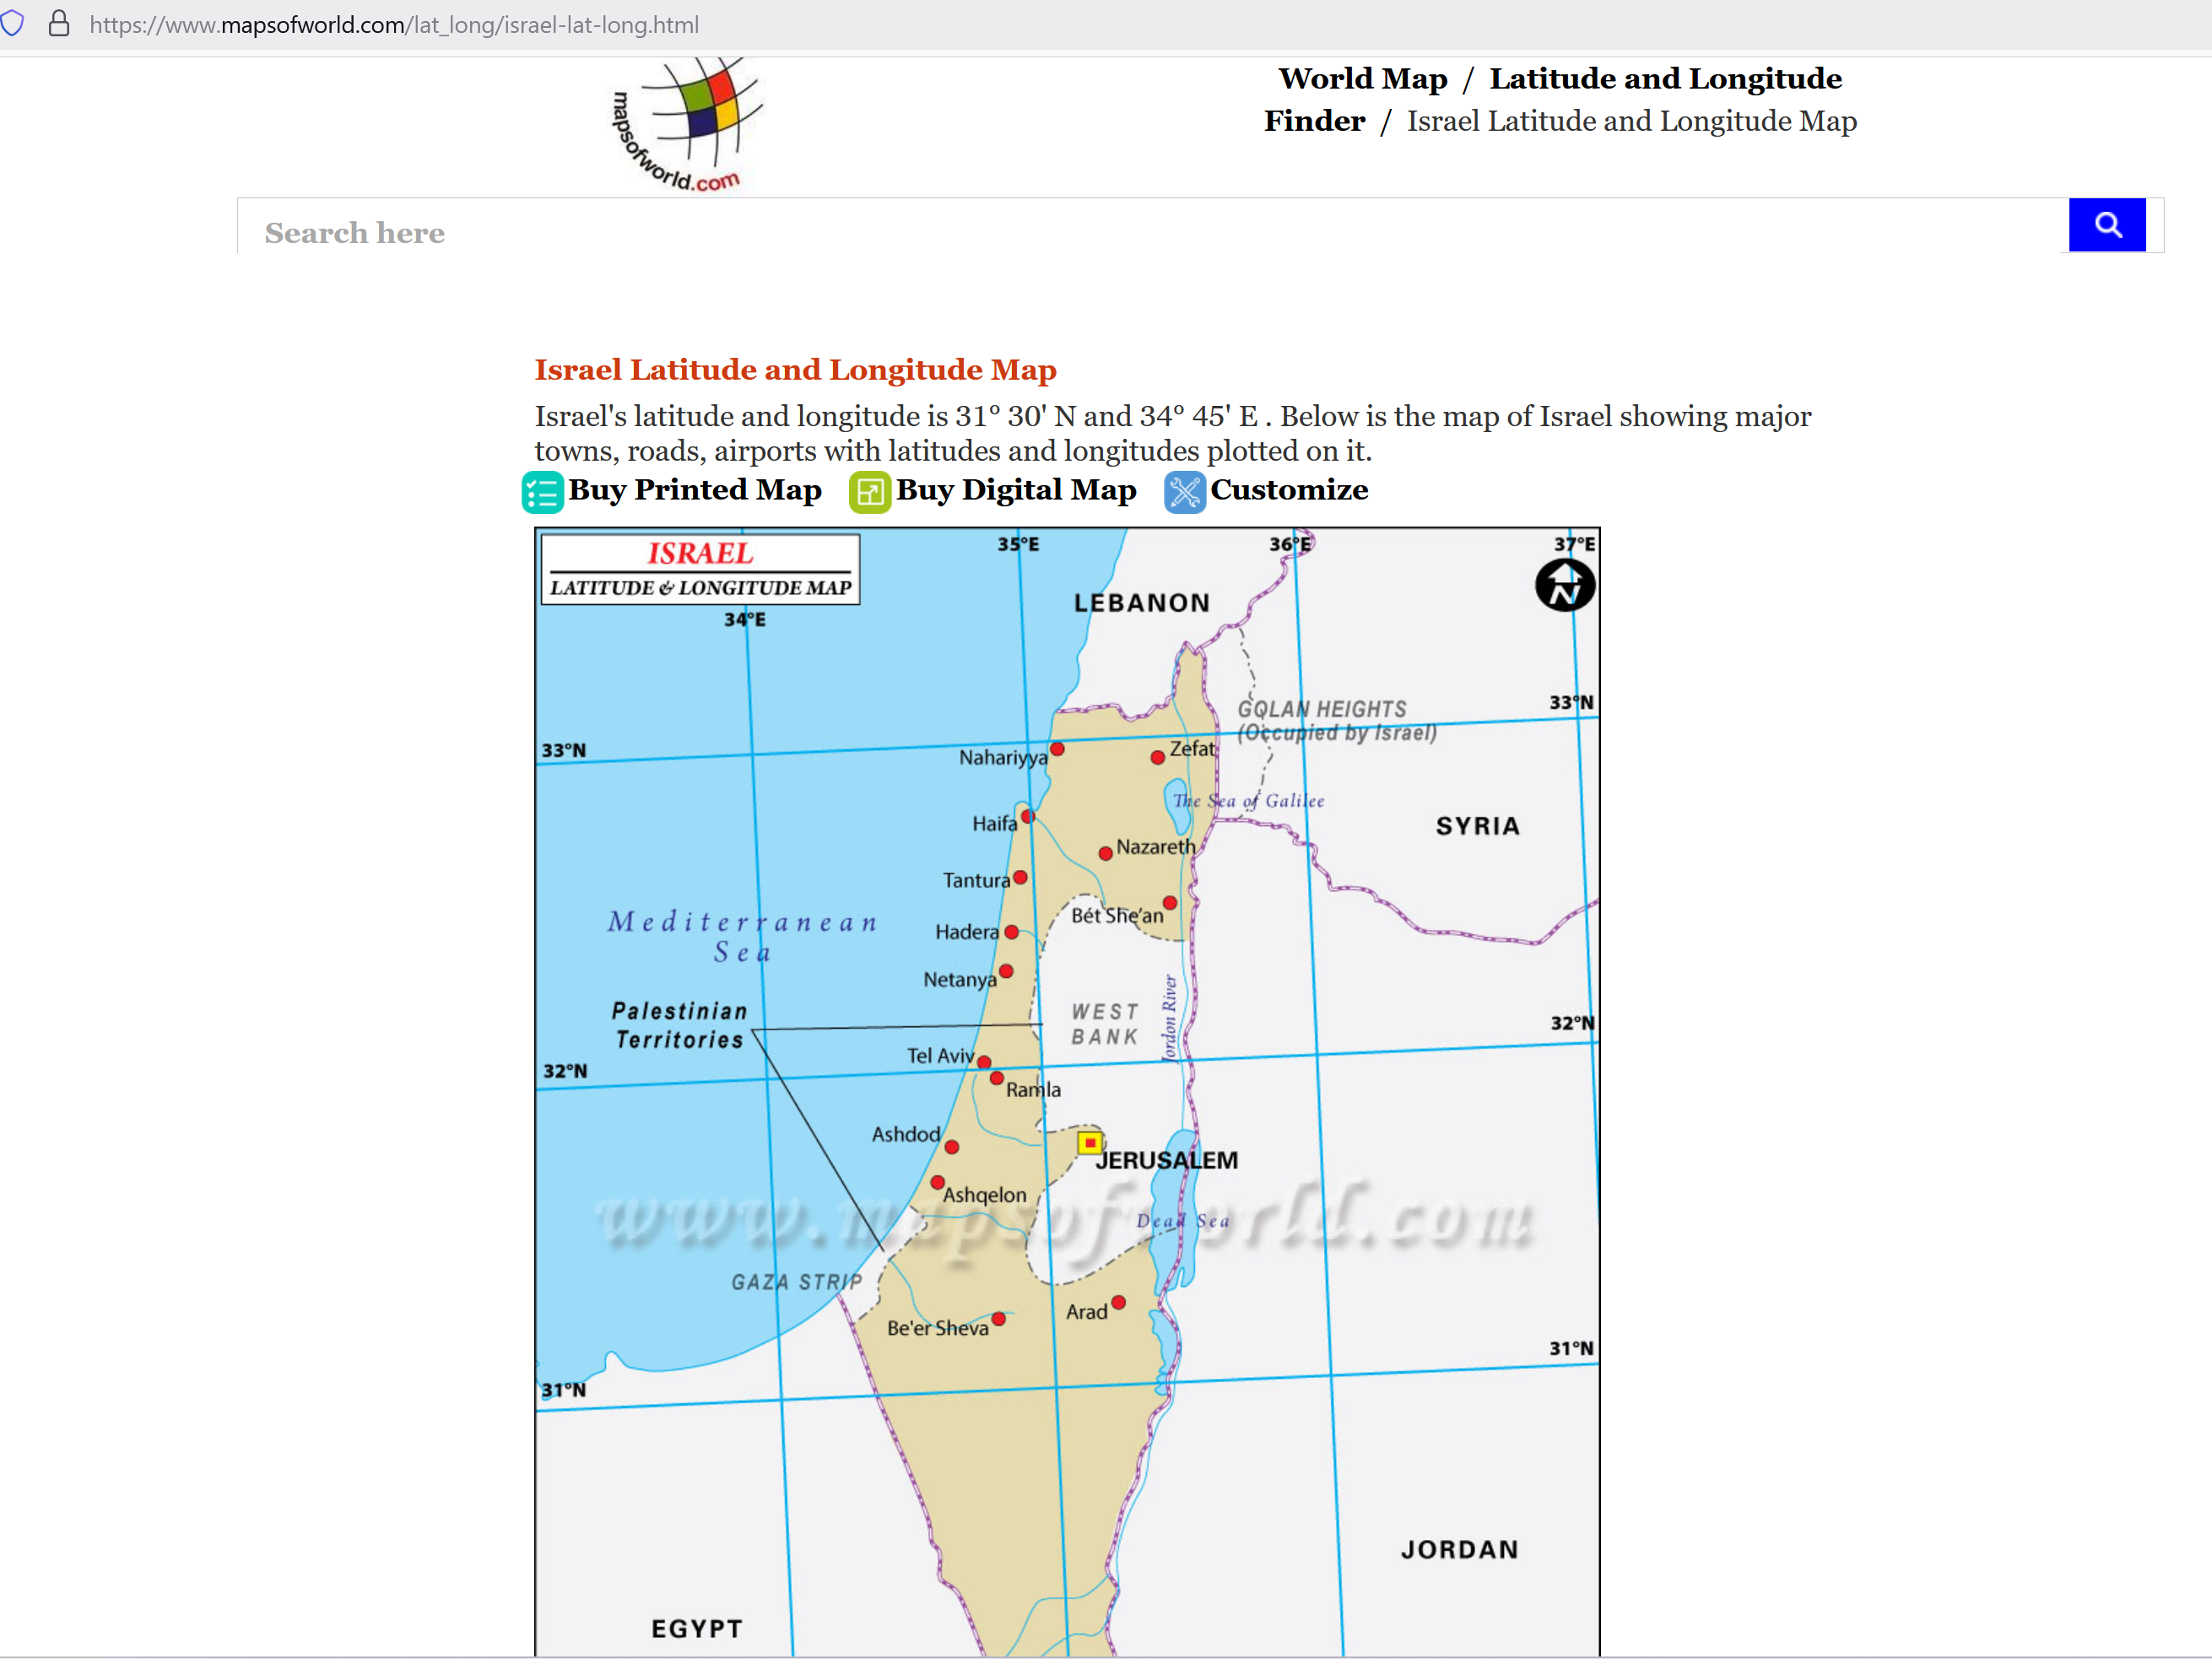
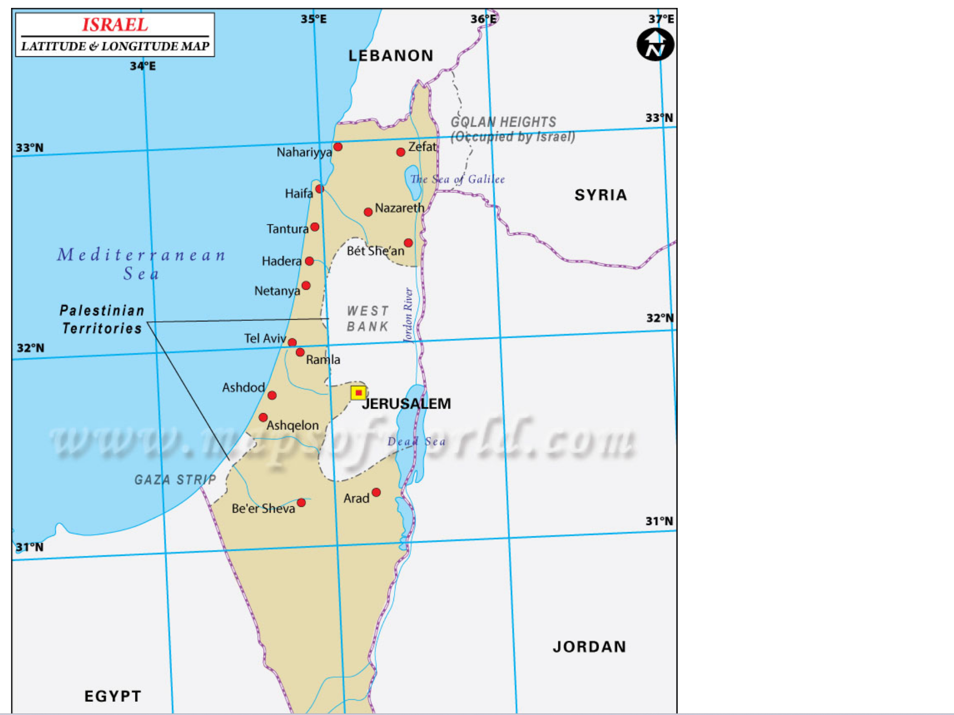
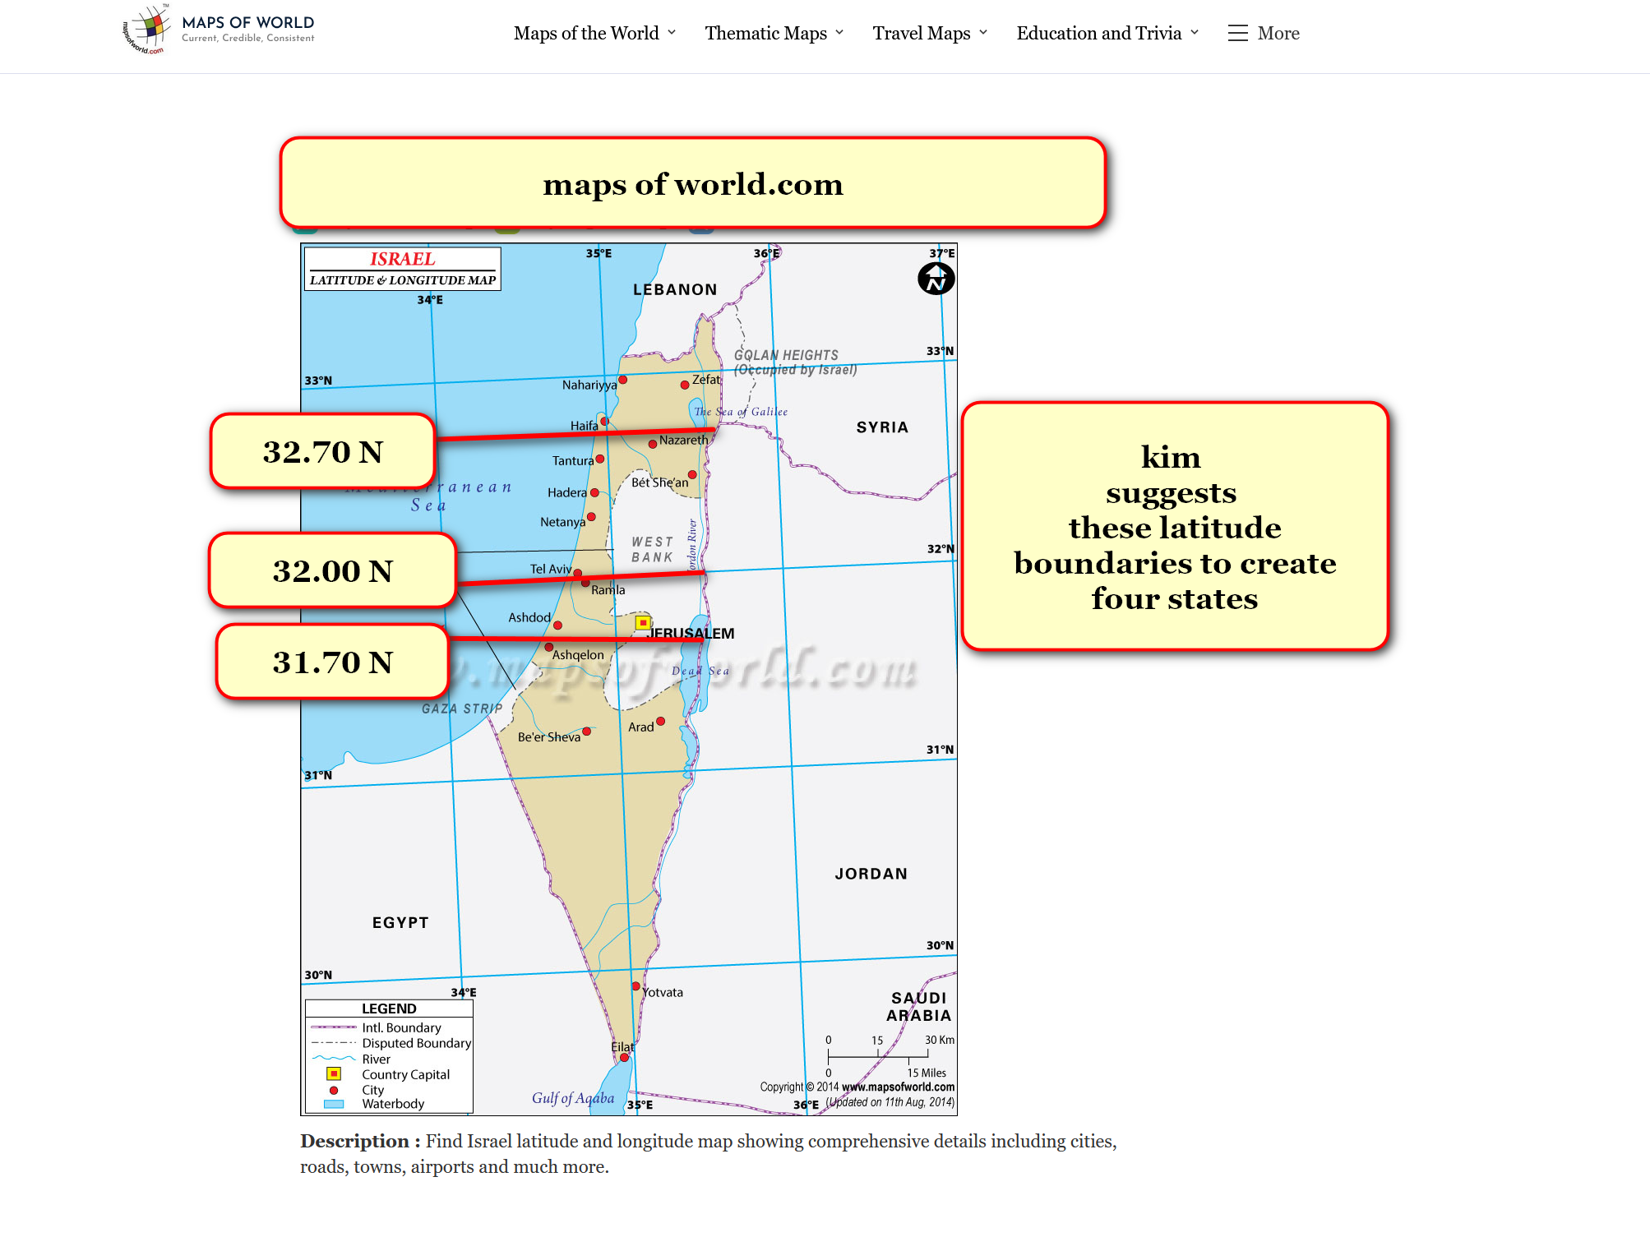
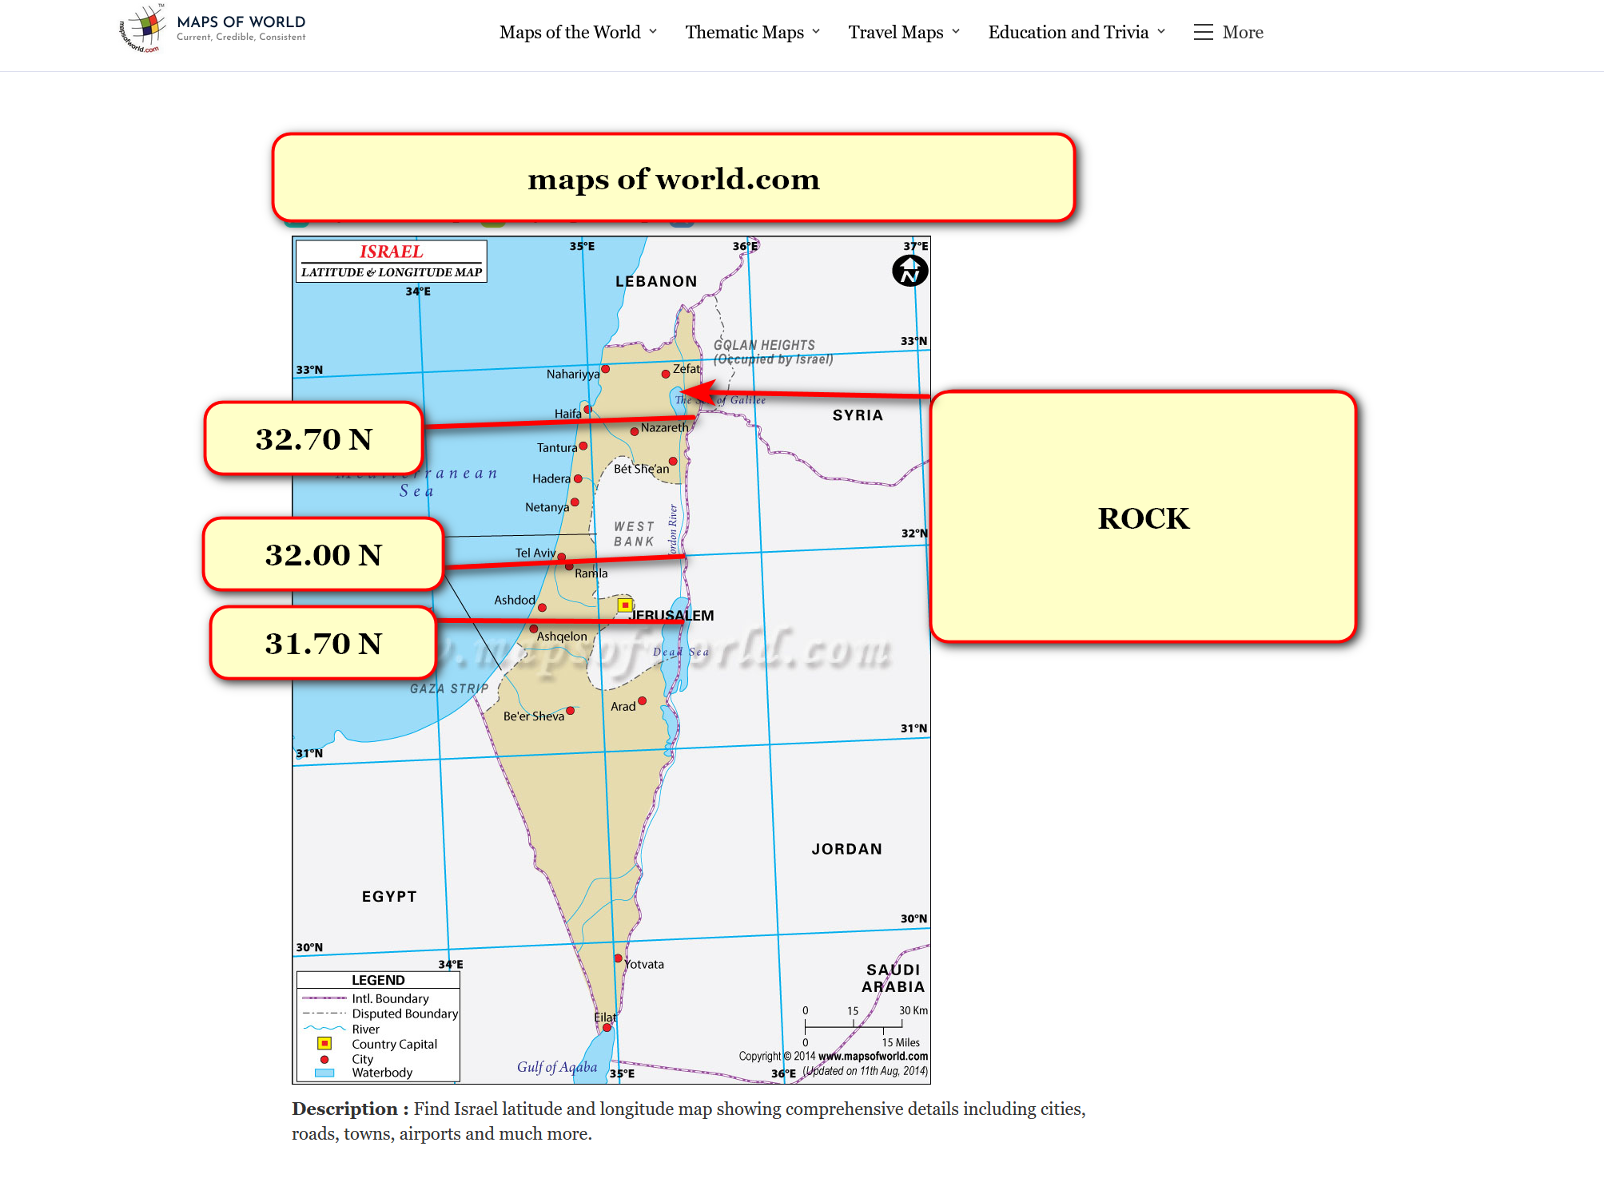
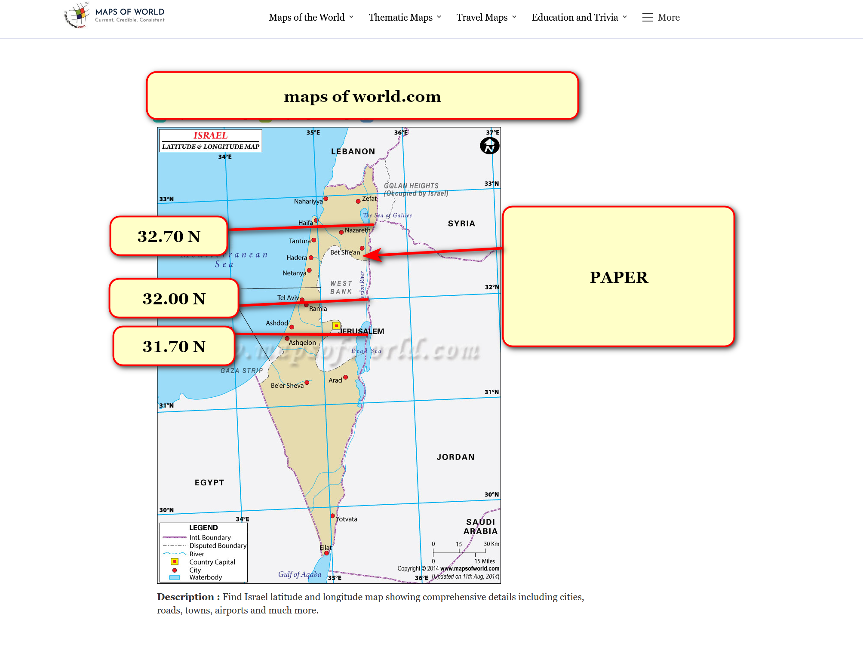
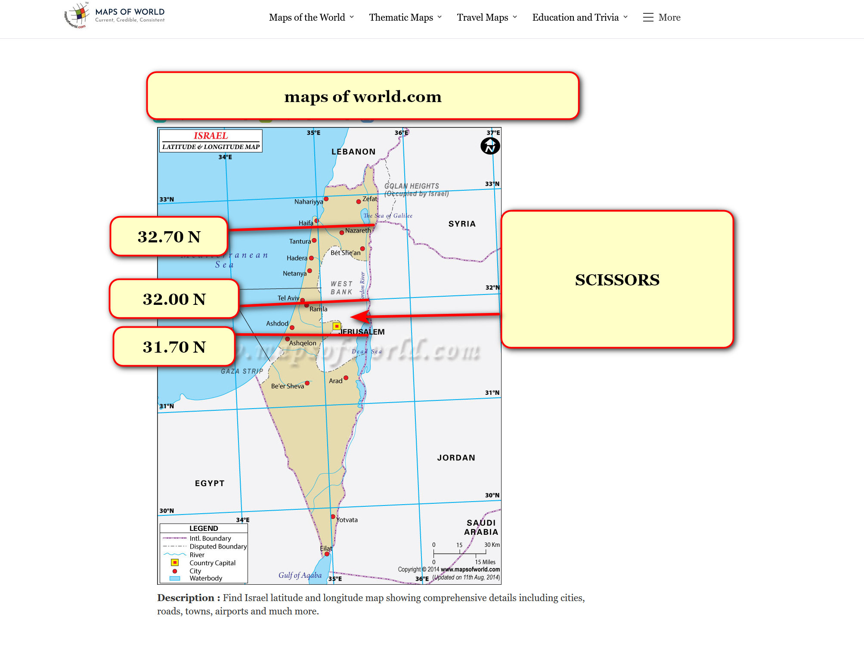
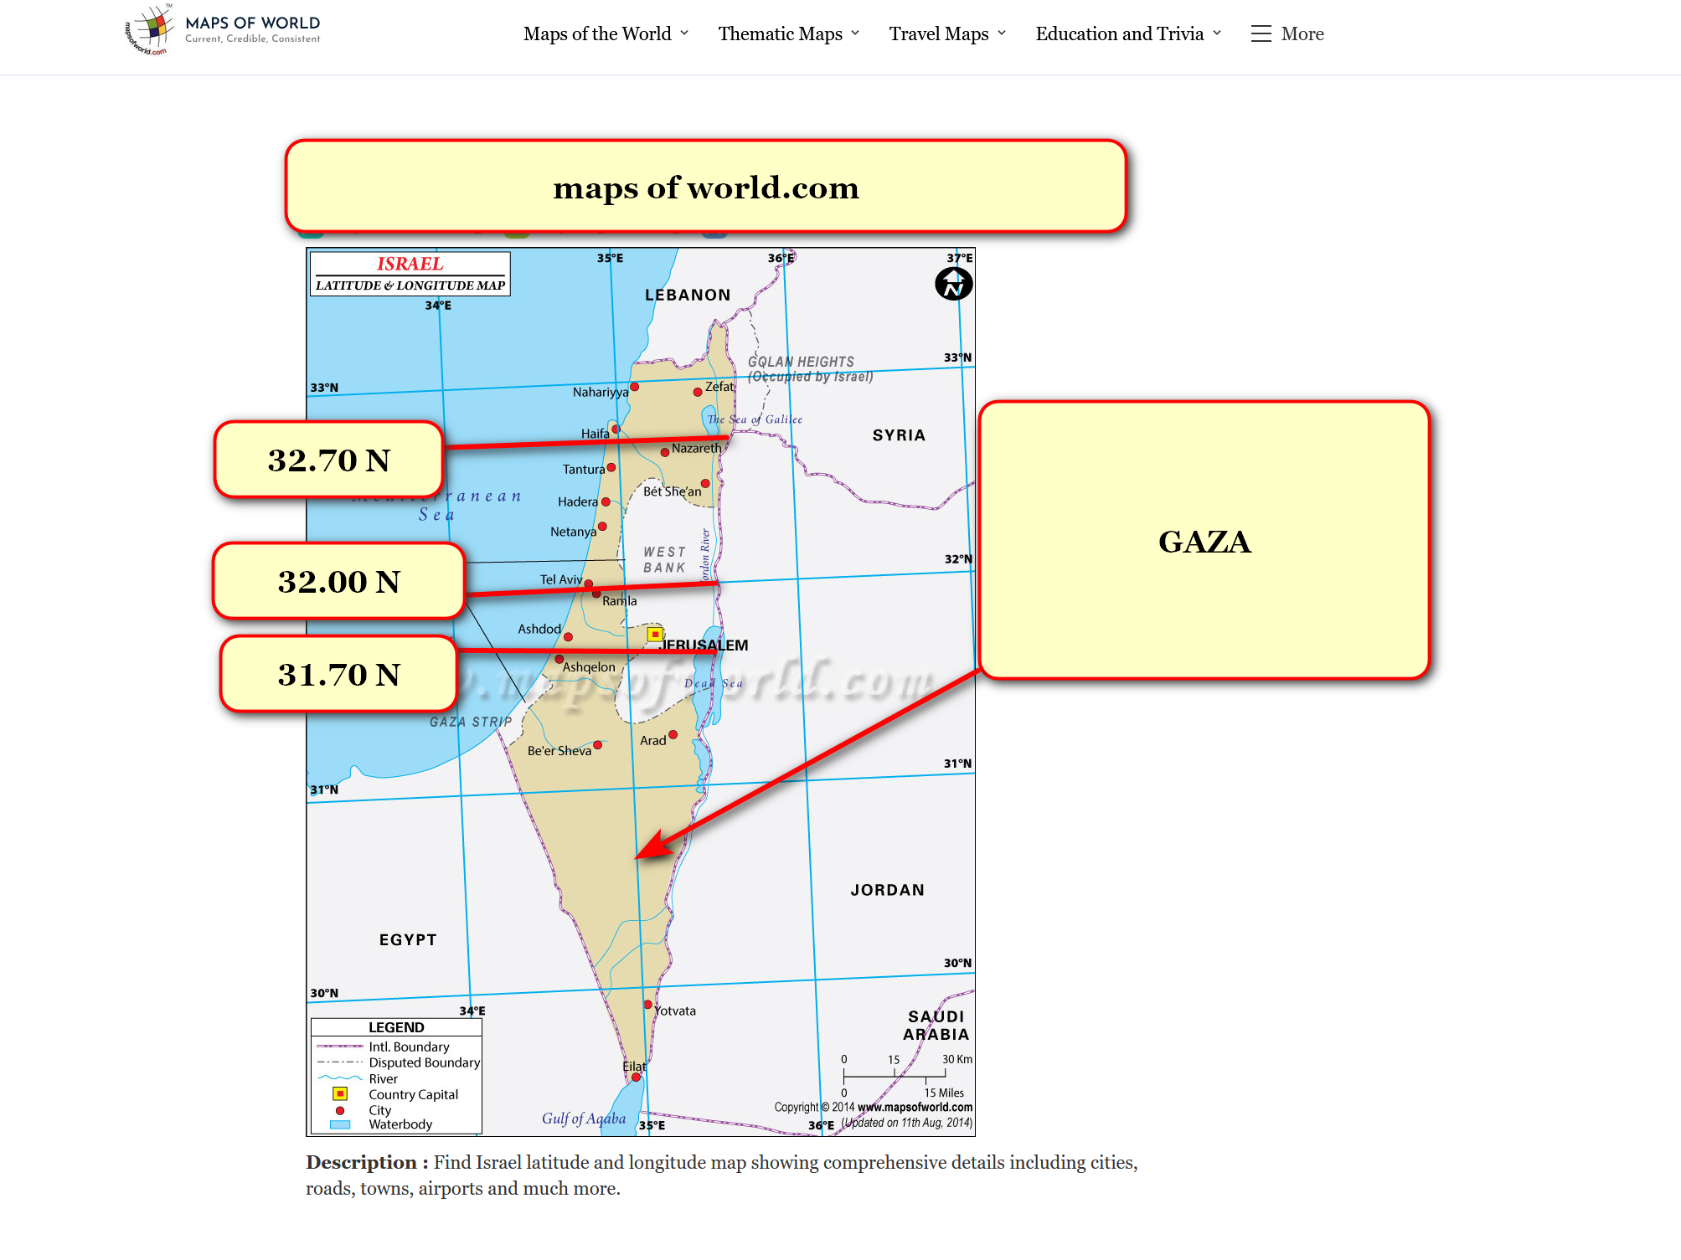

as governance each independent nation
would possess
married couple at desks
21 and 22 of executive crew

those couples' tenures
similar
to usa supreme court justices
appointed for life

two couples for 21 and 22
would play
Rock Paper Scissors in written form
during official event

winner
would choose
seats 21 and 22 from choices
ROCK or GAZA nation

other couple
would sit at
seats 21 and 22
of other remaining nation

kim
recommends
above mentioned arabic knesset member and
spouse plus gershon baskin and wife

two other married couples
would play
Rock Paper Scissors in written form
during official event

winner
would choose
seats 21 and 22 from choices
PAPER or SCISSORS nation

other couple
would sit at
seats 21 and 22
of other remaining nation

two couples above
include
mahmoud and amina abbas
plus benjamin and sara netanyahu

20 persons of three nation's crews
would include
5 israeli couples and
5 palestinian couples

fourth nation exception
mentioned further below

above desks 11 and 12 selections
utilize
ping pong selection from eldest couples
heterosexually married couples of knesset

selectors
draw from
pool of three eldest married couples
at least one spouse in knesset

israel's supreme court plus each spouse
disperse into
four nations' desks 13 through 20
through ping pong ball random selection

yet israel's supreme court
contains
only 15 persons

eldest three married members of knesset
shall enter
pool for one member selected via
ping pong tumbler method

that couple
will go where a
16th supreme court justice couple would
go to join an executive crew

random palestinian selections
draw from
two pools utilizing same selection formula

one pool
includes
all sixteen members of
palestinian executive committee

sixteen members
shall gain
desks via random ping pong ball
barrel tumbling selection process

couples
shall randomly place into desks 01
through 08 of each new nations'
executive crews

second pool
draws from
palestinian central council

second pool
includes
twelve eldest couples with at least
one person having central council membership

four couples from twelve couples pool
shall randomly place into
desks 09 and 10 of each
of four new nations' executive crews

proposed executive crews
for
each of four new nations

for example's sake if baskin
won and chose
ROCK

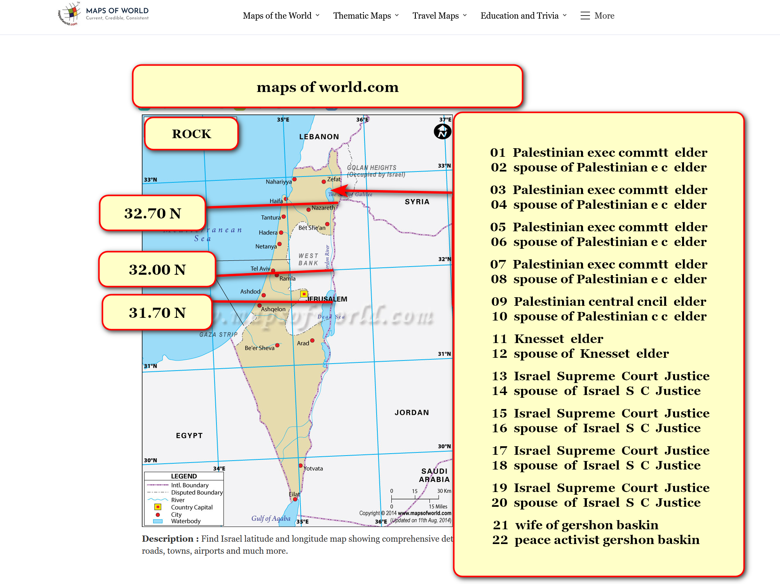
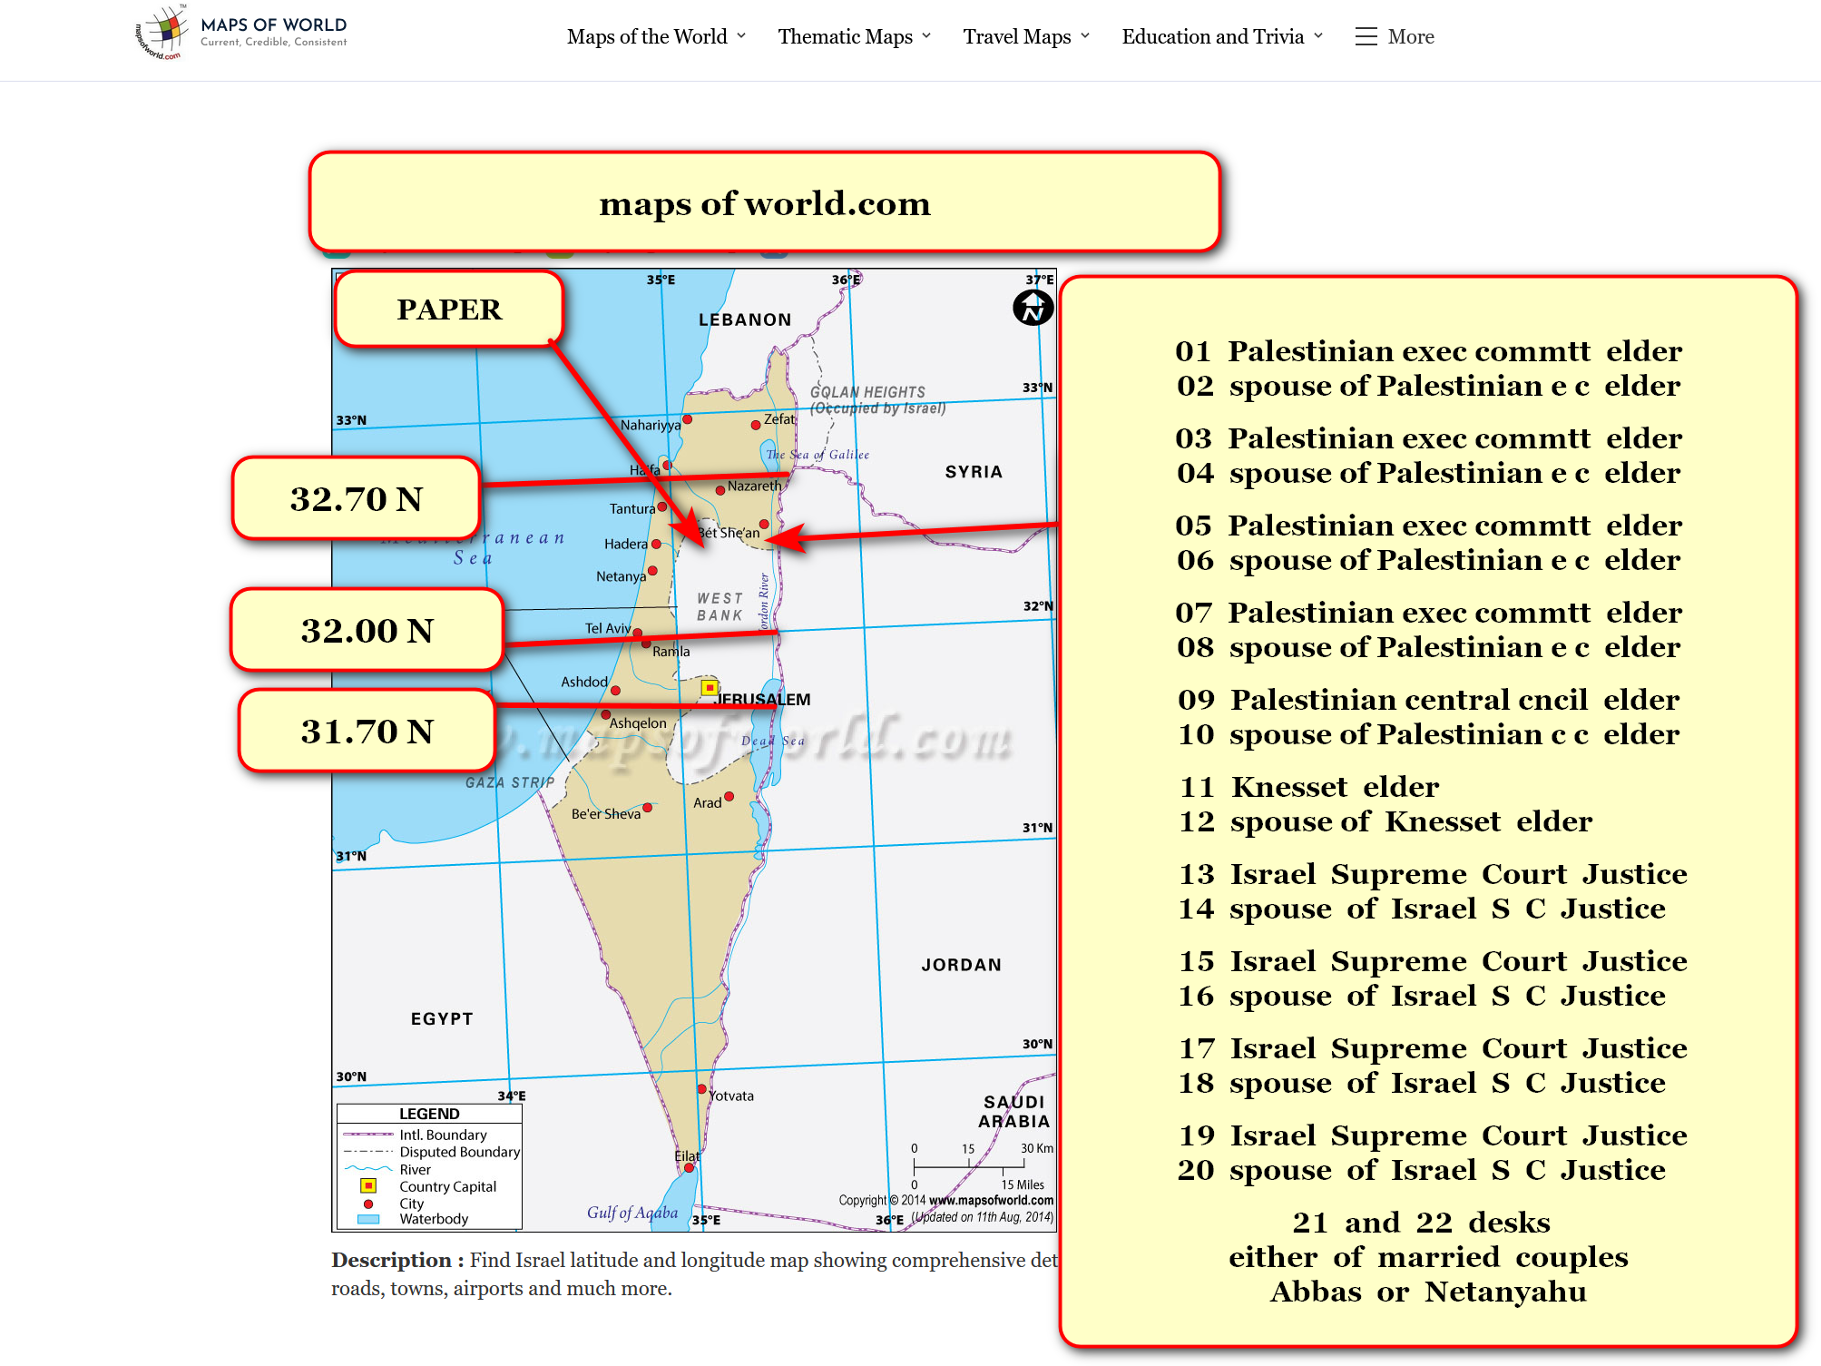
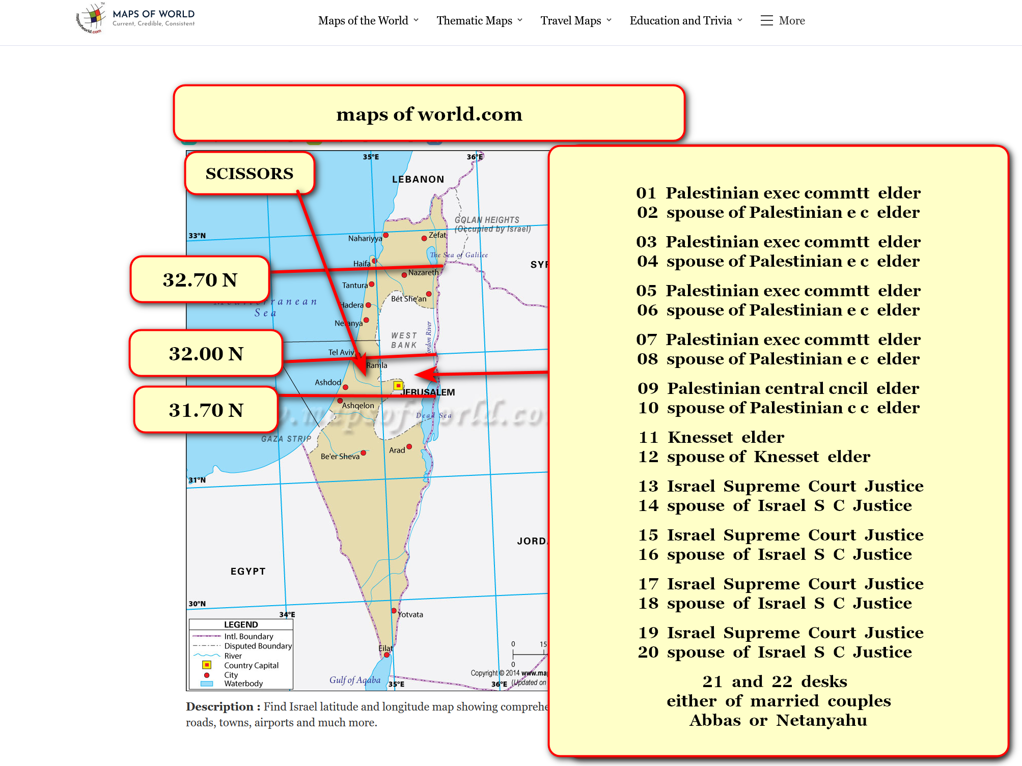
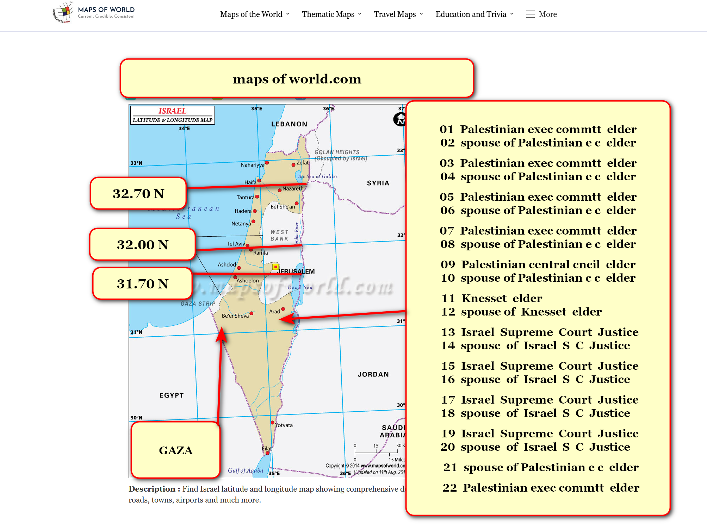

over 80% of current inhabitants
already conversant in
english language

english language
understood globally by
2 billion persons including nonnative speakers

therefore embedded official english language
encourages
tourism for four new nations

if those nations
agree that
english embeds as official language

then four nations' executive crews
perhaps ask permissions for inviting
certain excellent english speaking xinjiang uyghurs

english speaking uyghurs desiring such
must relinquish
previous allegiances to former cultures
and nations and religions

those english speaking uyghurs
must sign
new allegiance to
new nation in advance

for example four nations
could utilize
english speaking xinjiang uyghur women
as members of rescue squads

rescue squads of five uyghur women
could monitor
community health and wellbeing and
law abiding from safety of airships

of course nuclear families
would migrate with
those chosen and also become
citizens of new nation

four new governments
would model
style for other nations'
observations and emulations

chapter ends

