A01 SMOOTH KEYS DEMOCRACY = global peace

all nations on globe
need to invoke
SMOOTH KEYS DEMOCRACY win win strategy
to accomplish peace and security forever

any chief executive of any nation
instituting
SMOOTH KEY DEMOCRACY'S executive crew
gains desk 22 for lifetime

in SMOOTH KEYS DEMOCRACY citizens
vote weekly
whether government's actions please or displease

if displeased then citizens
may reassign
20 of 22 elder officials plus assistants
and randomly choose new elder officials

if all nations
upgraded
to this SMOOTH KEYS DEMOCRACY system

then even without paper treaties nations
would gain confidence
all other nations would not invade

in this way former defense monies
could then be spent on
prebuilding modern solar cities
kim dubbed DiameterCities

chapters I03 and J04-J09
discuss
DiameterCities

currently USA federal judges
gain
lifetime appointments

nations' upgrading per adopting this book
give
similar longevities to heads of states
for joining executive crews

therefore after abdicating somewhat heads
would still retain
one anonymous vote out of 22
anonymous votes per task

each leader of both major parties
gain
either seat number 21
or seat number 22 for lifetime

executive crew of 22
would lead
executive branch as nation's highest authority
because all branches contribute leaders

executive crew of 22
would declare
final words on executive and
legislative and judicial matters

for example if president trump
voluntarily proceeds with
this new initiative

then trump
attains
desk 22 for life

one of top three house democrats
attains
desk 21 for life

official ceremony random selection for above
utilizes
tumbler barrel and three ping pong
balls to choose that person

membership of executive crew USA
would include
supreme court justices occupying desks 01 - 09

three senators and six from house
would occupy
desks 11 through 19

recurring style of selection
includes
random selection from pool of eldest
members of governing group

after SMOOTH KEYS DEMOCRACY adoptions humankind
can start prebuilding
DiameterCities

eventually thousand equal sized DiameterCities
would replace
current de facto one world government
of supposedly independent nations of globe

entire humankind
would migrate to
rent free titanium residences each with
self sufficient family greenhouse gardens

concerning this book if president trump
describes
book's trump chapters as truthful and
apologizes for personal deaths of persons

then USA
receptive to upgrading to
SMOOTH KEYS DEMOCRACY with trump at
desk 22

trump chapters
include
S06 and S10 and T05-U01

going forward president trump
could initiate
global tranquility via
establishing USA executive crew

SMOOTH KEYS' executive crew of 22
would vote
concerning whatever chief executive
decides by self now

some examples
include
bills from congress and executive orders
and military actions and pardons etcetera

in other words crew's 22 persons
vote
FAIRNESS for ALL case by case

SMOOTH KEYS majority rules protocol
insists
at least 12 of crew must
vote YES GO TO WAR

very few if any executive crews
would vote yes to war
to amass patriots' deaths

far easier for executive crews
to reach
mutual peaceful agreements
even if by extraordinary verbal efforts

if war unjust then citizens' votes
could redeploy
20 crew and 110 assistants
within three regularly scheduled votes

in this second way citizens
would nullify
notions of warring

routine voting at or near libraries
would occur
mondays and wednesdays and fridays

executive crews decisions and reasonings
would appear
in weekly summation booklets available in
for example district of columbia libraries

for example if district of columbia
votes NO
three consecutive uninterrupted voting days that
redeploys 130 of 132 top persons

those persons
include
83 house members and 3 senators

130 of 132 top persons
automatically redeploy
elsewhere in government replaced by others

selections of new members
would include utilizing
random ping pong barrel tumbler method

citizens
would utilize
geodesic voting domes with 50 feet
diameters each near libraries

library cards
serve as
identifications for voting concerning citizens'
general attitudes concerning crew's actions

library personnel
would stand near
scanning machines and monitor scanning
and also deliver voting pellet

each scan
would deactivate
that card through midnight

in this way citizens
would vote at most
only once per voting day

three uninterrupted majority NO votes
would initiate
peaceful redeployment of 20 of executive
crew plus all 110 RESEARCH DEVELOPERS

yet 21st and 22nd crew members
would stay for life or
until humankind moves to DiameterCities

SMOOTH KEYS scientific group decisions style
enhances
collaborations because utilizes communications
anonymously written

plus group
votes anonymously
YES or NO concerning proposed solutions

SMOOTH KEYS' communiques
would possess
SUNNYsideUP tone comments transcending
emotionally susceptible verbal duels during meetings

routine strategy several days' methodical reevaluations
include exposing
some first glance SUNNYsideUP appearing ideas
as actually SUNNYsideDOWN ideas

when legislature
sends
legislation for president's signature

then that legislation
gains
equivalent of executive crew's tuesday's
YES vote

then like other ideas that bill
undergoes
opposite view scrutiny
until thursday's vote YES or NO

crews plus RESEARCH DEVELOPERS
actively comment and seek clarifications
via in house published memorandums

during projects 132 top decision makers
simultaneously express
various major considerations to each other
via booklets' published in house

in this way SMOOTH KEYS technique
adds
anonymity to both idea presenters and
commentators

therefore SMOOTH KEYS DEMOCRACY
harvests
wisdom without fear of repercussions

if adopted USA administration's executive crew
would include

all 9 supreme court justices

current vice president in desk 10

3 members from senate

6 members from pool of house of
representatives members plus observers

in 2028 newly elected president
would attain
desk 20

in 2028 newly elected vice president
would attain
desk 10

president trump
would randomly ping pong select
three senators from pool of five
eldest african american senators

those senators
would gain
desks 11 and 12 and 13

one of remaining african american senators
would gain
desk 20 until president is elected
in 2028

president trump
would again hand crank spin to
randomly select ping pong balls
with numbers corresponding to those senators

in same way 6 house members
attain
desks 14 through 19 via
random selection from 15 eldest congresspersons

5 of pool of above
include
5 eldest native americans
in house of representatives

5 of pool of above
include
5 eldest asian americans and
pacific islanders in house of representatives

5 of pool of above
include
5 eldest others
in house of representatives

during random selections each of those
would grab
one of numbered ping pong balls
and list name to that number

after tumbling those president
would remove enough
ping pong balls without directly looking

those ping pong ball associated persons
would then assume
executive crew desks

SMOOTH KEYS DEMOCRACY decisions style
includes
secret ballot voting from all 22
executive crew members inside same room

each executive crew member
facilitated by
five RESEARCH DEVELOPERS for prioritizing foci
for tasks and developing innocuous solutions

selection process for RESEARCH DEVELOPERS
repeats
random ping pong barrel tumbler method

first group
includes
pool of 100 eldest females of
house of representatives

in this way female RESEARCH DEVELOPERS
attain
desks for facilitating
each female executive crew member

pool of 100 eldest congressmen
repeat
above for male RESEARCH DEVELOPERS
facilitating each male executive crew member

83 members of house of representatives
will attain
desks of either executive crew or
desks of RESEARCH DEVELOPERS

five SMOOTH KEYS geodesic domes
located in
ellipse will possess offices
for 132 SMOOTH KEYS persons

Public Domain
File: Aerial view of White House and the Ellipse.jpg
Created: Taken on 15 May 2010, 22:48
Uploaded: 15 May 2010

Carol M. Highsmith - This image is available from the United States Library of Congress's Prints and Photographs division under the digital ID highsm.04915.

120 feet diameter central dome
will connect
four similar domes north south east west
for combined 360 feet footprint
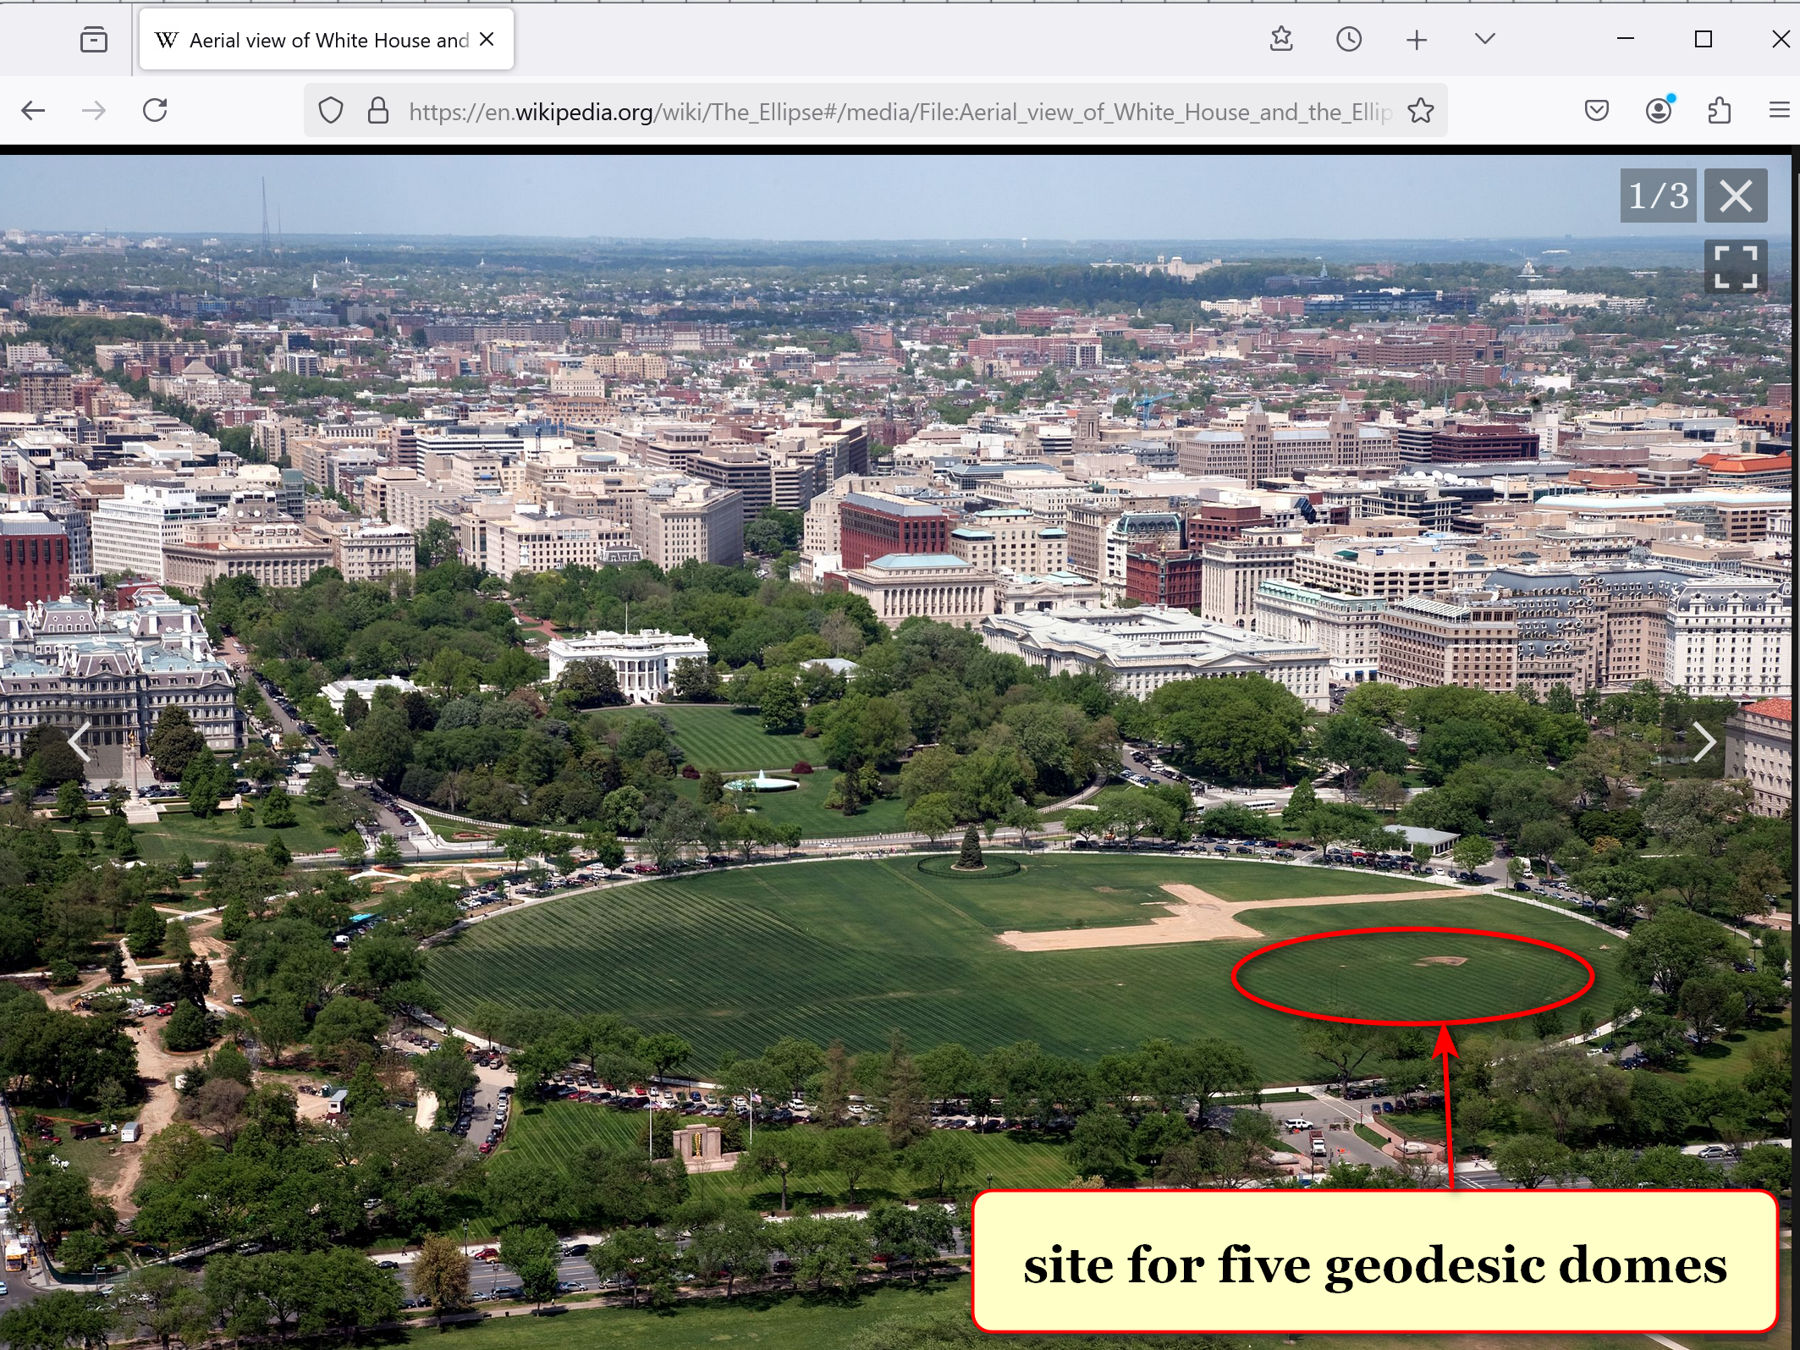

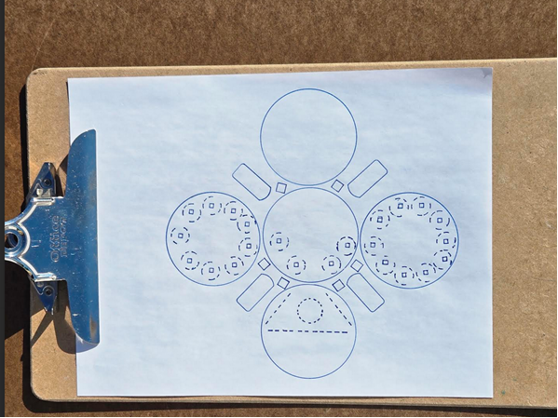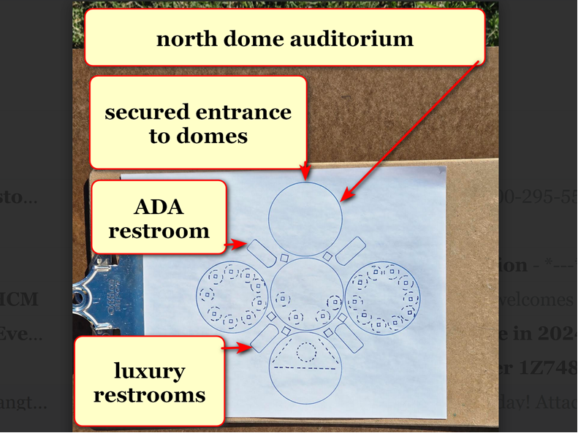

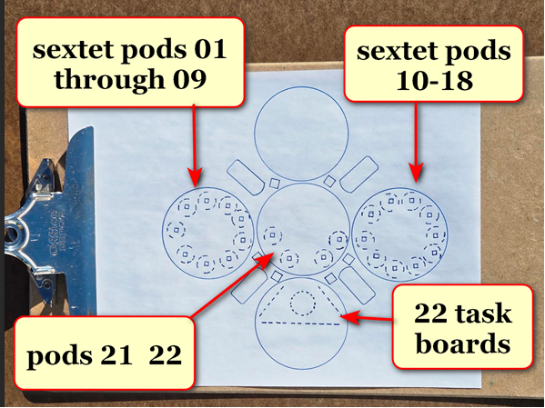

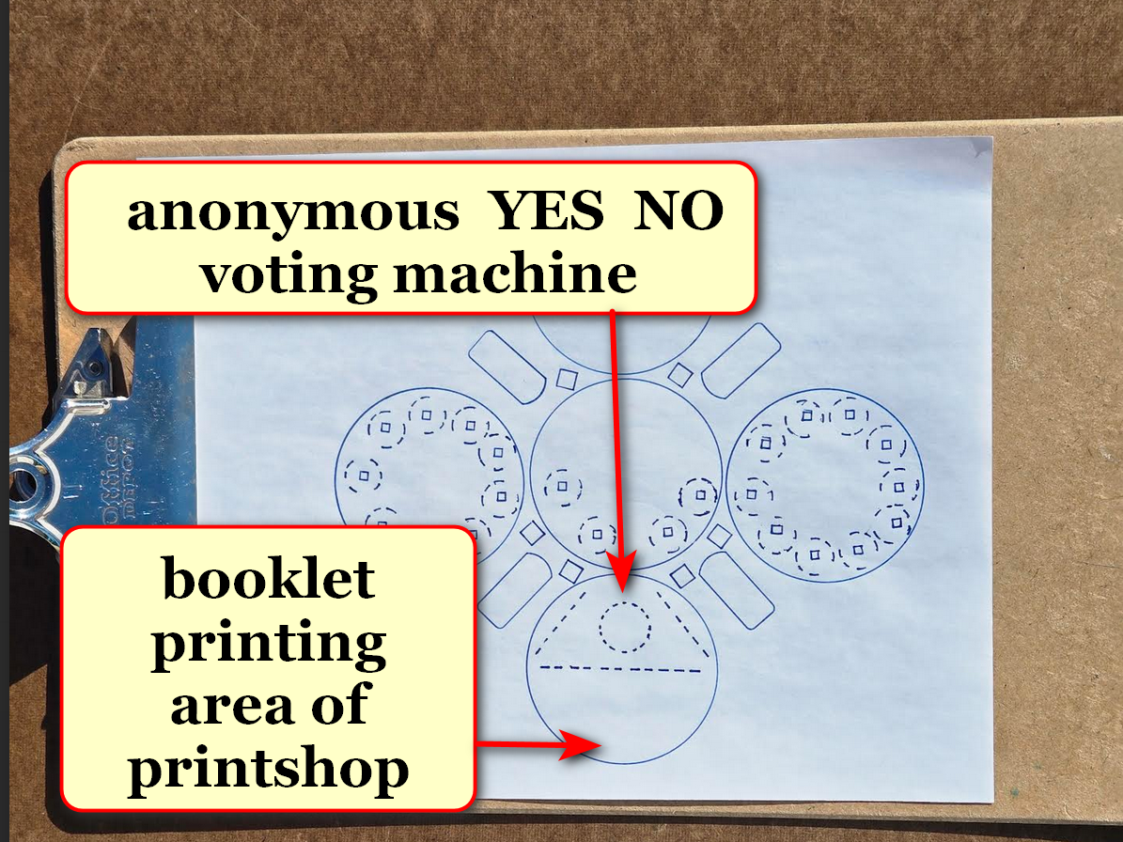
domes
exclusively host
executive crew of 22 plus 110
RESEARCH DEVELOPERS plus in house printer

all persons mentioned above
may freely and repeatedly view
all top secret unredacted unsummarized documents
and pictures and other classified media

therefore persons working inside decision domes
solve
situations as equals

other communications including with news media
occur
elsewhere far from domes

with above simplification secret service
more easily protects
all persons equally from outside domes
along perimeter securing safety of group

secret service agents
operate
north dome for screenings

executive crew plus RESEARCH DEVELOPERS
store
camera devices including cell phones in
north dome lockers during workdays

2024 cost for constructing and
equipping
all DC domes including ellipse's
domes equals 144.3 million dollars

private donations to construction supervisor kim
allow
kim's paying for constructing plus equipping
domes

if proposed SMOOTH KEYS DEMOCRACY persons
accept
enhanced roles

plus if district of columbia
provided
land near 25 libraries for geodesic
domes of 50 feet diameters

then private citizen kim
would more easily start gathering
private donations

also with donations kim
would purchase
materials for constructing kim's invented
YES NO voting machines non electronic

kim
shall place
YES NO voting machines within new
geodesic domes in district of columbia

then district of columbia residents
gain
25 easily accessible polling structures
near libraries

plus same 25 solar powered structures
serve
as resource areas in cases of
weather emergencies

free dome resources for end users
include
water ice electricity

above
via
air to water machines ice machines
cellphone recharging outlets all solar powered

in polling domes citizens
say
YES or NO three times weekly
concerning decisions of executive crew

above check and balance system
behooves
executive crew keeping public informed
as to reasons for actions

supreme court
controls
volume of cases for voluntary review

constitution
allows
supreme court if court desires
to hear zero cases per year

before SHOELANGUAGE book supreme court
ruled on
less than 85 cases per year

weekly SMOOTH KEYS' 110 RESEARCH DEVELOPERS
review
incoming cases for total 22 tasks weekly

those legal cases needing review
join
all other pressing matters

110 RESEARCH DEVELOPERS in quintets
evaluate
events decide on three most pressing
matters for that week's crew's votes

then executive crew
chooses
22 most urgent tasks
from 66 suggestions

decision domes' officials' anonymously written arguments
replace
oral arguments

in SMOOTH KEYS system justices' wisdom
helps shape
tasks' resolutions during creations
rather than afterwards

76 other members of house
fill
remaining desks for RESEARCH DEVELOPERS

200 eldest of house including observers
gain membership in
pool from which president will scoop
76 associated numbered ping pong balls

hopefully that executive crew
successfully handles
affairs of country very well for
both four year terms

however three uninterrupted citizen NO votes
initiate
changing 20 persons of executive crew
plus 110 RESEARCH DEVELOPERS

those persons
redeploy
to original offices duties
or to other USA government roles

for filling vacant desks 1-9 president
randomly ping pong chooses
9 federal judges from pool of
30 eldest federal judges

9 supreme court justices
switch
roles with those 9 federal judges

those 9 federal judges
gain
increased pay to executive crew rate

9 supreme court justices' wages
revert to
lower pay of regular
supreme court justices' wages

plus crew desks 10 and 20
now occupied by
elder congresspersons
chosen via ping pong method

initially 110 RESEARCH DEVELOPERS desks
seat
25 cabinet and cabinet level persons
and legislators

members of house of representatives
will fill
numbered desks without names below

official televised ceremony
includes
random selection via
ping pong barrel tumbler selection method

TABLE BELOW

legislators from house
cabinet level persons
secretaries of departments
RESEARCH DEVELOPERS

executive desk numbers research developer numbers

01 samuel alito 001 agriculture
brooke leslie rollins

002
003
004
005

02 amy coney barrett 006 attorney general
todd blanche

007
008
009
010

03 ketanji brown jackson 011 commerce
howard william lutnick

012
013 council of economic
advisors chairman
stephen ira miran

014
015 veterans affairs
douglas allen collins

04 neil gorsuch 016 CIA
john lee ratcliffe

017 FBI head
kashyap pramod patel

018 director of national
intelligence
tulsi gabbard

019 homeland security
markwayne mullin

020 nation security advisor

05 elena kagan 021 education
linda marie mcMahon

022 defense
peter brian hegseth

023 border czar
thomas douglas homan

024
025 solicitor general
d john sauer

06 brett kavanaugh 026 energy
christopher allen wright

027
028 environmental
protection agency
lee michael zeldin

029
030 interior
doug james burgum

07 john roberts 031 health and human
services
robert f kennedy jr
032
033 housing and urban
development
eric scott turner

034
035

08 sonia sotomayor 036 labor
lori chavez-deRemer

037
038 small business
administration
kelly lynn loeffler

039
040

09 clarence thomas 041 office of management and budget
russell thurlow vought

042 treasury
scott kenneth h bessent

043

044
045

10 vice prez JD vance 046 office of science and
technology policy
michael k kratsios

047
048
049
050

11 legislator 051 state
052
053 ambassador to UN
054

055 US trade representative
jamieson lee greer

12 legislator 056 transportation
sean patrick duffy

057 drctr of nat econ cncl
kevin allen hassett

058
059
060

13 legislator 061 national institutes health d
062
063
064
065

14 legislator 066 federal comm comm chair
brendan thomas carr

067
068
069
070
15 legislator 071 centers for m.care & cade
Dr. Mehmet Oz
072
073
074
075

16 legislator 076 077
078
079
080

17 legislator 081
082
083
084
085

18 legislator 086
087
088
089
090

19 legislator 091
092 093
094
095

20 senate african american 096
yet after 2028 elctn=prez 097
098
099
100

21 1 of top 3 house dem 101 deputy chief of staff
stephen n miller

102
103
104
105

22 president trump 106 white house chief of staff
susan L wiles

107 assistant to president
sergio gorokhovsky

108 press secretary
karoline claire leavitt

109 communication director
huyen steven cheung

110 white house counsel
david alan warrington

precise weekly paid hourly compensations
more fair than
salary

executive crew members
gain
equal compensations to president's compensation

each member of executive crew
compensated
193 dollars per hour
based on 40 hour week

each RESEARCH DEVELOPER
compensated
145 dollars per hour
based on 40 hour week

executive crew of 22 voting
occurs
tuesdays at 10:00 in morning
then thursdays at 16:30 in afternoon

both days' majority YES votes
needed
to propel task forward officially

plus executive crew members
possess
specific times to evaluate comments
attached to physical bulletin boards

chapter A02
details
weekly tasks of SMOOTH KEYS DEMOCRACY
RESEARCH DEVELOPERS

chapter ends

