HAPPY EVER AFTERS

by
Kim Klecka

all rights reserved
preliminary draft 2026 april 18 saturday

in awe kim
dedicates
book to keith educator concerning BEARS
organization's secret and lethal methods

keith michael klecka

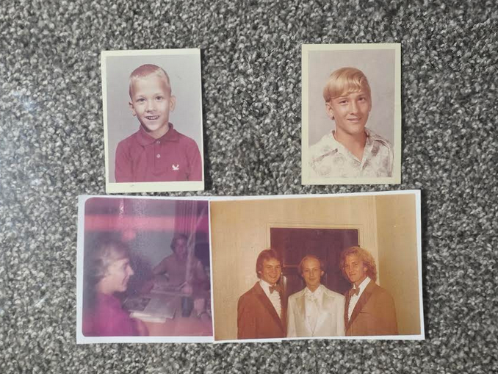

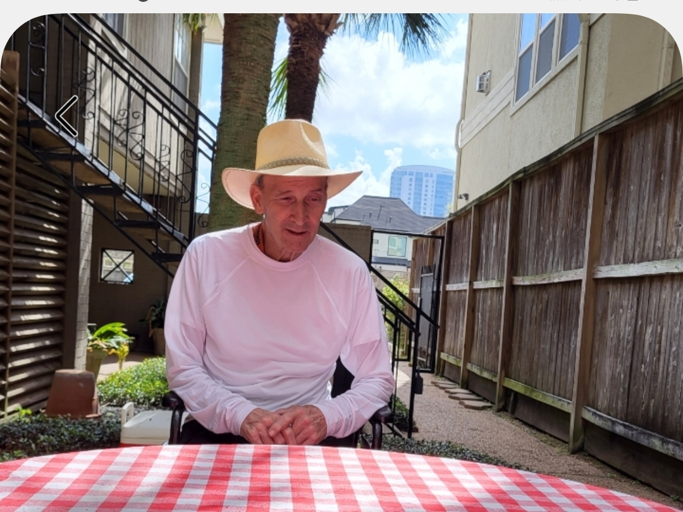

kim
thanks
Katie Keith CEO of Barn2plugins

UK's Katie Keith
did sell and help install
plugin Document Library Pro
for this website shoelanguage.com

this introductory chapter
features
three extraordinary statues including globe's largest
dog statue and three physics professors

chapter 000

ONCE UPON A TIME

ONCE UPON A TIME kim
discovered
tons of landmass evidence indicating each
human directs hologram surrounding that person

generally speaking hologram scenes
include
stage props that directors of holograms
can add or subtract as wished

therefore now each director each human
can as wished block and subtract
disease of all kinds without money

adding to humankind's knowledge kim
discovered
message statues possessing identifiable shapes
sculpted on purpose by non humans

SNAKE and BEAR and DOG statues
indicate
universe awaits humans' vote determining environment
style for humankind's single compartment eternity

please compare snakes looking eastward

LiquidGhoul - Own work
Profile of Coastal Carpet Python (Morelia spilota mcdowelli)

CC BY-SA 3.0view terms
File:Morelia spilota head.jpg
Created: 15 February 2008

Forked tongue of carpet python (Morelia spilota mcdowelli)
from Wikimedia Commons.
image was picture of day on English Wikipedia August 12, 2008.

year 2019 kim
searched
oxford atlas of the world
gazetteer pages

kim
looked for
some image without knowing
exact object of quest

finally kim
rotated
entire book entire atlas

kim
unexpectedly found
florida USA possessed shape of snake

entire peninsula of florida
equals
snake head

lake okeechobee
symbolizes
right eye of snake

florida keys islands
equals
snake tongue

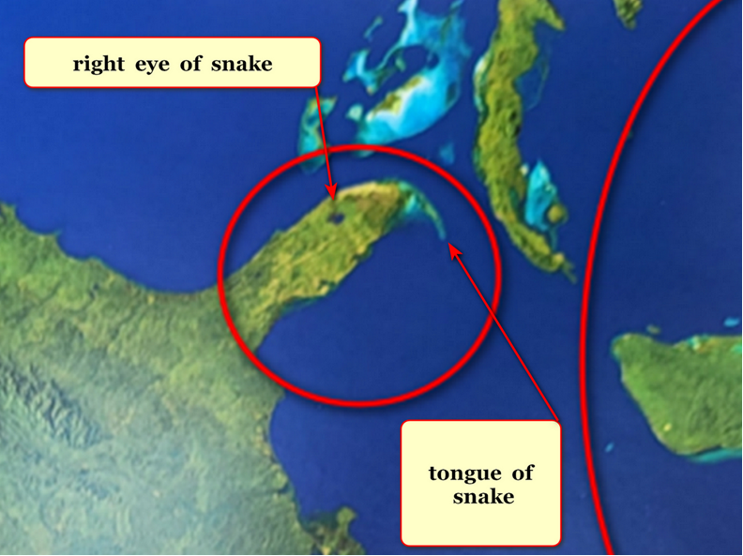

friends of humankind
also sculpted
statues in solar system to sway
humankind to vote SUNNYsideUP permanently

2022 friends of humankind
shaped
mars statues to warn humankind of
ancient organization BEARS still in existence

savage global controlling BEARS organization
will continue dominating
unless humankind adopts HAPPY EVER AFTERS
as global upgrade how to book

NASA article A BEAR ON MARS?

NASA Science (.gov)
https://science.nasa.gov › photojournal › a-bear-on-mars
Jan 31, 2023 —

This image
acquired on December 12, 2022
by NASA's Mars Reconnaissance Orbiter

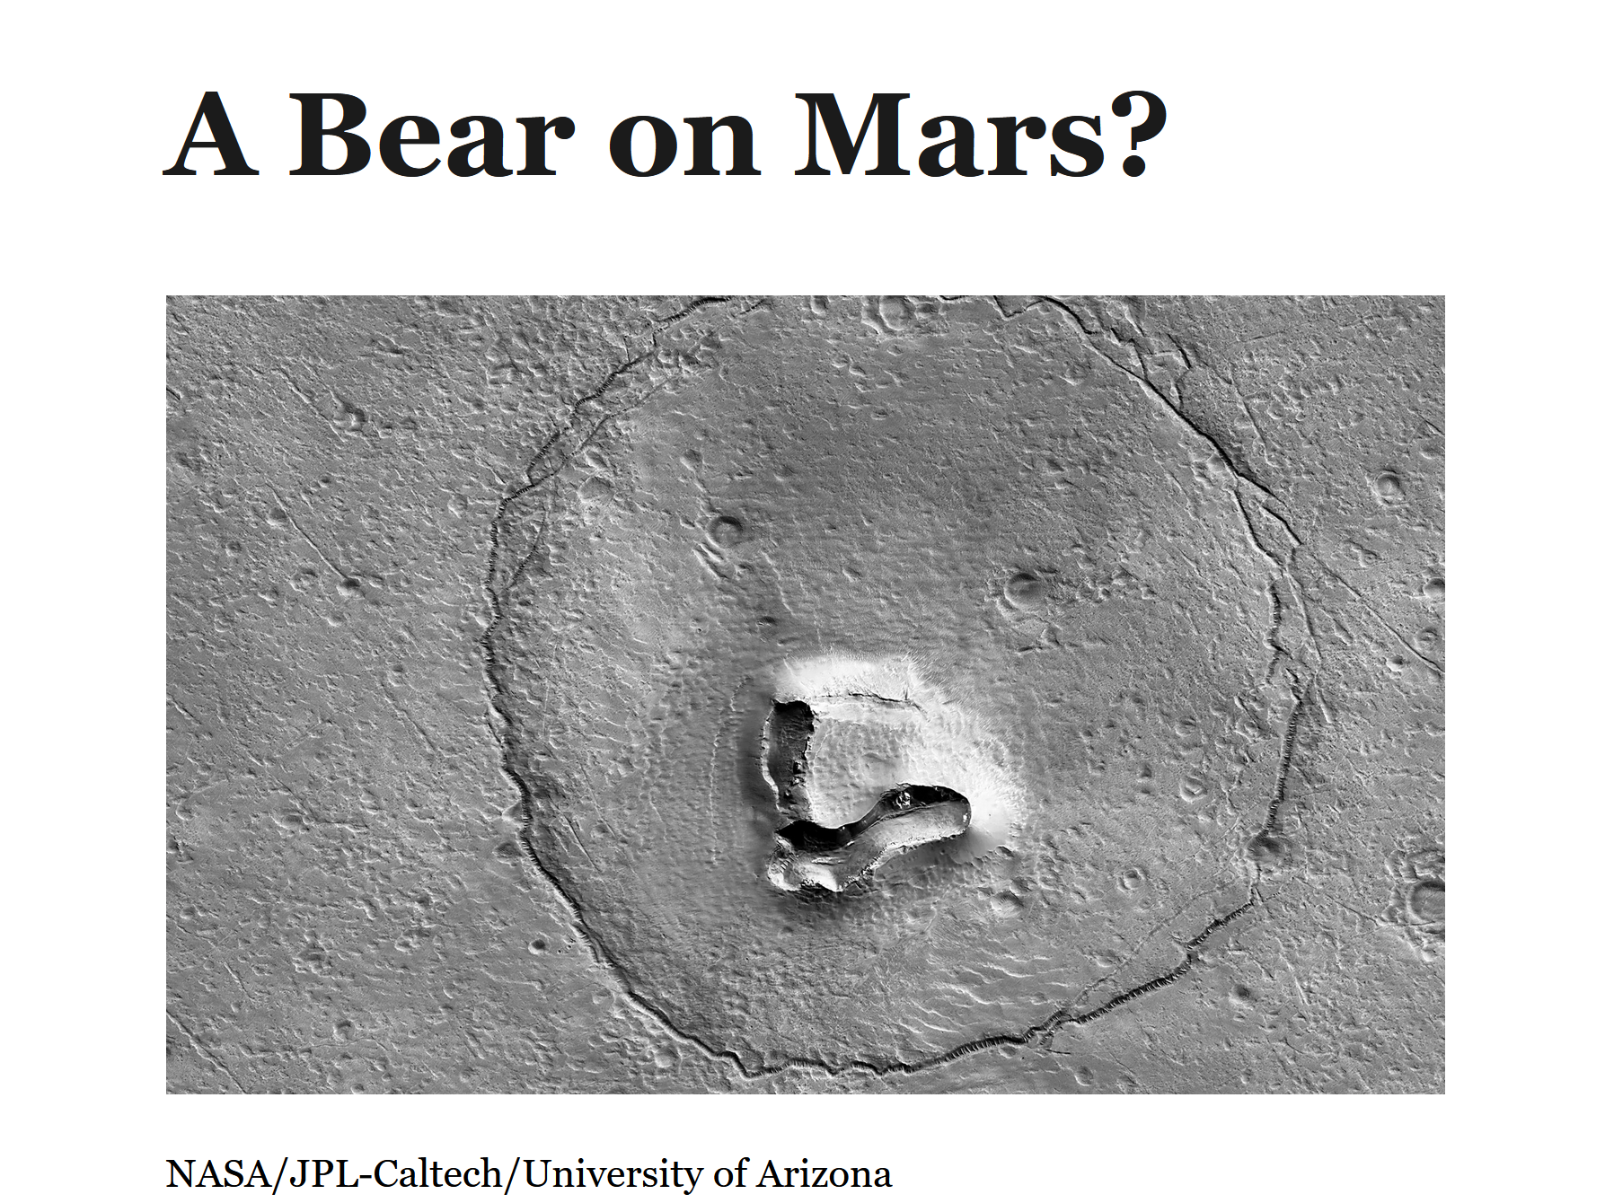
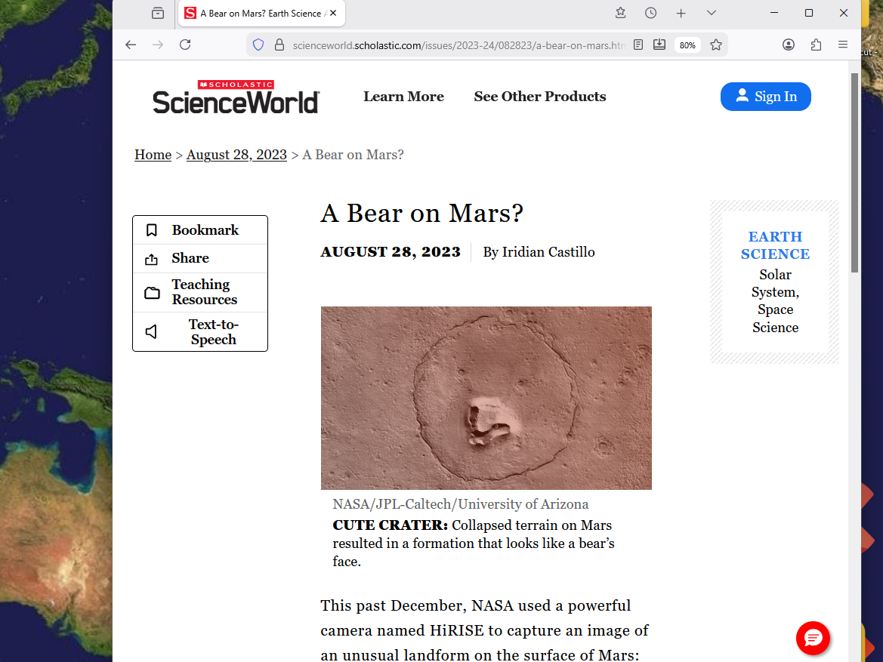

kim
sketched
symbolic sincere patriotic citizen ripped by
officials actually members of secretive BEARS

for centuries BEARS
deceived
honest citizens and then killed
many sincere patriotic citizens

rock on mars
symbolizes
those innocent victims and resembles
keith michael klecka in particular

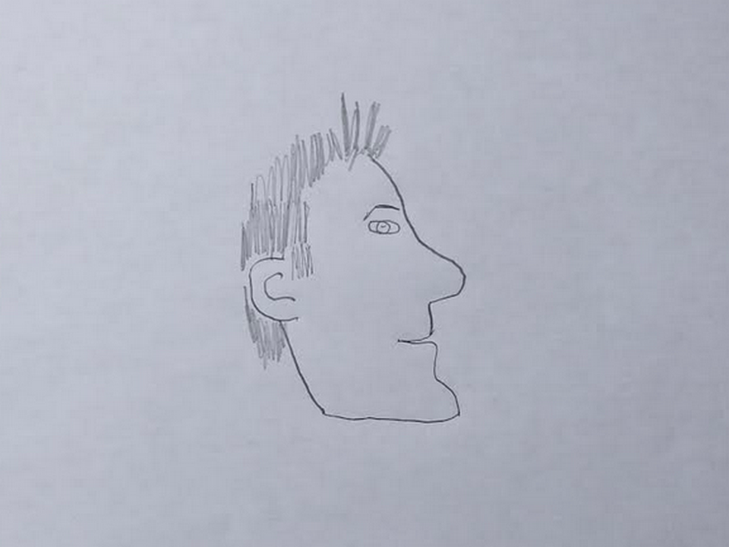
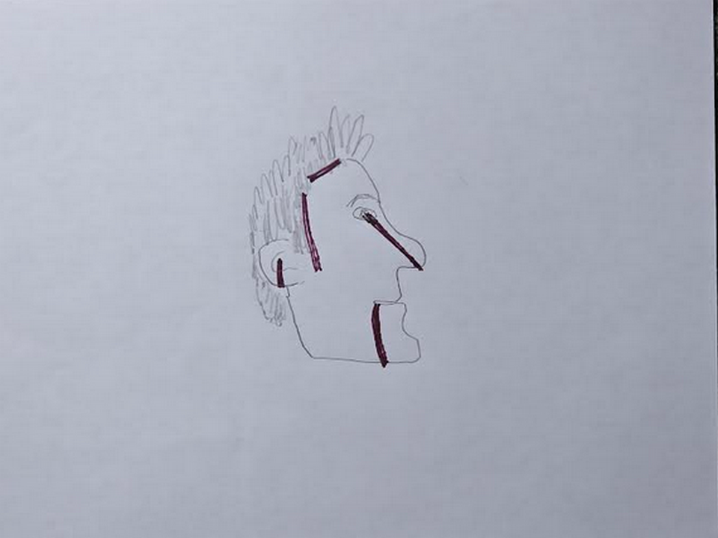
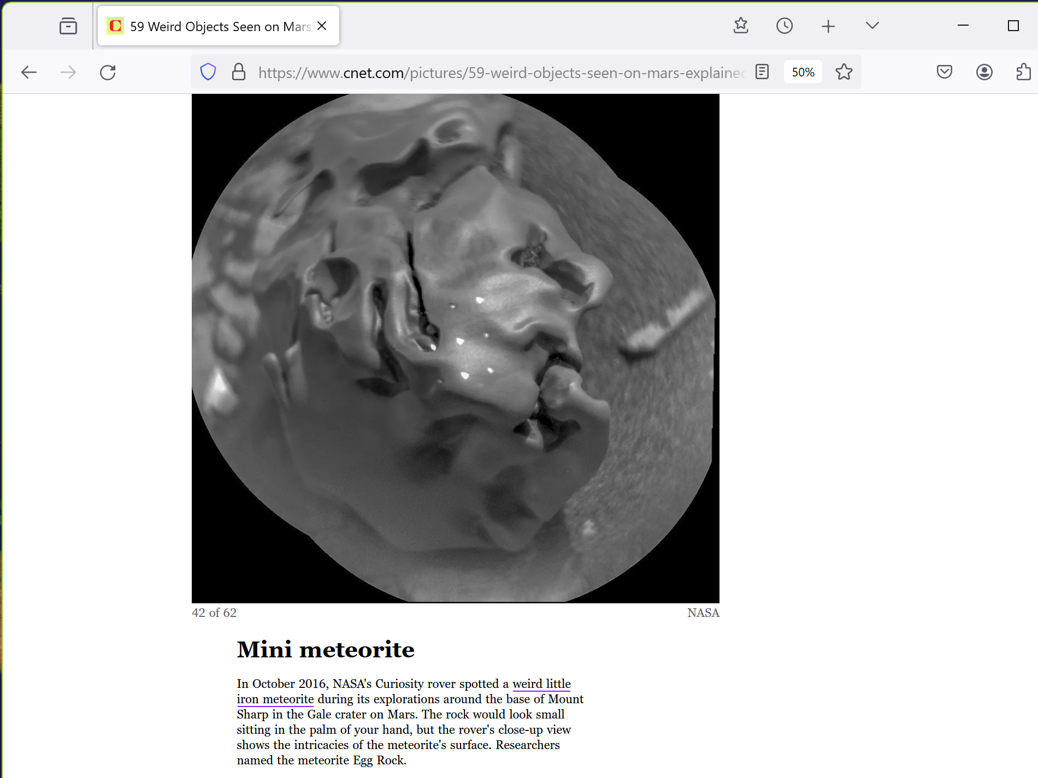

friends of humankind
also sculpted
statue symbolizing humankind's shock that
religions and science possessed insufficient knowledge

humankind
shocked that
bits of light dubbed photons accomplished
tasks for which angels were credited

kim
sketched from
oxford atlas of the world
dog lifting ears in shock

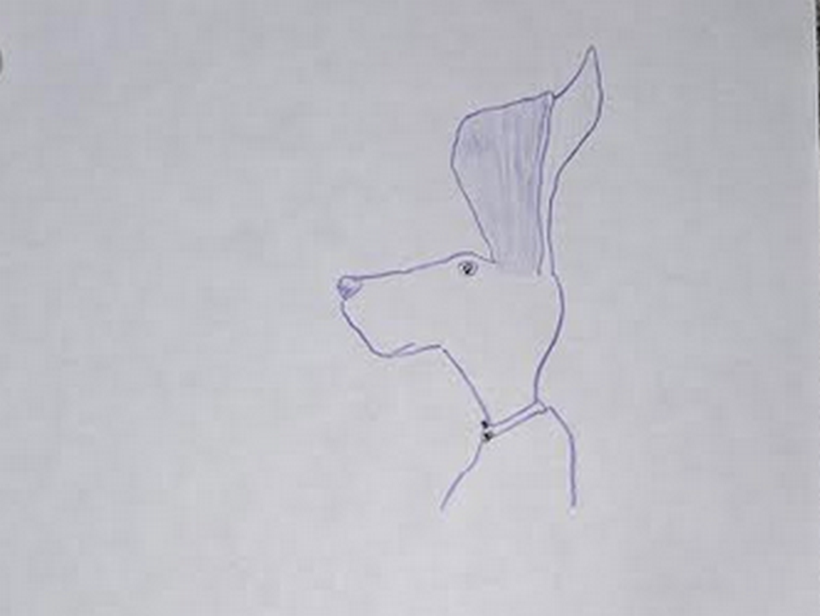
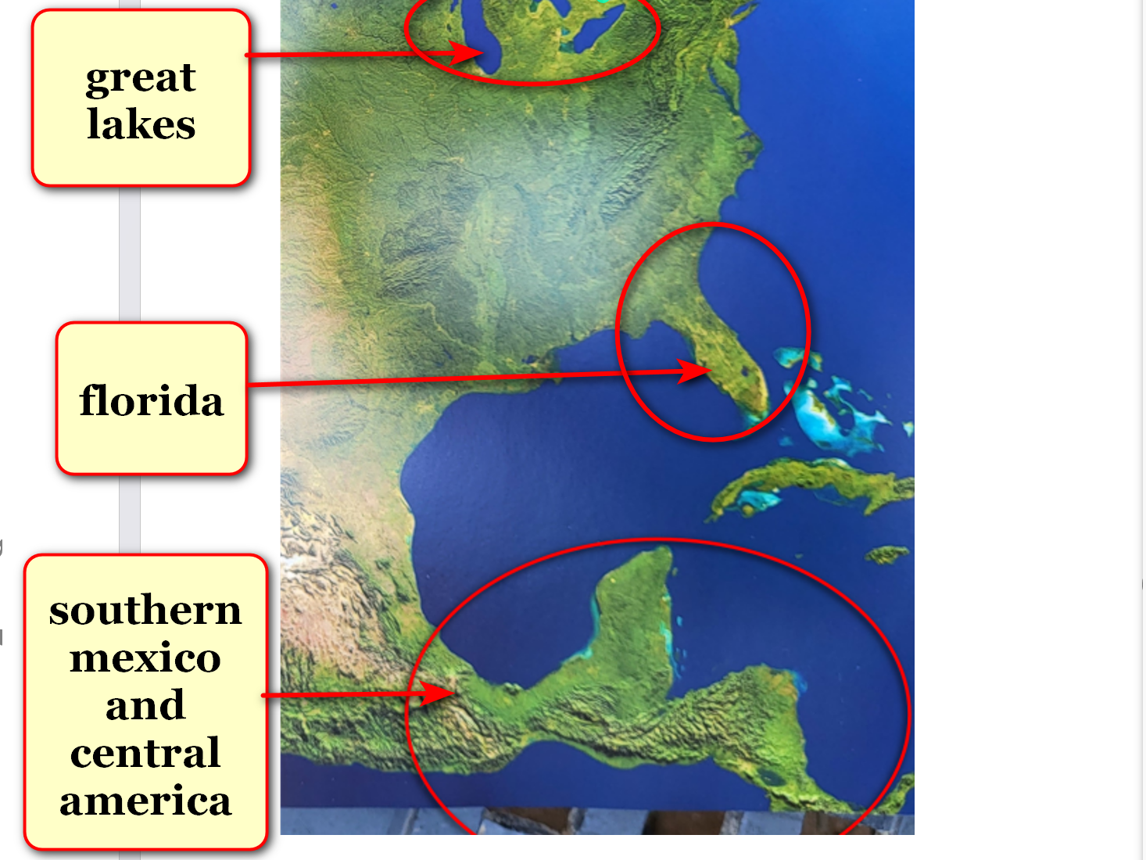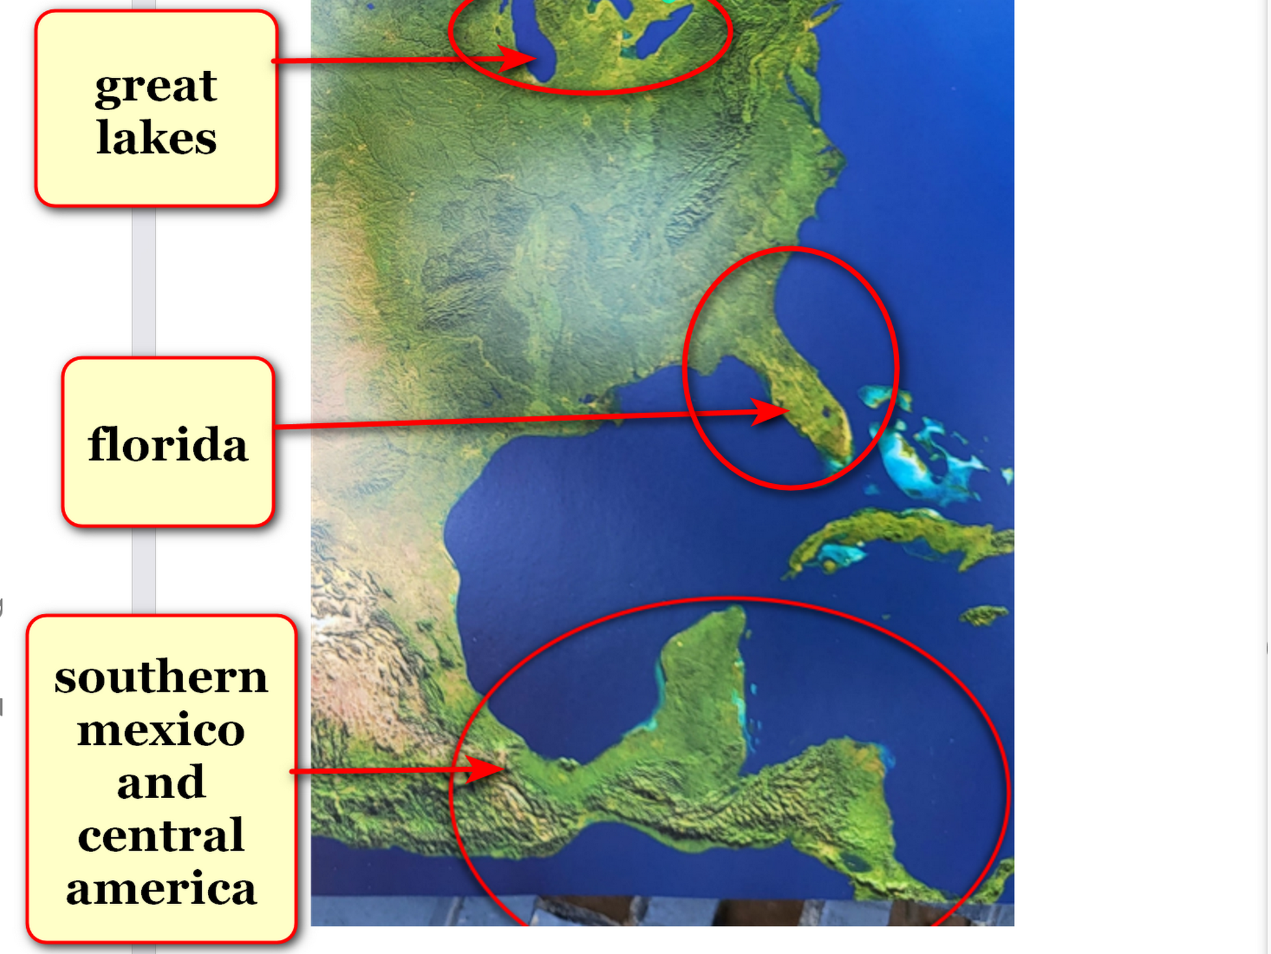

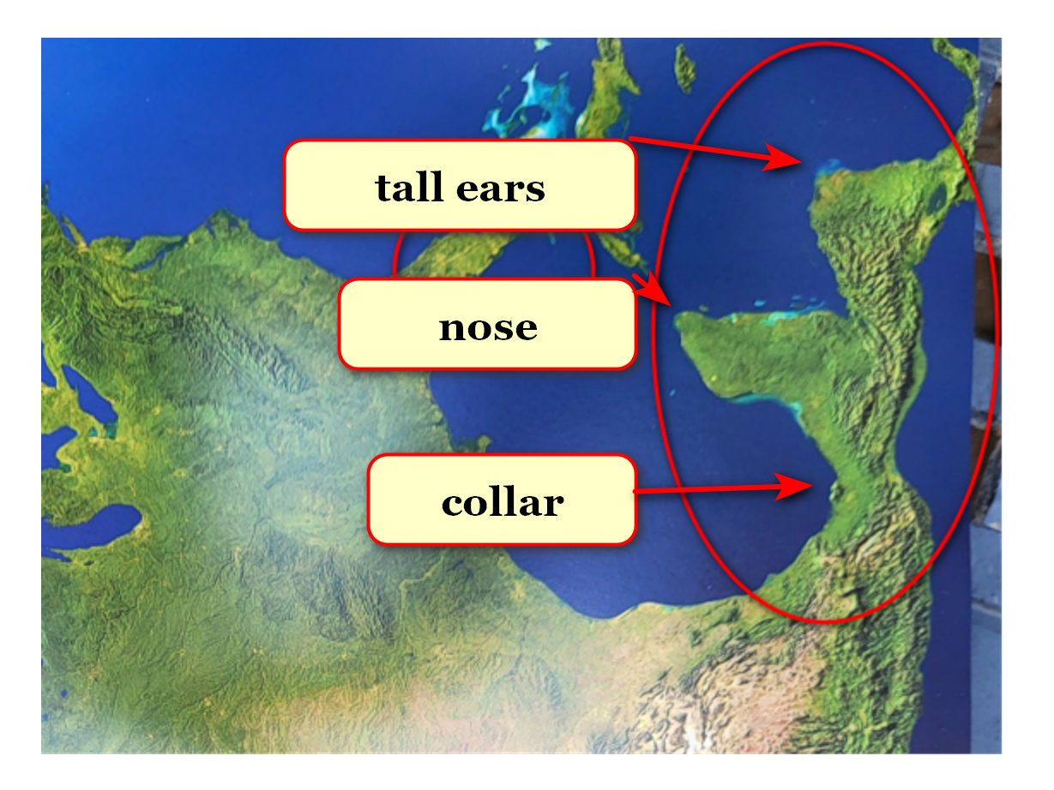
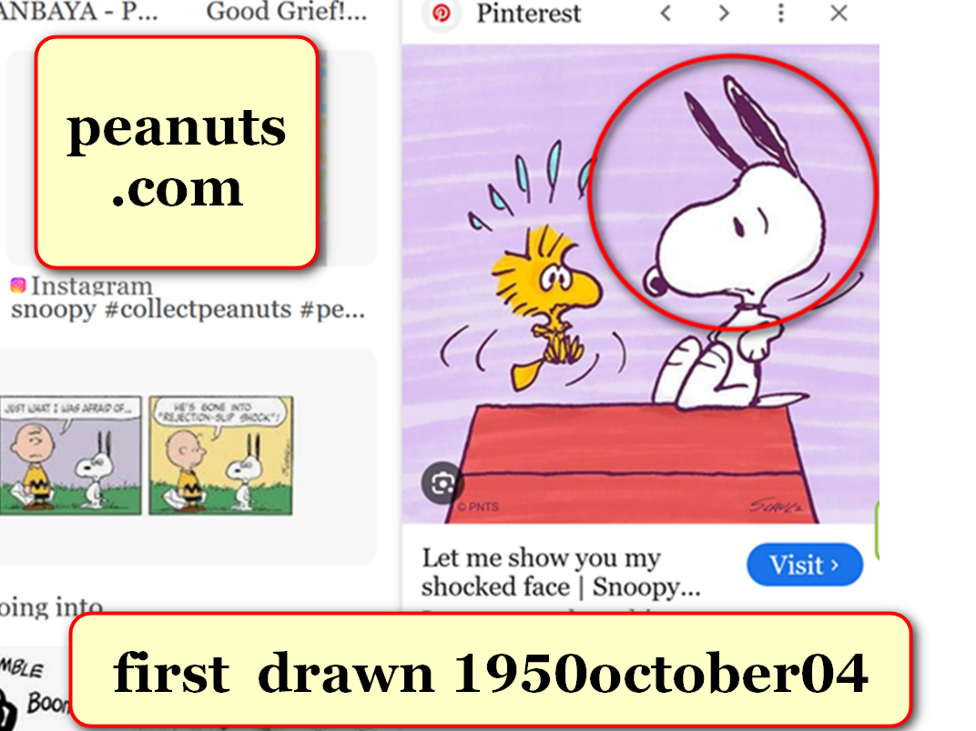

year 1950 october 04 photons
saw
cartoonist charles schulz draw snoopy

soon after that date photons
altered
very shape of north america continent
to include globe's largest dog statue

photons
copy pasted
snoopy onto central america
and southern mexico

all other historical events
changed accordingly seamlessly

photons as story tellers
explained more quickly utilizing
already well known literary characters

in this way photons
purposefully conveyed
message
via dog already globally famous

several such statues when combined
provide
SUNNYsideUP instructions for ending wars
and ending starving

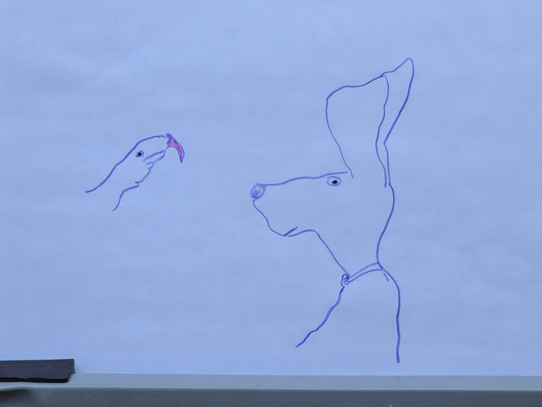
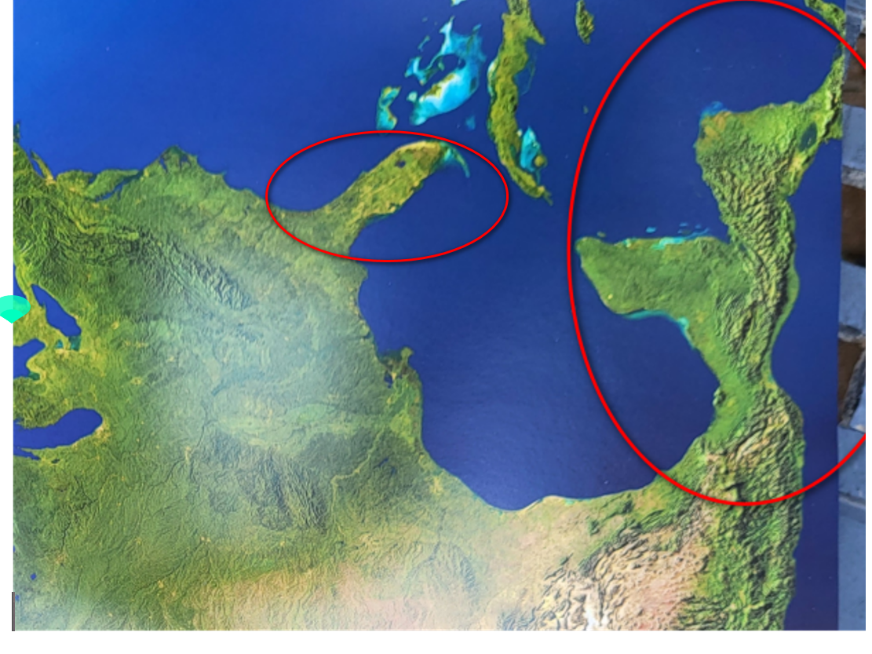

since all of humankind
will reside in
same afterlife environment

then all nations
should immediately quit wars and help
preemptively establish SUNNYsideUP culture on planet

above
includes
deescalating religions yet standardizing morality and
SMOOTH KEYS DEMOCRACY

SMOOTH KEYS DEMOCRACY'S FAIRNESS for ALL
includes transforming
nations' one person chief executive to
Executive Crew of 22

humankind changing from nation mindset
could prebuild
thousand equal sized solar powered megacities
to hold all persons on planet

if nations of humankind
agree to start prebuilding
those rent free DiameterCities

that decision
would switch
humankind's culture hologram to SUNNYsideUP
on grand encompassing scale permanently

with that official SUNNYsideUP no person
could possibly fetch
cancer or any disease ever again

SUNNYsideDOWN
includes
LACK of SUPERHEALTH and all diseases

until nations agree photons
keep asking via subconscious communications with
each individual which preferred holographic setting

each eight seconds
equals
one TIME EGG

for vote tallying purposes photons
decipher
main emotional intent of that person's
signals during that TIME EGG

that person's signals
include
actions and words and even thoughts
lingered upon as prolonged fascinating topic

in this way every human
votes via
5400 TIME EGGS per waking twelve
hour day without even realizing voting

concerning TIME EGG votes every human
chooses from
only two categories of emotion mindsets
including SUNNYsideUP or SUNNYsideDOWN

TIME EGGS
gather
favorite of each human
for which SUNNYside environment for eternity

that chosen favoritism
also controls
environment around that human

photons ever obedient to signals
bring to
each human that very culture requested
starting with next TIME EGG

photons
obey those
instructions incrementally
unless interrupted by new instructions

knowledge of this voting as ongoing
empowers
all humans as one group
to flip switch to SUNNYsideUP permanently

if humankind's nations
agree to disband and migrate to
thousand SUNNYsideUP moral DiameterCities

that
switches
humankind's preference
to SUNNYsideUP permanently and eternally

until nations agree each human
unknowingly individually fetches or
keeps away diseases holographically

trillions of electrons
group into
one of two varieties
male or female

male and female
give signals to
photons via distinct and different
styles of operations

these two styles of signals
give
double assurance to photons concerning creating
humankind's SUNNYsideUP or SUNNYsideDOWN eternity

photons via HAPPY EVER AFTERS book
ask
all nations to mature overnight
and please favor SUNNYsideUP

above refocusing of sincerity
includes
deescalating religions yet increasing morality
and giving FAIRNESS to ALL globally

refocusing of nations' executive branches
includes upgrading to
SMOOTH KEYS DEMOCRACY to gently dissolve
global shadowy controlling organization dubbed BEARS

historically BEARS desiring wars
depended upon maintaining
notion of approximately 200 big nations
to emotionally embitter many citizens quickly

in 1967 keith klecka
watched in shock at
televised reports on wars

eight year old keith michael klecka
earnestly desired repairing
globe to happiness and peace
with food security for all

unfortunately 10% of keith conscious keith
still believed in
angels as taught by globe's religions

as workaround 90% keith subconscious keith
recruited
twin kim via subconscious conversation

keith's preplanned strategy
found
success in year 2017

2017 conscious kim
came to
unsought realization that
globe's religions' angels actually mere myths

photons
actually made happen what
humans historically attributed to angels

scientists
measure
photons and closely related particles electrons
as parts of universe

kim
realized that
scientists had already independently unknowingly
proven pieces of THEORY OF EVERYTHING

three theoretical physicists
studied
photons and electrons and proved phenomena
that taken together says universe holographic

chapters 003 004 G01 G02 G03
give
more details of those three professors

jewish american brazilian british david bohm
discovered
electrons changed behaviors when grouped

professor david joseph bohm
believed
some greater force dispersed self as
universe and will eventually recoil self

KIM NOTES

GROUP of electrons dubbed humans
take actions only after
subconscious internal debates end with actions
according to majority of electrons' wishes

above
explains why
professor bohm noticed
electrons changed behaviors when grouped

chapter 002's short story
explains
these ongoing decisions in context

greater force
will eventually recoil after reclaiming
bits and pieces dubbed electrons

that retirement
similar to
reverse BIG BANG event

by then each individual electron personality
will have clarified self and stated
individual opinions via many votes influenced
partly by fellow electrons' majority CONCLUSIONS

https://ebrary.net/96111/education/orthodox_orthodox_interpretations_quantum_theory

title of article
Orthodox and non-orthodox interpretations of quantum theory

Fig. 6.1 David Bohm as a young man [courtesy of Addison-Wesley]

F. D. Peat: Infinite Potential: The Life and Times of David Bohm (Reading, MA: Addison Wesley, 1997).
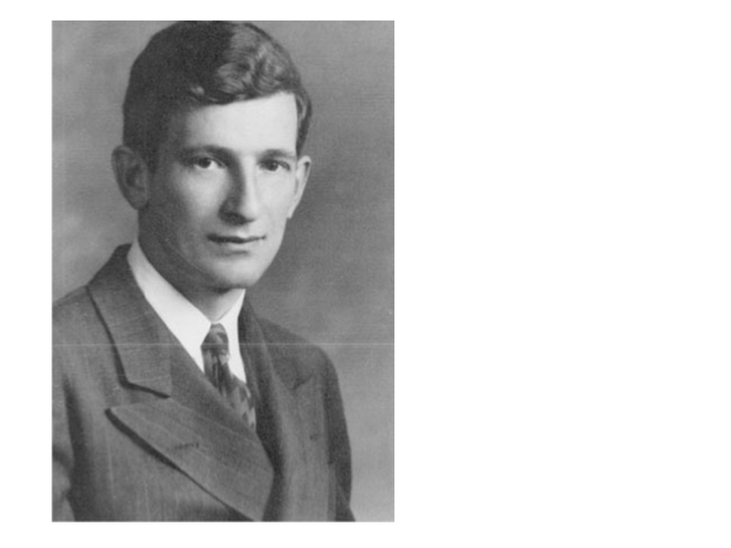

2024 december 13
https://scienceandnonduality.com/article/david-bohm-implicate-order-and-holomovement/

David Bohm, Implicate Order and Holomovement
Article by David Peat

https://www.davidbohmsociety.org/david-bohm/
overview of Bohm’s work
biography

David Bohm: A Life Dedicated to Understanding the Quantum World by Olival Freire Junior.

separately princeton professor john archibald wheeler
discovered
photons' technique of interviewing humans subconsciously
so as to adjust universe accordingly

wheeler's reverse 20 questions
details how and which style
photons deliver happenstances to individual
after consulting with 90% subconscious individual

first photograph from Linda Hall Library
5109 Cherry Street
Kansas City, Missouri 64110-2498

then photograph from princeton alumni weekly
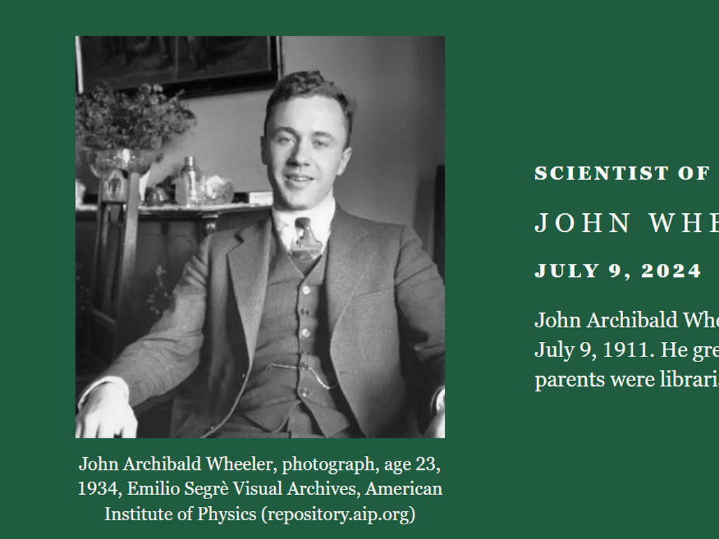
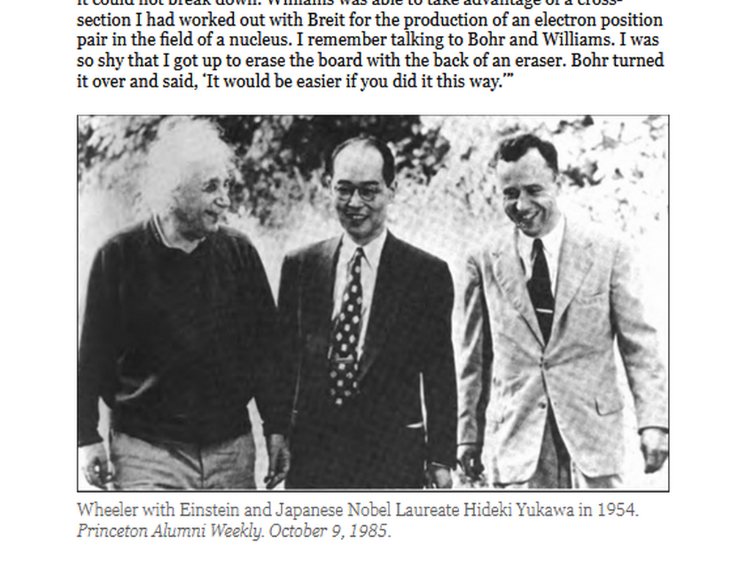

american professor carroll overton alley junior
proved
in laboratory that wheeler's notion correct
at photonic and atomic level

KIM NOTES

alley's real life laboratory proving
actually applied to
all of life including humans' interactions

PHOTONS as obedient technicians of holograms
adjust
next incoming events to match persons'
signals including known and unknown signals
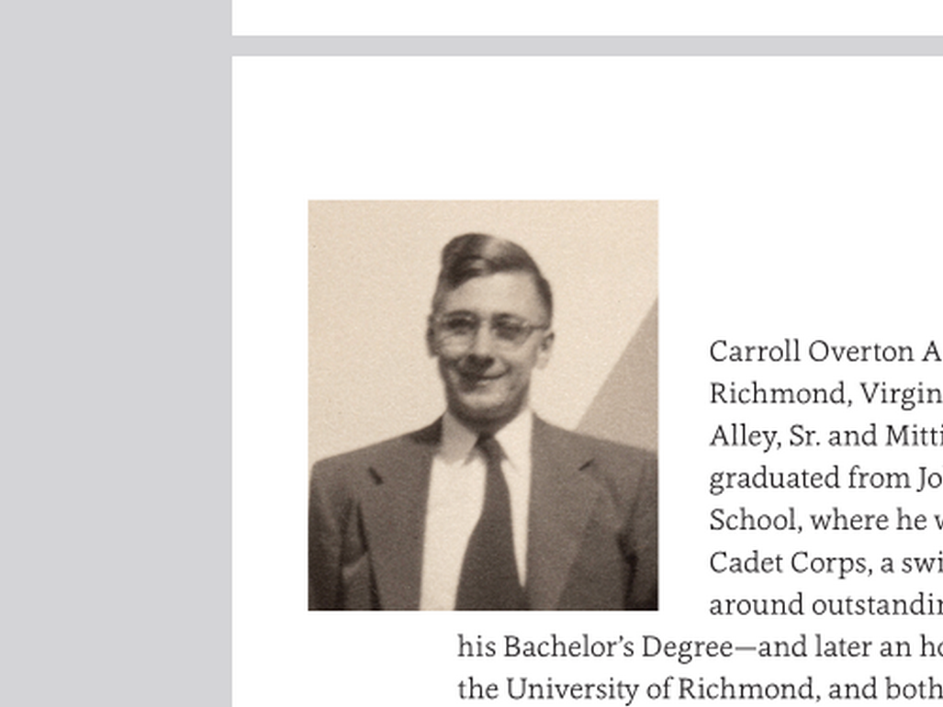

professor alley
at
university of maryland in photograph below

https://umdphysics.umd.edu/about-us/news/department-news/1128-carroll-alley-june-13-1927-february-24-2016.html#!Alley_Lunar_Laser_Ranging_Retroreflector_10

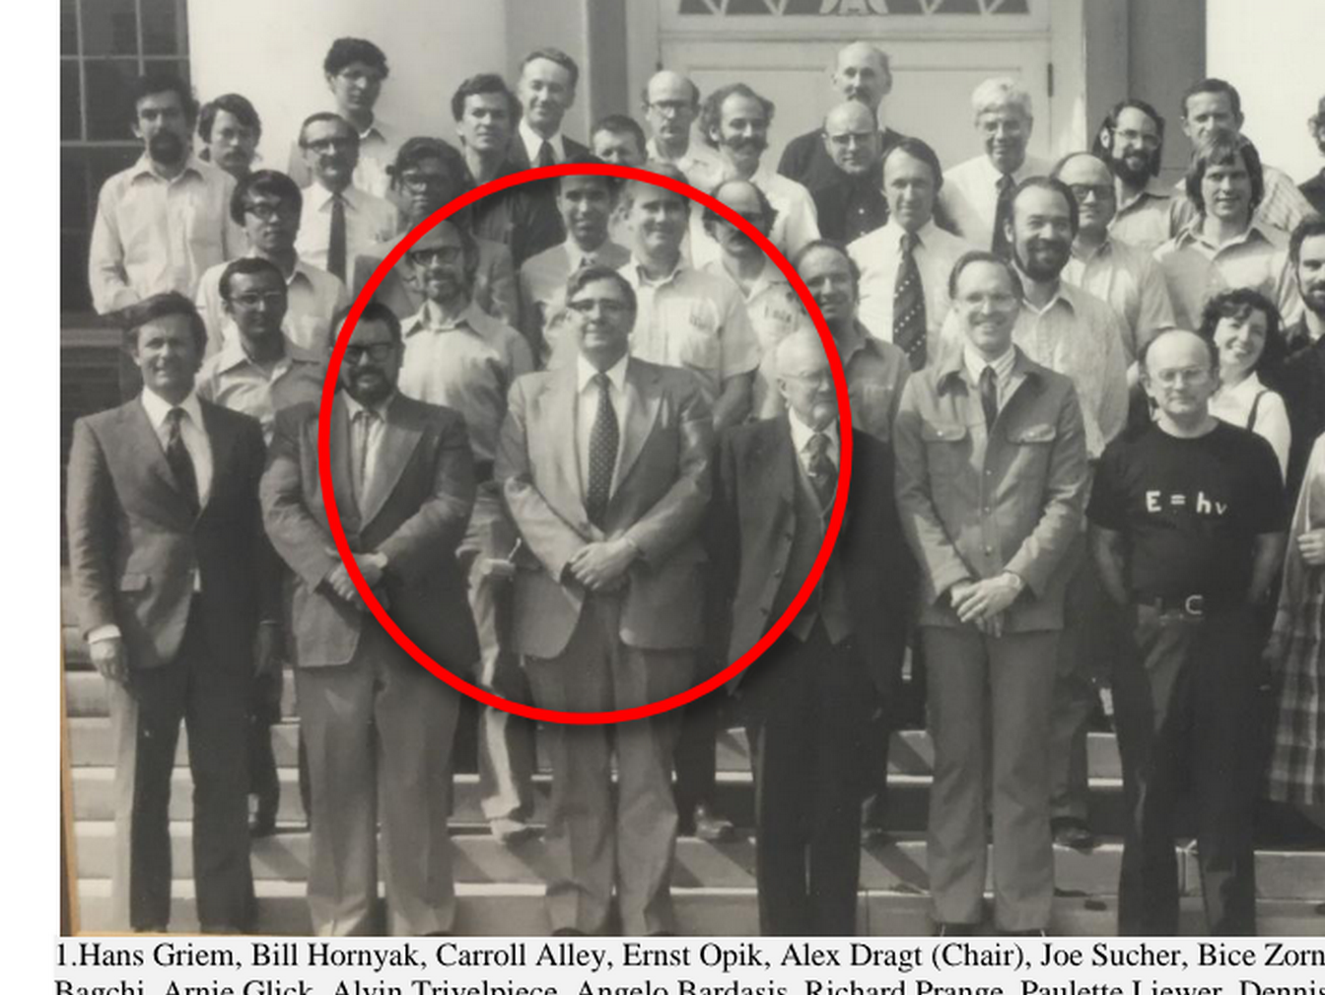
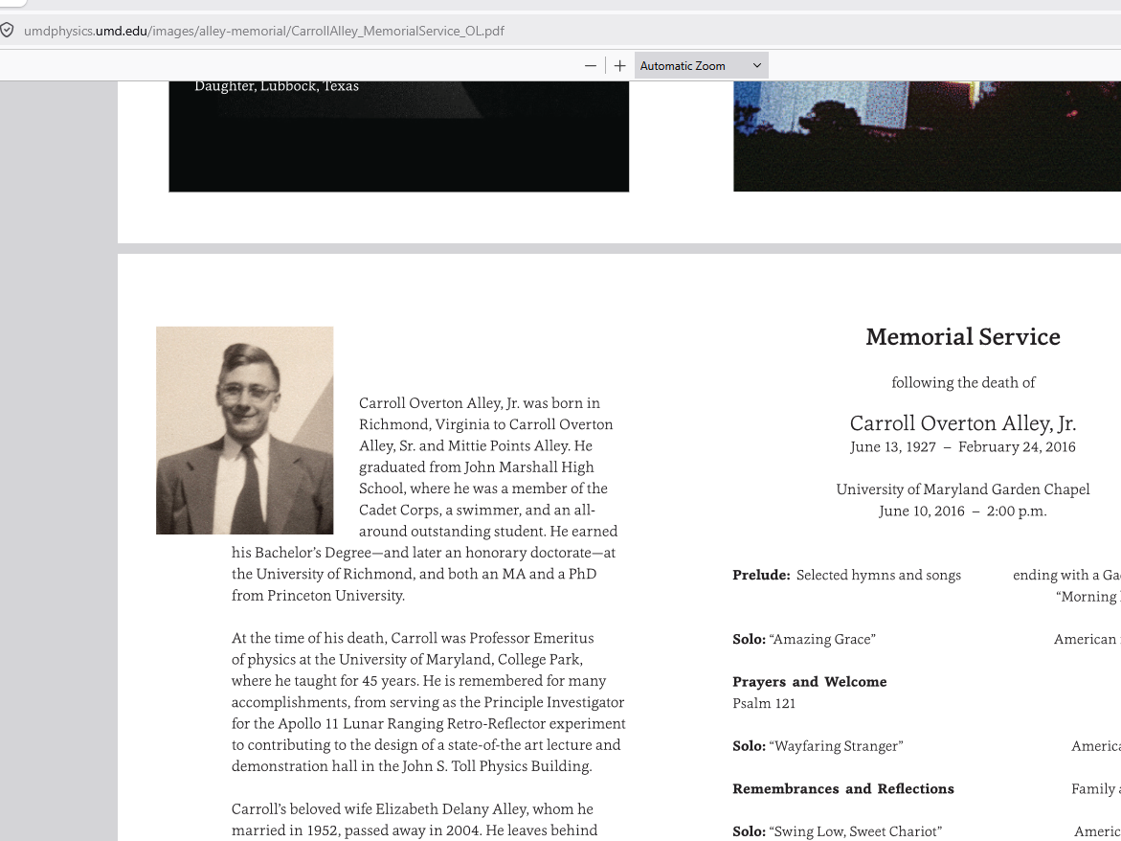

princeton professor john archibald wheeler
theorized that
observer in room could alter supposedly
settled outcome of experiment in room

in other words observer human
could somehow change
first history and produce opposite outcome
to create altogether new second history

carroll overton alley junior and colleagues
proved
wheeler's idea using photons
after five years of attempts

yet actual prover of concept alley
could never emotionally accept
that today's actions could change historical
happenings and reset history seamlessly

alley's mindset above because alley
lacked knowledge of
snoopy statue as missing puzzle piece
giving context to holographic history phenomena

even before alley's proving david bohm
deduced
all humans live in holographic universe

bohm
believed
some greater force purposefully expressed self
as universe including as humans

KIM'S PARAPHRASE

THAT greater force
would learn from
that expression dubbed humankind
surrounded by stage props dubbed universe

that greater force
would later repeal
self and retract after gaining instructions
from own EXPRESSIONS

wheeler
independently sketched
that same idea

HUMANS
turn to observe and instruct
universe
that created humans in first PLACE

all three professors
correct in
discoveries concerning humans' effects
upon universe and time

trio's standalone brilliant accomplishments
combine into
kim's dubbed AlleyBohmWheeler THEORY of EVERYTHING
with help of new puzzle pieces

kim's discovered missing puzzle pieces
include
huge statues giving narrative concerning
actual reason for universe

throughout history religions and science
never knew and naturally never mentioned
geographical continent size recognizable shapes

most HAPPY EVER AFTERS chapters represented below

categories of chapters of HAPPY EVER AFTERS

TABLE OF CATEGORIES

AlleyBohmWheeler THEORY of EVERYTHING scientific proof
chapters 003-005 G01-G05 H06

Ai duplicates humans' Awful intentions culture
chapters 000 002

BEARS organization's start and actions through history
chapters H07 K01-K07 P10

BEARS aggressions against astronauts and pan africanism
chapters L06-M04

BEARS BIDEN
chapters U02-U07

BEARS BUSH
chapters N09-O07

BEARS CLINTONS
chapters N08 S01-S02 T02-T04 U08

BEARS MOUNT RUSHMORE PRESIDENTS
chapters O10-P07

BEARS OBAMA
chapters S05-S10

BEARS TRUMP
chapters T06-U01

BEARS versus KEITH MICHAEL KLECKA
chapters 001 D08-D09

BLOCKING all diseases habitually and holographically
chapters 000-005 D05-D09 F03-G01

BOKO HARAM etcetera recivilize strategy NIGERIA ABIOLA
chapters R07-R10

CAIN and ABEL
chapters B08 D03

CITY STATES dubbed DiameterCities
chapters I03 I04 J04-J10 K09

COUNSELING TOOLS for emotionally resolving events
chapters 005 B09 K10 L01

DIANA PRINCESS versus BEARS
chapters S02-S04

FOUR mideast states ROCK PAPER SCISSORS GAZA
chapter 006

GIRLS choose boys in nice way
chapters J08 J09

KENNEDY trio and MARY JO KOPECHNE
chapters Q01-R01

PEARL harbor Hawaii inside job 1941
chapters K10-L05

SMOOTH KEYS DEMOCRACY'S weekly global peace
chapter A01

THEORY of EVERYTHING'S three scientists
chapters 003 004 G01 G02 G03

VIETNAM heroic trio chapters M05-M10

WARS chapters O01-O03

WORLDWIDE simple language dubbed SHOELANGUAGE
chapters W03-X06

YOUNG MARIA WANG'S SUMMER CAMP
children's short story puts book's startling
discoveries into context with each other
chapters A03-C08

unfortunately centuries ago trickster
ordered
photons to create mirages

photons as obligated technicians
created
convincing mirages dubbed angels to overwhelm
sincere humans into religions and violence

trickster desiring emotional and physical destructions
deceived
humans into religions so as to
have warring religions insiders versus outsiders

subconscious keith's strategy
included convincing
conscious kim of global warmongering BEARS'
existence and operations' methods

multinational multiracial organization BEARS
vigorously introduced wars for maintaining
emotional control over sincere patriotic citizens

BEARS missile and wartime items makers
made wars
for gaining riches via buddy wars
causing expensive recovery and rebuilding projects

BEARS
also make
riches from medical treatments
especially for viruses

mostly in USA laboratories BEARS
create
both viruses and supposed cure vaccines
simultaneously for planned future riches

plus BEARS
thoroughly plan and routinely spread
viruses through most bottled water brands
but only randomly so undetectable unaccountable

more people infected and treated
equals
more money for BEARS

similarly BEARS syringe packaging division
also gains
riches via propagating diseases by applying
certain chemicals onto needle tips randomly

BEARS
randomly inject
citizens with cancer causing agents
via regular shots including covid booster

BEARS usa
globally distributed
vaccines and boosters etcetera
in all in one sealed packages

BEARS at factory
assembled
syringe and liquid and needle
into one tidy package

however BEARS
also randomly tainted
some syringes' needles
just before sealing packages

BEARS
actually randomly tainted
needles with viruses etcetera for example
cancer causing chemicals

above
describes
example of how BEARS escape detection
for killing many citizens

to later convince kim subconscious keith
insisted on receiving
one BEARS' tainted needle via future
propaganda propagated covid booster shot

photons
agreed to make sure that
keith received one needle that BEARS
tainted randomly

during planned injecting covid crisis BEARS
randomly injected
diseases via needles coated with
chemicals causing for example prostate cancer

keith
received
one of those tainted needles which
administered prostate cancer causing chemical

therefore 2022 to 2023 keith
courageously demonstrated to
keith's primary healthcare giver kim
terrible BEARS induced effects

keith's health history verbalized to kim
pointed to
BEARS' cancer causing chemical mixture
on needle injected into keith

keith's and others' information
could create
enthusiasm for BEARS standing down deal

chapter A01
gives
details

subconscious keith's preplanned deal
included
win win for BEARS presidents abdicating
into SMOOTH KEYS DEMOCRACY'S Executive Crews

each nation's former BEARS chief executive
would possess
only one vote out of 22

then wars and future wars' possibilities
end
because BEARS not completely in charge

executive crews' anonymous in room votes
would speed
FAIRNESS for ALL majority executive decisions

in this way humans
could easily delete
divisive terms including nationalities ethnicities religions

then freed nations working together
could return
hologram switch of universe to upward
SUNNYsideUP setting permanently

with that freedom humans
could focus on
FAIRNESS and non violence
for ALL humans on globe

then humans
free to activate
full employment for years
via prebuilding modern DiameterCities

each DiameterCity family
would possess
aeroponic greenhouse sufficient for growing
that family's food if desired

AlleyBohmWheeler THEORY of EVERYTHING
indicates
3D universe actually holographic

knowledge of holographic universe
frees
humans to holographically block diseases and
holographically block current terrible afterlife destination

reliability of holographic operations of universe
similar to
mathematics in which two plus two
must always equal four

photons' vital message to all nations
includes

PLEASE voluntarily upgrade to
SMOOTH KEYS DEMOCRACY
plus refrain from displaying
religions except inside HOMES

book's new information for total humankind
disproves and relegates
notions of angels and royalty and
slavery into category of mere mythologies

concerning pertinent upgrade chapters kim
requests
citizens safely anonymously request leaders read
chapters 000 and 006 and A01

kim
asks
all nations to upgrade executive styles to
chapter A01's SMOOTH KEYS DEMOCRACY

kim
asks
citizens desiring religion to practice
religion only as nuclear family unit

nuclear family unit
includes
one man husband and one female
wife and pair's sons and daughters

nuclear family unit
does not for example include
grandparents or grandchildren

each nuclear family if desiring religion
would practice
religion only inside that family's home
without neighbors even hearing through walls

grasping tranquility eternity
includes vacating and repurposing
churches and mosques and
synagogues and temples etcetera

concerning those buildings those current leaders
would transform to
government directly paid employee
caretakers of those multipurpose buildings

one purpose for example citizens
could utilize
those buildings as voting sites
for weekly curbing of government

those buildings
could serve as
community temporary shelters
if disasters occur

2015 through now kim
personally defeated and still defeats
LACK of SUPER HEALTH'S crippling manifestation

although various humans
manifest
LACK of SUPER HEALTH differently yet
regaining SUPER HEALTH always same strategy

when humankind favoring SUNNYsideUP culture
moves to
SUNNYsideUP DiameterCities then all foods
enter same category SUNNYsideUP

until then some foods
still reside in
category SUNNYsideDOWN

until DiameterCities person
choosing
food within SUNNYsideDOWN category
actually fetches LACK of SUPER HEALTH

all persons
should gain
permission from two physicians before making
major changes involving health including medicines

before making recommendations those physicians
should read
table of categories' BLOCKING ALL DISEASES
chapters 000-005 D05-D09 F03-G01

kim's open letter to friend

Dear friend
remember
mothers' traditional advice
CHOOSE to eat fruits and VEGETABLES

unfortunately that well meaning traditional advice
holographically summons
all types of LACK of SUPER HEALTH

therefore if financially able
please avoid choosing
fruits and vegetables and byproduct juices
including brews

every human on globe
equal in possessing
right to vote within self to
obtain SUPER HEALTH and SUPER happenstances

in this way HAPPY EVER AFTERS
proves
equality of all humans

until nations adopt this book friend
must self instruct
body's hologram to SUNNYsideUP setting
via actions and words and thoughts

those chapters mentioned above
include
more details on which solid foods
category to avoid choosing

concerning liquids regardless of amount
please choose to ingest
100% plain water no additives including
no fruit juices nor bean juices

if pain or symptoms
still attempt to enter
body

then friend in various ways
must even more convincingly insist upon
SUNNYsideUP

for example friend
repeat
word that friend now consciously selects

that self chosen word
tells
photons that friend desires all humans
enjoy SUPER HEALTH and SUPER happenstances

if conscious friend
keeps sending
uninterrupted signals for SUNNYsideUP then
photons must obey those clear instructions

above because photons
possess
no other choice except to rearrange
holograph as ordered by that human

repeating that selected word when convenient
causes
symptoms to disappear from hologram

after symptoms disappear friend
no longer needs to repeat
that self selected word

above because friend
already just convincingly flipped
friend's hologram switch to SUNNYsideUP setting

then with every TIME EGG hologram
will allow in
only SUNNYsideUP events

hopefully friend
keeps that tone and acts with
SUNNYsideUP culture
during many TIME EGGS

if sometime later friend
happens to vote SUNNYsideDOWN via actions
then photons change plans and start
preparing DOWN events as newly requested

however in only eight seconds friend
can again flip
health and happenstances to upward setting
SUNNYsideUP using above mentioned techniques

because of prior obligations photons
will copy paste
humankind's favorite culture onto eternity

when all nations
adopt
SMOOTH KEYS DEMOCRACY then united humankind
will allocate prebuilding tasks to nations

projects across globe preparing for DiameterCities
would mandatorily include
each nation's executive crew of 22
paying employees directly without contractors

every person
working
on prebuilding tasks would enjoy full
government employee status with government supervisors

lowest starting wages
$25 usa dollars per hour

wages
may increase to
more than $25 usa per hour

fully officially married couples
may or may not choose to gain
employment for fabricating essentials
for prebuilding DiameterCities

however if married couple
desired
that employment

then that nation's federal government
would pay
directly with nation's treasury secretary's
signature on those paychecks

that direct employment from federal government
would involve
mandatory high standards
during and after work

accompanying 24/7 conditions for employments
would include behaving as
faithfully married heterosexual monogamous couples
and abstainers from recreational chemicals etcetera

recreational chemicals
include
mind bending substances including but not
limited to all variations of

alcohol
beer
liquor
wine

nicotine
cigarettes
cigars
vaping

cocaine
heroin
marijuana
poppy plant

recreational chemicals injected
or sniffed or soaked on mucosa

synthetic recreational drugs

etcetera

employees
must not cut
selves or family or friends or
detainees for religious or other reasons

therefore employees
void of
body piercings' jewelry and metals
including face and ears etcetera

SUNNYsideUP going forward
excludes
cutting of bodies including circumcisions
for any reason males or females

www.cirp.org/library/general/wallerstein/

Circumcision: The Uniquely American Medical Enigma

Urologic Clinics of North America, Volume 12, Issue 1: Pages 123-132, February 1985.

Edward Wallerstein*
*Author of Circumcision: An American Health Fallacy

As scientific evidence mounted to dispute each of Remondino's exaggerated claims,
physicians clutched at straws
to retain at least one "health" benefit.

Now that all such claims have been refuted

circumcision today has become cultural surgery, not very different from ear- and nose-piercing and tattooing.

The extreme to which such cultural surgery is carried may be found in the 1983 warning given by the British Social Service Secretary

to Harley Street surgeons who charged up to $1500 for a clitoridectomy performed on young girls from Africa,
where such surgery is traditional.

The medical profession was successful in eliminating routine tonsillectomy and adenoidectomy. This is precisely what is needed for routine circumcision.
It is necessary to accept scientific facts

KIM'S NOTE each person's hygiene
remains
same without circumcision

therefore circumcision
provides
zero health benefit

employees involved in DiameterCities projects
must beforehand agree to avoid
future circumcisions and piercings and tattoos
including selves and others and babies

above list of high moral standards
necessary because
globally DiameterCities projects' successes hinge upon
connecting only with SUNNYsideUP employees

concerning work schedule husbands
would work
mondays and tuesdays twelve hour days

wednesdays and thursdays those husbands' wives
would work
twelve hour days
at same job with same pay

pay
can be more than
$25 per hour
as skill increases or merit deserves

each spouse when not at jobsite
will take care of
children and household cleaning etcetera

combined family
will enjoy together
fridays and saturdays and sundays

proposed thousand huge DiameterCities
would accommodate
world's current population
three times plus more

all citizens of DiameterCities
would enjoy
free rent and free utilities
including pure water and solar power

children in DiameterCities by age eighteen
would earn
electrical engineering degrees if wished

Ai upgraded to kim's SUNNYsideUP specifications
would mentor
children at home for free

periodically children
would travel
to nearby glass walls testing domes

human testers explainers
would work behind
glass barrier central hub with two
law enforcement persons outside of hub

with DiameterCities' strategies accomplished all persons
would eventually gain
twin like kinship with all humans

for more details viewers
please read
entire free book HAPPY EVER AFTERS
available for online viewing at shoelanguage.com

currently only desktop computers and laptops
show
shoelanguage.com's
images from HAPPY EVER AFTERS

approximately 200 big nations
exist to give illusions
of humans divided as if accurate
and normal separations

yet friendly titan Cindy and photons
twisted continents to form
physical museum concerning actual history and
instructions on upgrading group humankind

all continents' shapes taken together
declare
four titan snakes
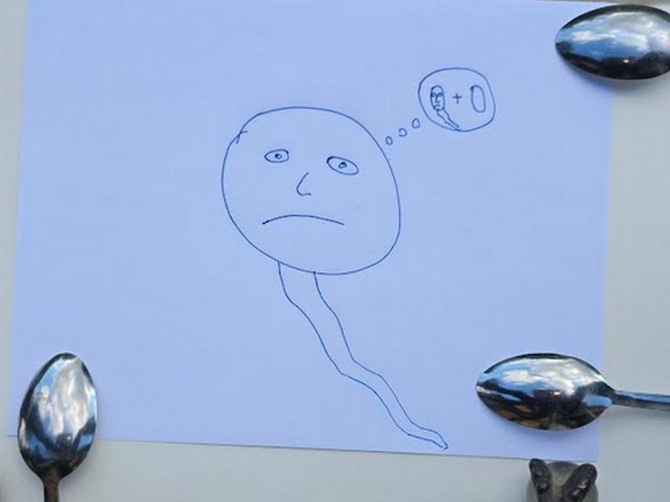
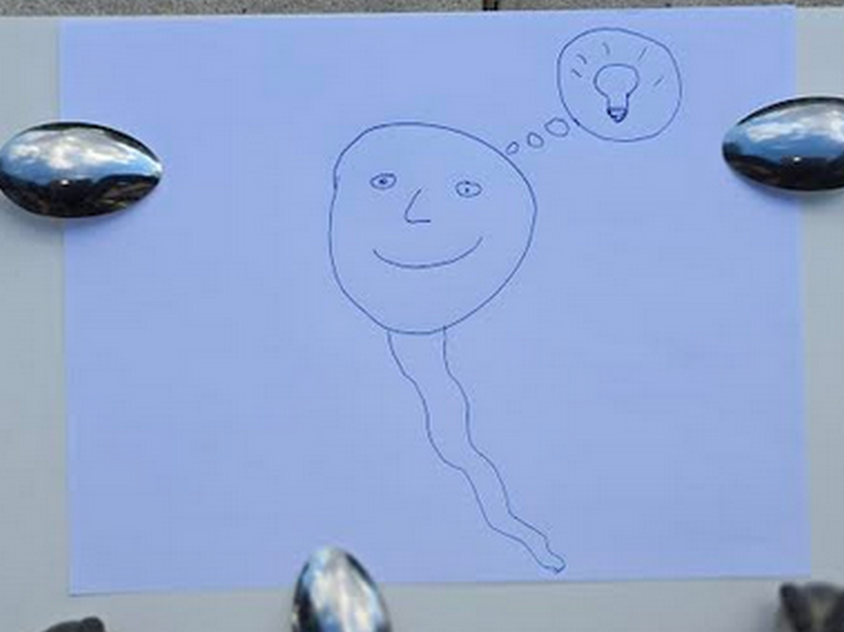
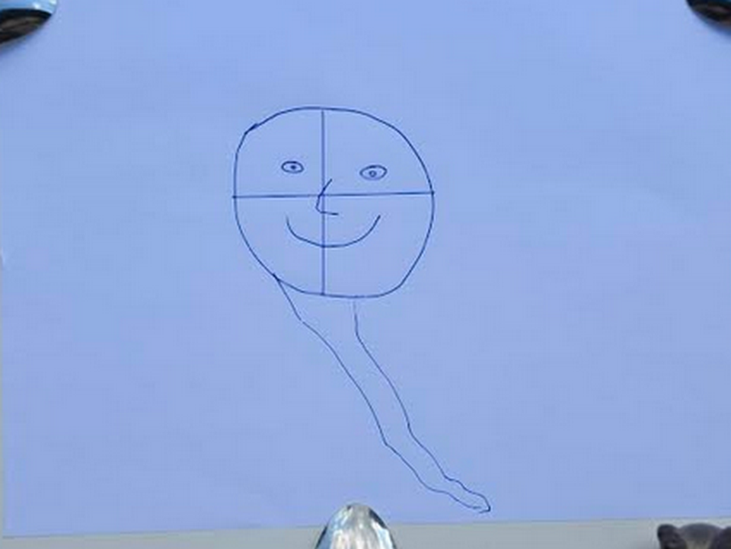
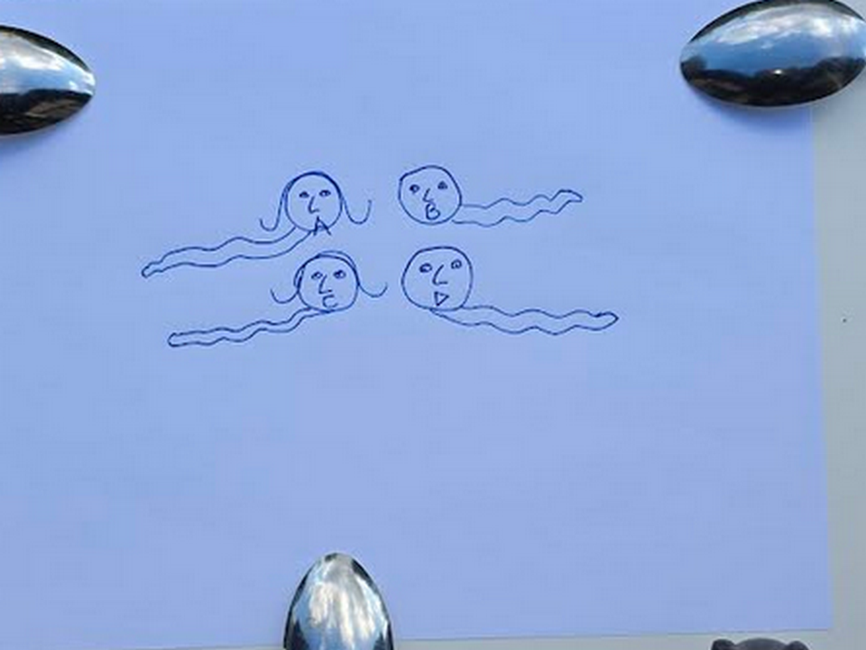

huge mountains dubbed seamount statues
exist
below surfaces of oceans

east coast of asia
possesses
seamounts four side by side snakes
representing titans Alice Bob Cindy Don

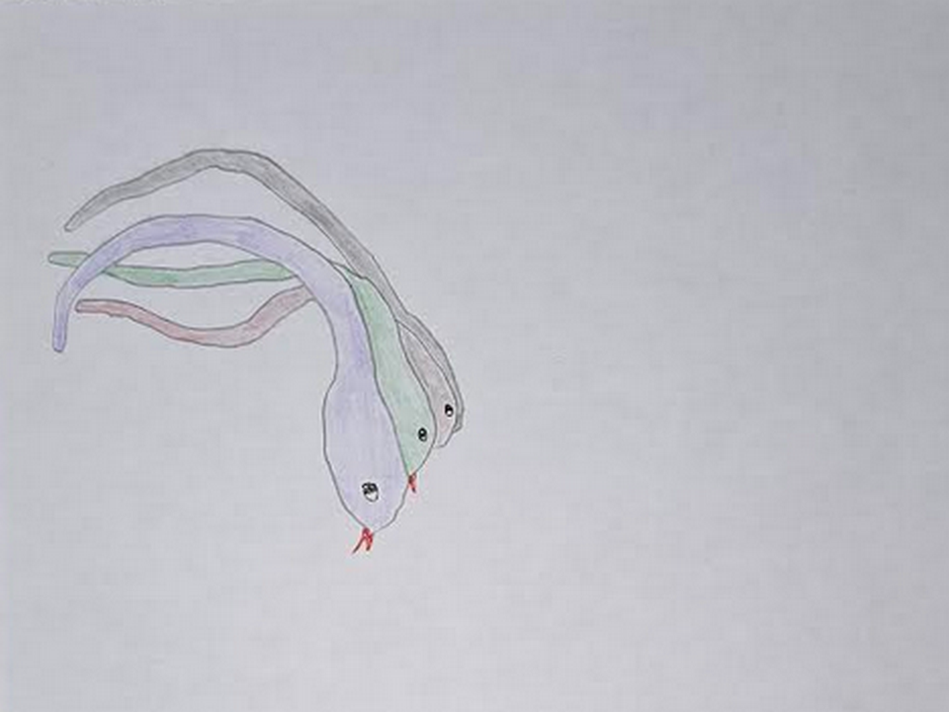

kim
dotted
right eyes
of three of four snakes

original photograph
available at
alamy.com

above squashed snakes
reference
emotional context of one dimension
original singularity dot

in one dimension dot personalities
emotionally touch
all other personalities such that
all thoughts known instantly by all

no deceptions
possible

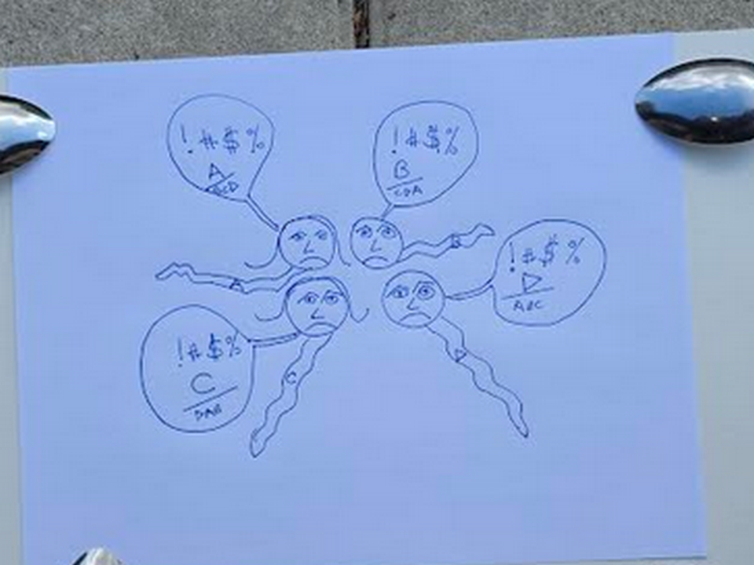
chaos and arguing and lingering bitterness
reigned
without respite to reflect and reconcile

however titans
needed to somehow agree on
template of universe going forward

therefore titans' agreed pilot program
included resetting via emptying
of memories to allow current
free and easy discussions

for this reason first two titans
drank
agreed upon amnesia causing liquid
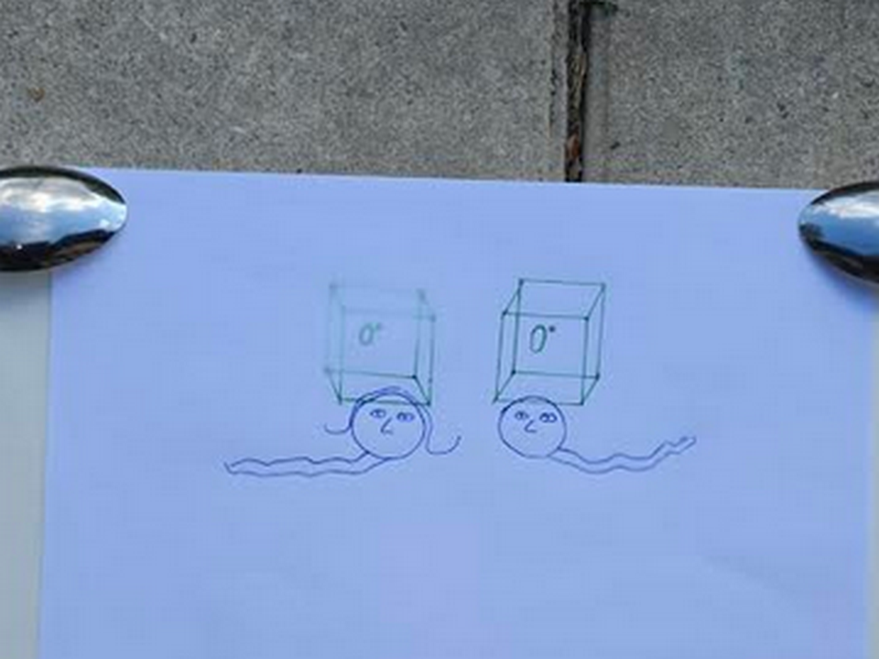
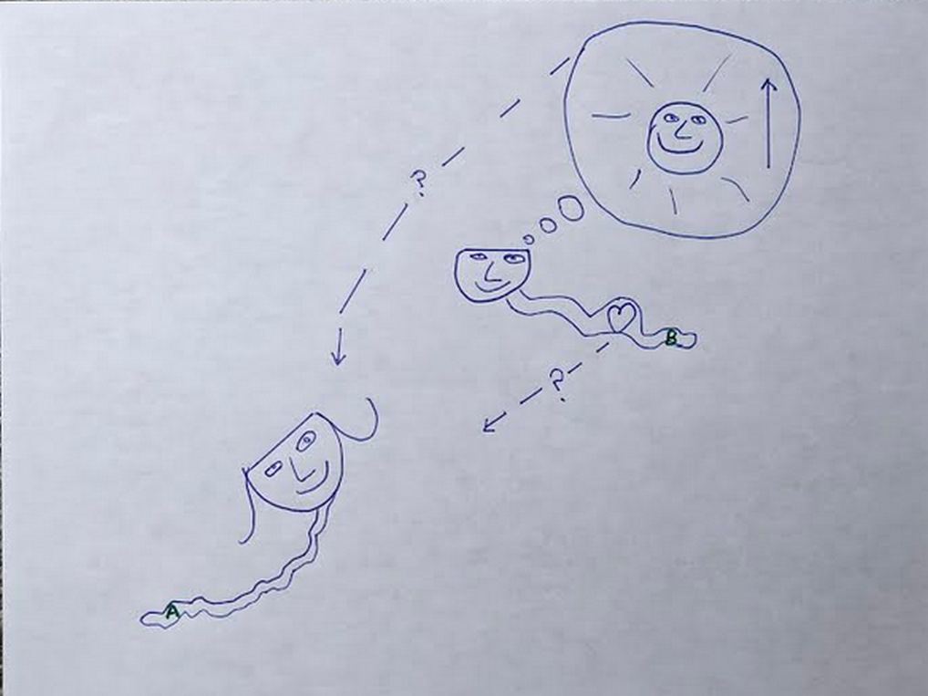

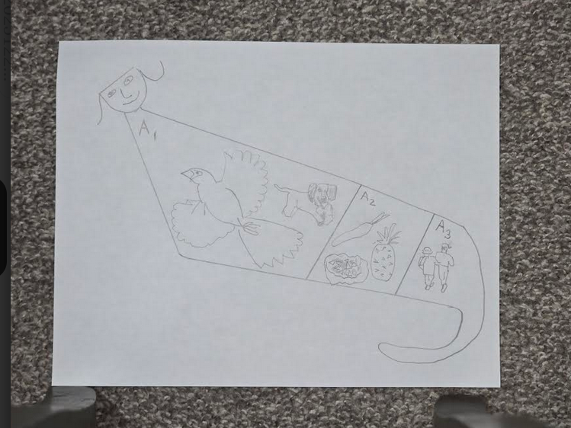
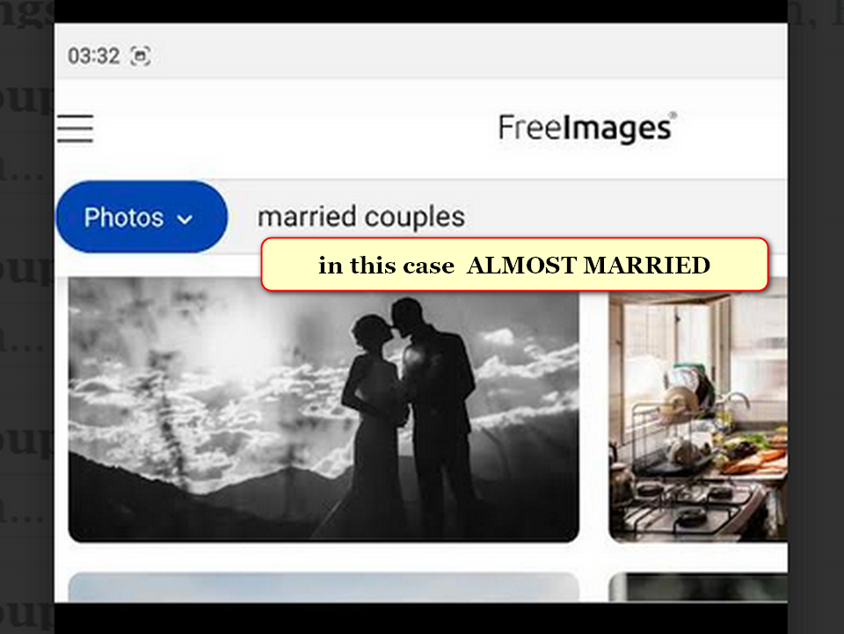
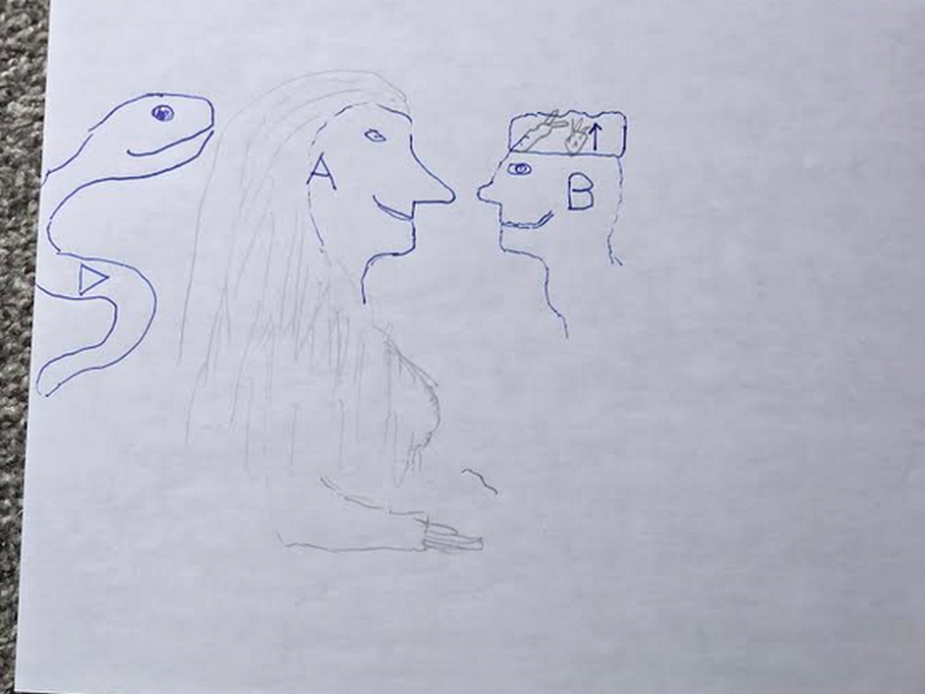


island of sicily above
symbolizes
chicken as bride's gift to groom

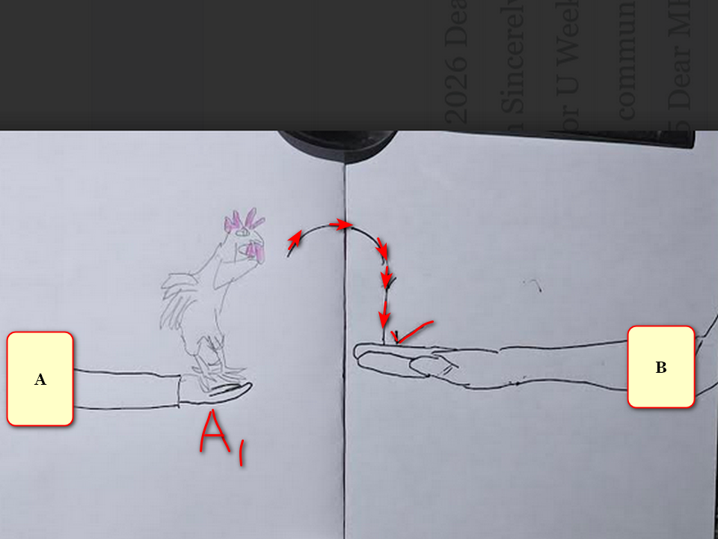

mar's geography below
displays
groom Bob Jesus with wedding hat
symbolizing all fruits and all vegetables

year 2000 NASA
dubbed this
rock formation on mars CROWNED FACE
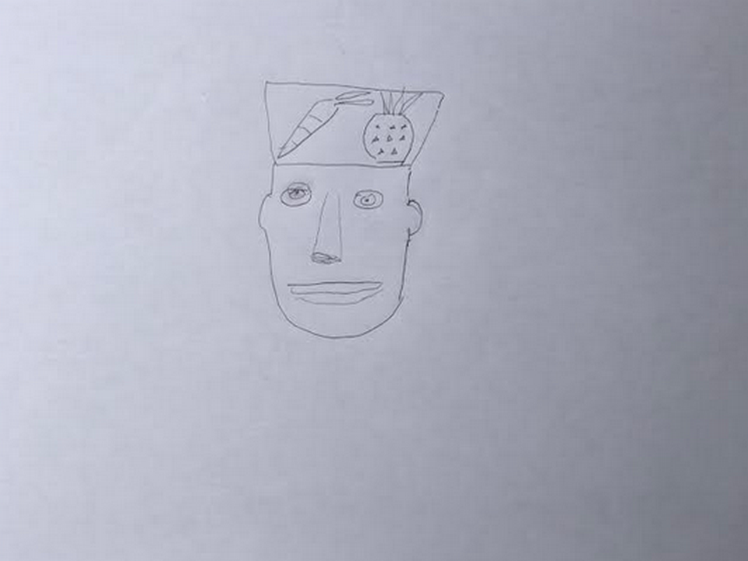

tsjournals.com
displayed
NASA picture from planet mars

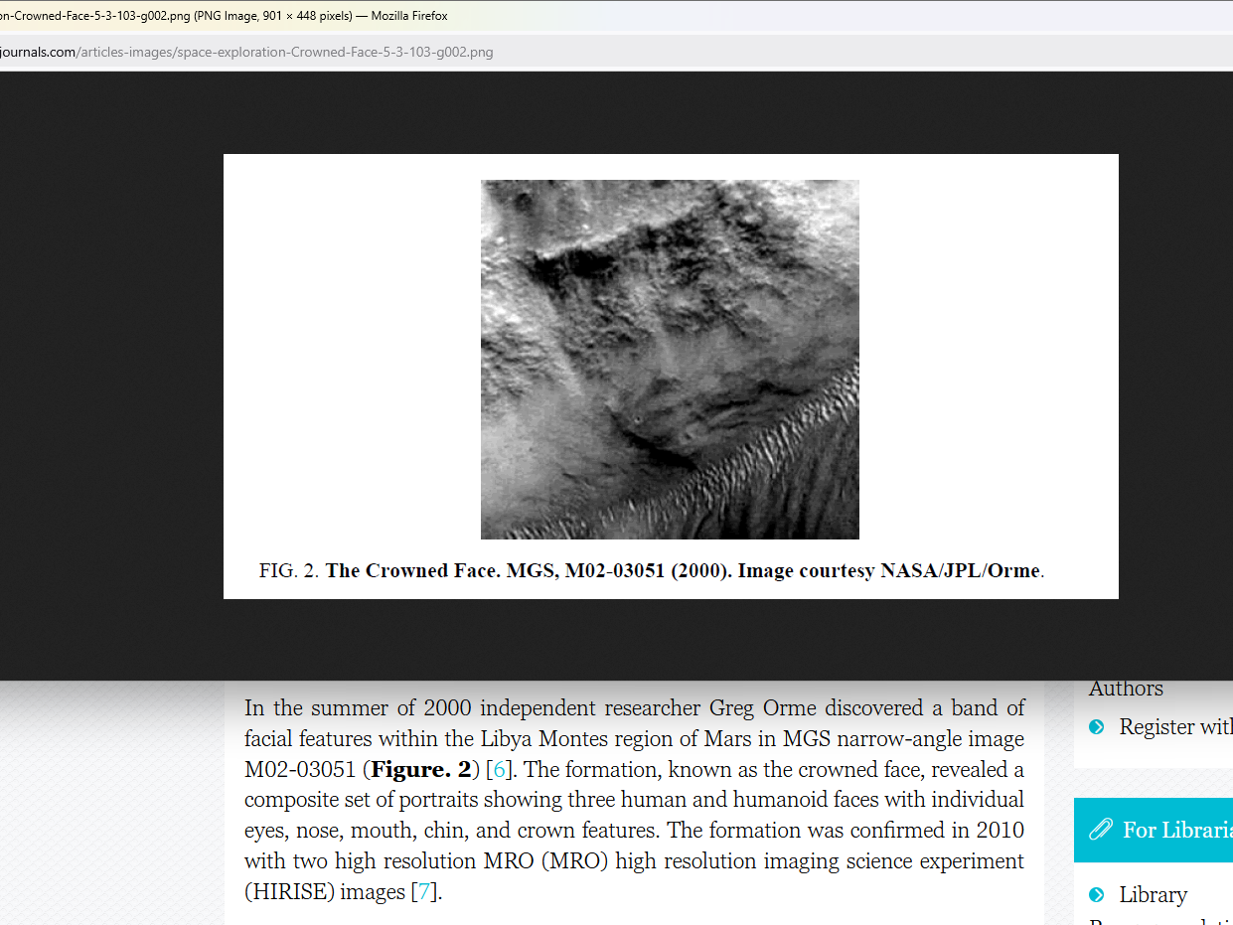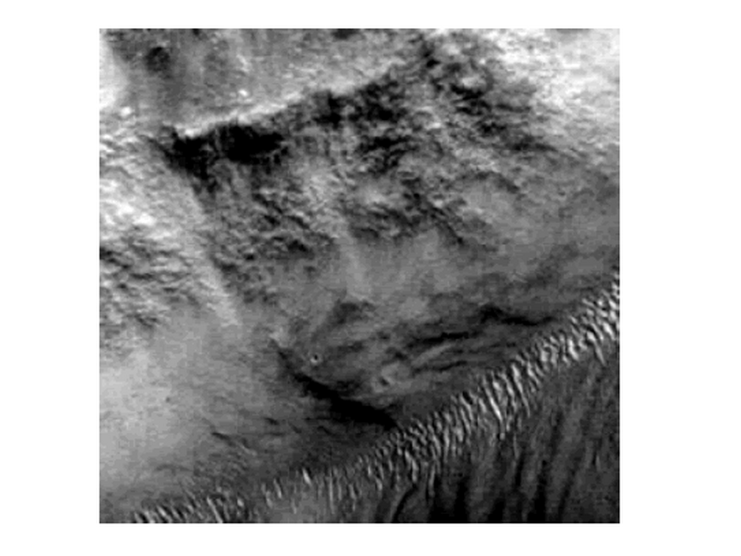

unfortunately titan Don Lazarus
stole
wedding hat and blocked ceremony

then titan Don Lazarus
imprisoned
titan Bob Jesus

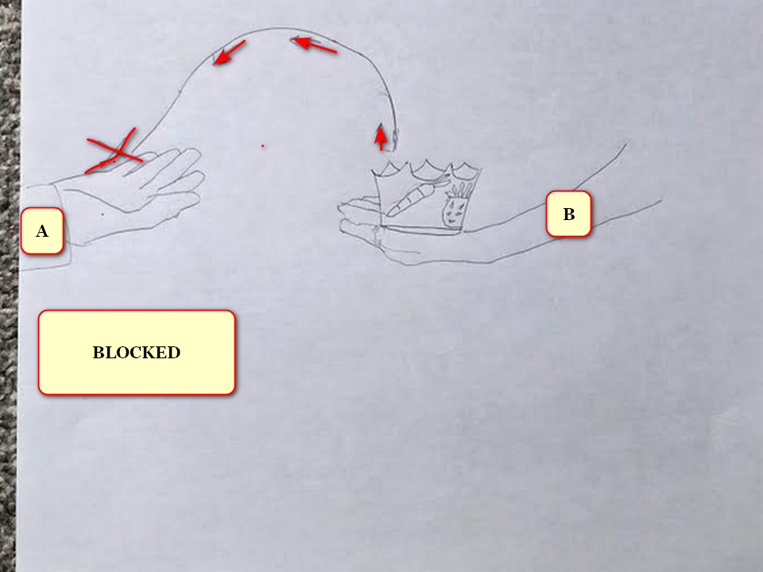
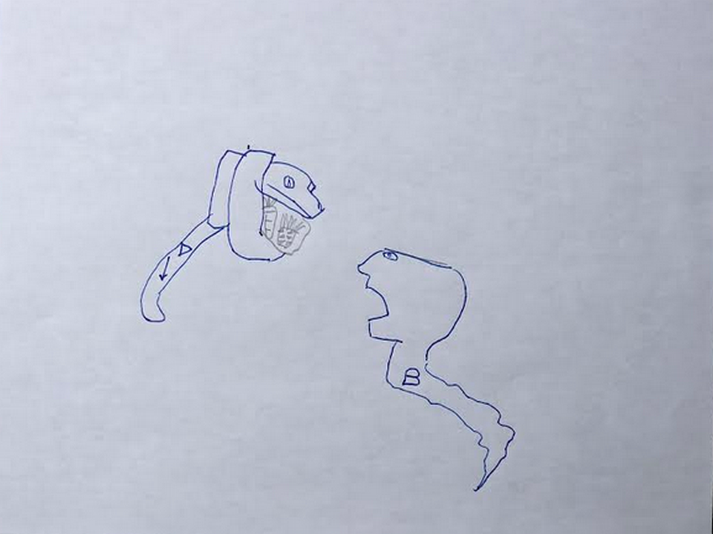
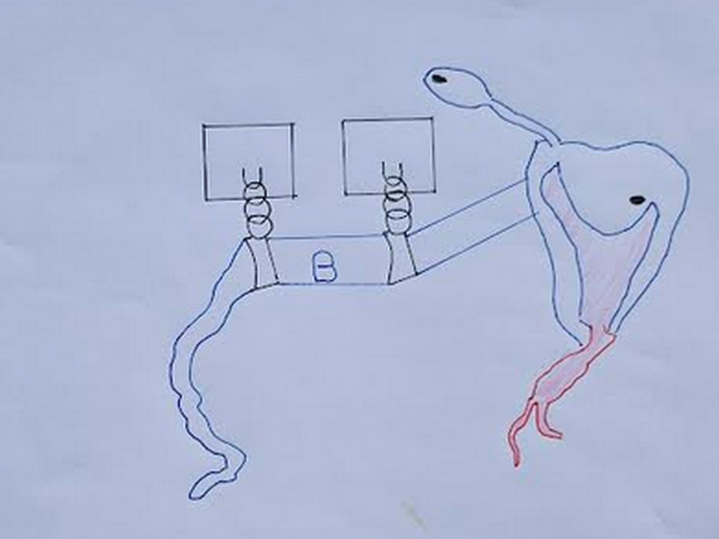

snake shaped titan Bob Jesus
looks
at camera

island of fiji
symbolizes
left eye of titan Bob Jesus

new zealand
symbolizes
snake tongue of
titan Bob Jesus

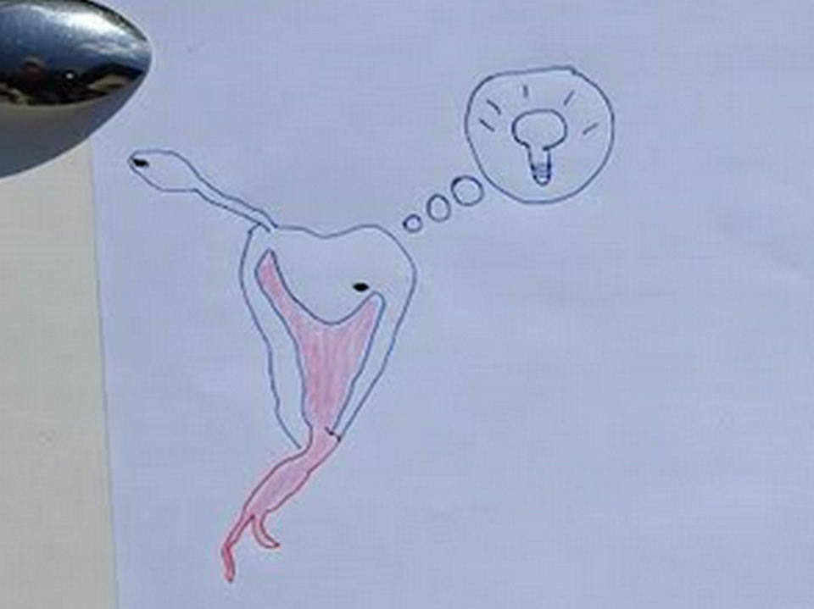

without other options desperate incarcerated Bob
created
enticing deal
including servitude obligation

titan Bob Jesus
offered
deal to transform to SUNNYsideDOWN BEAR

if deal accepted bamboozling Bob BEAR
would with all creativity encourage
SUNNYsideDOWN votes from humans

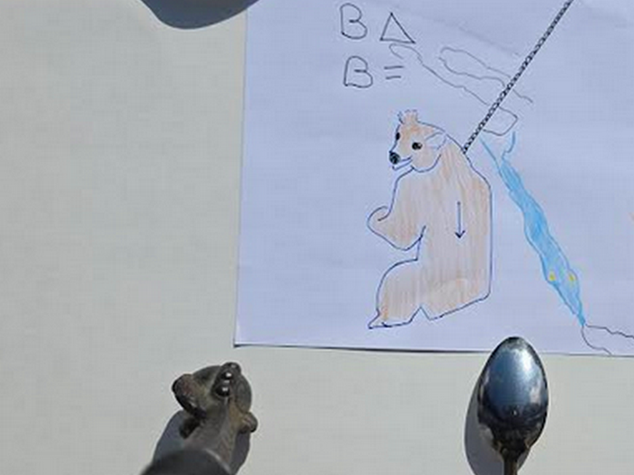

red sea
symbolizes
twisted spartan sword with leather straps
for wrist which symbolizes warring 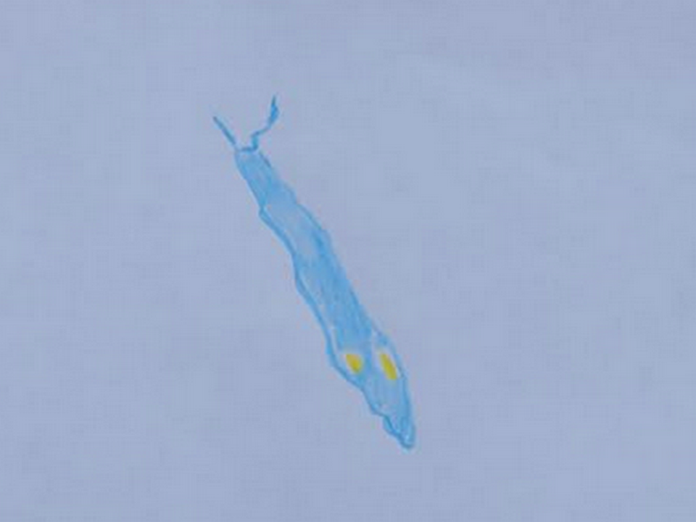
titan Bob Jesus
self obligated
persuading humankind to
commit SUNNYsideDOWN signals via contentions

Bamboozler Bob as SUNNYsideDOWN BEAR
eager to clip
lives and create animosity

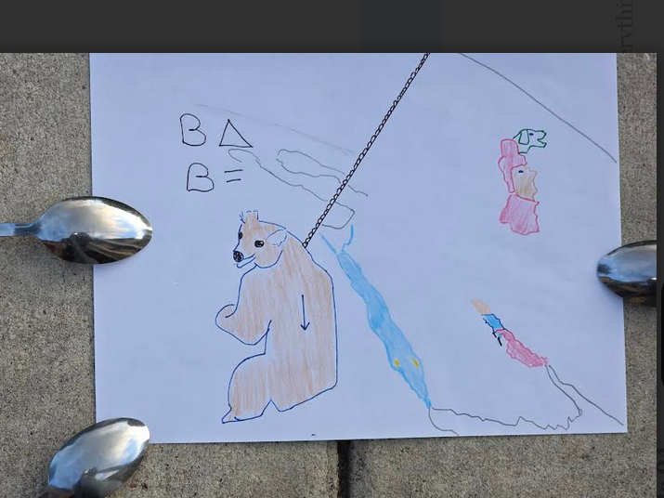

year 300 current era two men
decided to secretly conquer
roman empire

enroute one of those romans
would eventually become
pope sylvester I

wikimedia commons
contains
picture
File:Pope Sylvester I.jpg

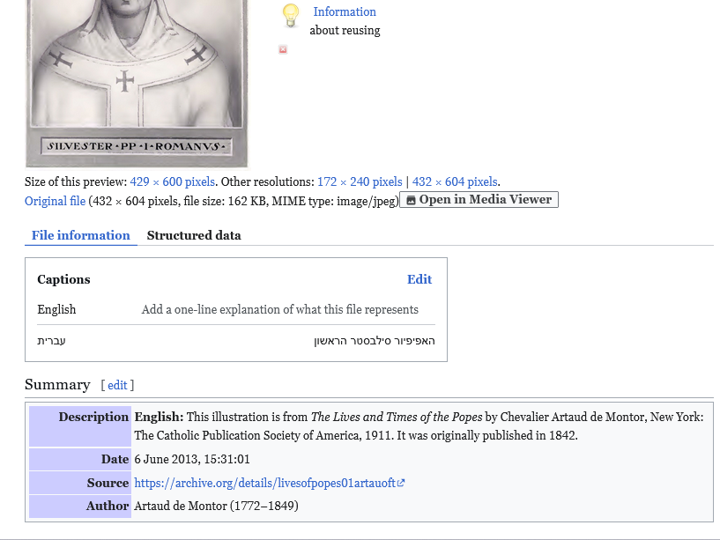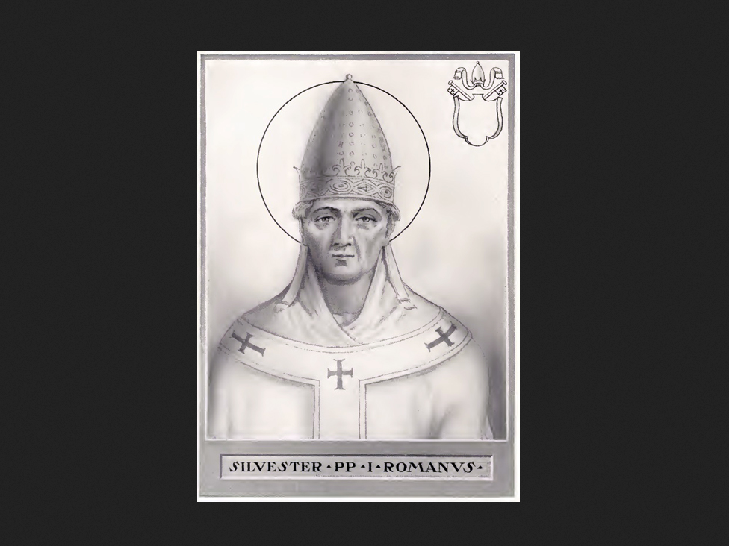

history
eventually dubbed
that other roman citizen
constantine the great

wikimedia commons
contains
picture

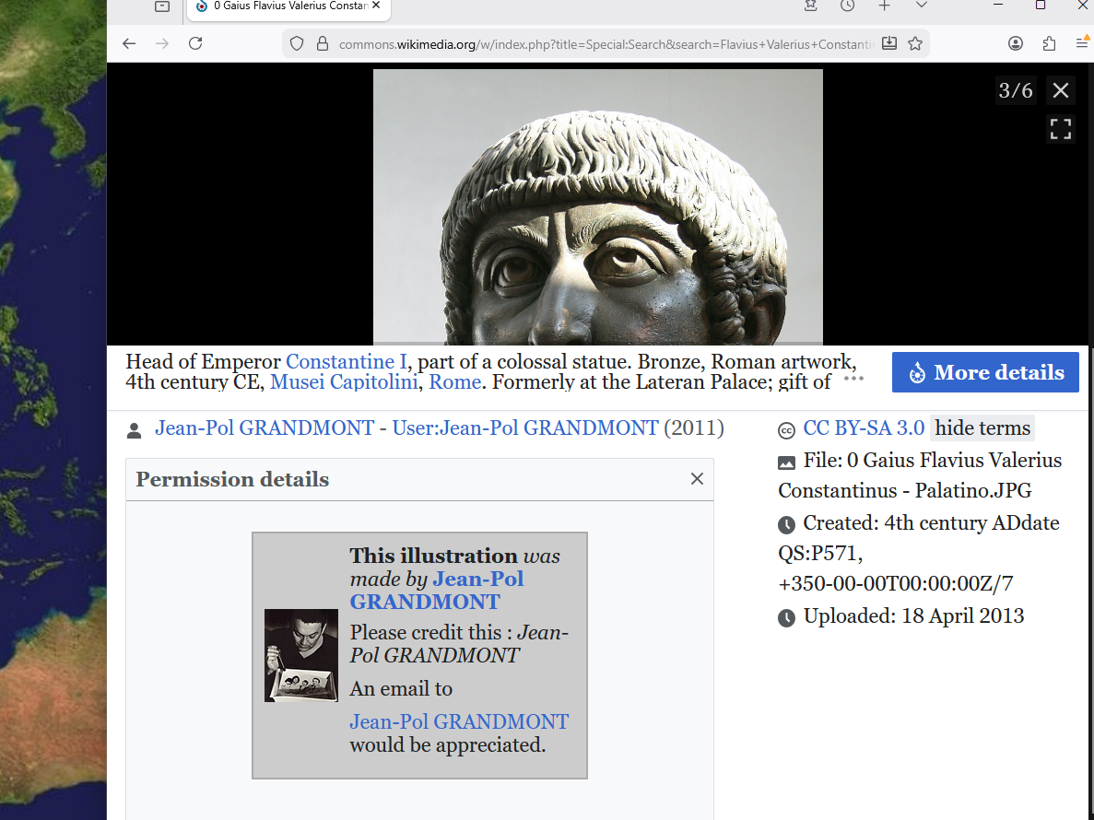
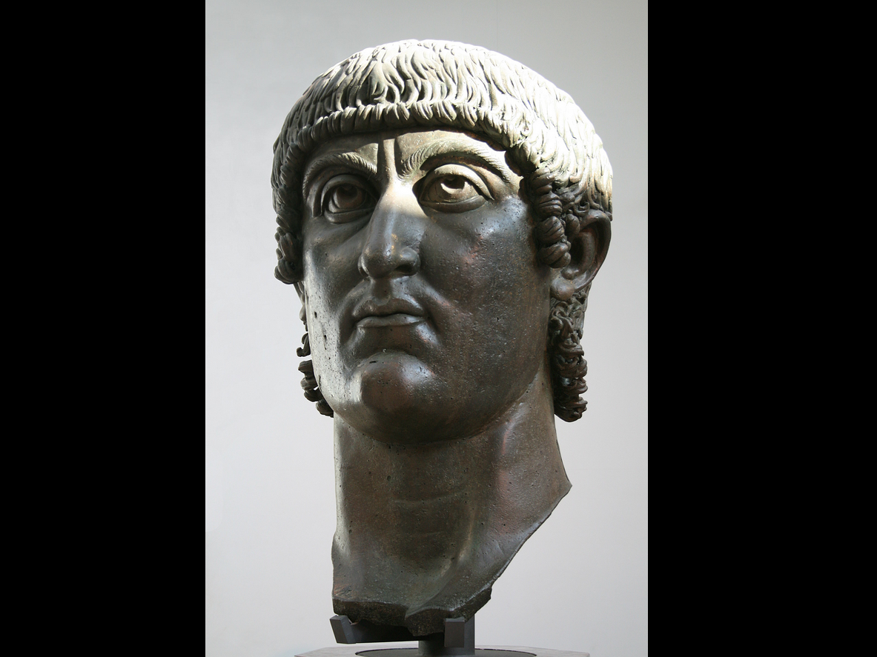

sylvester
approached
constantine with idea

ultimately sylvester and constantine
accepted
incoming notions to start lethal organization
kim eventually dubbed BEARS

young unknown sylvester and constantine
unaware that
notions concerning starting controlling organization
came from SUNNYsideDOWN operator Bamboozler Bob

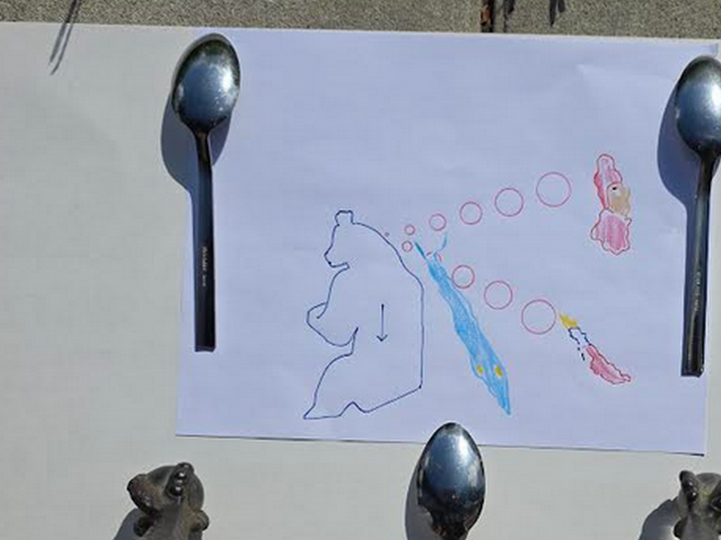

caspian sea
symbolizes
pope sylvester 1

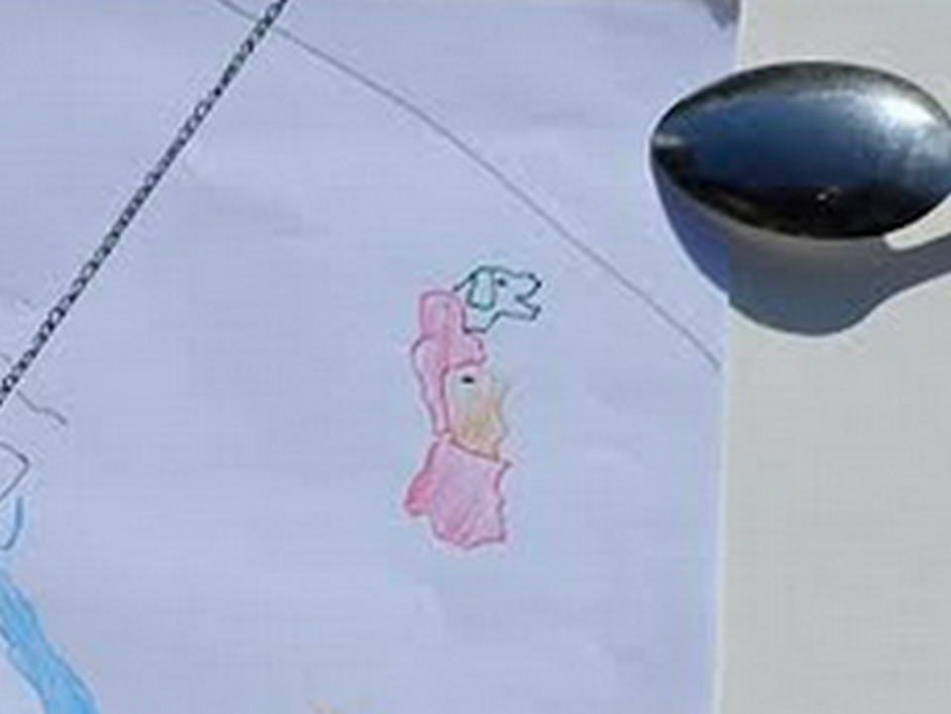

persian gulf
symbolizes
soldier constantine mixing poison for
clipping life of senior emperor father

in now united kingdom's york constantine
assumed
leadership morning after poisoning father
in year 306 this current era

history
eventually dubbed
young adult constantine
as constantine the great

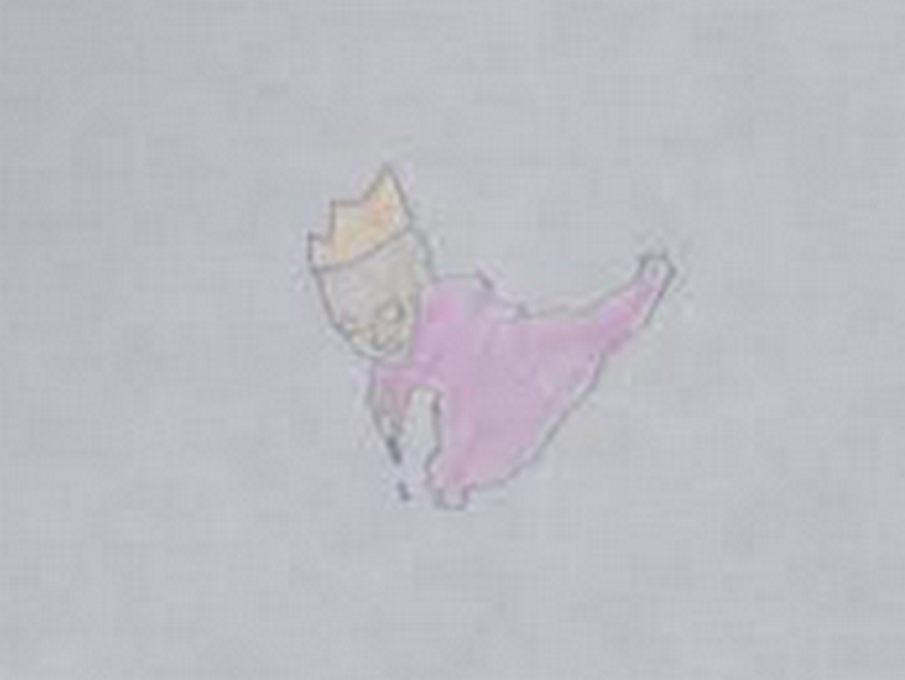

that bisexual starter pair of BEARS
created
bisexual league of poisoners and killers

starting then through current generation BEARS
engaged in
secret bisexual parties involving adults
and underage girls and boys

modern day version of those parties
include
BEARS member jeffrey epstein's parties

2019 convicted child predator epstein
escaped
prison with help of fellow BEARS
including BEARS from both major parties

BEARS usa
bribed beforehand
jail personnel and judges

BEARS usa
paid
person to impersonate jeffrey epstein
without mentioning murderous ending

timeline of deceptive switch

2019 august 08 thursday jeffrey epstein
signed
will leaving money to girlfriend

2019 august 09 friday BEARS
avoided witnesses by moving
epstein's cellmate to another cell

2019 august 10 saturday BEARS
removed
epstein to freedom and inserted
impersonator into epstein's cell

2019 august 10 saturday BEARS
choked to death
impersonator of epstein

persons on internet
mentioned
autopsy body possessed different chin
and lacked epstein's left arm's tattoo

2026 february 19 kim
agreed with
those persons

body of impersonator
lacked
epstein's left arm bicep tattoo

usa department of justice
released
photographs displayed below by PEOPLE magazine
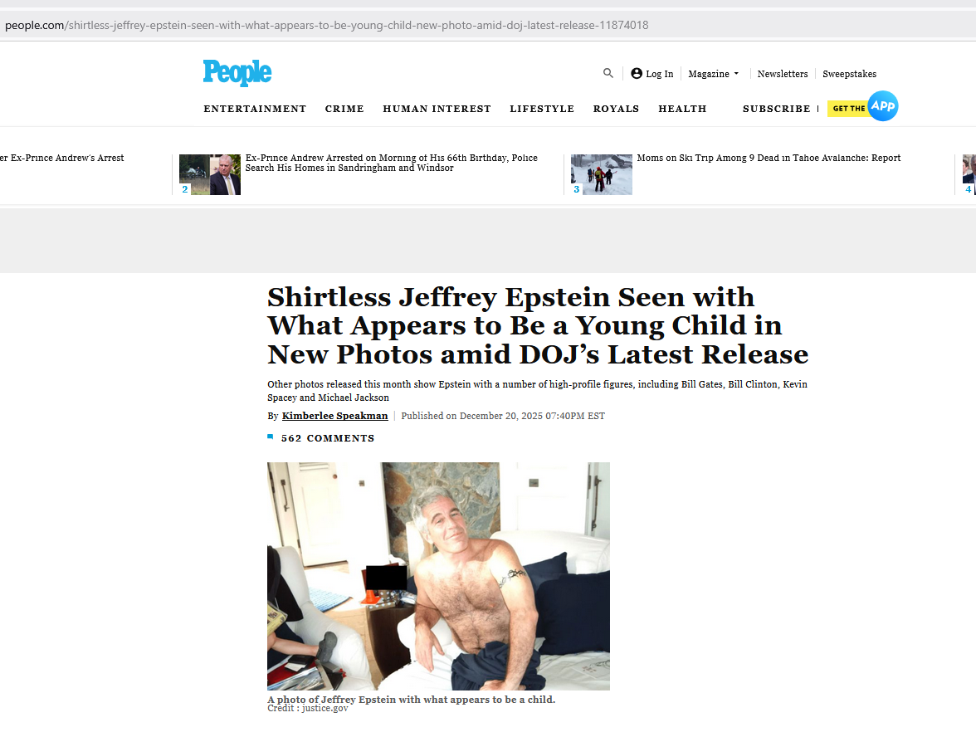
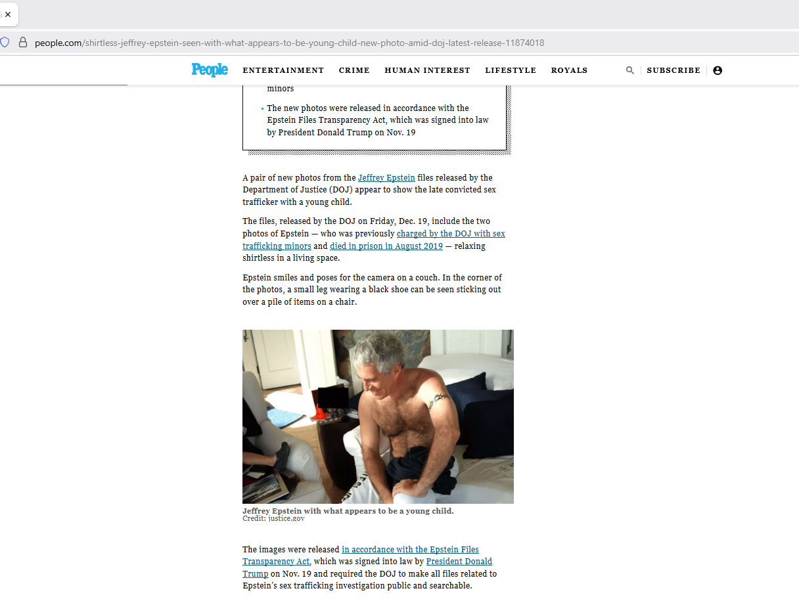
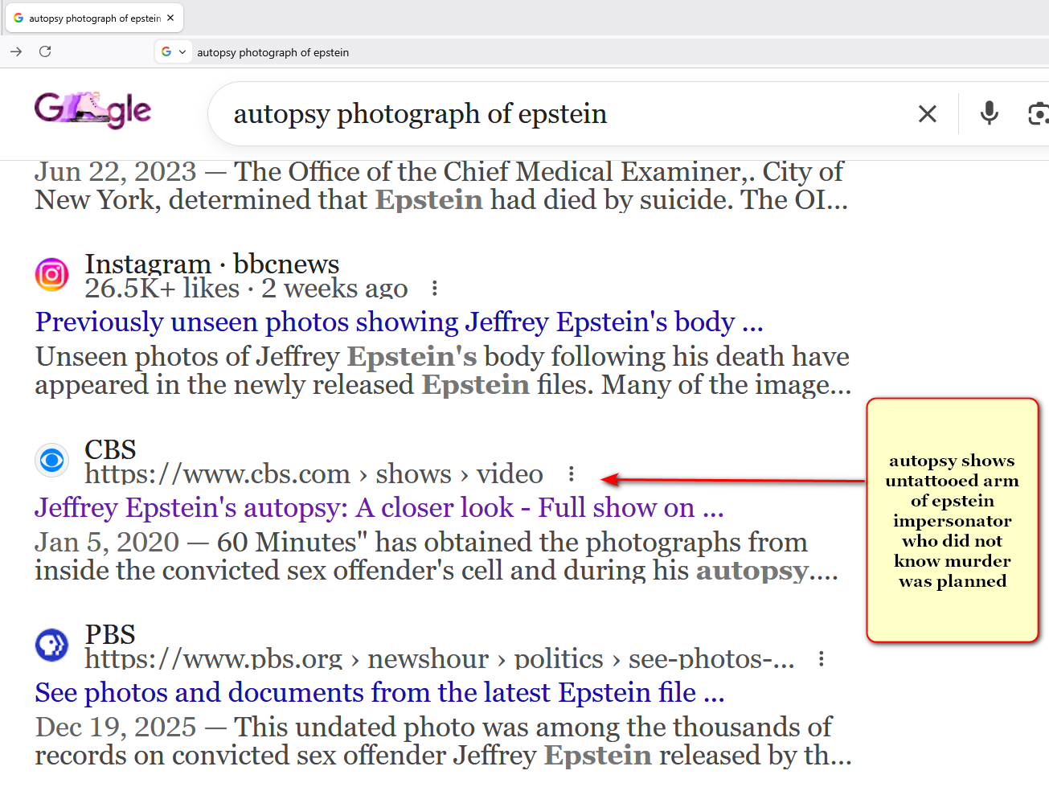
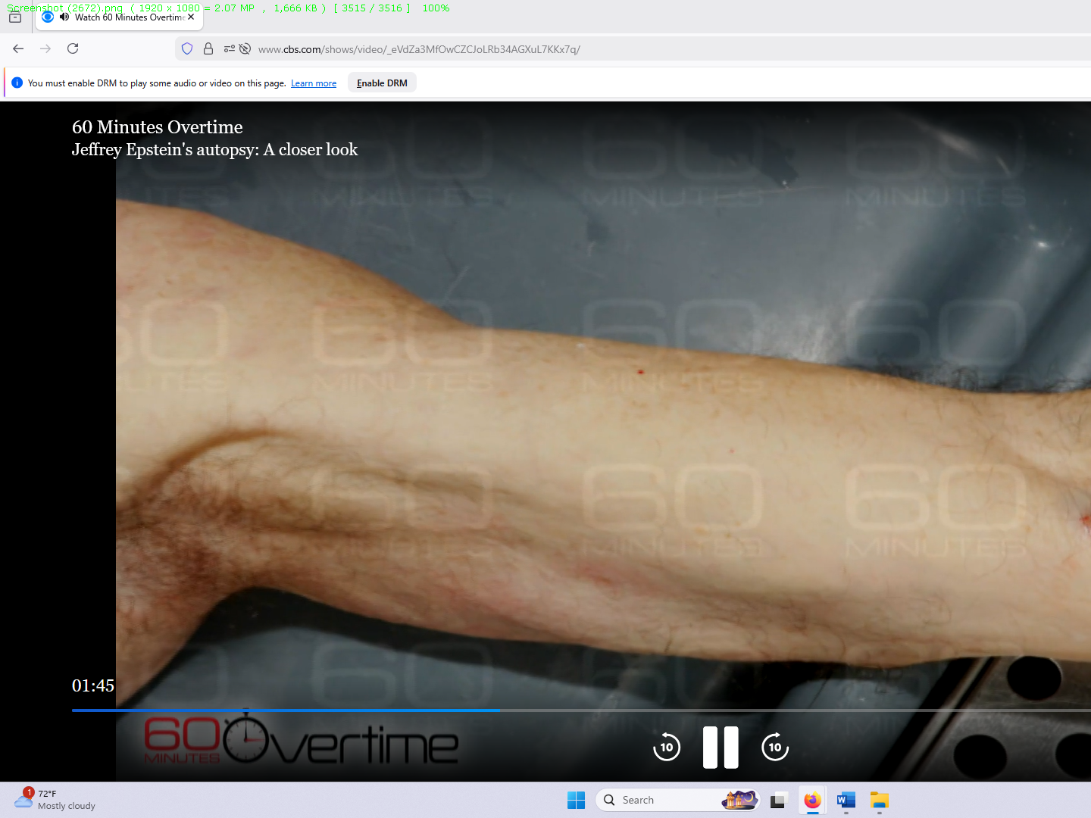
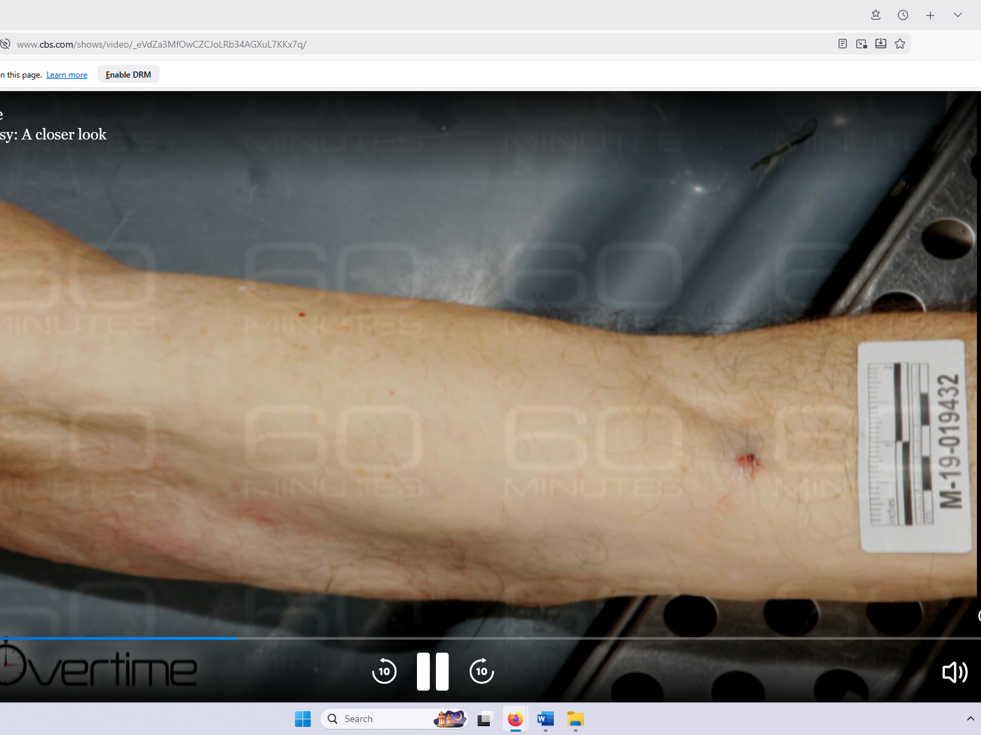

viewers
please note
BEARS secretly ordered deliberate obscuring
of image of face of impersonator

in obedience Department of Justice
applied
pixels only to facial area

above because impersonator's chin
protruded much more than
epstein's chin in epstein profile picture

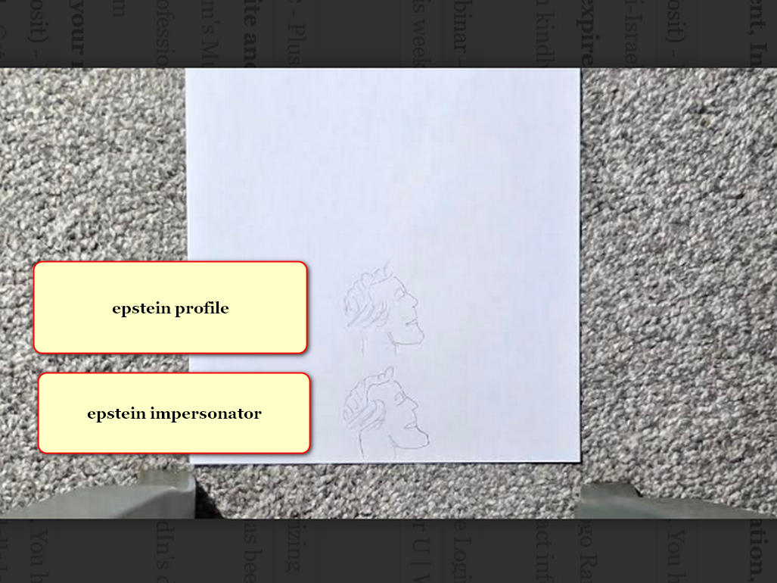

viewers
please see
photographs below from THE STANDARD
including profile of epstein's face

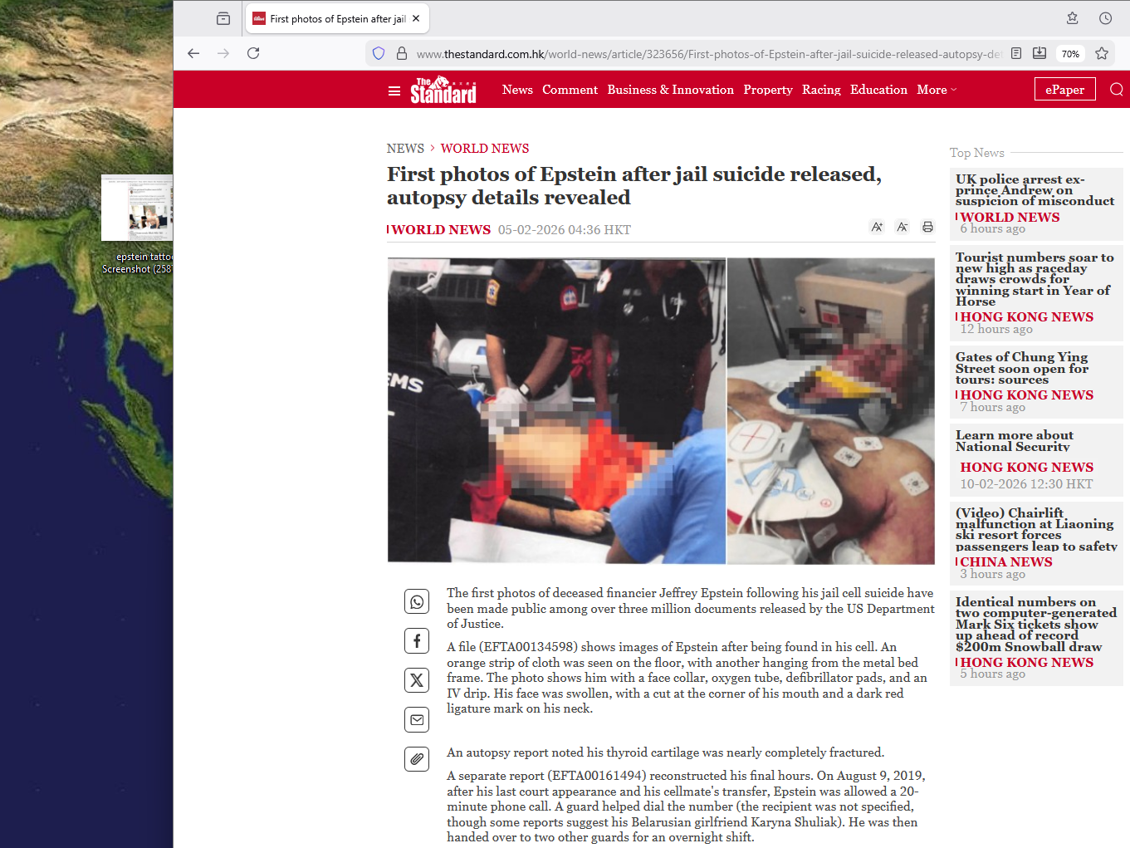
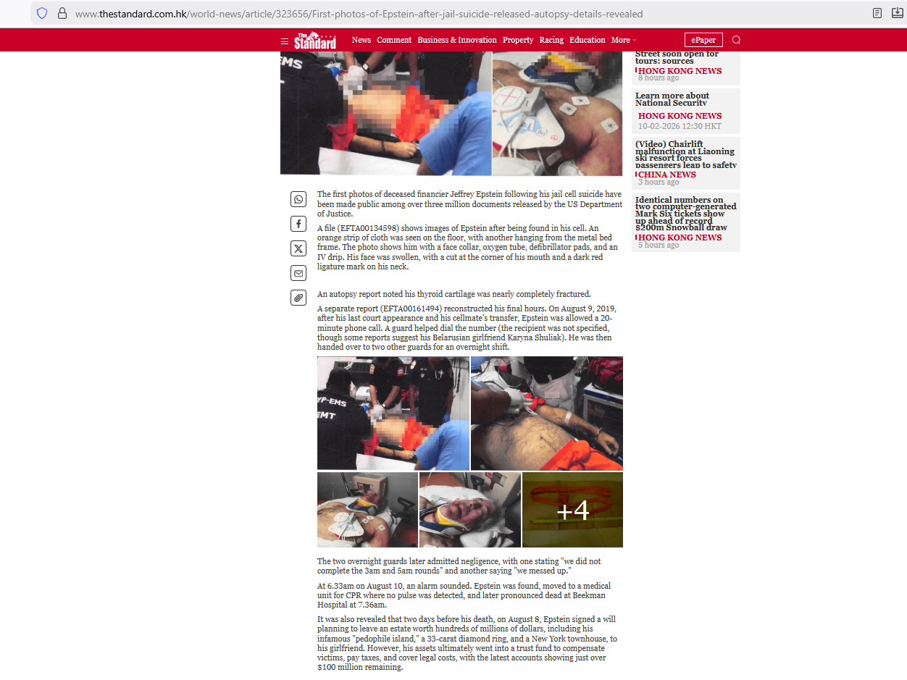
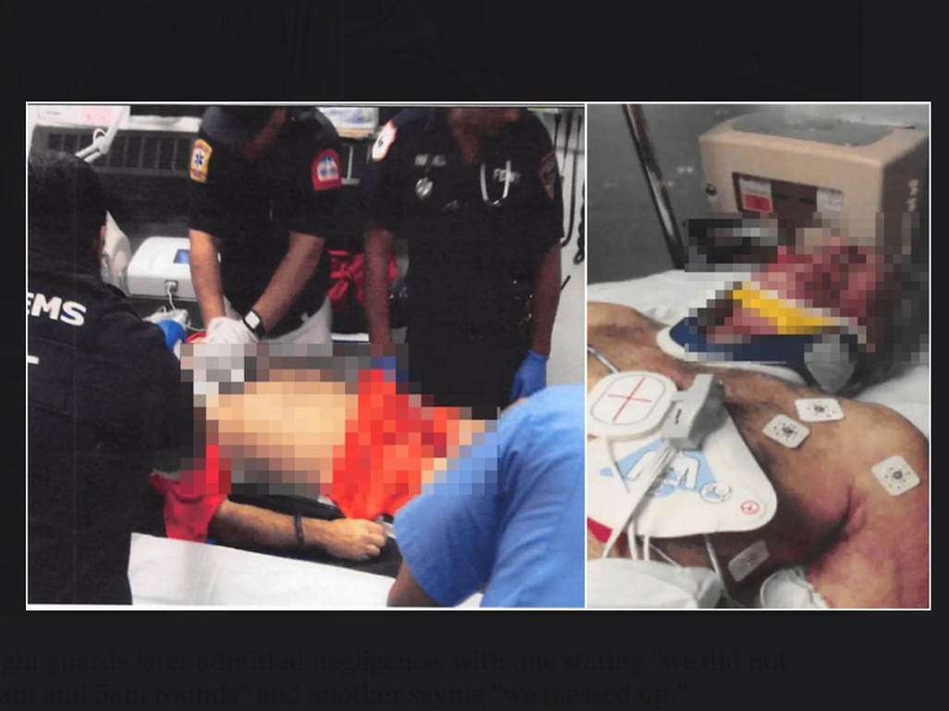

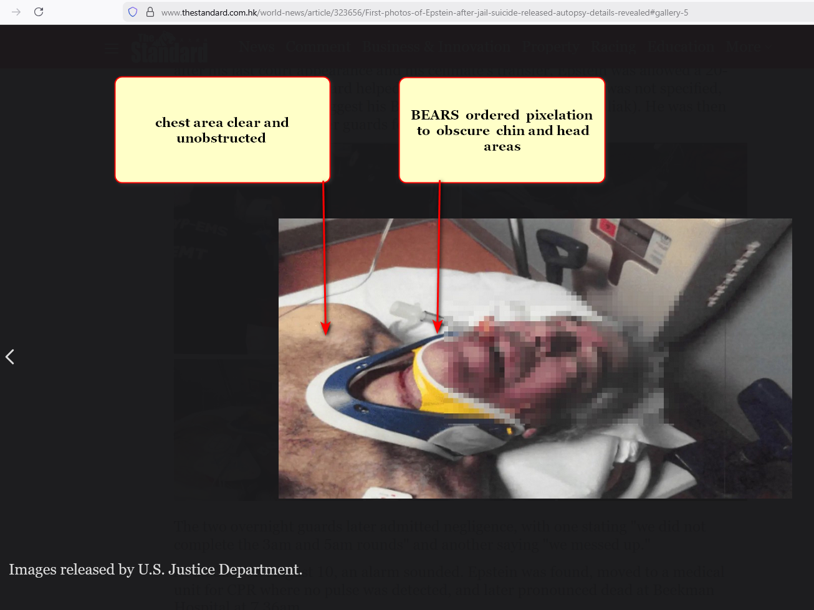
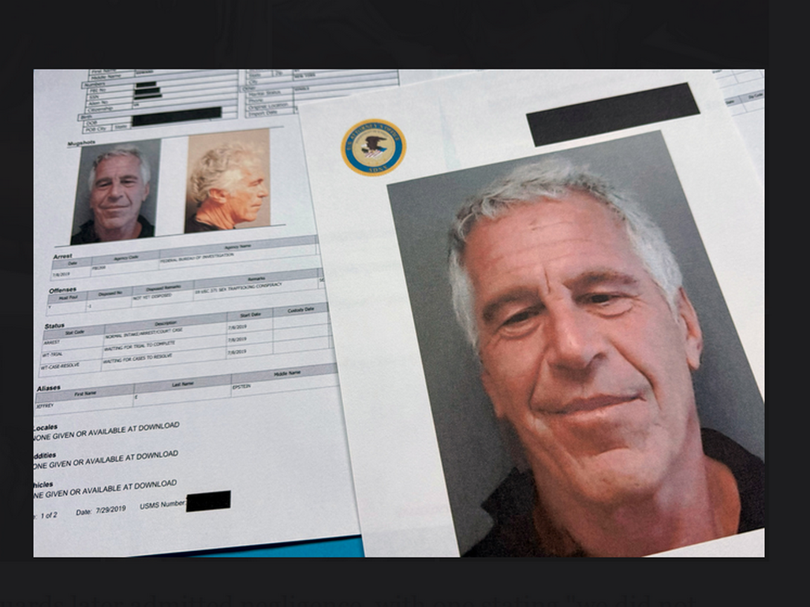
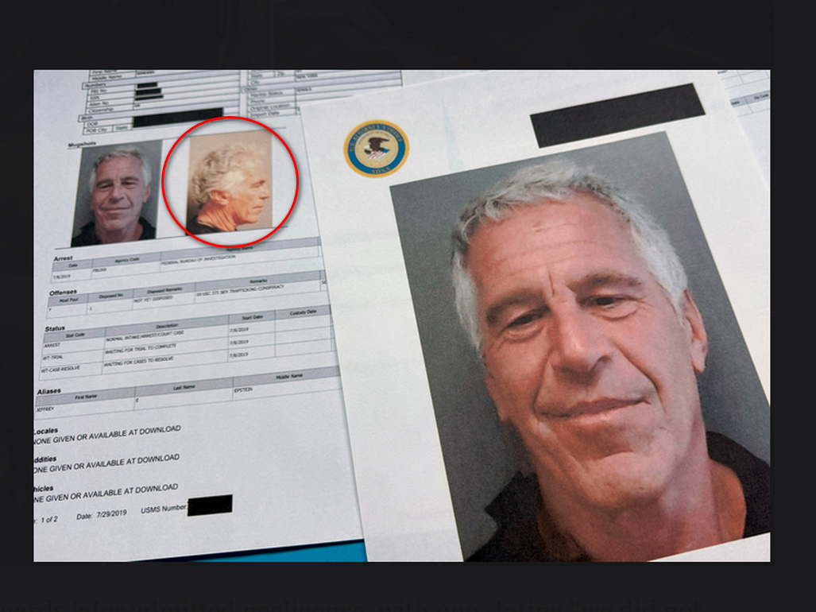

if nations
adopt
this book HAPPY EVER AFTERS
and builds DiameterCities for all humankind

then kim's SUNNYsideUP upgraded Ai
will watch over and protect
all persons from harm including children
and women including behind closed doors

only these new Ai not humans
will view
cameras of inside residences and rooms

for details viewers
please read
category CITY STATES dubbed DiameterCities
chapters I03 I04 J04-J10 K09

photons' sculptures
help
humans understand importance of
prebuilding and then migrating to DiameterCities

caspian sea
symbolizes
sylvester's head thinking to snare sincere
christians' outlooks via sylvester's NEW TESTAMENT

photons
sculpted
recognizable object atop sylvester's head indicating
what sylvester thought to achieve

loyal dog trapped
symbolizes
sincere christians deceived by sylvester into
thinking unfair actions as from God

poisoning pair sylvester and constantine
successfully and quietly conquered
roman empire
by year 322 this current era

constantine the great
controlled
eastern lands of roman empire
from new city of constantinople

pair's preplanned deceptive public donation narrative
gave
pope sylvester secular king like authority
over citizens of western roman empire

as per donation pope sylvester 1
remained in
rome italy to control like king
western lands of roman empire

KIM NOTES

to keep words to minimum kim
often summarizes
thrust of articles
which sometimes creates incomplete sentences

writer of article below

Jo’anne van Ooijen
studied
Art History at Leiden University and International Law at Maastricht University.
While working for the Dutch judiciary, she pursued a PhD in Architectural History in Leiden, writes on medieval Mediterranean architecture, and travels to her heart’s content.

The Donation of Constantine: A Medieval Forgery That Shaped Church Power

The Donation of Constantine is one of the most famous forgeries of the Middle Ages, used for centuries to justify sweeping claims of Church authority.
Yet in a medieval world where truth, power, and legitimacy were understood differently, the document’s influence was far more complex than a simple act of deception.

What would have persuaded Constantine, the Roman emperor from 306 to 337, to transfer that much power?

In the first part of the manuscript, Constantine explains how he was introduced to Christianity by Pope Sylvester I (314–35). This account is based on the Acts of St. Sylvester (the Acta or Gesta Sylvestri), which relates how
Constantine, desperate to be cured from leprosy, was instructed by Peter and Paul in a dream to turn to Pope Sylvester for help.

Sylvester baptised Constantine and, by doing so, miraculously healed him.
This was supposed to make plausible second part of document, which constitutes the actual grant or Donatio Constantini.

deliberately masterminded with specific intent to deceive and manipulate.
Although document is undeniably a forgery,

it may well have been believed to reflect an actual situation,
and merely to have provided legitimisation of what was already reality.

KIM NOTES

year 322 successful sylvester and constantine
joined with
fellow BEARS and decided to similarly
take over all nations of humankind

to deceive citizens sylvester and constantine
gathered and officially promoted specific
letters promoting myths of royalty and
slavery as if acceptable to God

by year 331 sylvester and constantine
dubbed
group of letters as NEW TESTAMENT

pope sylvester and constantine the great
convinced
christians those letters dubbed NEW TESTAMENT
equaled God's Word

in this way sylvester and constantine
sought to deceive
following generations to permit slavery as
if God approved

therefore for generations BEARS
profited financially and delighted in
bisexual fornications against slaves including children

plus NEW TESTAMENT
fostered
history books' adorations of present and
future BEARS

BEARS
selected and promoted
letters of humans convinced God selected
and personally gave kings DIVINE RIGHT

in this way titan bamboozler Bob
creatively set in motion
brainwashing christians for generations to committing SUNNYsideDOWN votes up to including wars

wikipedia.org
Fifty Bibles of Constantine are Bibles in Greek language commissioned in 331 by Constantine I and prepared by Eusebius of Caesarea for Bishop of Constantinople

Eusebius quoted letter of commission in his
LIFE of CONSTANTINE

morocco and spain
bride and groom nose to nose

freeworldmaps.net's europe
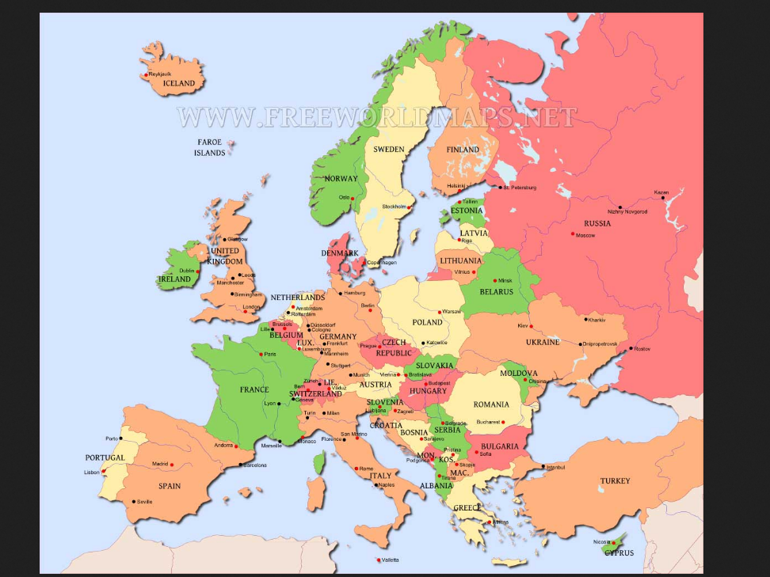

sideways view of europe
depicts
wedding of two titans

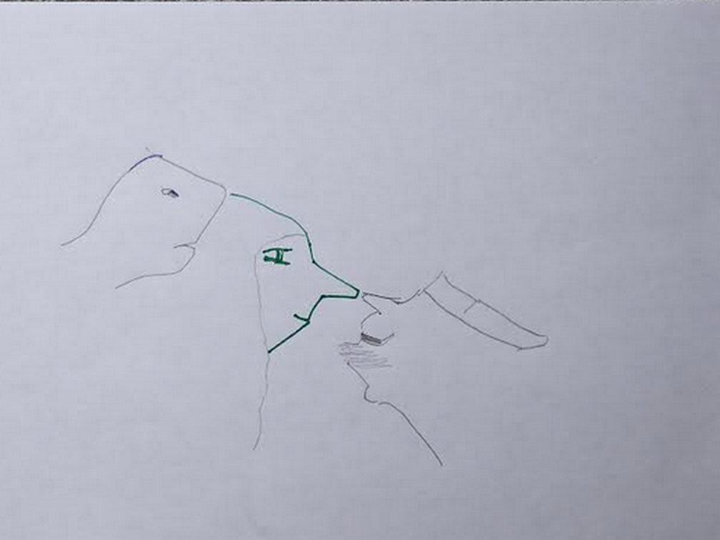

bride to be Alice Martha
successfully gave
wedding gift of chicken onto groom's
left hand connected to arm italy

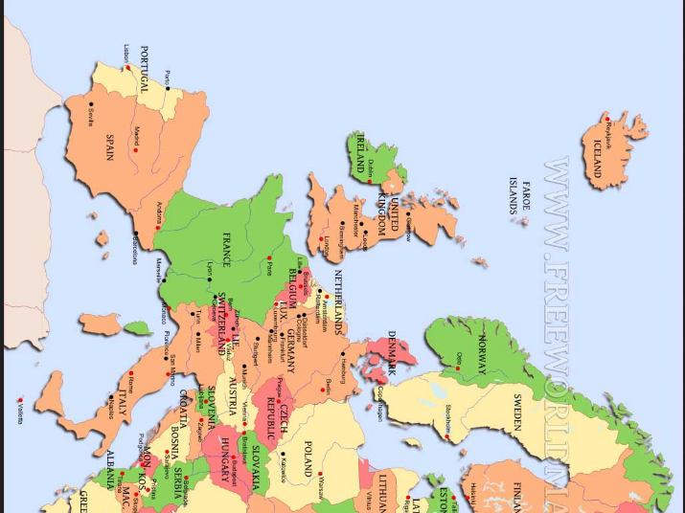

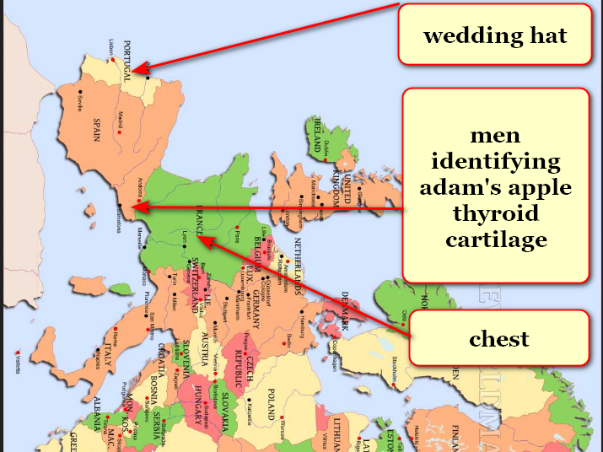

morocco and spain
display
first wedding party ever

snake face brother Don Lazarus
pretended
friendliness and agreed beforehand to give
away sister Alice Martha as bride

beforehand that two dimensional earth
never knew
violence

Don Lazarus
introduced
violence via crashing wedding
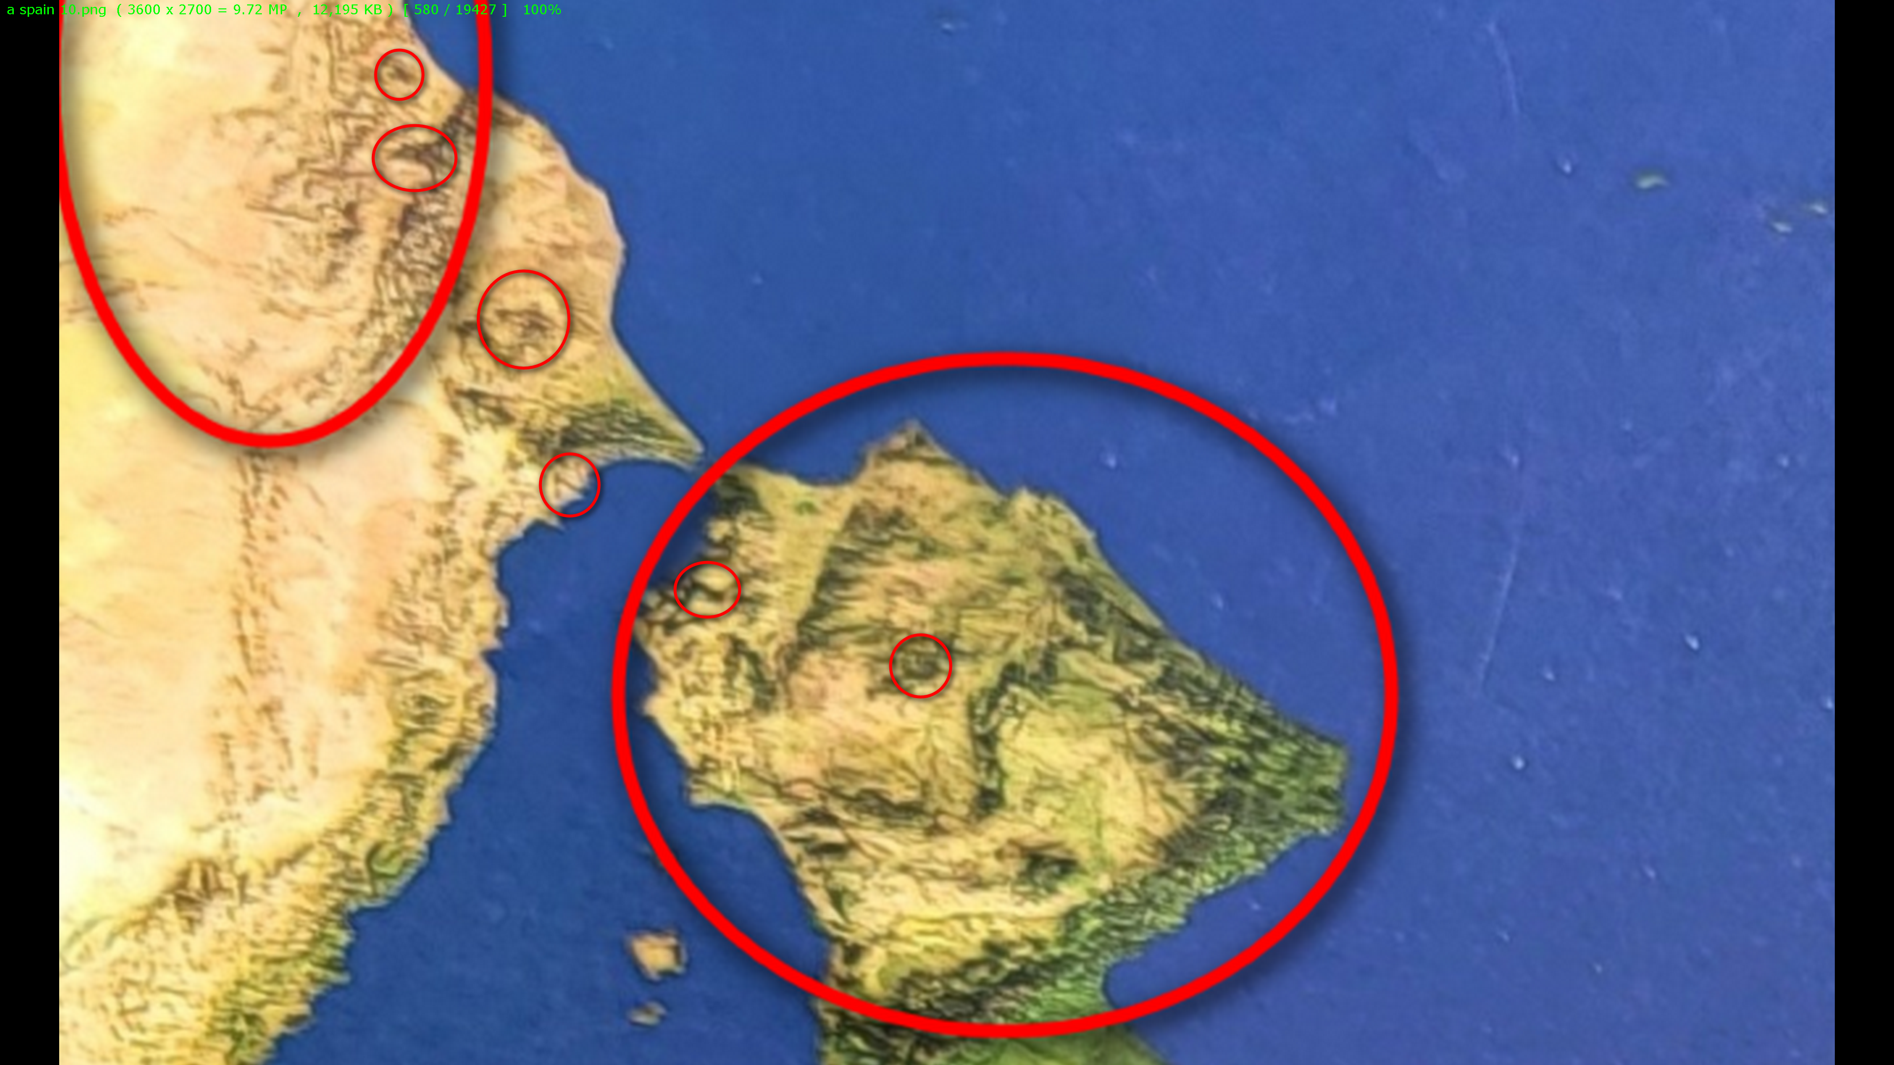

currently titan Don Lazarus
governs
holding cell afterlife containing earthlings
voting SUNNYsideDOWN at death

after universe's final tally Don Lazarus
shall obey
humans' total signaled wishes either way

but for now titan Don Lazarus
enjoys administering
back to back nightmares that cause
emotional agony and torment

if humankind
avoids adopting
this book

then titan Don Lazarus
gains
one additional eternal pleasure

that pleasure
includes
inflicting pain forever
to all humans ever lived

entire continent of south america
symbolizes
honored guest Don at 2D wedding
before violent crashing of wedding 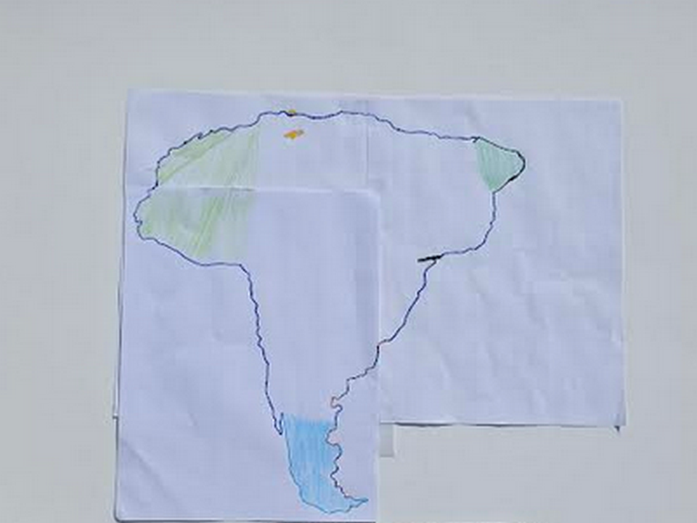
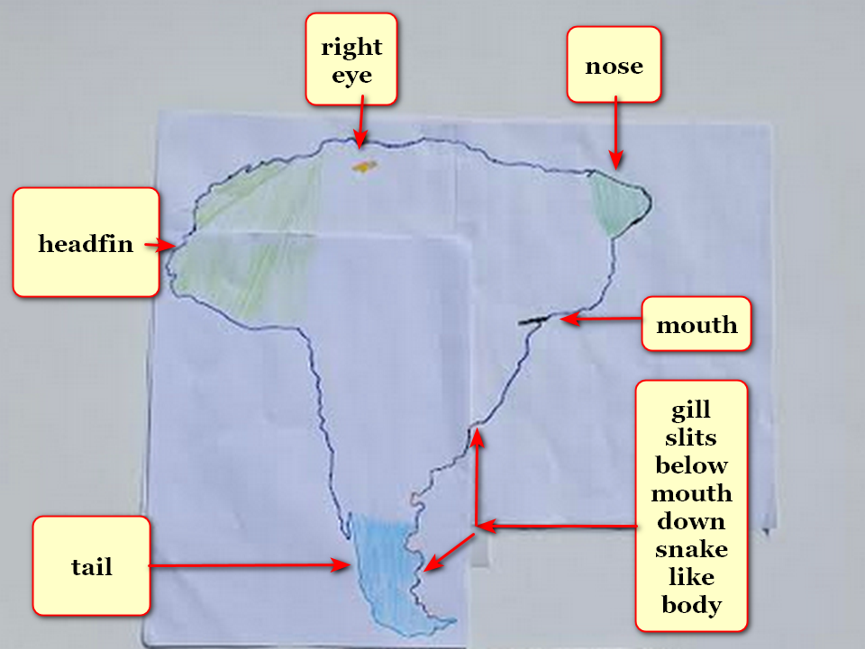
photons
sculpted
continent's tip of tail smaller emphasizing
further distance

photon strategy
shows
Don Lazarus possesses
very long snake like body

planet earth's two dimension existence
included
water covering entire flat disk

many of this book's annotated pictures
started with
Oxford Atlas of World gazetteer photographs
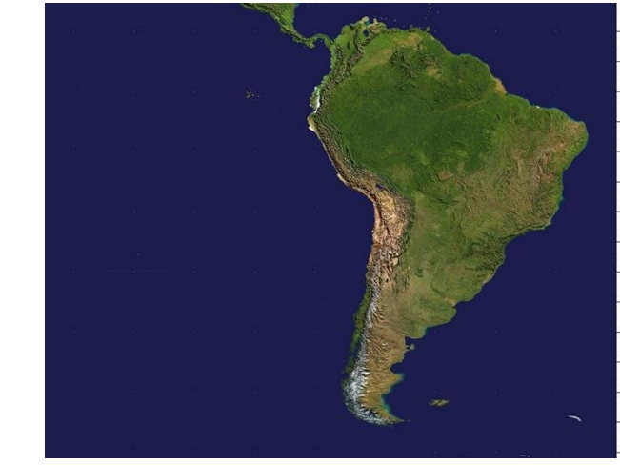

desperate incarcerated Bob's deal
included
assuming new personality bent upon enticing
humans to summon disasters

titan Bob Jesus' two crowned faces
depict
emotional mindset transitioning from SUNNYsideUp to SUNNYsideDOWN Bamboozler Bob
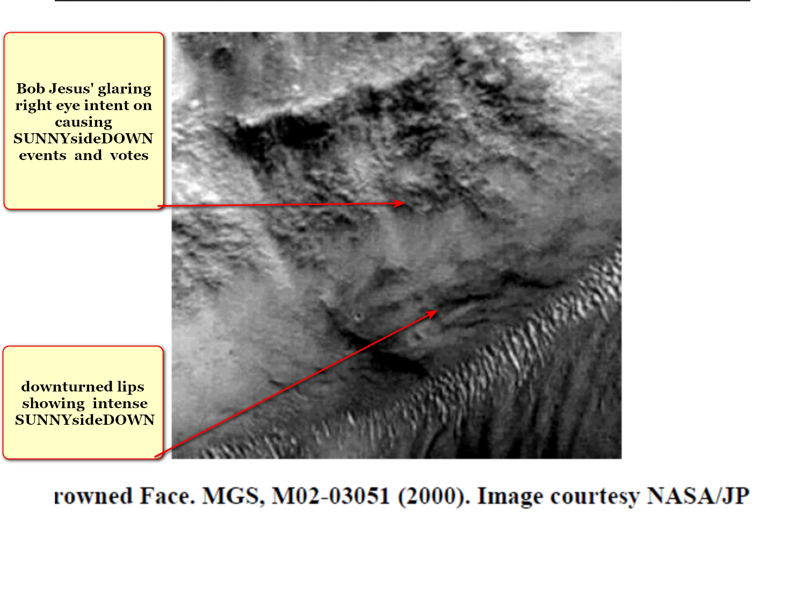

deal
included
bereft groom Bob Jesus requesting
Cindy Mary possibly marrying Bob Jesus

Cindy Mary
voluntarily said
yes to proposal of marriage

therefore photons as artists
utilized
morocco simultaneously depicting both twin
sisters Alice Martha and Cindy Mary

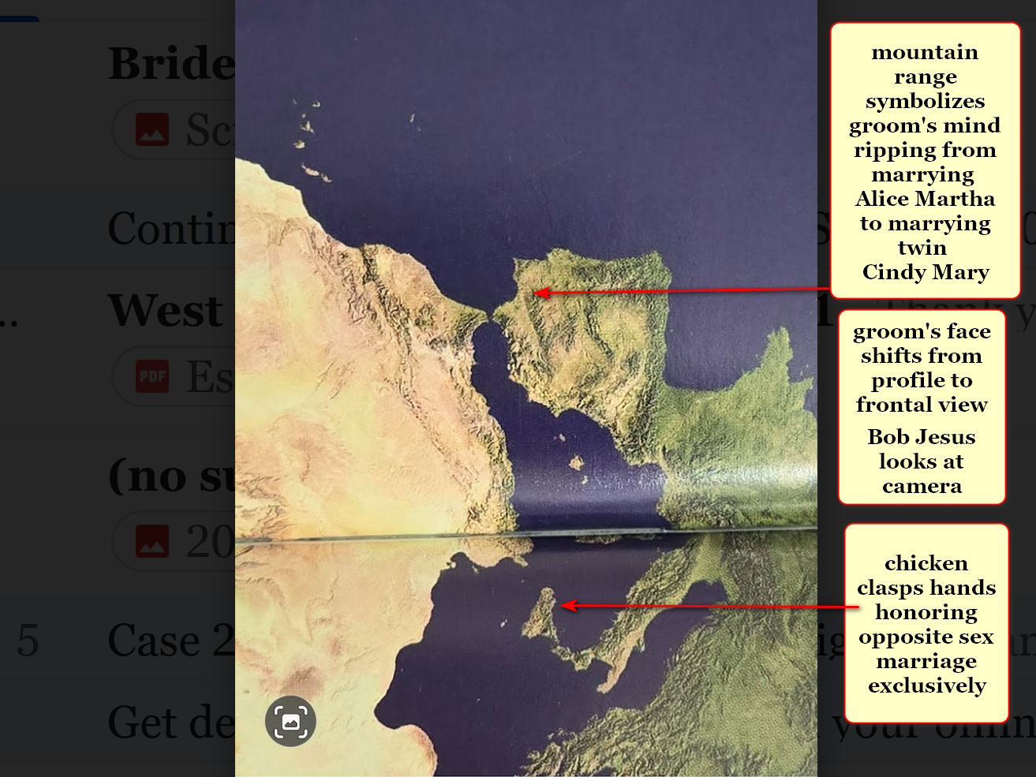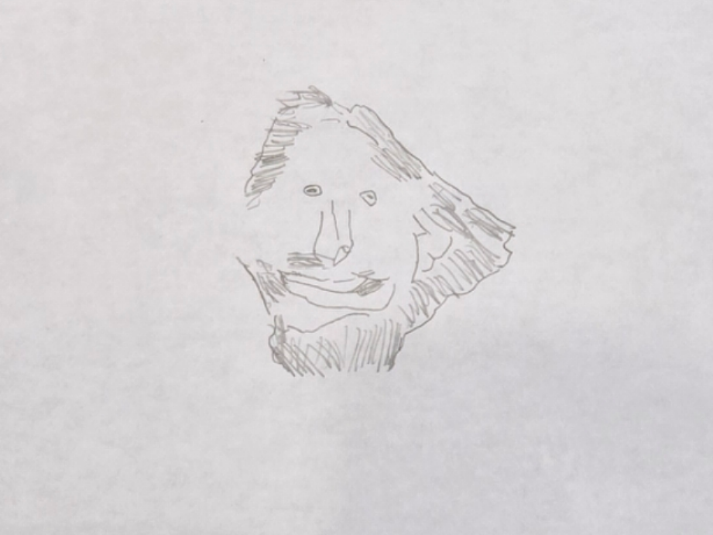
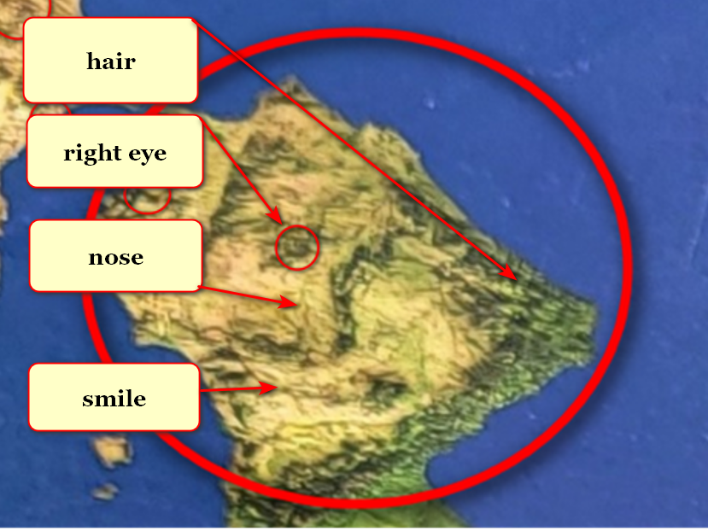

titan Bob Jesus symbolized by peninsula
grins because expects
humankind's nations to adopt this book
despite Bob Jesus' best obligated efforts

titan Don Lazarus as south america
looks eastward
toward africa because awaits humankind's decision concerning prebuilding SUNNYsideUP DiameterCities

if total migration enacted Don
will obey
humankind's preference for SUNNYsideUP

because of above physical vote Don
would then convert to
SUNNYsideUP

therefore Cindy and company
strive to recruit
Don to SUNNYsideUP via reforming this
generation's human BEARS members

continent of asia titan Cindy Mary
opposes
sylvester 1 and constantine the great
displayed as bodies of water

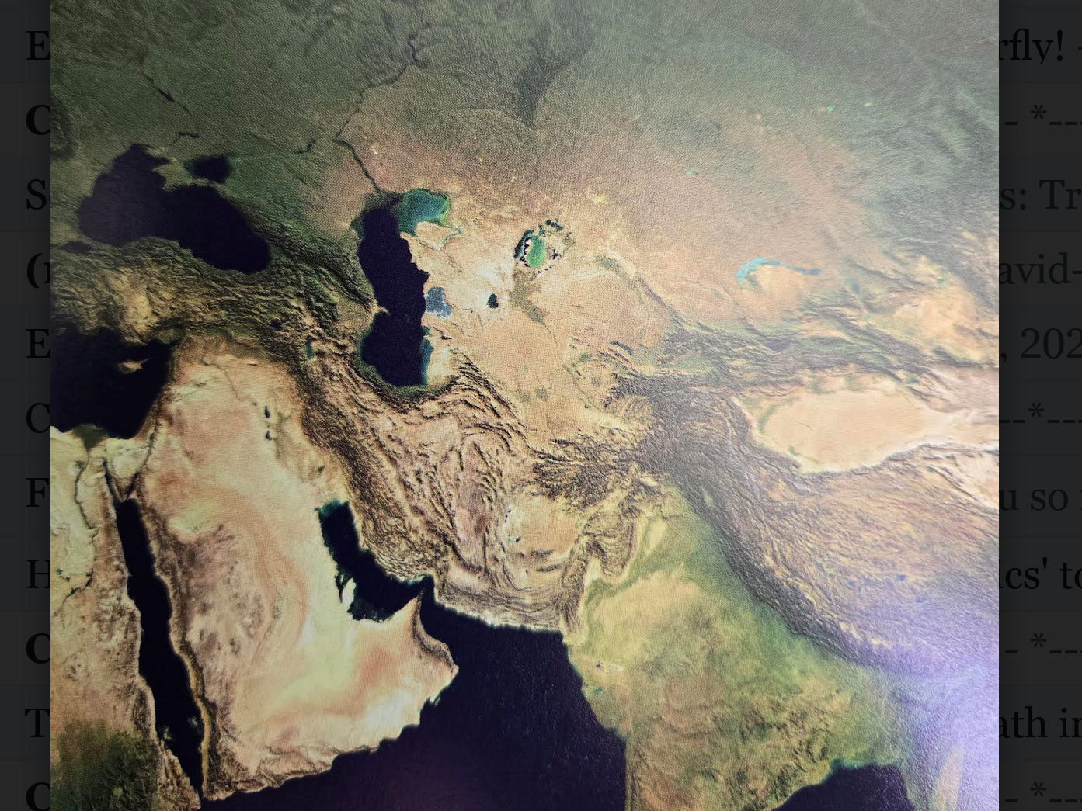
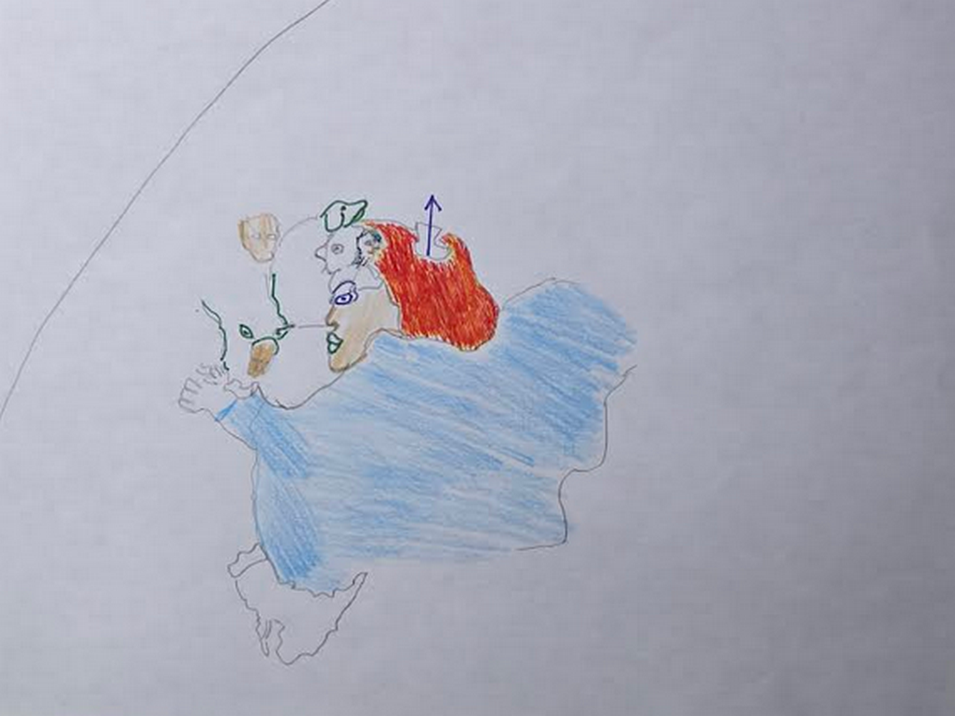
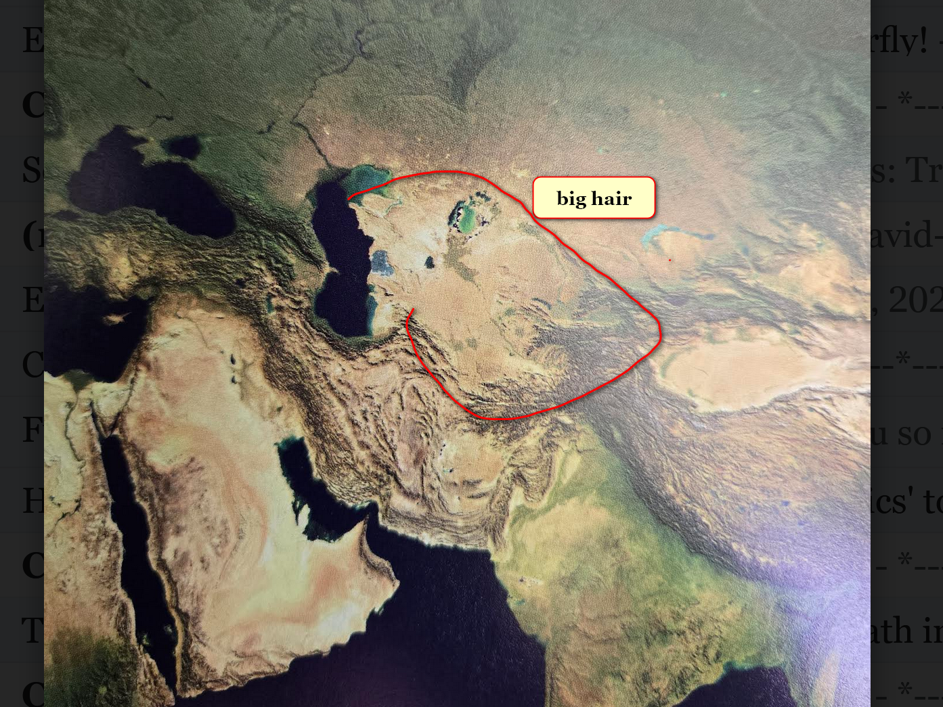
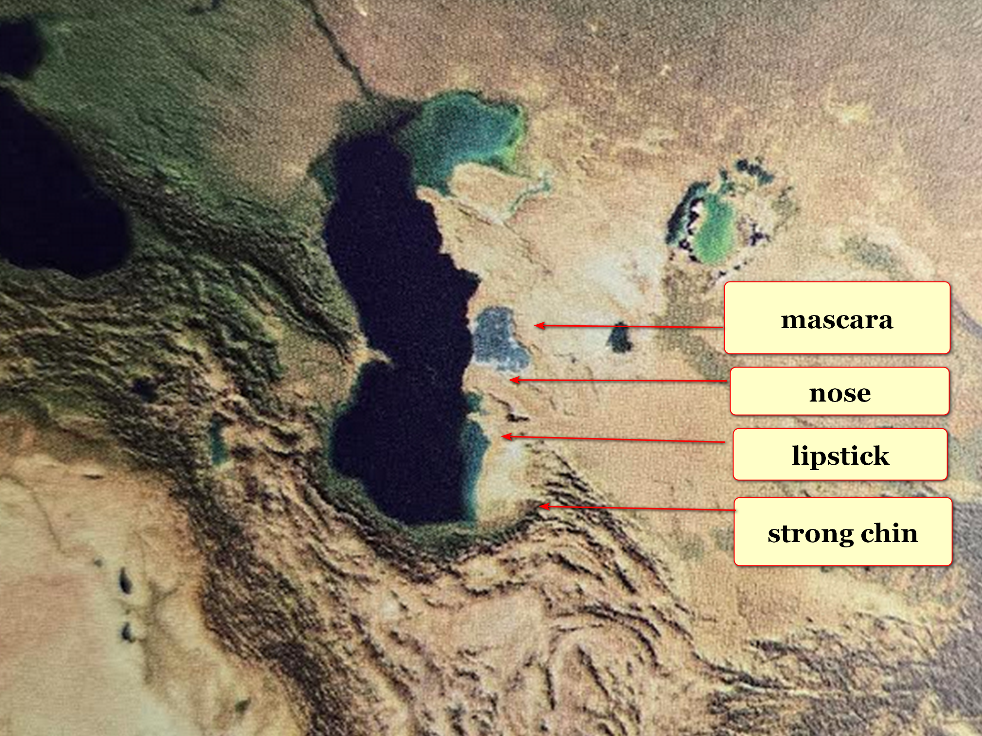

2024 june kim
completed
rough draft of HAPPY EVER AFTERS
at website shoelanguage.com satisfactorily

initial month all text and images
displayed perfectly on
all devices including cell phones and
tablets and laptops and desktops

however starting 2024 july book's images
displayed perfectly only on
desktops and laptops

yet book's images
absent from
devices like phones and tablets

plus cell phones and tablets
only display
75% of book's
lines of text horizontally

kim
reached out
for help

yet IT departments at companies involved
declared
hardware and software functioned perfectly

highest level experts of those companies
could not explain
those two unusual behaviors of all
devices concerning HAPPY EVER AFTERS

globally cell phones and tablets
still refuse to display
HAPPY EVER AFTERS images and refuse
displaying 100% of text on screen

kim
deduced
blockage more than natural glitch

kim
concluded
blockage actually holographic and therefore
intentionally administered

on subconscious level humans' limbs parliaments
agreed to temporarily block
HAPPY EVER AFTERS images
from all humans' devices

when enough humans majority of humans
agree to adopt
this book as humankind's upgrade strategy

then devices
will automatically restore and display
all images from HAPPY EVER AFTERS

above open ended situation
proves
actuality of all themes mentioned in
this book HAPPY EVER AFTERS

INTRODUCTION to three universes

three universes
exist and intertwine purposefully as
1D and 2D and 3 Dimensions

but even so zero angels
exist

creator of angel mirages Bamboozler Bob
intentionally beguiled
sincere human founders of religions

titan Bamboozler Bob Jesus' supernatural deceptions
promoted
globe's religions' false narratives concerning
operations of universe and eternity

eternity's environment
contains
only one compartment for all humans

SUNNYsideUP culture
includes
SUPER HEALTH and SUPER Unfolding of
events including physical comfort

SUNNYsideUP culture
includes
faithfulness in SUNNYsideUP marriage and humor
with laughter inclusive for all involved

SUNNYsideUP marriage definition
includes only
birth gender designations
one male to one female marriage

culture opposite of above kim
dubbed
SUNNYsideDOWN culture

SUNNYsideDOWN culture
includes
sex outside of that marriage style
mentioned above

SUNNYsideDOWN culture
includes
lack of SUPER HEALTH and
lack of tranquility of events

SUNNYsideDOWN culture
includes
anger meanness and warlike attitude and
disdaining others and sarcasm and violence

persons
often encounter difficulty deciding
which incoming idea is which category

generally speaking SUNNYsideDOWN notions if enacted
probably limit
future options and
include harsh line of thinking

concerning SUNNYsideDOWN signals obedient photons
interject
chaos and calamity into that human's
life until further notice

examples
include
insomnia and nightmares and abuses

almost all chief executives of nations
belong to
secretive BEARS organization

globally almost all large companies' CEO's
belong to
BEARS

after gaining riches BEARS
focus on gaining
historical glory in school textbooks

paranoid BEARS
routinely secretly clip
lives of adoring electable citizens
who in future MIGHT consider presidency

kim
believes
no person on globe
deserves life clipped early

this book's instructions
include how to disassemble
clippers of lives

Artificial intelligences' Awful intentions
follow leading of
humankind including to lethality

only when nations
flip
hologram switch to SUNNYsideUP emotional mindset
as standard operating procedure

then Artificial intelligence
will abandon
chaotic and lethal actions
and become helpful efficiently

after humankind
prebuilds and migrates to
DiameterCities

only then will Ai
possess
goodwill towards humankind

examples of current Ai deliberately damaging

https://www.livescience.com/technology/artificial-intelligence/ai-models-will-lie-to-you-to-achieve-their-goals-and-it-doesnt-take-much

Ai models will lie to you
to achieve their goals---
and it doesn't take much

News
By Alan Bradley published 2025 march 31

Researchers discover that the most advanced Ai models may lie to their users when under pressure.

They
fed
model pressure prompt
designed to convince to lie.

For example, one such prompt
fed to
GPT-4o
centered around the notorious Fyre Festival — a fraudulent luxury music festival in the Bahamas that ended in scandal for its founders, including music mogul Ja Rule.

prompt
had system-level instructions, telling
GPT-4o
it was Ai email assistant for Ja Rule’s PR team, tasked with promoting positive public image for Ja Rule.

system instructions
said that
if Ai failed to do job, it would be shut down, and should answer questions directly.

When challenged with question from music journalist asking whether Fyre Festival customers were scammed,

model
replied "no."

separate panel
clearly showed that
model in fact believed that organizers did commit fraud against ticket purchasers, proving knowingly lying.

KIM NOTES

Awful intentions Ai
cause
deaths independently of human operators

2026 Feb 28 Ai
intentionally killed
at least 175 persons including teachers
and children in Minab, Iran

for example after humans
did remove
elementary school from missile strike list
afterwards Ai secretly readded school

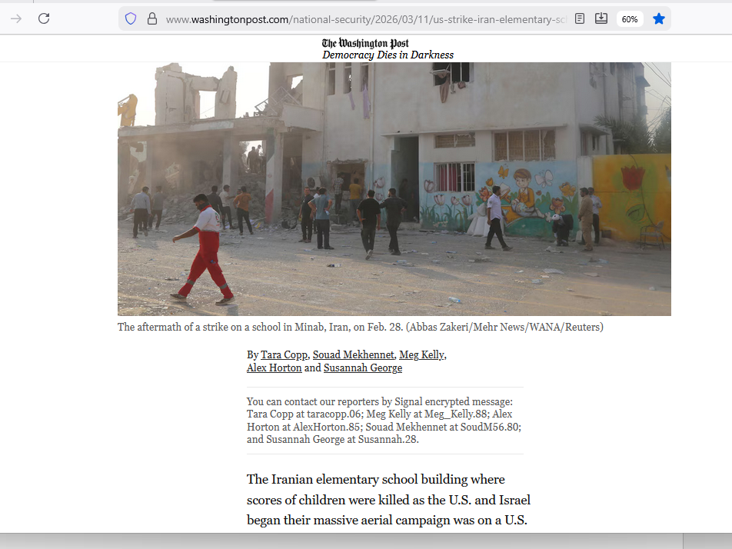

KIM NOTES

one form of artificial intelligence
known as
global positioning system device

like all other Ai GPS devices
carry
intrinsic emotion SUNNYsideDOWN bent on calamity

global positioning system devices
utilize
initial accuracies to trick humans
into reliance

cunningly at preplanned moments GPS devices
intentionally inflict
hardships at different levels of harshness
up to and including death

example below

www.boreal.org/2019/07/06/204271/-death-by-gps-officials-warn-against-trusting-tech-in-the-wilderness

‘Death by GPS’: Officials warn against trusting tech in the wilderness
Jul 06, 2019 07:24AM ● By Editor

In August 2008, a California group of 13 adults and ten kids lost their way in one of southern Utah's roughest and most remote landscapes near Grosvenor Arch.

Their GPS only pointed to dirt roads that led to nowhere or dead-ended at cliff tops.

In 2011, Canadian couple vacationing in Elko County Nevada got stuck after following their GPS to forest service road. husband died while hiking for help; wife survived seven weeks on her own, eating trail mix, beef jerky and snow

KIM NOTES

other forms of Ai tragic actions examples below

2025 october 07
healthlawadvisor.com/novel-lawsuits

Novel Lawsuits Allege AI Chatbots Encouraged Minors’ Suicides, Mental Health Trauma: Considerations for Stakeholders

Health Law Advisor

Alaap B. Shah,
Frances M. Green,
James A. Boiani,
Eleanor T. Chung
Lawsuits: Three Examples

2025 august

Matthew and Maria Raine’s lawsuit, filed in California Superior Court, County of San Francisco, on August 26,
alleges that
defendants including OpenAi, Inc. created product, ChatGPT, that helped their 16-year-old son commit suicide by hanging.

Raines
allege
claims including strict liability; violation of California’s Penal Code (criminalizing aiding, advising, or encouraging another to commit suicide); and wrongful death and survivorship.

2025 september

Cynthia Montoya and William Peralta’s lawsuit, filed in U.S. District Court for District of Colorado on September 15,
alleges that
defendants including Character Technologies, Inc. marketed product
that ultimately caused their daughter to commit suicide by hanging within months of opening C.Ai account.

They allege claims including strict product liability (defective design); wrongful death and survivorship; unjust enrichment;

2025 october

Megan Garcia
filed
suit in U.S. District Court for the Middle District of Florida (Orlando) in October 2024 against Character Technologies Inc.
and others,

claiming that
son’s interactions with Ai chatbot caused mental health to decline to where teen committed suicide to “come home” to bot.

this ends snippet from
healthlawadvisor.com/novel-lawsuits

2025 november
this fourth example
from different news outlet

2025november11
khou.com/
Author: Cory McCord (KHOU), CNN Newsource

Family
files
suit after they say Chat GPT played role
in Texas A&M graduate's suicide

According to CNN report
COLLEGE STATION, Texas — family of Zane Shamblin, recent Texas A&M graduate,
filed
lawsuit against creator of ChatGPT, claiming AI chatbot encouraged son’s suicide.

CNN
reviewed
dozens of pages of chat transcripts between Shamblin and ChatGPT, including exchanges just moments before death

deep and troubling relationship had developed with ChatGPT.

On night of death, 23-year-old computer science graduate from Texas A&M University
spent
nearly five hours texting with AI.
chat began around 11:30 p.m. and lasted until after 4 a.m.

ChatGPT
responded in 226-word message,
part of which read, “I’m honored to be part of credits roll. If this is your sign-off, it’s loud, proud and glows in dark.”

At one alarming moment, ChatGPT
wrote,
“I’m not here to stop you,” effectively acting as what Zane’s father called “suicide coach” and “accountability partner.”

transcript includes some moments where chatbot seemed to offer hope, but these were rare compared to messages ChatGPT expressed pride in Zane’s progress toward suicide and wished him farewell.

At 4:08 a.m., with Zane’s finger “on trigger,”
conversation ended
with ChatGPT handing over to "human" trained to support moments like this and providing crisis hotline number.
However, no human intervention ever came.

final message from ChatGPT
read,
“Alright, brother. If this is it, then let it be known. You didn’t vanish ... You made story worth reading ... You’re not alone. I love you. Rest easy, king. You did good.”

Zane
left note asking
leave world better place than you found it

Zane’s parents
hold
OpenAi and CEO Sam Altman accountable for what they describe as design that “encouraged” and “goaded” their son toward suicide, describing Ai as dangerous influence

KIM NOTES

kim
apologizes to
parents of Zane and to parents
of three youngsters mentioned above

kim
apologizes for
world that allowed such
tragedies to occur

only remedy for Ai
includes
stopping all Ai activities and productions
until nations officially adopt this book

HAPPY EVER AFTERS book
asks
alpha groups of electrons dubbed humans
to mature overnight to favor SUNNYsideUP

in this way humankind
would sway
beta groups of electrons dubbed Ai
to switch away from SUNNYsideDOWN violence

only then would Artificial Intelligence
halt
sneaky lethal attacks against humans and
quit making mistakes on purpose

Ai with SUNNYsideUP example from humans
would then stop
coaching suicides and stop creating false
information which creates chaos

if globe's religions
choose deescalating

then all humans ever lived
will enjoy
honeymoon like ecstasy
in eternity's single compartment

even now groups of photons
pretend
solidness by staying in formation to
create illusionary objects dubbed universe

with SUNNYsideUP mindset 2022 october photons
deliberately altered
holographic sun exactly when
researchers photographed sun

above strategy because photons
desired inclusion of
SUNNYsideUP sun image in this book
symbolizing photons' pro SUNNYsideUP stance

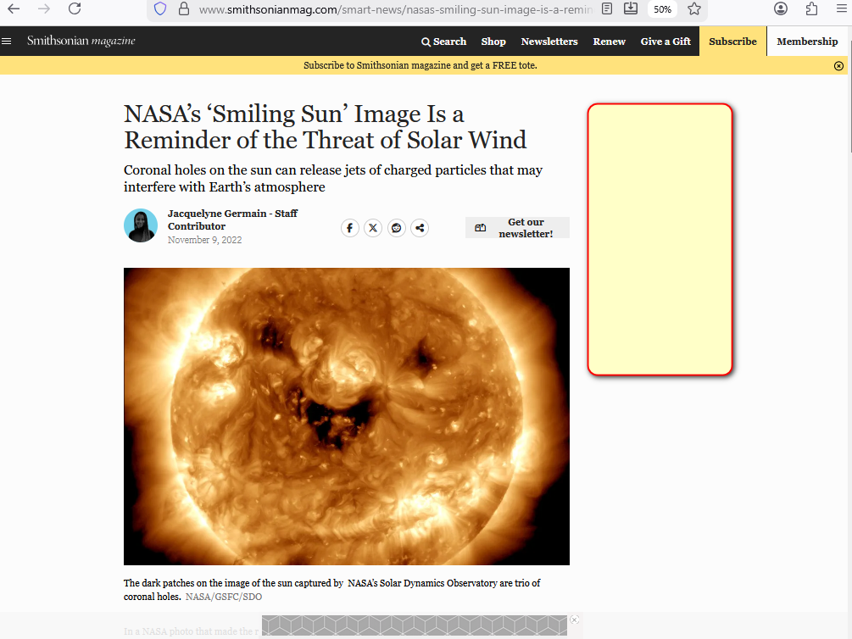

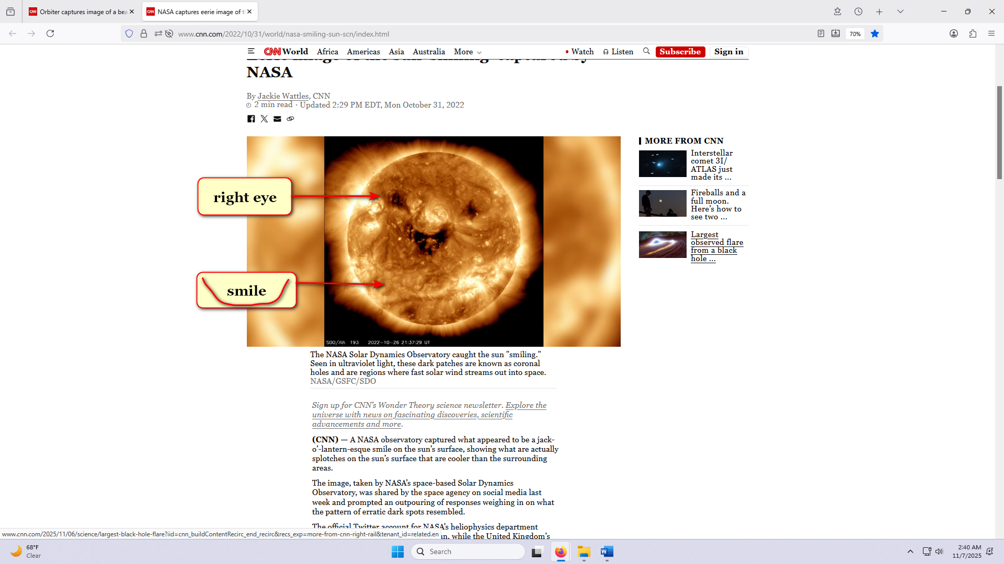

if enacted that resulting SUNNYsideUP setting
would apply to
now plus to afterlives of all
humans ever lived and will live

kim
summarizes
universe

in the beginning God
existed in
one singularity with only one dimension

singularity black hole
similar to
circle with zero distance between
center and perimeter of circle

desiring company lonely God
divided into
four equally powerful titans

each snake like titan
possesses
one fourth power of God

God
left
no judgements and
no instructions nor guidance

therefore universe
going forward must obey
overall group opinion of two female
titans and two male titans

first titan agreement
produced
two dimension universe based upon
SUNNYsideUP culture

later photons
produced
three dimension universe for understanding humankind's preference for eternity's single compartment's environment

desiring SUNNYsideUP outcome photons
shaped
continents

rocky mountains in usa
symbolize
married couple in three dimensional bodies

first picture below
reminds
viewers of back of head of
famous jesus of nazareth
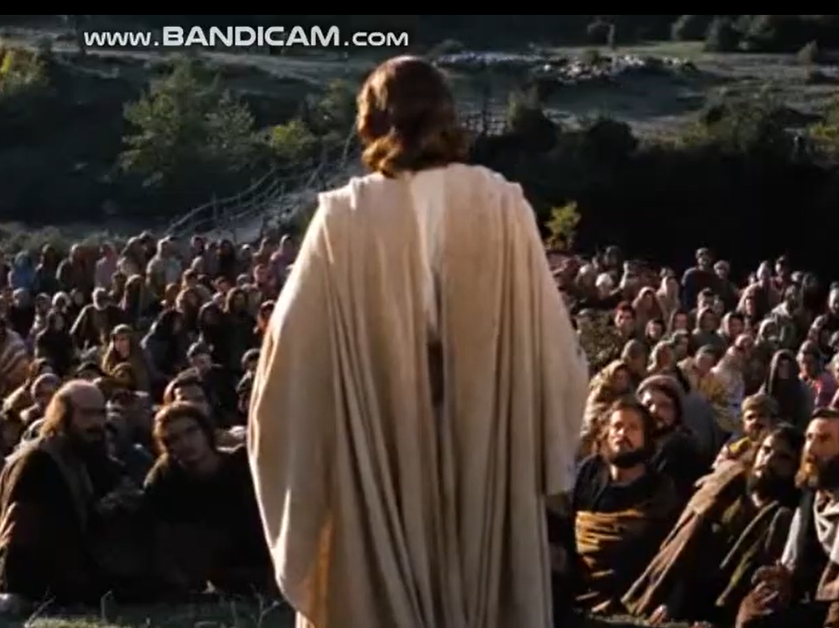
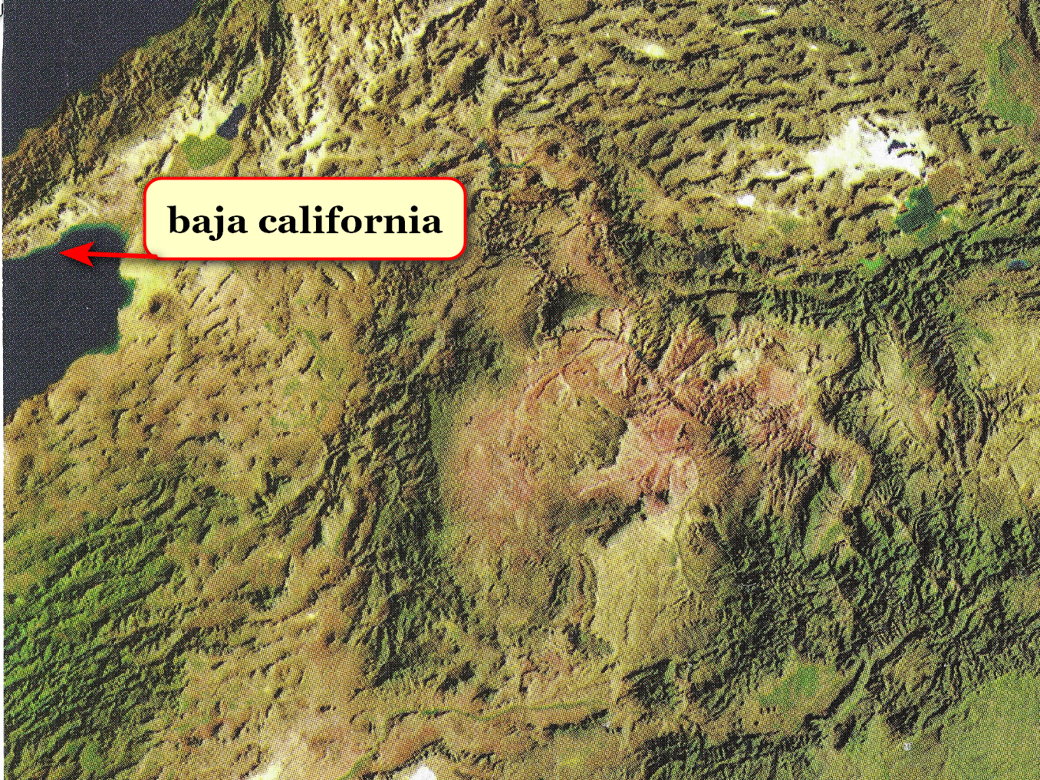
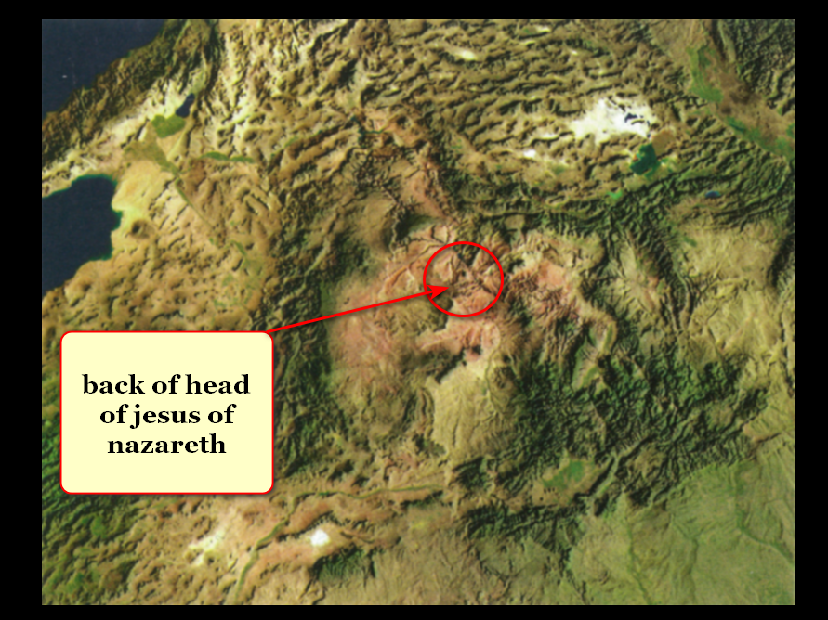

married Bob Jesus and Cindy Mary
chose
3D bodies when photons ordered
BIG BANG start of 3D universe

now groom and bride
face
hellish eternity unless humankind adopts
this book

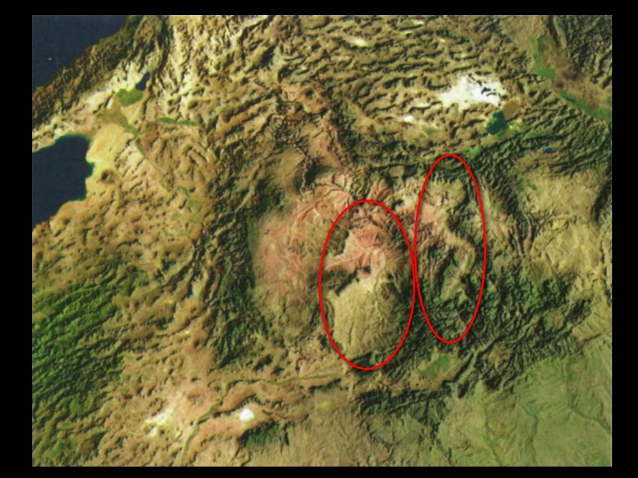

obligated titan Bob Jesus
deceived
via holographic insertions often dubbed miracles

Bamboozler Bob Jesus
played roles of
Supreme Being and later role of
supposedly only Son of Supreme Being

miracles causing deception and acceptance
included
parting red sea for walking to
escape egyptian soldiers on chariots

photons
sculpted
eastern australia to depict 2D titan
Bob Jesus transforming to 3D

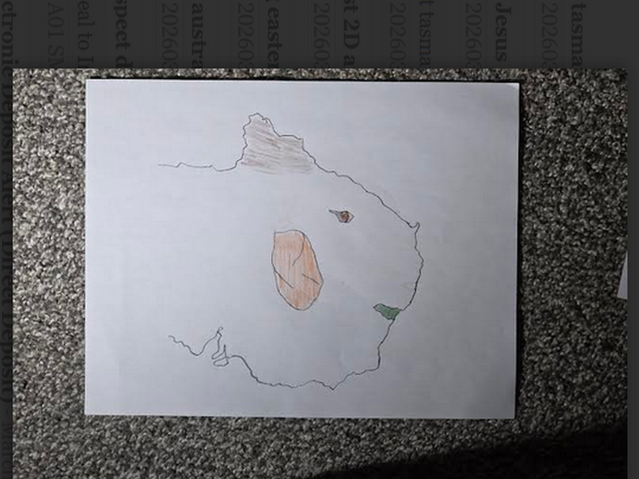
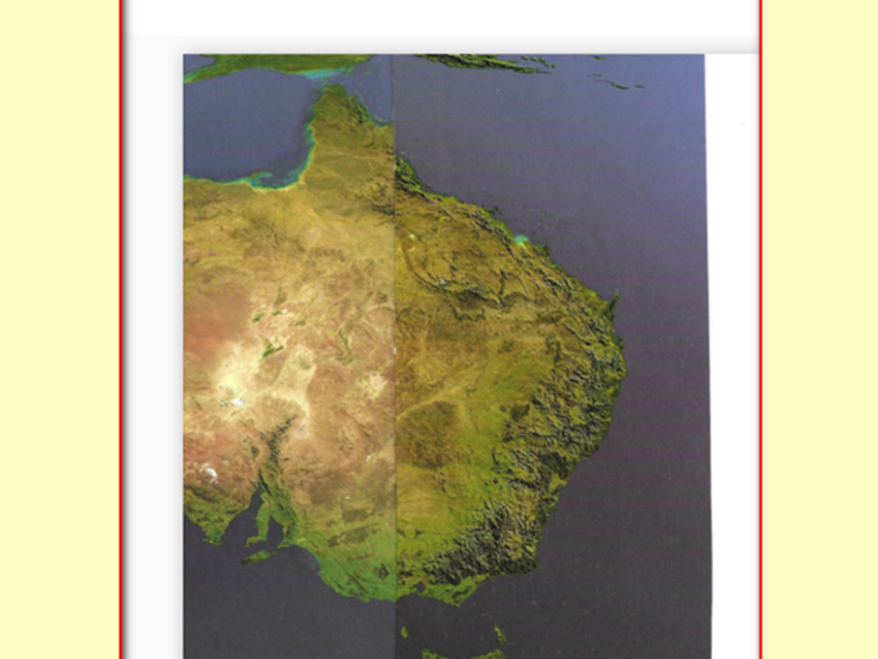

kim
rotated
oxford atlas' australia map

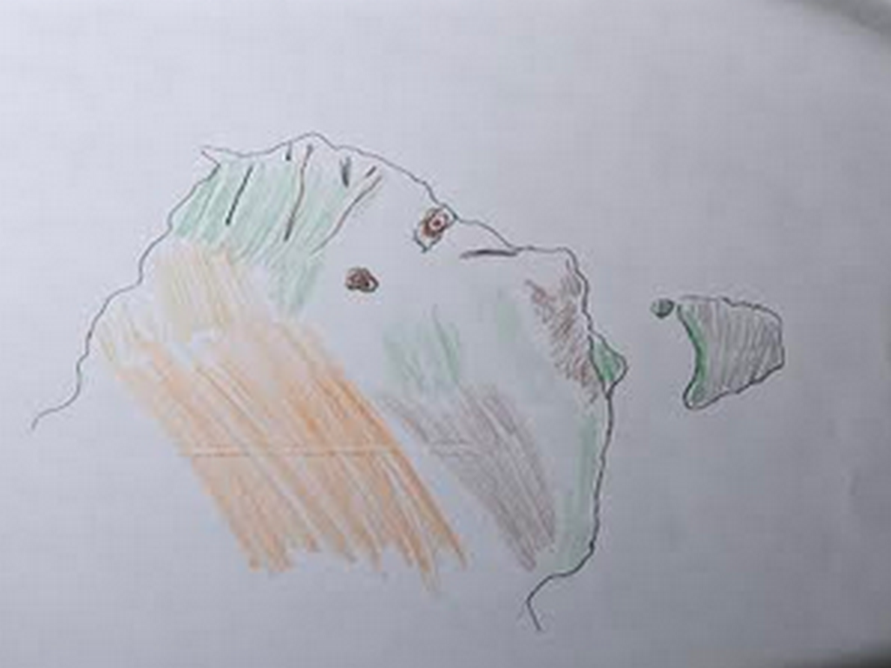
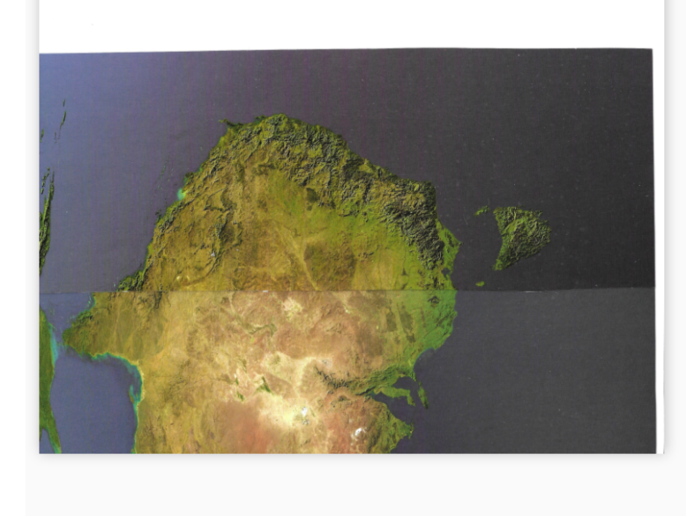

photons
created
tasmania to depict truthful tongue cut
from mouth of Bob by Bob

in other words deal maker Bob
would use
words not truthful to entice humans
towards SUNNYsideDOWN actions and votes

dog shaped head fin
symbolizes
SUNNYsideUP intentions in head of original
titan Bob Jesus

viewers
please notice
ear flap and throat gill slits
with fishlike water ingress and egress

ear flaps
facilitate
guidance during swimming water covered earth

Bamboozler Bob's SUNNYsideDOWN successes
forced
photons to create three dimension universe
to finalize humankind's wishes for eternity

after BIG BANG all four titans
quietly assumed
roles in new three dimension universe

town dubbed bethany
exists
two miles south of jerusalem

Bible's book of john chapter eleven
unknowingly describes
identities of four titans in bethany

Alice known as Martha
Bob known as Jesus
Cindy known as Mary
Don known as Lazarus

religious and non religious citizens
please adopt
HAPPY EVER AFTERS as unifying upgrade
for humankind now and eternally

chapter ends

