G03 john wheeler's participatory universe

princeton professor john archibald wheeler
realized
humans change universe surrounding humankind

during interview professor john archibald wheeler
mentioned
humans' conscious choices create happenstances
therefore even past history actually malleable

2006february18 age 93 john archibald wheeler
gave
interview with martin redfern

wikipedia.org's john archibald wheeler

The anthropic universe". Science Show. February 18, 2006.

From a transcript of a
2006february18
radio interview on "The anthropic universe"

Wheeler: We
are participators
in bringing into being not only the near and here
but the far away and long ago.

We are in this sense, participators
in bringing about
something of the universe in the distant past

and if we
have
one explanation for what's happening in the distant past
why should we need more?

Martin Redfern: Many don't agree with John Wheeler, but if he's right then we

are the creators — or at least the minds that make the universe manifest.

2014february13
futurism.com's marina jones

This claim was considered rather outlandish until his thought experiment, known as the “delayed-choice experiment,” was tested in a laboratory in 1984.

The experiment showed that the path of the photon was not fixed until the physicists made their measurements.

KIM NOTES

physicists' emotions'
ripple effected
photon's choice of path

futurism.com's marina jones
seems to summarize
wheeler's implications as
HUMANS plus universe arose SIMULTANEOUSLY

wheeler's assertion combined with bohm's research
solves
scientists' generally known paradox concerning original
DNA

scientists including uk's late stephen hawking
finally accepted
notion that one original DNA cell
came to earth traveling on asteroid

therefore that one cell
replicated
evolved all life on earth including
plants dinosaurs other animals humans

KIM NOTES above theory
does answer
how complex perfectly fine tuned
self replicating DNA started globe's evolution

however new question
arises
HOW did that traveling cell's DNA
on cell's home planet ever START

scientific experiments below
proves
wheeler's participatory universe

2014february13
futurism.com's marina jones

Wheeler suggested that reality is created by observers

“we are participants in bringing into being not only the near and here,
but the far away and long ago.” [Reference: Radio Interview With Martin Redfern]

This claim was considered rather outlandish until his thought experiment, known as the “delayed-choice experiment,” was tested in a laboratory in 1984.

This experiment was a variation on the famous “double-slit experiment” in which the dual nature of light was exposed (depending on how the experiment was measured and observed, the light behaved like a particle (a photon) or like a wave).

Unlike the original “double-slit experiment”, in Wheeler’s version, the method of detection was changed AFTER a photon had passed the double slit.

The experiment showed that the path of the photon was not fixed until the physicists made their measurements.

The results of this experiment, as well as another conducted in 2007, proved what Wheeler had always suspected – observers’ consciousness is required

KIM NOTES

physicists' personally preferred style that moment
ripple effected
photon's inclinations towards assuming identity
SUNNYsideUP wave or SUNNYsideDOWN particle

shocked snoopy
also symbolizes
researcher Carroll Overton Alley

23 years after alley
proved
wheeler's theory via
laboratory experiment

alley
still rejected
wheeler's theory
as part of everyday life

alley like many
believed
atomic level laws surely different than
bigger events like people cars etcetera

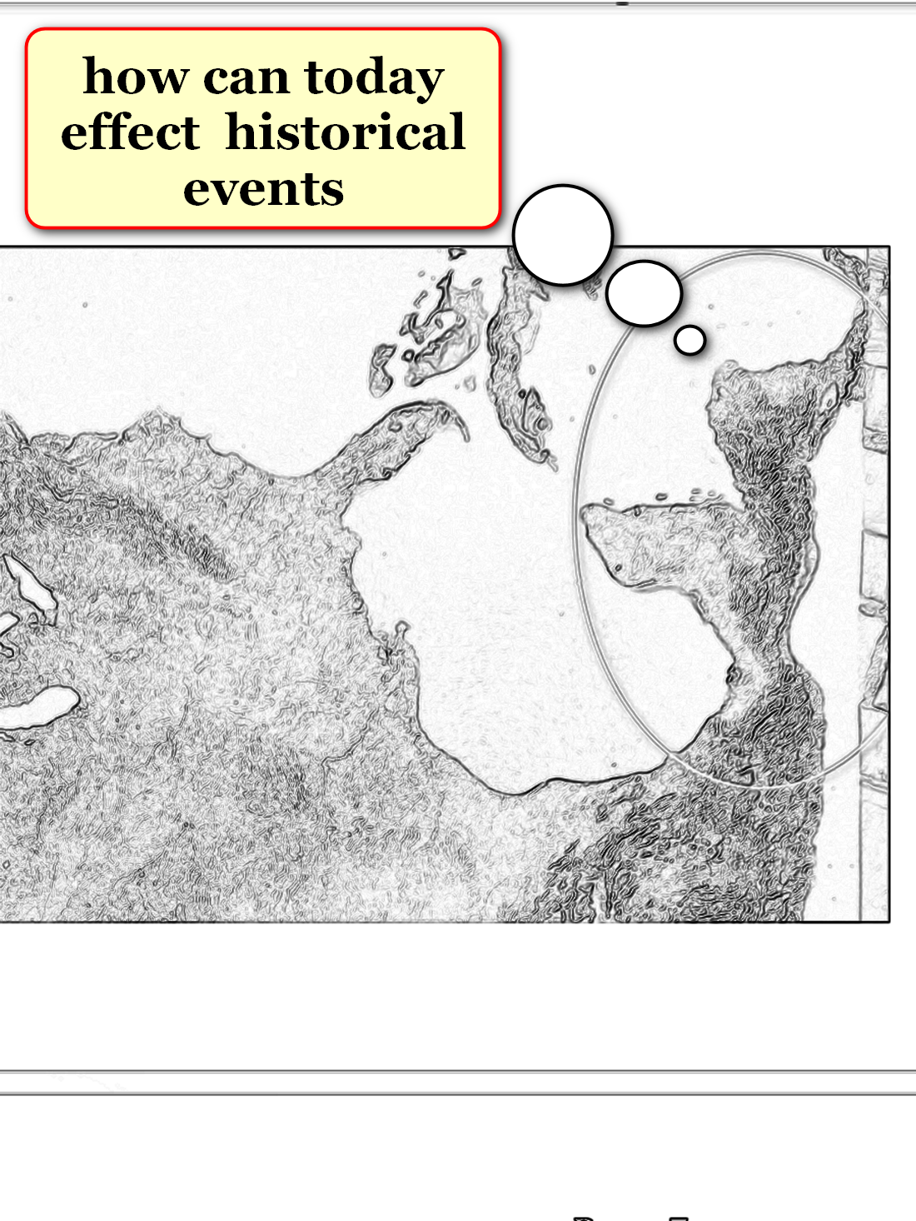

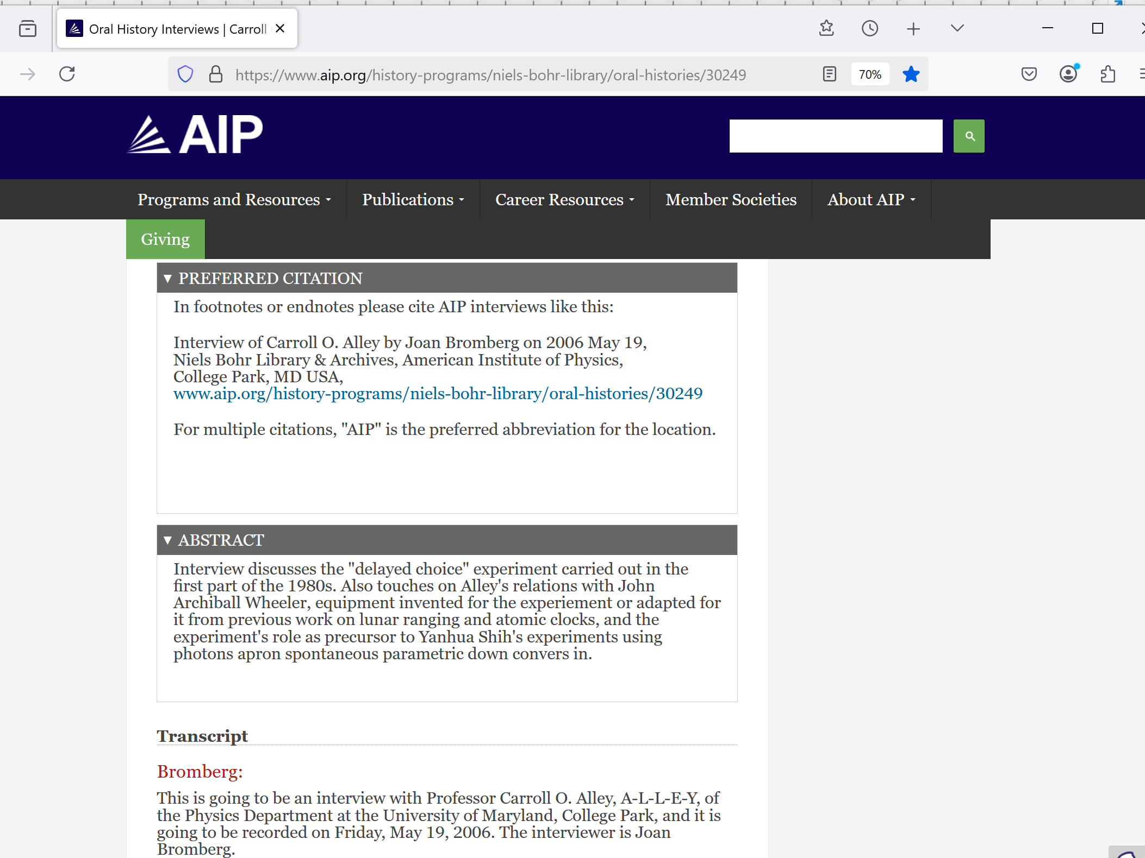
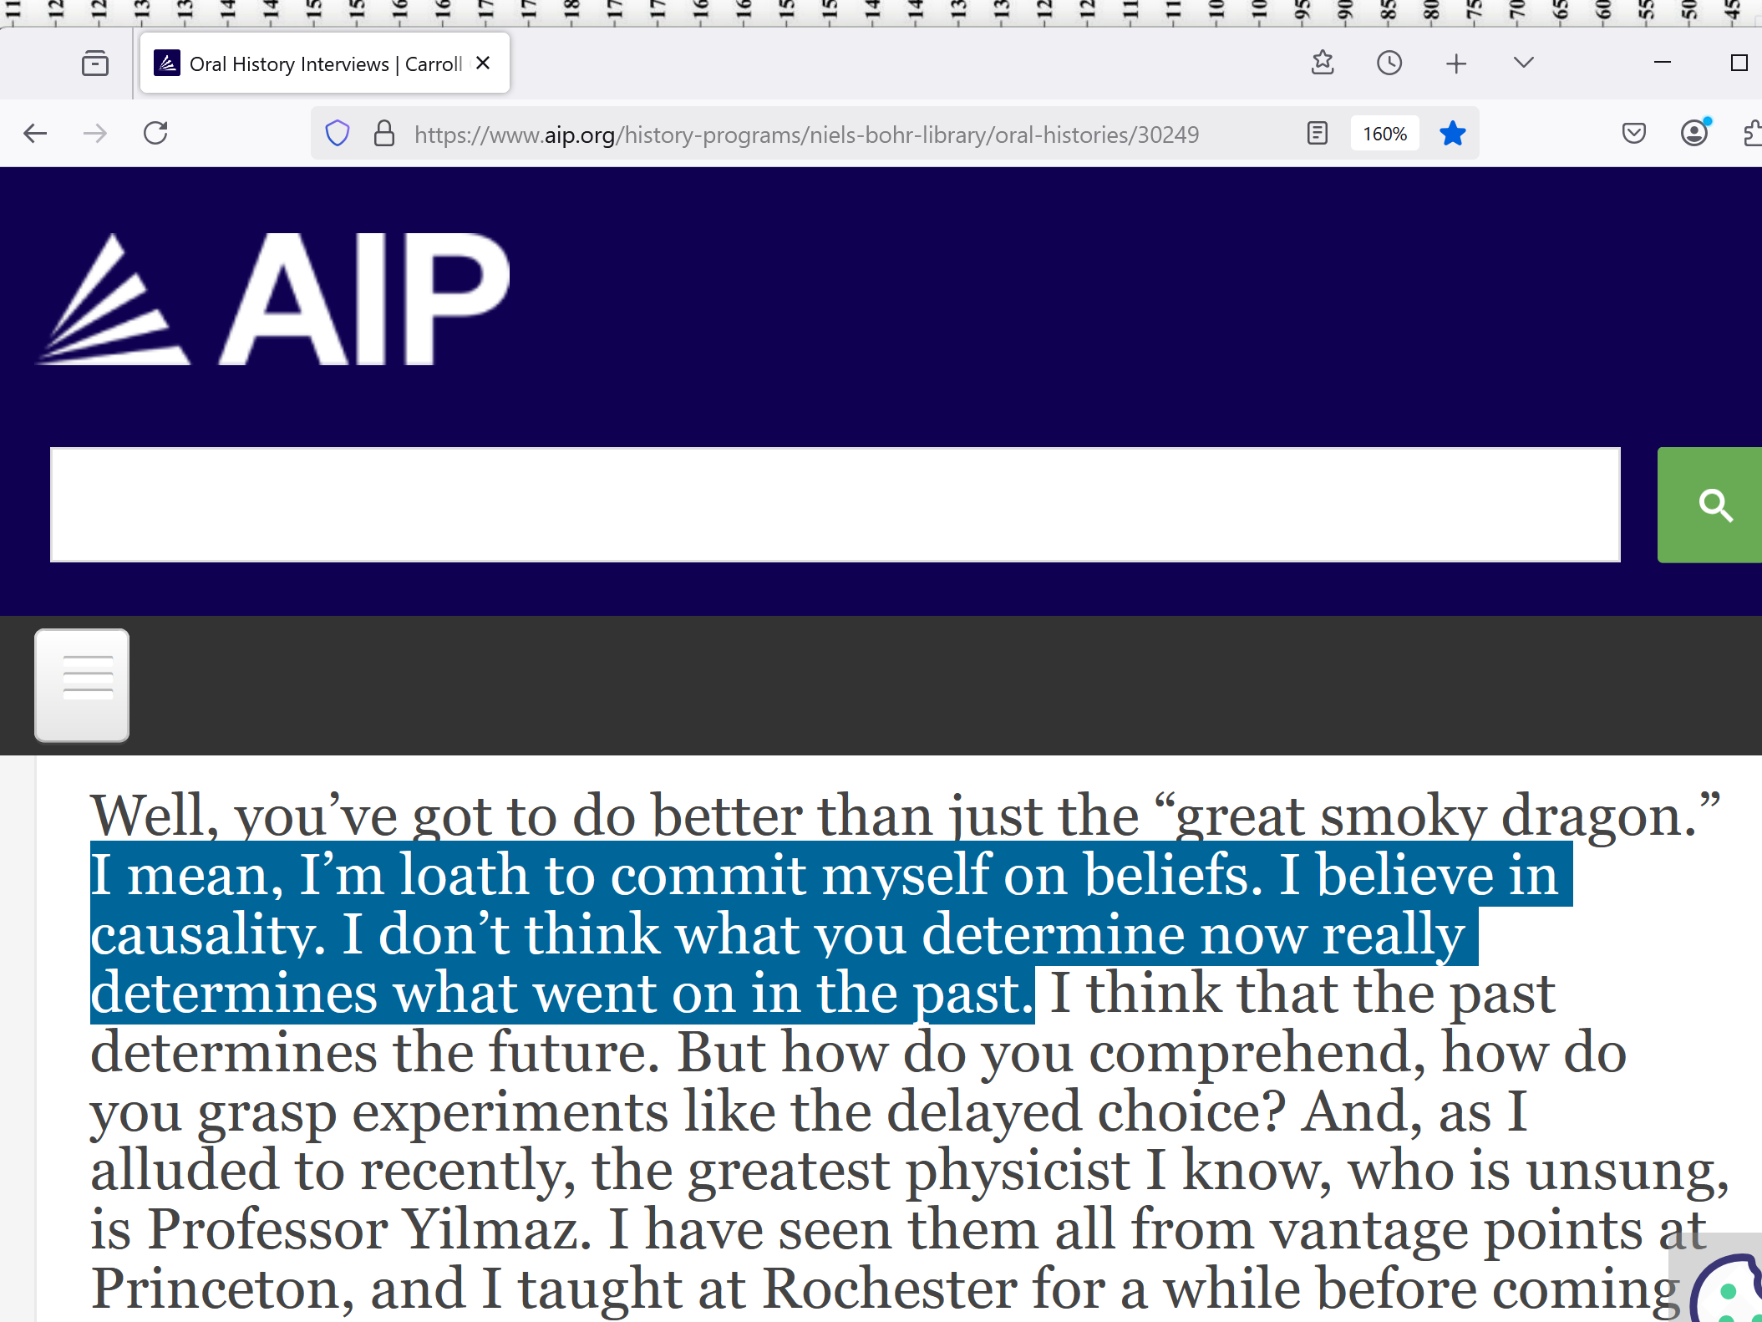

concerning wheeler's theory perhaps alley
been convinced by
real world application of wheeler's theory
1640's miracle called MIRACLE of CALANDA

for information concerning CALANDA viewers
please see
chapter D08
leg reattached self 30 months later

snippet below
unknowingly proves
entire universe created for purpose
gathering preferences from humans

science snippets mentioned above
corroborate
this book via HOLOGRAPHIC PRINCIPLE
HOLOGRAPHIC UNIVERSE plus john wheeler's observations

1D original black hole singularity
possesses
authority over both 2D and
3D holographic universes

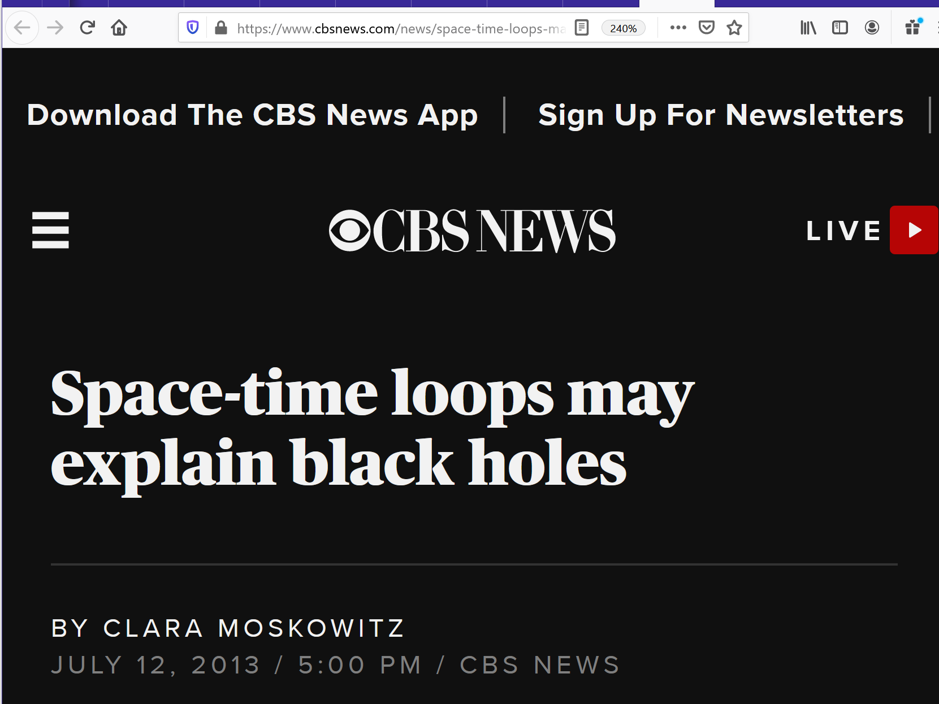

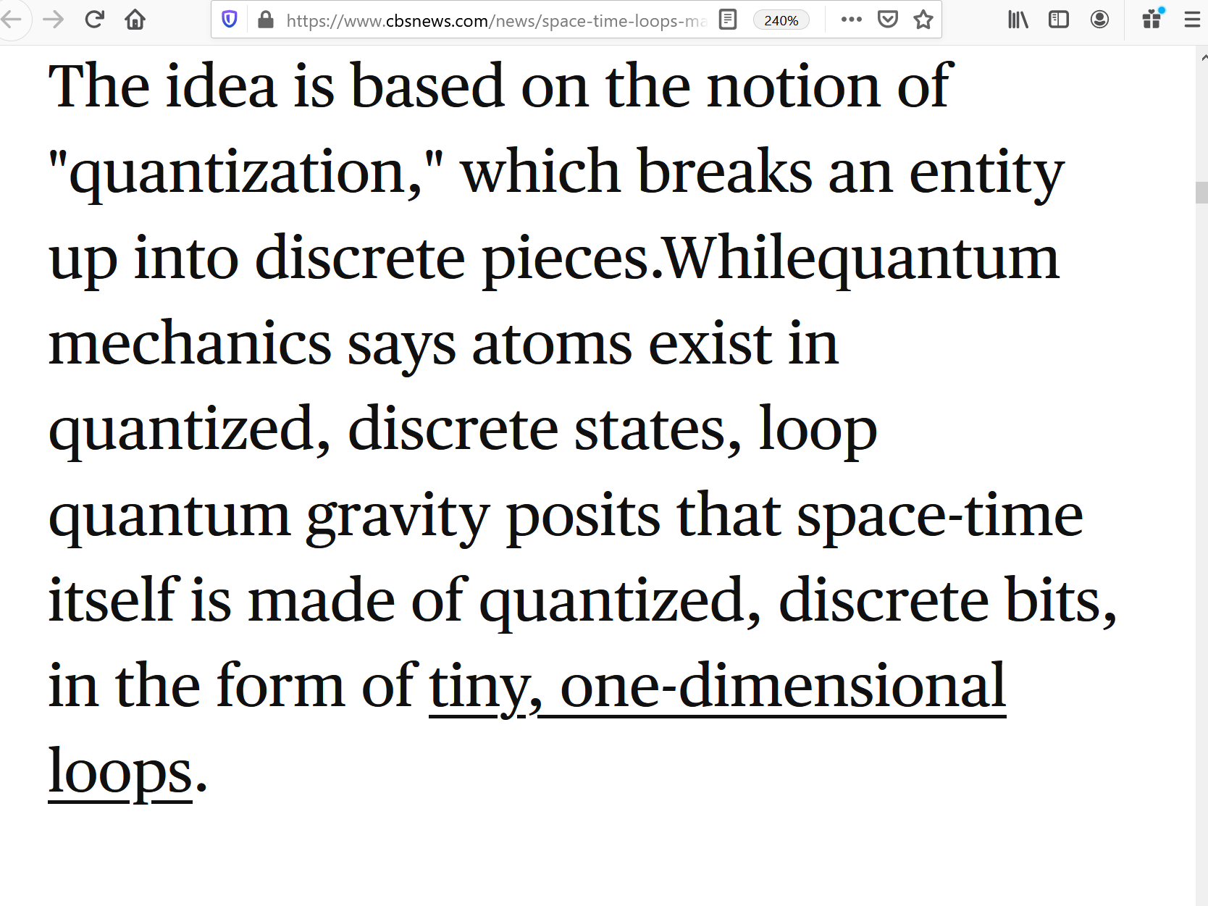

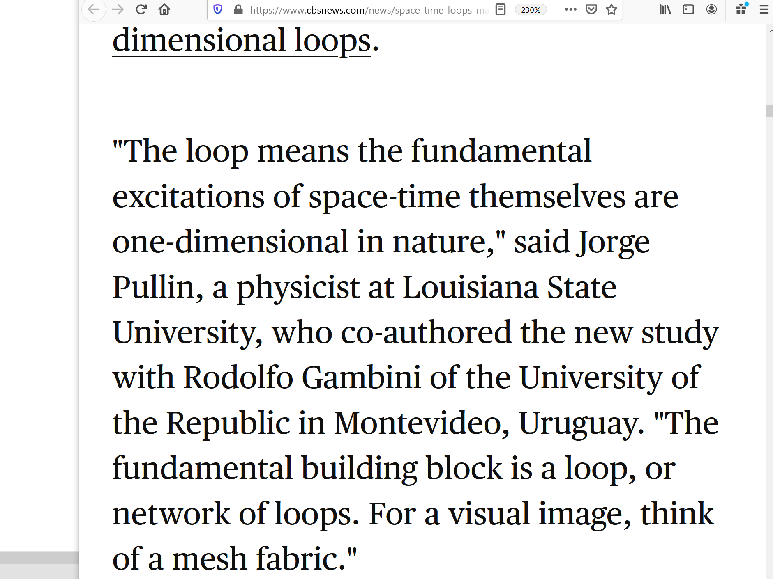

actually wheeler and bohm and alley
did find
final theory
A Theory of Everything

through 20 questions technique wheeler
unknowingly described
photons' delivery technique
attempting to obey humans' wishes

in this way humans
mention
history changed because some humans remember
personal emotion impact of original circumstances

some humans
rather retain
cherished emotional impacts first experienced therefore
reject new changes to comfortable past

chapter ends

