A01 CITIZENS' weekly votes curb government actions
2026 march 01

in SMOOTH KEYS DEMOCRACY citizens
vote weekly
whether government's actions please or displease

if displeased then citizens
may reassign
20 of 22 elder officials responsible
and randomly choose new elder officials

if all nations
upgraded
to this SMOOTH KEYS DEMOCRACY system

then all nations
gain confidence
all other nations shall not invade

in this way defense money
could then be spent on
prebuilding modern cities discussed in other
chapters including I03 and J04-J09

in ideal situation both parties
gain
seat either 21 or 22 for lifetime

in this way nations' two parties
each possess
vote in executive decisions

currently usa federal judges
gain
lifetime appointments

nations' upgrading per adopting this book
offer
similar longevity to heads of state
via offering executive crew memberships

therefore all heads of states
would still gain after abdicating somewhat

executive crew of 22
would lead
executive branch of nation
as highest authority

heads of states and opposition
would occupy
desks 22 and 21

if prime minister
not
top head of state

then in those cases prime minister
would occupy
desk 20

some nations' leaders
may choose
adult family member for desk 10

example possible assignments upon book adoption

china

desk 10 Xi Mingze
desk 20 Wang Qishan
desk 21 opposition leader
desk 22 Xi Jinping

denmark

desk 10 Christian Valdemar Henri John
desk 20 Mette Frederiksen
desk 21 opposition leader
desk 22 Frederik X

north korea

desk 10 kim song
desk 20 choe ryong hae
desk 21 opposition leader
desk 22 kim jong un

russia

desk 10 maria vladimirovna vorontsova
desk 20 mikhail vladimirovich mishustin
desk 21 opposition leader
desk 22 vladimir vladimirovich putin

ukraine

desk 10 denys shmyhal
desk 20 yulia volodymyrivna tymoshenko
desk 21 opposition leader
desk 22 volodymyr zelensky

membership of executive crew usa
would include
supreme court justices occupying desks 01 - 09

members of legislature
occupying
desks 11 through 19

recurring style of selection
includes
random selection from pool of eldest
members of governing group

after SMOOTH KEYS DEMOCRACY adoptions humankind
can start prebuilding
new modern green organized habitat
for humankind

thousand equal sized DiameterCities
could replace
current de facto one world government
of supposedly independent nations of globe

entire humankind
could migrate to
rent free titanium residences each with
self sufficient family greenhouse gardens

if president trump
described
SHOELANGUAGE book's trump chapters as all
truthful and apologizes

then usa
receptive to upgrading to
SMOOTH KEYS DEMOCRACY

trump chapters
include 000 and
K01 and O04 and S06
S10 and T05-T10 and U01

going forward president trump
could initiate
global tranquility via establishing executive crew

SMOOTH KEYS' executive crew of 22
would vote
concerning whatever chief executive
decides by self now

some examples
include
bills from congress and executive orders
and military actions and pardons etcetera

in other words crew's 22 persons
vote
FAIRNESS for ALL case by case

in this way SMOOTH KEYS DEMOCRACY
blocks
igniting wars with only one or
two leaders desiring war

SMOOTH KEYS majority rules protocol
insists
at least 12 of crew must
vote YES GO TO WAR

very few if any executive crews
would vote yes to war
to amass patriots' deaths versus reaching
mutual peaceful agreements via extraordinary efforts

if war unjust then citizens' votes
could redeploy
20 of executive crew
within three regularly scheduled votes

routine voting at or near libraries
would occur
mondays and wednesdays and fridays

if enacted executive crew of 22
would transcend
all branches governing nation and assume
final word executive legislative and judicial

executive crews decisions and reasonings
would appear
in weekly summation booklets available in
for example district of columbia libraries

for example if district of columbia
votes NO
three consecutive uninterrupted voting days

then persons from 130 top positions
automatically redeploy
elsewhere in government replaced by others
utilizing random ping pong tumbler method

executive crews
would utilize
geodesic voting domes with 50 feet
diameters each near libraries

library cards
serve as
identifications for voting concerning citizens'
general attitudes concerning crew's actions

library personnel
would stand near
scanning machines and monitor scanning
and also deliver voting pellet

each scan
would deactivate
that card through midnight

in this way citizens
would vote at most
only once per voting day

three uninterrupted majority NO votes
would initiate
peaceful redeployment of 20 of executive
crew plus all 110 RESEARCH DEVELOPERS

yet 21st and 22nd crew members
would stay
until humankind moves to DiameterCities

in SMOOTH KEYS dictator plus opposition leader
gain
lifelong memberships even if citizens' three
uninterrupted NO votes replace other members

SMOOTH KEYS scientific group decisions style
enhances
collaborations because utilizes communications
anonymously written

plus group
votes anonymously
YES or NO concerning proposed solutions

SMOOTH KEYS' communiques
would possess
SUNNYsideUP tone comments transcending
emotionally susceptible verbal duels during meetings

routine strategy several days' methodical reevaluations
include exposing
some first glance SUNNYsideUP appearing ideas
as actually SUNNYsideDOWN ideas

when legislature
sends
legislation for president's signature

then that legislation
gains
equivalent of executive crew's tuesday's
YES vote

then like other ideas that bill
undergoes
opposite view scrutiny
until thursday's vote YES or NO

crews plus RESEARCH DEVELOPERS
actively comment and seek clarifications
via in house published memorandums

during projects 130 top decision makers
simultaneously express
various major considerations to colleagues via
booklets' contents published in house

in this way SMOOTH KEYS technique
adds
anonymity to both idea presenters and
commentators

in this way SMOOTH KEYS DEMOCRACY
harvests
wisdom without repercussions

if adopted usa administration's executive crew
includes

all 9 supreme court justices
vice president in desk 10

3 members from senate

6 members from pool of house of
representatives members plus observers

president trump
chooses
person to occupy desk 20

in 2028 newly elected president
attains
desk 21

2028's elected vice president
attains
desk 10

president trump
would randomly select
three senators from pool of five
eldest african american senators

president trump
would hand crank spin
barrel tumbler to
randomly select three senators

in same way 6 house members
attain
desks of executive crew via
random selection from 15 eldest congresspersons

5 of pool of above
include
5 eldest native americans
in house of representatives

5 of pool of above
include
5 eldest asian americans
in house of representatives

5 of pool of above
include
5 eldest others
in house of representatives

during random selections each of those
grab
one ping pong ball

ping pong balls
possess
numbers for barrel tumbling

after tumbling without directly looking president
would remove
ping pong balls required

selected ping pong ball associated persons
would then assume
executive crew desks

SMOOTH KEYS DEMOCRACY scientific decisions style
includes
secret ballot voting from all 22
executive crew members inside same room

each executive crew member
facilitated by
five RESEARCH DEVELOPERS for prioritizing foci
for tasks and developing innocuous solutions

RESEARCH DEVELOPERS selection style process
repeats
random ping pong barrel tumbler method

first group
includes
pool of 100 eldest females of
house of representatives

in this way female RESEARCH DEVELOPERS
attain
desks for facilitating
each female executive crew member

pool of 100 eldest congressmen
repeat
above for male RESEARCH DEVELOPERS
facilitating each male executive crew member

five SMOOTH KEYS geodesic domes
located in
ellipse possess offices
for 132 SMOOTH KEYS persons

Public Domain
File: Aerial view of White House and the Ellipse.jpg
Created: Taken on 15 May 2010, 22:48
Uploaded: 15 May 2010

Carol M. Highsmith - This image is available from the United States Library of Congress's Prints and Photographs division under the digital ID highsm.04915.

120 feet diameter central dome
connects
four similar domes north south east west
for combined 360 feet footprint

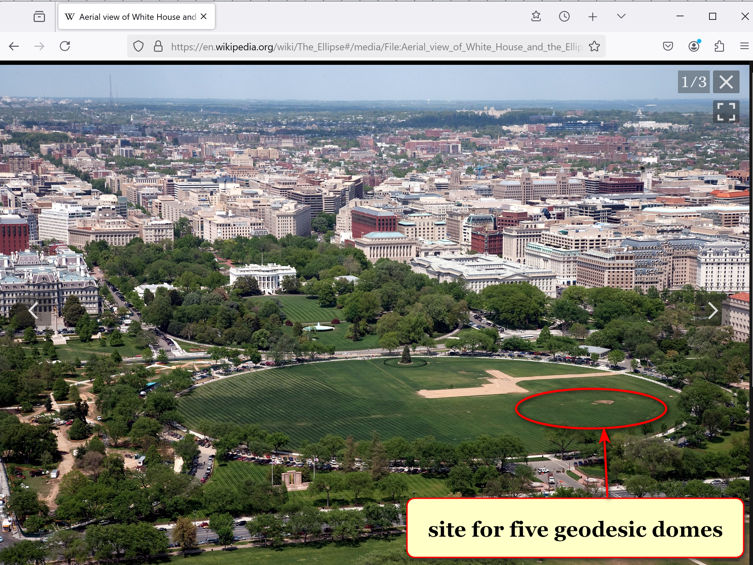

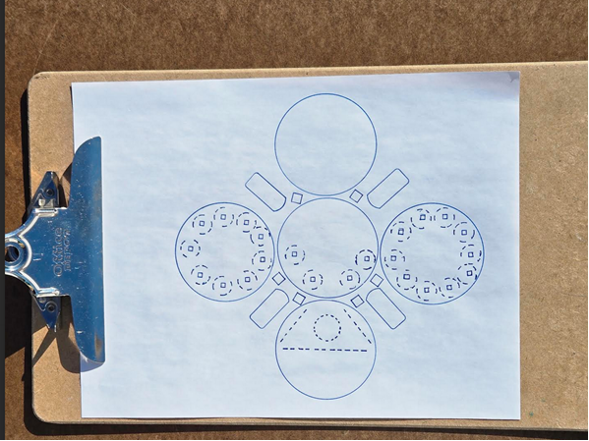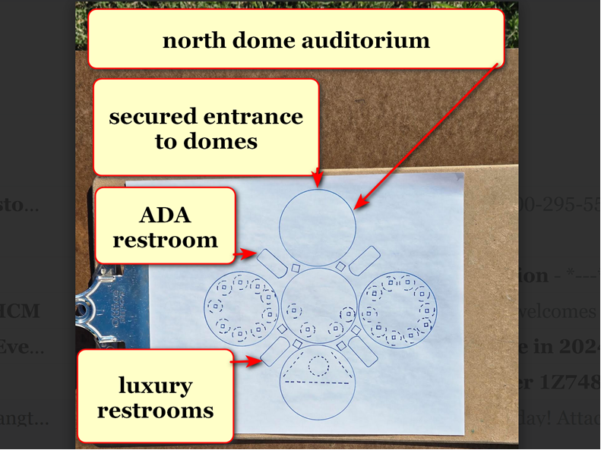

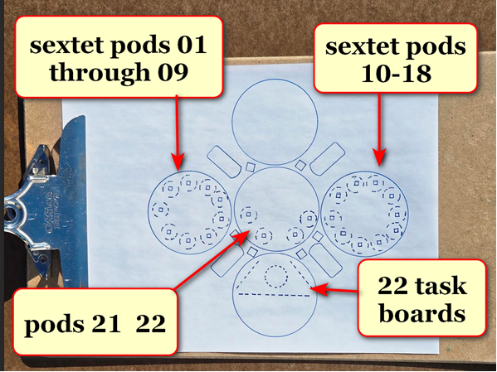

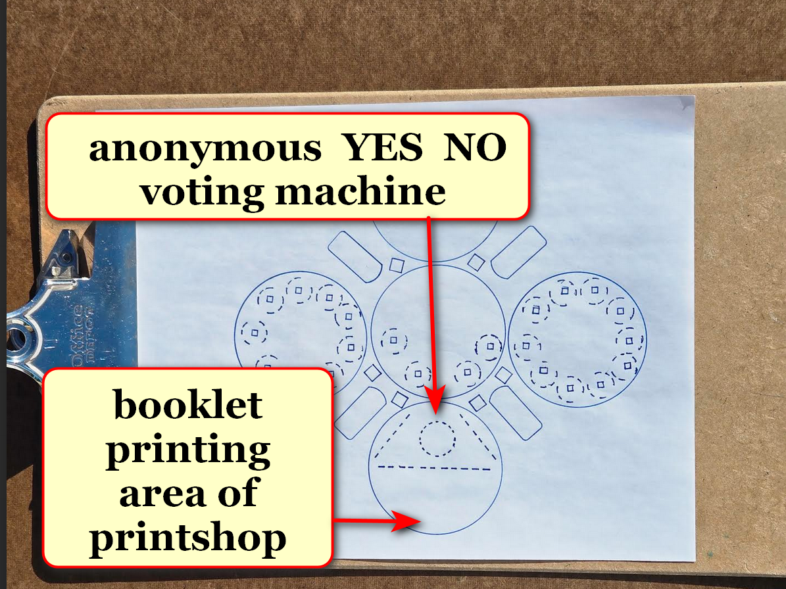

domes
exclusively host
executive crew of 22 plus 110
RESEARCH DEVELOPERS plus in house printer

all persons above
may view freely and repeatedly
all top secret unredacted unsummarized media

therefore persons working inside decision domes
solve
situations as equals

other communications including with news media
occur
elsewhere far from domes

with above simplification secret service
more easily protects
all persons equally from outside domes
along perimeter securing safety of group

secret service agents
operate
north dome for screenings

executive crew plus RESEARCH DEVELOPERS
store
camera devices including cell phones in
north dome lockers during workdays

2024 cost for constructing and
equipping
all DC domes including ellipse's
domes equals 144.3 million dollars

private donations to construction supervisor kim
allow
kim's paying for constructing plus equipping
domes

if proposed SMOOTH KEYS DEMOCRACY persons
accept
enhanced roles

plus if district of columbia
provides
land near 25 libraries for geodesic
domes of 50 feet diameters

then private citizen kim
more easily starts gathering
private donations

also with donations kim
purchases
materials for constructing kim's invented
YES NO voting machines non electronic

SMOOTH KEYS
places
YES NO voting machines within new
geodesic domes in district of columbia

then district of columbia residents
gain
25 easily accessible polling structures
near libraries

plus same 25 solar powered structures
serve
as resource areas in cases of
weather emergencies

free dome resources for end users
include
water ice electricity

above
via
air to water machines ice machines
cellphone recharging outlets all solar powered

in polling domes citizens
say
YES or NO three times weekly
concerning decisions of executive crew

above check and balance system
behooves
executive crew
keeping public informed reasons for actions

supreme court
controls
volume of cases for voluntary review

constitution
allows
supreme court if court desires
to hear zero cases per year

before SHOELANGUAGE book supreme court
ruled on
less than 85 cases per year

weekly SMOOTH KEYS' 110 RESEARCH DEVELOPERS
review
incoming cases for total 22 taskings weekly

those cases needing review
join
all other pressing matters

110 RESEARCH DEVELOPERS in quintets
evaluate
events decide on three most pressing
matters for that week's crew's votes

then executive crew
chooses
22 most urgent tasks
from 66 suggestions

decision domes' officials' anonymously written arguments
replace
oral arguments

in SMOOTH KEYS system justices' wisdom
helps shape
tasks' resolutions during creations
rather than afterwards

hopefully executive crew
successfully handles
affairs of country very well for
both four year terms

however three uninterrupted citizen NO votes
initiate
changing 20 persons of executive crew
plus 110 research developers

those crew members plus research developers
redeploy
to original offices duties
or to other usa government roles

for filling executive desks 1-9 president
randomly ping pong chooses
9 federal judges from pool of
30 eldest federal judges

9 supreme court justices
switch
roles with those 9 federal judges

those 9 federal judges
gain
increased pay to executive crew rate

9 supreme court justices' wages
revert to
supreme court wages

plus crew desks 10 and 20
now occupied by
congresspersons chosen via ping pong method

initially 110 RESEARCH DEVELOPERS desks
seat
25 cabinet plus cabinet level persons

TABLE BELOW

cabinet level persons
secretaries of departments
RESEARCH DEVELOPERS

executive desk numbers research developer numbers

01 samuel alito 001 agriculture
brooke leslie rollins

002
003
004
005

02 amy coney barrett 006 attorney general
pamela jo bondi

007
008
009
010

03 ketanji brown jackson 011 commerce
howard william lutnick

012
013 council of economic
advisors chairman
stephen ira miran

014
015 veterans affairs
douglas allen collins

04 neil gorsuch 016 CIA
john Lee ratcliffe

017 FBI head
kashyap pramod patel

018 director of national
intelligence
tulsi gabbard

019 homeland security
kristi lynn arnold noem

020 nation security advisor

05 elena kagan 021 education
Linda marie mcMahon

022 defense
peter brian hegseth

023 border czar
thomas douglas homan

024
025 solicitor general
d john sauer

06 brett kavanaugh 026 energy
christopher allen wright

027
028 environmental
protection agency
Lee michael zeldin

029
030 interior
doug james burgum

07 john roberts 031 health and human
services
robert f kennedy jr
032
033 housing and urban
development
eric scott turner

034
035

08 sonia sotomayor 036 labor
Lori chavez-deRemer

037
038 small business
administration
kelly Lynn Loeffler

039
040

09 clarence thomas 041 office of management and budget
russell thurlow vought

042 treasury
scott kenneth h bessent

043

044
045

10 vice prez JD vance 046 office of science and
technology policy
michael k kratsios

047
048
049
050

11 legislator 051 state
052
053 ambassador to un
054

055 us trade representative
jamieson Lee greer

12 legislator 056 transportation
sean patrick duffy

057 drctr of nat econ cncl
kevin allen hassett

058
059
060

13 legislator 061 national institutes health d
062
063
064
065

14 legislator 066 federal comm comm chair
brendan thomas carr

067
068
069
070

15 legislator 071 centers for m.care & cade
Dr. Mehmet Oz
072
073
074
075

16 legislator 076 077
078
079
080

17 legislator 081
082
083
084
085

18 legislator 086
087
088
089
090

19 legislator 091
092 093
094
095

20 selected by president 096
097
098
099
100

21 democratic leader 101 deputy chief of staff
stephen n miller

102
103
104
105

22 president trump 106 white house chief of staff
susan L wiles

107 assistant to president
sergio gorokhovsky

108 press secretary
karoline claire Leavitt

109 communication director
huyen steven cheung

110 white house counsel
david alan warrington

precise weekly paid hourly compensations
more fair than
salary

executive crew members
gain
equal compensations to president's compensation

each member of executive crew
compensated
193 dollars per hour
based on 40 hour week

each RESEARCH DEVELOPER
compensated
145 dollars per hour
based on 40 hour week

executive crew of 22 voting
occurs
tuesdays at 10:00 in morning
then thursdays at 16:30 in afternoon

both days' majority YES votes
needed
to propel task forward officially

plus executive crew members
possess
specific times to evaluate comments
attached to physical bulletin boards

chapter A02
details
weekly tasks of SMOOTH KEYS DEMOCRACY
RESEARCH DEVELOPERS

chapter ends

