G01 Bohm discovered electrons' acted differently grouped

concerning lone electron's movements david bohm
noticed
grouped with others that electron changed
behavior

professor david bohm
theorized
holographs surround humans

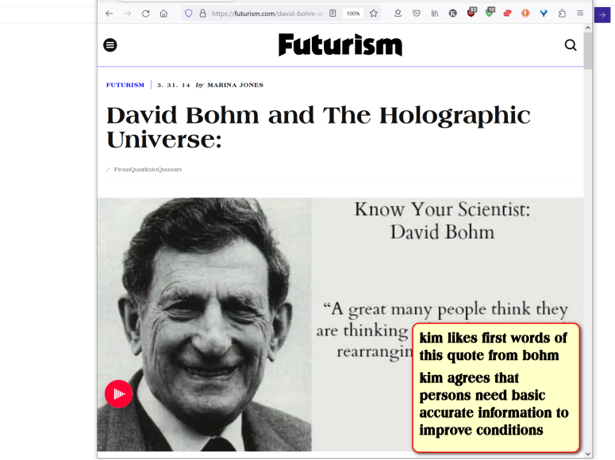
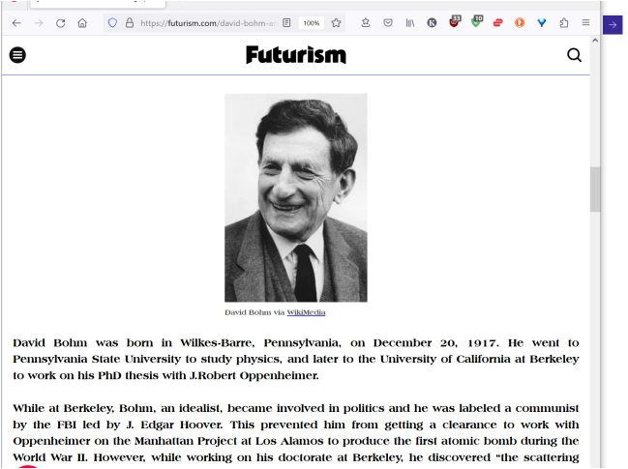

KIM NOTES

every electron
parallels
well informed member of parliament
knowing every aspect of all situations

electrons
debate
with other electrons

majority vote
represents
collective opinion

above
explains
bohm's ALIVE SEA OF ELECTRONS

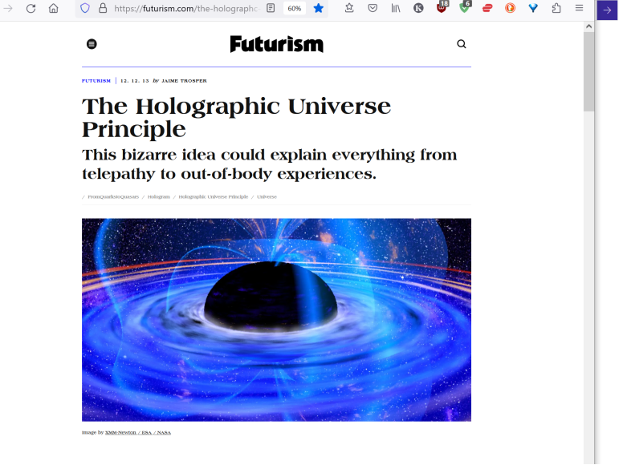

bohm
correct

HAPPY EVER AFTERS book
agrees with
bohm and describes same sentiments

since also residing in 1D electrons
possess
all knowledge of all other electrons
thoughts actions emotions

in 1D singularity dot all personalities
touch
all other personalities and
know all thoughts

since distance
merely illusion
then speed merely illusion

distance speed
merely parts
of each person's 3D holograph

summation ALL DISTANCES
merely illusions

1D universe
operates
only in EMOTIONS

statement in article below
unknowingly corroborates
TIME EGGS
situated side by side independent

entire history of humankind
happening even now
side by side cycling looping
adjustments made by characters voluntarily

above situation
exists
for voting purposes

currently three universes
operate
intertwined affecting each other

every person
possesses
two residences simultaneously
1D also 3D

first universe one dimension 1D length only
contains humankind's DNA awaits final configuring vote
•

three dimension universe 3D length width height

new spherical earth
water plus continents

earthlings morph to human shapes currently used

gravity limits mobility

new development labeled
pain introduced as option
emotions expressed
counted as votes

in 1D wedding crasher titan Don
reigns
supreme injecting SUNNYsideDOWN thoughts
into all residents enjoying resulting agony

in 3D field of electrons humans
vote
towards 1D or 2D SUNNYsideUP

each 8 second TIME EGG
involves
new incoming crew of electrons

kim
labelled
complete particles utilizing
TITAN names per combined particle

Alice electron

Bob proton

Cindy neutron

Don gravity

2D 3D universes
actually reside inside
titan Alice

plus Alice
self hosted
other three titans

because of above DNA
always contains
four nucleotides which inhabit
all living creatures including plant life

National Cancer Institute (.gov)
https://www.cancer.gov › genetics-dictionary › def › nu.

Definition of nucleotide - NCI Dictionary of Genetics Terms

DNA is made up of four building blocks called nucleotides: adenine (A),
thymine (T),
guanine (G),
cytosine (C).

above four building blocks
symbolize
four titans

chapter ends

