CHAPTER 003
hawking agreed CURRENT votes alter HISTORY

2024 september 25 science writer amanda gefter
contributed
article to QUANTA magazine concerning professor
wheeler who helped develop atomic bomb

KIM NOTES

in gefter's picture john archibald wheeler
walks on
east side of other two scientists
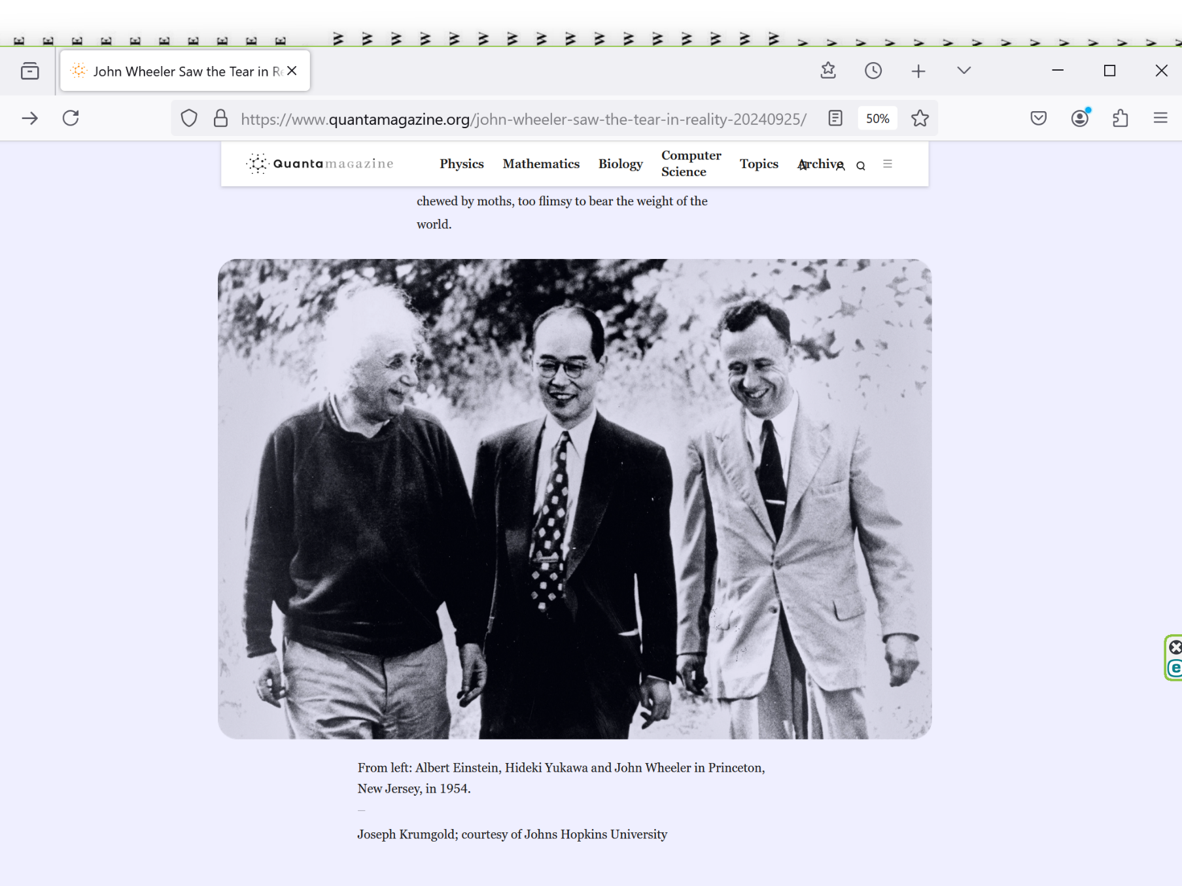

gefter
mentioned
wheeler's scientific discoveries concerning time

IT worked just as Wheeler
had imagined:
measurements made in the present
can create the past.

Time as we once knew it
does not exist;
past does not come indelibly before future.

History,
Wheeler discovered—the kind that brews guilt, ...
is never set in STONE.

KIM NOTES

kim
agrees with
and interprets wheeler's thesis

HISTORY
changes
and Universe REBUILDS

KIM'S EXAMPLE

of course every unified body
possesses
portions of that body

every body portion
knows
what other portions experience

every body portion
accepts
new common body wisdom to add
to generally agreed upon declared wisdom

2022 kim
experienced
universe rebuilding including time dilation

common scientific knowledge
mentions
objects entering singularity black hole
will experience time dilation slowing

2022february kim as employee
drove for
company transporting disabled individuals
for routine non emergency tasks

concerning steps elevation changes blind persons
hold
hand onto shoulder of leader
for monitoring elevation changes

for example above strategy
immediately references
movements when encountering staircases

at journey's destination kim
helped
blind lady exit van

lady's tallness
made unnecessary
usual portable stepping platform

image by Clker-Free-Vector-Images from Pixabay



on exiting driver's side lady's hands
held
grab handle and kim's shoulder

kim and nice lady
stood together
after lady exited van

conversation
contained
only 12 words

kim and lady
laughed together
at kim's punchline

each human's limbs' combined electrons
constitute
parliament with common belief among those
electrons that cns surely desires SUNNYsideUP

limbs parliaments of trio
agreed together to
redo scene with modifications to include
daughter in on joke as well

originally adult daughter
exited
van passenger side and therefore not
close enough to hear brief dialogue

then time
dilated
slowed from video to screenshots format

in mind's eye kim
saw
two screenshots snapshots

first still photograph of daughter
showed
daughter trotting from passenger door
turning corner of rear of van

then kim's mind's eye's next snapshot
showed
daughter close to mother and kim
forming group huddle

snapshot from pixabay
symbolizes
that group huddle



Mircea Iancu
Bucharest/Romania
Joined pixabay March 13, 2019

Camera
Nikon D5300
Media type JPG
Resolution 4981 x 3425
Published date September 16, 2023

pixabay.com/users/surprising_snapshots-11873433/

Surprising_SnapShots

If viewers find useful image of trio or audio tracks, please donate 2-10$ (or more)

KIM
hopes
pixabay operators like Mircea Iancu above
do prosper

return to video format

now daughter
part of trio huddle
during all 12 words including
when kim delivered punchline

now all three
laugh together



Free for use under the Pixabay Content License

Media type JPG
Resolution 5407 x 3605
Published date December 28, 2017

//pixabay.com/service/license-summary/

above occurrence in kim's holograph
proves
history's holographic TIME EGGS malleable
and improvable if involved actors agree

above
corroborates what
einstein and wheeler deduced independently

in summary TIME
merely persistent SHAM

https://nautil.us/haunted-by-his-brother-he-revolutionized-physics-234736/

Amanda Gefter’s book Trespassing on Einstein’s Lawn
a memoir about physics, her father, the universe, John Wheeler, nothing and everything—published 2014 january by Bantam.

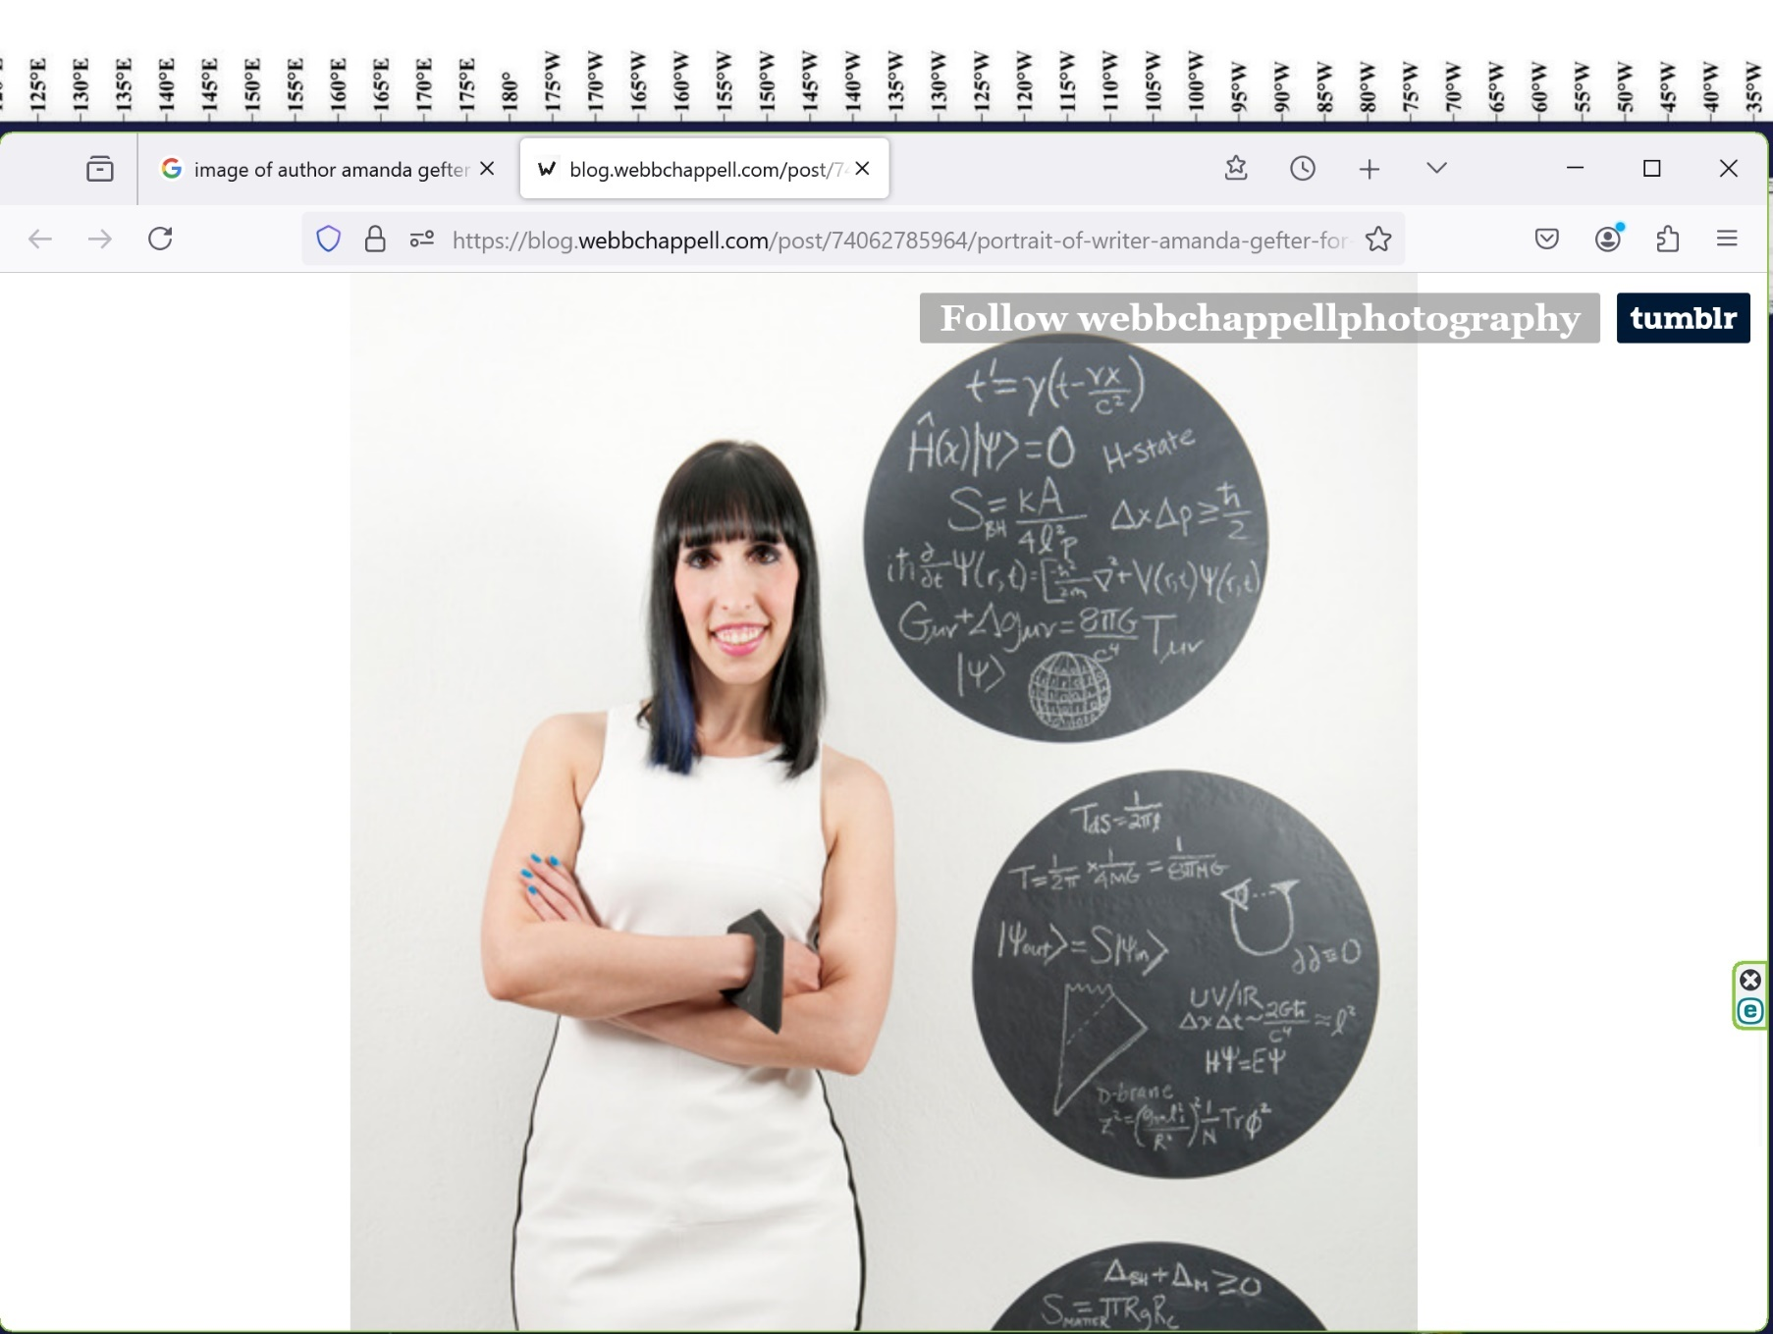

2014january10
nautil.us' amanda gefter

“OF all obstacles to a thoroughly penetrating account of existence, none looms up more dismayingly than ‘time,’” Wheeler wrote.

“Explain time?
Not without explaining existence.

Explain existence?
Not without explaining time.”

Now, at the Raleigh International Airport, that damned equation left
Wheeler with a nagging hunch that

TIME
couldn’t be
a fundamental ingredient of reality.

It
had to be as
einstein said STUBBORNLY persistent ILLUSION,

princeton professor john archibald wheeler
scrawled
in his journal on June 27, 1974.

“Past present and future
tied more intimately
than one realizes.”

In his journal, Wheeler
drew
picture of capital-U for “universe,” with
eye perched atop left-hand peak,

staring across
letter’s abyss to tip of
right-hand side: origin

universe
has created
observer
now ..., observer looks back creates universe.

Wheeler
scribbled caption
beneath drawing: “...universe ...self-excited SYSTEM.”
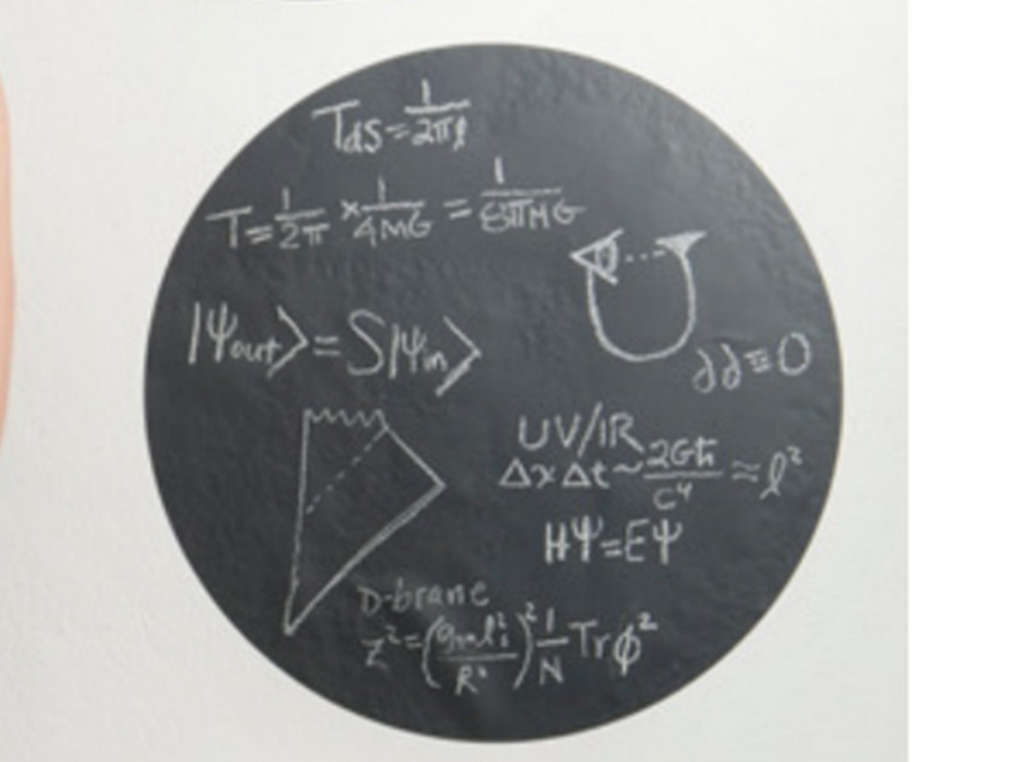

achieving permanent SUNNYsideUP culture
starts with exposing
traditional myths that indirectly model unfair
procedures as acceptable standard operating procedures

traditional myths of history
include

STINGY supreme being
usually withheld
affirmative answers to prayers for HEALING

taught myths' internal logic
concluded
EXTREMELY strict supreme being withheld healing
for some important humanly unknowable REASON

HAPPY EVER AFTERS book
declares
IN actuality all healing prayers
answered affirmatively INITIALLY

photons operating nonjudgmental holographic universe
always proceed towards
manifesting complete healing
unless given further notice

all citizens' healing prayers
always counted as
requesting flipping toggle switch upward towards SUNNYsideUP therefore healing citizens' holographic bodies

unfortunately many citizens within hours
unknowingly reflipped
toggle switch downward to SUNNYsideDOWN including inviting illness LACK of SUPER HEALTH

KIM NOTES

professor john wheeler
sketched
eye observing universe that created eye

eye
symbolizes
human observing universe including baby's
emotional eye at moment of conception

https://nautil.us/haunted-by-his-brother-he-revolutionized-physics-234736/

science writer Amanda Gefter

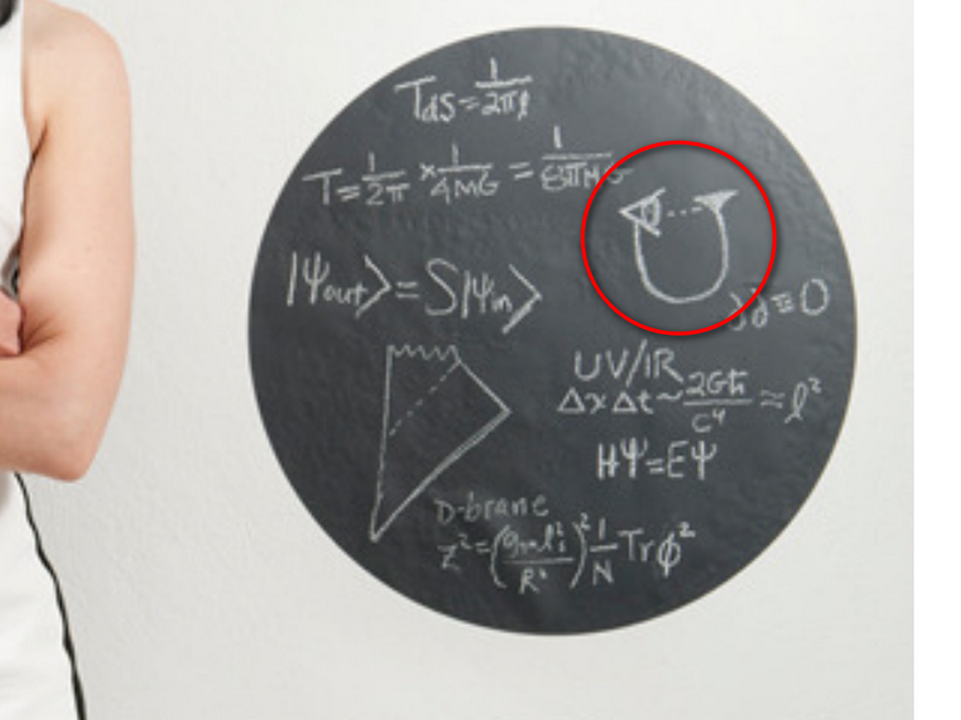

HAPPY EVER AFTERS book
confirms
professor wheeler's discovery because
every new baby proves thesis

in participatory way each new human
readies
self while in mother's body

some humans
gained
situation of sending only SUNNYsideUP signals

or more exactly those humans
unknowingly refrained from sending
SUNNYsideDOWN signals

therefore advantages
came unhindered

one example SHOELANGUAGE book's chapter C02
mentions
year 1640 spain's pellicer observed universe

yet pellicer
disliked
SUNNYsideDOWN results in pellicer's holograph

pellicer's holograph
included
amputation of one leg

for 30 months pellicer
prayed
via catholic prayers

without even knowing exact mechanism pellicer
asked in effect for
SUNNYsideUP holographic switch flipping upwards

photons
accepted
pellicer's emotional mindset even though pellicer
believed details not entirely accurate

pellicer
received
benefits of holographic switch
flipping to SUNNYsideUP genre

photons
obediently moved
previously amputated leg

therefore pellicer's amputated leg
exited
grave box then self reattached
onto sleeping pellicer in different town

pellicer
credited
angels

HAPPY EVER AFTERS book
declares
angels as mythologies

photons
accomplish
either genre according to signals
from that human

similar to broadway stage hands photons
add or subtract
props from stages during intermissions
as that citizen's script changes dictate

either SUNNYsideUP miracles and happenstances
or
SUNNYsideDOWN diseases and disastrous happenstances

1640's pellicer's accomplishment
gives
historical example of wheeler's theory
as fact

KIM NOTES

1974 june 27 eagle nebula
seamlessly changed
in order to match
human john wheeler's sketched eye
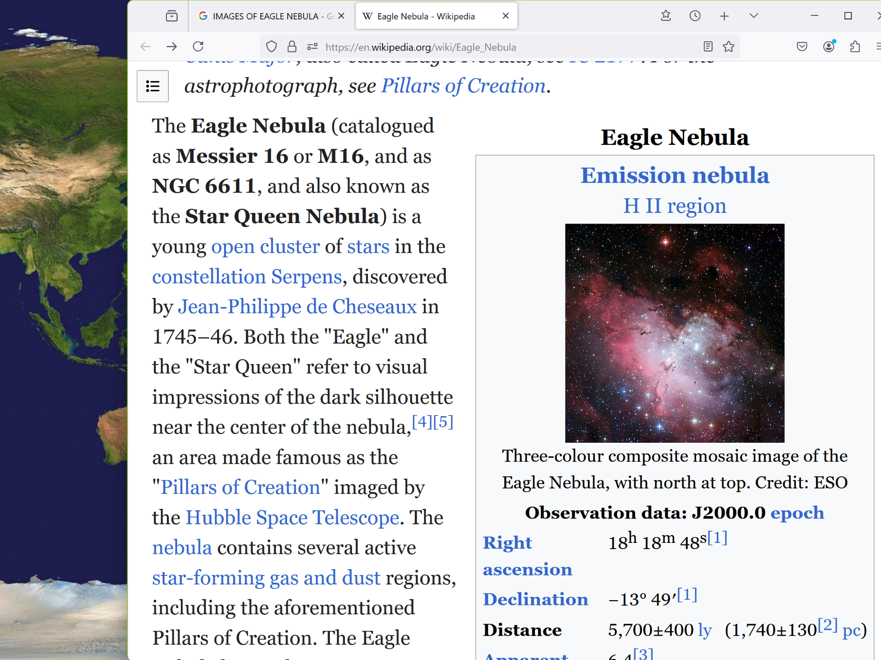
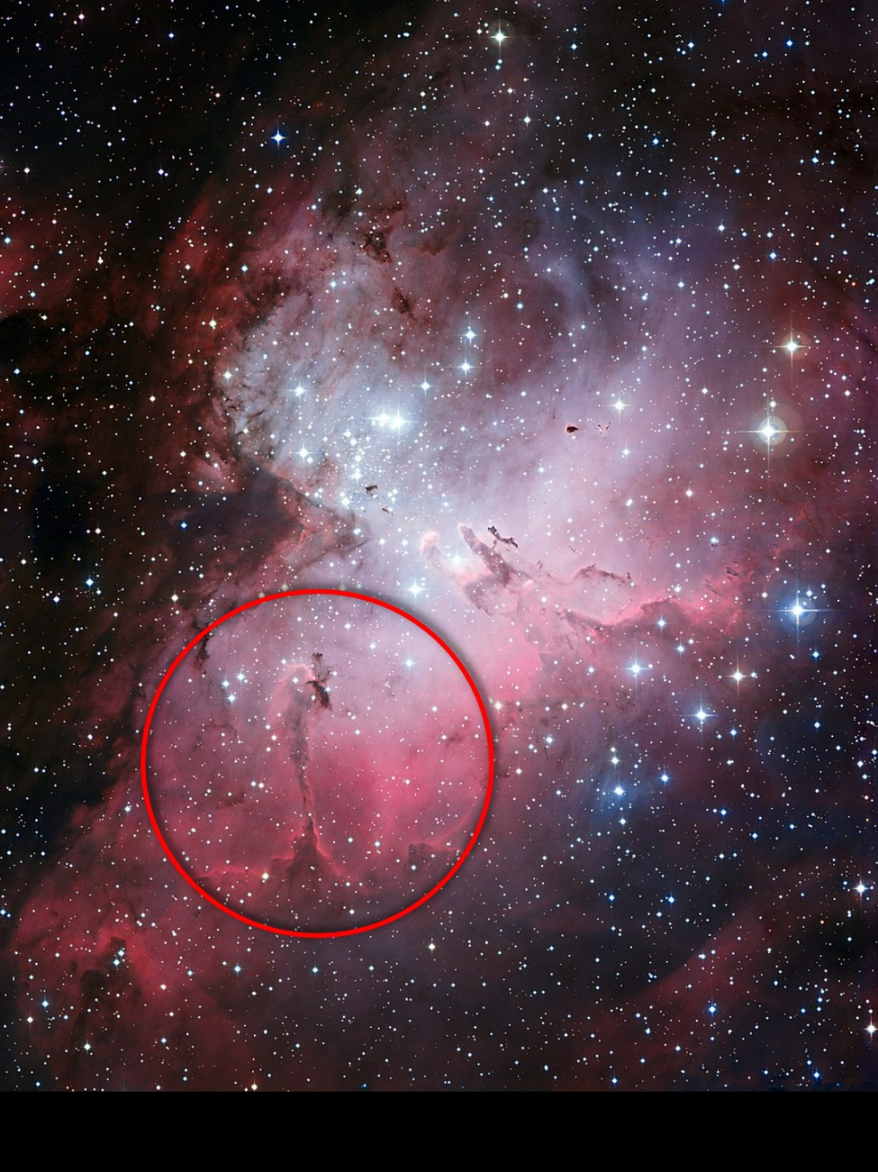

wikipedia's pillars of creation's
"Black Pillar" spire on eastern perimeter
9.5 light-years long.

this view 9.5 light-years tall

wikimedia.org's

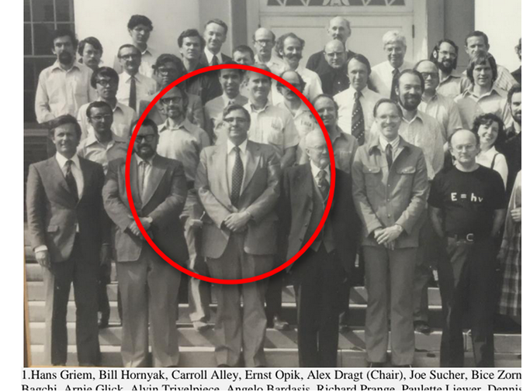

kim
circled
area created on 1974 june 27
based upon wheeler's sketch of eye

since time
merely illusion then
segments TIME EGGS all side by side

therefore wheeler's eye sketch TIME EGG
already located near
BIG BANG TIME EGG

photons as nebulae forming personalities
easily copied
wheeler's sketch of eye and pasted
onto nearby BIG BANG TIME EGG
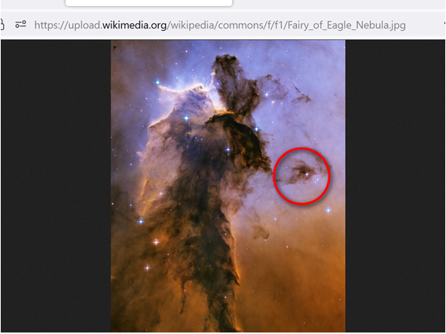

KIM NOTES

british physicist stephen william hawking
agreed with
wheeler's theory which kim now calls
CHANGEABLE TIME

wikipedia's

Stephen William Hawking (8 January 1942 – 14 March 2018) was an English theoretical physicist, cosmologist, and author who was director of research at the Centre for Theoretical Cosmology at the University of Cambridge.

Between 1979 and 2009, he was the Lucasian Professor of Mathematics at Cambridge, widely viewed as one of the most prestigious academic posts in the world.

Stephen Hawking
CH CBE FRS FRSA
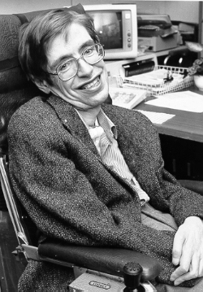
Hawking, c. 1980

excerpt from nautilus' amanda gefter

THE top-down approach “leads to a profoundly different view of cosmology,” Hawking wrote, “
and the relation between cause and effect.”
It’s exactly what Wheeler had been driving at when he drew the eye atop his self-creating UNIVERSE.

chapter ends

