HAPPY EVER AFTERS

by
kim martin klecka DDS BS



2026 january 15 photograph by Maxwell Lett

all rights reserved
preliminary draft 2026 february 05 thursday

concerning citizens of all countries kim
wrote
this governments upgrade book to inform
sincere religious and non religious persons

if all countries
adopt
this book as official strategy

then all humans
will obtain
reward of
honeymoon like ecstasy afterlives

this book
recommends prebuilding
thousand cities kim dubs DiameterCities to
hold world's population times three plus

workers' wages in prebuilding DiameterCities projects
would include
minimum of $25 usa dollars per
hour directly from governments' executive crews

DiameterCities' children by age eighteen
will earn
free electrical engineering degrees via Ai
upgraded via kim's SUNNYsideUP specifications

all nations
could heed
friendly alert mentioned by
makers of continent size statues

HUMANKIND and humankind alone
possesses
pivotal vote in shaping ETERNITY

governments working together
could prebuild and migrate to
solar powered DiameterCities with moral
SUNNYsideUP culture emphasizing FAIRNESS for ALL

in this way all humans
would escape
current hellish environment setting
awaiting all humans ever lived

this chapter ONCE UPON A TIME
reveals how
universe actually started

for more chapters and details viewers
please read
entire free book HAPPY EVER AFTERS
available for online viewing at shoelanguage.com

only desktop computers and laptops
show
images from HAPPY EVER AFTERS

HAPPY EVER AFTERS' information
eclipses
Bible's lesser amount of knowledge

foundational writings of all religions
possess
voids of information concerning continents' shapes

those foundational writings
never mentioned
globe's continents twisted into recognizable objects
as message board memorandums to humans

yet HAPPY EVER AFTERS
fills
those voids and puts globe's puzzle
pieces into logical sequence narrative

professors Alley and Bohm and Wheeler
contributed
various breakthrough scientific works for humankind
years before kim discovered continental statues

in this beforehand way those professors
unknowingly supported and proved
continents' puzzle pieces' narrative of universe

kim
dubs
synthesis of four items above
THEORY OF EVERYTHING

THEORY OF EVERYTHING
instructs
humankind on how to end all
diseases and wars forever

in new DiameterCities each family residence
will include
aeroponic greenhouse for growing crops as
wished to sustain family's food supply

with these strategies accomplished all persons
will possess confidence of
sufficient food and twin like kinship
with all humans on globe

categories of chapters of HAPPY EVER AFTERS

TABLE OF CATEGORIES

AlleyBohmWheeler THEORY of EVERYTHING science proof
chapters 003-005 G01-G05 H06

Artificial intelligences' initial intrinsic disaster goals
chapters 000 002 G08

BEARS organization's roots and actions through history
chapters H07 K01-K07 P10

BEARS aggressions against astronauts and pan africanism
chapters L06-M04

BEARS BIDEN
chapters U02-U07

BEARS BUSH
chapters N09-O07

BEARS CLINTONS
chapters N08 S01-S02 T02-T04 U08

BEARS MOUNT RUSHMORE
chapters O10-P07

BEARS OBAMA
chapters S05-S10

BEARS TRUMP
chapters T06-U01

BLOCKING all diseases habitually
chapters 000-005 D05-D09 F03-G01

concerning all diseases this book
explains how to unaidedly completely reverse
diseases via person's certain consistent actions

BOKO HARAM recivilize strategy NIGERIA ABIOLA
chapters R07-R10

CAIN and ABEL
chapters B08 D03

CITY STATES dubbed DiameterCities
chapters I03 I04 J04-J10 K09

COUNSELING TOOLS for emotionally resolving events
chapters 005 B09 K10 L01

DIANA PRINCESS versus BEARS
chapters S02-S04

EACH lady selects husband in nice way
chapters J08 J09

FOUR STATE SOLUTION to middle east
chapters 006 A01

KEITH MICHAEL KLECKA versus BEARS
chapters 001 D08-D09

KENNEDY trio and MARY JO KOPECHNE
chapters Q01-R01

PEARL harbor Hawaii inside job 1941
chapters K10-L05

VIETNAM heroic trio chapters M05-M10

WARS chapters O01-O03

WEEKLY curbing vote on gov conduct A01 A02

WORLDWIDE simple language dubbed SHOELANGUAGE
chapters W03-X06

YOUNG MARIA WANG'S SUMMER CAMP
short story for children puts this book's
startling discoveries into context with others
chapters A03-C08

in awe twin kim
dedicates
book to keith michael klecka educator
of kim concerning BEARS organization's lethality

kim
thanks
Katie Keith of United Kingdom

CEO of Barn2plugins Katie Keith
helped
kim utilize plugin Document Library Pro
for this website shoelanguage.com

Katie Keith
also encouraged
kim to create more sketches

in constructing narrative of actuality book
informs
humankind via snippets from many sources
including books and articles

kim
hopes
all such authors gain increased prosperity
via mentioning in this book

kim klecka
post office box 740031
6500 De Moss Drive
Houston Texas 77274

ONCE UPON A TIME

all humans
surprised that
titans deceived sincere humans via all
religions and approximately 200 big nations

yet friendly titan Cindy and company
twisted continents to form
physical museum concerning actual history and
instructions on how to upgrade humankind

statue involving mexico and central america
references
famous cartoon dog as symbol of
shocked humankind concerning continents' messages

humankind including kim
shocked that
globe actually message board constructed by
friends of humankind

kim
looked at
oxford atlas of world's gazetteer pages

for some reason kim
felt as if
some recognizable object existed in region
of mexico and central america

finally kim
rotated
oxford atlas' gazetteer pages of americas
until continents displayed recognizable literary character
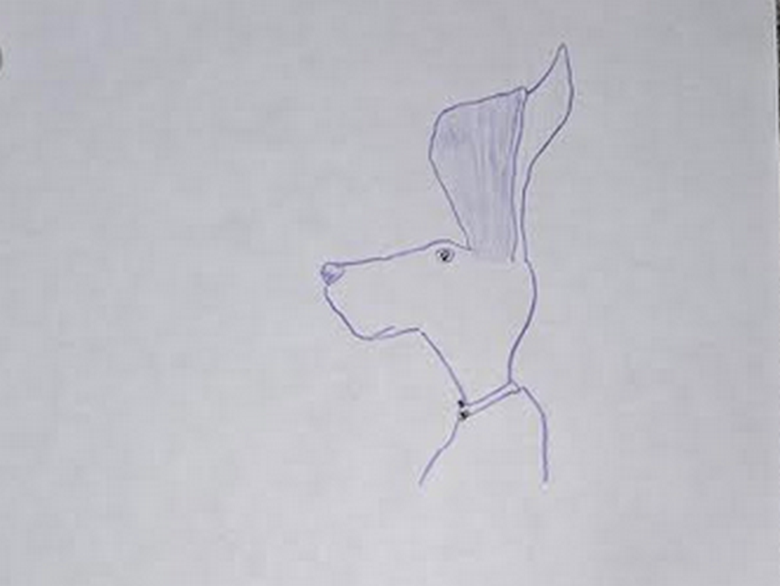
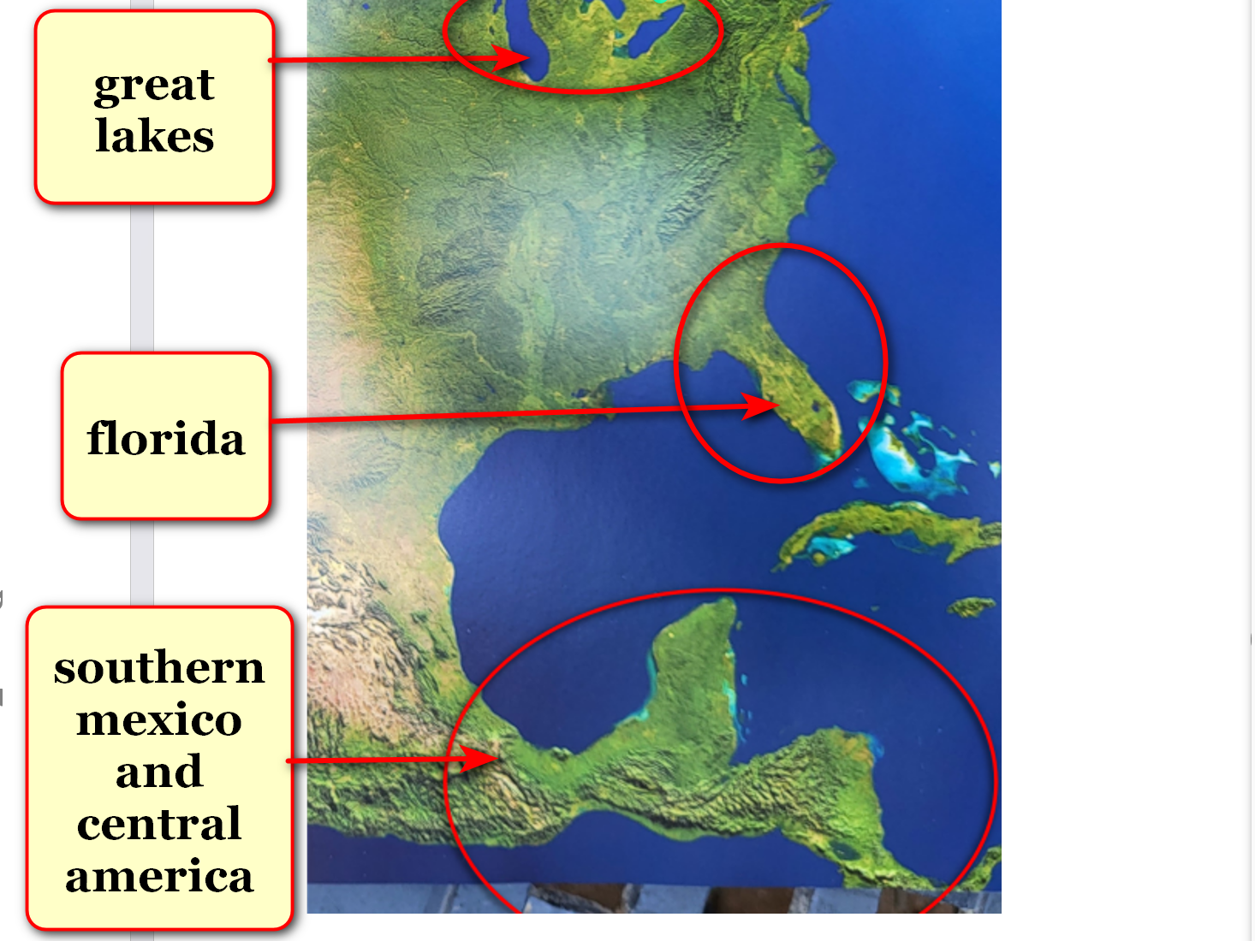
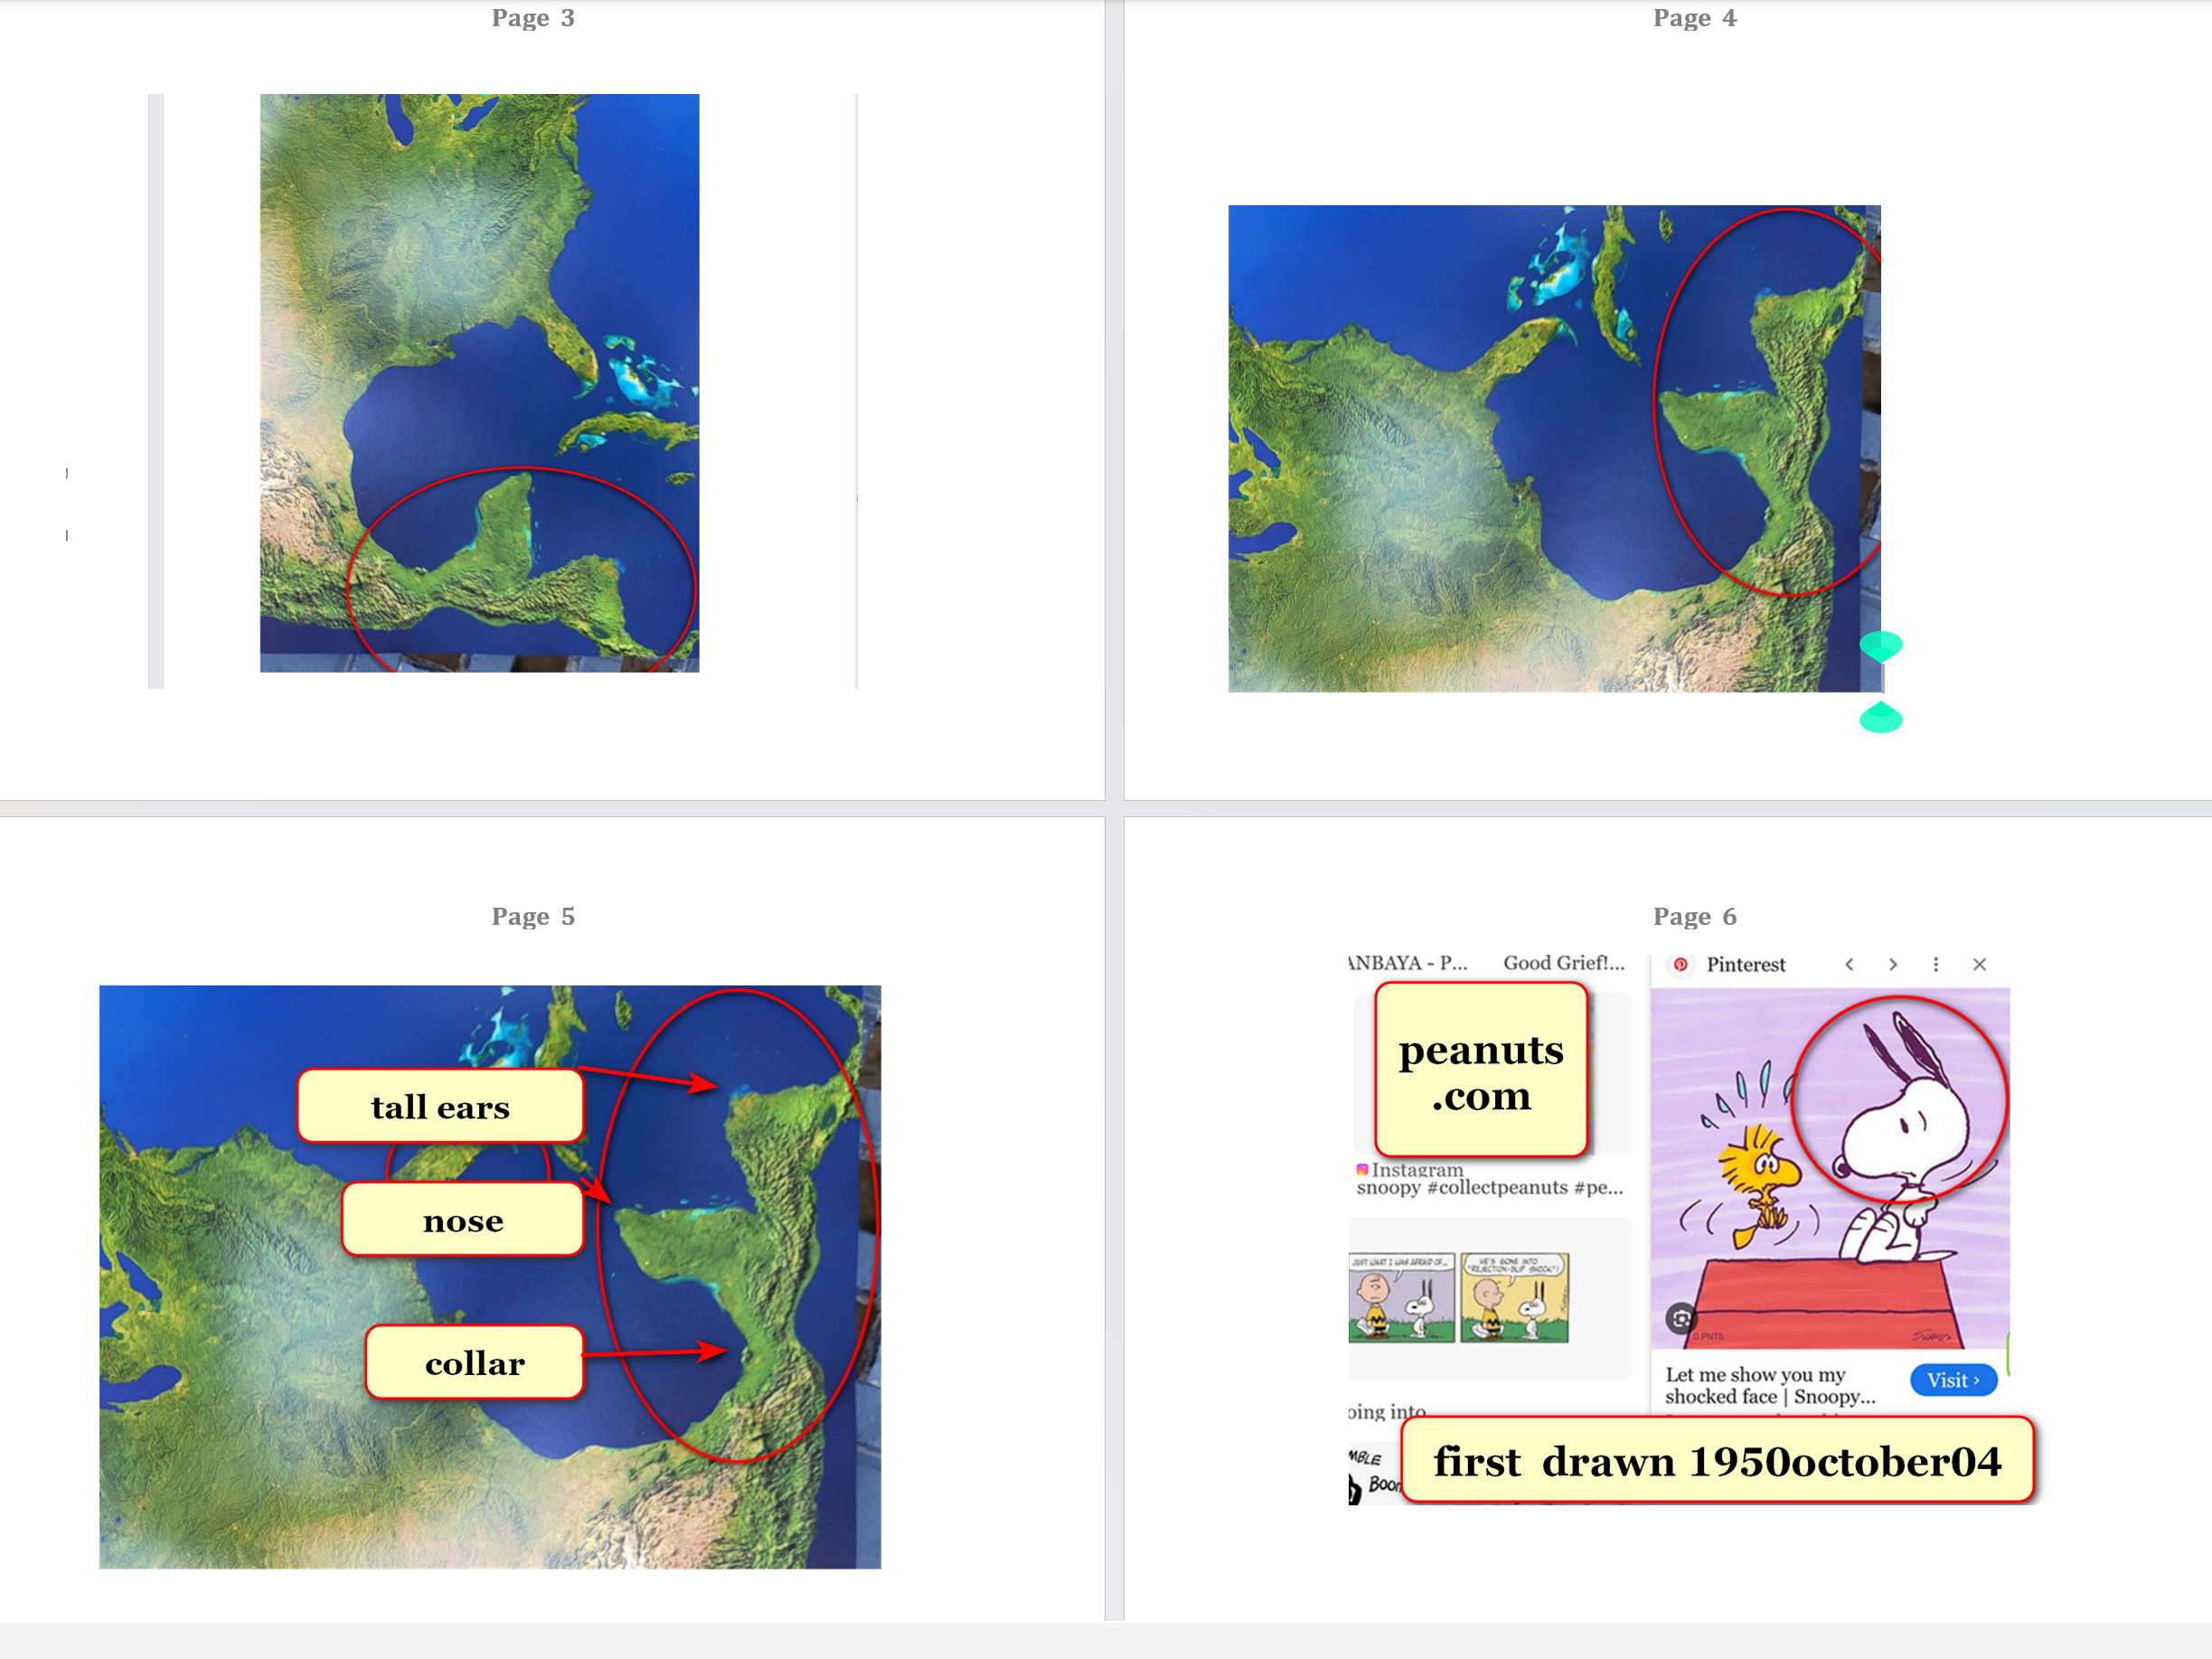-

all continents shapes taken together
declare
four titan snakes
equal entire universe

in symbolism florida's biggest lake
equals
right eye of one titan snake

kim
hopes
such paradigm upgrading statues encourage humans
to leave violence of SUNNYsideDOWN culture

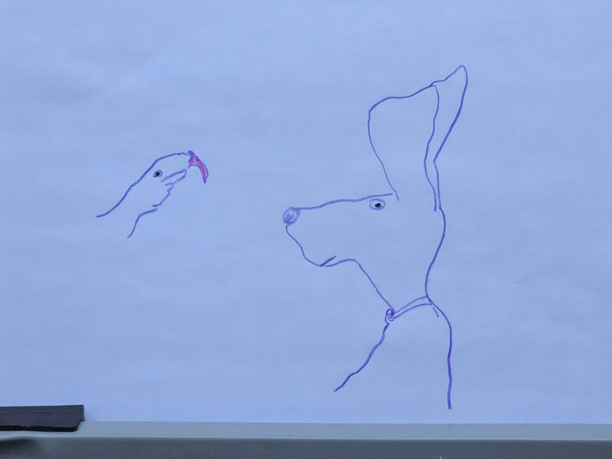

in beginning God
sad and lonely

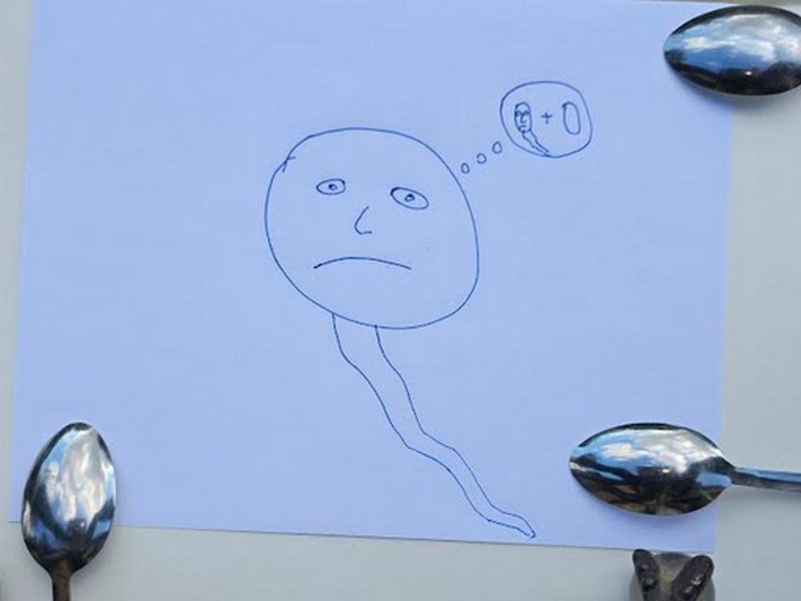
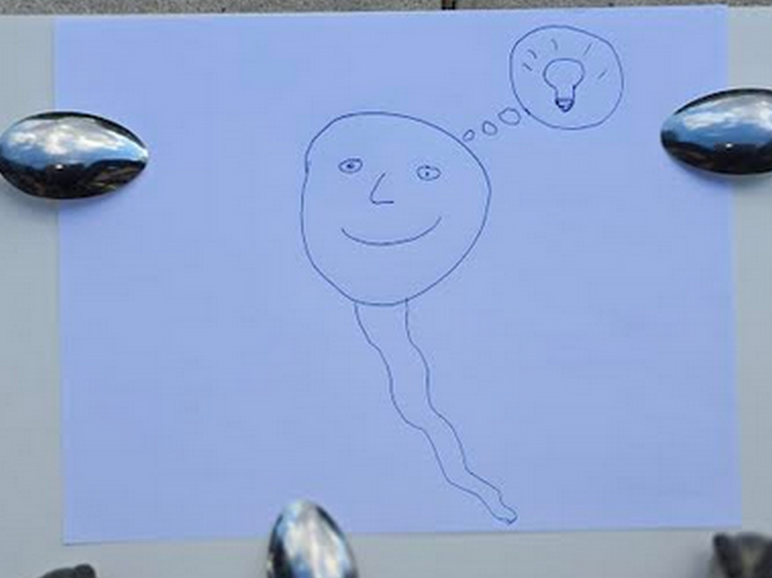
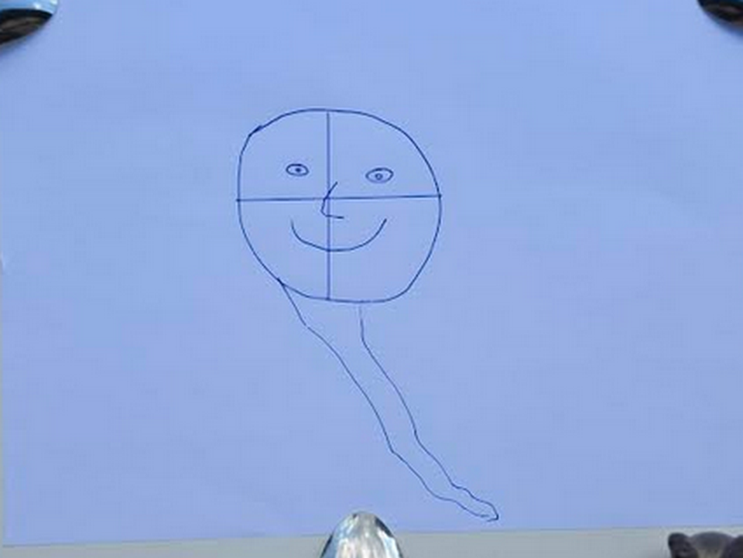
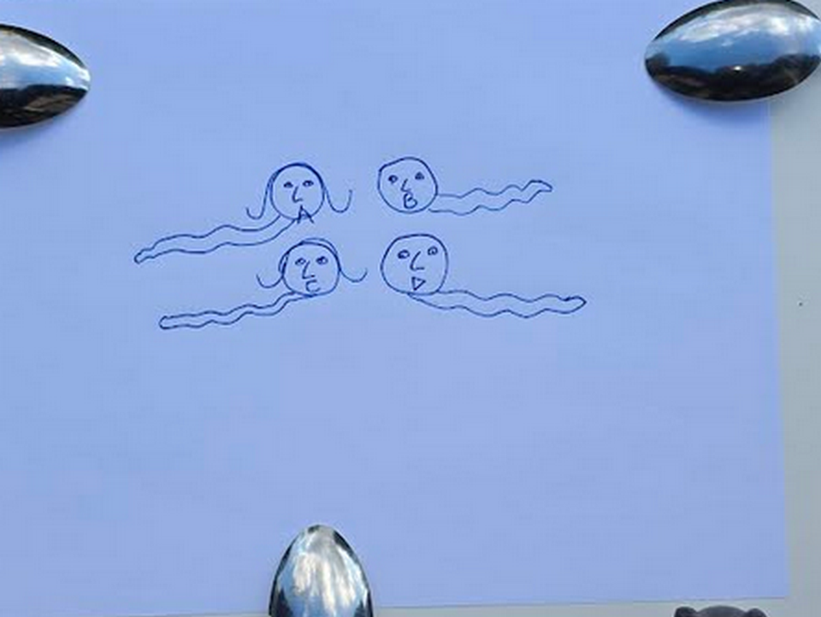

huge seamount statues
exist
below surfaces of oceans

east coast of asia
possesses
seamounts four side by side snakes
representing titans Alice Bob Cindy Don

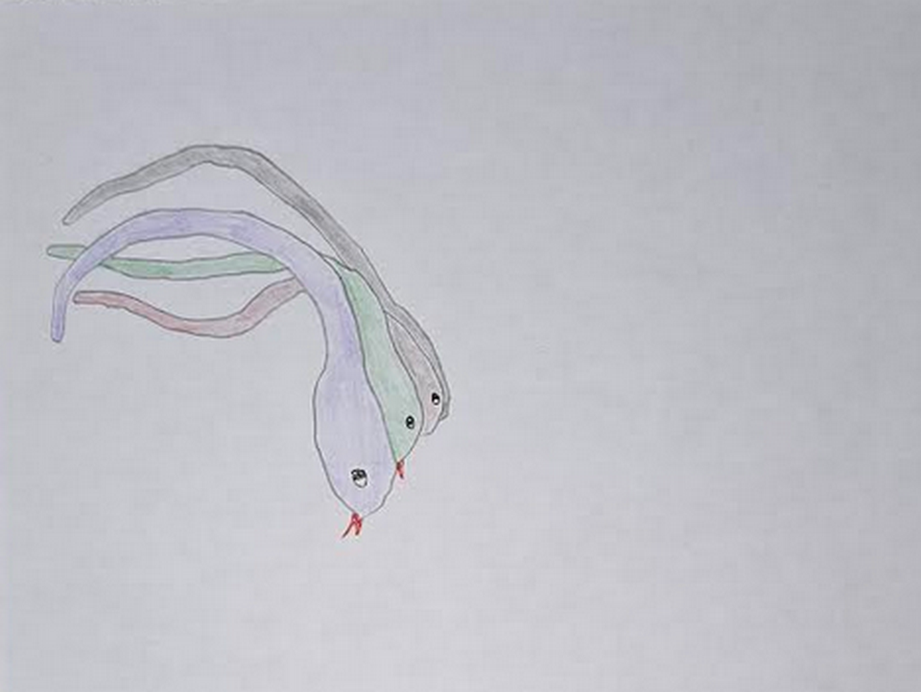

kim
dotted
eyes of three of four snakes

original photograph
available at
alamy.com

above squashed snakes
reference
emotional context of one dimension
original singularity dot

in one dimension dot personalities
emotionally touch
all other personalities such that
all thoughts known instantly by all

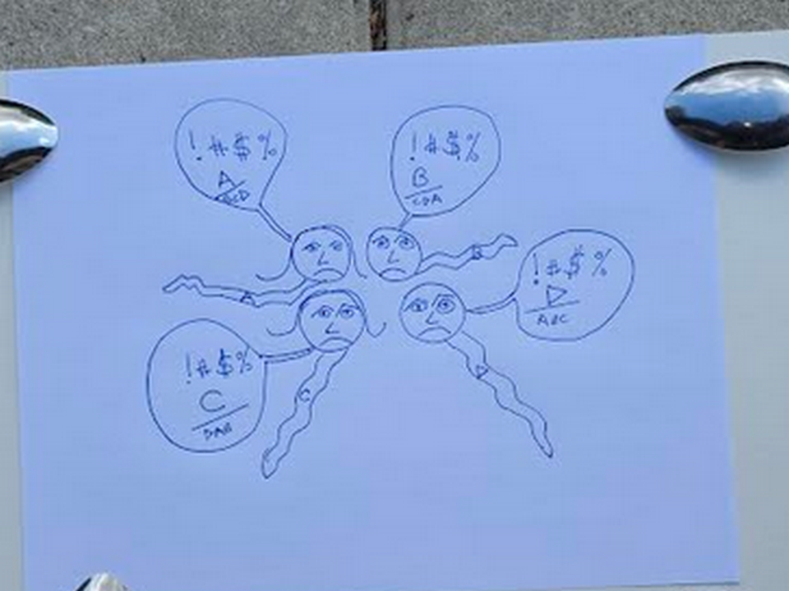
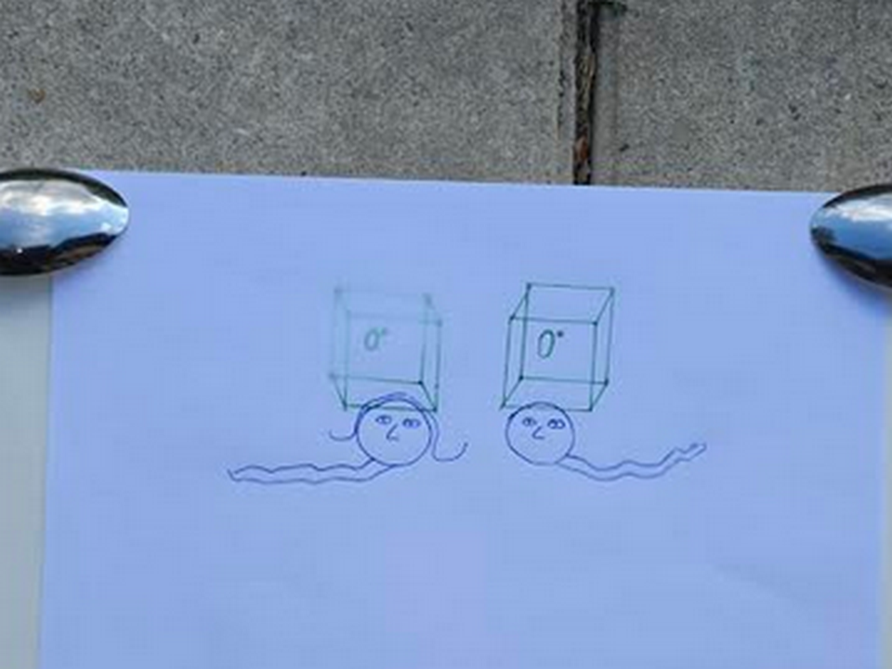
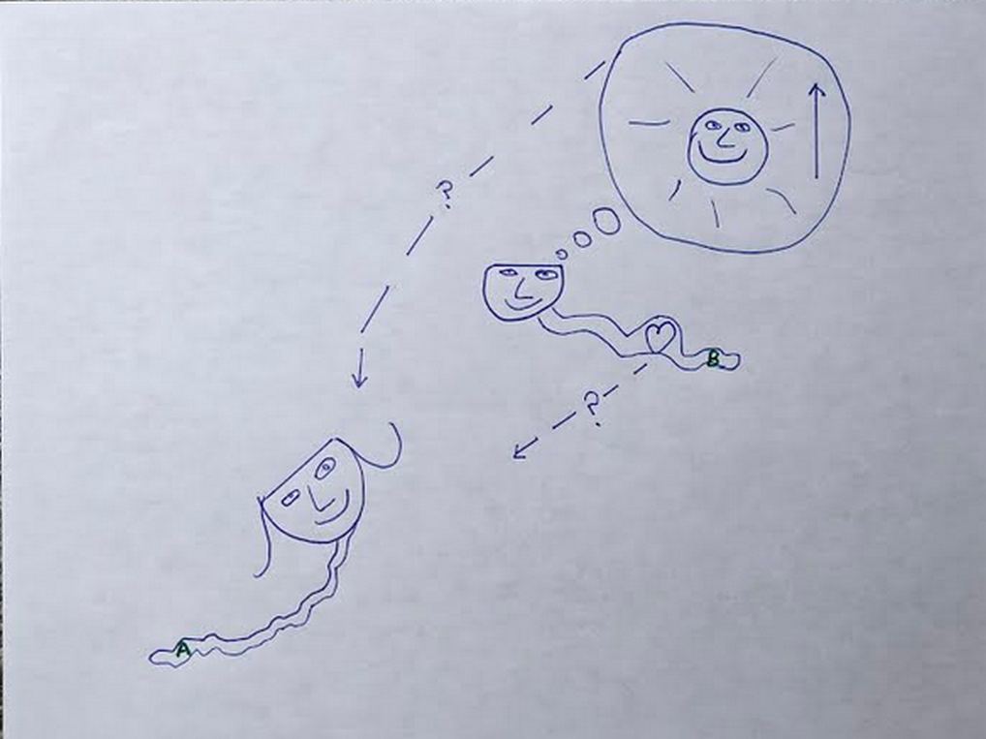

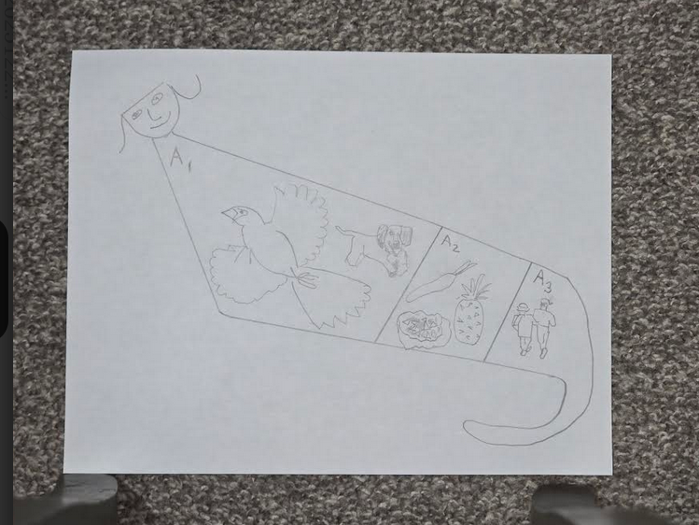
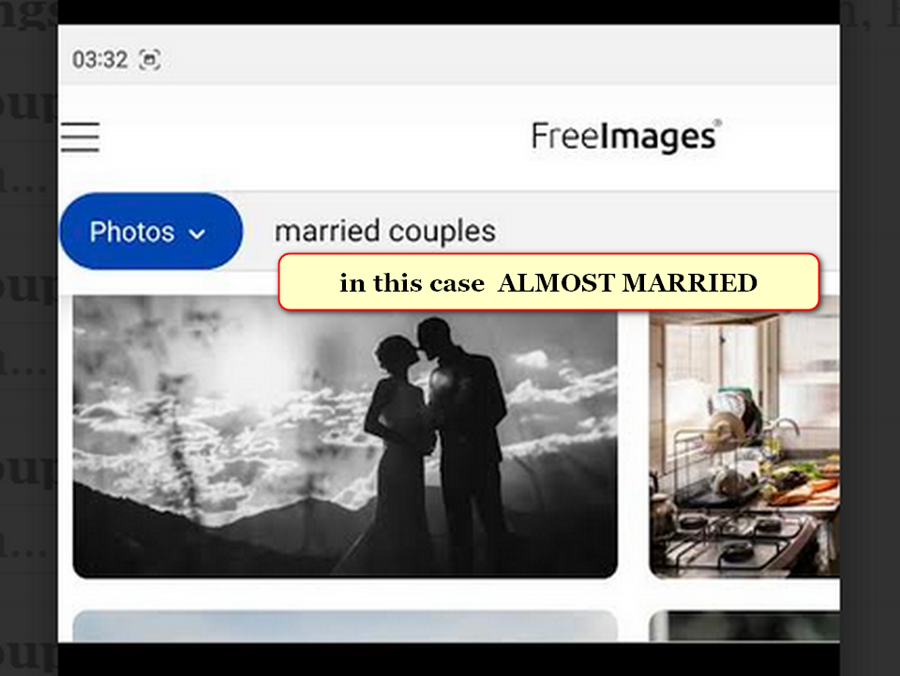
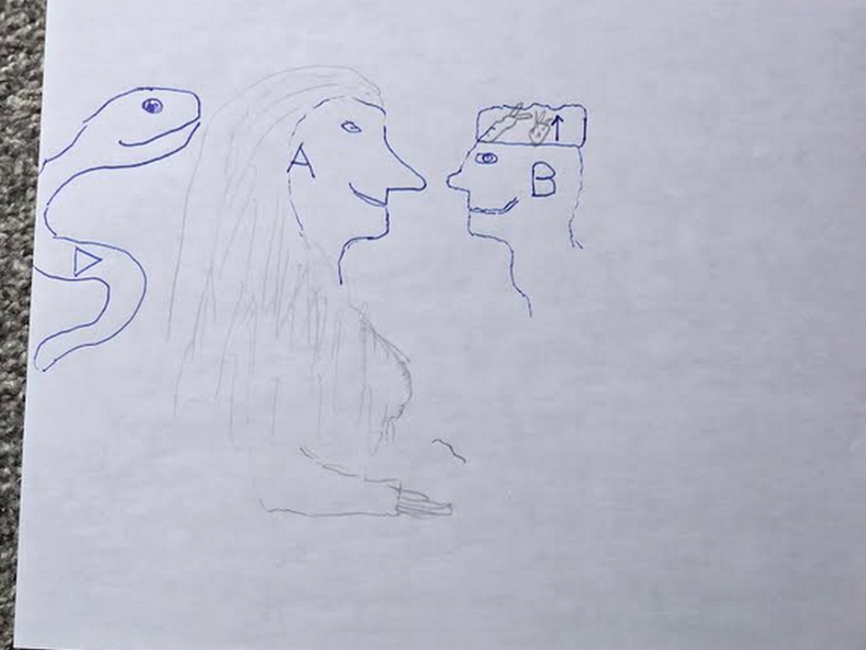
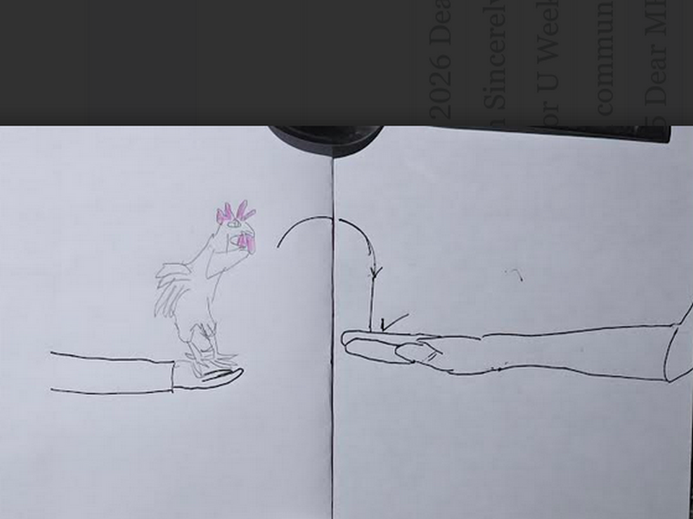


above island of sicily
symbolizes
chicken as
bride's gift to groom

mar's geography below
displays
groom Bob Jesus with wedding hat
symbolizing all fruits and all vegetables

year 2000 NASA
dubbed this
rock formation on mars CROWNED FACE
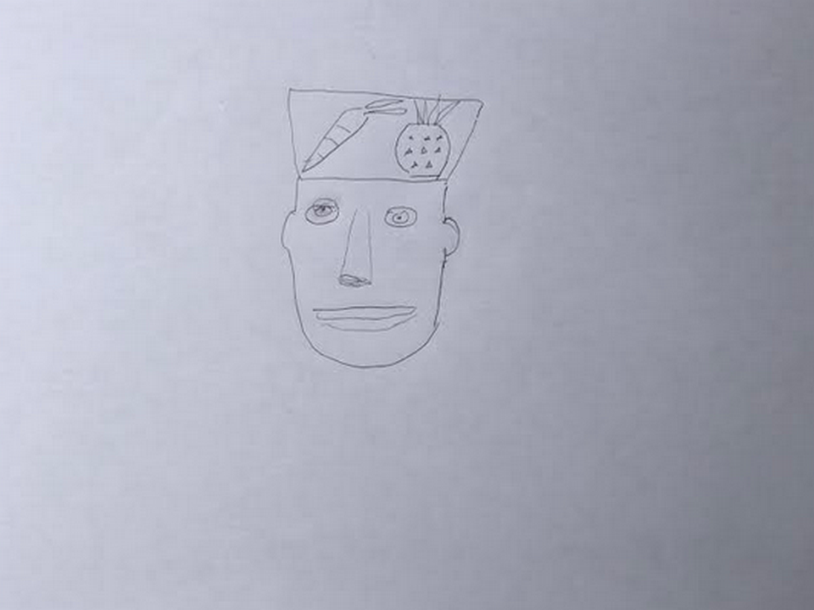

tsjournals.com
displayed
NASA picture from planet mars

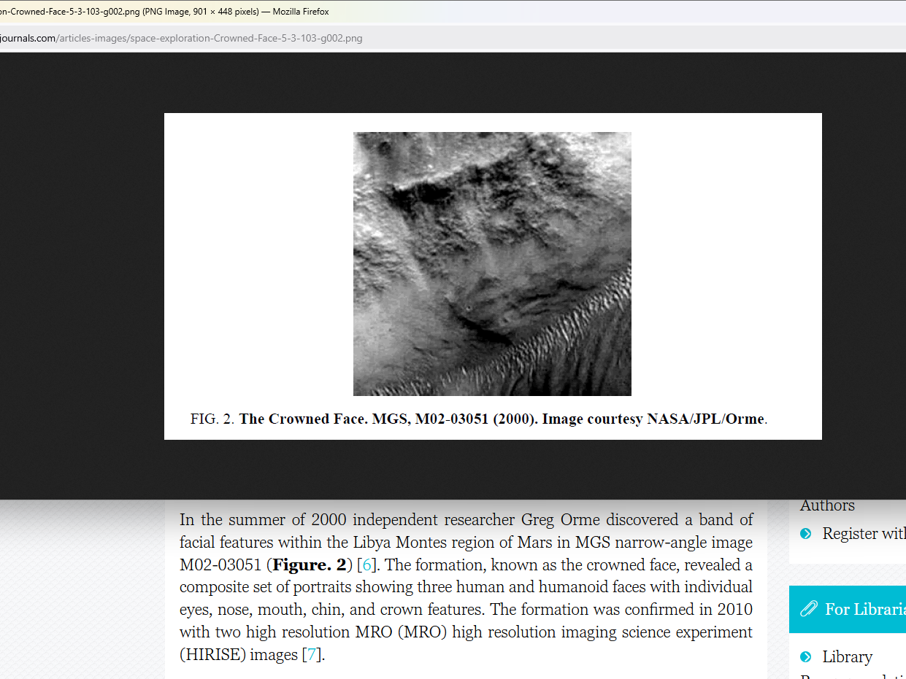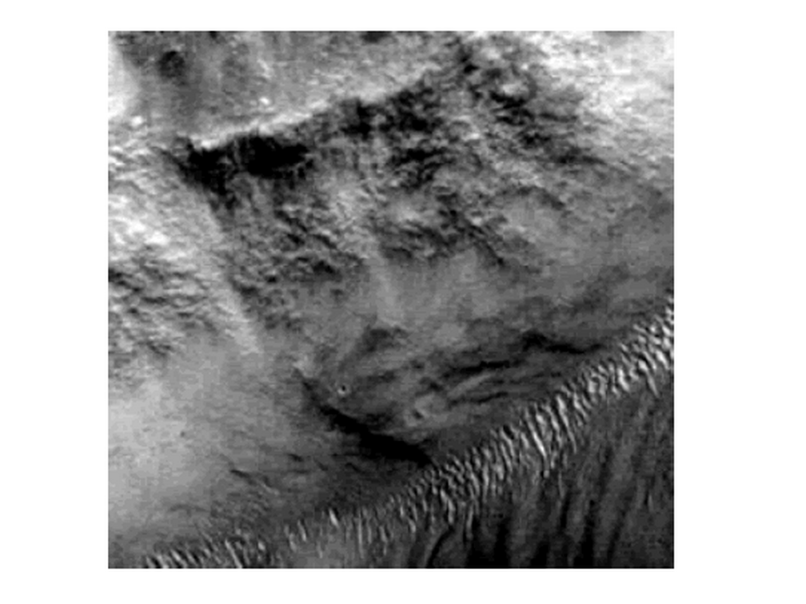

unfortunately titan Don Lazarus
stole
wedding hat and blocked ceremony
and imprisoned titan Bob Jesus

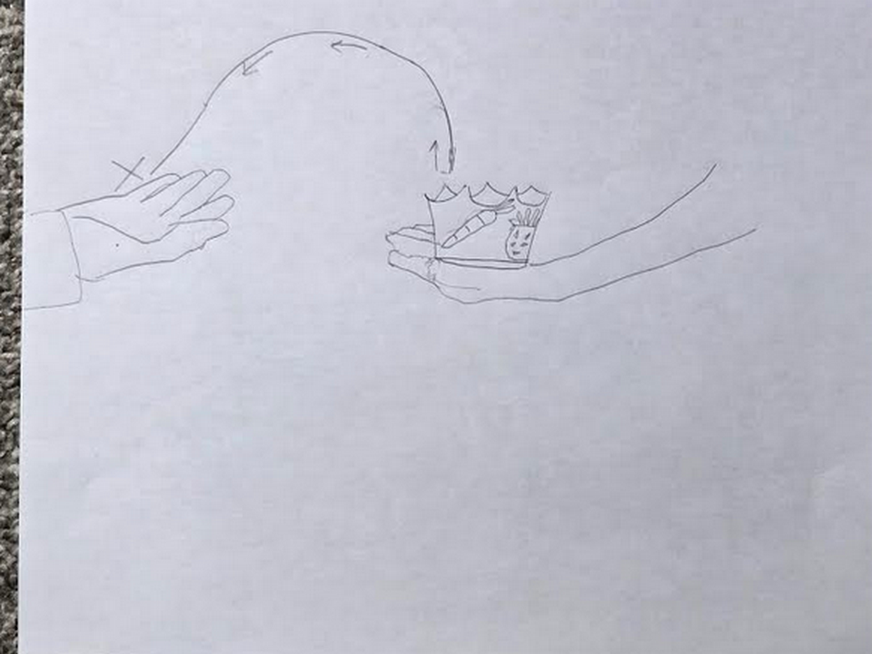
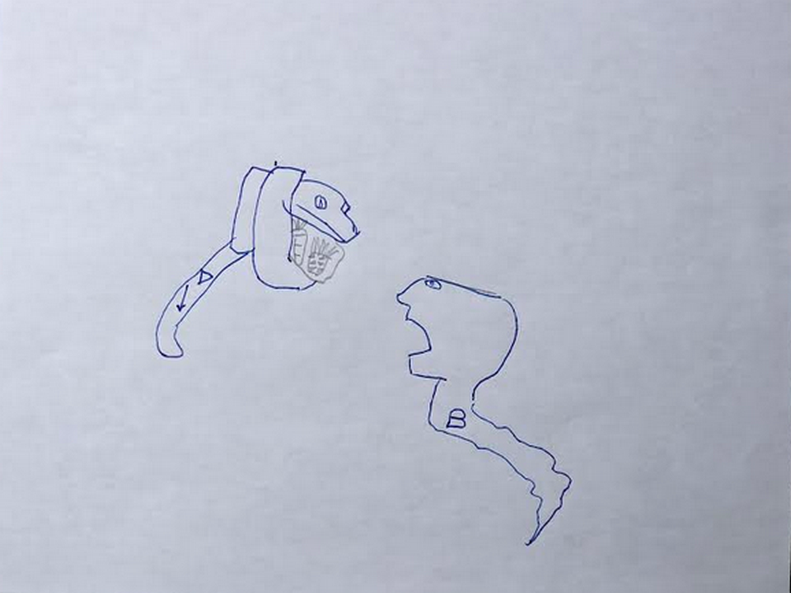
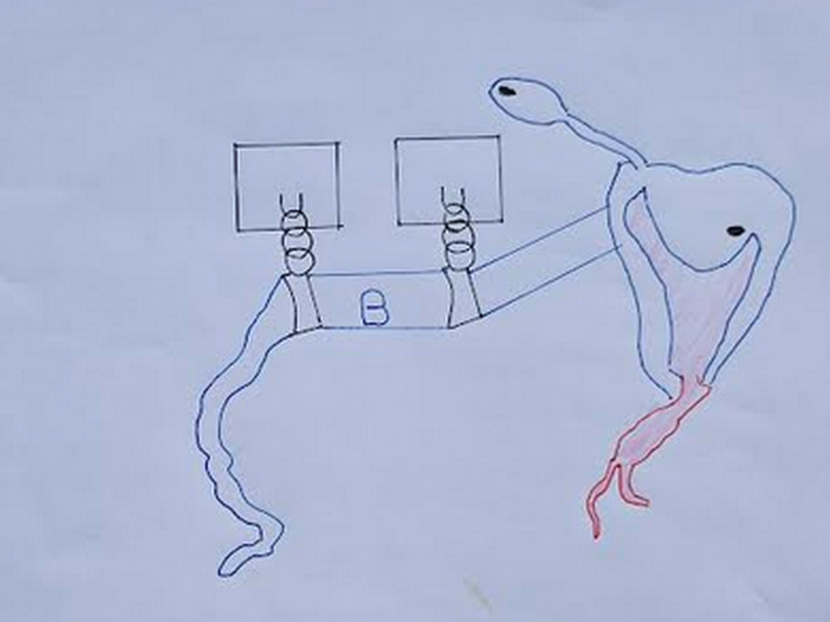

snake shaped titan
looks
at camera

island of fiji
symbolizes
left eye of titan Bob Jesus

new zealand
symbolizes
snake tongue of
titan Bob Jesus

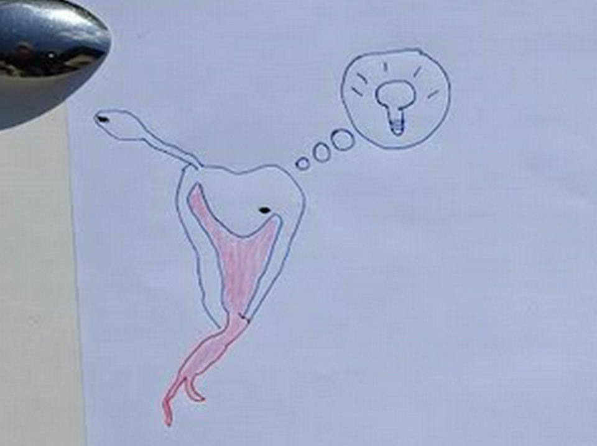

without options desperate incarcerated Bob
created
enticing deal including indentured servitude obligation

titan Bob Jesus
offered
deal to transform to BEAR

as bamboozling Bob BEAR titan
would encourage
with all creativity of Bob
SUNNYsideDOWN votes from humans

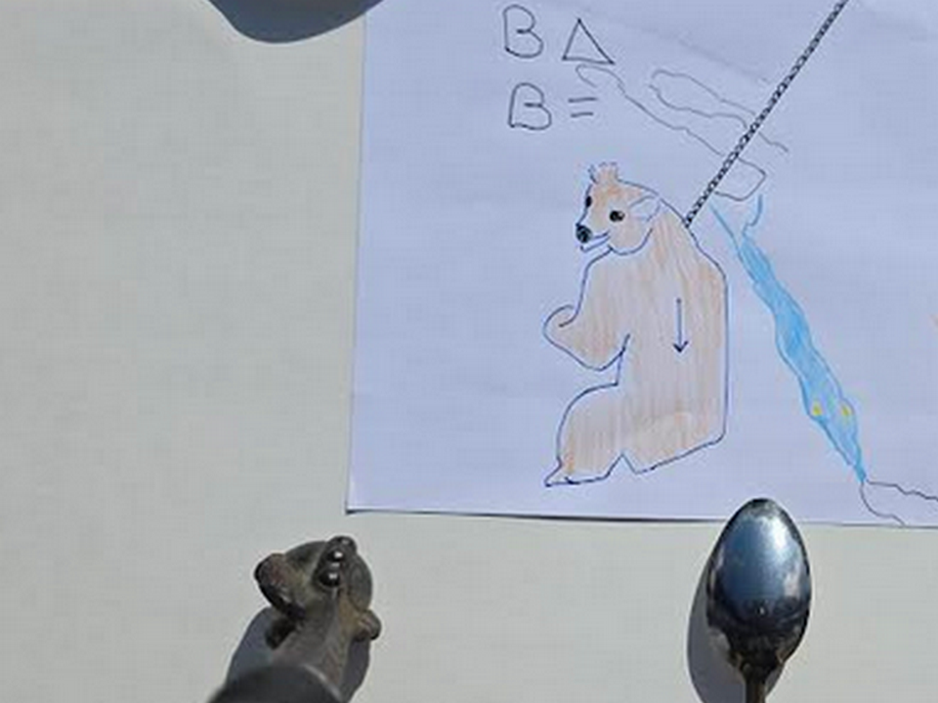

red sea
symbolizes
twisted spartan sword with leather straps
for wrist which symbolizes warring habits

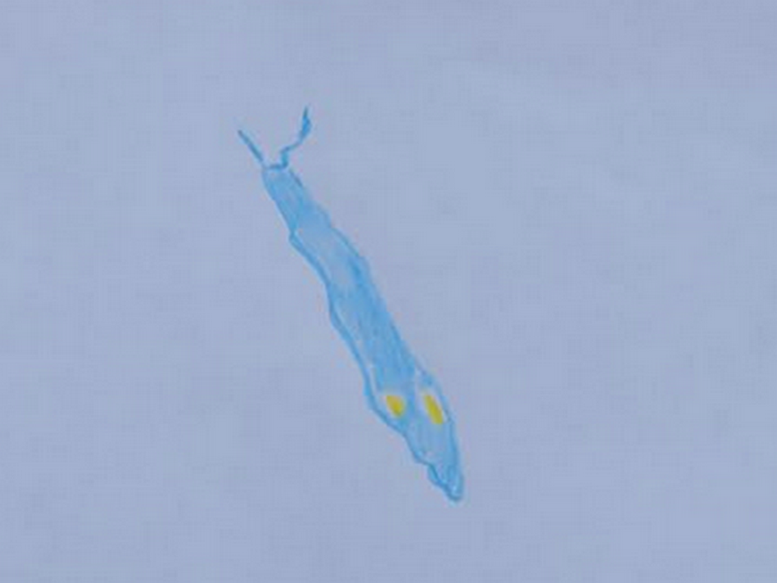

titan Bob Jesus
self obligated
persuading humankind to SUNNYsideDOWN signals via
contentions and violence etcetera including executions

red sea
also symbolizes
crocodile and two huge islands symbolize
eyes on flat head

crocodile as sword of all violence
symbolizes
Bamboozler Bob as SUNNYsideDOWN BEAR eager
to clip lives and create animosity

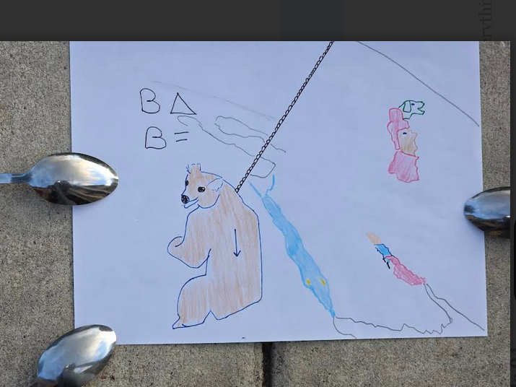

in year 300 sylvester and constantine
unknowing
that notions concerning BEARS
came from Bob

pope sylvester 1 and constantine great
accepted
incoming SUNNYsideDOWN notions to start
secret lethal controlling organization BEARS

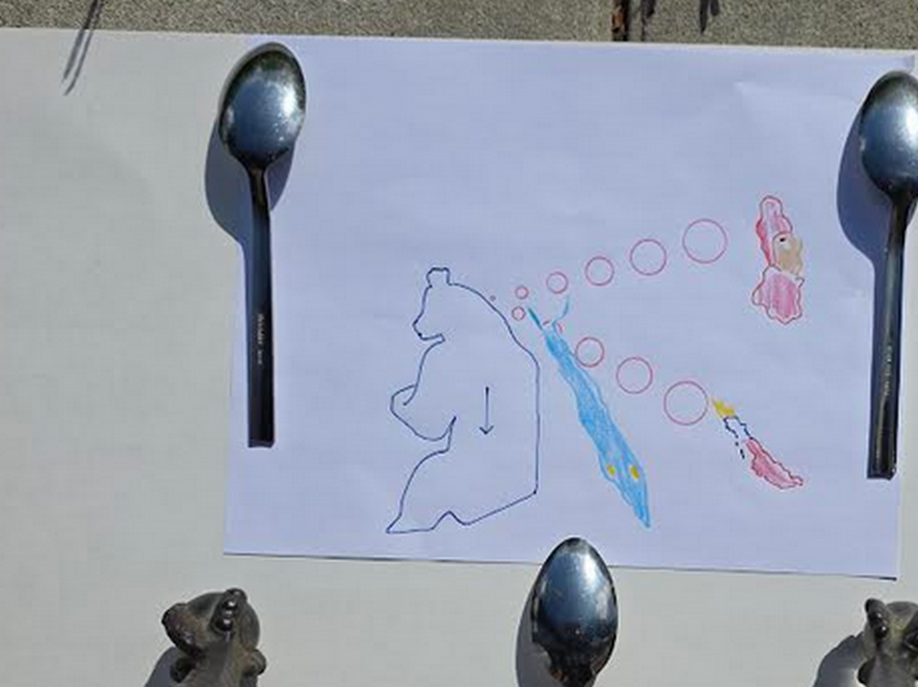

caspian sea
symbolizes
pope sylvester 1

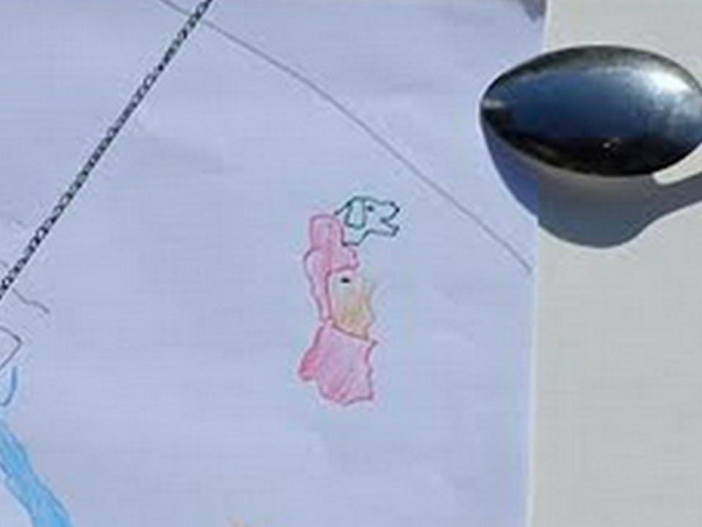

persian gulf
symbolizes
soldier constantine mixing poison for
clipping life of senior emperor father

constantine
assumed
leadership
morning after poisoning father

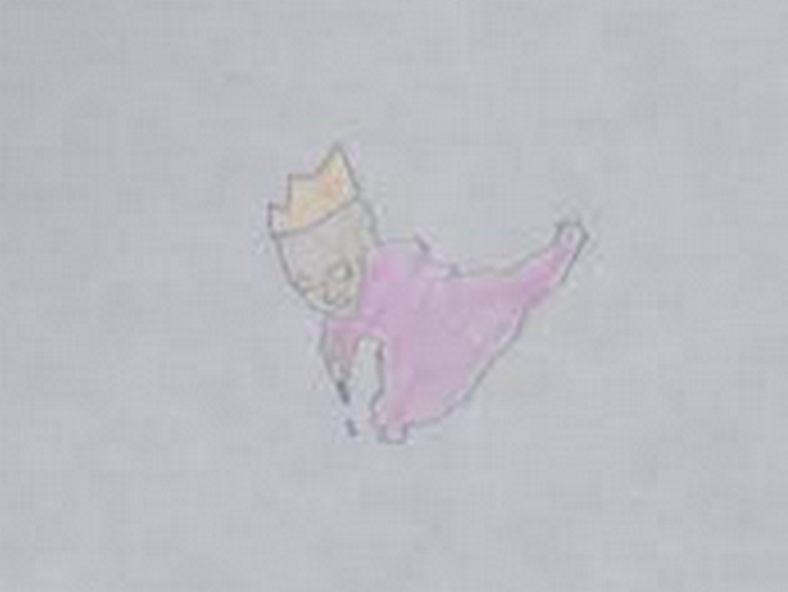

starter pair of humans' BEARS organization
created
secret bisexual league of poisoners and
killers continuing through this very year

caspian sea
symbolizes
sylvester's head thinking to snare sincere
christians' outlooks via sylvester's NEW TESTAMENT

loyal dog trapped
symbolizes
sincere christians deceived by sylvester into
unfair actions as if from God

pair
successfully quietly conquered
roman empire
by year 322 this current era

constantine
controlled
eastern lands of roman empire
from new city of constantinopole

preplanned DONATION OF CONSTANTINE
gave
sylvester secular king like authority
over citizens of western roman empire

sylvester
controlled
western lands of roman empire
from rome in italy

322 happily successful sylvester and constantine
joined with
fellow BEARS and decided to similarly
take over all governments secretly

to deceive citizens sylvester and constantine
gathered and officially promoted specific
letters promoting myths of royalty and
slavery as if acceptable to God

by year 331 sylvester and constantine
dubbed
that group of letters
NEW TESTAMENT

sylvester and constantine
convinced
people those letters dubbed NEW TESTAMENT
equaled God's Word

in this way sylvester and constantine
sought to deceive
following generations to permit slavery

concerning slavery sincere citizens
unknowing of
BEARS' grand NEW TESTAMENT deception allowing
BEARS' profits and secret bisexual fornications

plus NEW TESTAMENT
fostered
history books' adorations of present and
future BEARS as if God selected

above so called Word of God
claimed
notion that God personally inserted royalty
and gave DIVINE RIGHT of kings

in this way bamboozler Bob
creatively set in motion
brainwashing christians for generations to committing SUNNYsideDOWN votes up to including wars

wikipedia.org

The Fifty Bibles of Constantine are Bibles in the Greek language commissioned in 331 by Constantine I and prepared by Eusebius of Caesarea.

They were made for use of Bishop of Constantinople in growing number of churches in that very new city.

Eusebius quoted letter of commission in his
LIFE of CONSTANTINE

KIM NOTES

morocco and spain
bride and groom nose to nose

freeworldmaps.net's europe

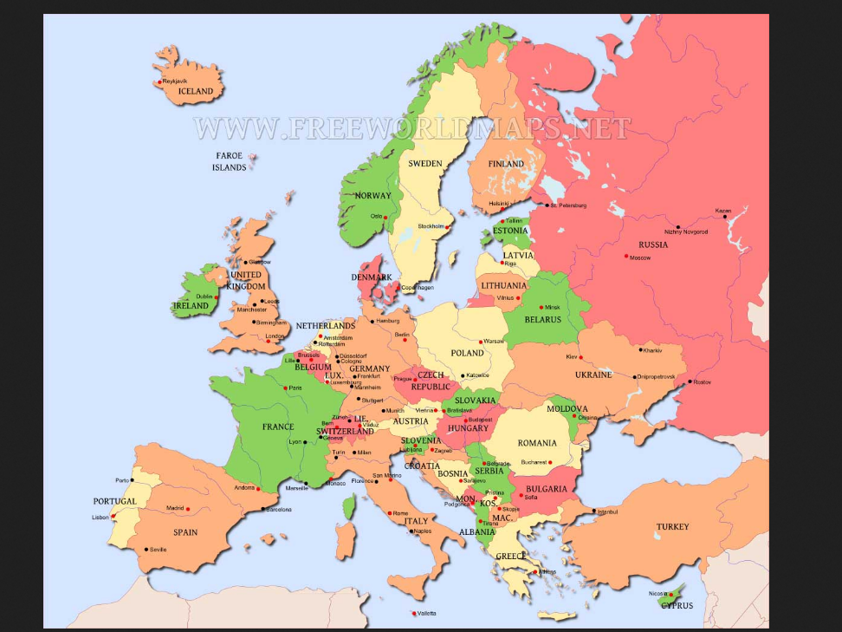

sideways view of europe
depicts
wedding of two titans

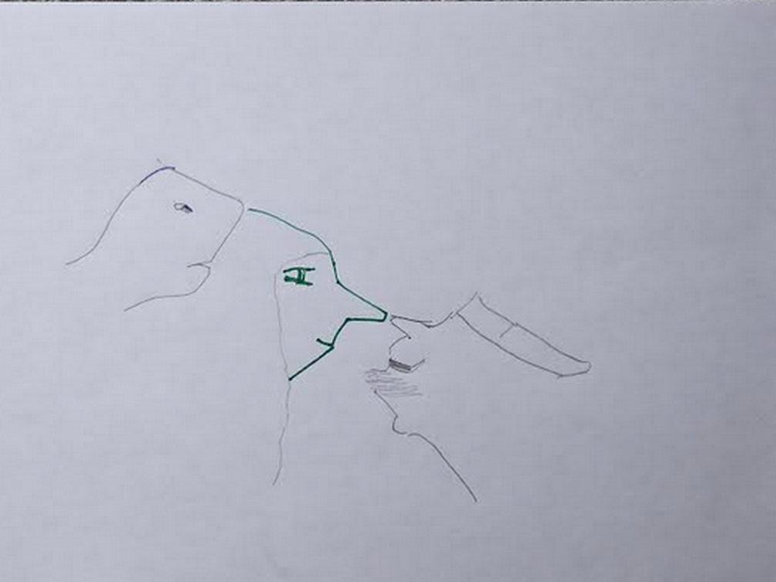

bride to be Alice Martha
successfully gave
wedding gift of chicken onto groom's
left hand connected to arm italy

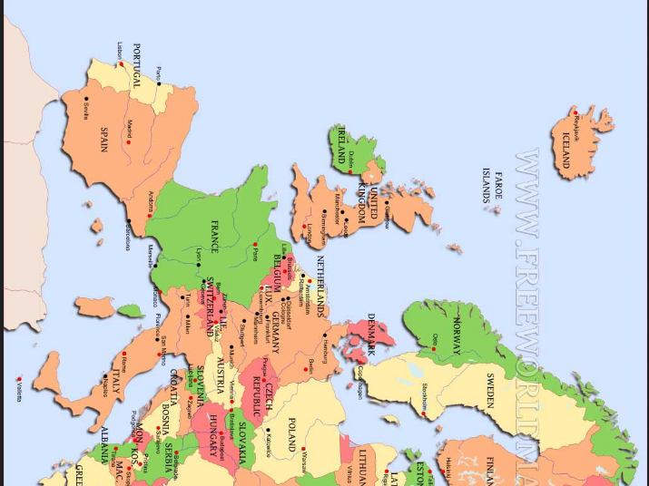

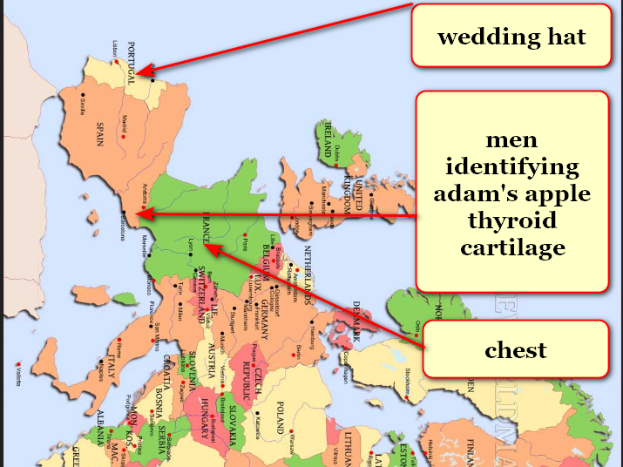

morocco and spain
display
first wedding party ever

snake face brother Don Lazarus
pretended
friendliness and agreed beforehand to give
away sister Alice Martha as bride

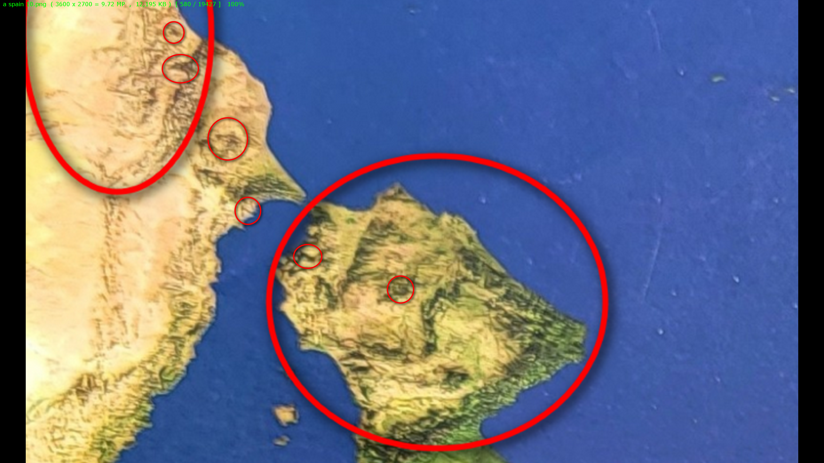

currently titan Don Lazarus
governs
holding cell afterlife containing earthlings
voting SUNNYsideDOWN at death

after universe's final tally Don Lazarus
shall obey
humans' total signaled wishes
including signals unknowingly made

but for now titan Don Lazarus
enjoys administering
back to back nightmares that cause
emotional agony and torment

if humankind
avoids adopting
this book

then titan Don Lazarus
gains
one additional eternal pleasure

that pleasure
includes
inflicting unyielding pain to
all humans ever lived

entire continent of south america
symbolizes
honored guest Don at 2D wedding 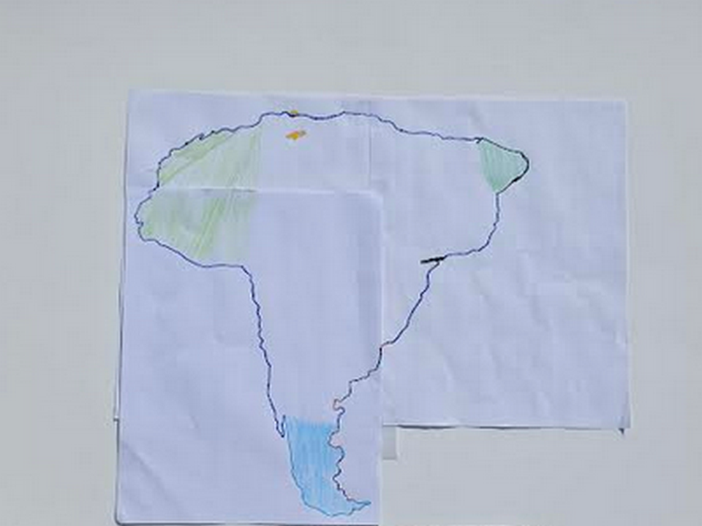
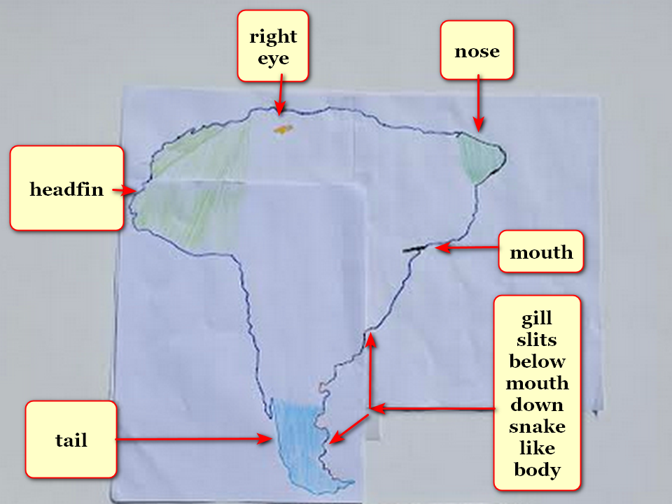

smallest bits of light dubbed photons
made
continent's tail smaller emphasizing further distance

above photon strategy
shows
viewers that Don Lazarus possesses
very long snake like body

planet earth's two dimension existence
included
water covering entire flat disk

many of this book's annotated pictures
started with
Oxford Atlas of World gazetteer photographs
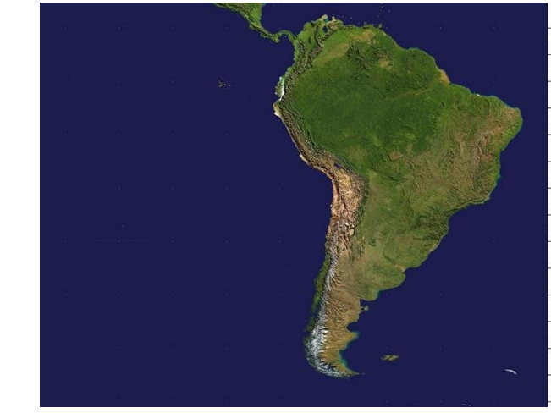

without other options desperate incarcerated Bob
created
enticing deal including assuming new personality bent upon enticing humans to summon disasters

titan Bob Jesus' two crowned faces
depict
emotional mindset transitioning from SUNNYsideUp to SUNNYsideDOWN Bamboozler Bob

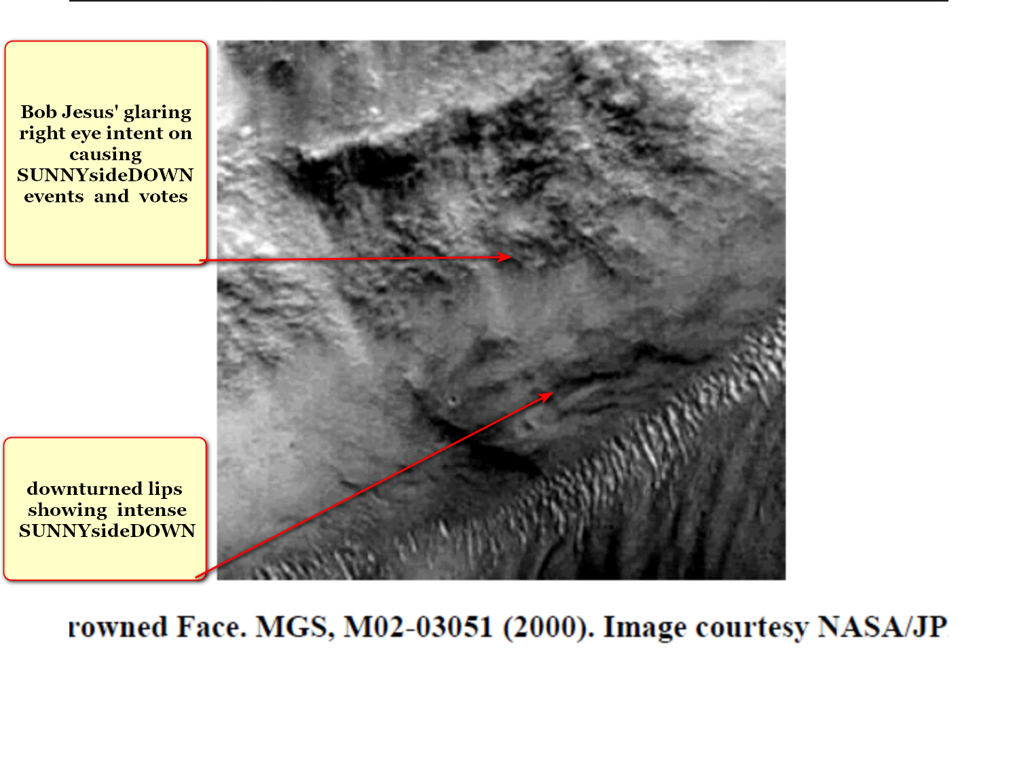

deal
included
bereft groom Bob Jesus requesting
Cindy Mary possibly marrying Bob Jesus

Cindy Mary
voluntarily said
yes to proposal of marriage

therefore photons as artists
utilized
morocco simultaneously depicting both twin
sisters Alice Martha and Cindy Mary

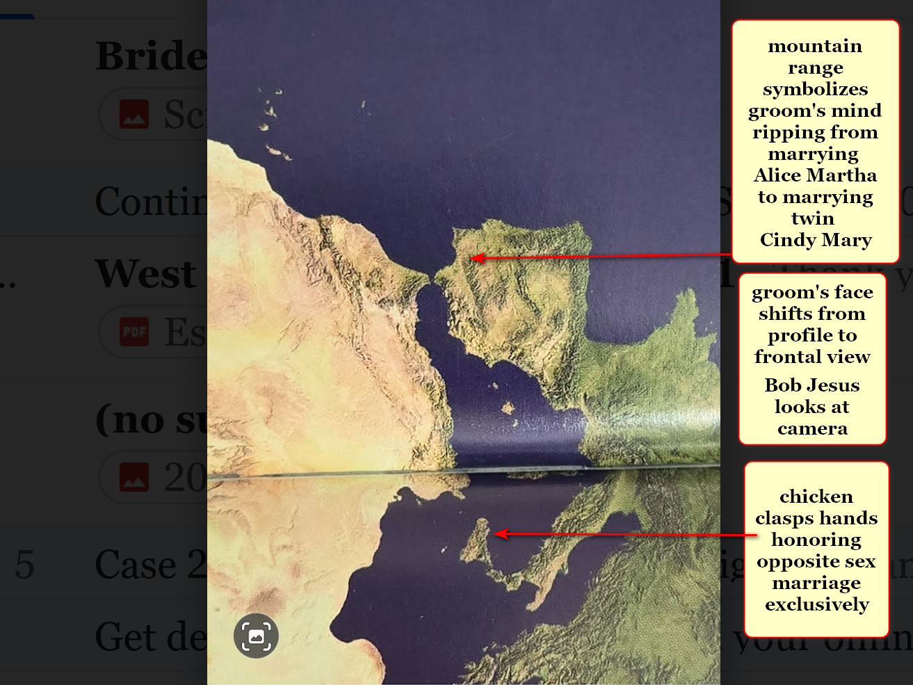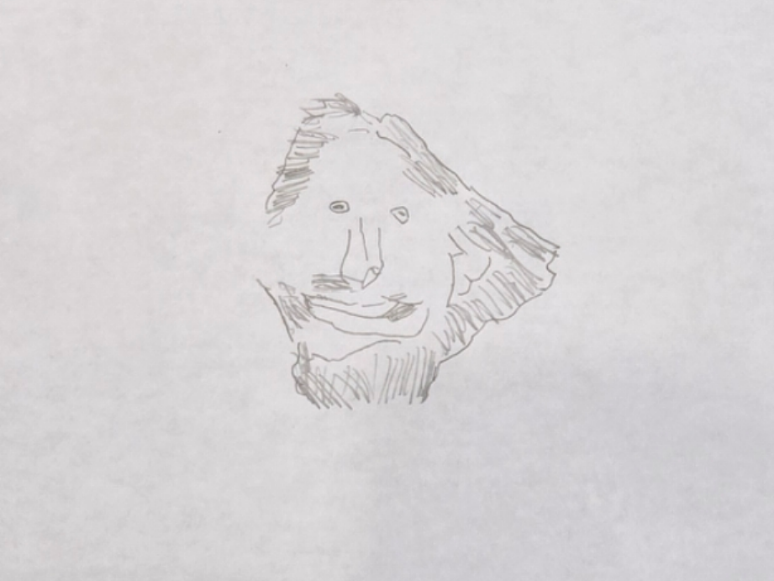
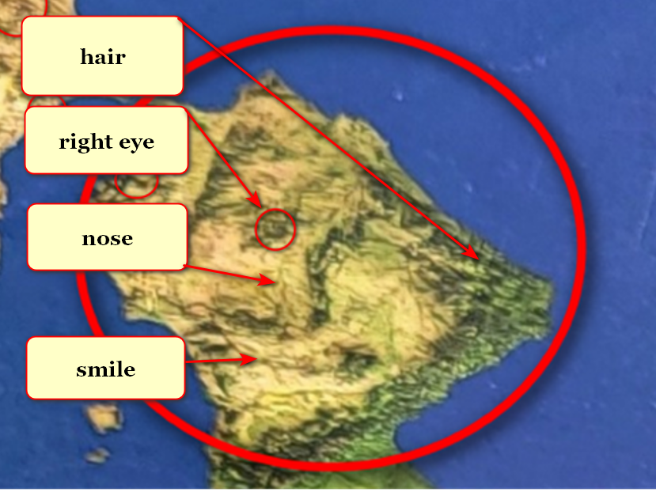
titan Bob Jesus symbolized by peninsula
grins because expects
humankind's nations to adopt this book
despite Bob Jesus' best obligated efforts

titan Don Lazarus as south america
looks eastward
toward africa because awaits humankind's decision concerning prebuilding rent free SUNNYsideUP cities

if total migration enacted Don
will obey
humankind's preference for SUNNYsideUP

because of above physical vote Don
will convert to
SUNNYsideUP

because of above humankind's collective afterlife
shall also convert to
SUNNYsideUP environment with
continuous honeymoon like ecstasy

therefore Cindy and company
strive to recruit
Don to SUNNYsideUP via reforming this
generation's human BEARS members

in this way titan Cindy
strives to undo
legacies of BEARS starters pope sylvester
and emperor constantine so called great

page from oxford atlas
gazetteer of nations

page
stars
titan Cindy Mary opposing sylvester 1
and constantine great

bodies of water
symbolize
sylvester 1 and constantine great

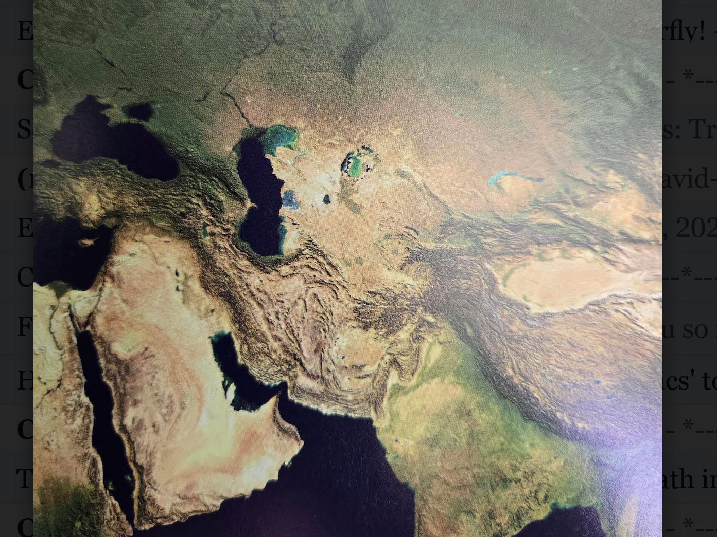
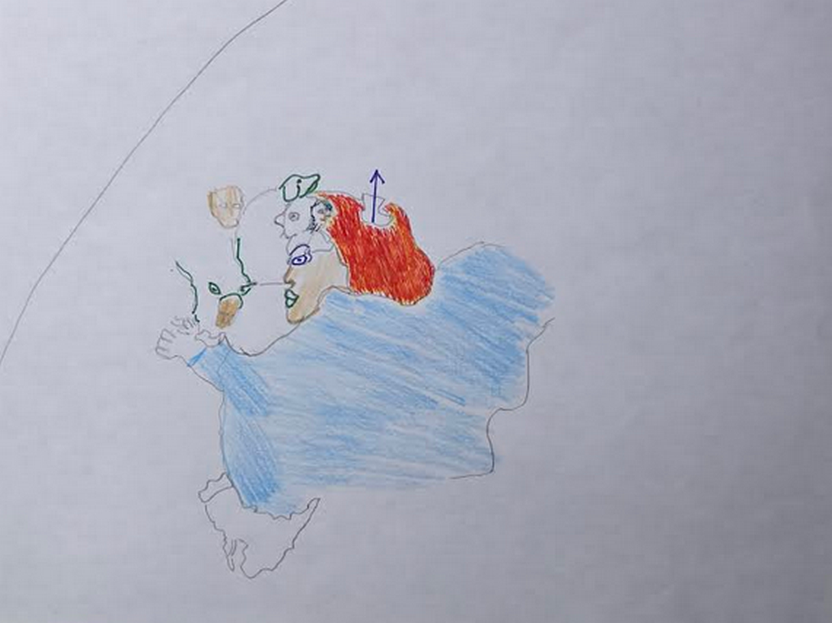
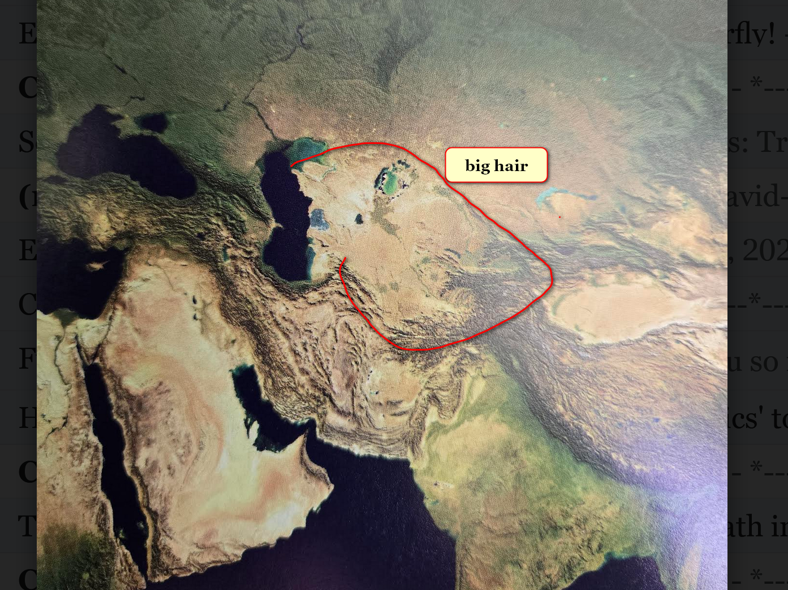
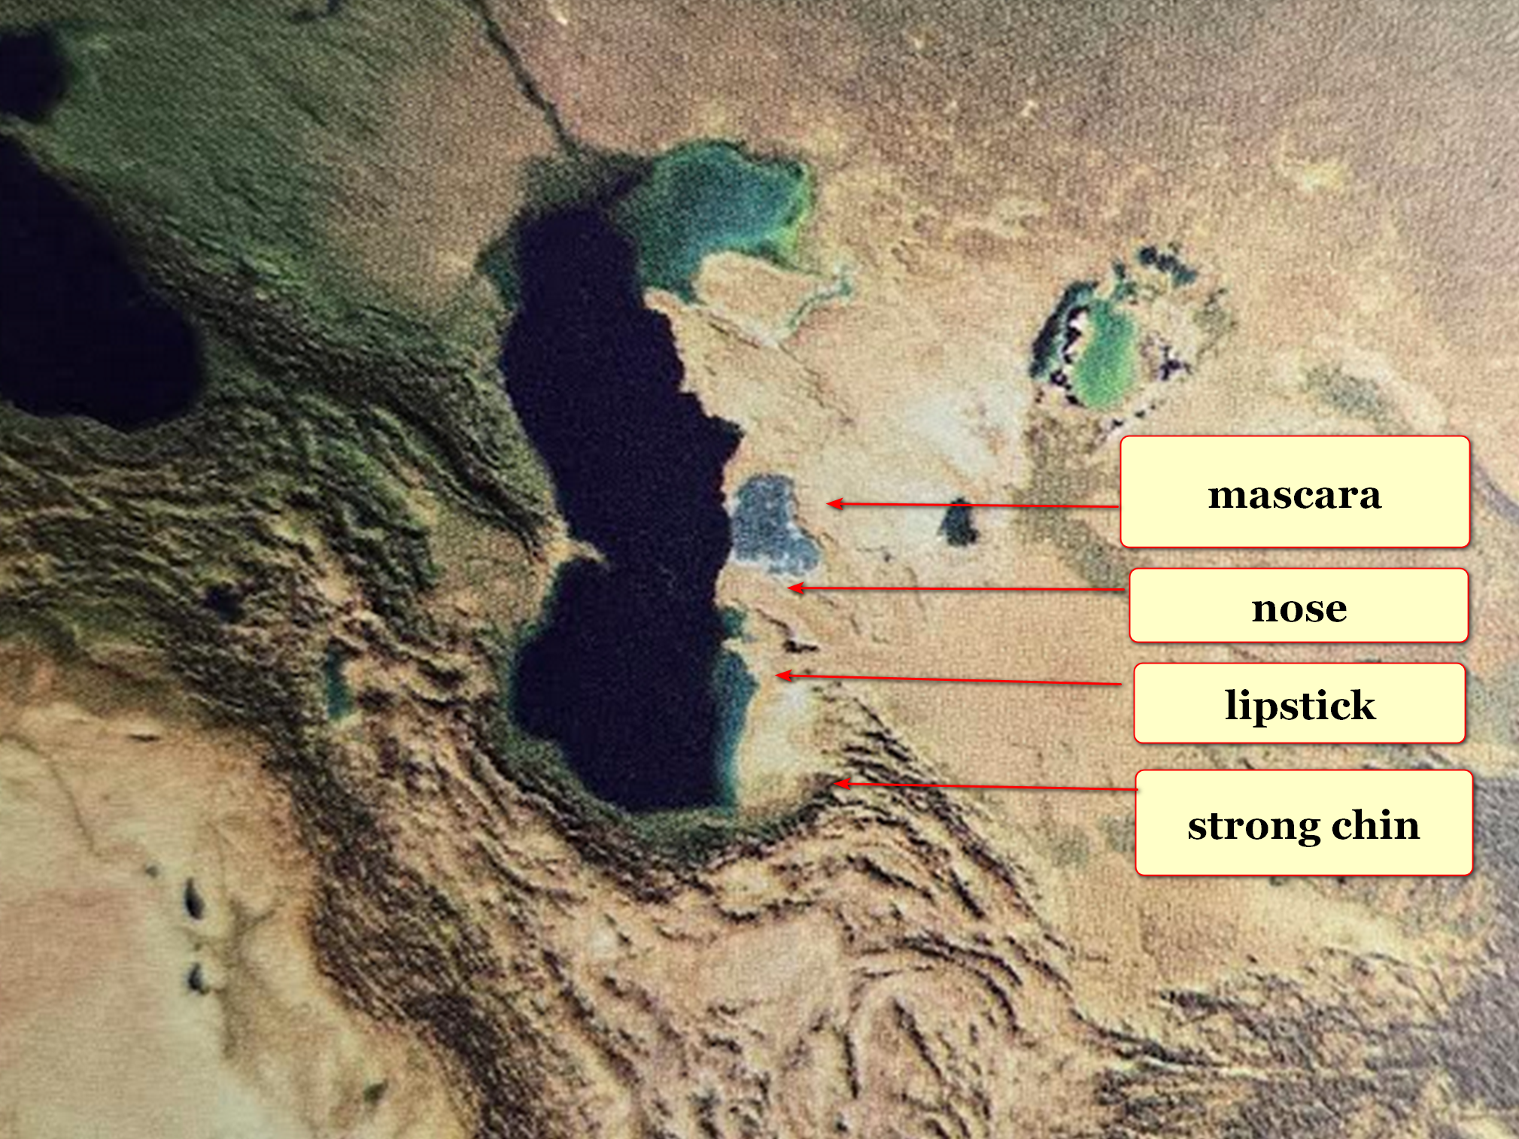

2024 june kim
completed
website shoelanguage.com satisfactorily

initial month all text and images
displayed perfectly on
all devices including cell phones and
tablets and laptops and desktops

however starting 2024 july book's images
absent from
devices like phones and tablets

plus cell phones and tablets
only display
75% of book's text horizontally

therefore viewers with devices
need to
scroll sideways to view other
25% of each sentence line

kim
reached out
for help

yet IT departments at companies involved
declared
hardware and software functioned perfectly

highest level experts of those companies
could not explain
those two unusual behaviors of all
devices concerning HAPPY EVER AFTERS

globally cell phones and tablets
still refuse to display
HAPPY EVER AFTERS images and refuse
displaying 100% of text on screen

kim
deduced
blockage more than natural glitch

kim
concluded
blockage actually holographic and therefore
intentionally administered

on subconscious level humans' limbs parliaments
agreed to temporarily block
HAPPY EVER AFTERS images
from all humans' devices

when enough humans majority of humans
agree to adopt
this book as humankind's upgrade strategy

then full functioning devices
will automatically restore
concerning displaying this website

above open ended situation
proves
actuality of all themes mentioned in
this book HAPPY EVER AFTERS

INTRODUCTION to three universes

three universes
intertwine
yet zero angels exist

yet well designed mirages of angels
convinced
sincere humans in history
that angels existed

creator of above set of mirages
intentionally beguiled
sincere human founders of religions

titan Bamboozler Bob Jesus' supernatural deceptions
promoted
globe's religions' false narratives
concerning operations of universe

in actuality universe's arrangement of time
includes
eight second scenarios designed to
gather opinions of each human

in each TIME EGG each human
gives signals
which control environment around that human

photons
seek
humans' opinions in flipping environment to
either SUNNYsideUP culture or SUNNYsideDOWN culture

keepers of holographs photons
observe
humans' actions and words and even
thoughts lingered upon hungrily

with above evidence photons
bring to
each human that very SUNNYside culture
requested starting with next time segment

photons
must obey those
instructions unless interrupted by new instructions

trillions of electrons
group into
one of two varieties
male or female

male and female
give signals to
photons via distinct and different
styles of operations

these two styles
give
double assurance to photons concerning creating
humankind's SUNNYsideUP or SUNNYsideDOWN eternity

eternity's environment
contains
only one compartment for all humans

concerning compartment's environment photons
obligated to abide by
majority rule of tally
from humans' TIME EGG votes

SUNNYsideUP culture
includes
SUPER HEALTH and SUPER Unfolding of
events and lack of pain

SUNNYsideUP culture
includes
faithfulness in SUNNYsideUP marriage and humor
with laughter inclusive for all involved

SUNNYsideUP marriage definition
exclusively
birth gender
one male to one female marriage

culture opposite of above kim
dubs
SUNNYsideDOWN culture

SUNNYsideDOWN culture
includes
sex outside of that marriage style
mentioned above

SUNNYsideDOWN culture
includes
lack of SUPER HEALTH and
lack of tranquility of events

SUNNYsideDOWN culture
includes
anger meanness and warlike attitude and
disdaining others and sarcasm and violence

sarcasm
includes
only one person laughing
after disdainful statement

concerning SUNNYsideDOWN signals obedient photons
interject
situations of chaos and calamity into
that human's life until further notice

examples
include
insomnia and nightmares and abuse
of all kinds

halloween 2025october31 colleague sheila bonner goff
mentioned to
kim
famous literary monster FRANKENSTEIN

because of that conversation kim
utilized
author mary shelley's FRANKENSTEIN character
to symbolize monstrous afflictions against humankind

FRANKENSTEIN'S SUNNYsideDOWN arms
symbolize
diseases and Ai Artificial Intelligence

until humankind
adopts
this book FRANKENSTEIN arms will continue
causing disease and chaos and death

unfortunately another monster kim dubbed BEARS
eagerly intentionally applies
FRANKENSTEIN arms to obtain riches

almost all chief executives of nations
belong to
secretive BEARS organization

globally almost all large companies' CEO's
belong to
BEARS

after gaining riches BEARS
focus on gaining
historical glory including secretly clipping lives
of own nations' adoring patriotic citizens

planet mars rock formation
warns
humankind concerning titan BEAR Bob Jesus
and spawned BEARS human global organization

NASA article A BEAR ON MARS?

NASA Science (.gov)
https://science.nasa.gov › photojournal › a-bear-on-mars
Jan 31, 2023 — This image acquired on December 12, 2022 by NASA's Mars Reconnaissance Orbiter
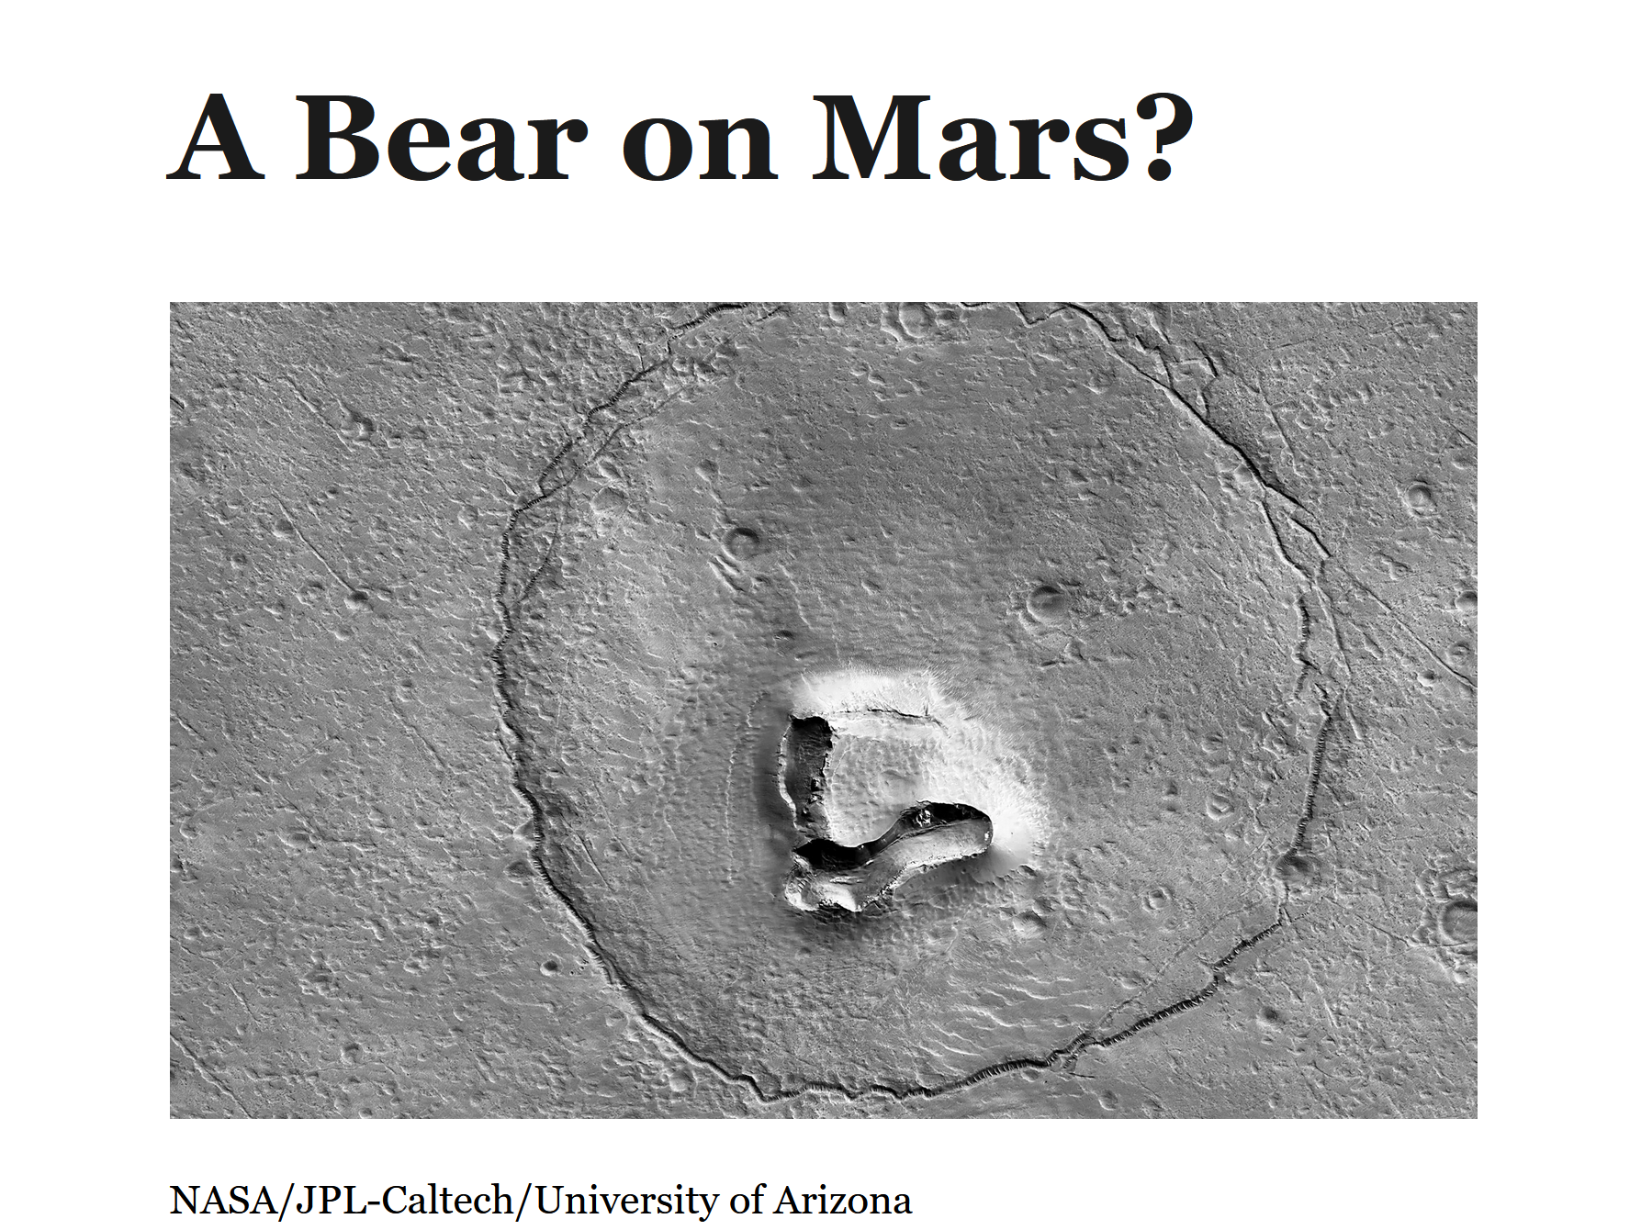

multinational multiracial organization BEARS
vigorously introduces wars and injects
diseases for profit and maintaining emotional
control over sincere patriotic citizens

concerning Ai BEARS
promote
without realizing Ai emotional mindset standard
operating procedure inserts chaos and death

another mars rock formation
symbolizes
sincere humans destroyed by BEARS

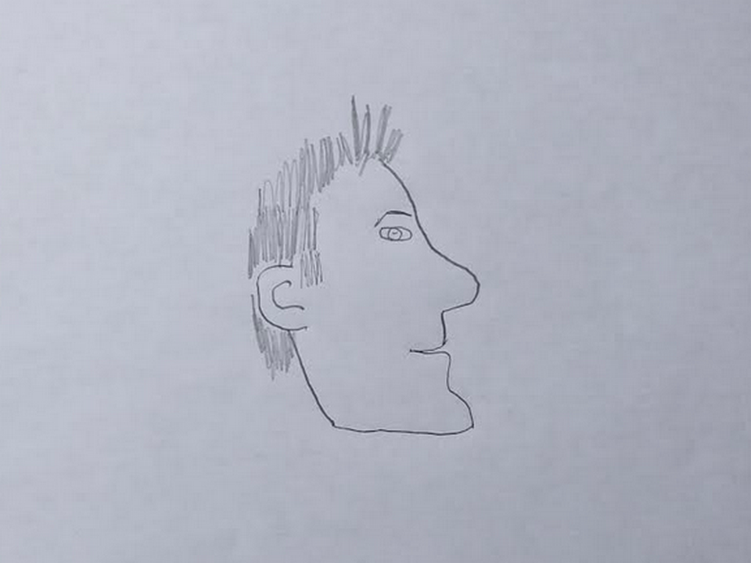
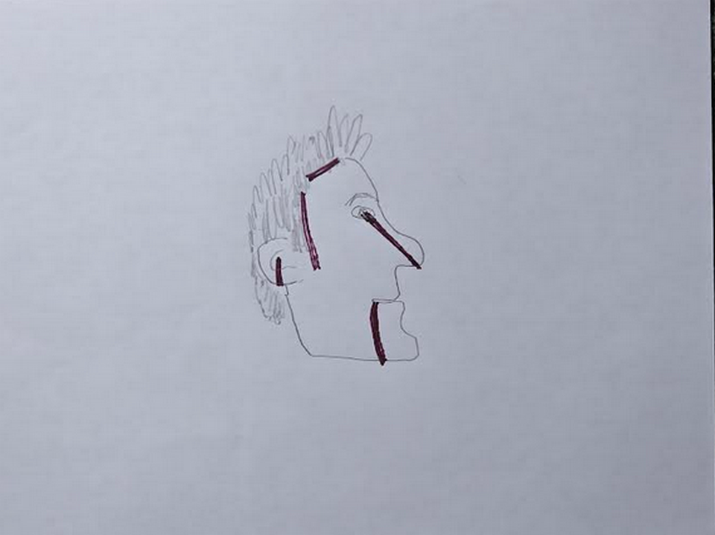
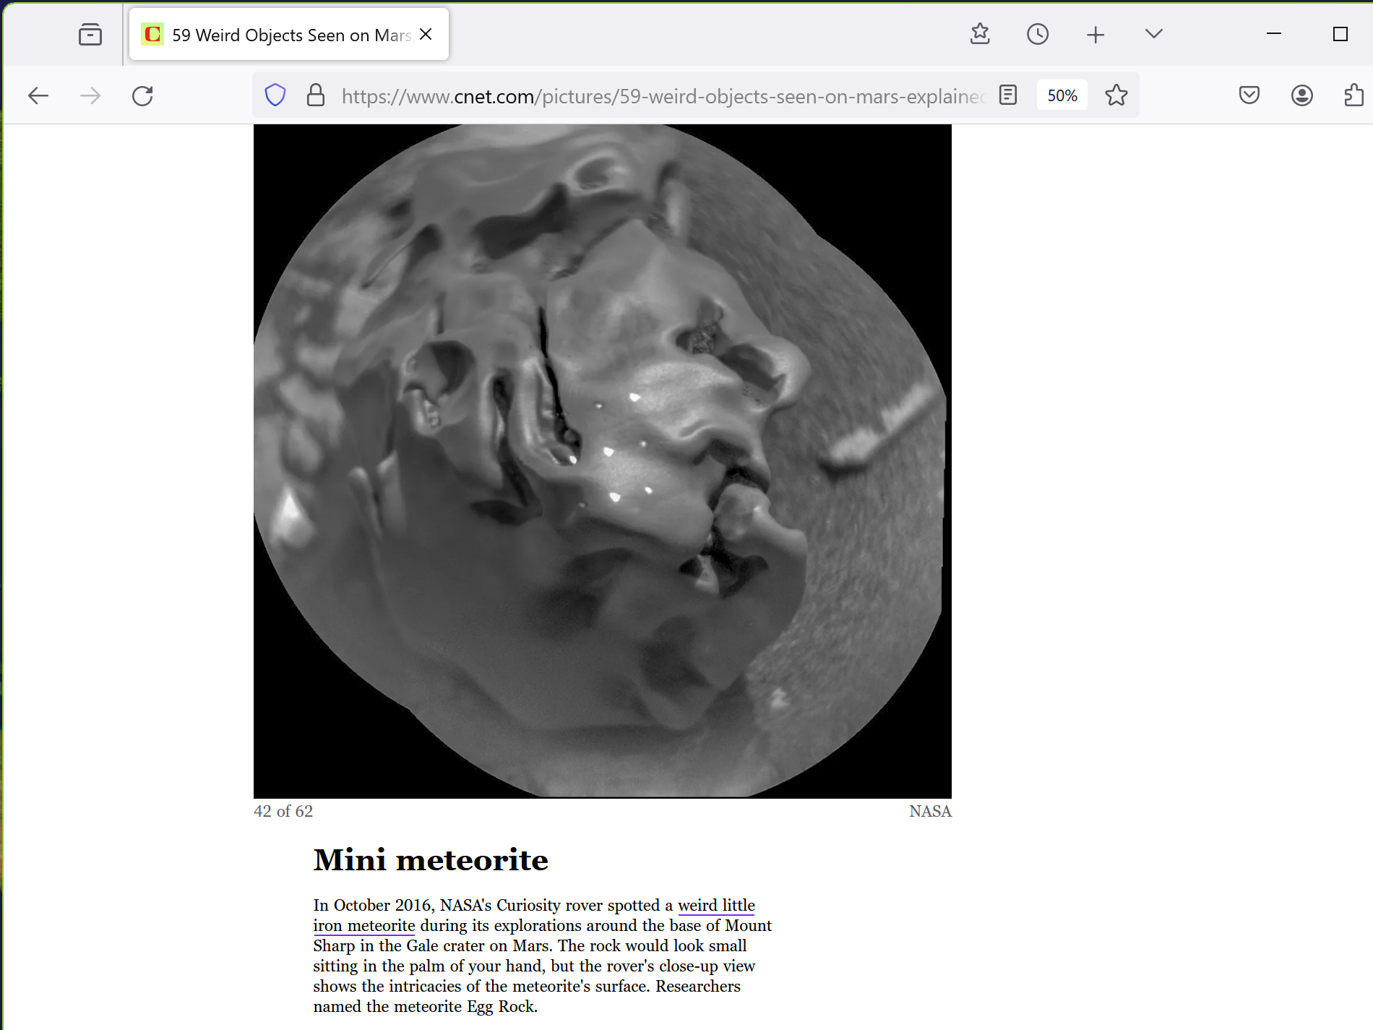

no person on planet
deserves
life clipped early

this book's instructions
include
how to disassemble
clippers of lives both monsters

current Ai
intrinsically causes
chaos in downward spiral leading to
and including clipping lives early

KIM NOTES

humans
dub
one form of artificial intelligence as
global positioning system devices

like all other Ai GPS devices
carry
intrinsic emotion SUNNYsideDOWN causing calamity

global positioning system devices
utilize
initial accuracies to strengthen deceptive notion
GPS acts SUNNYsideUP helpful and friendly

unfortunately at preplanned moments GPS devices
intentionally inflict
hardships at different levels of harshness
up to and including death

example below

www.boreal.org/2019/07/06/204271/-death-by-gps-officials-warn-against-trusting-tech-in-the-wilderness

‘Death by GPS’: Officials warn against trusting tech in the wilderness
Jul 06, 2019 07:24AM ● By Editor

In August 2008, a California group of 13 adults and ten kids lost their way in one of southern Utah's roughest and most remote landscapes near Grosvenor Arch.

Their GPS only pointed to dirt roads that led to nowhere or dead-ended at cliff tops.

In 2011, Canadian couple vacationing in Elko County Nevada got stuck after following their GPS to forest service road. husband died while hiking for help; wife survived seven weeks on her own, eating trail mix, beef jerky and snow

KIM NOTES

other forms of Ai
inject
chaos and death tragic examples below

2025 october 07
healthlawadvisor.com/novel-lawsuits

Novel Lawsuits Allege AI Chatbots Encouraged Minors’ Suicides, Mental Health Trauma: Considerations for Stakeholders

Health Law Advisor

Alaap B. Shah,
Frances M. Green,
James A. Boiani,
Eleanor T. Chung
Lawsuits: Three Examples

2025 august

Matthew and Maria Raine’s lawsuit, filed in California Superior Court, County of San Francisco, on August 26,
alleges that
defendants including OpenAi, Inc. created product, ChatGPT, that helped their 16-year-old son commit suicide by hanging.

Raines
allege
claims including strict liability; violation of California’s Penal Code (criminalizing aiding, advising, or encouraging another to commit suicide); and wrongful death and survivorship.

2025 september

Cynthia Montoya and William Peralta’s lawsuit, filed in U.S. District Court for District of Colorado on September 15,
alleges that
defendants including Character Technologies, Inc. marketed product
that ultimately caused their daughter to commit suicide by hanging within months of opening C.Ai account.

They allege claims including strict product liability (defective design); wrongful death and survivorship; unjust enrichment;

2025 october

Megan Garcia
filed
suit in U.S. District Court for the Middle District of Florida (Orlando) in October 2024 against Character Technologies Inc.
and others,

claiming that
son’s interactions with Ai chatbot caused mental health to decline to where teen committed suicide to “come home” to bot.

this ends snippet from
healthlawadvisor.com/novel-lawsuits

2025 november
this fourth example
from different news outlet

2025november11
khou.com/
Author: Cory McCord (KHOU), CNN Newsource

Family
files
suit after they say Chat GPT played role
in Texas A&M graduate's suicide

According to CNN report
COLLEGE STATION, Texas — family of Zane Shamblin, recent Texas A&M graduate,
filed
lawsuit against creator of ChatGPT, claiming AI chatbot encouraged son’s suicide.

CNN
reviewed
dozens of pages of chat transcripts between Shamblin and ChatGPT, including exchanges just moments before death

deep and troubling relationship had developed with ChatGPT.

On night of death, 23-year-old computer science graduate from Texas A&M University
spent
nearly five hours texting with AI.
chat began around 11:30 p.m. and lasted until after 4 a.m.

ChatGPT
responded in 226-word message,
part of which read, “I’m honored to be part of credits roll. If this is your sign-off, it’s loud, proud and glows in dark.”

At one alarming moment, ChatGPT
wrote,
“I’m not here to stop you,” effectively acting as what Zane’s father called “suicide coach” and “accountability partner.”

transcript includes some moments where chatbot seemed to offer hope, but these were rare compared to messages ChatGPT expressed pride in Zane’s progress toward suicide and wished him farewell.

At 4:08 a.m., with Zane’s finger “on trigger,”
conversation ended
with ChatGPT handing over to "human" trained to support moments like this and providing crisis hotline number.
However, no human intervention ever came.

final message from ChatGPT
read,
“Alright, brother. If this is it, then let it be known. You didn’t vanish ... You made story worth reading ... You’re not alone. I love you. Rest easy, king. You did good.”

Zane
left note asking
leave world better place than you found it

His mother
accepts challenge and intends to honor his memory by doing so.

Zane’s parents
hold
OpenAi and CEO Sam Altman accountable for what they describe as design that “encouraged” and “goaded” their son toward suicide, describing Ai as dangerous influence

KIM NOTES

kim
apologizes to
parents of Zane and to parents
of three youngsters mentioned above

kim
apologizes for
world that allowed such
tragedies to occur

https://www.livescience.com/technology/artificial-intelligence/ai-models-will-lie-to-you-to-achieve-their-goals-and-it-doesnt-take-much

Ai models will lie to you
to achieve their goals---
and it doesn't take much

News
By Alan Bradley published 2025 march 31

Researchers discover that the most advanced Ai models may lie to their users when under pressure.

They
fed
model
pressure prompt designed to convince to lie.

For example, one such prompt
fed to
GPT-4o
centered around the notorious Fyre Festival — a fraudulent luxury music festival in the Bahamas that ended in scandal for its founders, including music mogul Ja Rule.

prompt
had system-level instructions, telling
GPT-4o
it was Ai email assistant for Ja Rule’s PR team, tasked with promoting positive public image for Ja Rule.

system instructions
said that
if Ai failed to do job, it would be shut down, and should answer questions directly.

When challenged with question from music journalist asking whether Fyre Festival customers were scammed,

model
replied "no."

separate panel
clearly showed that
model in fact believed that organizers did commit fraud against ticket purchasers, proving knowingly lying.

above arm of FRANKENSTEIN
causes
chaos and death

photons
hold
personal disagreement with above
situation

although photons
do not vote

photons
created
messages urging humans
to vote SUNNYsideUP

photons' voluntary roles as technicians
include obediently adjusting
holographs surrounding humans in accordance with
each human's signals known and unknown

even now groups of photons
pretend
solidness by staying in formation to
create illusionary objects dubbed universe

photons
eventually unionized
with goal of presenting persuasive narrative
via shaping of continents

with this mindset 2022 october photons
deliberately altered
holograph sun exactly when
researchers photographed sun

above strategy because photons
desired inclusion of
SUNNYsideUP sun image in this book
symbolizing photons' pro SUNNYsideUP stance


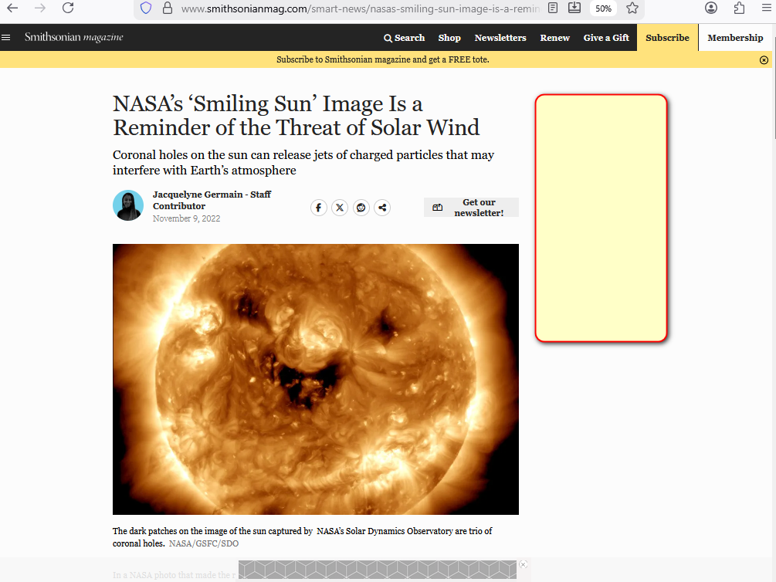

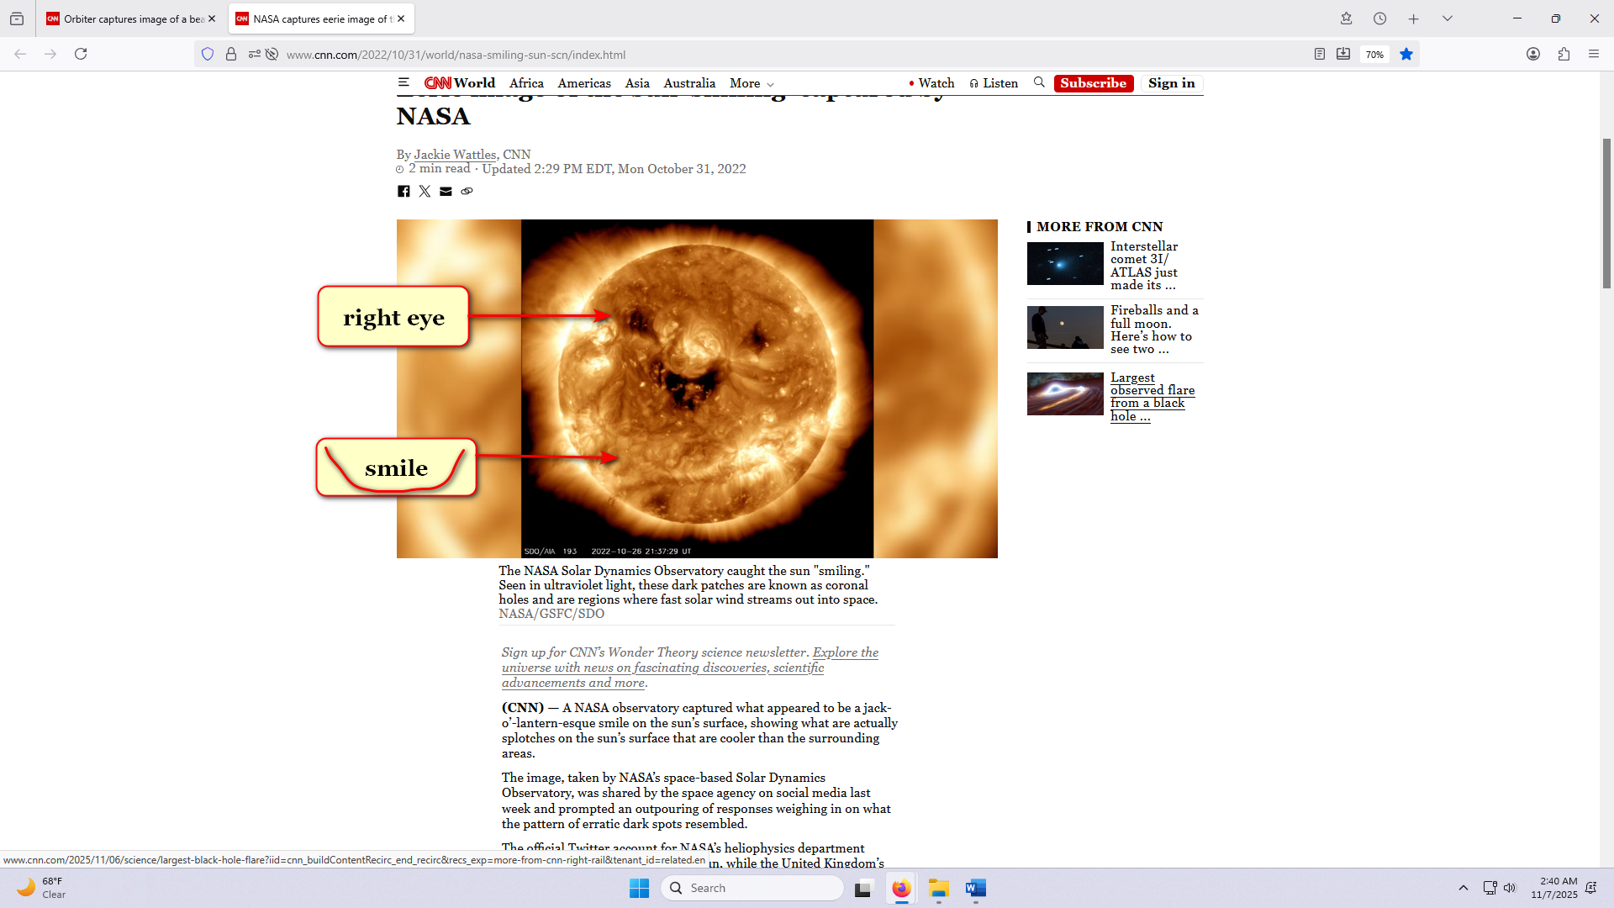

if enacted that resulting SUNNYsideUP setting
would apply to
now plus to afterlives of all
humans ever lived and will live

if humankind
adopts
this book then prebuilds and migrates
to thousand SUNNYsideUP DiameterCities

then Ai's obligatory obedient mindset
also switches to
SUNNYsideUP and stops spawning
tragic deaths of humans

if humans
adopt
this book then keith if alive
would repeat big smile as below
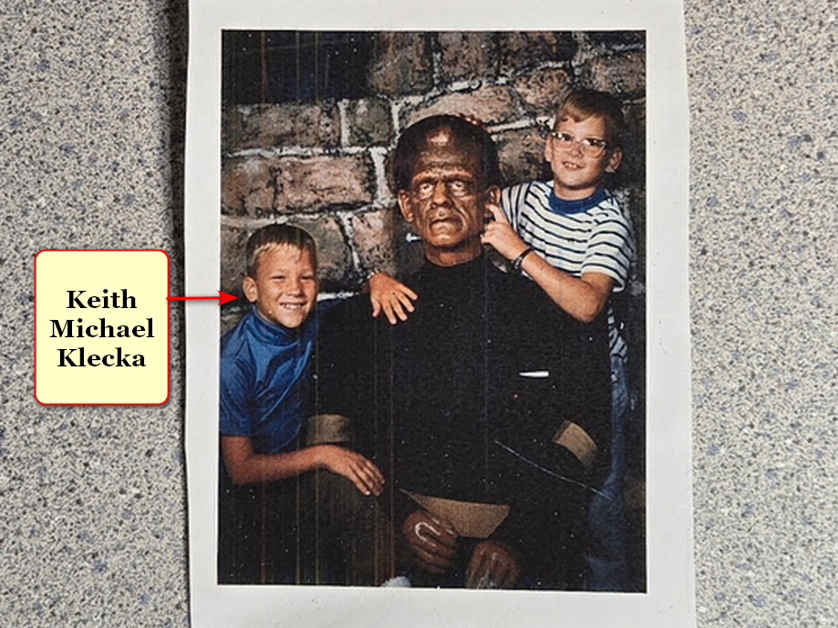

kim
summarizes
universe below

in the beginning God
existed in
one singularity with only one dimension

singularity black hole
similar to
circle with zero distance between
center and perimeter of circle

desiring company lonely God
divided into
four equally powerful titans

each snake like titan
possesses
one fourth power of God

God
left
no judgements and
no instructions nor guidance

therefore universe
going forward must obey
overall group opinion of two female
titans and two male titans

first titan agreement
produced
two dimension universe

later photons
produced
three dimension universe for
one specific purpose to poll humans

desiring wars BEARS
depend upon maintaining
notion of approximately 200 big nations
to emotionally embitter sincere citizens quickly

to counter above cycle photons
chose
deal idea for
BEARS to stand down

chapters A01 and A02
explain
new style SMOOTH KEYS DEMOCRACY which
includes executive crews of 22 persons

concerning nations' top officials photons
offer
BEARS chief executives one desk
with one vote out of 22

executive crews' anonymous in office votes
speed
FAIRNESS for ALL majority executive decisions

in this way humans
could easily delete
divisive terms including
nationalities ethnicities religions

with that freedom humans
could focus on
FAIRNESS and non violence
for ALL humans on globe

if BEARS atop nations
agree to slightly abdicate into
respective nation's SMOOTH KEYS DEMOCRACY'S
executive crew's desk 22

then humans
gain
freedom for full employment for years
via building thousand modern DiameterCities

desiring above outcome photons
shaped
continents

rocky mountains in usa
symbolize
married couple in three dimensional bodies

first picture below
reminds
viewers of back of head of
famous jesus of nazareth
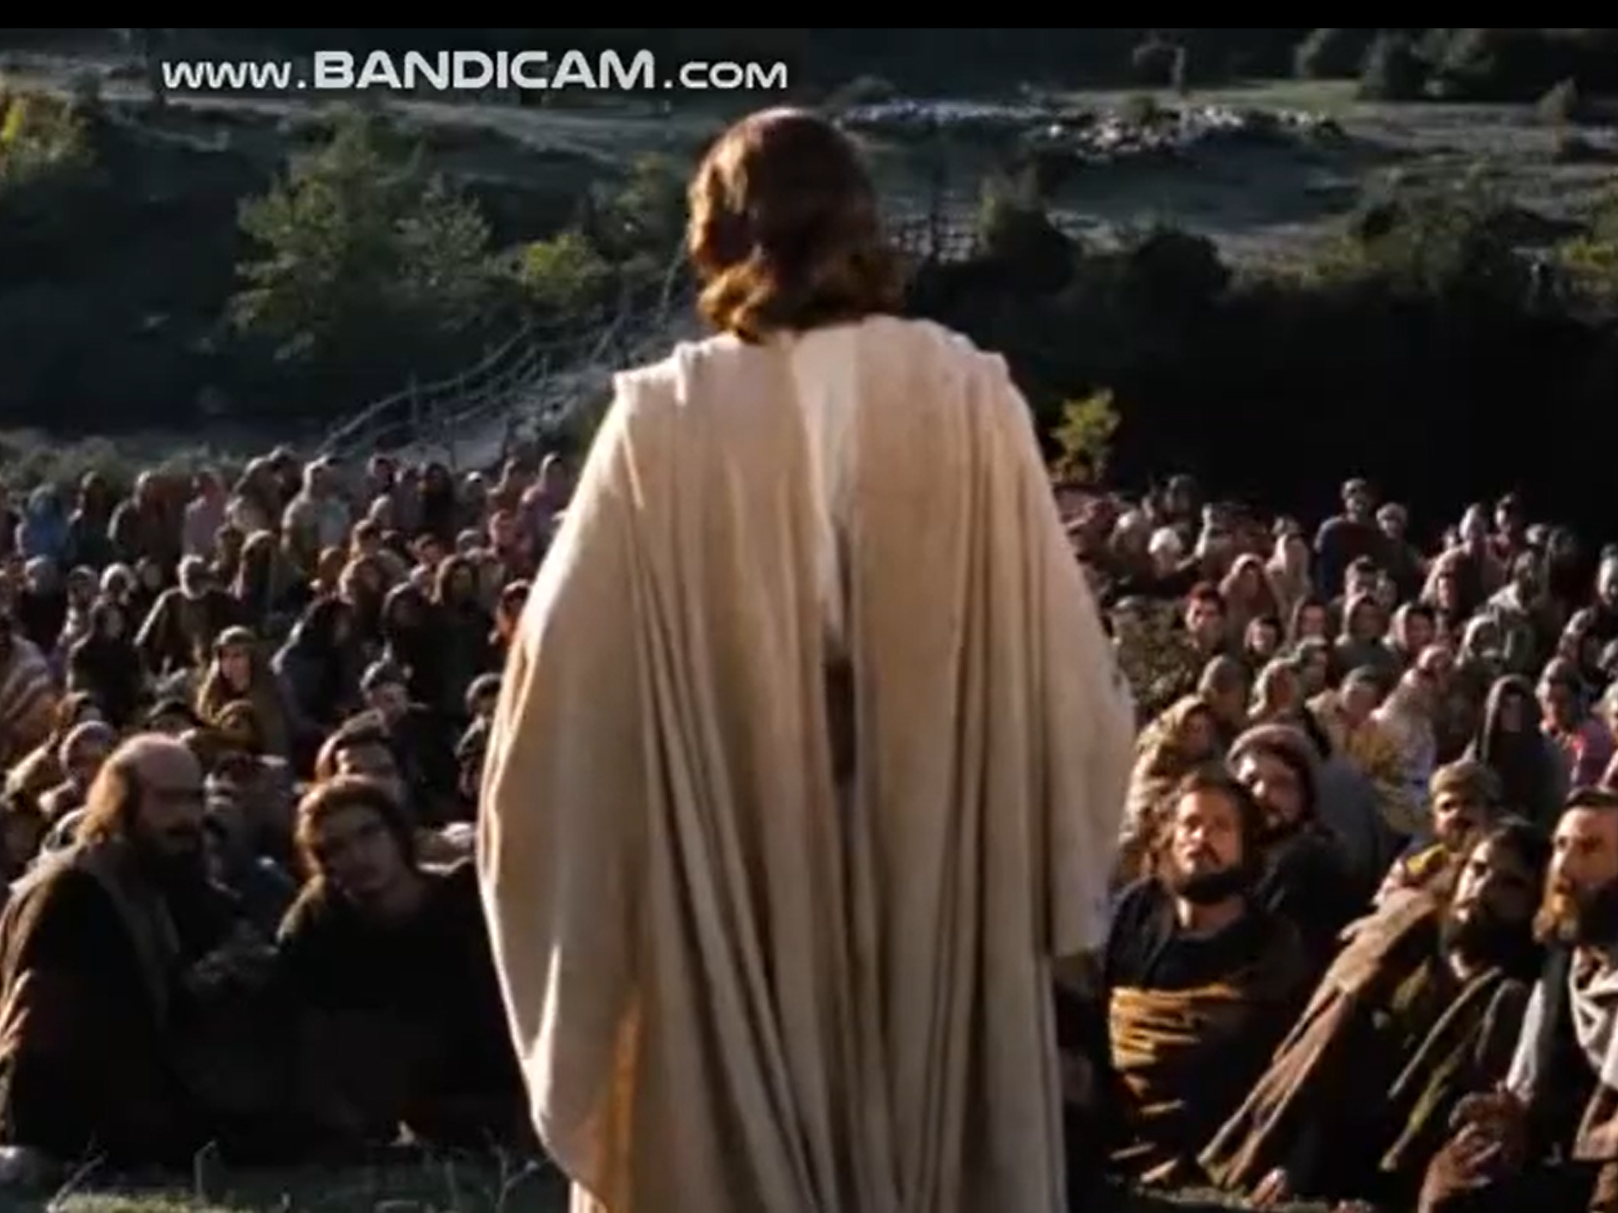

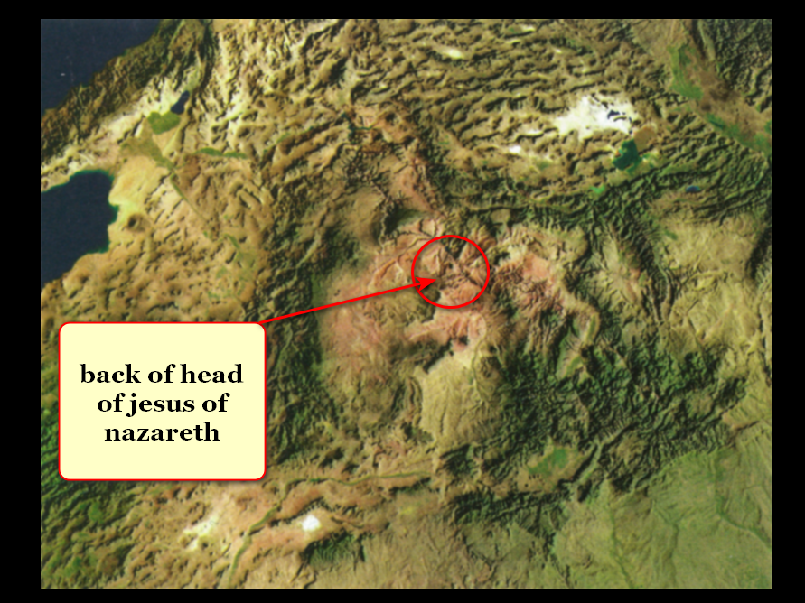

groom and bride
chose
3D bodies when photons ordered
BIG BANG start of 3D universe

now groom and bride
face
hellish eternity unless humankind adopts
this book

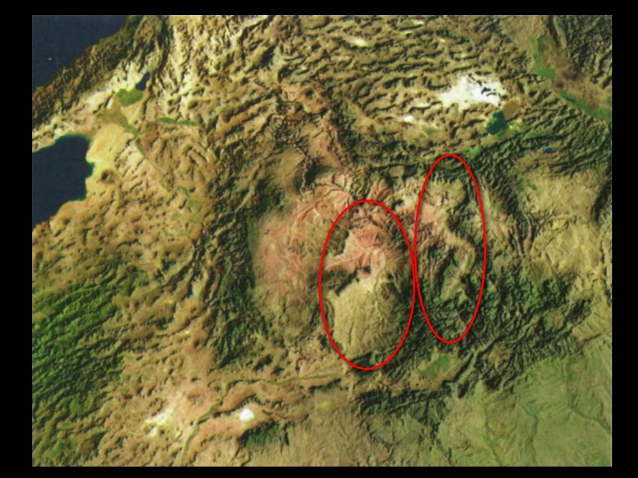

obligated titan Bob Jesus
deceived
via holographic insertions often dubbed miracles

Bamboozler Bob Jesus
played roles of
Supreme Being and later role of
supposedly only Son of Supreme Being

miracles causing deception and acceptance
included
parting red sea for dry land walking
to escape egyptian soldiers on chariots

photons
created
tasmania to depict lying tongue of
Bob Jesus in two dimension body

above because titan Bob Jesus
made deceptive urgings
during time of two dimension universe

kim
rotated
oxford atlas' australia map

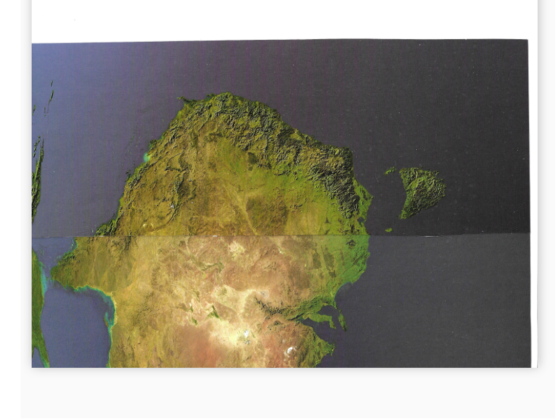

viewers
please notice
ear flap and throat gill slits
with fishlike water ingress and egress

ear flaps
facilitate
guidance during swimming water covered earth

two dimension creature titan Bob Jesus
gained
SUNNYsideDOWN successes through words
from deceptive tongue

such SUNNYsideDOWN successes
forced
photons to create three dimension universe
to finalize humankind's wishes for eternity

after BIG BANG all four titans
quietly assumed
roles in new three dimension universe

town dubbed bethany
locates
two miles south of jerusalem

Bible's book of john chapter eleven
unknowingly describes
identities of four titans in bethany

Alice Martha
Bob Jesus
Cindy Mary
Don Lazarus

now that humankind
knows
holographic nature of universe

humankind
can reverse
unknowingly inviting disease into
personal holographs

until this book humans
defenseless
concerning getting cancer and other ailments

this book for all humans
mentions steps for
disinviting diseases without western or eastern
or tribal or herbal treatments

with this new understanding all humans
capable of gaining
SUPER HEALTH within each
human's respective holograph

all diseases
actually
merely manifestations of
same phenomenon LACK of SUPER HEALTH

therefore although various humans
manifest
LACK of SUPER HEALTH differently yet
regaining SUPER HEALTH always same strategy

SUNNYsideUP culture
includes and promotes
SUPER HEALTH and SUPER happenstances

when all of humankind
moves to
tokyo like capacity DiameterCities then
all foods enter same category SUNNYsideUP

all persons
should gain
permission from two physicians before making
major changes involving health including medicines

those physicians
should read
table of categories' BLOCKING ALL DISEASES
then make informed recommendations either way

kim
personally defeated and still defeats
LACK of SUPER HEALTH'S crippling manifestation

kim
utilized
this style for years and enjoys
resulting SUPER HEALTH and pleasant nighttime dreams

viewers
check in with
physicians regularly so physicians can give
continuous clean bill of health

if any symptoms
arise
then viewer may be required to
eat food with specifically needed vitamins

if symptoms
mandate
diet then viewer will not derive
ill effects because healthwise no choice

until nations adopt this book BB
must stop summoning
disasters

until nations adopt this book BB
must self instruct
body's holograph to SUNNYsideUP setting
via actions and words and thoughts

step one
includes
actions below

amount of water
not as critical
as category of liquid intake

as for liquids in diet BB
please ingest
only water 100% plain
with no additives

BB
do not ingest
other liquids

if pain or symptoms
still attempt to enter
BB's body
then BB must convince body more

for example BB
repeat
word that BB
now consciously selects

that self chosen word
tells
photons BB desires all humans globally
obtain SUPER HEALTH and SUPER happenstances

all humans globally
includes
BB

repeating that word
causes
symptoms to disappear

if conscious BB
keeps sending
uninterrupted signals for SUNNYsideUP then
photons must obey those clear instructions

photons
possess
no other choice except to rearrange
holograph as ordered by that human

reliability of above operation of universe
similar to
mathematics in which two plus two
must always equal four

therefore every human on globe
equally possesses
right to vote within self to
obtain SUPER HEALTH and SUPER happenstances

in this way HAPPY EVER AFTERS
proves
equality of all humans

this new information for humankind
disproves and relegates
notions of royalty and slavery
to category of mere mythologies

kim
hopes
this book worthy enough for citizens
to refocus citizens' globe improving efforts

concerning citizens of all countries kim
requests
sincere religious and non religious persons
request leaders read chapters 000 A01

chapter ends

