I10 please fetch stick of fairness for all humans

if viewer
throws
stick of fairness at every incoming
situation SUNNYsideUP culture returns

loyal faithful SUNNYsideUP mentor dog
fetches
stick eagerly returns stick to viewer

V

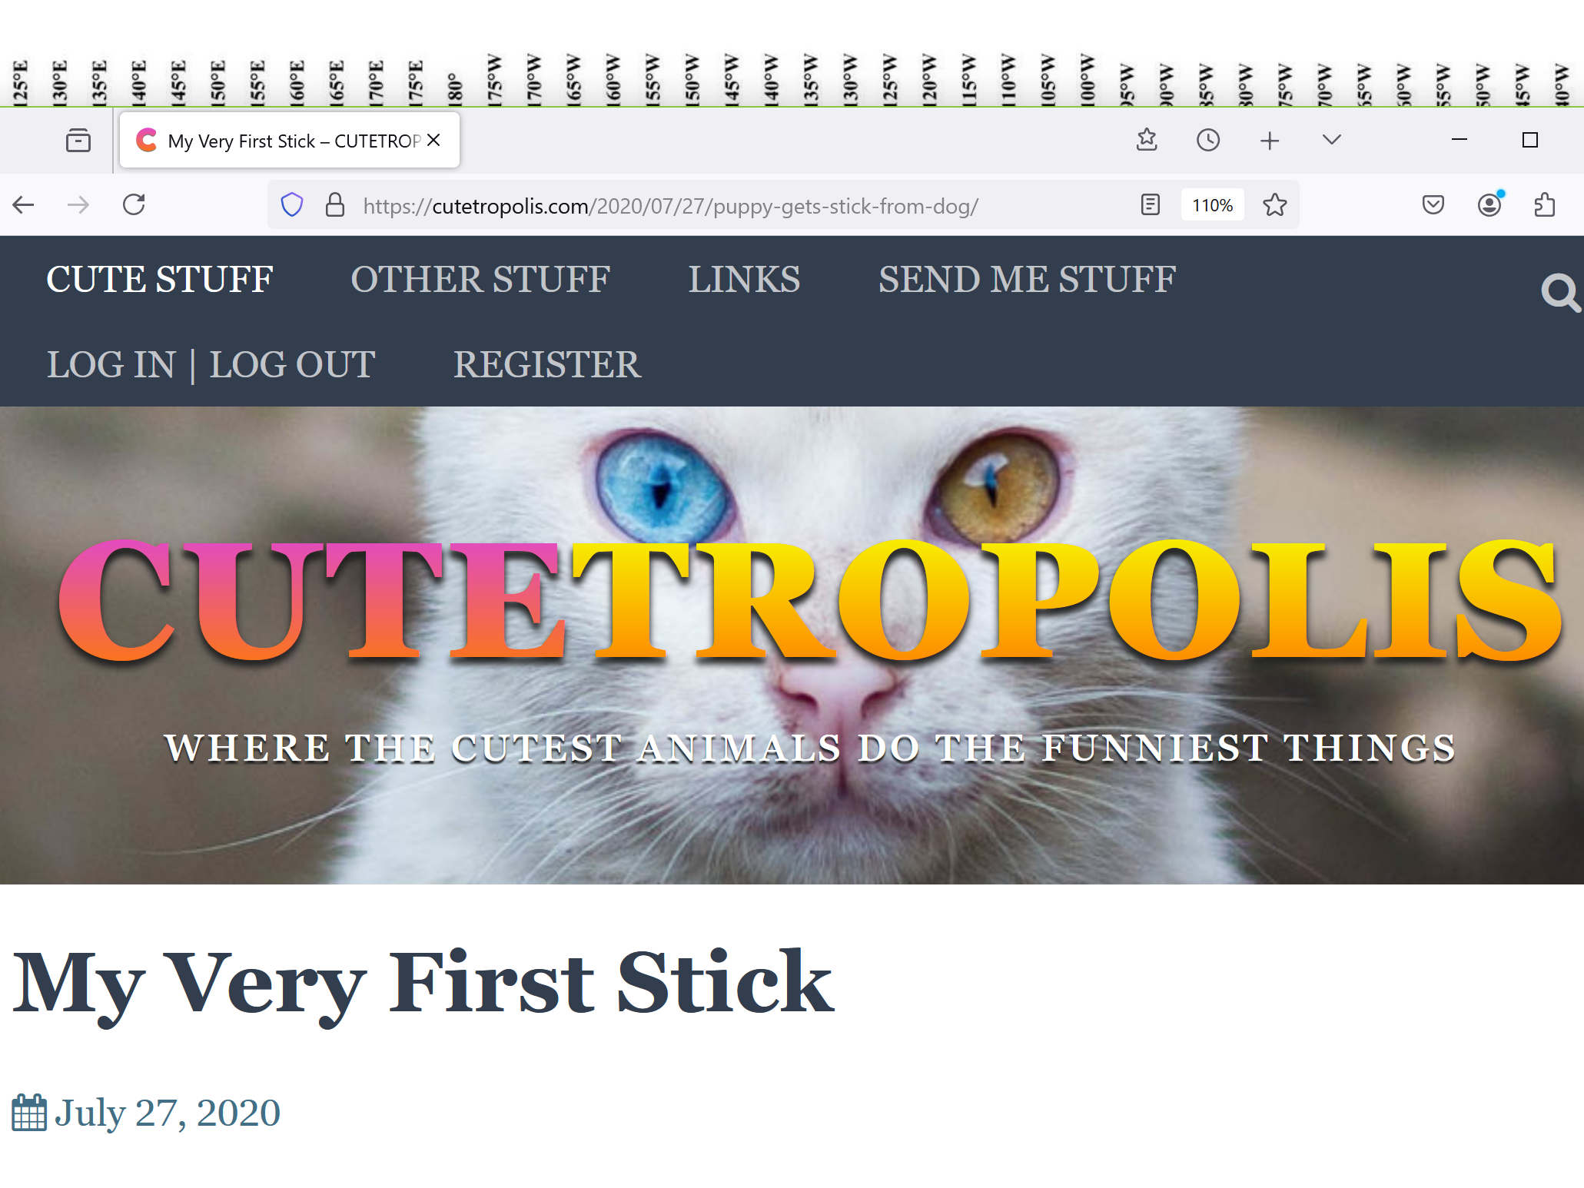

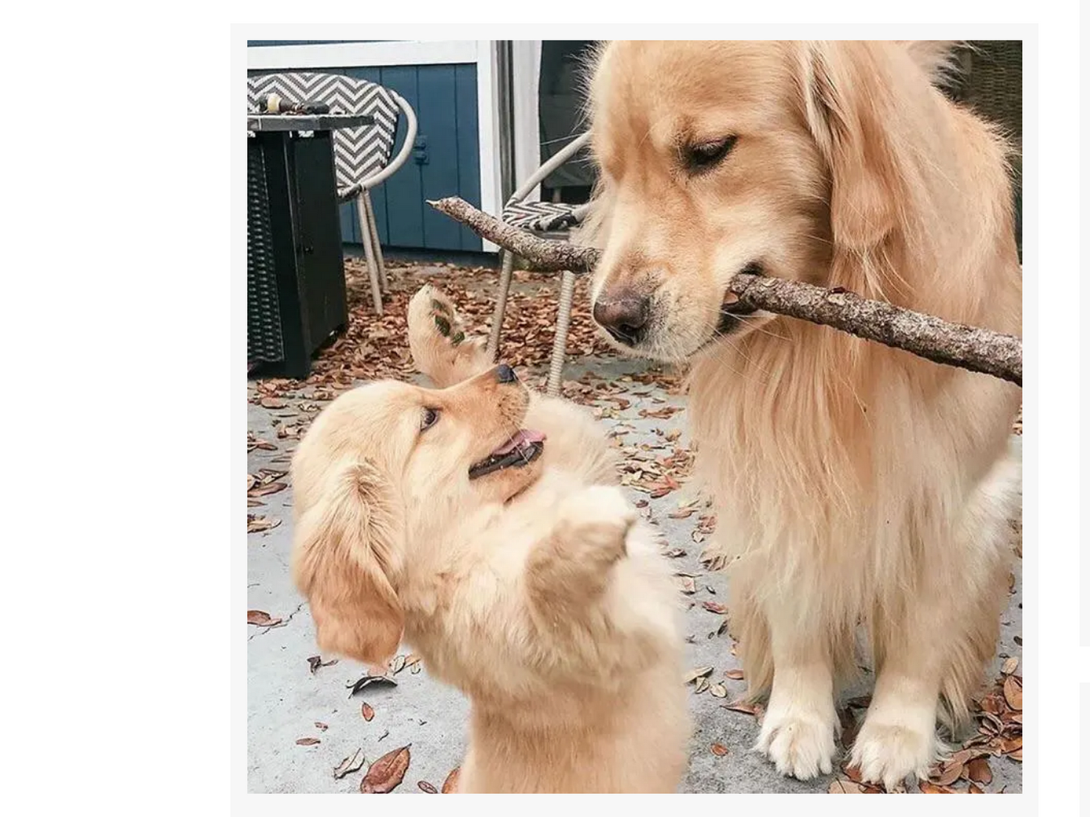

for centuries volunteer mentors dogs species
showed
apprentice humans good humor models

dogs with good humor
taught
humans
fetch correct stick stick of fairness

photon ushers
combined
Alice in wonderland’s dog’s fetching stick
with english nursery rhyme

photon ushers
constructed
statue groups portraying strategy
collective humankind’s escape from tragic afterlife

statue groups' stick
90 degrees meridian east’s seamount

australia’s western plus middle portion
symbolizes
dogs recommending
stick of fairness

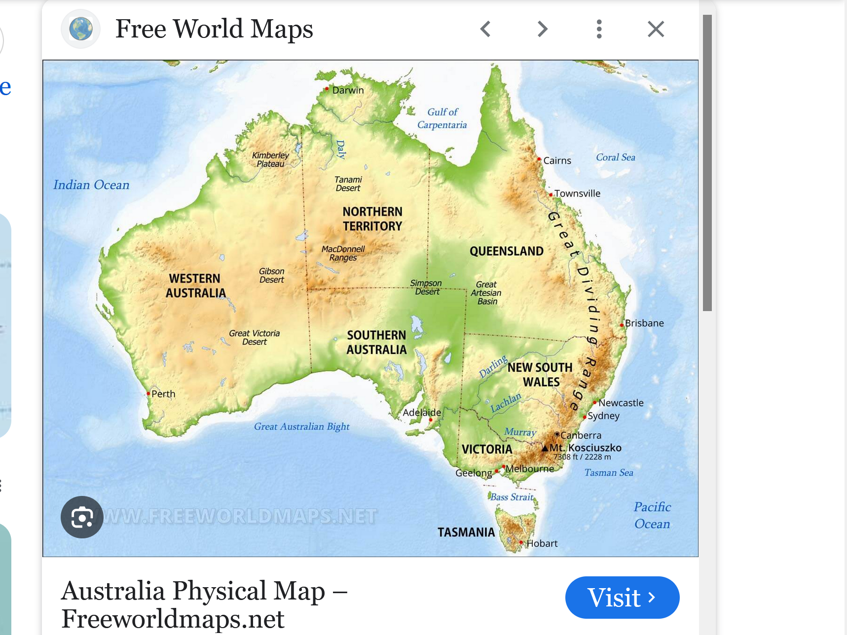

australia even in geography's colors
matches
dog's colors

there was an old lady
who lived in a shoe
she had so many children
that she did not know what to do

enticing bamboozling Bob
emptied
old lady’s purse of valuables kids

but this lady Alice’s
recovery recommendations
shoe’s children march together fetch
stick of fairness grasp SunnySideUp culture

west of australia
seamount
shows that nursery rhyme
in statue form

dog
looks
westward

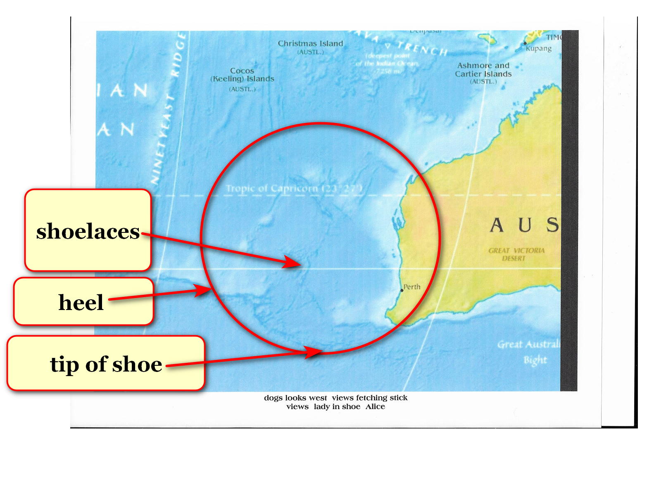

kim
noticed similarity
queen with hat in photograph

photon ushers
explained
concepts via symbolic literary figures
specifically for simplifying this book

example of above ALICE IN WONDERLAND
threw
stick for BIG PUPPY to fetch

chapter ends

