F05 time cylinder transformed to hourglass

kim
circled
giver of bride plus groom
nose to nose with fiancee

due to unwelcome circumstances groom
turns
towards replacement bride symbolized by
elephant representing Cindy

elephant symbol
because
Cindy now champion of HORTON like
nurturing SUNNYsideUP

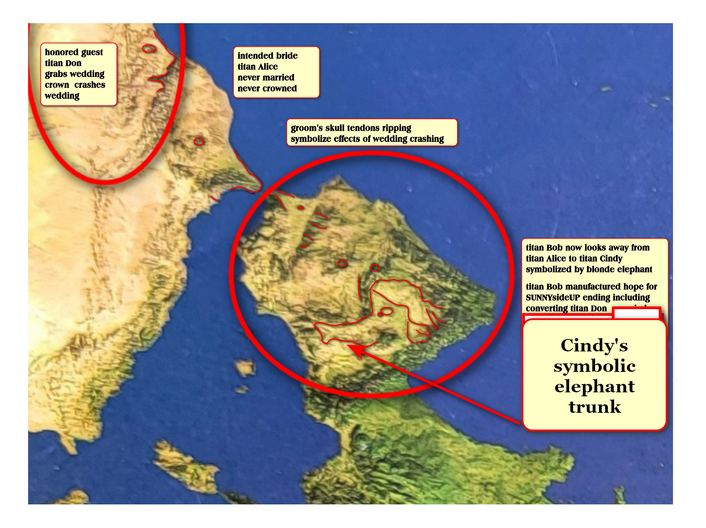

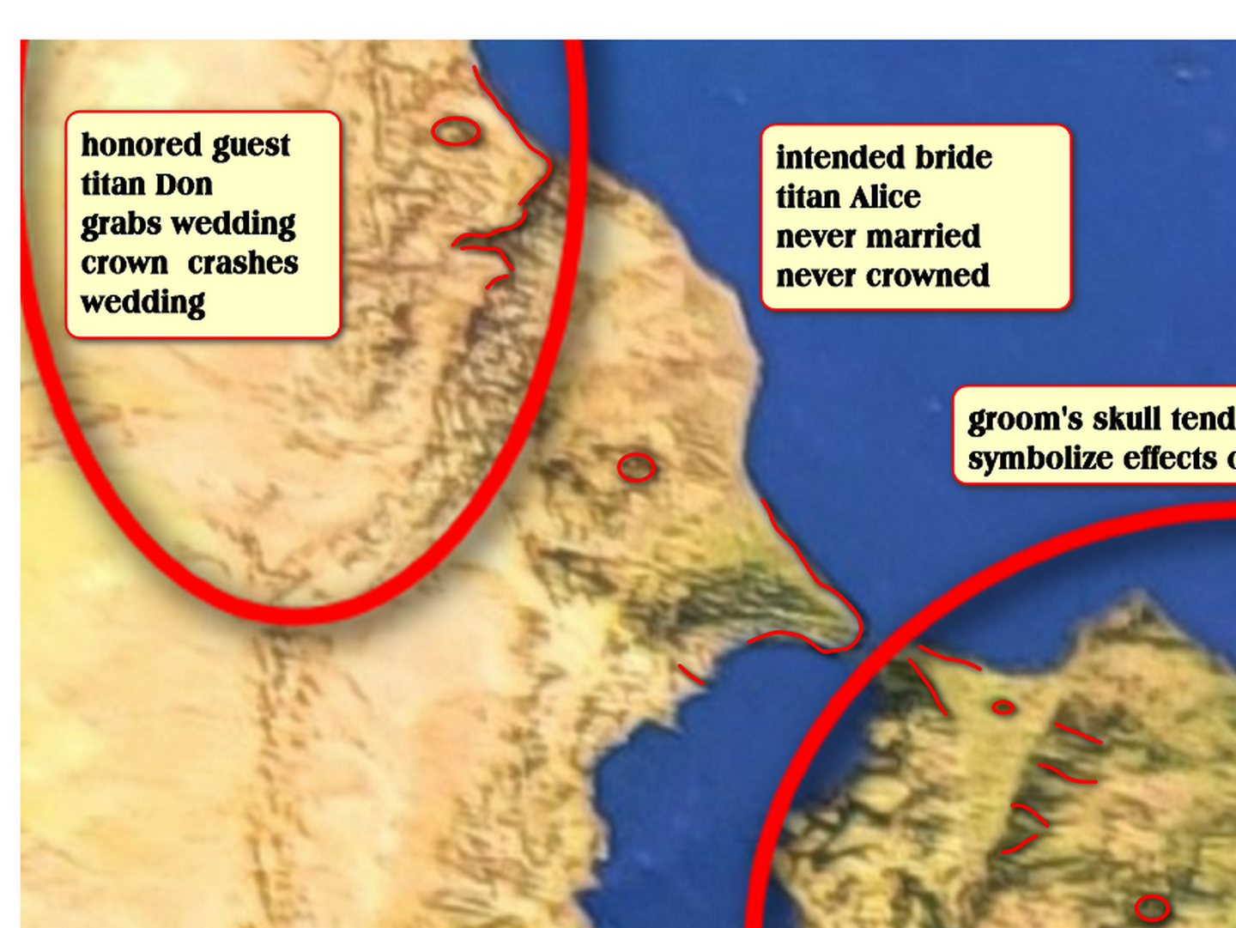

because of above agreement humankind
clarifying
even now which style preferred
SUNNYsideUP or SUNNYsideDOWN

3D universe
caused
cylinder time change now hourglass time
symbolized in hourglass protostar

www.nasa.gov/universe/nasas-webb-catches-fiery-hourglass-as-new-star-forms/

NASA Webb Telescope Team
Nov 16, 2022

NASA’s James Webb Space Telescope has revealed the once-hidden features of the protostar

within the dark cloud L1527,

providing insight into the beginnings of a new star.

These blazing clouds within the Taurus star-forming region are only visible in infrared light, making it an ideal target for Webb’s Near-Infrared Camera (NIRCam).

NASA's Webb
catches
fiery hourglass
ESA CSA STScl J DePasquale

phys.org's

wedding event of titans
changed
from cylinder bottom
end of time start of eternity

now wedding middle of hourglass time
accepts
votes from before wedding
plus after wedding this current era

groom
awaits
handouts rescue votes from globe

each human during waking hours
votes
approximately 5000 times

bamboozler Bob's strategy
persuade many
SUNNYsideDOWN votes because
facilitates SUNNYsideDOWN eternity

person during eight second scenarios
freely responds
as person wishes
no other personality's opinion interrupts choice

in another similar context person
freely spends
money as person judges appropriate

no binding blockade
prohibits
spending of money

comparatively universe
remembers
how that person feels money
well spent emotion well spent

globe's majority
decide
if fairness equals DiameterCities' culture
standard operating procedure from now forward

chapter ends

