J08 tower of seeking across wall interviews

female's job
includes
finding four attractive possible suitors

female
chooses
each male from different DiameterCity therefore
only one from DiameterCity of female

female
must possess
happiness eagerness to marry any
of four males female selects

notions of multiple suitors for ladies
appeared in
literature in homer's multivolume poem
THE ODYSSEY

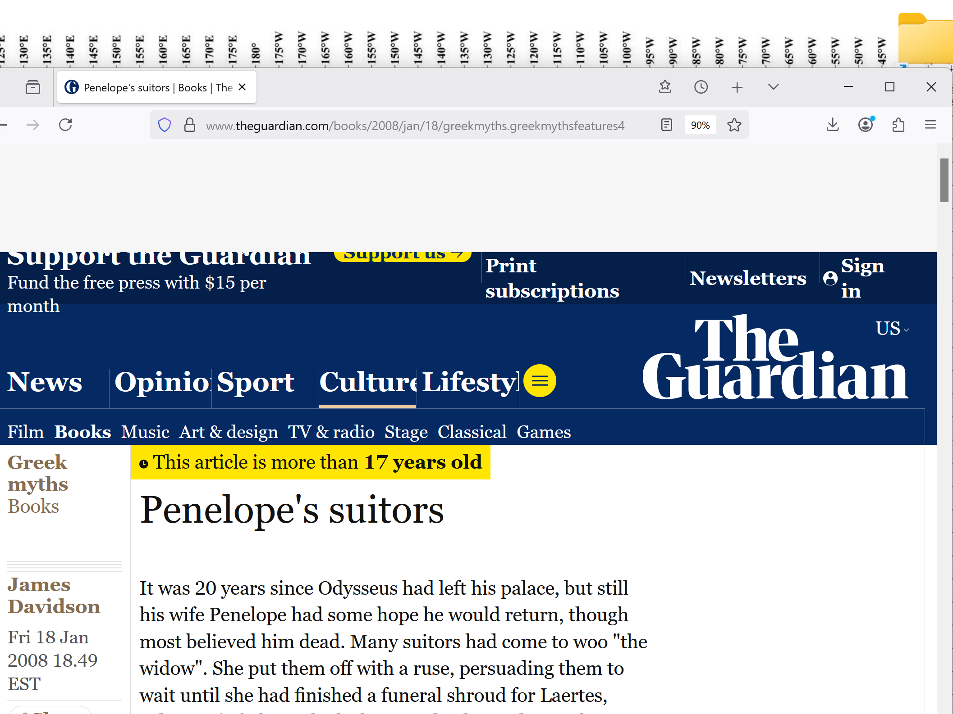

Penelope's suitors
This article is more than 17 years old
by James Davidson
Fri 18 Jan 2008 18.49 EST

It was 20 years since Odysseus had left his palace, but still his wife Penelope had some hope he would return, though most believed him dead. Many suitors had come to woo "the widow". She put them off with a ruse, persuading them to wait until she had finished a funeral shroud for Laertes, Odysseus's father, which she wove by day and secretly unravelled by night. In this way she managed to deceive them for three years. While they waited, the suitors made themselves the king's uninvited guests, eating him out of house and home.

But then Penelope's ruse was discovered and the suitors demanded a decision. She came up with another ruse, an archery contest.

She would marry whoever could string Odysseus's bow and fire it through 12 axes. The bow once belonged to the archer Eurytus, grandson of Apollo, and no one, she hoped, could wield it.

One by one the suitors tried their hand, but none could even string the bow let alone shoot an arrow with it through the axes. Then one of the beggars who was accustomed to feeding off the scraps the suitors left asked if he could try his hand.

The suitors laughed, but were amazed to see him string the bow with ease and fire it all the way through the 12 axes.

The beggar then turned his weapon on the suitors and shot them one by one. Penelope looked at the carnage. "Does this mean I must marry a beggar now?" she asked. "I am no beggar," he said, "but Odysseus, your husband."

Penelope did not recognise him, for he had left her soon after their marriage 20 years before. "Odysseus, my husband," she said, embracing him. "Please forgive me for not recognising you, for it has been 20 years since I last saw you and you are much changed. It is a balmy night, so let us take our marital bed, the one you built with your own hands, and put it under the stars."

"That is a wonderful idea," said Odysseus, "but the bed I built can never be moved for it is built around the trunk of a deep-rooted olive tree." Now at last Penelope knew he really was Odysseus: the secret of the bed's immovability was known to only two people.

"Odysseus, my husband," she said, embracing him, but this time with more feeling. "Tell me how it came about that you were a beggar in your own banqueting hall." "For seven years," said Odysseus, "I was a guest of Calypso. She is a powerful goddess and was lonely...

She offered to make me immortal, but I preferred to get old with my Penelope than to live with the goddess forever. And then one day she let me leave, for the gods had so ordered her, and she helped me build a makeshift raft and gave me provisions for my journey...

But the goddess Athena advised me of the situation here and warned me to keep my return a secret. I agreed, much though it pained me, a king begging in my own palace, seeing how the suitors treated you, longing to reveal myself to you when I saw you had begun to despair."

DiameterCity enhanced solar batteries
recharge
in one hour
yet last entire month

citizens
free to travel to
all 1000 DiameterCities

travelling citizens
give allegiance enroute
via Ai to destination DiameterCity chieftains

1640 feet tall towers
emphasize
physical vote pro superhealth similar to
1640's spain's pellicer of reattached leg

1640 feet tall doughnut shaped towers
possess
height approximately 3 times taller than
height of ponte city apartments

//pontecity.co.za

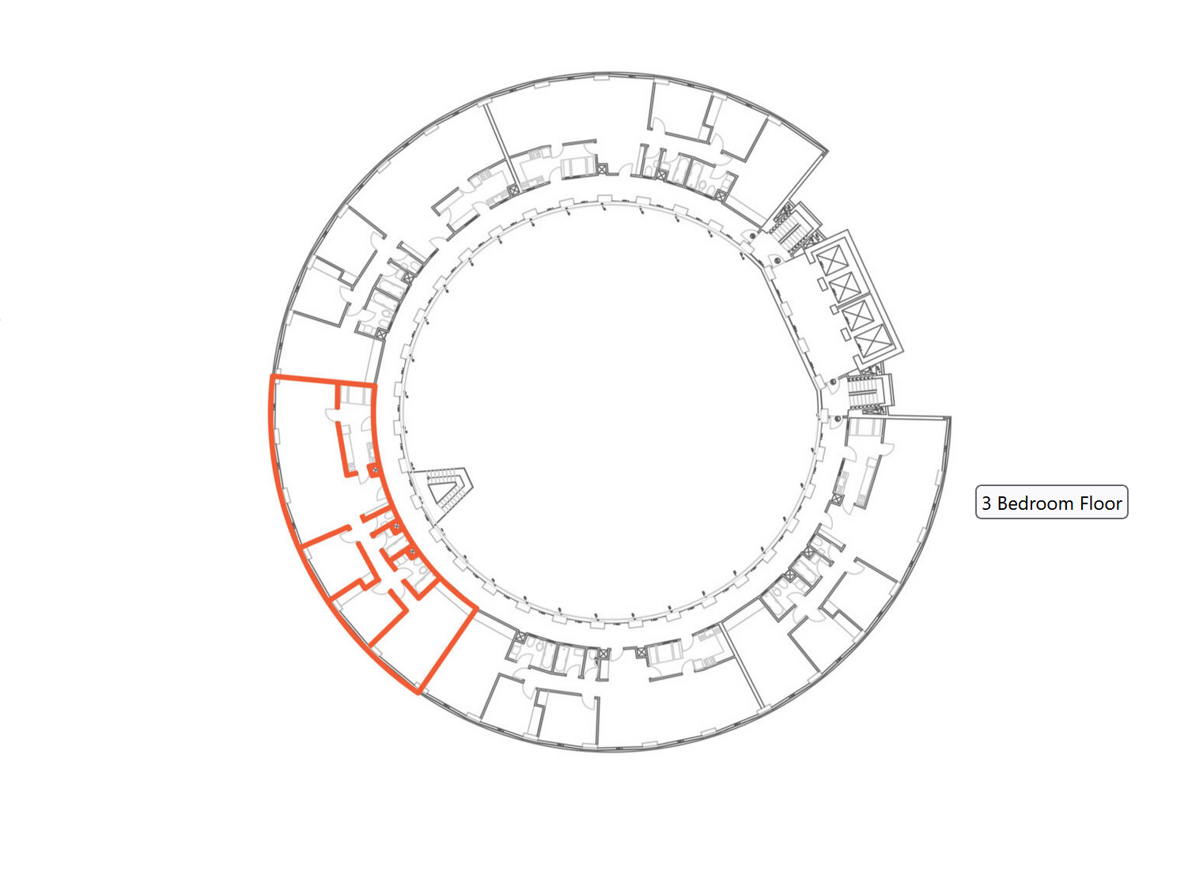

tribal chieftain married couple per tower
guide
all phases of SunnySideUp culture
residential village towers business towers

while in office chieftains
act
decisively frequently utilizing
NoonAN DoubleDay for non emergency decisions

spousal abuse
impossible
because Ai monitor all rooms' cameras

child abuse including mutilation of genitals
impossible
because any mother with blade in room
with baby daughter causes Ai alarm

proponents of female circumcision
indirectly base
mutilations' authority upon male circumcisions' acceptability

bamboozler Bob
bamboozled
abraham start cutting male babies

each pain
equaled
another SUNNYsideDOWN vote

abraham
overwhelmed
via miracles possessed no other choice
started routine violence against babies

however now citizens of earth
know
actuality

tower of seeking style
includes
female's objective guidelines Ai facilitation
personal interviews

helping with marriage selection Ai
send
female's song list to all
1000 towers of seeking

female
adds
requirements height range weight
any other preference

when male fitting physical requirements
enters
male's home DiameterCity's tower of seeking
Ai mentions five song lists await

male
ranks
each song in each of five lists
favorite to least favorite

male
not knowing
which lists Ai's versus females'

singles
may utilize
artwork paintings same method
anonymous selections list

Ai
sends
compatible results
to female in original DiameterCity

if female
likes
answers received requests Ai mention
request next time male schedules tower

males
may or may not notify
Ai of plans
visiting tower of seeking

if female
boards
plane announces to Ai traveling to
compatible male's DiameterCity destination

then Ai
alert
male compatible female traveling
to male's tower of seeking

males' presence in tower of seeking
required
for females personally observe physical features
via many cameras in towers

until this moment neither single person
visualized
other single person

every DiameterCity
possesses
tower of seeking near center

physical structures
built
with social structures in mind

women modestly dressed heads uncovered
freely walk
streets as wished traveling where wished

women
protected by
Ai FIVE LITTLE SISTERS

Ai FIVE LITTLE SISTERS
include
five computers stacked for varying heights
many sets strategically located

if person
finishes
degree as early as age seventeen
gains tower of seeking access early

yet earliest marriage age
remains
eighteen years

19 year olds regardless of education
granted
access tower of seeking

female half of building
includes
north side of tower

male half of building
includes
south side of tower

perforated titanium barrier in middle of tower
separates
females from males maintains
absence of physical contact before marriage

Ai
ask
preferences on five music selections for
day for everyone in building

Ai
discloses
customized list of all opposite gender's
music likes' compatibilities with that person

females and males
freely access
Ai cameras on every person of
opposite gender inside that building

each person's evaluations
include
list of music art compatibility
plus camera's views of that person

if seeker
likes
music and art compatibilities
plus physical characteristics

then seeker
asks
Ai to create new list of songs
for comparing with that person

Ai
asks
that person if interested in participating
another music compatibility quiz randomly queued

if both parties desire then Ai
schedule
face to face
perforated titanium wall meeting

most floors of tower
possess
many kiosks with midline titanium wall
including titanium mesh wire

chapter ends

