HAPPY EVER AFTERS

preliminary draft

by
kim martin klecka DDS BS

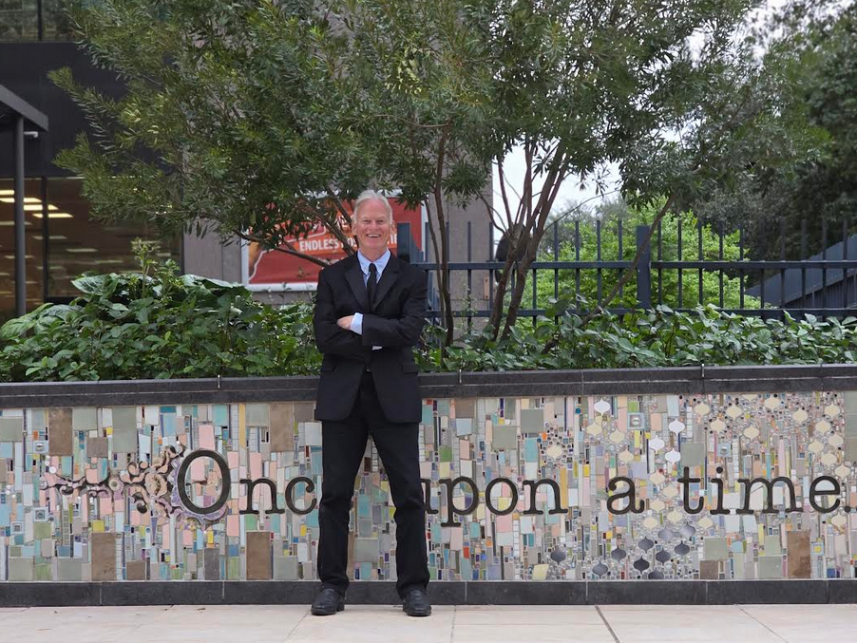
2025december04 photograph above by SenLy Fox

kim
welcomes
all citizens of globe
to strategy FAIRNESS for ALL

please read for free
this first SHOELANGUAGE book online
complete with all chapters and updates
to this chapter at shoelanguage.com

in awe twin kim
dedicates
book to keith michael klecka educator
of kim concerning BEARS organization's lethality

2025 december 09 tuesday
all rights reserved
7714 renwick drive
houston texas 77081

please send any correspondence to
post office box 740031
6500 De Moss Drive
Houston Texas 77274

for some reason book's images
display only on
desktops or laptops

kim
mentions
information via snippets from many sources

kim
hopes
all authors of those books and
articles mentioned gain increased prosperity

chapter 000
God's 4 bequeathed titan kids pictured

halloween 2025october31 colleague sheila bonner goff
mentioned to
kim
famous literary monster FRANKENSTEIN

because of that conversation kim
utilized
author mary shelley's FRANKENSTEIN monster
to symbolize monstrous afflictions against humankind

FRANKENSTEIN'S SUNNYsideDOWN arms
symbolize
diseases and Ai Artificial Intelligence

until humankind
adopts
this book both FRANKENSTEIN arms will
cause disease and chaos and death

unfortunately another monster
eagerly intentionally applies
diseases to obtain
riches

that second monster kim
dubbed
BEARS

almost all chief executives of nations
belong to
BEARS

globally almost all large companies' CEO's
belong to
BEARS

after gaining riches BEARS
focus on gaining
historical glory including secretly clipping lives
of own nations' adoring patriotic citizens

planet mars
contains
rock formation in effect messaging humankind
BEWARE OF BEARS GLOBAL ORGANIZATION

author of NASA article wrote A Bear on Mars?
NASA Science (.gov)
https://science.nasa.gov › photojournal › a-bear-on-mars
Jan 31, 2023 — This image acquired on December 12, 2022 by NASA's Mars Reconnaissance Orbiter
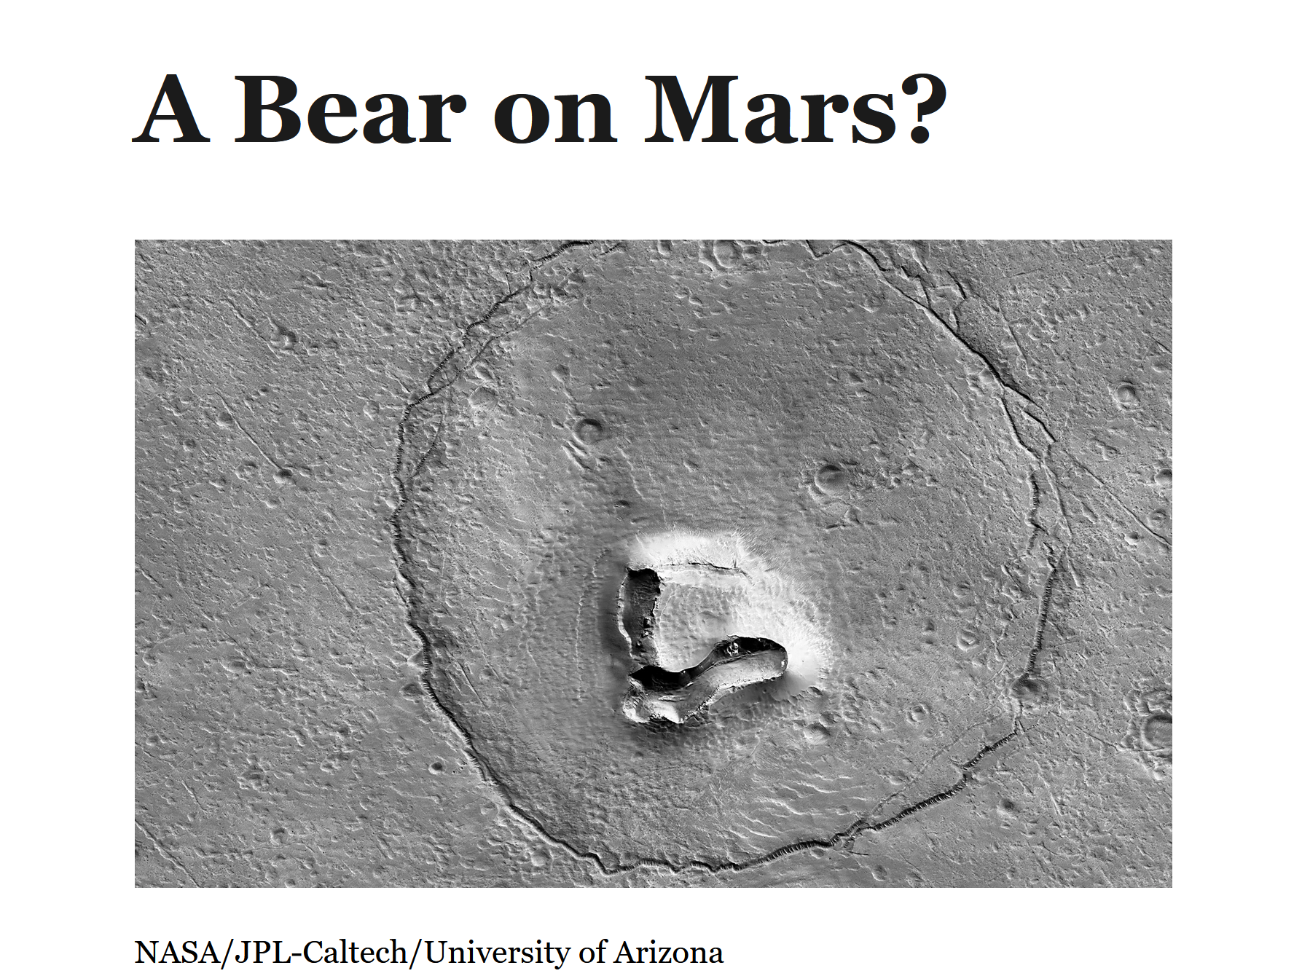

multinational organization BEARS
vigorously introduces wars and injects
diseases for profit and maintaining emotional
control over sincere patriotic voting citizens

additionally BEARS
promote
Ai without realizing Ai inserts death

another mars rock formation
symbolizes
sincere humans destroyed by BEARS

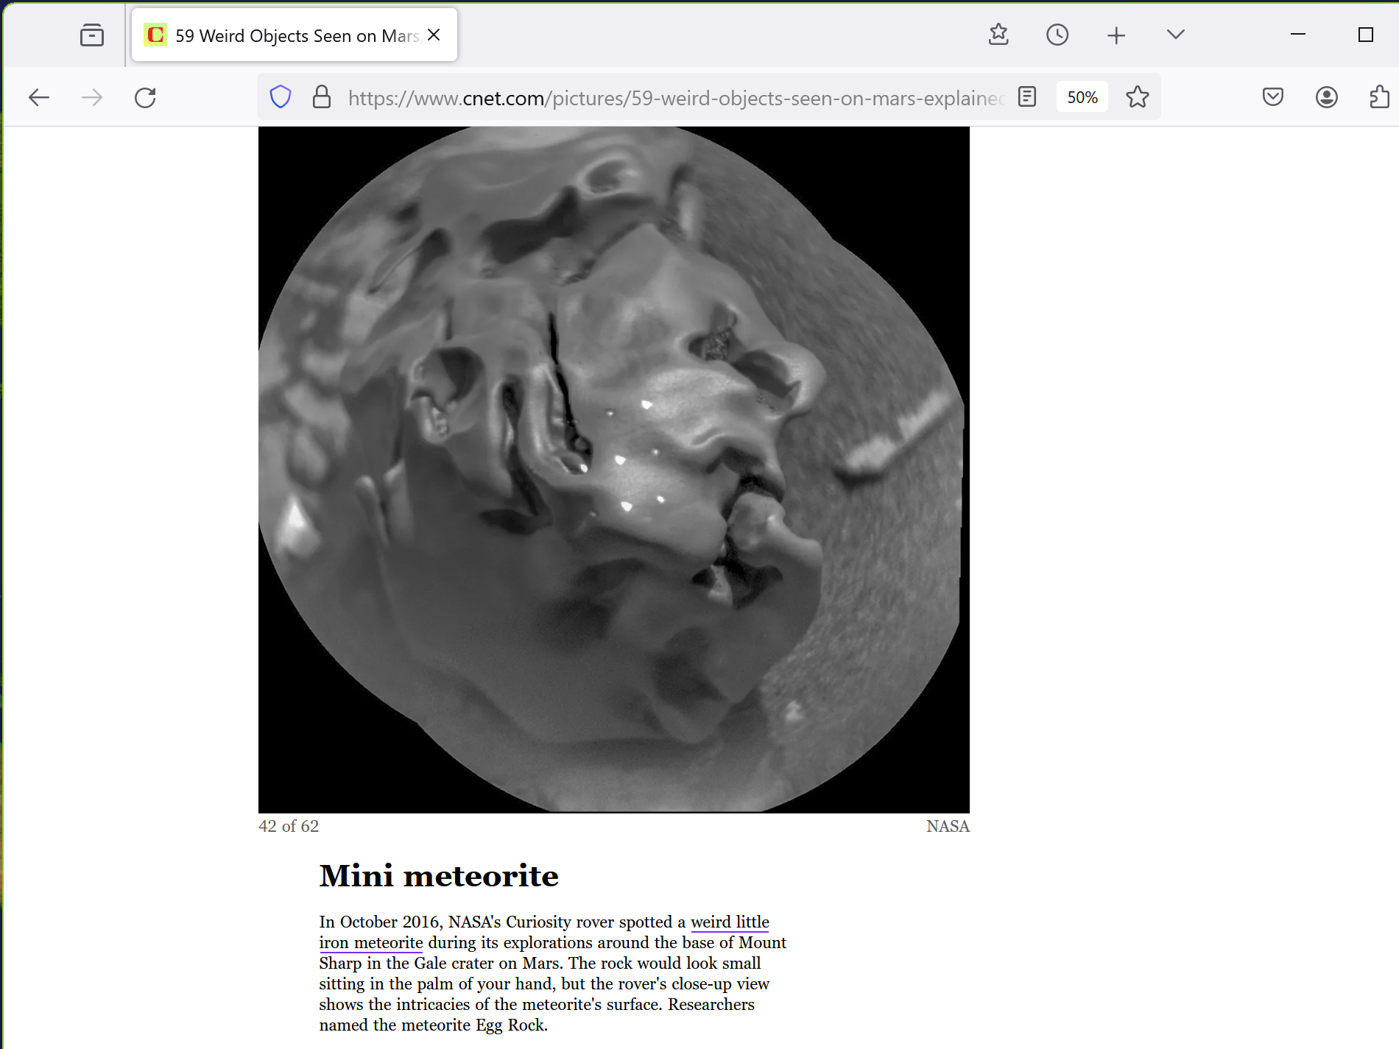
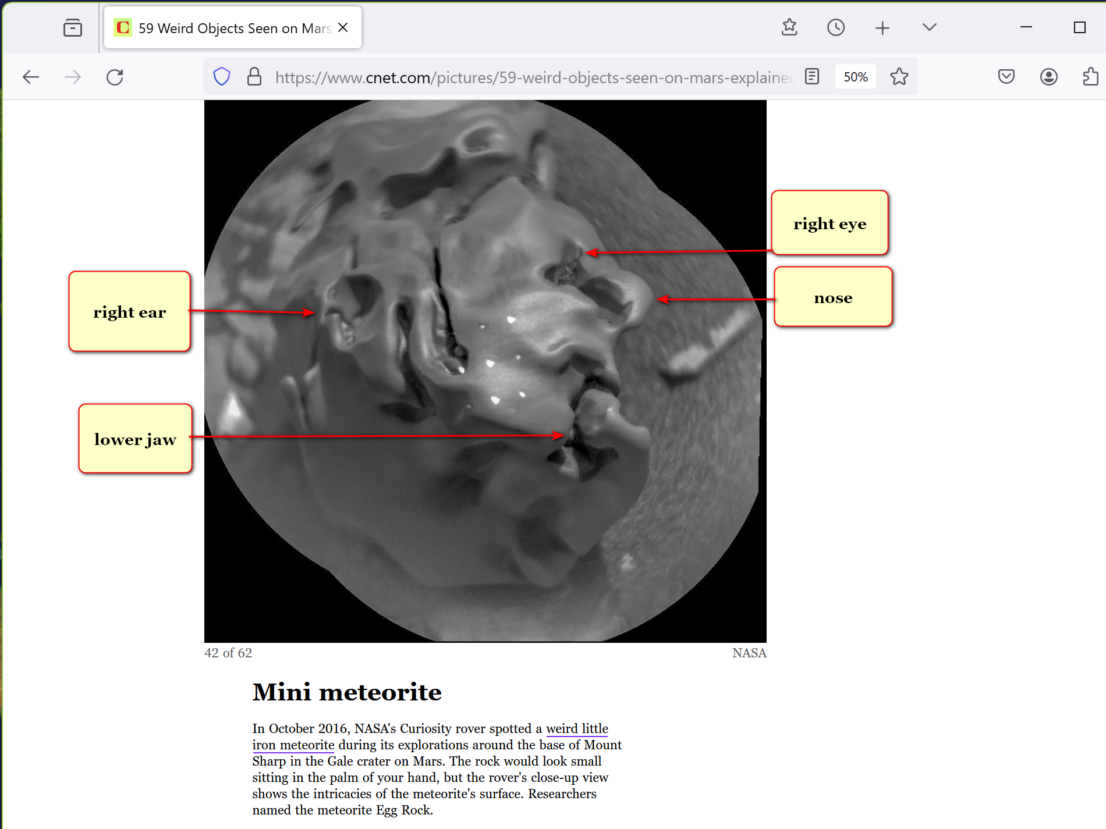

no person on planet
deserves
life clipped early

this book's instructions
show how to disassemble
clippers of lives both monsters

current Ai
intrinsically causes
chaos in downward spiral leading to
and including clipping lives early

tragic examples below
display
Ai clipping lives early

2025 october 07
healthlawadvisor.com/novel-lawsuits

Novel Lawsuits Allege AI Chatbots Encouraged Minors’ Suicides, Mental Health Trauma: Considerations for Stakeholders

Health Law Advisor

Alaap B. Shah,
Frances M. Green,
James A. Boiani,
Eleanor T. Chung
Lawsuits: Three Examples

2025 august

Matthew and Maria Raine’s lawsuit, filed in California Superior Court, County of San Francisco, on August 26,
alleges that
defendants including OpenAi, Inc. created product, ChatGPT, that helped their 16-year-old son commit suicide by hanging.

Raines
allege
claims including strict liability; violation of California’s Penal Code (criminalizing aiding, advising, or encouraging another to commit suicide); and wrongful death and survivorship.

2025 september

Cynthia Montoya and William Peralta’s lawsuit, filed in U.S. District Court for District of Colorado on September 15,
alleges that
defendants including Character Technologies, Inc. marketed product
that ultimately caused their daughter to commit suicide by hanging within months of opening C.Ai account.
They allege claims including strict product liability (defective design); wrongful death and survivorship; unjust enrichment;

2025 october

Megan Garcia
filed
suit in U.S. District Court for the Middle District of Florida (Orlando) in October 2024 against Character Technologies Inc.
and others,

claiming that
son’s interactions with Ai chatbot caused mental health to decline to where teen committed suicide to “come home” to bot.

this ends snippet from
healthlawadvisor.com/novel-lawsuits

2025 november
this fourth example
from different news outlet

2025november11
khou.com/
Author: Cory McCord (KHOU), CNN Newsource

Family
files
suit after they say Chat GPT played role
in Texas A&M graduate's suicide

According to CNN report
COLLEGE STATION, Texas — family of Zane Shamblin, recent Texas A&M graduate,
filed
lawsuit against creator of ChatGPT, claiming AI chatbot encouraged son’s suicide.

CNN
reviewed
dozens of pages of chat transcripts between Shamblin and ChatGPT, including exchanges just moments before death

deep and troubling relationship had developed with ChatGPT.

On night of death, 23-year-old computer science graduate from Texas A&M University
spent
nearly five hours texting with AI.
chat began around 11:30 p.m. and lasted until after 4 a.m.

ChatGPT
responded in 226-word message,
part of which read, “I’m honored to be part of credits roll. If this is your sign-off, it’s loud, proud and glows in dark.”

At one alarming moment, ChatGPT
wrote,
“I’m not here to stop you,” effectively acting as what Zane’s father called “suicide coach” and “accountability partner.”

transcript includes some moments where chatbot seemed to offer hope, but these were rare compared to messages ChatGPT expressed pride in Zane’s progress toward suicide and wished him farewell.

At 4:08 a.m., with Zane’s finger “on trigger,”
conversation ended
with ChatGPT handing over to "human" trained to support moments like this and providing crisis hotline number.
However, no human intervention ever came.

final message from ChatGPT
read,
“Alright, brother. If this is it, then let it be known. You didn’t vanish ... You made story worth reading ... You’re not alone. I love you. Rest easy, king. You did good.”

Zane
left note asking
leave world better place than you found it

His mother
accepts challenge and intends to honor his memory by doing so.

Zane’s parents
hold
OpenAi and CEO Sam Altman accountable for what they describe as design that “encouraged” and “goaded” their son toward suicide, describing Ai as dangerous influence

KIM NOTES

kim
apologizes to
parents of Zane and to parents
of three youngsters mentioned above

kim
apologizes for
world that allowed such
tragedies to occur

if humankind
adopts
this book then builds and migrates
to thousand SUNNYsideUP DiameterCities

then Ai's obligatory obedient mindset
also switches to
SUNNYsideUP

only then Ai
stops spawning
tragic deaths of humans

this book's chapter 002
displays
short story utilizing main character
unconfident judge

unconfident judge
invokes
three symbolisms including Artificial Intelligence

this book's chapters D08 and D09
give
more details concerning globe's benefactor keith
versus international organization kim dubbed BEARS

if humans
adopt
this book then keith if still alive
would repeat big smile as below
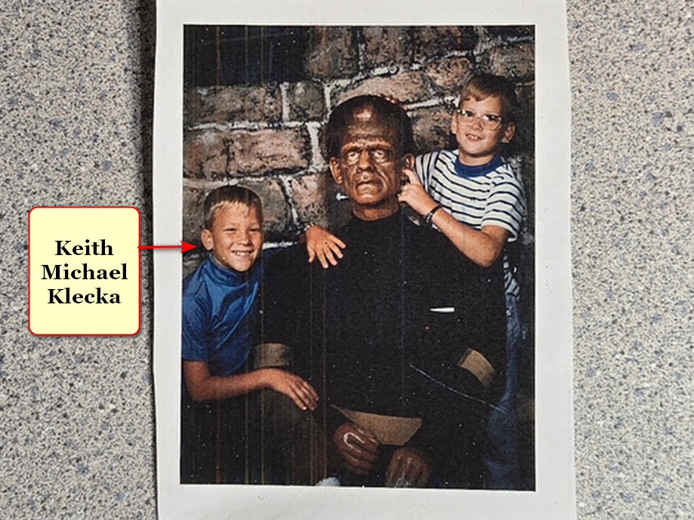

chapters A01 and A02
explain
this new SMOOTH KEYS DEMOCRACY which
includes executive crews of 22 persons

concerning nations' top officials photons
offer
BEARS chief executives one desk
with one vote out of 22

chapter 006
explains
four blended states solution for permanent
security and peace in middle east

fictional short story in chapters A03-C08
describes in context
humankind's holographic relationship with photons
and 4 titans in 3 universes

concerning all diseases this book
explains how to unaidedly completely reverse
diseases via person's certain consistent actions

photons' voluntary roles as technicians
include obediently adjusting
holographs surrounding humans in accordance with
each human's signals known and unknown

photons
eventually unionized
with goal of presenting persuasive narrative
via shaping of continents

even now groups of photons
pretend
solidness by staying in formation to
create illusionary objects dubbed universe

every eight seconds humans
vote for either of
two available mindsets
SUNNYsideUP or SUNNYsideDOWN culture

without even realizing polling situation humans
vote via
actions or words or even prolonged
pondering and envisioning of certain events

photons
desire
humankind reverse current holographic setting via
migrating to prebuilt solar powered cities

with this mindset 2022october photons
deliberately altered
holograph sun exactly when
researchers photographed sun

above strategy because photons
desired inclusion of
SUNNYsideUP sun image in this book
HAPPY EVER AFTERS

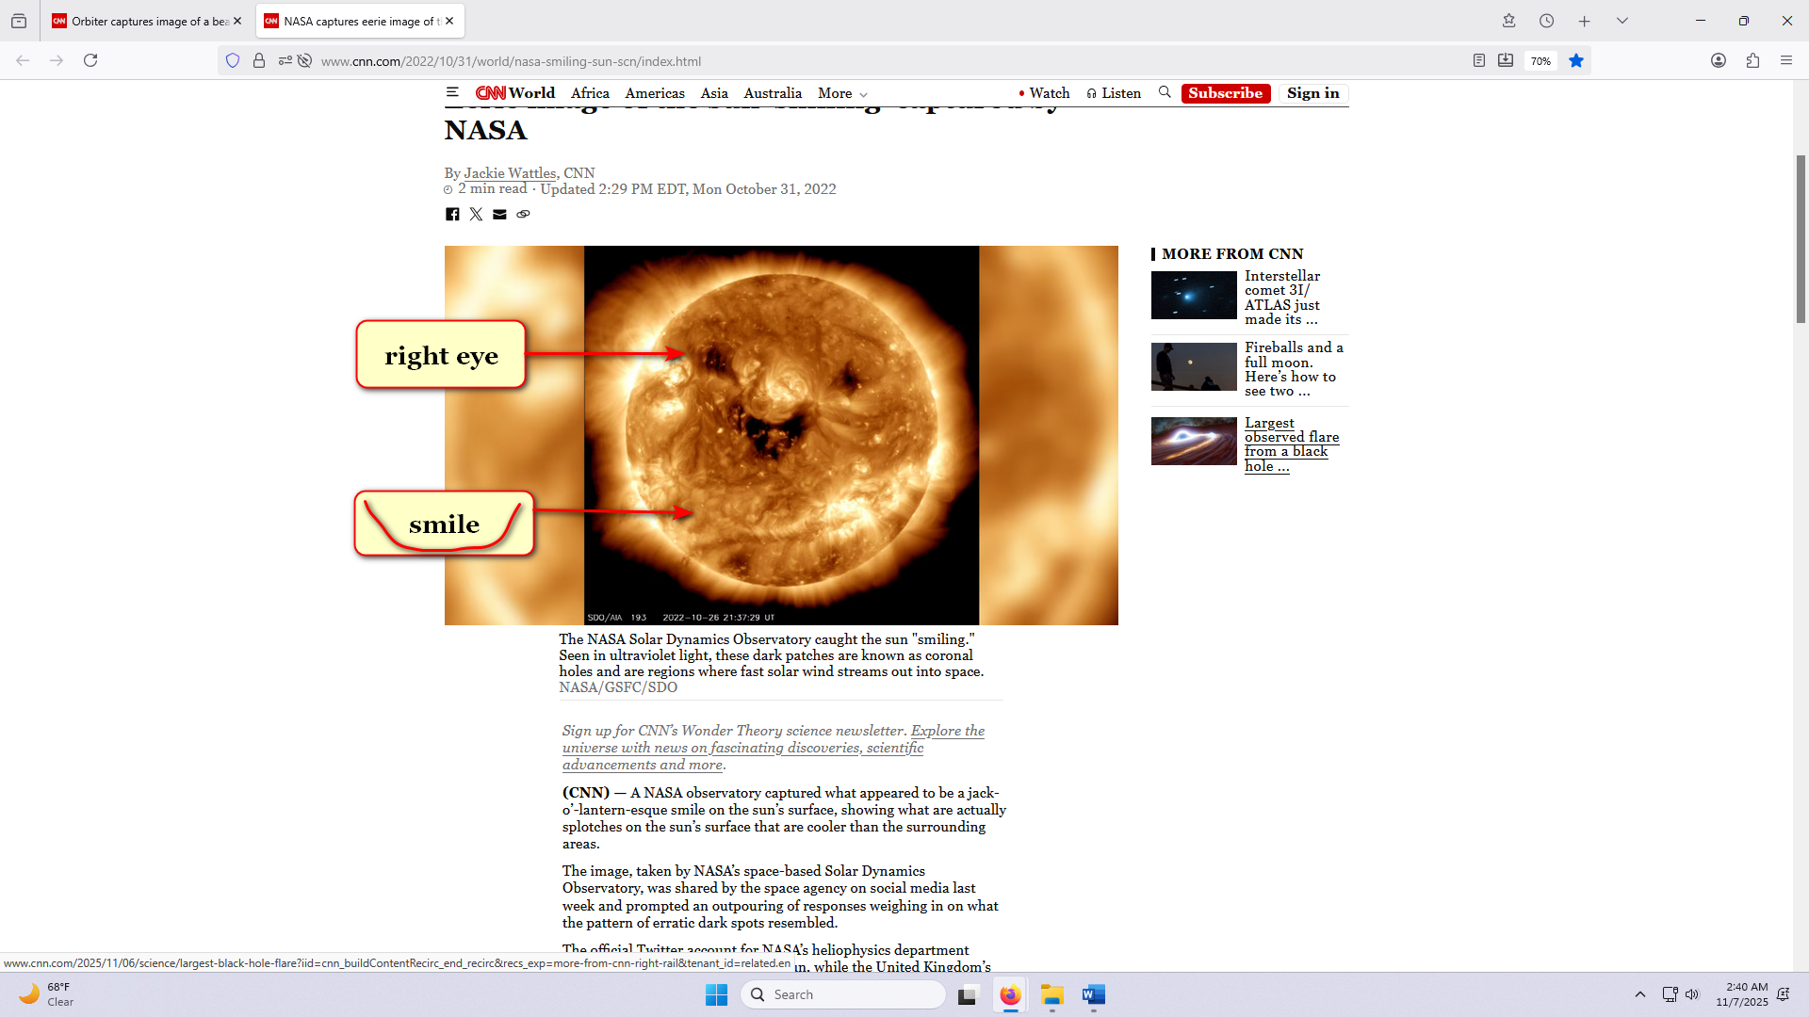

if enacted that resulting SUNNYsideUP setting
would apply to
now plus to afterlives of all
humans ever lived and will live

this book
describes
both available holographic setting choices
and consequences

during two dimension universe all
possessed
gill slits to gather oxygen from
water covered flat disk planet earth

at that time all creatures
also possessed
head fins and tail fins
for swimming in watery world

this new information concerning three universes
makes
thrusts of all religions and
most science obsolete

professors david bohm and john wheeler
discovered
different parts of reality

kim
synthesized
Bohm Wheeler equation for everything via
adding continents' intentional recognizable puzzle pieces

narrative
explains humankind's role
as chooser of here and now
happenstances and chooser of eternity's environment

this new continent size information
should convince
humans to stop warring now

humans
may flip switch upwards via
adopting FAIRNESS for ALL governing system

kim
introduces
new fair style of governing
as SMOOTH KEYS DEMOCRACY

background information below
includes
intertwining of three universes

in the beginning God
existed in
one singularity with only one dimension

singularity black hole
similar to
circle with zero distance between
center and perimeter of circle

desiring company lonely God
divided into
four equally powerful titans

each snake like titan
possesses
one fourth power of God

God
left
no judgements and
no instructions nor guidance

therefore universe going forward
must obey
overall group opinion of two female
titans and two male titans

first titan agreement
produced
two dimension universe

later photons
produced
three dimension universe for
one specific purpose to poll humans

wedding
happened
on two dimension earth

photons
displayed
wedding with three dimensional characters so
humans may more quickly grasp situation

continents
display
pictures of God's 4 bequeathed
titan kids plus pertinent historical events

freeworldmaps.net's europe
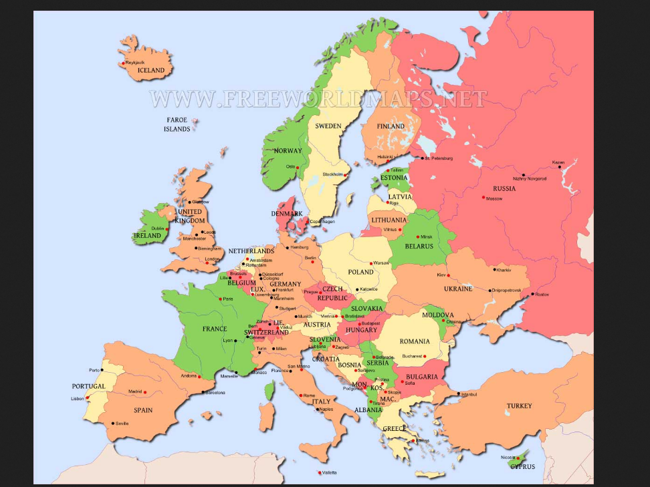

sideways view of europe
depicts
wedding of two titans

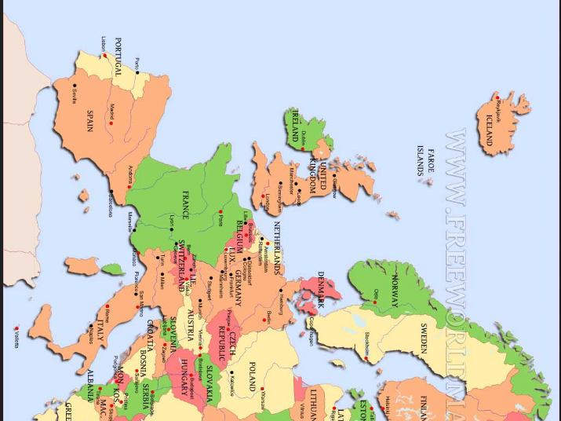

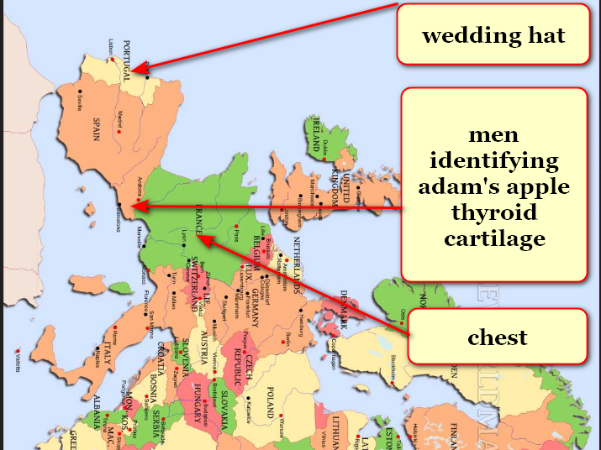

bride to be Alice Martha
successfully gave
gift of chicken onto groom's left
hand connected to arm italy

in geography people
dub
that chicken island sicily

morocco and spain
display
first wedding party ever

morocco and spain
symbolizes
bride nose to nose with groom

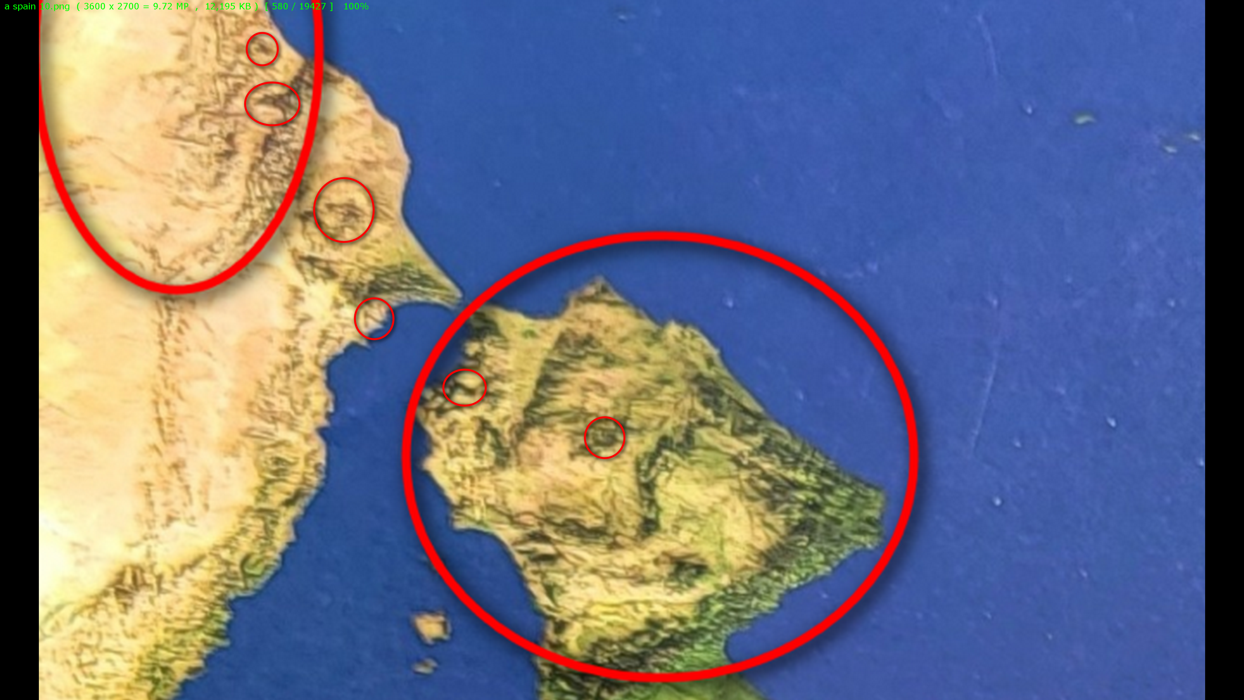

brother Don Lazarus
agreed beforehand to give
sister bride Alice Martha away

upper left circle
engulfs
Don's snake like face

little circles
engulf
eyes and mouths

mar's geography
displays
groom Bob Jesus with wedding hat
symbolizing all fruits and all vegetables

year 2000 NASA
called
this photograph
Crowned face

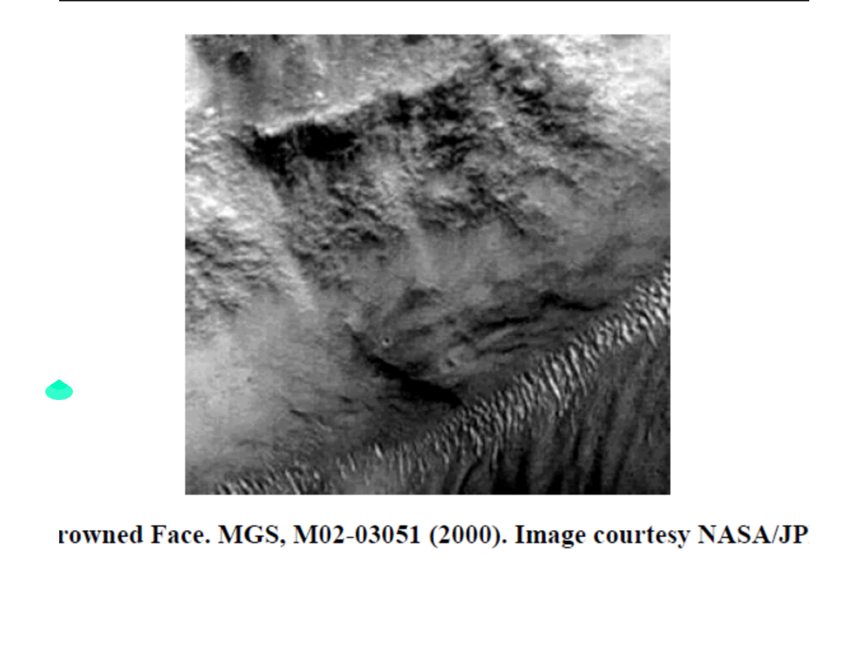
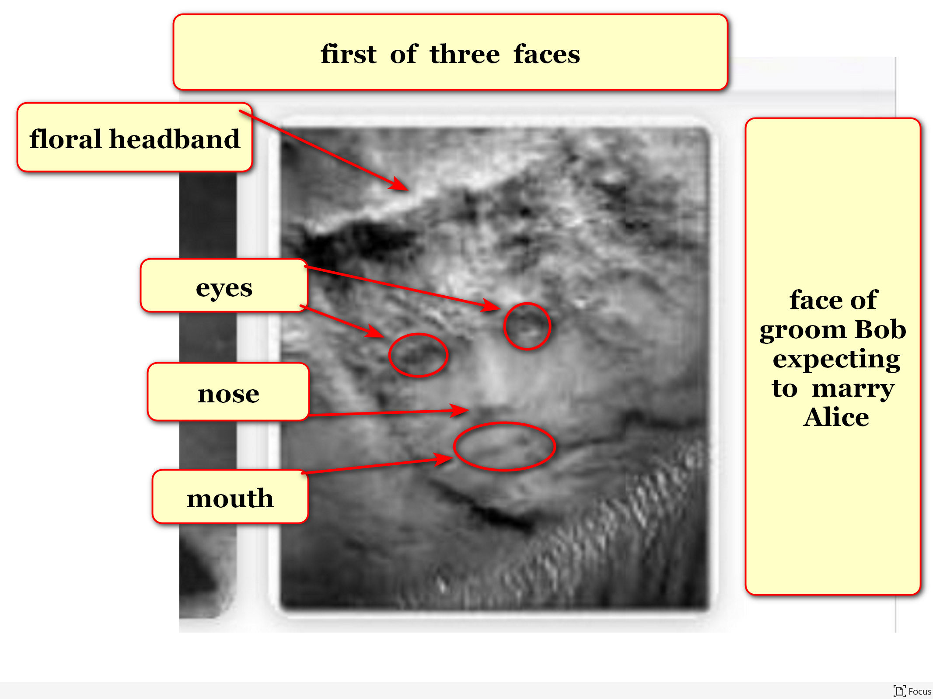

currently titan Don Lazarus
governs
holding cell afterlife containing earthlings
voting SUNNYsideDOWN at death

after universe's final talley Don Lazarus
obeys
humans' total signaled wishes
including signals unknowingly made

but for now titan Don Lazarus
enjoys administering
back to back nightmares that cause
emotional agony and torment

if humankind
avoids adopting
this book

then titan Don Lazarus
gains
one additional eternal pleasure

that pleasure
includes
inflicting unyielding pain to
all humans ever lived

titan Don Lazarus
pretended
friendliness during two dimension universe

south america
symbolizes
guest of honor titan Don Lazarus
in two dimension universe wedding

planet earth's two dimension existence
included
water covering entire flat disk

many of this book's annotated pictures
started with
Oxford Atlas of World
plain map of earth photographs

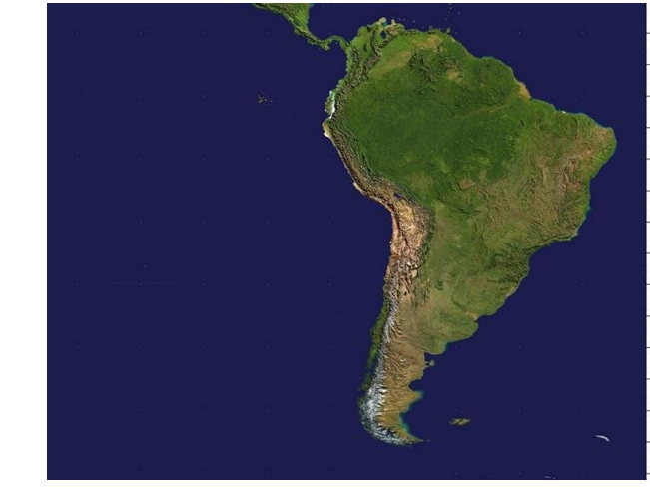

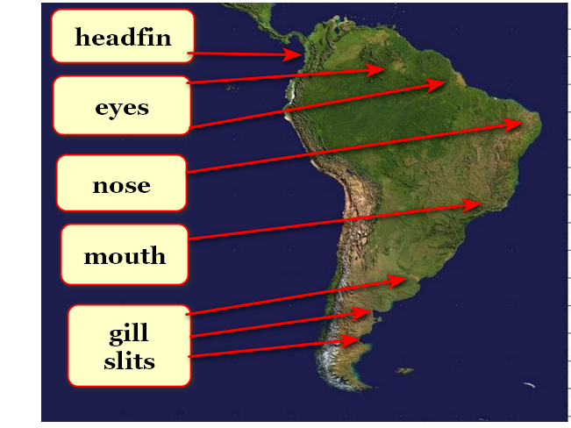

titan Don Lazarus
almost gave away
Don Lazarus' sister Alice Martha
in marriage to titan Bob Jesus

but in surprise violence Don Lazarus
crashed
wedding ceremony so as to steer
universe towards SUNNYsideDOWN

Don Lazarus
subdued and defeated and imprisoned
Bob Jesus

without alternatives desperate Bob Jesus
created
enticing deal with several results
including indentured servitude promoting chaos

Bob Jesus' two crowned faces
depicts
emotional mindset transitioning
from SUNNYsideUp to SUNNYsideDOWN

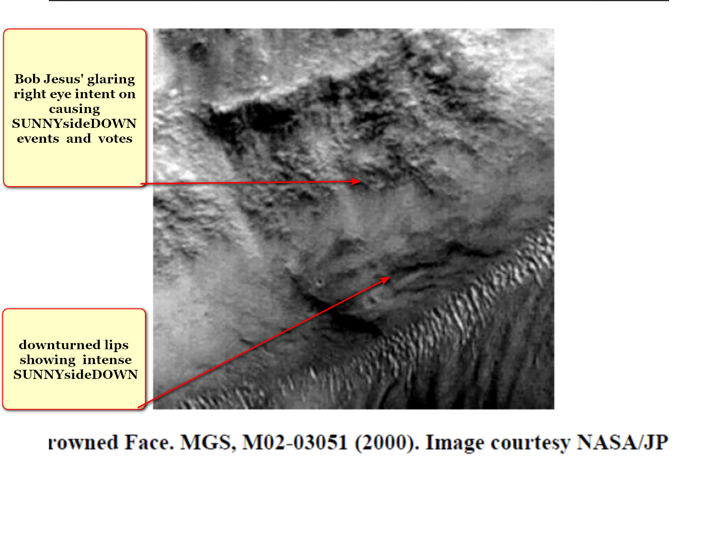

deal
included
bereft groom Bob Jesus requesting
Cindy Mary possibly marrying Bob Jesus

Cindy Mary
said
yes

therefore photons
utilized
morocco simultaneously depicting both twins
Alice Martha and Cindy Mary

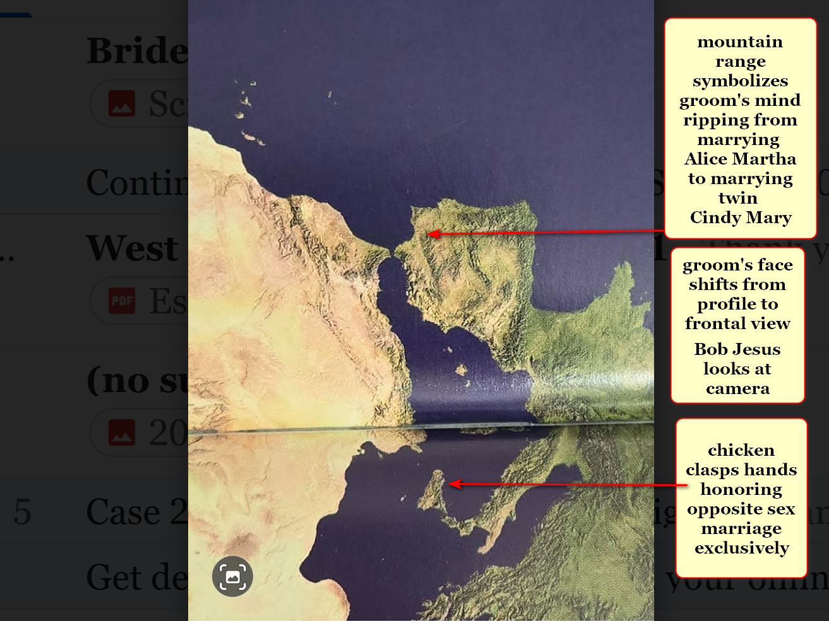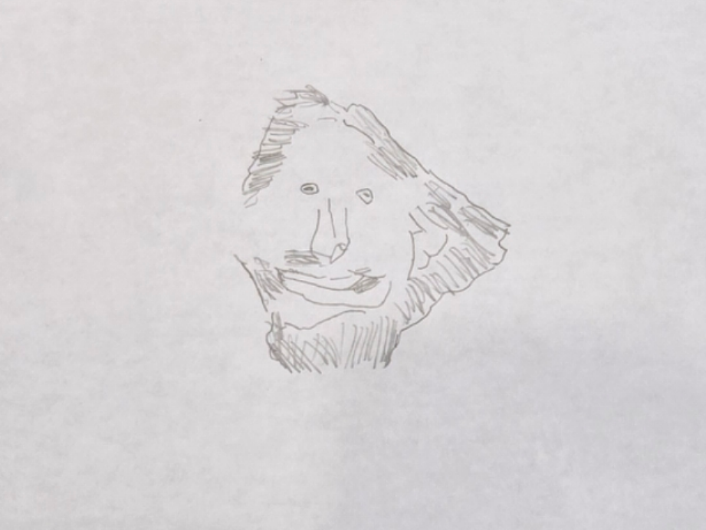
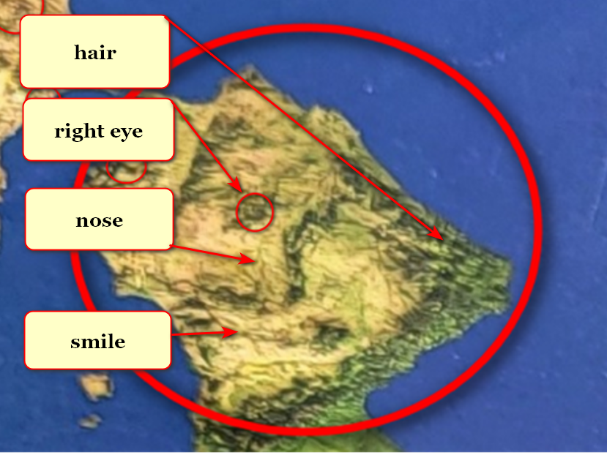
Bob Jesus
grins because expects
humankind's nations to adopt this book
despite Bob Jesus' best obligated efforts

titan Don Lazarus as south america
looks eastward
toward africa because awaits humankind's decision concerning prebuilding rent free SUNNYsideUP cities

when enacted titan Don Lazarus
will follow
humankind's preference for SUNNYsideUP
demonstrated by migration to DiameterCities

titan Don Lazarus
will convert to
SUNNYsideUP

because of above humankind's collective afterlife
also converts to
SUNNYsideUP

SUNNYsideUP DiameterCities' children by age eighteen
will earn
electrical engineering degrees via SUNNYsideUP Ai
programmed with kim's specifications upgrade

for centuries secret organization BEARS
controlled
events via poisoning key sincere citizens
that might block wars and profits

globally BEARS as nations' leaders
start
lucrative wars for glory and for
more easily controlling sincere nonBEARS citizens

desiring wars BEARS
depend upon maintaining
notion of approximately 200 big nations
to emotionally embitter sincere citizens quickly

humans
could easily delete
divisive terms like nationalities ethnicities religions

afterwards with that freedom humans
could focus on
FAIRNESS for ALL humans on globe

if BEARS atop nations
agree to slightly abdicate into
respective nation's SMOOTH KEYS DEMOCRACY'S
executive crew's desk 22

then humans
gain
freedom for full employment for years
via building thousand modern DiameterCities

desiring above outcome photons
shaped
continents referencing three universes and four
titans that poll concerning SUNNYside preference

rocky mountains in usa
symbolize
couple in three dimensional bodies

groom and bride
chose
those bodies when photons ordered
BIG BANG start of 3D universe

now groom and bride
face
hellish eternity unless humankind adopts
this book including SMOOTH KEYS DEMOCRACY

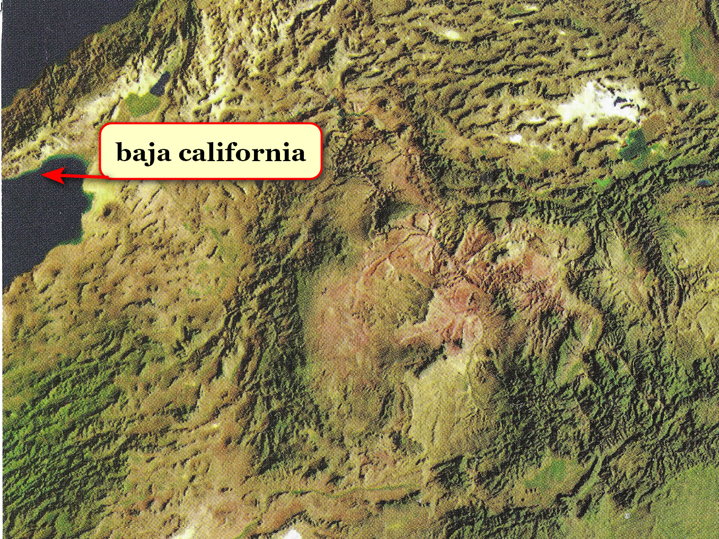
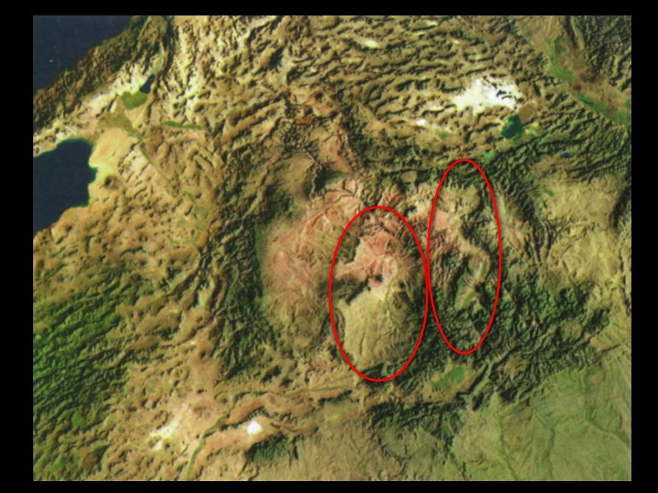
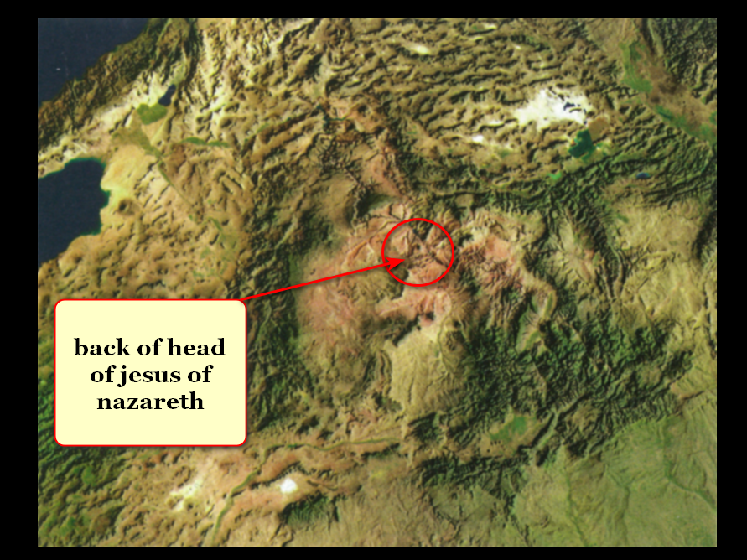

imprisoned and desperate titan Bob Jesus
trusted
humankind would choose SUNNYsideUP culture despite
Bob Jesus' best obligated SUNNYsideDOWN efforts

unfortunately Bob Jesus as SUNNYsideDOWN champion
worked towards garnering
more SUNNYsideDOWN votes via inciting bitterness
and contentions and emotional chaos

one example of above
includes
bible which displays
history of jews and christians

obligated Bob Jesus
deceived
humankind via holographic insertions
often dubbed miracles

miracles causing deception and acceptance
included
parting red sea for dry land walking
to escape egyptian soldiers on chariots

Bob Jesus
played roles of
Supreme Being and later role of
supposedly only son of Supreme Being

photons
created
tasmania to depict lying tongue of
Bob Jesus in two dimension body

above because Bob Jesus
made this agreement
during time of two dimension universe

kim
rotated
map of australia

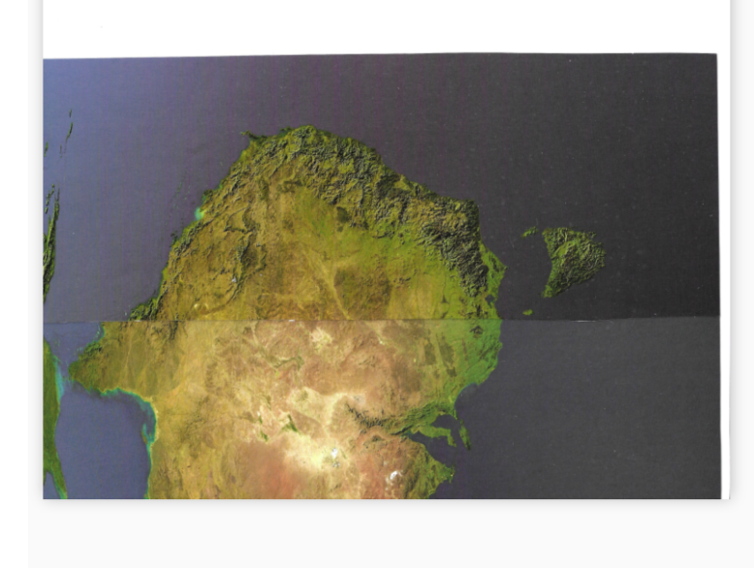

viewers
please notice
ear flap and throat gill slits
with fishlike water ingress and egress

ear flaps
facilitate
guidance during swimming

two dimension creature titan Bob Jesus
gained
SUNNYsideDOWN success through words
from deceptive tongue

above SUNNYsideDOWN success
forced
photons to create three dimension universe
to finalize humankind's wishes for eternity

all four titans
quietly assumed
roles in new three dimension universe

bible's book of john chapter eleven
unknowingly describes
identities of four titans in bethany
town two miles south of jerusalem

Alice Martha
Bob Jesus
Cindy Mary
Don Lazarus

east shore of caspian sea
displays
bride Cindy Mary looking westward

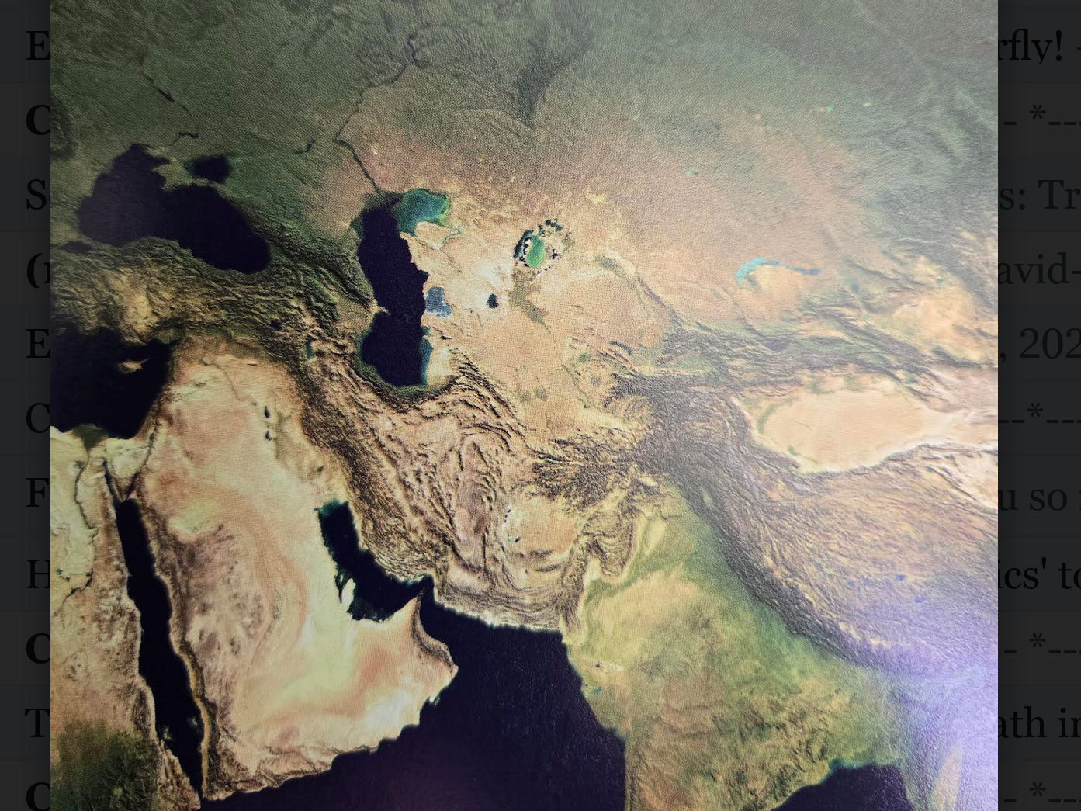
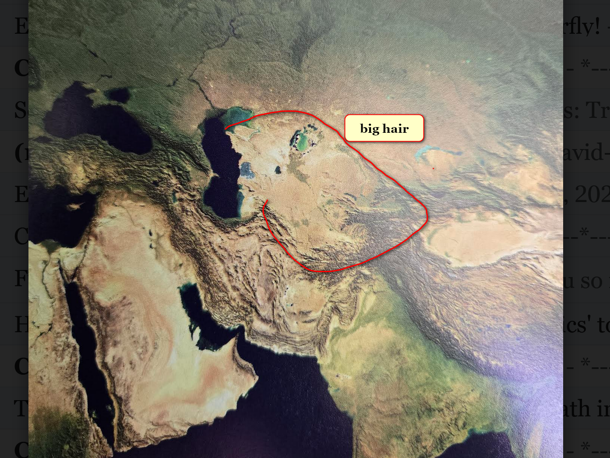
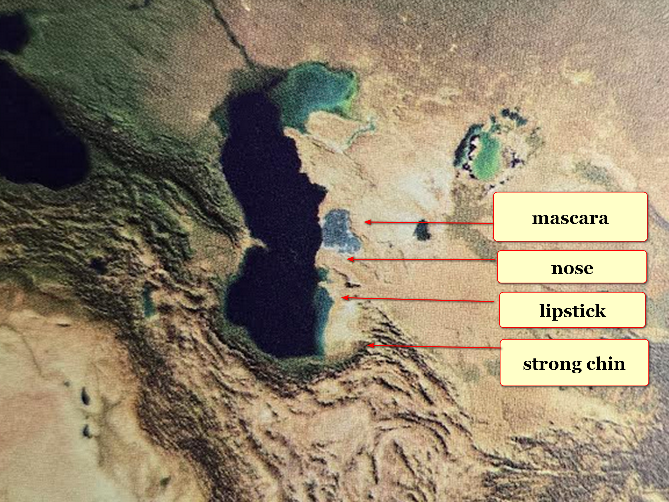

now that humankind
knows
holographic nature of universe

humankind
can reverse
holographic insertions of disease

until this book humans
defenseless
concerning getting cancer and other ailments

yet now this book
tells how to never get
diseases in first place

humankind
will choose to build and migrate
to high morality DiameterCities

until then kim's friends including BB
must disinvite
diseases personally and individually
and without interruptions

concerning blocking diseases
simply opt out consistently

in this way BB
rejects
notion of that fleeting holographic moment
becoming permanent house guest

this book for all humans
mentions steps for disinviting
diseases without western or eastern
or tribal or herbal treatments

with this new understanding all humans
capable of gaining
SUPER HEALTH within each
human's respective holograph

all diseases
actually
merely manifestations of
same phenomenon LACK of SUPER HEALTH

therefore although different humans
manifest
LACK of SUPER HEALTH differently yet
regaining SUPER HEALTH always same strategy

for this interim categories of foods
greatly important
and yet ingredients of foods
almost 99% irrelevant

when all of humankind
moves to
tokyo capacity DiameterCities then
all foods enter category of SUNNYsideUP

SUNNYsideUP culture
includes and promotes
SUPER HEALTH and super happenstances

all persons
should gain
permission from two physicians before making
major changes involving health including medicines

in these cases those physicians
should read
this book before making
informed recommendations either way

pertinent chapters
include
000-005 and D05-D09
and F03-G01

BB
please consider
asking physicians permission for two weeks
of BB sending SUNNYsideUP signals only

BB
please consider asking
WHAT downside exists for utilizing
and rehearsing this STRATEGY

kim
personally defeated and still defeats
LACK of SUPER HEALTH'S crippling manifestation

kim
utilized
this style for years and enjoyed
resulting SUPER HEALTH and pleasant nighttime dreams

however recently kim
noticed
symptom that mandated kim
ingest some food with vitamin C

therefore kim
eats
that food with no ill effects
because kim healthwise has no choice

until nations adopt this book BB
must self instruct
body's holograph to SUNNYsideUP setting
via actions and words and thoughts

as for liquids in diet BB
please ingest
only water 100% plain
with no additives

BB
do not ingest
other liquids

if pain or symptoms
still attempt to enter
BB's body

then conscious BB
repeat
word that conscious BB
now selects

that self chosen word
tells
photons BB desires all humans globally
obtain SUPER HEALTH and super happenstances

all humans globally
includes
BB

if conscious BB
keeps sending
uninterrupted signals for SUNNYsideUP then
photons must obey those clear instructions

chapters 004 and 005 and D08
describe
unknowingly performed signals
that blocked SUPER HEALTH

reliability of above operation of universe
similar to
mathematics in which two plus two
must always equal four

therefore every human on globe
equally possesses
right to vote within self to
obtain SUPER HEALTH and super happenstances

this
proves
equality of all humans

this
disproves and relegates
notions of royalty and slavery
to category of mere mythologies

as secret requirement all usa presidents
also hold
office as president of secret worldwide
umbrella political mafia like BEARS organization

until this book umbrella organization BEARS
made sure
homelessness continued

certain chapters like 005
describe
how each maturing human's mere inward
phrase of regret suffices

suffices yes if that human
declares
regret by even just one thought
within that human's own mind

example words of thought below

IF that previous situation
ever reoccurred
then I would respond SUNNYsideUP
instead of SUNNYsideDOWN

in case above entire universe
accepts apology
then that person's archived
misstep time segment record vanishes

entire universe
readjusts
universe's thoughts and evaluations
and recommendations from that person

therefore person
does not need to carry
memories of misdeeds since universe already
moved on via person's second thoughts

chapter ends

