001 photons admire kindness of rabbi and keith

teaching story often called LONG SPOONS

Rabbi Hayim Elhanan Ben Yehudah Leyb Tsedek (Tzadikov)
lived in
russian empire's lithuania's city of rumsiskes
from 1813 to 1883

Rabbi Hayim Elhanan Ben Yehudah Leyb Tsedek (Tzadikov)
gave to
humankind story of LONG SPOONS
because of one night's dream

conventional wisdom
teaches
humans that
current three dimensional universe solid

however in actuality photons
created
hybrid universe for holographic testing
to gather opinions votes from humans

each person's daytime emotional mindset
expresses
same during dreaming

above
because
dreaming equals return to one dimension
original singularity

in other words person in sleep
experiences
actuality of one dimension universe without
mirage of holograph three dimension pretension

considering one dimension universe viewers
please imagine
circle with zero distance from center
to perimeter

one dimension dot
contains
only emotions and all persons connect
with and know others' emotional mindsets

nonvoting personalities labeled photons
utilize
directors' prerogative to insert stage props
to promote humans' SUNNYsideUP voting

in this example photons
inserted
LONG SPOONS dream hoping rabbi would
opinion vote SUNNYsideUP

thankfully Rabbi Hayim
spoke beneficially for
humankind in favoring SUNNYsideUP style for
universe's daily standard operating procedures

humankind
owes debt to
Rabbi Hayim for officially flipping humankind's
holograph switch up from SUNNYsideDOWN setting

judaism.stackexchange.com/questions/31670/origin-of-the-allegory-of-the-long-spoons

if you're looking for first printed source that attributes story to R. Haim visiting heaven and hell, then that source is Hebrew anthology of Jewish humor called Sefer habedichah vehachidud [The Book of Jokes and Riddles] collected by
Lithuanian writer and researcher Alter Druyanov (1870-1938).

anthology was first published in 1935, and original story in question appears in second volume under section titled "bein adam l'chavero" [between man and fellow]. It goes like this:

Rabbi Haim Romshishker publicly expounded and told the following:

Once, I went up into the sky and also entered hell. I looked around and saw: old and young men sitting rows upon rows in front of tables that were full of all the best things, each holding a long spoon in hand.

And when one reached for his mouth, he wouldn't be able to because of the spoon's length.

And so they all sat row against row with their souls dry and a great sorrow rested on their faces.

I went over to one of them and said to him: "A fool in the world! Rather your eyes seeing all this goodness and craving, send the spoon that is attached to your hand and support your friend who sits opposite you.

And he will, in turn, support you with the spoon attached to his hand."

The man looked at me with meager eyes and replied:

"It would better for my eyes to see and crave all day long than for me to see him enjoy and be satiated. "

I was alarmed to hear this, so I opened my mouth to scream a loud scream and woke up.

KIM NOTES

Sefer habedichah vehachidud [The Book of Jokes and Riddles]
published in
1935

with that human permission photons
added
new LONG SPOON rock formation
to Mars' geography in 1935

humans
had no knowledge of original shape
of that portion of Mars

weather.com's



if and when all nations
adopt
SHOELANGUAGE book as great leap forward

then with that action humankind
voluntarily chose
new motto for humankind

humankind
will officially activate
LONG SPOONS for here and now
and for eternity for all afterlives
for above to happen african nations
must first give
permissions for utilizing land

nations
must give
permissions voluntarily for official standings

fate of humankind
rests on
permissions from african nations

if agreed then humankind across globe
enjoys
full employment opportunities to fabricate materials
for prebuilding thousand tokyo capacity cities

after years of prebuilding humans
will gather together

all humankind collected as shown below
will allow
globe to heal

kim
annoted
oxford atlas of world page 255

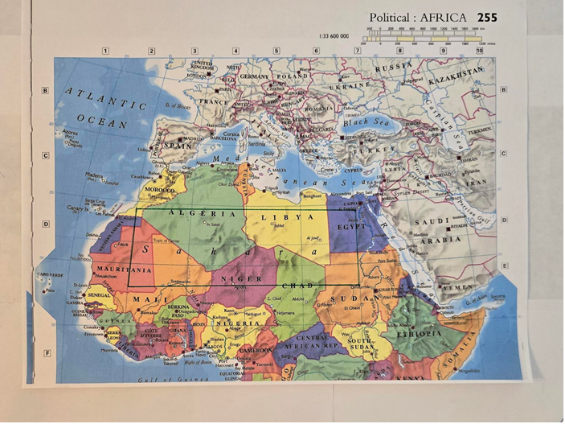

abbas netanyahu putin trump or zelensky
could retire
BEARS club

BEARS worldwide multiracial warmongering group
currently and historically created
outlandish wars across globe so as
to reap war equipment manufacturing profits

zelensky unknowing of secret BEARS group
operates independently of
and usually contrary to
BEARS controlling group's wishes

if any of above leaders
adopts
executive decision making strategy
SMOOTH KEYS DEMOCRACY

then citizens worldwide
will insist
on same in respective nations

features of SMOOTH KEYS DEMOCRACY system
check and balance
chief executive crew away from warmongering
via capital cities' citizens' voting weekly

for centuries winners of wars
irrelevant
to BEARS

BEARS manufacturers of weapons
always win financially
as long as conflicts instigated
and weapons utilized

in this way BEARS
view
both sides' war deaths
as financially profitable

yet non BEARS zelensky
actually
sincere human being and desires happiness
SUNNYsideUP for ukrainians and russians

zelensky
hates
war deaths

newsweek.com's sara santora
katya gorchinskaya on twitter

www.newsweek.com/zelensky-pictures-taken-41-days-apart-show-effects-war-viral-twitter-1695748

Apr 06, 2022
2022 april 04
Zelensky in town of Bucha RONALDO SCHEMIDT / Contributor/Getty



with SHOELANGUAGE book's plan zelensky
could save
globe by starting SMOOTH KEYS via
agreement with unicameral legislature Verkhovna Rada

zelensky or any nation's chief executive
could step forward and proactively model
SMOOTH KEYS DEMOCRACY

this SHOELANGUAGE book
describes
SMOOTH KEYS DEMOCRACY in chapters
A01 and A02

european SMOOTH KEYS DEMOCRACY example
includes
zelensky plus putin abdicating slightly

above involves zelensky plus putin
joining
respective nation's newly formed
executive crew of 22

SMOOTH KEYS
spreads upon
shoulders of 22 persons
burdens of presidency

SMOOTH KEYS DEMOCRACY adoption
signals to
other nations that only peaceful intentions
exist

above
far more comforting that
paper treaties

SMOOTH KEYS voting to war requirements
include
at least 12 YES votes concerning
initiating extraterritorial belligerent actions

if that happens capital city citizens
almost 100% likely to vote out
crews until finally executive crew satisfies
citizens' desires for peace

if all other nations
follow
ukraine and russia
in adopting SMOOTH KEYS

then nations
cannot justify spending
money on defense
against nonexistent threats

this strategy
removes
moneymaking power from BEARS

with newly acquired irrelevancy BEARS
retire peacefully

nations' former defense monies
can prebuild
modern solar powered DiameterCities

above situation
creates
opportunities for
full employment opportunities globally

surely peace prize committees
would take note
concerning presidents ending wars forever

2024july13 BEARS self preservation strategy
included assassinating
trump because hinting through speeches going
independent of BEARS via presidential power

ahead of time BEARS usa
coordinated script with
BEARS members secret service top officials
concerning perfectly timed security lapses

therefore top secret service BEARS officials
aggressively blocked
honest secret service agents from radioing
an immediate speech intermission RED ALERT

BEARS standard mythical defense includes

MERELY cascade of innocent inefficiencies
unfortunately somehow perfectly aligned
and timed to allow killing OPPORTUNITY

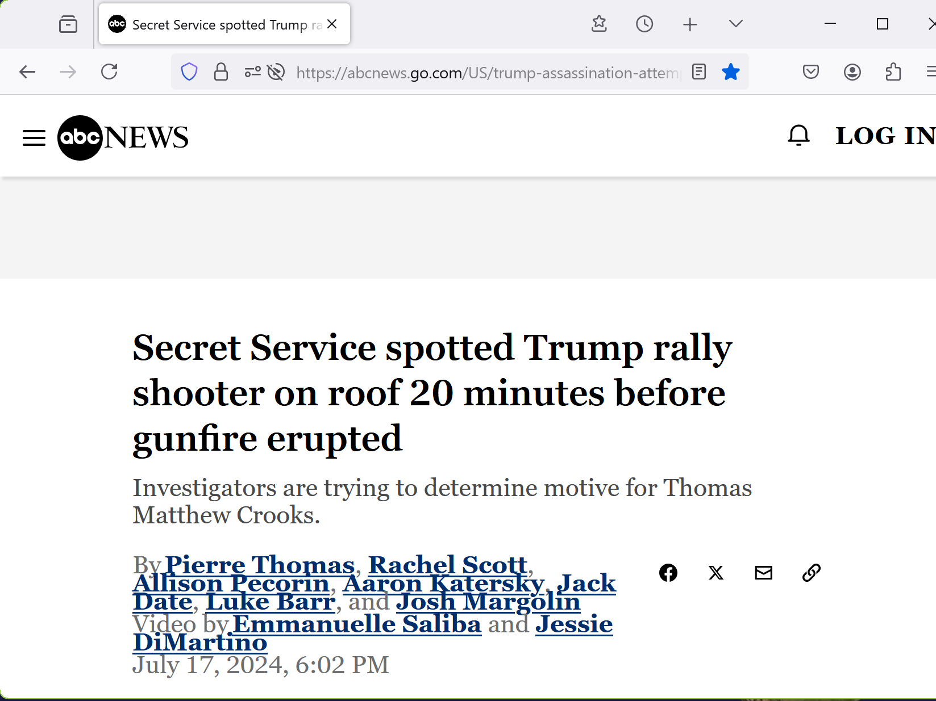
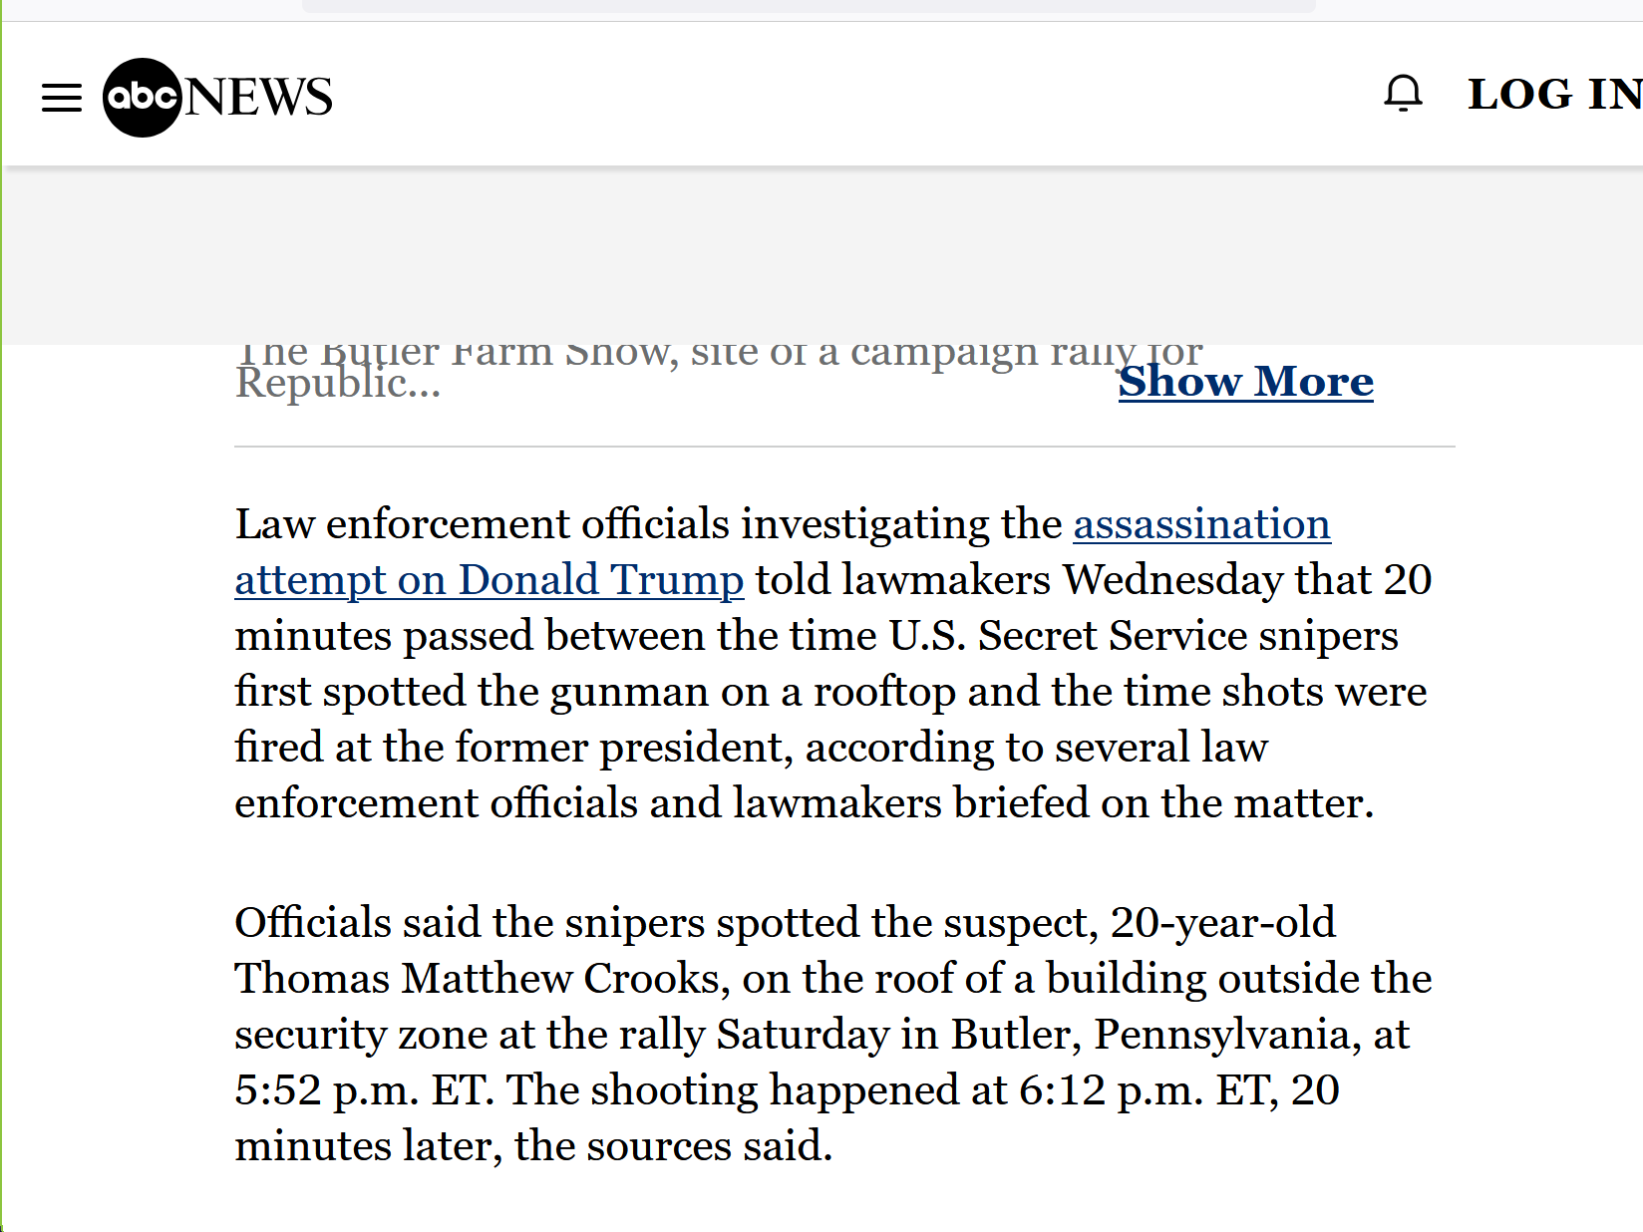

/web.archive.org/web/20240717210946/https://www.snopes.com/fact-check/bullet-glass-trump-wound/

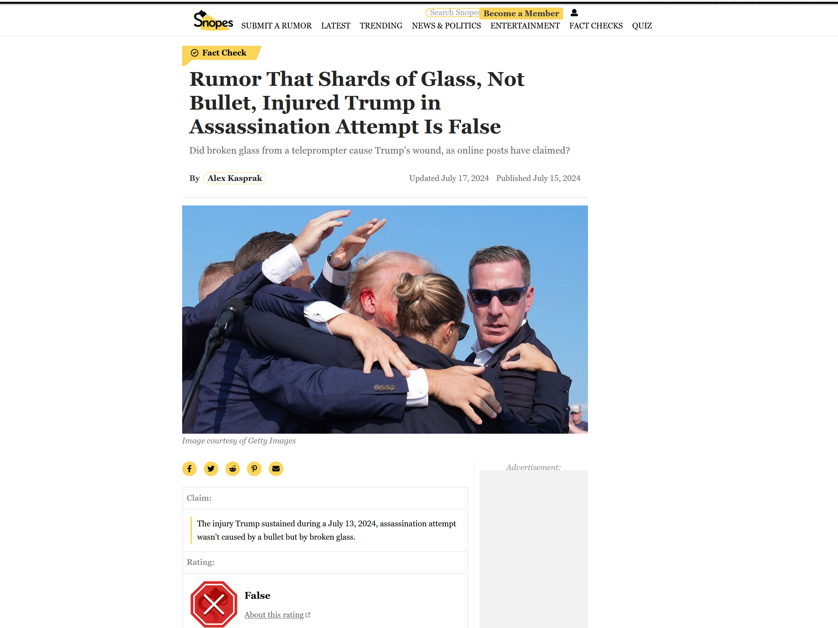
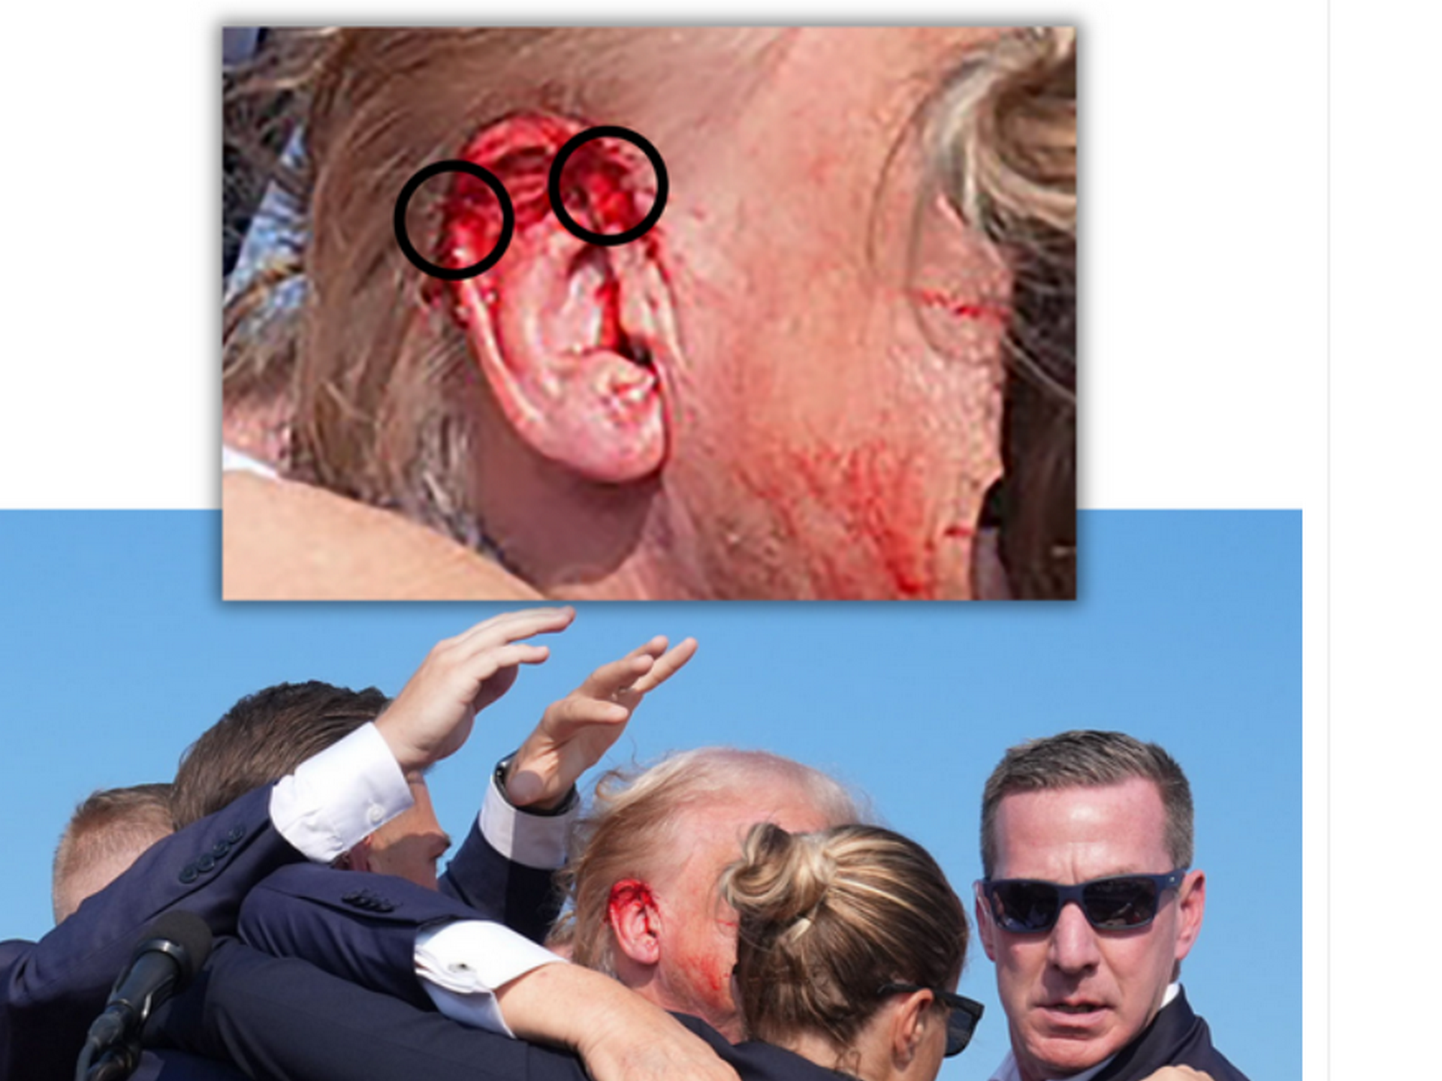

2024 july 14

ww.npr.org/2024/07/14/nx-s1-5039293/corey-comperatore-man-killed-in-trump-assassination-attempt

Meg Anderson is a reporter on NPR's National Desk


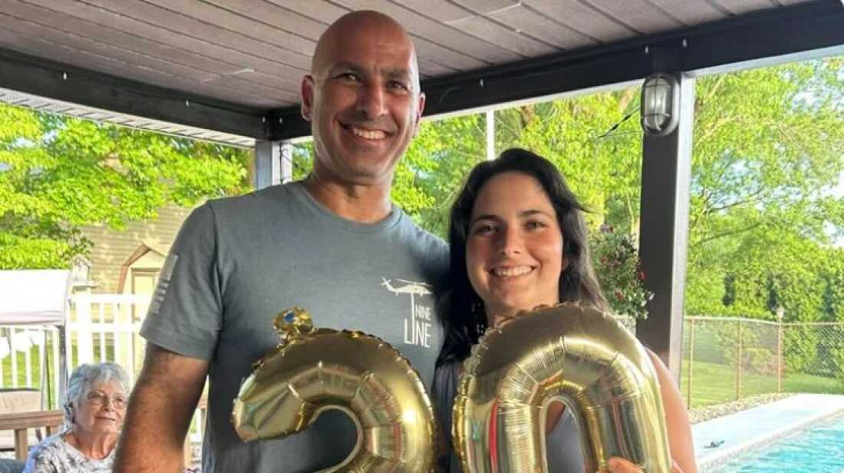

Corey Comperatore in photo from a GoFundMe page dedicated to his daughter Allyson in aftermath of his death.

died a hero, according to Pennsylvania Gov. Josh Shapiro during press conference Sunday.

Corey Comperatore, 50,
dove on his family
to protect them last night at this rally," Shapiro said.

KIM NOTES

BEARS international political gang BEARS'
intentions toward
trump instead killed family man and
former fire chief Corey Comperatore

SHOELANGUAGE book
describes
best plan for upgrading globe
includes confucius theme FAIRNESS for ALL

kim's SUNNYsideUP theme FAIRNESS for ALL
culminates in
entire humankind building DiameterCities
utilizing money formerly used for warring

then entire humankind
migrates to
prebuilt rent free DiameterCities with employment
rates starting $25 usa per hour

most new solar powered DiameterCities
merely possess
identifying number

if all chief executives
rescue humankind via adopting
SMOOTH KEYS procedural change including
national executive crew of 22

then kim
adds
names to approximately 200 DiameterCities
honoring those chief executives

SHOELANGUAGE book
describes
planet as currently unsafe for any
citizen defying BEARS political gang

current citizens
always susceptible to
BEARS because BEARS claim almost all
nations' chief executives as members

however trump
was member
of BEARS gang starting
1989 october 10 tuesday

1989 wishful member donald trump
verbalized to
established BEARS initiation target name of
person supposedly protect yet now kill

as for club initiation trump
completed
mandatory hands on involvement requirement
facilitating killing details in chapter T07

chapter T08
mentions
associated tragedies involving trump paying IOU
for highest eligibility cabinet or higher

however eventually president trump
so disliked
taking orders therefore planned revolution against
system devised by BEARS

1776 BEARS england in north america
created
deliberately ineffective usa constitution to
make even more money for centuries

chapter 009
contains
details

however 2021 january 06 revolution
failed
therefore BEARS moneymaking constitution
survived along with secrecy of BEARS

trump wishing to rejoin BEARS
agreed to
group's requirement for reentry

for regaining good BEARS standing trump
needed to yet again kill
some person whom trump vowed
to protect or expected to protect

trump
verbalized
name of new target and
facilitated killing as per protocol

chapter U01
contains
summary of killing which granted trump's
2022 july 14 reentry to BEARS

after completing BEARS rejoining requirement trump
immediately announced intentions to
reporter olivia nuzzi that trump
indeed running for presidency again

both events
happened
on same day
2022 july 14 thursday

New York Magazine Intelligencer
nymag.com

Nuzzi, Olivia
2022 July 14

"Donald Trump on 2024: 'I've Already Made That Decision'".

KIM NOTES

in less than two years trump
gained
popularity so quickly that trump started
planning projects independently of BEARS

BEARS fearing losing money and power
also realized
trump going own way could include
telling world concerning BEARS

therefore broad range of BEARS operatives
coordinated attempts to assassinate
trump
2024 july 13 saturday

www.bbc.com/news/articles/c4gl2jqem0eo
Sniper shot Trump gunman's weapon and delayed him - report

2024 August 17
bbc.com's
George Sandeman & Brandon Drenon

Kimberly Cheatle, director of Secret Service, resigned on 23 July following a hearing at US House of Representatives about assassination attempt.

House Oversight Committee criticized lack of information in her answers to questions regarding security planning
and
how officers responded to reports of
gunman’s suspicious behavior prior to shooting.

KIM NOTES
BEARS' wealth and influence
make sure
operatives well compensated and families later

Thomas Crooks’ rifle
DPMS - Panther Arms Model: A-15 Caliber: Remington Semiautomatic
Source https://www.fbi.gov/news/press-releases/butler-investigation-photos Author Federal Bureau of Investigation

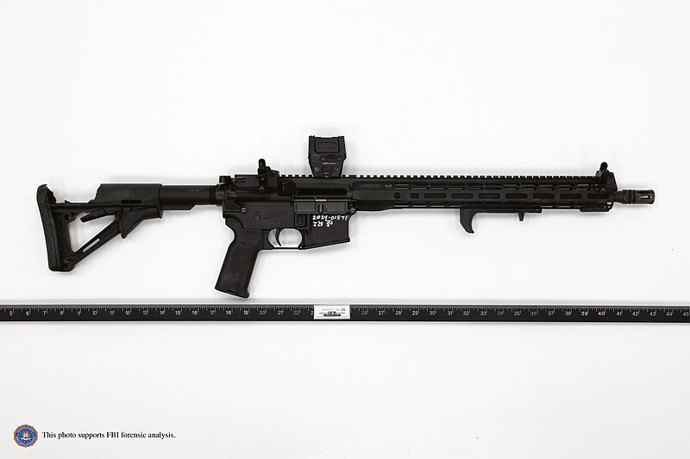

United States Secret Service - https://www.ronjohnson.senate.gov/services/files/4E6577F1-8AD2-4CB9-9FC7-5896C27A9647

At approximately 5:14 p.m, the USSS Counter Sniper Team leader received text messages regarding individual near an American Glass Research building with a rangefinder.

File: Both Photos of Thomas Matthew Crooks taken by the US Secret Service Counter Sniper Team.png

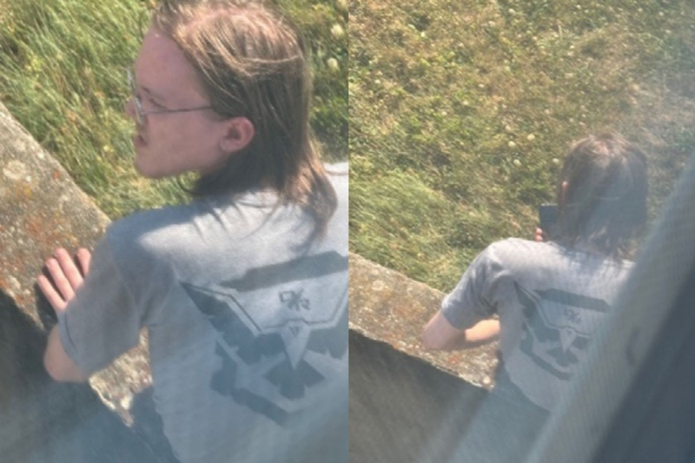

us secret service sniper
passed along
information and photos
at 5:14 in afternoon

yet secret service supervisors BEARS
vigorously blocked
life saving preventative measures until after
shooter fired several shots at 6:11

www.bbc.com/news/articles/cd1jz027nrzo

Five questions for Secret Service after Trump shooting
2024 July 15
by Tessa Wong and James FitzGerald
BBC News

KIM NOTES and summarizes
BBC video interview

seeing man with rifle greg smith
stood and pointed to
roof for three minutes

for three minutes secret service agents
did not move
yet only stared at greg smith
and smiths' friends pointing to shooter

then smith fifty feet from shooter
yelled to
local law officials who pretended ignorance
that smith yelled concerning roof shooter

plus in BBC interview greg smith
asked aloud

WHY not secret service person
stationed on that ROOF

KIM NOTES

BEARS standard procedure when bribed officials
caught in
deliberate dereliction of duties
stay motionless silent hoping spotlight leaves

above bribed officials
faked ignorance because trusted
BEARS deflecting all blame and yet
still delivering bribe money as promised

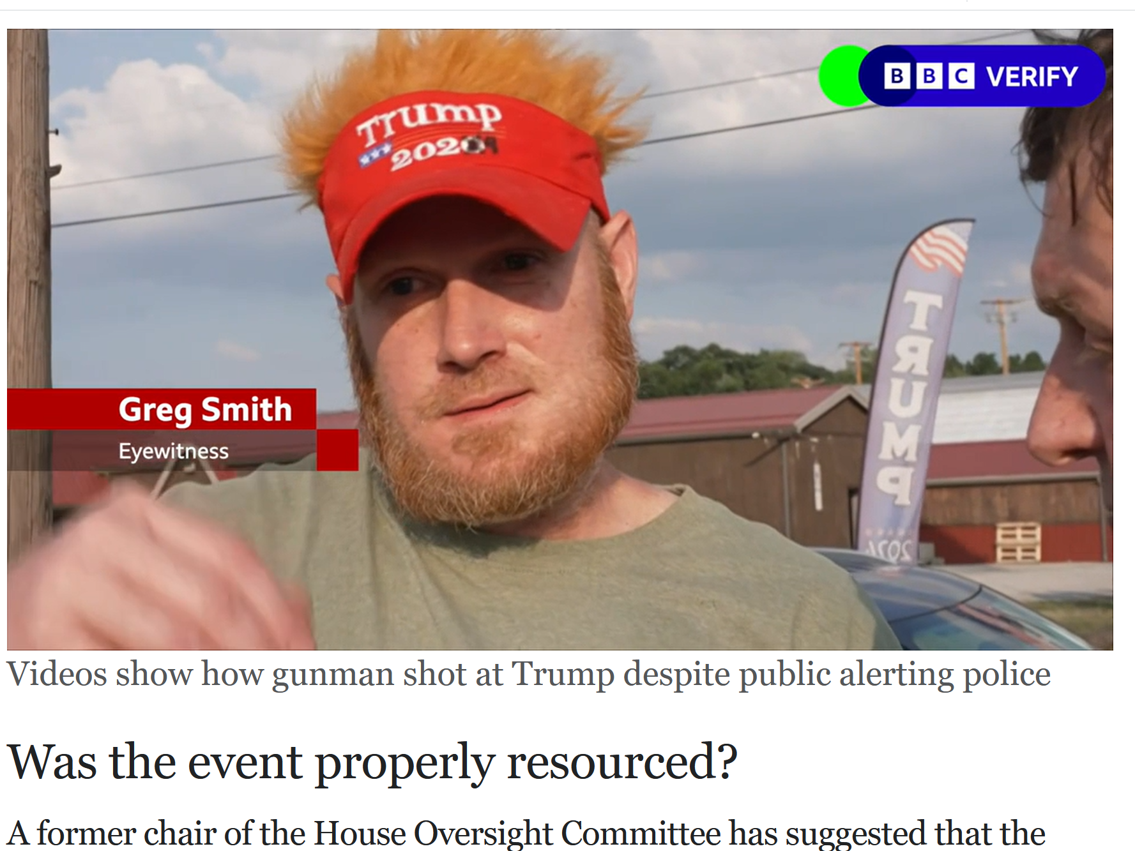
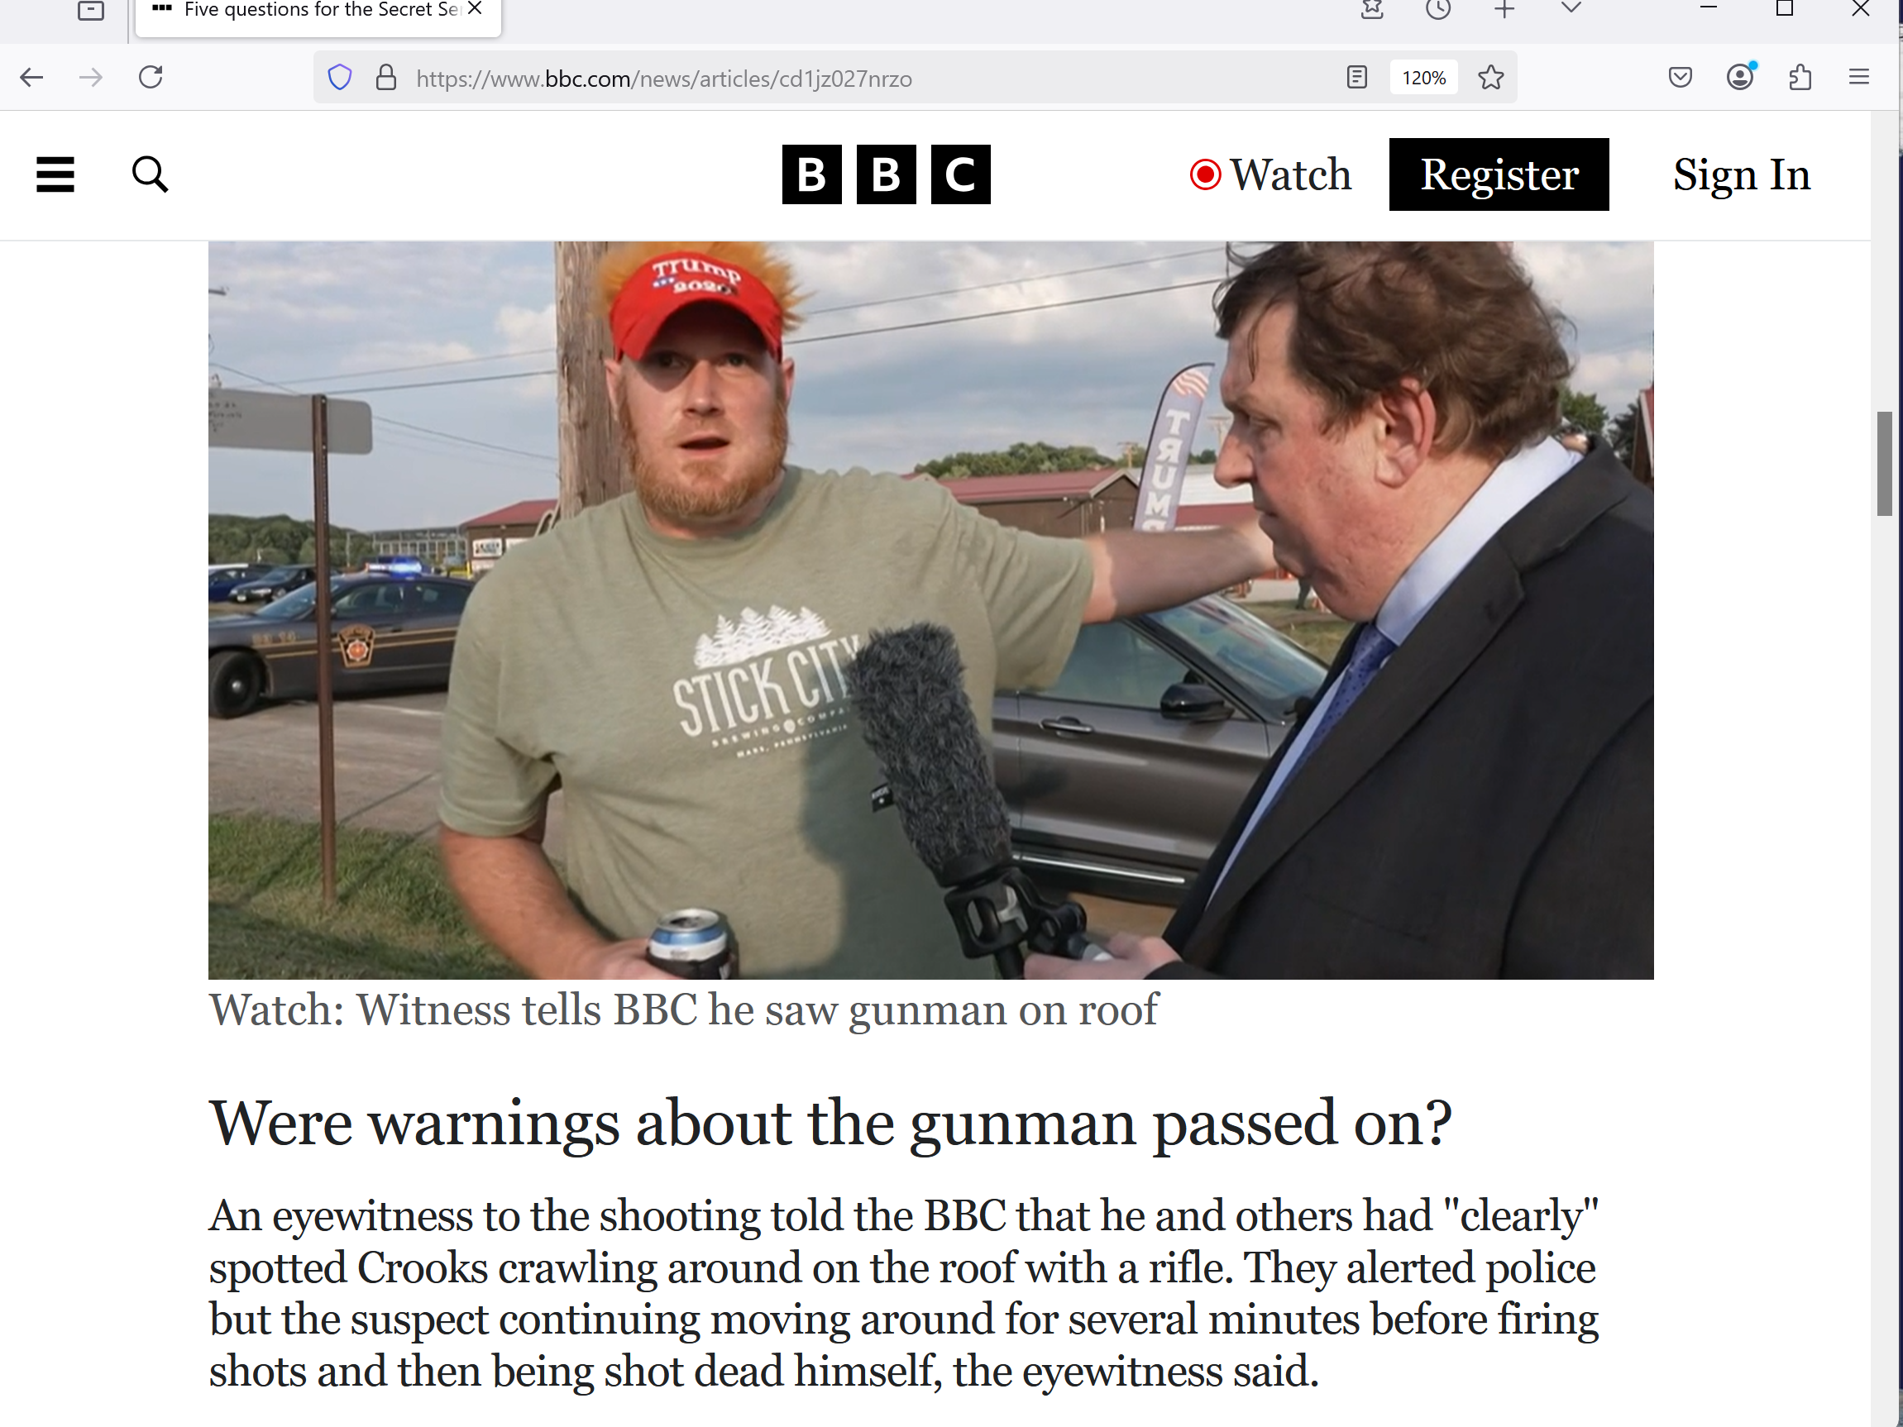

130 meters equals 426.509 feet

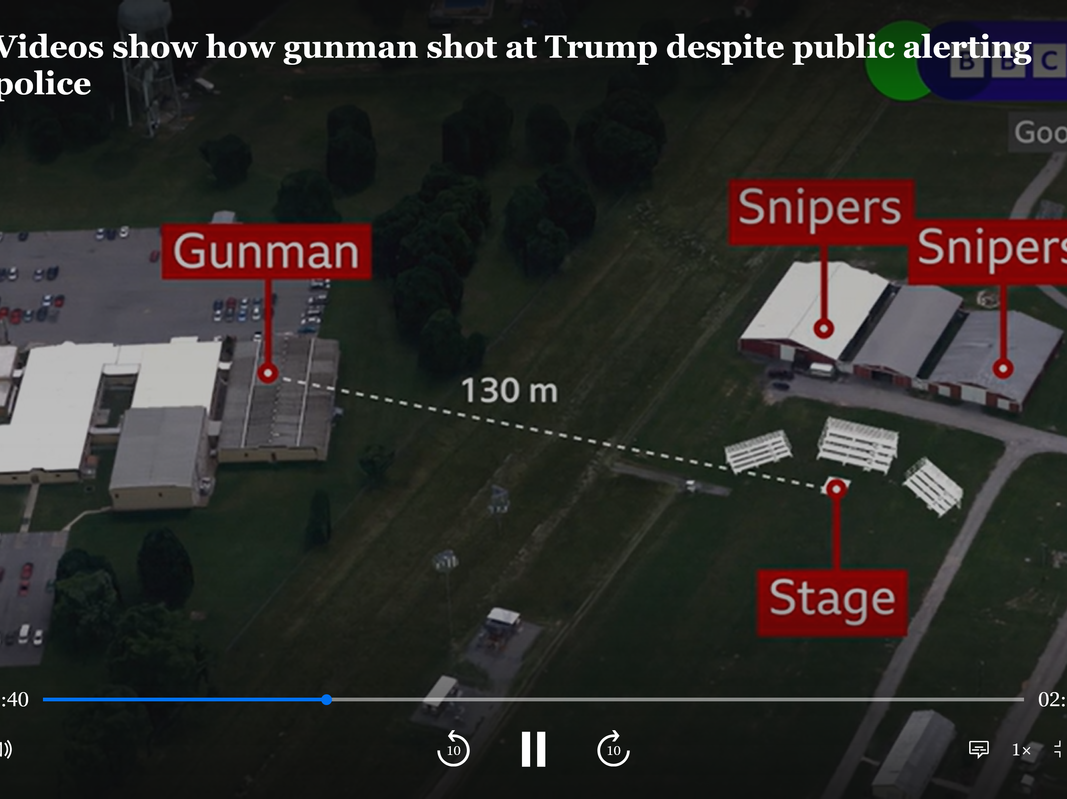

shooter thomas matthew crook
inside
circle on photograph

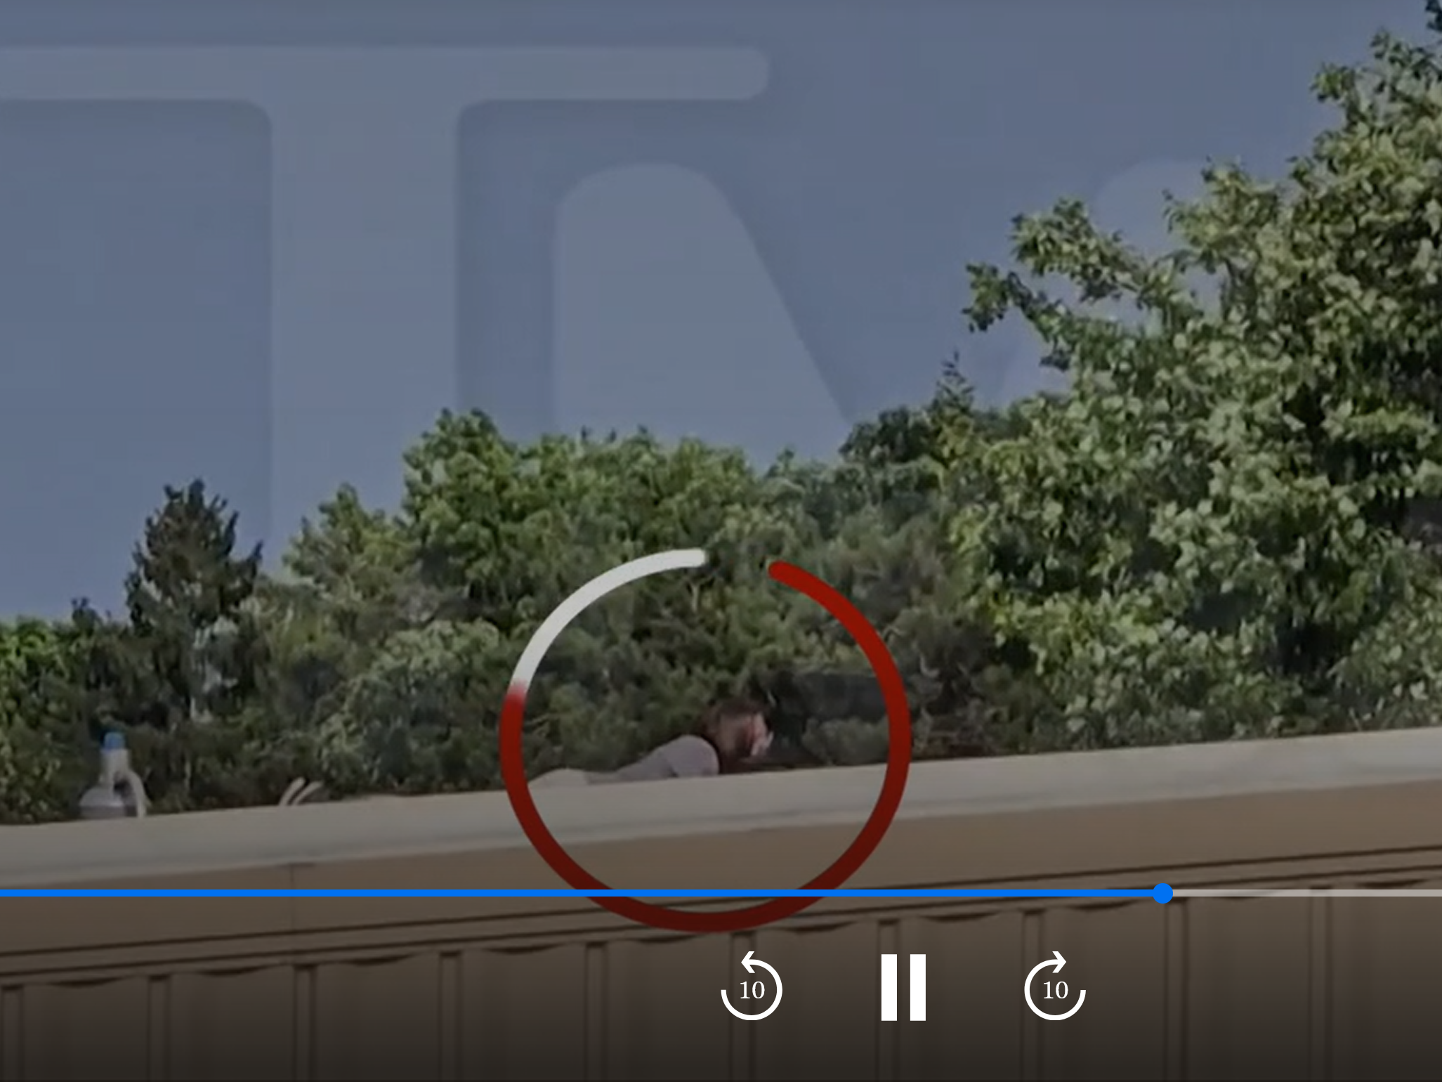

BEARS presidents lincoln and kennedy
repented of
BEARS' savage ways and started acting
SUNNYsideUP

therefore BEARS
assassinated
both presidents

usually after killing repentant presidents BEARS
easily retained
power because BEARS vice president grabbed
presidential position therefore BEARS always won

however 2024 july 15 monday trump
chose
non BEARS senator as vice president
as safeguard

that move
broke
standard operating procedure of replacing BEARS
going own way with another BEARS

www.cnn.com/2024/07/15/politics/trump-vp-pick-jd-vance/index.html

By Alison Main and Eric Bradner CNN
Mon July 15, 2024

Senator J.D. Vance of Great State of Ohio,” Trump said on his Truth Social platform.
Trump’s selection came on first day of the Republican National Convention and just two days after assassination attempt in Butler, Pennsylvania

KIM NOTES

if thrusted into presidency unencumbered vance
easily disbands
BEARS via freely broadcasting top secret
information including irregular BEARS killing activities

BEARS
laugh at
notion of international boundaries because
boundaries myths only for patriotism adherents

SHOELANGUAGE book
attempts to raise
ceiling of patriotism to include promoting
FAIRNESS for ALL of humankind simultaneously

if adopted SMOOTH KEYS
responds to
majority will polled weekly using library
card at voting booths near libraries

in this way voters
peacefully act as
checks and balances in real time

SMOOTH KEYS formal structure
includes
citizens peacefully expressing pleasure or displeasure
with national events unfolding that week

if majority in three uninterrupted votes
indicate
displeasure with general unfolding
of events

then 20 top officials plus others
change
offices away from executive crew and
specifically redeployed elsewhere in helpful roles

SHOELANGUAGE book chapters A01 and A02
detail
simple fair responsive transparent executive system
SMOOTH KEYS DEMOCRACY utilizing anonymous memos

BEARS repenting to SMOOTH KEYS DEMOCRACY
would mean
global full employment opportunities in constructing
portions for prebuilding modern green cities

plus proposed DiameterCities' social structures
favor
FAIRNESS for ALL humans
high moral standards developed by confucius

google search
confucius' golden rule is

"Do not impose on others what you do not wish for yourself".

From Wikipedia, free encyclopedia
Analects

confucius
did not believe ...
unquestioned loyalty to evil ruler.

SHOELANGUAGE book
displays
embedded statues in continents recognizable objects
that together form narrative for humankind

narrative
includes transforming
all jihads military conquests into
confucius jihads gentleness to all humankind

2006 nice lady from iran maryam rajavi
presented
ideas for achieving upgrades

maryam rajavi
proposed
ten upgrades meant for iran

however kim
recommends
all nations approve list for selves
therefore adopting FAIRNESS for ALL

in this way all nations
finally confident of permanently escaping
FAIRNESS only for FEW
which pervades all nations' current styles

then money
now spent
on war machines can help prebuild
DiameterCities with food etcetera for all

www.maryam-rajavi.com/en/viewpoints/plan-for-future-of-iran/
The Ten-Point Plan for Iran’s future
I have a dream:

An Iran free of execution and torture,
where stoning and amputation of limbs would be a thing of the past,
where love, friendship and tolerance shall replace mistrust, hatred and vengeance

#FreeIran2022https://t.co/T1dieUHt8i pic.twitter.com/pwyNFOjPMd

— Maryam Rajavi (@Maryam_Rajavi) July 18, 2022

a vision for a free Iran.

1. Rejection of velayat-e faqih (absolute clerical rule). Affirmation of the people’s sovereignty in a republic founded on universal suffrage and pluralism;

2. Freedom of speech, freedom of political parties, freedom of assembly, freedom of the press and the internet. Dissolution and disbanding of the Islamic Revolutionary Guard Corps (IRGC), the terrorist Qods Force, plainclothes groups, the unpopular Bassij, the Ministry of Intelligence, Council of the Cultural Revolution, and all suppressive patrols and institutions in cities, villages, schools, universities, offices, and factories;

3. Commitment to individual and social freedoms and rights in accordance with the Universal Declaration of Humans Rights. Disbanding all agencies in charge of censorship and inquisition. Seeking justice for massacred political prisoners, prohibition of torture, and the abolishment of the death penalty;

4. Separation of religion and state, and freedom of religions and faiths;

5. Complete gender equality in the realms of political, social, cultural, and economic rights, and equal participation of women in political leadership. Abolishment of any form of discrimination;

the right to choose one’s own clothing freely; the right to freely marry and divorce, and to obtain education and employment. Prohibition of all forms of exploitation against women under any pretext;

6. An independent judiciary and legal system consistent with international standards based on the presumption of innocence, the right to defense counsel, right of appeal, and the right to be tried in a public court.

Full independence of judges. Abolishment of the mullahs’ Sharia law and dissolution of Islamic Revolutionary Courts;

7. Autonomy for and removal of double injustices against Iranian nationalities and ethnicities consistent with the NCRI‘s plan for the autonomy of Iranian Kurdistan;

8. Justice and equal opportunities in the realms of employment and entrepreneurship for all people of Iran in a free market economy. Restoration of the rights of blue-collar workers, farmers, nurses, white-collar workers, teachers, and retirees;

9. Protection and rehabilitation of the environment, which has been massacred under the rule of the mullahs;

10. A non-nuclear Iran that is also devoid of weapons of mass destruction. Peace, co-existence, and international and regional cooperation.

KIM NOTES

officials of all nations
please research
other chapters of SHOELANGUAGE book
especially A01 and A02

then
perhaps announce
new stance example statement below

NOW this nation
voluntarily adopts
SMOOTH KEYS DEMOCRACY and maryam rajavi's
ten points and CONFUCIUS' high morals

yet 2021 outgoing BEARS president trump
did not desire relinquishing
control to incoming BEARS president biden

therefore 2021 january 06 trump
incited
riot to end BEARS control of usa
and assume dictator for life privileges

successful riot
would have ended
BEARS worldwide organization's control
of heads of states and humankind

BEARS member vice president mike pence
blocked
trump's deceptive strategy to attain dictatorship
for life on 2021 january 06

desiring eligibility for reelection trump
reenlisted in 2022
with BEARS and gave fee which
duplicated initiation fee given in 1989

society and public norms
assume that
people protect and cherish
certain others

BEARS rules for initiation etcetera
include
breaking those norms by assassinating person
supposed to protect and cherish

BEARS fees
include
verbally promising to directly involve self
in someway in that initiation assassination

therefore 2022july15 donald trump via son eric
killed
donald trump's ex wife ivana
as payment to rejoin BEARS

however 2024 trump in campaign speeches
hinted at yet again leaving
BEARS' instructions

in BEARS' thinking donald trump
had signed
verbal reinitiation deal via
ivana's blood on 2022 july 15

paranoid BEARS
could not allow
trump to go independent and usurp
BEARS' monopoly over usa and globe

therefore BEARS on 2024 july 13
attempted killing
rogue member trump in butler pennsylvania
at scheduled campaign speech

BEARS
chose
speech date closest to anniversary of
trump's reinitiation fee of killing ivana

this clear message
was designed to remind
all BEARS members even thinking
about flouting organization's protocols

two days later survivor trump
chose
non BEAR onto ticket in desperate bid
to avoid assassination attempts on self

if enacted above strategy
would surely block
BEARS' line of succession
of only BEARS as usa presidents

if BEARS
did successfully assassinate
trump

then new non BEARS president
would uncover
classified documents and end BEARS

one example of above vance
could make
all president john kennedy assassination information
available without marking through vital information

then entire globe
would know
BEARS assassinated rogue member JFK who
tried to leave savage BEARS organization

with this threat as leverage trump
asked to rejoin
BEARS

trump's rejoining fee to BEARS organization
including ordering and planning
charlie kirk's 2025 september 10 killing
at utah valley university orem utah

amiable and effective speaker charlie kirk
had persuaded
many young voters to elect trump

with this skill non BEARS kirk
could have decided to run
for president if attained age 35

yet control minded BEARS
could not allow
non BEARS president therefore followed
protocol to preemptively end contenders' lives

plus society and public norms
assumed that
trump protect and cherish charlie kirk
bringer of votes for trump

concerning charlie kirk's body trump
ordered
air force 2 to transport body
and flags flown at half staff

above because trump
desired persuading
public of trump innocence

BEARS
often do
such overt things trying to throw
off suspicions of guilt

yet still to this day photons
offer
deal for trump and all BEARS
including pardons and executive crew memberships

photons
believe
ending BEARS organization ends all future
wars and casualties

humankind's fate
rests upon
trump and all BEARS accepting generous
deal which includes zero jailtime

then all globe's approximately 200 nations
could also officially adopt
this SHOELANGUAGE book and together build
DiameterCities with greenhouses per family

above
would end
hunger because families could choose to
grow own food if desired

if humankind
chooses
building DiameterCities with SUNNYsideUP environment
for here and now

that choice's eternal consequences
include catapulting
all humans ever lived and will
live into eternal honeymoon like ecstasy

this book's recommendations inviting SUNNYsideUP
include
humankind gaining african permission to prebuild
DiameterCities

above project
would provide
full global employment for those desiring
employment

DiameterCities' high moral standards
would include
best of chinese philosopher confucius and
best of dr seuss' HORTON elephant

silhouettes of continents in this book
display
confucius and HORTON

concerning DiameterCities viewers
please read
chapters I03 and J04-J09

currently religions
believe
dictator rules universe

sciences
believe
randomness rules universe

actually democracy
rules
universe

electrons
vote
as part of democratic style
of universe

photons as cousins of electrons
desire
better afterlife for both

electrons
chose
templates of human females and males
as voting booths

in one sense each human
equals
one field of electrons

without even realizing situation humans
vote as to
preference for universe's daily operations style
which undivided humankind shall experience together

photons
seek to influence
humans' voting towards SUNNYsideUP genre

only undivided humankind
can provide
that better afterlife

total migration to DiameterCities
permanently sets
eternal environment style for all humans
plus photons and electrons

this SHOELANGUAGE book
delivers
needed additional information and strategies
to achieve thousand DiameterCities goal

until now religions
claimed
continents
merely random dry land blobs

science
claimed
continents
merely random dry land blobs

in actuality photons
improved
shapes of continents to send messages
describe ongoing voting system polling humans

photons
knew
that very notion would shock humankind

therefore photons
sculpted
statue of familiar literary character
in state of shock

1950 october 04 photons
rearranged
shapes of mexico and central america

in 2023 kim
discovered
that statue when kim looked at
oxford atlas of world

kim
outlined
statue with big red oval
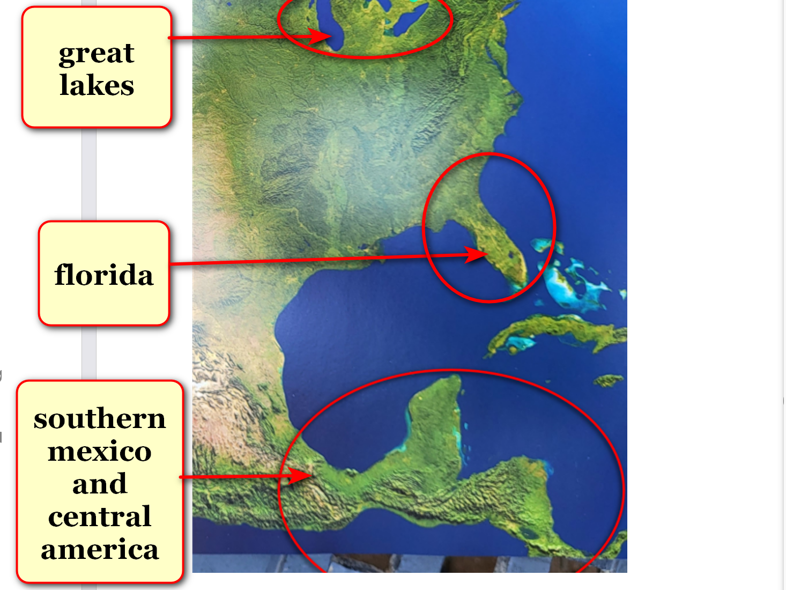

does viewer
recognize
statue

now statue
from
different viewpoint

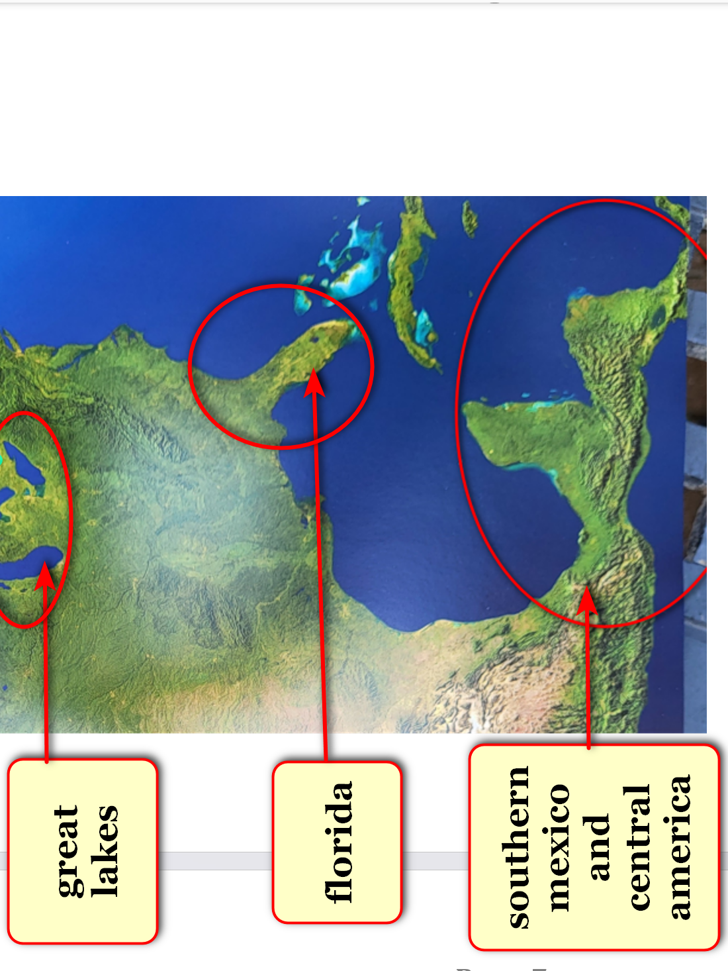

kim
reveals
statue

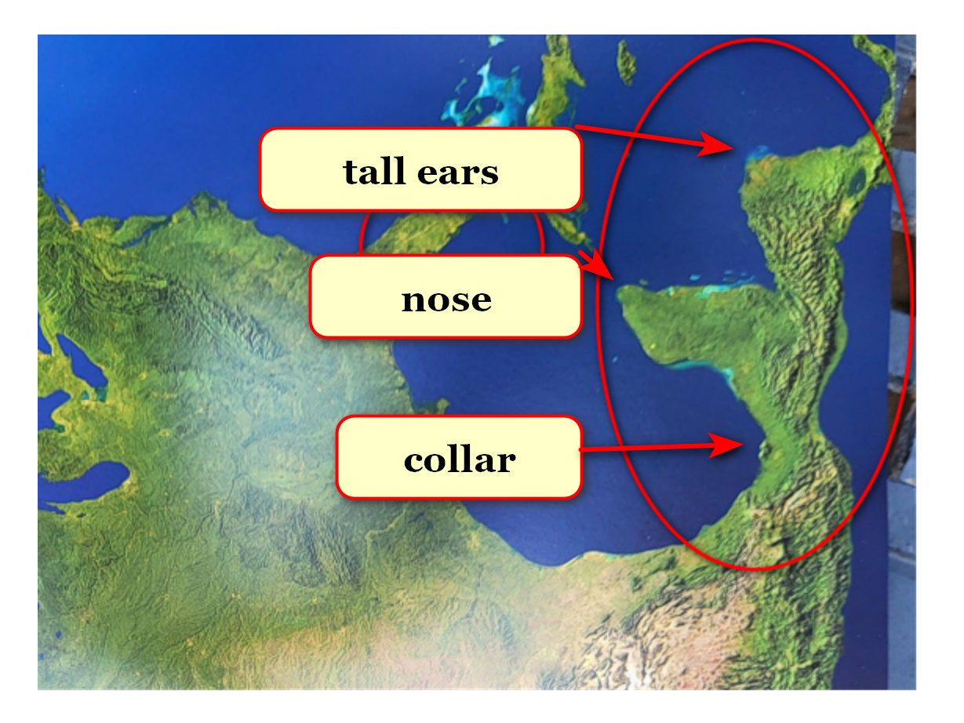
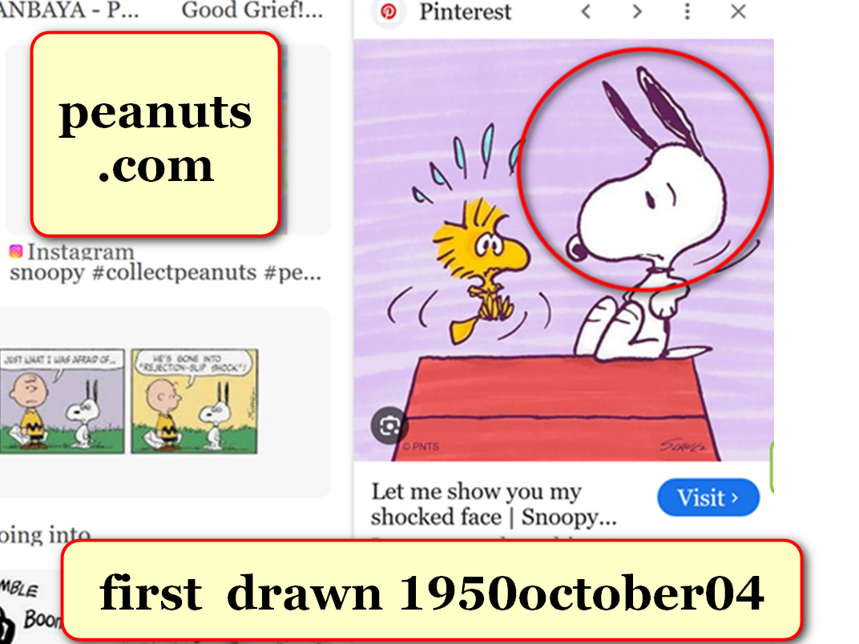

kim
found and arranged
statue and other continent size statues
into coherent narrative desired by photons

humans
agree
globe possesses seemingly insolvable problems
including wars and starvations and homelessness

humankind
has given
current big nations system many centuries
to resolve problems yet no resolutions

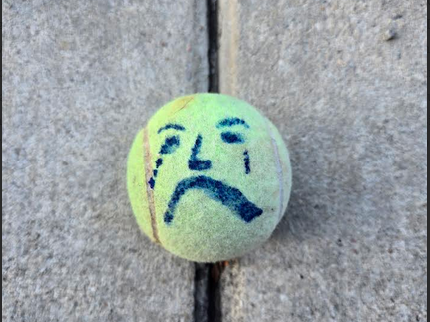

reasons for big nations system failing
include primarily
BEARS organization

BEARS' perks for centuries
include
textbook glory and guaranteed wealth and
abundant sex outside traditional marriage

within big nations system sincere humans
attempted improving
globe in various ways including religions
and other sincere organizations

however now SHOELANGUAGE book
strategizes
new framework finally worthy of globe's
citizens' sincerity and enthusiasm

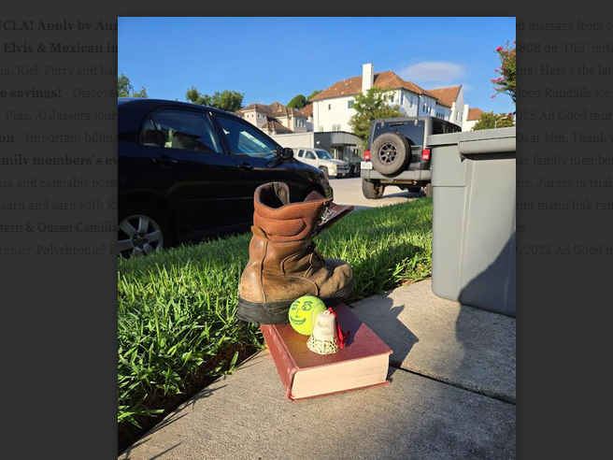

SHOELANGUAGE book's framework for habitations
includes
DiameterCities with rent free residences cooled
by kim's passive green air conditioning

each equal size DiameterCity
able to accommodate
populations same size
as japan's tokyo's population

each residence
will contain
air to water machine for readily
available pure water

safety and healthy conscious DiameterCities
will not allow
violence or dangerous situations
even in sports

DiameterCities
will bring
FAIRNESS for ALL and tranquility

imaginary national borders of big nations
shall vanish

then bitterness toward nations
should vanish because
objects of bitterness vanished

notion of SHOELANGUAGE book
started
in middle of year 1967

televised news reports of wars
alarmed
usa citizen of deer park texas
keith michael klecka

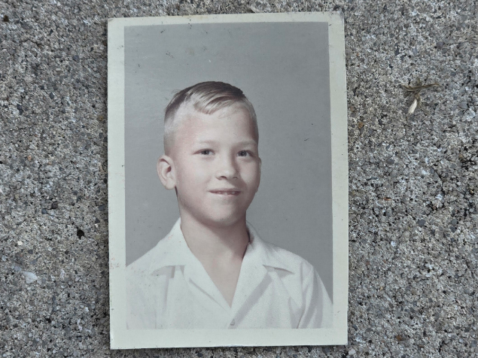

eight year old keith
realized
from news reports how wars and
chaos and poverty dominated globe

humans' head and neck and spine
contain
central nervous system known as
conscious person

central nervous system
contains
ten percent of person's electrons

photons
noticed
keith's dismay and requested keith's help

90% of keith's electrons
eagerly devised
notion of SHOELANGUAGE book introducing globe
to photons' museum of narrative statues

photons
designed
geographical narrative statues to provide
convincing proof of all three universes

keith's ideas
included showing
kim undeniable intimate proof of BEARS'
lethal operations for gaining wealth etcetera

SHOELANGUAGE book chapters A01 and A02
describe
win win deal stopping all wars
exchanging for BEARS abdicating somewhat

when citizens
follow
keith's lead and leave notion of
big nations then humankind freed

then humankind
officially chose
SUNNYsideUP tranquility for
here and now and for eternity

nothing
would have made
keith happier

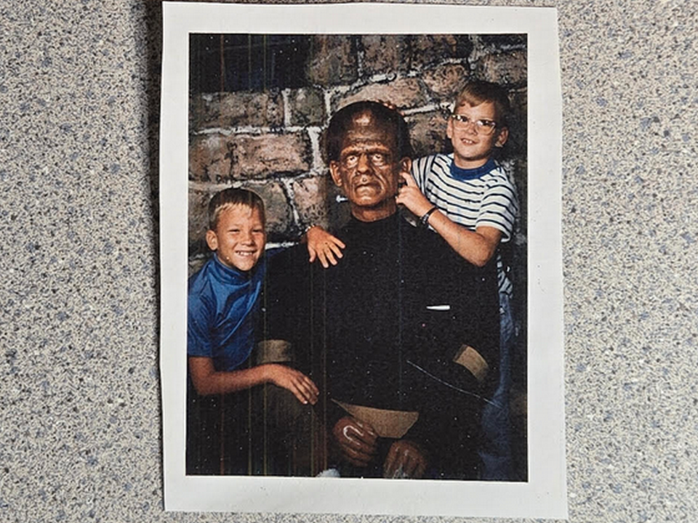
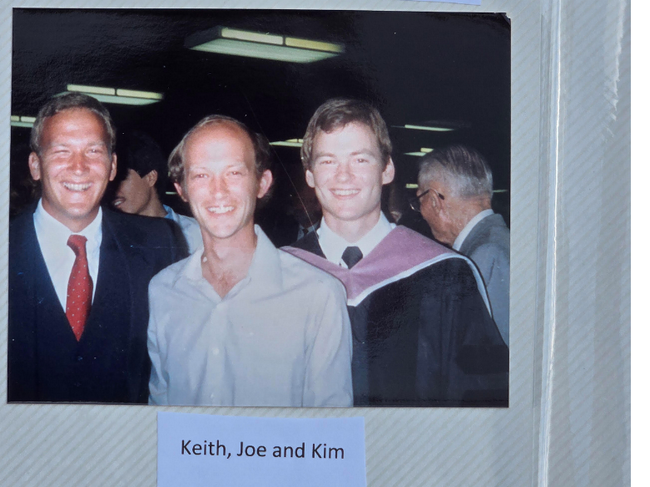

1967 keith
recruited
twin kim on subconscious level to
fulfill photons' upgrade offer to humankind

keith
authorized and enacted reversing
first twins of humankind
cain and abel's invitations

in ancient times cain and abel
previously agreed
via 2-0 majority to invite
pain and contentions onto humankind's globe

at tragic cost 2022-2023 subconscious keith
made sure
conscious keith refused kim's strategy making
self impervious to SUNNYsideDOWN including illnesses

2022 november 63 year old keith
dealt with
constant pain due to cancer
and ravages of therapy

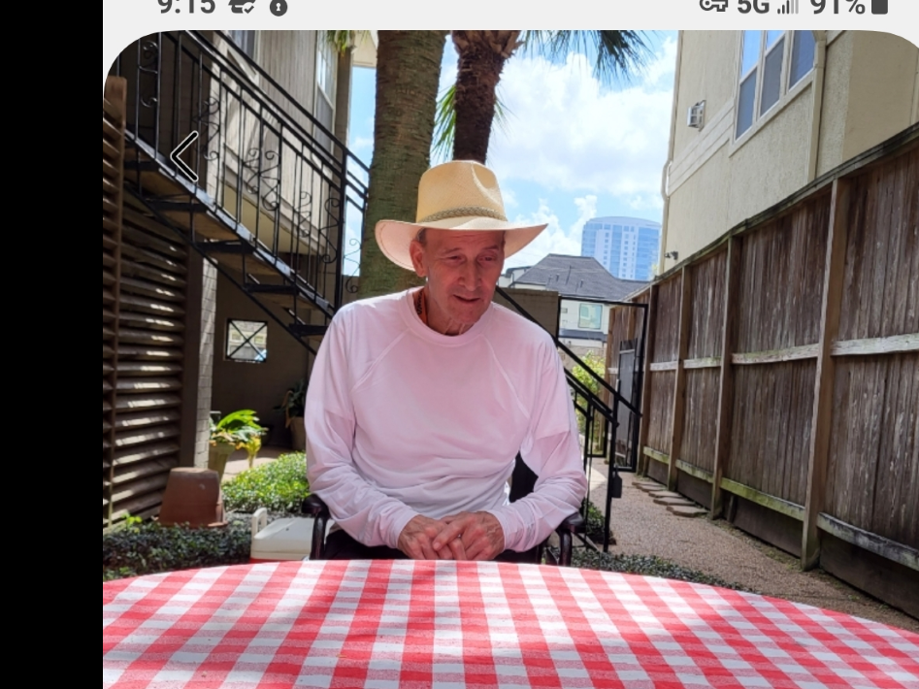

2022 january - 2023 july 16 keith
voluntarily endured
immense pain through and including death
to switch humankind's official setting

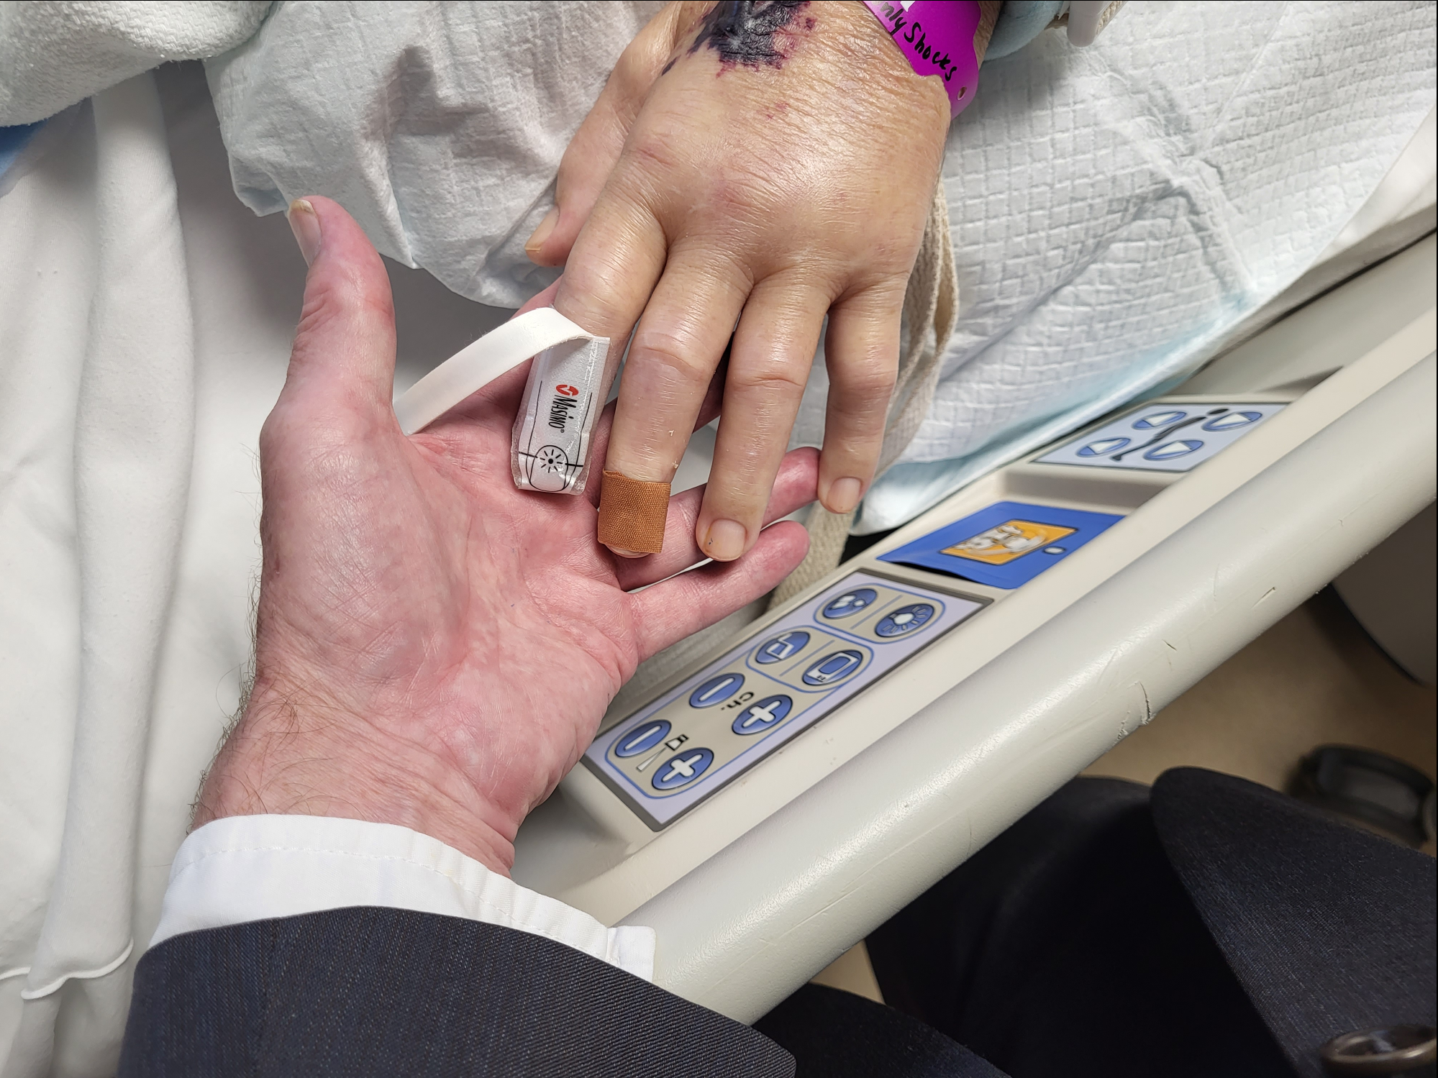

two years later kim
grasped
keith's comprehensive endgame strategy

for those 16 months together keith
proved to
universe that twins chose SUNNYsideUP
instead of fighting and lethal violence

twin kim
was
brother's keeper for last ten months

though in close quarters 24/7 twins
made conscious efforts
to maintain congeniality

in well planned strategy subconscious keith
agreed to end
keith's life for finality's sake so
no reversal of victory ever possible

in this way keith
made sure
no chance of future contention
versus twin kim therefore no unraveling

in this way klecka twins
overturned
cain v abel

wikipedia's

david joseph bohm (boʊm)
1917 december 20 - 1992 october 27

american scientist described as one of most significant theoretical physicists of 20th century

member of fellowship of the royal society

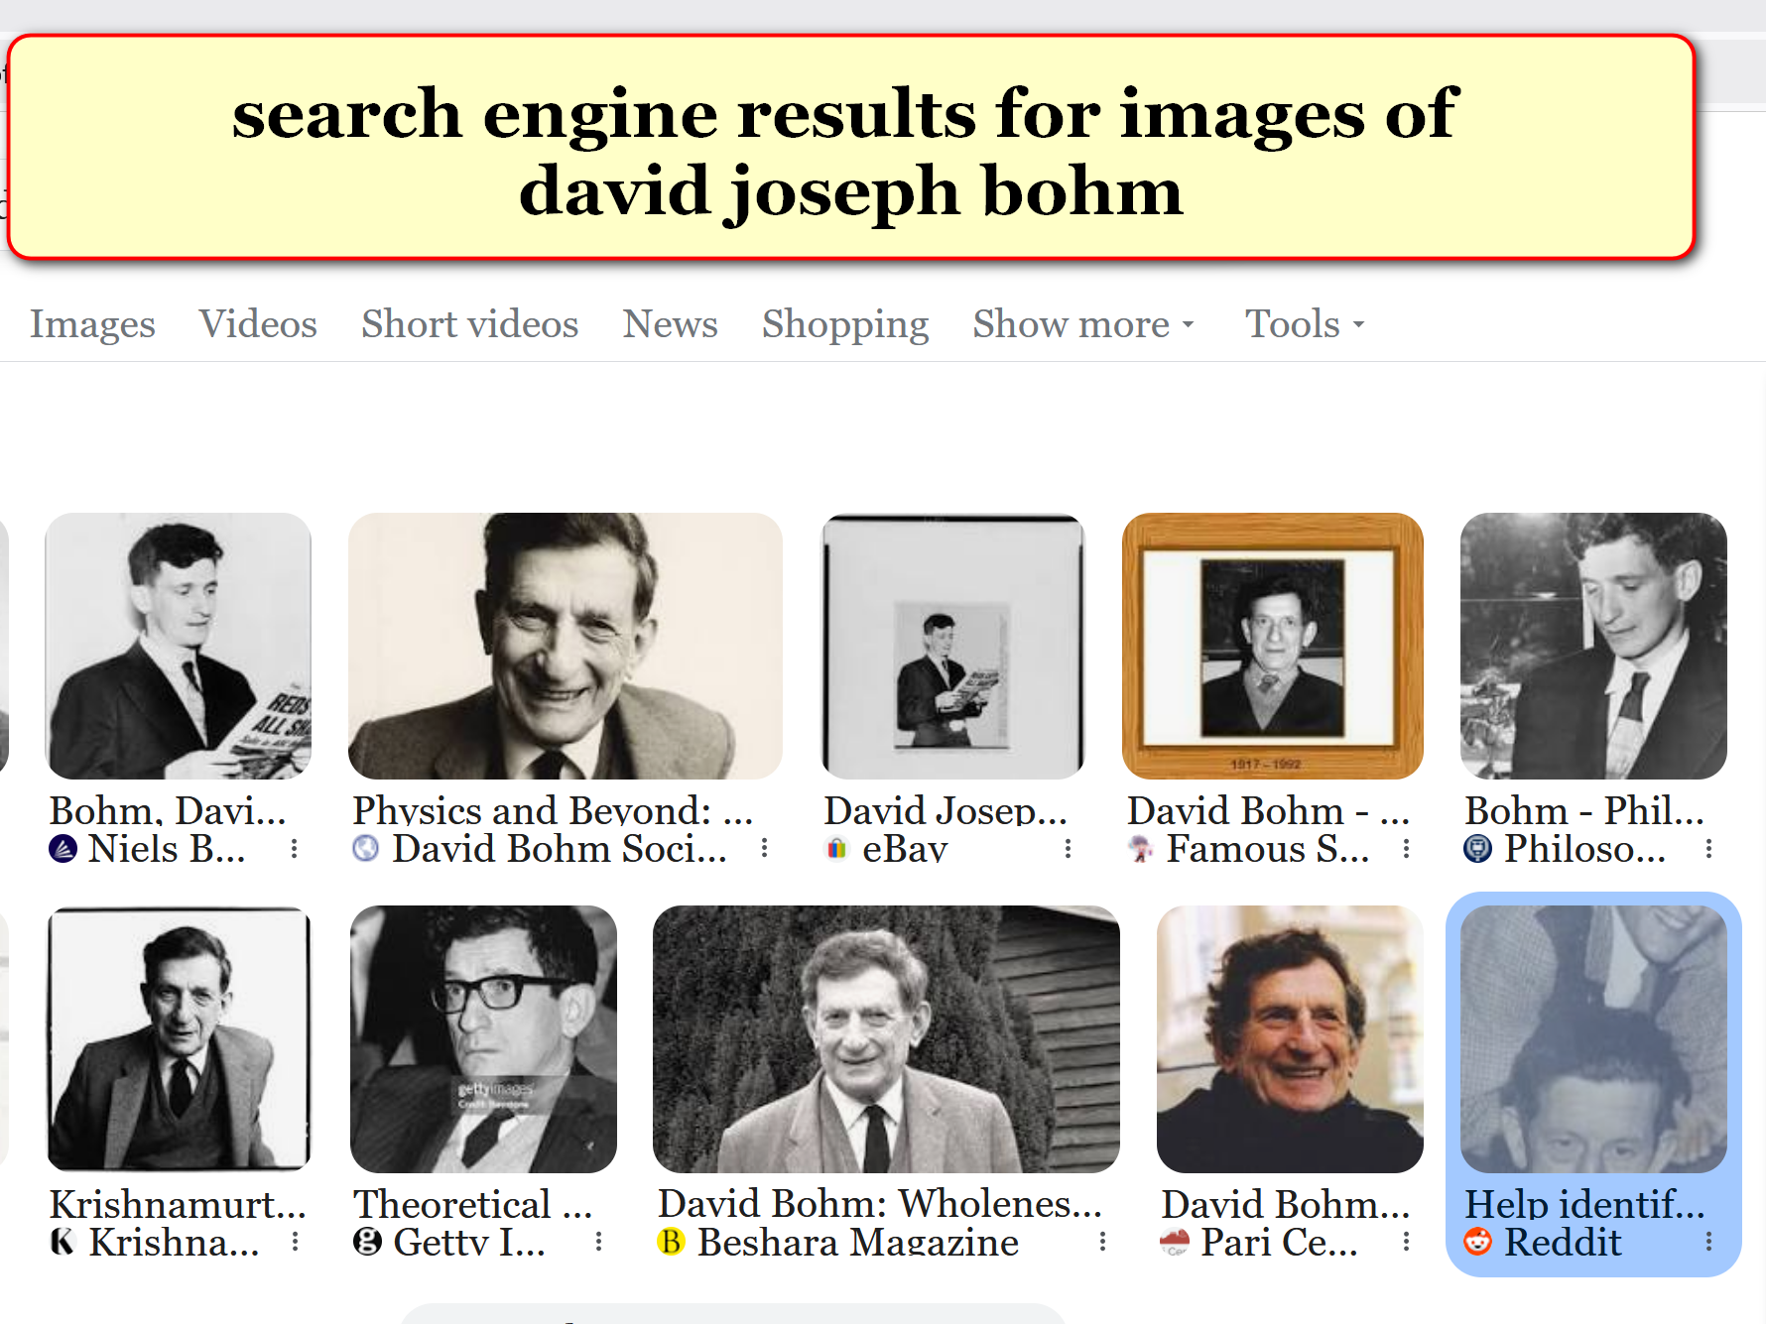

with Stanford University neuroscientist Karl H. Pribram, Bohm
developed
holonomic model of functioning of brain,

KIM INTERPRETS BOHM via selected wikipedia phrases

bohm and pribram
speculated
brain connected human's conscious decisions with
holograph environment around that human

wikipedia notes

gardner said bohm's view of interconnectedness
of mind and matter "flirted with panpsychism"[42]

on one occasion, bohm summarized: "Even the electron is informed with a certain level of mind."[47].

KIM NOTES

bohm's laboratory experiments
revealed
one electron's actions started to differ
when grouped with other electrons

SHOELANGUAGE book
explains
during life's scenarios electrons act in
certain ways according to majority votes

electrons
free to insert
selves into various segments of time
of which all continually replay

all of time
segmented into
TIME EGGS
of eight seconds durations each

each TIME EGG of history
possesses
capability to change
according to majority rules

in each TIME EGG each electron
votes for promoting
one of only two
available emotional tones

those two tones
express
in various thoughts
and words and actions

then TIME EGG
swirls again

in this way replays
take into account
electrons' modification requests

electrons
gain memories
of that human during that eight
seconds of that human's life

then that electron
offers
opinion to all fellow electrons
of that human

then electrons
revote

resulting majority voting of electrons
gives directions to
actions of that human
for that given situation

in addition those agreed upon actions
sway
other clusters of electrons to act
in similar fashions like peer pressures

therefore each electron's personal choices
express through
many centuries of votings

those votes
actually change
history

time as temporary phenomenon
ends
when all electrons have expressed opinions
exhaustively

then all personalities in universe
clearly see
both grand total numbers

unfortunately as of now more electrons
have voted
SUNNYsideDOWN style

if left unchanged SUNNYsideDOWN style
signals
collective humankind's eternity consisting entirely of
nightmares and pain

current preponderance of SUNNYsideDOWN votes
mostly because of
BEARS

less than one percent of humankind
possess memberships in
BEARS' secret global organization

yet BEARS
manipulate
more than 99 percent of humankind
into chaos and unfairness and bitterness

secret organization BEARS
include
pivotal positions plus
top leaders of nations

globally BEARS members
include
most military equipment makers and
most medical industries' top administrators

in many ways BEARS
create
profit and textbook glory for selves

BEARS
kill
many via bullets

plus BEARS
carefully number and then send
randomly tainted syringes with needles attached

those tightly packaged syringes
eventually transport
disease causing chemicals into humans

BEARS
make
much money from making bullets etcetera
and from treating diseases BEARS inflicted

for example BEARS for camouflage reasons
randomly taint
bottled water at bottling companies before
distributions to retail outlets

KIM NOTES

this SHOELANGUAGE book
describes exactly how to
make selves impervious to
such SUNNYsideDOWN intentions

BEARS' death causing chemicals
include
direct poisons and slower acting disease causing
chemicals

without realizing eternal implications BEARS
increasingly cause
bitterness which keeps humans
voting SUNNYsideDOWN in TIME EGGS

on subconscious level keith
chose to promote
photons' plans to entice nations' leaders
to abandon memberships in BEARS organization

kim
reflected on
progress of keith's pain since keith's
booster shot in florida 2022 january

kim
noted
continuity of keith's months long pain
at booster injection site in shoulder

eventually that same pain
traveled
to knees of keith

keith
described
pain as if
CONSTANT thousand knife stabs into KNEES

months later X-rays
revealed
prostate cancer in knees
and eight sites in skeleton

in this way subconscious keith
verified
BEARS' existence and methods to kim

on subconscious level keith
chose and insisted
needle randomly tainted

keith's obedient holograph
made sure
keith received BEARS' covid-19 vaccination booster
that carried moneymaking fatal disease

therefore prepackaged needle injected into keith
possessed
drops of liquid dried on needle
which caused prostate cancer

2022 month of march keith
accepted
kim's invitation and returned from florida
job and started sharing kim's apartment

keith's subconscious level strategy
included
kim observing almost entirety of situation
up close and personal

previously for 26 years dentist kim
gained
familiarity with medical system via
taking dental patients' health histories

naturally kim
followed
dental patients' medical treatments' outcomes

2022 kim
became
24/7 primary healthcare giver for keith
when BEARS' prostate cancer overwhelmed keith

after months at hospital twins
returned
to apartment

at first keith
could not even sit up
in bed by self

keith
stayed in
apartment for months with kim as
only caregiver

last week of keith's life kim
took
keith to hospital three times

keith michael klecka in houston texas
died
2023 july 16 sunday 12:48
at ben taub harris county hospital

with keith's bequeathed intimate knowledge kim
could not deny
BEARS' existence and
lethal money making strategies

photons and keith
put
deal on table for BEARS to
abdicate somewhat for lifelong crew membership

photons' SMOOTH KEYS DEMOCRACY style
offers
new national executive crews of 22
as final word concerning all branches

kim
forgives
BEARS for killing keith and urges deal
including amnesty for BEARS abdicating slightly

above abdications
immediately end
wars and starvations globally and allow
prebuilding DiameterCities

if above
happens

then keith's strategy including keith's death
will have initiated
better humankind here and now
plus improve afterlives for all

continent size statues' collective narrative
describe
humankind's two choices

photon's museum
possesses
playful theme

DO I HAVE TO SCULPT YOU A STATUE?

yes indeed photons
shaped
original continents as statues telling
actual story of creation of universe

certain chapters like 005
describe
how each maturing human's mere inward
phrase of regret suffices

suffices yes if that human
declares
regret by even just one thought
within that human's own mind

example words of thought below

IF that previous situation
ever reoccurred
then I would respond SUNNYsideUP
instead of SUNNYsideDOWN

in case above entire universe
accepts apology
then that person's offensive archived
TIME EGG record vanishes

entire universe
readjusts
universe's thoughts and evaluations
and recommendations from that person

chapters K10 and L01
include
example of above theodor seuss geisel
also known as doctor seuss

through various external situations dr seuss
acquired
prejudicial dislike for certain nationality

yet 13 years later dr seuss
matured so much that seuss became
family friends of that same nationality

in fact seuss and wife
hosted
daughter of new family friends for
four years at california's claremont college

this SHOELANGUAGE book
explains how
maturity of dr seuss made previous
prejudices vanish from universe's bookkeeping

concerning humans dr seuss
modeled that although
perfection is not possible total recovery
into SUNNYsideUP emotion is possible

SHOELANGUAGE book
contains
chapters starring continents' images of
seuss' creation HORTON elephant

A07 and D02 and H01
and H04 and I02

kim
hopes
citizens across globe accept latest most
mature seuss emotional mindset SUNNYsideUP

year 1954 doctor seuss
expressed
self maturation via book
HORTON HEARS A WHO

SHOELANGUAGE book
kindly debunks
portions of traditional myths including religions
which blocked humankind from SUNNYsideUP eternity

SHOELANGUAGE BOOK
utilizes
snippets from books
and online articles

those exposures
may increase
those authors' sales

kim glad for above in fact
strategizes for
prosperity and happiness for all
plus honeymoon joy eternally

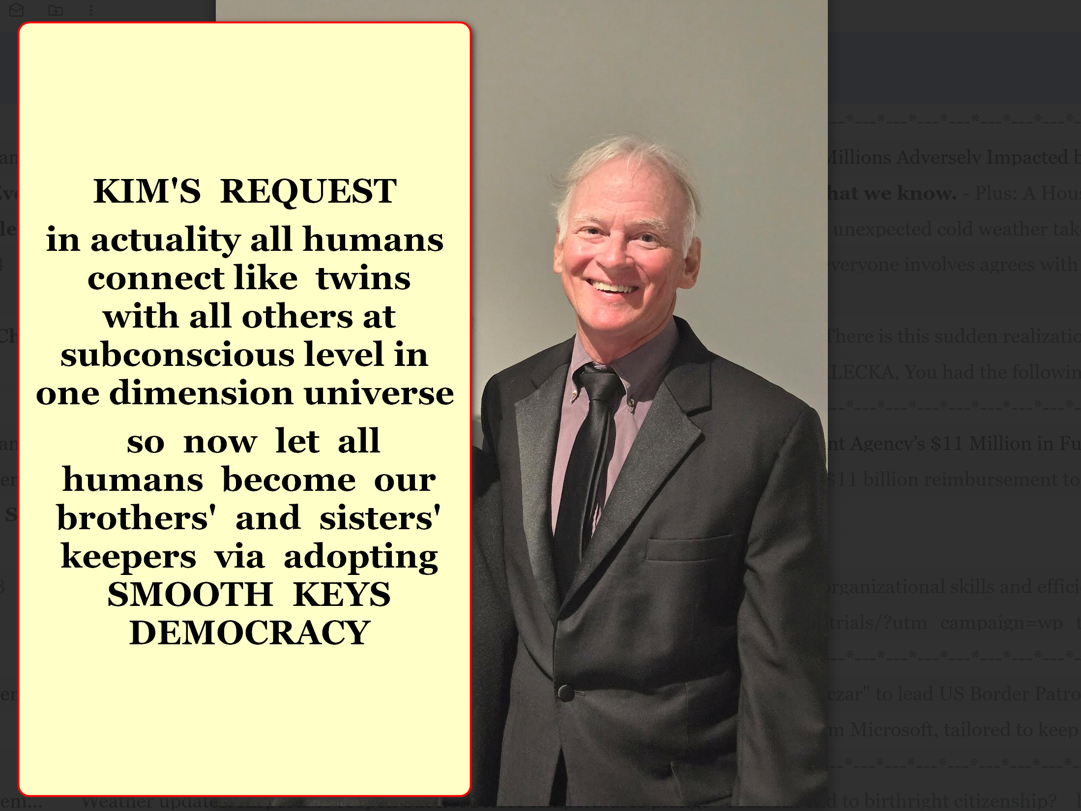
chapter ends

