005
egg chooses mate then pair eye universe create holograph

chapter 004
proved
each human actually master
of holograph surrounding that human

therefore globally citizens' regrets
suffice in every way

citizens
seemingly flow seamlessly from
one section of time to another

this illusion of continuity of TIME
allows for
citizens' rethinks and contemplations
of words and actions

when citizen
merely reflects regrets
past SUNNYsideDOWN words actions

then universe
accepts
person's switch of opinion to SUNNYsideUP

no punishment
involved
plus no records
of previous opinions kept

analogy

if typist
makes
typographical error then
when typist retypes word

universally public
accepts
typist's most recent spelling no punishment
no record of previous keyboarding kept

concerning past SUNNYsideDOWN reactions if citizen
makes up mind
if ever similar event occurs then
citizen shall pursue reacting SUNNYsideUP

then entire universe
accepts
citizen's new stance concerning that category
established merely via citizen's thoughts

in this way flow of time
becomes
ally of humankind

all of these emotional transactions
happen subconsciously

david bohm's term holomovement
accurately describes
subconscious of all personalities including
persons belittled as well as belittlers

all decisions of all persons
automatically broadcast to
all other persons subconsciously

therefore when citizen
privately decides to act
more SUNNYsideUP next time then
new stance goes viral into universe

instantly all know that citizen
in effect apologized
to other person plus other person
accepted apology with no lingering resentment

human body
works in
subconscious phase then cns cells
work in conscious phase

all electrons of subconscious bodies
know
all persons' thoughts emotions words actions

subconscious central nervous system electrons
in effect drink
amnesia inducing liquid after final voting

afterwards both trunk and limbs sections
still privy to
all other persons' decisions emotional mindsets

however conscious central nervous system
only remembers
conscious self's memories
from birth to present

therefore rethinking repentant citizens
now take
encouragement

rethinking repentant citizens
unaffected
by personal history

now rethinking repentant citizens
may freely act SUNNYsideUP
in every new encounter

each person
has charge
of that person's history

however other involved people's cns mindsets
in
those TIME EGGS eight seconds scenarios
possess personal independent emotions

therefore persons involved in TIME EGGS
must agree via
majority vote
to change replaying of that scenario

when that
happens
then all personalities in universe accept
that change even in conscious thoughts

only then do all textbooks
change and contain
new agreed wording for example

another example original movies
change
because original cast agreed

KIM NOTES

one dimension
contains
only one measurement

however distance
merely illusion

in other words
consider
1D circle contains zero distance from
center of circle to circle's periphery

humans
decide and customize
features concerning holograph even before conception

only alive personalities
capable of
choosing

in 1D all personalities
know
all other personalities' every thought

in 1D egg
made selection
of one sperm from millions

in 1D each egg
finally decides
upon one sperm then makes corresponding
action accordingly to original emotional selection

egg
now acting in
3D universe

egg after selecting favorite sperm
dispenses
unique chemical signal to attract only
that one far away desired sperm

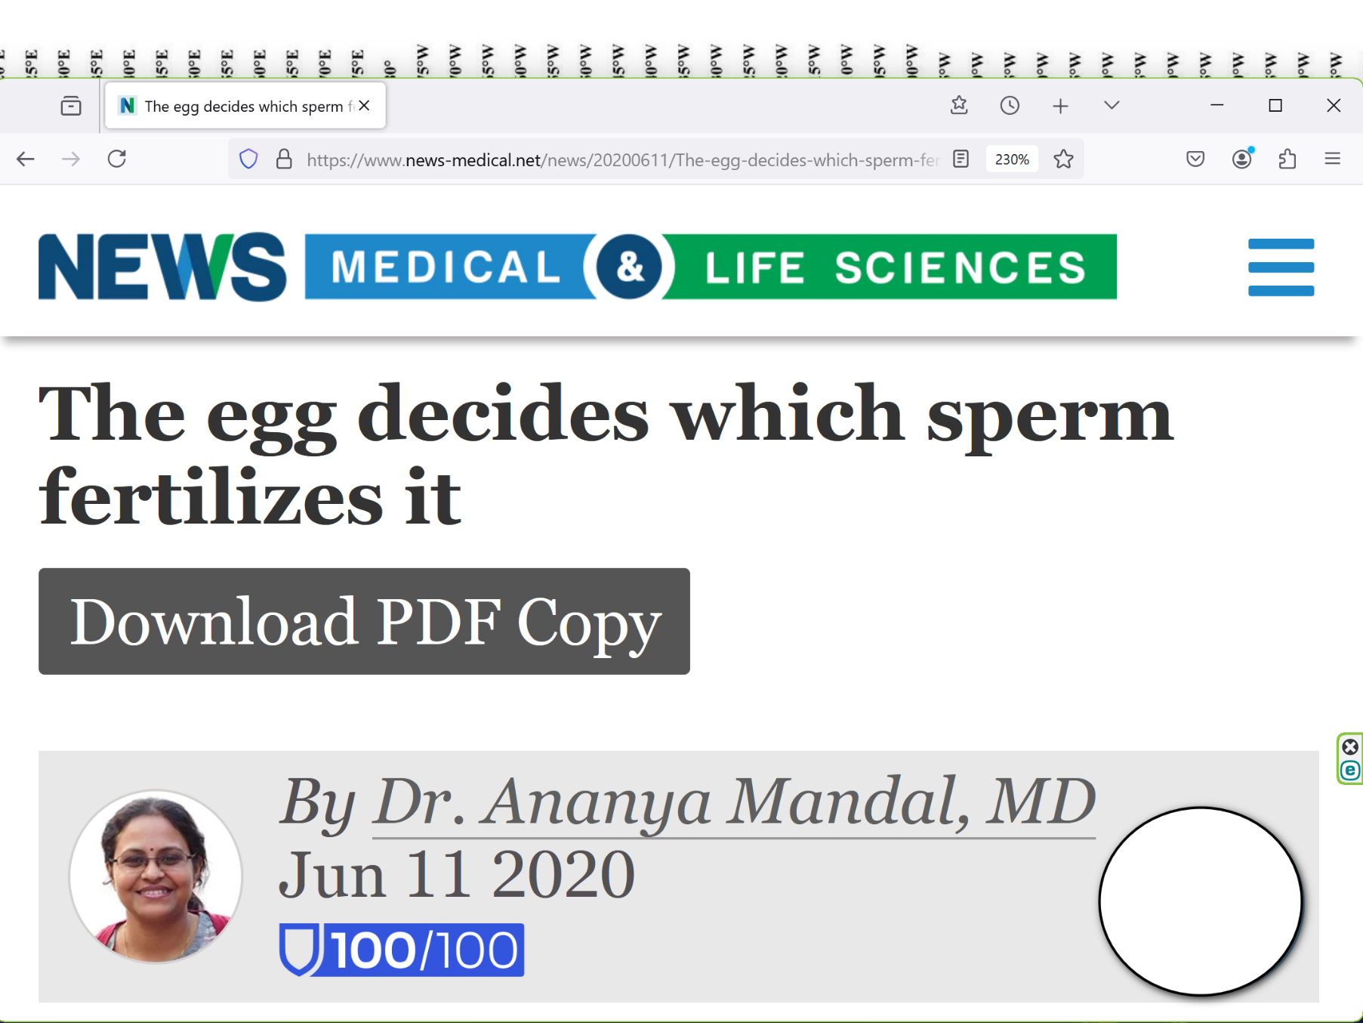
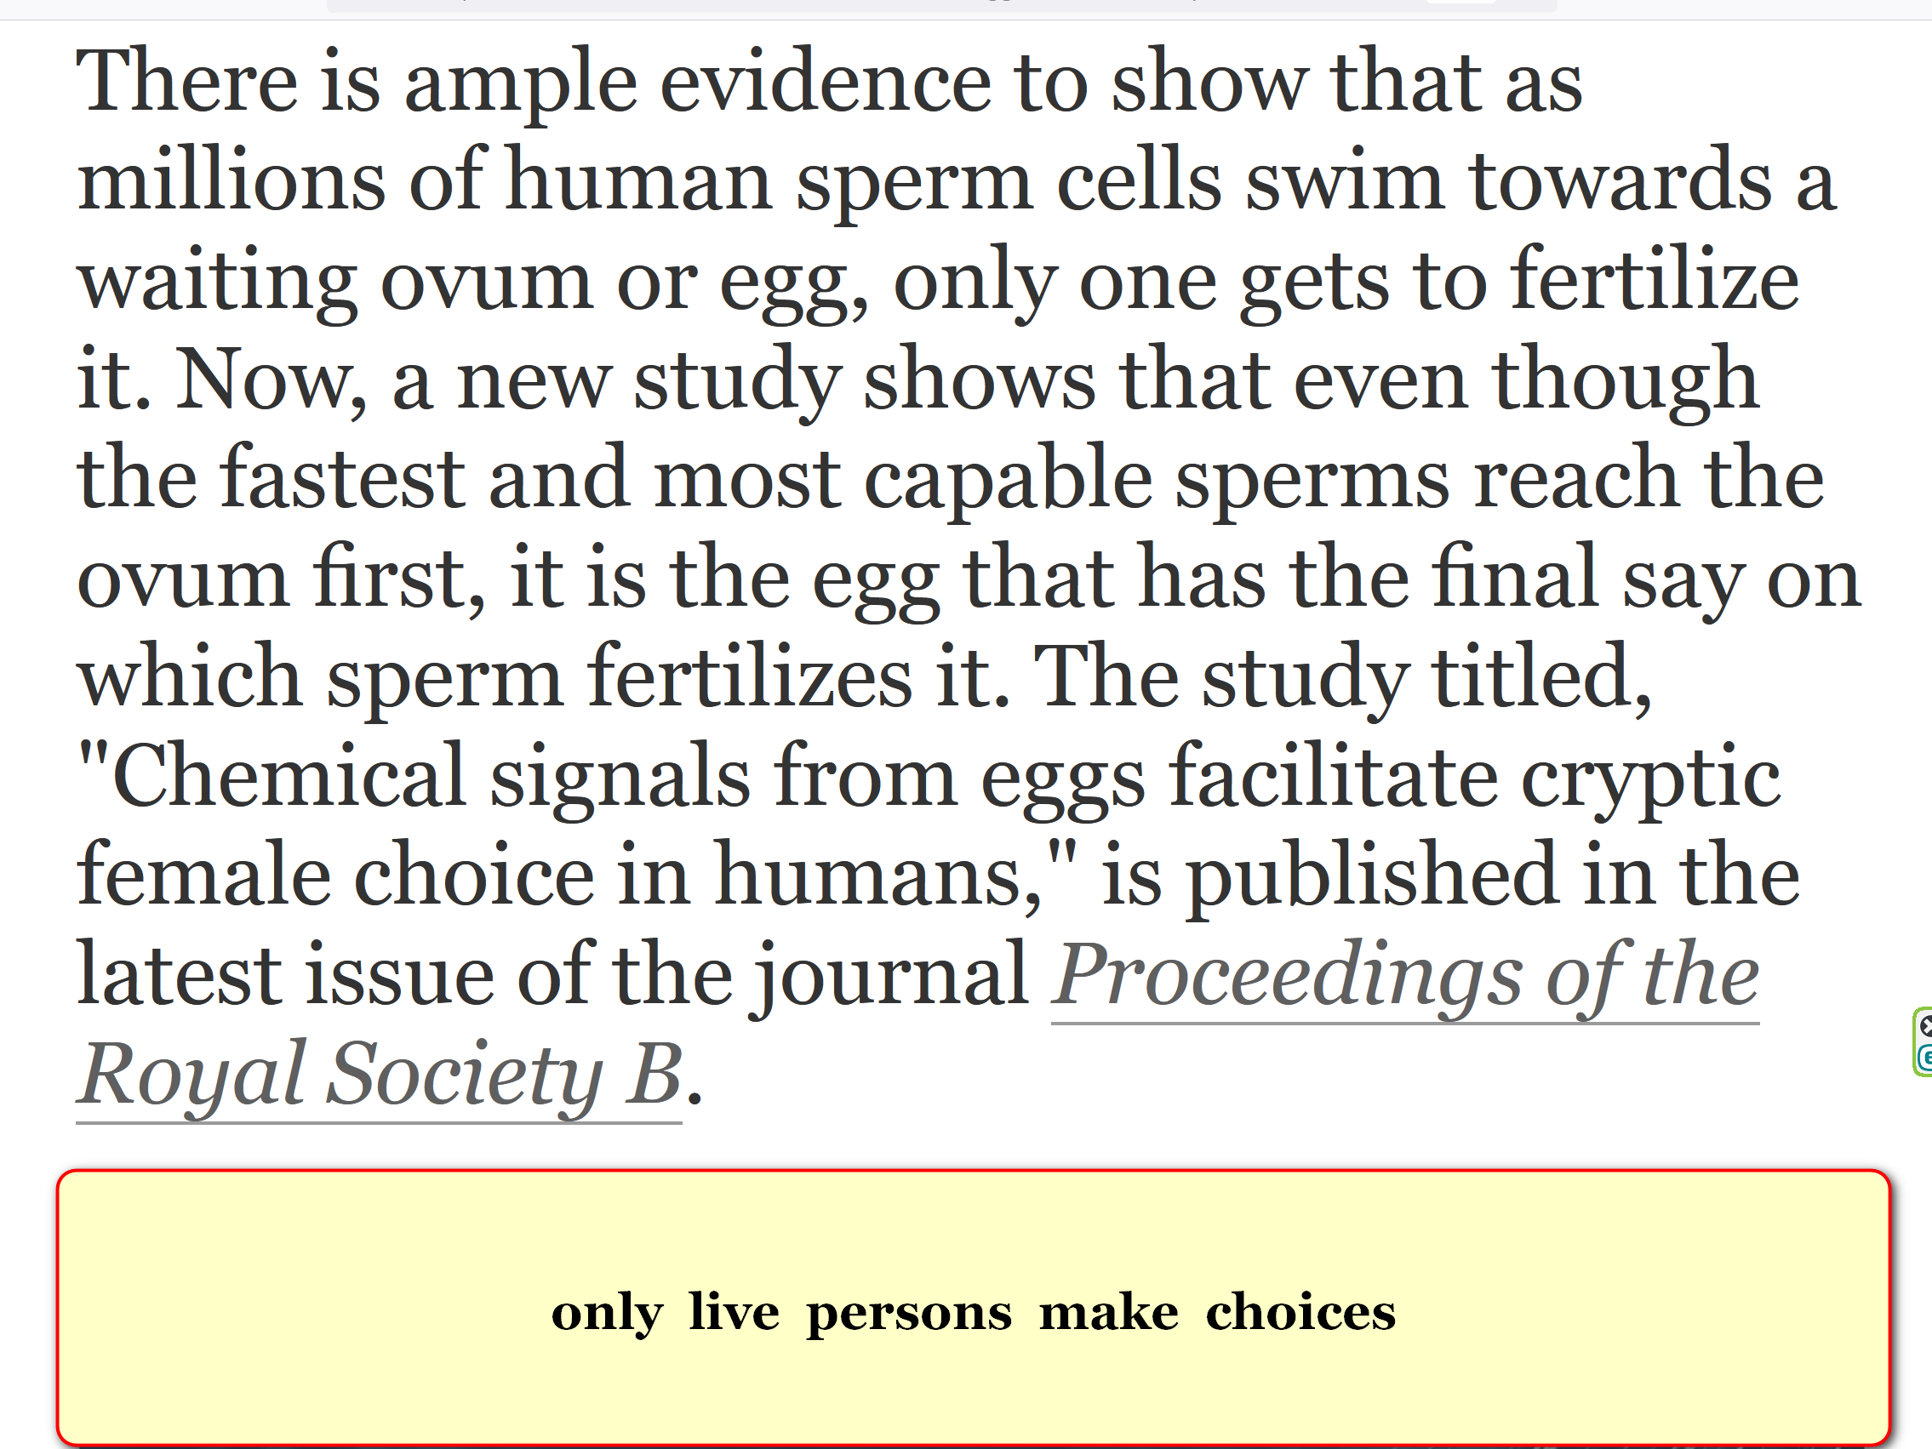

SMALL newly created FIELD OF ELECTRONS
stays alive
throughout nine months inside mother's body

through entire pregnancy time unborn baby
never experiences
non aliveness

KIM NOTES

alive sperm and alive egg combination
reach
2-0 majority vote concerning which
features to include in new personality

one woman to one man marriages
parallel
above

group of two persons in marriage
make
decisions for group actions via
2-0 majority vote

fidelity in marriage
equals vote for
SUNNYsideUP emotion for universe's operations

above
because
any additional intimacy partners
violate 2-0 majority guidance

new unborn baby
possesses
definite opinions on desired DNA features
including DNA sections already initially assigned

eagle nebula's eye circled by kim
symbolizes
unborn baby looking left observing universe
then choosing preferred nature of universe

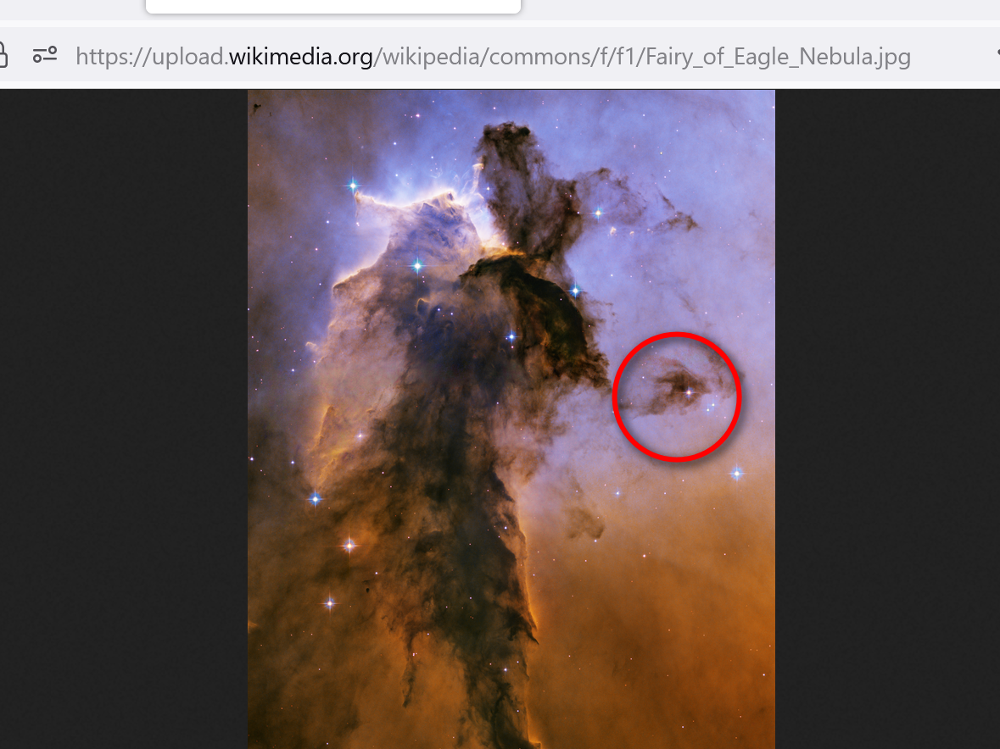

1974 june 27 photons
rearranged
eagle nebulae to copy and endorse
wheeler's chalk drawing explanation

professor john wheeler's theory
explains
humans choose what comes into
humans' holographs

KIM NOTES

2022 december kim
experienced
HISTORY is never set in STONE
therefore confirming wheeler and alley's proof

concerning wheeler's chalk drawing kim
experienced
what wheeler scribbled beneath the drawing
THE universe as a self-excited SYSTEM

2022november kim
pondered
concerning relative girl named nana

unlike peers nana's teenage years
void
of carefree fun

void
because
nana mandatory second mom
to three baby brothers

nana's best friend dee
lived
in quiet house shared
only with parents

when possible nana
visited
dee's quiet house

nana and dee
remained
best of friends after high school

dee
eventually moved to
california unfortunately passed from globe
after attaining only 51 years

nana
attended
dee's funeral in california

nana
telephoned
kim days later concerning sad details

dee's parents
performed
pagan funeral in california redwood forest

nana
found
those pagan burial rituals
unfamiliar and unsettling

during next 25 years when kim
conversed
with nana dee's name only rarely
mentioned as past memory naturally

2022 november 16 nana's husband
passed from globe
having last three years with solely
nana primary healthcare giver wonderfully attentive

then kim
pondered
nana's life

kim sad
because
nana possessed no buddy buddy confidant

month later kim
received
shocking communication causing emotion similar to
latin america's raised ears snoopy statue

during 2022december telephone conversation nana
casually mentioned
talking that week by telephone
with dee in california

kim
blurted
DEE

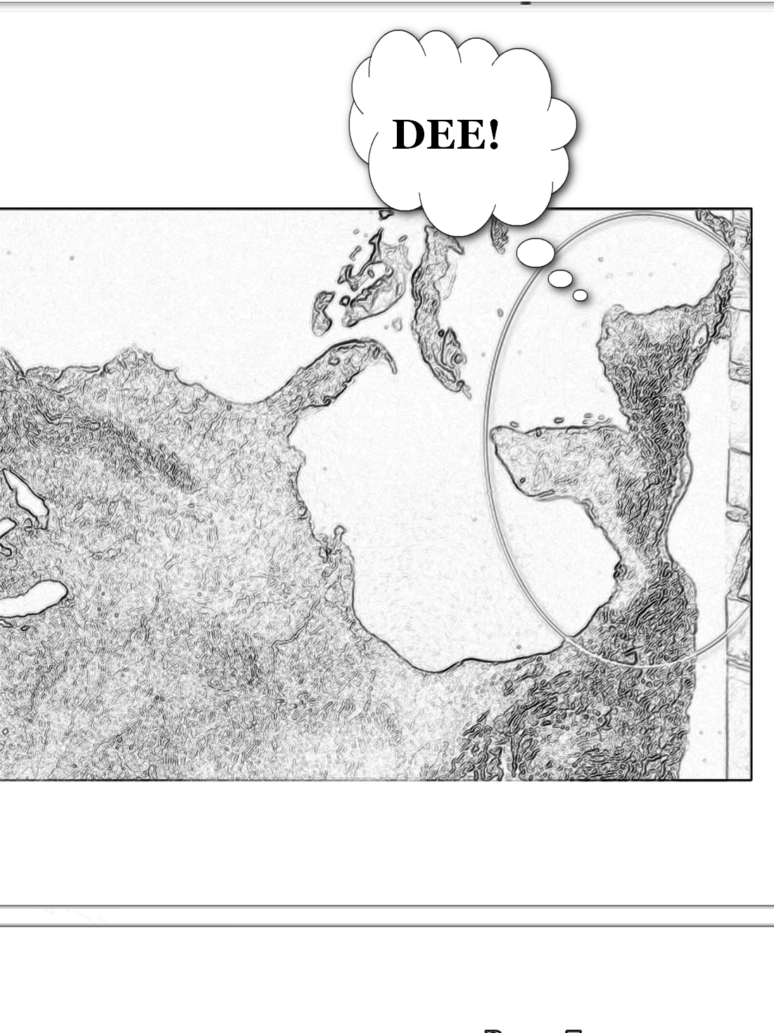

nana
said
YES do you remember
my best friend growing UP

kim
recovered enough
acted like nothing amiss

next day kim
remembered
kim's 2022 november fleeting ponderance

kim
realized
universe reformed history seamlessly
confirming wheeler's theories

universe's new history
included
nana possessed
continuous friendship with dee many years

universe
answered
kim's brief ponderance
although no prayers involved

above occurred even though kim
never referenced dee
in that brief ponderance

therefore wheeler
correct

furthermore wheeler
even discovered
method of universe's agents in determining
responses to humans' slightest whims

wikipedia.org

2006february18 interview with martin redfern wheeler mentioned
in developing Participatory Anthropic Principle,
wheeler used variant on Twenty Questions,

wheeler
used
variant on Twenty Questions method of
detection called Negative Twenty Questions

wheeler's Negative Twenty Questions
showed how
questions we choose to ask
about universe may dictate answers we get.

respondent
does not choose or decide upon
any particular or definite object beforehand,

but only on pattern of "Yes" or "No" answers.

this variant
requires
respondent provide consistent answers
to successive questions

so that each answer
can be viewed
logically compatible with all previous ones.

In this way successive questions
narrow
options

until questioner
settles upon
definite object

KIM NOTES when universe's photons
asked
wheeler's 20 Questions to subconscious human

that subconscious human
gave
20 parameter settings then universe found
puzzle piece fitting parameter settings

or sometimes universe
created
entirely new holographic item matching description

in dee's case universe's photons
devised
answer to nana's situation after
Negative Twenty Questions to subconscious kim

universe's photons via standard operating procedures
seamlessly reintroduced
dee into new history of globe

KIM NOTES 2025 dee
lives happily
near university of california santa barbara

1940 wheeler
told
feynman
only one electron in universe

theory of one actual electron
correct plus
one proton one neutron exist in
one black hole original 1D singularity

KIM NOTES below discovery
explains
above statements

wikipedia.org's one electron universe
wheeler via call to feynman 1940spring

KIM NOTES
below discovery
explains
above statements

wikipedia.org's one electron universe
wheeler via call to feynman 1940spring

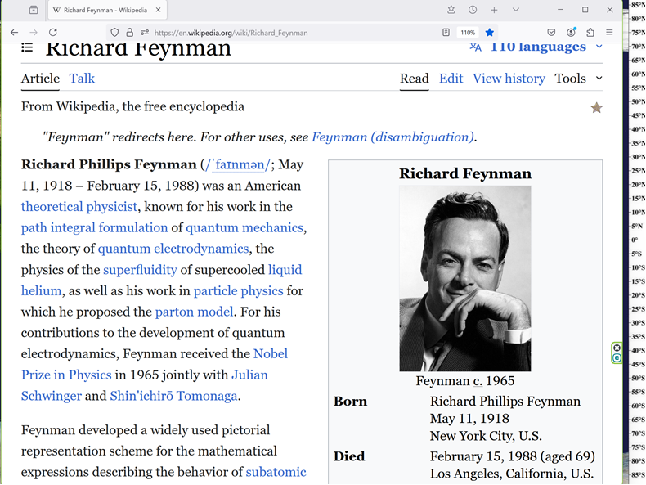

I
received
telephone call one day at graduate college at Princeton
from Professor Wheeler, he said

FEYNMAN
I know why all electrons have same charge and same MASS
Why?

BECAUSE, they are all the same ELECTRON!

KIM NOTES

all electrons
connect with
all other electrons in what scientists
call entanglement

until this book scientists
believed
only some electrons entangled with limited
number of other electrons

yet humankind's surrounding holograph 3D universe
gives
illusion of separate electrons

mid 1990's scientists
mentioned
surrounding holograph 3D universe

in 3D universe things
expand volumetrically

netherlands professor gerard 't hooft
noticed
black holes expanded only flatly
stanford professor leonard susskind agreed

above
proves
3D universe merely 2D universe disguised

SHOELANGUAGE book in chapters A03-C08
proves
whole idea of 2D universe involved
accepting SUNNYsideUP for 1D singularity eternally

chapter ends

