D09 klecka twins overturn cain versus abel

2023july16 unmarried male twins keith kim
officially overshadowed
unmarried male twins cain abel's
SUNNYsideDOWN permissions to afflictions

cain
assumed
position of judge sentencing abel
to first capital punishment legal precedent

biblegateway NIV version Genesis chapter 4

Now Abel kept flocks, and Cain worked the soil.

verse 3
In the course of time Cain brought some of the fruits of the soil as an offering to the LORD.

verse 8
Now Cain said to his brother Abel, "Let's go out to the field." [4] And while they were in the field, Cain attacked his brother Abel and killed him.

ABOUT the TWINS

leader keith klecka
volunteered for
toughest most painful strategy portion

subconsciously twin youngsters
agreed concerning
kim's loyalty and single focus mindset

conscious kim as adult
would never neglect
wife or children any timespan for
any reason even if God asked

therefore subconscious kim
agreed to frustrate
conscious kim's attempts at marriage

this non family strategy
positioned
kim for global improving tasks 24/7

ITEM ONE
street preaching for two years

ITEM TWO
across the hall 24/7 attendant plus primary healthcare giver to uncle carl nordstrand for five years
and later same to keith for final nine months

ITEM THREE
researching then expanding parameters of religion
and science and history

ITEM FOUR
creating new global language

resulting benefits of above
include
global systematic plan to permanently end
food shortages homelessness and wars

to guide circumstances subconscious kim
engineered retiring early
from dentistry plus engineered
losing financial ability to choose food

above non choosing of food
prepared
emotions for recognizing embedded image
in downtown houston library atlas pages

during those months family and friends
helped
kim as kim unknowingly researched for
eventual SHOELANGUAGE book

cousins donna and robin smith
generously made kim part of
smith household

years later 2025 january 26 kim
asked
smiths to pose with kim

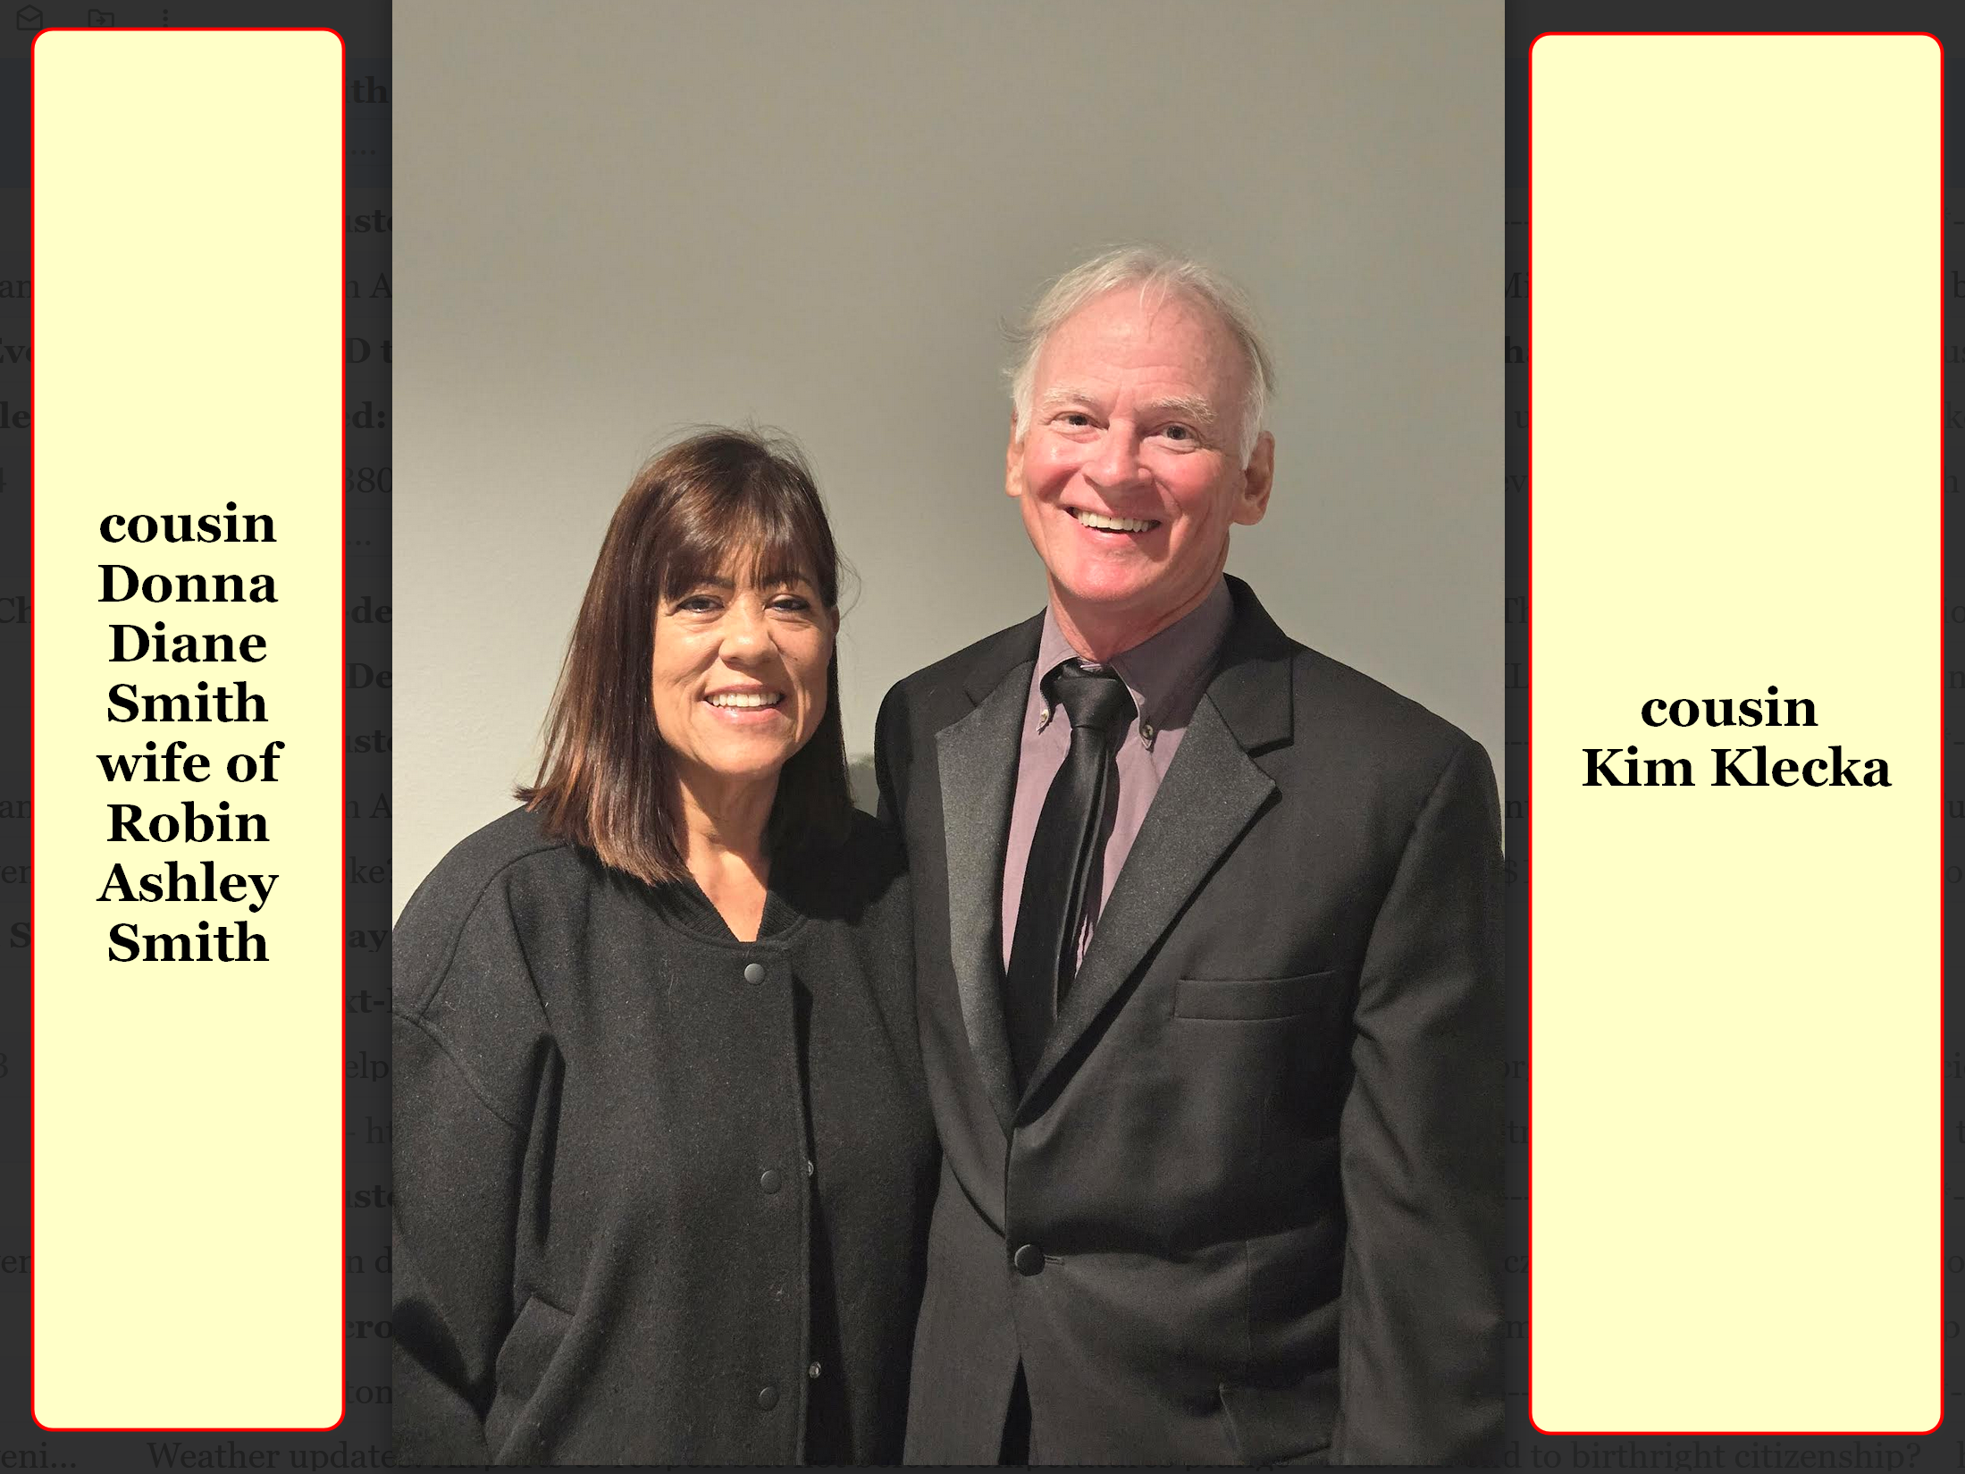
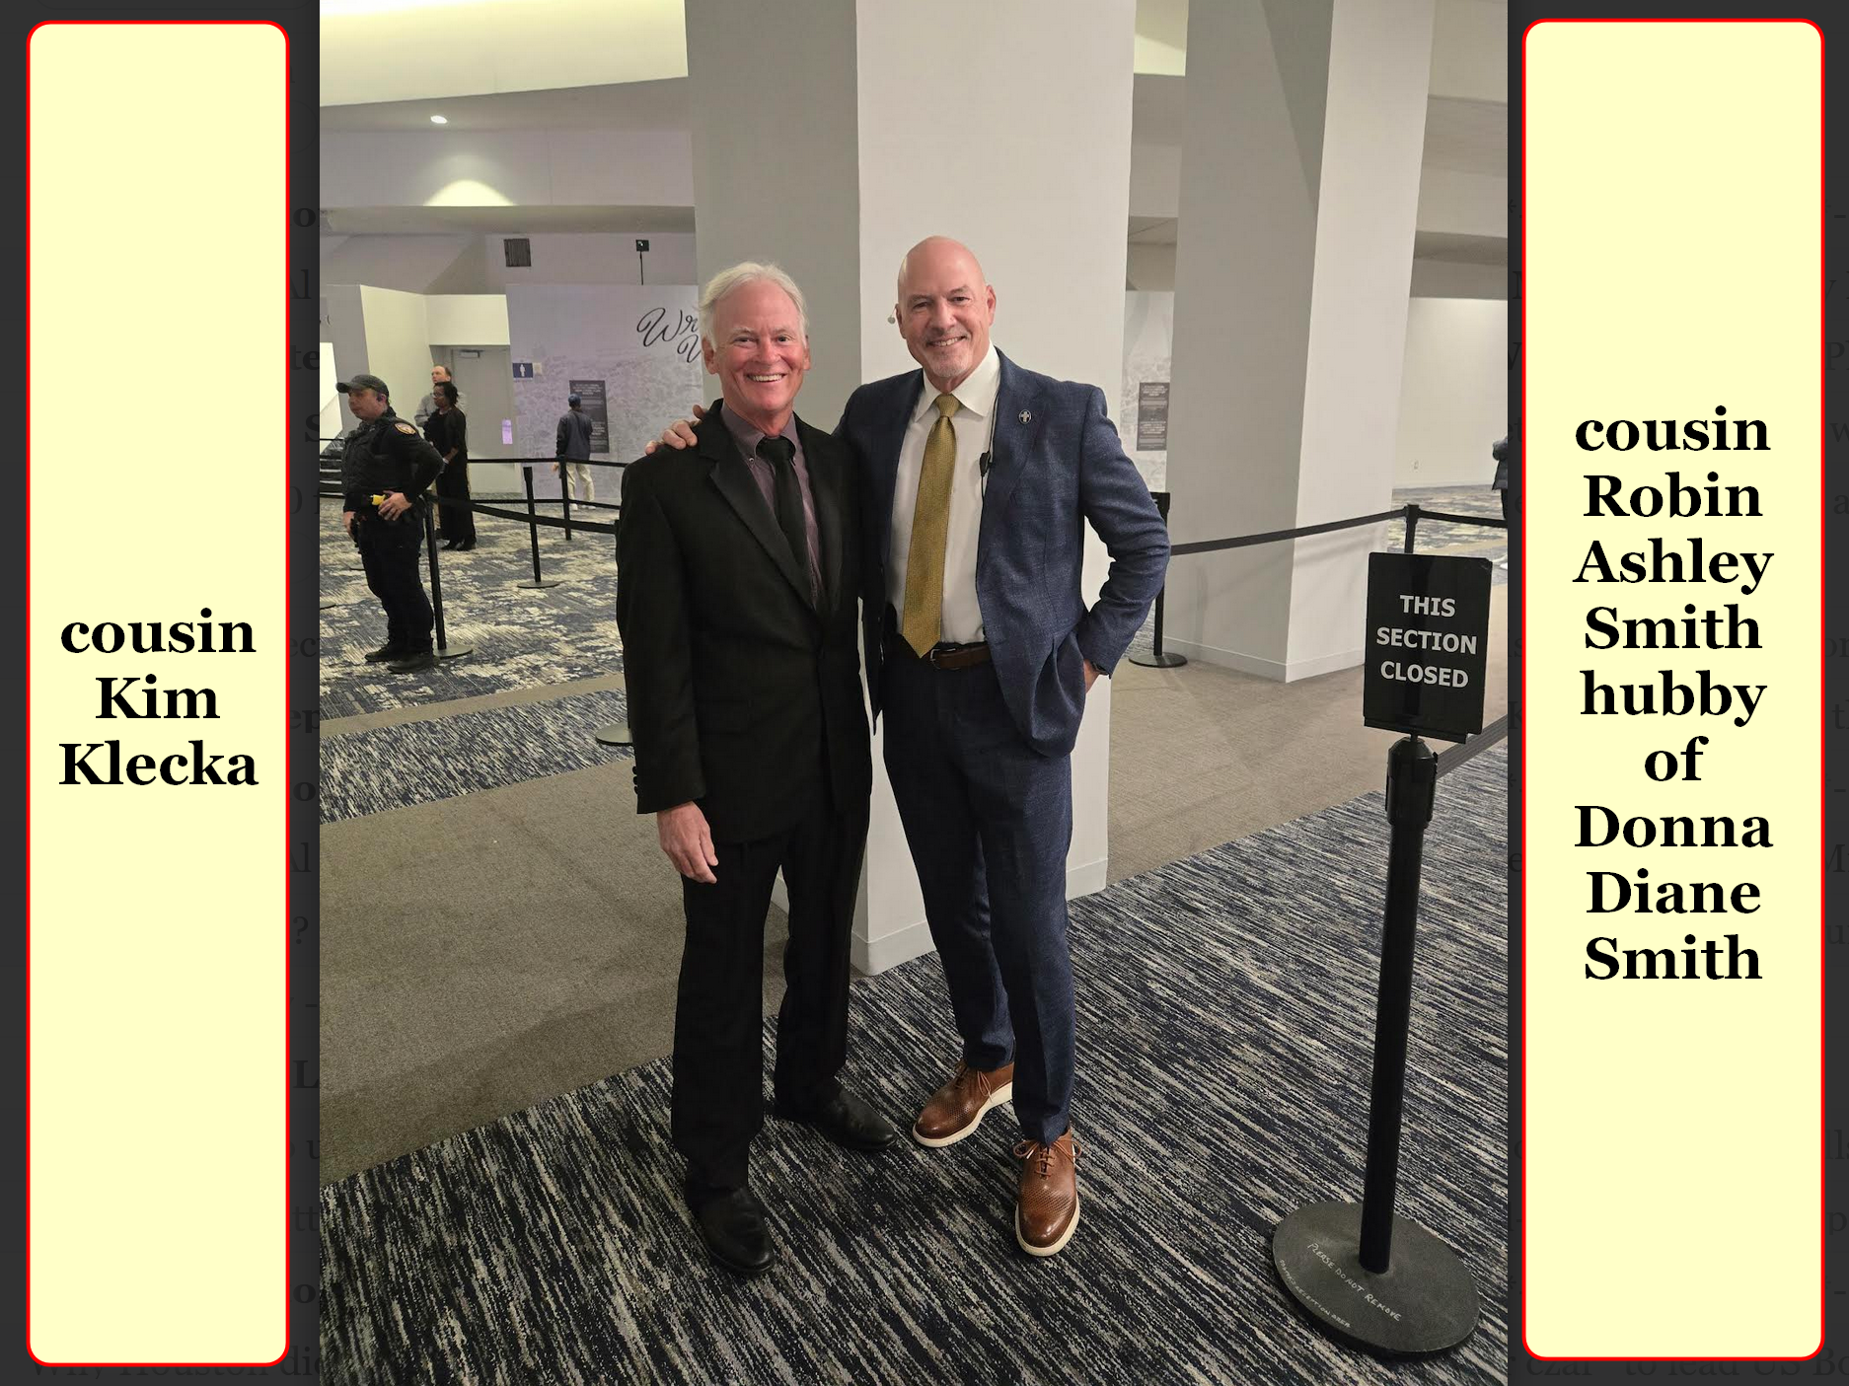

2013 after time with smiths kim
gained
employment at bush airport as custodian
rented single room near 69 north

third party contractor
paid
$8.50 per hour yet gave physically
impossible hourly checklist to fulfill

kim's income
barely paid for
essential expenses at rented room
inside collision shop 69 at beltway

nearest bus route to airport
mandated traveling south to
downtown then wait then take
another bus north to airport entrance

above
would have involved
4 hours daily in bus system

instead of above kim
walked
ten miles round trip daily

some custodians at same airport
enjoyed
$13 per hour via direct employments
from city of houston

surprisingly supreme being
disallowed
kim from applying for city employment

finally years later kim
realized connecting with
that houston mayor would have changed
kim's official emotion signals to universe

wikipedia.org's

Annise Danette Parker (born May 17, 1956) American politician who served as Houston, Texas' 61st mayor
from 2010 until 2016.
One of first openly gay mayors of major U.S. city

KIM NOTES

SUNNYsideDOWN mayor as employer connection
would have blocked
kim from 2014 december 14
SUNNYsideUP revelation in library

previously as dentist kim's patients' comments
explained
portions of
humankind's optional SUNNYsideDOWN package

writer of SUNNYsideDOWN scripts
utilized
STILL SMALL VOICE impersonating supreme being
to dental patients at HIV clinic

one male patient
told
kim that patient heard from Jesus
years before

according to that man Jesus
told
that man
CHOOSE to become GAY

another day at HIV clinic kim
fetched
next patient in waiting area
for dental work

male patient
closed
magazine remarked if that beautiful lady
entertainer pictured on cover liked him

then he
would choose to stop being
gay

kim
concluded

imitator of STILL SMALL VOICE
pushed
humans to choose that behavior

those three experiences above
supported
kim's later summation

persons choosing SUNNYsideDOWN package
included preferring
sex outside of heterosexual marriage plus
eventual sex preferences gaylesb pedobeasto

kim
realized
SUNNYsideUP package included
fidelity in heterosexual marriage exclusively

SUNNYsideUP package
brought
SUPER HEALTH pleasant dreams SUPER CIRCUMSTANCES

2014 at airport kim
devised
strategy to obtain food

during kim's lunchtime kim
kept using
cleaning cart but moved to
huge airport food court tables area

although not officially assigned kim
cleaned
selected airport restaurant tables
when clients left trays with scraps

plus kim
gladly gathered
scraps from restaurants' garbage bags

kim
volunteered to cart and drop
some restaurants'
garbage bags into basement dumpsters

for six months kim's diet
consisted mostly
of scraps from work etcetera

then kim felt supreme being
asking kim to
become street preacher to
homeless of downtown houston

2014august28 kim
obeyed

without any church support kim
started sleeping in
downtown houston texas
like downtown homeless under clear skies

kim's goals
included persuading
as many people as possible
to say prayer of eternal salvation

kim like other homeless persons
ate
when and where charities provided meals

kim
ministered to and prayed with
homeless in food lines
sometimes hours long lines

food kitchens' schedules days times
varied

kim
attempted being
front or near front of queues

kim
developed routine
of getting to charity food places
usually churches two hours early

kim
crisscrossed
houston's extended downtown area
totaling about 16 miles daily

in evenings under streetlights kim
wrote in
spiral notebook writing sermons for future
internet viewing for free

kim
slept serenely
with pleasant dreams

kim
was grateful
for front row seat when miracles
happened through praying

yet as most people
notice
but rarely discuss

only some prayers
answered affirmatively
example healing prayers

yet logically either all prayers
always answered
or none ever answered

this procedure people call prayer
either
100% valid in universe
or 100% false mere fantasy

this book's chapter 003
resolves
situation mentioned above

1981 keith klecka
graduated
from austin college
in sherman texas

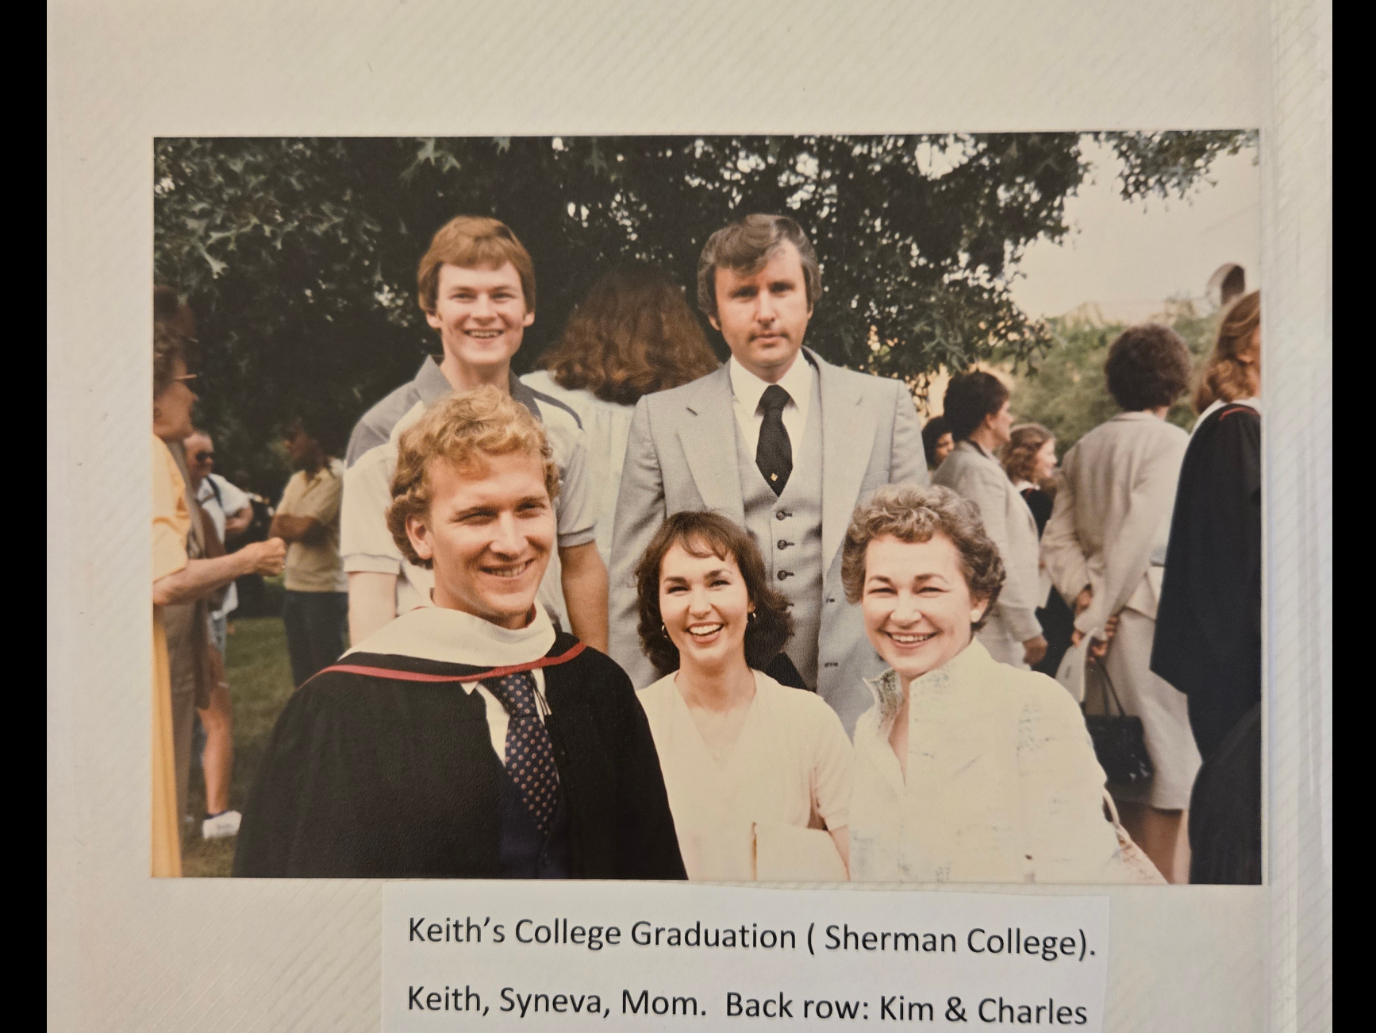

kim and keith
attended
brother joe's wedding

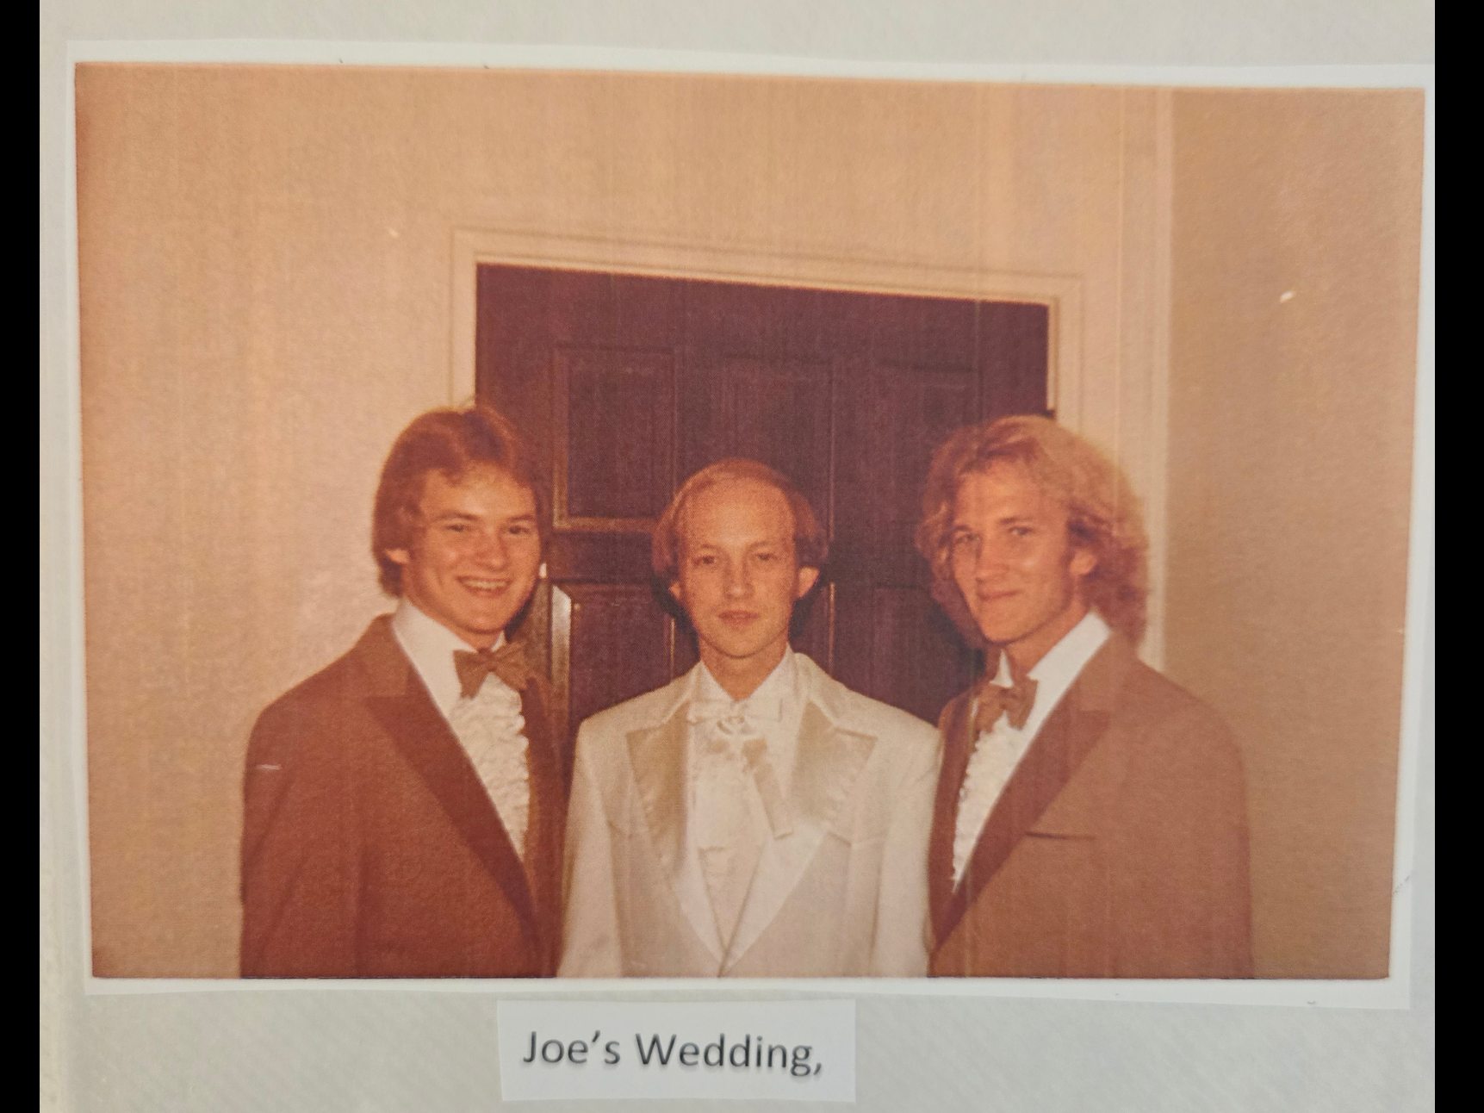

BEARS strategy broadcasting lethality randomly
killed
keith

BEARS
dripped
cancer causing
liquid onto needles

BEARS
tainted
needles randomly

keith
received
tainted needle

2022 keith michael klecka's florida workplace
keenly assured
customers all employees vaccinated
concerning Covid19

employers
not knowing
BEARS randomly tainted syringe needles
at site of manufacturing

sincere florida nurses like all nurses
unknowingly injected
cancer causing liquid via prefilled syringes
preattached needles into trusting citizens

2022january keith upon receiving booster shot
immediately felt
intense pain in shoulder injection site

pain at injection site
lingered
months

after four months keith's body
finally defeated
shoulder injection site's cancer causing agent

however liquid remnants
invaded
keith's knees plus other areas
creating accelerated cancer

carcinogenic liquid
contained
DNA sequence extracted from earlier prostate
cancer patient incubated multiplied

2022january injected cancer causing liquid
started
spreading cancer throughout keith's body
quickly as designed by perpetrators

2022july pervasive prostatic cancer stage IV
included
eight distant bone colonies metastases

2022august keith
desired
kim stay at hospital with keith

kim
desired staying
but financially unable

during each week kim
worked
60 hours additionally 20 hours
in bus system to from work

kim searching for answer
mentioned
solution yet knowing
only small chance for quick fruition

above included kim
explore possibility
sell invention quickly bargain price
but invention only sketched on paper

with that idea offered keith
realized utilize
keith savings
probably adequate through 2022december

kim
happily agreed
resigned job at transportation company
amid well wishes

with bills paid kim
started staying
at hospital during entire visiting hours

deer park high school 1977 classmates
started
GoFundMe account with great generosity

keith's former work colleagues florida etcetera
found
online GoFundMe account
contributed generously

keith's college friends from decades earlier
found
online GoFundMe account
also contributed generously

keith's college friends
visited
keith personally
defying keith's letters against visitors

such generosity above plus supportive siblings
allowed
kim with keith nine months 24/7

2022october keith
enjoyed family's visit

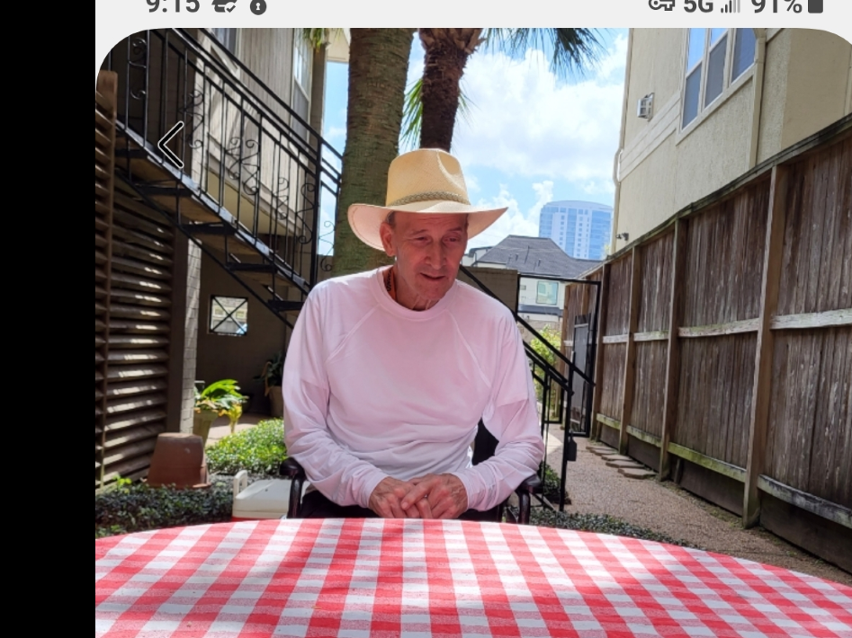

sadly keith
never accepted
kim's offer
prepare personally effective SUPER HEALTH diet

above because keith
still practiced
traditional wisdom diet
EAT YOUR FRUITS VEGETABLES etcetera

obedient to keith's wishes kim
prepared
meals in traditional diet

in may of 2023 keith
sat up
on edge of bed mentioned gladness that
keith contributed to academia

decades earlier keith
sent
friend dr gorman professor of literature
uh/clc copy of keith's favorite book

six weeks later dr gorman
wrote
thank you note ALL THE PRETTY
HORSES worthy as keith vigorously maintained

in fact dr gorman
included
book into uh/clc curriculum
for all future students

around 2023june15 keith
sat up
on edge of bed
gave sober recommendation to humankind

IN this short time we
have
on earth shouldn't we
try to make things BETTER

example of above victor anne
never heard
keith's sobering words yet made
keith's plus kim's world much better

uncle victor aunt anne nordstrand
gave
vehicle for kim transporting keith
plus traveling other places

plus uncle victor aunt anne nordstrand
gave
keith condominium

tragically keith
died
2023july16 sunday 12:48
two weeks before scheduled move

uncle victor aunt anne's generosity
continued insisted
kim though alone without keith
still move to condominium

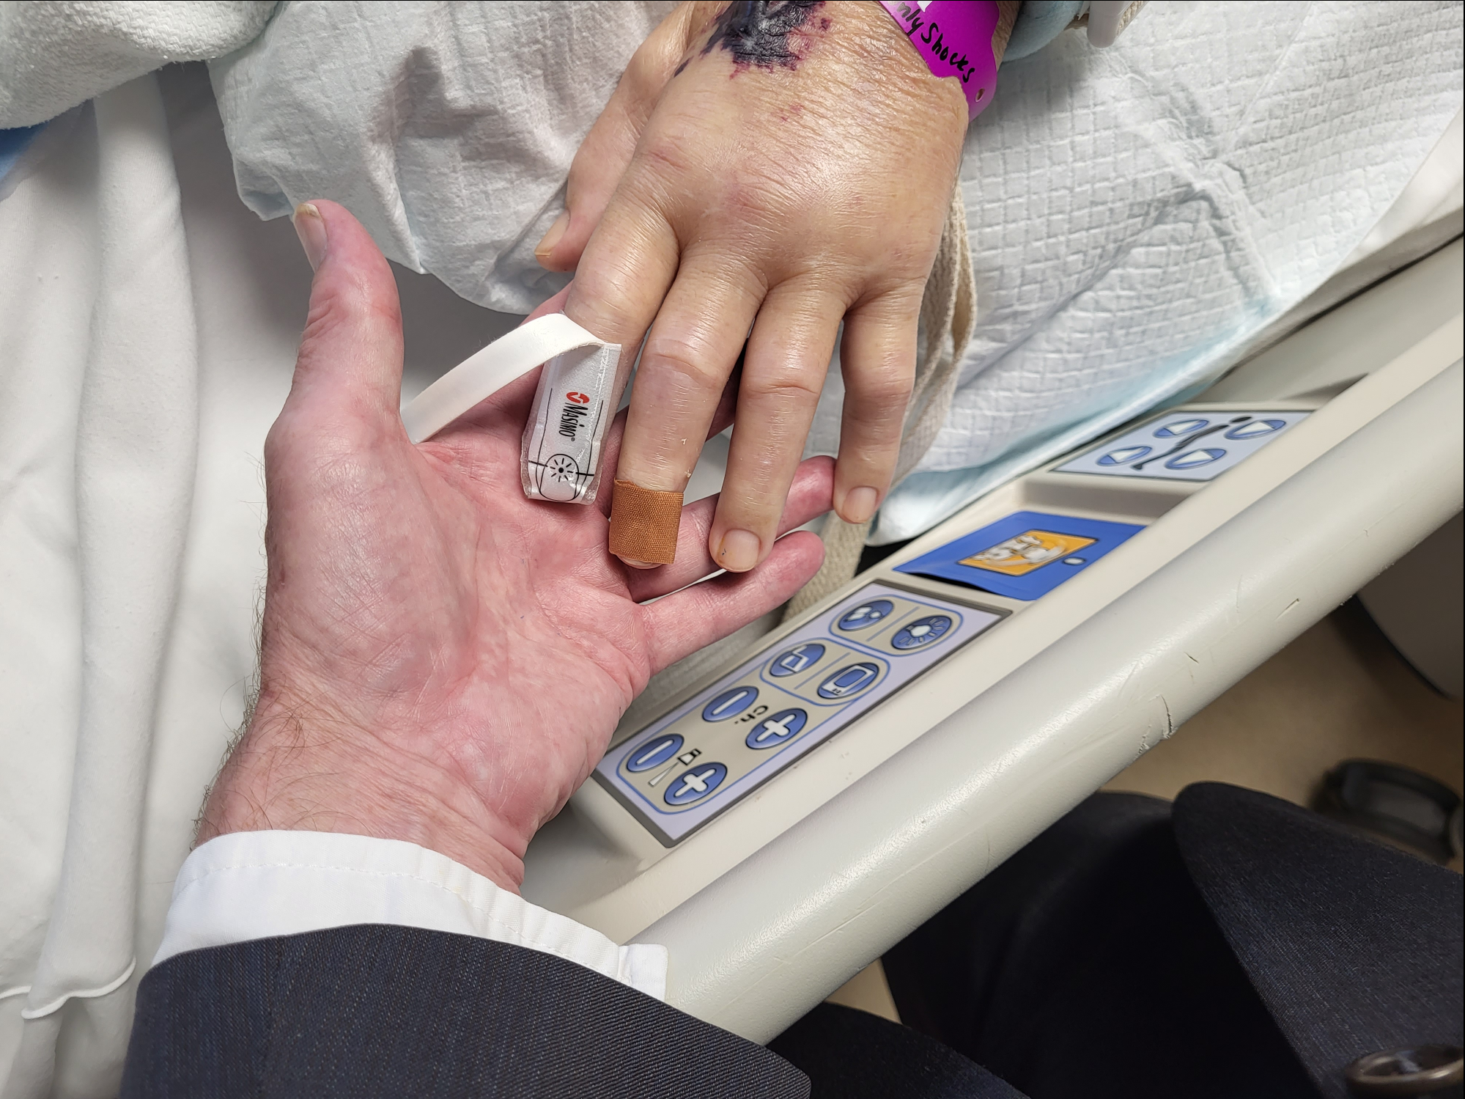

if keith
were alive
and gave guest lecture at university

keith
might say
somethings along these lines

ON behalf of all persons' whose lives
cut short
by BEARS' invented viruses invented wars

we
ask
BEARS to leave machiavelli's teachings and
instead choose confucius' moral standards

FAIRNESS for ALL
creates
better globe for all citizens including
BEARS' kids and grandkids

FAIRNESS for ALL
creates
better eternity for all humans ever

I kim klecka
add
comment with borrowed phrase from
abraham lincoln's gettysburg address speech

IT is for us the living rather

to convince
BEARS stand down voluntarily so no
more family nor friends needlessly perish

that this morality FAIRNESS for ALL
will gain favor
among all citizens of GLOBE

kim on behalf of humankind
forgives
BEAR for deaths in return BEAR
stand down stop killing

chapter V07
gives
details of proposed BEAR retirement ceremony
during special news conference from nigeria

week after keith died kim
realized
keith and kim's combined efforts reverse
paralleled early men's SUNNYsideDOWN choices

keith and kim
concentrated intently to
avoid contentions during intense
time in same apartment

very few times one twin
flared up
however other twin did not reciprocate

therefore during almost ten months twins
overshadowed
SUNNYsideDOWN decisions of twins abel cain

kim on behalf of keith
hopes
humankind joins in reversing early men's
impactful SUNNYsideDOWN emotion choices

other chapters
mention in detail
noah plus two of
triplet sons chose SUNNYsideDOWN

kim's non drinking of alcohol beer wine
overshadowed
noah's SUNNYsideDOWN liquid decision

for five years previous kim
specifically respected
elder oldest male of family via
kim 24/7 primary health giver

above
included
washing uncle's entire body during
visits to bathroom

unknowingly kim
overshadowed
ham's ridiculing disrespecting family elder
including ridiculing noah's waste function mishap

1968december picture below uncle carl nordstrand
stands
behind keith and kim's grandfather
arthur martin nordstrand

kim
jokes
concerning grandfather's body language

perhaps norway born grandfather
gave
sarcastic salute to hitler
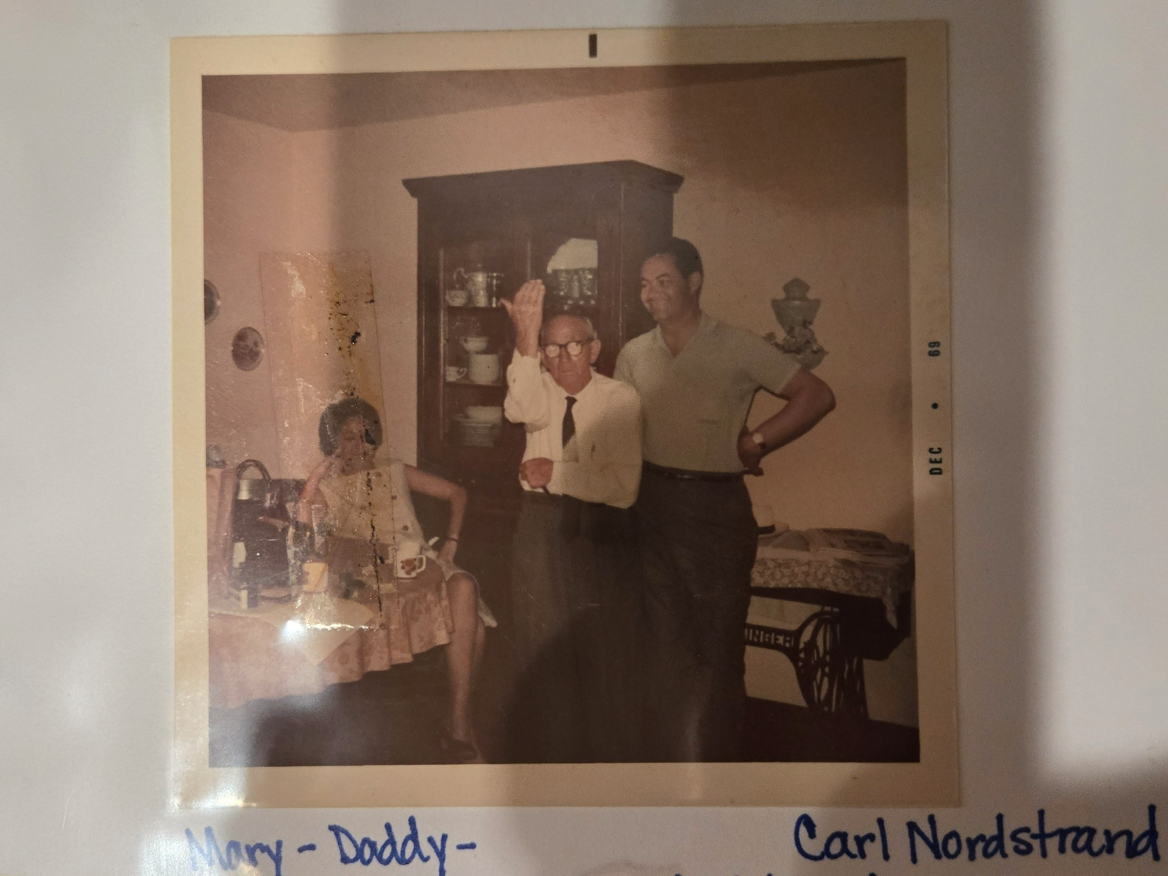

grandfather arthur martin nordstrand
born
in norway 1889 same year hitler

grandfather nordstrand
contributed
scandinavian DNA to children

uncle carl
possessed
52% scandinavian DNA

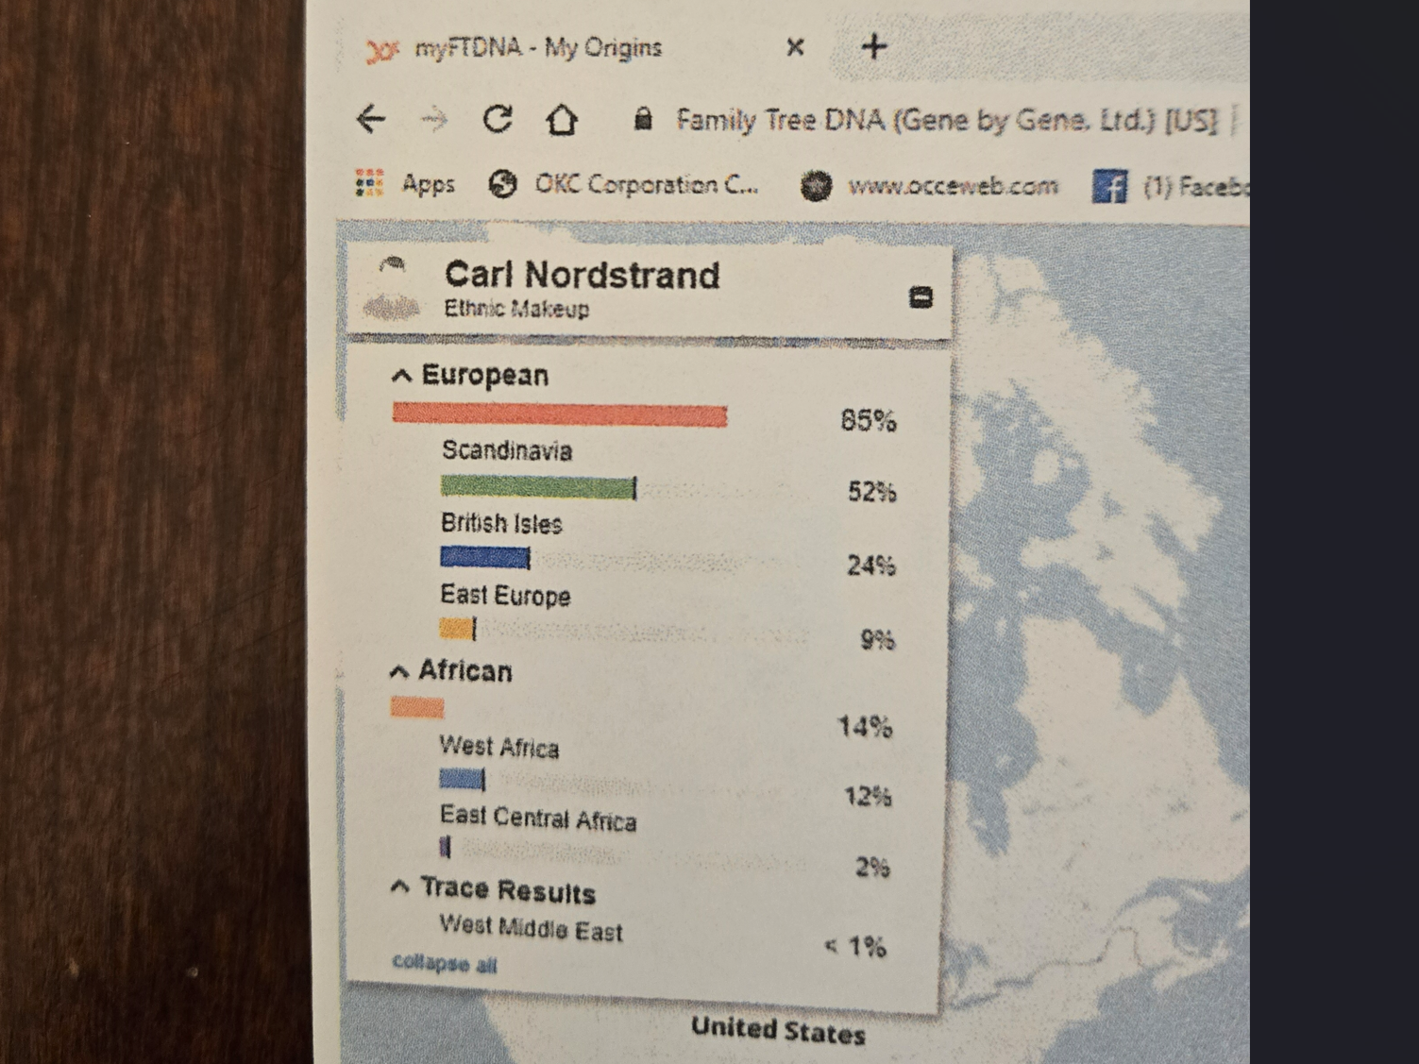

african and german and jewish portions
came
from grandmother mabel teichman nordstrand

rudolph teichmann
fathered
mabel

jewish name teichmann
americanized
equals teichman

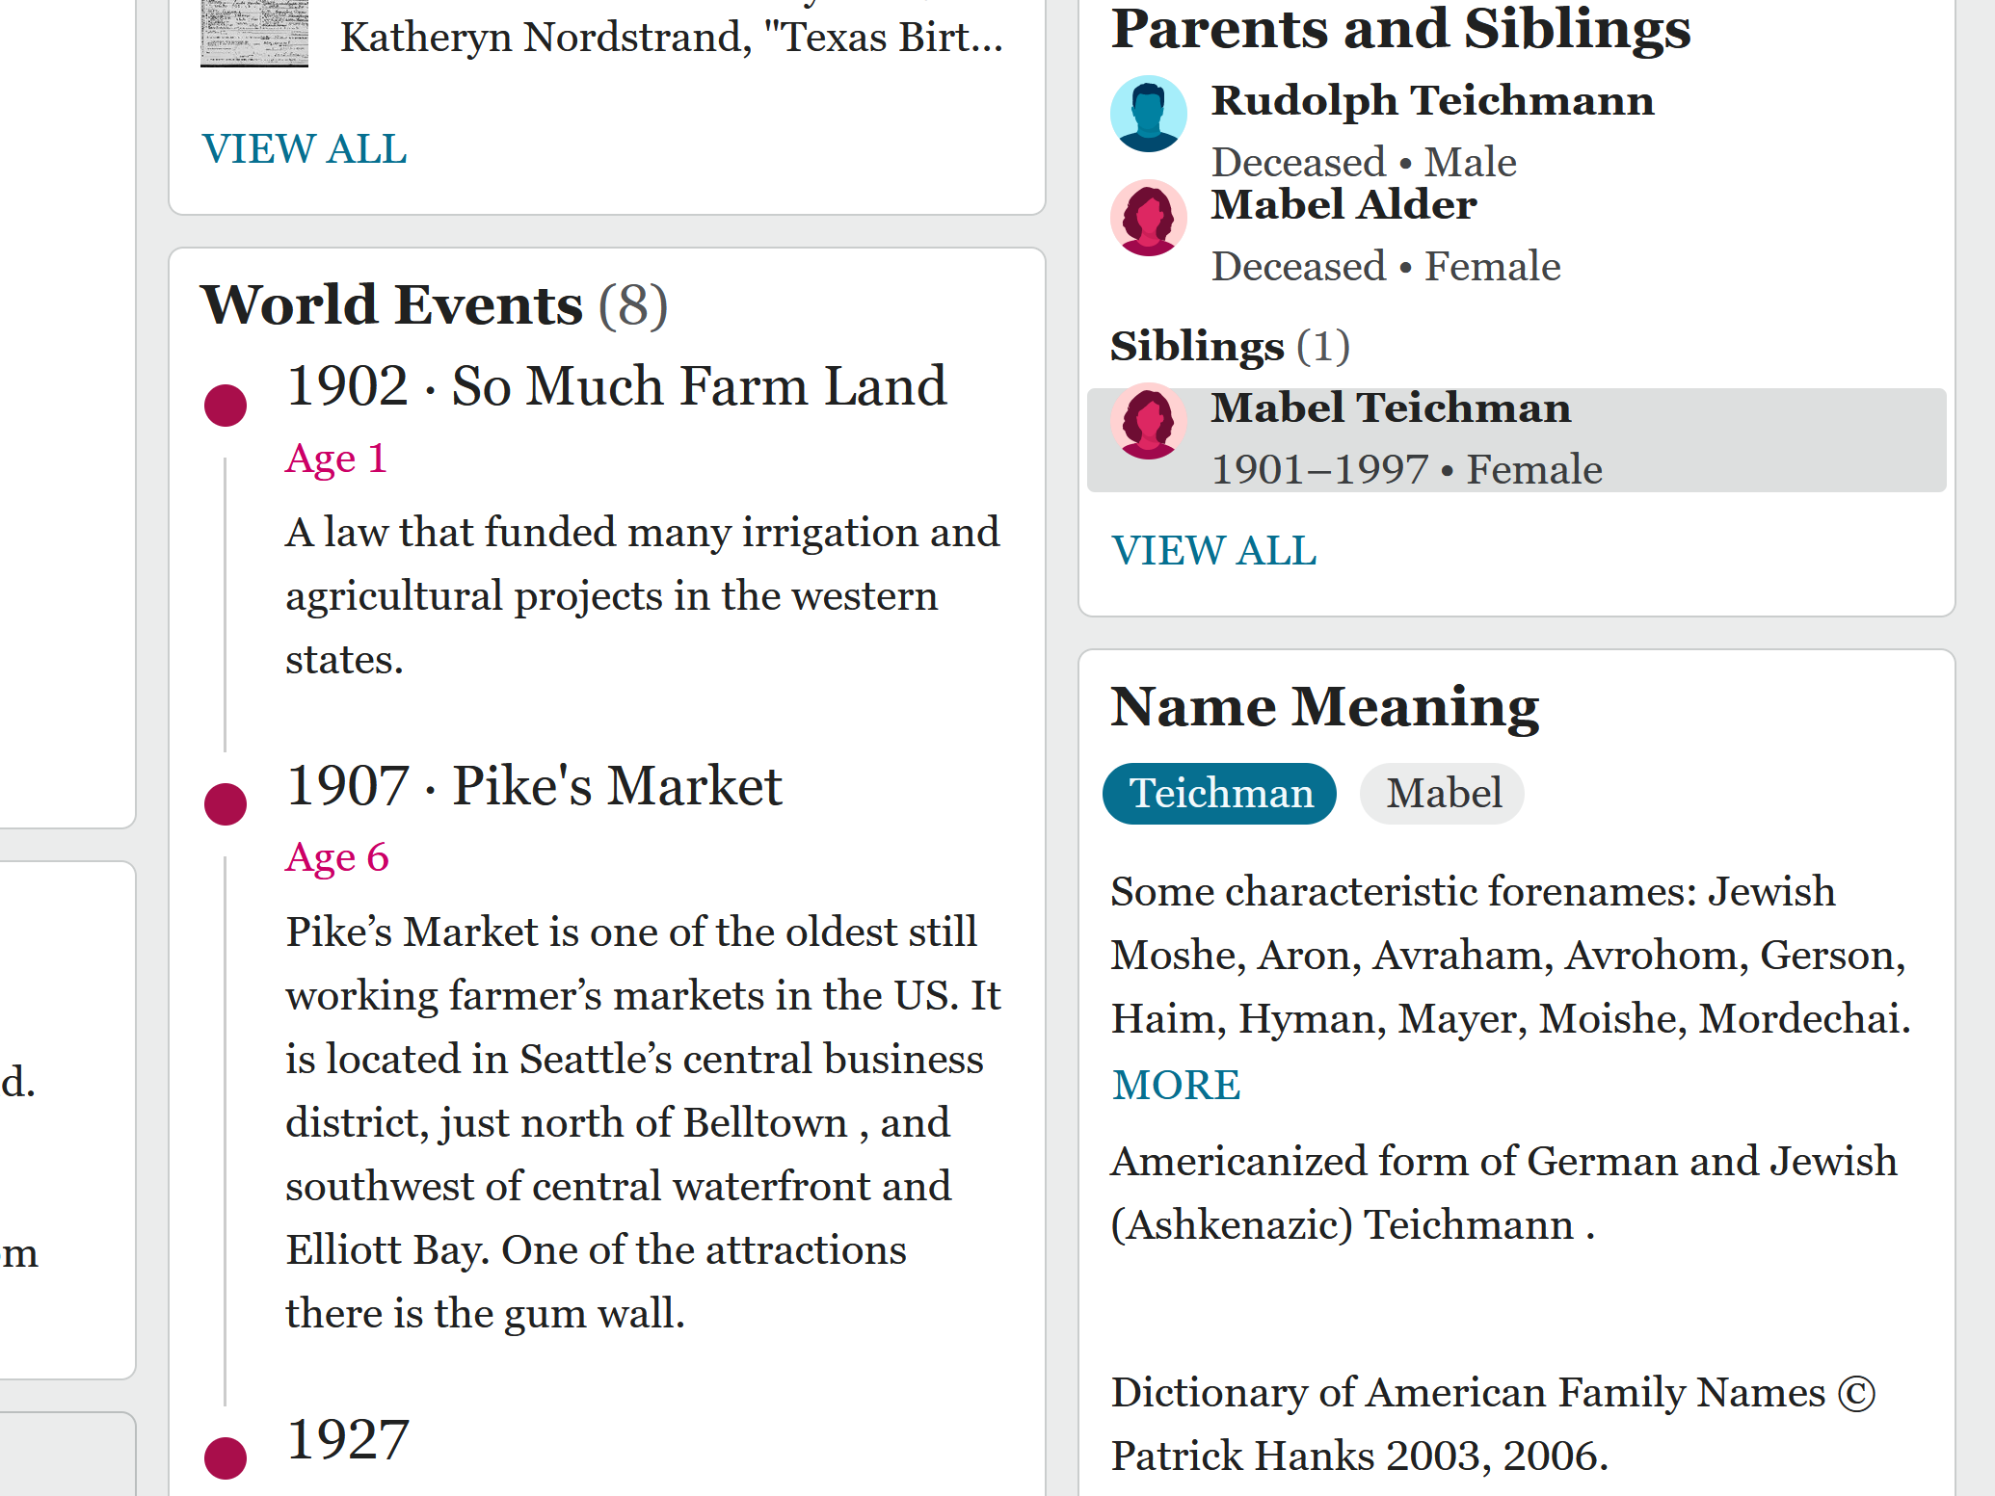

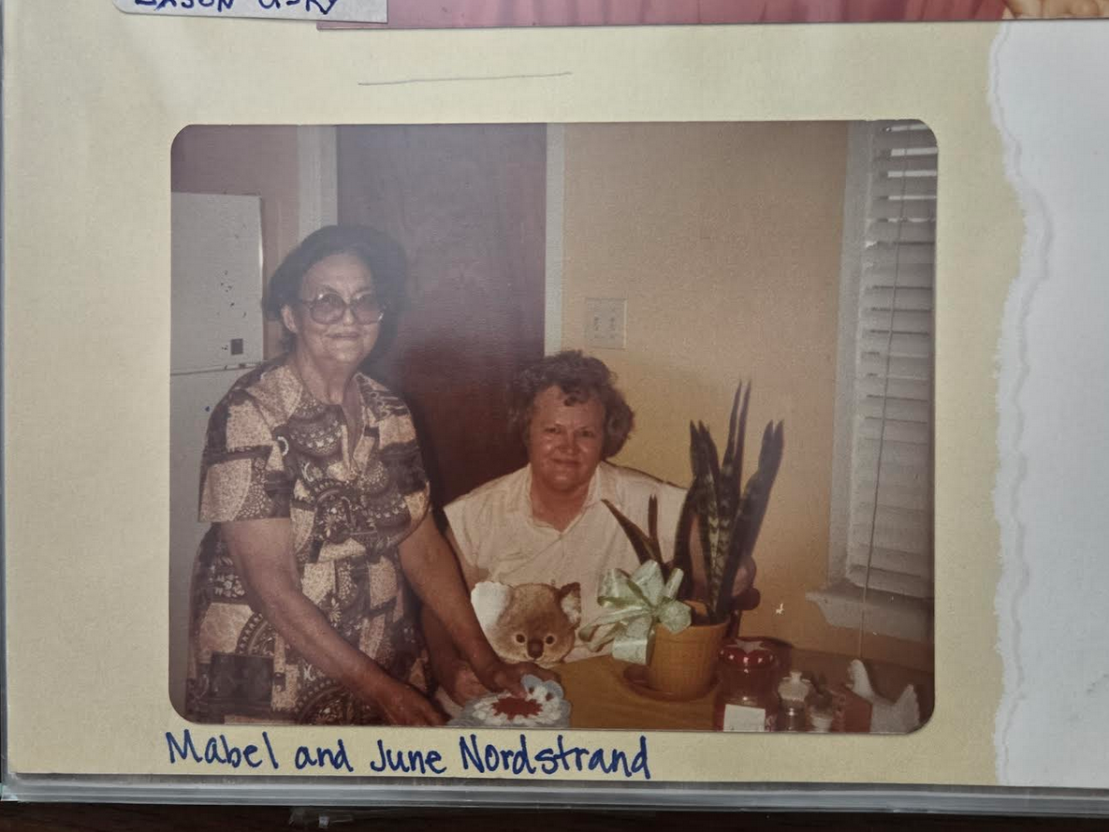

carl nordstrand 1948 picture
from
deer park high school deer park
texas showed 14% african heritage

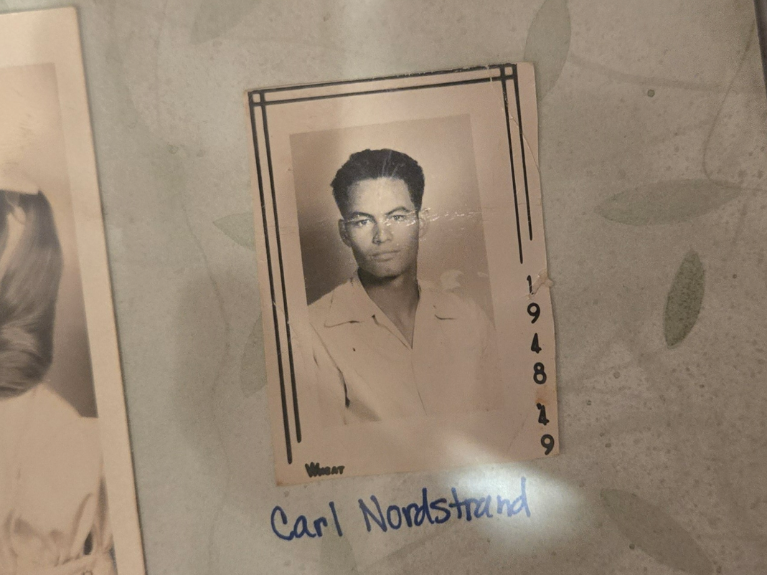

DNA of carl's brother victor nordstrand
includes
16% heritage from ham

together above proves ham's descendants
include
keith and kim

another triplet son of noah japheth
disrespected
family via clinging to gold versus
providing food shelter to family members

subconcious kim
purposely intersected
conscious kim with persons needing help

for several reasons 2023 kim
ate
least expensive food possible including
food coalition sack lunches

kim
thanks
generous food coalition volunteers
from ten churches two synagogues

2023november07 kim
found
work

2023december kim
gave
coworker trainee
needed gasoline money travel to work

2024january02 unusually cold temperature kim
gave
same gloveless coworker kim's new gloves

kim
reverted to
not as warm older gloves

2024january kim's limb parliament cells
convinced via twinge
kim earning enough now

therefore kim's limb parliament cells
insisted
kim purchase plus consume meat only

with mixed emotions kim
started
purchasing meat for consumption
even though more money expended

2024 january 17 kim
noticed
foursome diligent colleagues nicaragua craftsmen
working extreme wet cold conditions

2024february12
one of Environmental Allies' crews



standing above
ronald sunia rodriguez antonio diaz alexander rodriguez

kneeling
alberto canales kim klecka

persons in foursome
possessed
thin gloves
some not at all

with kim's hands kim
measured
quartet's hands palm to palm
mentioned warm gloves coming

normally throughout life frugal kim
purchased
least expensive items especially clothing

however this time kim
wanted
highest quality best for colleagues

unlike previous challenges kim
consciously realized
this situation paralleled japheth's situation

therefore kim
focused on overriding
japheth's SUNNYsideDOWN toggle switch setting

after jobsite work ended 19:00 kim
traveled to
ski store still open

ski store
probably possessed
better selection

30 minutes shopping time left kim
bought
warmest gloves stocked therefore fulfilled promise

plus while there limb parliament cells
urged
kim also purchase warmest jacket available
replacing kim's layers of older jackets

kim
agreed
yet kept looking for price tags

kim
eventually noticed
no items possessed price tags

kim
selected
warmest jacket yet kept calm face
when items' prices totaled at checkout

kim
eagerly paid
over half month of wages in
hopes japheth's decision overshadowed

2024january17 kim
delivered
gloves to colleagues

recipients
happy with
gifts

2024february01 company for various reasons
dismissed
kim's second trainee

2024february03 kim
noticed
grocery store sales
and bought discounted groceries

kim
saved
30% on month's meat supply
20% on month's water supply

2024february04 kim
reached out to
newly unemployed colleague texted offered help
much food water yet no response

therefore 2024february07 kim
gave
original trainee those groceries month of
meat plus ten gallons bottled water

plus kim
offered
new jacket to original trainee

original trainee
eagerly accepted
idea yet jacket when tried
too small

kim
urges
all nations adopt SHOELANGUAGE book because
delivers framework ending hunger homelessness

therefore kim on behalf of keith
announces reversing
japheth's decision cling to gold versus
providing food clothing shelter to family

chapter ends

