D08 leg reattached self 30 months later

2021december florida's keith texas' kim
confirmed
agreed upon roles concerning helping humankind

yet twins
agreed
at subconscious levels not consciously knowing

2-0 subconscious agreement because conscious kim
never capable of allowing
keith endure daily pain

later conscious keith's description concerning cancer
included
PAIN like thousand knives into KNEES

yet subconscious keith klecka
volunteered

above proves keith klecka
desired
happiness for all humans

kim's months at home attending keith 24/7
allowed
intermittent time segments for kim developing
finishing important pieces of SHOELANGUAGE book

in this additional way keith
sacrificed
comfort plus life
to help all humankind

conscious keith
politely refused
conscious kim's recommendations in diet for
gaining SUPER HEALTH flip to SUNNYsideUP

conscious keith not believing kim
therefore stayed with
childhood teachings EAT YOUR FRUITS VEGETABLES
drink tea coffee fruit juices etcetera

keith's heroic subconscious volunteering
parallels
1640's pellicer's subconscious internal voting
mentioned below

kim
estimated
healing success rate
via prayers of global citizens

prayers praise worship tongues speaking glossolalia
successfully healed
25% of instances globally

historically religious adherents' success rate
kept down
to 25% at best mainly because
persons counteracted via choosing vegetables ingestions

all humans even without prayers etcetera
capable
obtain 100% health recoveries if signals
consistently SUNNYsideUP

2015march23
findagrave.com's
contributor eman bonnici

created memorial online
number 144062292

1640march29 notable miracle

THE MIRACLE
by the Italian writer Vittorio Messori

book. . It deals with a miracle , in 17th century Spain

upon his arrival the doctors note his leg is now in an advanced state of gangrene and there is nothing left do but amputate it. In mid-October,

two master surgeons, Juan de Estanga and Diego Millaruelo, performed the operation:

the leg was cut off four fingers below the knee and, buried for the custom of the time,

in a special sector of cemetery the hospital. The stump is cauterized on fire.

In the first months of 1640 Pellicer, now twenty-three years old, decided return to Calanda with his parents, and after a journey of a week he arrived in the second week of Lent (between 4 and 11 March).

Not able to be help in the work in the fields, he takes up his "job" as a beggar, travel day every around the surrounding surrounding with villages

on the back of a donkey: many here other people can observe his mutilation.

On the evening of March 29, at around ten o'clock, Pellicer goes to sleep: since his bed is occupied by a soldier from a soldier a garrison who stopped in Calanda that night, he lies down on a temporary bed set up in his parents' room.

Between half past ten and eleven o'clock, her mother enters the room and see two feet sticking out of her cloak.

She thinks initially that the soldier and Miguel Juan have switched places, and she calls her husband to clear up her misunderstanding.

But, moving the cloak aside, the astonished couple realizes that it is indeed their son.

All three immediately agreed that the reappearance of the leg was a very discent to the intercession of the Virgin of Pilar.

The news of the event spread immediately throughout Calanda:

the following morning the town judge, assisted by two surgeons examined, Pellicer and drew up a report he immediately sent to his superiors.

On 1 April, Palm Sunday, Don Marco Seguer, parish priest of Mazaleon , a town about fifty kilometers away, went ,
accompanied by the

royal notary Miguel Andréu:

the latter drew up a deed in he recorded the sworn of ten testimony people.

On April 25th Pellicer and his parents went on pilgrimage to Zaragoza, to thank the Madonna del Pilar, and here too the young man was seen by people who had seen him before with one leg:

at the request of the municipal authorities a formal authority ascertained to the truthfulness of the fact.

The trial, presided over by the archbishop of the city, opens on June 5 and lasts a almost year. All hearings are public and there are no voices of dissent.

Twenty-four witnesses are recorded,

as chosen as the most reliable among many the who knew Pellicer, both in Calanda and in Zaragoza.

On 27 April 1641 , the archbishop of Zaragoza issued the sentence, with he officially recognized the authenticity the miracle.

At the end of that year Pellicer was invited to the court of Madrid and

King Philip IV

knelt before him and kissed the miraculous leg.

A singular circumstance that emerges from the reports is that the leg that reappeared to be the leg same that had amputated two and a half earlier years.

In fact, it was recognized by some pre- scratches and scars;more, further at the hospital in Zaragoza the grave in the severed leg had been dug was dug, and it was found empty.

KIM NOTES SUPER HEALTH diet
possesses
simple features

safest SUNNYsideUP signals diet to choose
includes
meats eggs bread

liquids portion of that diet
include
water water free of all
fruit juices bean juices leaf juices

kim's own experience to SUNNYsideUP SUPER HEALTH
included
conscious kim eating above diet long
enough to convince entire kim's body

long time later SUNNYsideUP convinced kim
reintroduced
source of vitamin C into diet
with no ill effects

KIM NOTES pellicer
possessed
advantage
pellicer's non choice of foods

as beggar pellicer
ate
from generosity of others

in this case pellicer
ingesting
vegetables not counted as SUNNYsideDOWN signals
because vegetables not actually chosen

choices
more important
than ingredients

100% of pellicer's subconscious cells
agreed
with tragedy strategy
for different reasons

pellicer's 45% of cells trunk parliament
always requested
pain trauma for pellicer experience
in this case accident amputation

pellicer's 45% of cells limbs parliament
surprisingly asked
head spine cells' permission continue with
traumas

limb parliament cells
planned
for future SHOELANGUAGE book's sake

pellicer's 10% subconscious cells head spine
agreed

pellicer's subconscious 10% head neck cells
voted
with 90% of subconscious cells therefore
100% of subconscious cells favored opinion

almost always trunk limb parliaments
oppose
each other's persuasions to head neck
spine cells neutral parliament

usually first thoughts entering conscious mind
possess
emotional advantage become tradition
difficult task for second thought unseat

in this case 90% conscious cells
agreed
45% trunk cells plus
45% limbs cells

conscious pellicer's head neck spine cells
unsuspecting
of strategy enacted

moot point because those cells
outvoted anyway
90% to 10%

proposed DiameterCities' buildings' 1640 feet heights
equal
signals requesting SUNNYsideUP superhealth similar to
pellicer's because miracle occurred 1640march29

2015 kim using verbal signals
reversed
cancer on kim's right ear
completely cured no remission

one of kim's uncles carl nordstrand
owned
business
with secretary named jan

jan
gained
success using verbal signals

in merely 2.5 days jan
started reversing
breast cancer via
repeating personal word

uncle carl's secretary jan
experienced success
observable to jan including shrinking and
softening of already diagnosed cancer lump

however then jan
started signaling
non super health

because of certain stresses jan
restarted
habit of smoking cigarettes thereby
unknowingly requested non super health

please notice tobacco
resides
in vegetable plants category

voluntarily choosing to connect with plants
sent
signal requesting non superhealth

jan's conscious 10% vote
sided with
trunk parliament's desired non SUPER HEALTH
creating 55% to 45% majority

rest of jan's body
obeyed
jan's central nervous system decisions
involving head and neck cells

tragically jan
passed away
from cancer

six months later kim
experienced
positive effects of SUNNYsideUP habits
without even praying

2023january kim washer of keith
very briefly thought
in future with more money
more wash cloths very handy

2 weeks later set of towels
appeared
in only washing machine
for complex of six apartments

kim
delayed
clothes washing because of
washed towel set still in washer

next morning kim for convenience
paid
quarters dried towels folded towels
left towels for owners unknown

in this way kim
allowed
space
for kim washing of twins' clothes

since combination lock gate
prohibited
outsiders kim quizzed all other residents
concerning ownership of towels

no resident
claimed
towels

so kim
took
possession of towels that kim dried

then kim
remembered
fleeting thought two weeks before
concerning washcloths

now kim
enjoyed
not just more washcloths

kim and keith
enjoyed
entire matching set
of new towels even without prayers

towels
even possessed
kim's favorite towel color

week later kim
decided to photograph
new set of towels

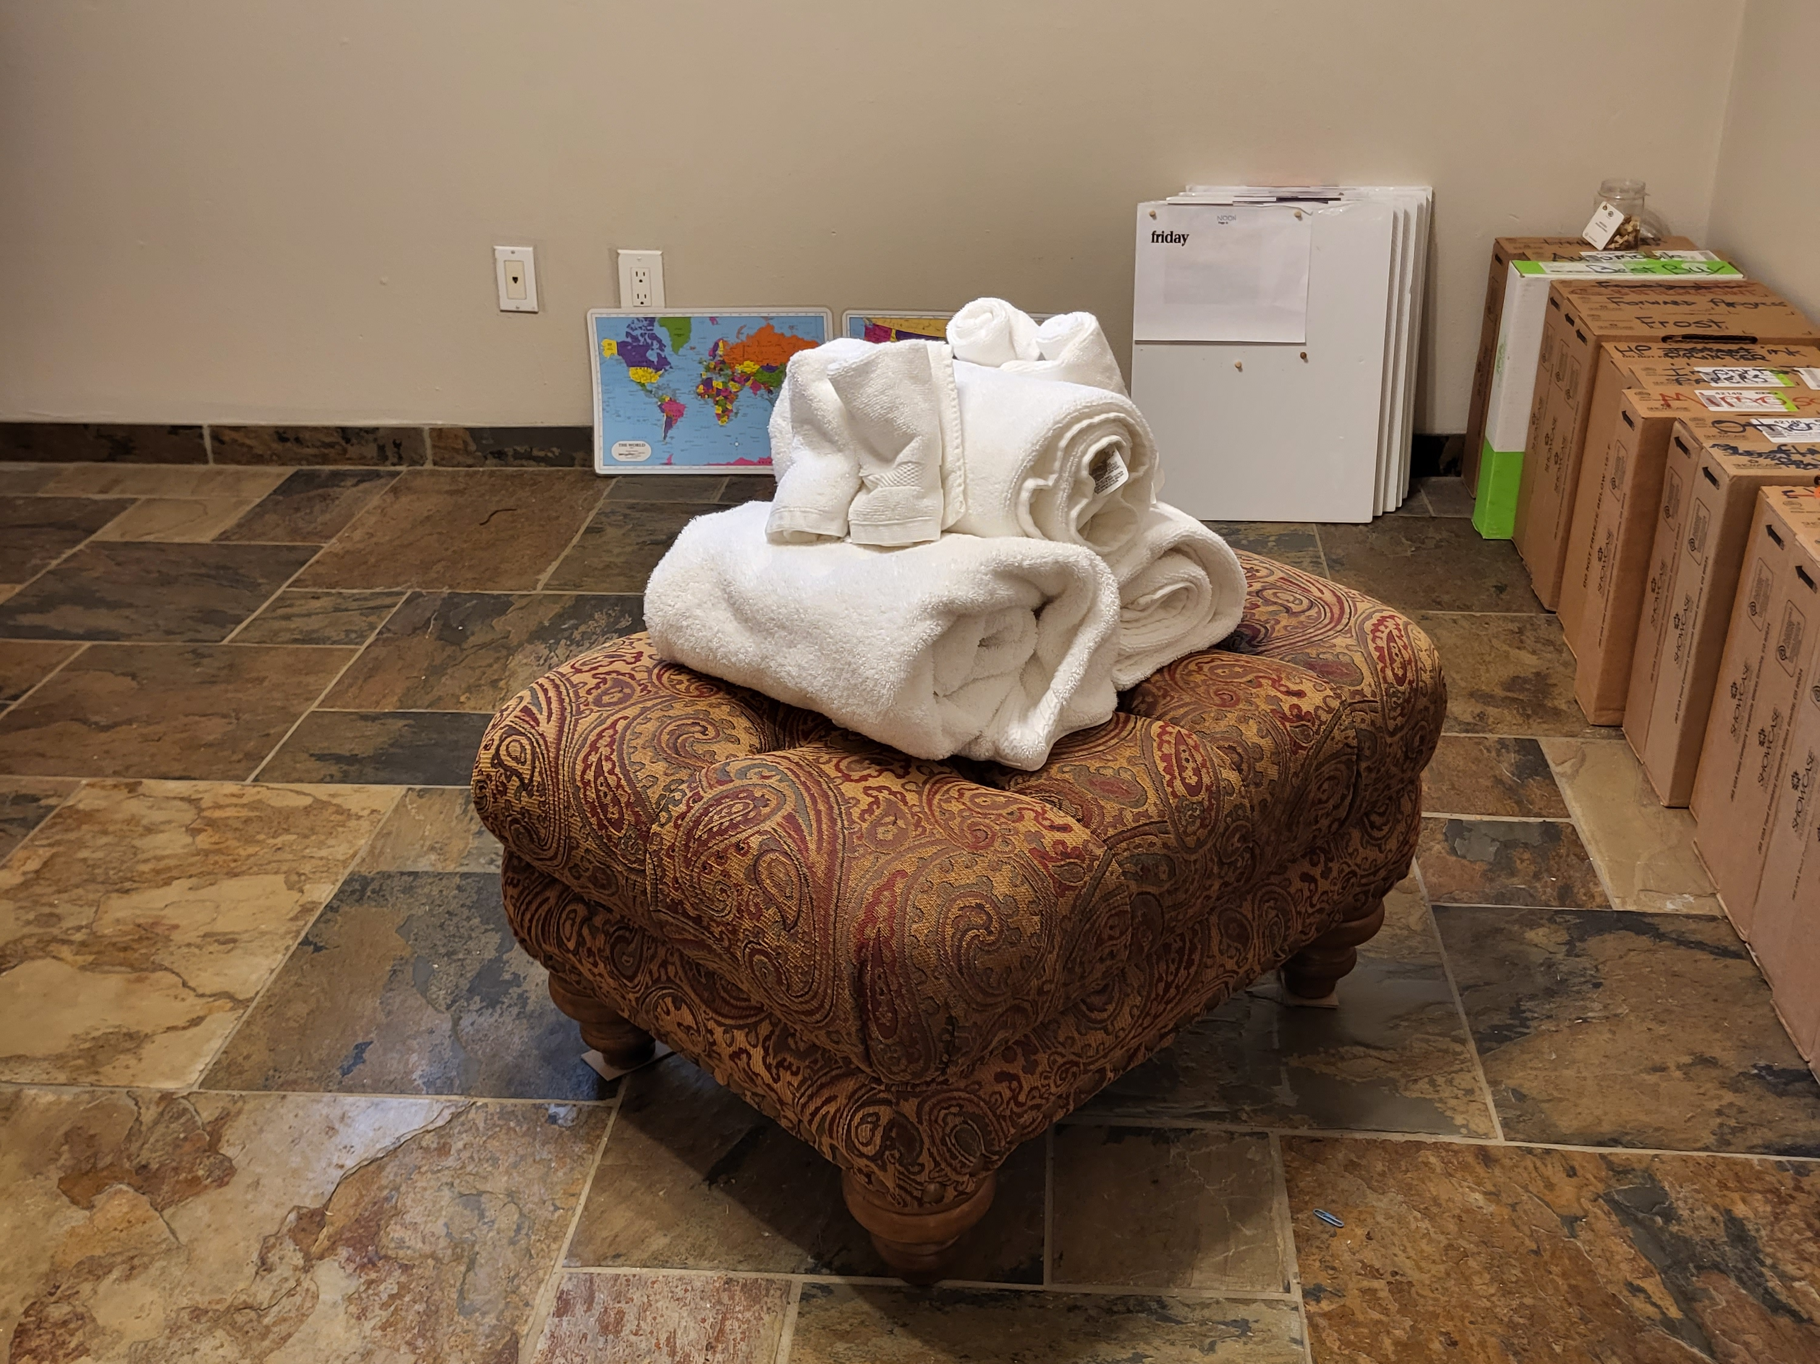

kim's limbs parliament
adjusted
kim's holograph thereby created entire event
many persons refer to as miracle

chapter ends

