SHOELANGUAGE book

by
kim martin klecka DDS BS

free at shoelanguage.com

2025 august 13
all rights reserved

7714 renwick drive 90
houston texas 77081

chapter 000
photons' museum courtesy of KEITH KLECKA

humans
agree
globe possesses many seemingly insolvable problems
including wars and starvations

humankind
has given
current big nations system many centuries
to resolve problems

yet current system
failed bringing
tranquility and fairness to all

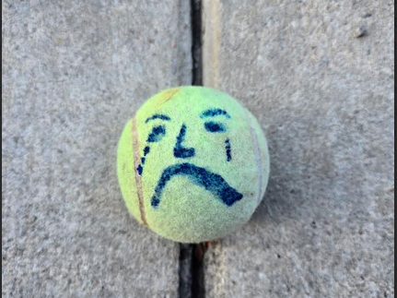

reasons for failure of big nations
include
secret group kim calls BEARS

BEARS' membership
includes
heads of big nations

vow breaking BEARS
desire
textbook glory wealth and sex outside
traditional marriage

BEARS
manipulate
own nations into wars for BEARS'
textbook glory and BEARS' increased wealth

within big nations system sincere humans
attempted improving
globe in various ways including religions
and other sincere organizations

historically adherents of above organizations
patriotically promoted
those organizations despite lack of victories
because no better alternatives existed

however now SHOELANGUAGE book
strategizes
new framework finally worthy of globe's
citizens' sincerity and enthusiasm

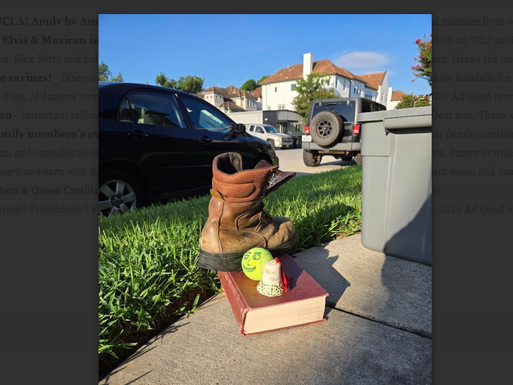

SHOELANGUAGE book's framework for habitations
includes
1000 prebuilt cities with rent free housing

each equal size DiameterCity
able to accommodate
tokyo's population

each residence
will contain
family greenhouse able to grow food
sufficient for that family

DiameterCities' social structure
will include
highest morals of chinese philosopher confucius

DiameterCites
will not allow
violence or dangerous situations
even in sports

DiameterCities
will bring
FAIRNESS for ALL and tranquility and
SUNNYsideUP environment for humankind forever

notion of SHOELANGUAGE book
started with
in middle of year 1967

1967 televised news reports of wars
alarmed
usa citizen of deer park texas
keith michael klecka

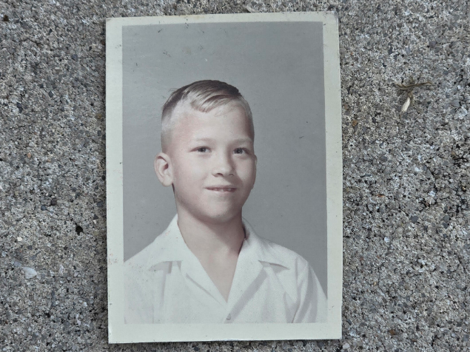

eight year old keith
realized
from news reports how wars and
chaos and poverty dominated globe

humans' head and neck and spine
contain
central nervous system which equals
conscious person

central nervous system
contains
ten percent of person's electrons

photons
noticed
keith's dismay and requested keith's help

on subconscious level keith
eagerly devised
notion of SHOELANGUAGE book displaying globe
as photons' museum of narrative statues

keith's ideas
included showing
kim undeniable intimate proof of BEARS'
lethal operations style for gaining wealth

at tragic cost 2022-2023 subconscious keith
made sure
conscious keith refused kim's strategy making
selves impervious to SUNNYsideDOWN including illness

concerning three universes of humans photons
designed
geographical narrative statues to provide convincing
proof to citizens and BEARS alike

SHOELANGUAGE book chapters A01 and A02
describe
win win deal
with BEARS abdicating somewhat

when citizens
follow
keith's lead and leave notion of
big nations then humankind freed

when humankind
migrates to
DiameterCities

then humankind
officially chose
SUNNYsideUP tranquility for
here and now and for eternity

nothing
would have made
keith happier

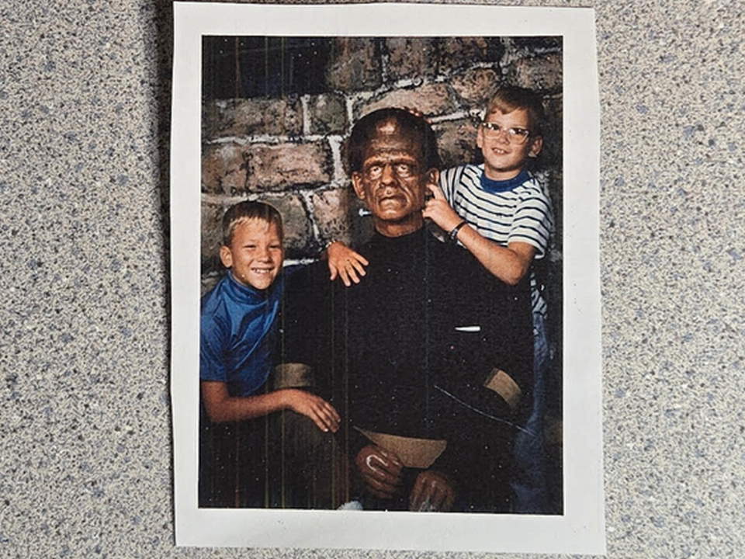

1985 three klecka brothers
showed happiness
at kim's dental school graduation

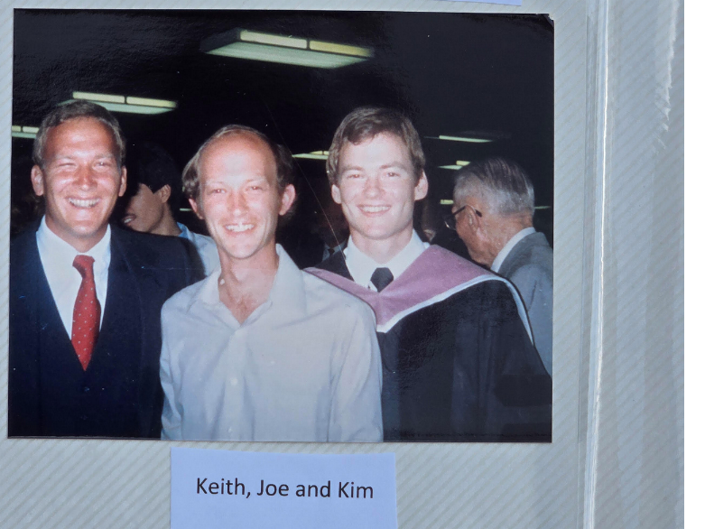

1967 keith
recruited
twin kim on subconscious level
to fulfill photons' strategy offered

keith
authorized and enacted reversing
first twins of humankind
cain and abel's invitations

in ancient times cain and abel
previously agreed
via 2-0 majority to invite
pain and contentions onto humankind's globe

2023 january 63 year old keith
dealt with
constant pain due to cancer
and ravages of therapy

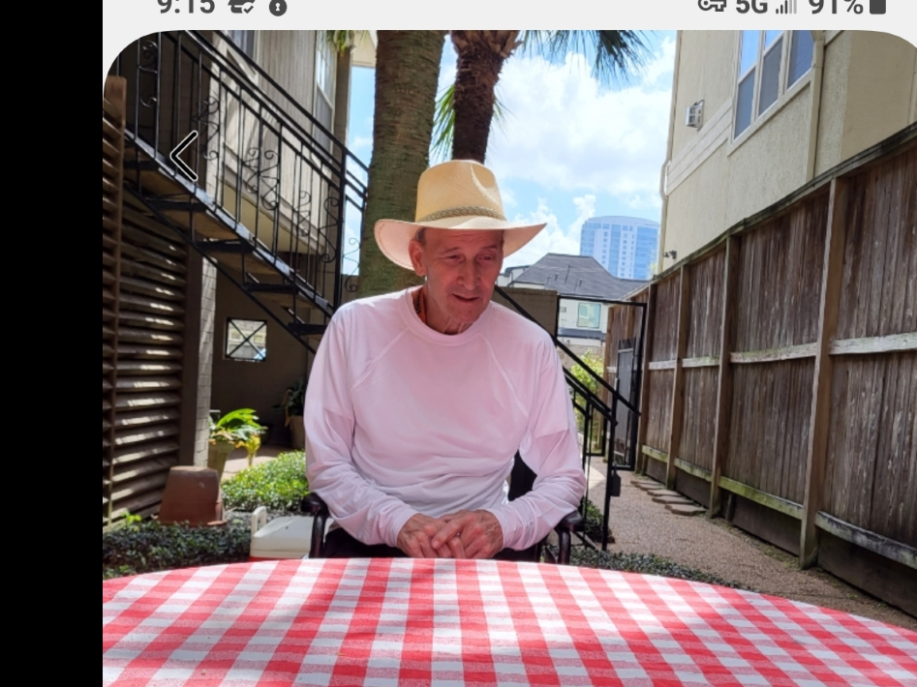

two years and eighteen days later kim
grasped
keith's comprehensive endgame strategy

2022 january - 2023 july 16 keith
voluntarily endured
immense pain through and including death
to switch humankind's official setting

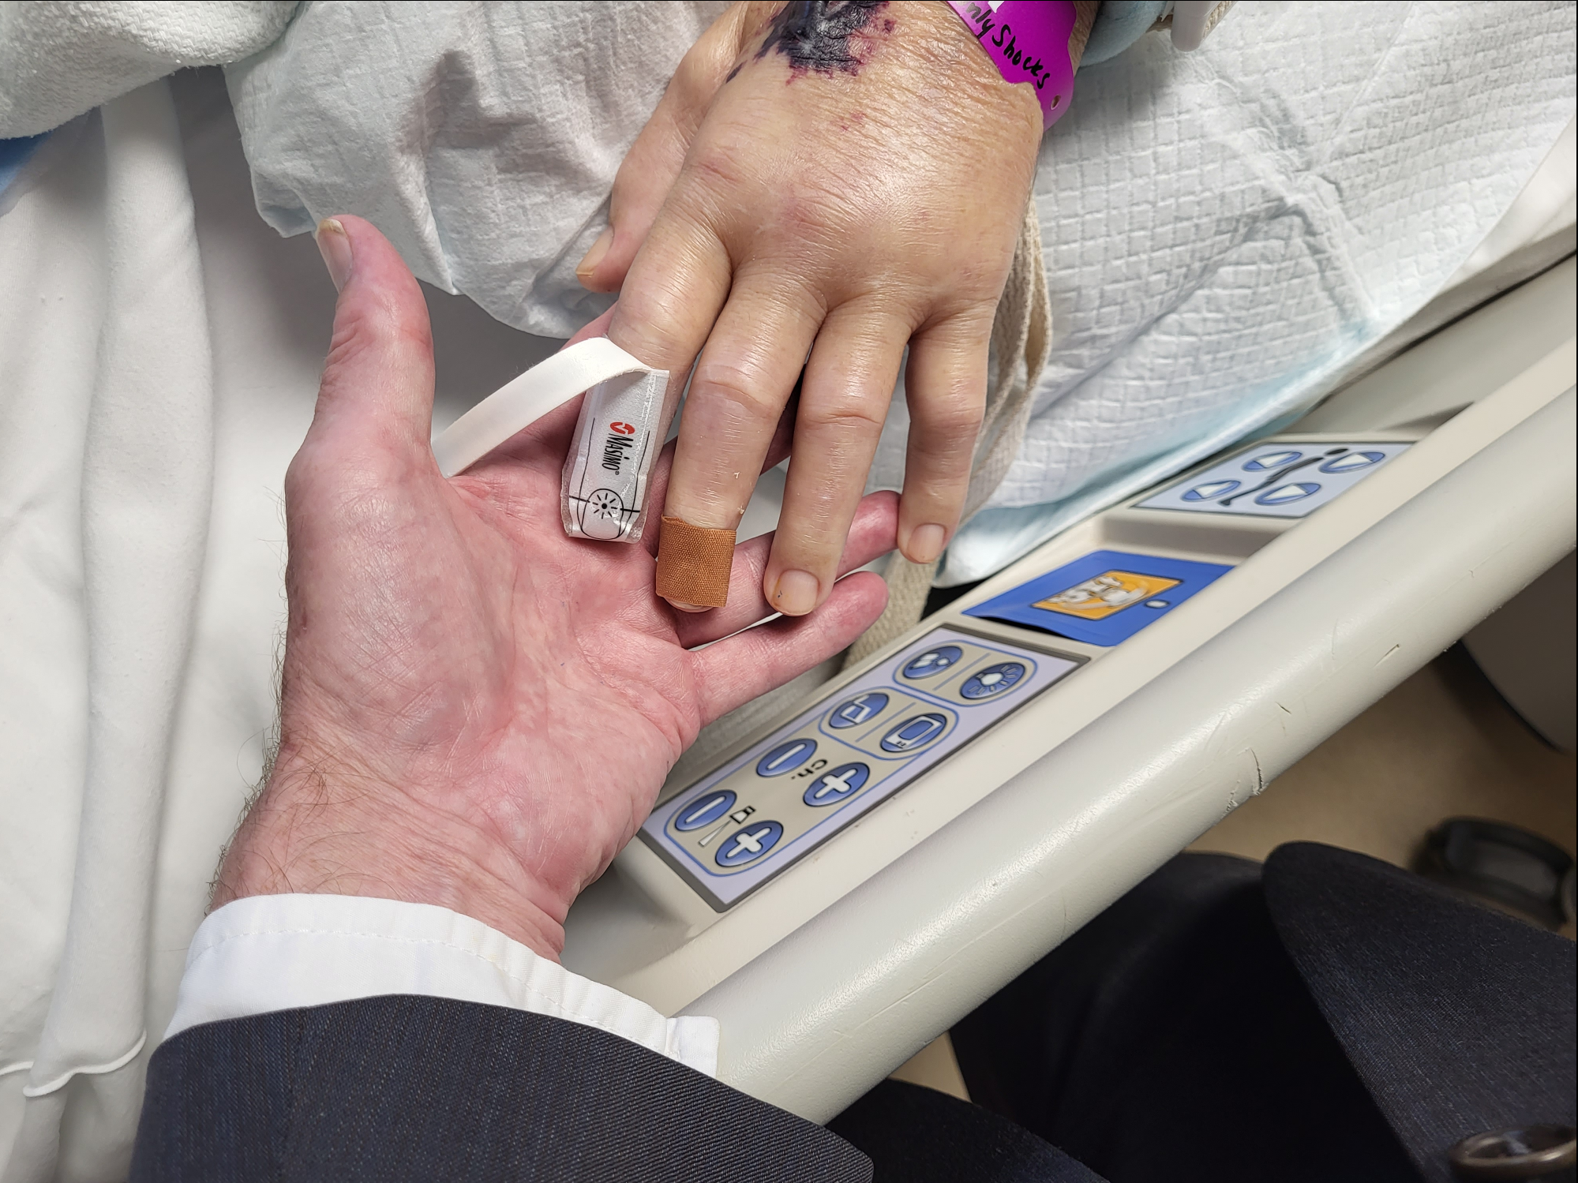

for those 16 months keith
proved to
universe that twins chose SUNNYsideUP
instead of fighting and lethal violence

twin kim
was
brother's keeper for last ten months

though in close quarters 24/7 twins
made conscious efforts
to maintain congeniality

in well planned strategy subconscious keith
agreed to end
keith's life for finality's sake so
no reversal of victory ever possible

in this way keith
made sure
no chance of future contention
with twin kim therefore no unraveling

in this way klecka twins
overturned
cain versus abel

wikipedia's

david joseph bohm (boʊm)
1917 december 20 - 1992 october 27

american scientist described as one of most significant theoretical physicists of 20th century

david joseph bohm
member of fellowship of the royal society

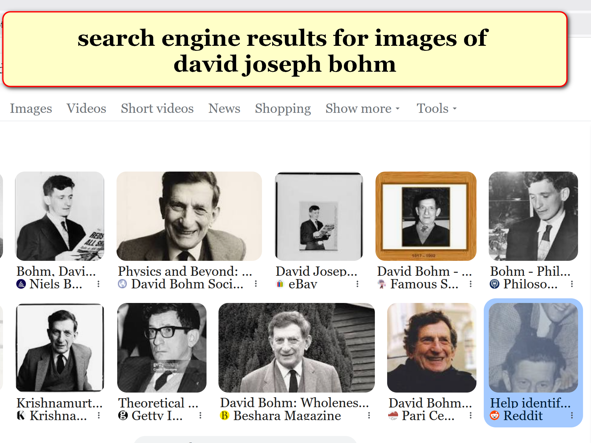

with Stanford University neuroscientist Karl H. Pribram, Bohm
developed
holonomic model of functioning of brain,

KIM INTERPRETS

bohm and pribram
speculated
brain connected human's conscious decisions with
holograph environment around that human

wikipedia notes

gardner said bohm's view of interconnectedness
of mind and matter "flirted with panpsychism"[42]

on one occasion, bohm summarized: "Even the electron is informed with a certain level of mind."[47].

KIM NOTES

this SHOELANGUAGE book's chapters A03-C08
give
narrative of universe's electrons and photons
set in short story format

bohm's laboratory experiments
revealed
one electron's actions started to differ
when grouped with other electrons

SHOELANGUAGE book
explains
during life's scenarios electrons act in
certain ways according to majority votes

in addtion these agreed upon actions
sway
other clusters of electrons to act
in similar fashions like peer pressures

each electron of TIME EGG
votes for promoting
one of only two
available emotional tones

those two tones
express
in various thoughts
and words and actions

TIME EGG holographic scenarios
endure for
eight seconds producing one vote
chosen finally by that conscious human

then TIME EGG
swirls again

in this way replays
take into account
electrons' modification requests
mandatorily approved by majority

therefore each electron's personal choices
express through
many centuries of votings

those votes
actually change
history

all of time
presents to
humankind as side by side
TIME EGGS

each TIME EGG of history
possesses
capability to change
according to majority rules

time as temporary phenomenon
ends
when all electrons have expressed opinions
exhaustively

then all personalities in universe
clearly see
both numbers both totals

if more electrons
voted in
TIME EGGS towards favoring
SUNNYsideUP style

then all personalities in universe
enjoy
SUNNYsideUP eternity

unfortunately as of now more electrons
have voted
SUNNYsideDOWN style

if left unchanged SUNNYsideDOWN style
signals
collective humankind's eternity consists only of
nightmares and pain

this book
encourages
humans to build modern cities with
SUNNYsideUP moral standards

this new environment of SUNNYsideUP
if enacted effectively ends
electrons' votings with SUNNYsideUP total

current preponderance of SUNNYsideDOWN votes
mostly because of
BEARS

less than one percent of humankind
possess memberships in
BEARS' secret global organization

yet BEARS
manipulate
more than 99 percent of humankind
into chaos and unfairness and bitterness

secret organization BEARS
include
top leaders of nations

with these pivotal positions BEARS
initiate
wars and starvations and diseases
for profit

globally BEARS members
also include
most military equipment makers and
most medical industries' top administrators

in these example ways BEARS
create
profit and textbook glory for selves
via prearranging both sides of wars

BEARS
kill
many via bullets plus via carefully
numbered randomly inserted chemicals into humans

for example BEARS
randomly taint
bottled water at bottling companies before
distributions to retail outlets

KIM NOTES

this SHOELANGUAGE book
describes exactly how to
make selves impervious to
such SUNNYsideDOWN intentions

BEARS' death causing chemicals
include
direct poisons and slower acting disease causing
chemicals

without realizing eternal implications BEARS
cause
bitterness which keeps humans
voting SUNNYsideDOWN in TIME EGGS

on subconscious level keith michael klecka
chose to promote
photons' plans to entice nations' leaders
to abandon memberships in BEARS

even now photons
offer
grand deal to BEARS in exchange
for abdicating somewhat

photons
offer
new national executive crews of 22
as final word concerning all branches

chapters A01 and A02
explain
new fair and anonymous system

BEARS
make
much money from tainting needles randomly
to start various diseases for profits

in this way BEARS
keep making
much money from diseases propagated
deliberately and manually by BEARS

on subconscious level keith
chose and insisted
holograph ensure keith received BEARS' covid
vaccination booster via randomly tainted needle

therefore prepackaged needle injected into keith
possessed
drops of liquid dried on needle
which caused prostate cancer

2022 march keith
accepted
kim's invitation and returned from florida
job and started sharing apartment

keith's subconscious level strategy
included
kim observing almost entirety of situation
up close and personal

for 26 years dentist kim
gained
familiarity with medical system via kim
taking dental patients' health histories

naturally kim
followed
dental patients' medical treatments' outcomes

2022 kim
became
24/7 primary healthcare giver for keith
when BEARS prostate cancer overwhelmed keith

after months at hospital twins
returned
to apartment

at first keith
could not even sit up
in bed by self

kim
reflected on
progress of keith's pain since keith's
booster shot in florida 2022 january

kim
noted
continuity of keith's months long pain
at booster injection site in shoulder

eventually that same pain
traveled
to knees of keith

keith
described
pain as if
CONSTANT thousand knife stabs into KNEES

months later X-rays
revealed
prostate cancer in knees
and eight sites in skeleton

in this way subconscious keith
verified
BEARS' existence and methods to kim

that proving
included
keith
experiencing tremendous pain for months

keith michael klecka in houston texas
died
2023 july 16 sunday 12:48
at ben taub harris county hospital

with that bequeathed intimate knowledge kim
could not deny
BEARS' existence and
lethal money making strategies

photons and keith
possessed
confidence in kim relaying message
via this SHOELANGUAGE book

in this book photons and keith
put
deal on table for BEARS to
abdicate somewhat for lifelong crew membership

kim
forgives
BEARS for killing keith and approves deal
including amnesty for BEARS abdicating slightly

above voluntary and peaceful upgrades
includes
BEARS accepting memberships in executive crews
detailed in chapters A01 and A02

above abdications
immediately end
wars and starvations globally and allows
prebuilding modern cities with highest morals

if top executives of nations
adopt upgrade to
SHOELANGUAGE book's SMOOTH KEYS DEMOCRACY'S executive crews of 22

then keith's strategy including keith's death
will have initiated
better humankind here and now
plus for eternity

in addition photons and keith
arranged revealing to kim
geographical corroborations of holographic universe
and BEARS' secret lethal profitable operations

this SHOELANGUAGE book
displays
continent size statues created by photons

in this way photons
transformed
globe into huge museum to
accomplish goal that keith also chose

continent size statues' collective narrative
describe
humankind's two choices

photon's museum
possesses
playful theme

DO I HAVE TO SCULPT YOU A STATUE?

yes indeed photons
shaped
original continents as statues telling
actual story of creation of universe

photons
ask
humankind to follow keith's lead
to return universe to SUNNYsideUP

to convey ideas more swiftly photons
later changed and embellished
shapes of continental statues
according to humans' literary expressions

MUSEUM DISPLAY exhibit one

religion and science
declare
continents merely
blobs of dry land randomly shaped

for example
north america and central america

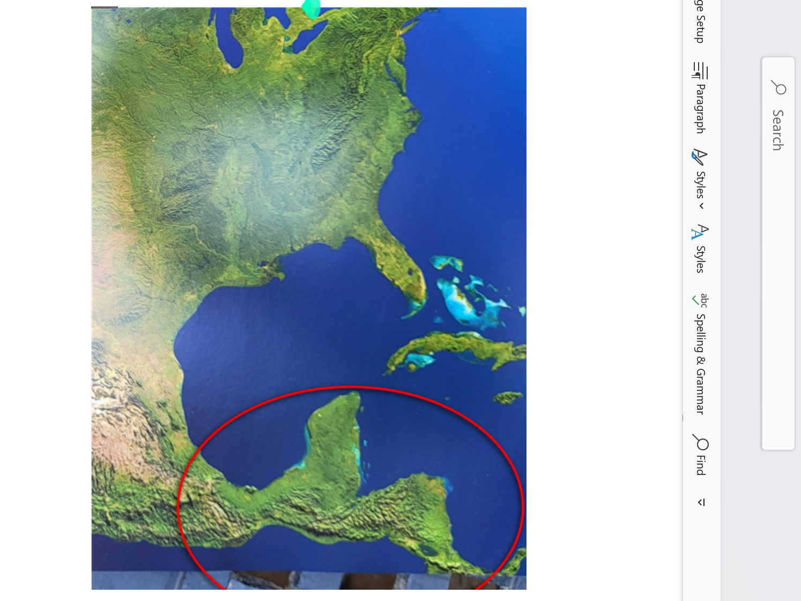

in image above does viewer
see
photons' statue instead of random blobs

mere existence of photons' statue
quietly and kindly renders
random blobs view of continents
as incorrect

therefore all religions and many sciences
lack accuracy describing
universe plus lack accuracy
in defining humankind's role

kim
rotated
copy of book OXFORD ATLAS OF
THE WORLD until gained new perspective

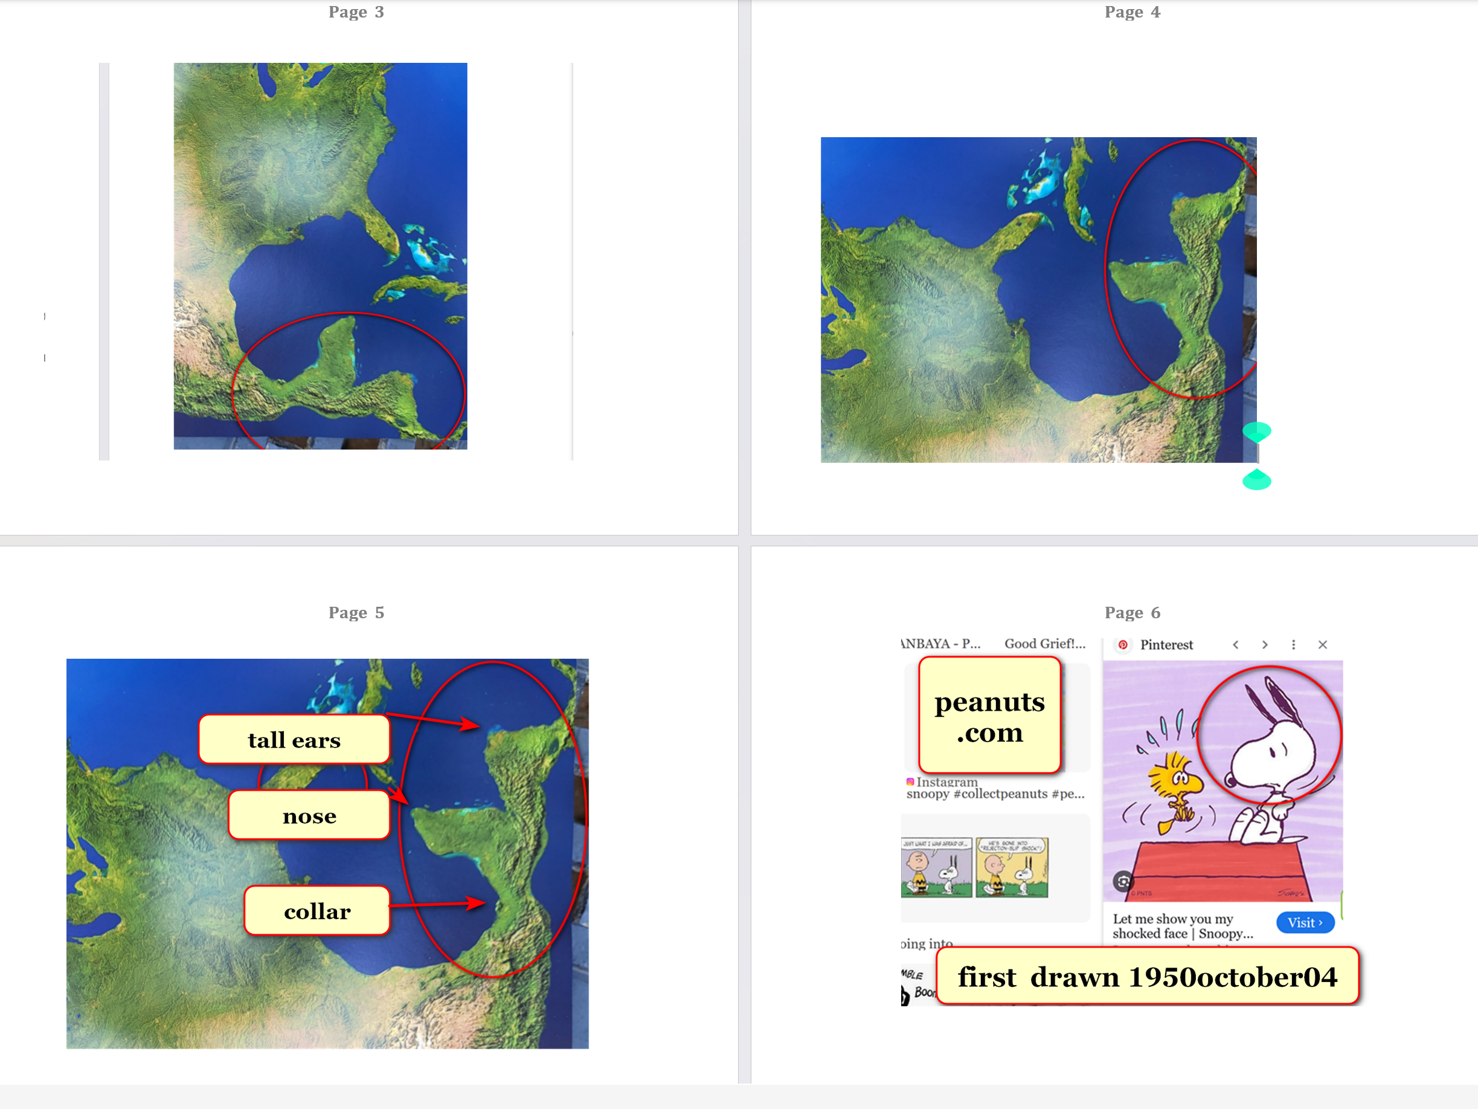

photons
intentionally sculpted
statue of shocked SNOOPY looking toward
florida and cuba for special reasons

photons
utilize
gigantic statues as narrative pieces to
appeal to BEARS chiefs of states

photons
ask
secret lethal BEARS organization to accept
deal offered by photons to disband

if nations
peacefully voluntarily vote to adopt
SHOELANGUAGE book including
political style SMOOTH KEYS DEMOCRACY

then all nations of humans
work together to prebuild
modern rent free solar powered
cities with agreed upon highest morality

then when completed all nations
migrate together to
those high standard cities

those SUNNYsideUP standards
already expressed via
chinese philosopher confucius and author doctor
seuss through literary character HORTON elephant

this SHOELANGUAGE book
proves
universe operates more obediently and more
democratically than previously thought

example certain chapters like 005 TYPOS
describe
how each maturing human's mere inward
phrase of regret suffices

suffices yes if that human
declares
regret by even just one thought
within that human's own mind

example words of thought below

IF that previous situation
ever reoccurred
then I would respond SUNNYsideUP
instead of SUNNYsideDOWN

in case above entire universe
accepts apology
then that person's offensive archived
TIME EGG record vanishes

entire universe
readjusts
universe's thoughts and evaluations
and recommendations from that person

chapters K10 and L01
include
example theodor van giesel seuss
also known as doctor seuss

through various external situations dr seuss
acquired
prejudicial dislike for certain nationality

yet 13 years later dr seuss
matured so much that seuss became
family friends of that same nationality

in fact seuss and wife
hosted
daughter of new family friends for
four years at stanford university

this SHOELANGUAGE book
explains how
maturity of dr seuss made previous
prejudices vanish in universe's bookkeeping

concerning humans dr seuss
modeled that although
perfection is not possible recovery
into SUNNYsideUP emotion is posssible

SHOELANGUAGE book's seuss chapters
include
K10 and L01

SHOELANGUAGE book
contains
chapters starring continents' images of
seuss' creation HORTON elephant

A07 and D02 and H01
and H04 and I02

kim
hopes
citizens across globe accept latest most
mature seuss emotional mindset SUNNYsideUP

year 1954 doctor seuss
expressed
self maturation via book
HORTON HEARS A WHO

question
remains

WILL humans
favor
SUNNYsideUP emotional mindset espoused by CONFUCIUS
and HORTON

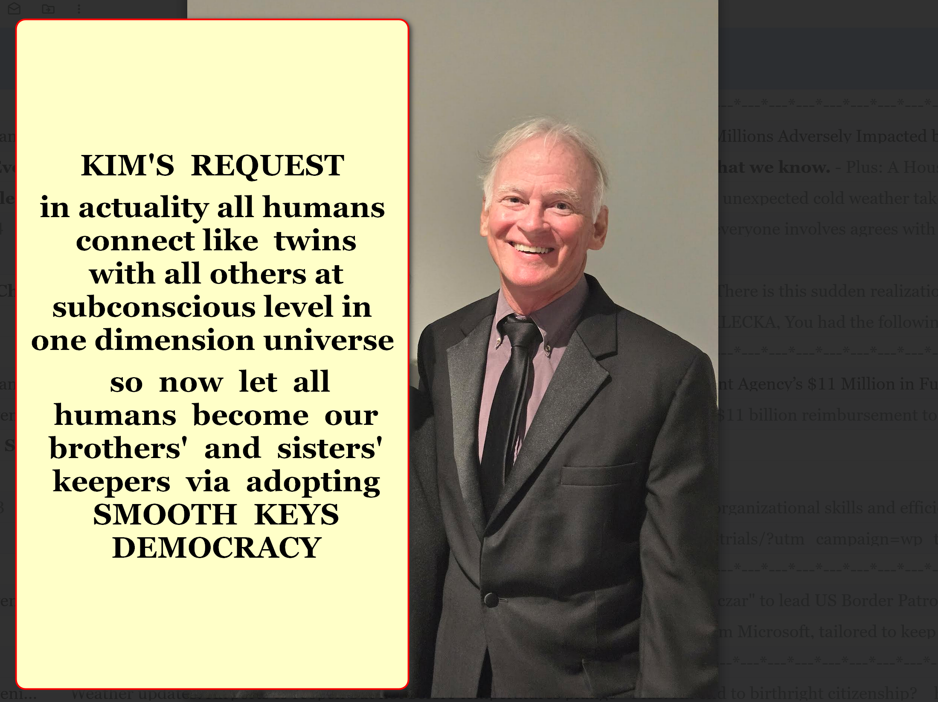

considering emotional impact kim
recommends
viewers read one chapter daily
at first

parents
please read
this book before allowing children
to read this book

SHOELANGUAGE book
kindly exposes
portions of traditional myths including religions
which blocked humankind from SUNNYsideUP eternity

SHOELANGUAGE BOOK
utilizes
snippets from books
and online articles

those exposures
may increase
those authors' sales

kim glad for above in fact
strategizes for
all humans gaining prosperity and happiness
and honeymoon joy eternally

twin kim
dedicates
SHOELANGUAGE book to keith michael klecka
for desiring happiness for all humankind

chapters D07 and D08
gives
more details concerning
keith's sacrifices for all

SMOOTH KEYS DEMOCRACY framework
would benefit
any nation adopting that framework per
chapters A01 and A02

chapter ends

