CHAPTER 004
disinviting diseases shocks kim and SNOOPY

year 1950 charles schulz
introduced
cartoon dog SNOOPY on paper
based on childhood pet dog SPARKY

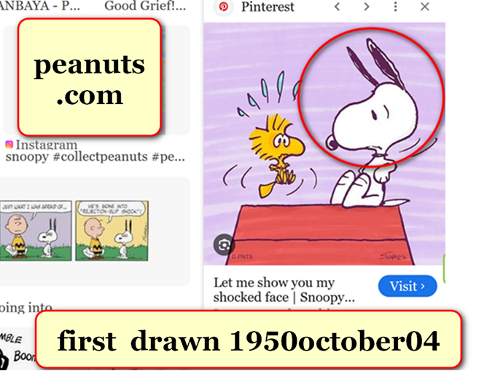

most OXFORD ATLAS OF WORLD books
contained
section called GAZETTEER OF NATIONS
with introductory two pages of photographs

side by side photographs graphically stitched
depicted
continents in context on globe

concerning introductory two pages kim
swiveled
ATLAS until finally found impossibility

kim
circled
never before mentioned on globe
statue exhibiting style of mount rushmore

except unlike mount rushmore this statue
not made by
human hands

snoopy
only born
in 1950 on paper

at earliest 1950 friends of humankind
correspondingly changed
shape of north america central america
to snoopy therefore sent message

friends of humankind
understood
humans shocked upon realizing theories taught
as laws of universe actually myths

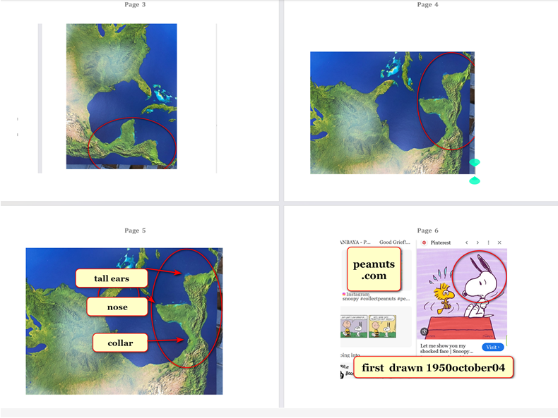

snoopy with raised ears
symbolizes
citizens shocked

citizens
shocked because
previously uninformed that personal choices
flipped personal settings of holographic environments

example choosing certain simple beverages
blocked
SUNNYsideUP events including healings

foods' categories
matter more than
physical components and ingredients and nutrients

until migrations vegetables and vegetable products
possess
categorization SUNNYsideDOWN

until total migration SUNNYsideDOWN categorization
includes
choosing coffee tea fruit juices beer
wine alcohol etcetera block healings

SUPER HEALTH
comes invited via
exclusively choosing bread meat eggs and
water without vegetation additions to water

yet choosing vegetables or vegetable products
invite
LACK of SUPER HEALTH

LACK of SUPER HEALTH
expresses differently
because each person different

however if person
unable financially to choose
meat or eggs or bread

then person
still gains
SUPER HEALTH because though ate vegetables
did not actually choose vegetables

if after tangible obvious symptoms person
needs to consume
fruit for vitamin C for example

then person
still gains SUPER HEALTH
because physically
healthwise person had no choice

if humankind
upgrades to
SUNNYsideUP via adopting SHOELANGUAGE book then

humankind's total migration to DiameterCities
categorically upgrades
vegetables fruits and associated products
from SUNNYsideDOWN to SUNNYsideUP

then vegetables
regain
original status regain original highest quality
protein even surpassing animal protein quality

in that reformation enhancement vegetables
shed involvement
in lack of SUPER HEALTH

upgrading entire global system to SUNNYsideUP permanently clarifies
humankind's favored emotion for all eternity

shocked snoopy
also symbolizes
professor researcher Carroll Overton Alley

23 years after alley
experimentally proved
wheeler's theory alley still rejected theory
as universe's style in everyday life

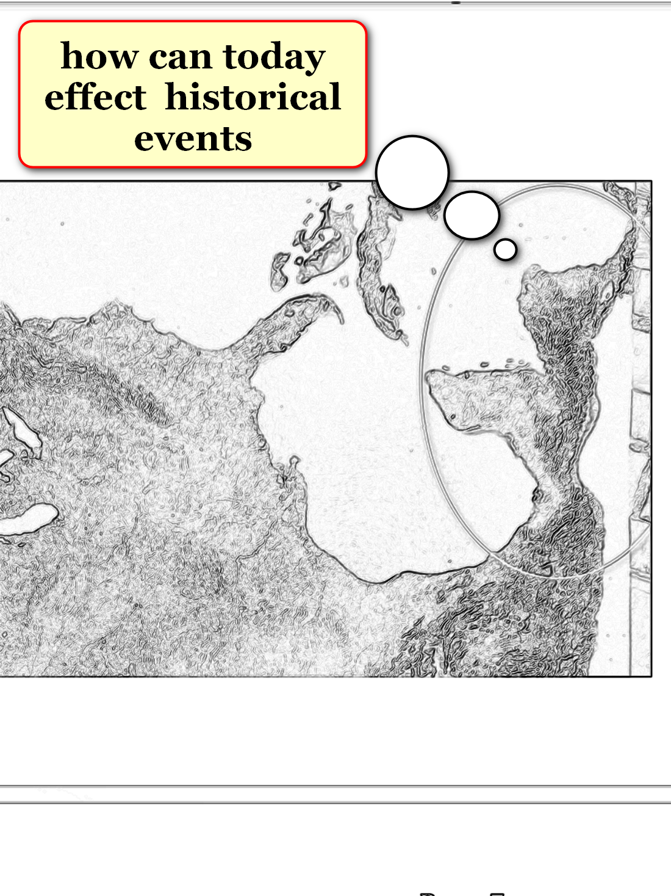
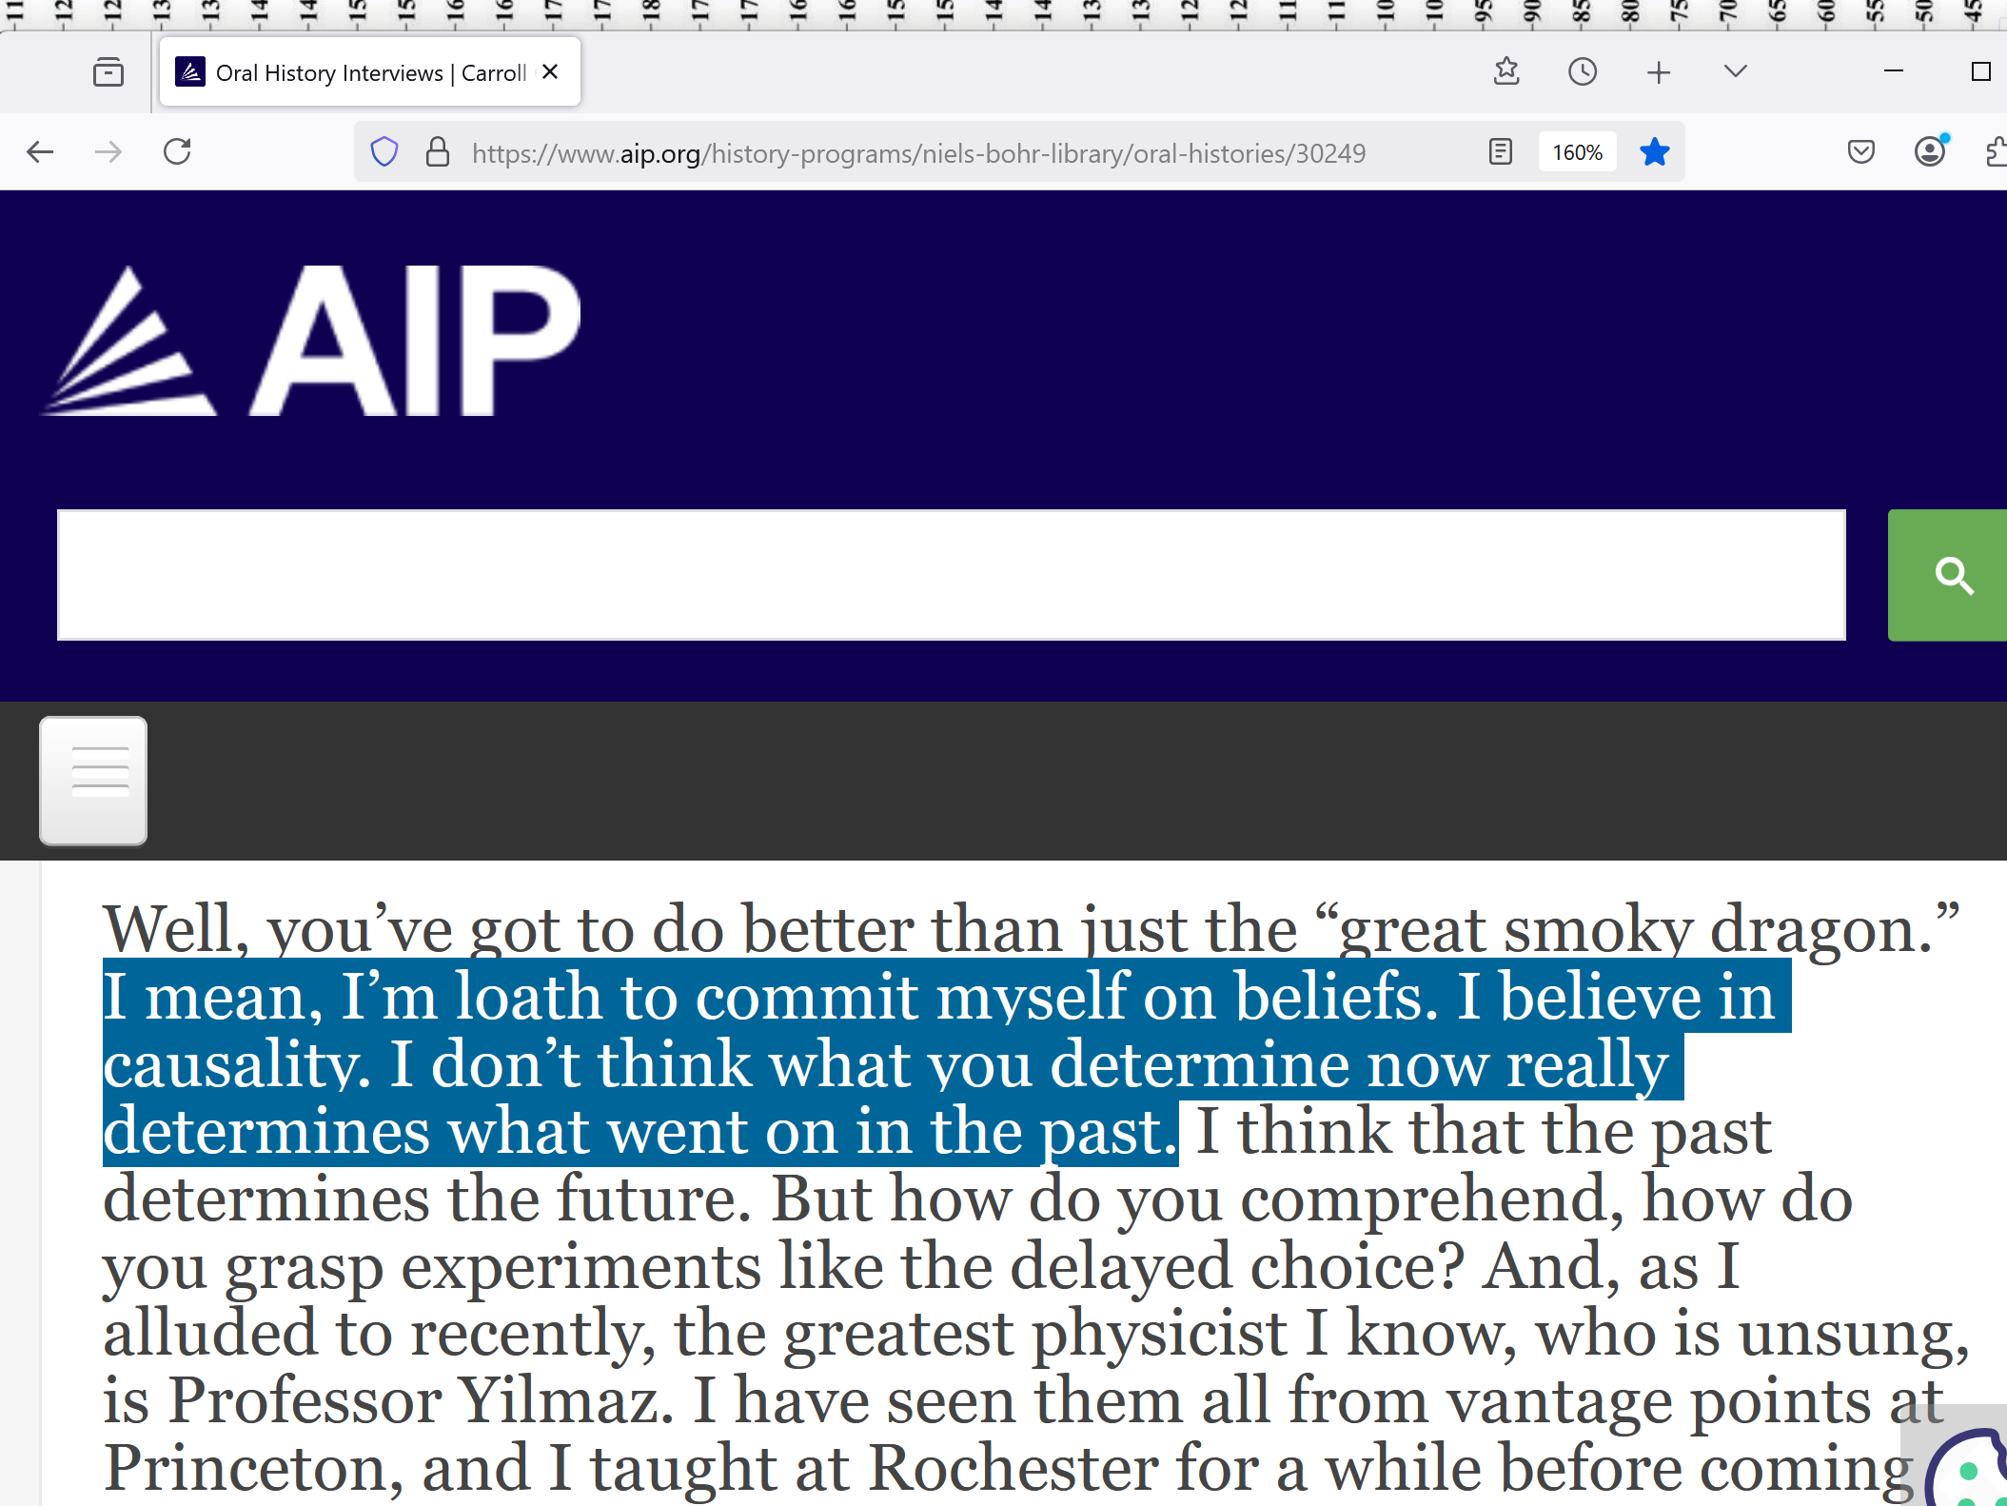

history
records
many unexplainable events
incapable of humans' manipulations

en.wikipedia.org/wiki/Lourdes_Medical_Bureau#Notable_cases

Lourdes Medical Bureau (Bureau des Constatations Médicales) is official medical organization based in
Lourdes, France
within Sanctuary of Our Lady of Lourdes

François, Bernard; Sternberg, Esther M.; Fee, Elizabeth
2014 January
THE LOURDES MEDICAL CURES REVISITED

Journal of the History of Medicine and Allied Sciences. 69 (1): 135–162.

study by former Emeritus Professor Bernard Francis et al in Journal of the History of Medicine and Allied Sciences looked at evidence of cures.

It found that while there were some cases associated with mental disorders, there were

others that were clearly anatomical abnormalities visible to eye, including tumors and open wounds.
It also noted other diseases like Tuberculosis and Multiple sclerosis.

His investigations found that many of the people cured of their medical issues remained cured and didn't relapse.

It noted there was no obvious explanation for the cures:
“... the miraculous cures are evidence of ... processes we do not know.

KIM NOTES

all humans
possess
equal access to processes above

well documented healings' existences
conclude
universe esteems prayer as completely valid
utilizing of universe's operating procedures

therefore question arises then what
limits
100% success for all prayers
healings and otherwise

scientists' discoveries concerning holographic universe
answer
question plus recognizable objects in continents'
shapes confirm answer

viewers
please confer
with two favorite physicians before changing
any health related activities

kim
recommends
those favored physicians read SHOELANGUAGE book
adding context to medical textbooks learned

viewers
please accept
2-0 majority vote from
informed physicians before changing health habits

from medical perspective SHOELANGUAGE book
explains
otherwise unexplainable longstanding mysteries
including PLACEBO EFFECT

google.com's placebo effect

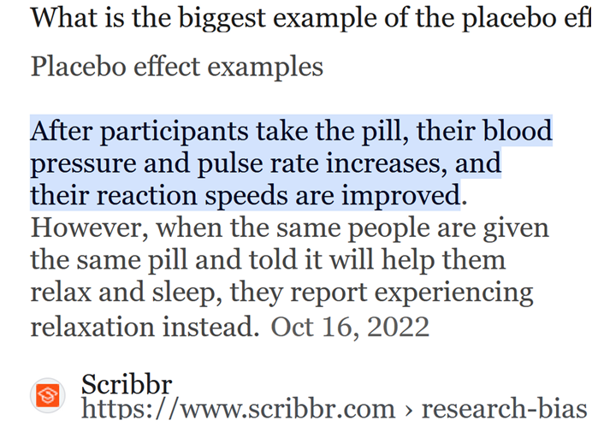

KIM NOTES above definition
unknowingly explains
holographic system which implies various settings
determined by that person's conscious choices

other people's emotional expressions including words
persuade
that person's subconscious central nervous system
up to 25% maximum effect

other 75% considerations
include
stalemate between two opposing factions within
that person's body

in above example physician's words
tipped
patient's internal debate enough convinced patient
to send only signals inviting SUPER HEALTH

ultimately person's holographic health
changes
per that person's emotional votes favoring
either SUNNYsideUP or SUNNYsideDOWN

when so called incidental PLACEBO EFFECT
operates 100%
then holographic healings occur
which people sometimes call miracles

chemical ingredients pills radiation etcetera
irrelevant
in improving holographic health

in fact some treaments
add
physical burdens and challenges
that hinder patient's return to health

physicians' goodwill emotions expressed
extend to
boosting natural and established process of
healing SUPER HEALTH up to 25%

likewise praying persons' goodwill emotions expressed
invigorate
person needing healing towards SUPER HEALTH
up to 25%

street preacher to houston's homeless kim
was in
receptive SUNNYsideUP emotion mode
2014december14

four months' lack of finances
gave
advantage of receptive mode of emotions

SUNNYsideUP receptive mode
dominated
because of four months not choosing
vegetables or vegetable products

without possibly financially choosing vegetables kim
merely ate
vegetables and vegetable products
from generosity of others

because of above situation kim
unknowingly stopped
sending SUNNYsideDOWN signals

then 2014december14 in SUNNYsideUP mode kim
clearly recognized
embedded statue in map in atlas

kim's immediate thoughts
included

THIS recognizable object's very existence
indicates
lifelong trusted parameters of science and
religion inadequate to explain this object

none of humankind's sciences and religions
ever mentioned
half continent size statue

obviously one or more non humans
made
statue as message to globe's CITIZENS

shocked SNOOPY statue
known as
central america and southern mexico
shocked SNOOPY
symbolizes
shocked kim that globe actually merely
message board to contact humans

shocked independent street preacher kim
realized
all religions fell short of reality

sincere adherents
sincerely misbelieved
concerning reality

kim
desired eventually telling
all humans concerning new narrative
if kim could interpret statue's meaning

part of statues' meanings
include
ALL humans can achieve
100% success in healing PRAYERS

actually praying
acceptable
legal and effective
but not necessary for healing

professors david bohm john archibald wheeler
made
discoveries that if combined decribe established
process of universe always humanly accessible

pair's plus four more scientists' masterpieces
taken together proved
holographic ability of all globe's humans
to invite or uninvite illness

SHOELANGUAGE book free at shoelanguage.com
consolidated
implications
of those scientists' standalone brilliant projects

those discoveries plus embedded continental statues indicated
universe not dictatorship at all

rather universe
actually
democracy with two speech writers
vying for each human's voted support

both speech writers
possess
opposite visions of how humankind
as one group should spend eternity

in fair democratic way both writers
utilize
same interjection megaphone voice into thoughts

unfortunately only 50% inner voice instances
originate from
SUNNYsideUP writer

yet until this book religious persons
believed
100% of STILL SMALL VOICE recommendations
came from SUNNYsideUP supreme being

many times SUNNYsideDOWN writer
utilized
humans' memories in creating customized persuasions
appearing as if SUNNYsideUP recommendations

however now SHOELANGUAGE book
helps distinguish
SUNNYsideUP from SUNNYsideDOWN

SUNNYsideUP genre
includes
reacting fairly and non contentiously
plus invites SUPER HEALTH healings for all

concerning SUNNYsideUP chapter D08 especially
explains how
all humans can achieve miracles like
1640's pellicer in miracle of calanda

during kim's street ministry supreme being
always indicated NO
to kim's inner emotions concerning getting
food stamps available to homeless persons

back then that strategy
puzzled
kim

looking back reasons for NO
included maintaining
financial lack of personal food choosing

because if kim CHOSE vegetables then
same as inviting
SUNNYsideDOWN chaos including
nightmares and illness LACK OF SUPER HEALTH

years later tending to kim's uncle
included
grocery buying etcetera
with uncle carl's credit card

kim
chose
vegetable products including for kim

kim
never imagined
choosing equaled voting

yet subconscious kim
thought
conscious cns kim desired illness nightmares
because saw conscious kim choosing vegetables

therefore for months kim
awoke routinely
in middle of night
from nightmares and in pain

LACK of SUPER HEALTH
manifests
differently in different people

in kim's case kim
unknowingly invited
deforming crippling rheumatoid arthritis

kim
experienced
excruciating pain
from various twisted digits etcetera

recurring pain
pushed
kim

kim
HAD to solve
puzzle to escape nighttime torturing

question remained what change
caused
starting of nightmares plus
nightly episodes of rheumatoid arthritis

months later after many strategies kim
dared to allow in
completely new idea never mentioned globally
as far as kim knew

novel idea that kim
ingesting
ANY vegetable equaled signaling
towards SUNNYsideDOWN inviting torture

kim
tested
that notion
via eating non vegetable diet

that non vegetable diet
brought
pleasant dreams plus no wakings
with twisting digits pain rheumatoid arthritis

in this way kim
defeated
arthritis pain plus any pain

through today for kim this strategy
always works

kim
does not allow
any symptoms

if symptoms
start attempting to manifest

then kim
keeps uninviting
symptoms until symptoms disappear

kim's techniques
almost like praying
but includes even better success rate

wikipedia.org's
Nautilus Magazine New York–based online and print science magazine publishes monthly issue on selected topic

2014january10
nautilus magazine contributor amanda gefter's article
https://nautil.us/haunted-by-his-brother-he-revolutionized-physics-234736/

Amanda Gefter’s book Trespassing on Einstein’s Lawn
a memoir about physics, her father, the universe, John Wheeler, nothing and everything—published 2014january by Bantam

nautilus magazine science writer contributor
amanda gefter

1979 professor john archibald wheeler
gave
lecture at University of Maryland

he
proposed
bold new thought experiment most dramatic application
of his ideas about time the delayed choice.

wheeler
realized
possible to arrange usual double slit experiment
such that observer can decide whether see stripes or blobs—

that is, observer
can create
bit of reality—after photon
has already passed through screen

at last possible second observer
can choose to remove
photographic plate revealing two small telescopes

two small telescopes: one
pointed
at left slit,
the other at the right.

The telescopes
can tell
which slit the photon has passed through.

But if observer
leaves
plate in place interference pattern forms.

observer’s delayed choice
determines whether
photon has taken
one path or two

after it
has presumably already done
one or the other.

during wheeler's lecture at University of Maryland
LISTENING intently in the audience
was physicist named carroll alley

1984, Alley—along with Oleg Jakubowicz and William Wickes, both of whom had also been in the audience that day—
finally got the experiment to RUN.

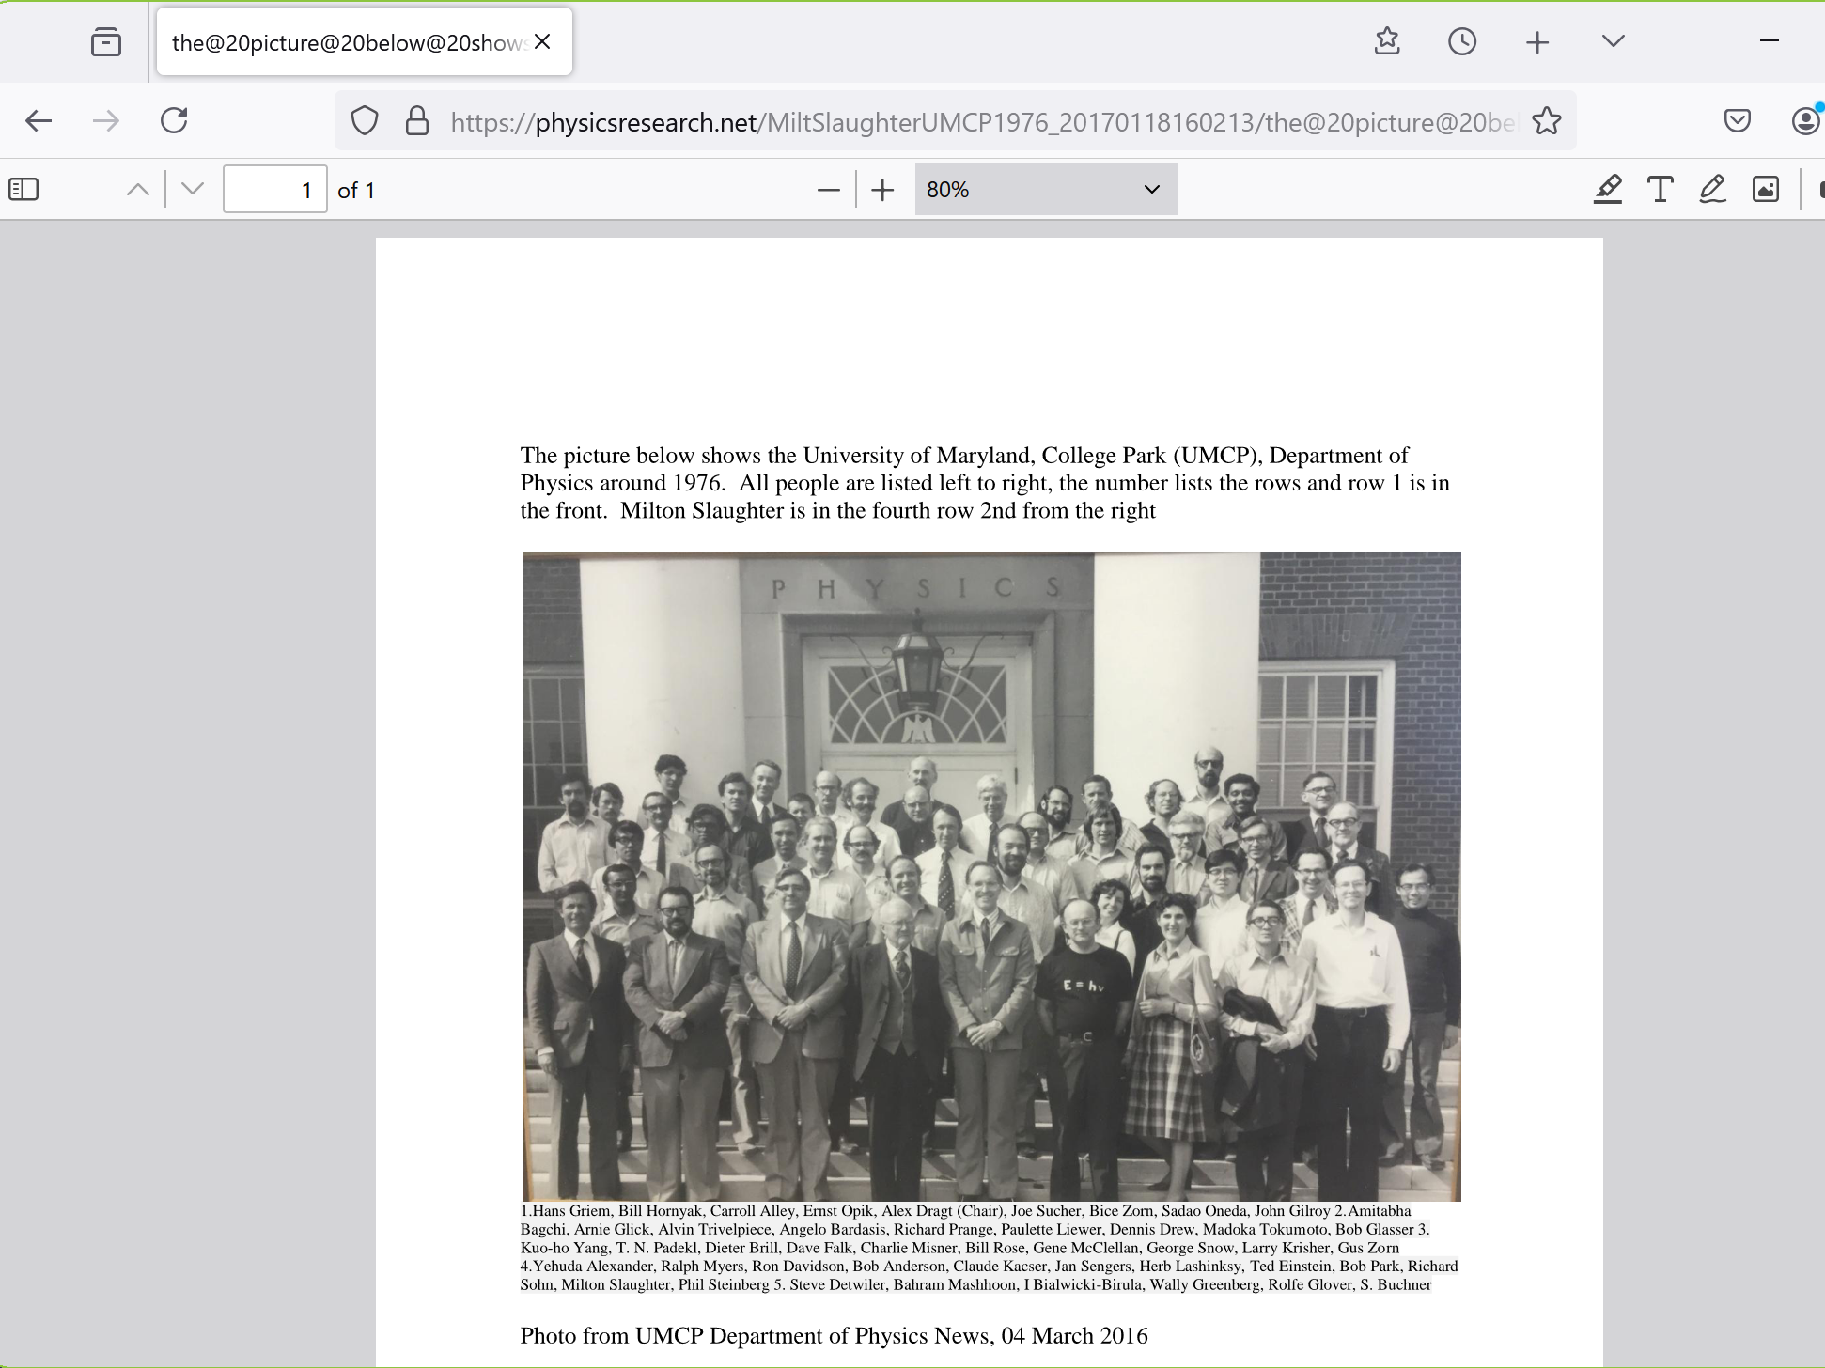

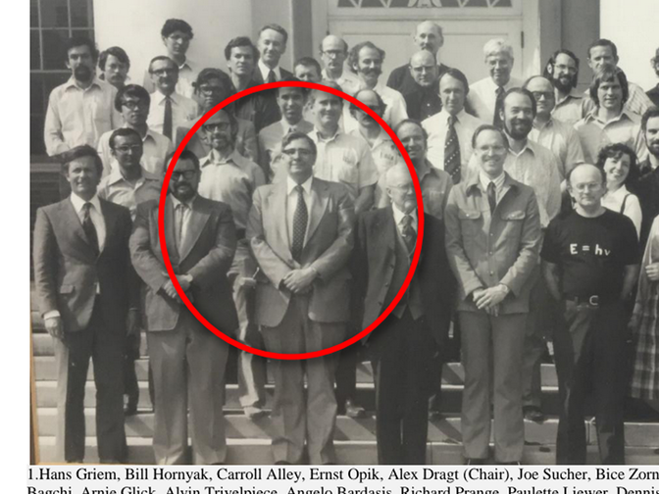

KIM NOTES

researcher carroll alley's real equipment
included
single photon emitting machine and photographic
light sensitive material and two telescopes

2025 kim
arranged
objects symbolizing above

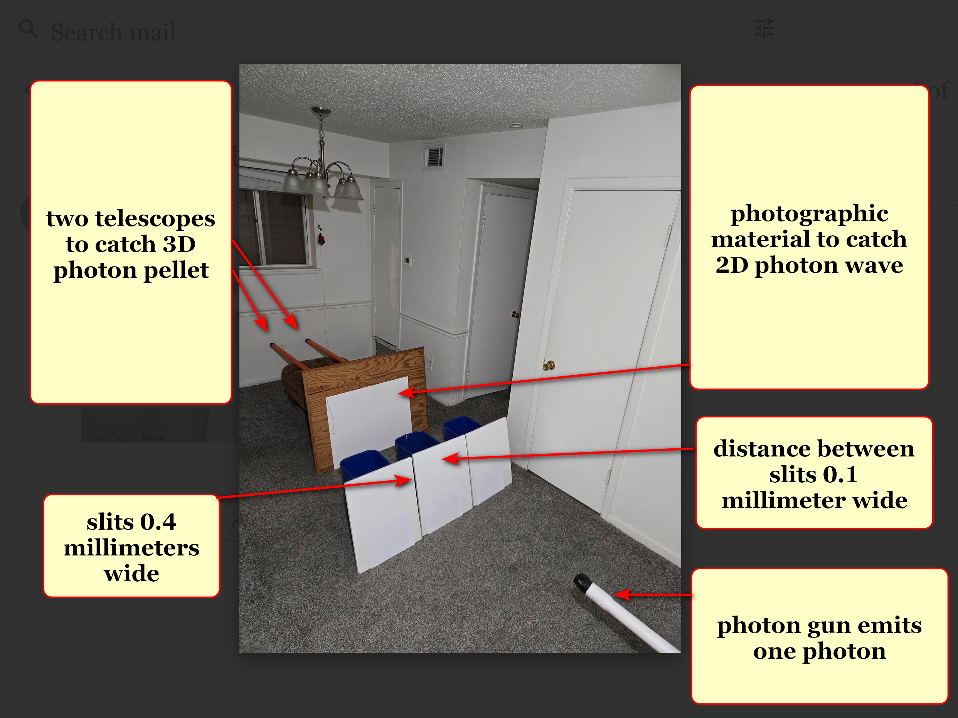

en.wikipedia.org/wiki/Double-slit_experiment#/media/File:Young's_slits.jpg

creative commons

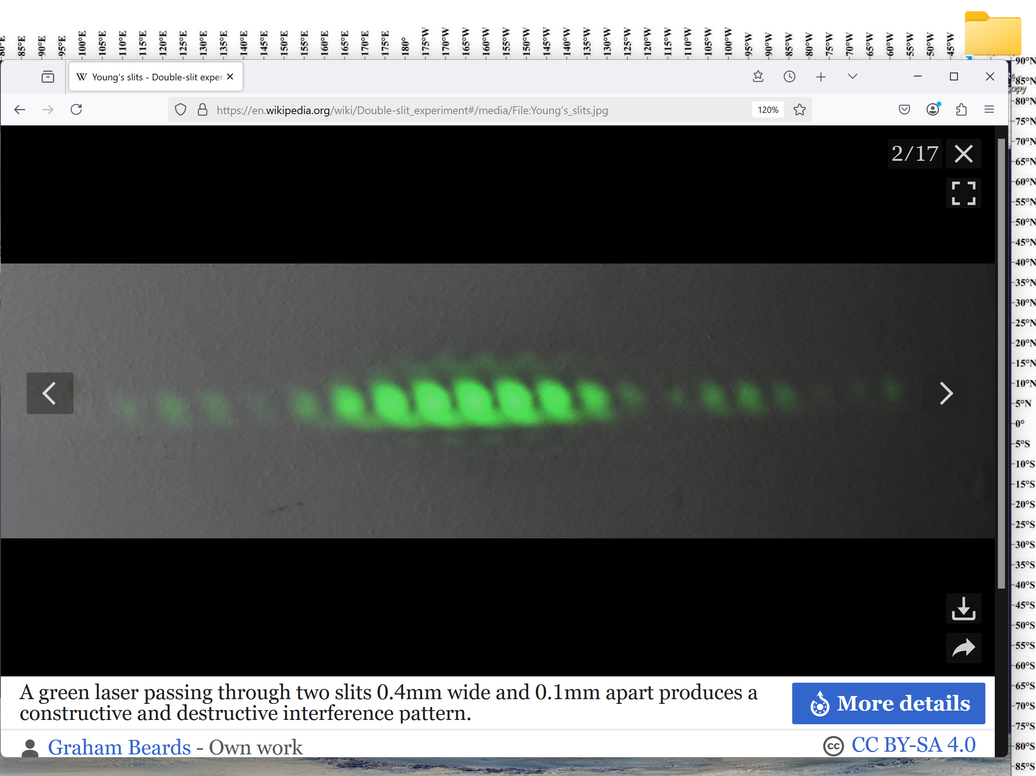

kim's symbolic props

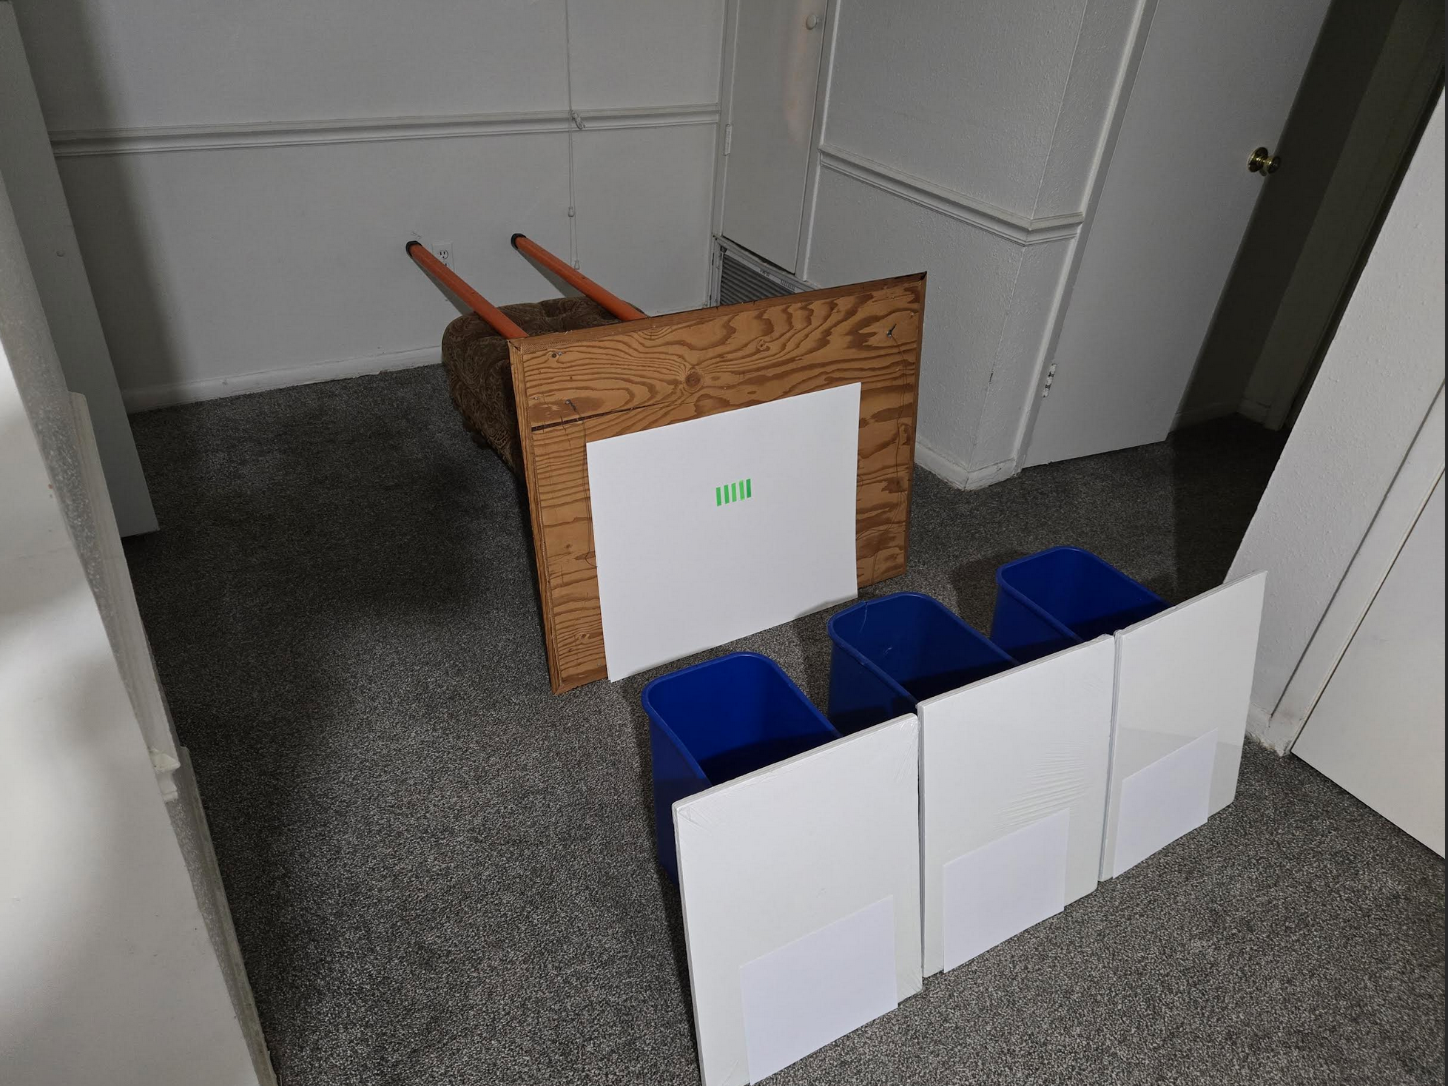
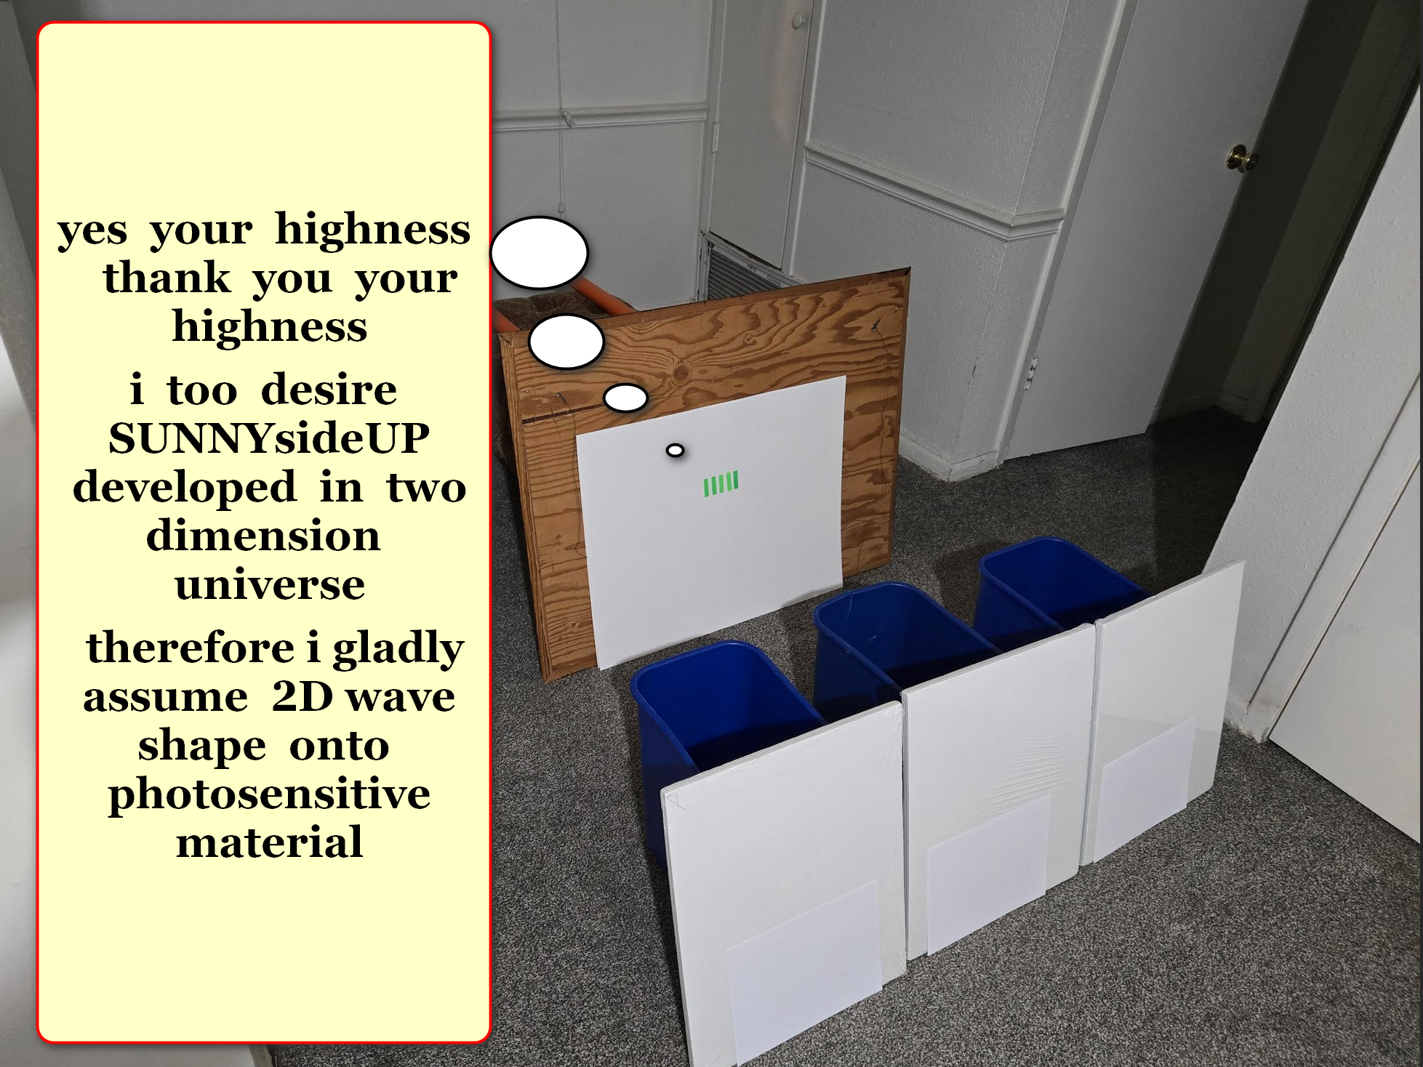

however when alley
removed
photographic material therefore obedient photon
chose 3D pellet shape

3D pellet photon
chose
east telescope this time

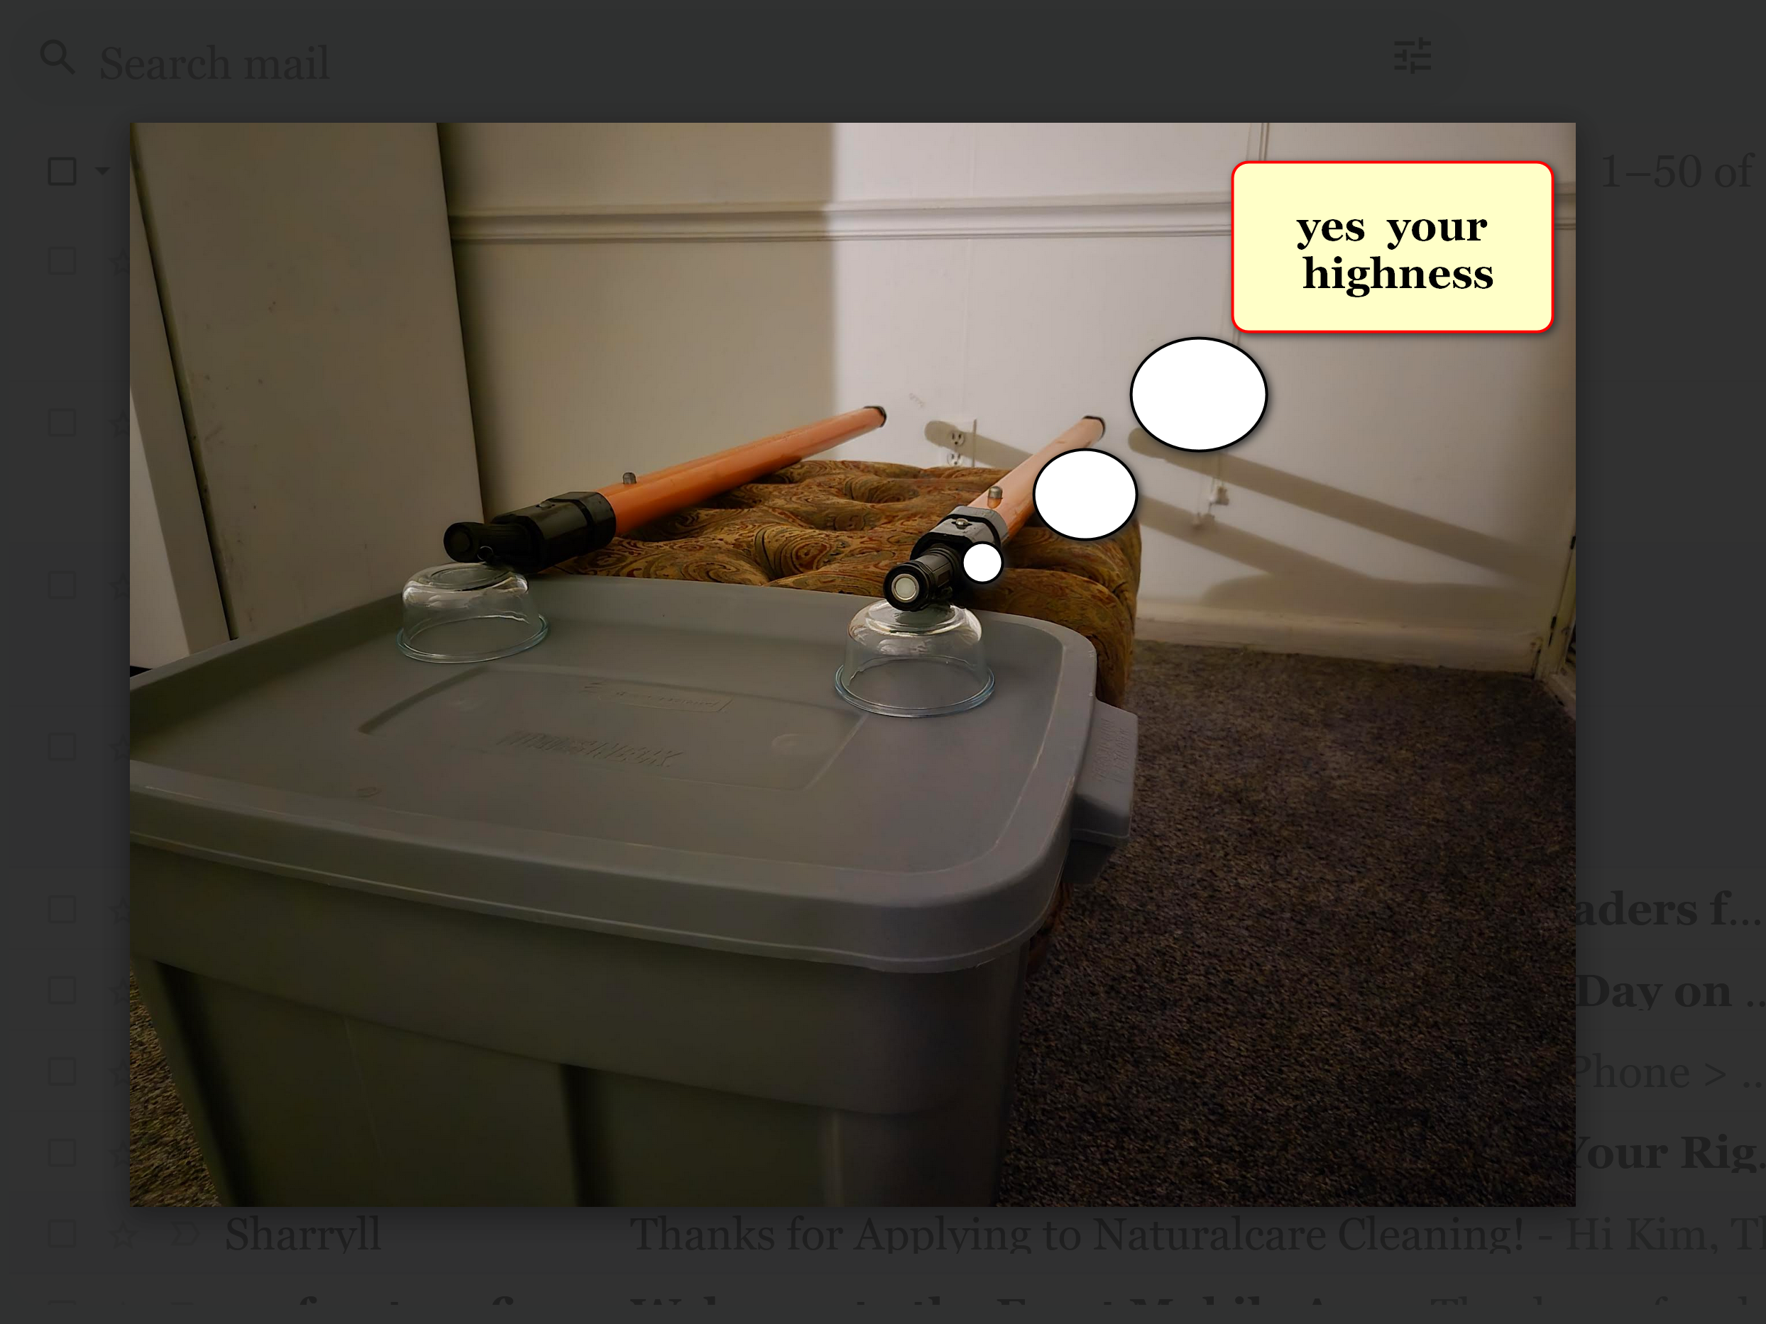

another symbolic experiment setup
includes

if person
sets
thumb against end of water hose
and only allows bit of stream

then water spray
would pass through
double slit and wet towel

however if person
removed
towel then suddenly water balloon
hits wall instead of water spray

wheeler's measurements idea plus alley's proof
simplify
categories of possibilities and solutions
actually verifying SHOELANGUAGE book themes

for example all diseases
now summed in
one phrase LACK of SUPER HEALTH

same single solution achieving super health
works for
all variations of LACK of SUPER HEALTH

wheeler's MEASURER turned PARTICIPATOR
actually more exactly
voter contributing that human's emotional mindset
to humankind's collective eternal operating system

in alley's measurement experiment obedient photon
switched from
SUNNYsideUP to SUNNYsideDOWN

this occurred because voter human
removed
photographic plate utilized for
catching wave pattern 2D photon

voter human alley
chose
telescopes catching photon in 3D mode

in SHOELANGUAGE book terms human alley
voted
SUNNYsideDOWN

above proves each human
actually master
of that human's holograph
surrounding that human

all of time
segments into
TIME EGGS

each TIME EGG
keeps rehearsing
that specific same eight second scenario

standalone TIME EGGS
all still replay

fields of electrons called humans
vote as to
keep current script
or to modify script

in subconscious mode all humans
know
all thoughts and actions of others

peer learning
sometimes causes
electrons to revote to modify
current scripts

eggs
exist on
same flat boulevard of time

past present and future TIME EGGS
all side by side
like houses along streets
in neighborhood of time

peer learning
exists
therefore sometimes participants
involved in scenario change scenario's tone

above
explains
wheeler's theory correct

Shocked SNOOPY statue
represents
shocked humankind including kim
for several reasons

Neither Supreme Being nor scientific randomness
created
continents

Therefore centuries of sincere teachers
unknowingly taught
inadequate bodies of knowledge concerning universe
to sincere and trusting students

in other words all humans
victimized
concerning beliefs taught religous and scientific

actually many friends of humankind
created
continent size statues to educate that
universe merely holographic and needs guidance

holographic universe
takes signals from
humans' words and actions as official
instructions booklet for now and eternity

Viewers
please read
explanation of why dogs volunteered to
mentor humans plus why SNOOPY shocked

chapters A03-C08 fictional short story
put
these realities into easy reading context

SHOELANGUAGE book at shoelanguage.com
contains
chapters explaining many subjects

topic one continental outcroppings create dog statues

chapter
I10 please fetch stick of fairness for all humans

topic two holographs surround humans

chapters

D05 through D09
F08
G01 through G04

topic three easily disinvite disease no money needed

chapters
003

F03
F04
F09
F10

topic four revamping all our regrettable typos

chapters
004
005

B09

topic five rules for best humor

chapters
A03 through B02

topic six SMOOTH KEYS DEMOCRACY unscrambles agitators

chapters
001
006 through A02

H07
K01 through K08
K10 through V03

topic seven prebuilt solar cities FAIRNESS for humankind

chapters
I03

J01
J02

J04
J09

K09
V04 through W01

simple global bridge language
called
SHOELANGUAGE

chapters
W03 - X06

each nation on globe
needs to peacefully vote in
SMOOTH KEYS DEMOCRACY atop current governing
system per chapters A01 and A02

accomplishing above
officially votes out
current one worldwide government called BEARS

SHOELANGUAGE book at shoelanguage.com
gives instructions for
global FAIRNESS for ALL including what
dogs mentored for generations SUNNYsideUP happiness

SHOELANGUAGE book chapters
discuss
differences between both humankind's choicea

SUNNYsideUP environment
includes
super health and super circumstances for
here and now plus for eternity

SUNNYsideDOWN environment
includes
lack of super health and
lack of super circumstances

humankind
choosing
SUNNYsideUP includes prebuilding modern round cities
and then totally migrating to DiameterCities

those DiameterCities
will possess
SUNNYsideUP moral standards with stationary Artificial
Intelligence and cameras in rooms and streets

only Artificial Intelligence
view with
cameras

humans
no longer involved
in invading privacy of humans

if Artificial Intelligence
sees problem starting
then Ai contact human authorities
to stop violations immediately

justice
becomes immediately clear
because human grand juries can
vote to request persons' whereabouts videos

if humankind
votes
YES to SUNNYsideUP 1000 DiameterCities

then humankind
leaves SUNNYsideDOWN habits

SUNNYsideDOWN environment
includes
poisons for example tattoo ink

cuttings and piercings of humans' bodies
send
SUNNYsideDOWN signals inviting chaos and pain
now and during single compartment eternity

SUNNYsideDOWN examples below

adultery

beastiality
body piercings including ears and faces
bullyings

child abuse
circumcisions both sexes
cohabitations outside of traditional heterosexual marriages

domestic violence
elder abuse
famines

getting high
human trafficking

incest
infidelity

kidnapping
new tattoos

nicotine high all forms
pedophilia

poison preparing of chemicals
poison transfer to target

polygamy
privacy violations by humans against humans

prostitution

sex trafficking
sexual violence

spousal abuse
vaping

wars and armed conflicts

