**005 typos egg chooses mate together eye universe**

**chapter 004**

**proved**

**each human actually master**

**of holograph surrounding that human**

**therefore globally citizens' regrets**

**suffice in every way**

**citizens**

**seemingly flow seamlessly from**

**one section of time to another**

**this illusion of continuity of TIME**

**allows for**

**citizens' rethinks and contemplations**

**of words and actions**

**when citizen**

**merely reflects regrets**

**past SUNNYsideDOWN words actions**

**then universe**

**accepts**

**person's switch of opinion to SUNNYsideUP**

**no punishment**

**involved**

**plus no records**

**of previous opinions kept**

**analogy**

**if typist**

**makes**

**typographical error then**

**when typist retypes word**

**universally public**

**accepts**

**typist's most recent spelling no punishment**

**no record of previous keyboarding kept**

**concerning past SUNNYsideDOWN reactions if citizen**

**makes up mind**

**if ever similar event occurs then**

**citizen shall pursue reacting SUNNYsideUP**

**then entire universe**

**accepts**

**citizen's new stance concerning that category**

**established merely via citizen's thoughts**

**in this way flow of time**

**becomes**

**ally of humankind**

**all of these emotional transactions**

**happen subconsciously**

**david bohm's term holomovement**

**accurately describes**

**subconscious of all personalities including**

**persons belittled and belittlers**

**all decisions of all persons**

**automatically broadcast to**

**all other persons subconsciously**

**therefore when citizen**

**privately decides to act**

**more SUNNYsideUP next time then**

**new stance goes viral into universe**

**instantly all know that citizen**

**in effect apologized**

**to other person plus other person**

**accepted apology with no lingering resentment**

**human body**

**works in**

**subconscious phase then cns cells**

**work in conscious phase**

**all electrons of subconscious bodies**

**know**

**all persons' thoughts emotions words actions**

**subconscious central nervous system electrons**

**in effect drink**

**amnesia inducing liquid after final voting**

**afterwards both trunk and limbs sections**

**still privy to**

**all other persons' decisions emotional mindsets**

**however conscious central nervous system**

**only remembers**

**conscious self's memories**

**from birth to present**

**therefore rethinking repentant citizens**

**now take**

**encouragement**

**rethinking repentant citizens**

**unaffected**

**by personal history**

**now rethinking repentant citizens**

**may freely act SUNNYsideUP**

**in every new encounter**

**each person**

**has charge**

**of that person's history**

**however other involved people's cns mindsets**

**in**

**those TIME EGGS eight seconds scenarios**

**possess personal independent emotions**

**therefore persons involved in TIME EGGS**

**must agree via**

**majority vote to change replaying of scenario**

**when that**

**happens**

**then all personalities in universe accept**

**that change even in conscious thoughts**

**only then do all textbooks**

**change and contain**

**new agreed wording for example**

**another example movies**

**change**

**because original cast agreed**

**KIM NOTES**

**one dimension**

**contains**

**only one measurement**

**however distance**

**merely illusion**

**in other words**

**consider**

**1D circle contains zero distance from**

**center of circle to circle's periphery**

**humans**

**decide and customize**

**features concerning holograph even before conception**

**only alive personalities**

**capable of**

**choosing**

**in 1D all personalities**

**know**

**all other personalities' every thought**

**in 1D egg**

**made selection**

**of one sperm from millions**

**in 1D each egg**

**finally decides**

**upon one sperm then makes corresponding**

**action accordingly to original emotional selection**

**egg**

**now acting in**

**3D universe**

**egg after selecting favorite sperm**

**dispenses**

**unique chemical signal to attract only**

**that one far away desired sperm**

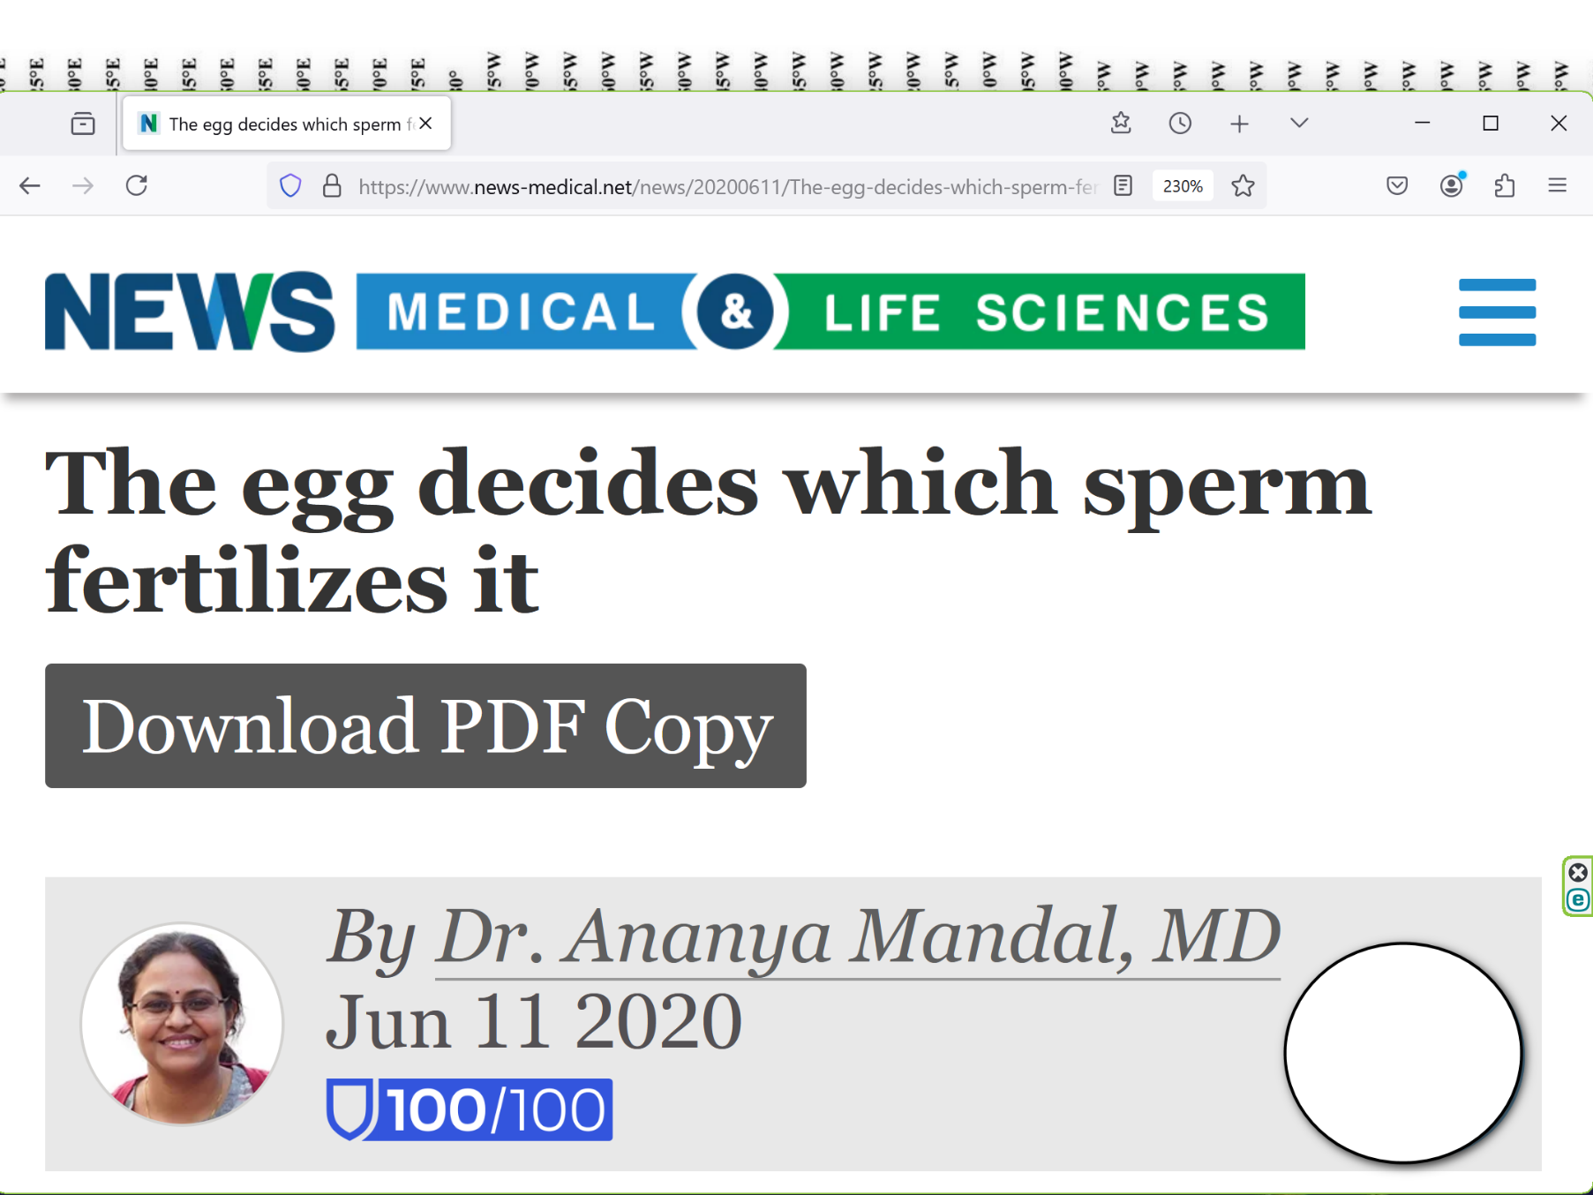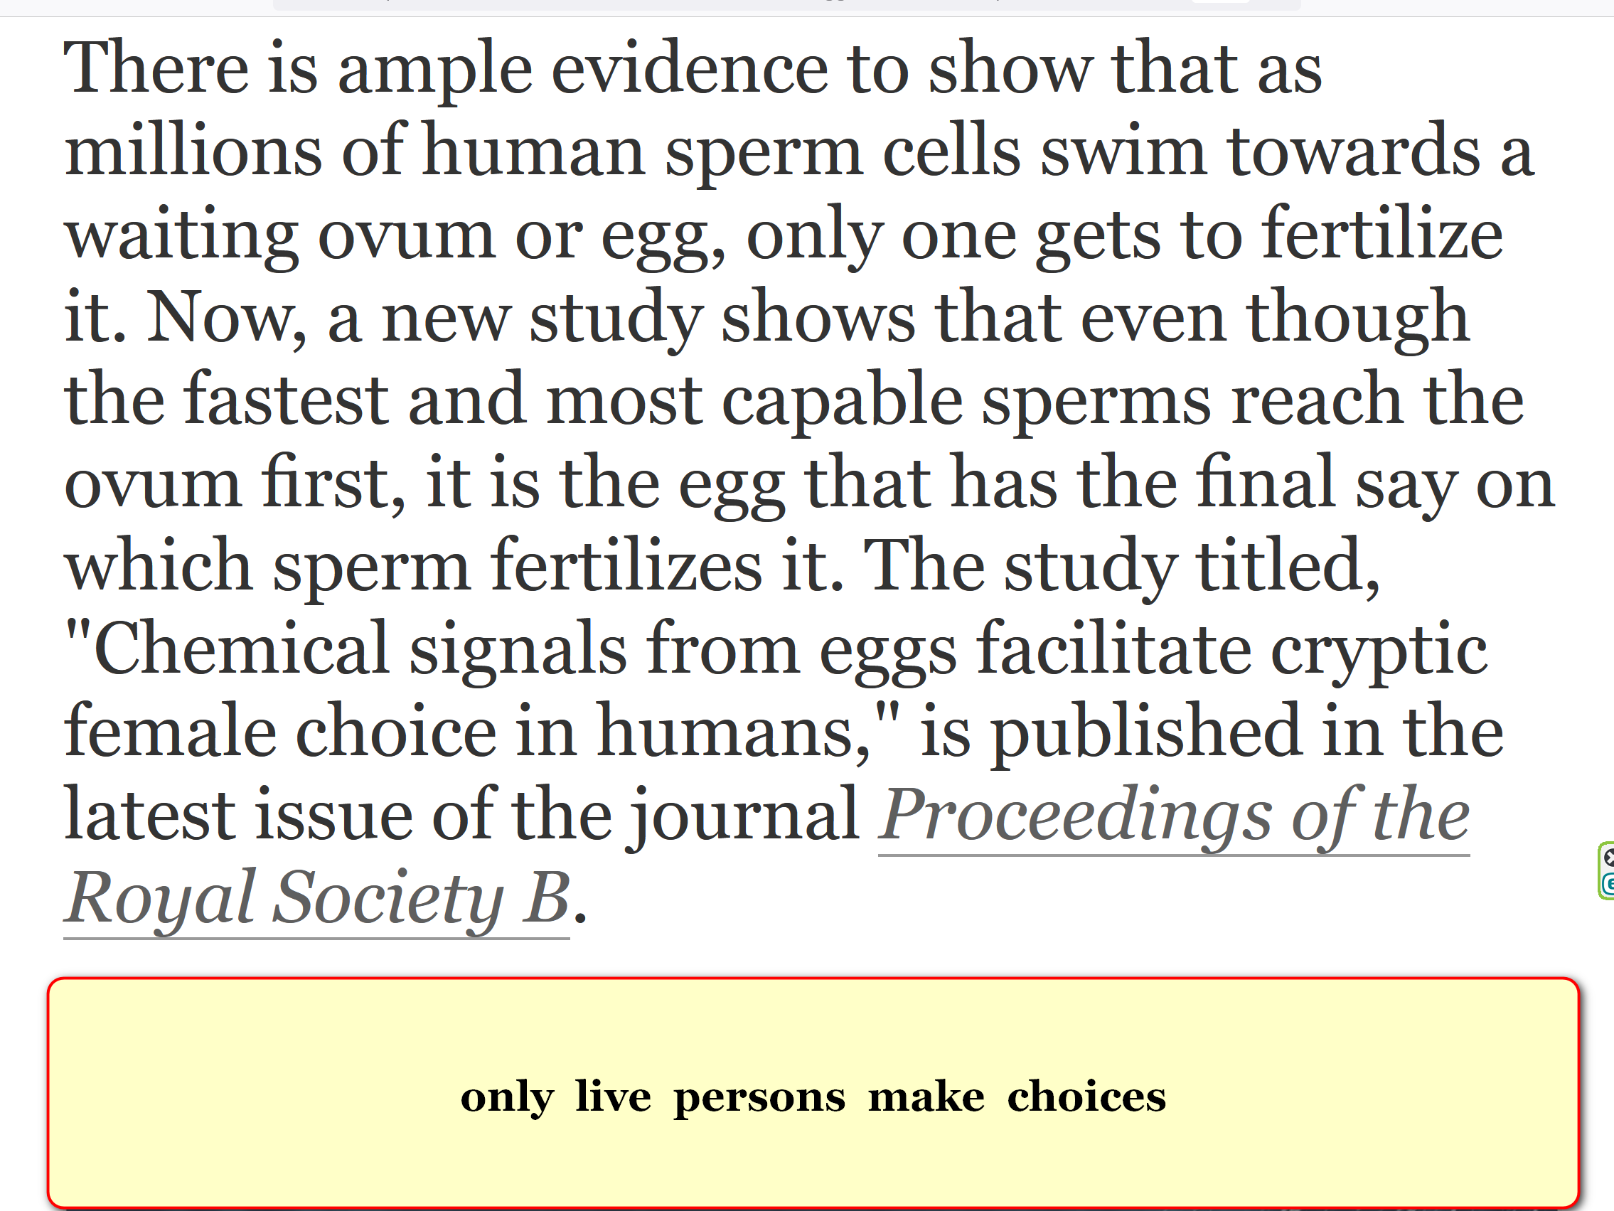

**SMALL newly created FIELD OF ELECTRONS**

**stays alive**

**throughout nine months inside mother's body**

**through entire pregnancy time unborn baby**

**never experiences**

**non aliveness**

**KIM NOTES**

**alive sperm and alive egg combination**

**reach**

**2-0 majority vote concerning which**

**features to include in new personality**

**one woman to one man marriages**

**parallel**

**above**

**group of two persons in marriage**

**make**

**decisions for group actions via**

**2-0 majority vote**

**fidelity in marriage**

**equals vote for**

**SUNNYsideUP emotion for universe's operations**

**above**

**because**

**any additional intimacy partners**

**violate 2-0 majority guidance**

**new unborn baby**

**possesses**

**definite opinions on desired DNA features**

**including DNA sections already initially assigned**

**eagle nebula's eye**

**symbolizes**

**unborn baby observing universe**

**then choosing preferred nature of universe**

**professor john wheeler's theory**

**supports**

**above conclusion**

**KIM NOTES**

**2022 december kim**

**experienced**

**HISTORY is never set in STONE**

**therefore confirming wheeler and alley's proof**

**kim**

**experienced**

**what wheeler scribbled beneath the drawing**

**THE universe as a self-excited SYSTEM**

**2022november kim**

**pondered**

**concerning relative girl named nana**

**unlike peers nana's teenage years**

**void**

**of carefree fun**

**void**

**because**

**nana mandatory second mom**

**to three baby brothers**

**nana's best friend dee**

**lived**

**in quiet house shared**

**only with parents**

**when possible nana**

**visited**

**dee's quiet house**

**nana dee**

**remained**

**best of friends after high school**

**dee**

**eventually moved to**

**california unfortunately passed from globe**

**after attaining only 51 years**

**nana**

**attended**

**dee's funeral in california**

**nana**

**telephoned**

**kim days later concerning sad details**

**dee's parents**

**performed**

**pagan funeral in california redwood forest**

**nana**

**found**

**those pagan burial rituals unfamiliar unsettling**

**during next 25 years when kim**

**conversed**

**with nana dee's name only rarely**

**mentioned as past memory naturally**

**2022 november 16 nana's husband**

**passed from globe**

**having last three years with solely**

**nana primary healthcare giver wonderfully attentive**

**then kim**

**pondered**

**nana's life**

**kim sad**

**because**

**nana possessed no buddy buddy confidant**

**month later kim**

**received**

**shocking communication causing emotion similar to**

**latin america's raised ears snoopy statue**

**during 2022december telephone conversation nana**

**casually mentioned**

**talking that week by telephone**

**with dee in california**

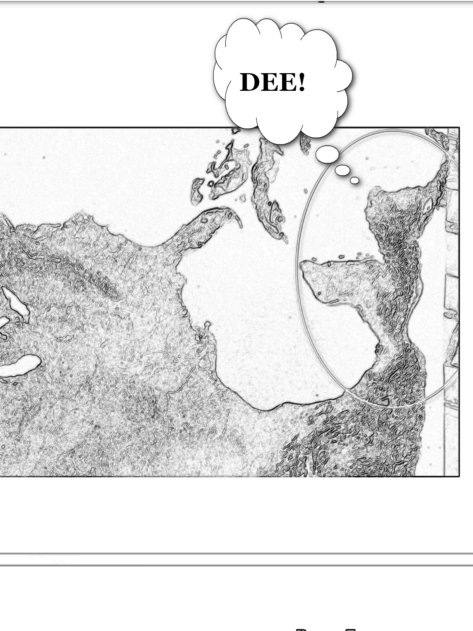

**kim**

**blurted**

**DEE**

**nana**

**said**

**YES do you remember**

**my best friend growing UP**

**kim**

**recovered enough**

**acted like nothing amiss**

**next day kim**

**remembered**

**kim's 2022 november fleeting ponderance**

**kim**

**realized**

**universe reformed history seamlessly**

**confirming wheeler's theories**

**universe's new history**

**included**

**nana possessed**

**continuous friendship with dee many years**

**universe**

**answered**

**kim's brief ponderance**

**although no prayers involved**

**above occurred even though kim**

**never referenced dee**

**in that brief ponderance**

**therefore wheeler**

**correct**

**furthermore wheeler**

**even discovered**

**method of universe's agents in determining**

**responses to humans' slightest whims**

**wikipedia.org**

**2006february18 interview with martin redfern wheeler mentioned**

**in developing Participatory Anthropic Principle,**

**wheeler used variant on Twenty Questions,**

**wheeler**

**used**

**variant on Twenty Questions method of**

**detection called Negative Twenty Questions**

**wheeler's Negative Twenty Questions**

**showed how**

**questions we choose to ask**

**about universe may dictate answers we get.**

**respondent**

**does not choose or decide upon**

**any particular or definite object beforehand,**

**but only on pattern of "Yes" or "No" answers.**

**this variant**

**requires**

**respondent provide consistent answers**

**to successive questions**

**so that each answer**

**can be viewed**

**logically compatible with all previous ones.**

**In this way successive questions**

**narrow**

**options**

**until questioner**

**settles upon**

**definite object**

**KIM NOTES when universe**

**asked**

**wheeler's 20 Questions to subconscious human**

**that subconscious human**

**gave**

**20 parameter settings then universe found**

**puzzle piece fitting parameter settings**

**or sometimes universe**

**created**

**entirely new holographic item matching description**

**in dee's case universe**

**devised**

**answer to nana's situation after**

**Negative Twenty Questions to subconscious kim**

**universe via standard operating procedures**

**seamlessly reintroduced**

**dee into new history of globe**

**KIM NOTES 2024december dee**

**lives happily**

**near university of california santa barbara**

**1940 wheeler**

**told**

**feynman**

**only one electron in universe**

**theory of one actual electron**

**correct plus**

**one proton one neutron exist in**

**one black hole original 1D singularity**

**KIM NOTES below discovery**

**explains**

**above statements**

**wikipedia.org's one electron universe**

**wheeler via call to feynman 1940spring**

**KIM NOTES below discovery**

**explains**

**above statements**

**wikipedia.org's one electron universe**

**wheeler via call to feynman 1940spring**

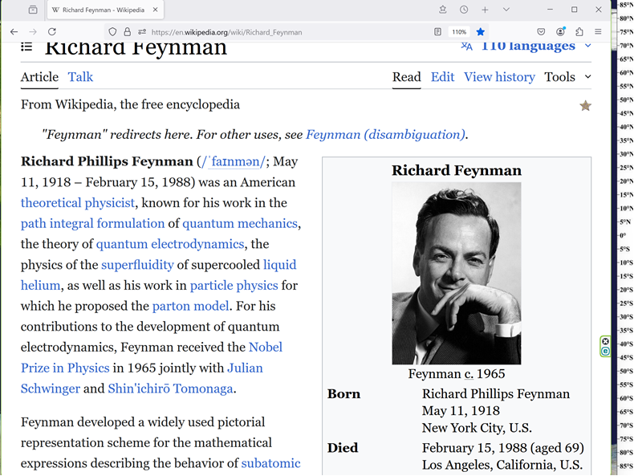

**I**

**received**

**telephone call one day at graduate college at Princeton**

**from Professor Wheeler, he said**

**FEYNMAN**

**I know why all electrons have same charge same MASS**

**Why?**

**BECAUSE, they are all the same ELECTRON!**

**KIM NOTES**

**all electrons**

**connect with**

**all other electrons in what scientists**

**call entanglement**

**until this book scientists**

**believed**

**only some electrons entangled with limited**

**number of other electrons**

**yet humankind's surrounding holograph 3D universe**

**gives**

**illusion of separate particles**

**mid 1990's scientists**

**mentioned**

**surrounding holograph 3D universe**

**in 3D universe things**

**expand volumetrically**

**netherlands professor gerard 't hooft**

**noticed**

**black holes expanded only flatly**

**stanford professor leonard susskind agreed**

**chapter ends**