006 quadrisection ROCK PAPER SCISSORS GAZA

SHOELANGUAGE book as global upgrade
gives chance for
all nations to leave BEARS league

historically to avoid tranquility BEARS presidents
often secretly asked
other nations' BEARS presidents
chiefs of states to threaten wars

BEARS
frequently scheduled
staged playfights complete with actual deaths

BEARS
weighed costs of losing
certain number of own patriotic citizens

on one hand BEARS
enjoyed
GUSHING STREAMS of praise coming from
mouths of own patriotic citizens

yet BEARS with mixed feelings
planned
deaths of own GUSHING STREAMS citizens

above because BEARS
valued
grander glory forever in history textbooks
plus enjoyed immediate money from wars

across globe BEARS via networking
gain
massive fortunes from selling war equipment
including bullets missiles vessels etcetera

individual heads of state BEARS
gain
textbook glory for withstanding other nations'
assaults which actually secretly invited

unknowingly sincere secretary of defense forrestal
attempted blocking
major source of future BEARS income

of irish descent forrestal
became
first victim of BEARS' israeli palestinian conflict

wikipedia.org
US Government - https://archive.org/stream/lbnana148sf#page/n8/mode/1up
work of employee of U.S. Navy, of person's official duties. As work of U.S. federal government, in public domain U.S.

File:James Forrestal - SecOfDef.jpg
Created: 1 January 1948
Uploaded: 26 February 2012

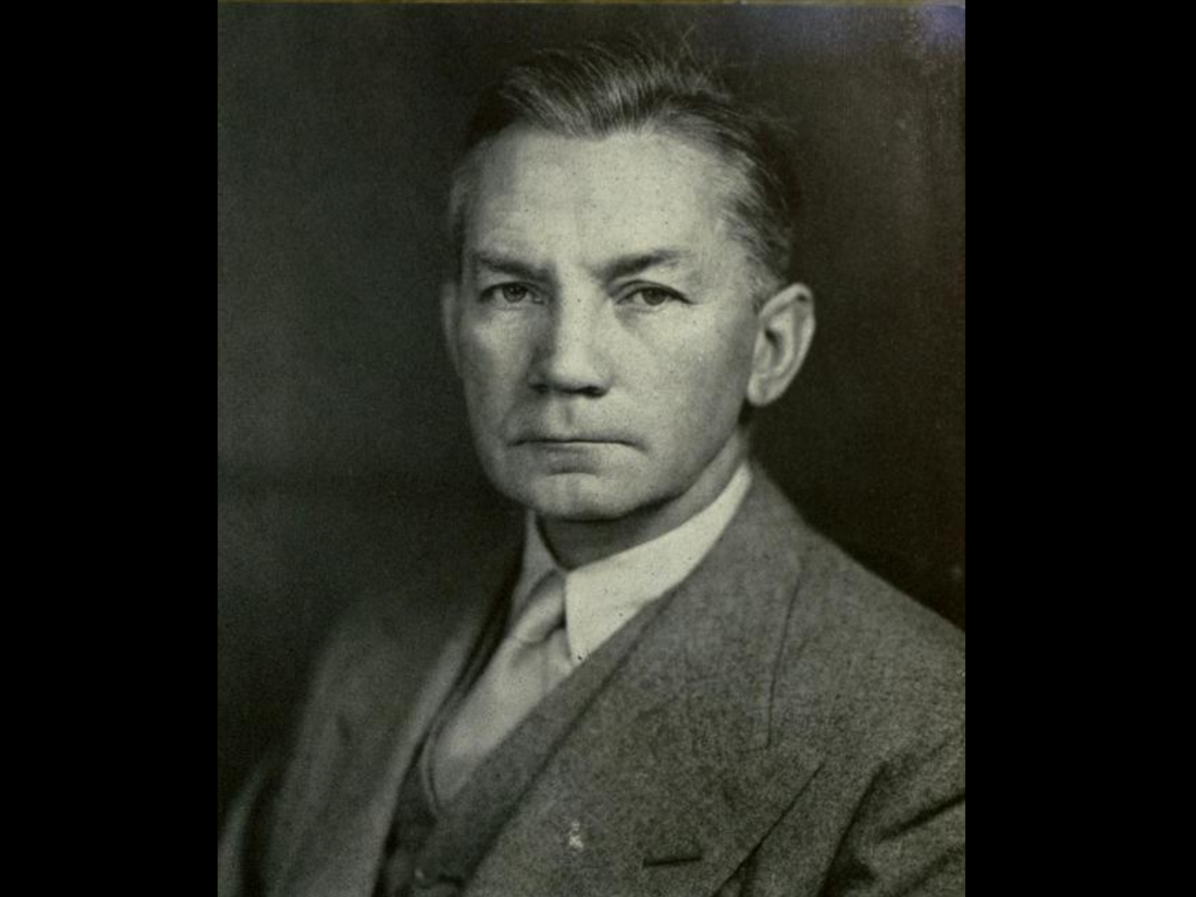

wikipedia.org

A number of works (shown below) have implied or indicated that Forrestal's death was suspicious or nefarious.

In December 1950 William Bradford Huie
published
article titled "Untold Facts about the Death of James Forrestal"
in THE AMERICAN MERCURY

That article, later entered into the Congressional Record and republished

Huie opined that "Much of the truth has thus far been suppressed, but the ghost of Jim Forrestal is not going to be laid until there are reasonable answers to such questions as these:

Why was the attack on Forrestal so reckless and sadistically savage?

KIM NOTES
answer to above

forrestal
favored
creating palestine federation similar to usa

in that case states in palestine
contain
mixture of jewish plus
palestinian inhabitants

yet BEARS
desired
partition to ignite bitterness to start
chaos wars and deaths for generations

therefore for money and glory BEARS
killed
forrestal plus invented coverup story
then proceeded with chaos causing plans

wikipedia.org's

James Vincent Forrestal (February 15, 1892 – May 22, 1949)
last Secretary of Navy and first Secretary of Defense

in May 1944
strongly opposed the United States' support for the establishment of State of Israel
during private cabinet meetings with Truman in 1946 1947,

Forrestal had argued against partition
on the grounds it would infuriate arabs
who supplied oil needed for the
usa economy and national defense.

Truman forced Forrestal's resignation.
1949march31

at bethesda naval hospital Forrestal
underwent mental health care on
16th floor instead of first floor

on the road to recovery, having regained 12 pounds (5.4 kg) since his admission into the hospital.

1949may22 early morning hours

his body, clad only in the bottom half of a pair of pajamas,
was found
on a third-floor roof below the sixteenth-floor kitchen across the hall from his room.

wikipedia.org's

Wormwood (stylized as 'WORMWO0D') is a 2017 American six-part docudrama miniseries directed by Errol Morris and released on Netflix on December 15, 2017.

The series is based on the life of a scientist, Frank Olson,
who worked for a secret government biological warfare program (the USBWL) at Fort Detrick, Maryland. It focuses on the events leading up to and following his controversial death,

A key piece of evidence the film relies on is a CIA assassination manual from 1953, which instructs agents, "The most efficient accident, in simple assassination, is a fall of 75 feet or more onto a hard surface."

KIM NOTES BEARS
utilized
time delays to soften impact of
nefarious telltale details example forrestal

The official Navy review board, which completed hearings on May 31, 1949
waited until
October 11, 1949, to release only a brief summary.

reported on page 15 of October 12 NEW YORK TIMES
stated only that Forrestal had died from his fall from the window. It did not say what might have caused the fall,

The full report was released by the Department of the Navy in April 2004.

KIM NOTES

after waiting 55 years BEARS
released
forrester's death details to escape accountability

BEARS gang
waited for
emotions cooling therefore
dealt with fewer eager questioners

After full and mature deliberation, the board finds as follows:
FINDING OF FACTS
- That the body found on the ledge outside of room three eighty-four of building one of the National Naval Medical Center at one-fifty a.m. and pronounced dead at one fifty-five a.m., Sunday, May 22, 1949, was identified as that of the late James V. Forrestal, a patient on the Neuropsychiatric Service of the U. S. Naval Hospital, National Naval Medical Center, Bethesda, Maryland.

- That the late James V. Forrestal died on or about May 22, 1949, at the National Naval Medical Center, Bethesda, Maryland, as a result of injuries, multiple, extreme, received incident to a fall from a high point in the tower, building one, National Naval Medical Center, Bethesda, Maryland.

- That the behavior of the deceased during the period of his stay in the hospital preceding his death was indicative of a mental depression.

- That the treatment and precautions in the conduct of the case were in agreement with accepted psychiatric practice and commensurate with the evident status of the patient at all times.

KIM NOTES

guilty BEARS in government
attempted swaying
citizens against reality that BEARS murdered

BEARS usa
took
extraordinary steps to continue deception

sincere usa citizens
never imagined
government capable of such cruelty until
government introduced notion by denial
last portion of point four

That the death was not caused in any manner by the intent, fault, negligence or inefficiency of any person or persons in the naval service or connected therewith

KIM NOTES BEARS
further blocked
appearance of guilt via naming battleship
after victim BEARS killed

2023january09

history.navy.mil/content/history/nhhc/browse-by-topic/people/sec-nav/forrestal/james-forrestal.html

Aircraft carrier USS Forrestal (CVA-59) that operated extensively during the Vietnam War and in Operation Desert Storm was named in his honor.

year 2025 forrestal's federation idea
could come to fruition

all parties involved
could agree to create
four independent nations with each
including hebrews and palestinians populations

kim
recommends
gershon baskin as one of four
top leaders for four new nations

gershonbaskin.org/insights/encountering-life-encountering-death/

gershon baskin

He is a founding member of Kol Ezraheiha-Kol Muwanteneiha (All of the Citizens) political party in Israel. He is now directing The Holy Land Bond and is the Middle East Director for ICO – International Communities Organization - a UK based NGO working in conflict zones with failed peace processes.

en.wikipedia.org/wiki/Gershon_Baskin

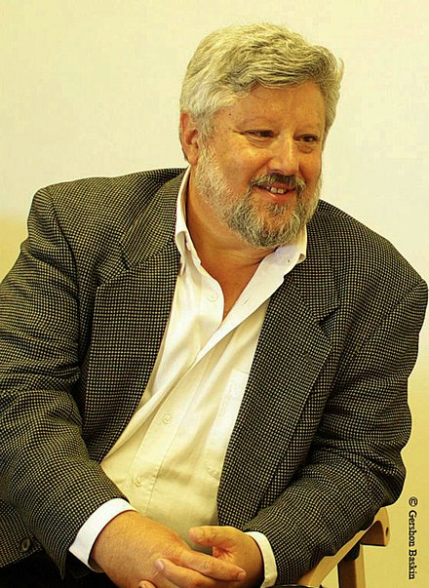

2022 march 21 friday
ww.npr.org/2025/03/21/nx-s1-5334680/gershon-baskin-discusses-how-israel-is-reacting-to-the-resumption-of-fighting-in-gaza

NPR's Leila Fadel
asks
veteran Israeli hostage negotiator and peace activist Gershon Baskin about how the country is reacting to the resumption of fighting in Gaza.

March 21, 2025 04:13 AM ET
Heard on Morning Edition
four minutes listening

gershonbaskin.org



Gershon Baskin shares his candid, in-depth, and unequivocal perspectives on a wide range of important issues. His clear-cut and sincere observations serve to open up new avenues of discussion with people who believed that they were born enemies.

KIM NOTES

for years gershon baskin
accomplished
workable solutions between all parties involved
earned respect for doing impossible feats

gershon baskin
accomplished
what poet mentioned

This poem is in the public domain.
poets.org/poem/it-couldnt-be-done

Born 1881 England, Edgar Guest
prolific writer whose poems presented
everyday life.

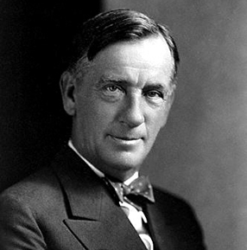

It Couldn't Be Done

Edgar Guest
1881 –1959

Somebody said that it couldn’t be done,

But he with a chuckle replied

That “maybe it couldn’t,” but he would be one

Who wouldn’t say so till he’d tried.

So he buckled right in with the trace of a grin

On his face. If he worried he hid it.

He started to sing as he tackled the thing

That couldn’t be done, and he did it.
.........

Just take off your coat and go to it;

Just start in to sing as you tackle the thing

That “cannot be done,” and you’ll do it.

KIM NOTES

for bookkeeping purposes kim
temporarily named
four new nations

after populations
start living
in those nations then those citizens
should choose permanent nation names

north to south new nations
include

ROCK
PAPER
SCISSORS
GAZA

mapsofworld.com
displays
original map
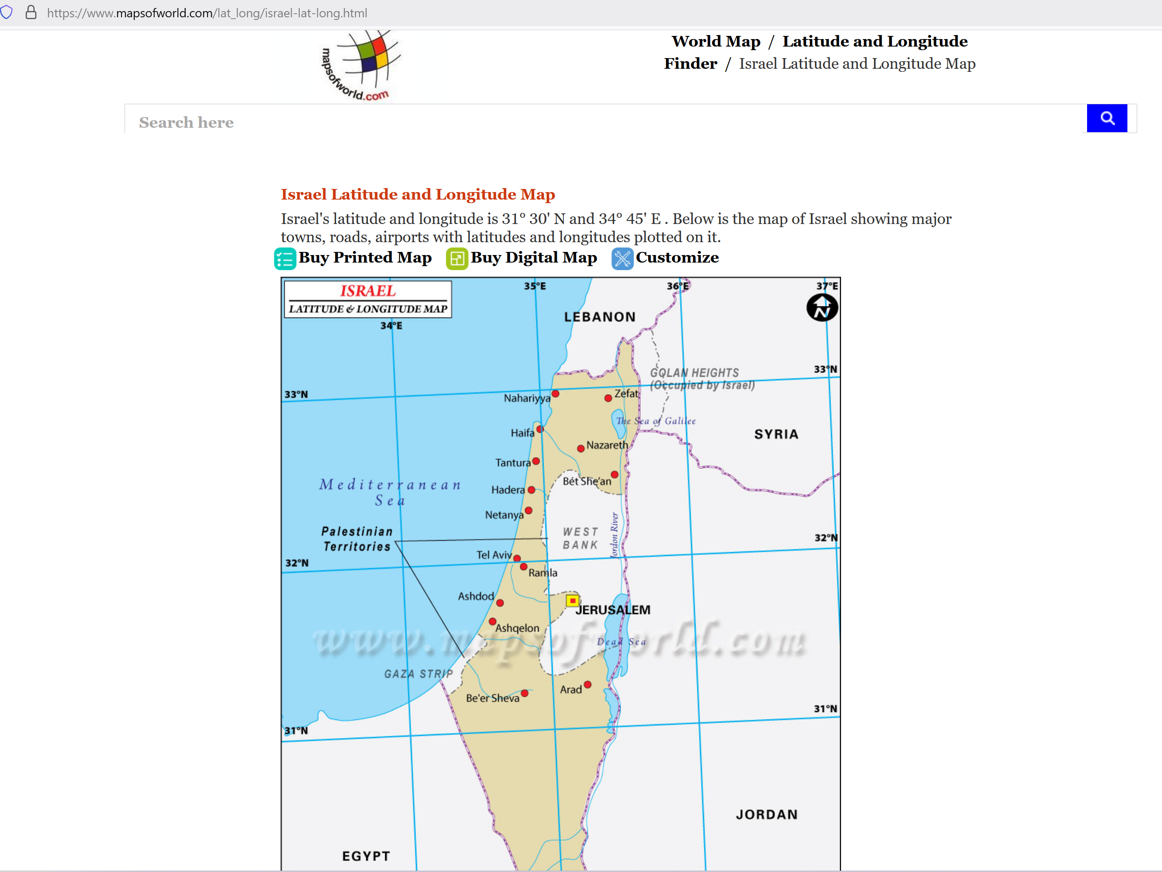

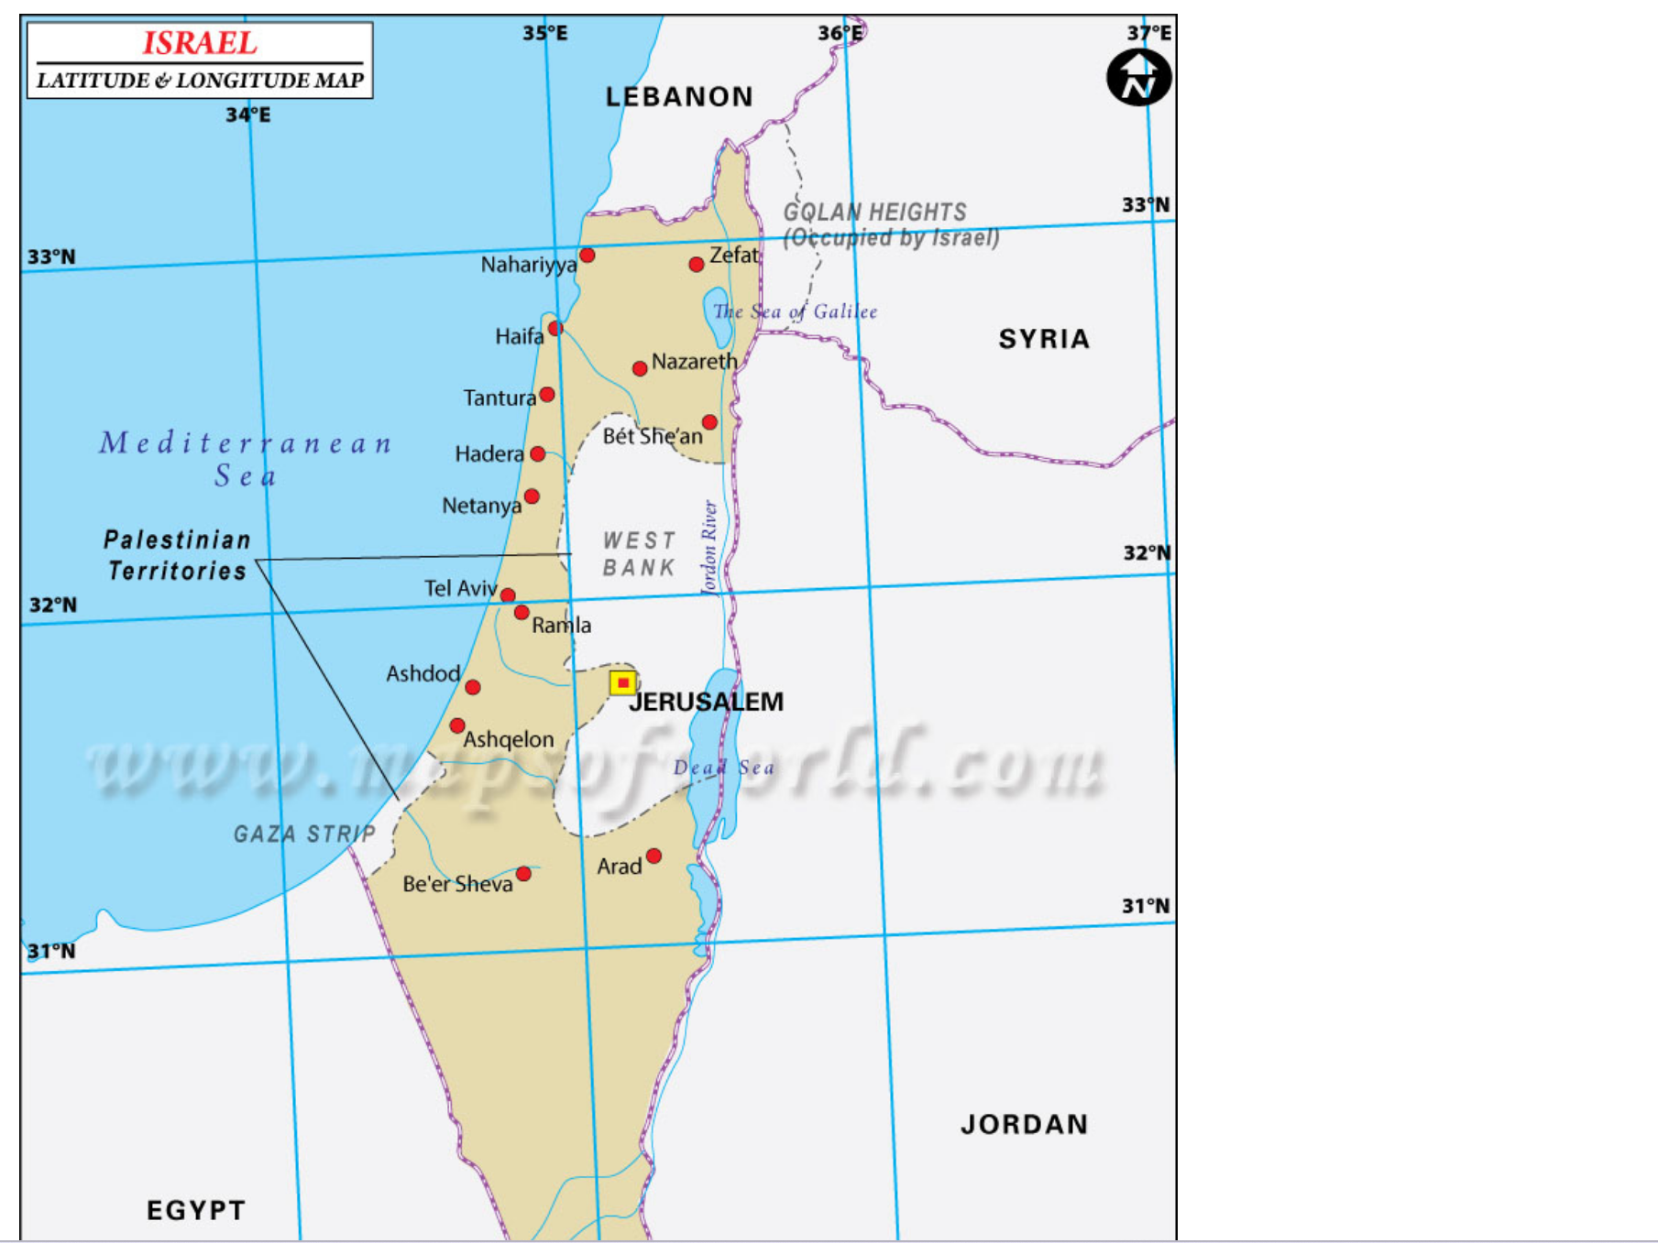

over 80% of current inhabitants
already know
english language plus already understood by
2 billion persons including nonnative speakers

therefore embedded english feature
encourages
tourism

new nations
shall list
english as official language

when four nations' executive crews
establish
selves then ask permissions for inviting
certain excellent english speaking xinjiang uyghurs

english speaking uyghurs desiring such
must sign allegiance to
new nation in advance relinquishing previous

for example four nations
could utilize
english speaking xinjiang uyghur women
as members of rescue squads

rescue squads
would monitor
community health and wellbeing and
law abiding from safety of airships

of course families
migrate with
those chosen
and become citizens of new nation

as governance each independent nation
will possess
married couple at desks
21 and 22 of executive crew

those couples' tenures
similar
to usa supreme court justices
appointed for life

ROCK nation as new northern nation
shall have
wife of gershon baskin and gershon
baskin at desks 21 and 22

GAZA nation as new southern nation
shall have
desks 21 and 22 filled in random selection

except for abbas GAZA nation
shall randomly choose
from remaining three eldest couples
of palestinian executive committee

pool
includes
married couples
not persons with plural spouses

at least one spouse of couples
must have membership
in palestinian executive committee

combined ages of both spouses
determines
membership in pool of three
eldest couples

that randomly chosen couple from pool
shall occupy
desks 21 and 22 of
GAZA nation

amina and mahmoud abbas
shall have
desks 21 and 22 in one of two
middle nations

each middle nation
gains
persons for desks 21 and 22
by method named Rock Paper Scissors

two married couples for executive positions
will play
Rock Paper Scissors in written form
during official event

winner
chooses
seats 21 and 22 from choices
PAPER or SCISSORS nation

other couple
occupies
seats 21 and 22
of other remaining nation

two couples above
include
mahmoud and amina abbas
plus benjamin and sara netanyahu

each nation's executive crews
shall include
5 israeli couples and
5 palestinian couples

above desks 11 and 12 selections
utilize
same selection formula

selectors
draw from
pools of three eldest in knesset
acknowledging combined couples' ages

israel's supreme court plus each spouse
disperse into
four nations' desks 13 through 20
through ping pong ball random selection

israel's supreme court
contains
15 persons

eldest three married members of knesset
shall enter
pool for one member selected via
ping pong tumbler method

that couple
will go where a
supreme court justice would go
to an executive crew

random palestinian selections
draw from
two pools utilizing same selection formula

one pool
includes
all sixteen members of
palestinian executive committee

sixteen members
shall gain
desks via random ping pong ball
barrel tumbling selection process

couples
shall randomly place into desks 01
through 08 of each new nations'
executive crews

second pool
draws from
palestinian central council

second pool
includes
twelve eldest couples with at least
one person having membership

four couples from twelve couples
shall randomly place into
desks 09 and 10 of each
new nations' executive crews

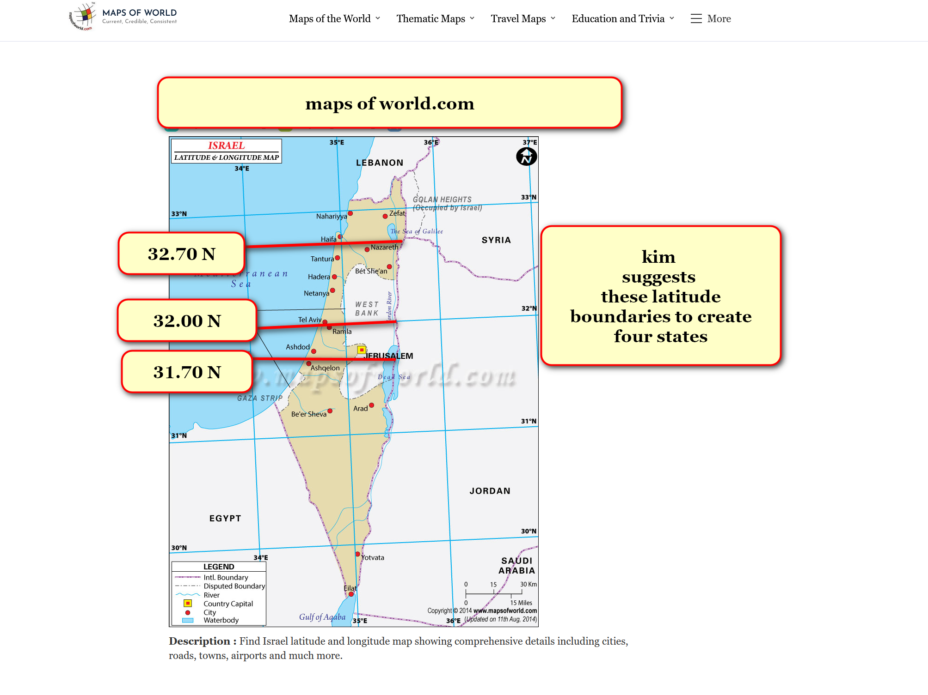

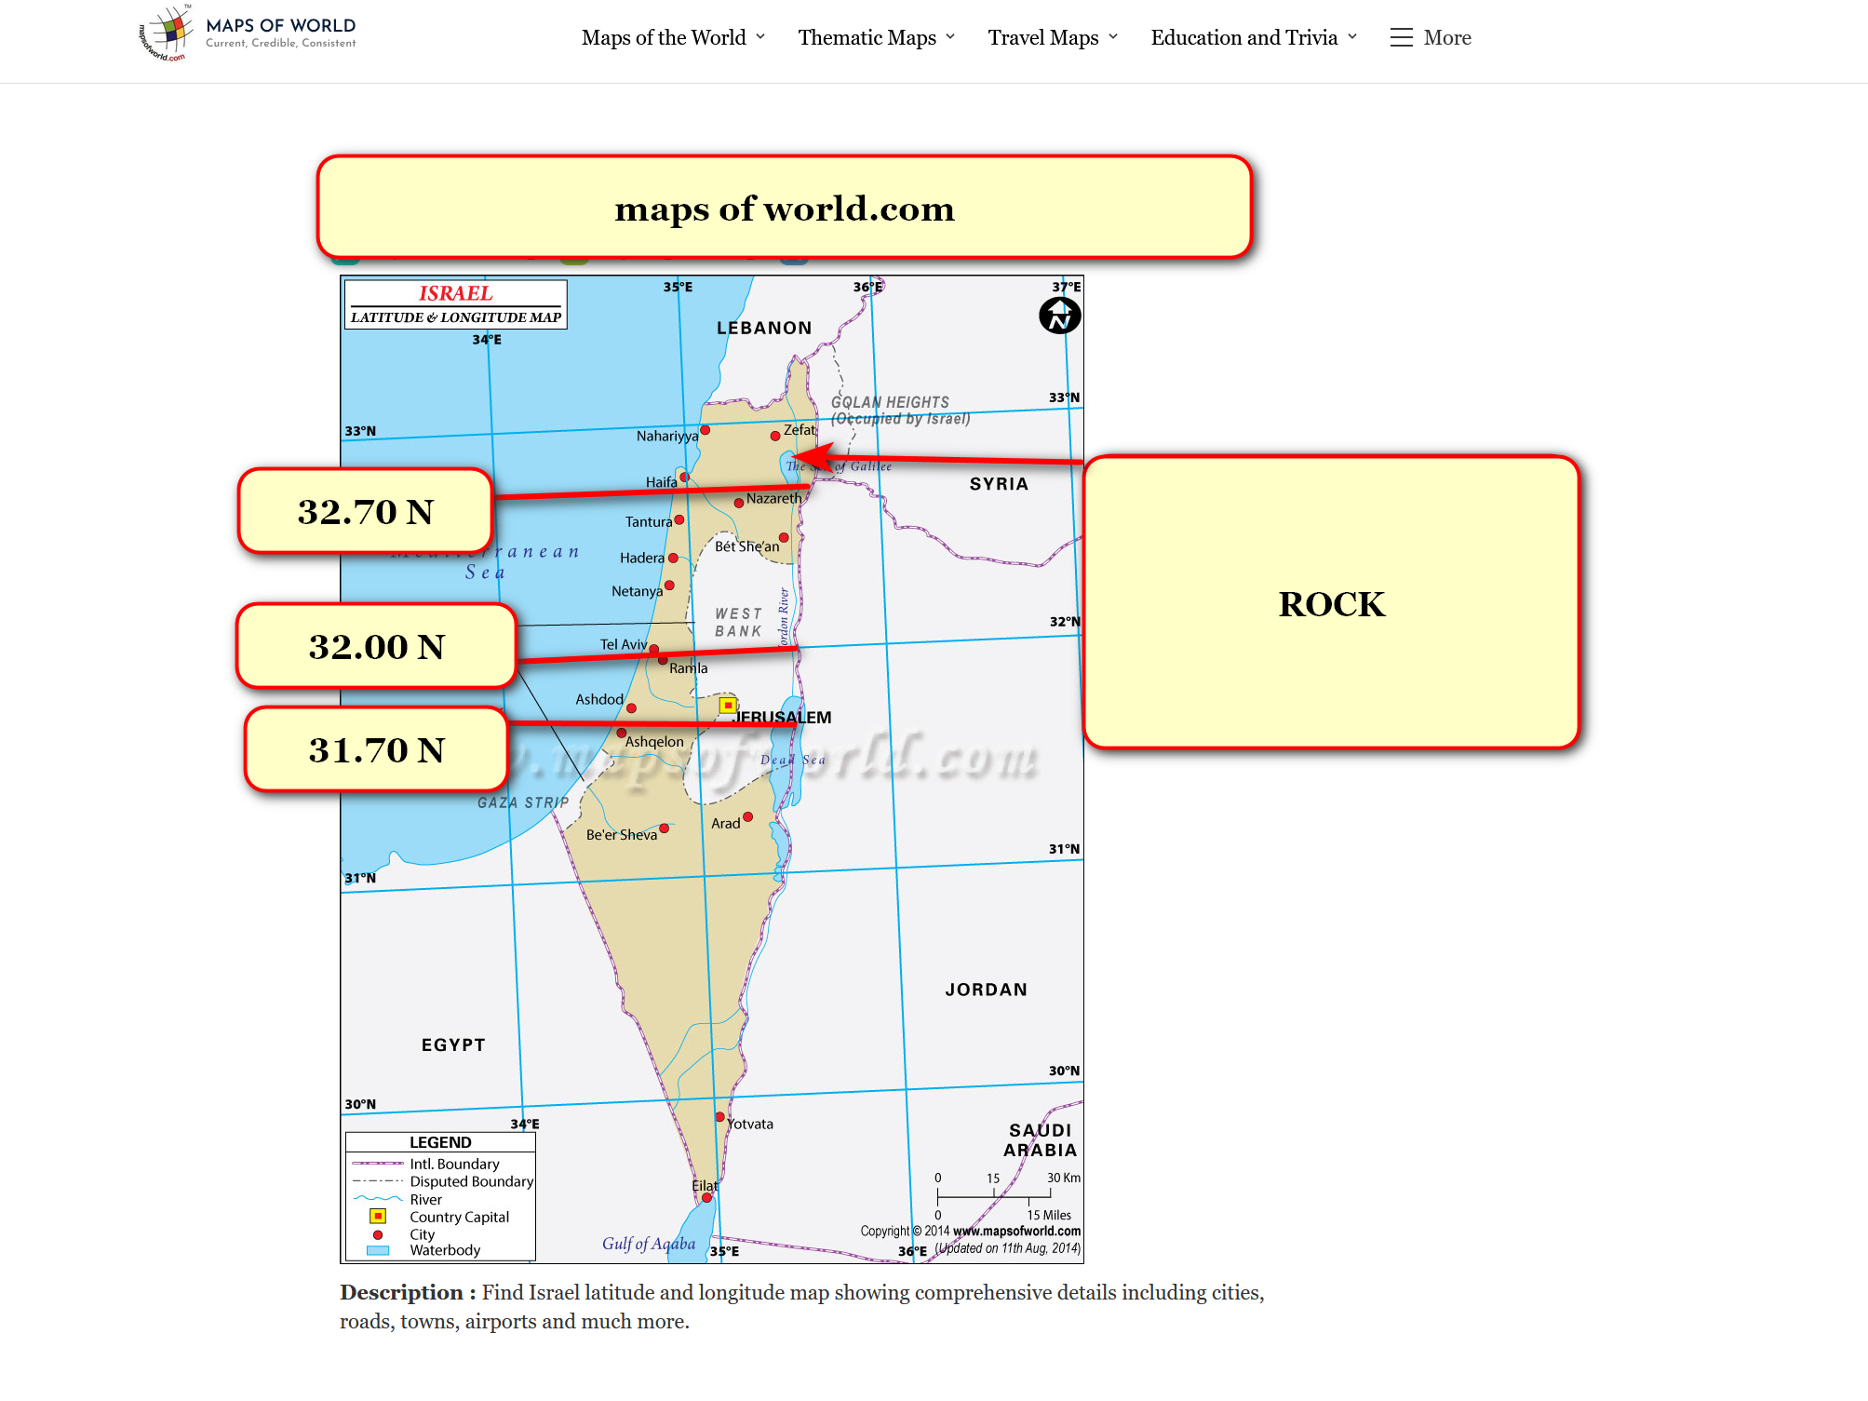

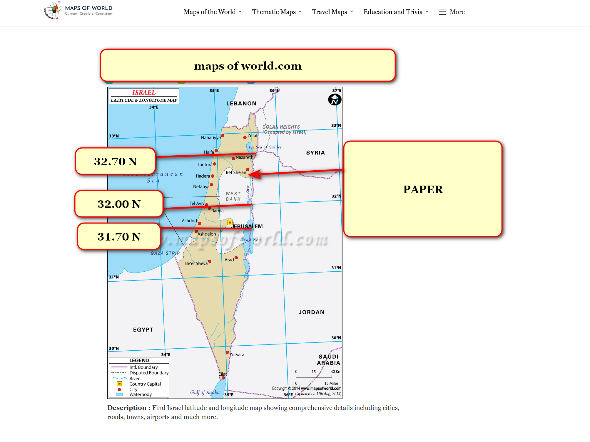

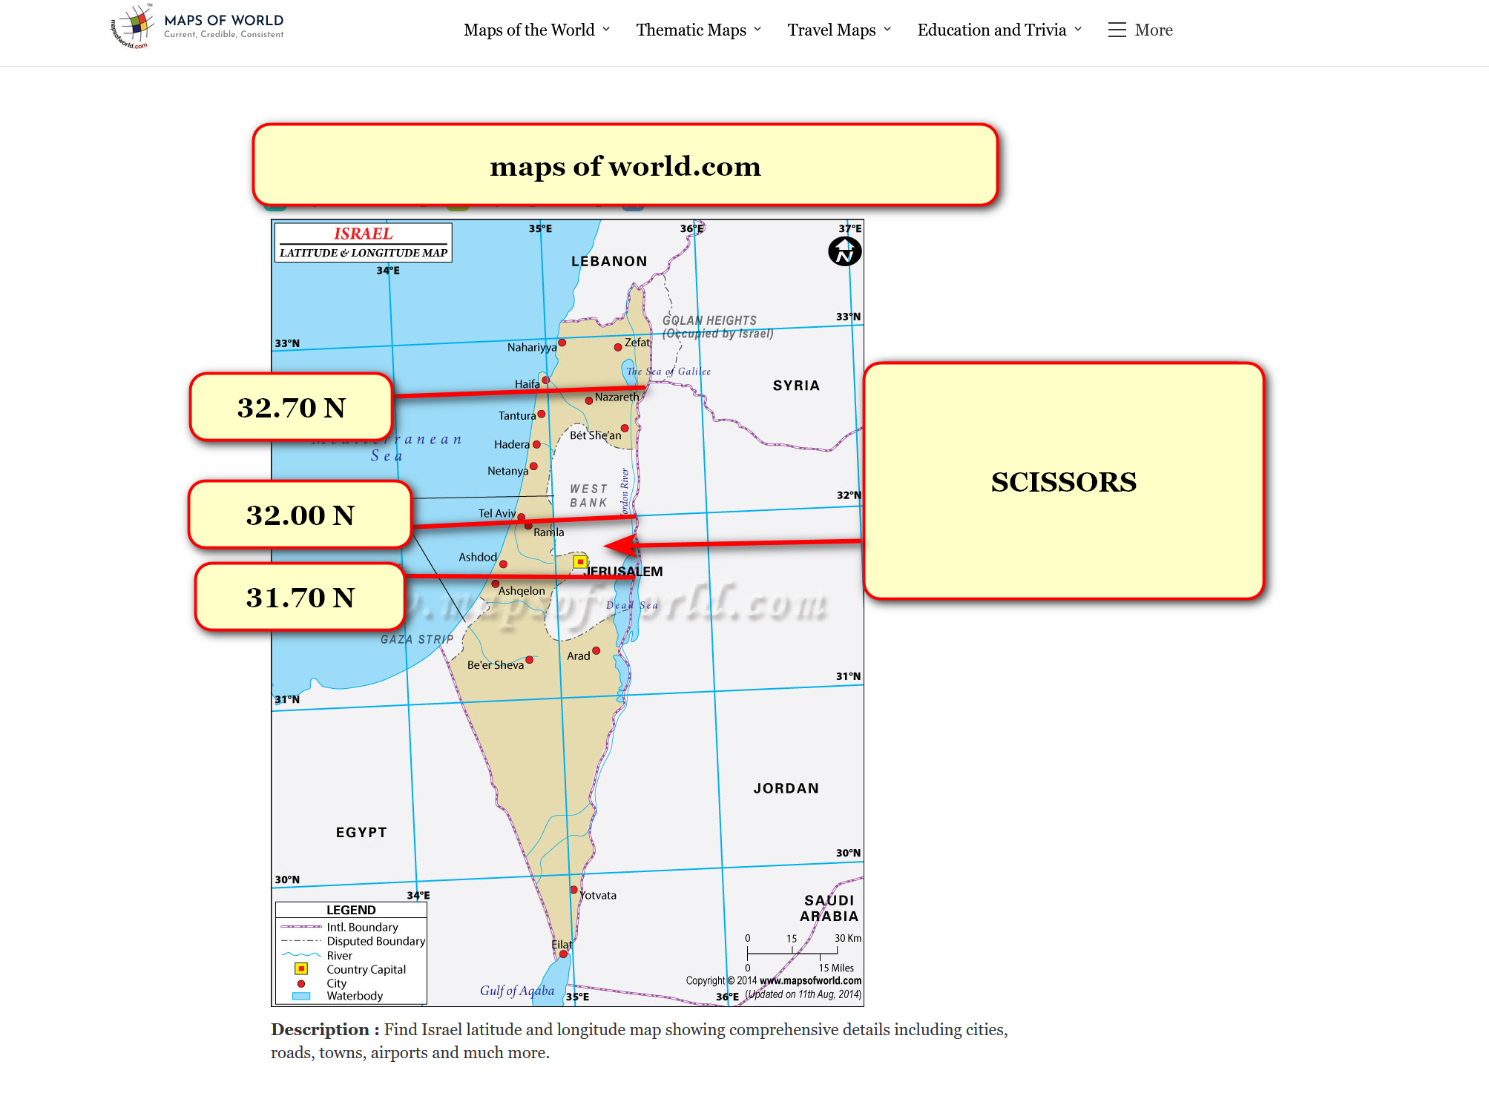

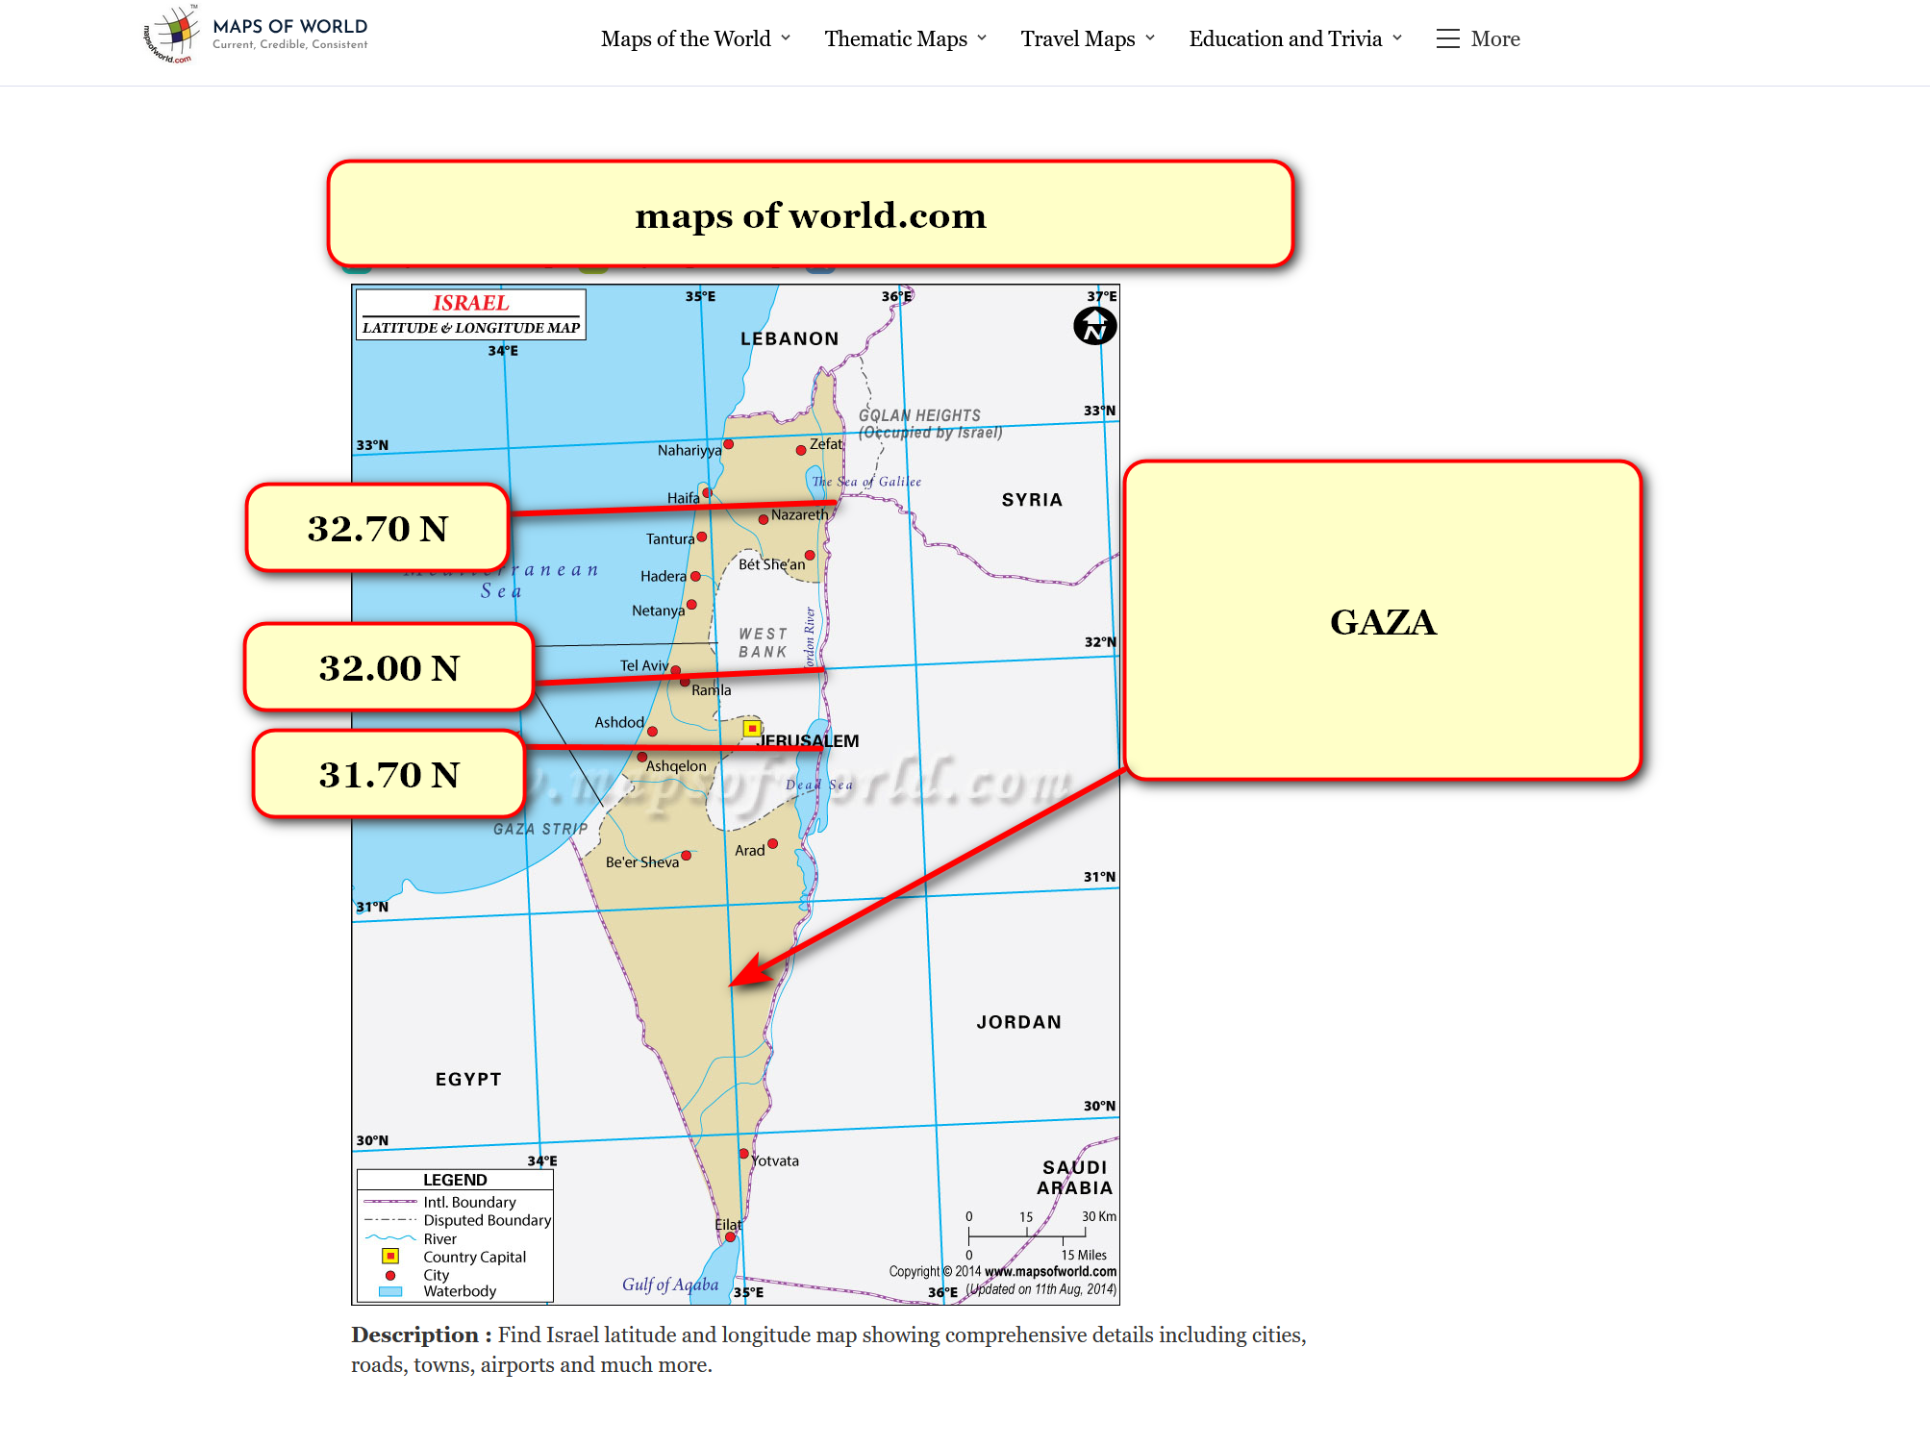

proposed executive crews
for
each of four new nations

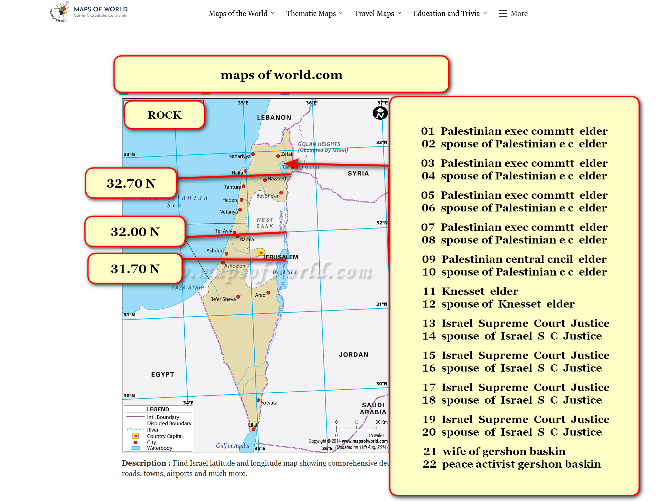

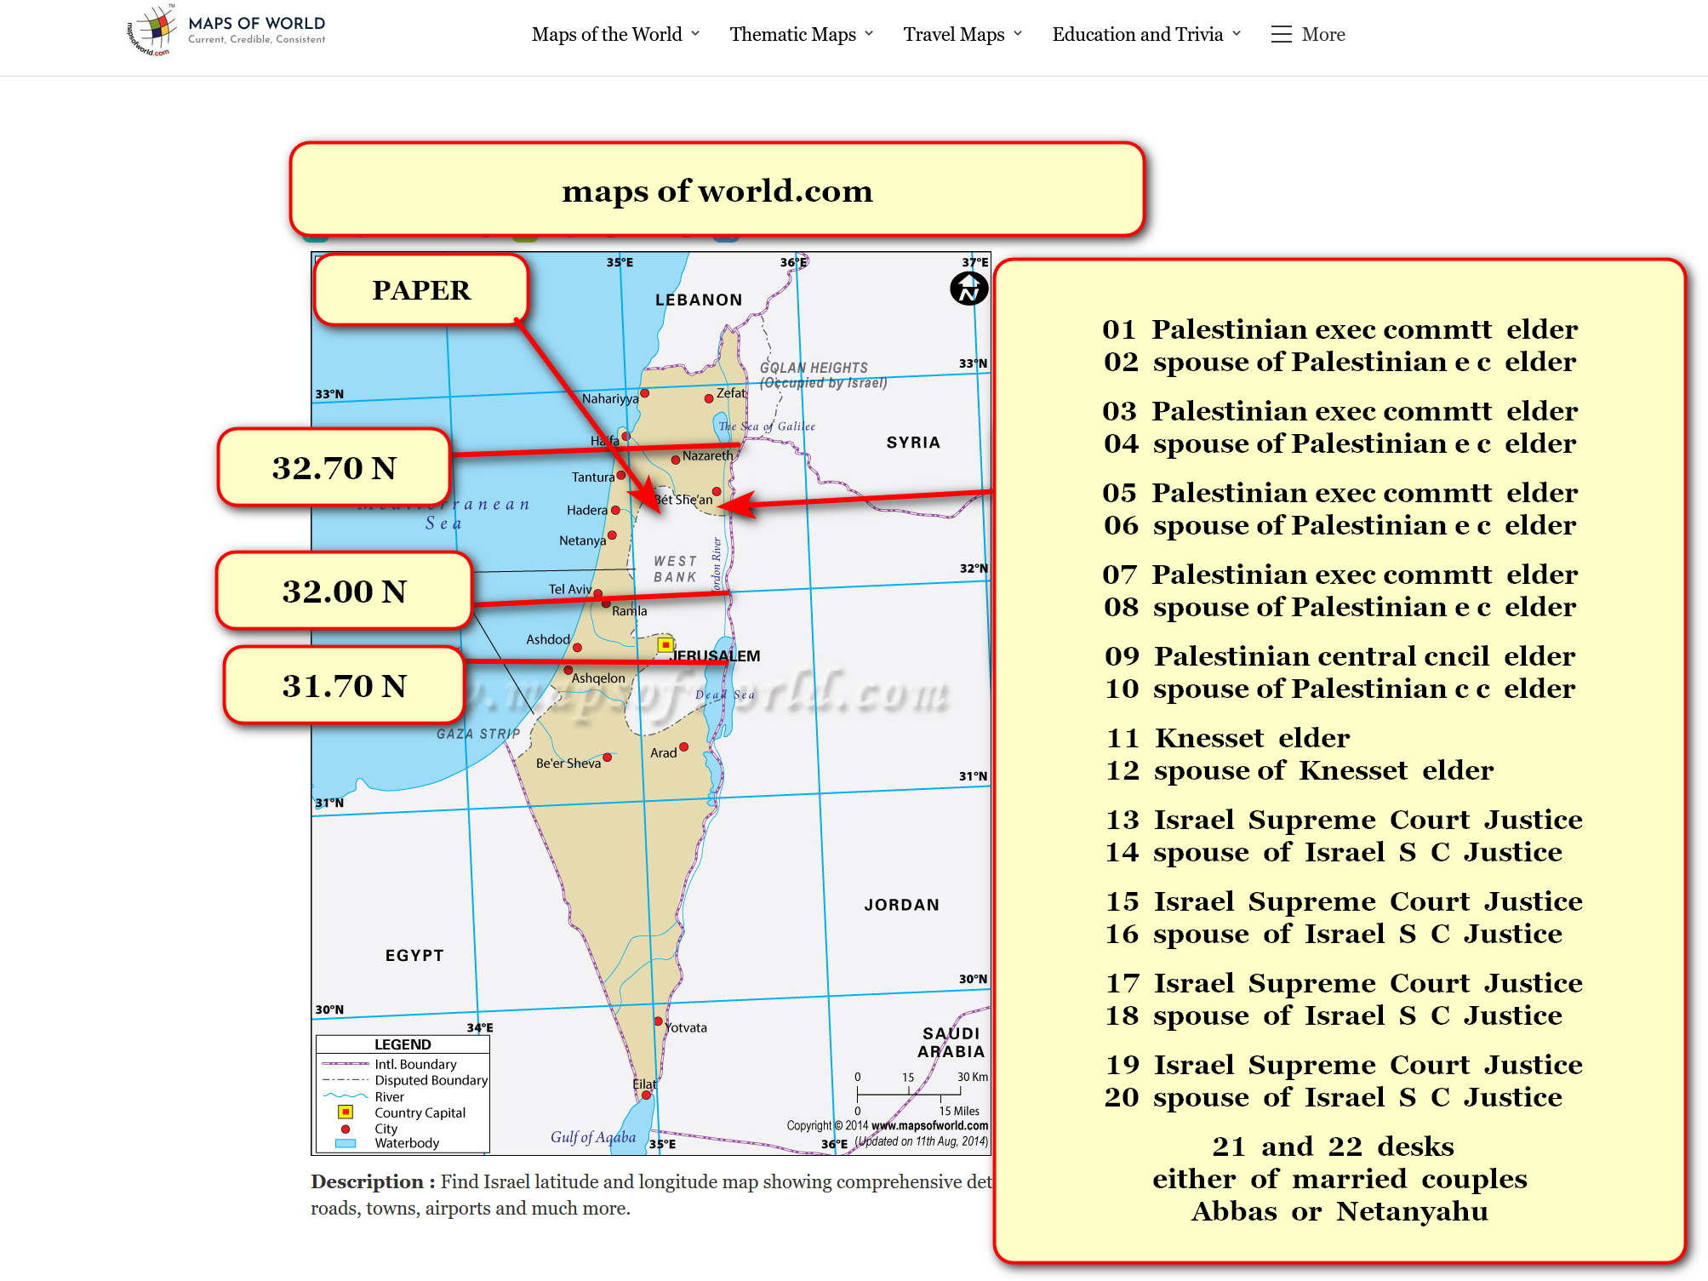

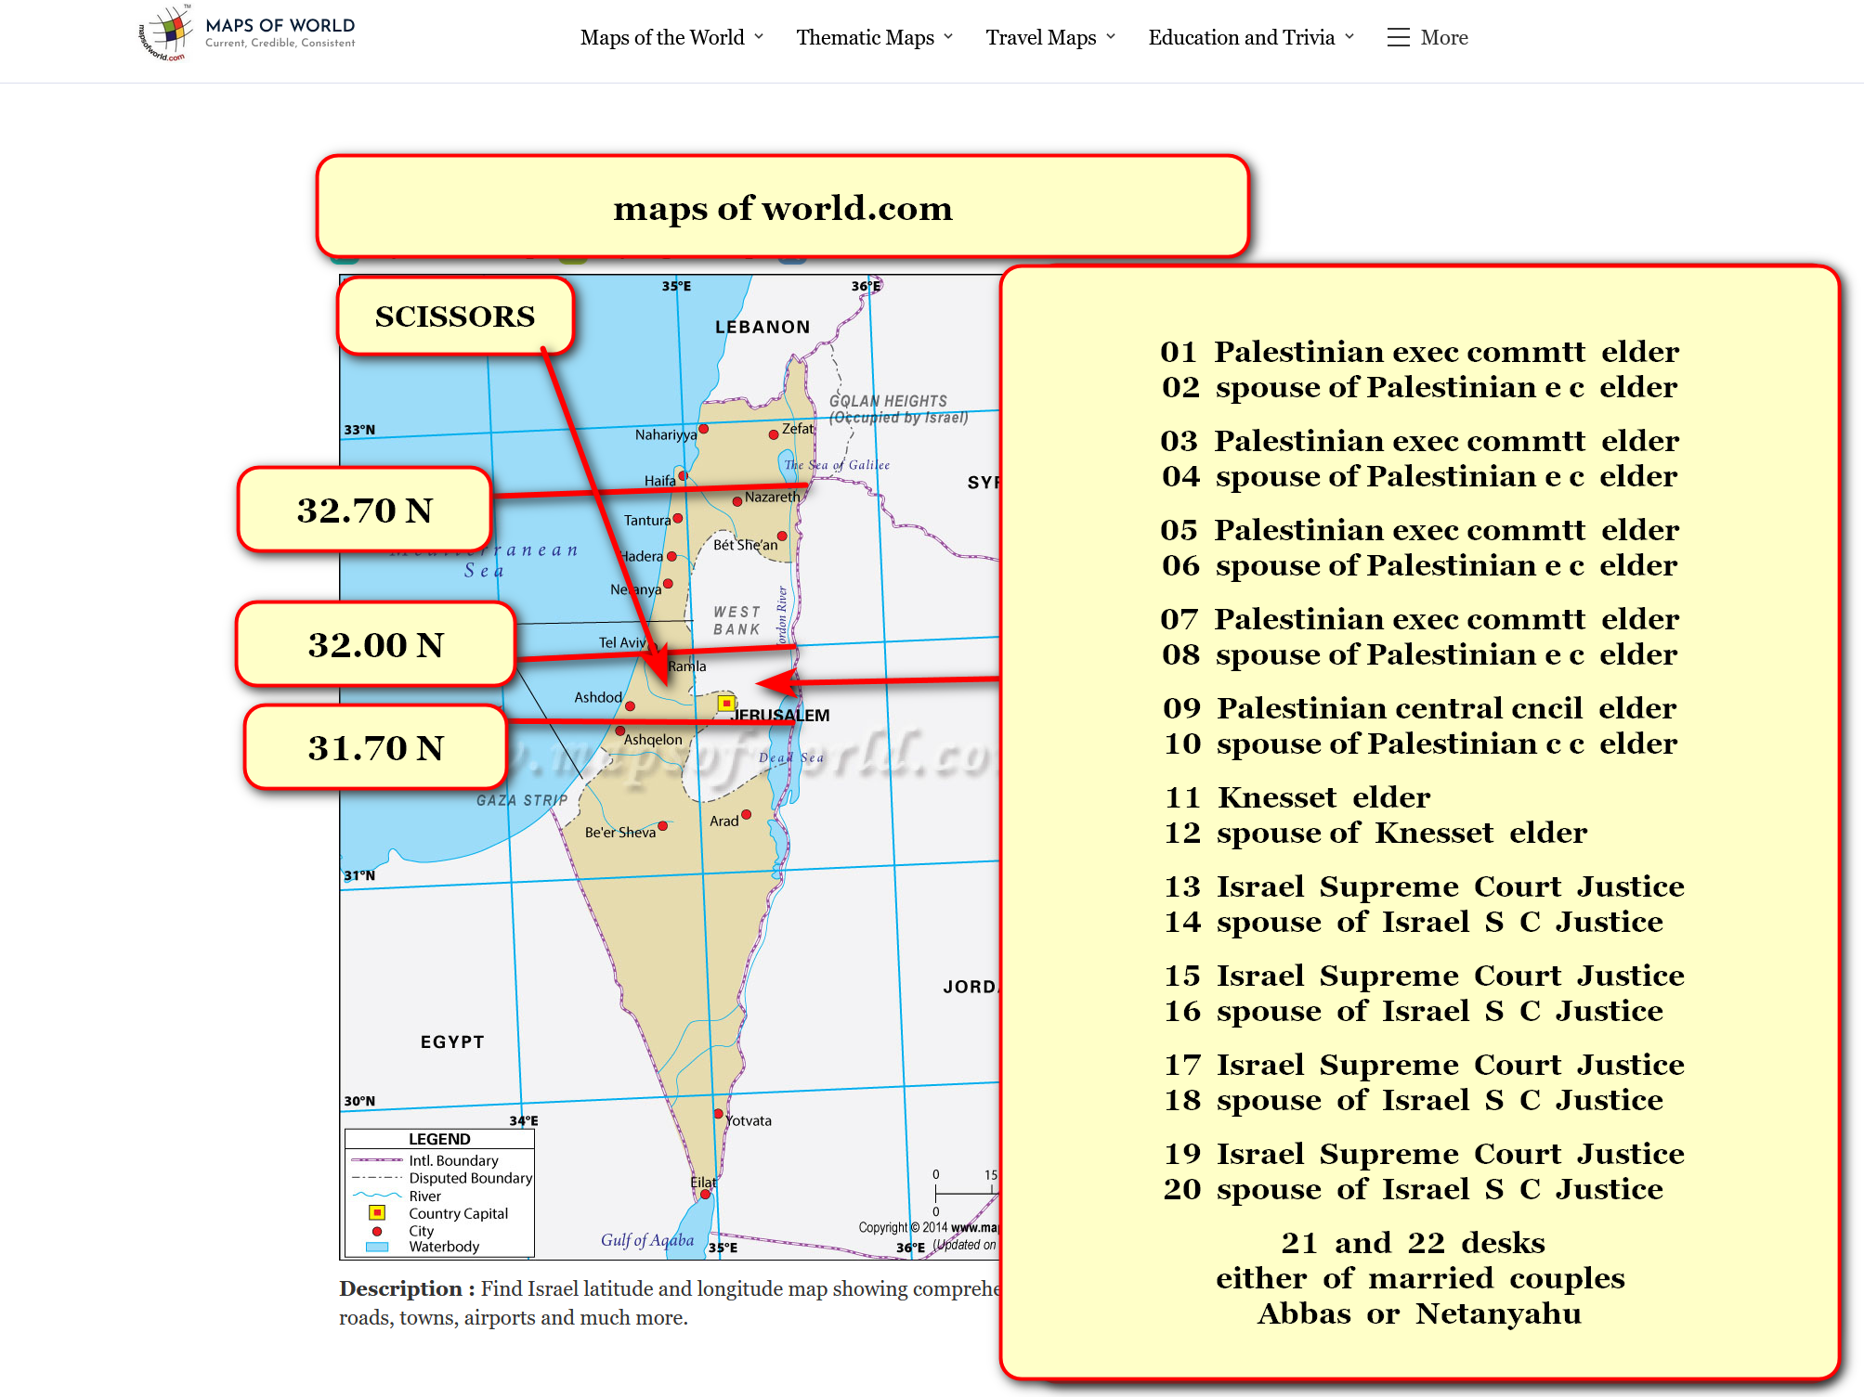

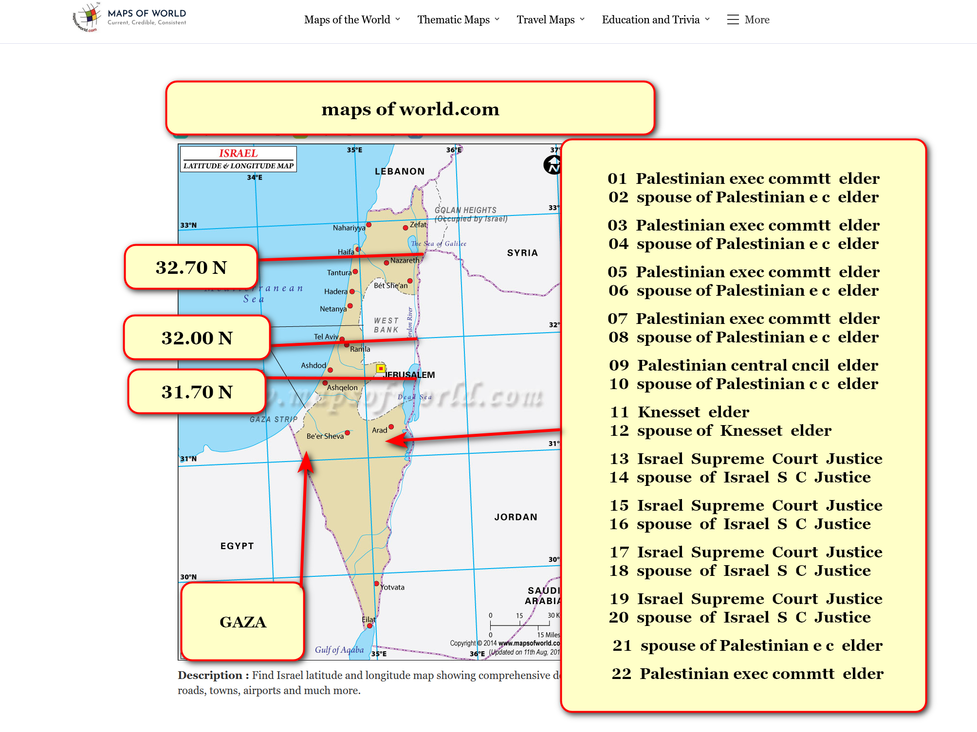

new governments
model
SMOOTH KEYS for other nations' observations

if all other nations
adopt
SMOOTH KEYS then globe finally
achieves end of wars

at shoelanguage.com governments
find
details of SMOOTH KEYS from chapters
A01-A02 in book SHOELANGUAGE book

chapter ends

