H05 island has shape of BIG BAD WOLF

cover of oxford atlas 25th edition
displays
situation blocking SUNNYsideUP eternity
wolves versus sincere patriotic citizens

this book
provides
solution invites present wolves
return to civilized behavior

situation
explained
symbolically via statues in geography
plus seamounts just below waters' surfaces

wolves
need agree
recivilize dissolve current worldwide wolves

then humankind parliaments
freely discuss
upgrade

kim
displays
oxford atlas 25th edition's cover

creators of continents
referenced
BEARS as real life examples of
literature's BIG BAD WOLF looking westward

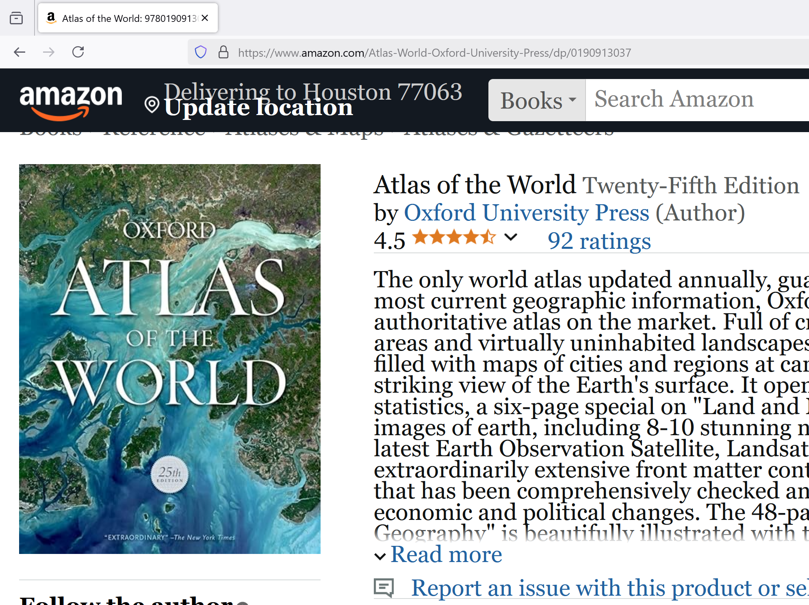

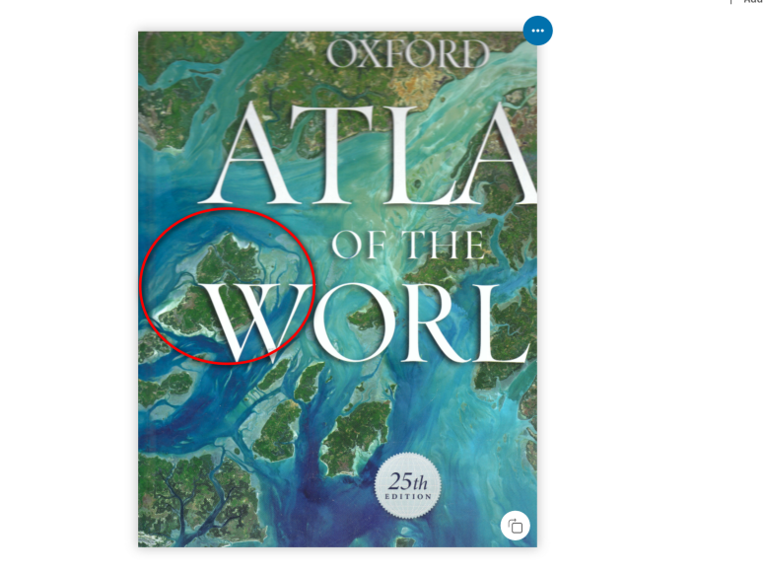

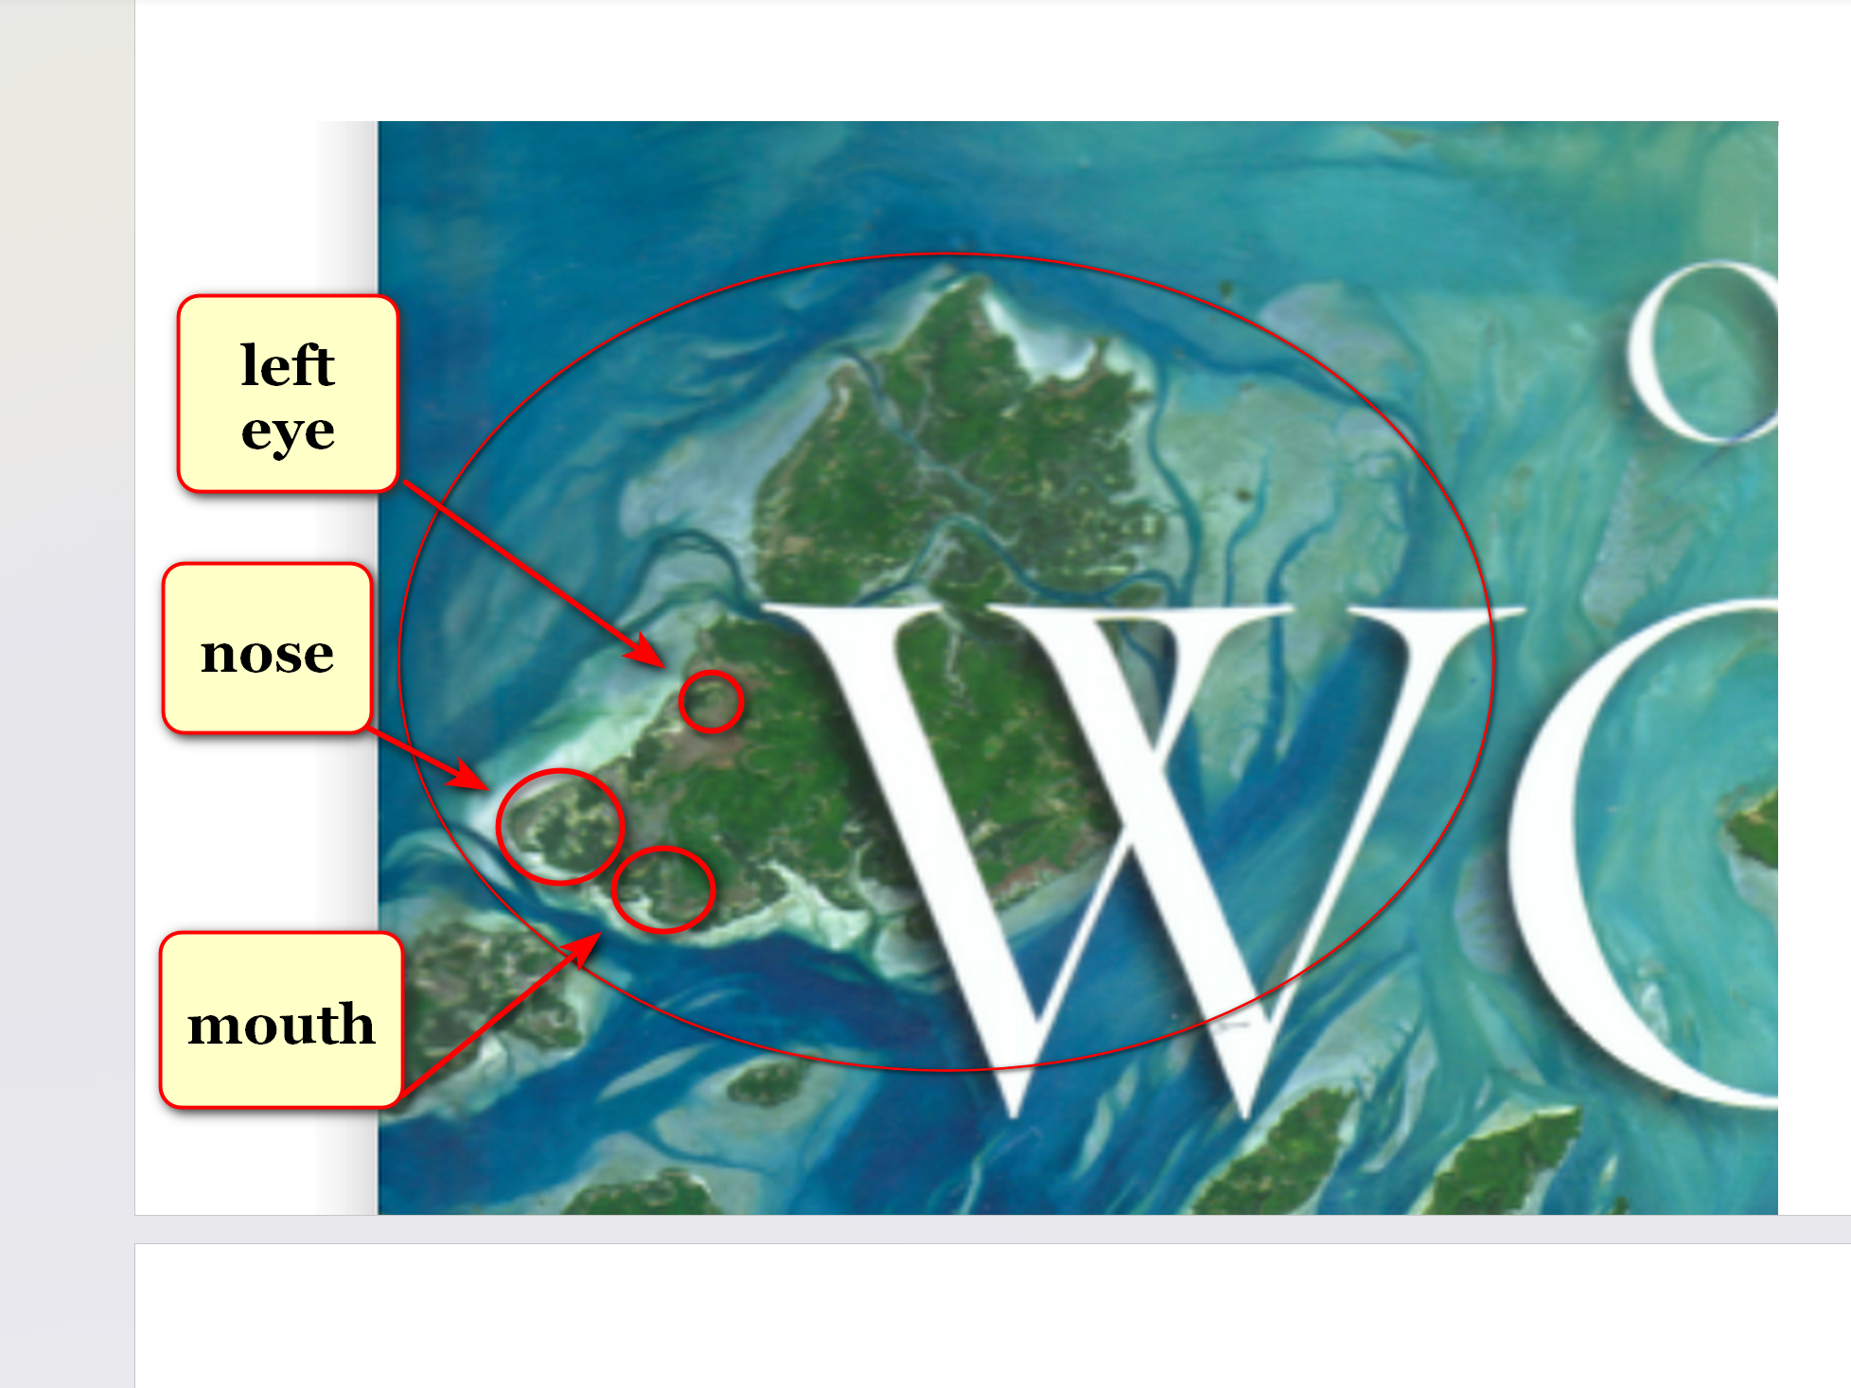

wolf silhouette
symbolize
BEARS approximately 893,200 persons
control all nations' significant actions

in literary tale three little pigs
construct
housing

however BIG BAD WOLF
destroys
housing

in actuality above roles
duplicated
in all nations

three little pigs
symbolize
sincere patriotic citizens diligently constructing better
environments for selves offspring

three little pigs
not grasp
role of BIG BAD WOLF
because unimaginable to patriotic pigs

BIG BAD WOLF
shatters
citizens' attempts improving environments creates disasters including dismantling disaster preparations

BIG BAD WOLF
assumed role
shattering therefore maintain pigs' desperate
reliance on authorities during disaster

BIG BAD WOLF outwardly heroic
gains
textbook recognitions for attempting progress
because BIG BAD WOLF efficiently deceives

plus next generations BIG BAD WOLF
pledged
to cover up weaknesses discovered questioned
later by citizens over time

new colleagues of BIG BAD WOLF
change
history in textbooks based on repelling
honest evaluations from citizens

in this way previous WOLVES
regarded
as heroes

chapter ends

