A01 SMOOTH KEYS weekly polling peace safeguard

if putin and zelensky
adopted
SMOOTH KEYS

then russia ukraine and all nations
would deem
almost impossible for russia to invade
again in future

plus all nations
would deem
almost impossible for ukraine
to ever invade

above
because
in SMOOTH KEYS citizens vote weekly
whether government's actions please or displease

therefore if government
moves troops unjustly
then citizens may recall people responsible
and randomly choose new elder officials

if rest of nations on globe
adopt
SMOOTH KEYS that signals
all other nations similarly

therefore entire group of nations
gain confidence
all other nations shall not invade

in this way warring money
could then be spent on
prebuilding modern cities discussed in other
chapters including I03 J04 through J09

persons occupying desks 21 and 22
gain
lifetime appointments

some prime ministers
occupy
desk 20 and opposition leader 10
or adult family member 10

example possible assignments if those nations
voluntarily chose
this executive style

ukraine

desk 10 denys shmyhal
desk 20 yulia volodymyrivna tymoshenko
desk 21 olena zelenska
desk 22 volodymyr zelensky

russia

desk 10 maria vladimirovna vorontsova
desk 20 mikhail vladimirovich mishustin
desk 21 katerina tikhonova
desk 22 vladimir vladimirovich putin

/www.businessinsider.com/how-old-is-kim-jong-uns-wife-ri-sol-ju-is-he-married-bio-photos-north-korea-2017-9

businessinsider.com's michelle mark

Updated
Feb 26, 2019, 11:14 AM CT

North Korean leader Kim Jong Un and wife Ri Sol Ju
pose with
Chinese President Xi Jinping and his wife Peng Liyuan in Beijing, China. KCNA/Reuters

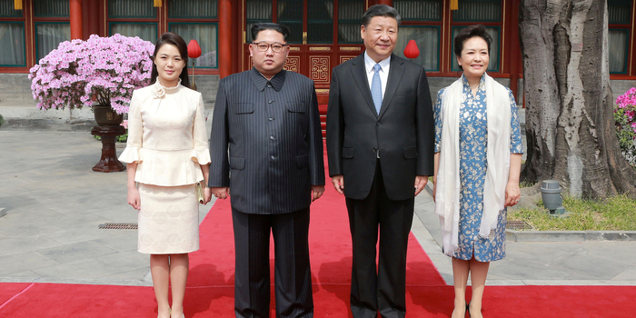

north korea

desk 10 kim song
desk 20 choe ryong hae
desk 21 ri sol ju
desk 22 kim jong un

china

desk 10 Xi Mingze
desk 20 Wang Qishan
desk 21 Peng Liyuan
desk 22 Xi Jinping

iran

desk 10 Badri Hosseini Khamenei
desk 20 Mojtaba Hosseini Khamenei
desk 21 Mansoureh Khojaste Bagherzadeh
desk 22 Ali Hoseini-Khamenei, Ayatollah

denmark

desk 10 Christian Valdemar Henri John
desk 20 Mette Frederiksen
desk 21 Mary Elizabeth
desk 22 Frederik X

example of SMOOTH KEYS helpful effect
includes
ukraine's occupied by russia provinces become
independent neutral nation devoid of military

occupied territories
could combine to create
new independent neutral nation with
own executive crew of 22

new independent neutral nation
for sake of discussion temporarily called
AZOV
not aligned with russia

all persons in AZOV
on or before
2025 march 30 possess AZOV citizenship

new nation AZOV
allows
for example russian ships to refuel
but sailors exit ships without weapons

from airships AZOV quintet rescue squads
keep order
with non bullet guns

AZOV quintet rescue squads' members
include
only women

one feature rescue squad members
descend to ground
only after fleeing actor is incapacitated

2025 entirely new steam powered airships
could start with
proven steam airplane engine design enhanced
with kim's selected researched powering style

Stephen Pope's

www.flyingmag.com/blogs-fly-wire-steam-powered-airplane-anyone/

Besler Brothers (George and William) apparently built the only steam-powered airplane in history to success. With an engine produced by the Doble Steam Motors Co. in Detroit, it put out 150 hp and weighed about 500 pounds.

Most interesting, the Bessler's biplane was capable of extremely short landings because the steam engine was easily reversible.

newspaper reporter’s account of one early test flight at the Oakland, California, airport in the spring of 1933

airplane passed overhead at 100 mph
landing with the propeller suddenly spinning backward, rolling to a stop in less than 100 feet.

Bessler Steam Plane
youtube video of the first demonstration flight on April 12, 1933.

rescue sqads
could utilize
non lethal pellet firing rifles with
crimson Trace Red / green Dot aiming
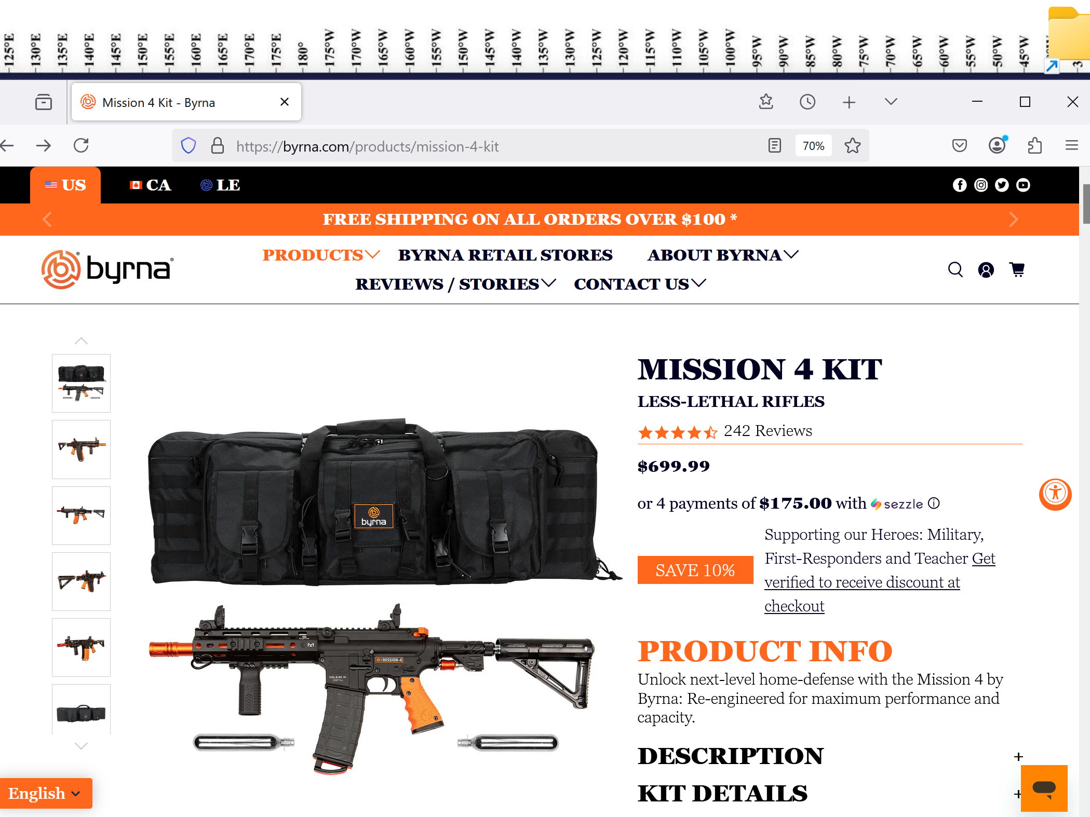

membership of executive crews
include

supreme court judges
occupy
desks 01 through 09

members of parliament
occupy
desks 11 through 19

recurring style of selection
includes
random selection from pool
of eldest members of group

after SMOOTH KEYS adoptions humankind
can start prebuilding
new modern green organized habitat
for humankind

1000 equal sized modern solar cities
could replace
current de facto one world government
of supposedly independent nations

in this initiative nations
could erase
national borders and establish DiameterCities
with three mile buffer zones each

amplifying environmental friendliness humankind
could prebuild
solar powered DiameterCities including Ai homeschooling
dual degrees including electrical engineering degree

entire humankind
could migrate to
rent free titanium residences each with
self sufficient family greenhouse gardens

in this future scenario each citizen
bands with
several hundred favorite persons to populate
one village tower of one DiameterCity

each village tower population
would randomly vote in one
married chieftain couple as family facilitators
from pool of 05 eldest couples

concerning migration destinations chieftain couple wives
hand crank
tumblers to randomly choose which DiameterCity
and which tower for village habitation

chieftain couple wives
accomplish
above selection after all buildings in
1000 DiameterCities prebuilt

achieving that end goal
starts with
current governments adopting even smoother
style of executive decision making

any nation
could accept
leadership role via modeling simple procedural
upgrade in executive decisions SMOOTH KEYS

then humankind's new goal
would include
gaining permissions from 13 north african
presidents to prebuild 1000 modern DiameterCities

then every continent
could create
continental executive group to coordinate full
employment for manufacturing building materials

if case usa started executive order
could create
SMOOTH KEYS presidential advisory group
introducing anonymous discussion and voting styles

SMOOTH KEYS executive crew of 22
would still be subject to
congressional override on vetoes to bills

plus district of columbia voters
would possess
easy method to redeploy 20 of
22 members exchanging places with others

president trump and melania trump
would gain
lifetime appointments similar to
supreme court justices' tenures

if president trump
described
SHOELANGUAGE book's trump chapters as all
truthful and apologizes then usa receptive

trump chapters
include
K01 O04 S06 S10 T05-T10 U01

going forward president trump
could initiate
global tranquility via certain executive orders
including establishing executive crew

SMOOTH KEYS' executive crew of 22
would vote concerning
bills from congress executive orders
military actions pardons etcetera

in other words crew's 22 persons
decide
FAIRNESS for ALL agreed upon by majority
which overcomes any one's blind spot

SMOOTH KEYS
blocks
igniting wars with only one
or two leaders desiring war

SMOOTH KEYS majority rules protocol
insists
at least 12 of crew must
vote YES GO TO WAR

very few if any executive crews
would vote to go to war
to amass patriots' deaths versus
reaching mutual agreements via extraordinary efforts

if war unjust then citizens
could vote out
01 through 20 of executive crew
within three regularly scheduled votes

voting at or near libraries
occur
mondays wednesdays and fridays

if enacted executive crew of 22
would transcend
all other branches governing nation and
assume final word executive legislative judicial

except 2/3d of house and senate
may override

executive crews decisions and reasonings
would appear
in weekly summation booklets available in
for example district of columbia libraries

kim
inserted
population of 500,000,000
for obtaining sample size

box below
shows only
last digits of five hundred million

checkmarket.com's sample needed 16,587

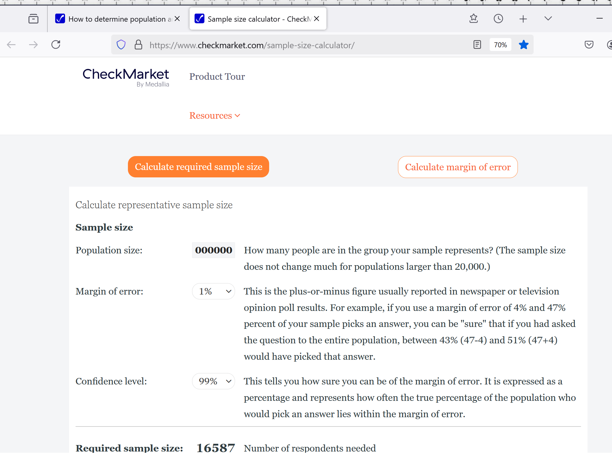

for example if district of columbia
votes NO
three consecutive uninterrupted voting days

then persons from 130 top positions
automatically redeploy
elsewhere in government replaced by others
utilizing random ping pong tumbler method

executive crew
utilizes
geodesic voting domes with 50 feet
diameters each near libraries

library cards
serve as
identifications for voting concerning citizens'
general attitudes concerning crew's actions

library personnel
would stand near
scanning machines monitor scanning
deliver voting pellet

each scan
would deactivate
card through midnight

in this way citizens
would vote at most
only once per voting day

three uninterrupted majority NO votes
would initiate
peaceful redeployment of 20 of executive
crew plus all 110 RESEARCH DEVELOPERS

yet 21st 22nd members of crew
stay
until humankind moves to DiameterCities

in SMOOTH KEYS dictator plus spouse
gain
lifelong memberships even if citizens' three
uninterrupted NO votes replace other members

SMOOTH KEYS scientific group decisions style
enhances
collaborations because utilizes
anonymously written communications

plus group
votes anonymously
YES or NO concerning proposed solutions

SMOOTH KEYS' communiques
will possess
SUNNYsideUP tone comments transcending
emotionally susceptible verbal duels during meetings

routine strategy several days' methodical reevaluations
include exposing
some first glance SUNNYsideUP appearing ideas
as actually SUNNYsideDOWN ideas

when legislature
sends
legislation for president's signature

then that legislation
gains
equivalent of executive crew's tuesday's
YES vote

then like other ideas that bill
undergoes
opposite view scrutiny
until thursday's vote YES or NO

crews plus RESEARCH DEVELOPERS
actively comment
seek clarifications
via in house published memorandums

during projects 130 top decision makers
simultaneously express
various major considerations to colleagues via
booklets' contents published in house

in this way SMOOTH KEYS technique
adds
anonymity to both idea presenters and
commentators harvests wisdom without repercussions

if adopted usa administration's executive crew
includes

all 9 supreme court judges

vice president in desk 10

3 members from senate

6 members from pool of house of
representatives members plus observers

until humankind migrates melania trump
occupies
21st desk

until humankind migrates president donald trump
occupies
22nd desk

president trump
chooses
person to occupy desk 20

in 2028 newly elected president
attains
desk 20

2028's elected vice president
attains
desk 10

president trump
randomly selects
three senators
from pool of 10 eldest senators

president
hand cranks to spin
barrel tumbler to
randomly select three senators

in same way 6 house members
attain
desks of executive crew via
random selection from 15 eldest congresspersons

during random selections each of those
grab
one ping pong ball

ping pong balls
possess
numbers for barrel tumbling

after tumbling without directly looking president
removes
ping pong balls required

selected ping pong ball associated persons
assume
executive crew desks

SMOOTH KEYS scientific decisions style
includes
secret ballot voting from all 22
executive crew members inside same room

each executive crew member
facilitated by
five RESEARCH DEVELOPERS for prioritizing foci
for tasks developing innocuous solutions

RESEARCH DEVELOPERS selection style process
repeats
random ping pong barrel tumbler method

first group
includes
pool of 100 eldest females of
house of representatives

in this way female RESEARCH DEVELOPERS
attain
desks for facilitating
each female executive crew member

pool of 100 eldest congressmen
repeat
above for male RESEARCH DEVELOPERS
facilitating each male executive crew member

five SMOOTH KEYS geodesic domes
located in
ellipse possess offices
for 132 SMOOTH KEYS persons

Public Domain
File: Aerial view of White House and the Ellipse.jpg
Created: Taken on 15 May 2010, 22:48
Uploaded: 15 May 2010

Carol M. Highsmith - This image is available from the United States Library of Congress's Prints and Photographs division under the digital ID highsm.04915.

This work is from the Carol M. Highsmith Archive collection at the Library of Congress. According to the library, there are no known copyright restrictions on the use of this work.
Carol M. Highsmith has stipulated that her photographs are in the public domain.

120 feet diameter central dome
connects
four similar domes north south east west
for combined 360 feet footprint

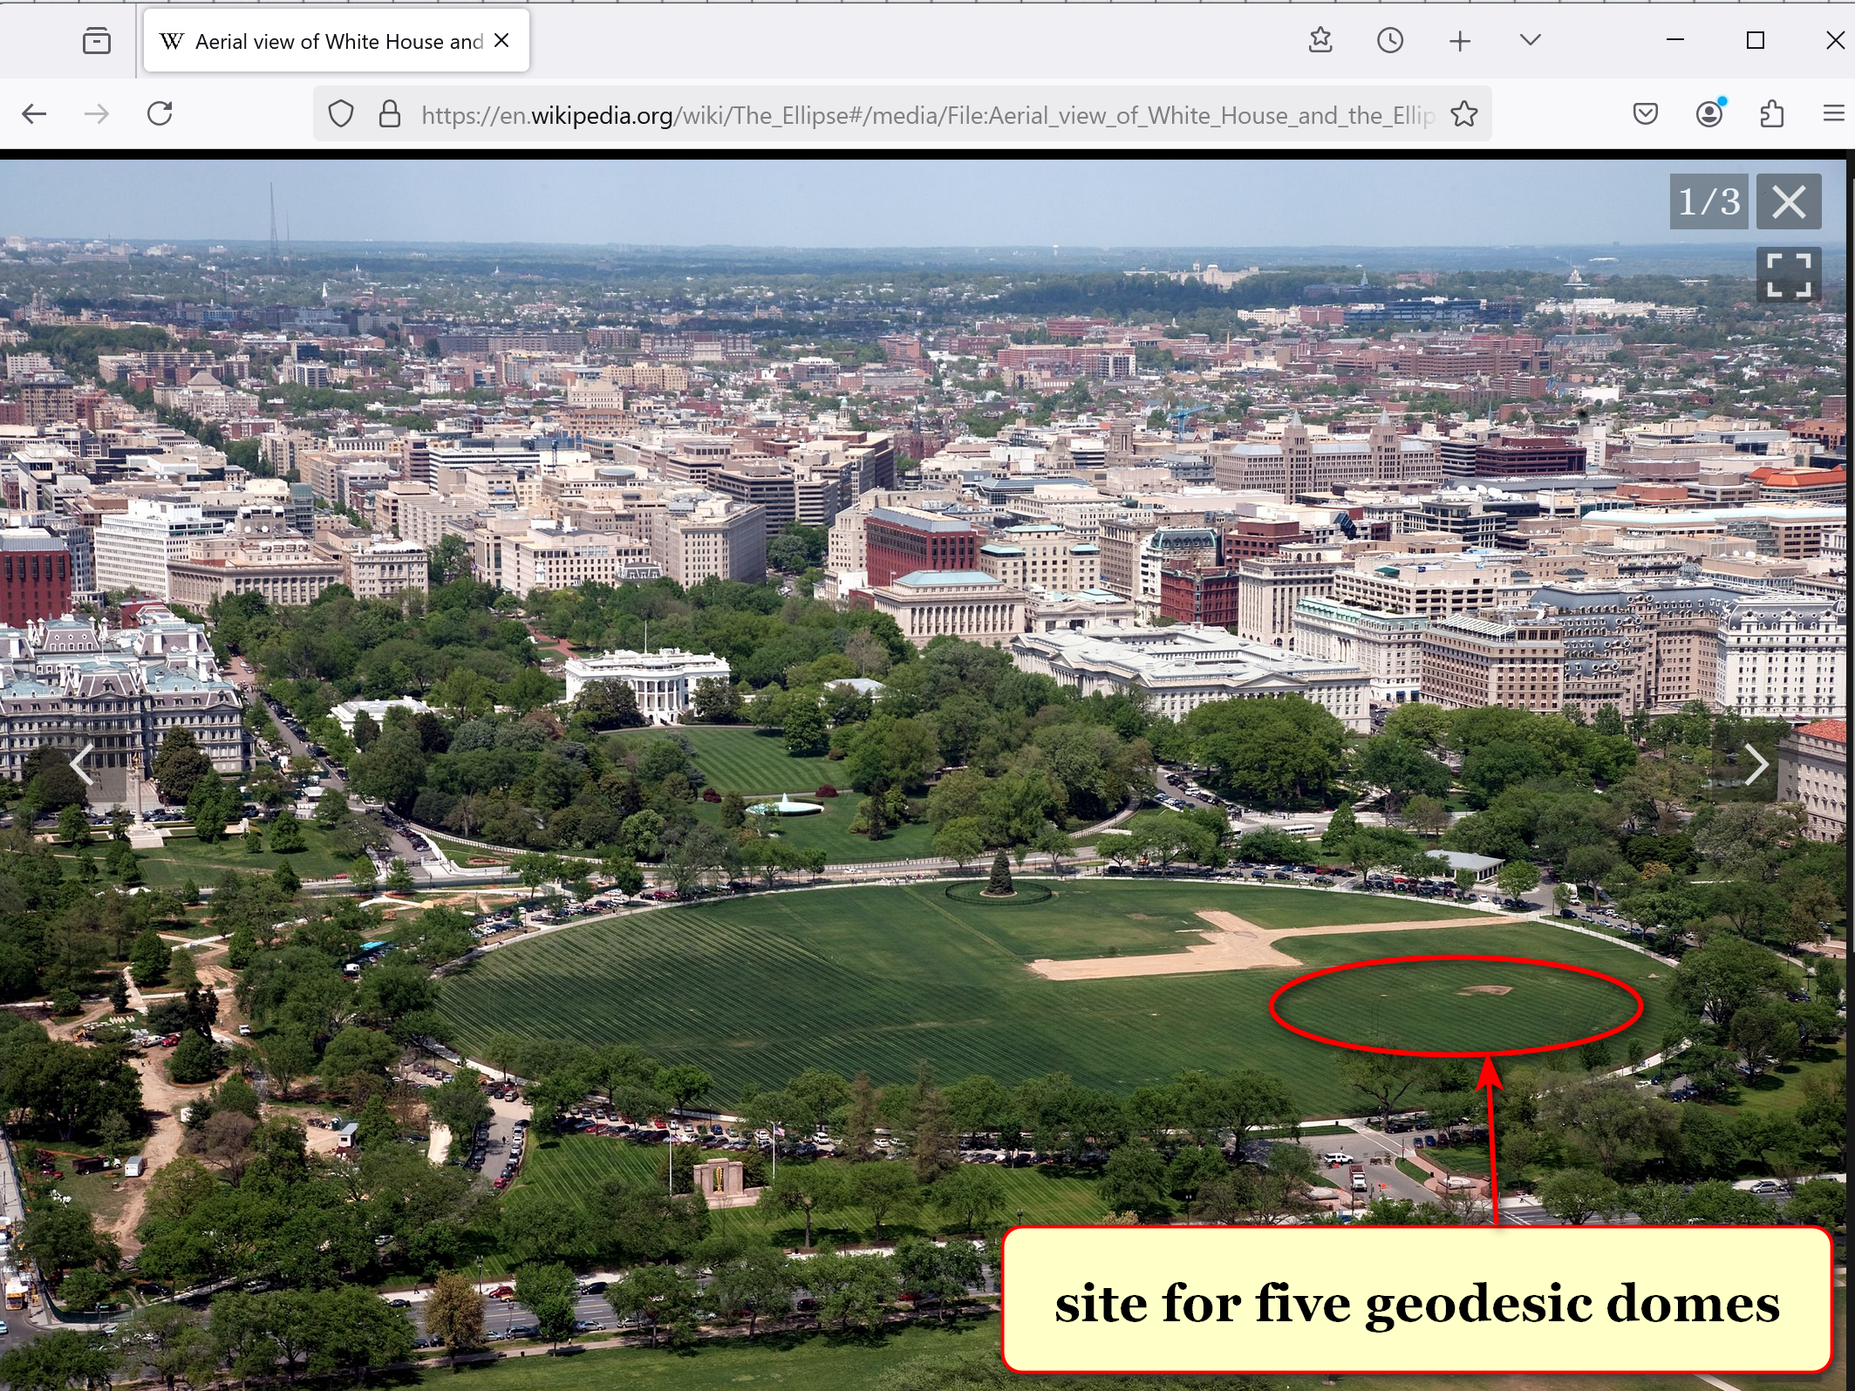

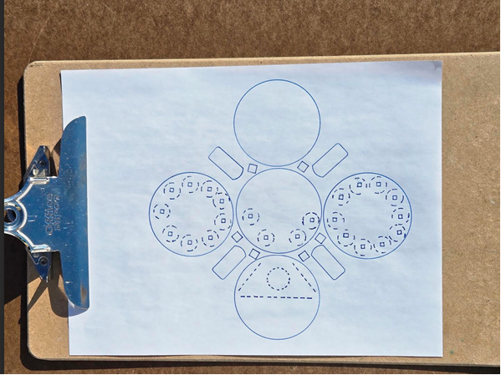

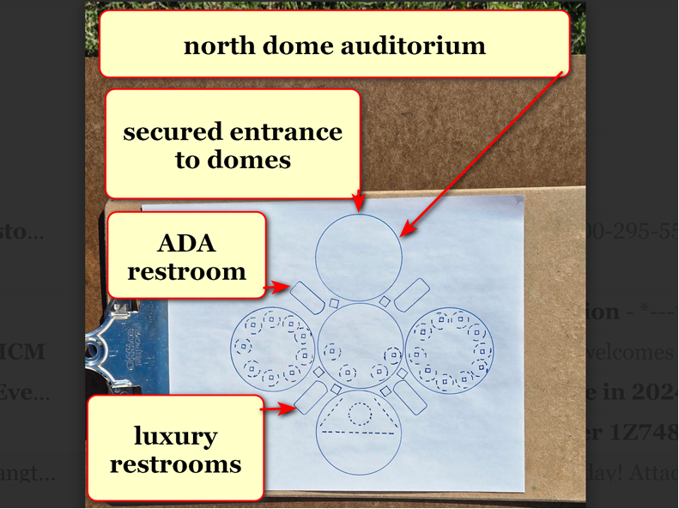

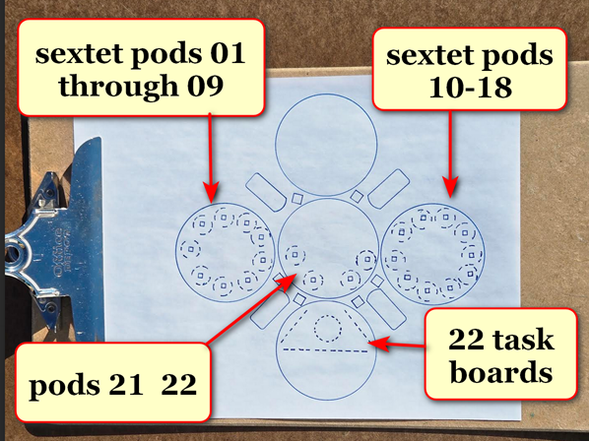

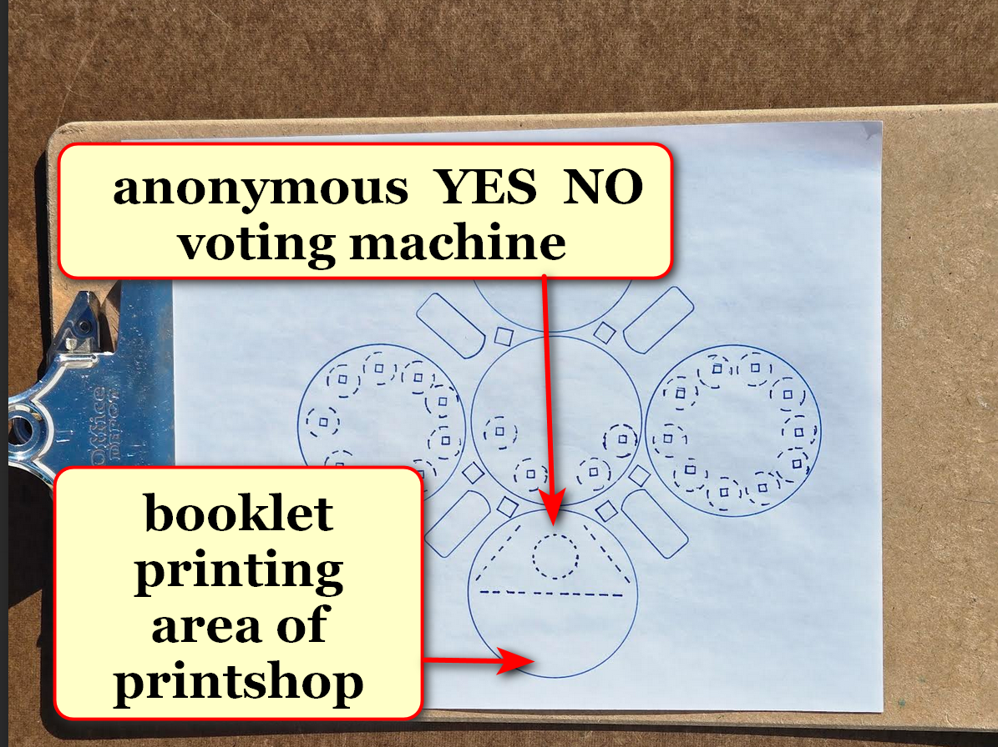

domes
exclusively host
executive crew of 22 plus 110
RESEARCH DEVELOPERS plus in house printer

all persons above
may view freely and repeatedly
all top secret unredacted unsummarized media

therefore persons working inside decision domes
solve
situations as equal colleagues

other connecting including with news media
occur
elsewhere far from domes

with above simplification secret service
more easily protects
all persons equally from outside domes
along perimeter securing safety of group

secret service agents
operate
north dome for screenings

executive crew plus RESEARCH DEVELOPERS
store
camera devices including cell phones in
north dome lockers during workdays

2024 cost for constructing and
equipping
all DC domes including ellipse's
domes equals 144.3 million dollars

private donations to construction supervisor kim
endow
kim's paying for constructing plus equipping
domes

if proposed SMOOTH KEYS persons
accept
enhanced roles

plus if district of columbia
provides
land near 25 libraries for geodesic
domes of 50 feet diameters

then private citizen kim
more easily starts gathering
private donations

also with donations kim
purchases
materials for constructing kim's invented
YES NO voting machines non electronic

SMOOTH KEYS
places
YES NO voting machines within new
geodesic domes in district of columbia

then district of columbia residents
gain
25 easily accessible polling structures
near libraries

plus same 25 solar powered structures
serve
as resource areas in cases of
weather emergencies

free dome resources for end users
include
water ice electricity

above
via
air to water machines ice machines
cellphone recharging outlets all solar powered

in polling domes citizens
say
YES or NO three times weekly
concerning decisions of executive crew

above check and balance system
behooves
executive crew
keeping public informed reasons for actions

kim
requests
president trump's issuing
two other executive orders

second recommended executive order

treasury department
immediately complete
process of placing tubman's image on bill

from then on $20 bills
remind
citizens of president trump's unifying action

nytimes.com's alan rappeport

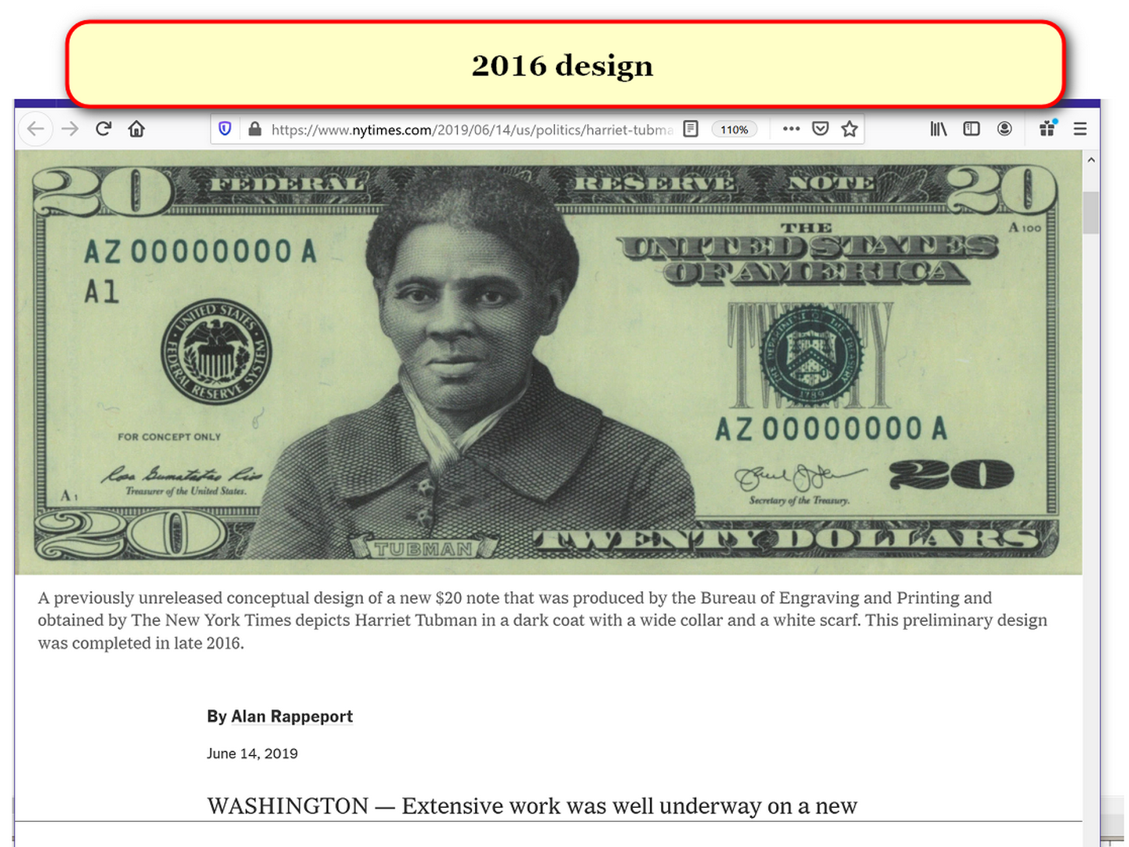

third recommended executive order
abolishes
death penalty in usa
institutes 20 year maximum like northern europe

2024february21
afsc.org's peniel ibe's
It's time to repeal the death penalty

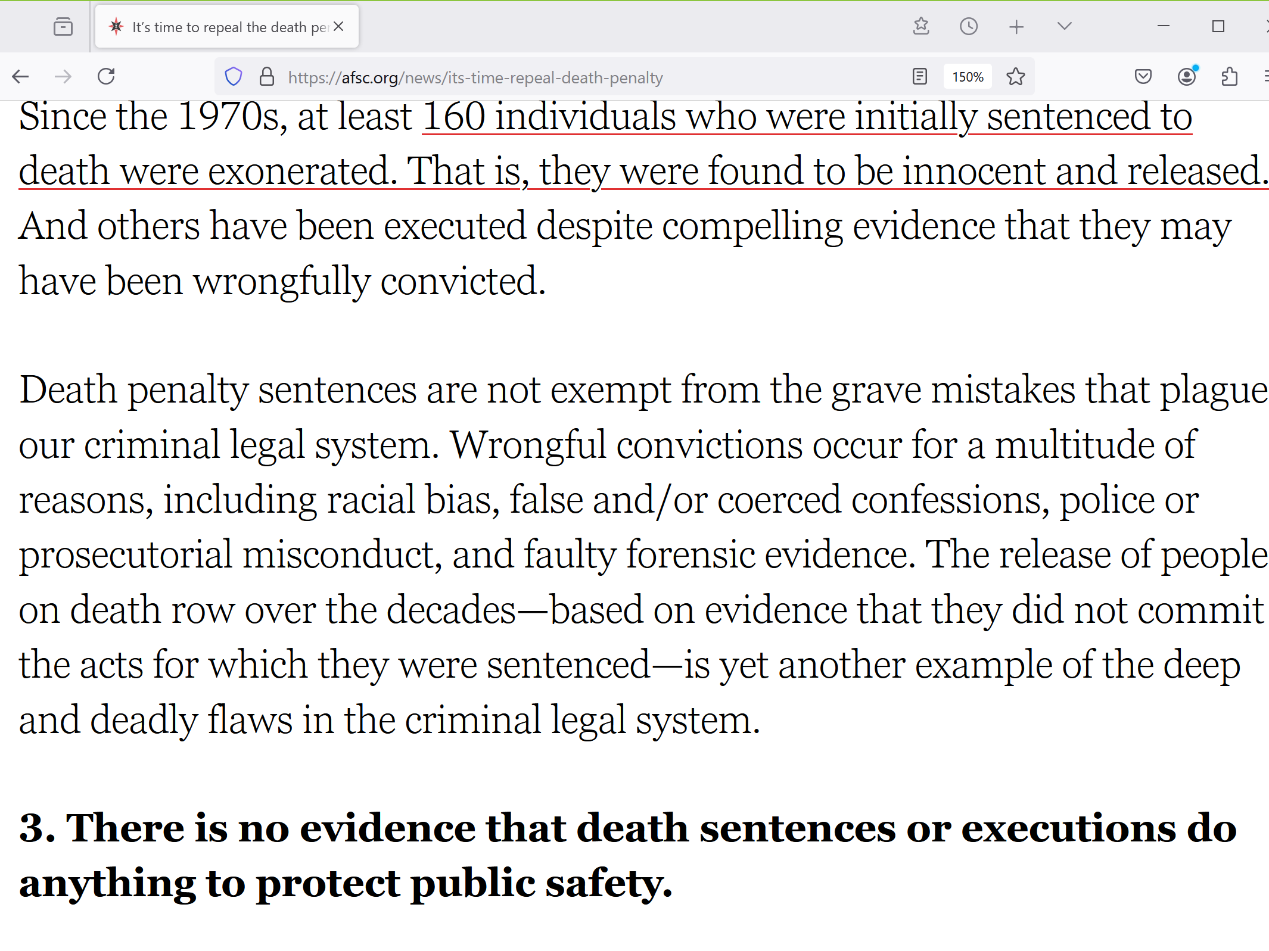

sentencingproject.org's



As discussed above, in countries such as Germany and Norway, periods of incarceration rarely exceed 20 years, including for homicide offenses.

Research shows that, while very serious, committing homicide is typically an isolated offense.

When individuals who commit homicides return to the community, their likelihood of committing another homicide is extremely low, typically 1-3%.

The majority of individuals convicted of homicide will never violently recidivate.
above mentioned executive orders
end
BEARS usa as organization therefore president
trump and vp vance even safer

WEEKLY ROUTINE DETAILS concerning SMOOTH KEYS

supreme court justices
shall occupy
desks
one through nine of executive crew

supreme court
controls
volume of cases for voluntary review

constitution
allows
supreme court if court desires
to hear zero cases per year

before SHOELANGUAGE book supreme court
ruled on
less than 85 cases per year

weekly SMOOTH KEYS' 110 RESEARCH DEVELOPERS
review
incoming cases for total 22 taskings weekly

those cases needing review
join
all other pressing matters

110 RESEARCH DEVELOPERS in quintets
evaluate
events decide on three most pressing
matters for that week's crew's votes

then executive crew
chooses
22 most urgent tasks
from 66 suggestions

decision domes' officials' anonymously written arguments
replace
oral arguments

in SMOOTH KEYS system justices' wisdom
helps shape
tasks' resolutions during creations
rather than afterwards

hopefully executive crew
successfully handles
affairs of country very well for
both four year terms

however three uninterrupted citizen NO votes
initiate
changing 20 persons of executive crew
plus 110 research developers

those crew members plus research developers
redeploy
to original offices duties
or to other usa government role

for filling executive desks 1-9 president
randomly ping pong chooses
9 federal judges from pool of
30 eldest federal judges

9 supreme court justices
switch
roles with those 9 federal judges

those 9 federal judges
gain
increased pay to executive crew rate

9 supreme court justices' wages
revert to
supreme court wages

plus crew desks 10 and 20
now occupied by
congresspersons chosen via ping pong method

initially 110 RESEARCH DEVELOPERS desks
seat
25 cabinet plus cabinet level persons
TABLE BELOW

cabinet level persons
secretaries of departments
RESEARCH DEVELOPERS

executive desk numbers research developer numbers

01 samuel alito 001 agriculture
brooke leslie rollins

002
003
004
005

02 amy coney barrett 006 attorney general
pamela jo bondi

007
008
009
010

03 ketanji brown jackson 011 commerce
howard william lutnick

012
013 council of economic
advisors
stephen ira miran

014
015 veterans affairs
douglas allen collins

04 neil gorsuch 016 CIA
john L ratcliffe

017 FBI head
kash patel

018 director of national
intelligence
tulsi gabbard

019 homeland security
kristi lynn arnold noem

020 nation security advisor
michael george waltz

05 elena kagan 021 education
linda mcMahon

022 defense
peter brian hegseth

023 border czar
thomas douglas homan

024
025 solicitor general

06 brett kavanaugh 026 energy
christopher allen wright

027
028 environmental
protection agency
lee michael zeldin

029
030 interior
ryan keith zinke

07 john roberts 031 health and human
services
robert f kennedy jr
032
033 housing and urban
development
eric scott turner

034
035

08 sonia sotomayor 036 labor
lori chavez-deRemer

037
038 small business
administration
kelly Lynn Loeffler

039
040

09 clarence thomas 041 office of management and budget
russell thurlow vought

042 treasury
scott kenneth h bessent

043

044
045

10 vice prez JD vance 046 office of science and
technology policy
michael k kratsios

047
048
049
050

11 legislator 051 state
052
053 ambassador to un
elise marie stefanik

054

055 us trade representative
jamieson lee greer

12 legislator 056 transportation
sean patrick duffy

057 drctr of nat econ cncl
kevin allen hassett

058
059
060

13 legislator 061 national institutes health d
062
063
064
065

14 legislator 066 federal comm comm chair
brendan thomas carr

067
068
069
070

15 legislator 071 centers for m.care & cade
072
073
074
075

16 legislator 076 077
078
079
080

17 legislator 081
082
083
084
085

18 legislator 086
087
088
089
090

19 legislator 091
092 093
094
095

20 selected by president 096
097
098
099
100

21 melania trump 101 deputy chief of staff
stephen miller

102

103
104
105

22 president trump 106 white house chief of staff
susan wiles

107 assistant to president
sergio gorokhovsky

108 press secretary
karoline claire leavitt

109 communication director
huyen steven cheung

110 white house counsel
david alan warrington

precise hourly compensations
more fair than
salary because of employers' plantation like
expectations possessing no time boundaries

executive crew members
gain
equal compensations to president's compensation

each member of executive crew
compensated
193 dollars per hour
based on 40 hour week

each RESEARCH DEVELOPER
compensated
145 dollars per hour
based on 40 hour week

executive crew of 22 voting
occurs
tuesdays at 10:00 in morning
then thursdays at 16:30 in afternoon

both days' majority YES votes
needed
to propel task forward officially

plus executive crew members
possess
specific times to evaluate comments
attached to physical bulletin boards

SMOOTH KEYS details
appear in
A02 executive crew
RESEARCH DEVELOPERS routine

chapter ends

