007 Kursk uss Cole Lesin Krivov Nemtsov Navalny Churkin

example of BEARS helping BEARS
includes
russian president putin and usa presidents

1990's BEARS boris yeltsin and bill clinton
welcomed
vladimir putin into global gang

personally usa president bill clinton
planned to pay
two lives BEARS dues by arranging
deaths of sailors on uss cole

in auckland new zealand bill clinton
off cameras advised
putin to act similarly to
pay putin's BEARS initiation fees

with extensive planning putin
arranged
russian submarine disaster

2000 august 12 kursk disaster
killed
all 118 trusting patriotic sailors

2000 october 12 uss cole bombing
killed
17 trusting patriotic sailors

commander in chief president bill clinton
gave
first order down chain of command
for uss cole to break protocol

uss navy protocol
includes
making all vessels approaching navy ship
identify selves or risk destruction

example of megaphone
for
loudly warning approaching vessel to avoid
close dangerous proximity to naval ship

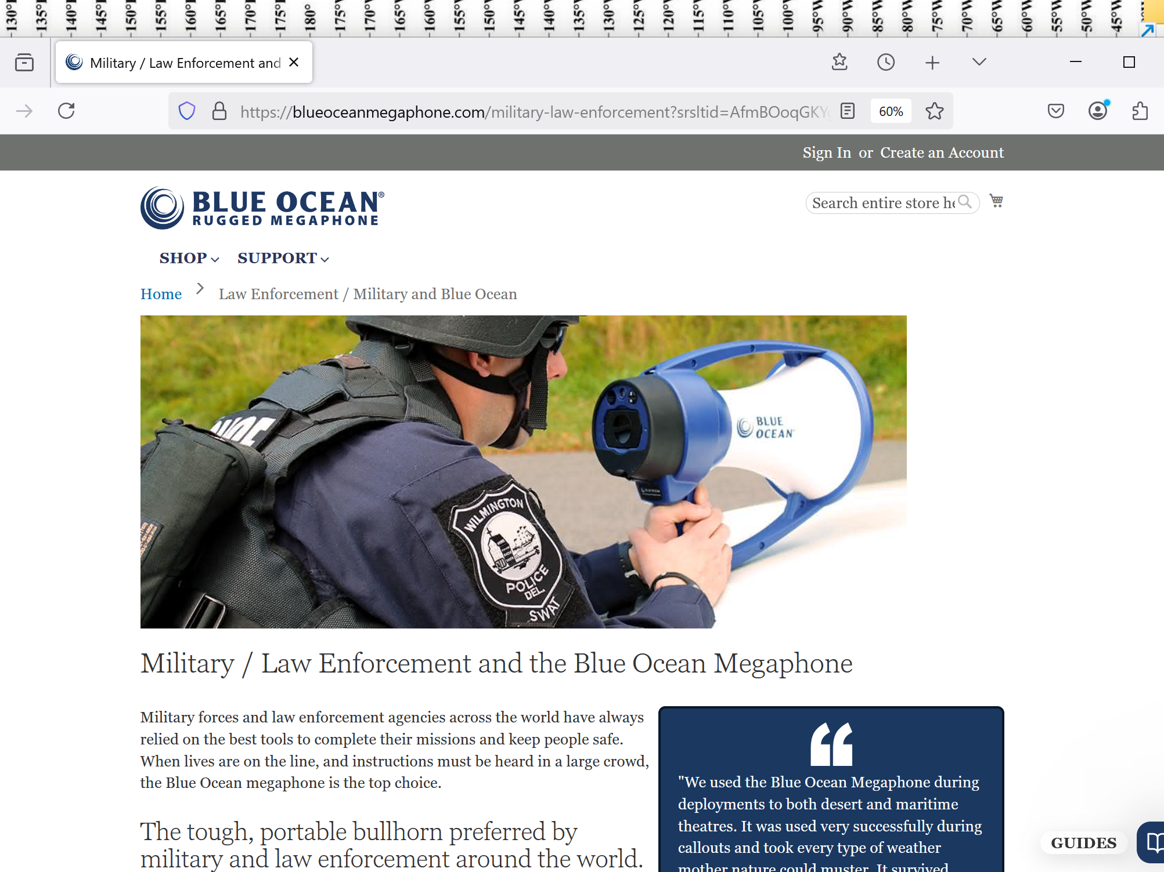

archived picture below
shows
sailors of russian submarine KURSK

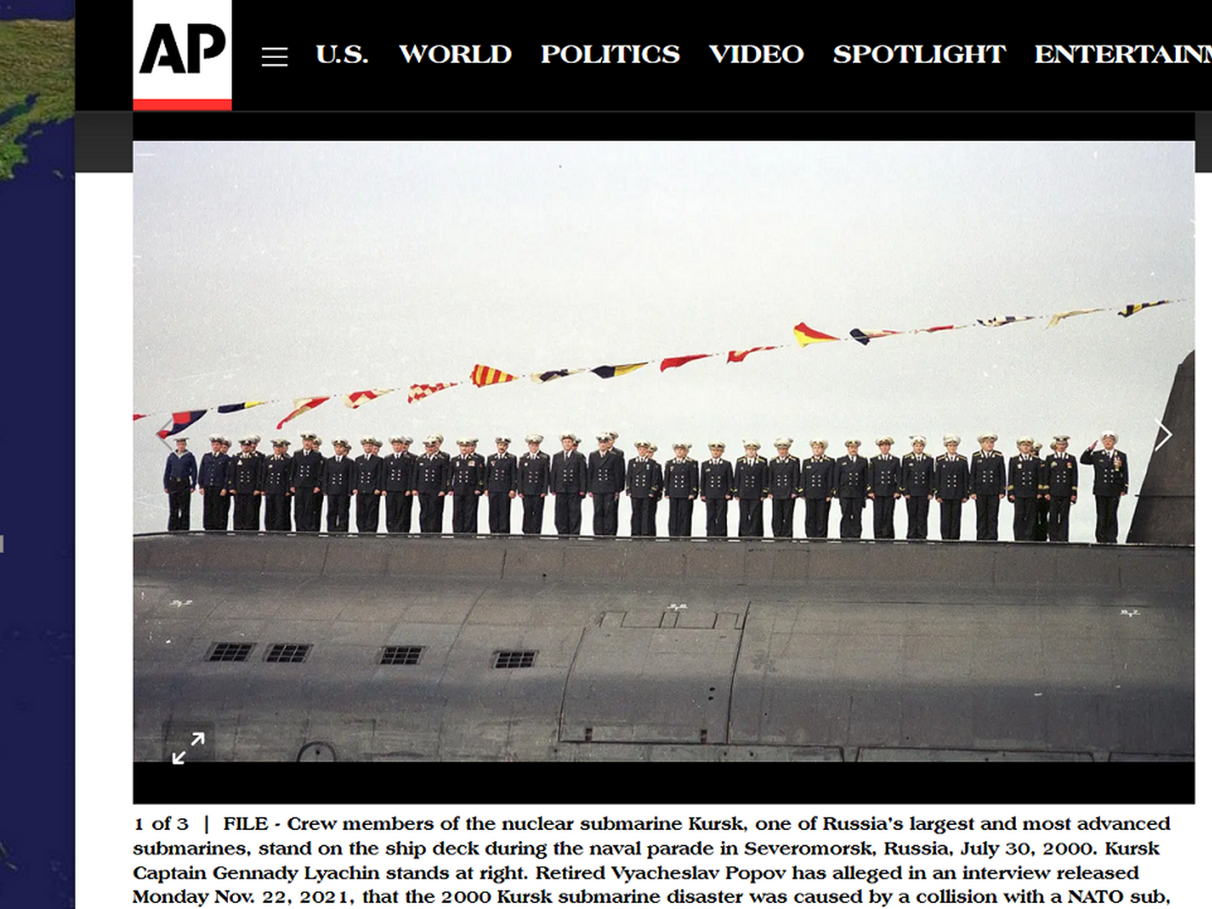

global president of BEARS bill clinton
provided
two usa submarines to help
russia's putin kill 118 russian sailors

putin
disallowed
foreign rescuers for 48 hours
to make sure all sailors died

putin
eventually paid
families blood money

later putin
forbade
media
mentioning kursk submarine deaths

in this example BEARS newcomer putin
took
advice from global BEARS president
usa president bill clinton

paranoid BEARS member russian president putin
desired staying
in power without even slight possibility
future opponents live to challenge presidency

putin
killed
not only current rivals but even
merely possible future rivals

global BEARS president usa president obama
gave
BEARS putin permission for killings and
gave help

BEARS global president obama
supplied
BEARS bribed physicians
for killings on usa soil

those victims
included

Mikhail Lesin on November 5, 2015, in Washington in a Dupont Circle hotel

BBC's article
2016 march 11 concerning
2015 november 05

ww.bbc.com/news/world-us-canada-35781333

Former Putin aide Lesin died of 'head injuries'

reuters photograph below

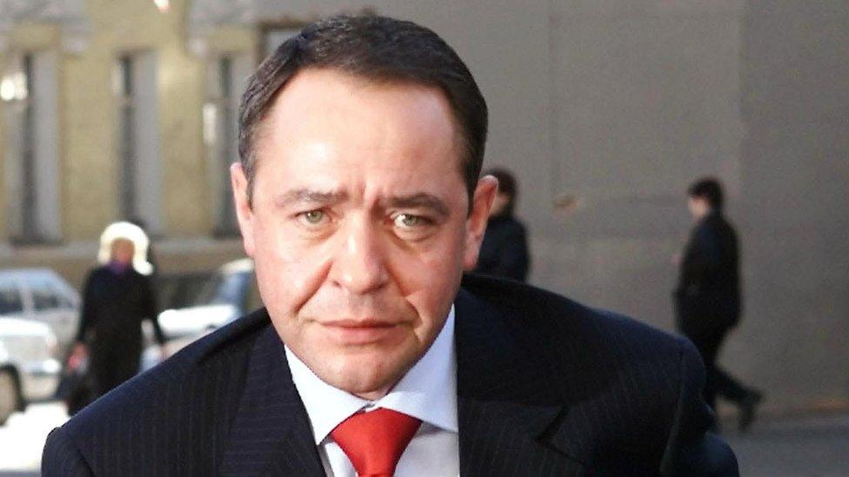

A former aide to Russian President Vladimir Putin, who was found dead in a US hotel four months ago, died of head injuries, US coroners say.

Mikhail Lesin, 57, also had blunt force injuries to the neck, torso, arms and legs, Washington DC's chief medical examiner said, without concluding how the injuries had been sustained.

He was one of the most influential figures on the Russian media scene.
A former Russian press minister and one-time head of the powerful Gazprom-Media Holding group

www.vbirstein.com

vadim birstein

I recall that when Mikhail Lesin died in the city of Washington, there were also official reports about a heart attack.

As an investigation by the Federal Bureau of Investigation (FBI) showed, it turned out that he died of numerous injuries,

In the last paragraph Venediktov
refers to
the strange death of Mikhail Lesin on November 5, 2015, in Washington in a Dupont Circle hotel.

For a long time, from 1999 to 2009, he was an influential player in Putin’s circle with the nickname “Bulldozer.”

From 2011-2013, Lesin
lived in
Beverly Hills, California, and created a corporation to buy expensive homes.

Then he was back to Russia, where he headed the Gazprom-Media, the state controlled media giant.
In December 2014, he resigned and according to the press, planned to continue business in the US.

On March 10, 2016, the Washington D.C. medical examiner declared the results of the autopsy:

Lesin died of blunt-force injuries to his head,
and not of a heart attack, as the Russian mass media had announced.

On October 28, 2016, the D.C. chief medical examiner announced it’s final finding that

Lesin “sustained the injuries that resulted in his death while
alone
in his hotel room.”

However, all circumstances of the death are so suspicious that it’s hard to believe that Lesin was not killed.
Russian consular staff told the BBC that Lesin had died of “a heart attack” This death remains a mystery.

2025 ali watkins now with new york times in london

however in 2017
buzzfeed.com's
ali watkins



Ali Watkins was a national security correspondent for BuzzFeed News and was based in Washington, DC.

2017 february 15

www.buzzfeednews.com/article/alimwatkins/the-strange-case-of-the-russian-diplomat-who-got-his-head-sm

The Strange Case Of The Russian Diplomat Who Got His Head Smashed In On Election Day

How did Sergei Krivov die? And why did NYPD close the case?

Initial reports said the nameless man had plunged to his death from the roof of the consulate.

As journalists rushed to the scene, consular officials quickly changed the narrative.

The anonymous man had not fallen dozens of feet from the roof of the consular building, they said,

But a November report from Sputnik, the English-language Russian media outlet,
says he was a consular duty commander.

That position is no ordinary security guard. According to other public Russian-language descriptions of the duty commander position,

Krivov would have been in charge of, among other things, “prevention of sabotage” and suppression of “attempts of secret intrusion” into the consulate.

It was likely Krivov who helped transmit cables in and out of the heavily guarded building

KIM NOTES

kim
takes
only small leap more to conclude

PUTIN
helped elect
trump then putin killed
russian insider with that KNOWLEDGE

plus on russian soil putin
killed
electable persons

boris yefimovich nemtsov
born 9 October 1959
Sochi, Soviet Union

gunned down 27 February 2015 (aged 55)
Moscow, Russia

/www.rferl.org/a/boris-nemtsov-a-life-and-death-in-pictures/29793952.html

2020 february 25

in 1997 and 1998 boris nemtsov
held position of
boris yeltsin's deputy prime minister

Russian Federation President Boris Yeltsin and Nemtsov at a tennis event in Nizhny Novgorod in 1994.

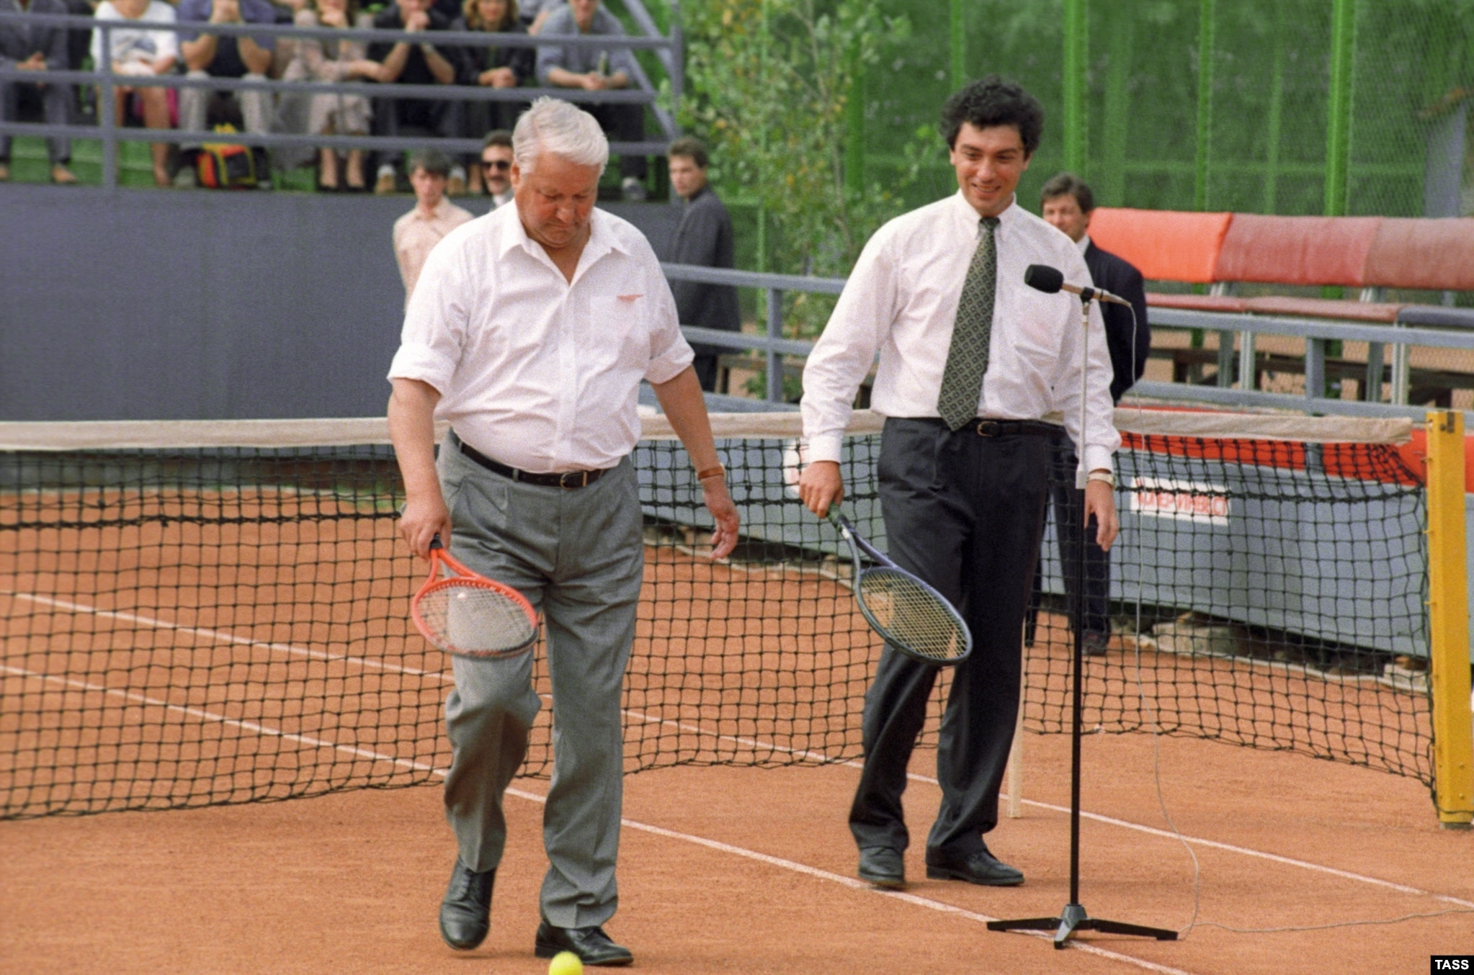

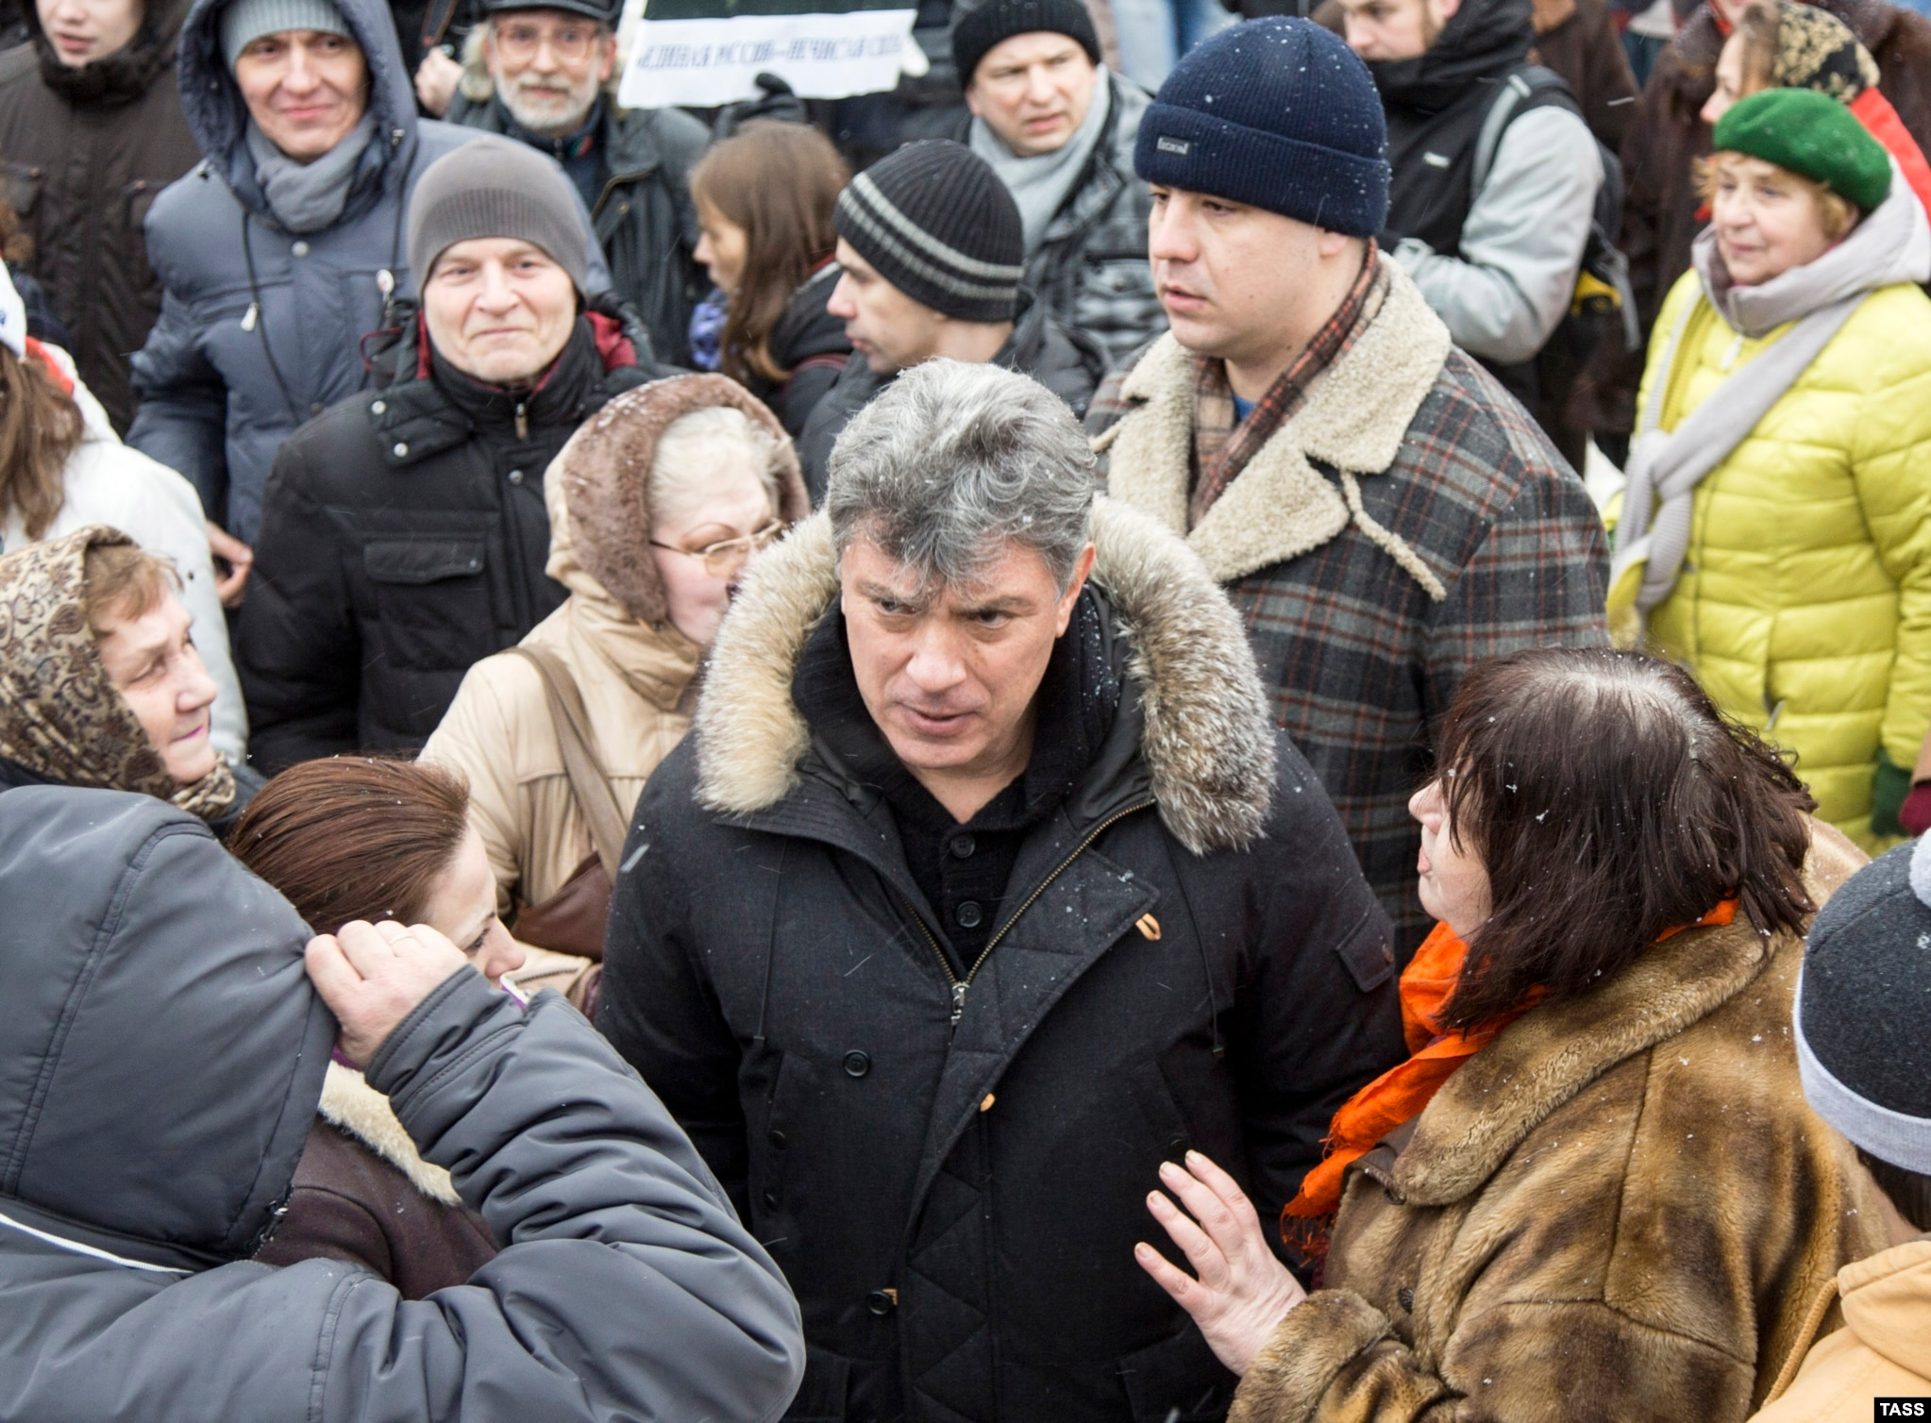

KIM NOTES

putin
killed
electable boris nemtsov

.bbc.com/news/world-europe-60878663
Bellingcat, The Insider and the BBC found evidence that Nemtsov was shadowed on 13 trips before his murder.

Bellingcat has previously used data from Magistral to investigate assassination attempts in Russia. Their investigations revealed evidence of the existence of a secret hit squad within the FSB, which has targeted opponents of the Kremlin. The Russian government has always denied these allegations.

For this investigation, we got hold of the train and flight reservations made by Mr Sukharev - and when we compared them to the known movements of Boris Nemtsov, an unmistakable pattern emerged.

Boris Nemtsov rose to prominence in the 1990s, served as deputy prime minister under President Boris Yeltsin, and was widely tipped to be Yeltsin's successor.

Instead, Mr Putin came to power and Mr Nemtsov was pushed to the margins of Russian politics. He became an effective campaigner, exposing corruption and denouncing Russia's 2014 attack on eastern Ukraine.

On 27 February 2015, Mr Nemtsov was shot dead just yards from the Kremlin, and just days before he was due to lead a protest against the war.

KIM NOTES

patriotic Nemtsov
protested
russia's war against ukraine

findagrave.com

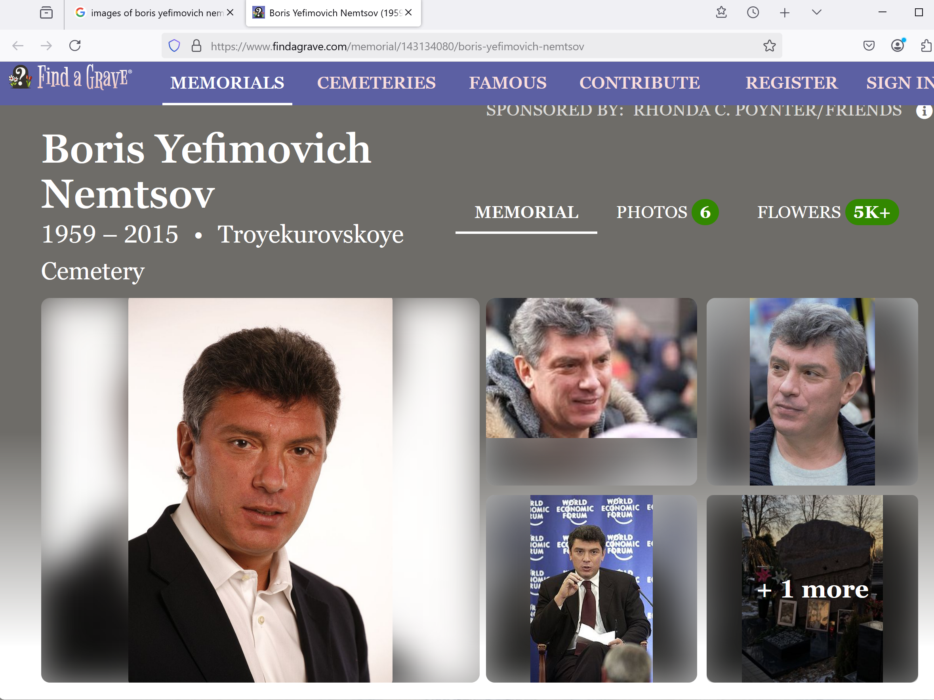

on russian soil putin
killed
alexei anatolyevich navalny

/en.wikipedia.org/wiki/Alexei_Navalny
1976 june 04 to 2024 february 16

reuters.com

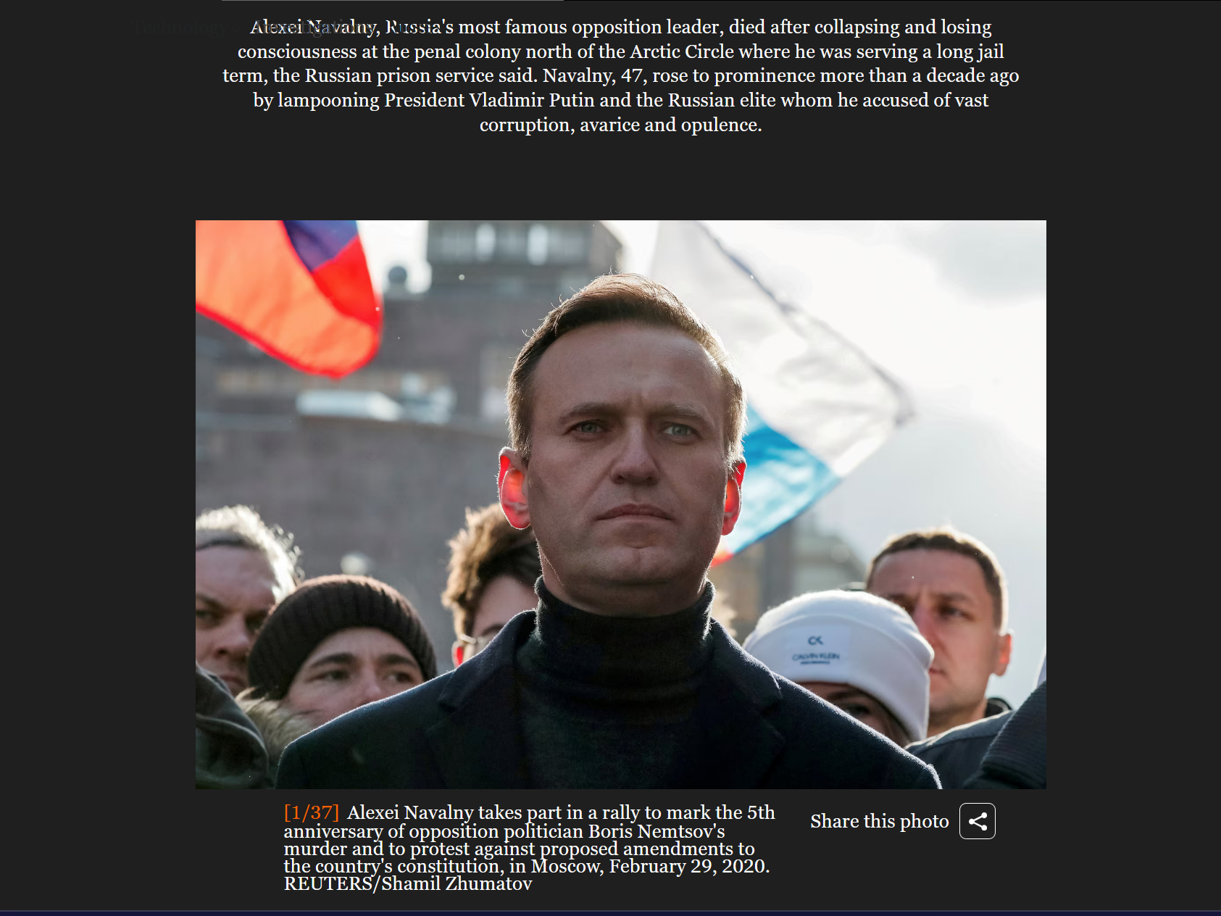

/archive.ph/20240218015905/https://meduza.io/en/news/2024/02/17/several-prison-cameras-not-working-on-day-of-navalny-s-death-says-human-rights-group-gulagu-net#selection-259.0-288.0

Several prison cameras not working on day of Navalny’s death, says human rights group Gulagu.net

9:16 am, February 17, 2024
Source: Gulagu.net

On the day of Alexey Navalny’s death, several cameras in the prison colony where he was being held were not operating says Gulagu.net, a human rights group that focuses on the rights of prisoners in Russia.

Their claim is based on a report which was attached to an official inspection of the Federal Penitentiary Service of the Yamalo-Nenets Autonomous District.

According to the Gulagu.net source, two days before Navalny’s death, FSB officers came to the colony, which, as Gulagu.net suggests, disconnected and dismantled listening devices and hidden cameras “that could have recorded what happened to Alexey Navalny on February 15-16.”

Additionally, they claim that on the evening of February 16, the expert conducting the autopsy was verbally instructed to describe the bruises on Alexey Navalny’s body as having occurred after death.

://thehill.com/homenews/campaign/4476866-haley-calls-trump-weak-in-the-knees-on-putin-after-navalny-death/

by Sarah Fortinsky - 02/19/24 11:04 AM ET

“Not at all,” Haley said in a Monday interview on Fox News’s “Fox & Friends” when asked by Steve Doocy whether she and Trump were “on the same page when it comes to Russia.”

“I mean it’s amazing to me how weak in the knees he is when it comes to Putin.

Because you look at the fact, he has yet to say anything about Navalny’s death,”

Haley continued, quickly adding,
“Putin murdered him.
It’s what he does to his political opponents.”

/www.nationalreview.com/corner/nikki-haley-suggests-that-putin-murdered-his-u-n-ambassador/

By Jimmy Quinn

August 24, 2023 8:21 PM

When Nikki Haley served as U.S. ambassador to the U.N., her Russian counterpart, Vitaly Churkin, died suddenly at the age of 64.
During the GOP primary debate last night, she suggested during a heated exchange with Vivek Ramaswamy that she believes Vladimir Putin had him killed.

“Look at one Putin did today. He killed Prigozhin,” she said, referring to the reported death yesterday of the paramilitary leader who led an aborted mutiny in June. “

A jet carrying Prigozhin was either shot out of the sky in Russian airspace or blown up by a bomb on board, which U.S. officials reportedly believe is a possibility.

When I was at the U.N., the Russian ambassador suddenly died.

This guy is a murderer, and you are choosing a murderer over a pro-American country,” she said,

asserting that Ramaswamy’s plan to end the war in Ukraine would hand the country to Vladimir Putin.

on usa soil putin and trump
killed
russian un ambassador Vitaly Ivanovich Churkin

2017 february 20 monday
Russian ambassador to UN rushed to hospital

Story by
jamie schram and Gina Daidone

//nypost.com/2017/02/20/russian-ambassador-to-un-rushed-to-hospital/

Vitaly Churkin Getty Images
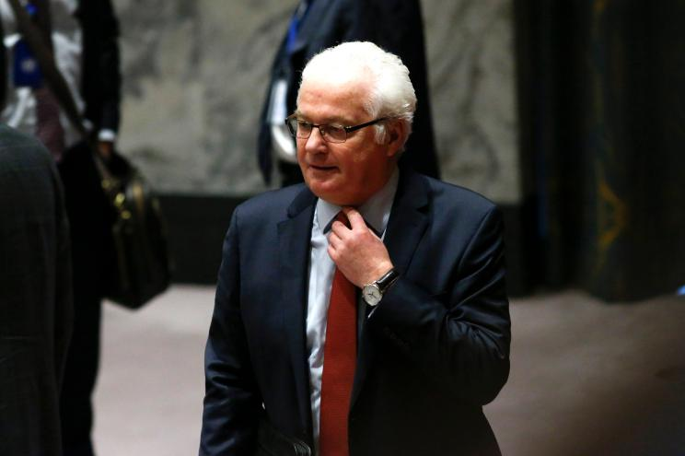

Russia’s ambassador to the United Nations was rushed to a Manhattan hospital Monday morning
sources told The Post.

Vitaly Churkin was at the Russian embassy on East 67th Street when he became sick around 9:30 a.m., sources said.

He was unconscious and needed CPR when he was rushed to New York Presbyterian Hospital.

The 64-year-old diplomat has served as Russia’s permanent representative to the UN since 2006.

2017 february 20
w.wbur.org/news/2017/02/20/russia-ambassador-dies

associated press's
Edith M. Lederer and Jennifer Peltz

Vitaly Churkin, died suddenly Monday after falling ill in his office at the mission, Russian officials said.
Churkin, 64, was rushed to New York-Presbyterian/Columbia University Medical Center in New York,
where he died

Russia's deputy U.N. ambassador, Vladimir Safronkov, told The Associated Press.
His cause of death wasn't immediately known.

KIM NOTES

BEARS global president trump
assisted
putin's poisoning of churkin because churkin
possible presidential opponent favorite of many

president trump
forbade
NY hospital announcing details of churkin's
death therefore blocking investigators and family

www.vbirstein.com

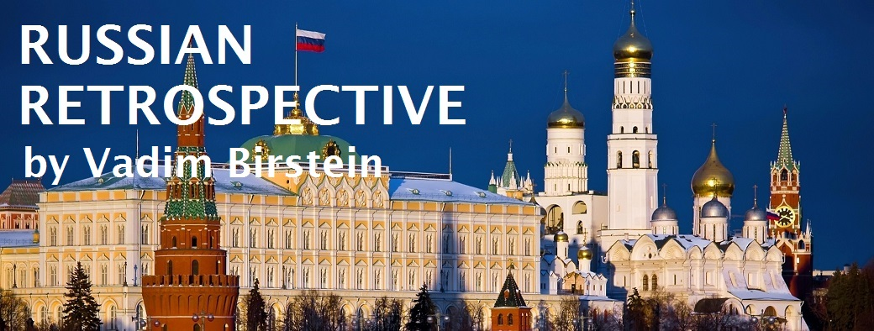

The Convenient Death of Vitaly Churkin

On February 27, 2014, Russian troops in unmarked green uniforms, the so-called “green men” or “polite people”, as the Russians called them, entered Crimea.

On March 4, 2014, at an emergency meeting of the UN Security Council Russia’s ambassador to the UN,

Vitaly Churkin, delivered a notarized copy of a letter written by Viktor Yanukovych, at the time pro-Putin Ukrainian President,

in which he appealed to the Russian leadership to invade Ukraine to save his regime.

At that time, Yanukovych, who on February 25th agreed to resign and later refused to do so, fled to Russia with the help of Russian secret services . The letter, dated March 1, 2014, stated (my translation from Russian):

As the legally elected President of Ukraine, I declare: the events at the Maidan, the illegal seizure of power in Kiev led to Ukraine being on the verge of civil war.

There is chaos and anarchy in the country.

The life and safety of people, especially in the southeast [of the country] and in the Crimea, is under threat.

Under the influence of Western countries, open terror and violence are carried out.

People are persecuted on political and linguistic grounds.

In this connection, I appeal to Russian President Vladimir Putin with a request to use the armed forces of the Russian Federation to restore law, peace, law and order, stability, and protection of the Ukrainian population.

At the emergency Council meeting, Churkin furiously defended the then ongoing Russian military invasion into Ukraine.

Putin himself mentioned Yanukovych’s letter at his press conference on March 4, 2014, the same day when Churkin made his statement at the UN: “First, on the legitimacy [of the Russian military invasion].

We have a direct appeal from the acting and legitimate Ukrainian President Yanukovych to use the armed forces to protect the life, liberty and health of Ukrainian citizens.”

A year later, in November 2016, at a press conference, Yanukovych confirmed that he had written that 2014 letter to Putin, explaining that it was “an emotional decision.”

The Russian Senator Andrei Klishas stated that in 2014 Yanukovych sent the same appeal to the Russian Federation Council (Russian Senate).

Recently, in January 2017, the UN Secretariat officially provided the Ukrainian government with a copy of the letter after the Ukrainian General Prosecutor’s Office started collecting materials for indicting Yanukovych of treason.

On January 19, Yanukovych confirmed again that he, in fact, wrote that letter.

A few days later, on February 20, 2017, Churkin, veteran of Soviet and then Russian diplomacy, suddenly died in New York

Immediately after Churkin’s death Yanukovych completely changed his story regarding the letter.

On February 22, 2017, at a press conference,
he denied that he wrote the 2014 letter.

KIM NOTES

BEARS member Yanukovych
came clean
to set record straight because thought
Yanukovych possibly next killing by putin

www.vbirstein.com

In the meantime, American officials
made
a bizarre statement about Churkin’s death.

On February 24, the U.S. Department of State
asked
the New York City authorities in writing

“to not reveal the autopsy results, because Churkin’s diplomatic immunity survives his death.”

One can only wonder about how diplomatic immunity can survive a diplomat’s death.

And on March 10, 2017, AP reported that “the New York City medical examiner’s office will not release the cause and manner of death for Russia’s ambassador to the United Nations.”

KIM NOTES

BEARS as poisoners
dislike
publicizing that fact

On March 14, 2017, at a briefing in Kiev, Ukraine’s Prosecutor General Yuri Lutsenko
announced
the filing of pre-trial investigation materials in a charge of treason against ex-President Viktor Yanukovych.

According to Lutsenko, the fugitive Ukrainian ex-President, who is currently hiding in Russia,
in writing asked
the Kremlin to commit aggression against Ukraine.

Lutsenko added that more than 50 witnesses, photos, video materials, material evidence and documents proving Yanukovych’s guilt
have been presented during pre-trial investigation.

On March 16, 2017, Putin’s spokesman Dmitry Peskov also repeated that

in 2014, the Kremlin did not receive a letter from Yanukovych requesting an invasion of Russian troops into Ukraine: “
No letter was officially received by the President’s Administration,
no such letter was registered in the Administration.”

KIM NOTES

honest churkin
would have verified
letter existed because churkin delivered
letter to un 2014

On March 11, 2017, Aleksey Venediktov, editor-in-chief of Echo Moskvy radio station, discussed the circumstances of Churkin’s death on the air.

This radio station is considered to be independent from the government, but Venediktov has a reputation as a person who is used from time to time by the officials for leaking information. Venediktov raised some questions:

Was there a second autopsy done in the Russian Federation, after Vitaly Churkin’s body was transported here?

Another question:
Why do we refer to an official in the [New York] mayor’s office? Why does the [Russian] Foreign Ministry not officially state the reasons for Churkin’s death? […]

Why do I not believe in the sad story of a heart attack and ask questions about it?

Recently there was an even more mysterious death of a Russian citizen in New York.

On November 8, 2016, on Election Day, Sergei Kirov, a 63-year-old employee of the Russian Consulate, was found outside the Russian Consulate.

He was unconscious and unresponsive, with head and facial wounds.
He died soon after.

The consulate said in a statement posted on Facebook: “An American physician that was admitted to the Consulate’s building clearly ruled out signs of a violent death.

KIM NOTES

above last paragraph
contains
telltale denials that in actuality confirms
violent death occurred because preplanned killing

BEARS russia and usa
comfortable partners
inflicting deaths on patriotic citizens

chapter ends

