**006 ROCK PAPER SCISSORS GAZA vindicates forrestal**

**SHOELANGUAGE book as global upgrade**

**gives chance for**

**all nations to leave BEARS league**

**historically to avoid tranquility BEARS presidents**

**often secretly asked**

**other nations' BEARS presidents**

**chiefs of states to threaten wars**

**BEARS**

**frequently scheduled**

**staged playfights complete with actual deaths**

**BEARS**

**weighed costs of losing**

**certain number of own patriotic citizens**

**BEARS**

**enjoyed**

**GUSHING STREAMS of praise coming from**

**mouths of own patriotic citizens**

**BEARS with mixed feelings**

**planned**

**deaths of own GUSHING STREAMS citizens**

**above because BEARS**

**valued**

**grander glory forever in history textbooks**

**plus enjoyed immediate money from wars**

**across globe BEARS via networking**

**gain**

**massive fortunes from selling war equipment**

**including bullets missiles vessels etcetera**

**BEARS**

**gain**

**textbook glory for withstanding other nations'**

**assaults which actually secretly invited**

**unknowingly sincere secretary of defense forrestal**

**attempted blocking**

**major source of future BEARS income**

**of irish descent forrestal**

**became**

**first victim of BEARS' israeli palestinian conflict**

**wikipedia.org**

**US Government - https://archive.org/stream/lbnana148sf#page/n8/mode/1up**

**work of employee of U.S. Navy, of person's official duties. As work of U.S. federal government, in public domain U.S.**

**File:James Forrestal - SecOfDef.jpg**

**Created: 1 January 1948**

**Uploaded: 26 February 2012**

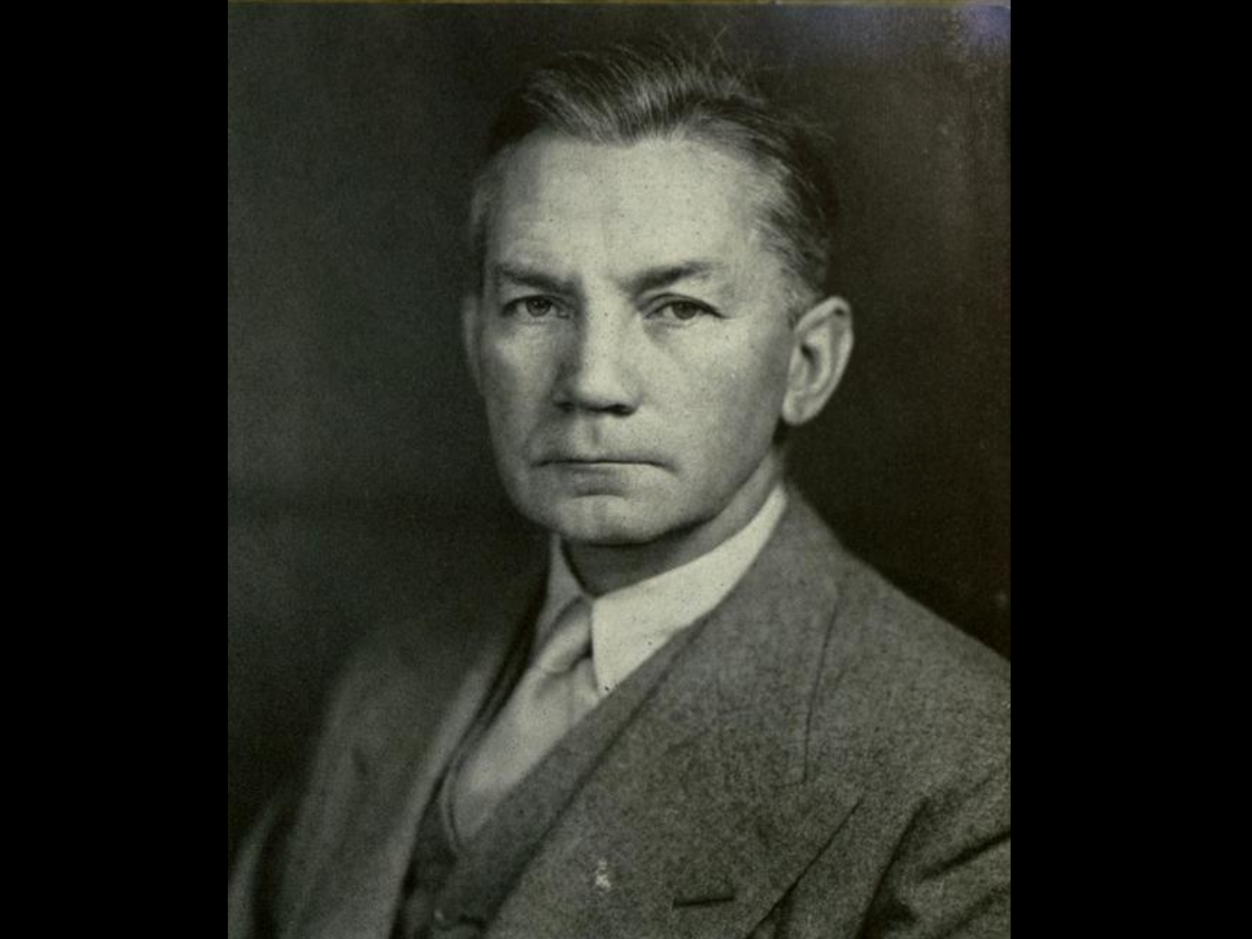

**wikipedia.org**

**A number of works (shown below) have implied or indicated that Forrestal's death was suspicious or nefarious.**

**In December 1950 William Bradford Huie**

**published**

**article titled "Untold Facts about the Death of James Forrestal"**

**in THE AMERICAN MERCURY**

**That article, later entered into the Congressional Record and republished**

**Huie opined that "Much of the truth has thus far been suppressed, but the ghost of Jim Forrestal is not going to be laid until there are reasonable answers to such questions as these:**

**Why was the attack on Forrestal so reckless and sadistically savage?**

**KIM NOTES**

**answer to above forrestal**

**favored**

**creating palestine federation similar to usa**

**each state in palestine**

**to contain**

**mixture of jewish plus**

**palestinian inhabitants**

**yet BEARS**

**desired**

**partition to allow bitterness to start**

**chaos wars and deaths for generations**

**therefore BEARS**

**killed**

**forrestal plus invented coverup story**

**then proceeded with chaos causing plans**

**wikipedia.org's**

**James Vincent Forrestal (February 15, 1892 – May 22, 1949)**

**last Secretary of Navy and first Secretary of Defense**

**in May 1944**

**strongly opposed the United States' support for the establishment of State of Israel**

**during private cabinet meetings with Truman in 1946 1947,**

**Forrestal had argued against partition**

**on the grounds it would infuriate arabs**

**who supplied oil needed for the**

**usa economy and national defense.**

**Truman forced Forrestal's resignation.**

**1949march31**

**at bethesda naval hospital Forrestal**

**underwent mental health care on**

**16th floor instead of first floor**

**on the road to recovery, having regained 12 pounds (5.4 kg) since his admission into the hospital.**

**1949may22 early morning hours**

**his body, clad only in the bottom half of a pair of pajamas,**

**was found**

**on a third-floor roof below the sixteenth-floor kitchen across the hall from his room.**

**wikipedia.org's**

**Wormwood (stylized as 'WORMWO0D') is a 2017 American six-part docudrama miniseries directed by Errol Morris and released on Netflix on December 15, 2017.**

**The series is based on the life of a scientist, Frank Olson,**

**who worked for a secret government biological warfare program (the USBWL) at Fort Detrick, Maryland. It focuses on the events leading up to and following his controversial death,**

**A key piece of evidence the film relies on is a CIA assassination manual from 1953, which instructs agents, "The most efficient accident, in simple assassination, is a fall of 75 feet or more onto a hard surface."**

**KIM NOTES BEARS**

**utilized**

**time delays to soften impact of**

**nefarious telltale details example forrestal**

**The official Navy review board, which completed hearings on May 31, 1949**

**waited until**

**October 11, 1949, to release only a brief summary.**

**reported on page 15 of October 12 NEW YORK TIMES**

**stated only that Forrestal had died from his fall from the window. It did not say what might have caused the fall,**

**The full report was released by the Department of the Navy in April 2004.**

**KIM NOTES**

**therefore after waiting 55 years BEARS**

**released**

**forrester's death details to escape accountability**

**BEARS gang**

**waited for**

**emotions cooling therefore**

**dealt with fewer eager questioners**

**After full and mature deliberation, the board finds as follows:**

**FINDING OF FACTS**

1. **That the body found on the ledge outside of room three eighty-four of building one of the National Naval Medical Center at one-fifty a.m. and pronounced dead at one fifty-five a.m., Sunday, May 22, 1949, was identified as that of the late James V. Forrestal, a patient on the Neuropsychiatric Service of the U. S. Naval Hospital, National Naval Medical Center, Bethesda, Maryland.**
2. **That the late James V. Forrestal died on or about May 22, 1949, at the National Naval Medical Center, Bethesda, Maryland, as a result of injuries, multiple, extreme, received incident to a fall from a high point in the tower, building one, National Naval Medical Center, Bethesda, Maryland.**
3. **That the behavior of the deceased during the period of his stay in the hospital preceding his death was indicative of a mental depression.**
4. **That the treatment and precautions in the conduct of the case were in agreement with accepted psychiatric practice and commensurate with the evident status of the patient at all times.**

**KIM NOTES**

**guilty BEARS in government**

**attempted swaying**

**citizens against reality that BEARS murdered**

**BEARS usa**

**took**

**extraordinary steps to continue deception**

**KIM NOTES sincere usa citizens**

**never imagined**

**government capable of such cruelty until**

**government introduced notion by denial**

**last portion of point four**

**That the death was not caused in any manner by the intent, fault, negligence or inefficiency of any person or persons in the naval service or connected therewith**

**KIM NOTES BEARS**

**further blocked**

**appearance of guilt via naming battleship**

**after victim BEARS killed**

**2023january09**

**history.navy.mil/content/history/nhhc/browse-by-topic/people/sec-nav/forrestal/james-forrestal.html**

**Aircraft carrier USS *Forrestal* (CVA-59) that operated extensively during the Vietnam War and in Operation Desert Storm was named in his honor.**

**year 2025 forrestal's federation idea**

**could come to fruition**

**all parties involved**

**could agree to create**

**four independent nations with each**

**including hebrews and palestinians**

**kim**

**recommends**

**gershon baskin as one of four**

**top leaders for four new nations**

**gershonbaskin.org/insights/encountering-life-encountering-death/**

**gershon baskin**

**He is a founding member of Kol Ezraheiha-Kol Muwanteneiha (All of the Citizens) political party in Israel. He is now directing The Holy Land Bond and is the Middle East Director for ICO – International Communities Organization - a UK based NGO working in conflict zones with failed peace processes.**

**en.wikipedia.org/wiki/Gershon_Baskin**

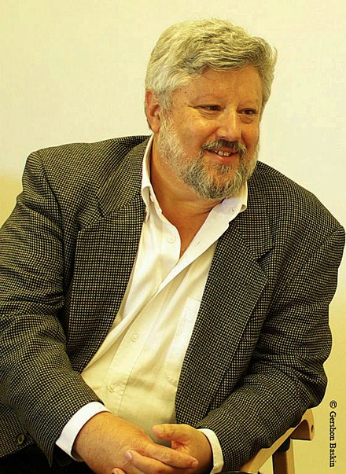

**2022 march 21 friday**

**ww.npr.org/2025/03/21/nx-s1-5334680/gershon-baskin-discusses-how-israel-is-reacting-to-the-resumption-of-fighting-in-gaza**

**npr's mike morgan**

**photographed**

**npr host leila fadel**



**NPR's Leila Fadel**

**asks**

**veteran Israeli hostage negotiator and peace activist Gershon Baskin about how the country is reacting to the resumption of fighting in Gaza.**

**March 21, 2025 04:13 AM ET**

**Heard on Morning Edition**

**four minutes listening**

**gershonbaskin.org**

**[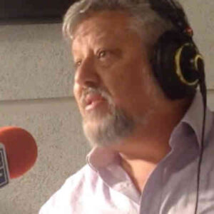](https://gershonbaskin.org/audio/)**

**Gershon Baskin**

**Hear Gershon**

**Listen to Gershon.**

**Gershon Baskin shares his candid, in-depth, and unequivocal perspectives on a wide range of important issues. His clear-cut and sincere observations serve to open up new avenues of discussion with people who believed that they were born enemies.**

**KIM NOTES**

**for years gershon baskin**

**accomplished**

**workable solutions between all parties involved**

**earned respect for doing impossible feats**

**gershon baskin**

**accomplished**

**what poet mentioned**

**poets.org/poem/it-couldnt-be-done**

**Born in 1881 in England, Edgar Guest**

**was**

**a prolific writer whose poems presented**

**deeply sentimental view of everyday life.**

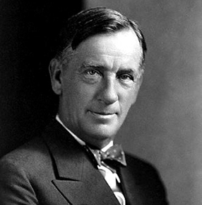

**It Couldn't Be Done**

**Edgar Guest**

**1881 –**

**1959**

**Somebody said that it couldn’t be done,**

**But he with a chuckle replied**

**That “maybe it couldn’t,” but he would be one**

**Who wouldn’t say so till he’d tried.**

**So he buckled right in with the trace of a grin**

**On his face. If he worried he hid it.**

**He started to sing as he tackled the thing**

**That couldn’t be done, and he did it.**

**.........**

**Just take off your coat and go to it;**

**Just start in to sing as you tackle the thing**

**That “cannot be done,” and you’ll do it.**

**This poem is in the public domain.**

**for bookkeeping purposes kim**

**temporarily named**

**four nations**

**after populations**

**start living**

**in those nations then those citizens**

**choose permanent nation names**

**north to south new nations**

**include**

**ROCK**

**PAPER**

**SCISSORS**

**GAZA**

**maps of world.com**

**displays**

**original map**

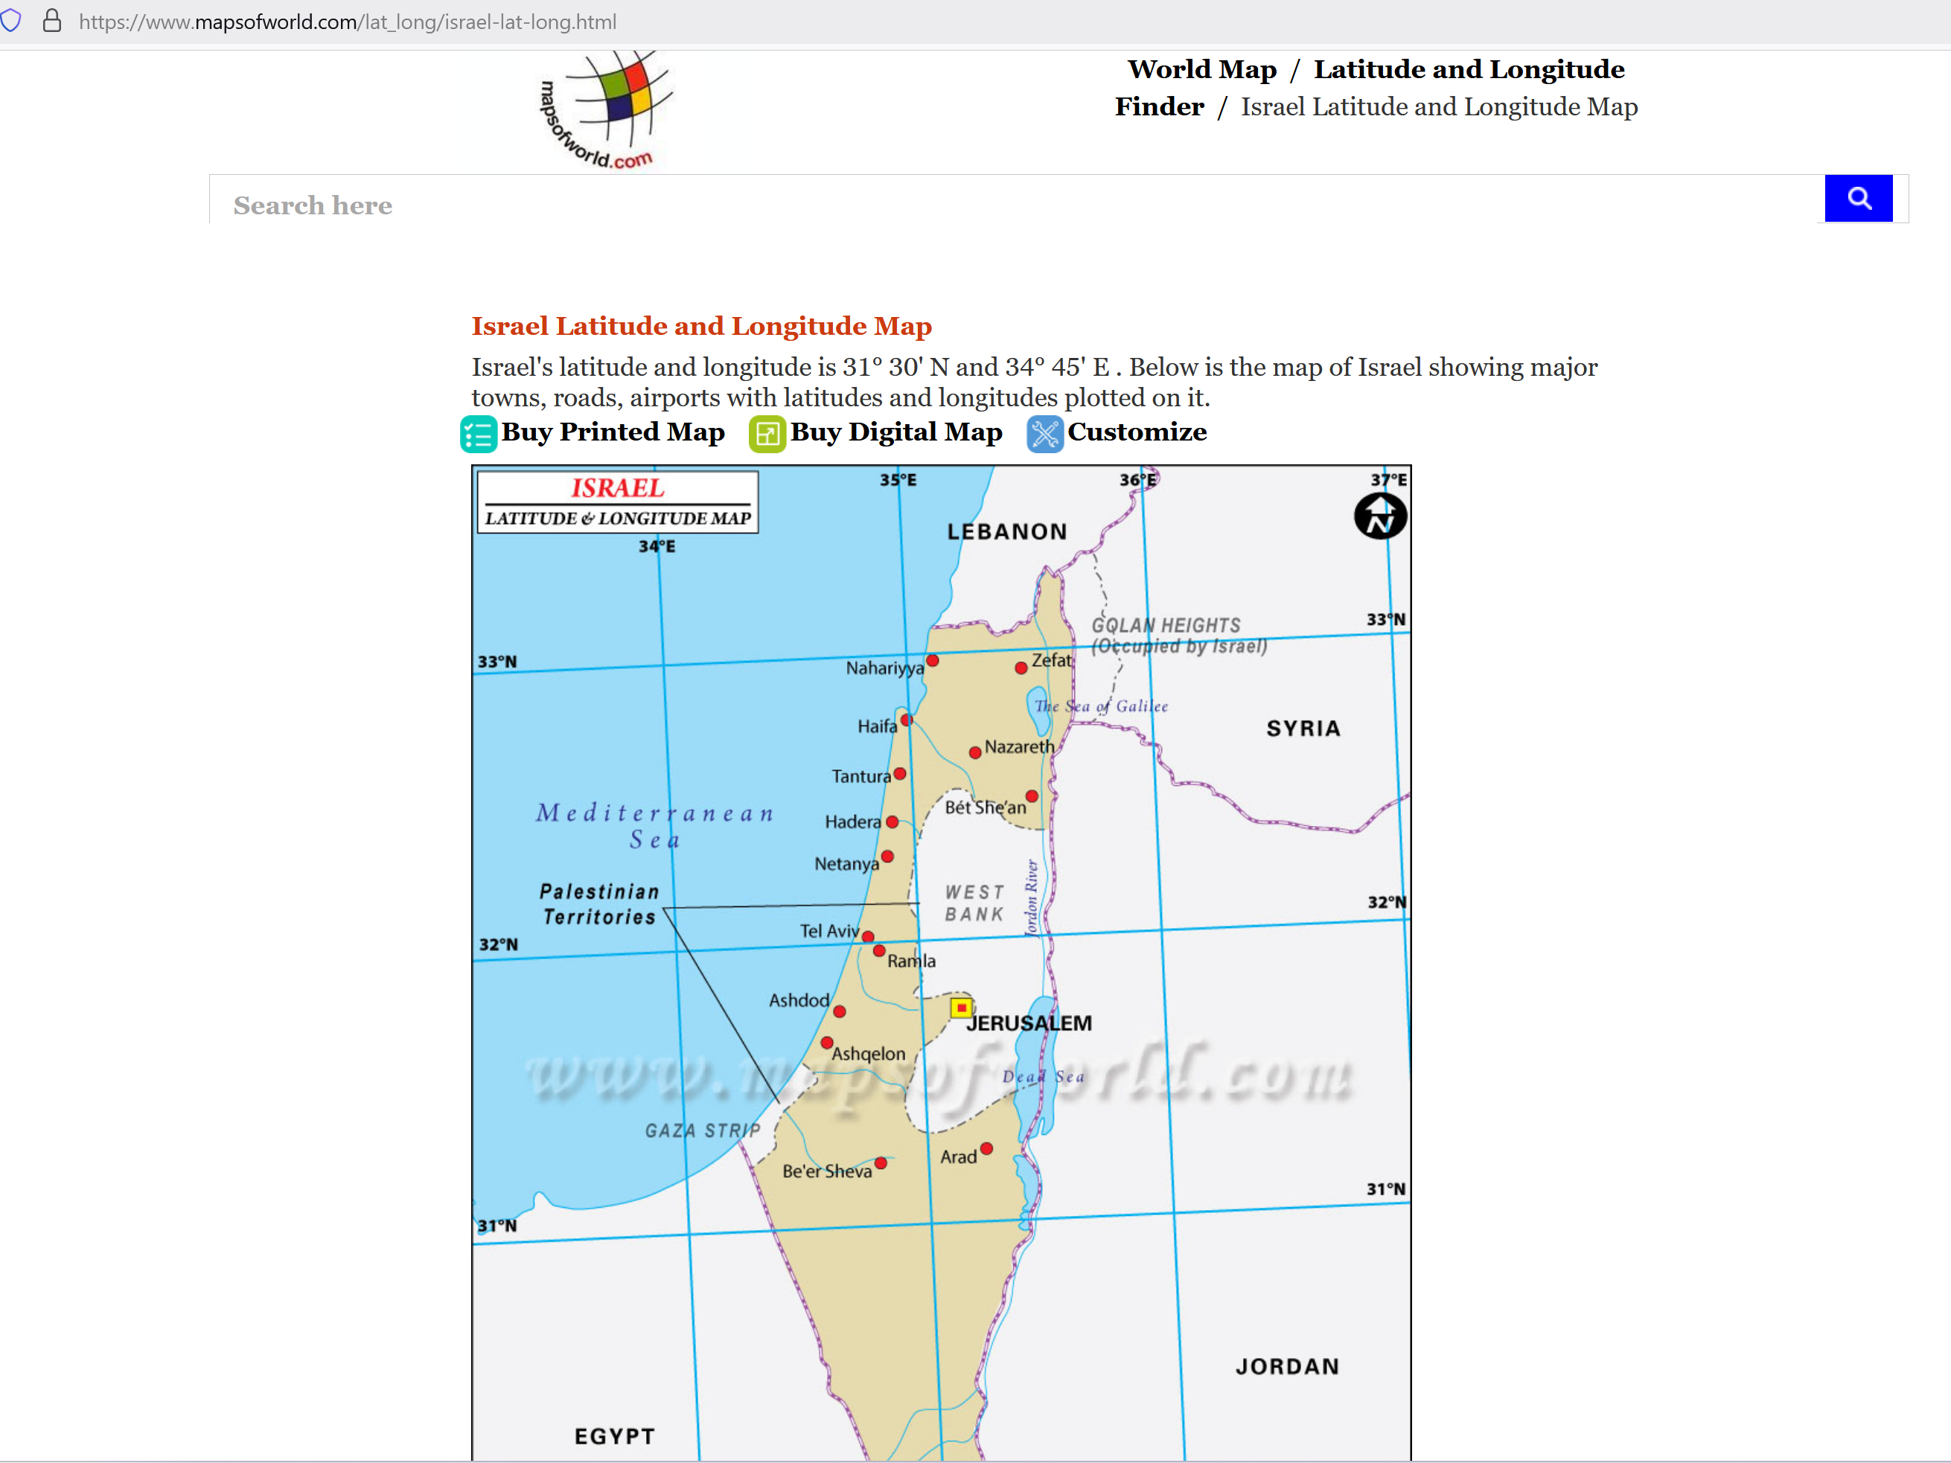

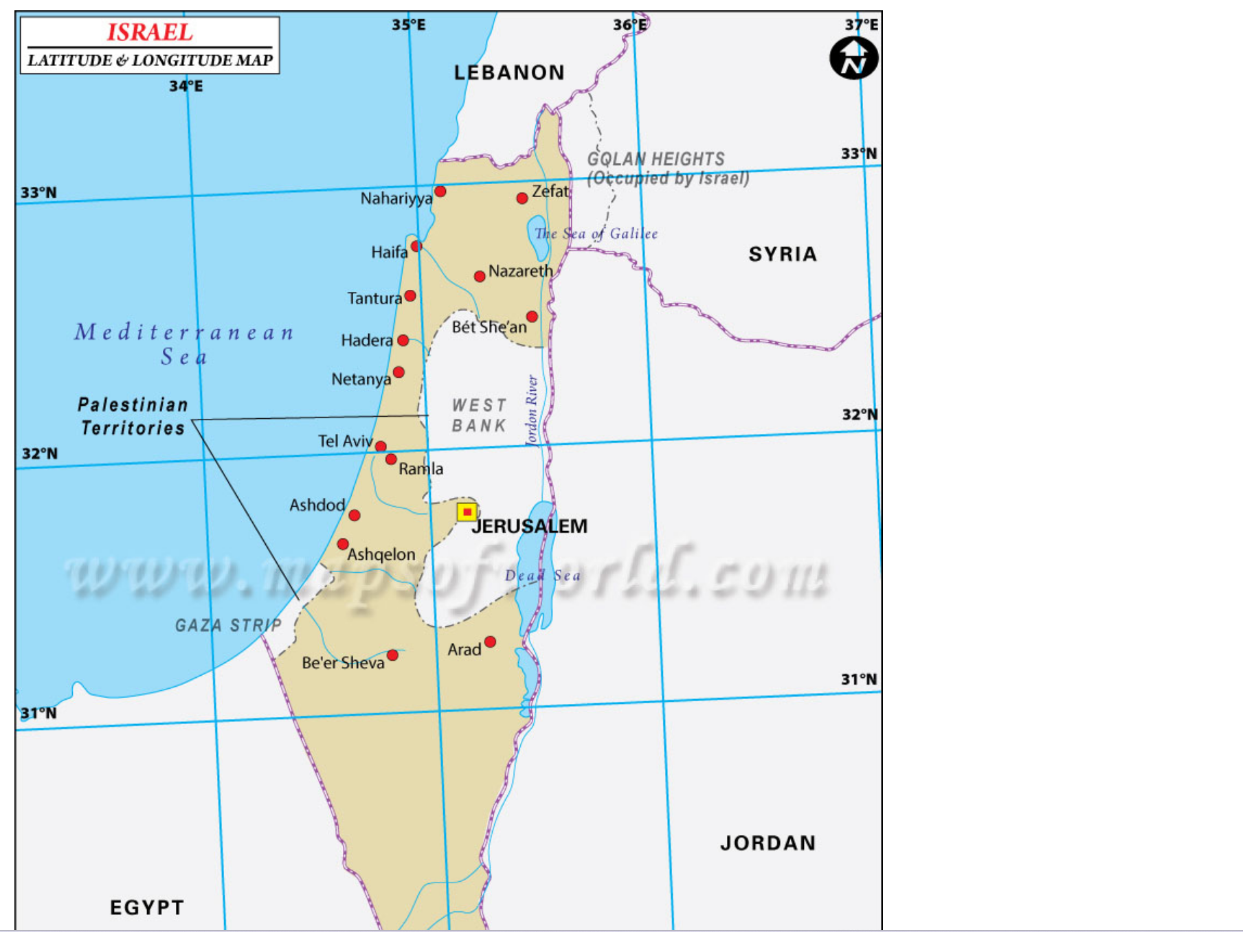

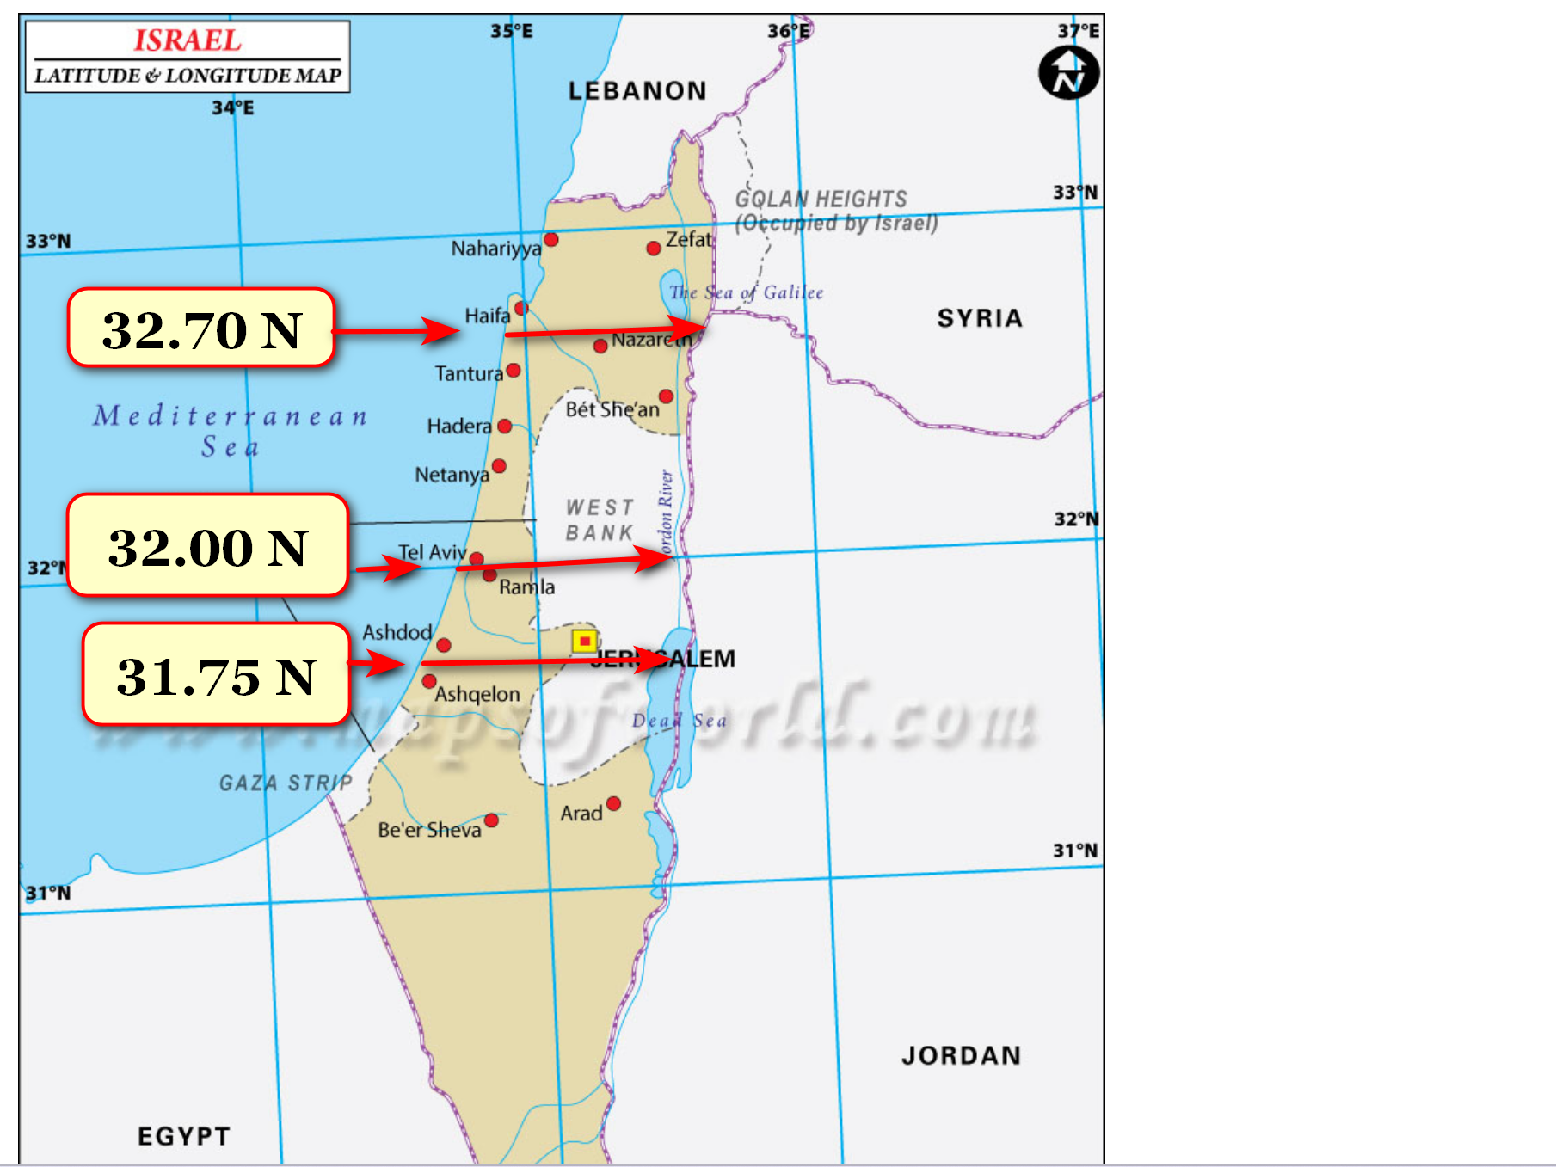

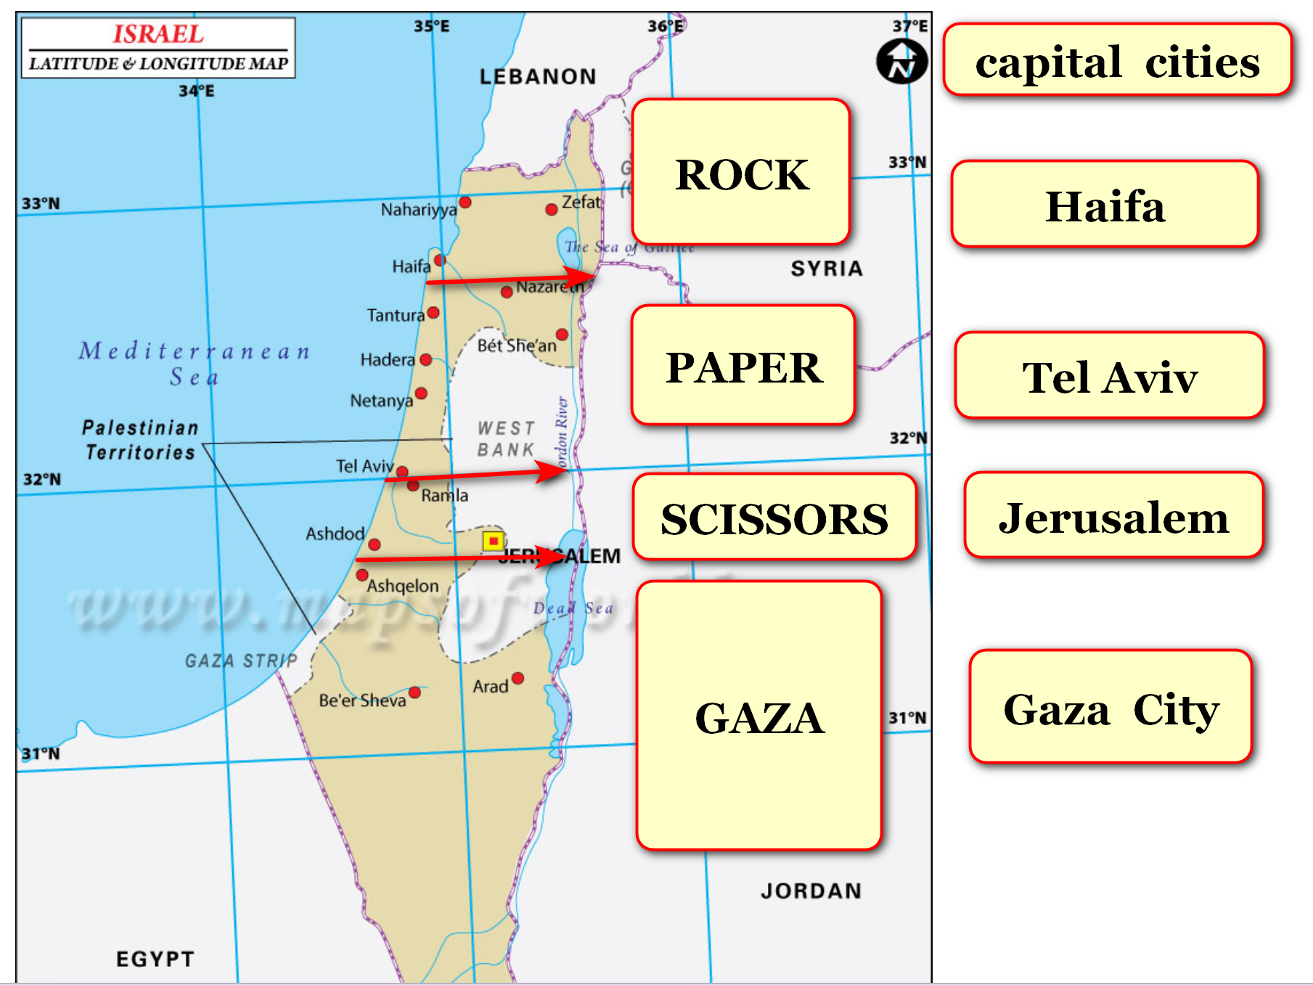

**over 80% of current inhabitants**

**already know**

**english language plus already understood by**

**2 billion persons including nonnative speakers**

**therefore embedded english feature**

**encourages**

**tourism**

**new nations**

**shall list**

**english as official language**

**when four nations' executive crews**

**establish**

**selves then ask permissions for inviting**

**certain excellent english speaking xinjiang uyghurs**

**english speaking uyghurs desiring such**

**must sign allegiance to**

**new nation in advance relinquishing previous**

**for example four nations**

**could utilize**

**english speaking xinjiang uyghur women**

**as members of rescue squads**

**rescue squads**

**would monitor**

**community health and wellbeing and**

**law abiding from safety of airships**

**of course families**

**migrate with**

**those chosen**

**and become citizens of new nation**

**each independent nation**

**would possess**

**permanent married couple at desks 21**

**and 22 of executive crew**

**those couples' tenures**

**similar**

**to usa supreme court justices**

**appointed for life**

**ROCK nation as new northern nation**

**shall have**

**wife of gershon baskin and gershon**

**baskin at desks 21 and 22**

**GAZA nation as new southern nation**

**shall randomly choose**

**from three eldest couples of**

**palestinian legislative council**

**pool**

**includes**

**married couples**

**not persons with plural spouses**

**at least one spouse**

**must have membership**

**in palestinian legislative council**

**combined ages of both spouses**

**determines**

**membership in pool of three**

**eldest couples**

**that couple**

**shall occupy**

**desks 21 and 22 of**

**GAZA nation**

**each middle nation**

**gains**

**persons for desks 21 and 22**

**by new method**

**two married couples for executive positions**

**will play**

**rock paper scissors in written form**

**during official event**

**winner**

**chooses**

**seats 21 and 22 from choices**

**PAPER nation or SCISSORS nation**

**other couple**

**occupies**

**seats 21 and 22**

**of other nation**

**two couples above**

**include**

**mahmoud and amina abbas**

**plus benjamin and sara netanyahu**

**each nation's executive crews**

**include**

**5 knesset couples and**

**5 palestinian legislative council couples**

**above random selections**

**draw from**

**pools of twelve eldest in legislatures**

**plus each member's heterosexual spouse**

**new governments**

**model**

**SMOOTH KEYS for other nations' observations**

**if all other nations**

**adopt**

**SMOOTH KEYS then globe finally**

**achieves end of wars**

**new governments**

**utilize**

**SMOOTH KEYS from chapters A01-A02**

**from free online book SHOELANGUAGE book**

**shoelanguage.com**

**contains**

**SHOELANGUAGE book with many chapters concerning**

**BEARS plus science concerning holographic surroundings**

**chapter ends**