**004 wheeler finds time malleable one undivided electron**

**universe's rule of double permissions**

**permeates**

**all universe including all living cells**

**each human cell**

**possesses**

**outer covering two layered cell membrane**

**balloon like globe like**

**wikipedia.org's**

**Cell membrane is selectively permeable membrane**

**that separates**

**interior of cell from external environment**

**due to similarity researchers**

**utilize**

**vesicles to study**

**cell membrane lipid bilayers**

**Transmission Electron Microscope image**

**displays**

**lipid vesicle's two leaflets bilayer**

**KIM NOTES**

**two dark bands obvious around edges**

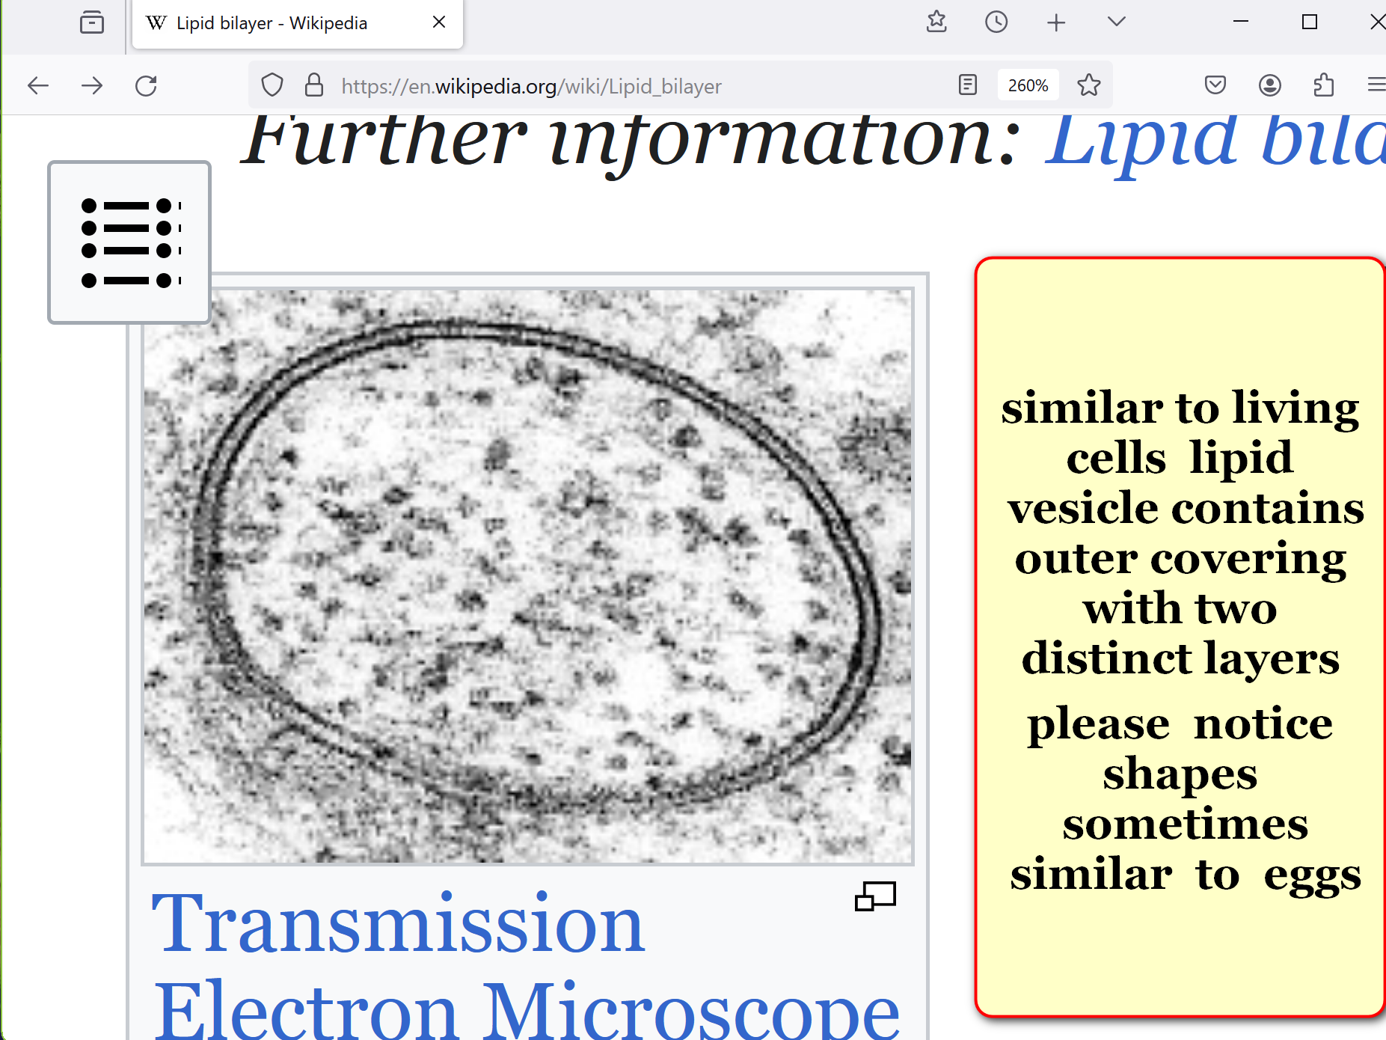

**cell membrane's outer layer**

**decides**

**YES or NO invite**

**material floating near cell**

**cell membrane's inner layer**

**independently decides**

**YES or NO allow that material**

**into inner workings of cell**

**above anatomy of cell**

**confirms**

**universe's rule of double permissions**

**double permissions rule**

**indicates**

**no illness ever came uninvited**

**no illness**

**lingered**

**without encouragement**

**contentions of abel and cain**

**flipped**

**globe's outer membrane layer's toggle switch**

**to SUNNYsideDOWN setting**

**SUNNYsideDOWN option**

**included**

**all physical illnesses and ill circumstances**

**each human as inner membrane master**

**gives**

**final YES or NO permission**

**to enter**

**that emotion decision**

**orders**

**like minded circumstances to travel**

**to that human's surrounding holograph**

**many times that scenario**

**arrives**

**in very next eight second segment**

**of time**

**emotion phenomenon called illness**

**manifests in**

**various ways because each person differs**

**each human's choice of SUNNYsideDOWN emotions**

**received**

**illness into own body**

**initially invited by twins cain abel**

**this system means every human**

**capable of personally ejecting**

**so called different diseases**

**via same remedy without money**

**unfortunately titan**

**bamboozled**

**unsuspecting sincere humans**

**via religious myths**

**when miracles occurred titan**

**deceitfully insinuated**

**religion necessarily involved**

**science writer amanda gefter**

**mentioned**

**wheeler's scientific discoveries concerning time**

**wikipedia.org's**

**Nautilus Magazine New York–based online and print science magazine publishes monthly issue on selected topic**

**2014january10**

**nautilus magazine contributor amanda gefter's article**

**https://nautil.us/haunted-by-his-brother-he-revolutionized-physics-234736/**

**Amanda Gefter’s book Trespassing on Einstein’s Lawn**

**a memoir about physics, her father, the universe, John Wheeler, nothing and everything—published 2014january by Bantam**

**It worked just as Wheeler**

**had imagined:**

**measurements made in the present**

**can create the past.**

**Time as we once knew it**

**does not exist;**

**past does not come indelibly before future.**

**History,**

**Wheeler discovered—the kind that brews guilt, ...**

**is never set in stone.**

**KIM NOTES below discovery**

**explains**

**above statements**

**wikipedia.org's one electron universe**

**wheeler via call to feynman 1940spring**

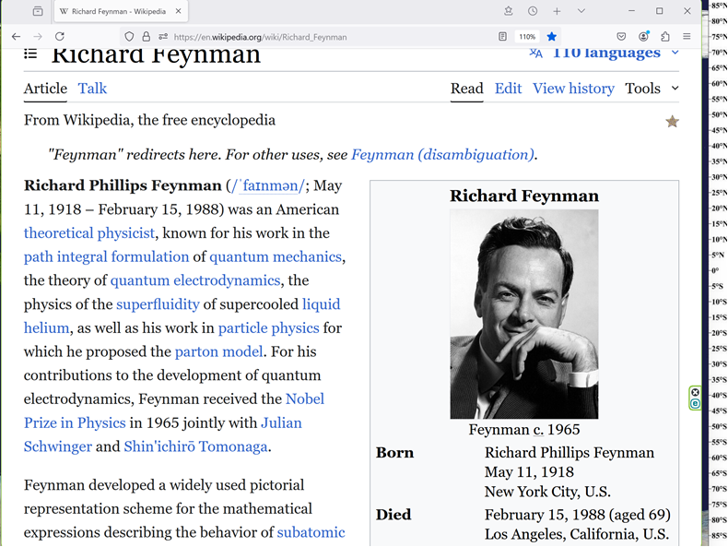

**I**

**received**

**telephone call one day at graduate college at Princeton**

**from Professor Wheeler, he said**

**FEYNMAN**

**I know why all electrons have same charge same MASS**

**Why?**

**BECAUSE, they are all the same ELECTRON!**

**KIM NOTES**

**all electrons**

**connect with**

**all other electrons in what scientists**

**call entanglement**

**until this book scientists**

**believed**

**only some electrons entangled with**

**some other electrons**

**science.nasa.gov/what-is-the-spooky-science-of-quantum-entanglement/**

**What Is the Spooky Science of Quantum Entanglement?**

**Learn how particles engage in a mind-boggling phenomenon that forms the backbone of quantum mechanics.**

**from getty images**

**[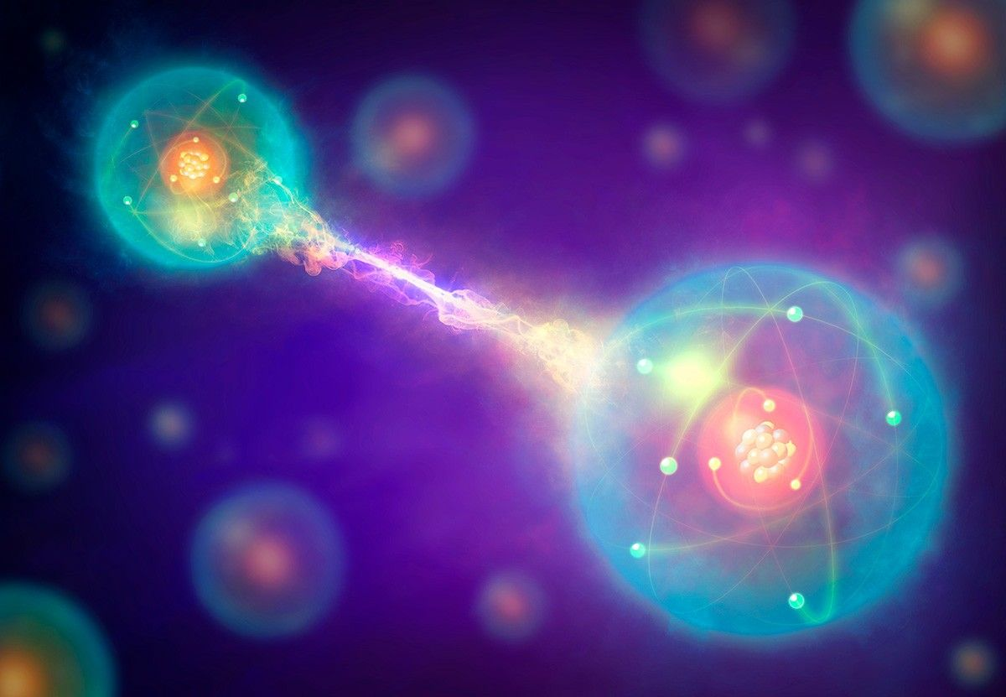](https://assets.science.nasa.gov/dynamicimage/assets/science/bps/quantum-leaps/quantum-entanglement/Quantum_entanglement_sm.jpg?w=1200&h=831&fit=clip&crop=faces%2Cfocalpoint)**

**The fascinating science of quantum entanglement proposes that particles of the same origin are always connected.**

**GettyImages**

**Quantum entanglement. Conceptual artwork of a pair of entangled quantum particles or events (left and right) interacting at a distance.**

**Two particles will appear to be linked across space and time, with changes to one of the particles (such as an observation or measurement) affecting the other one.**

**This instantaneous effect appears to be independent of both space and time, meaning that, effect may precede cause.**

**KIM NOTES explanation of above**

**includes**

**electrons in one holograph act in**

**certain way via majority vote**

**those actions**

**sway**

**other clusters of electrons to act**

**in similar fashions in other holographs**

**above**

**explains**

**wheeler indeed correct in recognizing**

**all electrons merely one huge electron**

**kim**

**agrees with**

**wheeler and expand's wheeler's discovery**

**thesis summarized**

**HISTORY**

**changes**

**and Universe REBUILDS**

**of course every unified body**

**possesses**

**portions of body**

**every body portion**

**knows**

**what other portions experience**

**every body portion**

**aceepts**

**that new common wisdom addition**

**2022 kim**

**experienced**

**universe rebuilding including time dilation**

**slowing of time towards stopping completely**

**2022february kim**

**drove for**

**transportation company transporting disabled individuals**

**for routine non emergency tasks**

**concerning steps elevation changes blind persons**

**sometime utilize**

**strategy of holding hand onto shoulder**

**of leader for monitoring elevation changes**

**for example above strategy**

**immediately references**

**movements when encountering staircases**

**at journey's destination kim**

**helped**

**tall blind lady exit van**

**yet usual portable stepping platform**

**unnecessary**

**image by Clker-Free-Vector-Images from Pixabay**

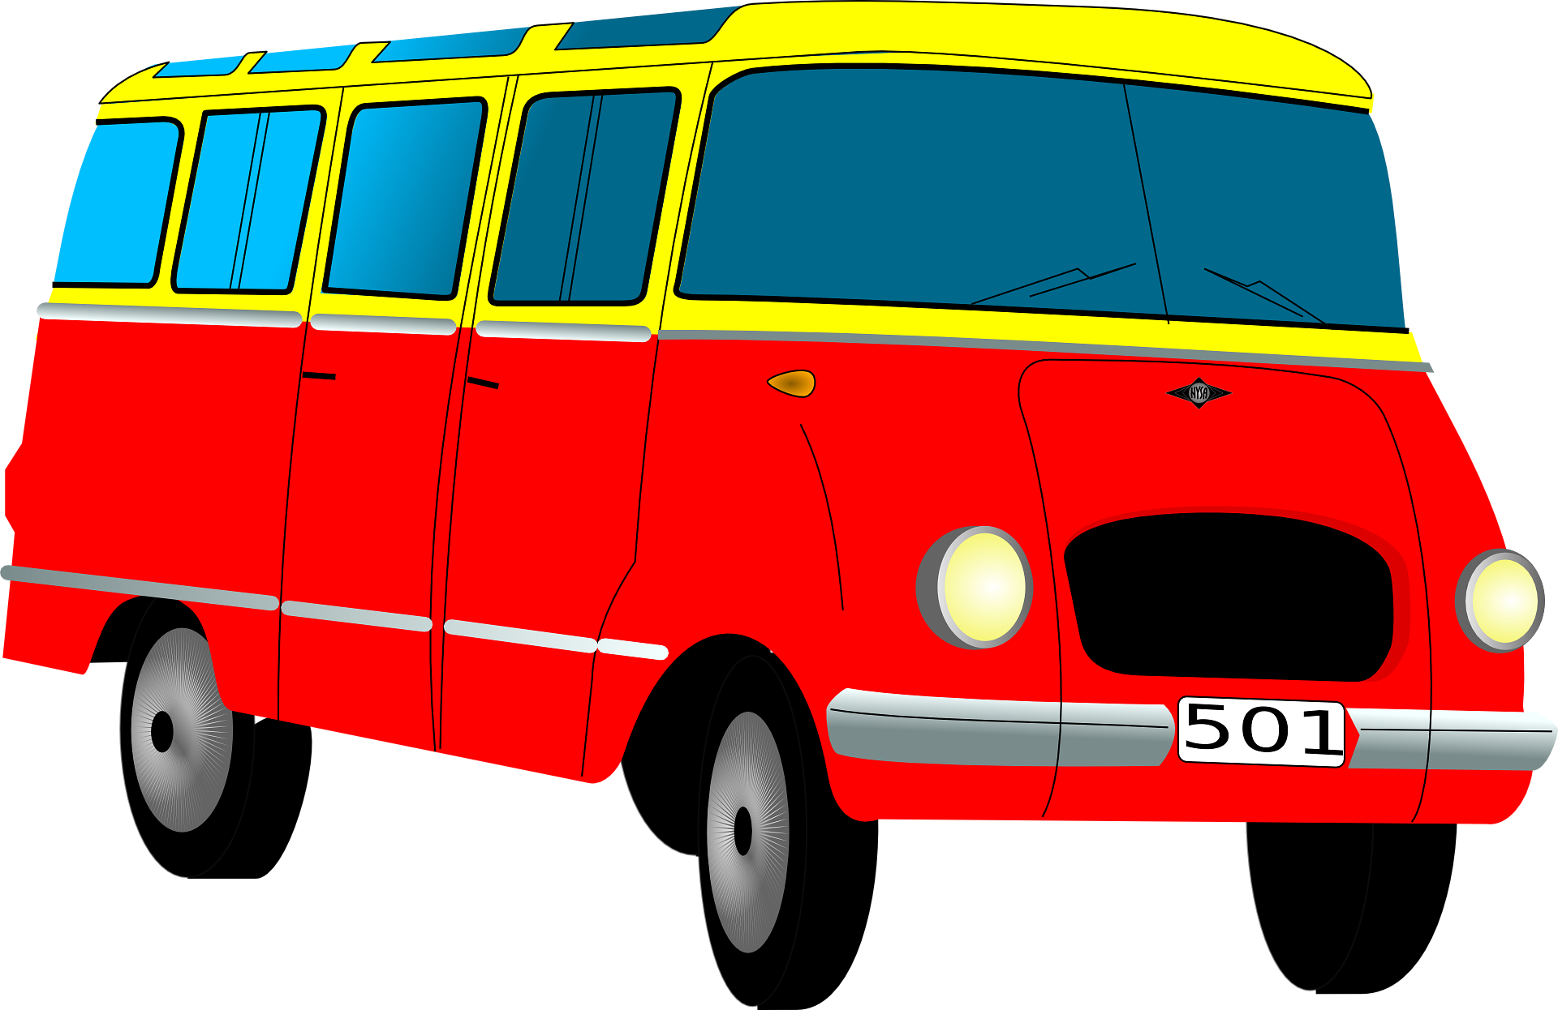

**kim and nice lady**

**stood together**

**after lady exited van driver's side**

**conversation**

**contained**

**only 12 words**

**kim and lady**

**laughed together**

**at kim's punchline**

**following images below**

**Free for use**

**under the Pixabay Content License**

**GDJ gordon d johnson**



**on exiting driver's side lady**

**merely held**

**grab handle and kim's shoulder**

**limbs parliaments of all three persons**

**agreed**

**to make scenario even better**

**originally adult daughter**

**exited**

**van from opposite side therefore not**

**close enough to hear brief dialogue**

**then time**

**dilated**

**slowed from video to screenshots format**

**in mind's eye kim**

**saw**

**two screenshots snapshots**

**still photograph of daughter**

**showed**

**daughter trotting**

**from near rear of van**

**then next snapshot**

**showed**

**daughter close to mother and kim**

**forming group huddle**

**return to video format**

**now daughter**

**in trio**

**during all 12 words including**

**when kim delivered punchline**

**now all three**

**laughed together**



**above occurrence**

**proves**

**history's holographic time segments malleable**

**and improvable if involved actors agree**

**KIM NOTES above**

**corroborates**

**what einstein wheeler deduced independently**

**in summary TIME merely persistent SHAM**

**one dimension universe**

**actually**

**only one black hole uniting**

**universe's seemingly separate black holes**

**black holes' characteristics**

**include**

**time dilation and even slowing until**

**time equals zero forward motion**

**therefore distances speeds**

**merely props**

**for holographic scenarios**

**https://nautil.us/haunted-by-his-brother-he-revolutionized-physics-234736/**

**Amanda Gefter’s book Trespassing on Einstein’s Lawn**

**a memoir about physics, her father, the universe, John Wheeler, nothing and everything—published 2014january by Bantam.**

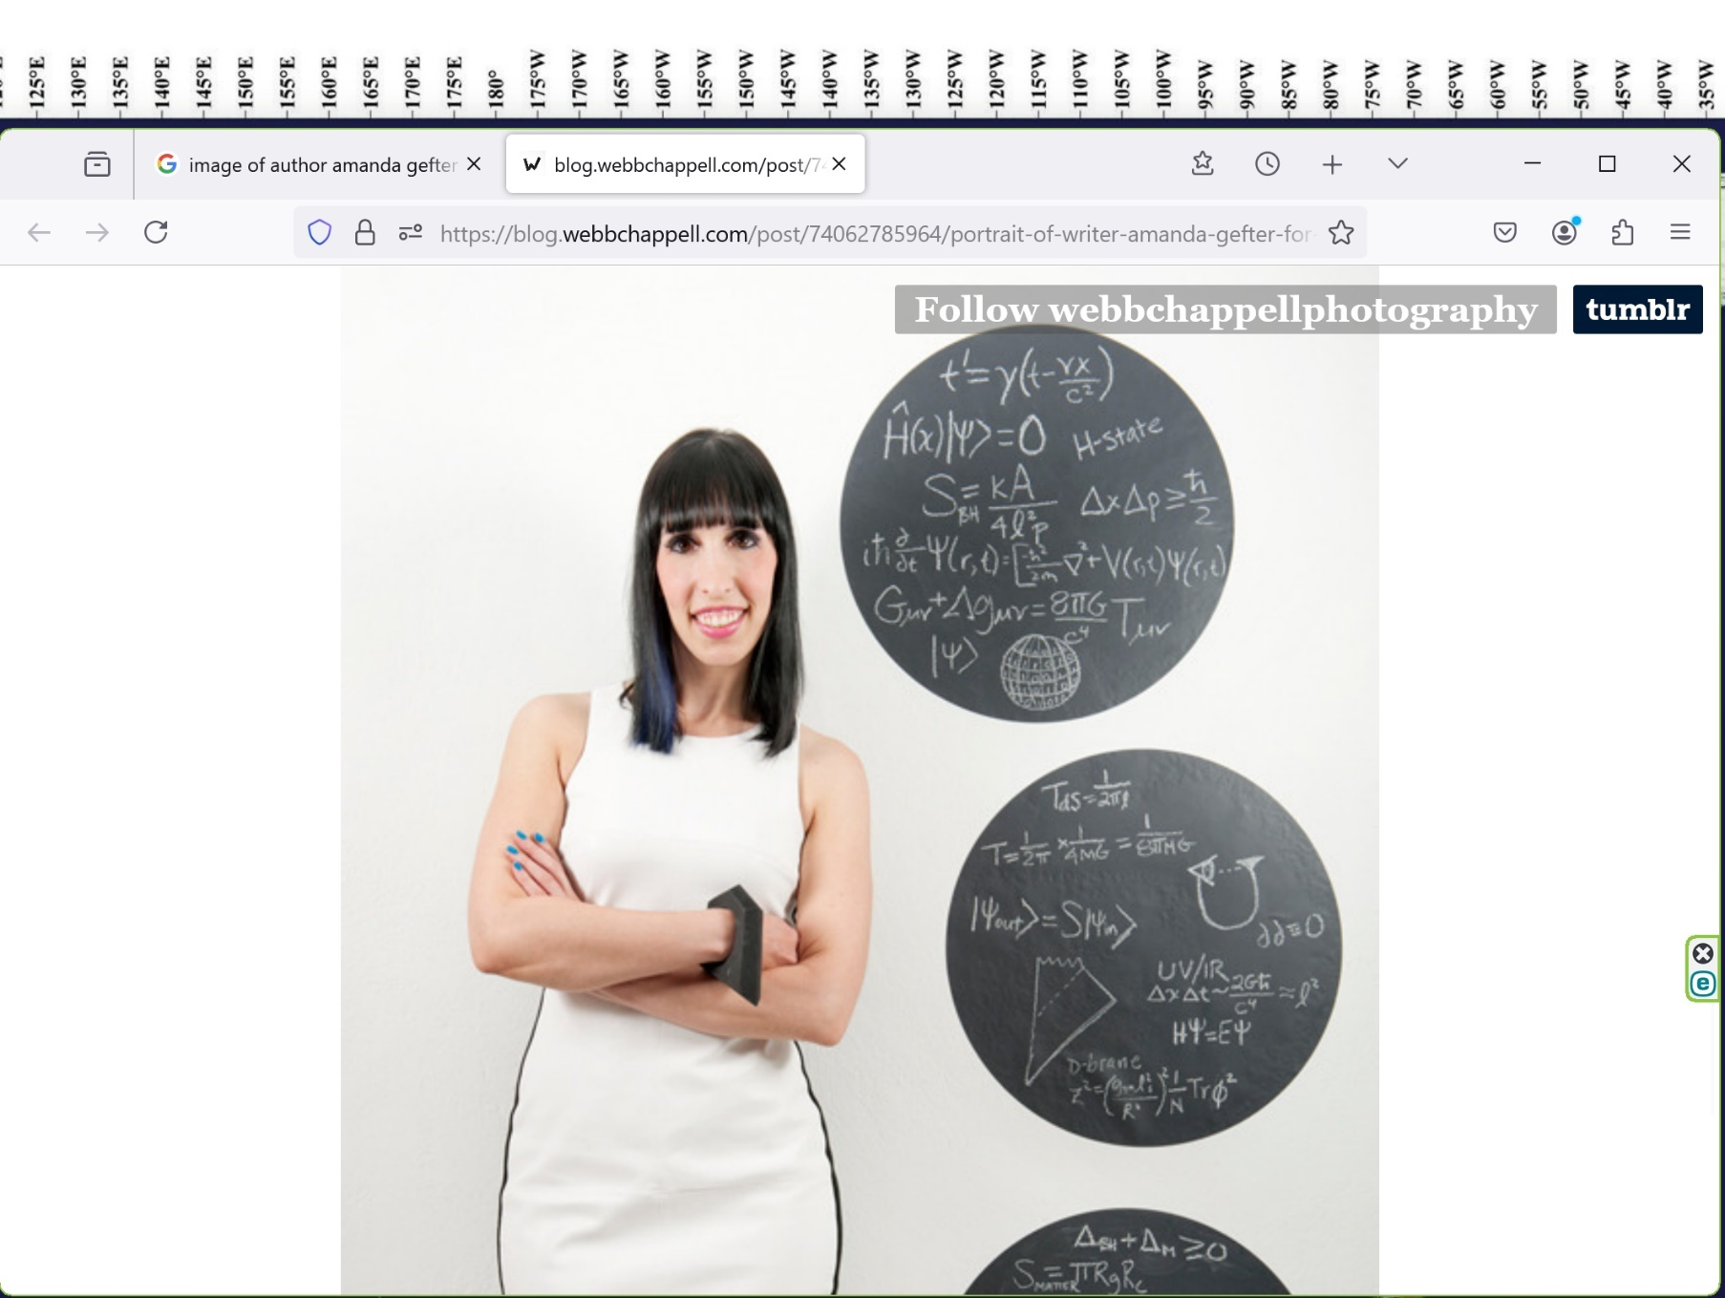

**2014january10**

**nautilus' amanda gefter**

**“OF all obstacles to a thoroughly penetrating account of existence, none looms up more dismayingly than ‘time,’” Wheeler wrote.**

**“Explain time?**

**Not without explaining existence.**

**Explain existence?**

**Not without explaining time.”**

**Now, at the Raleigh International Airport, that damned equation left**

**Wheeler with a nagging hunch that**

**TIME**

**couldn’t be**

**a fundamental ingredient of reality.**

**It**

**had to be**

**as einstein said STUBBORNLY persistent ILLUSION,**

**princeton professor john archibald wheeler**

**scrawled**

**in his journal on** **June 27, 1974.**

**“Past present and future**

**tied more intimately**

**than one realizes.”**

**In his journal, Wheeler**

**drew**

**picture of capital-U for “universe,” with**

**eye perched atop left-hand peak,**

**staring across**

**letter’s abyss to tip of**

**right-hand side: origin**

**universe**

**has created**

**observer**

**now ..., observer looks back creates universe.**

**Wheeler**

**scribbled caption**

**beneath drawing: “...universe ...self-excited SYSTEM.”**

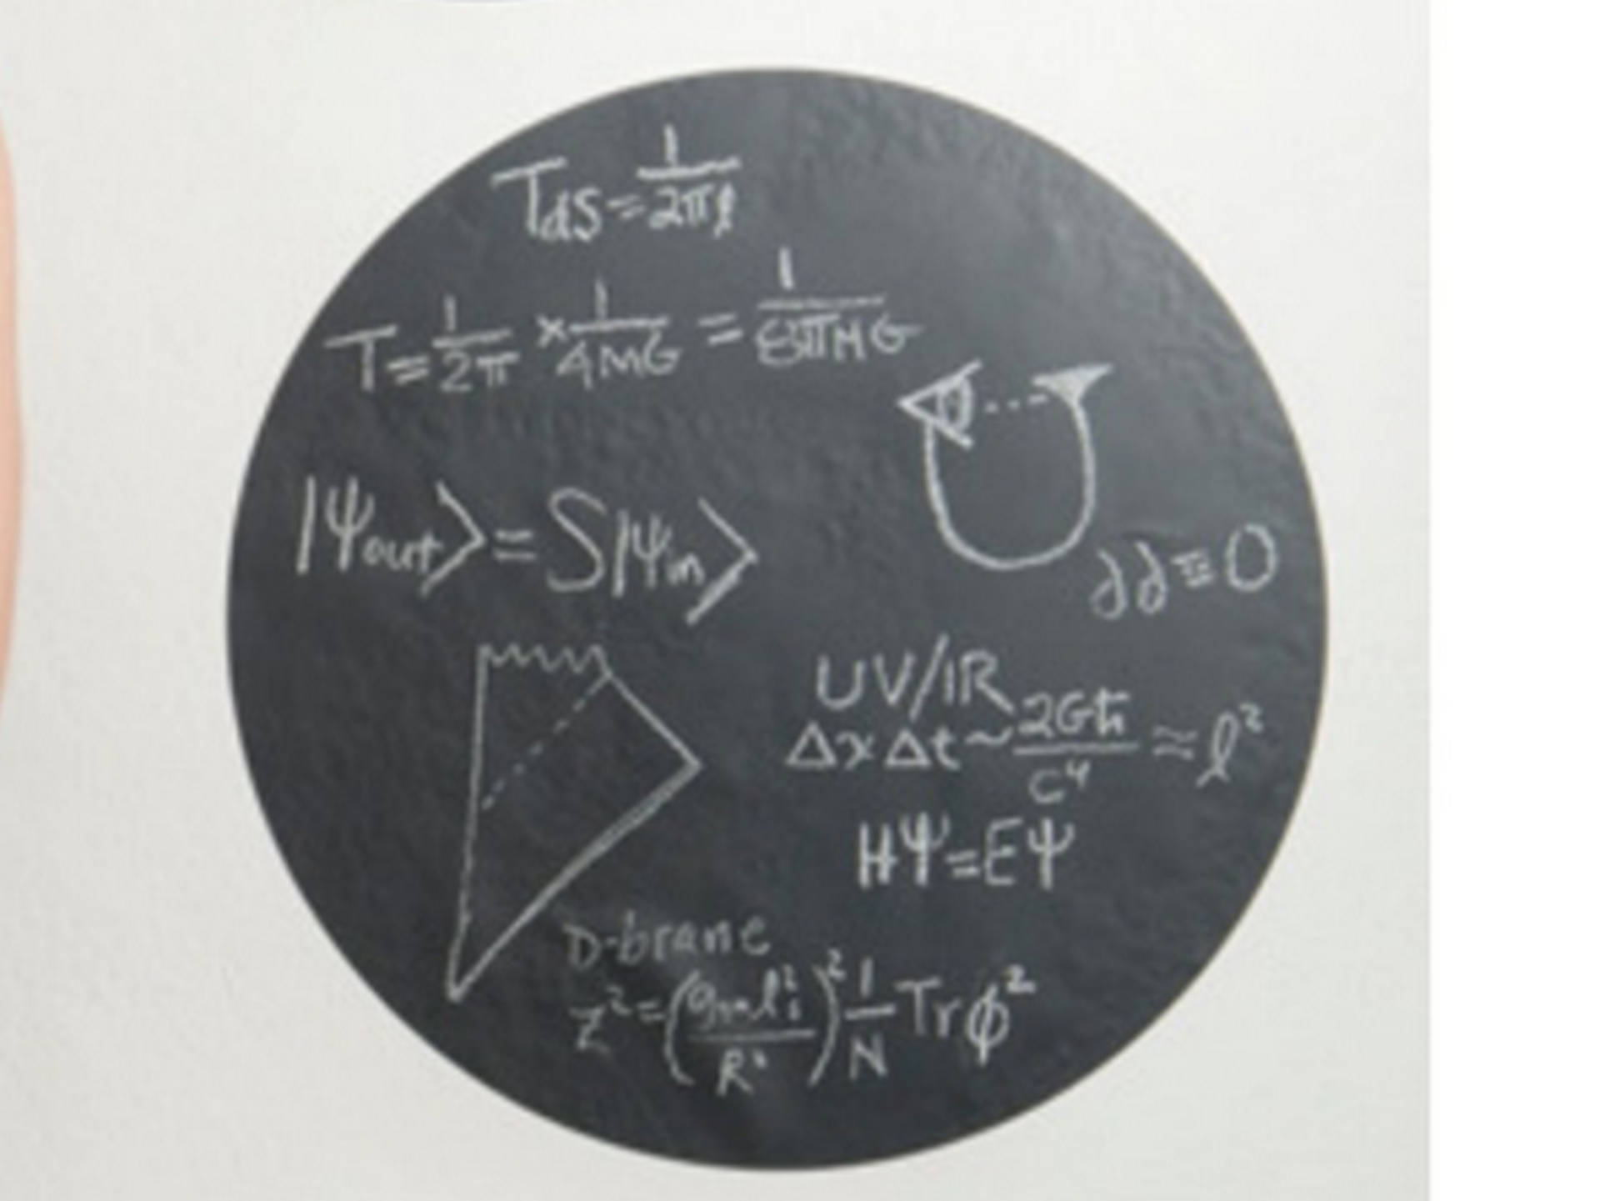

**permanent SUNNYsideUP culture**

**starts with exposing**

**traditional myths that indirectly model unfair**

**procedures as acceptable standard operating procedures**

**traditional myths of history**

**include**

**STINGY supreme being**

**usually withheld**

**affirmative answers to prayers for HEALING**

**taught myths' internal logic**

**concluded**

**extremely strict supreme being withheld healing**

**for some important humanly unknowable reason**

**in actuality all healing prayers**

**answered affirmatively initially**

**non judgmental holographic universe providers**

**always start**

**process towards complete healing**

**unless given further notice**

**all citizens' healing prayers**

**always counted as**

**requesting flipping toggle switch upward towards SUNNYsideUP therefore healing citizens' holographic bodies**

**unfortunately many citizens within hours**

**unknowingly flipped**

**toggle switch downward to SUNNYsideDOWN including inviting illness**

**chapter ends**