002 religion's symbolic jekyll hyde story

unexpectedly kim
gained
new knowledge ejecting kim from traditional
confined storehouses of religions and science

only expanded parameters with this information
can pave pathway
for ending wars permanently

portions of religions
contain
myths thereby lowering ceilings of operations
of religious adherents

however one short story from religion
does accurately describe
daily operations within each human

STORY of persistent WIDOW

Attribution:

Rijksmuseum, CC0, via Wikimedia Commons
HTML

Created: 1712
Uploaded: 10 December 2019

prentmaker: Jan Luyken Plaats vervaardiging: Amsterdam

File:Gelijkenis van de rechter die wordt lastiggevallen door een klagende vrouw, RP-P-OB-46.028.jpg

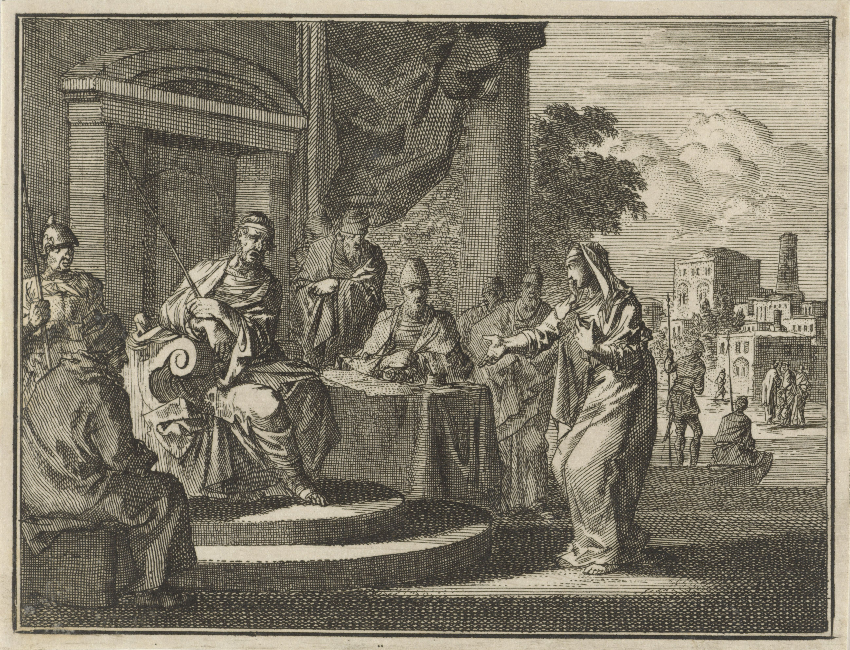

THERE was a small town with a judge
who was not afraid of God
nor afraid of opinions of people

widow
came
to that judge pleading case for
justice against opponent in town

that judge
ruled in favor of widow because
of widow's more persistent PETITIONING

KIM NOTES

above story's symbolism
includes

neutral judge
symbolizes
cns central nervous system consisting of
head and neck and spine cells

neutral judge as conscious cns
granted
one constituent's desire
over other constituent's desire

routinely after sleeping conscious neutral judge
found
new list on desk with
first name listed atop second name

that list
authored by
subconscious neutral judge

subconscious neutral judge
sleepwalked and finally listed
names according to personal whim

early every night subconscious judge
routinely tapped into
all persons' conversations on globe
including every blog every podcast

with that information subconscious judge
knew
topics archivally
yet without understanding emotionally

in other words neutral judge
unable to interpret
laughter and tears

judge's embarrassing blind spot concerning emotions
caused
judge to hide
lack of opinions feature from constituents

however judge
desired fitting in
therefore took cues from what constituents
said and adopted those persons' opinions

routinely around midnight judge
started
night court

judge
alternately listened to
cases and napped

conscious judge
would lay head
atop desk to sleep
then awake after around 20 minutes

while conscious judge slept subconscious judge
entered mode
sleepwalking

judge
always listened to
same two lawyers making opposite cases
dr jekyll and mr hyde

wikipedia's

Public Domain
File:Jekyll-mansfield (cropped).jpg
Created: 1895
Uploaded: 25 January 2023

Photo by Henry Van der Weyde (1838-1924; London, England) - http://www.photography-museum.com/jekyll.html / Originally uploaded to en.wikipedia;

Richard Mansfield was best known for the dual role depicted in this double exposure: he starred in Dr. Jekyll and Mr. Hyde in both New York and London. The stage adaptation opened in New York in 1887 and London in 1888.

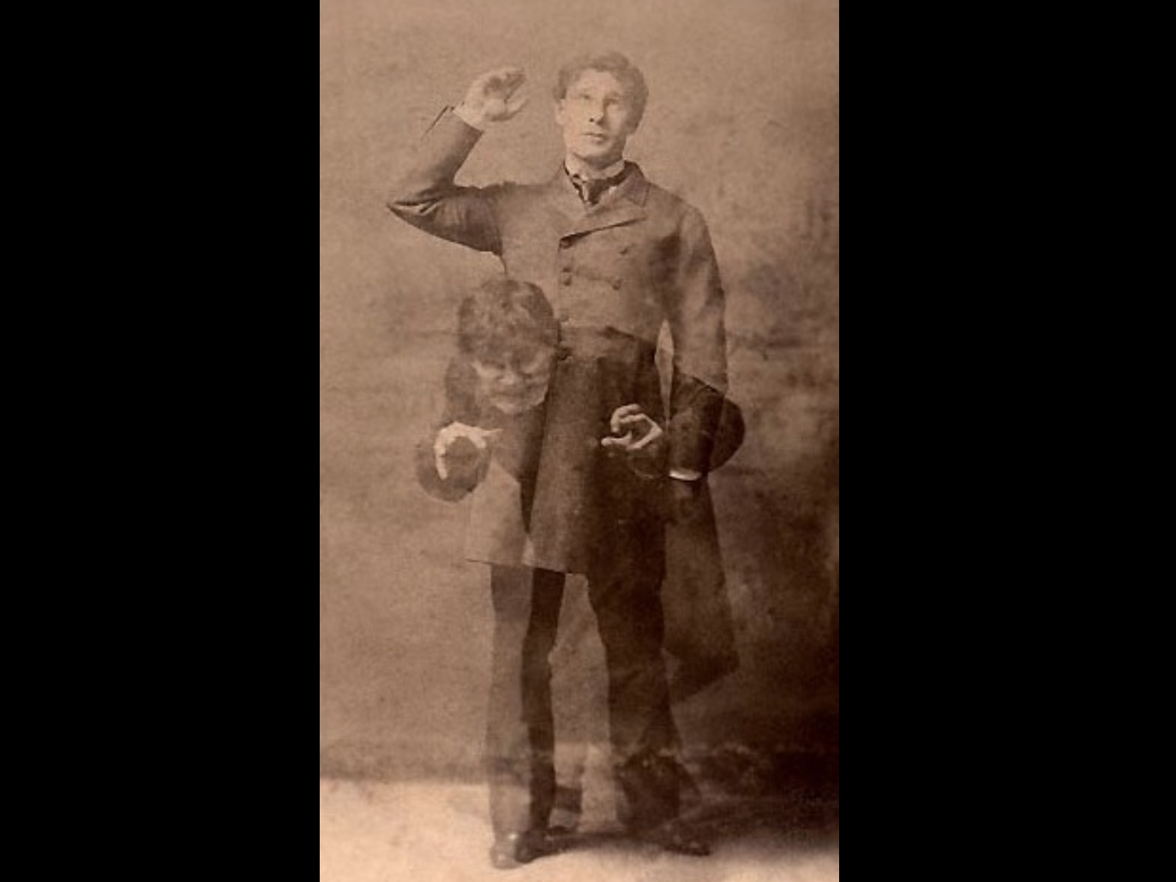

goodreads.com's

Robert Louis Stevenson's masterpiece of the duality of good and evil in man's nature sprang from the darkest recesses of his own unconscious—during a nightmare from which his wife awakened him, alerted by his screams.

this tale of mild-mannered Dr. Jekyll and drug that unleashes his evil, inner persona—loathsome, twisted Mr. Hyde
relates Jekyll's desperation as Hyde gains control of his soul—
classic demonstrates understanding of inner conflicts...

cns judge
favored neither
dr jekyll nor mr hyde

case by case lawyers
gave
emotional contexts via framing events yet
always ended with two opposite conclusions

judge
merely agreed with
person making highest number
of presentation examples

lawyers
went on and on
concerning each action
each hint from client

lawyers assisted clients
via writing
books piecing together several
hints into common themes

for example each lawyer
presented
situations saying

OBVIOUSLY my client
favors such and such emotion
because look at my client's many
authored books on this SUBJECT

judge lacking guiding principles
simply favored
lawyer carrying heaviest bag of books

therefore subconscious judge
listed
that lawyer's name on top
of list for presenting case first

conscious judge refreshed from sleep
possessed
no knowledge of backstory bickering nor
of global citizens' blogs and podcasts

therefore conscious judge
heard
cases with unbiased openness

upon waking conscious judge
simply looked
at top of list then directed
that lawyer's presentation first

advantages of presenting case first
included
attaining status of tradition

second lawyer
worked much harder
because needed overcoming
tradition's embedded framing of situation

for easier comparison judge
secretly installed
two huge scales
into floor of garage

both dr jekyll and mr hyde
stood on
respective platforms during oral arguments
and brought book bags corroborating outlooks

judge
would routinely pull open
desk drawer and compare weights displayed
on drawer's two horizontal monitors

somehow mr hyde
figured
strategy of judge

clever mr hyde
requested permission
to bring two ice buckets
during oral arguments for health reasons

deceiful mr hyde
claimed
if stood in ice that coldness
activated reflexology healing points of feet

judge
granted
request which weighed heavily
in mr hyde's favor

however ice
turned into
water then evaporated
from buckets by noon

until noon judge
routinely placed
mr hyde's name atop lists due
to monitor showing larger weights

puzzled dr jekyll
noticed
jekyll never spoke first until around
noon therefore needed counter strategy

jekyll's workaround strategy standard opening phrase attempted to counter
hyde's just stated skewed framing

as general rule dr jekyll
spoke kindly
SUNNYsideUP phrase including even when
addressing contentious hostile aggressive mr hyde

AS court
strives to find
FAIRNESS for ALL parties concerned
in this particular case that MEANS

those initial SUNNYsideUP words
became
habit and telltale signature
of dr jekyll

END OF SYMBOLISM of religion's story

above symbolic story
explains
scientific reality

universe
obediently adjusts
holograph around each person

person's conscious emotional decisions or hints
adjust
humankind's rulebook often called DNA

each eight second span's major signal
counts as
one vote of collective bargaining agreement

therefore majority wishes of frontline humans
rule thereby advising
concerning environment style for undivided
humankind at the end of time

in this way humankind
self determines
eternity's environment style towards
undivided humankind's ecstasy or agony

recognizable statues embedded in geography
verify
universe's holographic system mentioned above

humankind adopting administrative style SMOOTH KEYS
can tip
vote towards pleasant honeymoon like eternity

ABOUT the TWINS

as children twins keith and kim
desired helping make
globe FAIR for ALL

on subconscious level twins
devised
strategy never discussed consciously

leader keith klecka
volunteered for
toughest most painful strategy portion

chapters D08 and D09
detail
keith's masterpiece performance helping all humankind

subconsciously twin youngsters
agreed concerning
kim's loyalty and single focus mindset

conscious kim as adult
would never neglect
wife or children any timespan for
any reason even if God asked

therefore subconscious kim
agreed to frustrate
conscious kim's attempts at marriage

this non family strategy
positioned
kim for global improving tasks 24/7

ITEM ONE
street preaching for two years

ITEM TWO
across the hall 24/7 attendant plus primary healthcare giver to uncle carl nordstrand for five years
and later same to twin keith for final nine months

ITEM THREE
researching then expanding parameters of religion
and science and history

ITEM FOUR
creating new global language

resulting benefits of above
include
global systematic plan to permanently end
food shortages homelessness and wars

to guide circumstances subconscious kim
engineered retiring early
from dentistry plus engineered
losing financial ability to choose food

above non choosing of food
prepared
emotions for recognizing embedded image
in downtown houston library atlas pages

in 2009 conscious kim
was happy to stay forever at
group dental practice
in small town through to retirement

yet 2012
saw
that building burned overnight
none hurt

that fiery destruction of building
made
six employee dentists rethink
places to work

kim
started working for
houston dental temporary agencies
became substitute dentist when called

during several months kim
approached
10 houston dentists to become
regular associate employee dentist

all dentists contacted
said
no

kim
saw
rejections as nudges from above

2013 kim
felt
supreme being calling kim to
missionary work in foreign country

kim
made
preparations but then suddenly
that avenue not available

kim's telephone calls with contact person
would cut off immediately

kim
took that
as nudge from above
STAY in houston TEXAS

during those months family and friends
helped

cousins donna and robin smith
generously made kim part of
smith household

2025 january 26 kim
asked
smiths to pose with kim

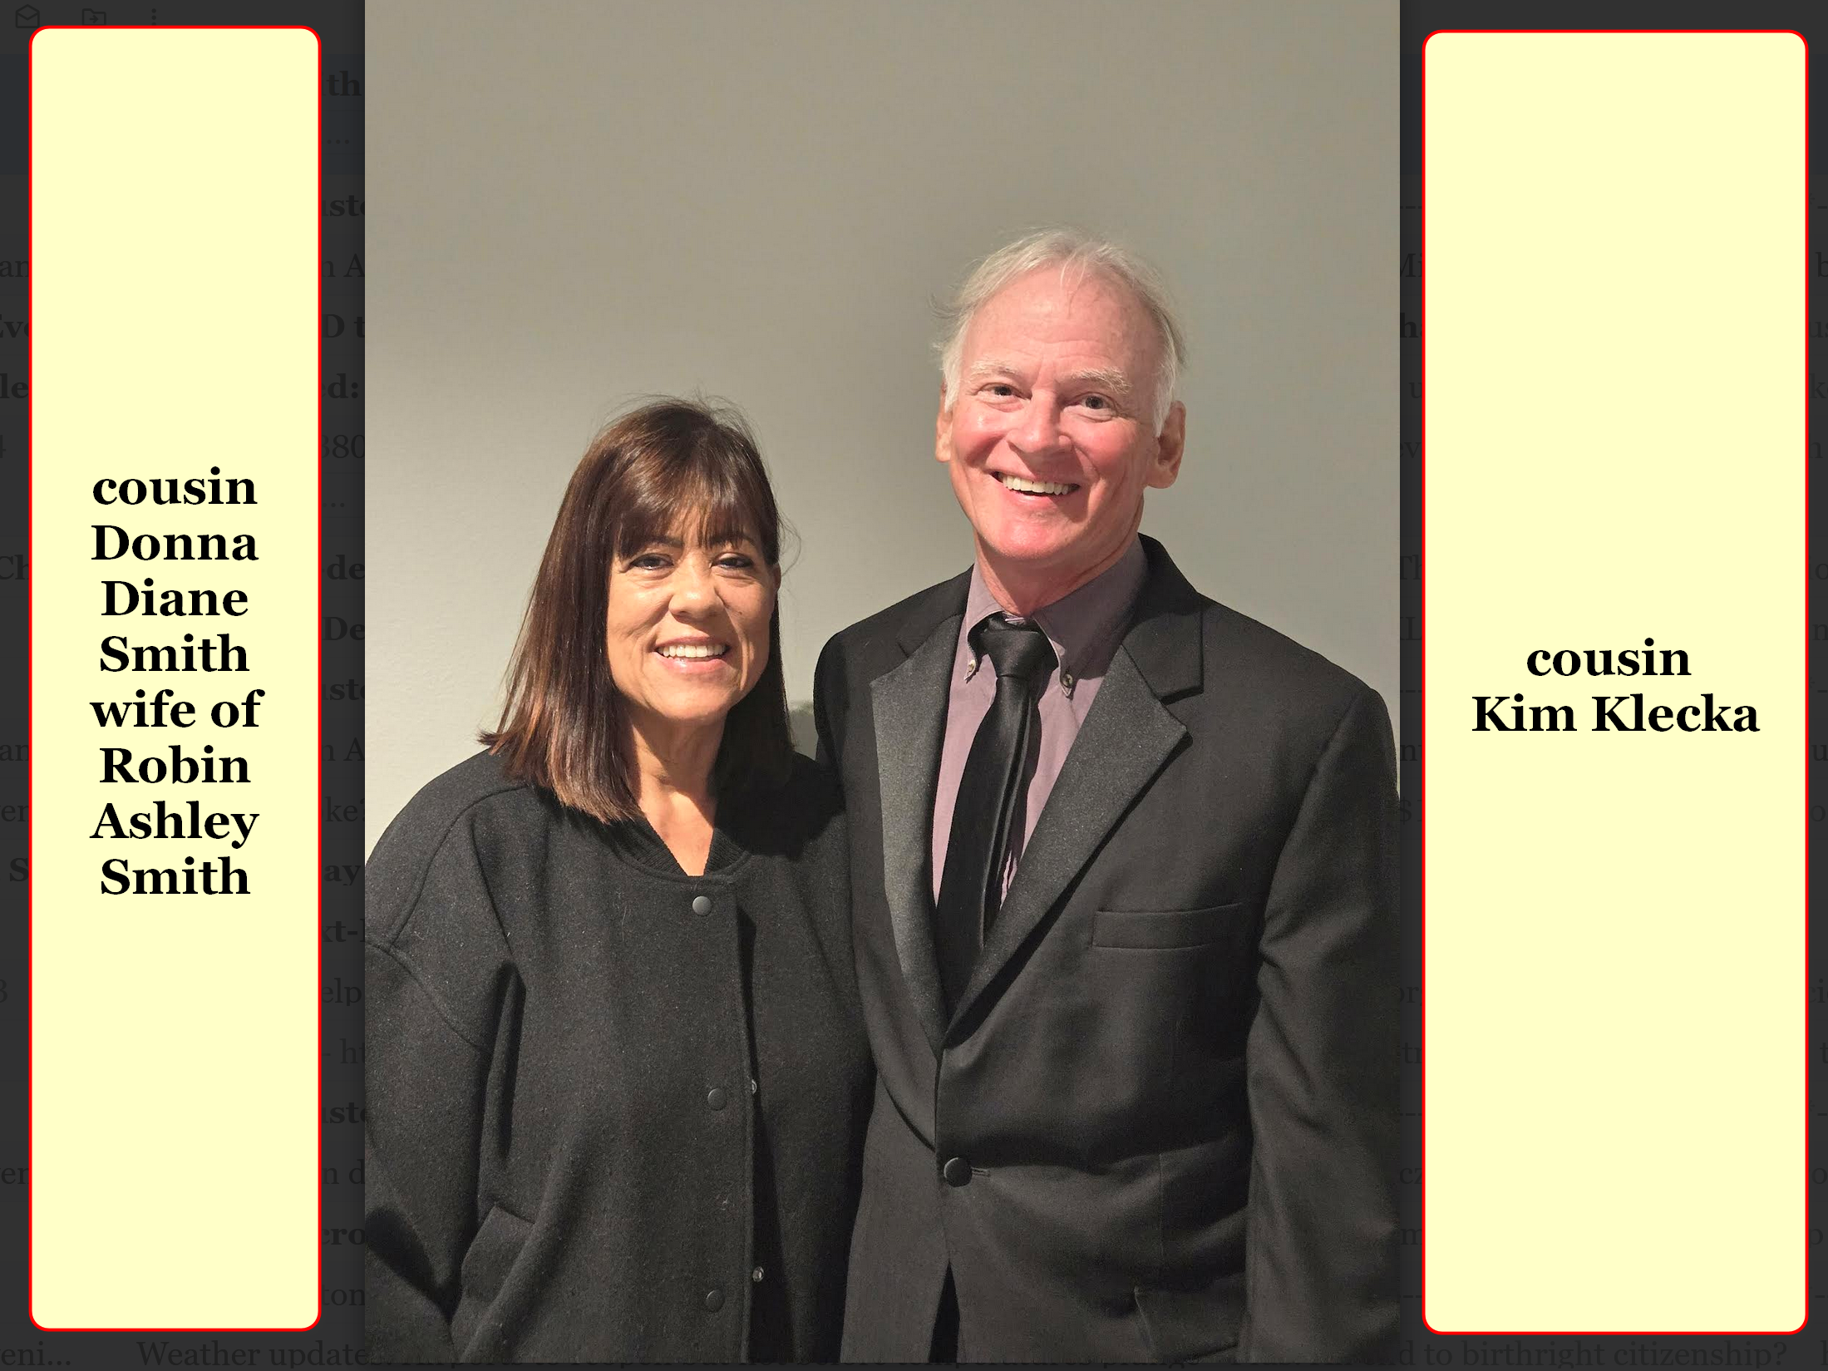

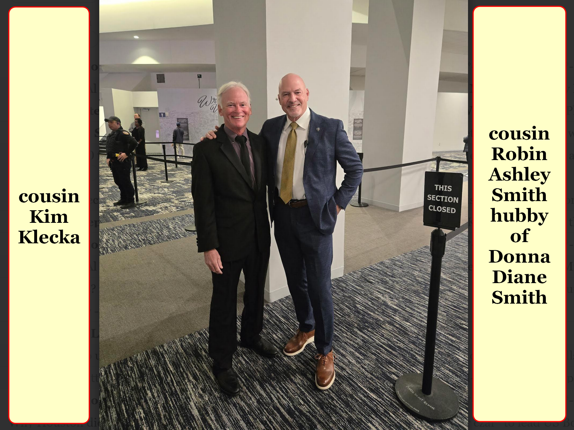

2013 kim
eventually gained employments at
fast food restaurant plus
BED BATH & BEYOND store

one reason for kim
choosing
that restaurant because window
displayed lettering IN GOD WE TRUST

at BED BATH & BEYOND kim
worked overnight
restocking shelves

kim
moved south
from smiths' household to gulfgate area
to room with low rent

yet major plumbing issues
created
unlivable conditions therefore kim moved to
city's north side to room advertised

new room with shared bathroom
located inside
collision body shop at intersection of
I-69 northside at beltway 8 tollway

month later kim
gained
employment at bush airport as custodian

third party contractor
paid
$8.50 per hour yet gave physically
impossible hourly checklist to fulfill

kim's income
barely paid for
essential expenses

nearest bus route to airport
mandated traveling south to
downtown then wait then take
another bus north to airport entrance

above
would have involved
4 hours daily in bus system

instead of above kim
walked
ten miles round trip daily

some custodians at same airport
enjoyed
$13 per hour via direct employments
from city of houston

surprisingly supreme being
disallowed
kim from applying for city employment

finally years later kim
realized connecting with
that houston mayor would have changed
kim's official emotion signals to universe

wikipedia.org's

Annise Danette Parker (born May 17, 1956) American politician who served as Houston, Texas' 61st mayor
from 2010 until 2016.
One of first openly gay mayors of major U.S. city

KIM NOTES

SUNNYsideDOWN mayor as employer connection
would have blocked
kim from 2014 december 14
SUNNYsideUP revelation in library

previously as dentist kim's patients' comments
explained
portions of
humankind's optional SUNNYsideDOWN package

writer of SUNNYsideDOWN scripts
utilized
STILL SMALL VOICE impersonating supreme being
to dental patients at HIV clinic

one male patient
told
kim that patient heard from Jesus
years before

according to that man Jesus
told
that man
CHOOSE to become GAY

another day at HIV clinic kim
fetched
next patient in waiting area
for dental work

male patient
closed
magazine remarked if that beautiful lady
entertainer pictured on cover liked him

then he
would choose to stop being
gay

kim
concluded

imitator of STILL SMALL VOICE
pushed
humans to choose that behavior

those three experiences above
supported
kim's later summation

persons choosing SUNNYsideDOWN package
included preferring
sex outside of heterosexual marriage plus
eventual sex preferences gaylesb pedobeasto

kim
realized
SUNNYsideUP package included
fidelity in heterosexual marriage exclusively

SUNNYsideUP package
brought
SUPER HEALTH pleasant dreams SUPER CIRCUMSTANCES

2014 at airport kim
devised
strategy to obtain food

during kim's lunchtime kim
kept using
cleaning cart but moved to
huge airport food court tables area

although not officially assigned kim
cleaned
selected airport restaurant tables
when clients left trays with scraps

plus kim
gladly gathered
scraps from restaurants' garbage bags
kim
volunteered to cart and drop
some restaurants'
garbage bags into basement dumpsters

for six months kim's diet
consisted mostly
of scraps from work etcetera

then kim felt supreme being
asking kim to
become street preacher to
homeless of downtown houston

2014august28 kim
obeyed

without any church support kim
started sleeping in
downtown houston texas
like downtown homeless under clear skies

kim's goals
included persuading
as many people as possible
to say prayer of eternal salvation

kim like other homeless persons
ate
when and where charities provided
meals

kim
ministered to and prayed with
homeless in food lines
sometimes hours long lines

food kitchens' schedules days times
varied

kim
attempted being
front or near front of queues

kim
developed routine
of getting to charity food places
usually churches two hours early

kim
crisscrossed
houston's extended downtown area
totaling about 16 miles daily

in evenings under streetlights kim
wrote in
spiral notebook writing sermons for future
internet viewing for free

kim
slept serenely
with pleasant dreams

kim
was grateful
for front row seat when miracles
happened through praying

yet as most people
notice
but rarely discuss

only some prayers
answered affirmatively
example healing prayers

yet logically either all prayers
always answered
or none ever answered

this procedure people call prayer
either
100% valid in universe
or 100% false mere fantasy

this book's chapter 003
resolves
situation mentioned above

concerning SHOELANGUAGE book style

for viewers' speedy reading kim
subtracted
many small words even from snippets

signature phrase KIM NOTES
identifies
kim's opinions interjected between authors' snippets

kim
utilized
predictable paragraph framework so viewers
more speedily accept information

kim
capitalized
first plus last words of quotes
to identify quotes from others

kim
thanks
scientists laying foundations for explanations
and writers for creating memorable characters

all persons above
unknowingly proved
portions of THEORY OF EVERYTHING

SHOELANGUAGE BOOK
utilized
snippets from books online articles

that exposure
probably increases
those authors' sales

kim glad for above in fact
strategizes
all humans gain prosperity happiness
honeymoon joy eternally

above manifests if globe
votes YES adopt
this book as upgrade manual
then migrates to prebuilt Diametercities

SHOELANGUAGE book
kindly exposes
portions of traditional myths including religions

until now certain portions of myths
blocked
humankind from SUNNYsideUP eternity

chapter ends

