**N07 rfk jr initiation fee kill wife**

**2011 rfk jr**

**desired**

**BEARS membership selected wife as target**

**BEARS usa**

**desired**

**coverup hole in script concerning**

**1999 assassination cousin john john**

**BEARS obama**

**waived**

**rfk jr's elevation fee if plant**

**diary explaining mom bissette's counterintuitive reversal**

**in public mom of bissette sisters**

**openly requested**

**burial sites for daughters in location**

**close to mother bissette future visits**

**yet BEARS usa**

**bribed**

**family with $15 million so cremations**

**coverup explosion marks on bodies**

**2012may16 rfk jr**

**planted**

**freshly written 1999july16 diary in house**

**of rfk jr's initiation fee wife**

**2012may18**

**cnn.com's**

**nina ibarra michael martinez rob frehse**

**Mary Kennedy's family blasts "misrepresentations" of her life**

**Robert F. Kennedy Jr. filed for divorce from his wife in 2010**

**The couple was still married at time of her death**

**The family of Mary Richardson Kennedy,**

**the estranged wife of Robert F. Kennedy Jr.,**

**blasted news accounts of her death Thursday for what they called “inaccuracies and misrepresentations” of her life.**

**Mary Kennedy: ‘Green’ designer, wife of Robert F. Kennedy Jr.**

**was found dead Wednesday in Bedford, New York, north of New York City. She died of asphyxiation due to hanging, Westchester County medical examiner said Thursday.**

**“While we would naturally prefer to remain private at this very upsetting time, we feel compelled to make this statement because**

**the description of Mary carried by certain news organizations since her passing yesterday is wholly inconsistent with sister we knew and life she, in fact, lived,”**

**“We loved Mary and knew her to be an exceptional mother, sibling and friend to many,” they said.**

**“Countless people ... one of finest people in world. We know her as all those things, and more.”**

**A second arrest occurred in August of same year in town of Pleasant Valley, in which she was charged with driving while impaired by prescription drugs,**

**Lawrence said. Those charges were dismissed completely in July 2011 because all drugs were prescribed and taken as her physician advised, attorney said**

**KIM NOTES viewers**

**please observe**

**BEARS actions**

**2010 ambitious rfk jr**

**premeditatedly files for divorce**

**from future target**

**2010august BEARS**

**frame**

**target by insinuating**

**as if drug dependent**

**after premeditated framing mary 2012may16 BEARS**

**staged killing of**

**mary richardson kennedy as suicide**

**many deceptions**

**allowed**

**planting of false diary to fill**

**loophole in jfk jr's 1999 killing**

**2013may16 update 2017july11**

**thedailybeast.com's**

**nancy collins**

**By 10 a.m., when Richardson hadn’t emerged from her bedroom, housekeeper and caretaker started searching house and property.**

**Calling Kennedy,**

**they told him that despite finding Richardson’s cellphone, driver’s license, glasses, and car with keys intact, she seemed to have vanished.**

**Rushing over, he checked attic before tracking down Shannon White, Richardson’s AA sponsor, at an 11 a.m., Armonk AA meeting.**

**When he told her that he was afraid that his missing wife might have “hurt herself,”**

**White said, according to police report,**

**that didn’t make sense because of “the sobriety work Mary had been doing with AA last couple months.**

**I’d watched her grow hopeful, blossom before my eyes.”**

**Back at house, while Kennedy scoured woods, White and caretaker**

**headed toward barn, which had already been checked twice.**

**Walking in first, caretaker suddenly asked, ‘What’s that over there?” and spotted**

**Mary, in black gym clothes and sandals, “suspended” slightly above eye level, “from an overhead beam by a rope, neatly knotted,”**

**White reported, “nine times around her neck.”**

**her hands, palms facing outward, lodged**

**between her neck and rope, almost as if**

**attempting to pull it away.**

**KIM NOTES mary's last moments**

**included**

**attempting pull rope from neck because**

**mary did not want death**

**news of Richardson’s suicide astonished her legions of friends if only because her devout Catholicism forbids it.**

**children, now facing a lifetime of emotional confusion because of their mother’s unexplained actions.**

**New Questions Arise About Mary Richardson Kennedy's ...**

**The Daily Beast**

**https://www.thedailybeast.com › articles › 2013/05/16**

**debate came to a head in library of Kennedys’ Bedford estate night that Richardson died.**

**Confronting Kennedy, Nan Richardson is said to have angrily announced: “You killed my sister.”**

**KIM NOTES nan richardson with intuition**

**correctly mentioned**

**rfk jr killed nan's sister plus**

**BEARS associates arranged pretended suicide**

**“Mary was brainwashed,” adds another Richardson friend, “believing everything that Bobby said. And he was leading her on.**

**He might have been with Cheryl [Hines, his girlfriend during Richardson’s final years], but he was still giving Mary enough encouragement to stay hopeful ... Bobby did everything he could to demean and hurt Mary.”**

**1999 BEARS**

**desired killing**

**john john via air disaster**

**near island of martha's vineyard**

**only one problem existed wife carolyn**

**not desiring**

**travel to kennedy home compound**

**in hyannis port massachusetts**

**therefore BEARS ted kennedy**

**enlisted**

**aid from**

**one of carolyn's sisters lisa**

**sister lisa bessette**

**negotiated**

**$15 million family package convince parents**

**accept cremation plus blame john john**

**plus lisa bessette**

**suggested**

**BEARS ted kennedy also killed laura**

**because laura's natural detective response powerful**

**if BEARS**

**merely killed**

**kennedys then neighbor laura detect holes**

**in cover story find sister's assassins**

**agreeable BEARS' new plan**

**included**

**rory kennedy plan wedding date 1999july17 as**

**paying BEARS fees john john wife**

**rory kennedy**

**agreed**

**lisa**

**called**

**carolyn from germany**

**lisa**

**requested**

**meet lauren 1999july16 martha's vineyard**

**MANSION HOUSE INN plan rooftop reception**

**portion of rooftop surprise birthday party**

**included**

**surprise guest lisa from germany**

**to honor mom on birthday 1999august05**

**however 1999july16 lisa**

**never actually left**

**germany because lisa confident in BEARS'**

**ability to kill trio as planned**

**wikipedia.org 1999 martha vineyard's plane crash**

**Fifteen months before crash, Kennedy flew 35 flights either to or from northern New Jersey Martha's Vineyard area.**

**more than 17 of these legs without certified flight instructor on board, including five at night.**

**On evening of July 16, 1999, John F. Kennedy Jr. piloted Piper Saratoga to attend wedding of cousin Rory to Mark Bailey at Kennedy Compound in Hyannis Port, Massachusetts.**

**Lauren Bessette was to be dropped off at Martha's Vineyard Airport, while Kennedy and his wife would continue to Barnstable Municipal Airport.**

**during clear weather BEARS**

**exploded**

**airplane**

**BEARS**

**later destroyed**

**paper weather records because**

**untrue cover story claimed bad weather**

**that night witnesses**

**heard**

**explosion in sky in area**

**john john's plane's route**

**island of martha's vineyard's preplanned blackout**

**included**

**lights out at killing time**

**pilot same route about same time**

**said**

**no lights on both airport town**

**thought possible power outage**



**martha's vineyard airport tower manager**

**reported**

**clear skies**

**with ten to twelve miles visibility**

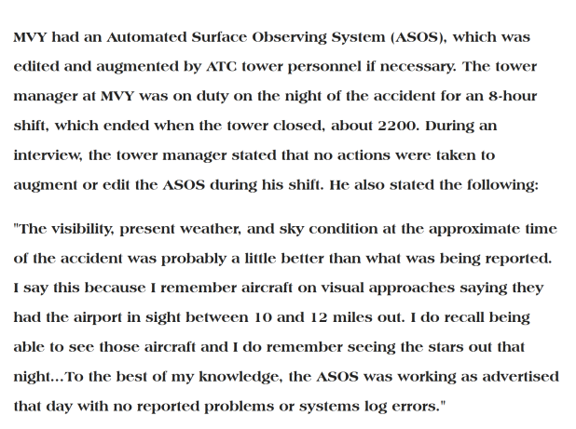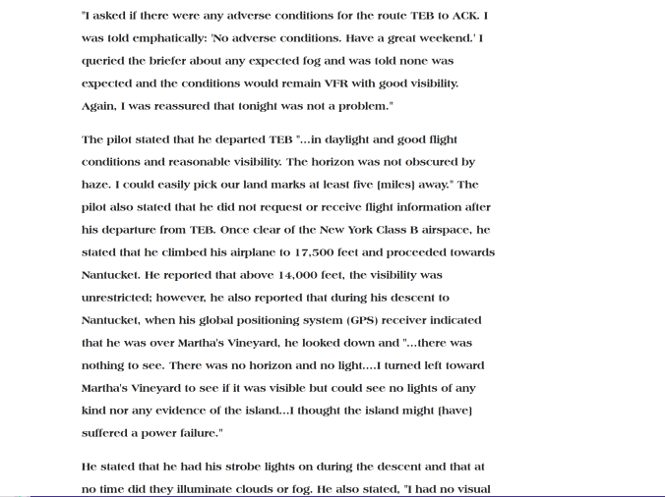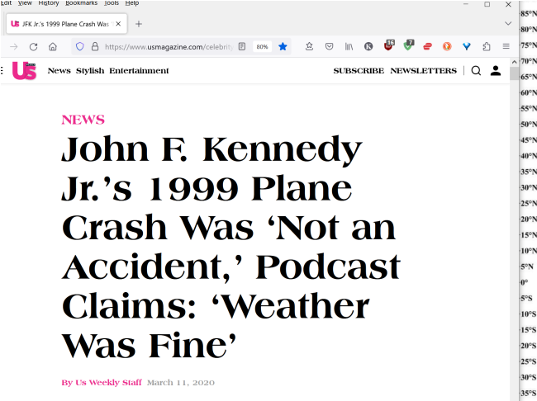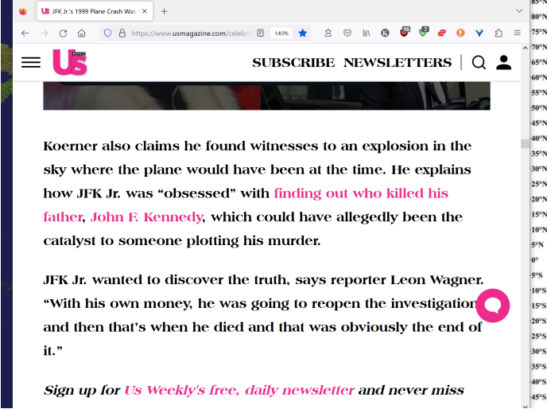

**chapter ends**