**F03 placebo effects equal real effects**

**researchers for centuries**

**declared**

**examples of paradoxes**

**no way both things coexist**

**humans**

**evaluate**

**various points of information**

**with various acceptance speeds learning styles**

**given time all humans**

**categorize**

**new details beneficially interject details into**

**emotional equation of life**

**immediate first glance acceptance without examining**

**involves**

**risk possibly trunk parliaments' pushiness**

**detouring person away from SUNNYsideUP**

**electrons**

**watch**

**time happening in every TIME EGG**

**if conscious human person**

**gives**

**enough time answers eventually hurdle over**

**emotional trainings' taught blockades**

**consistent SUNNYsideUP signals**

**allow**

**bypassing**

**taught inadequate parameters of thinking**

**in this way conscious person's cns**

**finally invites**

**requested information already known by all**

**electrons in subconscious 1D singularity dot**

**researchers**

**noticed**

**certain paradox then**

**labeled that paradox placebo effect**

**australia's**

**www.betterhealth.vic.gov.au/health/conditionsandtreatments/placebo-effect**

**Summary when convenient please read full fact sheet**

**placebo any treatment**

**has no active properties,**

**such as sugar pill.**

**There are many clinical trials where a person who has taken the placebo instead of the active treatment has reported**

**an improvement in symptoms.**

**Belief in a treatment**

**may be enough**

**to change the course**

**of a person's physical illness.**

**SHOELANGUAGE book**

**explains**

**paradox**

**called placebo effect**

**toggle switch universe**

**astonishes**

**well meaning health providers**

**placebo effect**

**merely**

**regular part of universe's operations**

**only patients' SUNNYsideDOWN signals**

**block**

**placebo effect from 100% resolution occurrences**

**placebo effect**

**actually**

**entire effect**

**unfortunately entire effect**

**often blocked**

**by SUNNYsideDOWN signals**

**unknowingly given**

**tranquility**

**includes**

**erasing myths example 3D universe only**

**in actuality each human**

**lives simultaneously in**

**two universes example great grandfather of**

**author vivian higginbotham nichols**

**HIGGENBOTHAMS pages 10-11**

**amazon.com's**

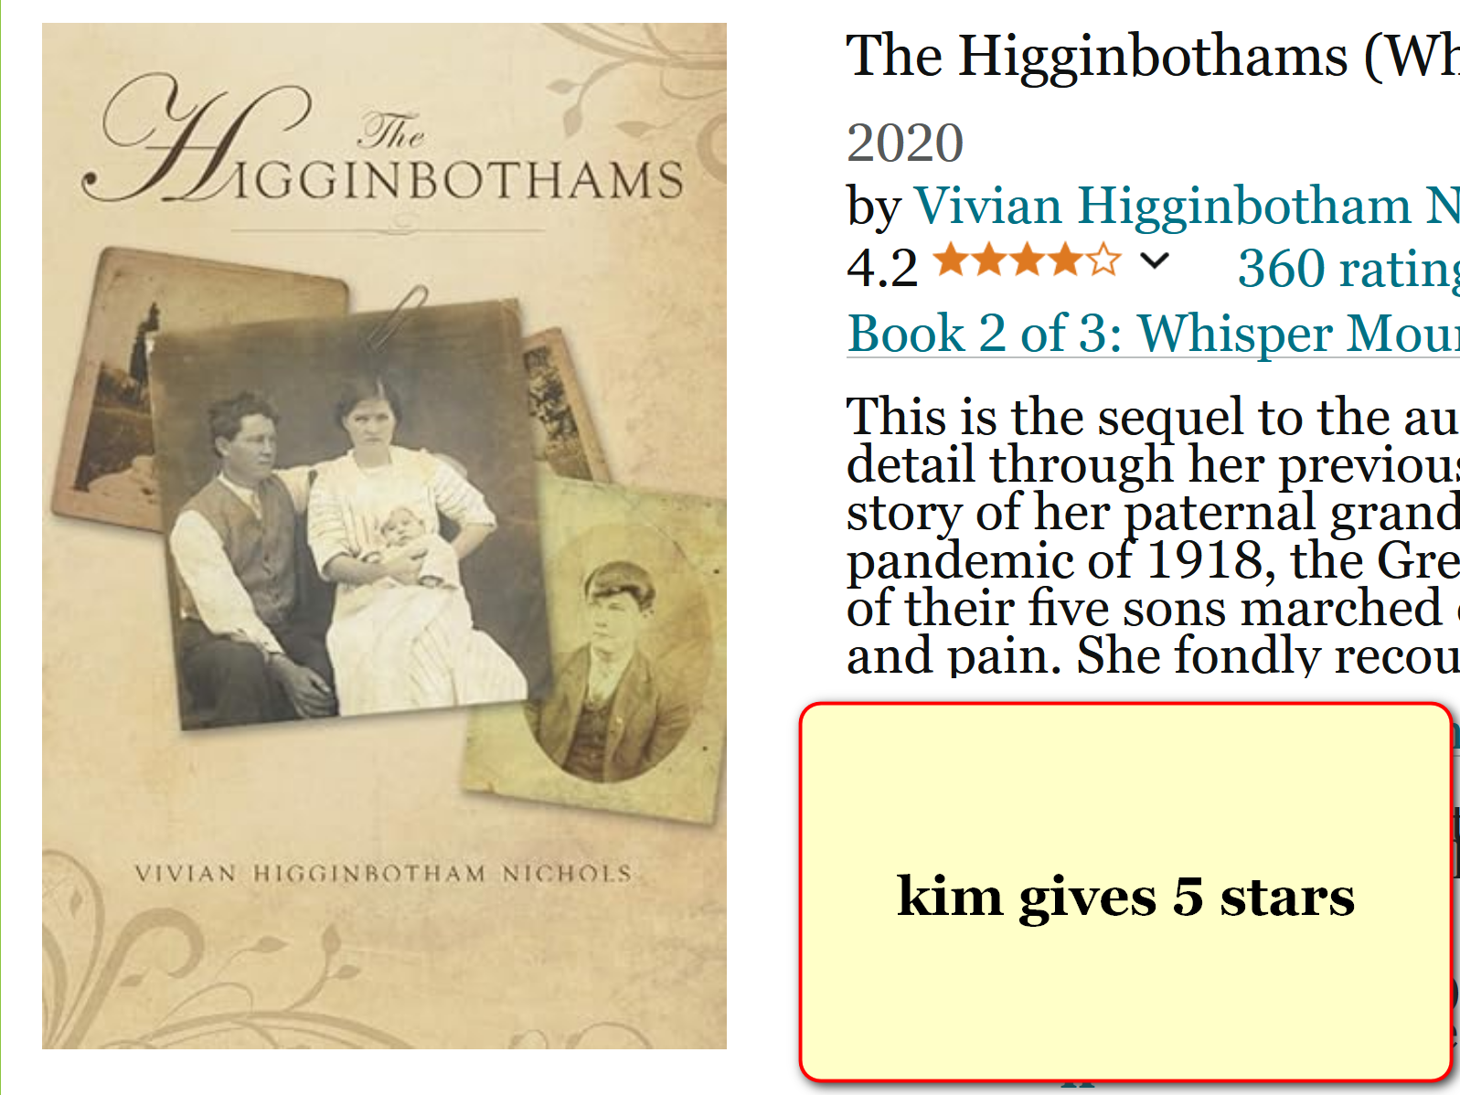

**portions of human FIELD of ELECTRONS**

**communicate with**

**other portions of body**

**this higginbotham case electrons of legs**

**communicated**

**with electrons of main body**

**though distantly located**

**buried amputed leg**

**complained**

**of ants to main body**

**main body**

**complained so much that**

**finally family members retrieved buried casket**

**indeed ants**

**covered**

**leg**

**family members**

**wrapped**

**leg well reburied leg**

**man**

**felt better**

**above snippet**

**gives**

**one example of intertwining**

**of universes**

**chapter ends**