B03 time pudding wedding album mars

in earlier 2D universe photons
agreed
deliver to each field of electrons
requested emotion situation

yet sometimes photons
unsure
of person's intentions

in those cases photons
hesitated
delivering SUNNYsideUP or SUNNYsideDOWN

therefore photons
initiated
time pudding protocol
clarifying main character's intentions

in time pudding protocol photons
gave
main character separate holographic detour
unlike other actors on stage

special script
often involved
person's memories plus thoughts
lightly entertained concerning future events

both opposing SUNNYside script writer champions
contributed to
varying script elements hoping to sway
main character's emotions intentions

when main characters' decisions during journey
clearly favored
one of equally available choices SUNNYsideUP or SUNNYsideDOWN then time pudding ended

at journey's end character
seamlessly reunited
with colleague actors
inside main holograph on stage

now returning to Bob's seminar

when lesson concluded Bob
gave
parting gifts

Bob
gave
left ear inserts for helmets designed
especially for Bob’s Alice's ongoing advice

Bob's Alice's ongoing encouraging one liners
provided
possible SUNNYsideUP script interjections
utilized by kids if wished

kids’ usages of script snippets
increased
audiences’ laughters dramatically

Bob Alice
spread thin
by creating scripts
helping all kids as needed

wedding day bride Alice
needed
symbolic gift to give groom Bob

girls
donated
pet chicken for Alice
to give Bob

bride Alice
placed
chicken on groom's left hand palm

above
counted
as animals' minerals' vote 2-0

therefore animals minerals GRAND VOTE
officially recommended
SUNNYsideUP universe via wedding chicken
on groom's left hand

dreamstime's wedding statues' drawings
below

OXFORD ATLAS OF WORLD
gazetteer of nations pages

female bride
close contact
between two males

Don circled in red
gives away
bride

groom Bob circled in red
almost receives
bride in fact nose to nose

almost bride Alice
successfully gave
gift sealing animals' minerals' intentions GRAND
VOTE for SUNNYsideUP universe environment forever

before wedding groom Bob
needed
symbol give Alice

boys
donated
bright flowers wove flowers into headband
placed headband ring onto groom Bob

mars' wedding statue photograph
below

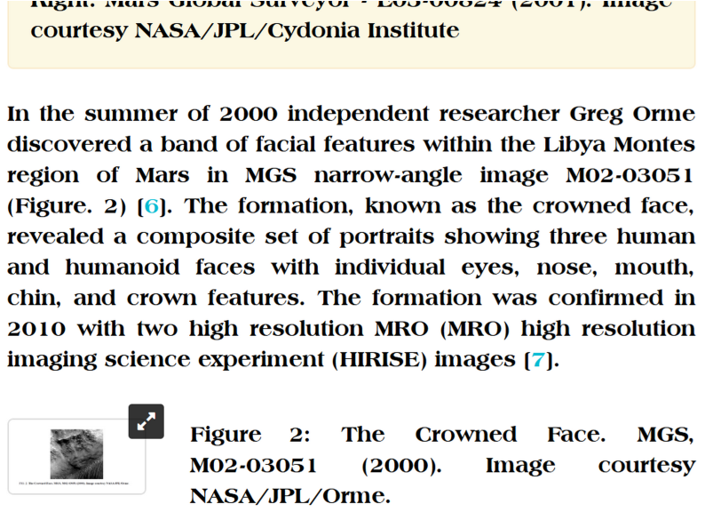

groom Bob above
removed
headband desiring crown bride seal marriage
affirm VEGETATION ALL OTHER LIFE vote

if VEGETATION ALL OTHER LIFE's vote
joined
ANIMALS MINERALS' vote
2-0 GRAND VOTES' majority created

then HUMANKIND’s GRAND VOTE
unnecessary
because majority rules therefore soldifies eternity's
environment SUNNYsideUP honeymoon ecstasy style

chapter ends

