**H04 HORTON'S nurturing merges with Cindy's**

**photon ushers**

**created**

**images of Horton elephant Cindy**

**in eagle nebula's PILLARS of CREATION**

**File:Eagle nebula pillars.jpg**

**Credit: NASA, Jeff Hester, and Paul Scowen (Arizona State University)**

**Date circa 2003 ( HST image is from 1995)**

**Source//hubblesite.org/newscenter/newsdesk/archive/releases/2003/34/image/a**

**Author Credit: NASA, Jeff Hester, and Paul Scowen (Arizona State University)**

**pillars in the Eagle Nebula, as seen by the Hubble Space Telescope's WFPC2. The picture is composed of 32 different images from four separate cameras in this instrument.**

**The photograph was made with light emitted by different elements in the cloud**

**and appears as a different colour in the**

**composite image:**

**green for hydrogen,**

**red for singly-ionized sulphur and**

**blue for double-ionized oxygen atoms.**

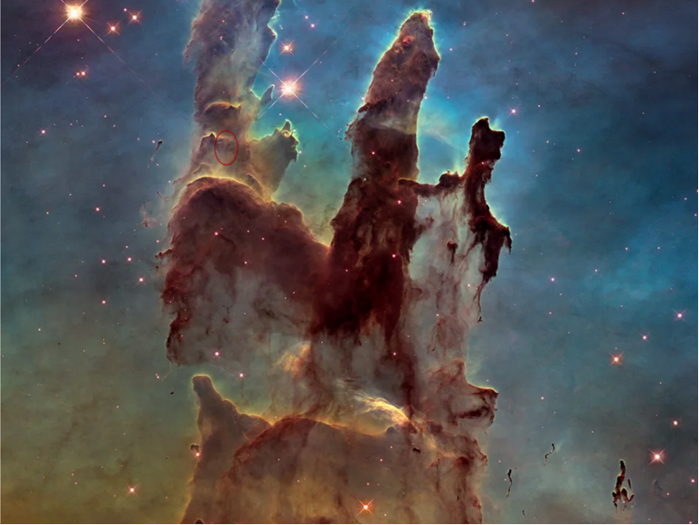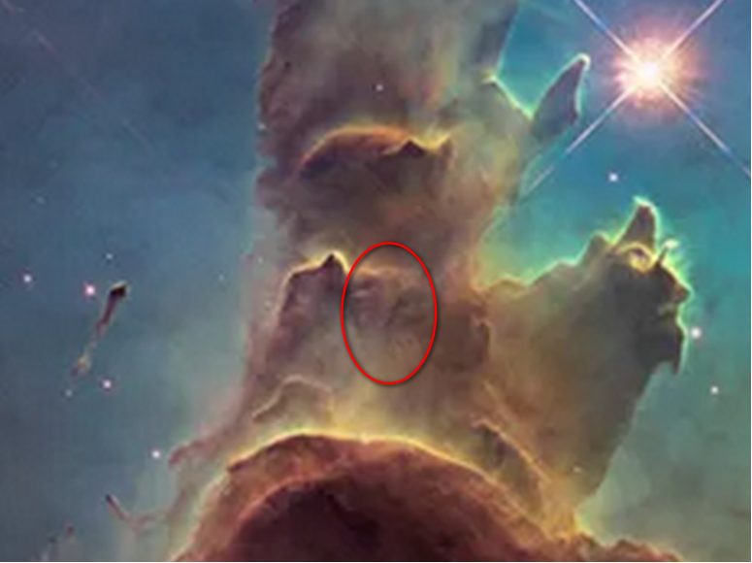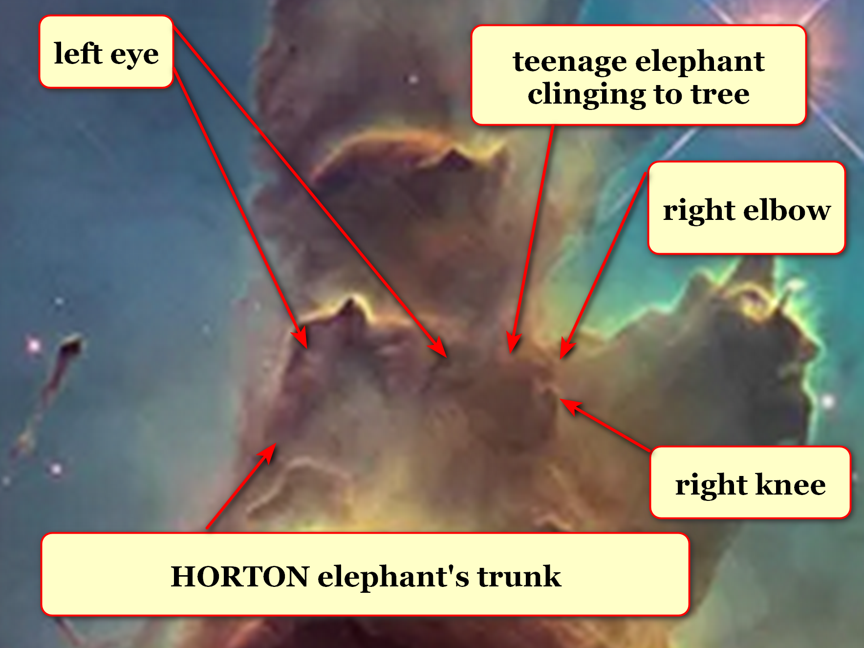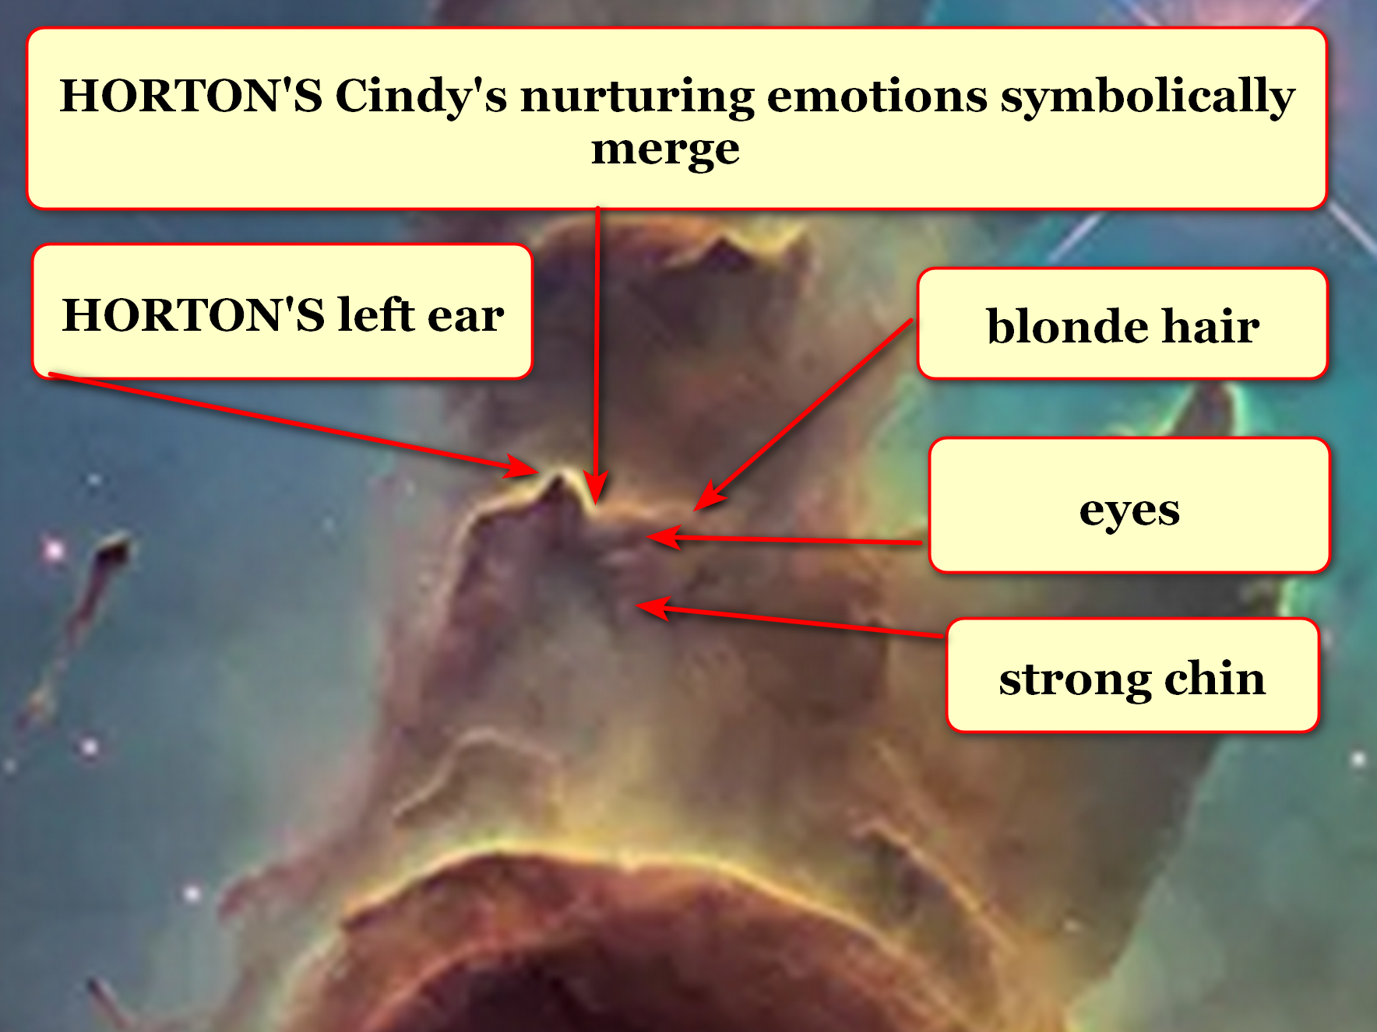

**chapter ends**