D03 2D africa australia alice in shoe

bamboozler Bob
needed
majority permission
to activate operations

bamboozler Bob
manipulated
holographic settings
entered TIME EGGS by voice overs

impersonating supreme being bamboozler Bob
urged
cain abel noah ham japheth
accept scheme SUNNYsideDOWN culture

twins cain abel
accepted
offer
via majority vote 2-0

cain
created
role for cain
legal judge against abel

earth only 2D before cain
utilized
capital punishment against abel

2D earth
covered
with water entirely

first earthlings
swam
underwater with gills webbed appendages

2D watery earth
absent of gravity
therefore easy locomotion

original earthlings
enjoyed
SUNNYsideUP culture utilized SHOELANGUAGE
during era water covered entire earth

kim
displays
northwest africa from oxford atlas of world

face
looks
westward

northwest africa
depicts
silhouette of cain twin of abel
looking left during original SUNNYsideUP culture

viewers
please notice
in picture above left ear flap
ALGERIA's tasili plateau including city hoggar

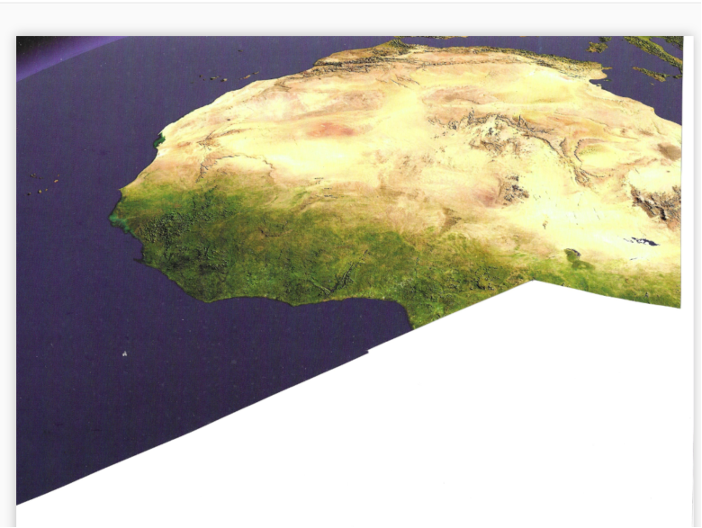
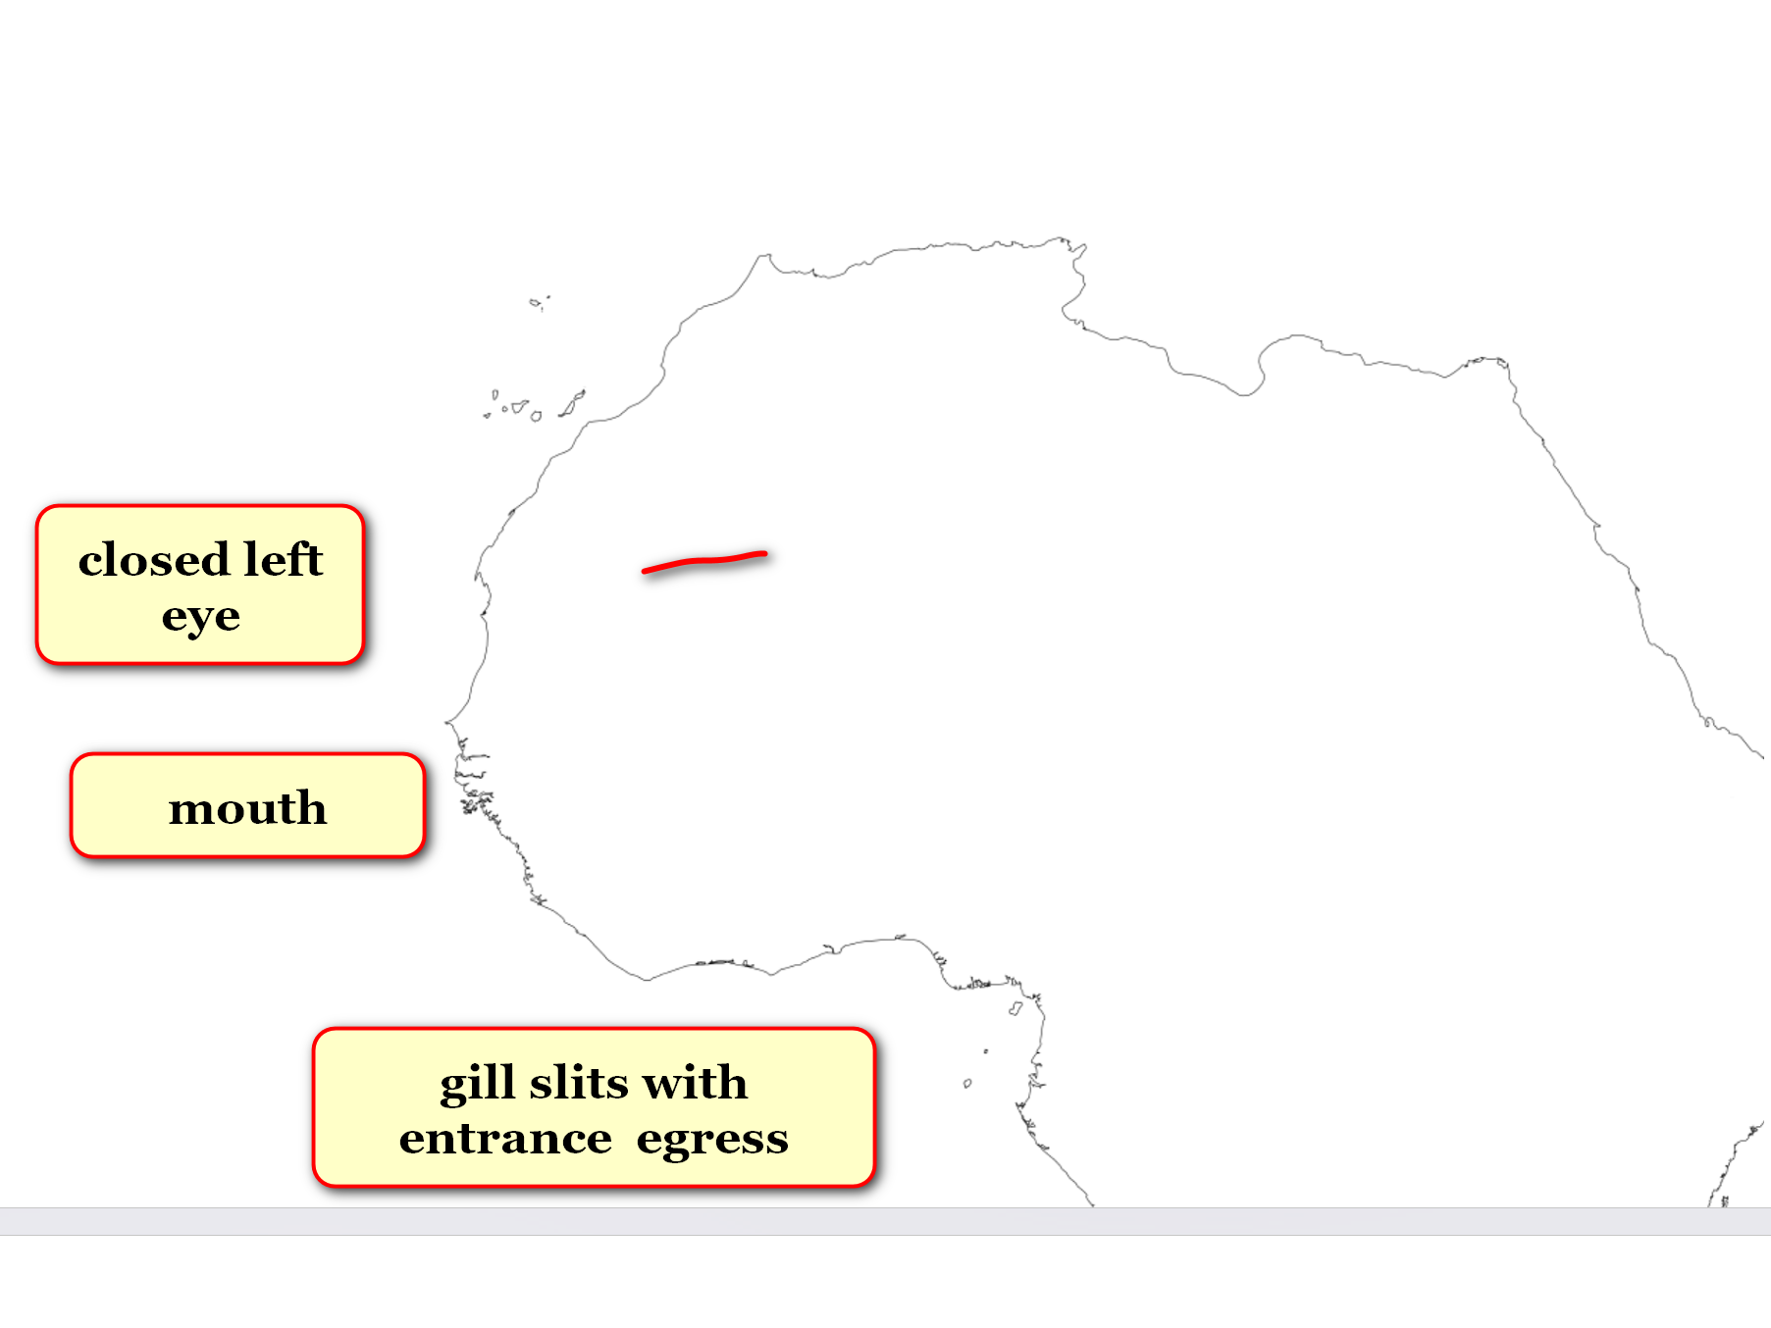

titan Cindy
holds
handset of landline telephone
to right ear of Cindy

titan Cindy
attempts
contacting cain but cain not answering

cain
keeps
eyes closed to SUNNYsideUP

two dimension universe 2D length width

flat watery earth disc

complete mobility
weightlessness tranquility
○
emotions expressed
via words actions
thoughts like eggs
nurtured warmed hatched

webfooted webhanded
earthlings
nearly officially adopted
SUNNYsideUP

oxford atlas gazetteer pages' pictures
include
eastern australia

kim
displays
north coast as facing left

eastern australia's shape
displays
tranquility Bob assuming shape of
2D earthlings

viewers
please notice
head fin for navigating watery world

tasmania
represents
cut away tongue portion symbolizing silencing
SUNNYsideUP Bob

SUNNYsideUP Bob
transformed
now bamboozler Bob

dogs via species wide vote
volunteered
mentor humankind
teach SUNNYsideUP culture

mentor dog
symbolized
coming forth from SUNNYsideUP inventor's mind
northward left side in picture

viewers
please notice
dog shape blends into head fin

head fin
guides
during swimming 2D earth

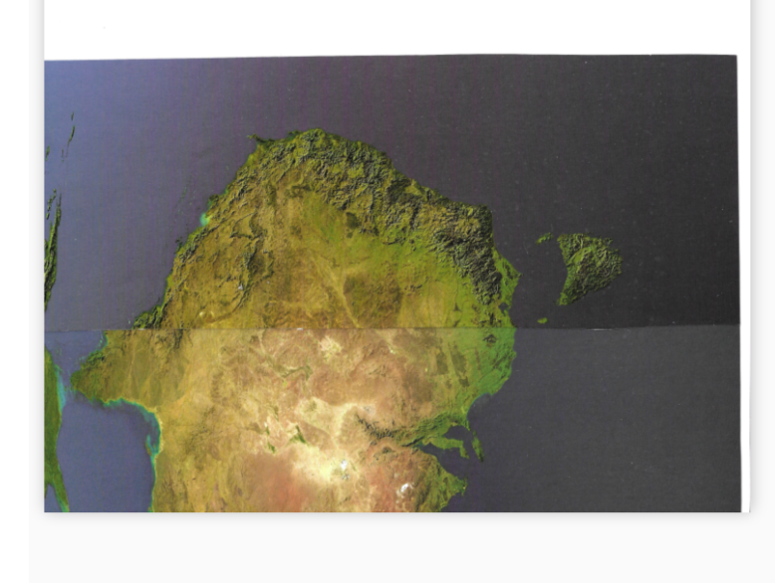

viewers concerning above picture
please notice
right ear flap throat gill slits
with water ingress egress like fish

ear flaps
facilitate
guidance during swimming

africa's double meaning crying face coastline
symbolizes both
cain's regret capital punishment against abel
ham's regret disrespecting father noah

entire east coast of africa
cries

lake tanzania
equals
right eye

madagascar
references
man lying prone
with knees bent upward slightly

head facing south downward
indicates
death specifically abel's death from hand
of cain yet cain now cries

ham with tears running down cheek
regrets
publicly humiliating father noah noah's
head facing south downward indicating disgrace

faces circled in red
symbolize
agonies allowed into world
via cain ham

madagascar shape
also references
dutch shoe

above
references
SHOELANGUAGE part of SUNNYsideUP recovery culture
way to restore humankind

madagascar shape
resembles
dutch shoe
recommending SHOELANGUAGE language plus book

famous english nursery rhyme
involved
huge shoe many children

for decades kim
heard
all other persons mentioning OLD LADY
as in

there was an old lady
who lived in a shoe
she had so many children
she did not know what to do

for decades kim
understood
main character OLD LADY

in 2015 kim
saw
photon ushers' seamount west of australia
referencing nursery rhyme concerning shoe

kim's online search
found
main character's name changed

2023december25 kim's sister named syneva
showed
kim 1915 nursery rhyme collections book
before kim opened book asked question

kim concerning person in shoe
asked
syneva about scottish nursery rhyme's
main character's name

syneva
replied
OLD LADY exactly as kim remembered

kim opened 1915 book
found
rhyme concerning shoe
utilized term OLD WOMAN

matriculating electrons utilizing original TIME EGG
revoted
on some date before 2015

majority
favored
switching name to OLD WOMAN

therefore all printed documents
acquiesced
holographic stage props updated
to OLD WOMAN

however each person's emotional impacted memory
keeps
prized memories as personal possessions

because of above situation two persons
utilized
OLD LADY memory
in making item for sale

pinterest.com's

large top image
utilizes
original
word OLD LADY

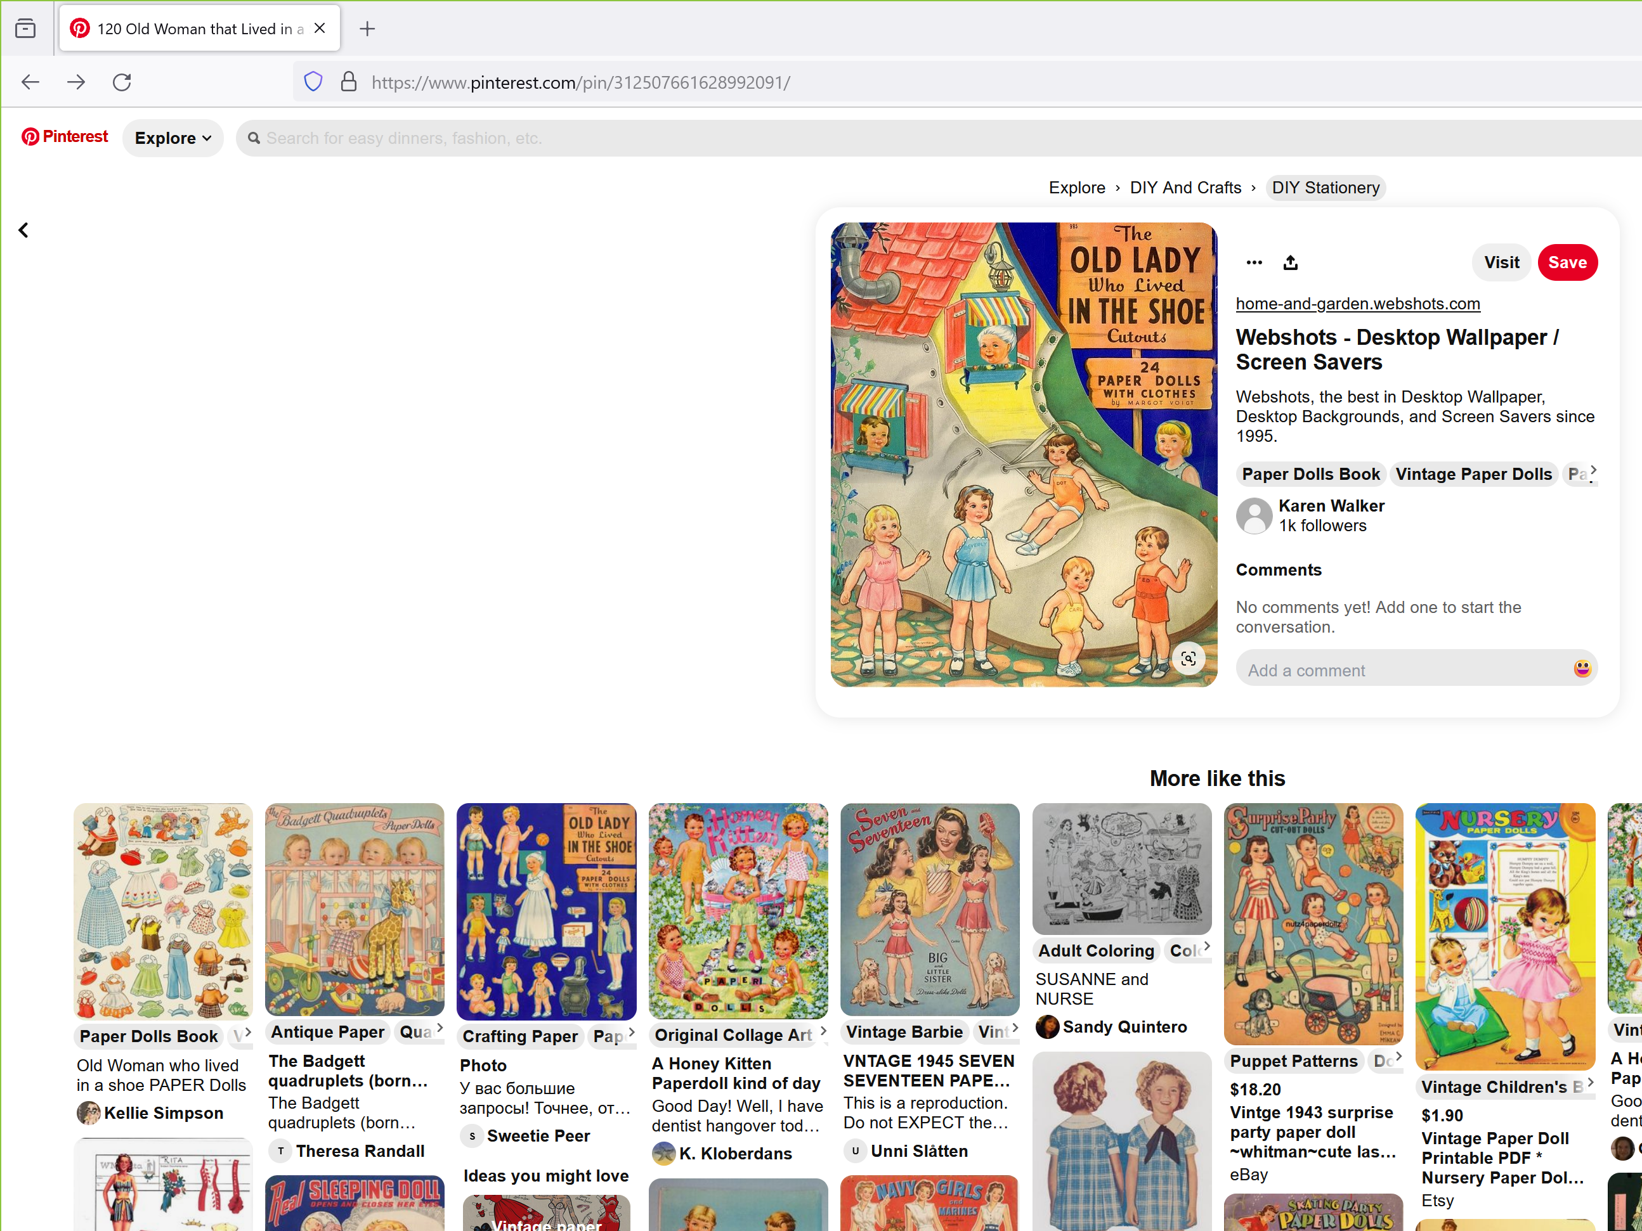

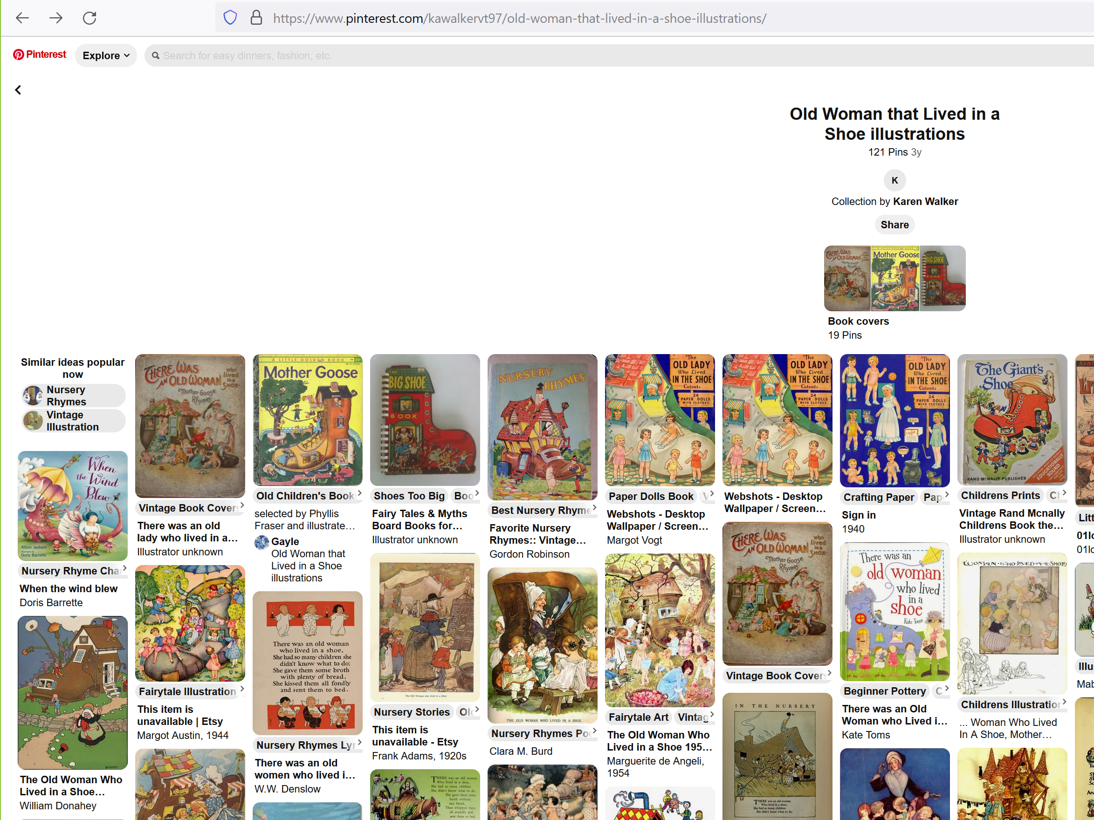

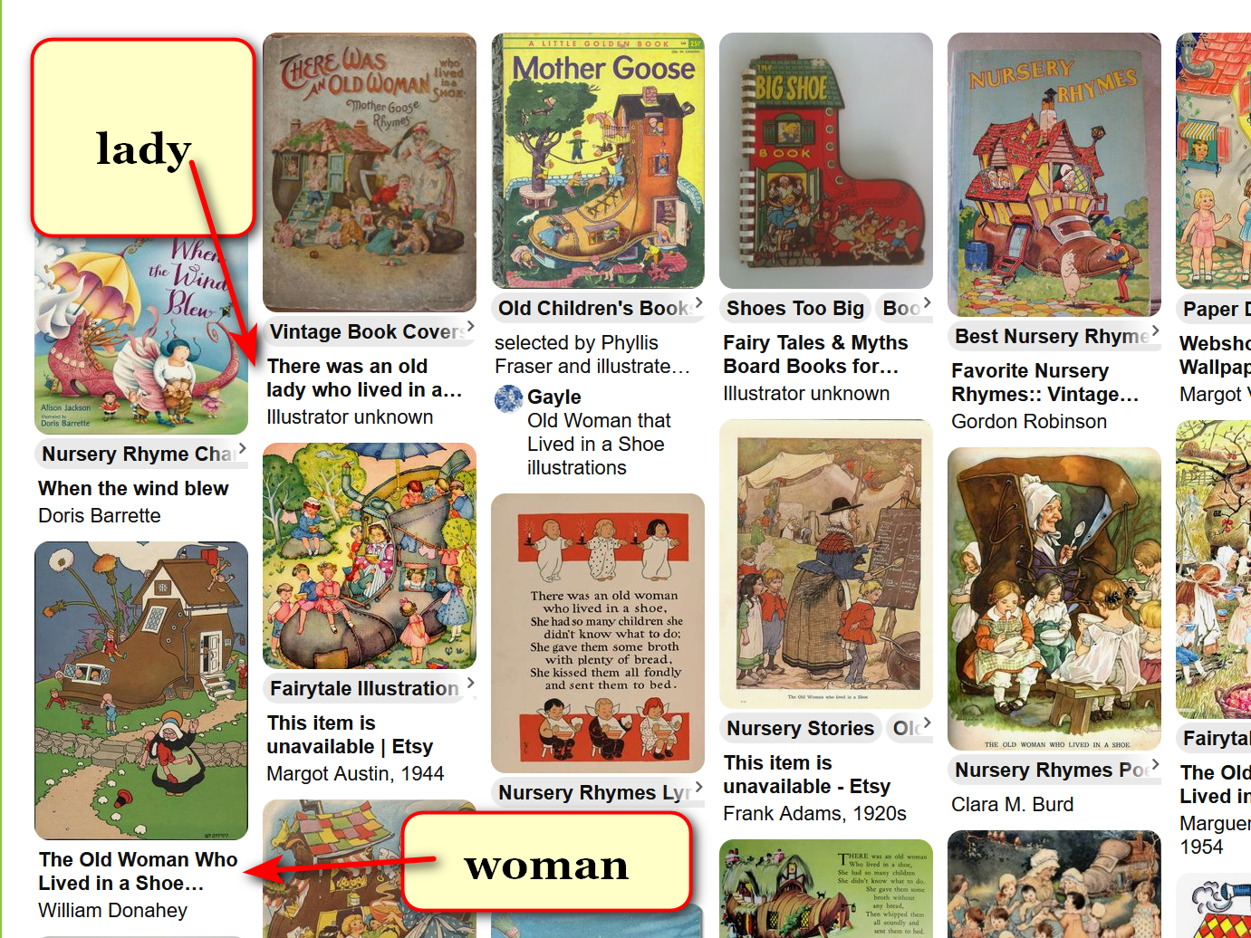

kim
gave
name Alice to
OLD LADY WHO LIVED IN A SHOE

https://www.newforestnpa.gov.uk › famous-forest-folkAlice in
New Forest National Park Authority
Wonderland inspiration

Alice Pleasance Liddell (1852 – 1934) was the little girl who inspired Lewis Carroll's Alice's Adventures in Wonderland and Through the Looking Glass.

alice liddell of ALICE IN WONDERLAND
shown
later in life
distinctive hat

chapter ends

