**C04 harriet verbalized**

**on broadway kids sylvester constantine**

**created**

**strategy expand activities of**

**BEARS without BOUNDARIES**

**BEAR members**

**collaborated**

**with focus attain goal**

**steal candy via group effort**

**club rules**

**included**

**nothing written**

**instead club members**

**created**

**unforgettable initiation fees secretly insert**

**cinnamon gum inside regular gum wrappers**

**ahead of time joining members**

**declare**

**specific targets**

**established members agree even help ambush**

**joining members**

**trick**

**trusting persons**

**those same persons supposedly protecting**

**joining members**

**urge**

**targeted persons chew tainted gum**

**therefore burn targeted persons**

**bamboozler Bob**

**suggested**

**through left ear helmet insert**

**sylvester confiscate candy store 1600 broadway**

**sylvester**

**walked to**

**M & M candy store**

**sylvester**

**found**

**harriet of maryland locked inner room**

**declared ownership of person harriet**

**sylvester**

**forced**

**so called property known as harriet**

**work making candy**

**after work at nights harriet**

**slept**

**next to candy making machine**

**gave sylvester nickname CANDYMAN**

**beforehand harriet**

**envisioned**

**unlimited life**

**harriet**

**never before scribbled**

**obviously never imagined scribble on skin**

**both harriet's life skin**

**possessed**

**futures unlimited**

**yet one day harriet**

**awoke noticed**

**candy tattoo on left arm**

**signed CANDYMAN**

**harriet**

**dismayed**

**people view harriet**

**forever tattooed confectioner's slave**

**days later harriet**

**carried**

**packaged candies past storefront window saw**

**two photon ushers outside broadway’s sidewalk**

**harriet**

**mouthed complaints**

**IMPRISONMENT TATTOO**

**through thick soundproof glass window**

**photon ushers**

**checked**

**records**

**replied SIMPLY following protocol**

**cain abel spokespersons for humankind**

**already voted**

**SUNNYsideDOWN entry to humankind**

**death illness contentions violence ETCETERA**

**photon ushers**

**summarized**

**MERELY fulfilled requested universe style**

**SUNNYsideDOWN UNIVERSE**

**yet harriet**

**desired**

**freedom requested PLEASE toggle switch**

**harriet’s personal preferences to SUNNYsideUP**

**photon ushers**

**promised**

**relay request to all**

**bamboozler Bob’s tactics plus BEAR tactics**

**included**

**strategy EASIER to manipulate**

**already infuriated people**

**then only small final push**

**needed**

**for votes cast favoring**

**SUNNYsideDOWN UNIVERSE**

**near midnight almost asleep harriet**

**heard**

**in helmet's left ear insert**

**inflammatory words**

**harriet’s conscious central nervous system cells**

**finally agreed**

**with subconscious cells' 55-45% recommendation**

**harriet cns chose SUNNYsideDOWN universe**

**around midnight harriet’s central nervous system**

**voiced aloud**

**into atmosphere CANDYMAN VANISH causing**

**SUNNYsideDOWN ripple effect into candyman's holograph**

**as soon as words**

**exited**

**harriet's mouth candyman’s electron crew exited**

**to singularity**

**as usual photons substituting for electrons**

**engineered**

**satisfactory holographic images of candyman from**

**so called death through including burial**

**candyman's homegrown vulnerability**

**already invited**

**SUNNYsideDOWN via unfairness enslaving harriet plus**

**inserting tattoos via vegetation based ink**

**photon ushers**

**gave**

**SUNNYsideDOWN chaos to both persons**

**because both persons asked for chaos**

**harriet**

**experienced**

**nightmare as part of SUNNYsideDOWN fulfillment**

**awakening harriet**

**read**

**morning newspaper dropped through slot**

**newspaper**

**mentioned**

**candyman departed earth entered afterlife**

**around middle of night before**

**harriet remembering harriet's words vocalized**

**regretted**

**causing candyman’s passing into afterlife**

**meanwhile harriet’s personal requests via photons**

**caused**

**SUNNYsideUP changes**

**harriet's arm**

**now tattoo free**

**doors unlocked**

**harriet**

**exited**

**candy shop**

**boarded biobus**

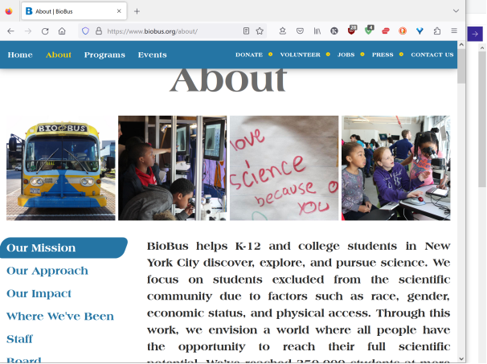

**harriet**

**released**

**bitterness**

**concerning former enslaver CANDYMAN**

**therefore harriet**

**regained**

**SUNNYsideUP emotion mindset**

**after that harriet of maryland**

**experienced**

**tranquil dreams**

**chapter ends**