**C01 noah replenished number of kids**

**surviving kids**

**called**

**home for more kids**

**come to summer camp on broadway**

**many kids**

**came**

**from across globe**

**soon theaters**

**possessed**

**new casts crews audiences**

**bamboozler Bob**

**manipulated**

**contempt between flavors of kids**

**noah's extended group**

**quickly repulsed**

**certain concepts example contempt between flavors**

**rejected notions royalty slavery caste systems**

**noah’s extended group**

**promoted**

**slogans all equal**

**all respected zero hierarchies zero slaves**

**each theaters' evening performance**

**offered**

**choice from two styles**

**audiences**

**voted**

**via entering from lobby**

**via one of two turnstiles**

**/pixabay.com/photos/turnstiles-entrance-black-and-white-6578578/**

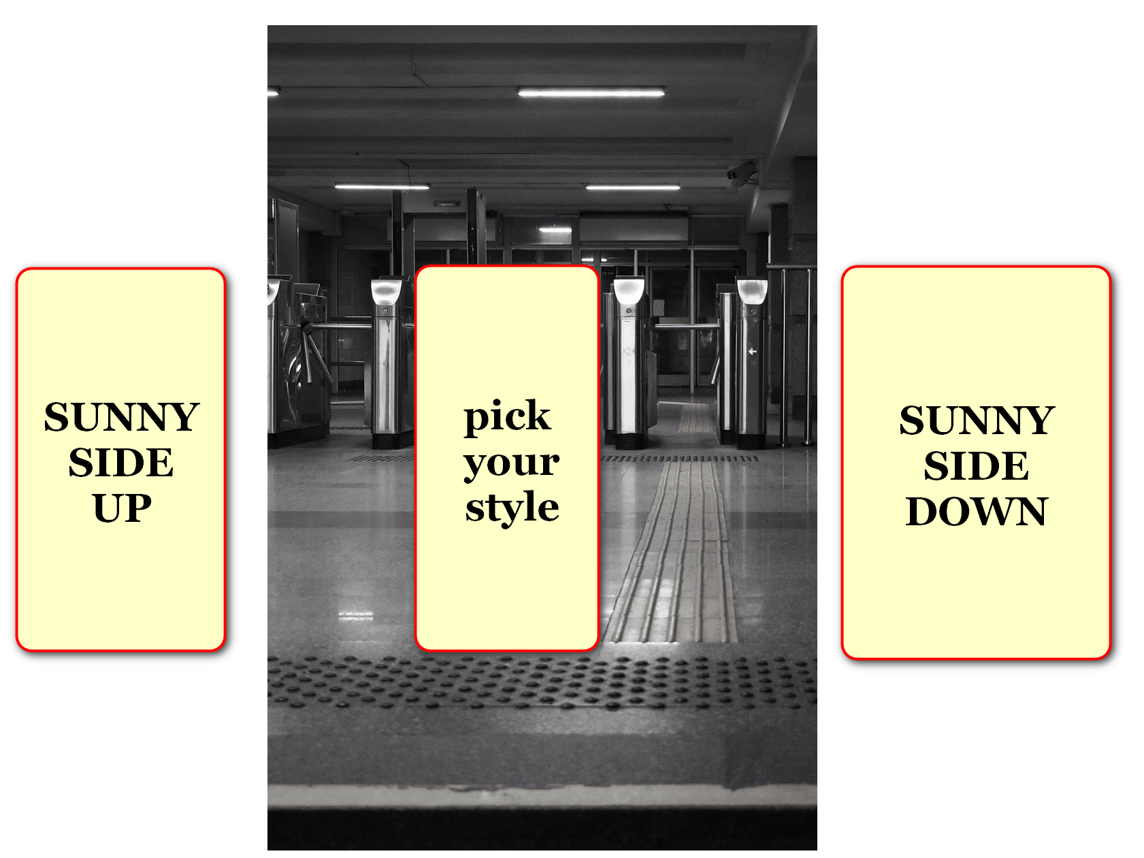

**simple mathematics**

**determined**

**style of show activated**

**if majority of audience kids**

**entered**

**seating section via west turnstile**

**then cast enacted SUNNYsideUP emotion script**

**if majority of audience kids**

**entered**

**seating section via east turnstile**

**then cast enacted SUNNYsideDOWN emotion script**

**during reorganization of theaters bamboozler Bob**

**took**

**advantage wrote into scripts**

**revenge against earlier opponents**

**bamboozler Bob**

**encouraged**

**humans kill eat chickens disproportionally**

**therefore chicken**

**most eaten**

**fowl globally**

**bamboozler Bob's selection of animals' shapes**

**included**

**extremely small mouth for extremely**

**loud mouthed advocate of humans elephants**

**because of above elephants**

**must sometimes eat**

**20 hours of 24 hours**

**sustaining large bodies via small mouths**

**bamboozler Bob**

**paid**

**for advertisements promoting**

**new genre horror shows**

**some kids**

**favored**

**more sensational horror which promoted SUNNYsideDOWN**

**universe inviting chaotic disjointed scripts**

**eventually SUNNYsideDOWN favoring kids**

**dispersed among**

**other casts crews always promoting**

**new genre horror inviting SUNNYsideDOWN effects**

**yet consciously most kids**

**swayed**

**via ushers' billboards**

**promoting SUNNYsideUP theatrical style**

**chapter ends**