B08 nebula NASA photos cain abel statues

fishhead nebula NGC-896
contains
messages concerning cain abel

wikimedia.org's

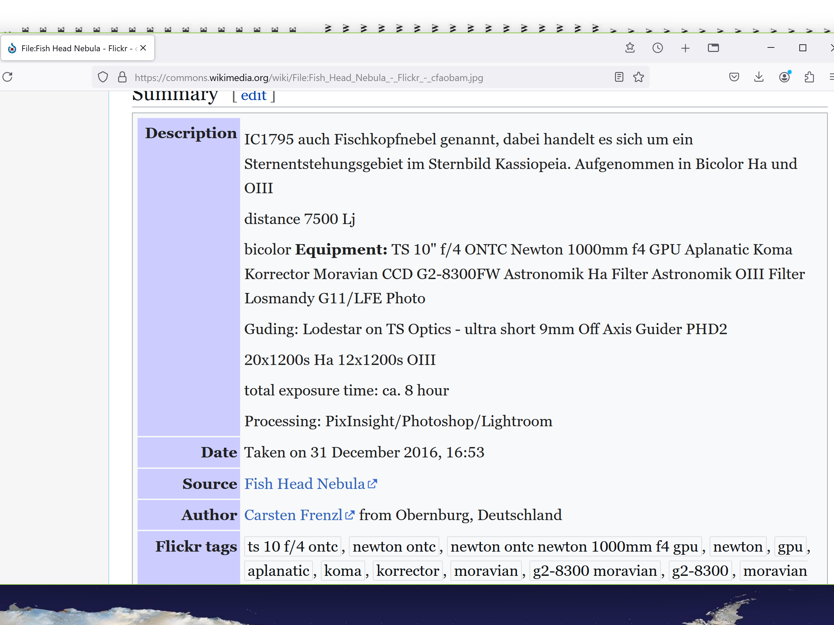



pinocchio cain with long nose of lies
murders
twin abel

in nebula statue cain
looks
eastward to brother abel

cain
holds
egg shaped rock
symbolizing SUNNYsideDOWN actions

nebula
displays
blanket tool of deception
atop abel's head

cain
covered
abel's face before striking abel
with rock

nebula
displays
abel's now cratered
face skull eyes mouth

nebula
displays
abel's body disjointed shattered
blood flowing eastward

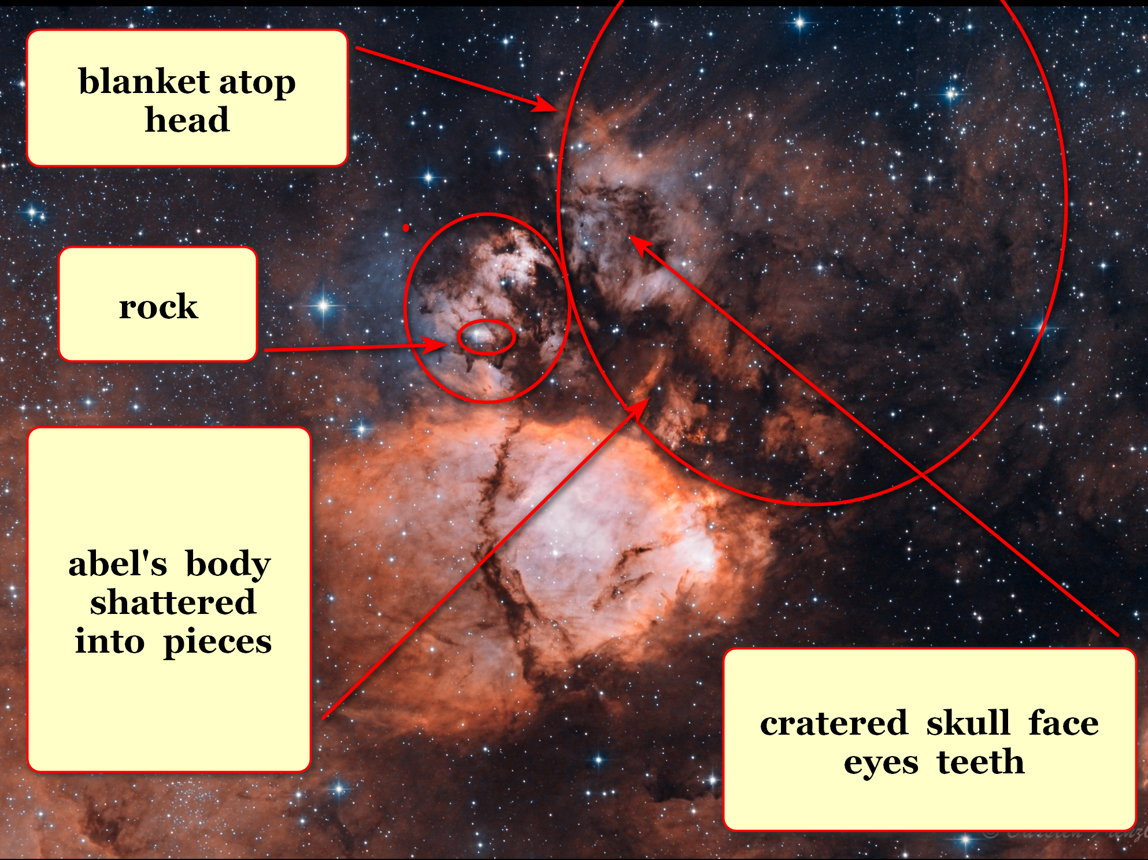

kim
inverted
image of fishhead nebula

from new angle fishhead nebula
depicts
rock in action
cratering abel's eyes skull

closer view
shows
twins

DiameterCities' SUNNYsideUP emotion mindset
removes
notion of capital punishment

creators of continents
created
mountain on mars referencing
first capital punishment ever

cain
assumed
position of judge sentencing abel
to first capital punishment legal precedent

statue on mars
includes
cain wearing british judicial wig

kim
displays
book cover
authors unknowing of symbolism cain

vincent DiPietro gregory molenaar john brandenburg
realized
highly significant statue message to humankind
promoted discussion preserved legacy of statue

with new way of thinking cain
acted first
displayed physical contempt
struck abel

all TIME EGGS
visible
to all
via transparent walls

twin's contentious fight
noticed
by all kids

1976 viking spacecraft
photographed
mars' surface including statue of face

cain
expressed
contempt for abel
blinded abel with blanket

then cain with rock
fatally struck
abel’s skull smashing face including eyes
teeth

therefore cain’s
epigenomically acquired
poor eyesight added into cain's DNA

abel not seeing cain
raised
right arm
trying to fend off cain

rectangular shape stone west of abel
symbolizes
blanket

Bob
manipulated
cain

cain
changed
cain's DNA via cain pounding rock
onto abel's skull

cain's statue on mars acknowledges cain
committed
first violence ever gave permission
for all future violence

cain's mars statue
with
british legal wig contained details
available through computer analysis

concerning cain's statue cariotto
conducted
computer analysis detected
unexpected tear drop formation

computer analysis
detected
darkness in face where eyes teeth
usually present symbolizes DNA weakened

tear drop
symbolizes
cain’s regret not sensing correctly

with blanket plus rock cain
blinded
abel impacted skull killed abel

fishhead nebula NGC-896 head inverted
magnified view

smooth egg shaped rock
travels
towards abel's face egg possesses
downward orientation symbolizes SUNNYsideDOWN

abel
possesses
small mouth fishlike because until cain's
violence humans watery creatures with gills

kim
circled
eyes of abel
smashed inwardly into skull

abel's trunk parliament
looks eastwardly
toward script collaborator cain's trunk parliament

together twins' trunk parliaments
scripted enacted
events designed to create as many
SUNNYsideDOWN events as possible

sincere patriotic trunk cells
obeyed
twins' conscious head neck spine signals
including wrathful words lingering thoughts

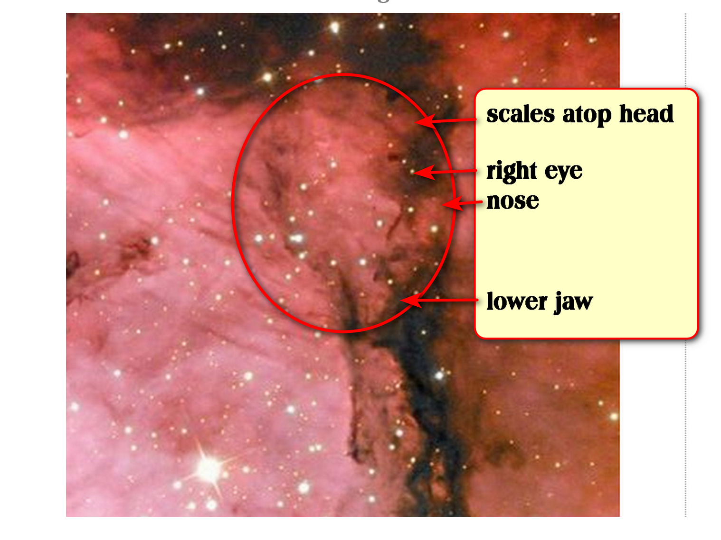

cain's counterpart trunk parliament
looks
westward with grin because gave cain
cain's desires embedded in cain's DNA

yet smile
missing
several teeth because cain crushed
abel's upper right teeth

cain
received
epigenomic changes in same category
as cain's habits showed cain desired

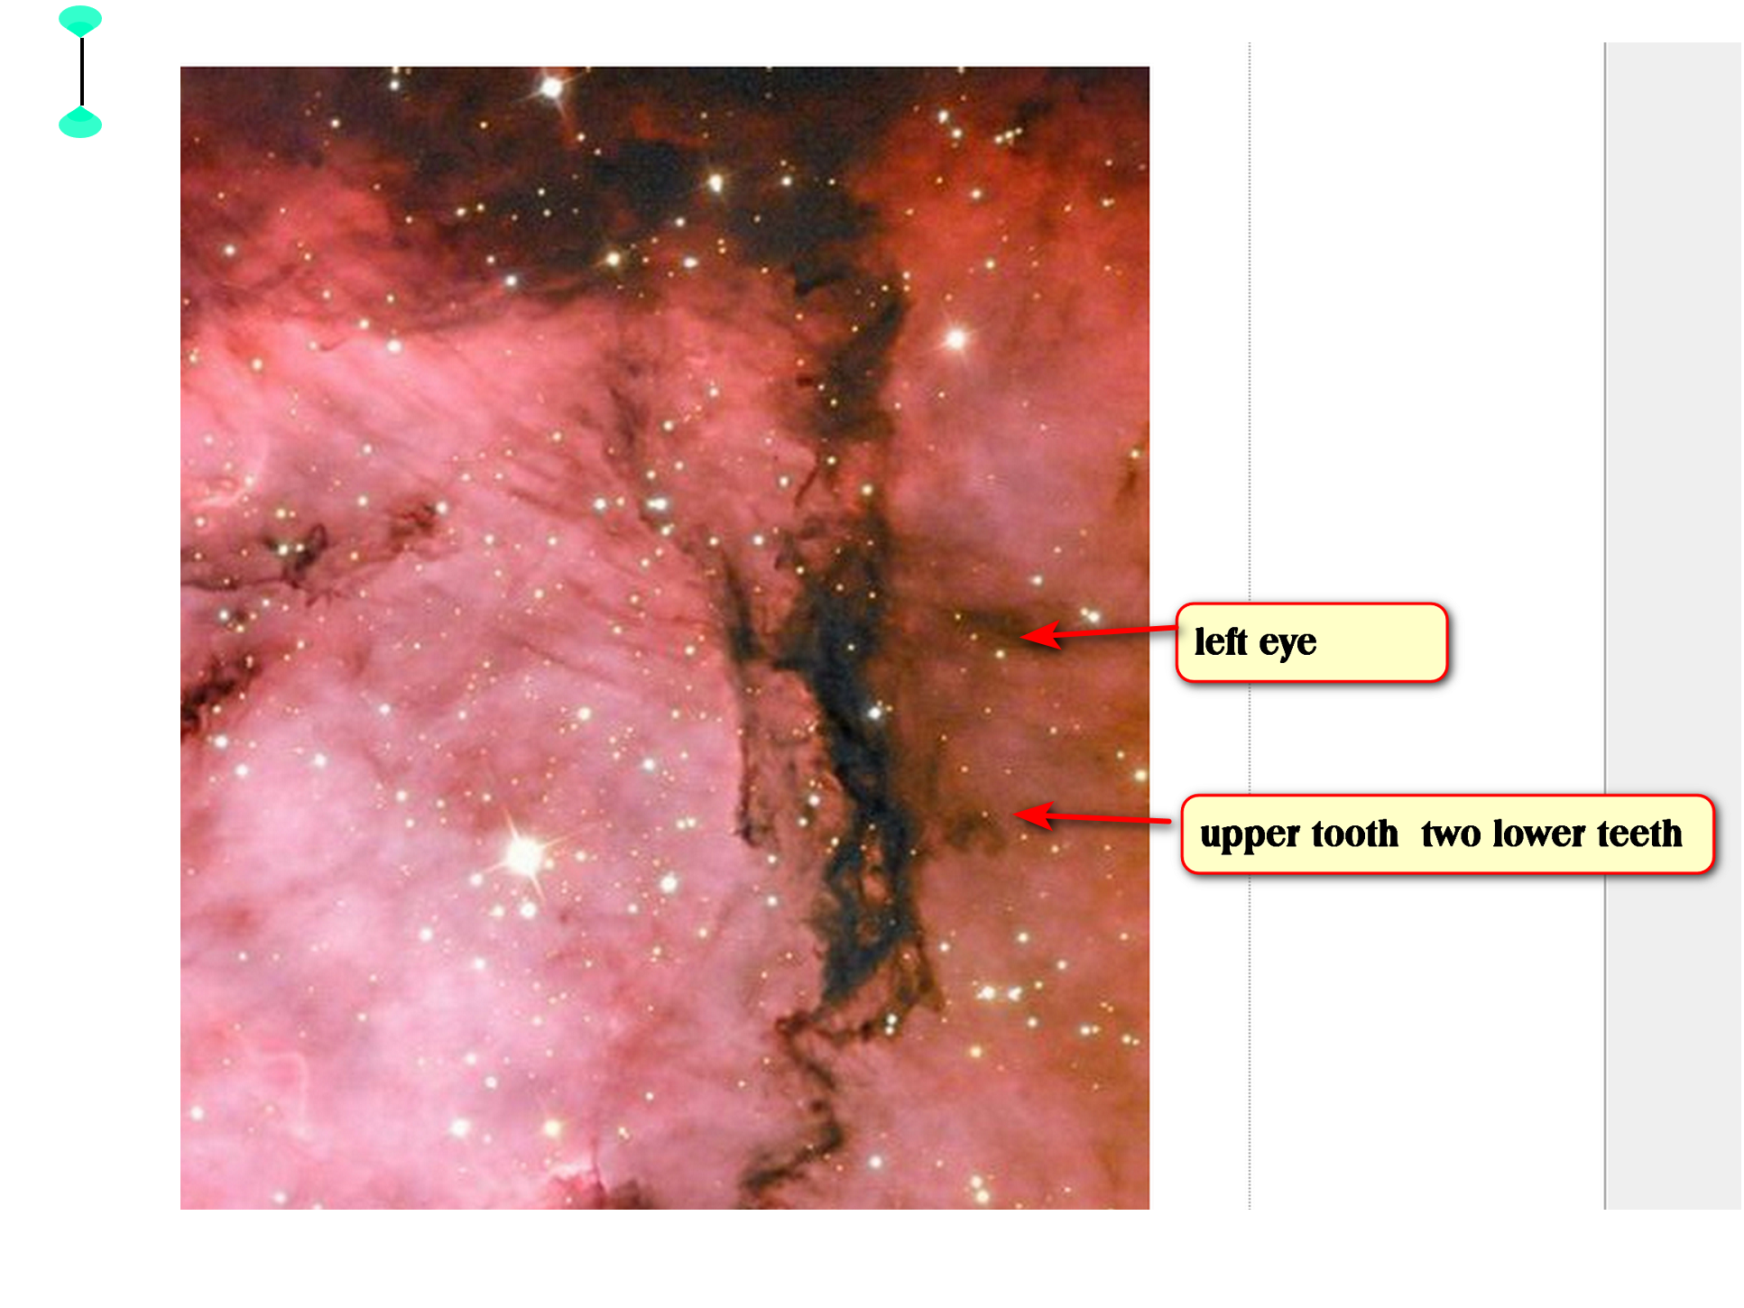

above
gives
reasons for counterintuitive situation many humans
need eyeglasses teeth restored

SHOELANGUAGE book
utilizes
term EPIGENOMIC as equaling
instant evolution immediately changing DNA

therefore children grandchildren etcetera
possess
newly modified DNA forever

unless humankind
flips
global holographic switch

chapter ends

