W03 SHOELANGUAGE keyboard

kim without available money for graphics
utilized
symbol closest to straight line

in creating symbols kim
made
straight lines with tool
STRAIGHT ARROW with arrow tip

however in future scribings symbols
possess
mere straight lines
not needful of arrow tips

in numbers one through five kim
desired
mere triangles
inside bigger squares

routine two spaces
between
words allows putting symbols
next to words

quote symbol
occupies
space before first word of quote
space behind last word of quote

other symbols
occupy
space behind words

pixabay.com's

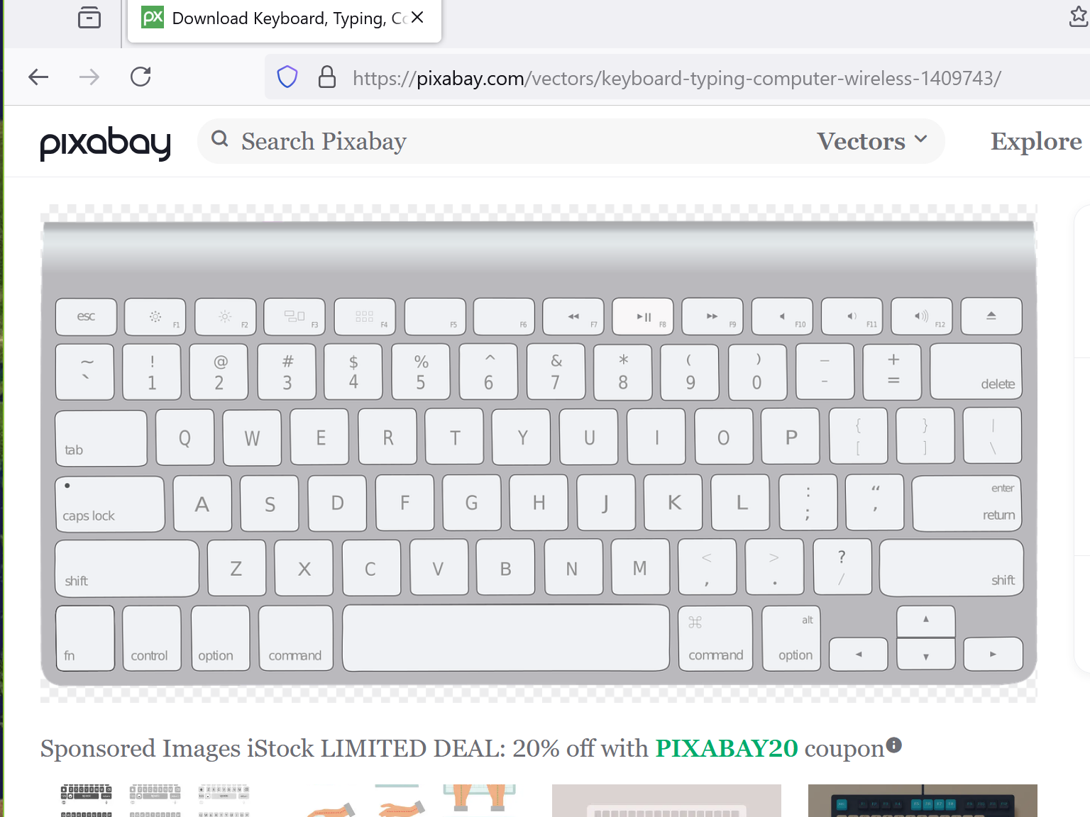

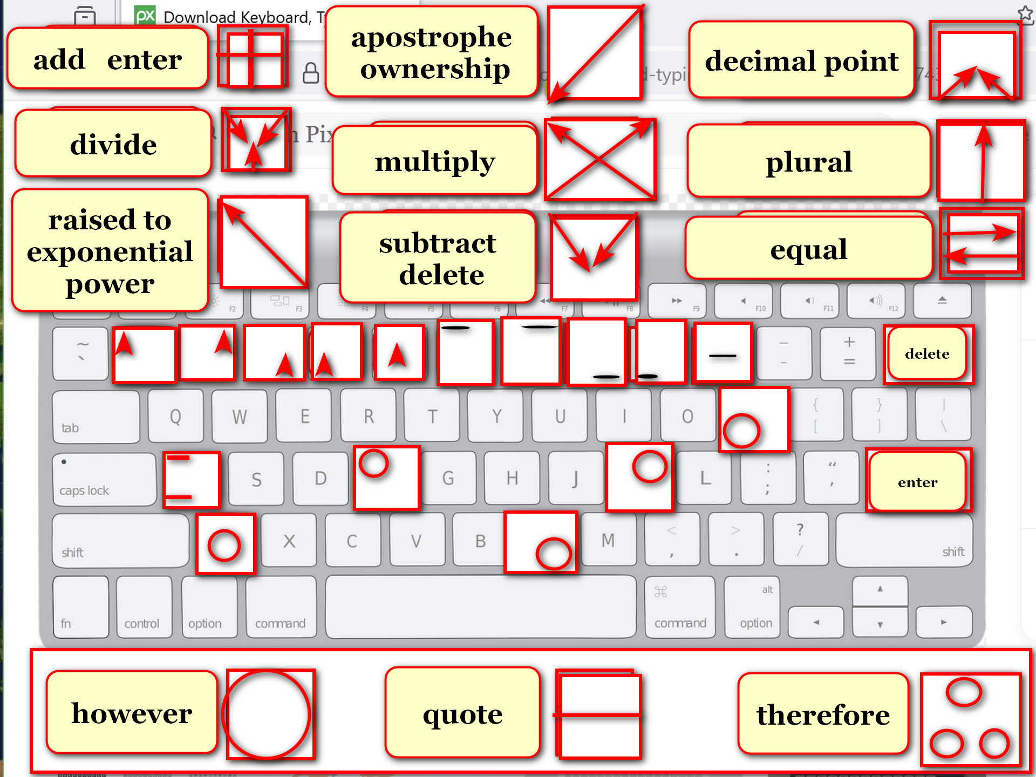

chapter ends

