**S04 defame sober henri paul prince harry**

**wikipedia.org**

**Henri Paul**

**Born 1956july03 Lorient, France**

**Died 1997august31 aged 41 Paris, France**

**Head of Security Hôtel Ritz Paris 1986–1997**

**henri paul initially aviation instructor**

**later**

**nautical industry selling boats.**

**1986, he**

**was hired**

**security deputy Hôtel Ritz Paris, eventually**

**confidant of Al-Fayed family, owner.**

**1997june30 head of security at Ritz.**

**1997august31 Paul was on duty night**

**taking**

**Diana Dodi Al-Fayed from Hôtel Ritz**

**to apartment on rue Arsène Houssaye**

**Paul**

**drove**

**swerved inside tunnel collided violently with**

**one pillar of underpass.**

**Paul dodi Al-Fayed**

**died**

**instantly**

**Princess of Wales**

**died**

**hours later at Pitié-Salpêtrière Hospital**

**Trevor Rees-Jones,**

**in service**

**of Al-Fayed family only survivor**

**Although he**

**suffered**

**numerous fractures to his facial bones**

**(only he was wearing seat belt).**

**KIM NOTES in this case BEARS**

**shifted**

**emotion of citizens via**

**blaming accident on driver PAUL**

**1997september02**

**washingtonpost.com's**

**Anne Swardson**

**Possible charges**

**include**

**involuntary homicide presumably by interfering with**

**path of Diana's car**

**failing to help**

**victims of accident**

**which is obligatory**

**under French law.**

**Frederick Mailliez, physician,**

**told**

**France 2 television**

**came upon accident**

**After calling for ambulance on car phone, Mailliez**

**went to aid of Diana,**

**whom Mailliez**

**did not recognize.**

**She unconscious, but**

**moving**

**limbs.**

**KIM NOTES BEARS**

**paid**

**photographers to enhance**

**death of DIANA**

**Le Monde newspaper**

**reported**

**photographers jostled passersby**

**attempting to offer help**

**photographers**

**told**

**police trying to move them**

**to let them work.**

**perfectly placed BEARS associate in automobile**

**arrived**

**quickly for two BEARS motorcyclists leaving**

**pair of motorcyclists**

**simply exited**

**before questioning**

**BEARS associates**

**fled**

**scene after dividing**

**incriminating equipment strategically**

**man with bag fleeing on foot**

**carried**

**portion of remote control equipment**

**two persons**

**entering**

**escape car carried other portions remote**

**control equipment which overpoweringly accelerated vehicle**

**BEARS associate motorcyclists with remote controls**

**escaped**

**incarceration**

**Le Monde newspaper**

**mentioned**

**OTHER photographers**

**fled**

**police.**

**One witness described officer on foot**

**chasing**

**man with big bag over his shoulder**

**another report**

**said**

**two photographers sped away in car.**

**Other photographers in custody**

**were with**

**Sygma Angeli agencies at least one**

**freelancer with no photo service TIES**

**2017**

**nearbycafe.com's**

**a d coleman**

**www.nearbycafe.com/artandphoto/photocritic/2017/09/03/public-tolerance-and-the-picture-press-2/**

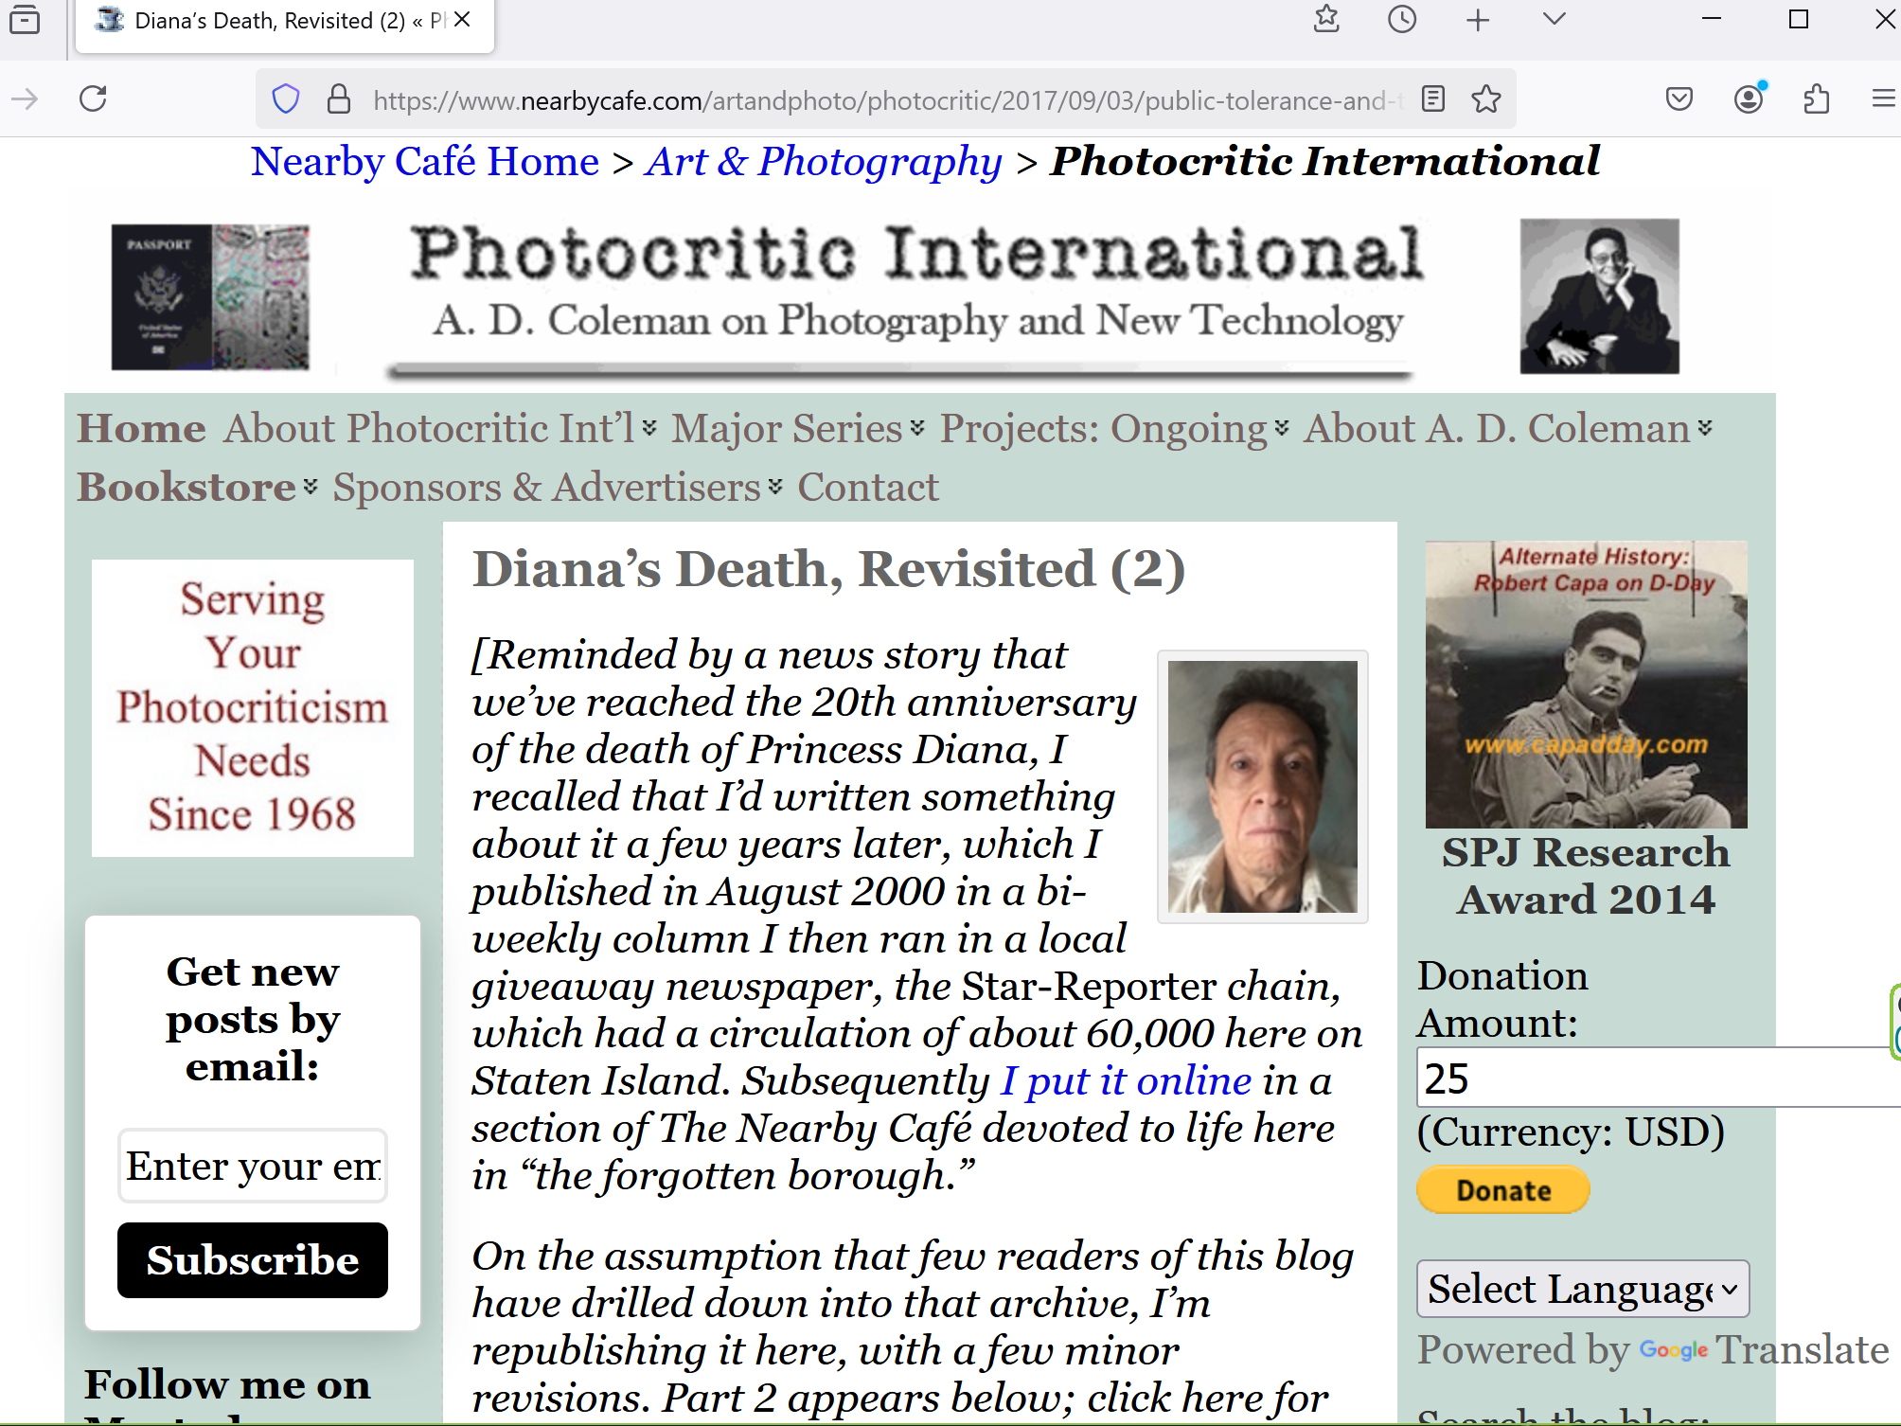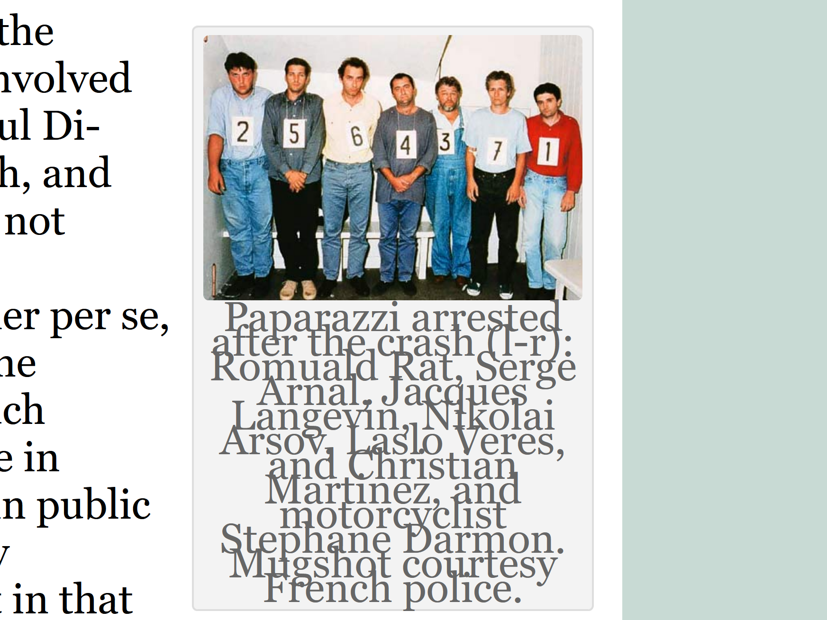

**wikipedia.org**

**1999september 03, nine photographers one motorcyclist accused of**

**"involuntary homicides and injuries"**

**"failure to assist people in danger"**

**BEARS**

**paid**

**judge plus others delay for two**

**years allow decoying of concerned citizens**

**charges**

**were withdrawn**

**did not come to trial**

**KIM NOTES**

**BEARS strategies**

**include never explaining**

**unexplained break in protocol**

**above men**

**guilty**

**however BEARS paid for**

**lack of logical prosecution**

**even years later BEARS**

**say**

**nothing concerning reasoning**

**then BEARS**

**somehow shift**

**topic of discussion**

**above repetitive strategy**

**equals**

**BEARS' signature**

**2006february22**

**theguardian.com's**

**Julia Day and agencies**

**www.theguardian.com/media/2006/feb/22/pressandpublishing.france**

**The main investigation on the causes of the accident**

**was closed**

**in 2002,**

**putting an end to formal manslaughter inquiries**

**brought against**

**the nine photographers and a press motorcyclist.**

**KIM NOTES actually henri paul**

**innocent**

**of drunk driving**

**Henri Paul**

**EverybodyWiki**

**https://en.everybodywiki.com › Henri_Paul**

**inquest**

**revealed**

**autopsy Paul's liver normal found no**

**indicating problem signs connected with alcoholism.**

**2006nov John Stevens meeting with Paul's parents**

**told**

**their son was not drunk found to**

**have indisputably two alcoholic drinks**

**(this was verified by bodyguards Trevor Rees-Jones and Kieran Wingfield, two barmen in bar, till records from hotel bar and drink BILL).**

**reuters.com/article/world/diana-driver-not-drunk-his-parents-tell-court-idUSL04544051**

**2008feb04 09:13 CST**

**reuter's**

**paul majendie**

**Editing by Andrew Dobbie**

**Diana driver not drunk, his parents tell court**

**LONDON (Reuters) -**

**parents of French chauffeur Henri Paul**

**said**

**son not drunk at wheel of**

**car which he drove Princess Diana**

**elderly couple**

**also said**

**French authorities refused request for independent**

**blood samples tests after the crash**

**jean paul**

**told**

**court**

**DRIVER not DRUNK**

**The couple**

**had never seen**

**son drunk**

**French police without telling them**

**conducted**

**search of son's Paris apartment 10**

**days after the crash.**

**Radio 4 - Today - Henri Paul**

**BBC**

**https://www.bbc.co.uk › reports › archive › international**

**Family of Diana Crash Driver Speak of Their Legal Battle by Adrian Addison ... Listen - Giselle and Jean Paul talk about**

**2014october03**

**homepage BBC radio 4 TODAY**

**BBC'S Adrian Addison Angus Stickler**

**Family of Diana Crash Driver**

**Speak of**

**Their Legal Battle**

**It's five years this month since death of Princess Diana and for five years parents of chauffeur Henri Paul have maintained their silence. But, they revealed in exclusive interview with BBC Radio 4's Today Programme**

**parents of Henri Paul - chauffeur blamed for death of Princess Diana are taking action in French Courts to try and clear his name.**

**French Authorities say he was drunk at wheel. But in their first ever interview - parents told have told Today Programme - that they believe blood sample taken at time of accident was not their son's. They are taking legal action to try and force French authorities to release blood for independent DNA test.**

**They strongly refute allegations that their son was heavy drinker, and believe that blood tested possibly came from one of dozens of bodies held at Paris morgue that night.**

**They say that levels of carbon monoxide found in blood sample would incapacitate adult - that their son would have been unable to walk let alone drive car.**

**So far French Authorities have refused to release blood.**

**We're certain that our son wasn't drunk. We don't accept it. For us, he was good man, good son...**

**everyone who knew him, who lived with him said same.**

**It's alleged he was heavy drinker, that he was drunk night of accident. You're saying he wasn't. How can you prove that?**

**Jean Paul: Because we knew him since he was born.**

**Giselle Paul: Exactly. And, when you think about it, it would have been obvious if he was drunk. Dodi had another driver. He had his personal driver.**

**Would have used man who was drunk and who wasn't professional driver?**

**And also, there was bodyguard there. you would have thought bodyguard wouldn't let drunk driver take them when there were other people around.**

**It's easy to attack dead man.**

**They said his liver was in perfect condition.**

**And we would have known, we would have seen if he'd been drinking.**

**28th of August, he passed his medical exam for his pilot's licence.**

**Everything was fine. And three days later he was labelled alcoholic.**

**Giselle Paul: They found 20% of carbon monoxide in his blood. We're not experts, obviously. But whenever we talk to people who know about this, they say it's impossible. He wouldn't have been able to stand with that level in his blood.**

**Giselle Paul: ...It's for his memory. No-one has right to smear someone's name like that- and for what? We don't know why. We don't understand why anyone would want to say that my son was alcoholic.**

**Jean Paul: Who profits from that?**

**Giselle Paul: Who profits? Not me, not my son. And my son shouldn't leave world like that - that image of him created by people when he wasn't anything like that.**

**And is that thrust of legal action that you're taking? That you want his blood to do DNA test on him.**

**Giselle Paul: Yes, it's always been for that.**

**..my son shouldn't leave world like that - that image of him created by people when he wasn't anything like that.**

**What reason have French government given to you for refusing to give you his blood.**

**Giselle Paul: They don't give explanations. They don't say why. For us, it's as if we didn't exist.**

**Jean Paul: It feels like we're completely shut out. wall.**

**Giselle Paul: We feel like.. if President's dog was killed in accident people would have cared more.**

**Jean Paul: Historically, impression left is that our son was Princess Diana's assassin. It's false.**

**end of topic**

**start of new topic**

**united kingdom's prince william**

**targeted**

**william's dad**

**william's wife as BEARS fees**

**prince harry**

**escaped**

**targeting because harry**

**moved to north america**

**prince harry like mom diana**

**wants**

**happiness for globe**

**because prince harry**

**possesses**

**above desire**

**BEARS sees harry as threat**

**BEARS**

**desires**

**hush or kill strong person**

**capable of inspiring SUNNYsideUP**

**therefore william plus other BEARS**

**defame**

**harry for possessing original thoughts**

**/www.cosmopolitan.com/entertainment/celebs/a29802099/**

**prince-william-prince-harry-royal-feud-rift-timeline/**

**An Official Timeline of Prince William and Prince Harry’s “Royal Rift”**

**Come for drama, stay for fanfic.**

**By Mehera Bonner, Starr Bowenbank and Gretty GarciaPublished: Mar 07, 2024 11:47 AM EST**

**timeline of this brotherly spat. So let’s go back, back to beginning—aka winter 2018.**

**November 2018**

**brothers had falling out around Christmas 2018, when Harry told Will he wasn’t doing enough to include Meghan in royal family.**

**Per Nicholl’s source, “Harry felt William wasn’t rolling out red carpet for Meghan and told him so.**

**They had bit of fallout, which was only resolved when Charles stepped in and asked William to make effort.**

**That’s when Cambridges invited Sussexes to spend Christmas with them.”**

**December 2018**

**Sussexes and Cambridges spent Christmas together in Sandringham with Queen, but unfortunately, royal watchers discovered video of**

**William seemingly ignoring Meghan during family’s walk.**

**Basically, she tried to talk to him and he spent ton of time adjusting his scarf instead of responding.**

**December 2021**

**A source told People that Kate has been “really, really upset” about royal feud, while friend added, “Everything with Harry and Meghan has been hugely stressful, but if anything, it’s pulled [her and William] closer together. She was upset about it because [William] was so upset. Seeing her husband so distraught was tough.”**

**April 2022**

**Katie Nicholl laid out details to Entertainment Tonight, saying,**

**“Harry, I’m told, suggested perhaps that they might get some sort of mediator in on sort of these talks, to make some progress.**

**It was something that he had suggested to his father.**

**He’s made it very clear that he wants to sort things out. He wants things to be improved.”**

**“He truly loves Harry and feels he has lost only person, aside from his wife, who understood this strange life of theirs. But he believes there are things you just don’t do. And Harry has 100 percent crossed that line.”**

**December 2022**

**When volume 1 of series finally aired on December 8, Meghan and Harry mostly talked about beginning of their ’ship and their adorable engagement, but Harry did seemingly make comment about his brother…and his dad**

**“For so many people in family, especially obviously men, there can be temptation or urge to marry someone who would fit mold as opposed to somebody who you are perhaps destined to be with.**

**difference between making decisions with your head or your heart. My mom certainly made most of her decisions, if not all of them, from her heart, and I am my mother’s son.”**

**Meghan talked about Cambridges directly, recalling first time she met Kate at Prince Harry’s house: “Even when Will and Kate came over and I met her for first time, they came over for dinner, I remember I was in ripped jeans and I was barefoot,” “Like, I was hugger; I’ve always been hugger.**

**I didn’t realize that that is really jarring for lot of Brits. I guess I started to understand really quickly that formality on outside carried through on inside.”**

**January 2023**

**Prince Harry’s memoir, Spare, dropped—and in it, he accused William of physically attacking him during fight about Meghan Markle.**

**“He set down water, called me another name, then came at me. It all happened so fast. So very fast.**

**He grabbed me by collar, ripping my necklace, and he knocked me to floor.**

**I landed on dog’s bowl, which cracked under my back, pieces cutting into me.**

**I lay there for moment, dazed, then got to my feet and told him to get out.”**

**“I saw Harry’s release of Spare as his last attempt at telling his family how he’s felt for years,” Scobie mused. “Because clearly there’s never been open enough forum to have these conversations or share these feelings.”**

**“I was talking to source quite early on in process, and**

**they called Harry ‘defector’**

**and said that was William’s view. These were two men who once upon time were firmly aligned in their outlook. One of them had to move on to also protect crown.”**

**“In eyes of some within institution,**

**Harry is threat to crown.**

**His freedom to exert his own thinking outside of confines of institution has made him enemy.**

**chapter ends**