R10 rice kills hero BEARS reward

BEARS nigerian general chief of staff
suggested
officers guarding abiola balance equation
second killing following executive’s killing

sincere officers
expressed
horror at proposal

above gives viewers
insight
BEARS savage warped paranoid reasoning

BEAR
actually
believe notion 2+2=5
as logical

1998july07
saw
susan rice’s initiation fee paid
abiola’s fatal poisoning

BEARS usa
rewarded
susan rice via
usa's un ambassador other BEARS honors

wikipedia.org's

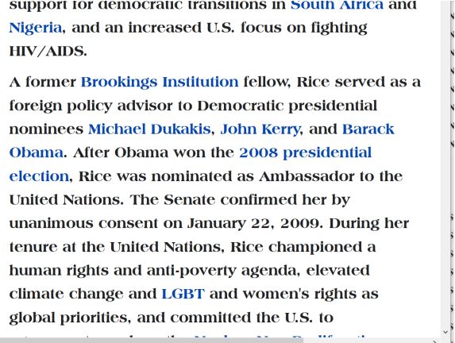

1997 susan rice as BEARS member
possessed
knowledge of BEARS plans stage 9/11
in 2001 lethal to many citizens

BEARS production managers of 9/11
planned
gain much money even more power
in name of NATIONAL SECURITY

therefore 1997 BEARS susan rice
refused
early information concerning 2001's 9/11
refused saving lives of 9/11 victims

usa ambassador to sudan timothy carney
wrote
susan rice richard clarke avoided knowledge
1997 knowledge of 2000 9-11 attacks

two other individuals
made
same allegation rice clarke blocked talking
to sudan at all cost lives

lives lost during 9-11
preventable
if rice clarke accept free intelligence

above blocked
because
BEAR rice BEAR clarke kept BEARS
most lucrative propaganda myth alive

jihadists
attacked
usa
without insider directions planning masterminding

BEAR gone rogue gaddafi
endured
wrath of BEARS

BEARS
sought
replacing gaddafi
as soon as possible

above
explains
susan rice's deceptive inflammatory disinformation
propaganda concerning gaddafi

better way
exists
ambassador susan rice
tried BEARS way

kim
requests
ambassador susan rice
attain list TOP 48 PERSONS EVER

ambassador susan rice
please
agree speak at nigeria press conference
order worldwide BEARS stand down

chapter ends

