**R03 george floyd negotiated $27 million**

**2019 george floyd negotiated with BEARS**

**desired**

**family gain money negotiated to $27,000,000**

**BEARS concerning george floyd**

**paid**

**scripted victim plus executioner via financially**

**rewarding families at appropriate times**

**george floyd plus floyd family spokesman**

**present**

**at negotiations called by BEARS**

**george floyd floyd's family leaders**

**agreed**

**financial arrangement with BEARS**

**george family agreed because george floyd**

**wanted**

**enduring legacy fame in textbooks**

**floyd's assassin**

**agreed**

**to script as reward**

**fame in history textbooks**

**people.com's**

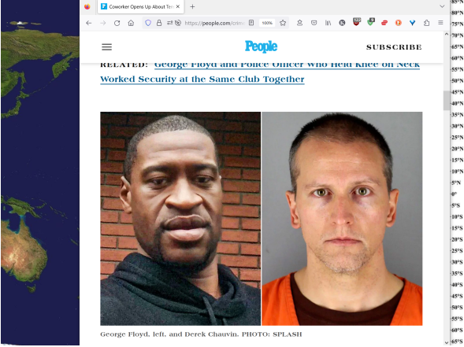

**floyd's assassin in well written script**

**agreed**

**avoiding death penalty due to technicality**

**secret financial compensation many years later**

**BEARS**

**made sure**

**BEARS judge presided over case**

**floyd's assassin**

**actually**

**buddy therefore outcome more predicatable**

**both men**

**worked**

**security same latino club**

**said owner**

**KIM NOTES buddies**

**staged**

**play arguments at club providing**

**cover story for later**

**google.com's**

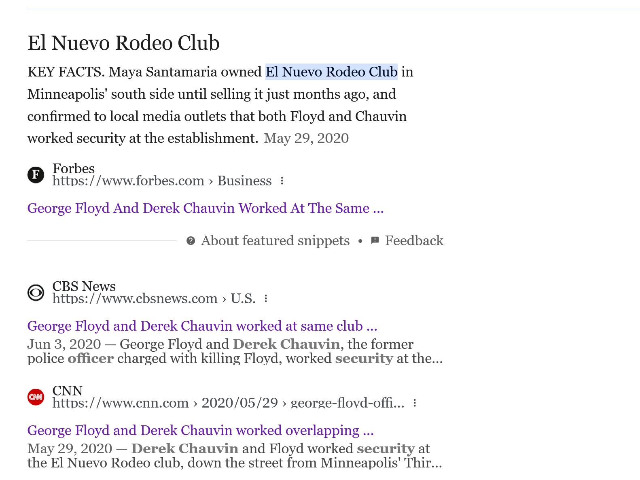

**2021may21**

**cnn.com's**

**How George Floyd’s death reignited a movement**

**Published 2:57 PM EDT, Fri May 21, 2021**

**Anger poured through communities across the United States after video of George Floyd's last moments began circulating last May.**

**The incident recalled the 2014 death of Eric Garner, who uttered the words "I can't breathe" while in an officer's chokehold in New York.**

**KIM NOTES BEARS**

**paid**

**both sides much money**

**BEARS**

**invest**

**much money in chaos**

**BEARS**

**controlled**

**citizens via creating incidents**

**consuming citizens' emotional mindsets**

**BEARS strategy**

**includes**

**fostering hatred**

**citizens to other citizens**

**2014 BEARS**

**invested**

**money time staging real tragedy so**

**as to introduce slogan fomenting hatred**

**2014 sincere tranquility minded citizens**

**avoided**

**destructive behavior in response**

**to staged tragedy**

**however persistent BEARS**

**spoke**

**with george floyd derek chauvin**

**buddy security officers at latino nightclub**

**both men**

**agreed**

**to roles in stage play**

**fame plus plenty of cash**

**cnn.com's**

**Floyd, a 46-year-old Black man,**

**was killed**

**in police custody in Minneapolis.**

**A bystander's video**

**showed**

**police officer Derek Chauvin kneeling on Floyd's neck for more than nine minutes as Floyd pleaded for help, saying he couldn't breathe.**

**The incident**

**recalled**

**2014 death of Eric Garner**

**who**

**uttered**

**"I can't breathe" while in**

**officer's chokehold in New York.**

**Floyd's death**

**sparked**

**widespread protests**

**rekindled Black Lives Matter movement.**

**KIM NOTES**

**BEARS investment money in chaos**

**brought dividends**

**according to script george floyd**

**handed**

**sincere clerk obviously counterfeit money**

**for cigars wet ink**

**regular counterfeiters**

**flee**

**scene quickly**

**yet george floyd**

**waited**

**across street on purpose**

**desired arrest**

**eventually clerk**

**exited**

**store walked across street**

**demanded real money from floyd**

**george floyd**

**refused**

**most criminals**

**flee**

**when spotted knowing police coming**

**yet george floyd**

**awaited**

**police purposefully desired arrest**

**george floyd**

**took**

**drugs beforehand for ease into death**

**due to drugs george floyd**

**repeated**

**memorized script too early**

**as soon as first police officer**

**exited**

**police car some feet distant**

**floyd said I CAN'T BREATHE**

**chapter ends**