Q08 w pinney's book chappaquiddick s

1978 house select committee on assassination
requested
rfk assassin david sanchez morales
testify therefore BEARS killed morales

theodore sorensen
left
university vice presidency took deputy campaign
manager job for purpose overseeing kopechne

BEARS theodore sorensen
needed
pay initiation fee verbalized target
mary jo kopechne

rfk deputy campaign manager theodore sorensen
supposedly protect
campaign workers therefore kopechne qualified
as payment to BEAR

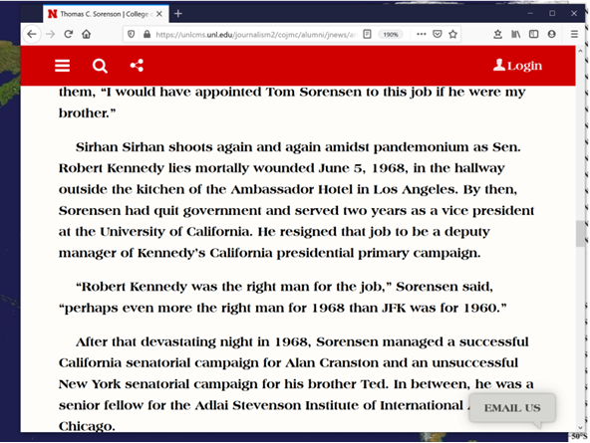

ted kennedy
directly requested
sorensen find way assassinate brother rfk

chapter 33 of theodore sorensen's COUNSELOR
said
brother thomas previously worked covertly cia

KIM NOTES theodore sorensen
recruited
brother thomas

thomas sorensen concerning trigger man
recruited
disgruntled morales mad at all kennedys
for BAY OF PIGS cuban slaughtering

theodore sorensen
directed
recruiting kopechne through teddy's seductions

as scheduled sorensen's david sanchez morales
shot
back of head while hypnotized sirhan
sirhan drew attention front of rfk

theodore sorensen oral history archives 2006
replies
to question
concerning relationship with ted kennedy

theodore sorensen
stopped
calling senator kennedy TEDDY instead used
term SENATOR KENNEDY 1970 to 1980

above date 1970
after
1969 chappaquiddick incident

therefore theodore sorensen
maintained
mentor relationship through chappaquiddick incident aftermath

yet theodore sorensen’s 2008 autobiography COUNSELOR
said
teddy never called sorensen
that friday saturday

yet 1969 telephone records
reveal
hours of discussions that night

theodore sorensen
directed coordinated
assassination mary jo kopechne 1969july18 via
accomplice senator edward moore ted kennedy

1968 summer edward moore teddy kennedy
rented
floor edgartown’s harbor view hotel supposedly
mourning brother actually researching ambush location

1968 sorensen kennedy others
developed
script for 1969 assassination of kopechne

four years earlier 1964 airplane crash
broke
ted kennedy's back

ted kennedy
wore
back brace
utilized pain medicine

month before kopechne assassination sorensen
recommended
kennedy ask pharmacist renew pain medicine
in form of suppository

rectally inserted drugs’
possess
advantage quicker absorptions
because more blood vessels for uptakes

same medicine
swallowed
pill form slower
takes 30 minutes for digestion effectiveness

medicine oxycodone overdose
intensifies
alcohols’ effects example when
alcohol forced down drugged kopechne's throat

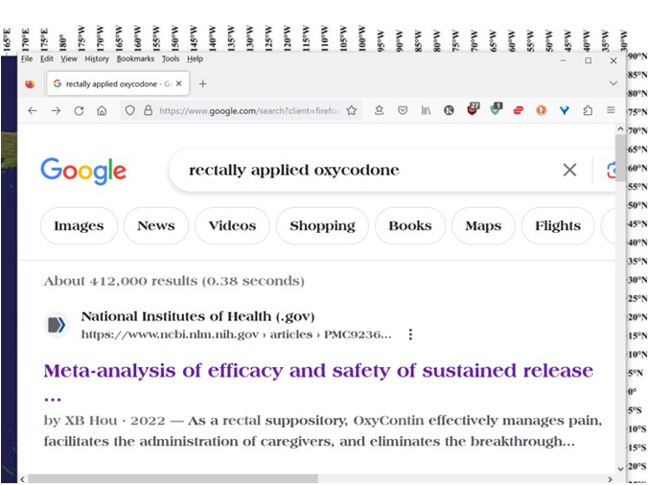

symptoms of overdose

slow shallow breathing

severe drowsiness

slow heartbeat

severe dizziness

pinpoint pupils

cold/clammy skin

limp weak muscles

coma

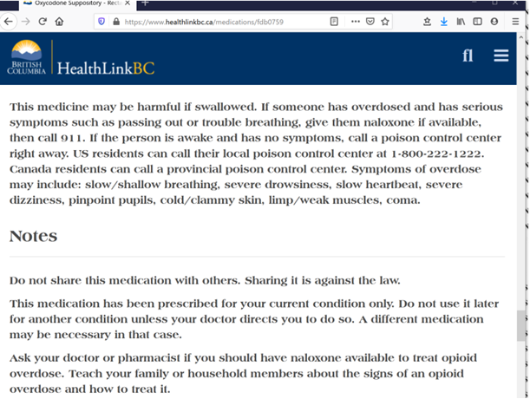

theodore sorensen
arranged
dates locations rosters

theodore sorensen
synchronized
nasa’s apollo 11 moon landing journey
with edgartown’s annual yacht races

theodore sorensen
scheduled
four reunion parties
within 13 months after rfk assassination

parties' females
always included
six campaign assistants boiler room girls
including mary jo kopechne

theodore sorensen
arranged
senator teddy kennedy impregnate kopechne
on schedule

therefore at final party kopechne
not yet showing
pregnancy yet very eager discuss future
therefore irresistible reason for private dialogue

only two people sorensen kopechne
aware
of involvement of teddy kennedy in
rfk's assassination

kennedy’s perfectly timed purposeful impregnation
accompanied
deceitful promise of marriage to kopechne

mary jo kopechne
possessed
catholic faith
including anti abortion stance

theodore sorensen’s strategy
create
calamity acceptable for senator’s assistants agree
save senator’s career by sacrificing colleague

massachusetts's investigative reporter william pinney
finalized
third edition CHAPPAQUIDDICK SPEAKS 2018march12

native of chappaquiddick bill pinney
deduced
car damage involved longstanding construction equipment

senator ted kennedy
rammed
mytoi garden's construction equipment with car

chapter ends

