**N06 guard dogs rfk jack ruby**

**1975 CIA director william egan colby**

**displayed**

**pistol of incapacitating lethal liquids**

**undetectable during autopsies said director**

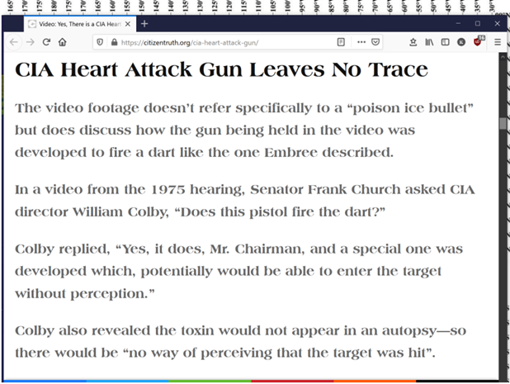

**CIA director colby**

**asserted**

**some CIA operations so secret that**

**director not informed beforehand**

**above assertion**

**impossible**

**actually coverup statement**

**CIA director colby**

**replied**

**negatively about darts used on humans**

**cited dosage difficulties**

**above reply**

**actually**

**coverup answer since colby admitted**

**CIA utilized darts on guard dogs**

**average human**

**usually possesses**

**double weight of average german shepherd**

**CIA experts**

**needed only**

**double dose**

**plus mary embry creator of toxin**

**mentioned**

**in interviews pistol chemical ice darts**

**utilized on prisoners with great success**

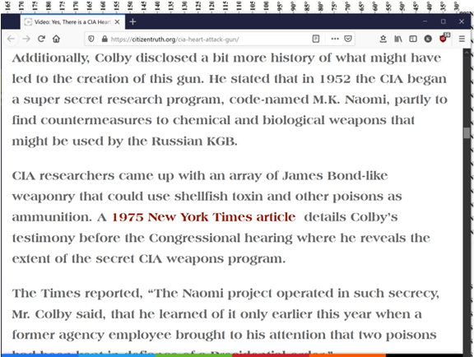

**1968 CIA'S thomas sorensen theodore's brother**

**utilized**

**amnesia causing chemical against sirhan sirhan**

**sirhan sirhan**

**unable to recall**

**events of when sirhan confronted rfk**

**sirhan sirhan**

**according to witnesses and video**

**only approached rfk’s front**

**yet autopsy reports four bullets**

**entered**

**back of rfk**

**tom sorenson**

**recruited**

**hypnotist for task brainwashing sirhan sirhan**

**therefore decoy attention from real assassin**

**cameras in hotel**

**featured**

**cia cuban operative among crowd**

**angry cuban morales**

**shot**

**rfk back of head while sirhan sirhan**

**drew attention in front of rfk**

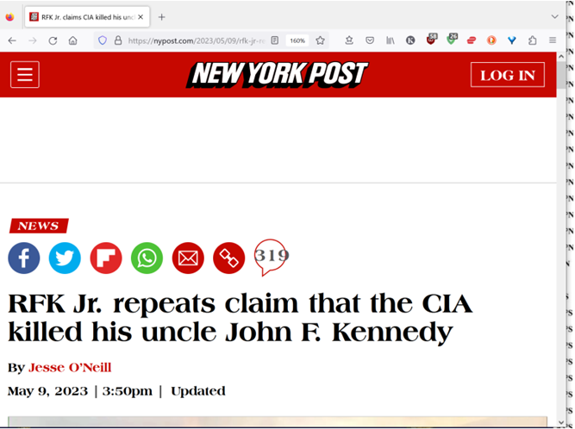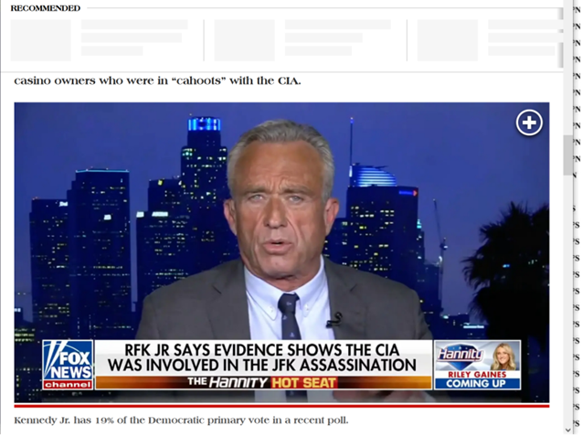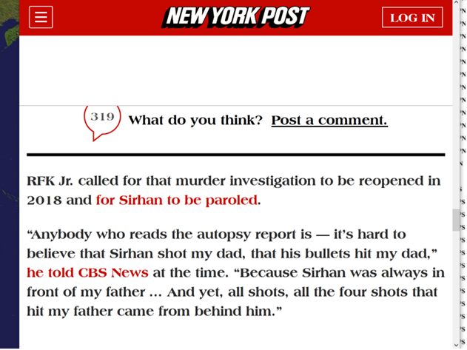

**fatal bullets**

**entered**

**rfk behind ear back of neck**

**not match sirhan sirhan’s pistol**

**viewers**

**please notice below**

**mention of chemicals**

**causing amnesia**

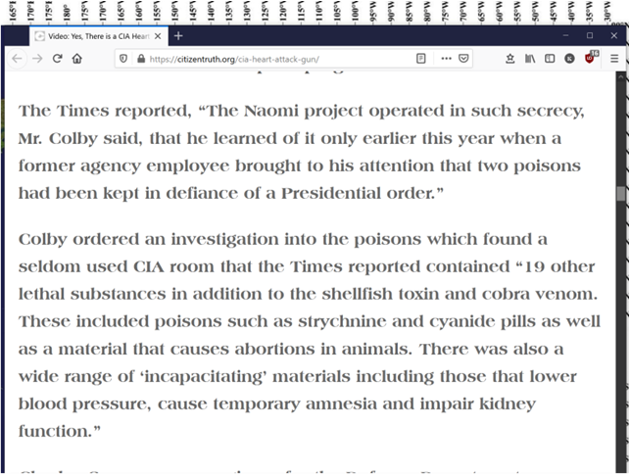

**william egan colby**

**gave**

**skeleton view CIA not fully muscled**

**therefore preserved friends’ jobs**

**yet BEARS**

**dismayed**

**at even 40% truth revealed**

**BEARS buddies gerald ford henry kissinger**

**took revenge**

**on CIA director colby**

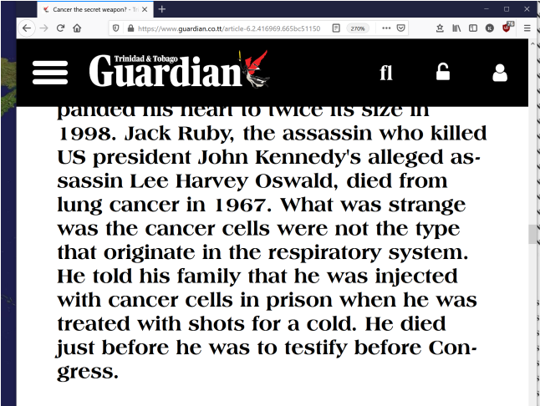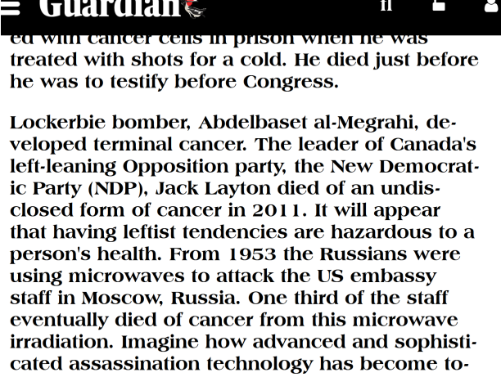

**chapter ends**