**J06 transactions mining environment**

**only DiameterCity chieftain couple**

**dispenses**

**loan to** **business tower chieftain couple**

**needing large equipment for example**

**business tower chieftain couples**

**only recipients**

**of loans**

**DiameterCity chieftain couple**

**allow**

**one loan per business tower**

**always interest free**

**in this way DiameterCity**

**facilitates**

**business heavy equipment plus increased sales**

**transactions causing increased 10% tax revenues**

**business towers' chieftain couples**

**repay**

**current loan before eligible another loan**

**business towers' tenants**

**decide**

**which of businesses inside tower**

**need loan majority rules**

**Diametercities**

**possess**

**only one tax embedded 10% transaction tax**

**income tax**

**non existent**

**mining companies**

**pay**

**set compensation amount to DiameterCities**

**for mining minerals anywhere on globe**

**mining**

**occurs**

**in bulk areas of globe**

**between circles arctic antarctic**

**mining meridians**

**include**

**bulk of globe from** **meridian 170**

**degrees west to 156 degrees east**

**334 degrees of meridians' mining rights**

**divided**

**among 1000 DiameterCities**

**every DiameterCity**

**allotted**

**3 degrees of meridian except 1000th**

**DiameterCity allotted 4 degrees**

**above**

**in effect**

**for first year of DiameterCities**

**every year possession of mining rights**

**switches**

**west to east**

**to next set of meridians**

**switching**

**bypasses**

**small meridian segment 156 degrees east**

**to 170 degrees west**

**therefore citizens of DiameterCites**

**profit**

**from mining revenue fees**

**any mining company**

**mining**

**along that meridian pays directly to**

**that DiameterCity's chieftain wife's account**

**in DiameterCities chieftain couples' personal money**

**resides**

**in chieftain husband's account**

**therefore chieftain wife's account**

**contains**

**DiameterCity funds only**

**allows for easier public scrutiny**

**each location**

**possesses**

**many meridians**

**Ai track deposit mining company payments**

**Ai FIVE LITTLE SISTERS**

**possess**

**monitor screen keyboard**

**yet Ai FIVE LITTLE SISTERS**

**immobile**

**DiameterCities**

**not possess**

**full body mobile Ai robots**

**Ai**

**fields**

**video calls for financial transactions**

**all**

**sales**

**include video of both parties**

**all citizens**

**possess**

**access to all Ai video financial**

**transactions**

**businesses**

**self generate**

**water via air to water machines**

**utilize solar batteries**

**chieftain couple of business towers**

**assign**

**spaces for businesses**

**one floor**

**equals**

**maximum space per business**

**outside area**

**available for machinery not offices**

**above**

**maintains**

**chieftain couple status**

**supervisors of business towers**

**all chieftain couples**

**subject to**

**easy retirement**

**in business towers each floor**

**possesses**

**one vote**

**every adult in company that day**

**votes**

**daily combining to that floor's vote**

**three voting days majority NO votes**

**equals**

**chieftain couple retirement**

**next five eldest couples in tower**

**eligible**

**for chieftain couple position**

**group**

**uses**

**random ping pong tumbler method**

**in this way group**

**randomly chooses**

**next chieftain couple of business tower**

**DiameterCities**

**utilize**

**plasma arc technology burn garbage with**

**heat five times hotter than incinerations**

**plasma arc**

**independent of**

**oxygen therefore no emissions into atmosphere**

**plasma arc end product**

**includes**

**small amount of molten slag**

**malleable into bricks**

**environment of globe**

**heals**

**almost undisturbed although mining occurs**

**FIVE LITTLE SISTERS**

**include**

**paper for printing or manual writing**

**paper**

**renewable**

**via natural processes**

**trees**

**easily replanted**

**so environment renewed**

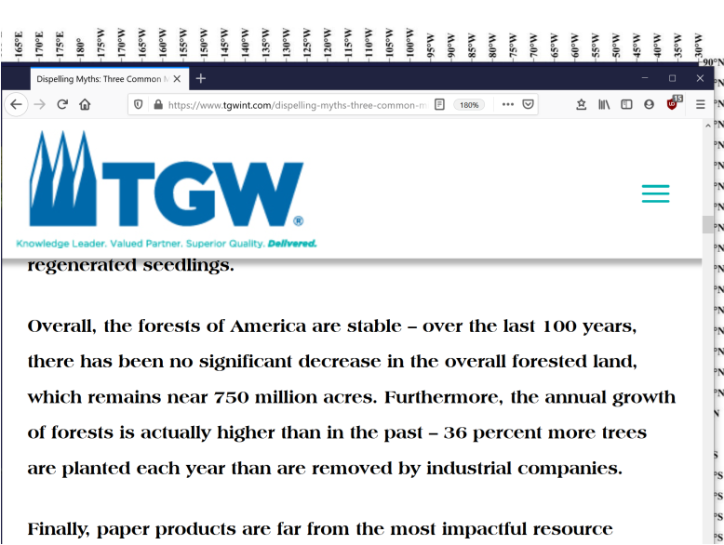

**furniture**

**contains**

**only non flammable material**

**mainly titanium hevea brasiliensis**

**materials for towers fences etcetera**

**include**

**titanium**

**DiameterCities design**

**decreases**

**chance of disease**

**air to water machines residences businesses**

**provide**

**pure water**

**residences’ businesses’ total rooms steamers**

**clean**

**fabrics equipment floors walls regular basis**

**rooms steamers**

**timed**

**by resident daily for when vacant**

**steam**

**sterilizes**

**bacteria viruses**

**Ai**

**confirm**

**no human in residence**

**before steaming residence**

**married couple chieftains per tower**

**facilitate**

**operations within towers**

**MINING ENVIRONMENT**

**DiameterCities**

**utilize**

**remote controlled machinery**

**for mining**

**hot air dirigibles**

**move**

**machinery**

**excavators**

**claw**

**material needed**

**dirigibles**

**fly**

**tons of material to DiameterCities**

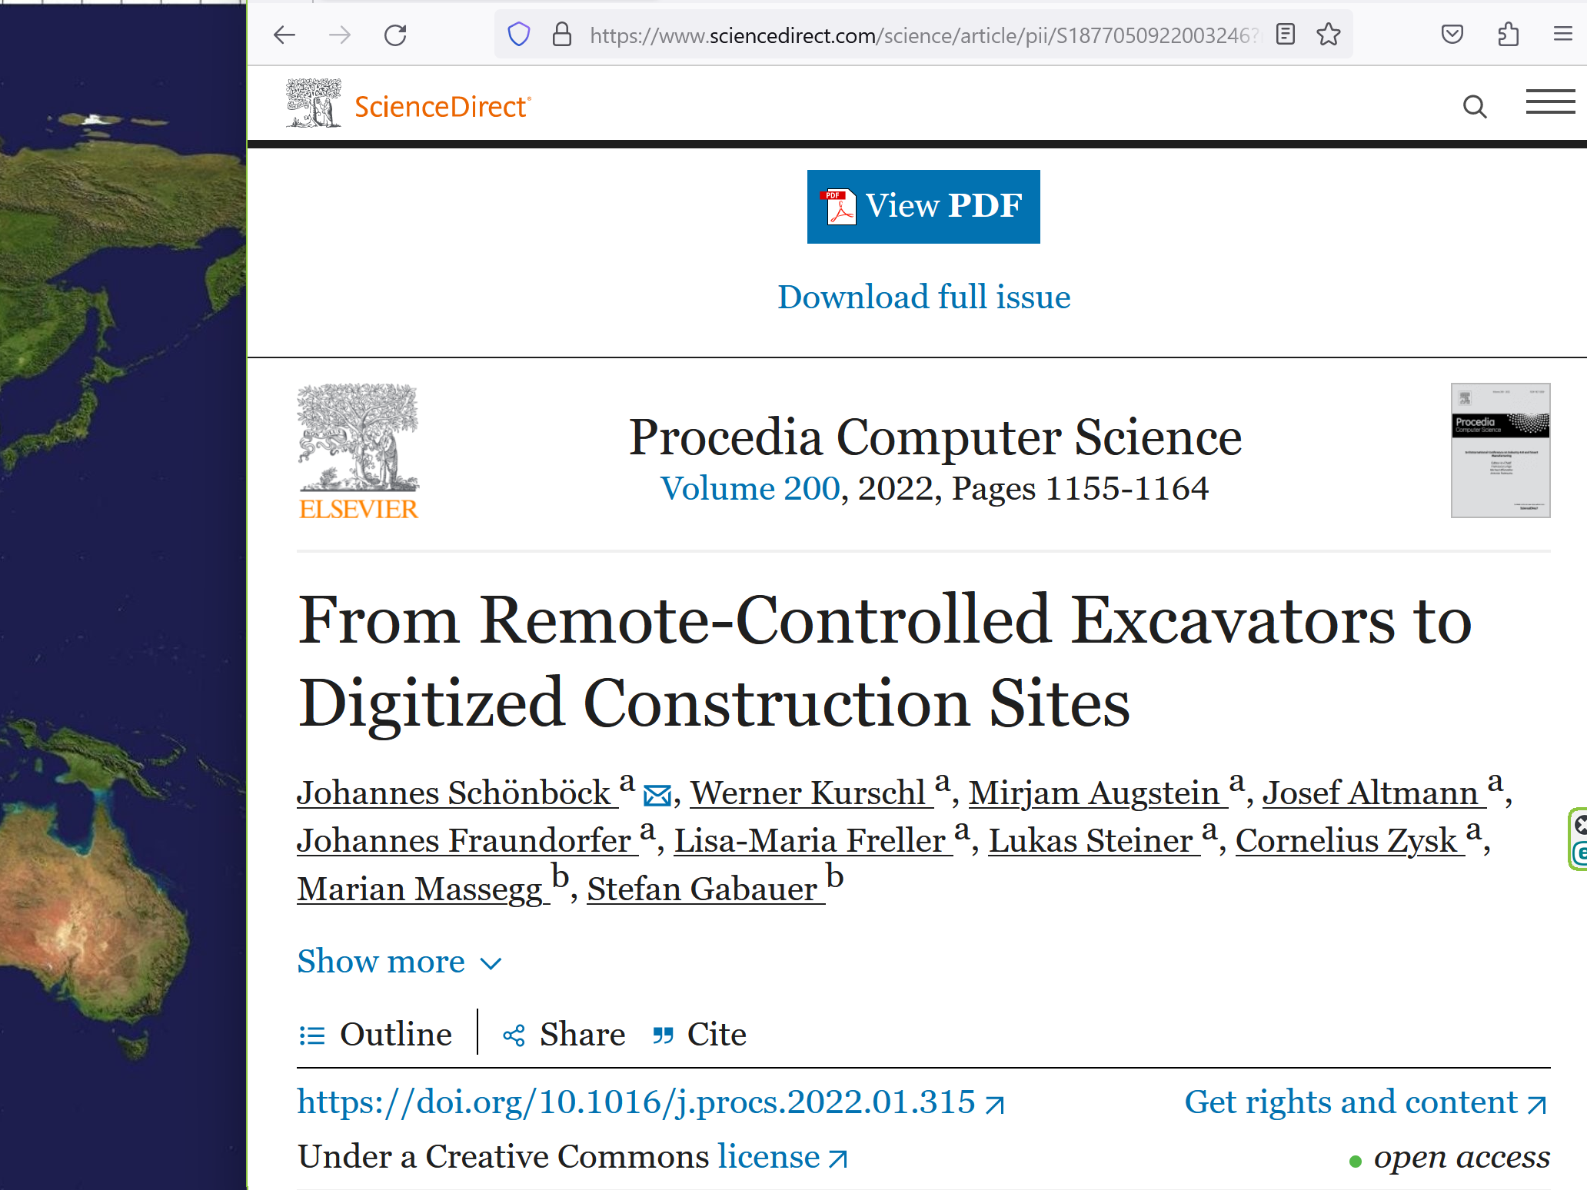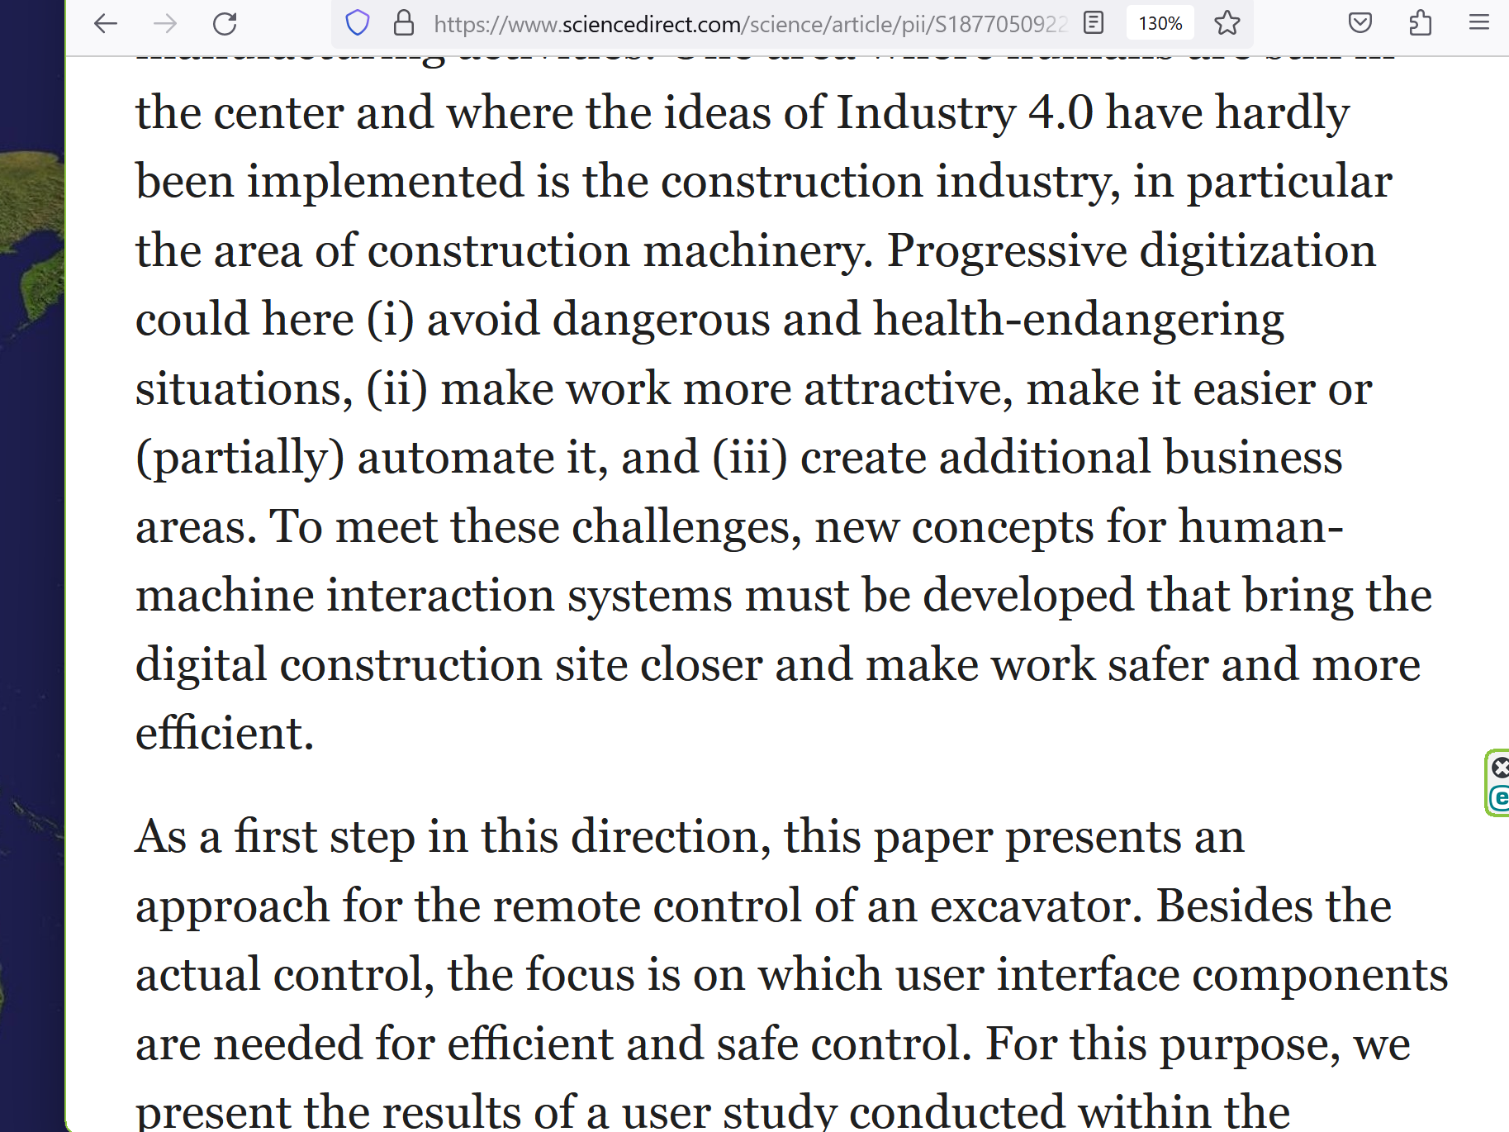

**chapter ends**