**J05 businesses**

**after former chieftain couple**

**leave**

**for year vacation then next five**

**oldest married couples eligible**

**at village meeting youngest person**

**inserts**

**five ping pong balls into tumbler**

**cranks tumbler at least seven spins**

**wife of each couple**

**grabs**

**ping pong ball from tumbler**

**holds number for audience viewing**

**then all five ladies**

**insert**

**five ping pong balls into tumbler**

**for more spins**

**young person looking away**

**grabs**

**one ping pong ball from tumbler**

**couple**

**corresponding**

**to number of ping pong ball**

**now officially chieftain couple**

**each family**

**free**

**anytime move to another village tower**

**in same DiameterCity or any DiameterCity**

**family**

**first needs**

**permission from new village chieftain couple**

**aspects of SUNNYsideUP culture**

**include**

**all physical structures prebuilt before humankind**

**migrates to DiameterCities**

**after migration to DiameterCities arrangement below**

**applies**

**to most families**

**DiameterCities jobs**

**usually involve**

**married couples**

**each husband concerning mondays tuesdays**

**works**

**two days maximum per week**

**with 12 hour maximum per day**

**each wife**

**possesses**

**same arrangement works same jobsite often**

**same desk wednesdays thursdays**

**for two days spouse at home**

**takes care**

**of children**

**housework etcetera when not at jobsite**

**entire family**

**enjoys**

**fridays saturdays sundays**

**together**

**single females**

**work**

**jobsite on fridays all day**

**saturday mornings**

**single males**

**work**

**jobsite on saturday afternoons**

**sundays all day**

**professors experts of many subjects**

**gain**

**money via paid scheduled lectures courtyards**

**tower chieftain couples**

**possess**

**complete say in lodgings**

**locations of tower resident families**

**tower**

**belongs**

**to tribes not families**

**in DiameterCities' businesses citizens**

**all become**

**equal owners of company**

**all companies**

**number 14 or 16 employees**

**usually 7 or 8 married couples**

**one couple of three eldest couples**

**randomly chosen**

**chieftain couple that company via**

**random ping pong tumbler system**

**1% of company’s profits**

**goes to**

**company’s chieftain couple**

**plus chieftain couple each as employees**

**gain**

**1/14th or 1/16th as employee owners**

**all companies**

**located**

**in business towers**

**each business tower**

**randomly chooses**

**chieftain couple of tower from pool**

**of five eldest couples in tower**

**1% of companies’ profits**

**go to**

**business tower chieftain couple**

**initially chieftain wife**

**empties**

**chieftain wife's bank account into**

**chieftain husband's account**

**chieftain husband**

**pays**

**for couple's expenses leaves chieftain wife's**

**account for governing easily publicly inspected**

**10% of citizens’ transactions**

**pay**

**chieftain couple of DiameterCities**

**Ai**

**automatically send**

**10% seamlessly**

**money into chieftain wife's account**

**utilized**

**for nation’s maintenance transportation**

**public transportation trains etcetera**

**above tax money**

**also pays**

**rescue squad pilot teams all women**

**corresponding husbands' squads**

**maintain**

**same aircraft**

**nation’s parliament**

**consists of**

**only two persons chieftain couple of nation**

**couple**

**votes**

**mandatorily 2-0 for laws’ enactments**

**two branches of government executive legislative**

**combined**

**easily discernible allows easy accountability**

**last branch of government judicial**

**possesses**

**jurors only majority rules judges absent**

**99 jurors via majority vote**

**request**

**Ai for pertinent videos of all**

**involved jury watches videos**

**transportation via trains**

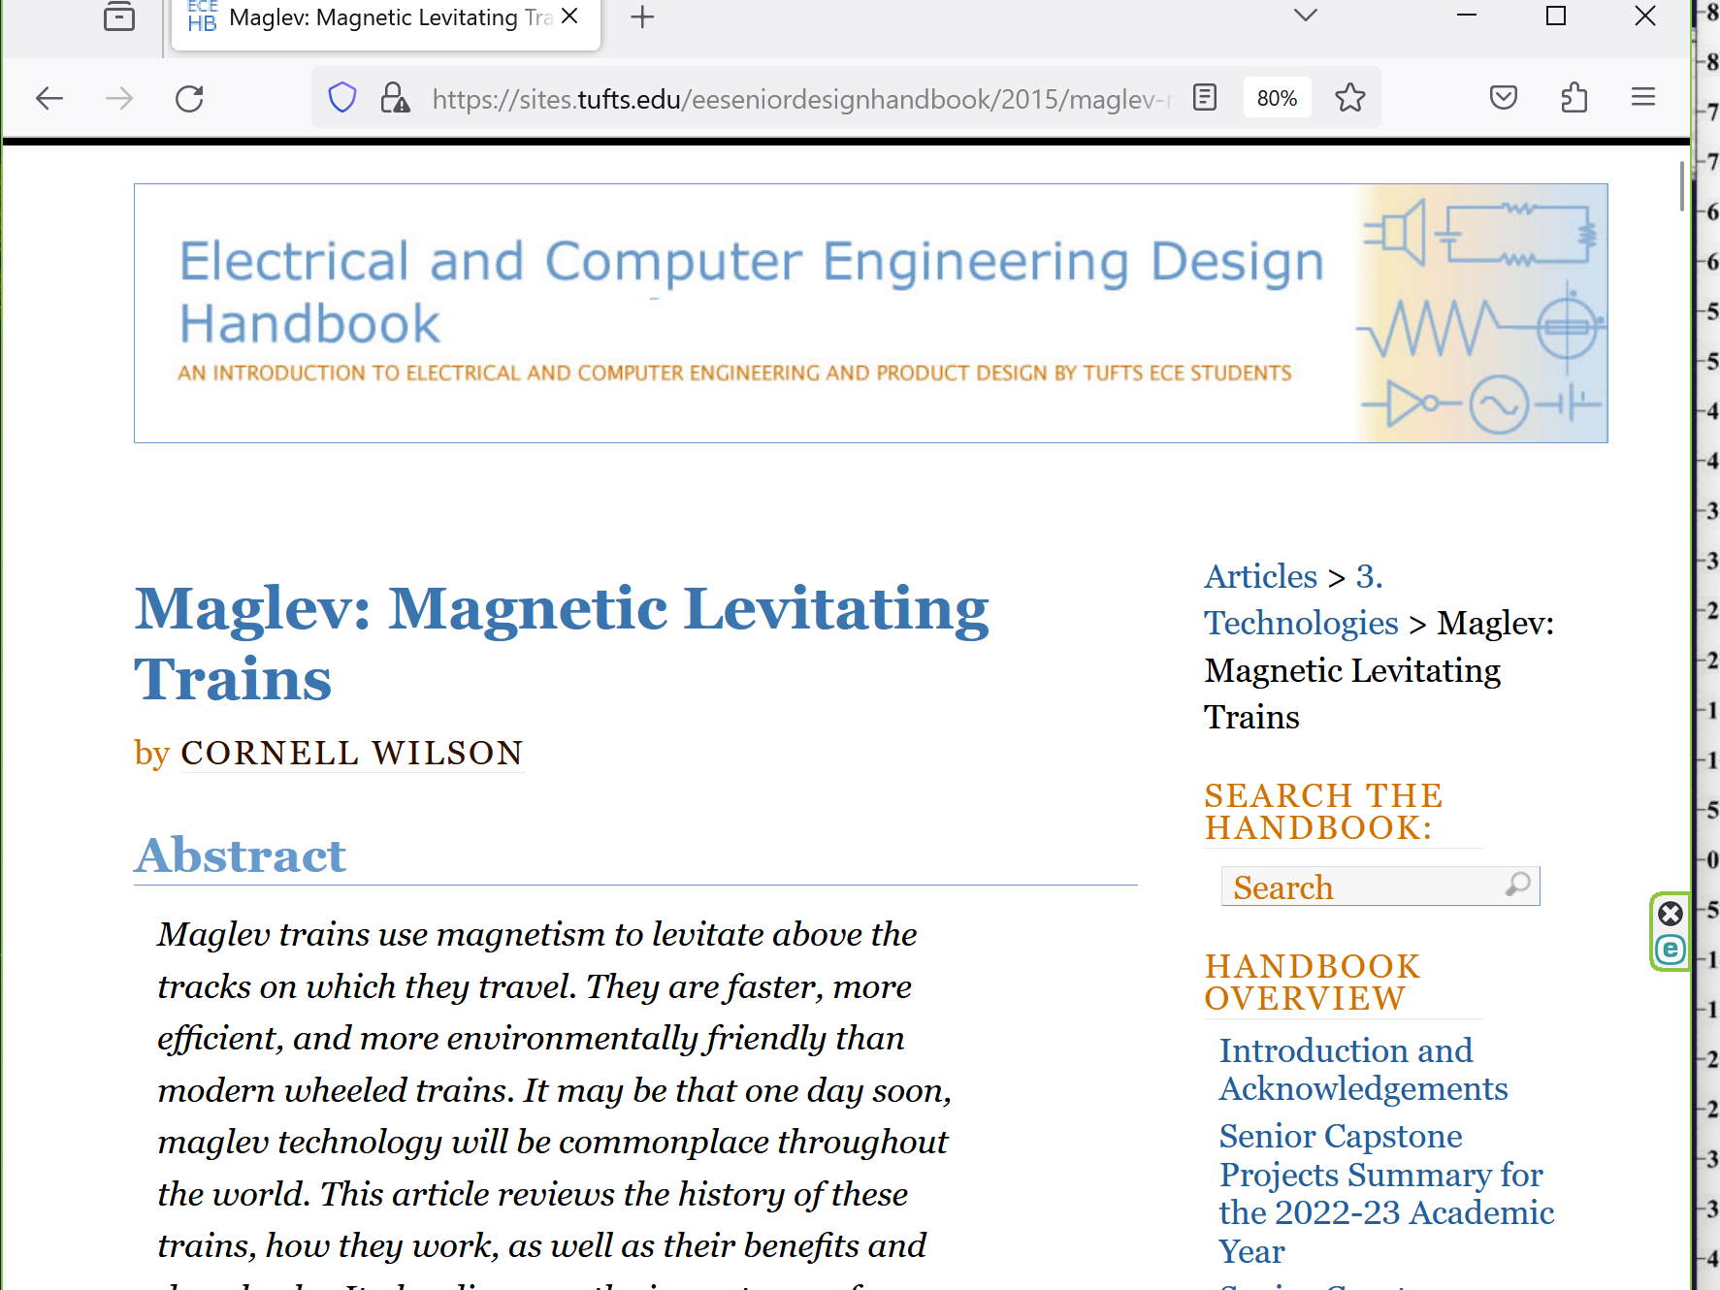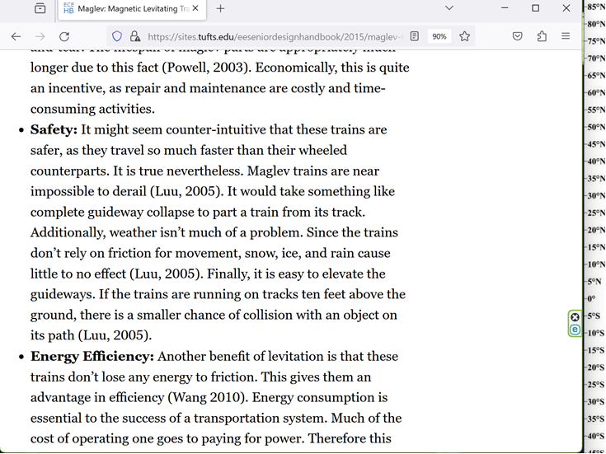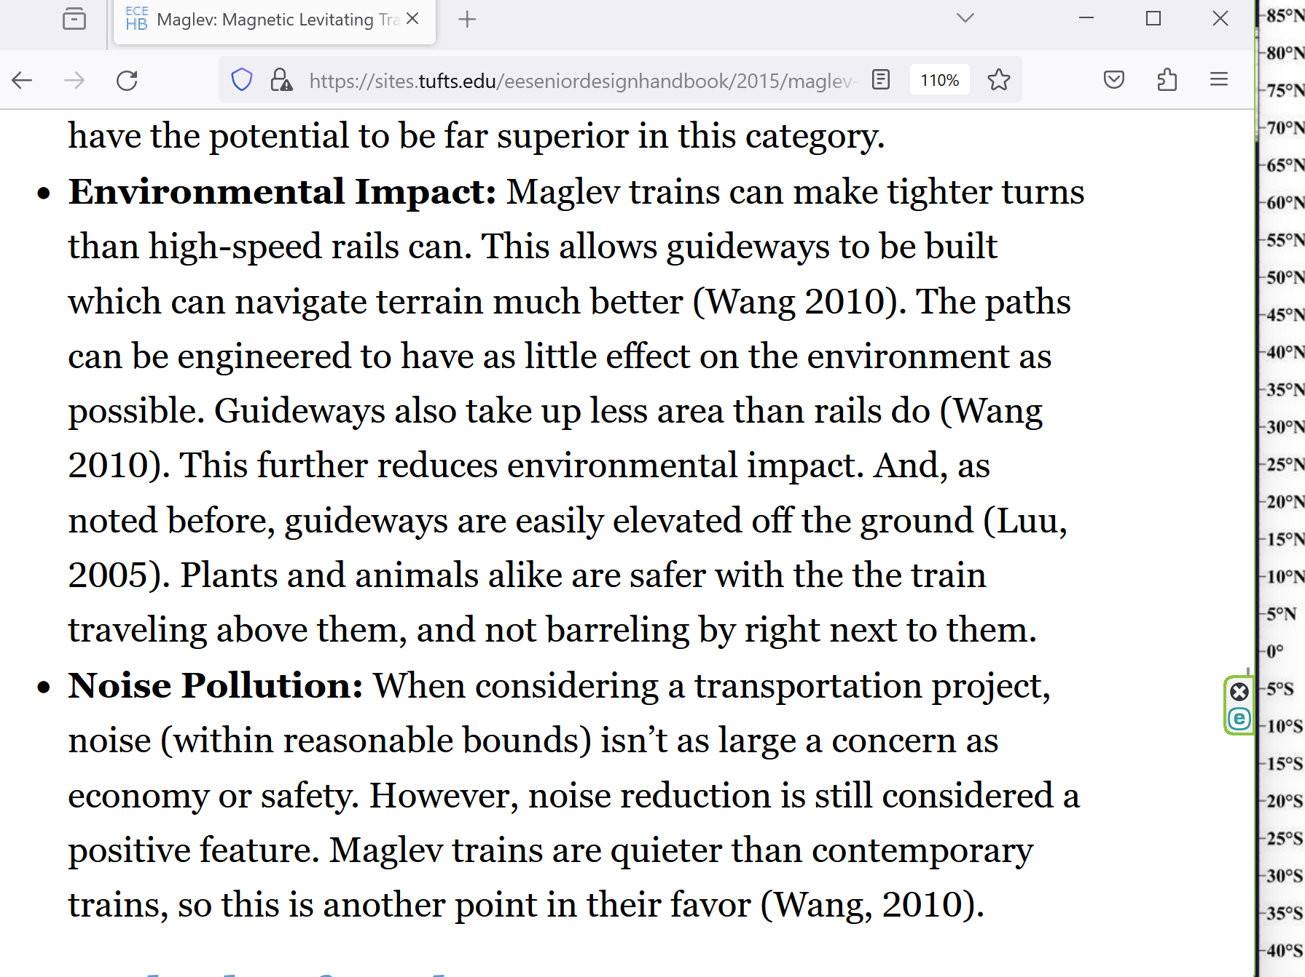

**chapter ends**